

English Ready
22636VIC Course in Initial EAL
VU23575 Recognise and use extremely familiar digital devices

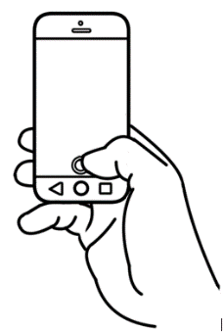
Phones and
Computers

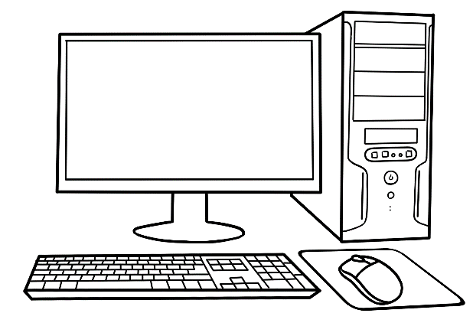

Name _________________________________________________
Teacher _____________________________________________ Class _________________________________________________
Date__________________________________________________

This workbook is designed to be used with the support of a teacher.

Design team: Vicki Hambling, Sue Paull, Frida Dean and Mary Wallace
Illustrations: Madelena Scott
Image acknowledgements:
Google icons – Photos by Unknown Author is licensed under CC BY-SA
Acknowledgements: The design team would like to thank the AMEP service providers and practitioners who participated in the trial and gave valuable feedback. The team would also like to acknowledge the use of the EAL Framework which underpins the design of this book.

Copyright of the EAL Framework is reserved to the Crown in the right of the State of Victoria. © State of Victoria (Department of Education and Training) 2023.
__________________________________________________________________________________
This English Ready Resource is licensed under a Creative Commons Attribution-NoDerivs 3.0 Australia licence (More information is available here). You are free to use, copy and distribute to anyone in its original form as long as you attribute Department of Home Affairs as the author and you license any derivative work you make available under the same licence.
© Commonwealth of Australia 2023
With the exception of the Commonwealth Coat of Arms, the department’s logo, any material protected by a trade mark and where otherwise noted all material presented in this document is provided under a Creative Commons Attribution 4.0 International (https://creativecommons.org/licenses/by/4.0/) licence.
The details of the relevant licence conditions are available on the Creative Commons website (accessible using the links provided) as is the full legal code for the CC BY 4.0 licence. (https://creativecommons.org/licenses/by/4.0/legalcode).
Use of all or part of this document must include the following attribution:
© Commonwealth of Australia 2023
As far as practicable, material for which the copyright is owned by a third party will be clearly labelled. The department has made all reasonable efforts to ensure that this material has been reproduced in this document with the full consent of the copyright owners.
Copyright requests and enquiries concerning usage not addressed by the CC BY 4.0 licence should be addressed to:
comms@homeaffairs.gov.au at the Department of Home Affairs.
The terms of use for the Commonwealth Coat of Arms are available from the It's an Honour website.
Where a copyright owner, other than the Commonwealth, is identified with respect to this material, please contact that third party copyright owner directly to seek permission.



Table of contents
1 Instructions 1
2 Meet the students and teachers. 2
3 What is that? 3
4 What can you use? 5
5 How many phones? 11
6 I have a phone. 13
7 My phone is locked. 19
8 Text the teacher. 21

Instructions
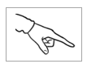
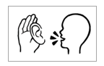

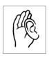  listen | 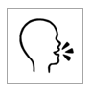  say
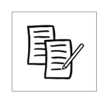  4  copy | 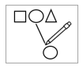  match
  colour |   circle
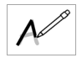  trace | tick
point | 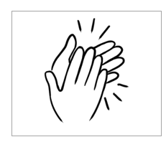  clap

Meet the students and teachers.

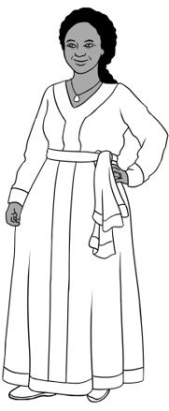
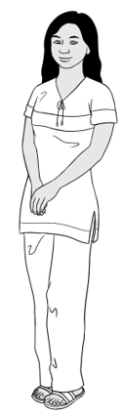
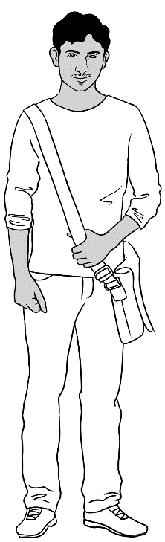
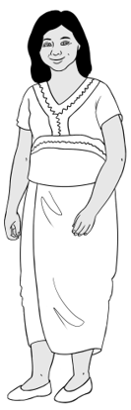
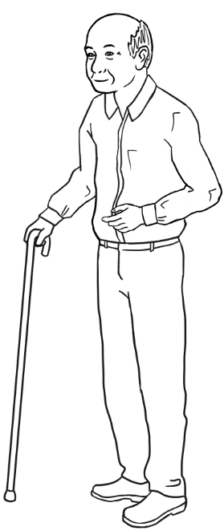
Students
3. Jamila
2. San
4. Rahim
1. Zarni
5. Ming

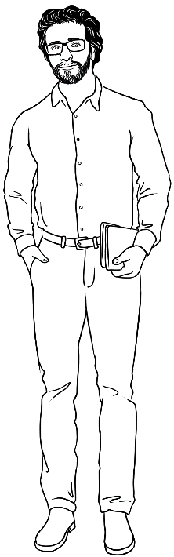
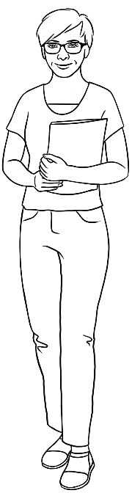
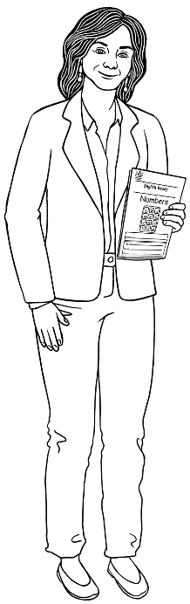
Teachers
6. Rosie
8. Peter
7. Wendy

What is that?

- a phone

- a laptop
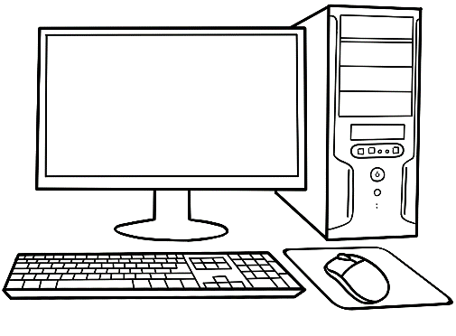
- a computer
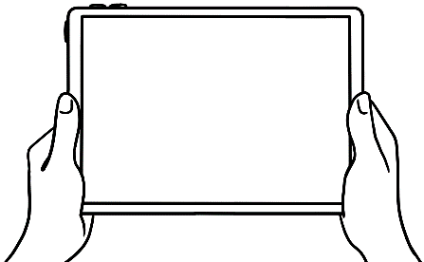
- a tablet

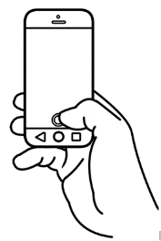
- This is a phone.
- This is a laptop.
- This is a computer.
- This is a tablet.

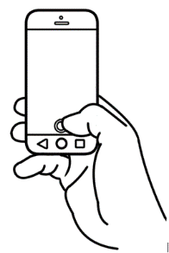

What can you use?

- I can use a phone.

- I can use a laptop.
- I can use a computer.
- I can use a tablet.
Rahim
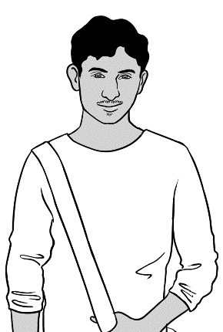

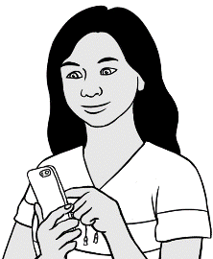

San

1. | 2. | 3. | 4.

- I can use a phone.
- I can use a laptop.
- I can use a computer.
- I can use a tablet.
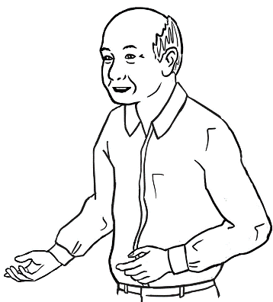
Ming

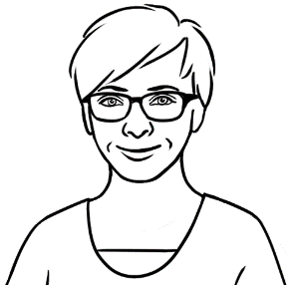

1. | 2. | 3. | 4.
What can you use?

Phone
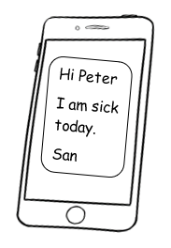

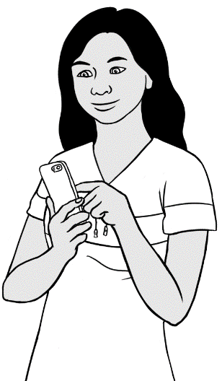
I text my teacher.
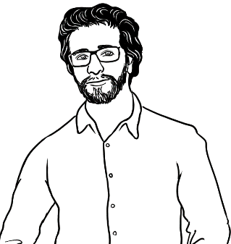
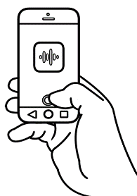
I record my teacher.

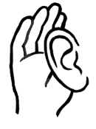
I listen to my teacher.

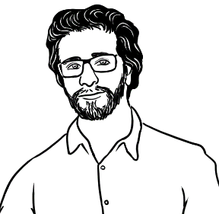
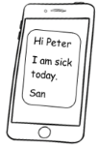
I text my teacher.
I record my teacher.
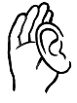
I listen to my teacher.
What can you do?
Laptop

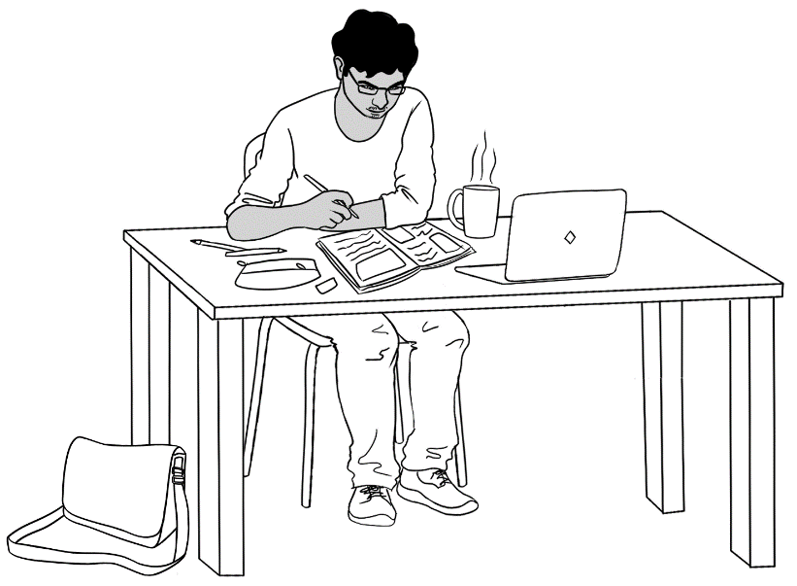


I use the internet.
I learn English.

I learn English.
I use the internet.
What can you do?
Computer

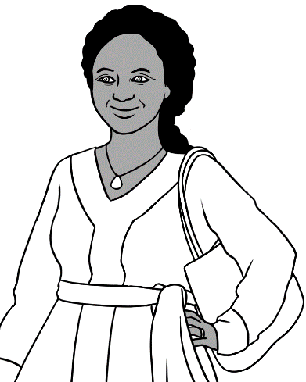
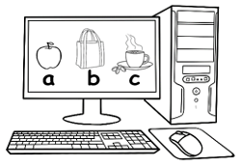
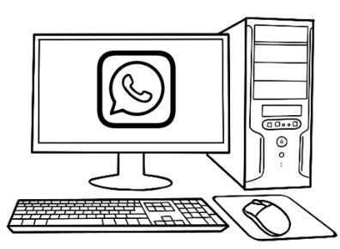
I learn English.
I talk to
my family.

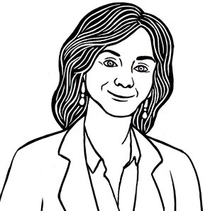
What can you do?
I learn English.
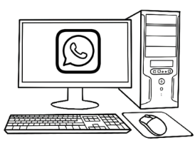
I talk to my family.

Tablet

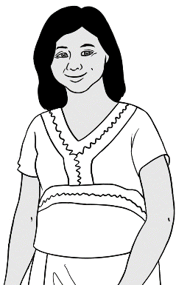
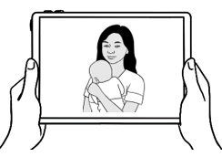
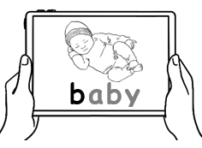
I look at photos.
I learn English.

What can you do?
I learn English.
I look at photos.

How many phones?

How many phones
in the classroom?
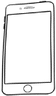

1 | 2 | 3 | 4 | 5 | 6 | 7 | 8 | 9 | 10
11 | 12 | 13 | 14 | 15 | 16 | 17 | 18 | 19 | 20
21 | 22 | 23 | 24 | 25 | 26 | 27 | 28 | 29 | 30

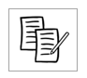

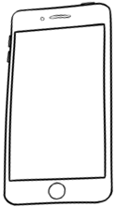
___ phones | ___ laptops | ___ computers | ___ tablets

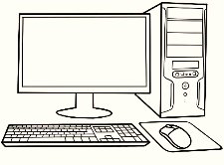
How many computers
in the computer room?

1 | 2 | 3 | 4 | 5 | 6 | 7 | 8 | 9 | 10
11 | 12 | 13 | 14 | 15 | 16 | 17 | 18 | 19 | 20
21 | 22 | 23 | 24 | 25 | 26 | 27 | 28 | 29 | 30

- .
___ computers | ___ laptops | ___ tablets

I have a phone.







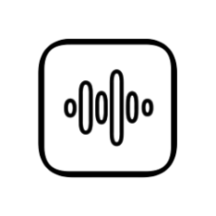

9:00

Google
Camera
Photos
Record
Time

9:00



Text
Talk
WhatsApp

Talk | Text | WhatsApp | Record

Camera | Photos | Google | Time  9:00
9:00

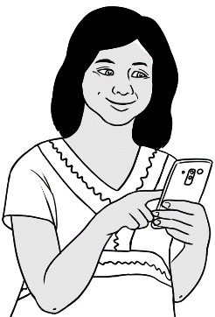
I have a phone.

- I talk to my family.
Hi.
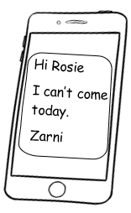
- I text my teacher.
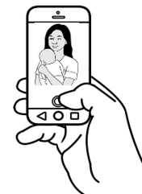
- I take photos.
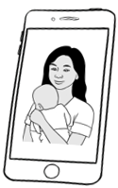
- I look at photos.

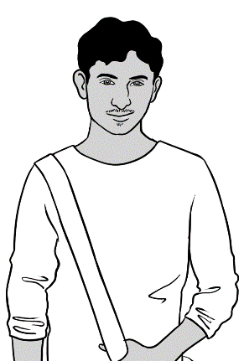
I have a phone.

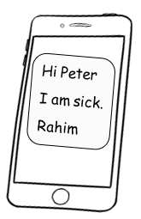
- I text my teacher.
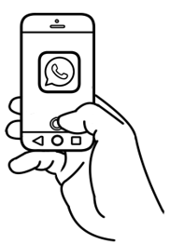
- I talk to my friends.
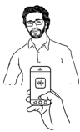
- I record my teacher.
I listen to my teacher.
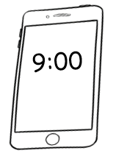
- I look at the time.

9:00

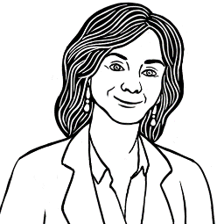
Do you have a phone?

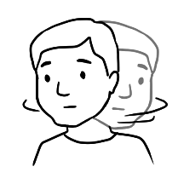
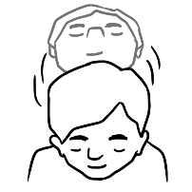

Yes No
- I talk to my family
and friends.
- I text my teacher.
- I look at the time.

- I take photos.
- I look at photos.
- I record my teacher.
- I listen to my teacher.

My phone is locked.

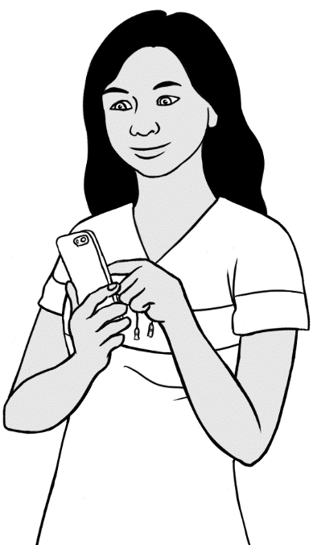

My phone is locked.

9:00

Swipe to unlock

I have a pin number.

0 | 1 | 2 | 3 | 4 | 5 | 6 | 7 | 8 | 9

1
4
7
2
5
0
8
3
6
9
OK
X
Emergency call

I press
the numbers.
I press OK.

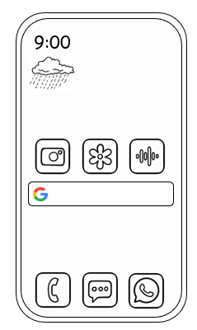

My phone
is unlocked.



Text the teacher.
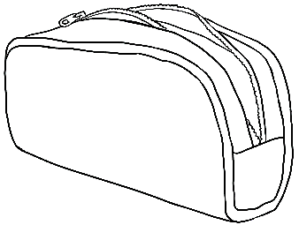
I am sick.
Hi Peter
I am sick.
San
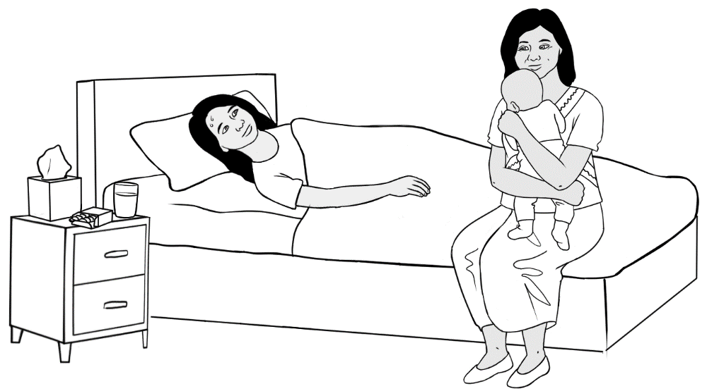

Hi Peter
H i __ eter

I am sick.
__ __ m __ ick.

San
__ an

Text the teacher.
0 | 1 | 2 | 3 | 4 | 5 | 6 | 7 | 8 | 9

My teacher’s phone number is

Hi __________________
I am sick.
______________________
You are sick.

