
Student book with teacher notes

English Ready
22636VIC Course in Initial EAL
VU23575 Recognise and use extremely familiar digital devices

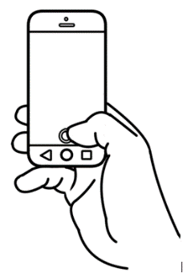
Phones and
Computers

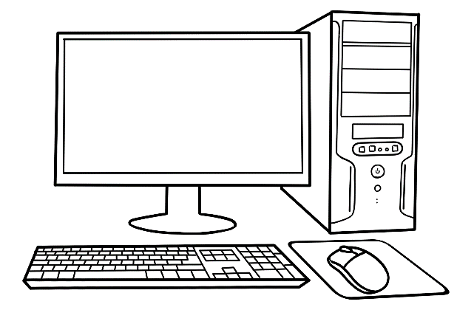

Name _________________________________________________
Teacher _____________________________________________ Class _________________________________________________
Date__________________________________________________

This workbook is designed to be used with the support of a teacher.

Design team: Vicki Hambling, Sue Paull, Frida Dean and Mary Wallace
Illustrations: Madelena Scott
Image acknowledgements:
Google icons – Photos by Unknown Author is licensed under CC BY-SA
Acknowledgements: The design team would like to thank the AMEP service providers and practitioners who participated in the trial and gave valuable feedback. The team would also like to acknowledge the use of the EAL Framework which underpins the design of this book.

Copyright of the EAL Framework is reserved to the Crown in the right of the State of Victoria. © State of Victoria (Department of Education and Training) 2023.
__________________________________________________________________________________
This English Ready Resource is licensed under a Creative Commons Attribution-NoDerivs 3.0 Australia licence (More information is available here). You are free to use, copy and distribute to anyone in its original form as long as you attribute Department of Home Affairs as the author and you license any derivative work you make available under the same licence.
© Commonwealth of Australia 2023
With the exception of the Commonwealth Coat of Arms, the department’s logo, any material protected by a trade mark and where otherwise noted all material presented in this document is provided under a Creative Commons Attribution 4.0 International (https://creativecommons.org/licenses/by/4.0/) licence.
The details of the relevant licence conditions are available on the Creative Commons website (accessible using the links provided) as is the full legal code for the CC BY 4.0 licence. (https://creativecommons.org/licenses/by/4.0/legalcode).
Use of all or part of this document must include the following attribution:
© Commonwealth of Australia 2023
As far as practicable, material for which the copyright is owned by a third party will be clearly labelled. The department has made all reasonable efforts to ensure that this material has been reproduced in this document with the full consent of the copyright owners.
Copyright requests and enquiries concerning usage not addressed by the CC BY 4.0 licence should be addressed to: comms@homeaffairs.gov.au at the Department of Home Affairs.
The terms of use for the Commonwealth Coat of Arms are available from the It's an Honour website.
Where a copyright owner, other than the Commonwealth, is identified with respect to this material, please contact that third party copyright owner directly to seek permission.



Table of contents

1 Instructions 1
2 Meet the students and teachers. 2
3 What is that? 3
4 What can you use? 5
5 How many phones? 11
6 I have a phone. 13
7 My phone is locked. 19
8 Text the teacher. 21

Instructions
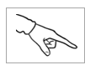
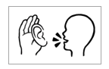
Mime and point to each instruction.

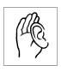  listen | 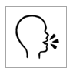  say
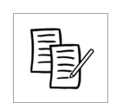  4  copy | 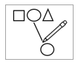  match
  colour |   circle
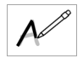  trace | tick
point | 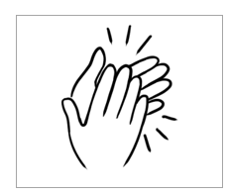  clap

Meet the students and teachers.
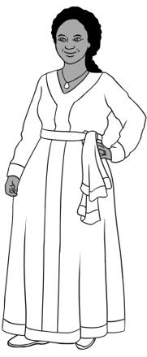
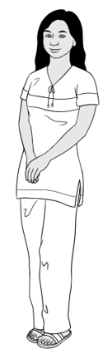
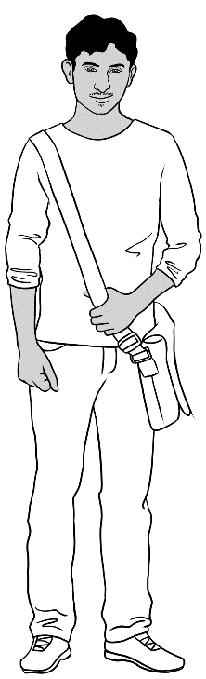
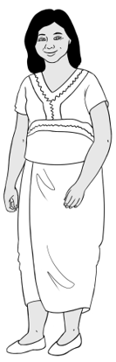
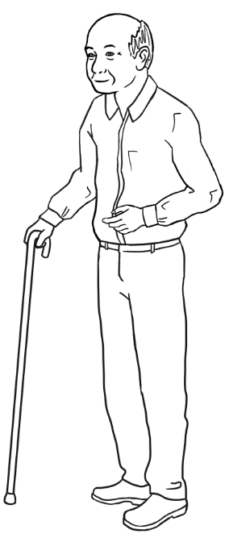
Students
3. Jamila
2. San
4. Rahim
1. Zarni
5. Ming
Project the page. Students point to the students and teachers.
Name the characters. Create sentences. e.g. Zarni is a student.

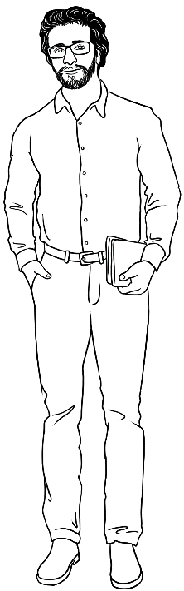
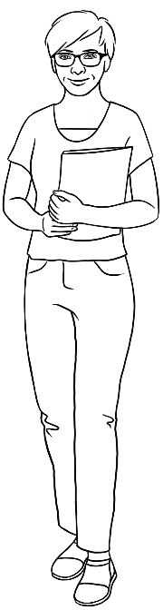
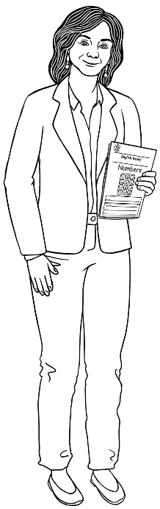
Teachers
6. Rosie
8. Peter
7. Wendy

What is that?

- a phone

- a laptop
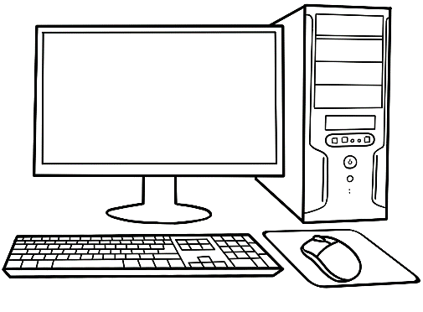
- a computer
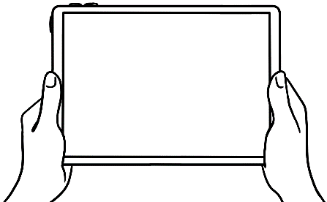
- a tablet

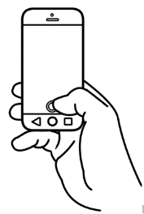
- This is a phone.
- This is a laptop.
- This is a computer.
- This is a tablet.

Give instructions to point to each device.

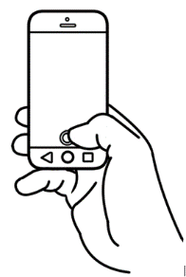

What can you use?
The boxes are ticked in the student book.

- I can use a phone.

- I can use a laptop.
- I can use a computer.
- I can use a tablet.
Rahim
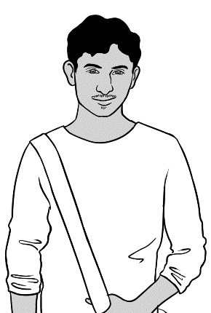

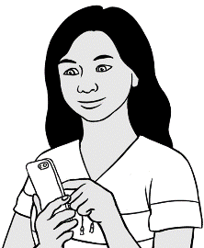
Listening: exercise Tell students what San says. e.g. I can use a phone.
Students tick the devices. These are not ticked in the student book.

San

1. | 2. | 3. | 4.

Listening exercise. Tell students what Ming says.
Students tick the devices. The boxes are not
ticked in the student book.

- I can use a phone.
- I can use a laptop.
- I can use a computer.
- I can use a tablet.
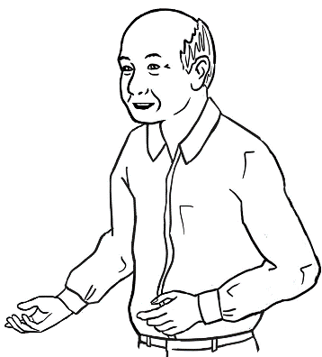
Ming

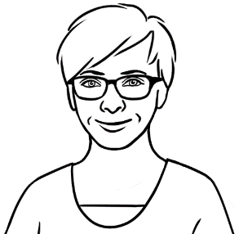
Students tick what they can use and then tell you and their partner.

1. | 2. | 3. | 4.
What can you use?

Phone
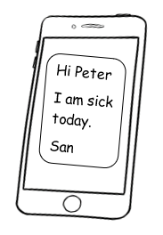
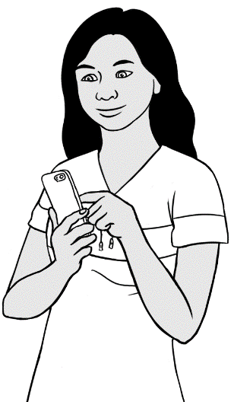
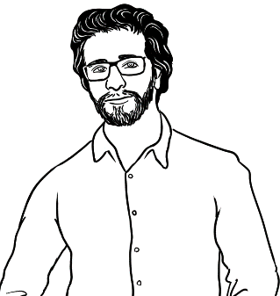
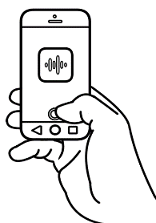
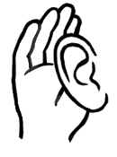
I text my teacher.
I record my teacher.
I listen to my teacher.

Trace the verbs pages 8 -11.
What can you do?

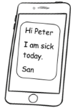
I text my teacher.
I record my teacher.
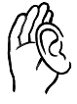
I listen to my teacher.

Laptop

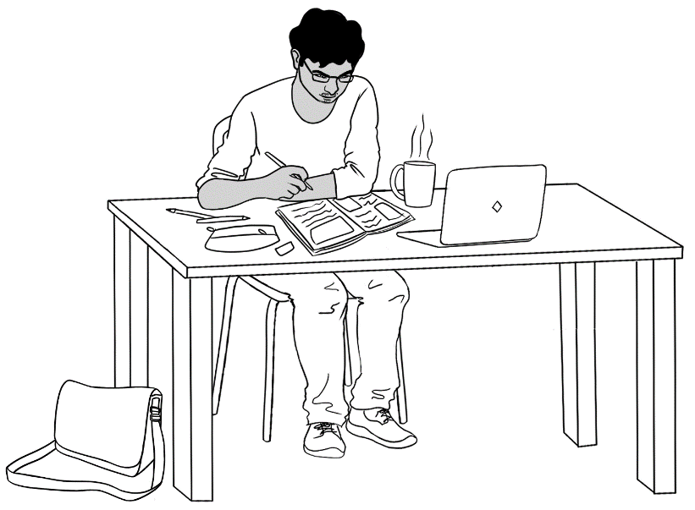


I use the internet.
I learn English.

I learn English.
I use the internet.
What can you do?
Computer

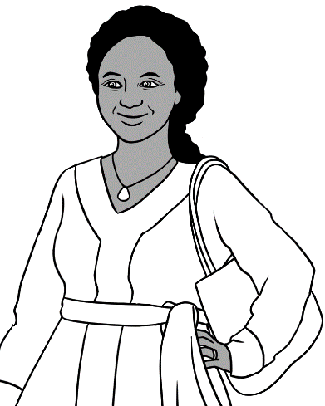
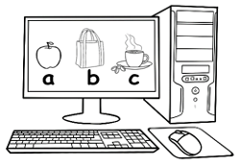
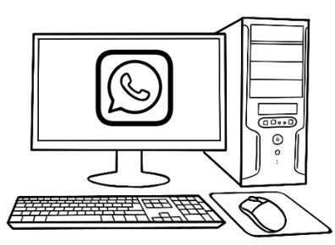
I learn English.
I talk to
my family.

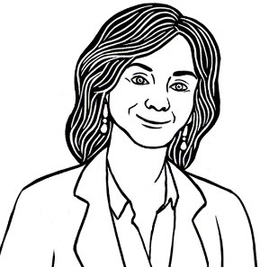
What can you do?
I learn English.
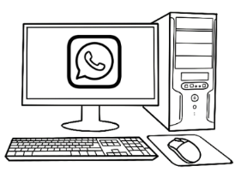
I talk to my family.

Tablet

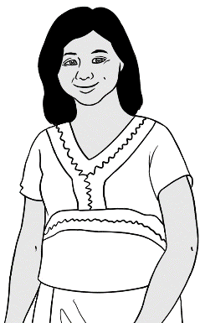
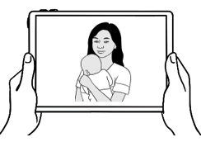
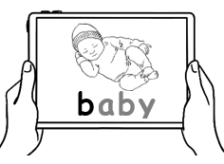
I look at photos.
I learn English.

What can you do?
I learn English.
I look at photos.

How many phones?

How many phones
in the classroom?
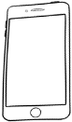

1 | 2 | 3 | 4 | 5 | 6 | 7 | 8 | 9 | 10
11 | 12 | 13 | 14 | 15 | 16 | 17 | 18 | 19 | 20
21 | 22 | 23 | 24 | 25 | 26 | 27 | 28 | 29 | 30

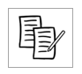
Count the number of devices in the classroom.
Students copy the numbers from above or from the board.

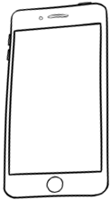
___ phones | ___ laptops | ___ computers | ___ tablets

Count the number of computers in the computer room.


How many computers
in the computer room?

1 | 2 | 3 | 4 | 5 | 6 | 7 | 8 | 9 | 10
11 | 12 | 13 | 14 | 15 | 16 | 17 | 18 | 19 | 20
21 | 22 | 23 | 24 | 25 | 26 | 27 | 28 | 29 | 30

Count the number of computers, laptops and tablets
in the computer room. Students copy the numbers
from above or from the board.
- .
___ computers | ___ laptops | ___ tablets

I have a phone.
Project the page. Instruct students to point to the time and different icons. Mime the actions of the icons. Match the icons.

Students could colour the icons to match the icons on their phones.








9:00

Google
Camera
Photos
Record
Time

9:00



Text
Talk
WhatsApp

Talk | Text | WhatsApp | Record

Camera | Photos | Google | Time  9:00
9:00

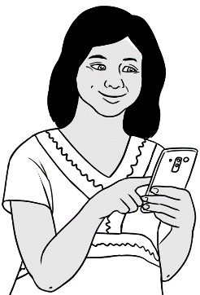
I have a phone.

- I talk to my family.
Hi.
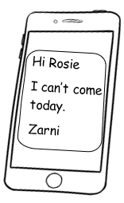
- I text my teacher.
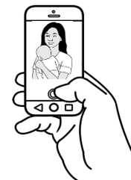
- I take photos.
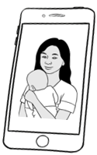
- I look at photos.

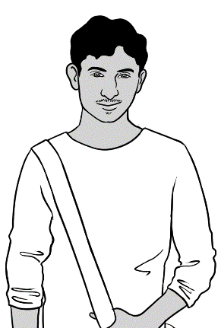
I have a phone.

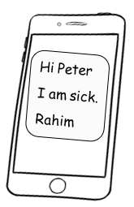
- I text my teacher.
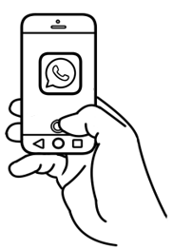
- I talk to my friends.
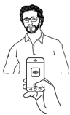
- I record my teacher.
I listen to my teacher.
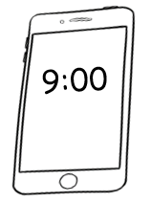
- I look at the time.

9:00

Instruct students to tick what they do on their phones. .
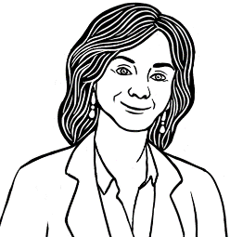
Do you have a phone?

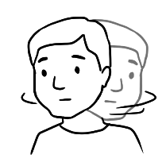
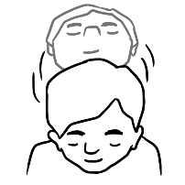

Yes No
- I talk to my family
and friends.
- I text my teacher.
- I look at the time.

- I take photos.
- I look at photos.
- I record my teacher.
- I listen to my teacher.

My phone is locked.

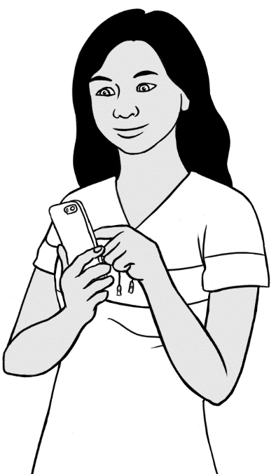

My phone is locked.

9:00

Swipe to unlock

I have a pin number.

Listening exercise. San’s pin number is 4730.

0 | 1 | 2 | 3 | 4 | 5 | 6 | 7 | 8 | 9

Listen, repeat and point to San’s four pin numbers. Press OK. Explain the meaning of the back arrow and if possible,
the emergency call feature.

1
4
7
2
5
0
8
3
6
9
OK
X
Emergency call

I press
the numbers.
I press OK.

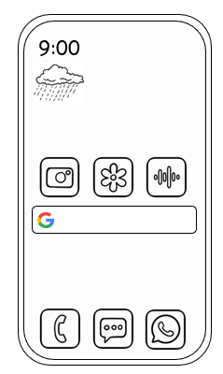

My phone
is unlocked.



Text the teacher.
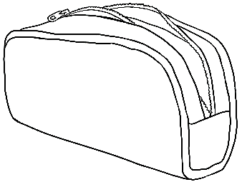
I am sick.
Hi Peter
I am sick.
San
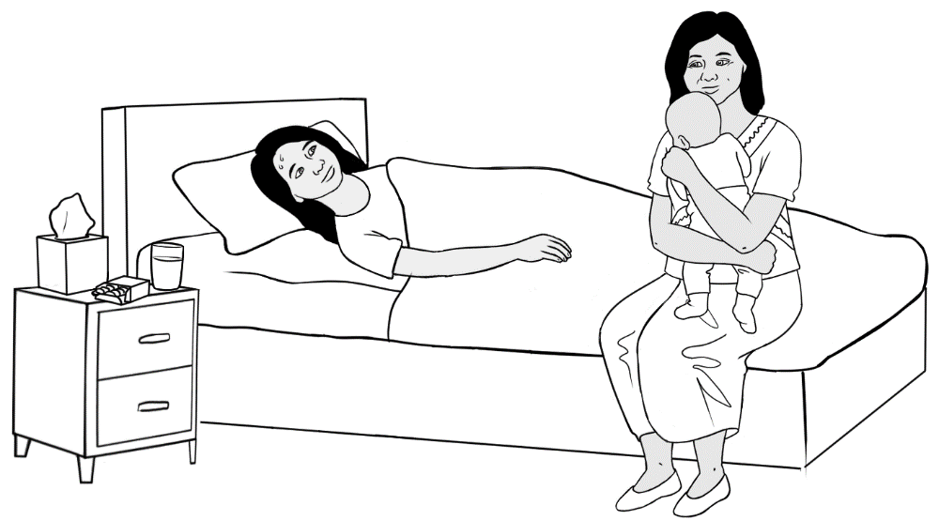

Hi Peter
Hi __ eter

I am sick.
__ __ m __ ick.

San
__ an

Text the teacher.
0 | 1 | 2 | 3 | 4 | 5 | 6 | 7 | 8 | 9
Students listen and copy the teacher’s phone number below
and onto their phone.
My teacher’s phone number is

Students copy the teacher’s name and their name in the text below. They then copy the text onto their phone and send it to the teacher.

Hi __________________
I am sick.
______________________
You are sick.

