

English Ready
22636VIC Course in Initial EAL
VU23575 Recognise and use extremely familiar digital devices

Phones and Computers

Teacher Resources

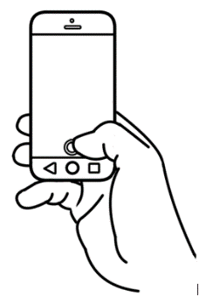
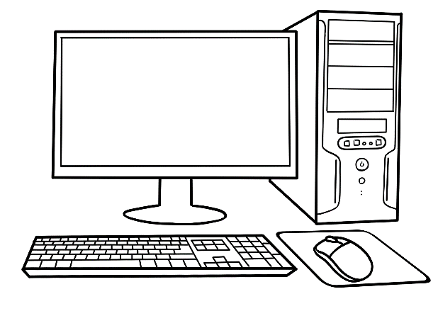

Design team: Vicki Hambling, Sue Paull, Frida Dean and Mary Wallace
Illustrations: Madelena Scott
Image Acknowledgements:
Huawei phone & phones with photo & weather - These Photos by Unknown Author is licensed under CC BY-NC
Tablet photo, A sunny day - This Photo by Unknown Author is licensed under CC BY-SA-NC
Phone with time - This Photo by Unknown Author is licensed under CC BY
Google and WhatsApp icons – Photos by Unknown Author is licensed under CC BY-SA,
Acknowledgements: The design team would like to thank the AMEP service providers and practitioners who participated in the trial and gave valuable feedback. The team would also like to acknowledge the use of the EAL Framework which underpins the design of this book.
Copyright of the EAL Framework is reserved to the Crown in the right of the State of Victoria. © State of Victoria (Department of Education and Training) 2023.
___________________________________________________________________________
This English Ready Resource is licensed under a Creative Commons Attribution-NoDerivs 3.0 Australia licence (More information is available here). You are free to use, copy and distribute to anyone in its original form as long as you attribute Department of Home Affairs as the author and you license any derivative work you make available under the same licence.
© Commonwealth of Australia 2023
With the exception of the Commonwealth Coat of Arms, the department’s logo, any material protected by a trade mark and where otherwise noted all material presented in this document is provided under a Creative Commons Attribution 4.0 International (https://creativecommons.org/licenses/by/4.0/) licence.
The details of the relevant licence conditions are available on the Creative Commons website (accessible using the links provided) as is the full legal code for the CC BY 4.0 licence. (https://creativecommons.org/licenses/by/4.0/legalcode).
Use of all or part of this document must include the following attribution:
© Commonwealth of Australia 2023
As far as practicable, material for which the copyright is owned by a third party will be clearly labelled. The department has made all reasonable efforts to ensure that this material has been reproduced in this document with the full consent of the copyright owners.
Copyright requests and enquiries concerning usage not addressed by the CC BY 4.0 licence should be addressed to: comms@homeaffairs.gov.au at the Department of Home Affairs.
The terms of use for the Commonwealth Coat of Arms are available from the It's an Honour website.
Where a copyright owner, other than the Commonwealth, is identified with respect to this material, please contact that third party copyright owner directly to seek permission.


Introduction to the books
The Teacher Resources
The oral and kinaesthetic activities in this book utilise a variety of senses
to improve memory retention. This is particularly important for students impacted by trauma. The most productive classes are noisy and active. Resources here aim to promote noisy active learning. They include:
- drawings of the characters for use in the design of additional materials
- flashcards for printing
- individual and class activities
- revision and homework exercises
- extension exercises.
The book is an electronic reference. Print pages as needed.
The Student Workbook
The student book requires teacher direction and is not intended for independent learning. It is also not intended to be the only material used
to teach these units or to be used as an assessment task. It is recommended that students buy and use a notebook for general class work and practice.
The book is available as a Word document so that teachers can:
- localise and update the content
- adjust the material to suit the requirements of particular classes and students
- delete, add and grade materials as required. If you add or deduct pages, be mindful of the layout as the document has been designed
so that particular pages are opposite one another.
NB * A teacher version of the student workbook contains additional guidance for activities and also answers for listening exercises.
* Considering the cost of photocopying, colour has been used sparingly.

Table of contents

1. Meet the students and teachers. 3
2. What is that? 5
3. Mobile phones 8
4. My phone is locked. 22
5. Text the teacher. 24
6. Digital resources 27

Meet the students and teachers.

The characters using digital devices:
- Sending a text

San Zarni
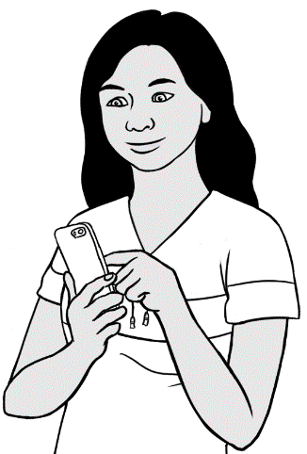
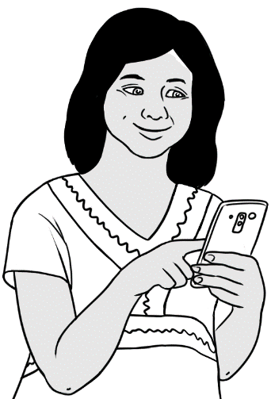

- Using a laptop

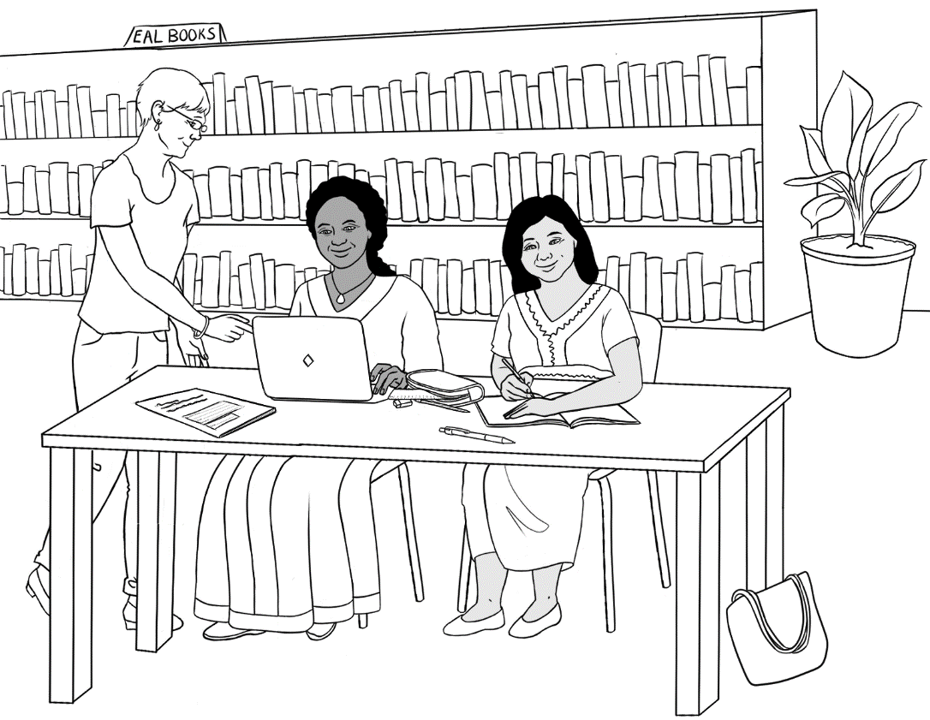
Jamila Rahim
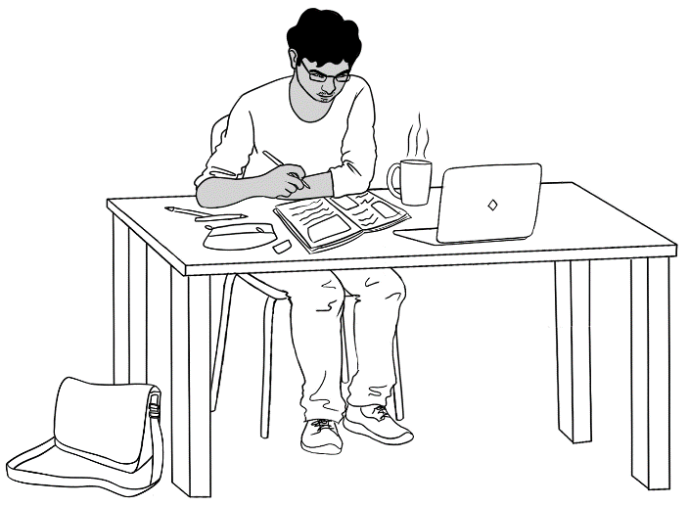

- Recording the teacher


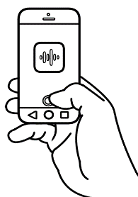
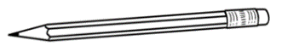
San Peter
I have a pencil.

- Listening to the teacher
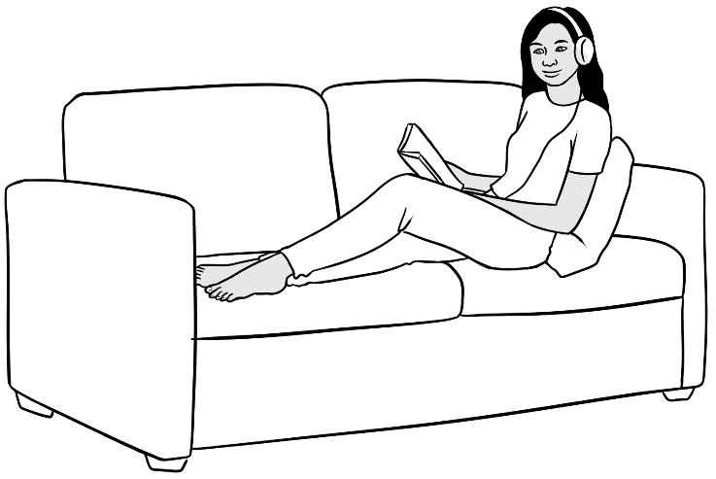

San

- Using a phone to listen and read
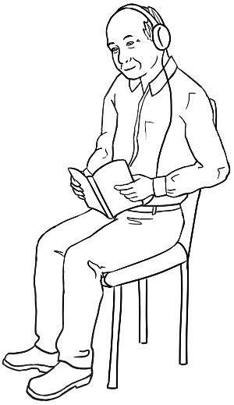

Ming

What is that?
Introduction
The four digital devices most relevant to Course in Initial EAL students have been included in the student workbook – phone, laptop, computer and tablet. The work in this book extends the work on these devices. Additional devices may be introduced if considered appropriate for your students.
The challenge with studying digital devices such as ATMs, EFTPOS machines, GPS, train ticketing machines, parking meters etc is their infinite variety and changeability. Any study needs to be localised and dealt with at a need-to-know basis. For example, if your centre has installed parking meters, learning how to use these would be appropriate.
Activity 1 - A walking excursion
Go for a walk around the local area to find and photograph digital machines. Encourage students to pose next to the machines, or pretend to be using them:
- at bus and train stations – ticketing machines
- at shopping centres - parking meters, information screens and EFTPOS machines etc
A checklist of equipment can be ticked off as equipment is found.
*These machines could be photographed beforehand and used to illustrate the checklist, so students are ticking off accurate images of the devices they find.
Back in class, tally up the number of devices found. Project the photos taken and identify/mime their use. Students will enjoy this follow-up more if they are featured in the photos.

* Alternatively, bypass the excursion and simply project the photos of digital equipment you have taken in your local area and identify their use through mime.

Activity 2 – Phones, laptops, computers, tablets
- Drawings and photos of devices
Project the drawings and photos and elicit names. The aim of this exercise is to link the drawing of an object to the real thing; this can be difficult for some students.
You could use the images to introduce some vocabulary common to the devices. e.g. screen, keyboard etc

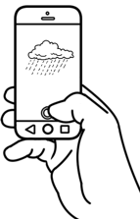 | 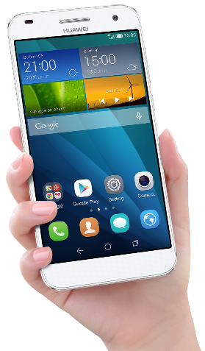
 | 
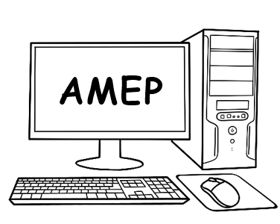 | 
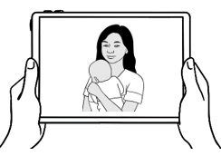 | 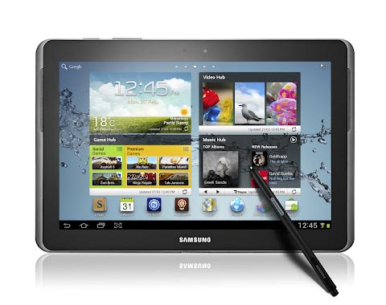
Digital devices

Mobile phones
Phones – An introduction
As students and teachers have various brands and versions of mobile phones,
it can be difficult to do hands-on activities with the whole class. Not only will brands and versions be different, but also the icons and the procedure for unlocking the phone.

Activity 1 - Introduce icons
- Project the following two pages. Students listen to and then repeat the statements.
- Students locate and point to the icons on their phone.
- Print the pages for students to trace the statements and tick the boxes to show what they can do. If possible, students could read the sentences to their partner.

Activity 2 – Chants
The aim of these chants is to:
- Highlight the fact that an action can be done on different devices
- Recycle single words and useful collocations to aid memory.
Some of the sentences in Activity 3 have been converted into chants with each of the four characters in the book saying what they can do and then asking the class, What can you do? [See the following pages.] Once the chants are familiar, the class could chant as the characters, and a confident student could answer the question.

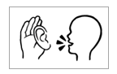




- I talk.
I talk.

- I text.
I text.

- I take photos.
I take photos.

- I look at photos.
I look at photos.
- I look at the time.
9:00
I look at the time.


- I record my teacher.
I record my teacher.

- I listen to my teacher.
I listen to my teacher.


- I use the internet.
I use the internet.

- I look at the weather.
I look at the weather.
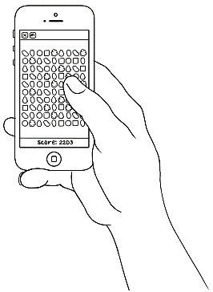
- I play games.
I play games.


Chant #1

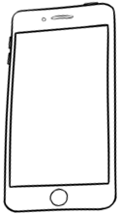



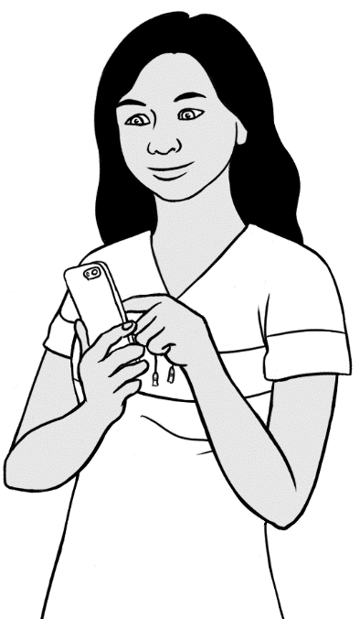
I talk on my phone.
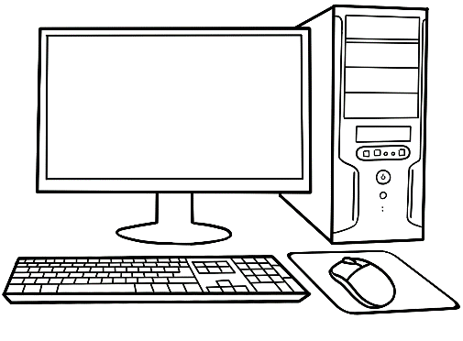

I talk on a laptop.
I talk on a computer.

I talk on a tablet.

What can you do?

Chant #2



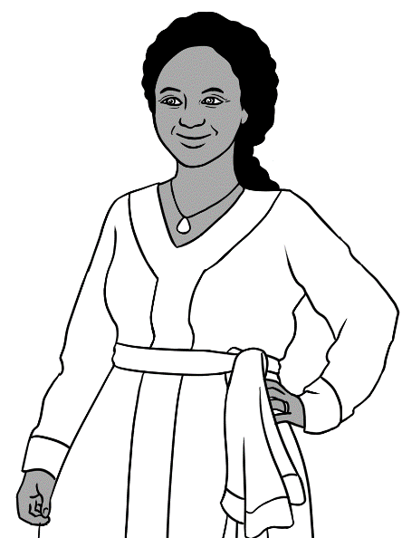
I video talk on my phone.

I video talk on a laptop.

I video talk on a computer.
I video talk on a tablet.

What can you do?

Chant #3

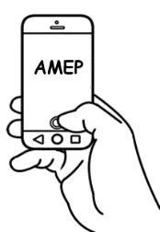
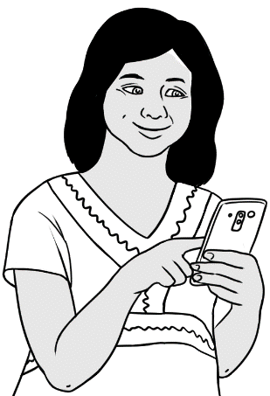

I learn English on my phone.
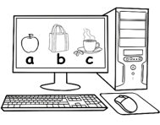
I learn English on a laptop.
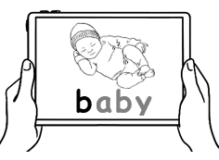
I learn English on a computer.
I learn English on a tablet.

What can you do?

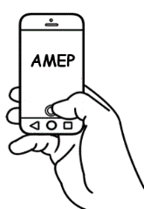

Activity 3 - Use basic phone features
Demonstrate how to locate and use the Time, Camera, Photo Gallery and Weather features on a phone.
- Time
- Project the following page and ask students to say the times.
- Ask students to locate the Time feature on their phone and show it
to their partner.
- Some students may be able to show the current time in their own country on their phone.
- The phones could be cut out and sequenced. Perhaps start sequencing at the time most students get up to avoid the hours of sleeping.

- Camera
- Project the drawing of the phone on the following pages and point to the Camera icon.
- Students may need to be shown how to use the camera.
- Students take a photo out of the classroom window, or somewhere outside the classroom with no people in the frame. They then show it to their partner.

- Photo Gallery
- Project the drawing of the phone on the following pages and point to the Photo Gallery icon.
- Students may need to be shown how to open the photo gallery and navigate it.
- Students locate the Photo gallery feature on their phone then show it to their partner. If appropriate, students can show other photos from their gallery.

- Weather
- Project the Weather #1. Teach and practise new vocabulary: sunny, cloudy, windy, rainy.
- Complete the worksheet on the Weather #2 together. In exercise 3, students point to and colour the icon for the day’s weather.
- Identify the weather on each phone on Weather #3. [Notice the changing time.]
- Students locate the Weather feature on their phone and show it to their partner. Describe the day’s weather if possible.

- Revision Worksheet – to revise vocabulary around icons and also alert the teacher to gaps in skills.

- Time [Project]
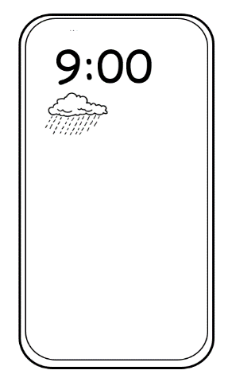
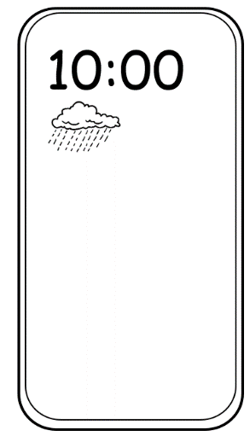
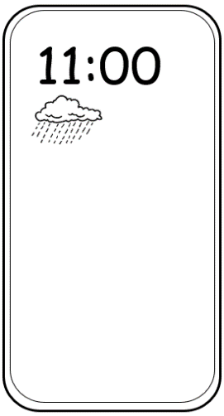
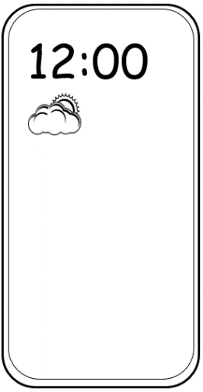
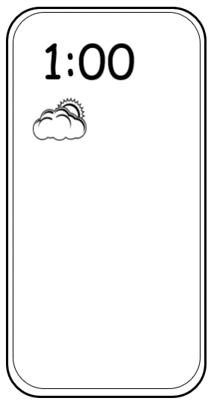
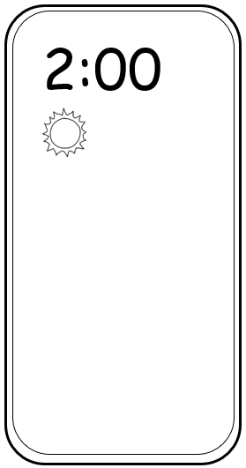
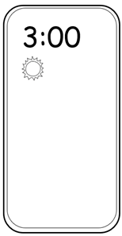
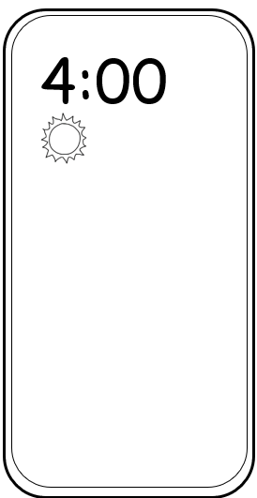
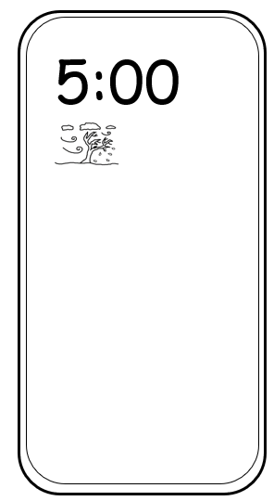
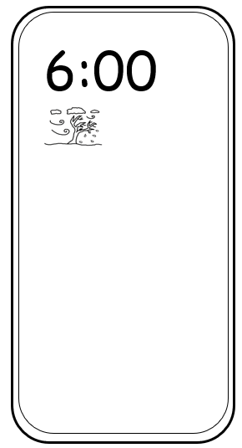
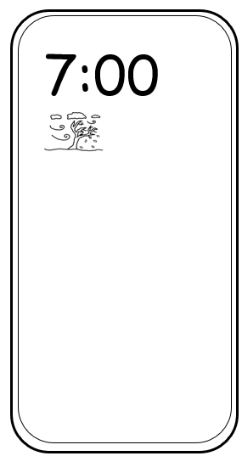
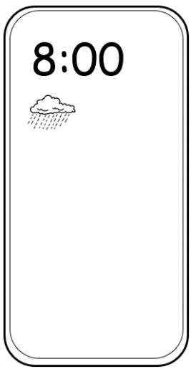

- Camera [Project]

9:00



- Photo Gallery [Project]

9:00


- Weather #1 [Project]

sunny
1



cloudy

2



windy
3



rainy
4

Weather #2
Weather

 |  |  | 
sunny | cloudy | windy | rainy

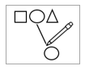
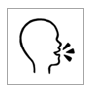

sunny | cloudy | windy | rainy


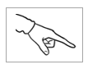


- .

Today is

Weather #3 [Project]
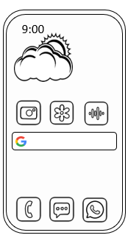
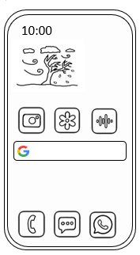

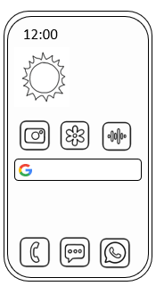
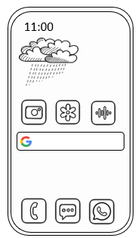

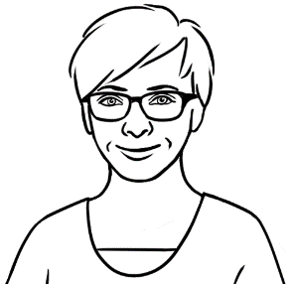
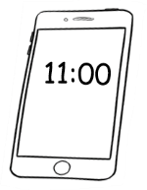
5. Revision Worksheet
Do you have a phone?
Can you take a photo?
Can you look at photos?
Can you text?
Can you see the time?
9:00
Can you use WhatsApp?
Can you talk?
Can you record?
Can you use the internet?

My phone is locked.

Mobile phone security
Activity - PINs
- Introduce the word strong.
You can do this by:
- miming
- using photos such as this one
- demonstrating with objects such as a thin piece of string and
a thick rope etc.

- On the board, show two strong PINs. e.g.

0 | 5 | 8 | 2

9 | 7 | 0 | 3

Then show two weak PINs
1 | 1 | 1 | 1

1 | 2 | 3 | 4

- Project the following page. Students confirm which PINs are strong and which are not. Print the page for student to copy strong PINs.

- Emphasise the importance of keeping PINs secret.

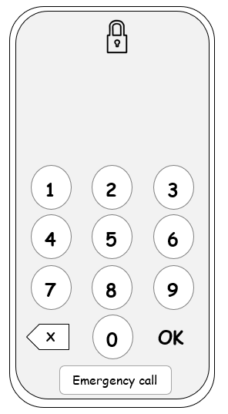

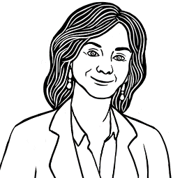
Do you have a strong PIN?

5 3 9 1 | 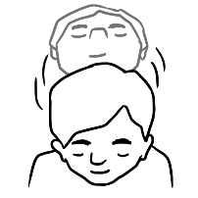  Yes
2 7 1 0
0 0 0 0 | 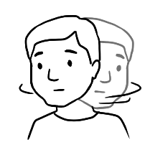  No
1 1 2 2



4 | 1 | 9 | 3 |  | 8 | 6 | 5 | 3
___ | ___ | ___ | ___ |  | ___ | ___ | ___ | ___
Strong PINs

7 | 3 | 0 | 5 |  | 2 | 8 | 1 | 6
___ | ___ | ___ | ___ |  | ___ | ___ | ___ | ___

Text the teacher.
Send a written text
Texting the teacher to notify absences can be a difficult task for Course in Initial students. Practise copying and writing texts and sending them to the teacher. [See the following pages.] Students from a higher class could show students how to add the teacher’s and the centre’s phone numbers to their phone and how to type and send a text.

Send a voice message
Students can send a voice message via WhatsApp or message bank.
Build skills gradually in the following way:
- Teach greetings.– Hello, Hi, Good morning
- Teach the pattern for giving names over the phone
Introduction | Repeat the name. | Spell the name. | Repeat the name.
My name is Zarni. | Zarni | Z - A – R – N – I | Zarni
- Practise naming the teacher.
My teacher is ________________.
- Practise the reason for the phone call.
I am sick.
I can’t come today.
- Teach closings everyday as students leave – Bye
All of the above phrases and sentences could be chanted.

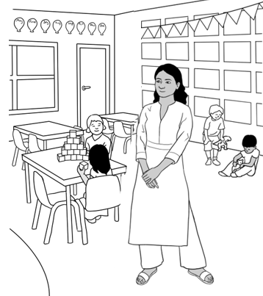
San sends a text
to child care.
1.

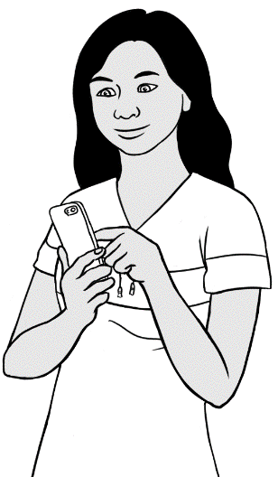
Hi
My son is sick.
San
My son is sick.

Hi
H i

My son is sick.
__ y __on __s __ ick.

San
__ an

Alternative messages
Hi
__ i

I am sick.
__ __ m __ick.

San
__ an
Hi
__ i

I am sick.
__ __ m __ick.

San
__ an

Hi
H__

I am sick.
__ __ __ __i__k.

San
S__ n
Hi
__ i

I am sick.
__ a __ s__ck.

San
Sa__

Digital resources

NB. It is advisable to copy and paste the web addresses in the address box
rather than click on the link.
- AMEPOnline AMEPOnline (homeaffairs.gov.au)
This site offers a wealth of resources for Course in Initial EAL students.

- Google translate - https://translate.google.com/
A free and useful service to translate words, phrases and web pages in over
100 languages.

- Protea Text ware - https://www.proteatextware.com/ [Australian]
The Alphabet program is a valuable resource for Course in Initial EAL students and worth purchasing.
- Helpful websites with audio files
Although many of the audio files will be too advanced for this level, they contain useful information which could be simplified. Some sites include translated materials.
- https://www.sbs.com.au/language/english/en/settlement-guide
- https://www.sbs.com.au/language/english/en/collection/australian-laws
- https://www.servicesaustralia.gov.au/multicultural-services-audio-translation
- https://www.healthtranslations.vic.gov.au/resources/home-fire-safety-audio
- https://www.ses.vic.gov.au/information-in-other-languages
- https://www.cfa.vic.gov.au/about-us/publications/other-languages-lote
- https://beachsafe.org.au/surf-safety/multilingual video
- https://beachsafetyhub.org.au/resources-&-program/multilingual-resources/multilingual-beach-safety-videos/
- https://www.betterhealth.vic.gov.au/survive-heat-cald-kit
- https://childroadsafety.org.au/professional-development/cald-safe-transportation-of-children/
- Calling 000
The following website explains how to call triple zero. The videos are in English with translations in many languages. Course in Initial EAL students would need a translator to explain the 000 procedure in their language.
- https://www.healthtranslations.vic.gov.au/resources/in-an-emergency-call-triple-zero-000

