English Ready
22636Vic Course in Initial EAL
22637VIC Course in EAL
22638VIC Certificate 1 in EAL


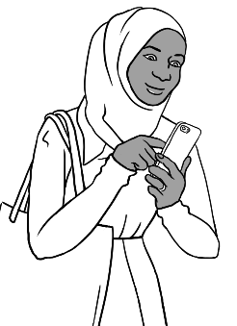
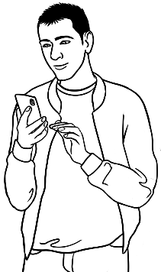

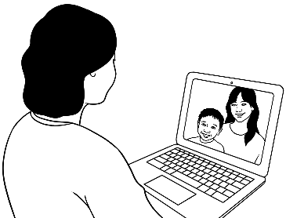
Catalogue
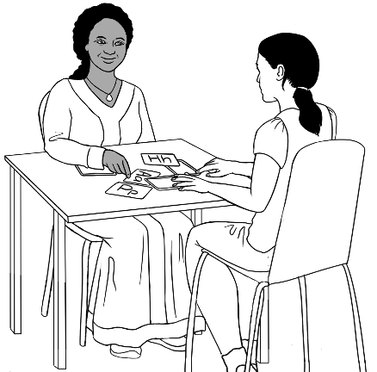
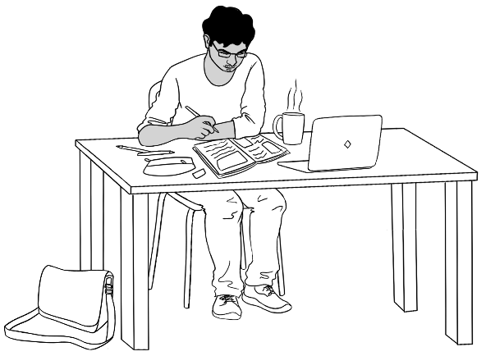
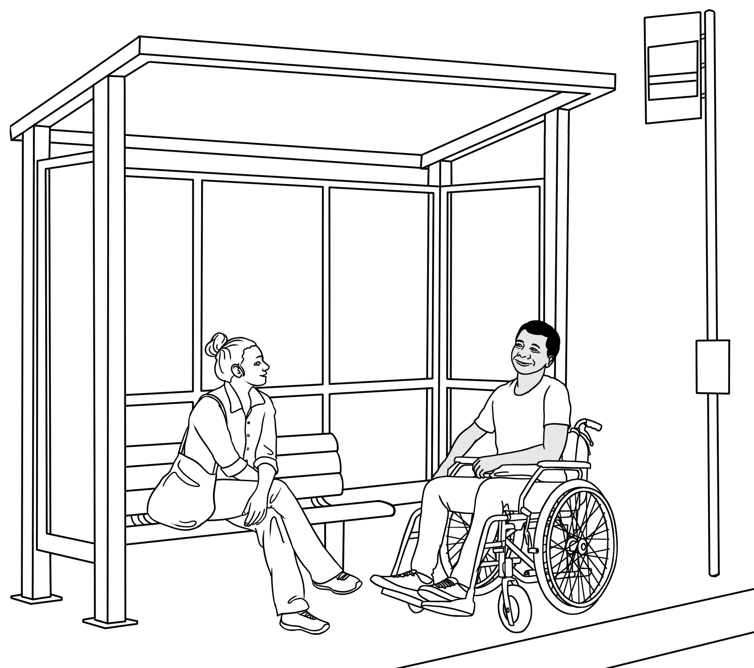
of illustrations

Design team: Vicki Hambling, Sue Paull, Glenise Kleehammer and Mary Wallace
Illustrations: Madelena Scott
Illustration acknowledgement
Globe with Australia highlighted: This file is licensed under the Creative Commons Attribution-Share Alike 3.0 Unported license.

Acknowledgements: The design team would like to acknowledge the use of the EAL Framework which underpins the design of this book.
Copyright of the EAL Framework is reserved to the Crown in the right of the State of Victoria. © State of Victoria (Department of Education and Training) 2023.
_________________________________________________________________________________________
This English Ready Resource is licensed under a Creative Commons Attribution-NoDerivs 3.0 Australia licence (More information is available here). You are free to use, copy and distribute to anyone in its original form as long as you attribute Department of Home Affairs as the author and you license any derivative work you make available under the same licence.
© Commonwealth of Australia 2024

With the exception of the Commonwealth Coat of Arms, the department’s logo, any material protected by a trade mark and where otherwise noted all material presented in this document is provided under a Creative Commons Attribution 4.0 International (https://creativecommons.org/licenses/by/4.0/) licence.
The details of the relevant licence conditions are available on the Creative Commons website (accessible using the links provided) as is the full legal code for the CC BY 4.0 licence (https://creativecommons.org/licenses/by/4.0/legalcode).
Use of all or part of this document must include the following attribution:
© Commonwealth of Australia 2023
As far as practicable, material for which the copyright is owned by a third party will be clearly labelled. The department has made all reasonable efforts to ensure that this material has been reproduced in this document with the full consent of the copyright owners.
Copyright requests and enquiries concerning usage not addressed by the CC BY 4.0 licence should be addressed to:
comms@homeaffairs.gov.au at the Department of Home Affairs.
The terms of use for the Commonwealth Coat of Arms are available from the It's an Honour website.
Where a copyright owner, other than the Commonwealth, is identified with respect to this material, please contact that third party copyright owner directly to seek permission.



Contents

1. Introduction 5
2. Family 1 – Ming, Lan, Bao and Mai 6
a. Ming 7
b. Lan – Ming’s daughter 12
c. Bao – Ming’s grandson 14
d. Mai – Ming’s granddaughter 18
3. Family 2 – Sahra, Tahiil, Hani, Abdi 21
a. Sahra 22
b. Tahiil – Sahra’s husband 27
c. Hani – Sahra and Tahiil’s daughter 31
d. Abdi – Sahra’s brother 32
4. Family 3 – Ko, Zarni, San, Thein, Yaza 34
a. Ko 35
b. Zarni – Ko’s wife and baby Yaza’s grandmother. 38
c. San – Ko and Zarni’s daughter 42
d. Thein – San’s husband 45
e. Yaza – San and Thein’s son 46
5. Family 4 – Amina, Nabi, Parwana, Jomeh, Bibi, Mustafa, Rahim 47
a. Amina 48
a. Nabi – Amina’s husband 50
a. Parwana – Amina and Nabi’s daughter 51
b. Jomeh – Parwana’s husband 55
c. Bibi – Parwana and Jomeh’s daughter 56
d. Mustafa – Parwana and Jomeh’s son 57
e. Rahim – Amina and Nabi’s son, Parwana’s brother 59
6. Family 5 – Jamila, Anika 61
a. Jamila 62
b. Anika – Jamila’s daughter 65
7. Family 6 – Ahmad, Carim, Fatima 66
a. Ahmad 67
b. Carim – Rahim’s younger brother 69
c. Fatima – Rahim and Carim’s younger sister 70
8. Family 7 – Nisha and her children 71
a. Nisha 72
b. Pari and Dev – Nisha’s daughter and son 74
9. Linh and Basam 75
a. Linh 75
b. Basam 77
10. Teachers 79
a. Jenny 79
b. Rosie 81
c. Peter 84
d. Wendy 86
11. Additional people 87
12. Learning centres, classrooms and learning strategies 89
a. Learning centres 89
b. Classrooms 91
c. Learning strategies in class time 95
d. Learning strategies outside class time 97
13. Classroom instructions 101
a. Workbook instructions 101
b. General class instructions 102
14. Classroom stationery and equipment 104
15. Digital devices, icons and use 106
a. Devices 106
b. Icons 108
c. Use 109
16. Childcare 114
17. Forms, bills and identity cards 116
a. Forms 116
b. Bills 129
c. Identity cards 130
18. Work – Paid and volunteer 133
a. Paid work 133
b. Volunteer work 136
c. Jobs at home 137
19. Free-time activities and sport 138
a. Free time 138
b. Sport 141
20. The beach 143
21. The park 146
22. Houses and apartments 150
23. Maps 153
a. Maps 153
b. Floor plans 158
24. Directions 160
25. Signs 161
a. At the learning centre 161
b. Road safety signs 162
26. The weather 165
a. Weather icons 165
b. Temperature 166
c. Weather scenes 167
27. Medical 168
a. Medical workers 168
b. Medical situations 169
c. Thermometers 173
28. Clothing, shoes, accessories and shopping scenes 174
a. Women’s clothes 174
b. Women’s shoes and accessories 176
c. Men’s clothes 178
d. Men’s shoes and accessories 179
e. Shopping scenes 180
29. Food 182
a. Fruit and vegetables 182
b. Meat, dairy, eggs and tofu 185
c. Pantry 187
d. Pantry food and goods – labelled 188
e. Pantry food containers – unlabelled 192
30. Cooking - tools, instructions, scenes and dishes 195
a. Cooking tools 195
b. Cooking instructions 197
c. Cooking scenes 199
d. Dishes 200
31. Numeracy 201
a. Time 201
b. Measurement – length 204
c. Measurement – weight 207
d. Measurement – litres 208
e. Measurement – temperature 210
f. Money 211
g. Shapes 213
32. Appendix – Character information 218

Introduction

Rationale
Visuals are especially important for the lower levels of the EAL Framework, and they are an essential part of the English Ready workbooks and Teacher Resources. However, when teachers need to develop their own materials, sourcing copyright-free visuals can be time-consuming and difficult.
This catalogue contains the wide range of illustrations which featured in the English Ready materials. It is hoped that the catalogue will assist teachers in the creation of new materials to suit the needs of their class and complement the English Ready workbooks.
There are significant advantages in using the English Ready illustrations:
- They are copyright-free.
- The style of the illustrations and the characters themselves will be familiar and therefore easier to ‘read’ for students using the English Ready workbooks.
- The consistency of style in the illustrations will add a more professional element
to new worksheets, games and activities.

The illustrations
The illustrations for each character have been collated, and the characters have been organised in family groups rather than their certificate level. To maintain the story lines developed in the English Ready books, some limited information has been added before each character’s section. For clarity, some characters in the drawings have been labelled for teacher guidance only. Further details about the characters can be found in the appendix at the back of the book.
Note:
- The illustrations can be snipped and modified as needed.*
- There is some repetition of the illustrations between the sections.

* Illustrations can also be copied and snipped from the workbooks and
teacher resources.

We hope you enjoy using these illustrations to make additional resources to suit your particular class and your own teaching style.

Family 1 – Ming, Lan, Bao and Mai

Ming’s family comes from China.
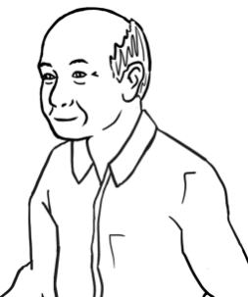
Ming
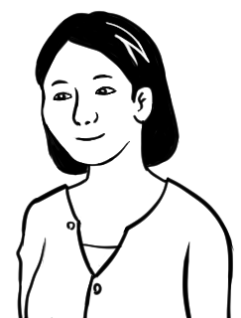
Lan
Ming’s daughter
Bao  Lan’s son   |  | Mai  Lan’s daughter  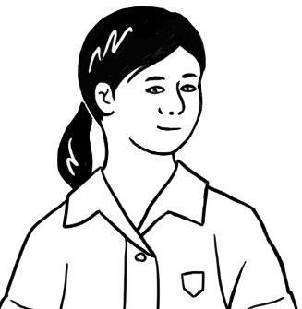

Ming
Ming is a student in the Course in EAL workbooks.
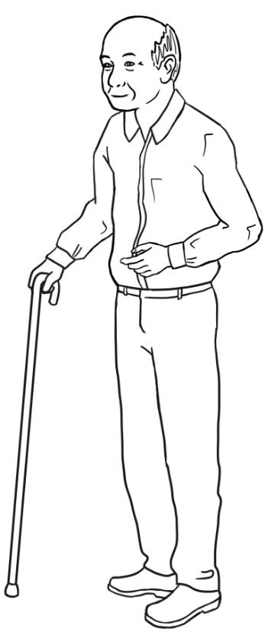 | 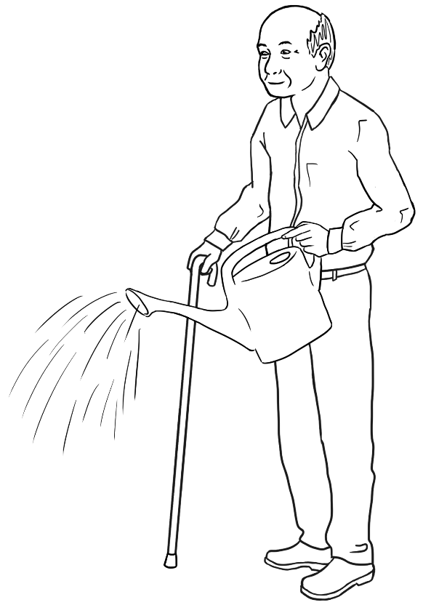
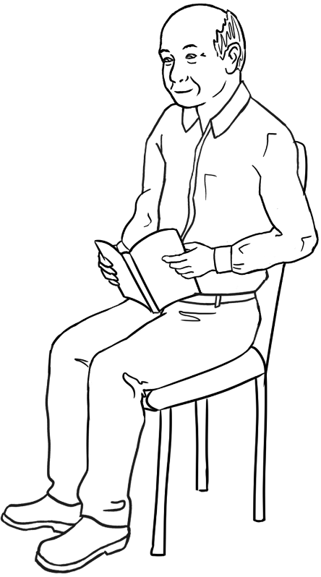 | 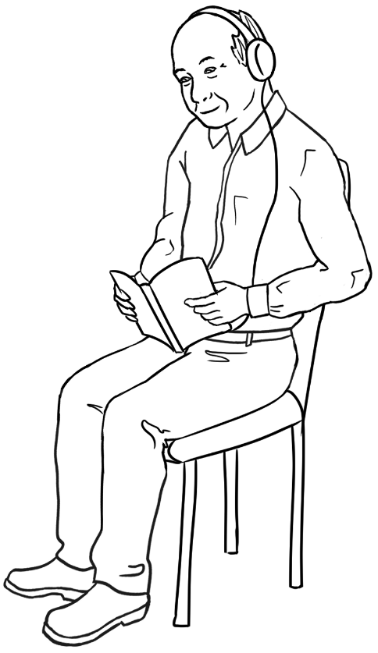

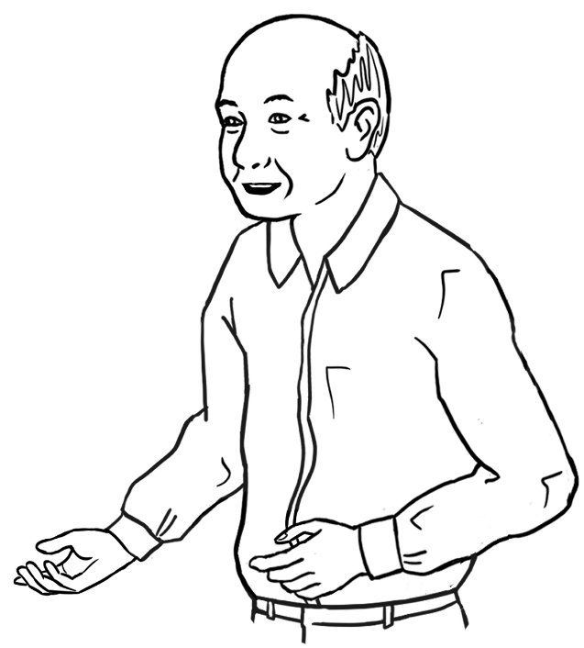 |  | 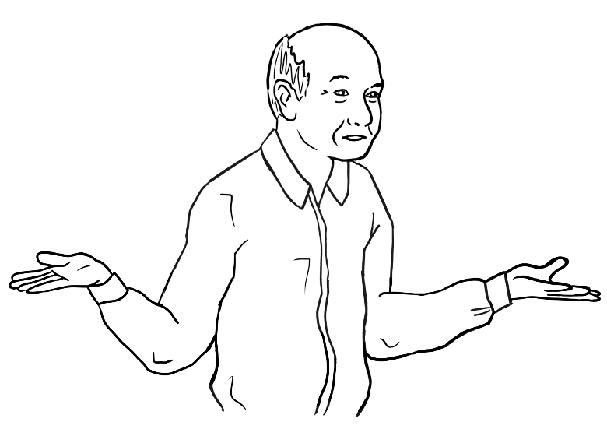
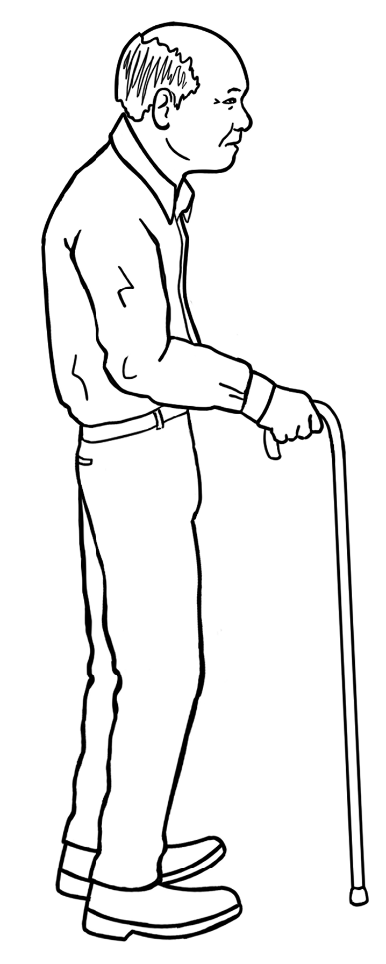 | 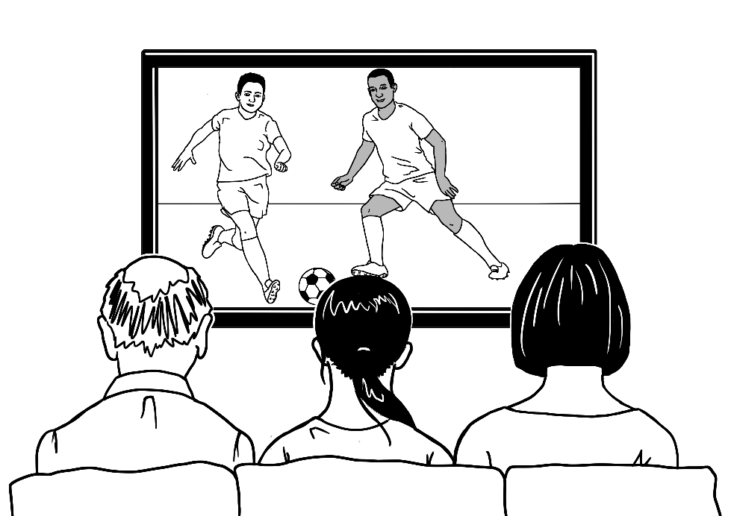

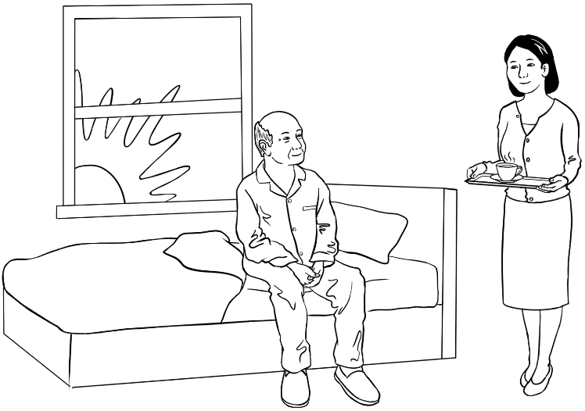
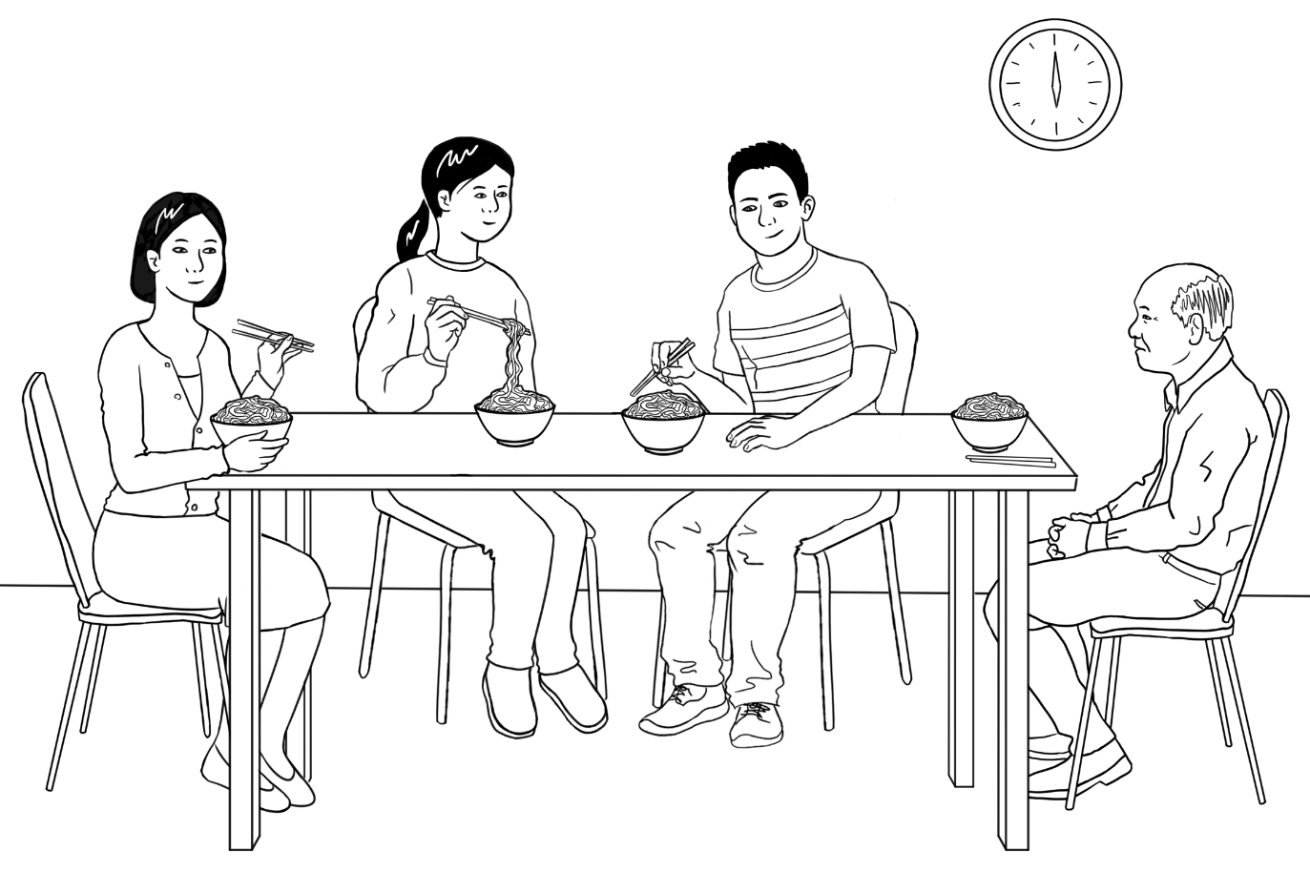

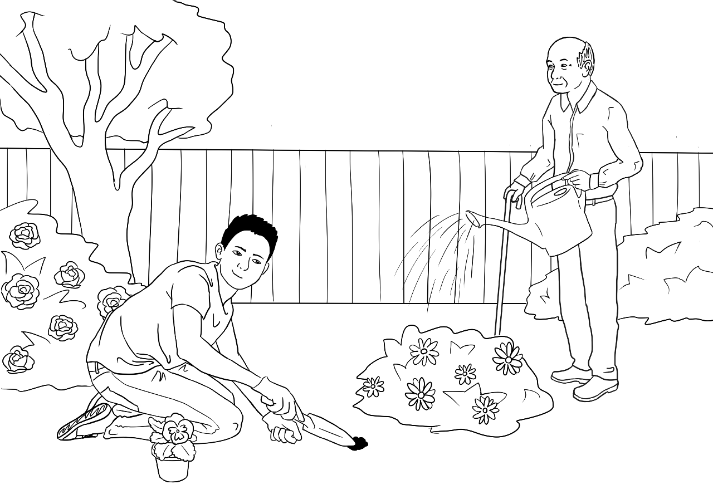
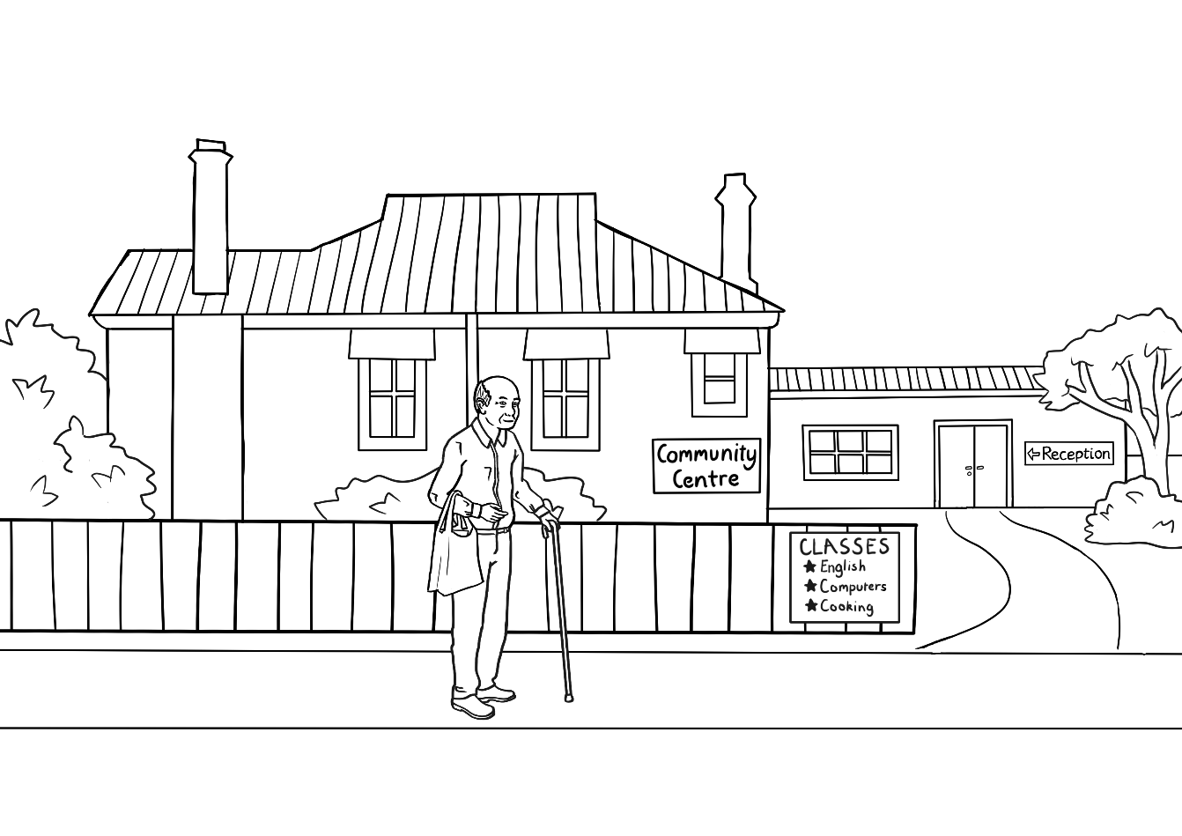

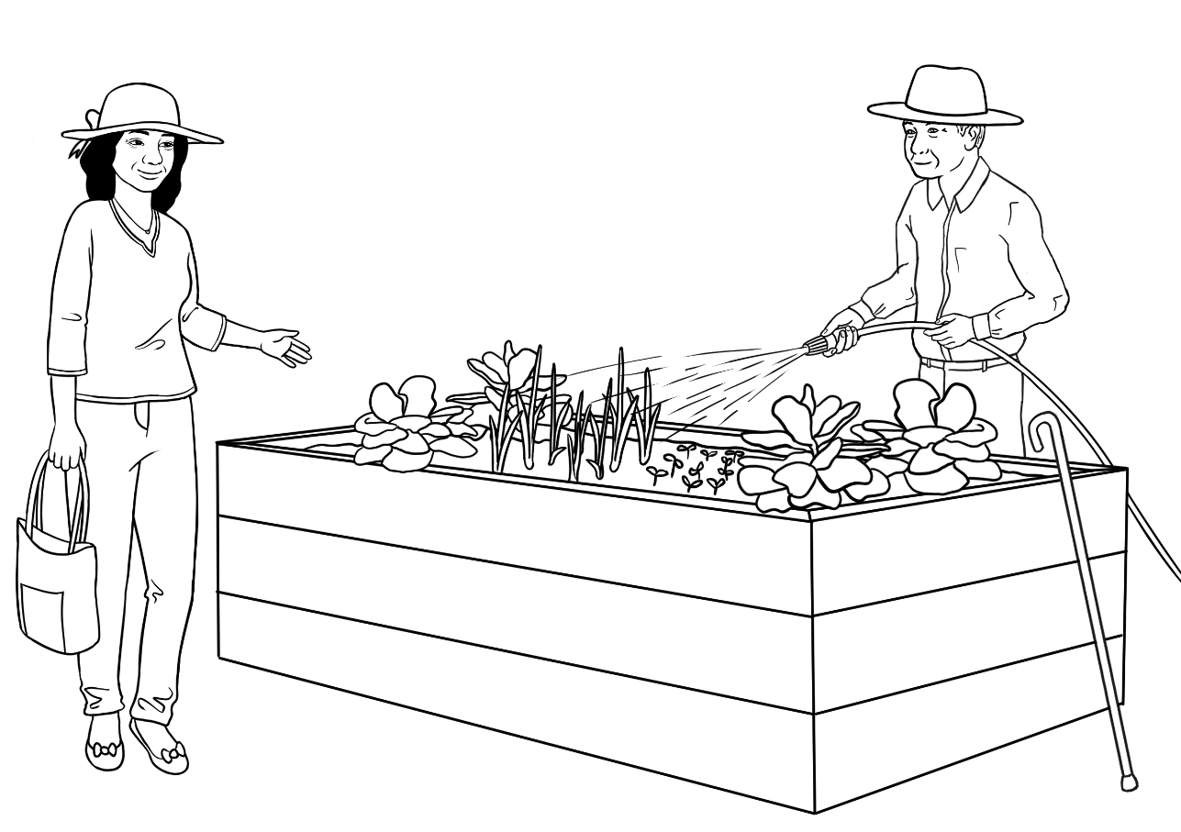
Linh
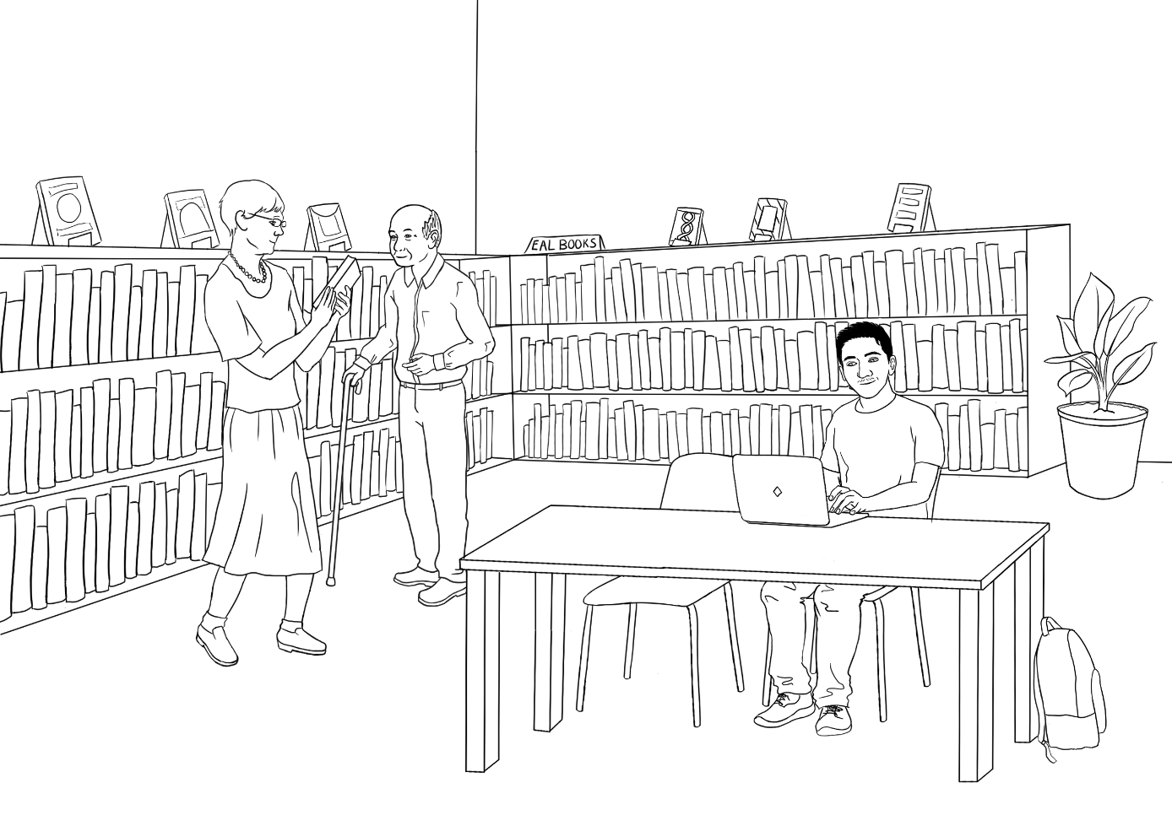
Carim
Librarian

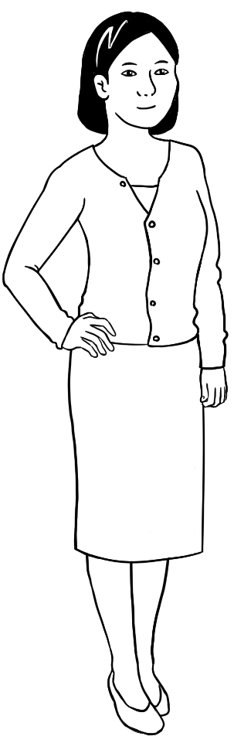 | 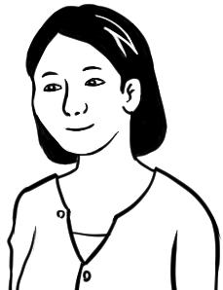
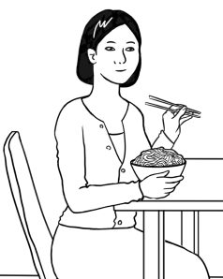 | 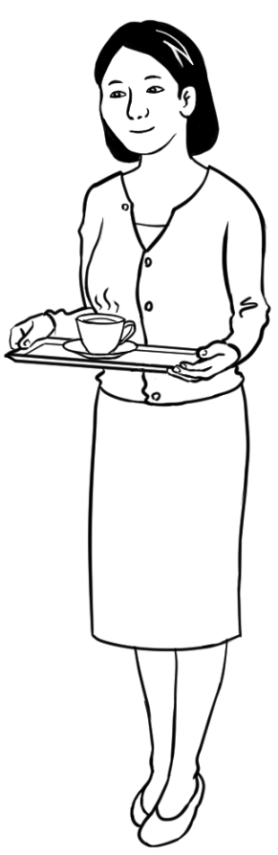

Lan – Ming’s daughter
Lan works in an office and is the mother of Bao and Mai.

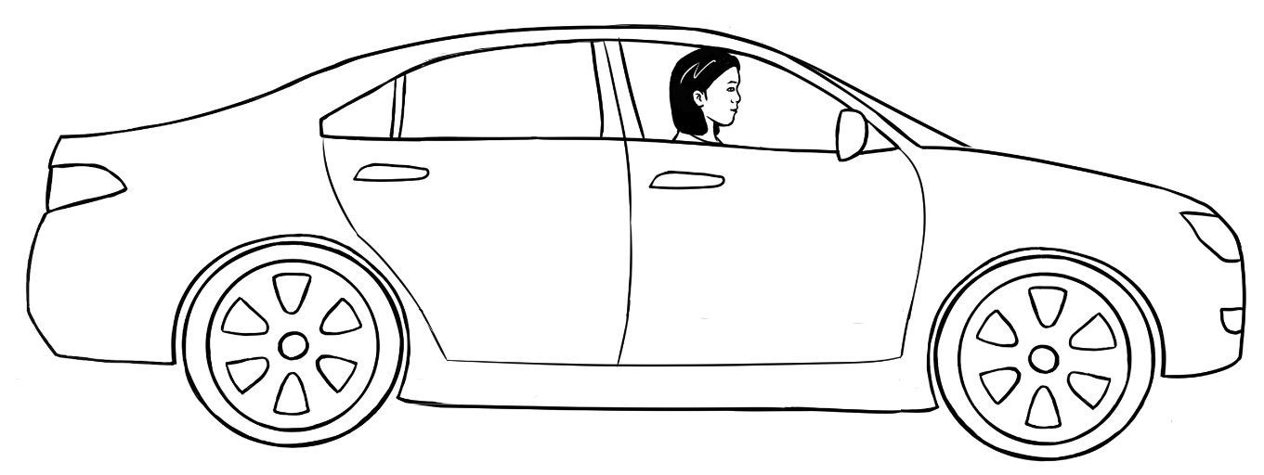
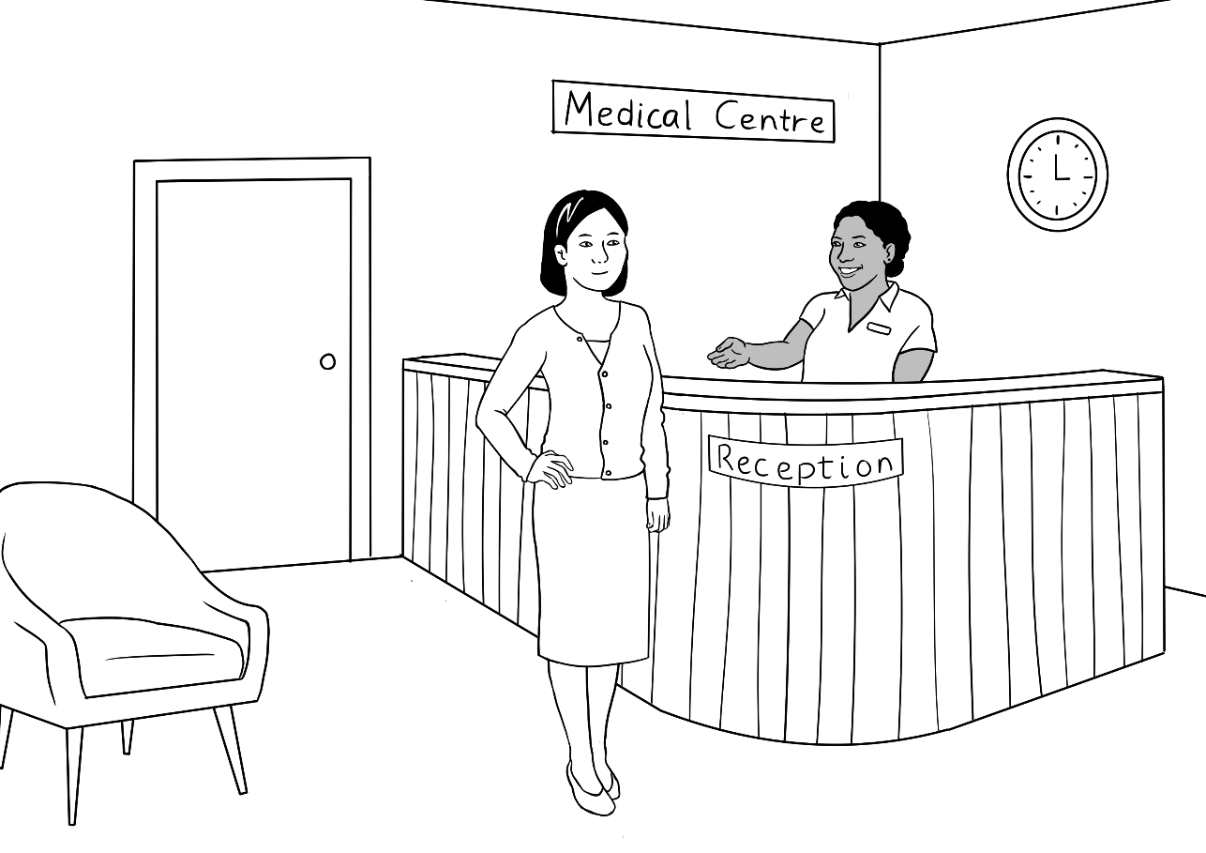

Bao – Ming’s grandson
Bao is a university student.
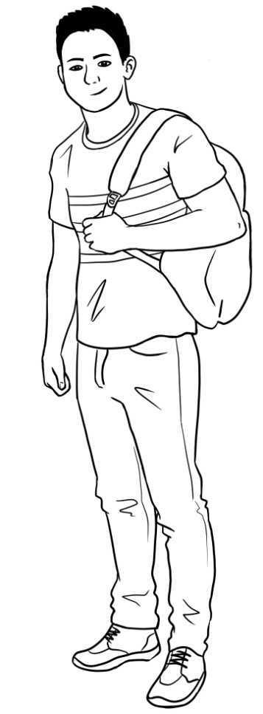 | 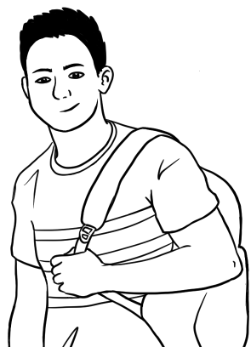
 | 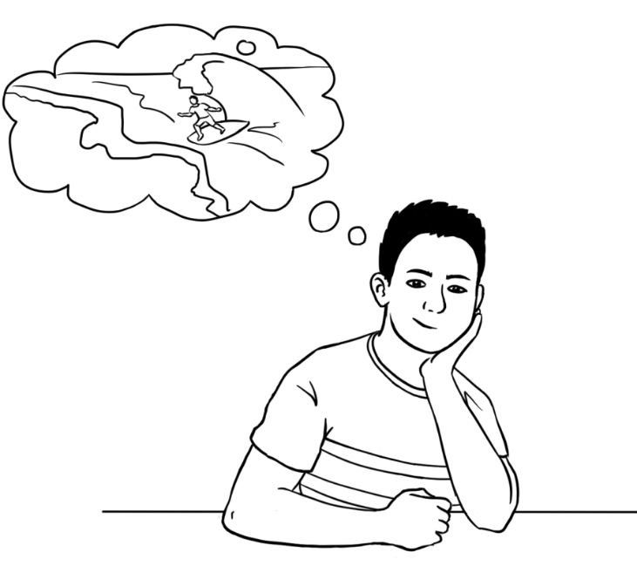

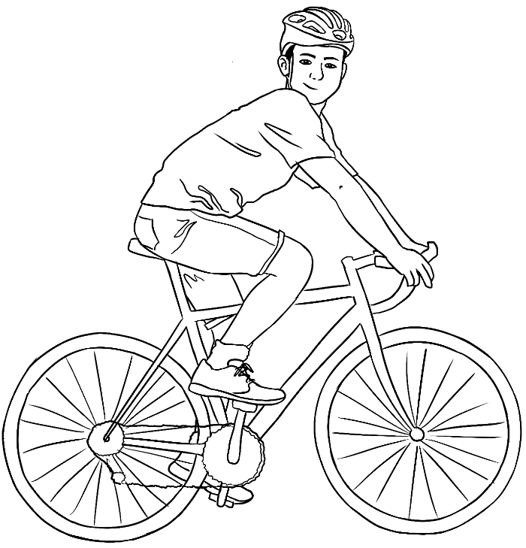 | 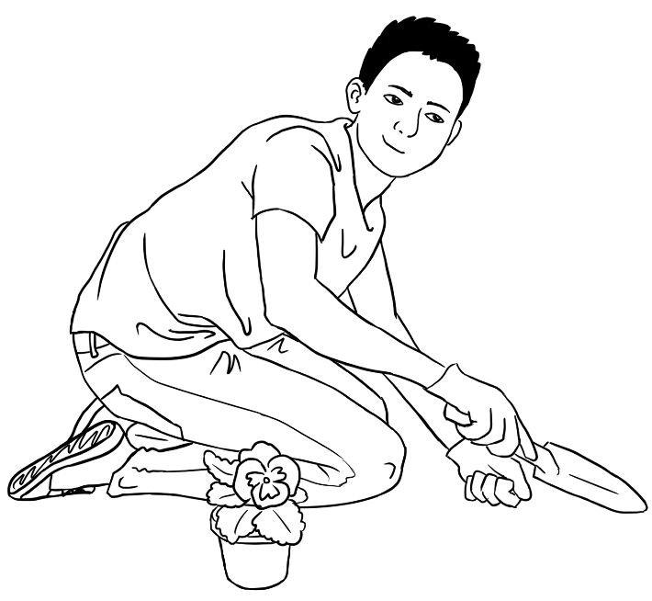
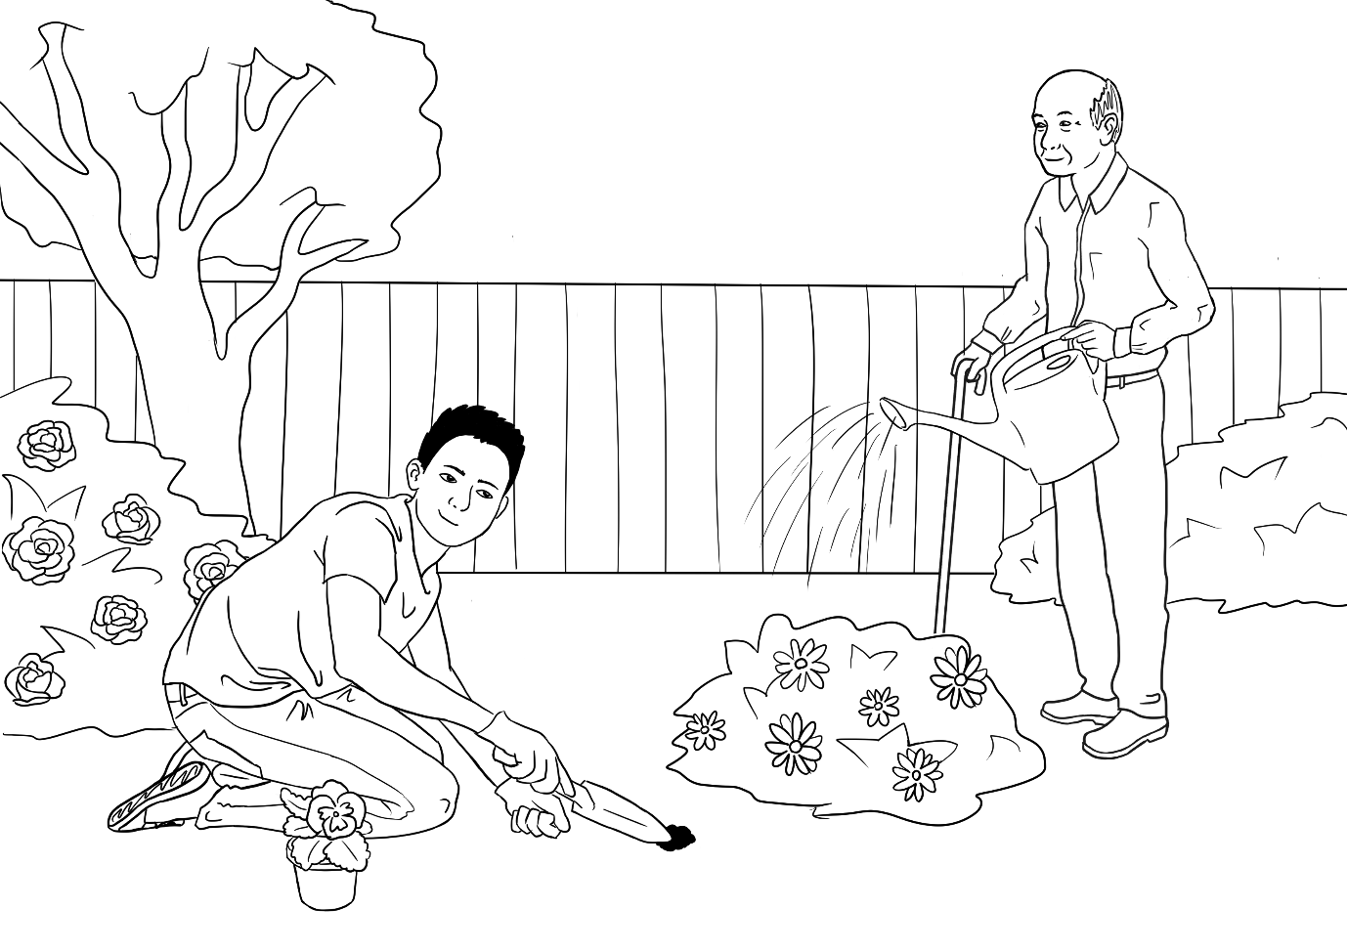

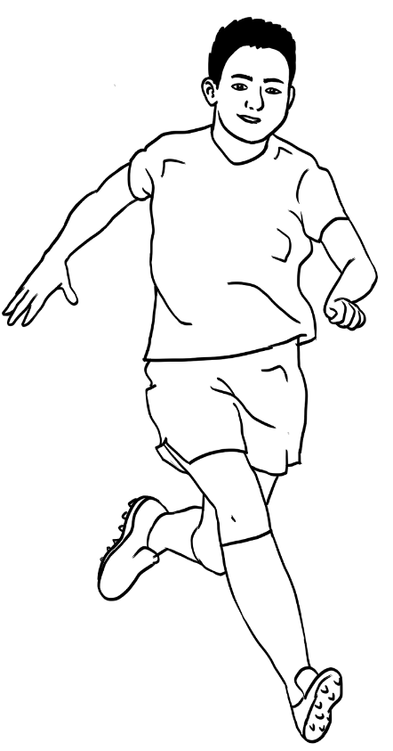 | 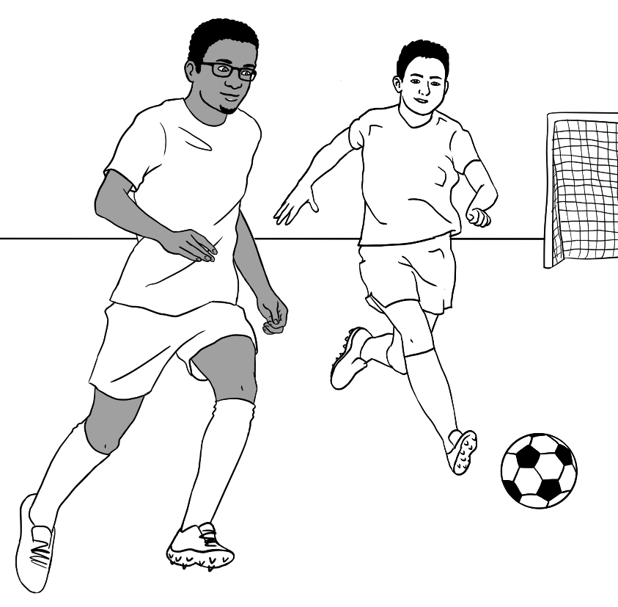  Tahiil
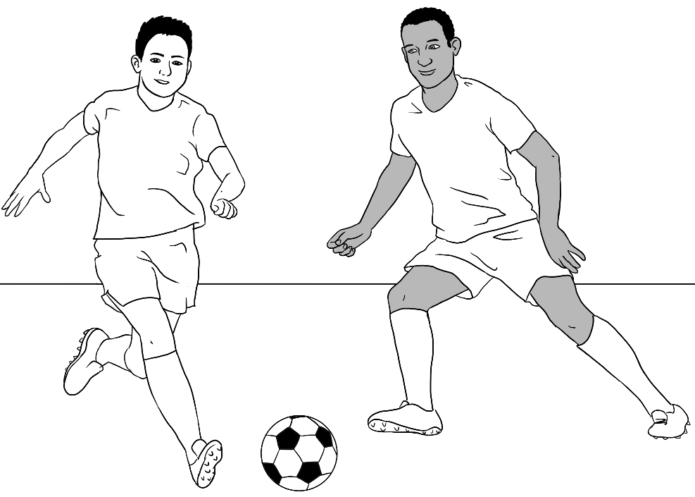  Abdi |  | 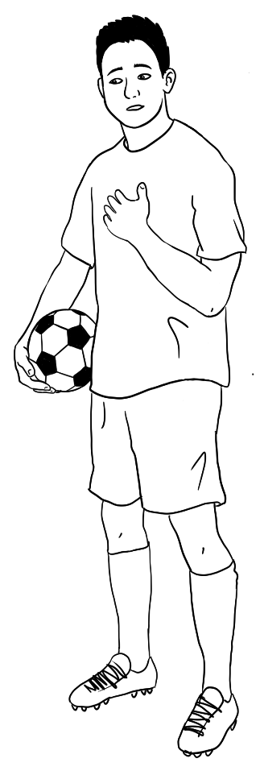

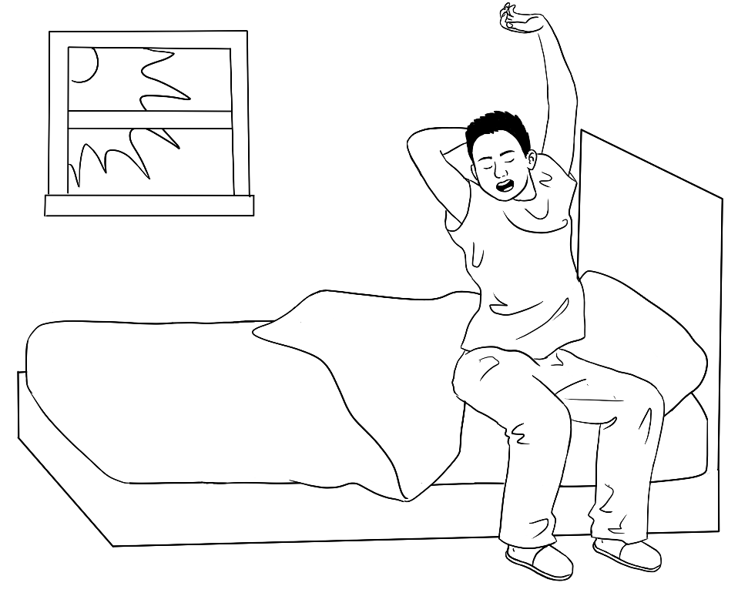 |  | 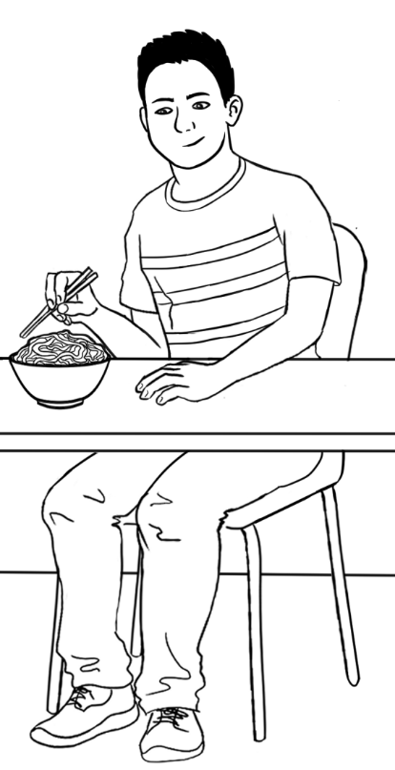
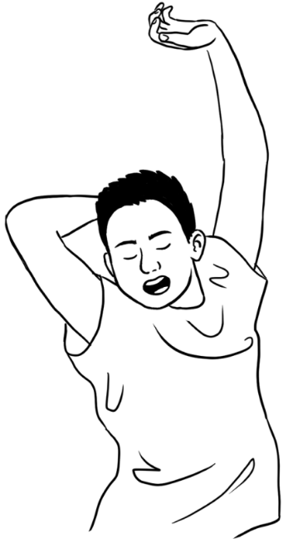 | 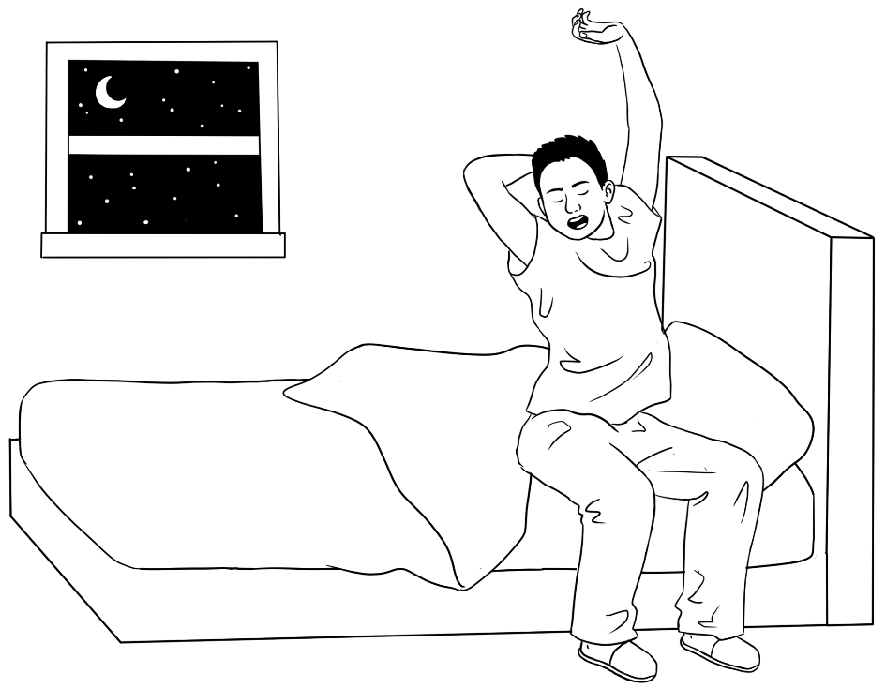

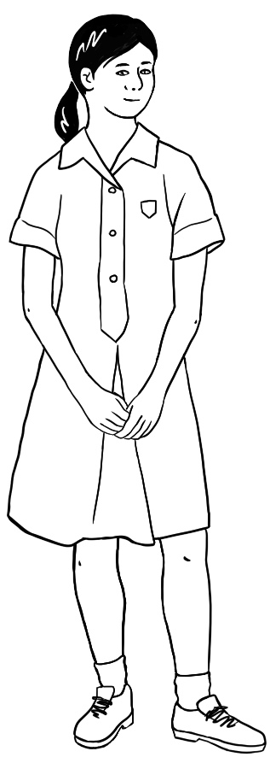 |  | 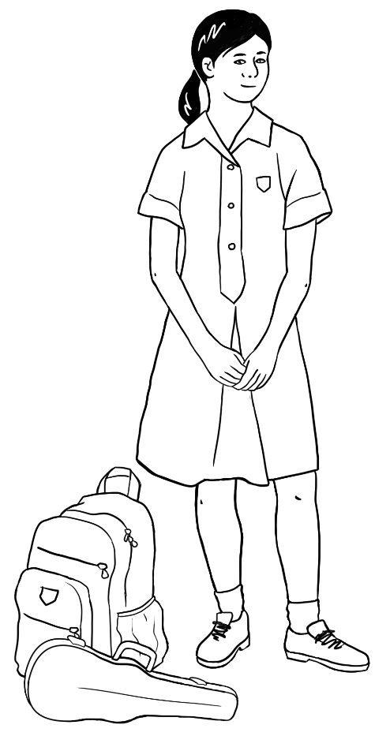
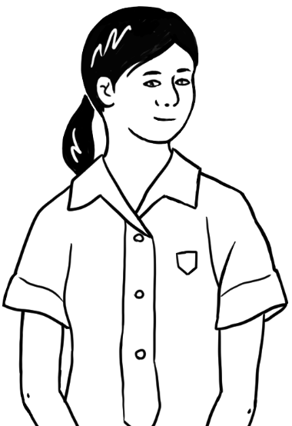 | 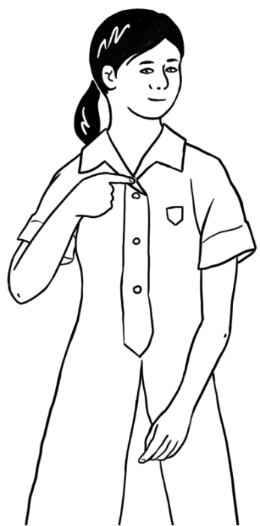 |  | 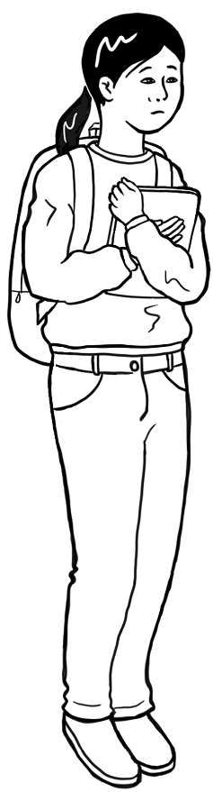

Mai – Ming’s granddaughter
Mai is a high school student. She works part-time in a supermarket.

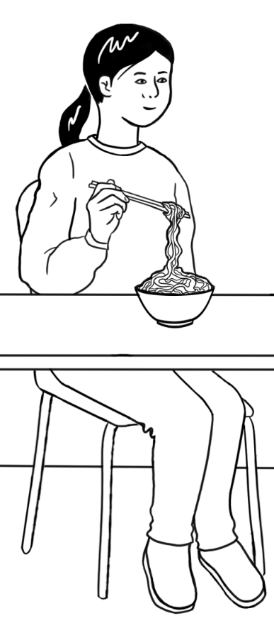 | 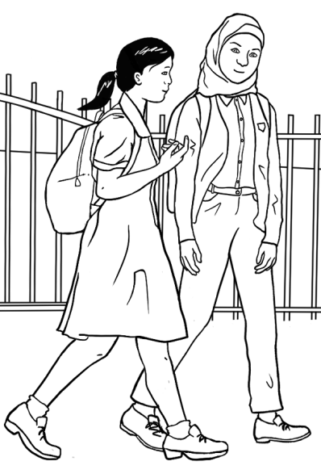  Fatima
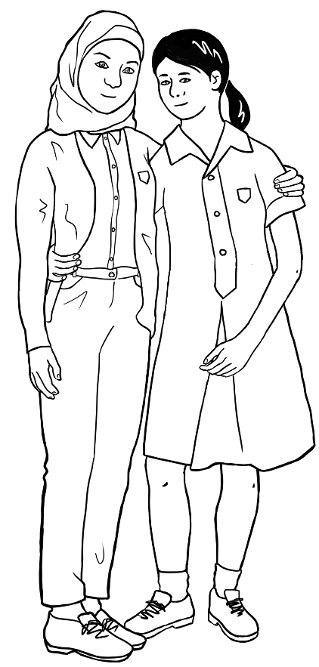 | 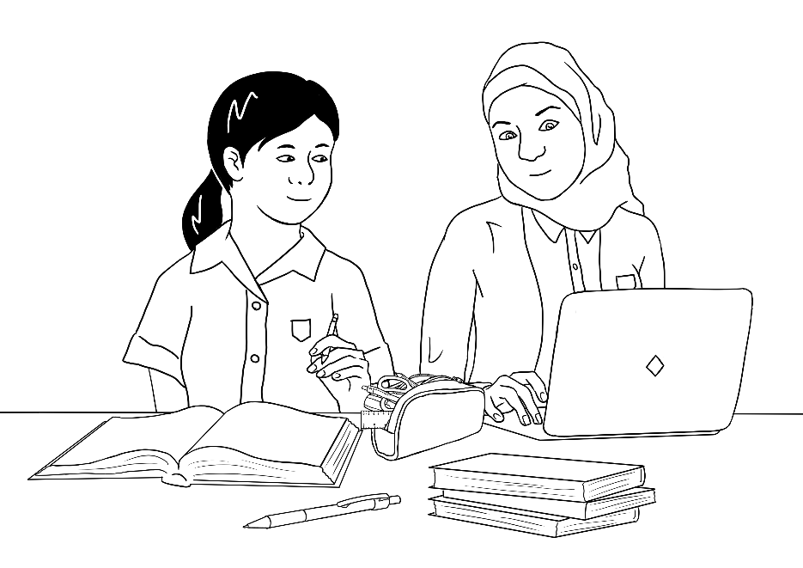

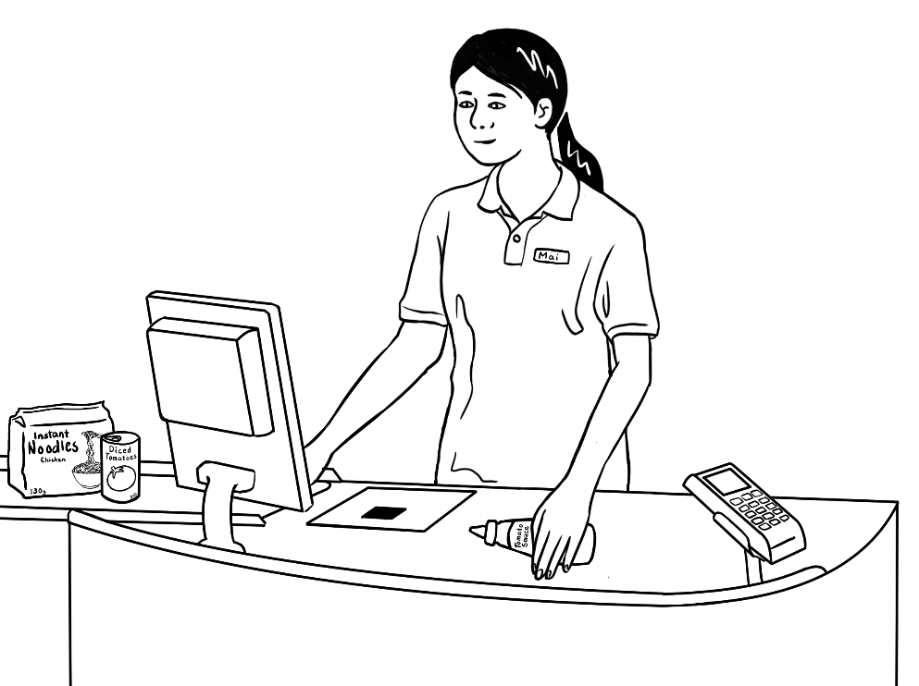 |  | 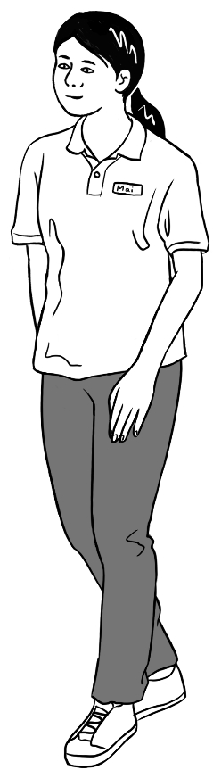
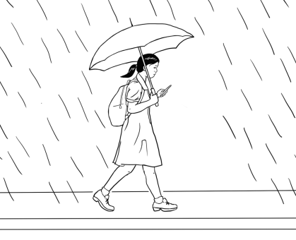
 | 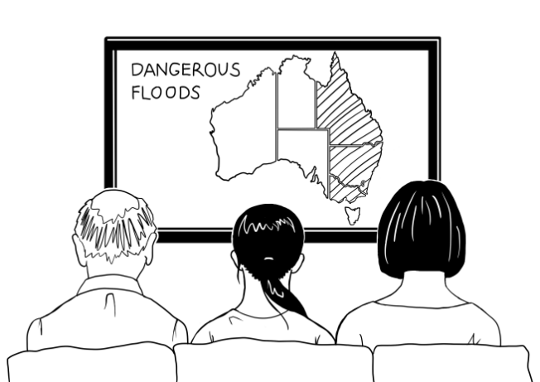

Family 2 – Sahra, Tahiil, Hani, Abdi

Sahra’s family comes from Somalia.

Abdi  Sahra’s brother  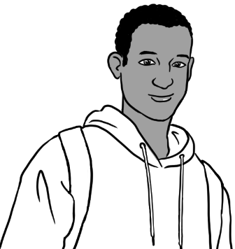 |  |  |   Sahra |  |   Tahiil  Sahra’s husband
Hani
Sahra and Tahiil’s daughter


Sahra
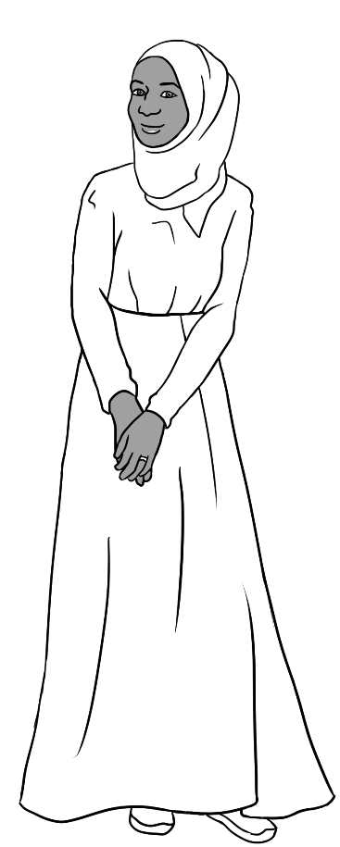 | 
 | 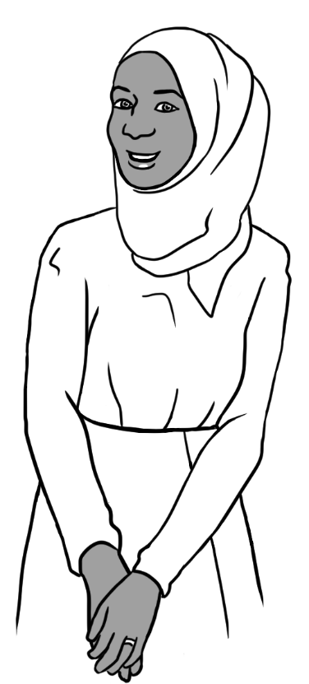
Sahra is a student in the Course in EAL workbooks.

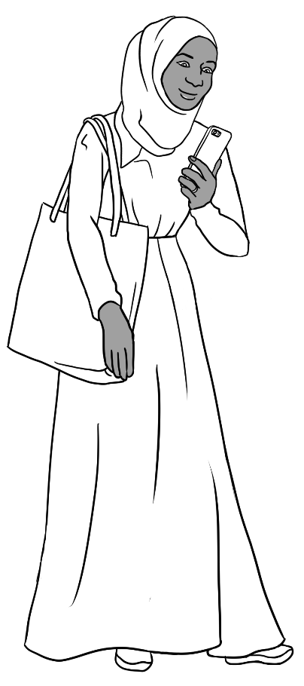 | 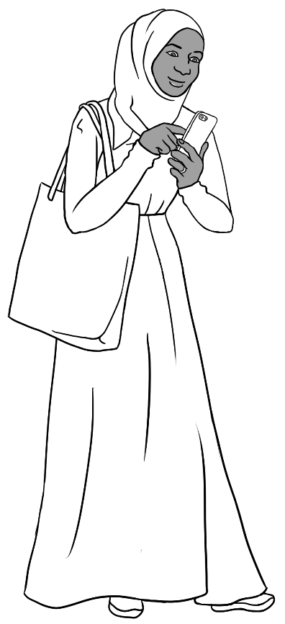
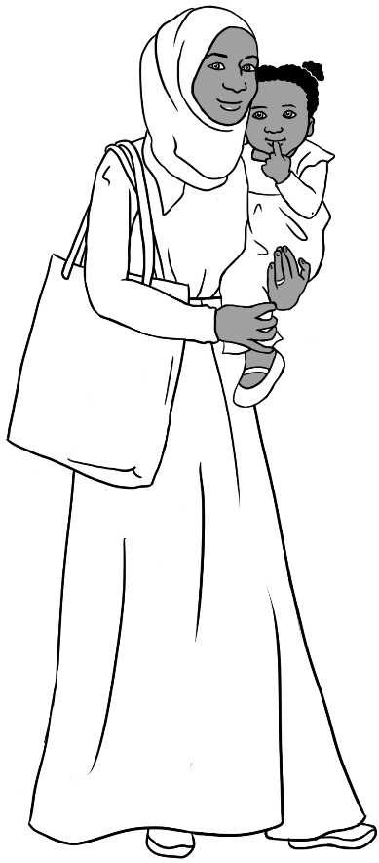 | 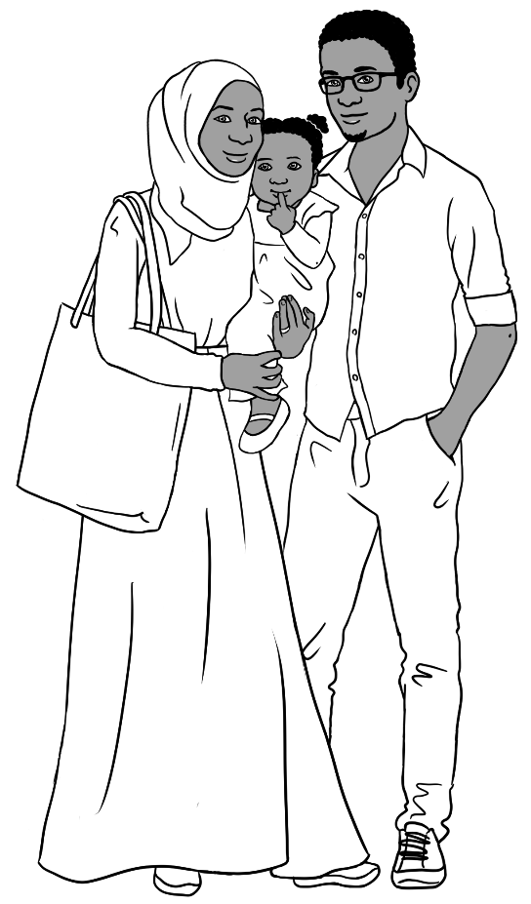

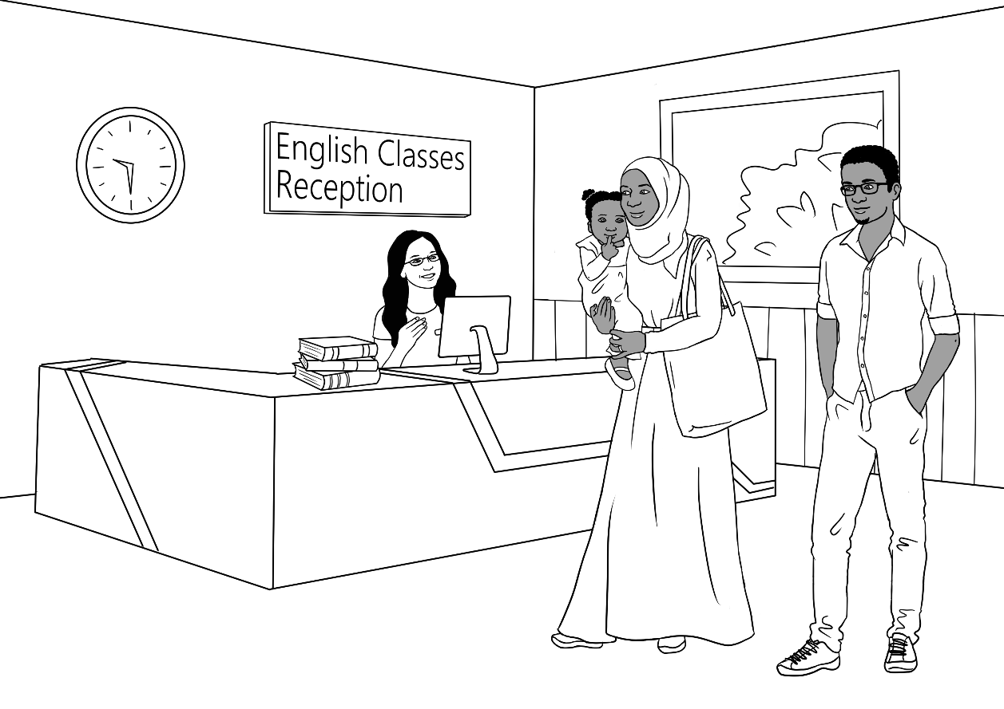
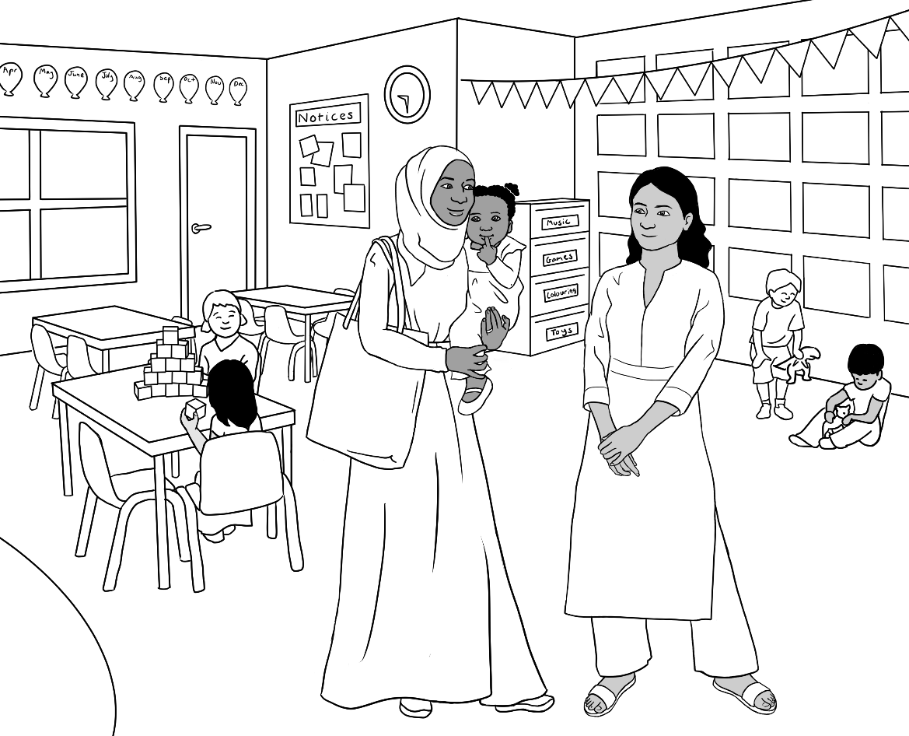
Nisha

Sahra works with unnamed students in pictures 1 – 4.
Teacher Jenny
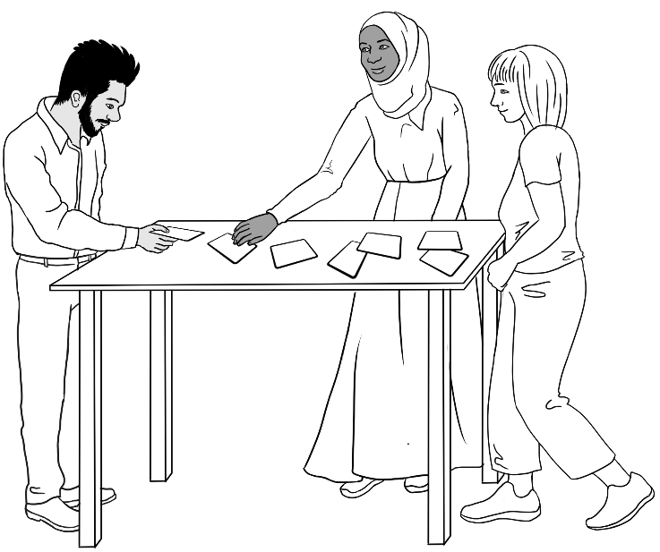  1 | 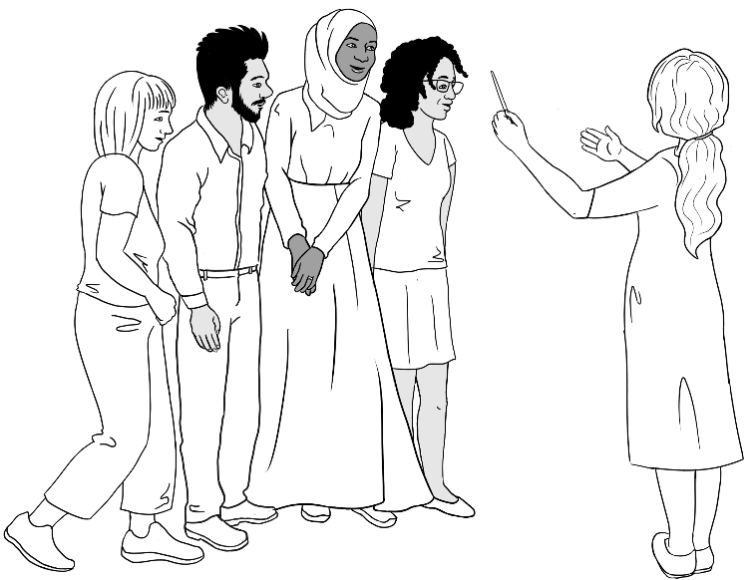  2
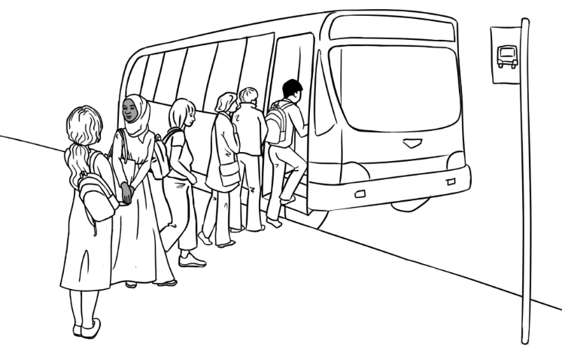  3 | 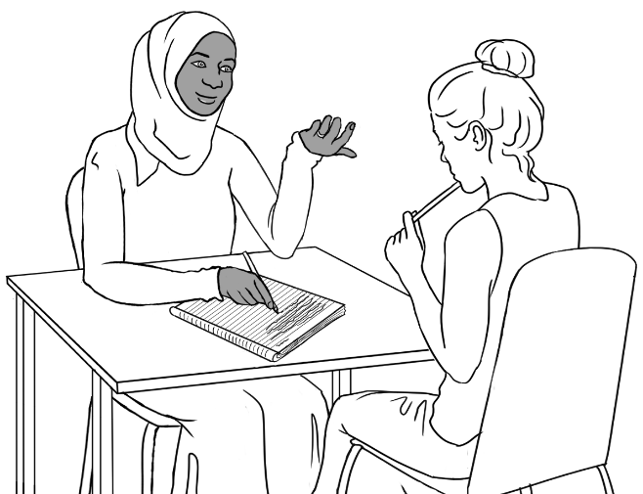  4
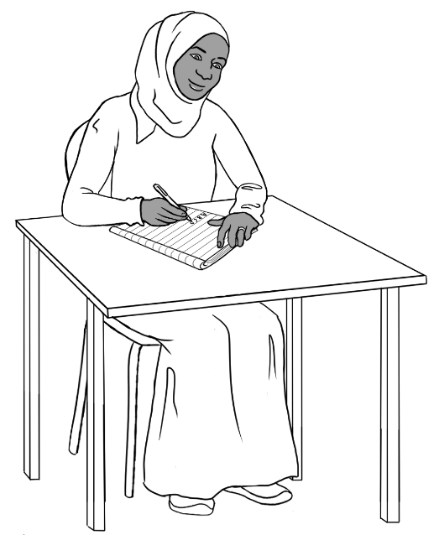 | 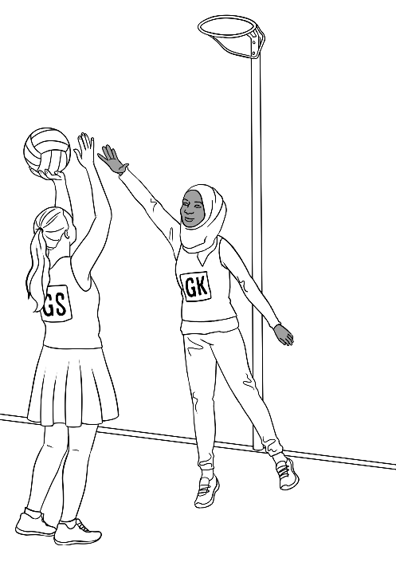

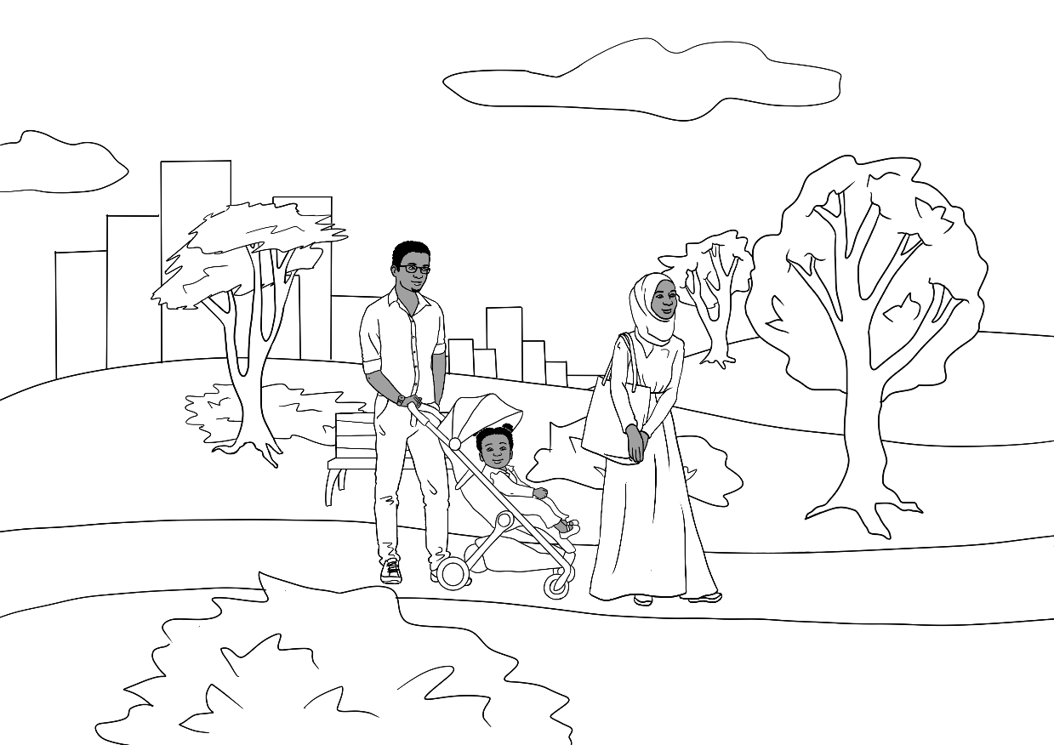

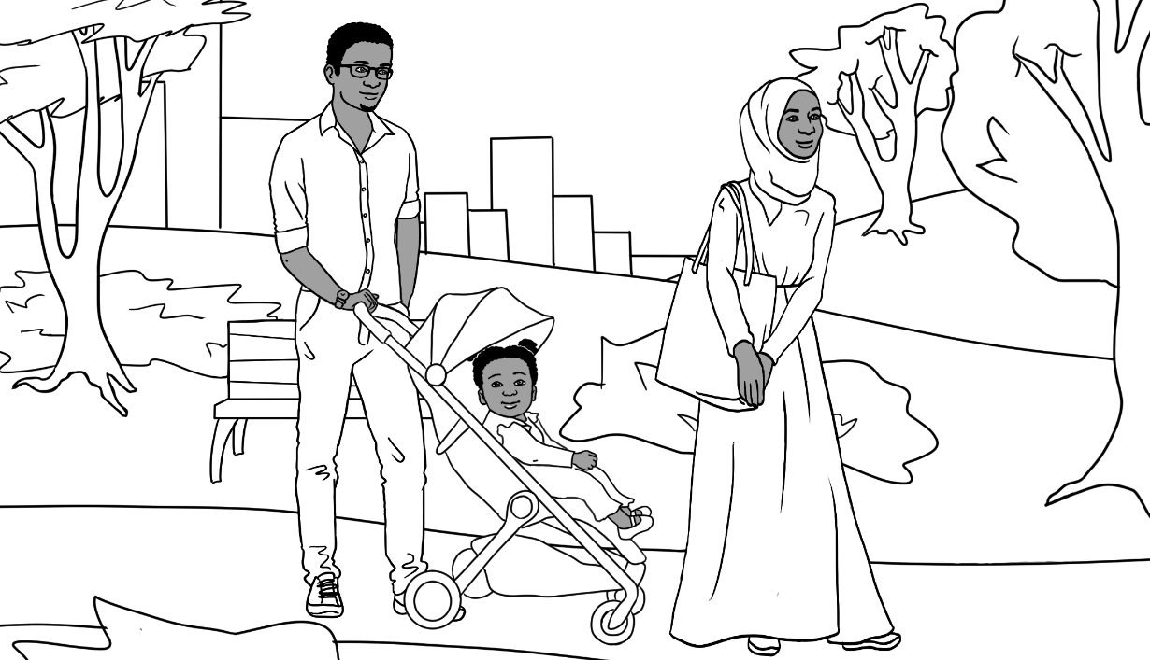

Tahiil – Sahra’s husband
Tahiil works as a painter and is a student in the Course in EAL workbooks.
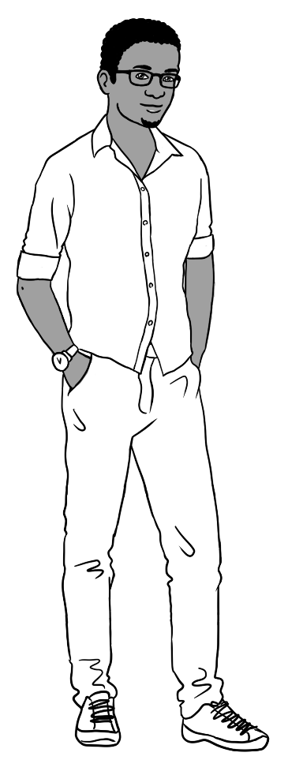 |    |  | 
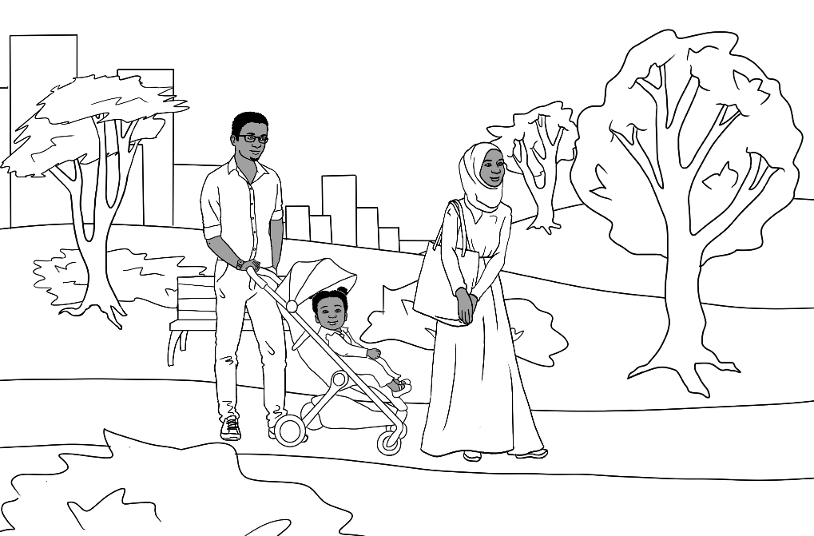 |  | 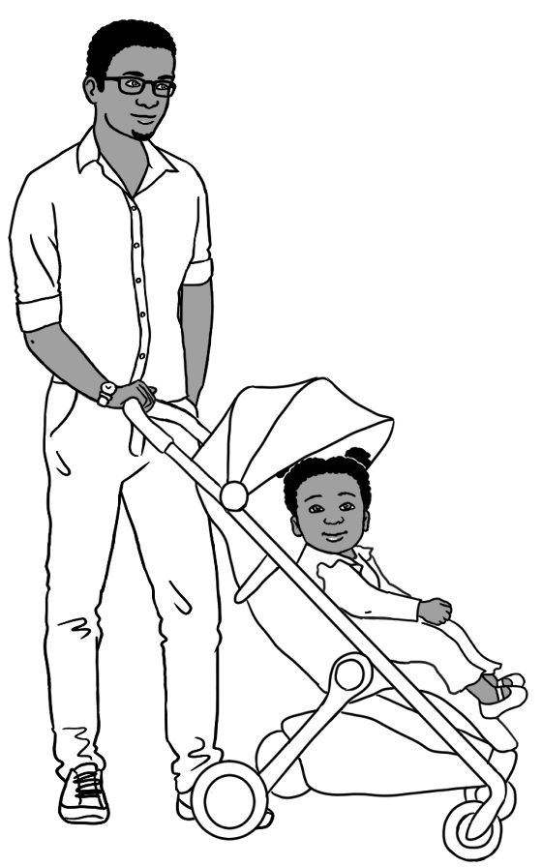

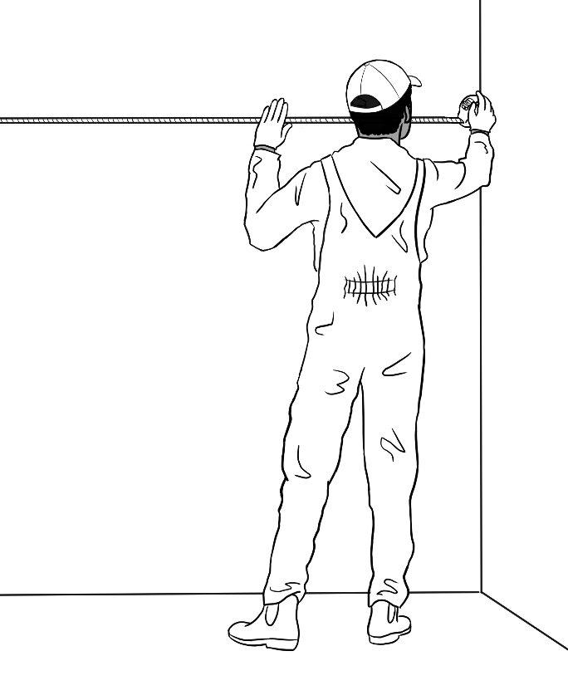 | 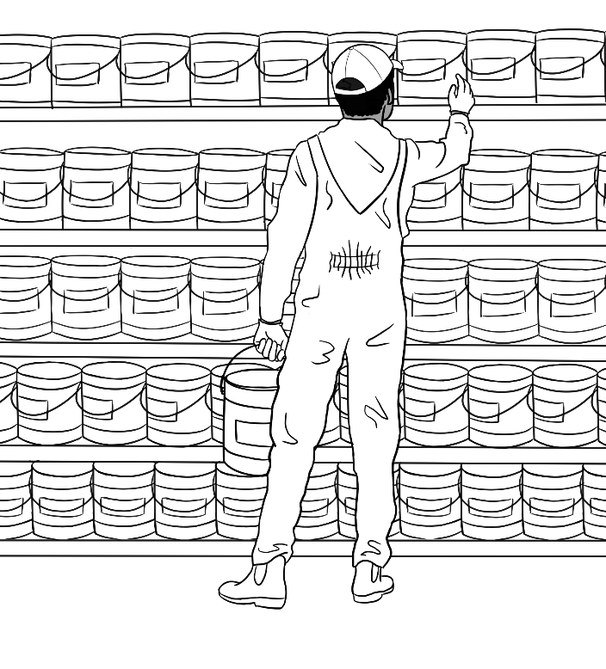
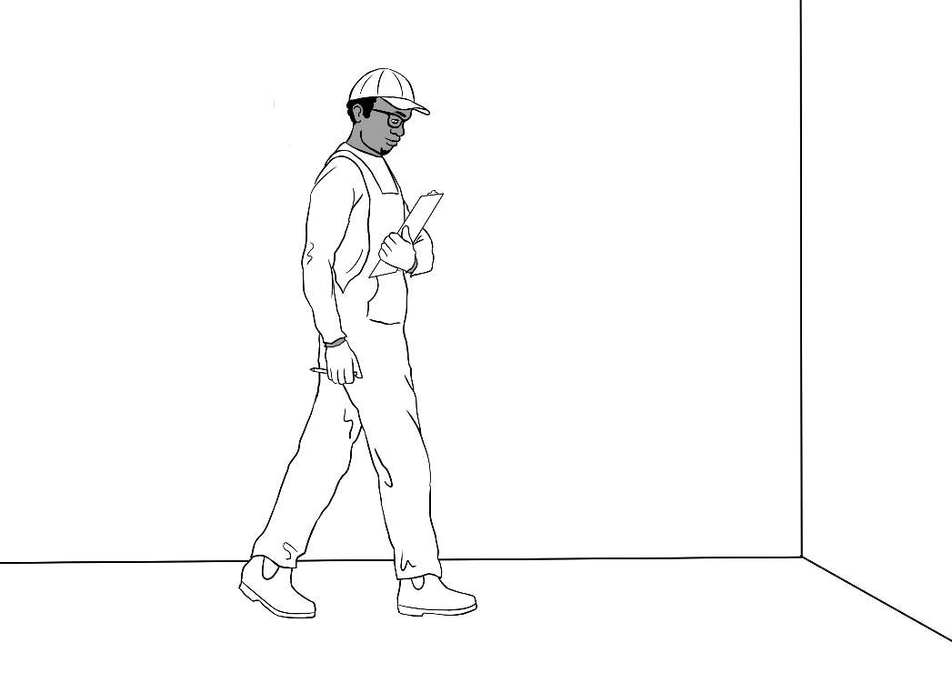 |  | 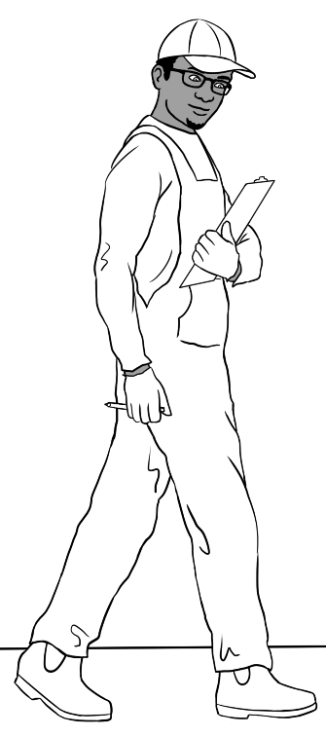

Bao
Abdi
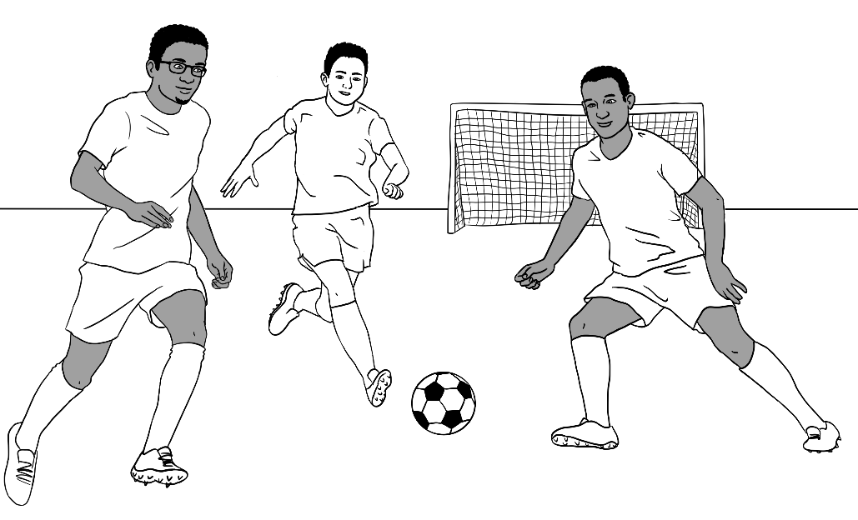 |  | 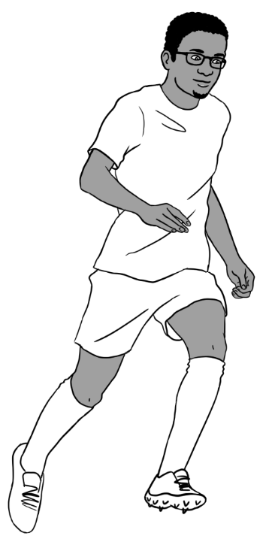
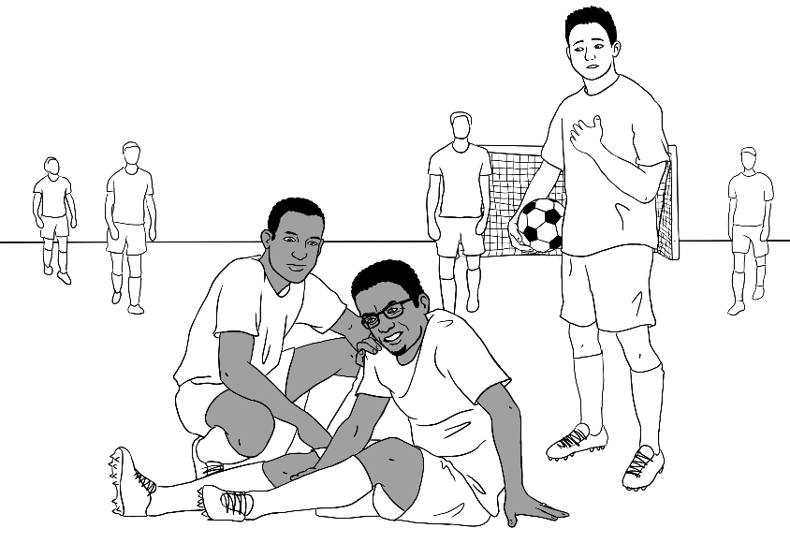 | 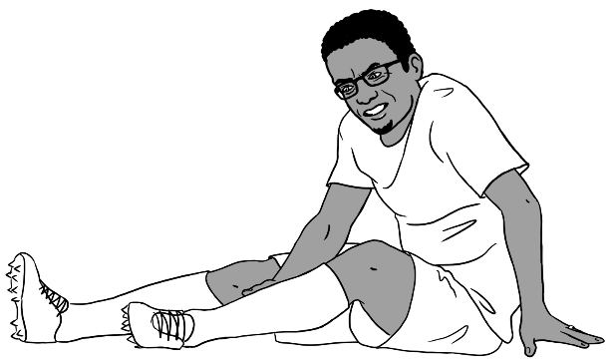
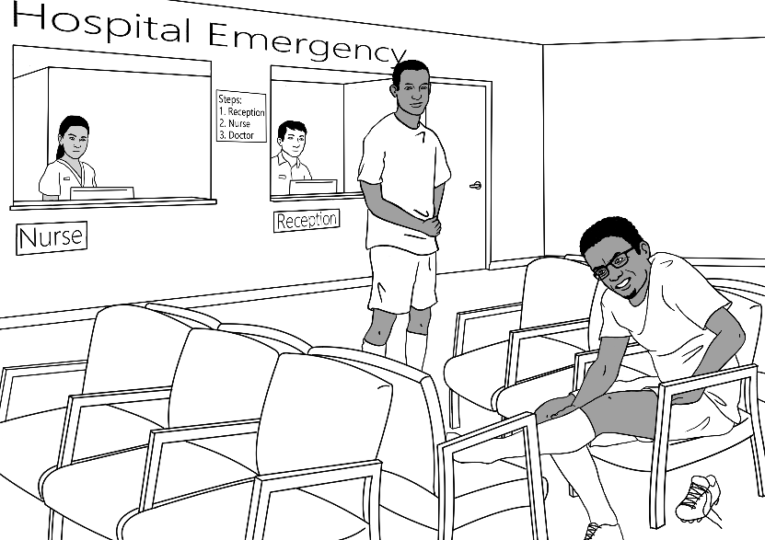

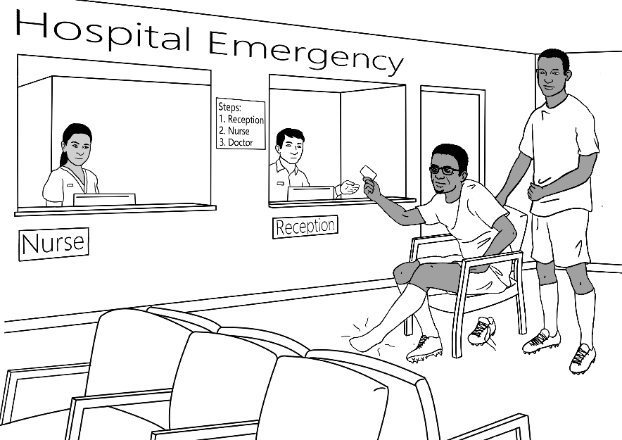 |  | 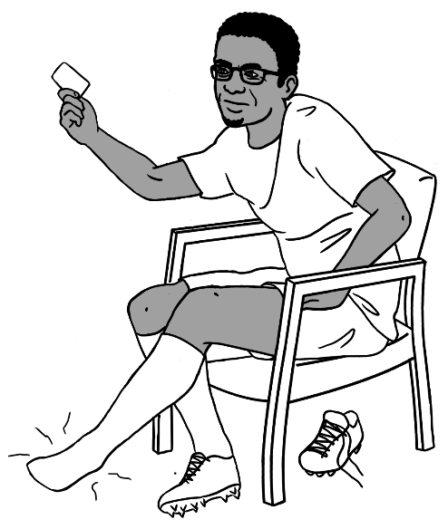
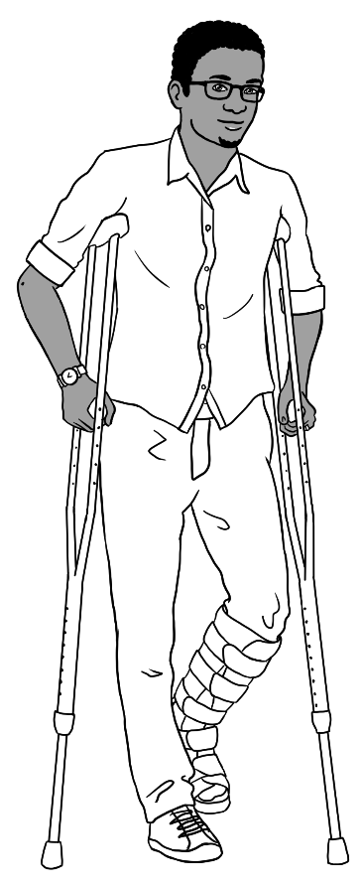 | 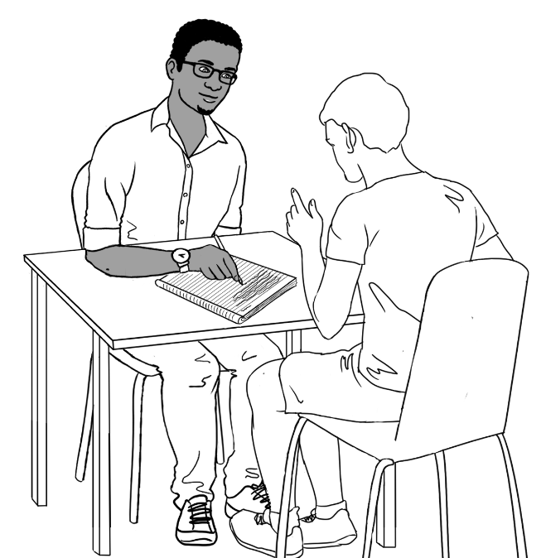  Volunteer tutor
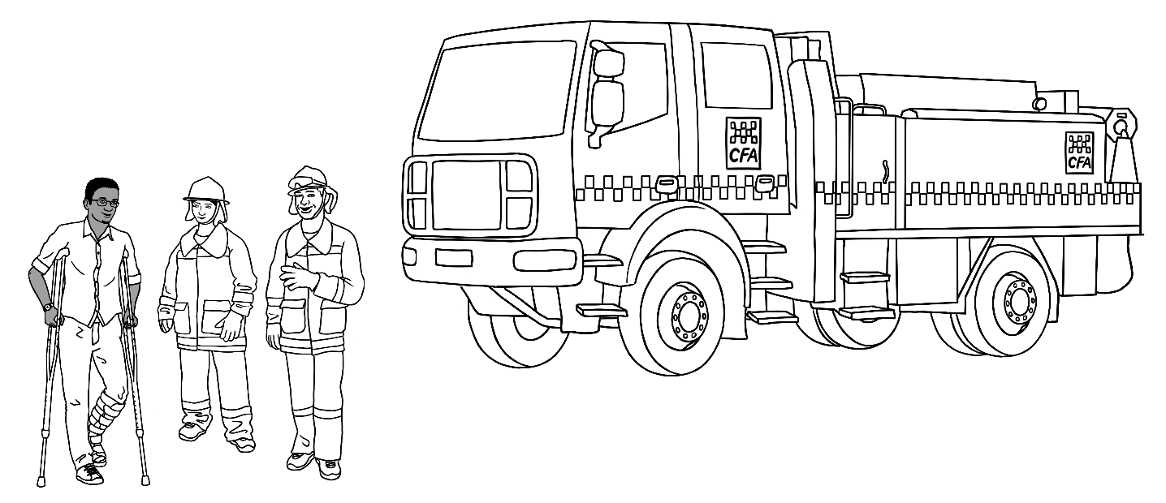
Tahiil is a volunteer fireman and talks here with other volunteers.

Hani – Sahra and Tahiil’s daughter
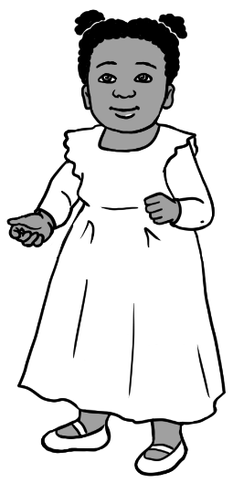 | 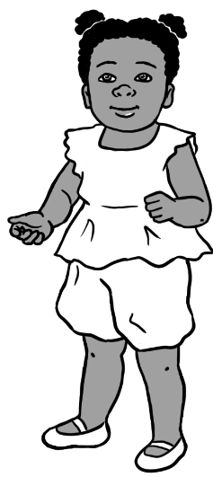 | 
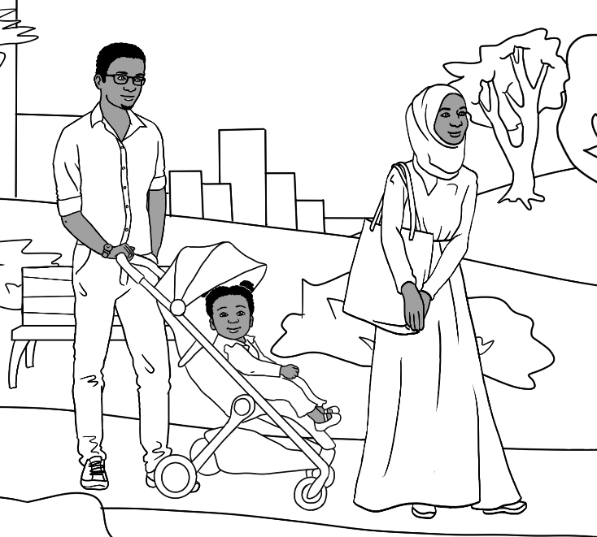 |  | 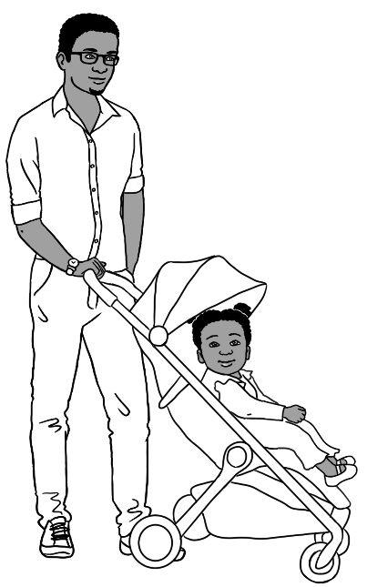
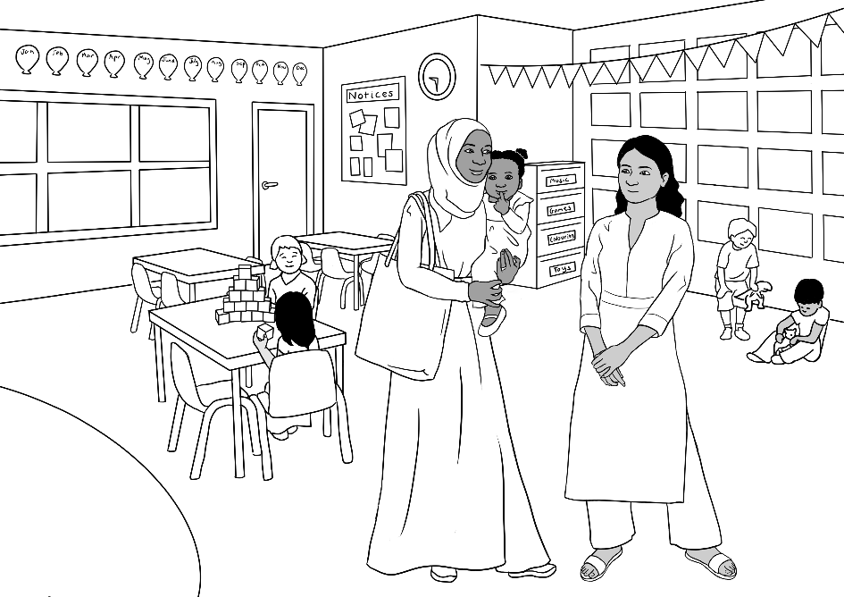 |  | 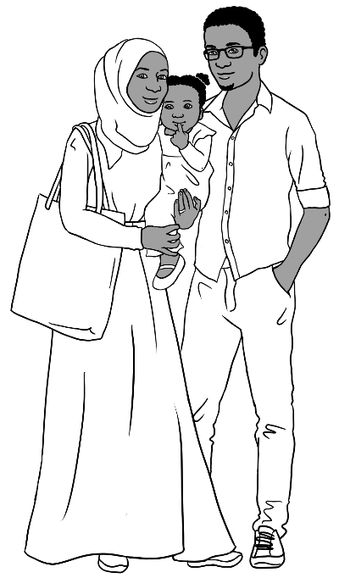

Abdi – Sahra’s brother
Abdi is a university student.
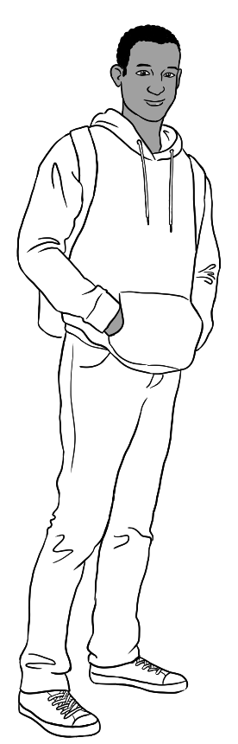 | 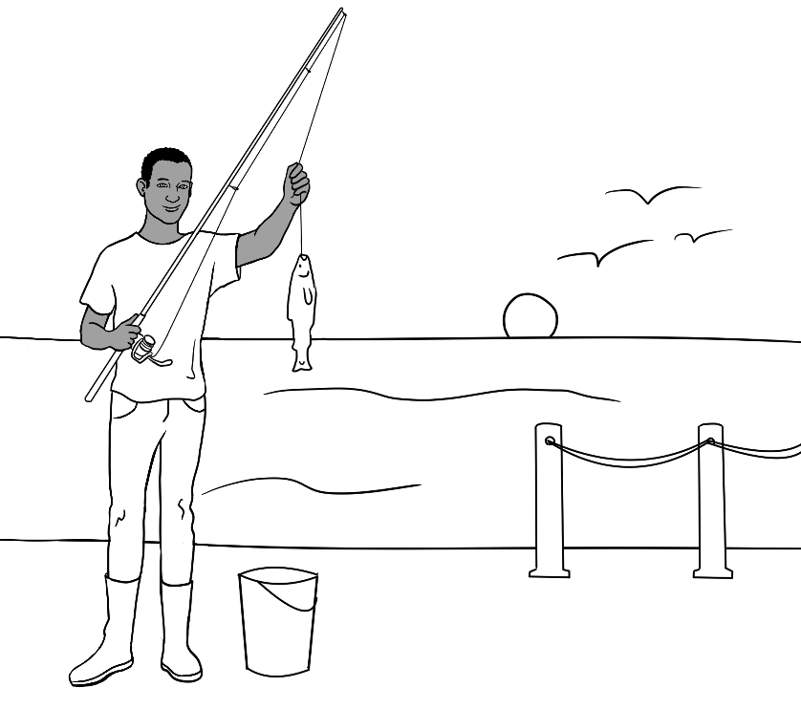
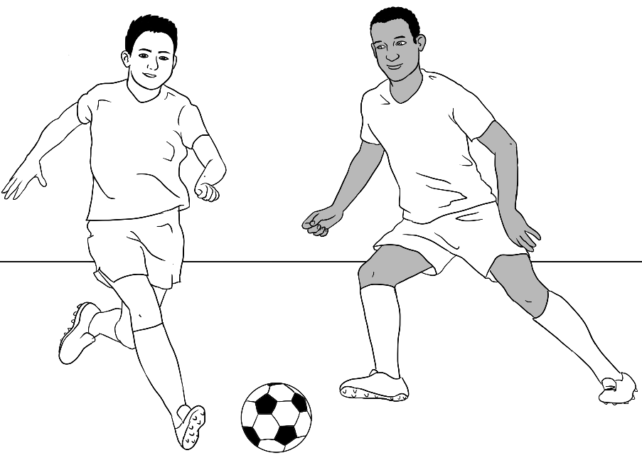  Bao |  | 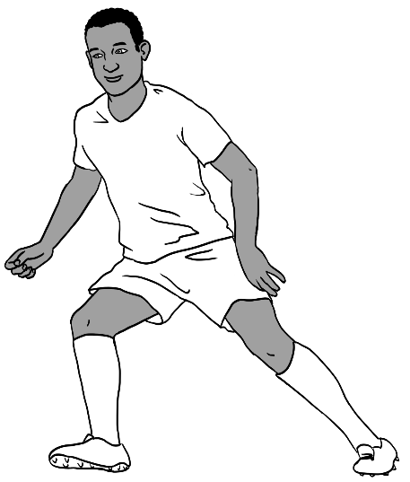

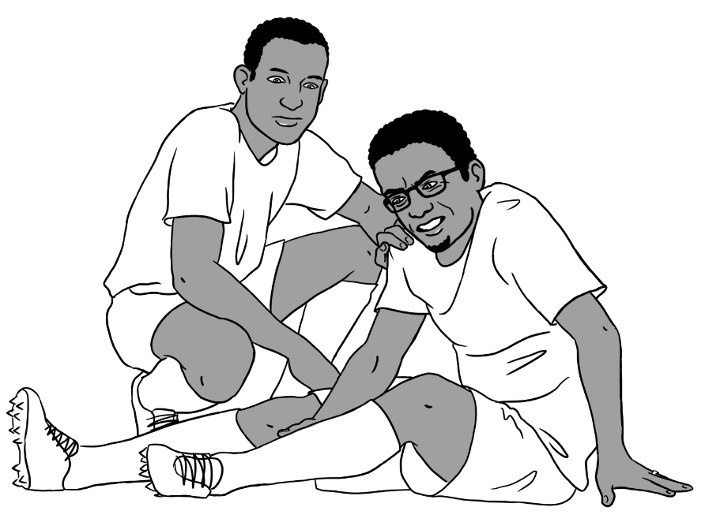 |  | 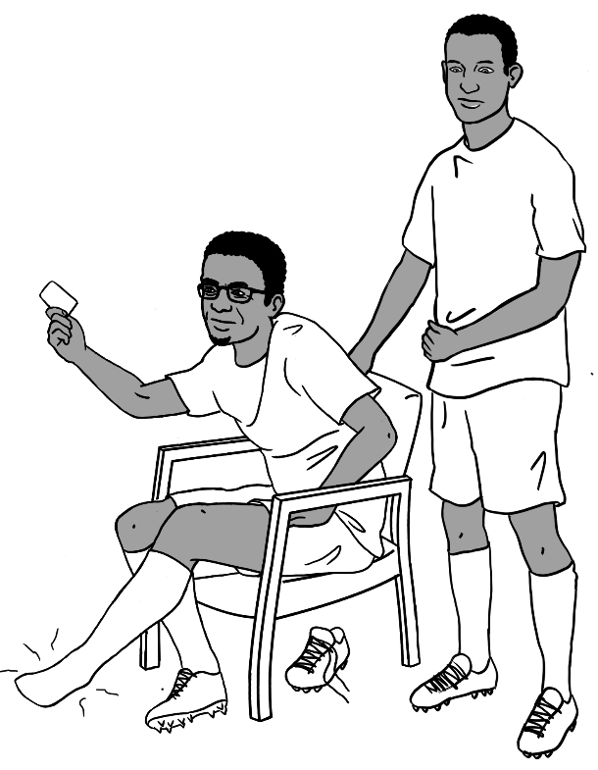
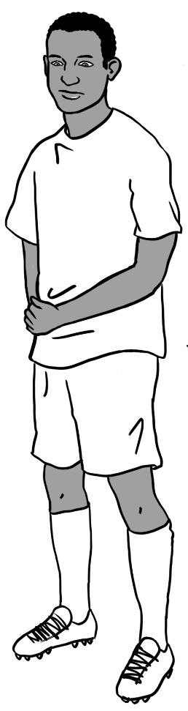 |  |  | 
 | 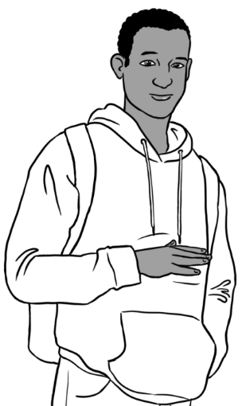 |  | 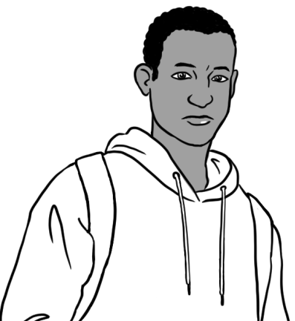

Family 3 – Ko, Zarni, San, Thein, Yaza

Ko’s family comes from Myanmar.
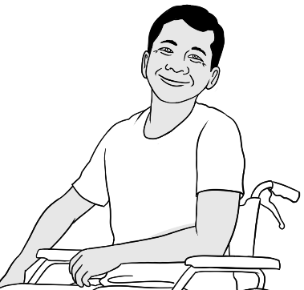  Ko |  | 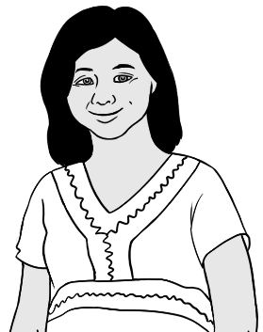  Zarni  Ko’s wife
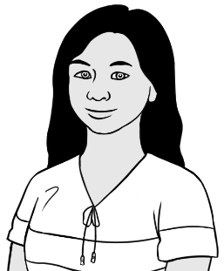  San  Ko and Zarni’s daughter |  |   Thein  San’s husband
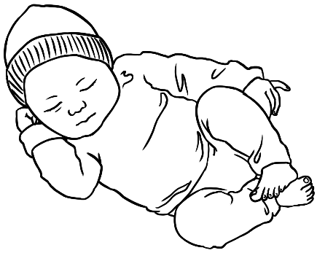
Yaza
San and Thein’s son

Ko
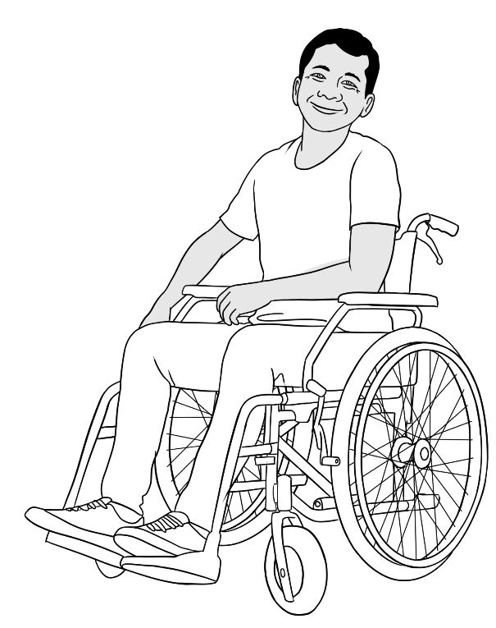 | 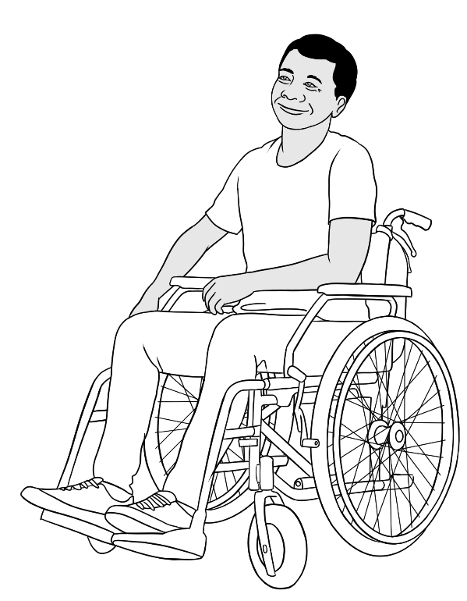
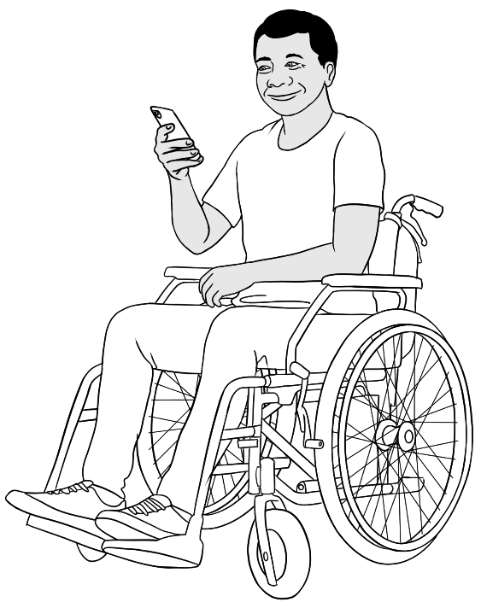 | 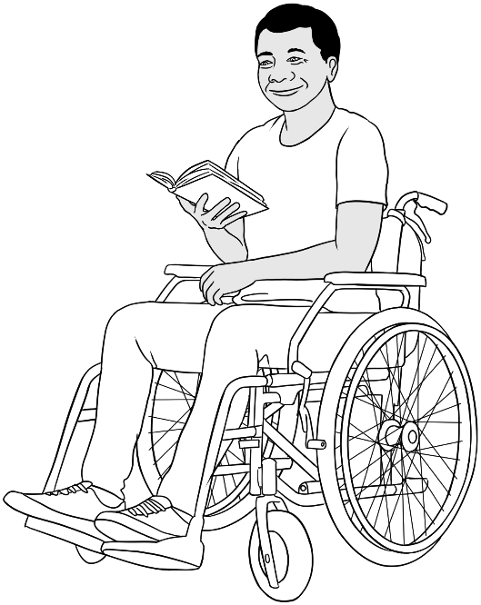
 | 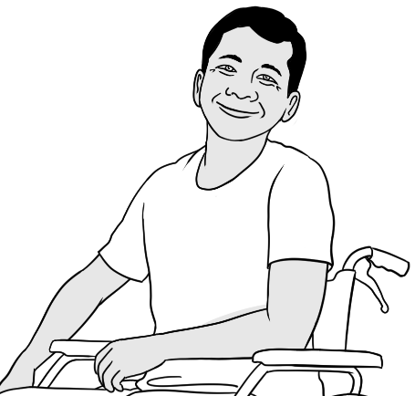
Ko is a student in the Certificate 1 in EAL workbooks. In Myanmar,
he was a motorbike mechanic. He now wants to be a computer technician. His current disability and its cause is not explained in the workbooks.

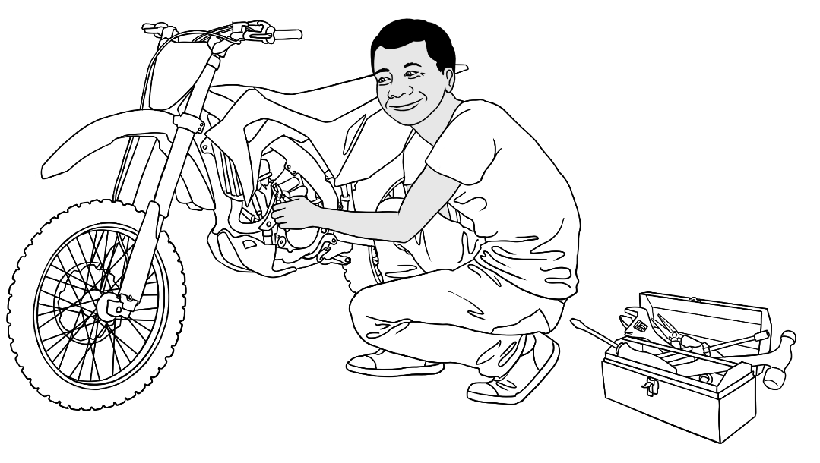
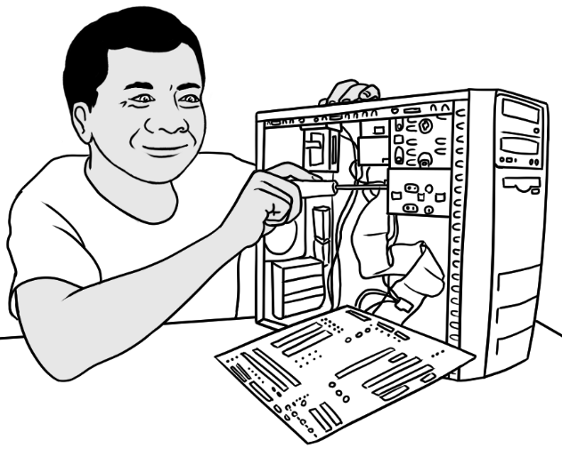 | 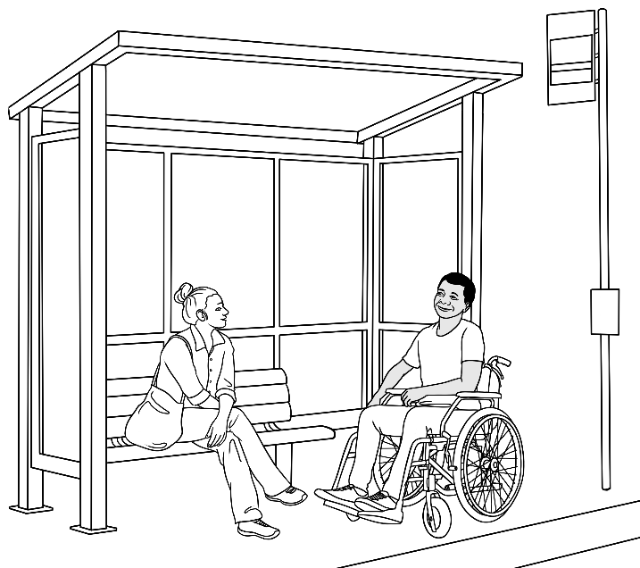
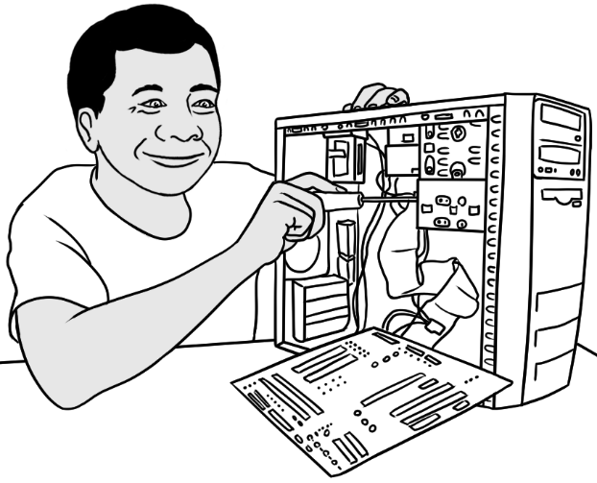

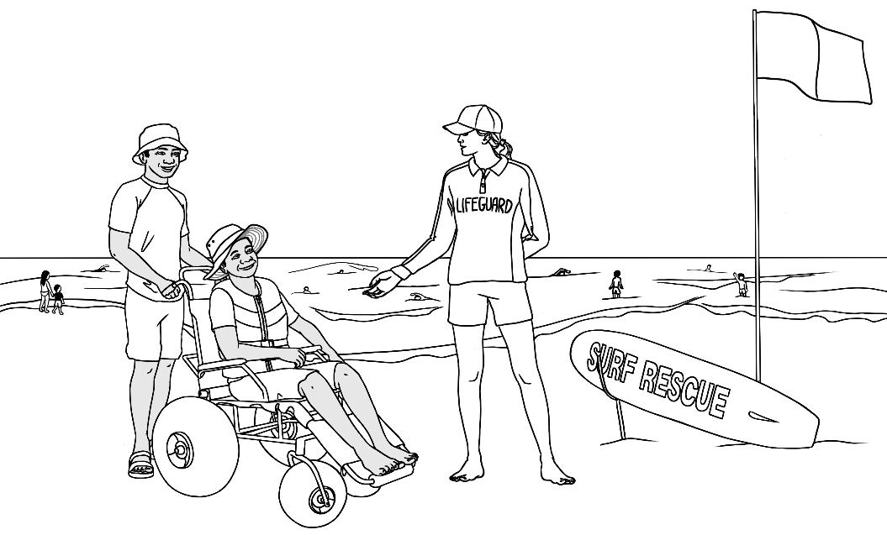 | 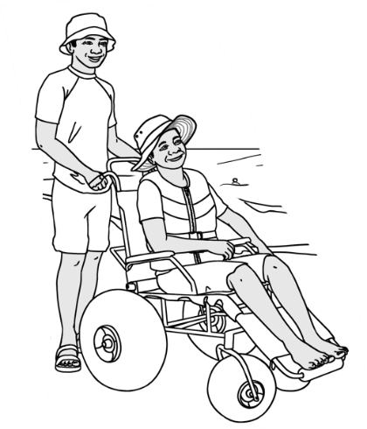
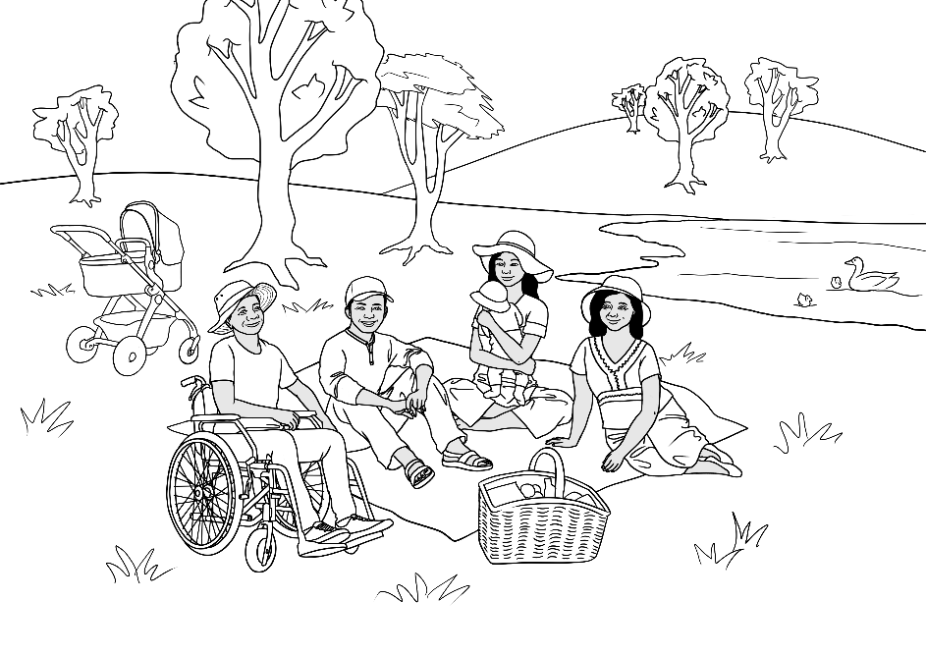
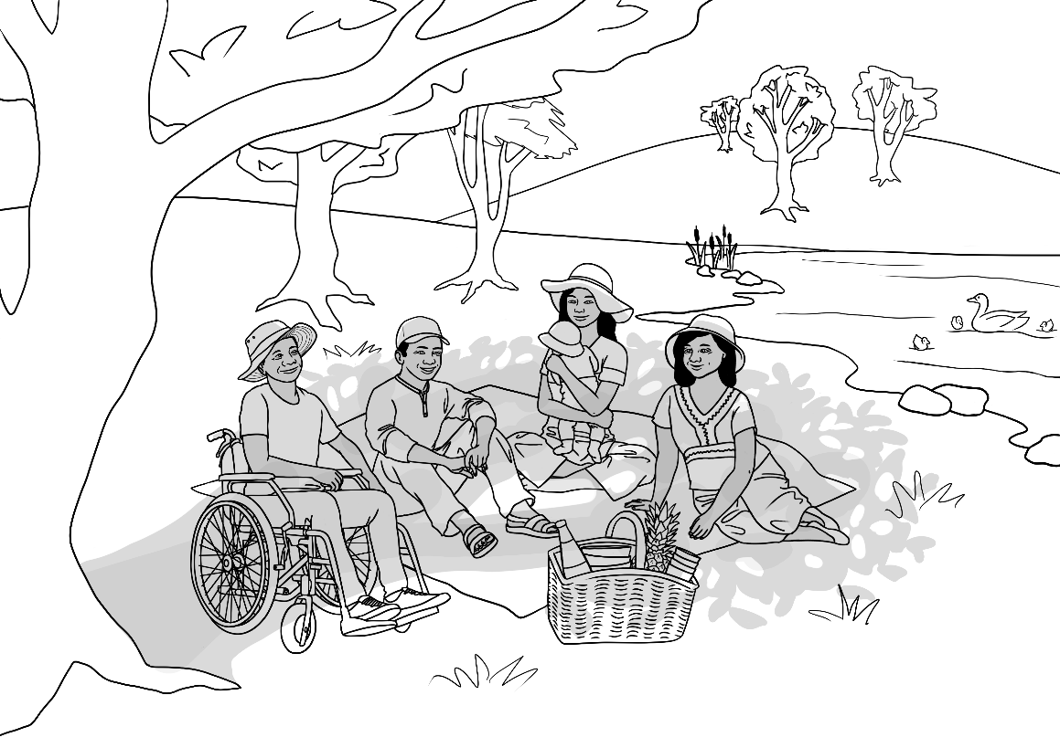

Zarni – Ko’s wife and baby Yaza’s grandmother.
Zarni is a student in the Course in Initial EAL workbooks.
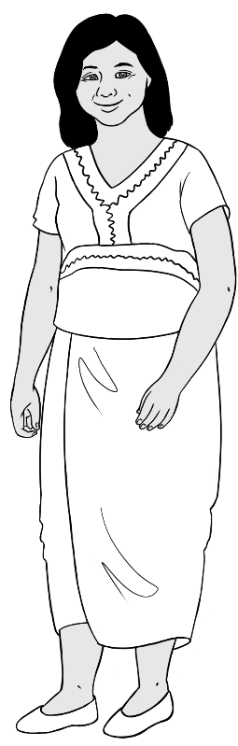 | 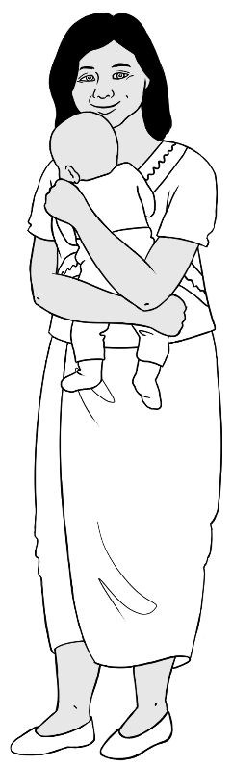 |  | 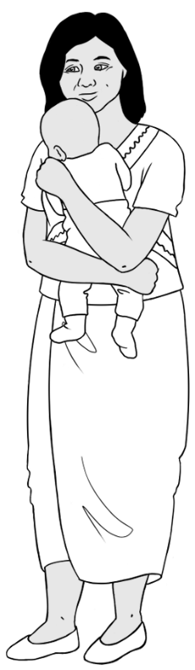
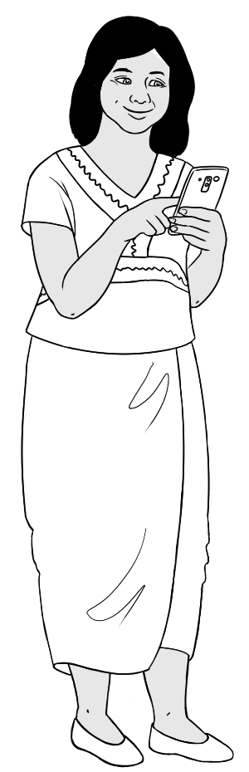 | 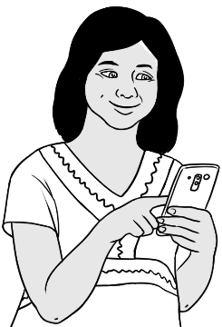
 | 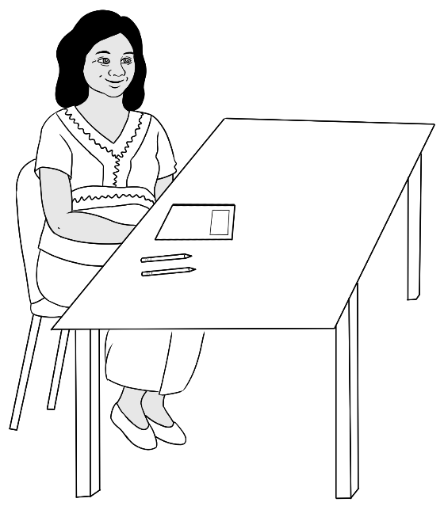

Teacher Rosie
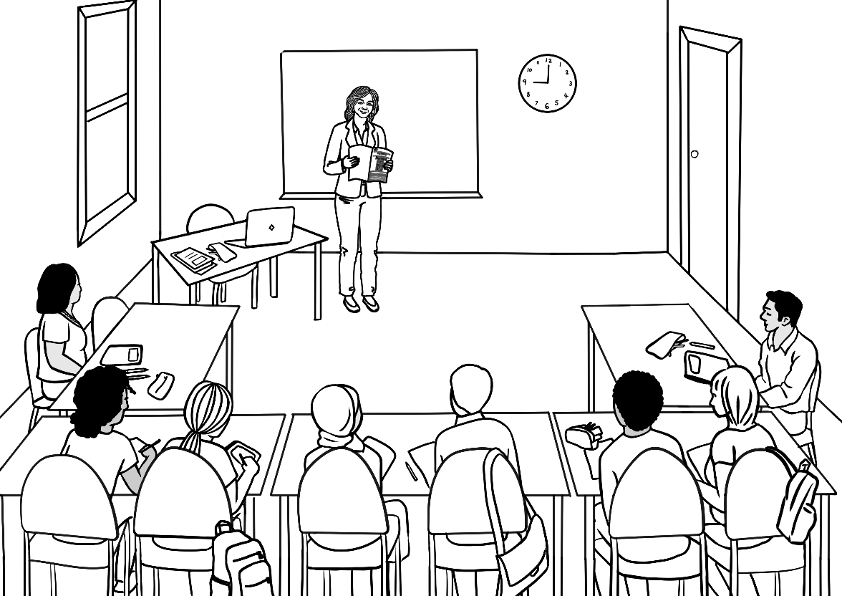
Zarni
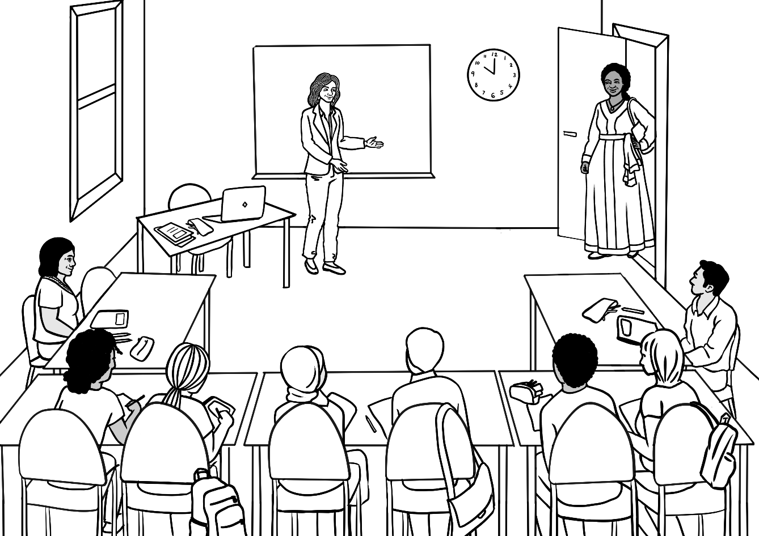
Zarni
Jamila

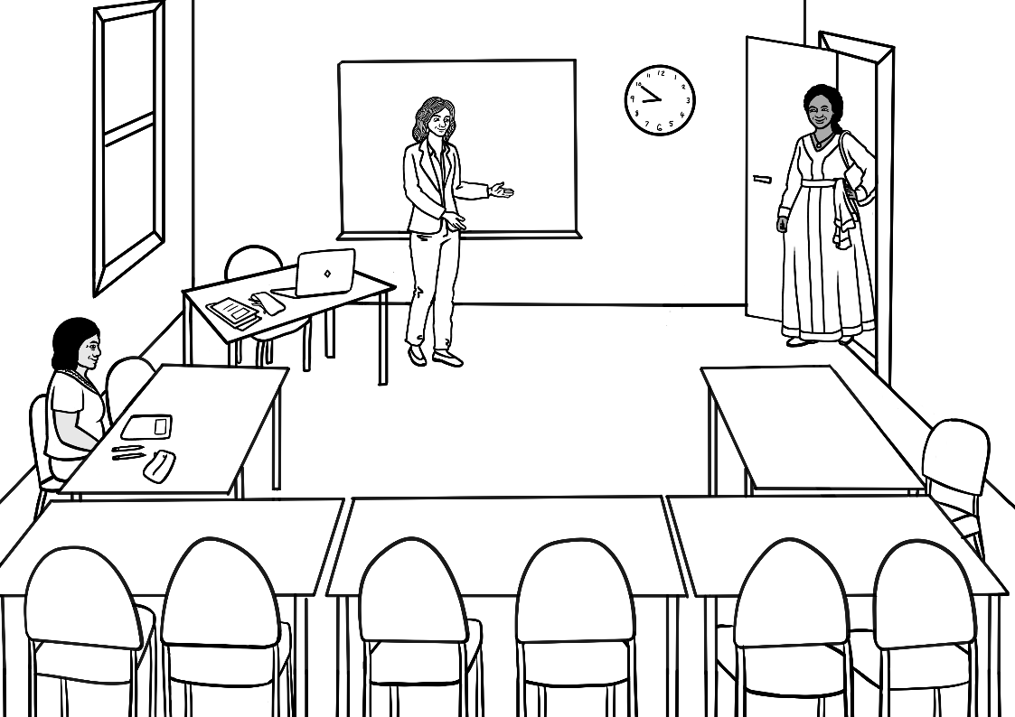
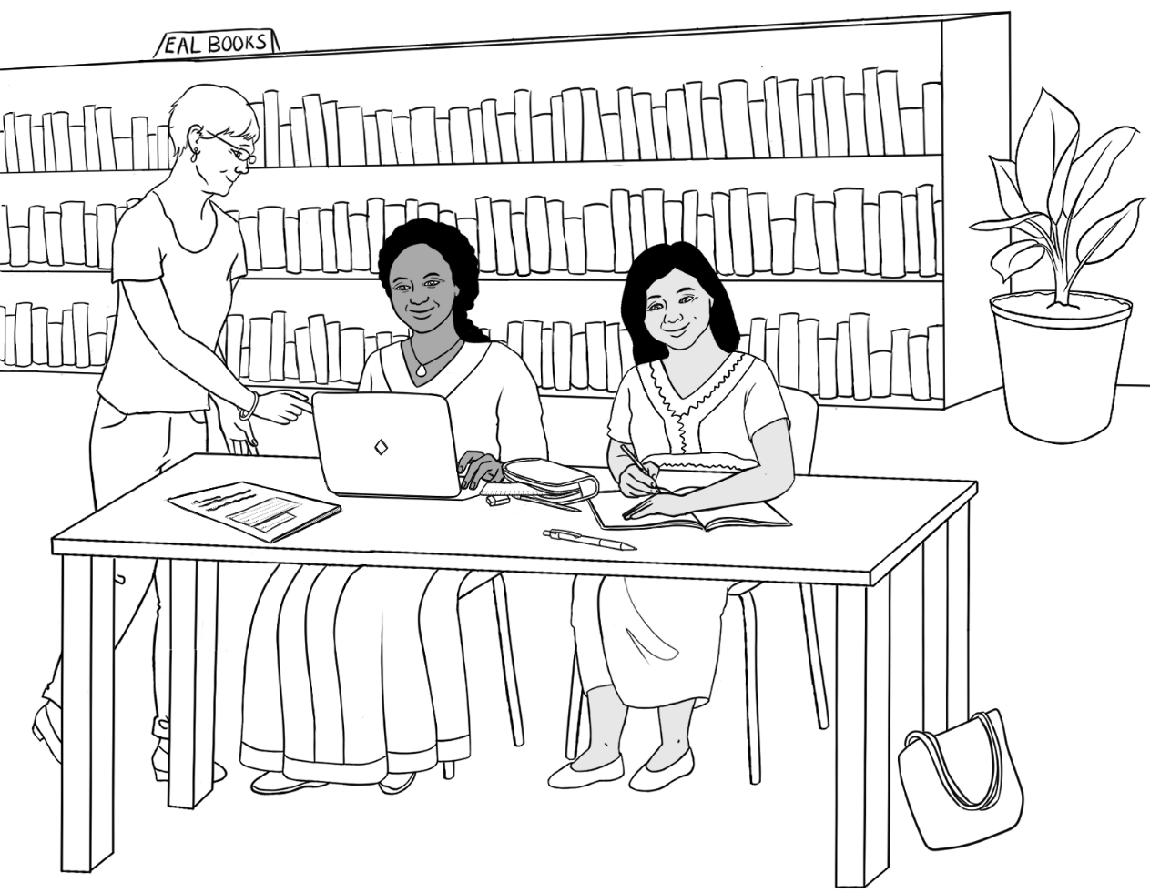
Librarian
Jamila

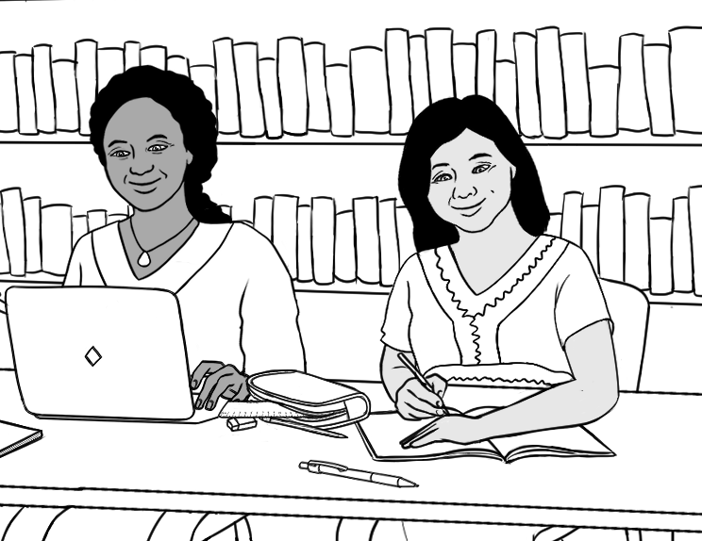

San – Ko and Zarni’s daughter
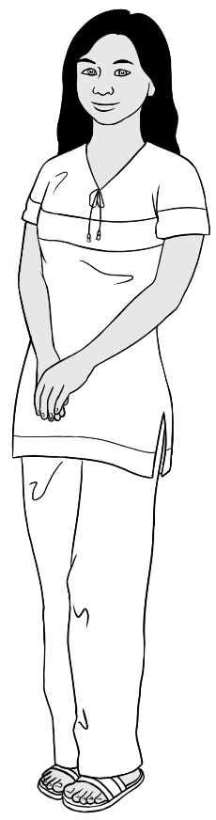 | 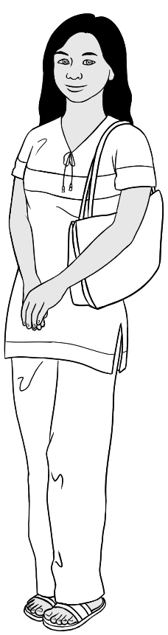 | 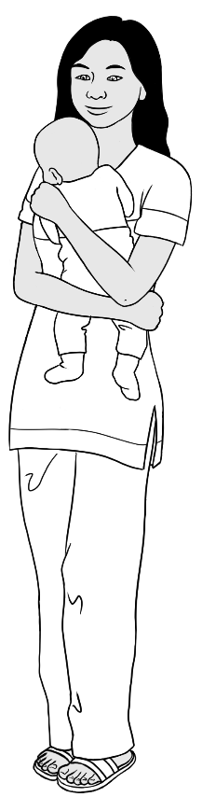
 | 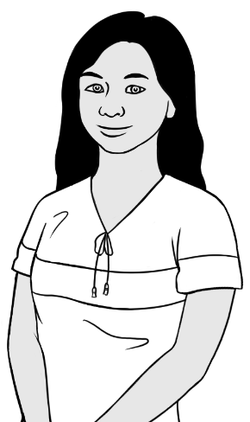 | 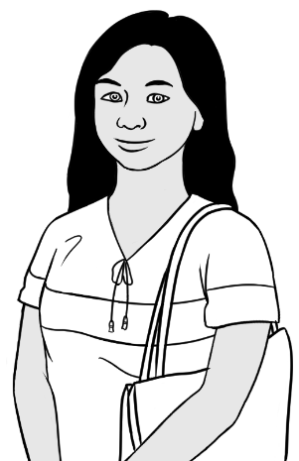
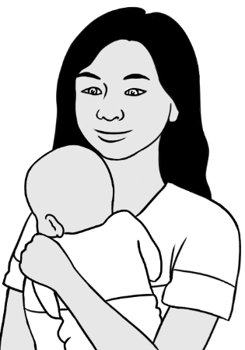 | 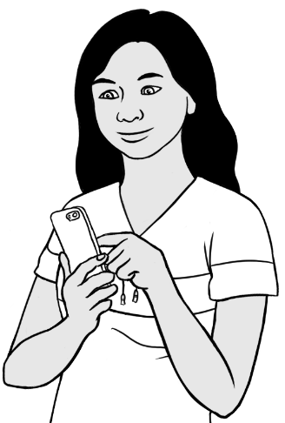 | 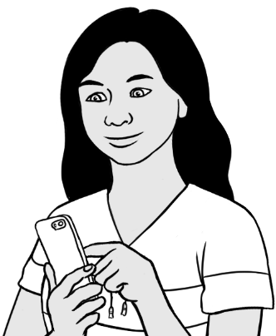
San is a student in the Course in Initial EAL workbooks.
She wants to work in childcare.

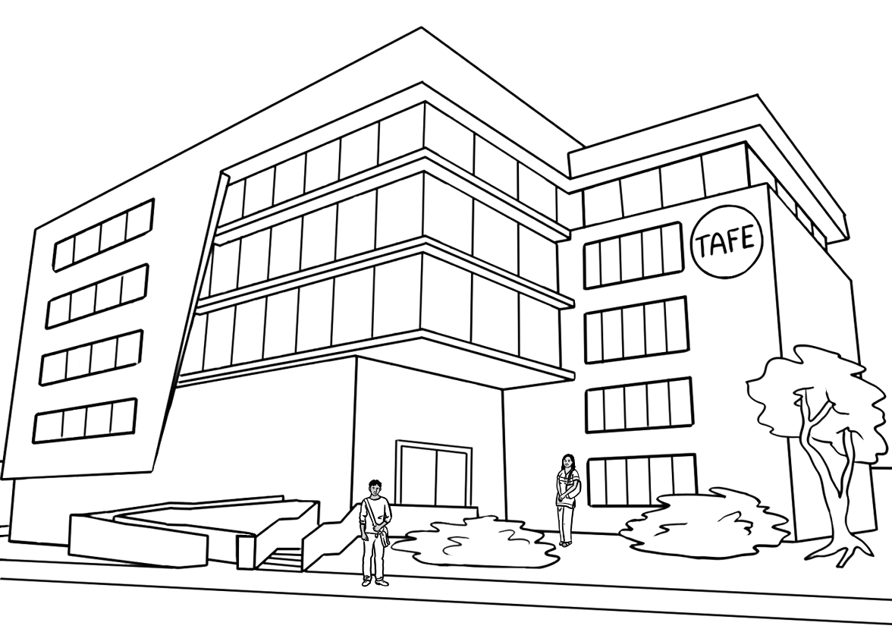
Rahim
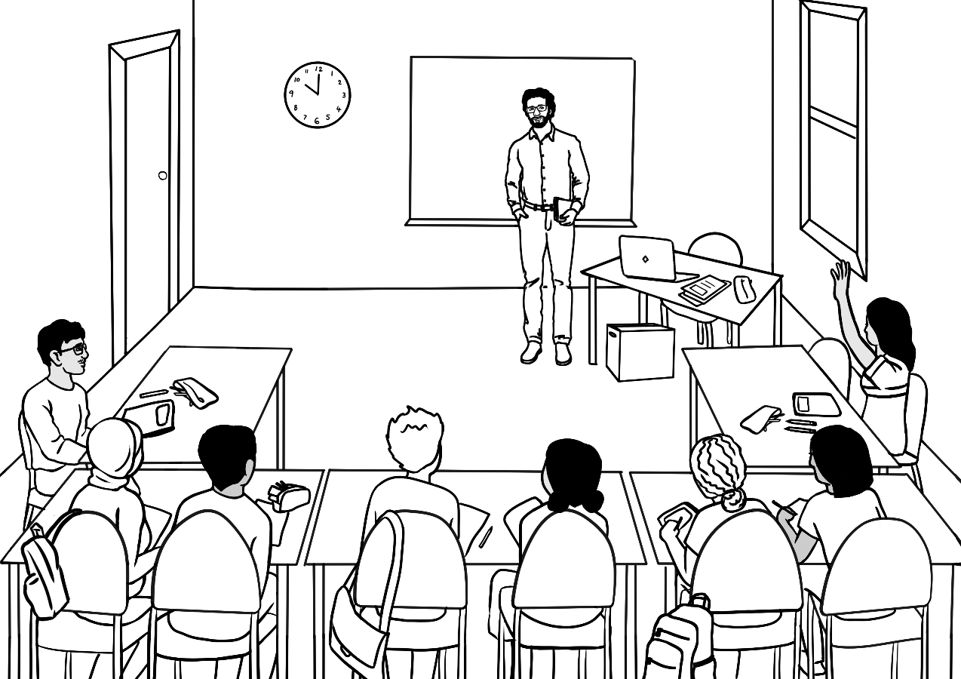
San
Teacher Peter
San
Rahim

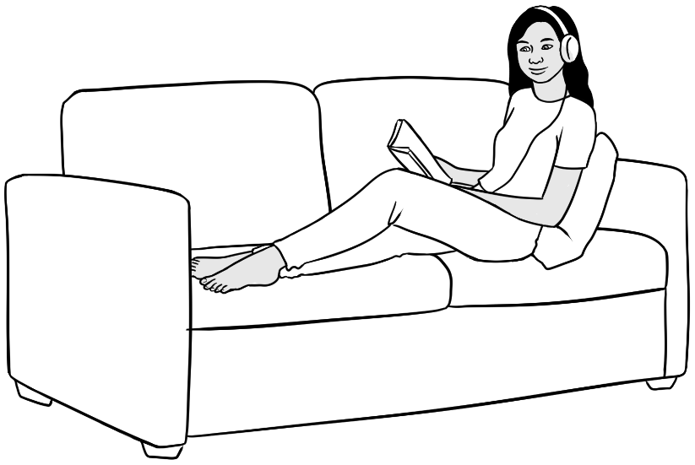 |  | 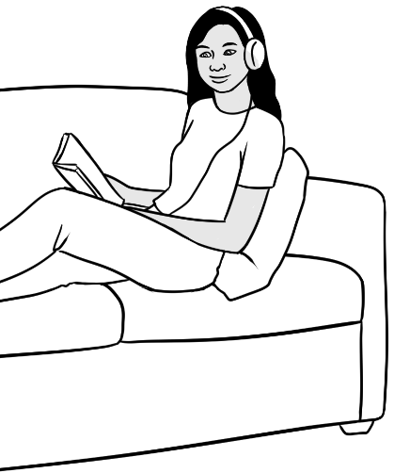
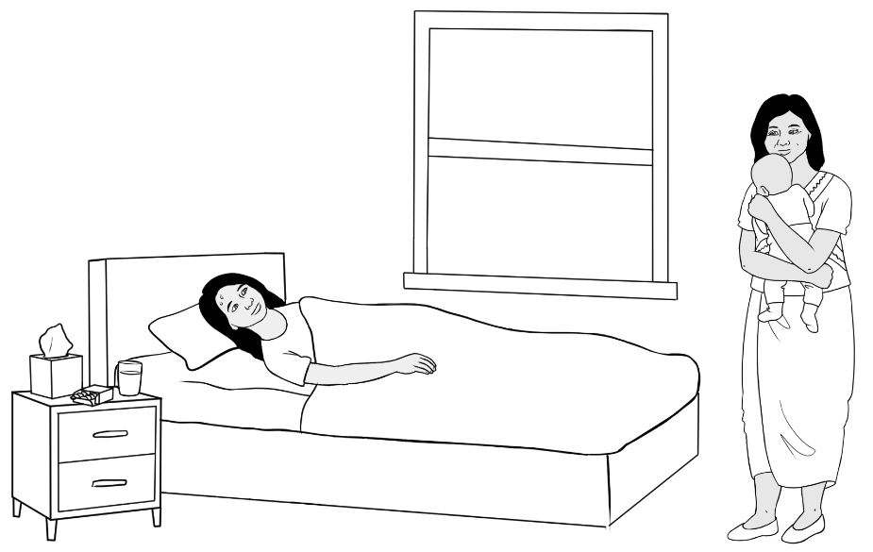 |  | 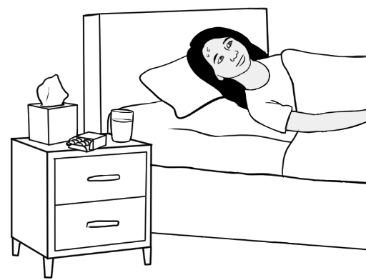
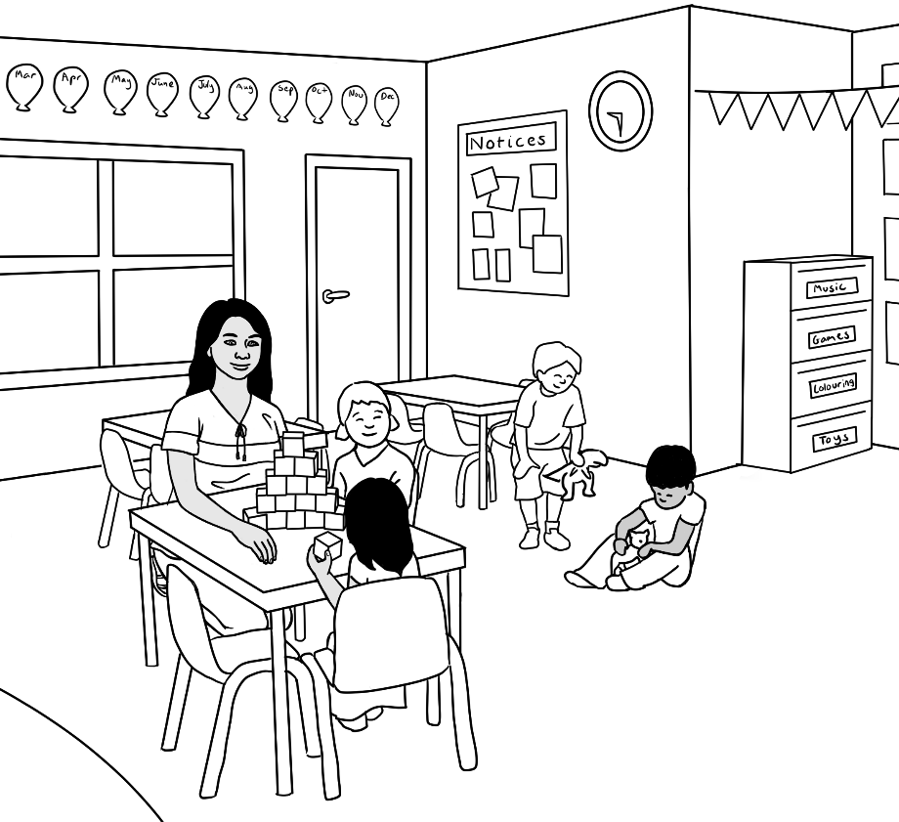

Thein – San’s husband
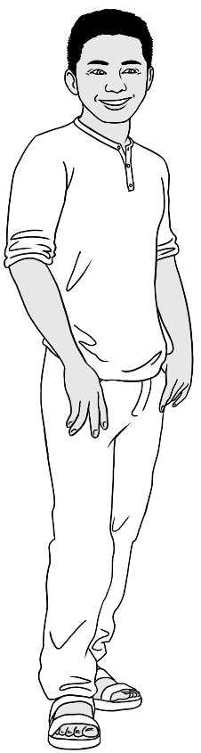
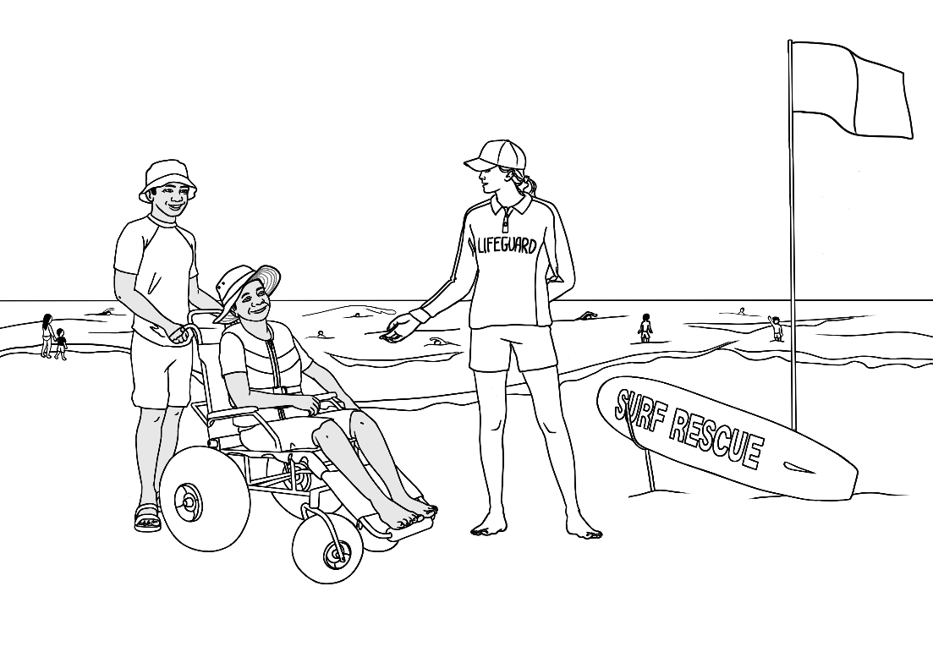 |  | 

Yaza – San and Thein’s son
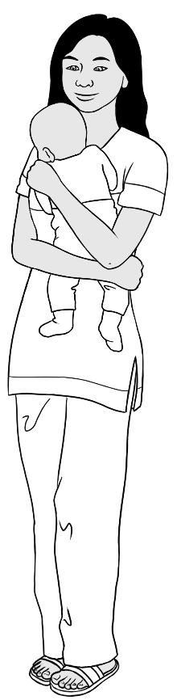 | 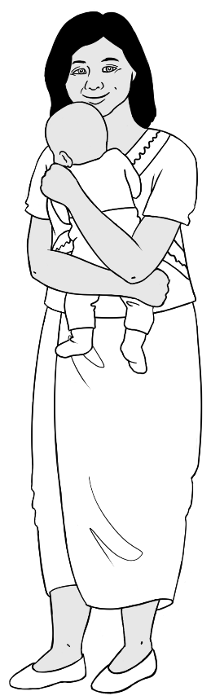 | 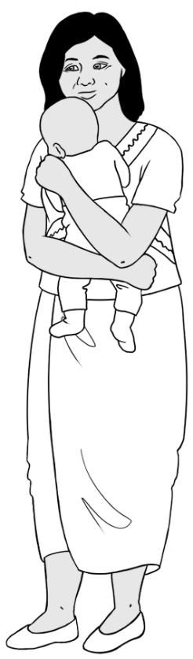
 |  | 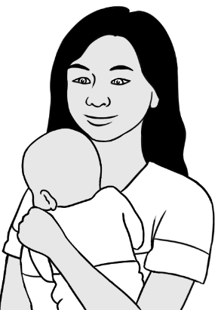
 | 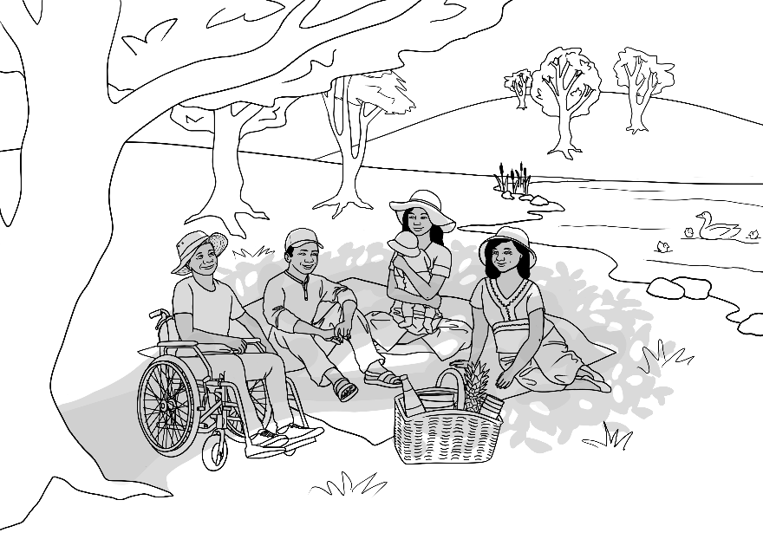 | 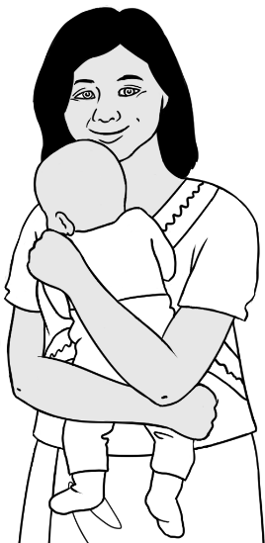

Family 4 – Amina, Nabi, Parwana, Jomeh, Bibi, Mustafa, Rahim

Amina’s family comes from Afghanistan.

 | 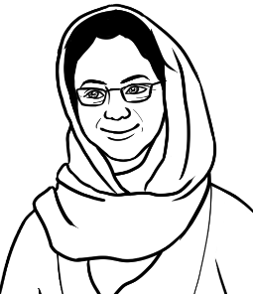  Amina |   Nabi  Amina’s husband
Jomeh  Parwana’s husband   | 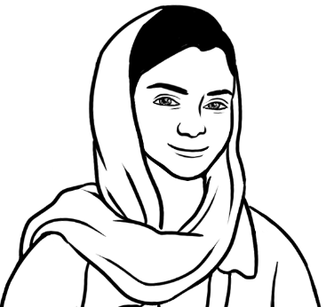  Parwana  Amina and Nabi’s daughter | 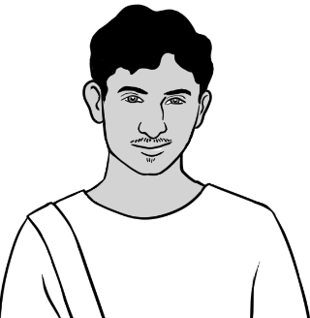  Rahim  Amina and Nabi’s son
  Bibi  Parwana and Jomeh’s daughter |   Mustafa  Parwana and Jomeh’s son

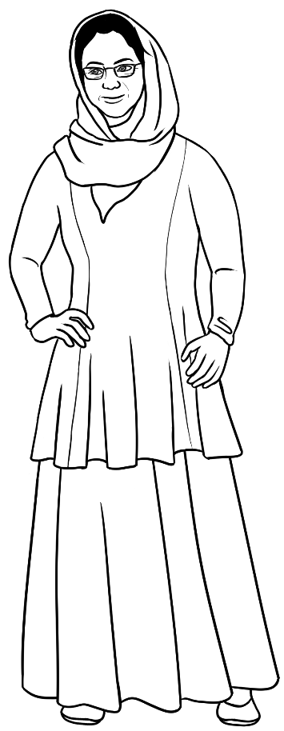 | 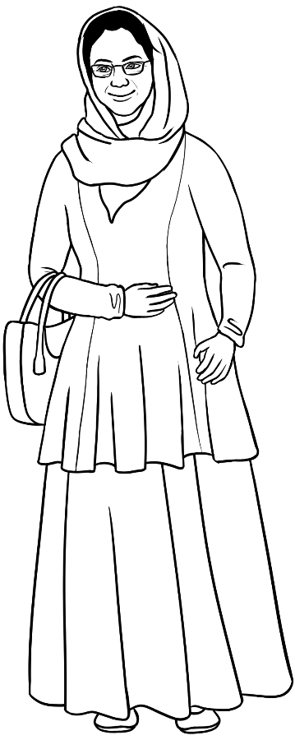 | 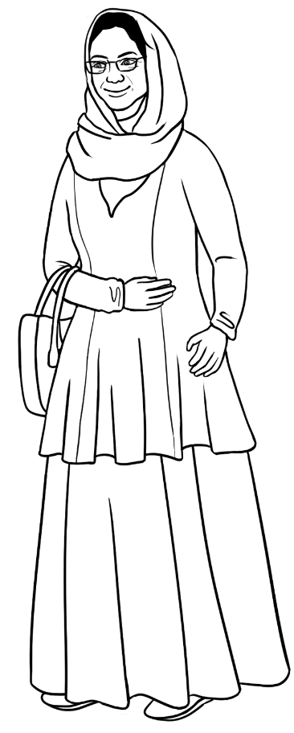
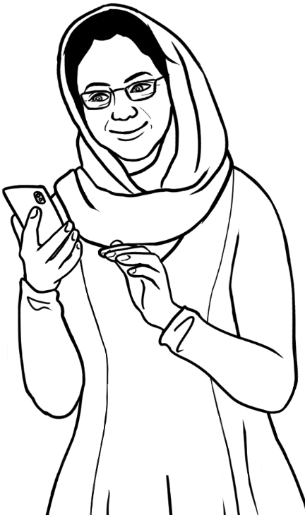 | 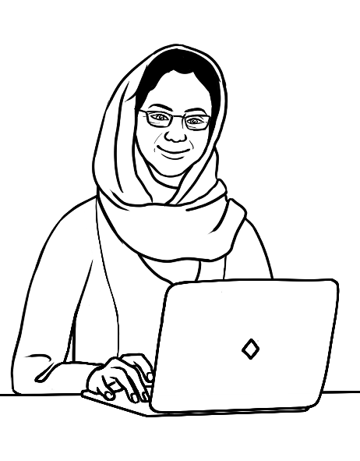 | 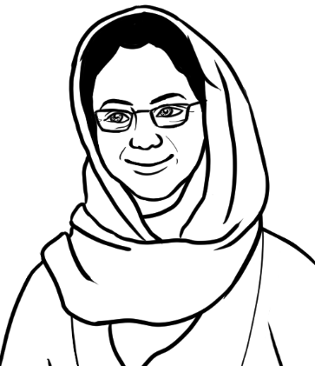
 |  | 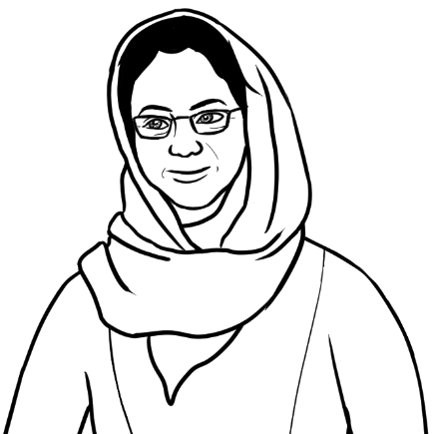

Amina
Amina is a student in the Certificate 1 in EAL workbooks.
In the future, she wants to do some volunteer work.

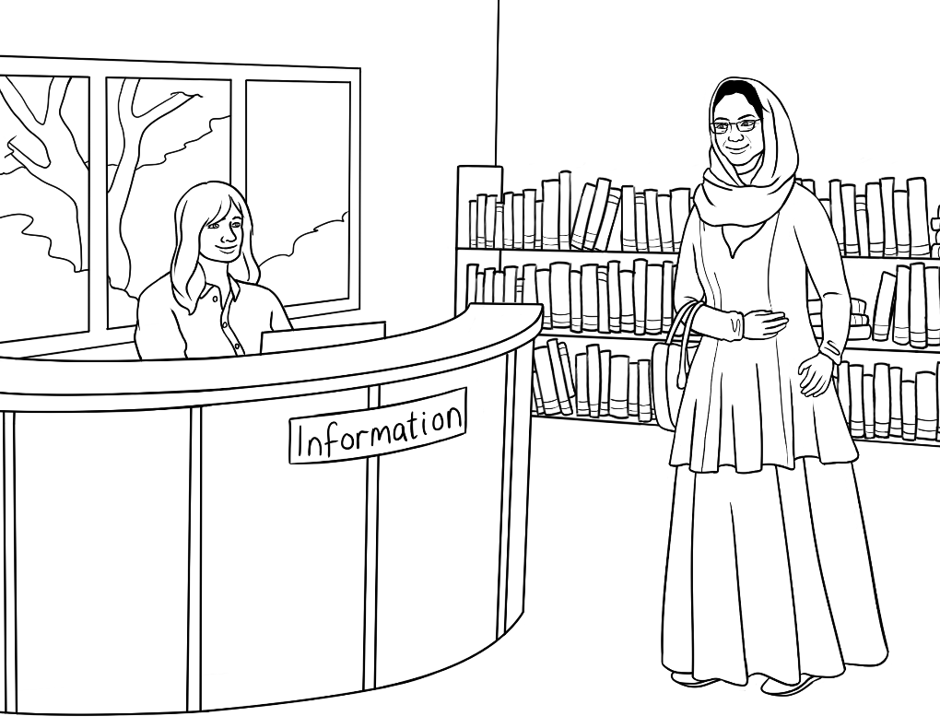
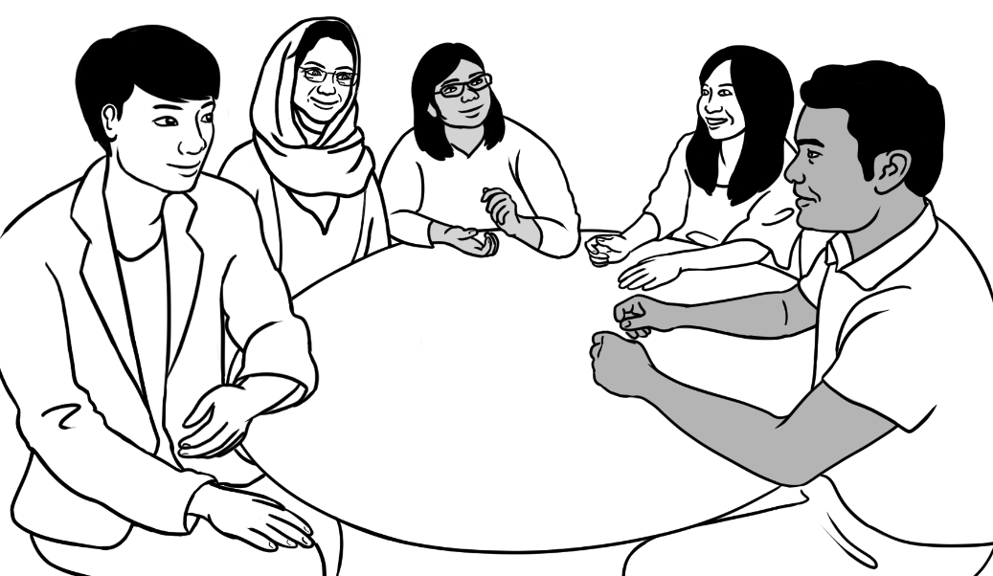
Amina participates in a conversation group at the library with unnamed students.

Nabi – Amina’s husband
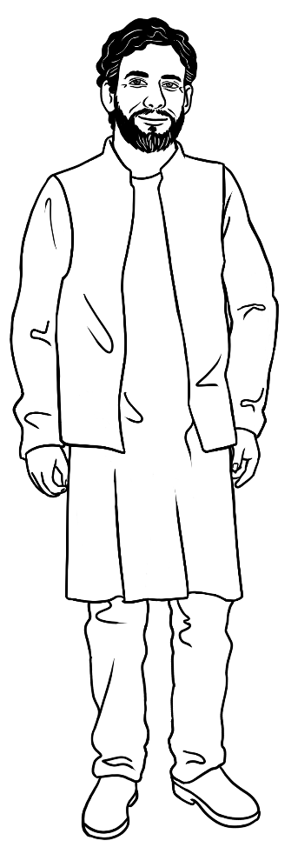 | 
Nabi applies for work at a service station.

Parwana – Amina and Nabi’s daughter
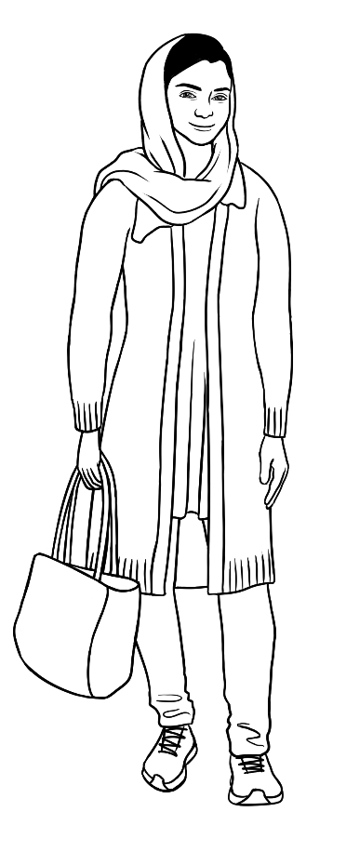 | 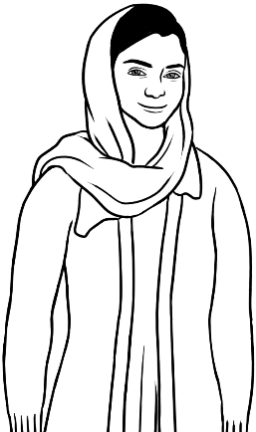 | 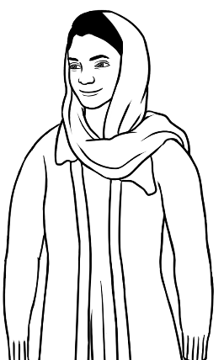
 |  | 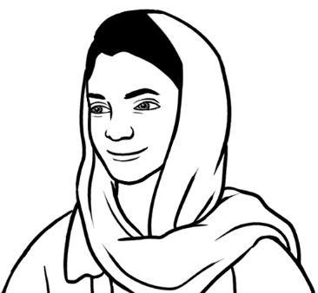
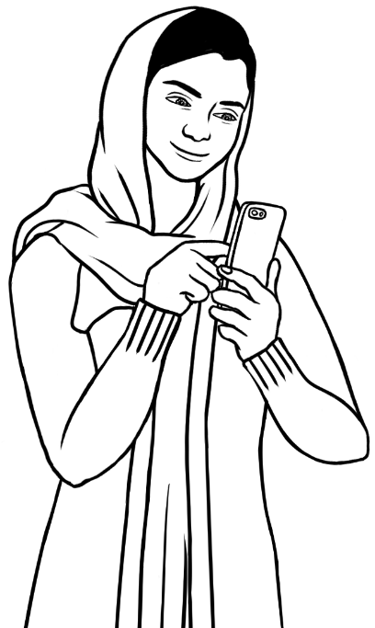 | 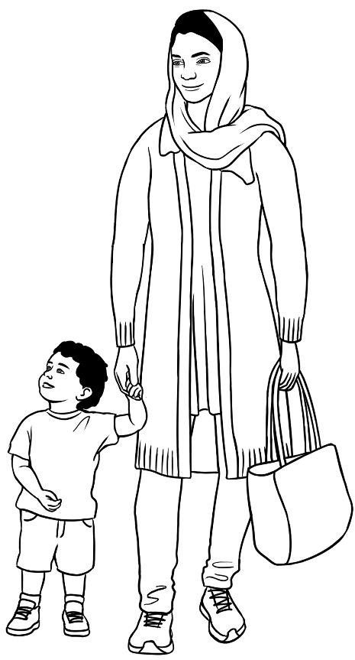  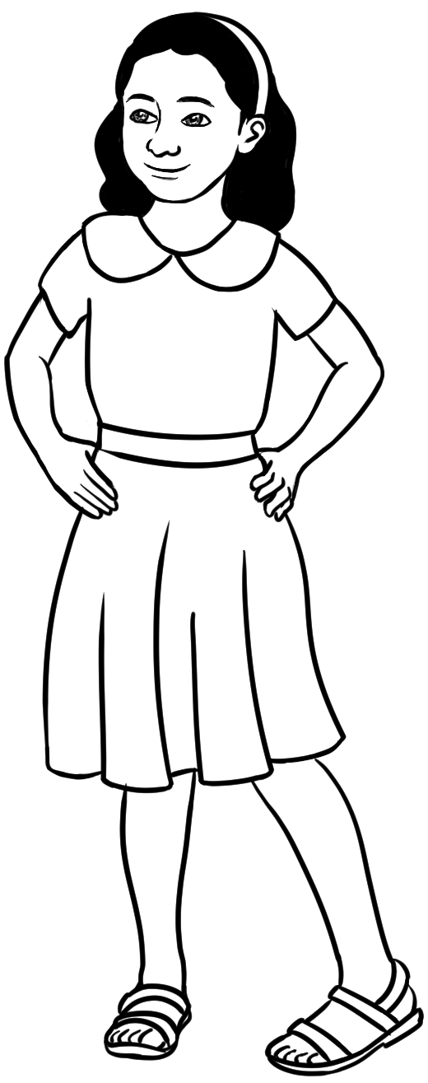
Parwana is a student in the Certificate 1 in EAL workbooks.
She wants to be a nurse.

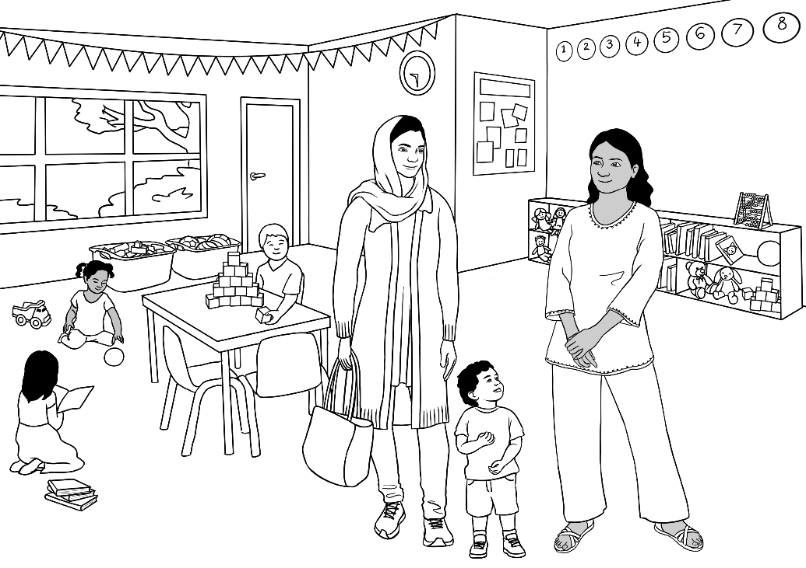
Nisha
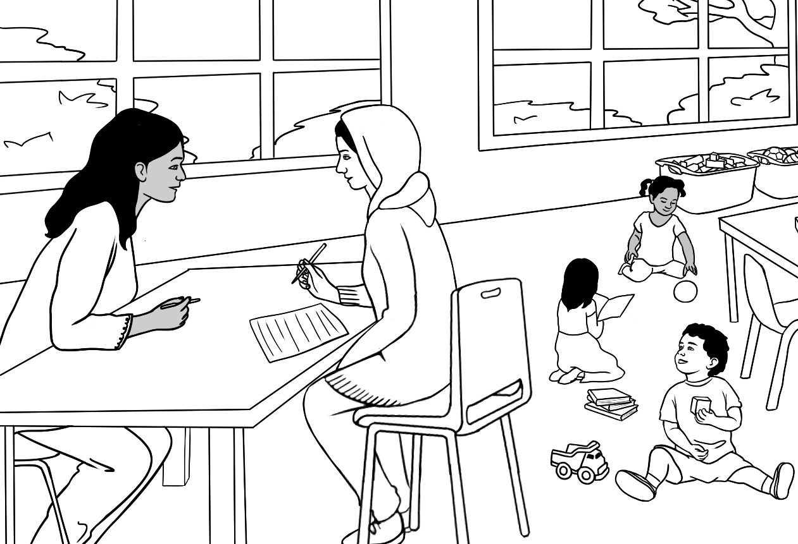
Nisha
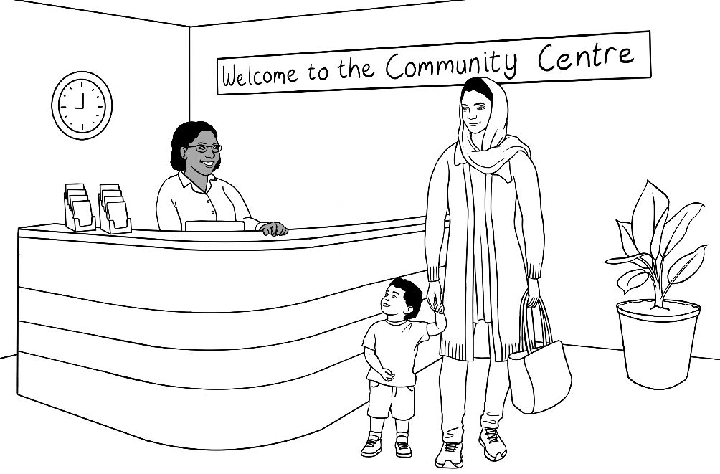 | 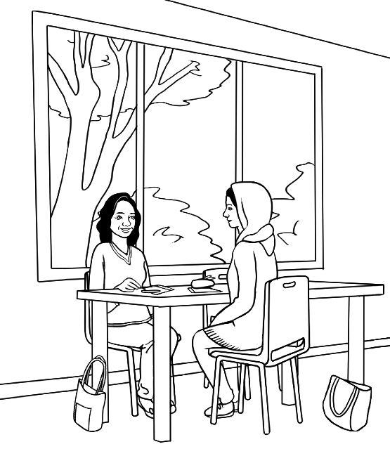
Linh
Volunteer tutor
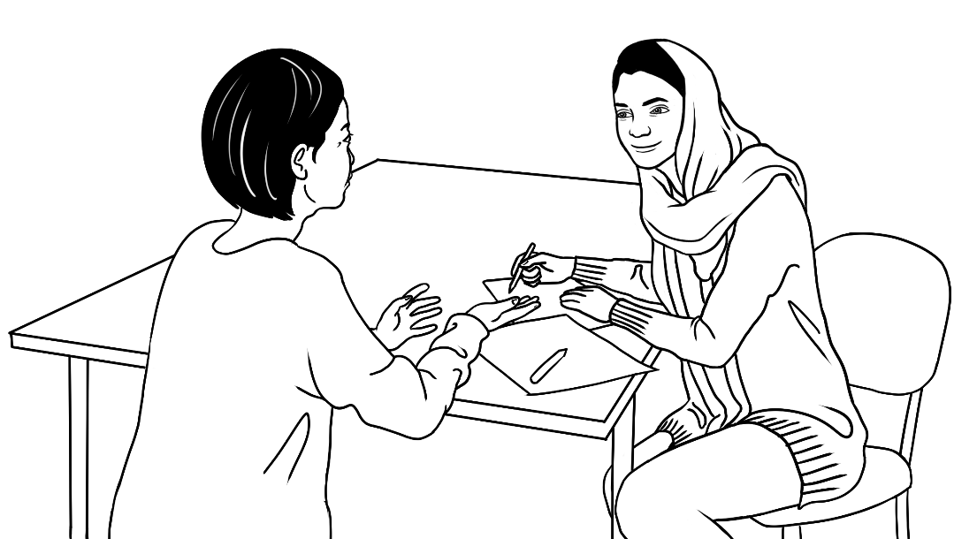 | 
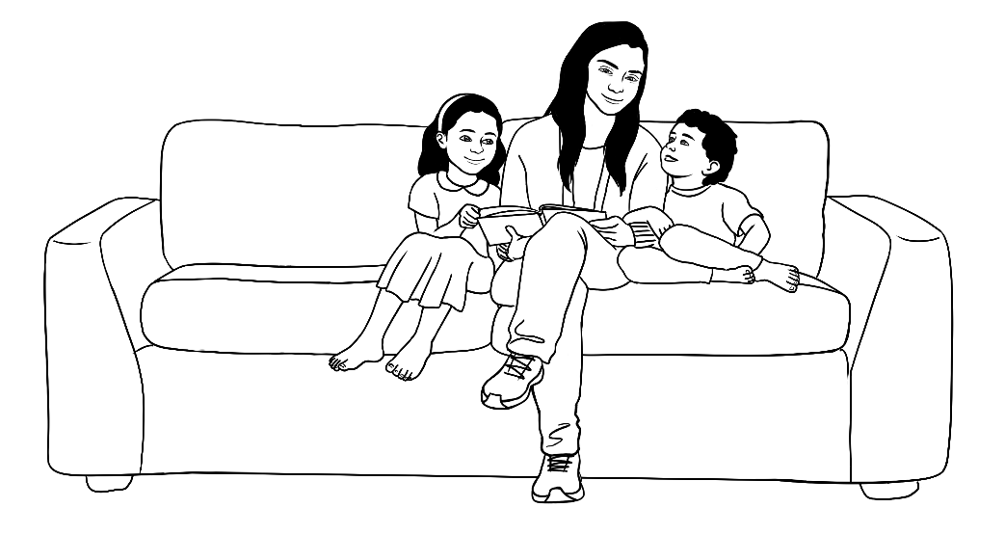
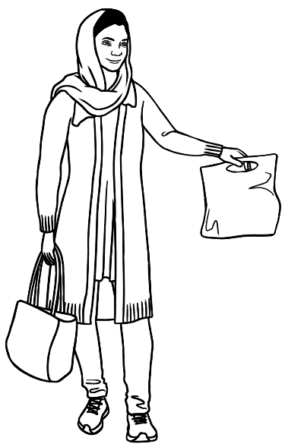
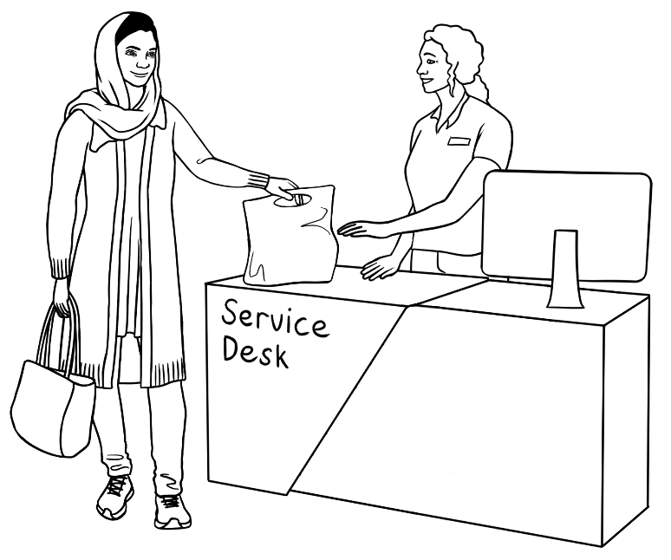

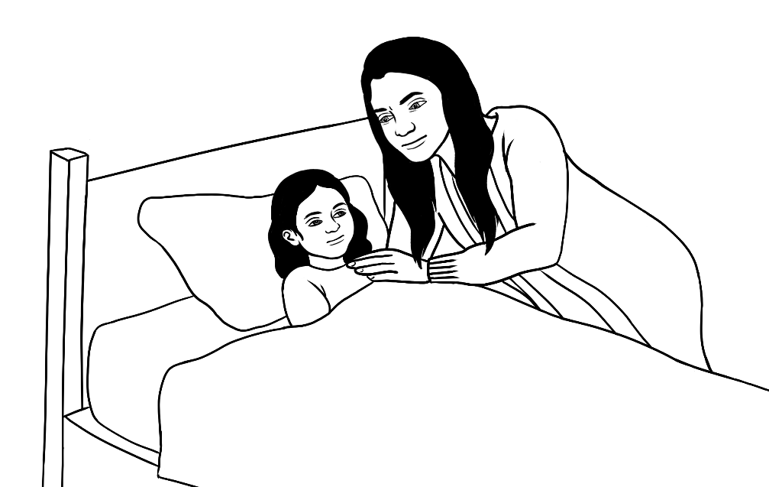
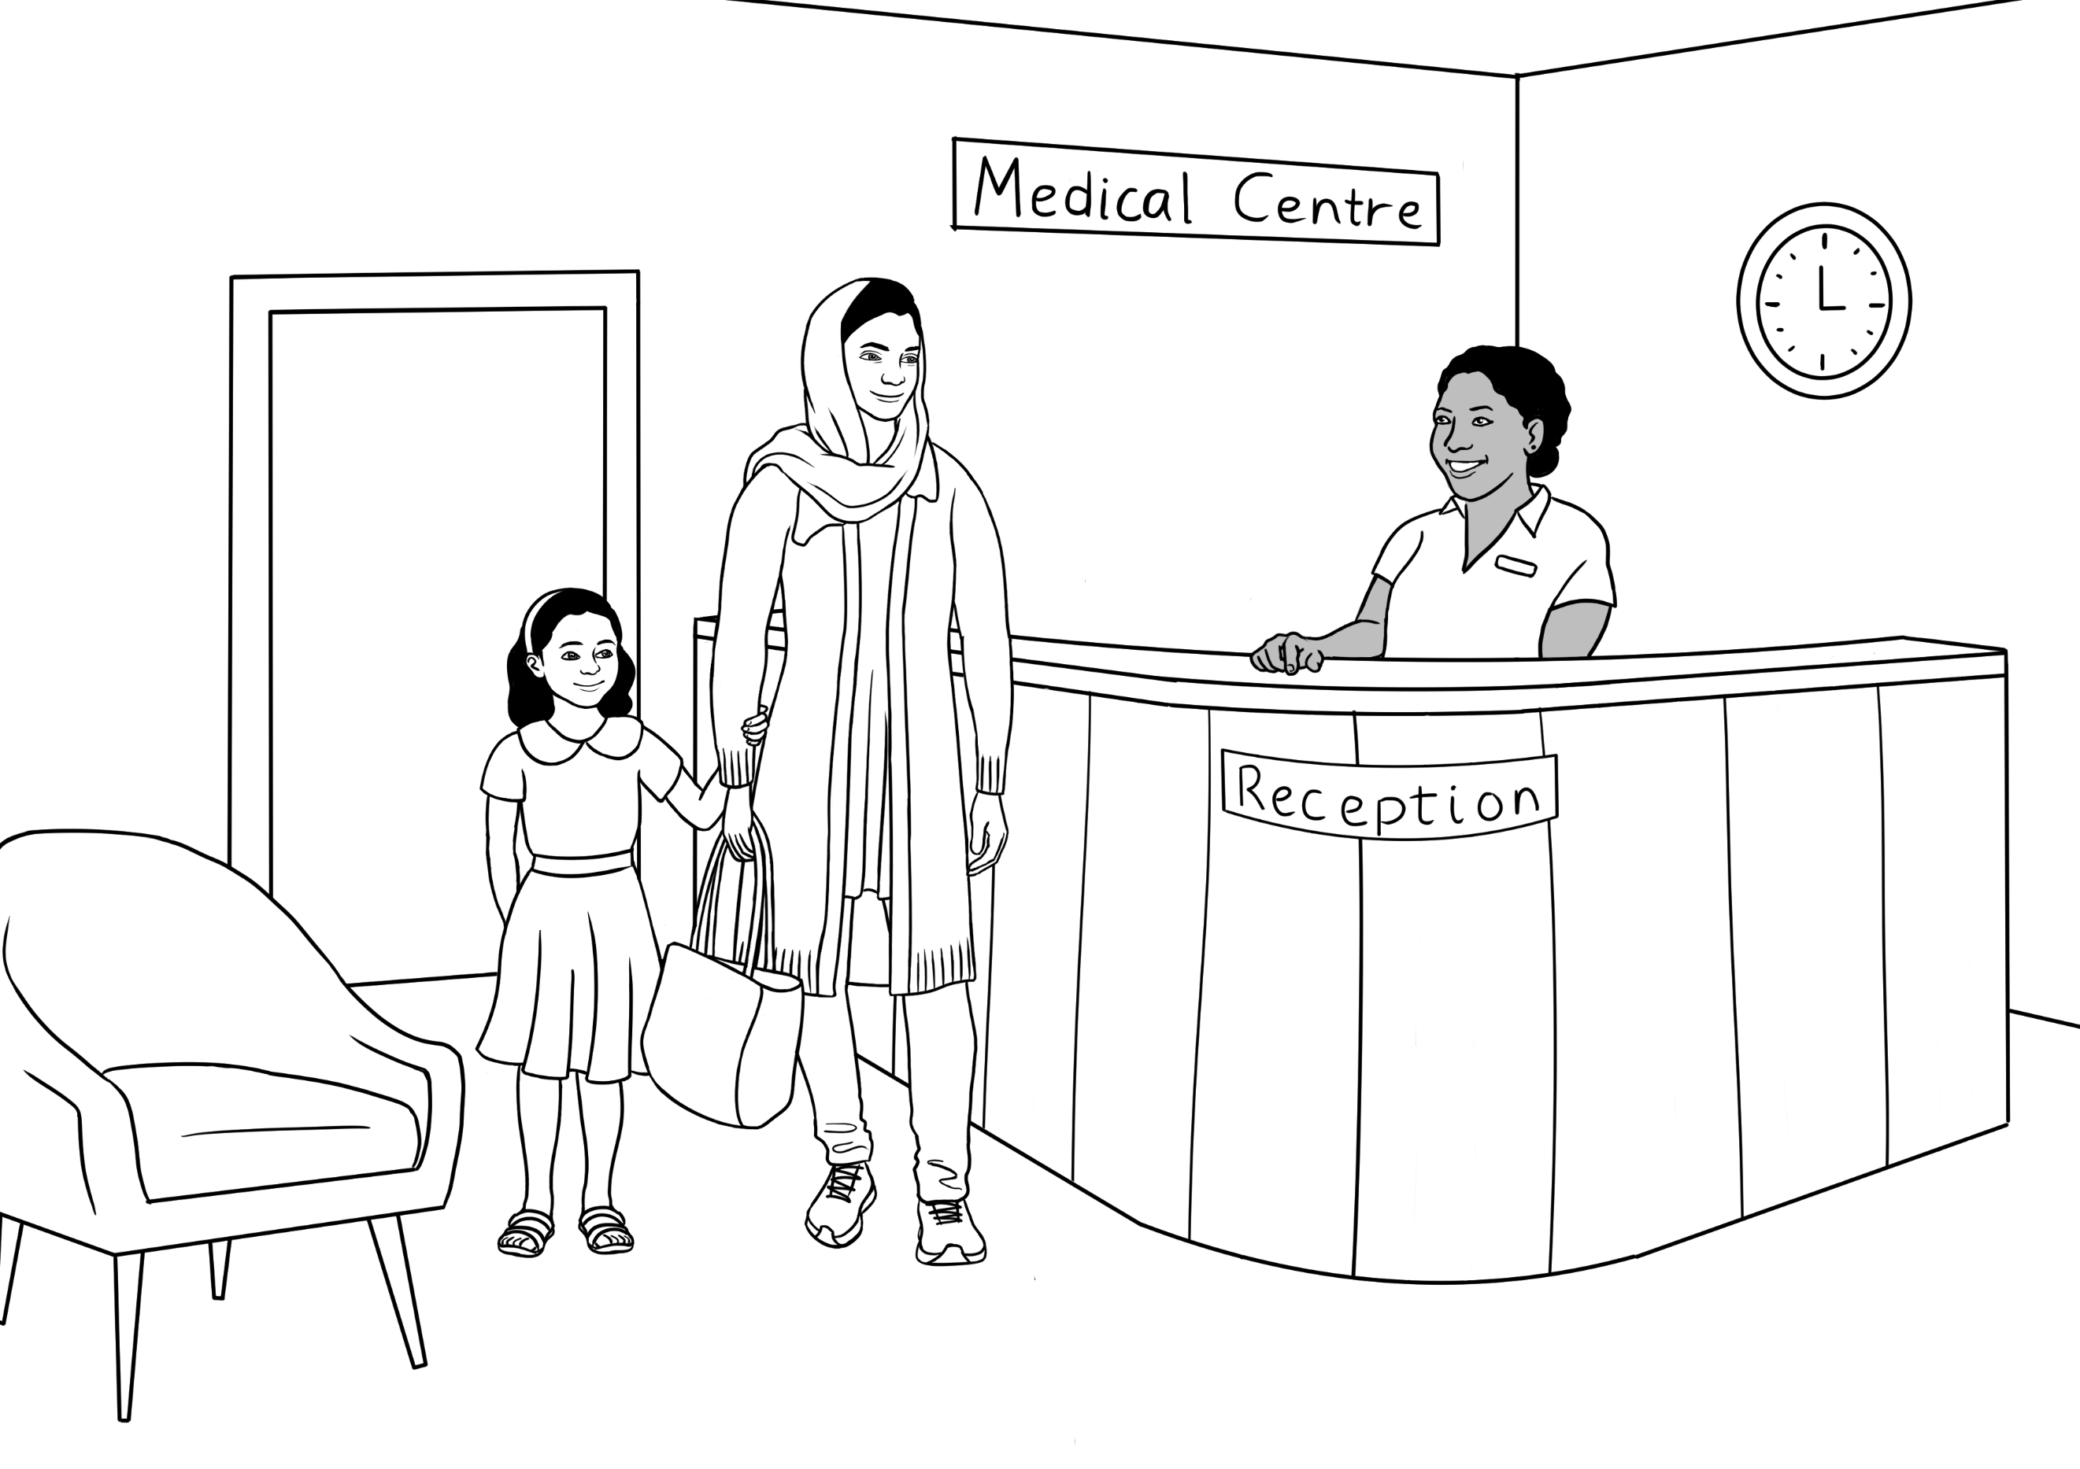
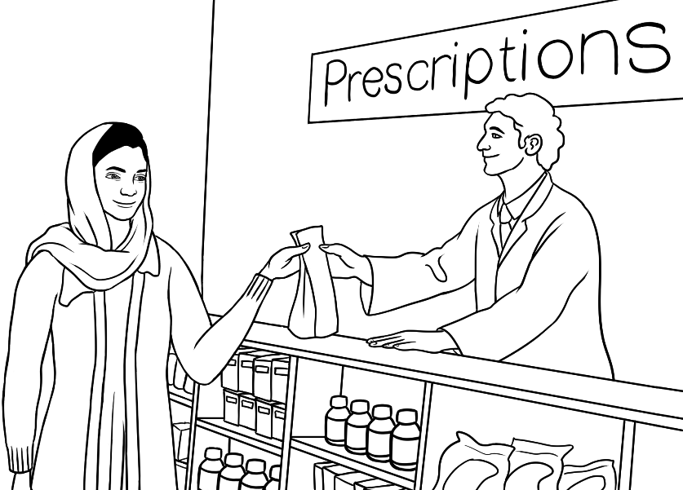 | 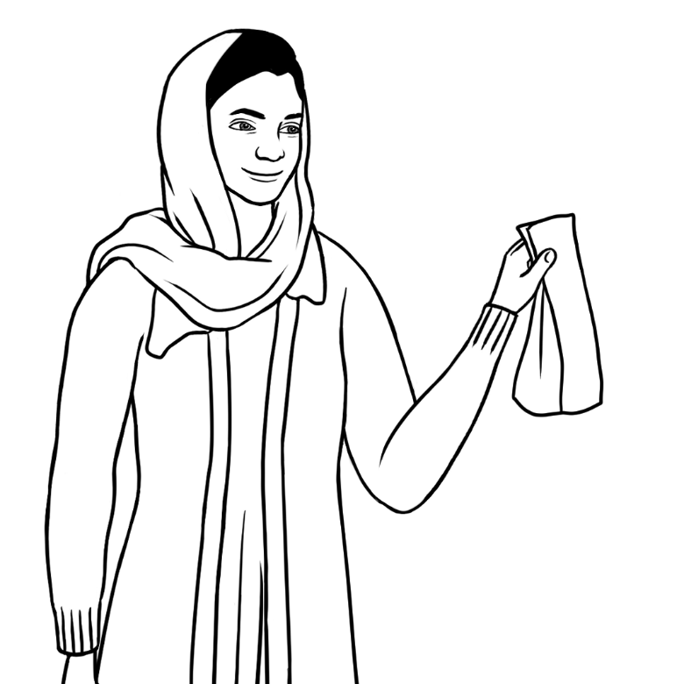

Jomeh – Parwana’s husband
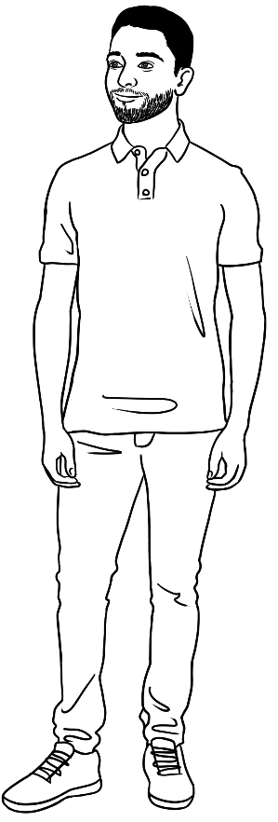

Bibi – Parwana and Jomeh’s daughter
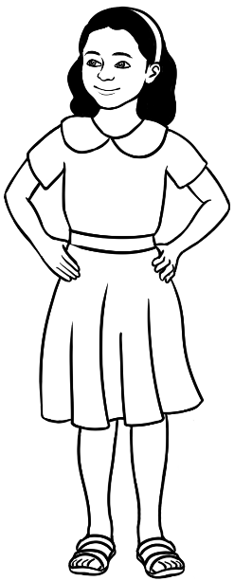 | 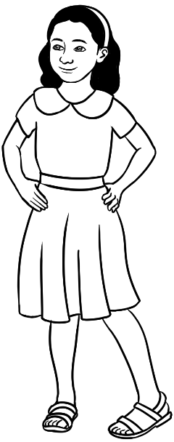 | 
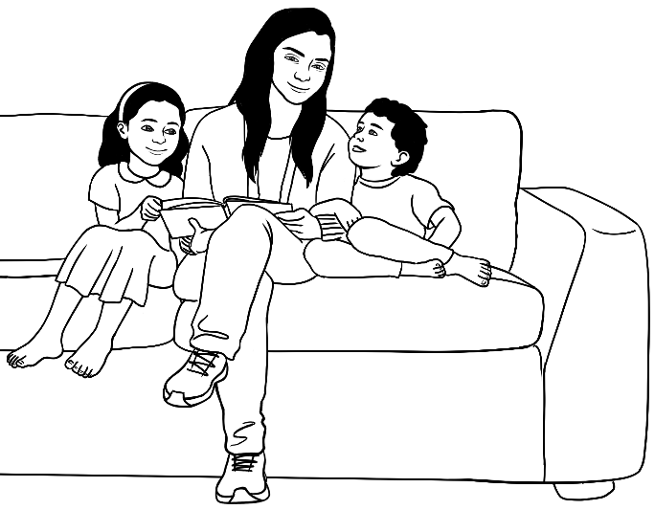 |  |  | 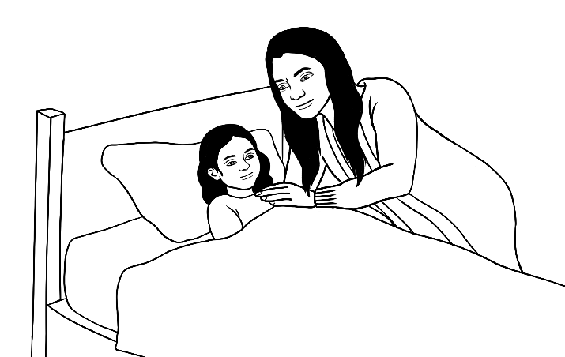
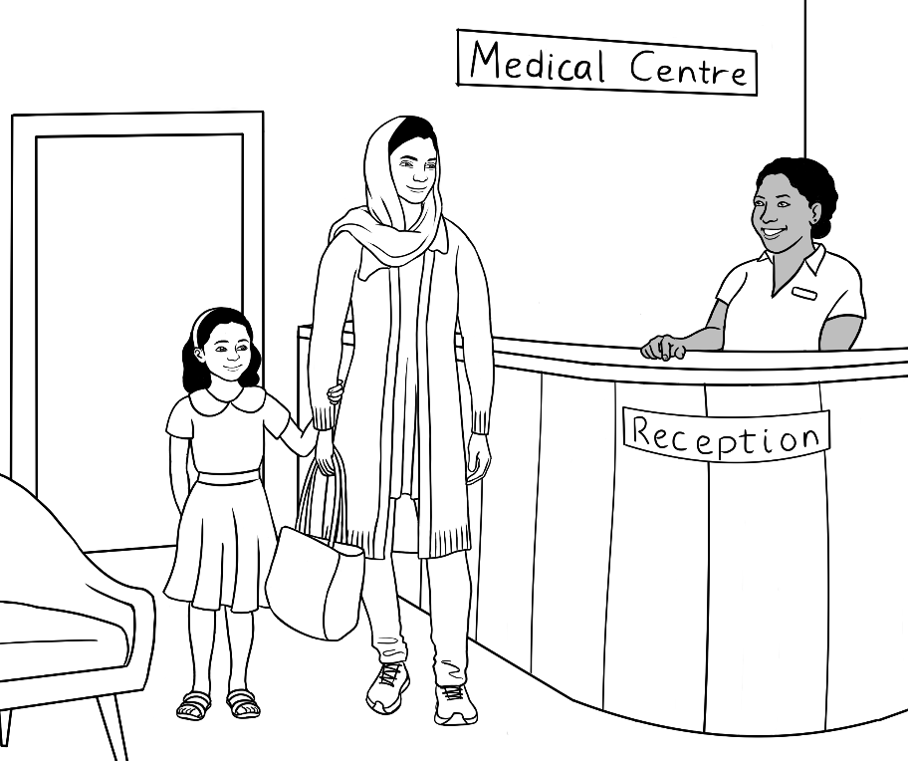

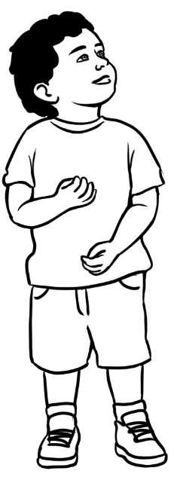 | 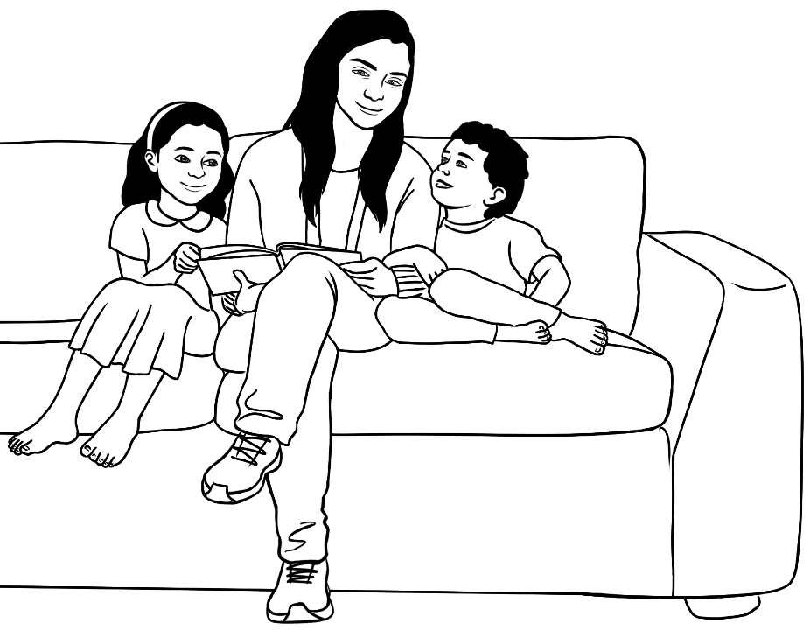
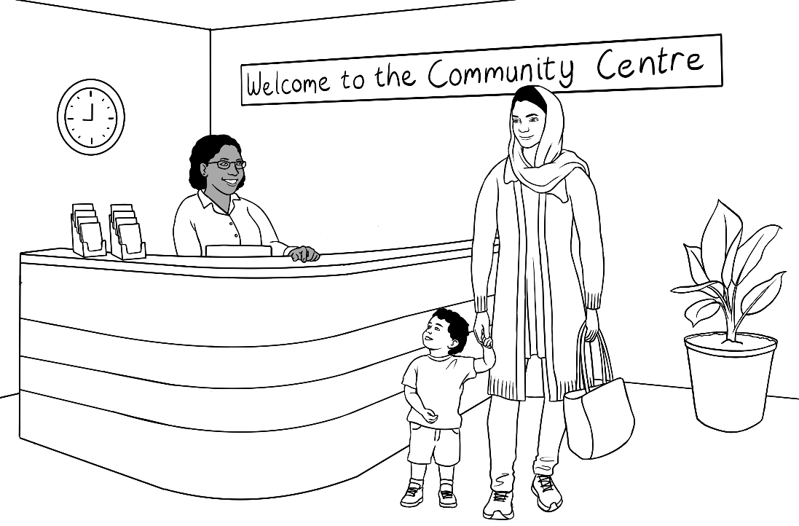 |  | 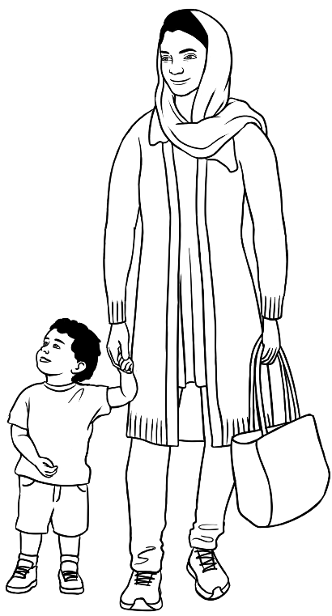

Mustafa – Parwana and Jomeh’s son

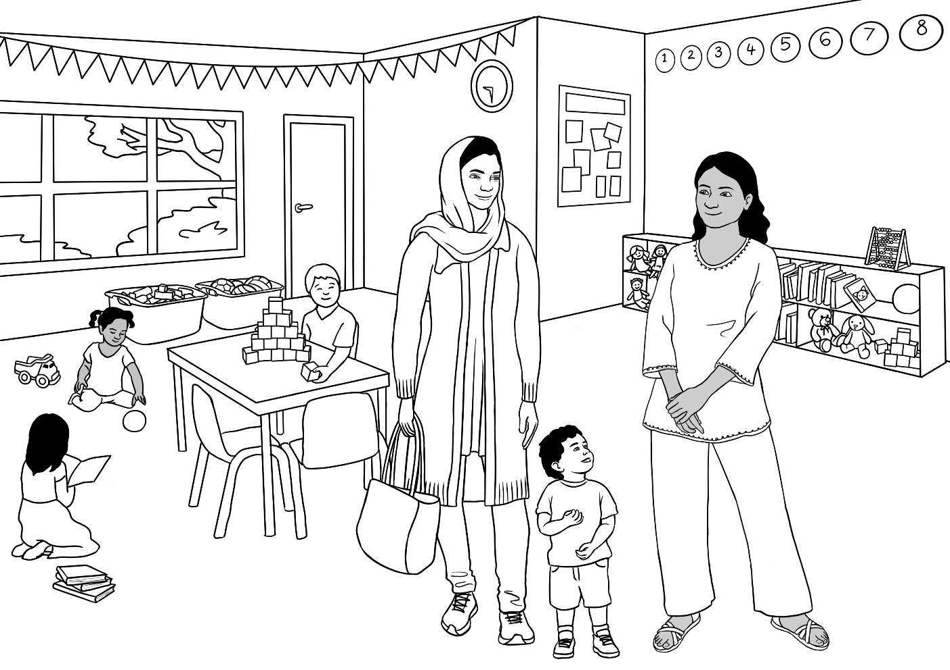
Nisha
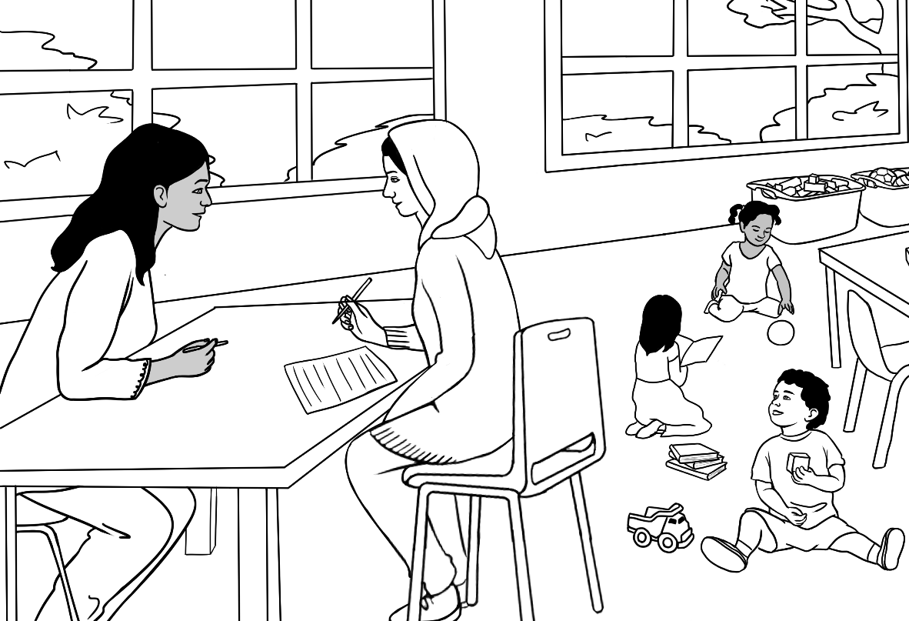
Nisha

Rahim – Amina and Nabi’s son, Parwana’s brother
Rahim is a student in the Course in Initial EAL books. He wants to be
a house painter.
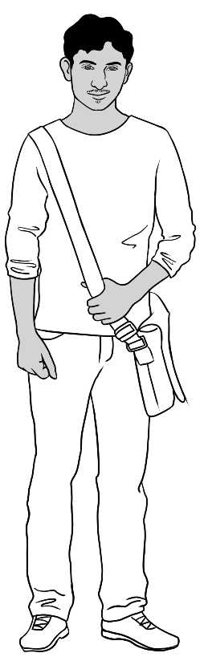 | 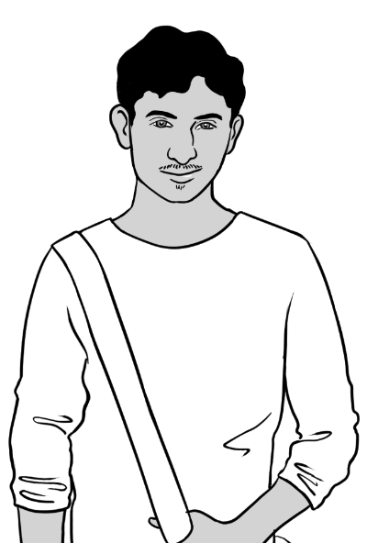 | 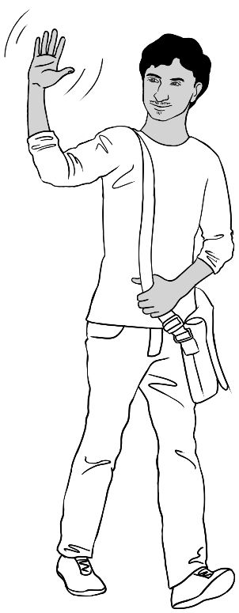
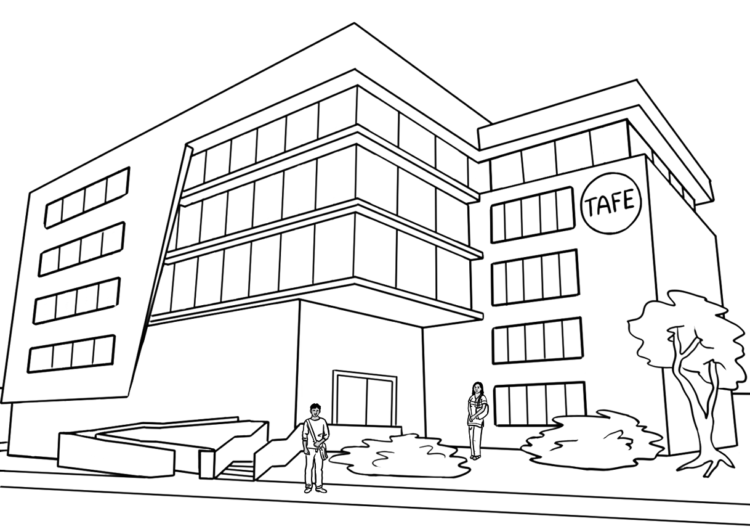
San
Rahim

Rahim
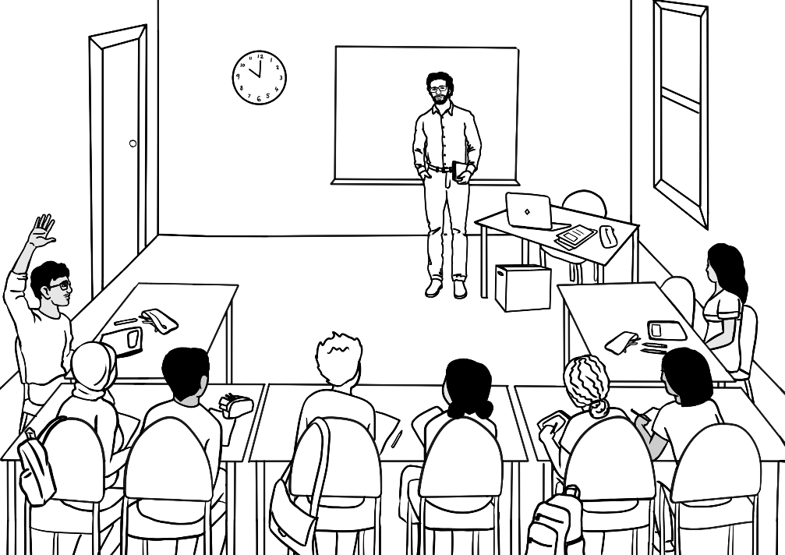
San
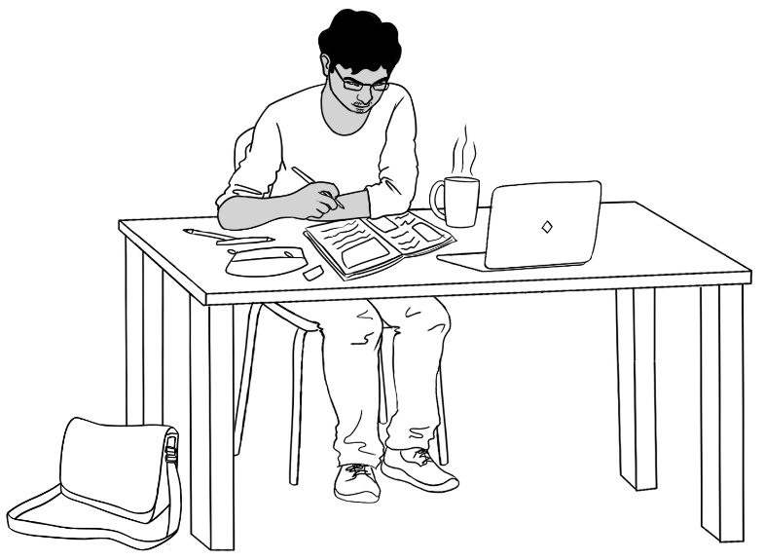 | 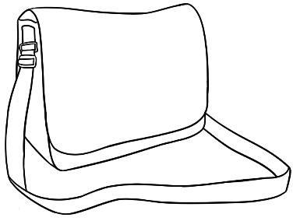

Family 5 – Jamila, Anika

Jamila’s family comes from Ethiopia.

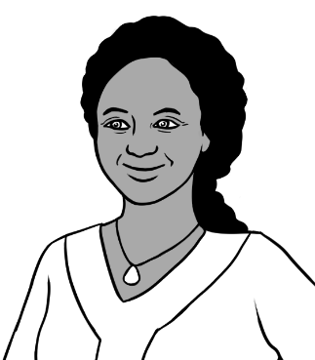
Jamila
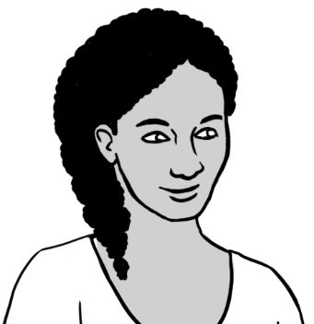
Anika
Jamila’s daughter

Jamila
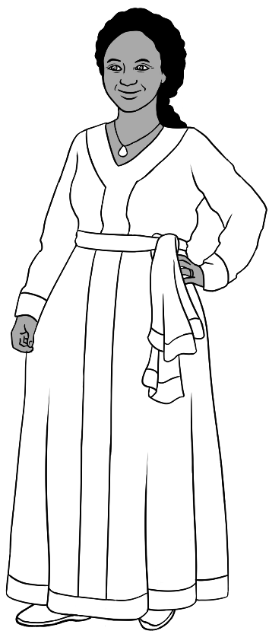 | 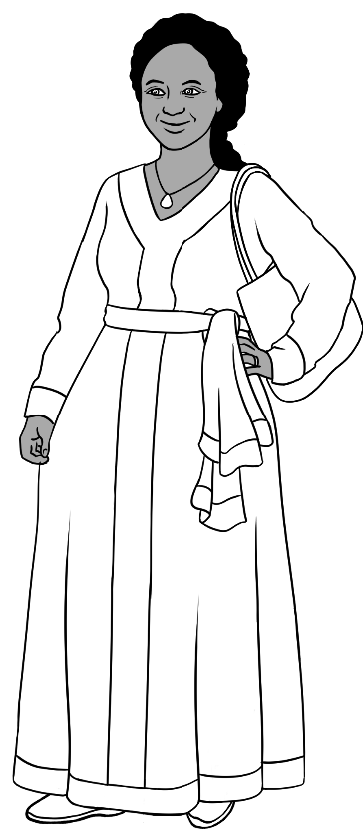
 |  |  | 
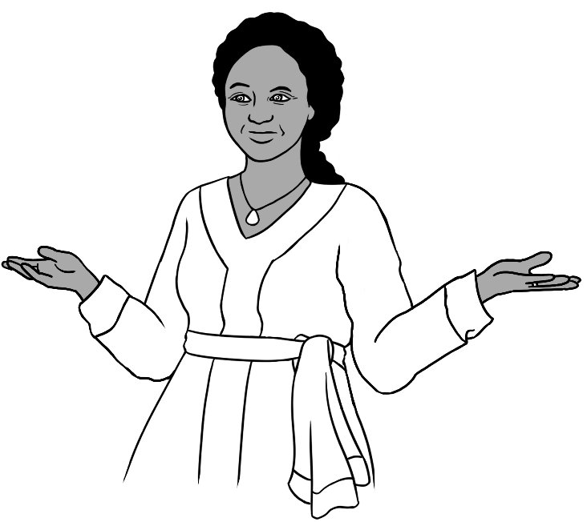 |  | 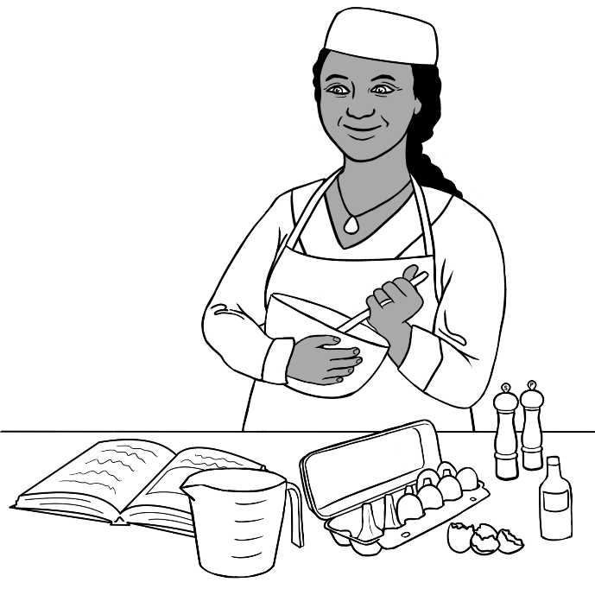
Jamila is a student in the Course in Initial EAL workbooks.
She wants to be a cook.

Zarni
Librarian
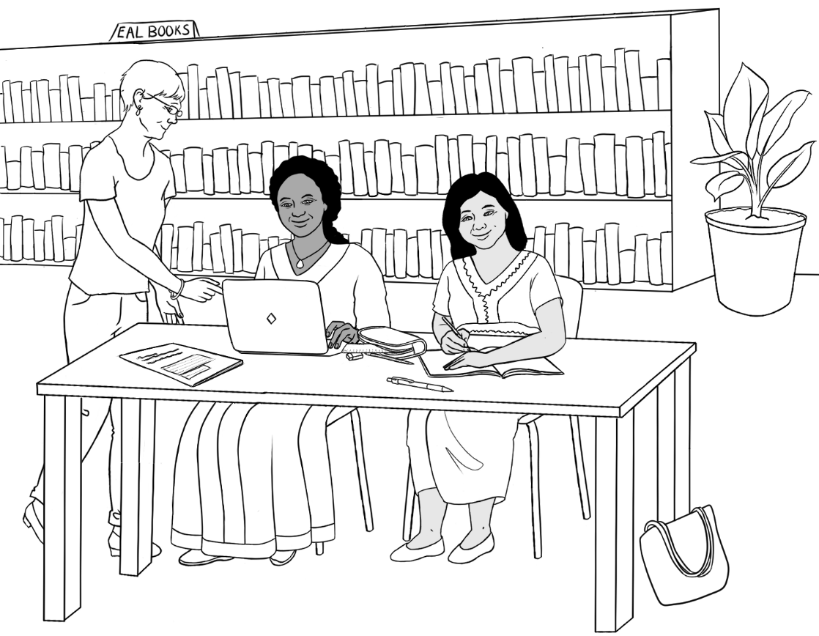
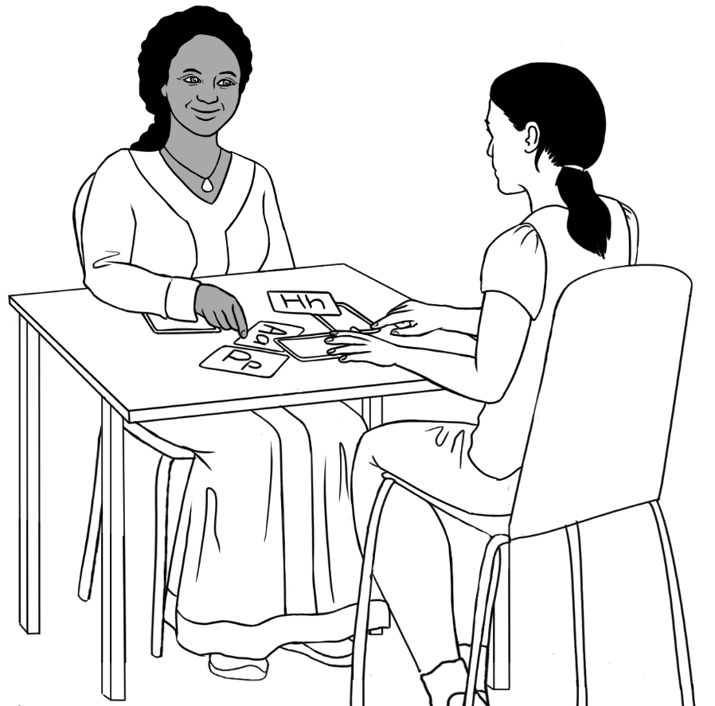
Jamila works with an unnamed student.

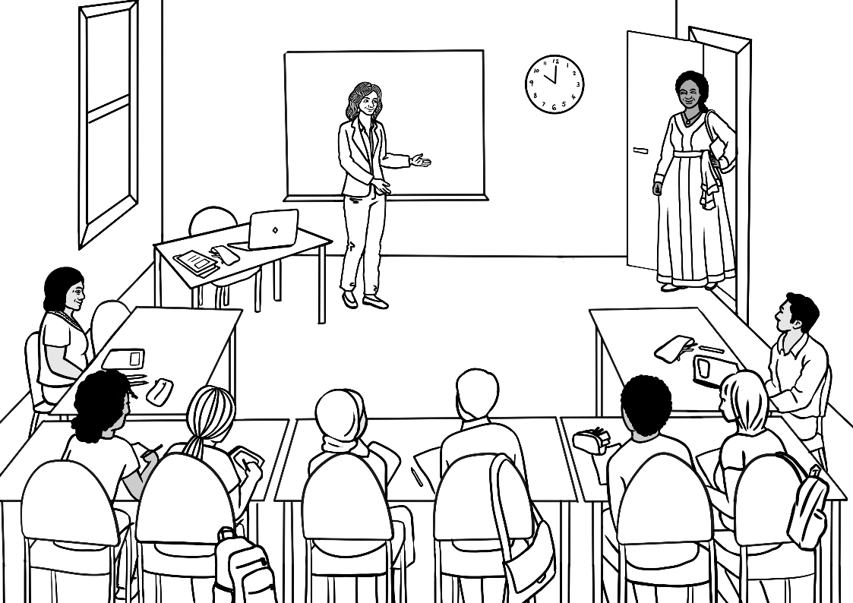
Zarni
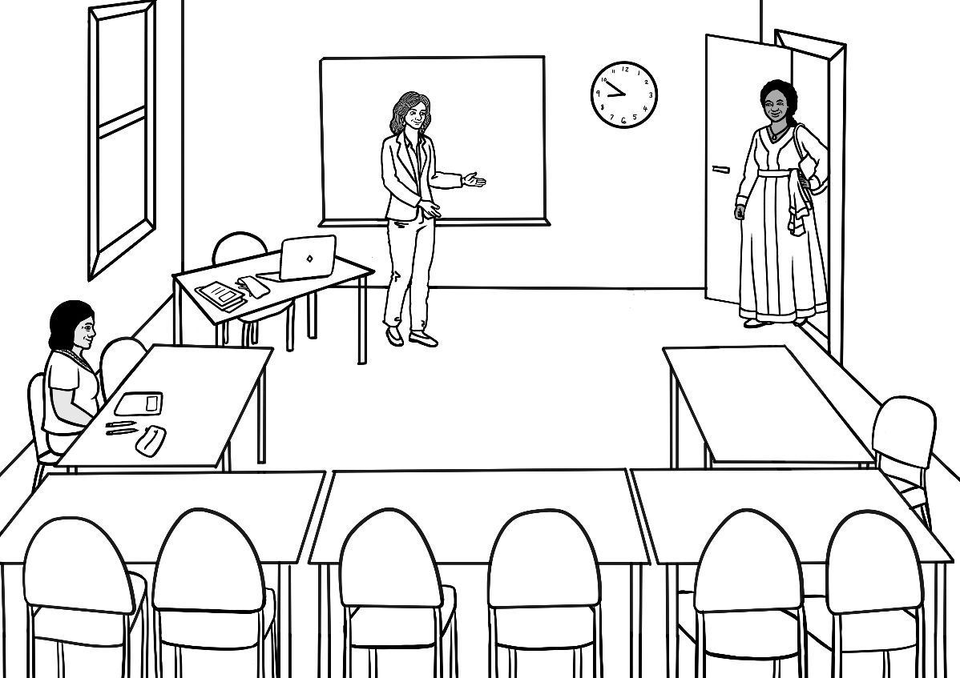

Anika – Jamila’s daughter
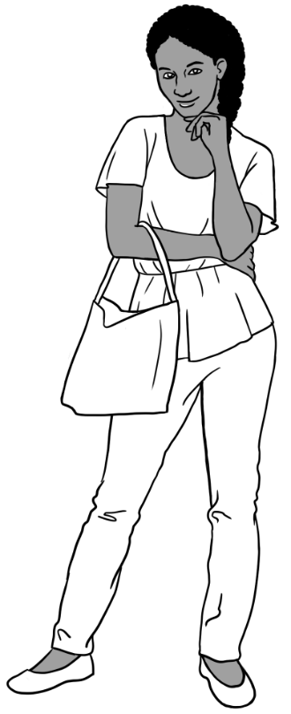 | 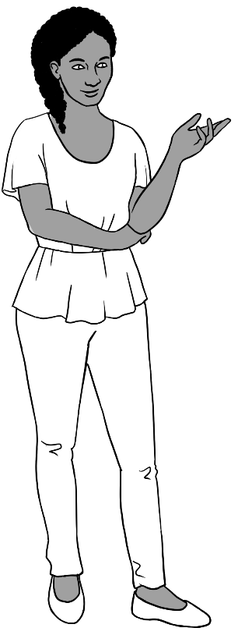
 |  | 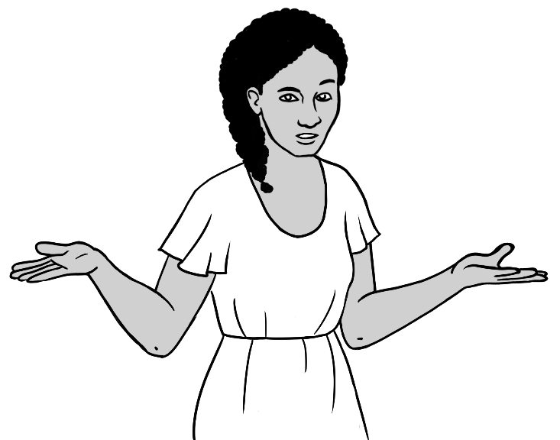
Anika is a student in the Course in EAL books.

Family 6 – Ahmad, Carim, Fatima

Ahmad’s family comes from Syria.

  Ahmad | 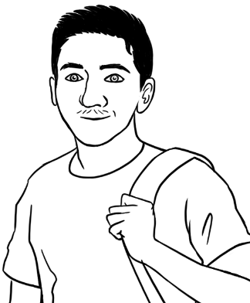  Carim  Ahmad’s younger brother | 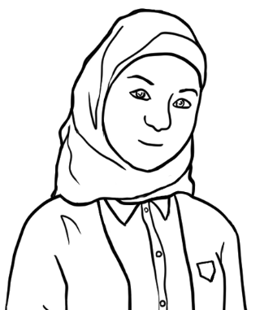  Fatima  Ahmad’s younger sister

Ahmad
 |  |  | 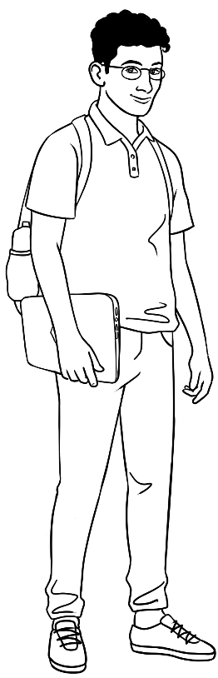
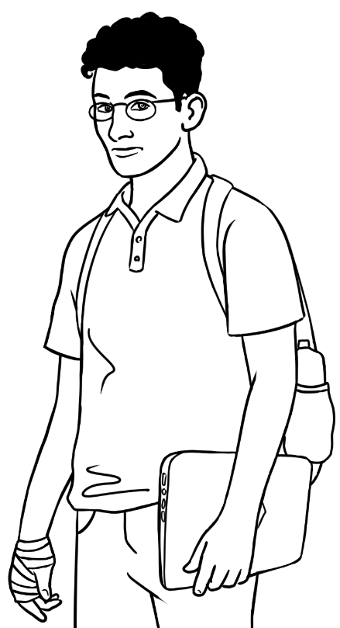 |  | 
 |  | 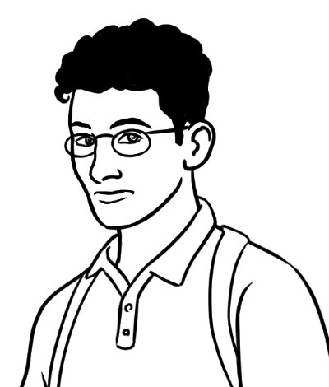
Ahmad is a student in the Certificate 1 in EAL workbooks. He works part-time as a delivery driver and wants to be an electrician.

Librarian
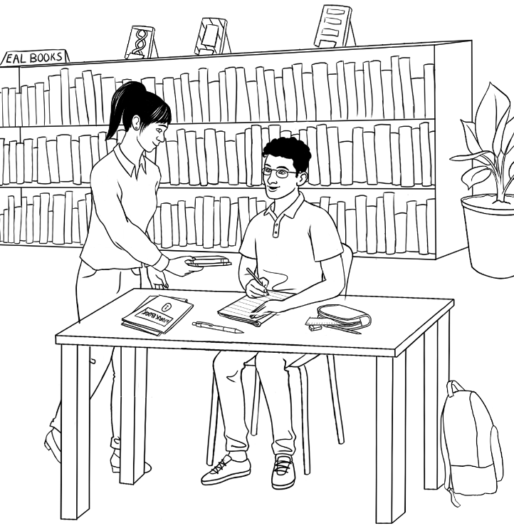 |  | 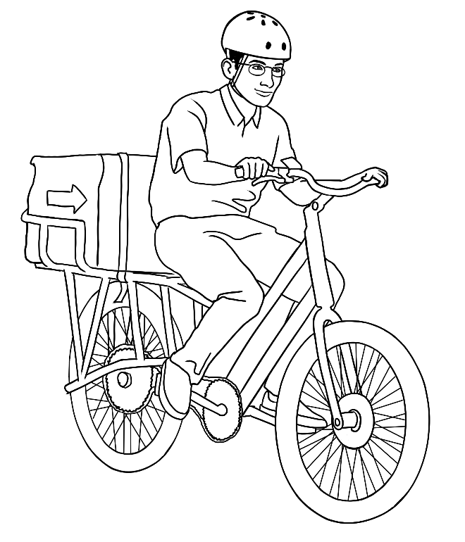
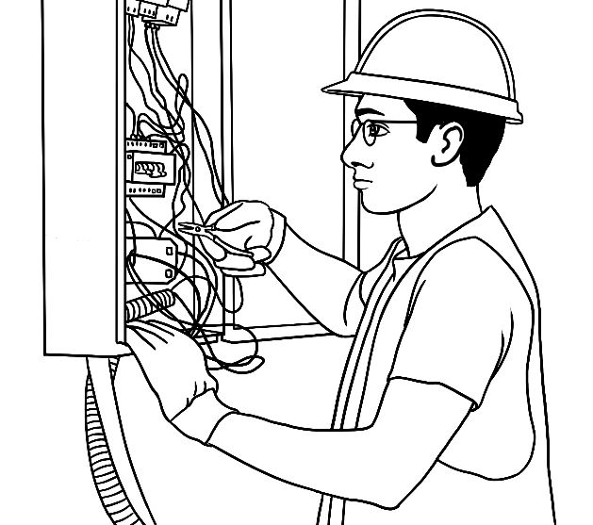 | 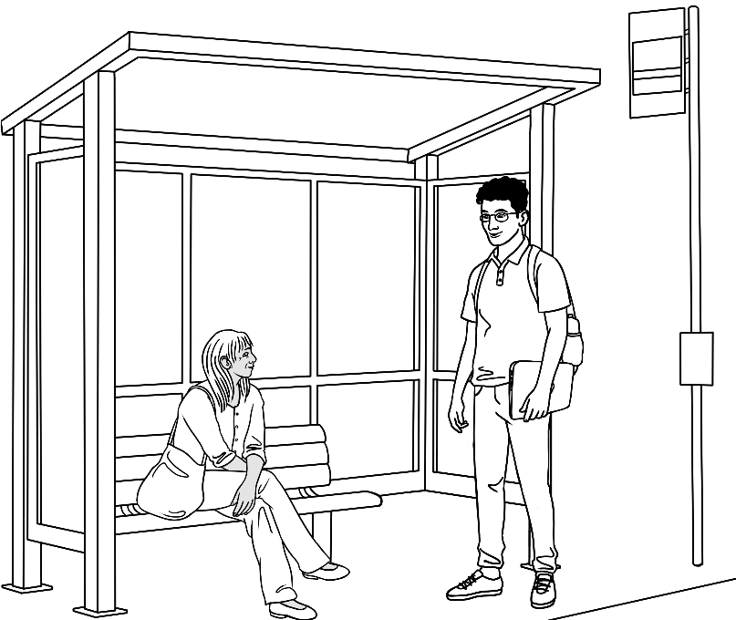  a stranger

Carim – Rahim’s younger brother
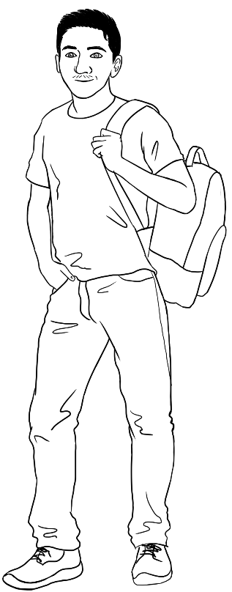 | 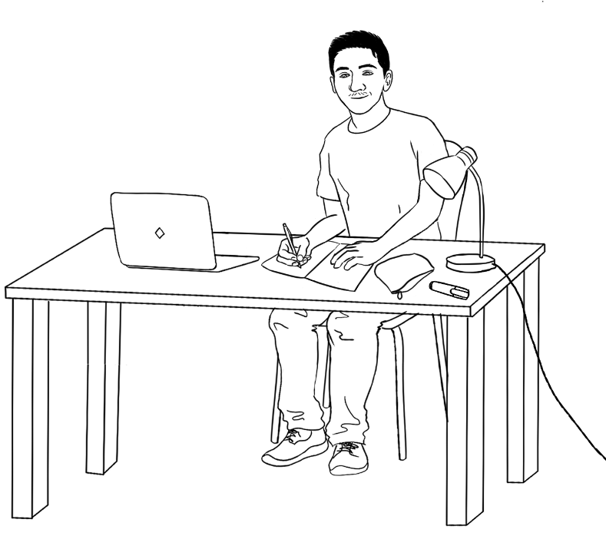
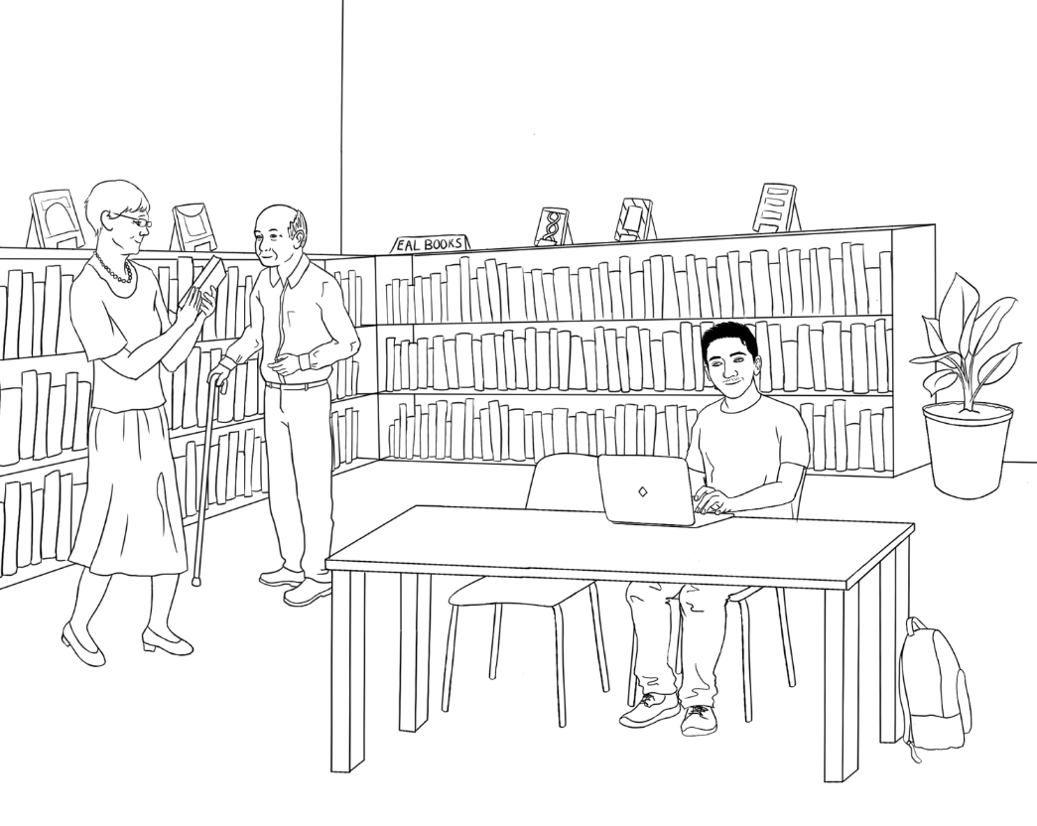  Librarian & Ming |  | 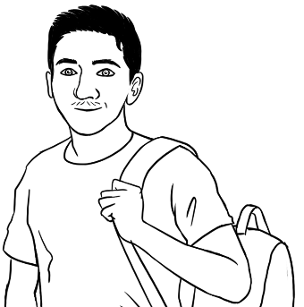
 |  | 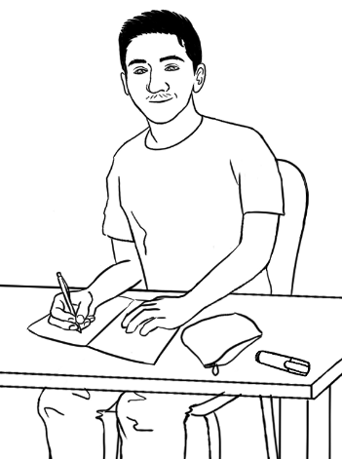
Carim is a student in the Course in Initial EAL workbooks.

Fatima – Rahim and Carim’s younger sister
Mai
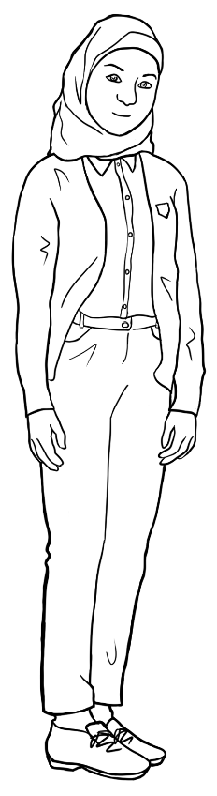 | 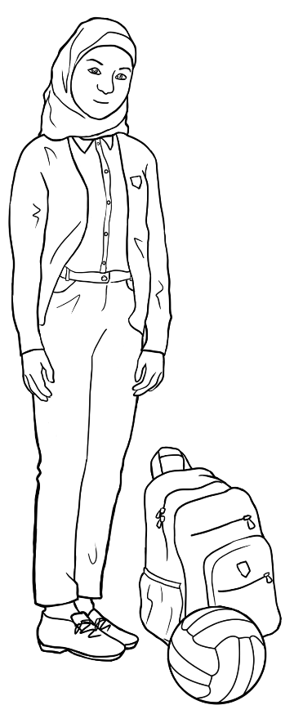 |  | 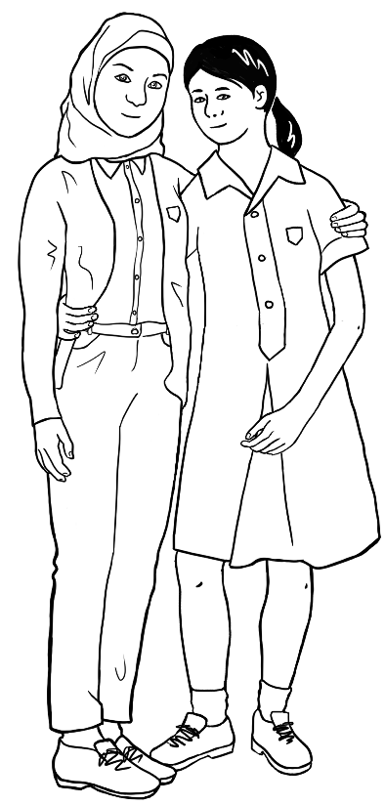
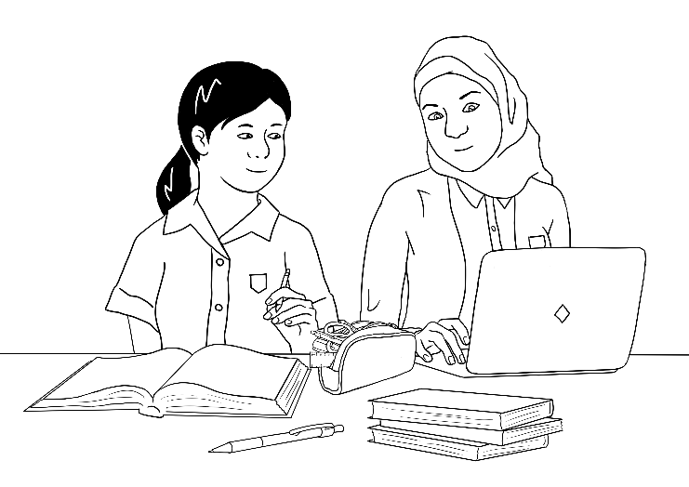 |  | 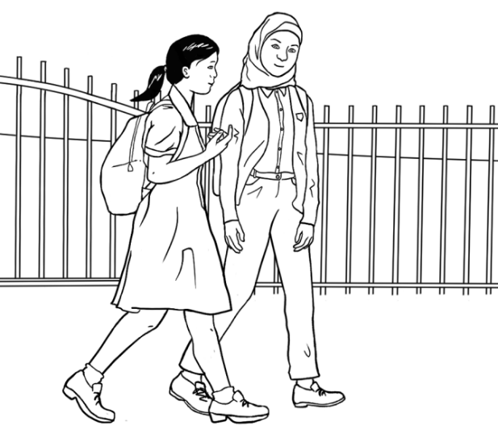
 |  | 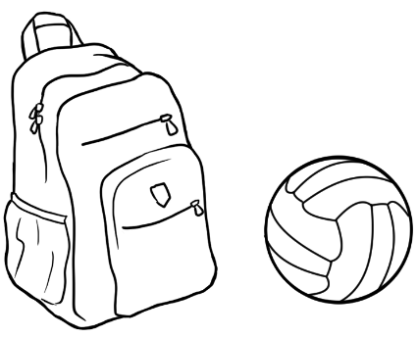
Fatima is a high school student.

Family 7 – Nisha and her children

Nisha’s family comes from India.

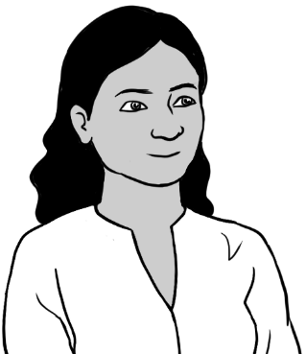
Nisha
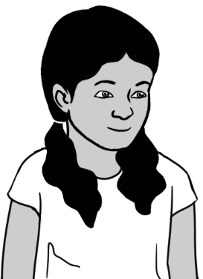  Pari  Nisha’s daughter |  | 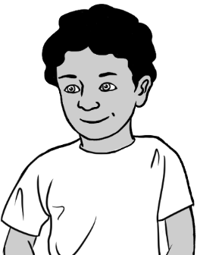  Dev  Nisha’s son

Nisha
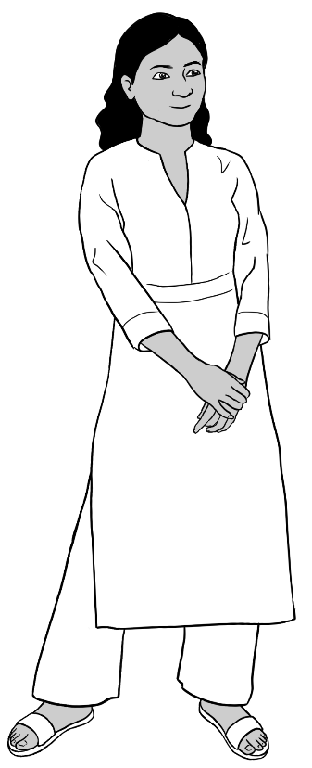 | 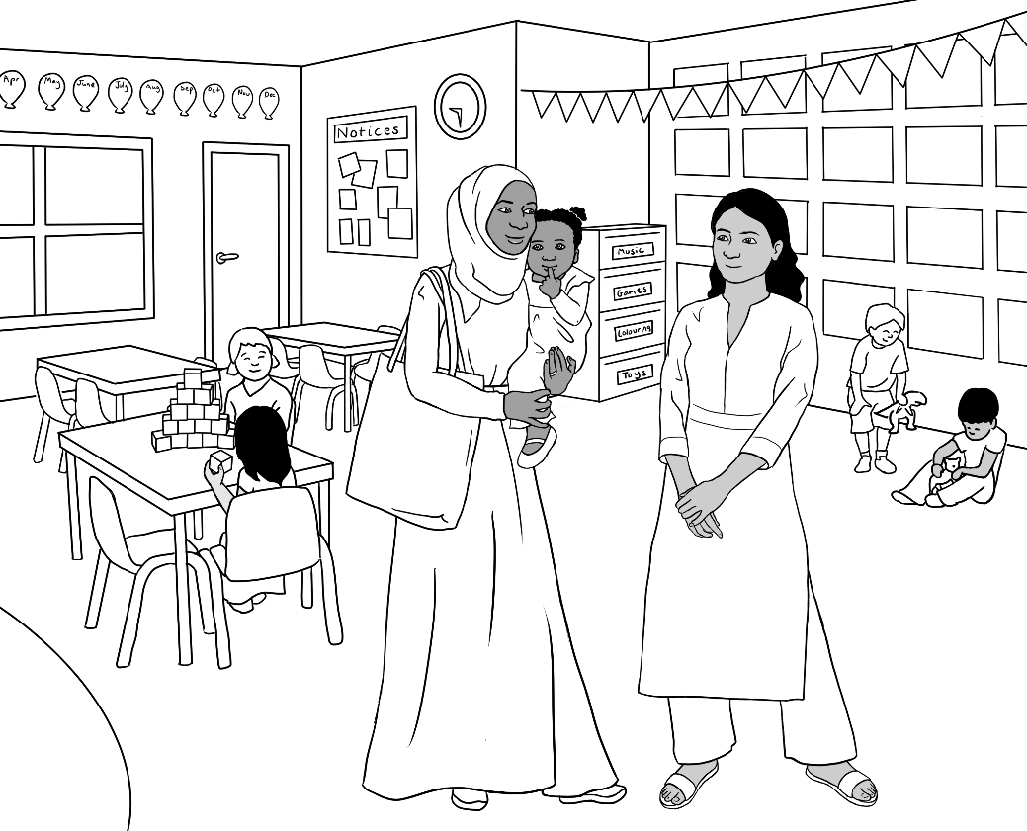
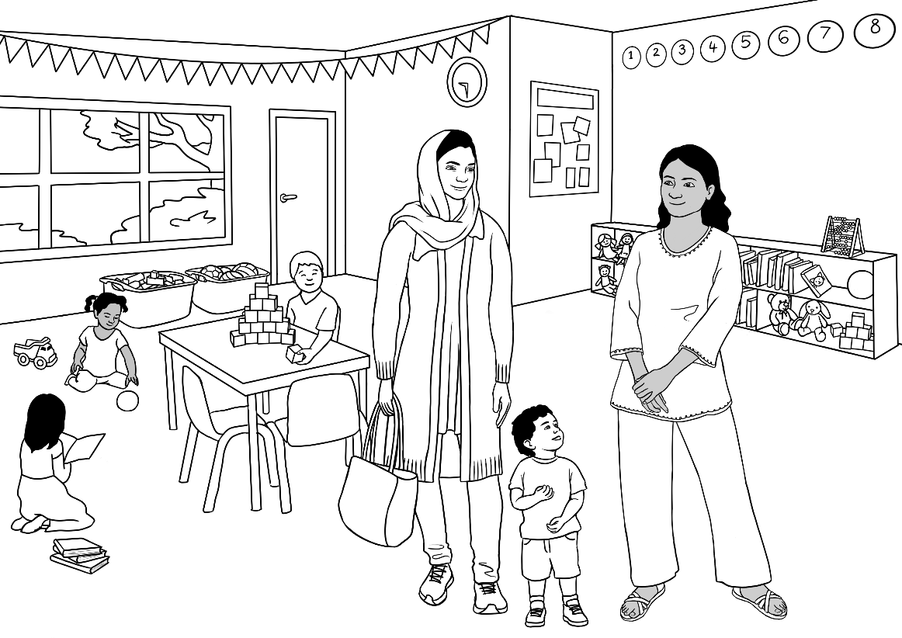  Parwana and Mustafa |  | 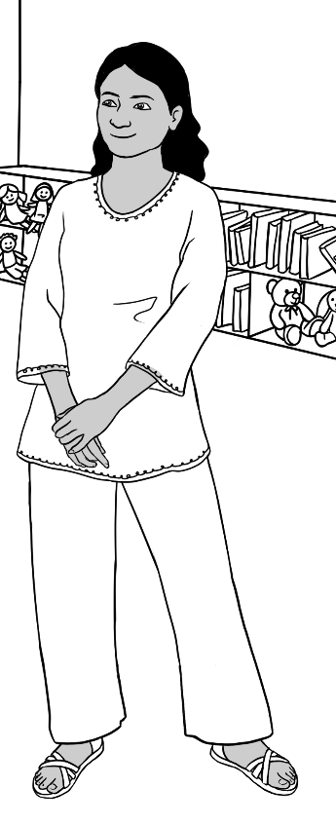
Nisha works in child care.
Sahra and Hani

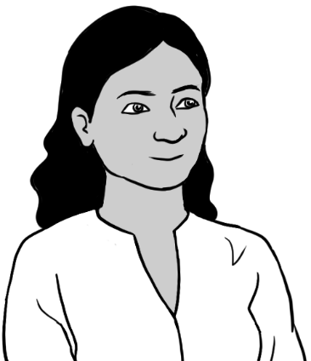 | 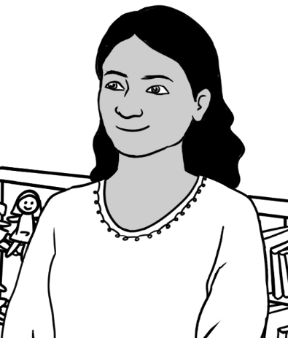
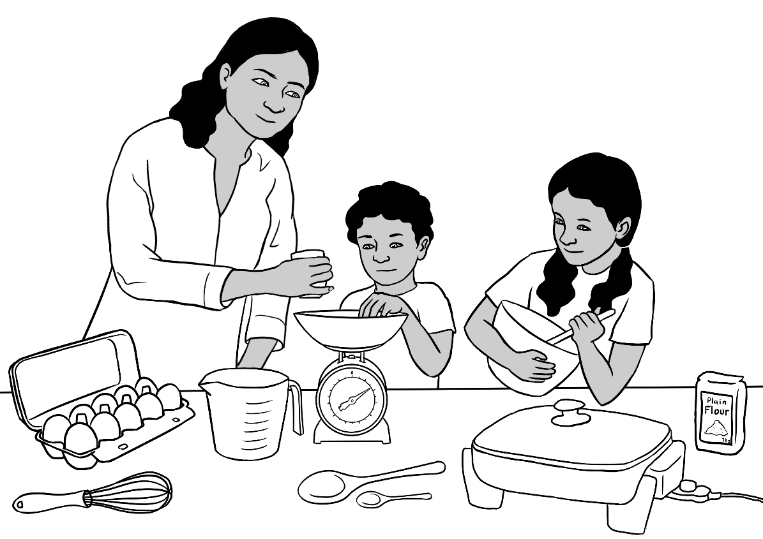
Dev and Pari

Pari and Dev – Nisha’s daughter and son
Pari and Dev are primary school students.
Pari | 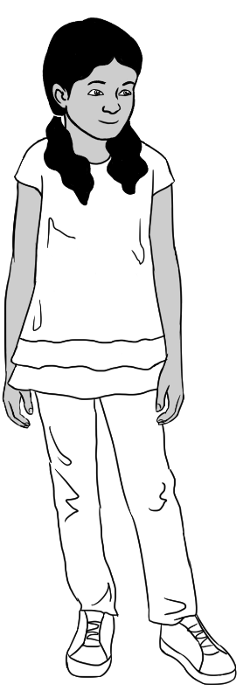 |  | 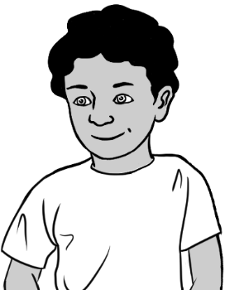  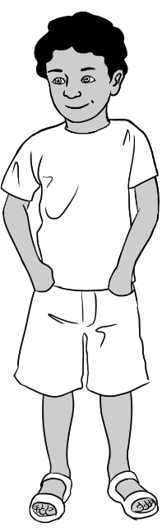  Dev
 |  | 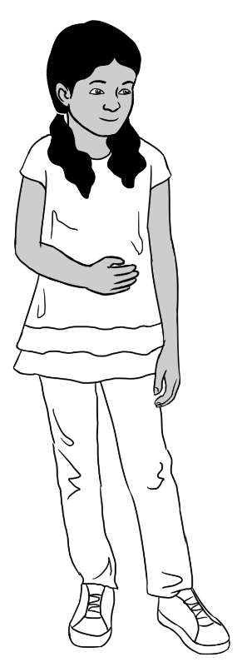
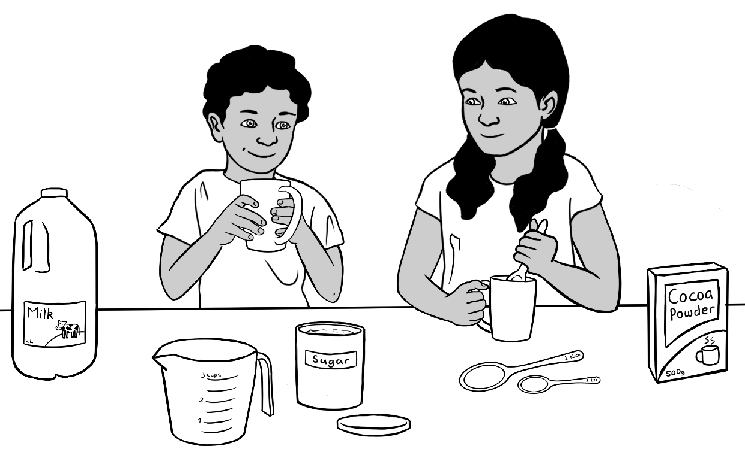

Linh and Basam

Linh
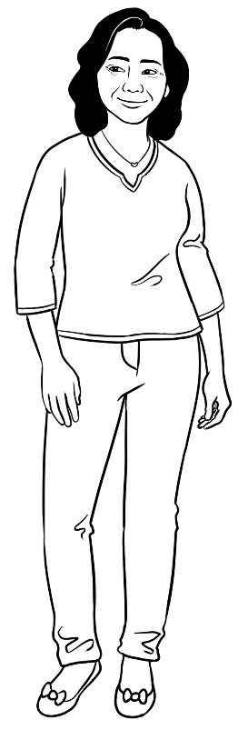 | 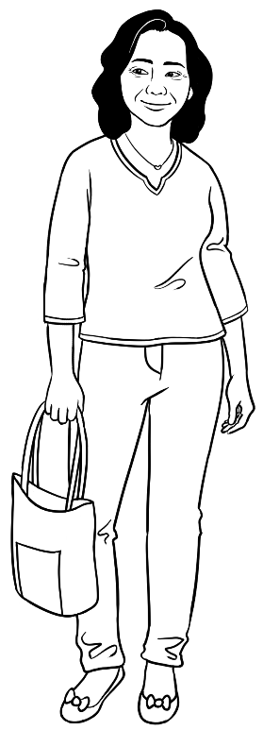 | 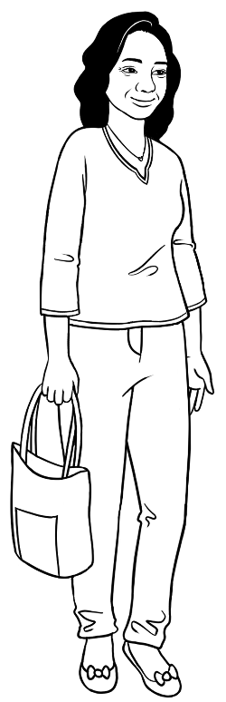
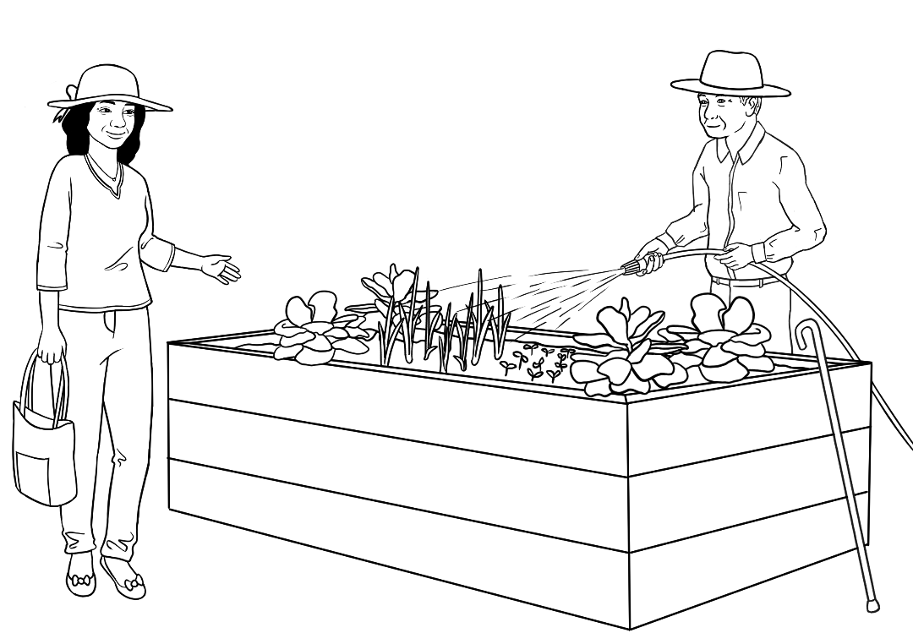  Ming |  |  | 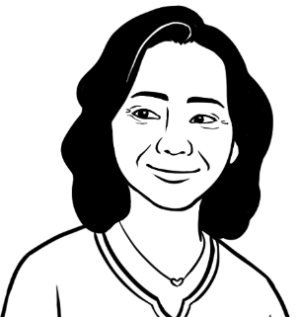
 |  |  | 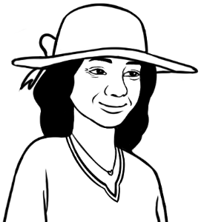
Linh comes from Vietnam. She is a Certificate 1 in EAL student.

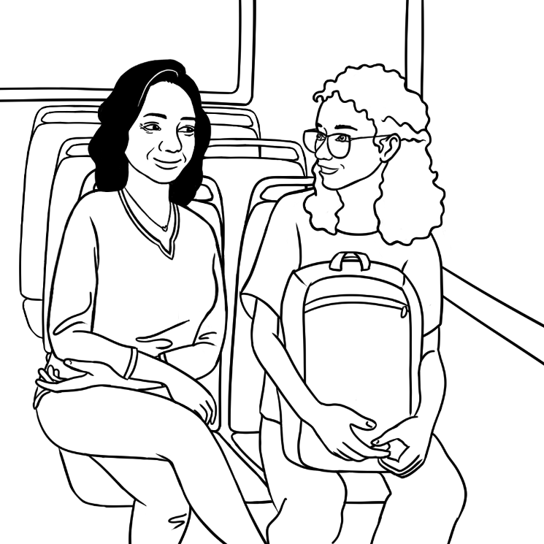  Linh with an unnamed student or a stranger. |  | 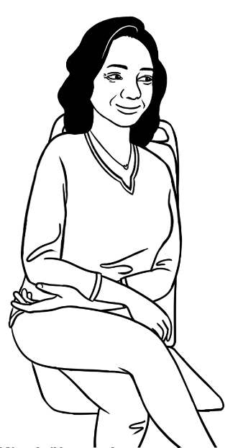
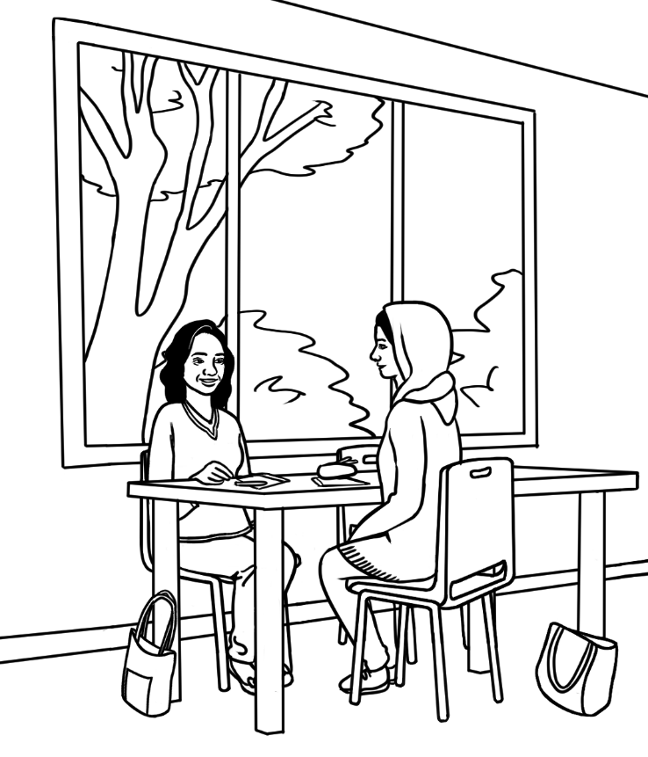  Parwana | 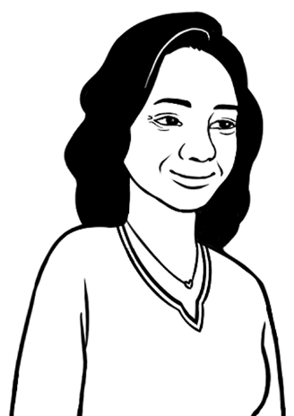
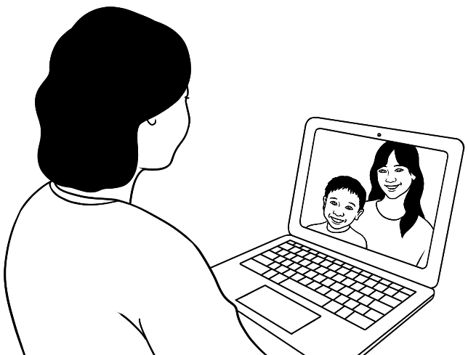
Linh talks to friends or family in Vietnam.

Basam
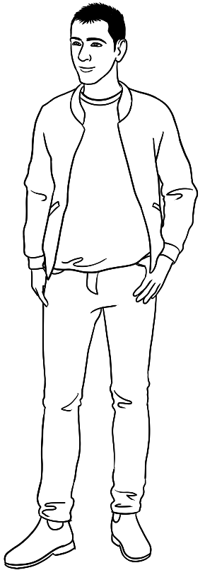 | 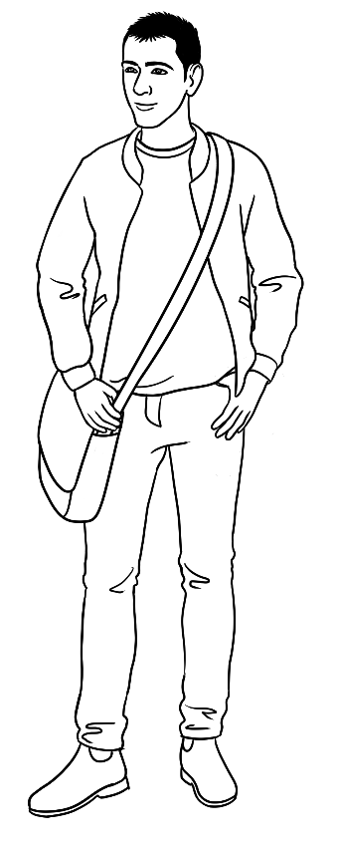 | 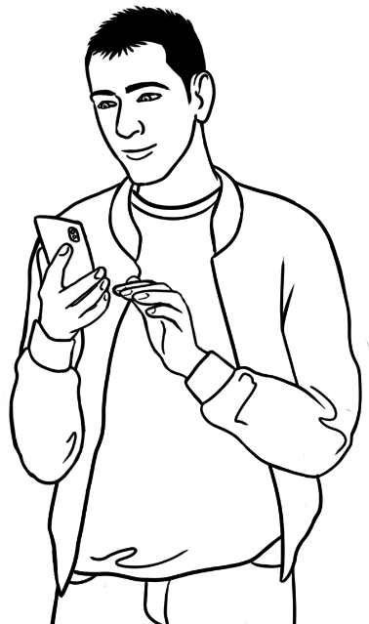
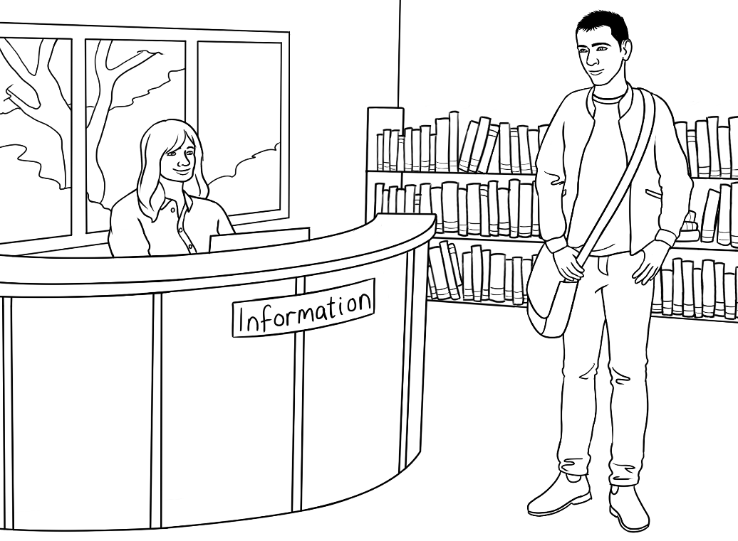 |  |  | 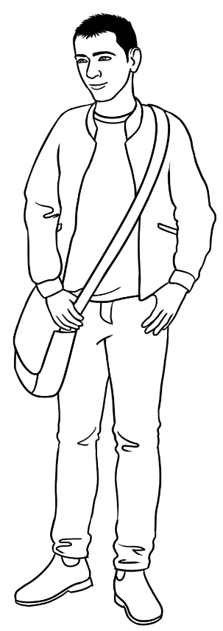
Basam comes from Iraq. He is a student in the Certificate 1 in EAL workbooks.

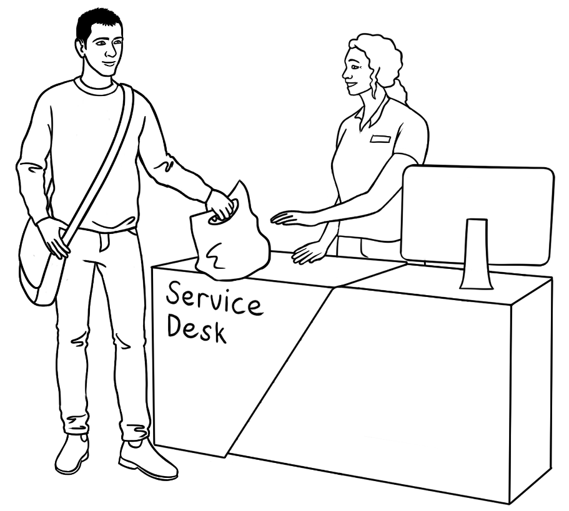 |  | 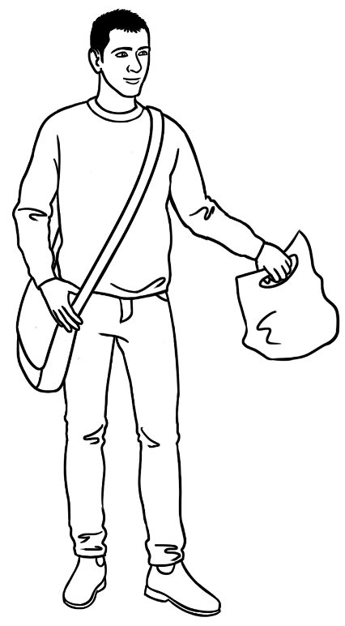
 | 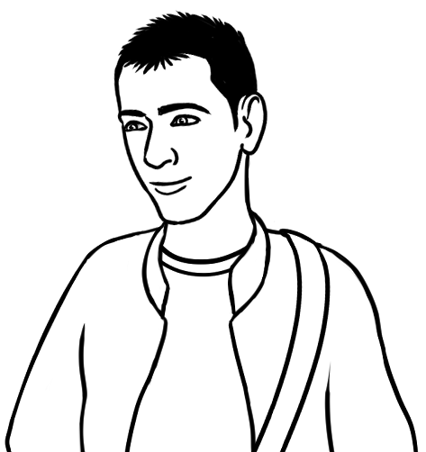

Teachers

Jenny
Jenny is a Course in EAL teacher.
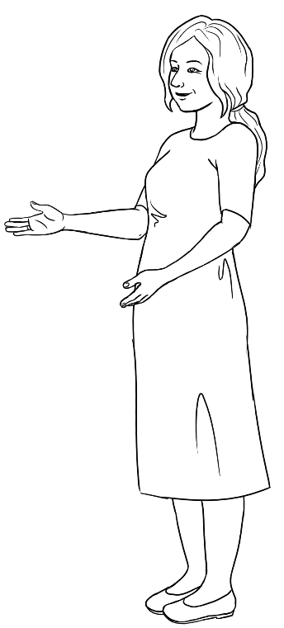 | 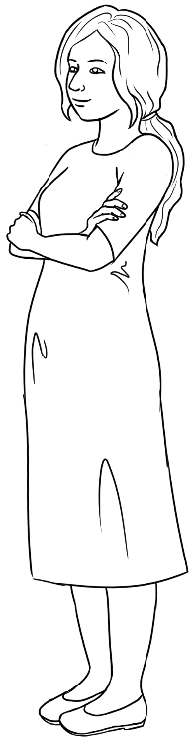 |  | 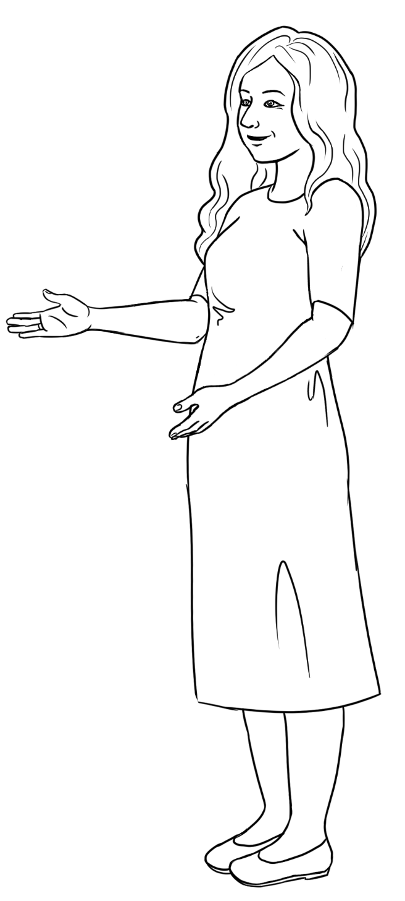
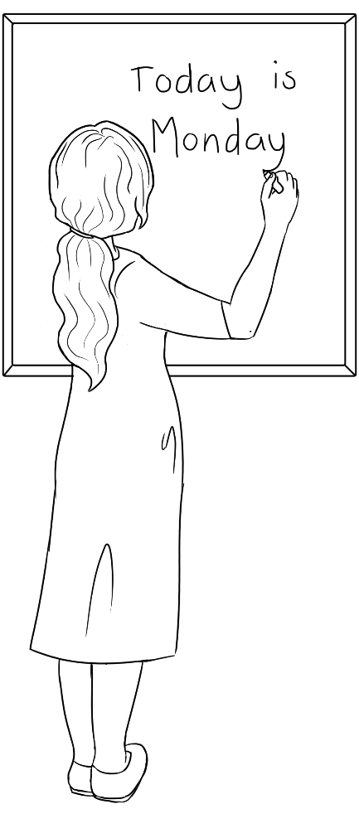 |  | 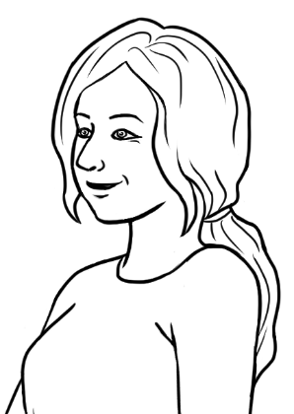
 |  | 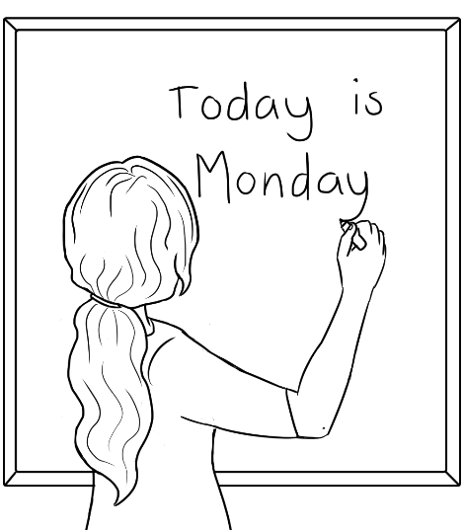

All students are unnamed.
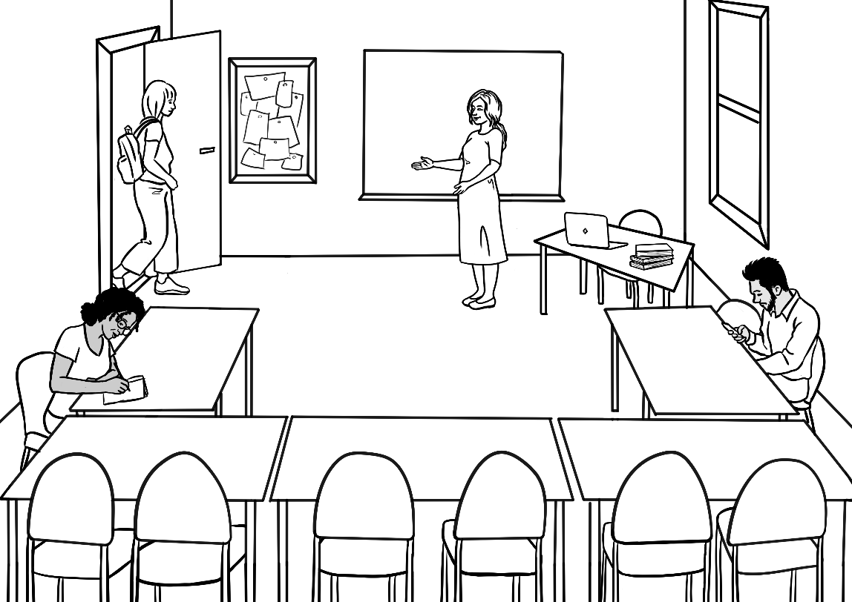
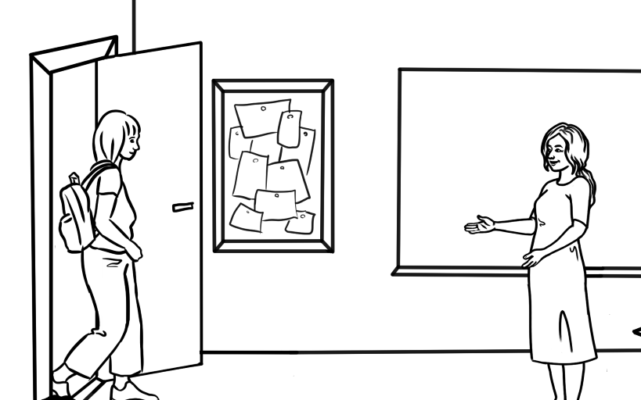

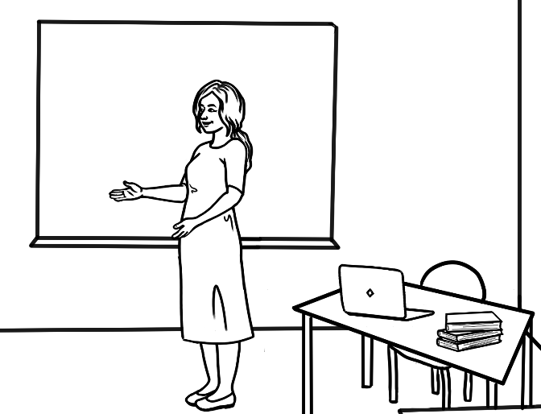

Rosie
Rosie is a Course in Initial EAL teacher.
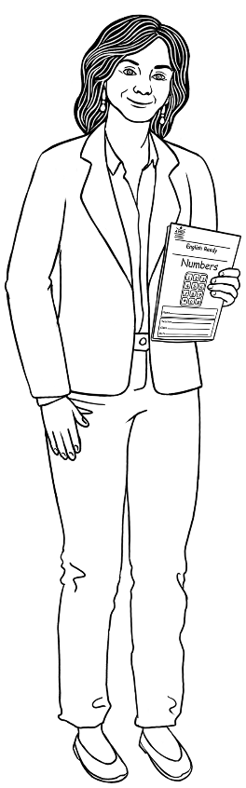 | 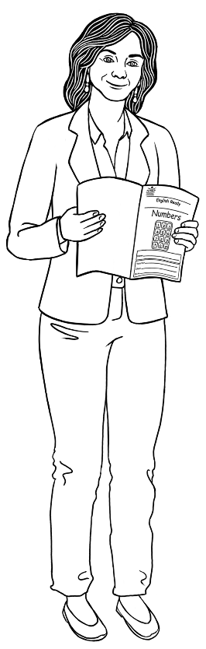 | 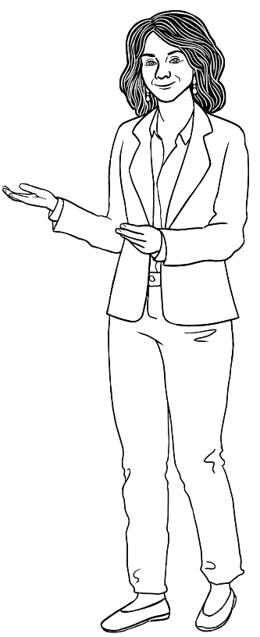
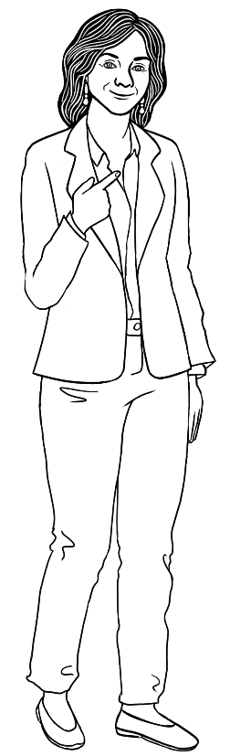 | 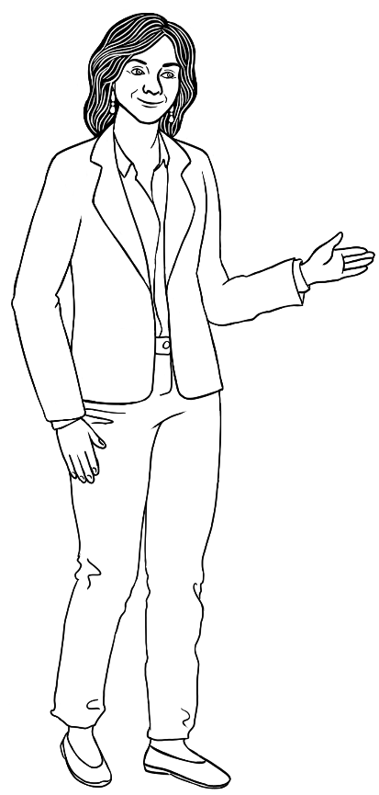 |  | 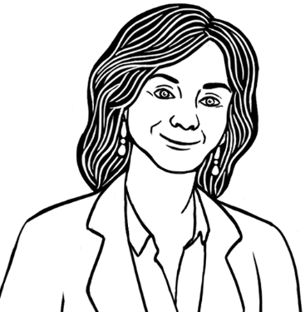
 |  |  | 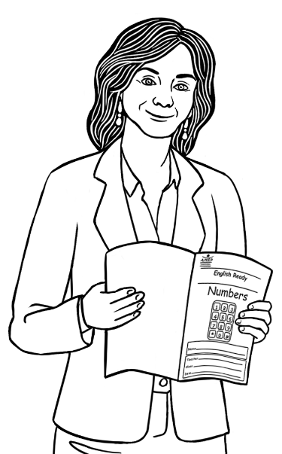

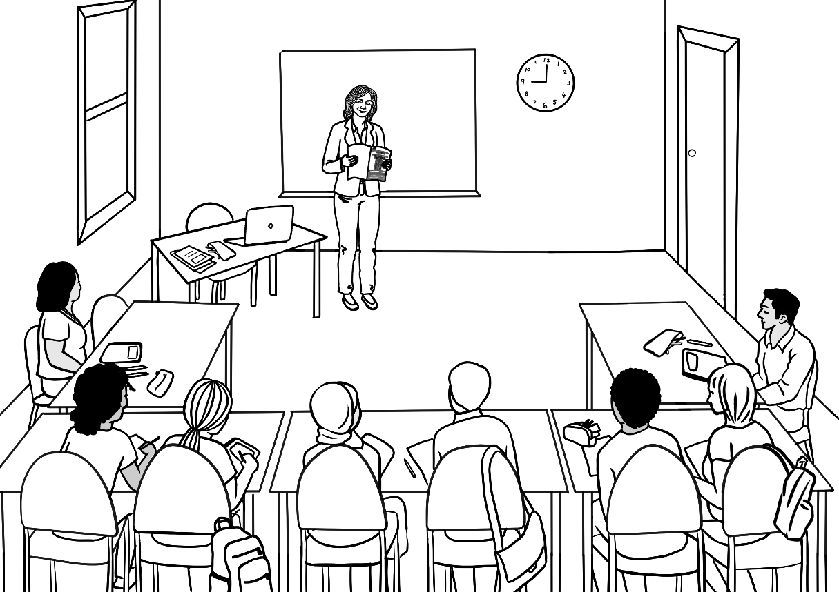
Zarni
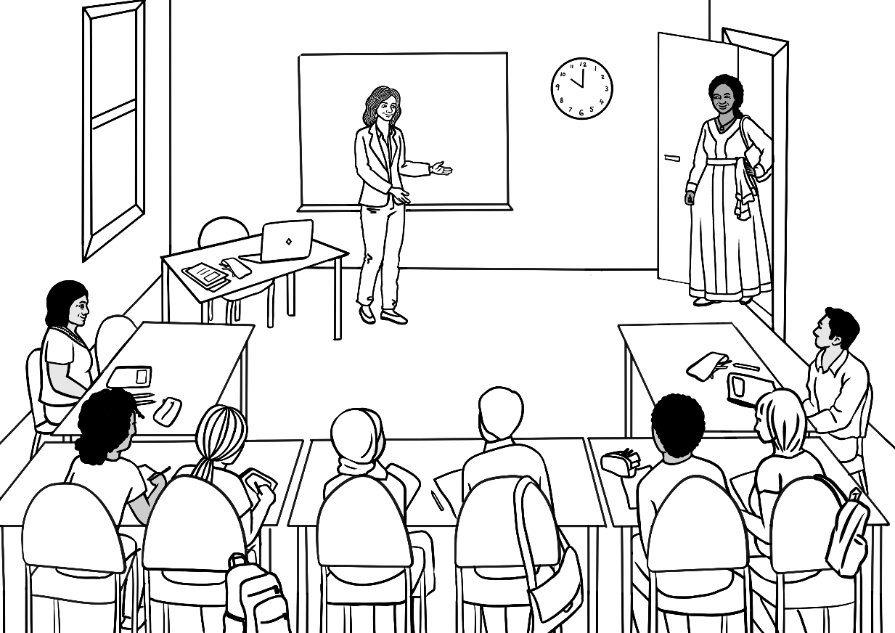
Zarni
Jamila

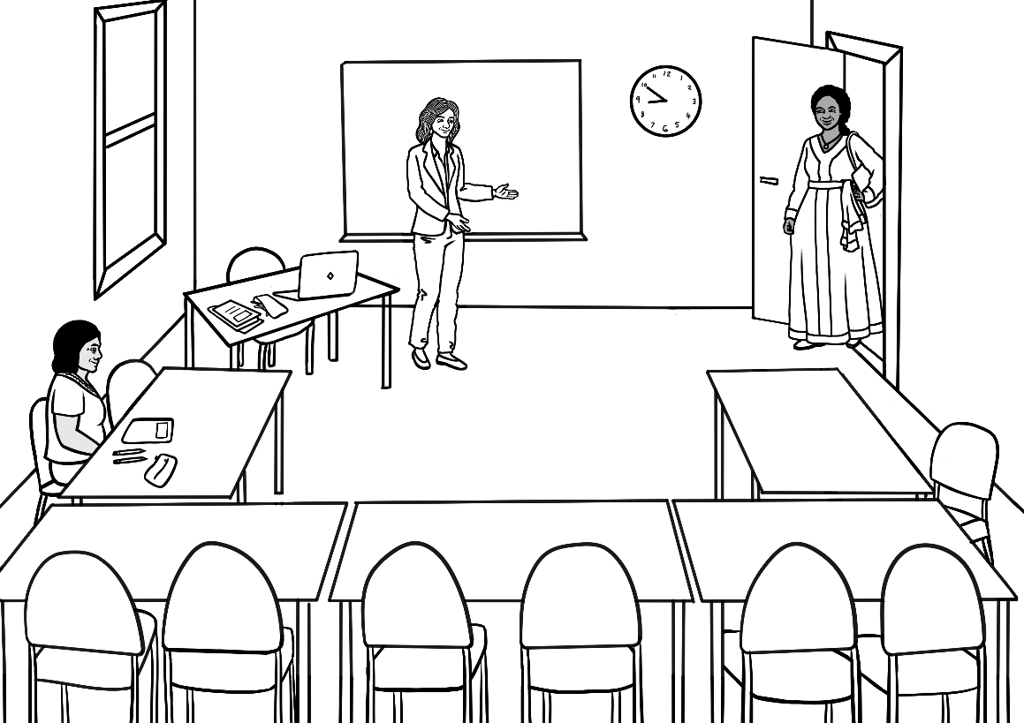
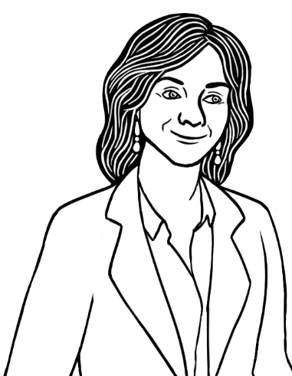 | 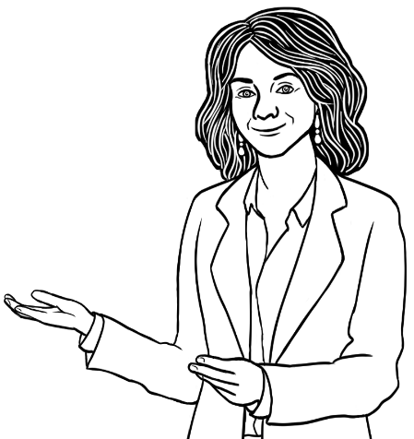

Peter
Peter is a Course in Initial and Certificate 1 in EAL teacher.
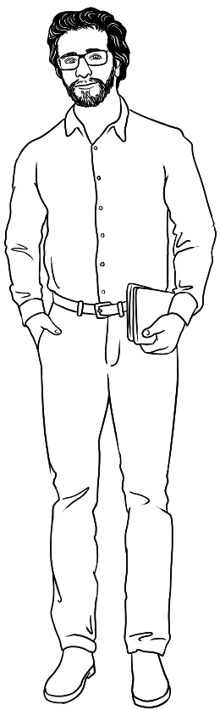 | 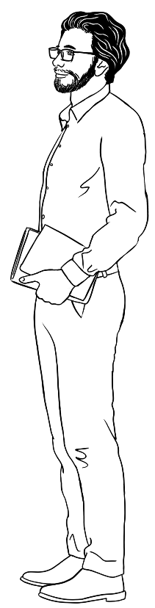 |  | 
 |  | 
 |  | 

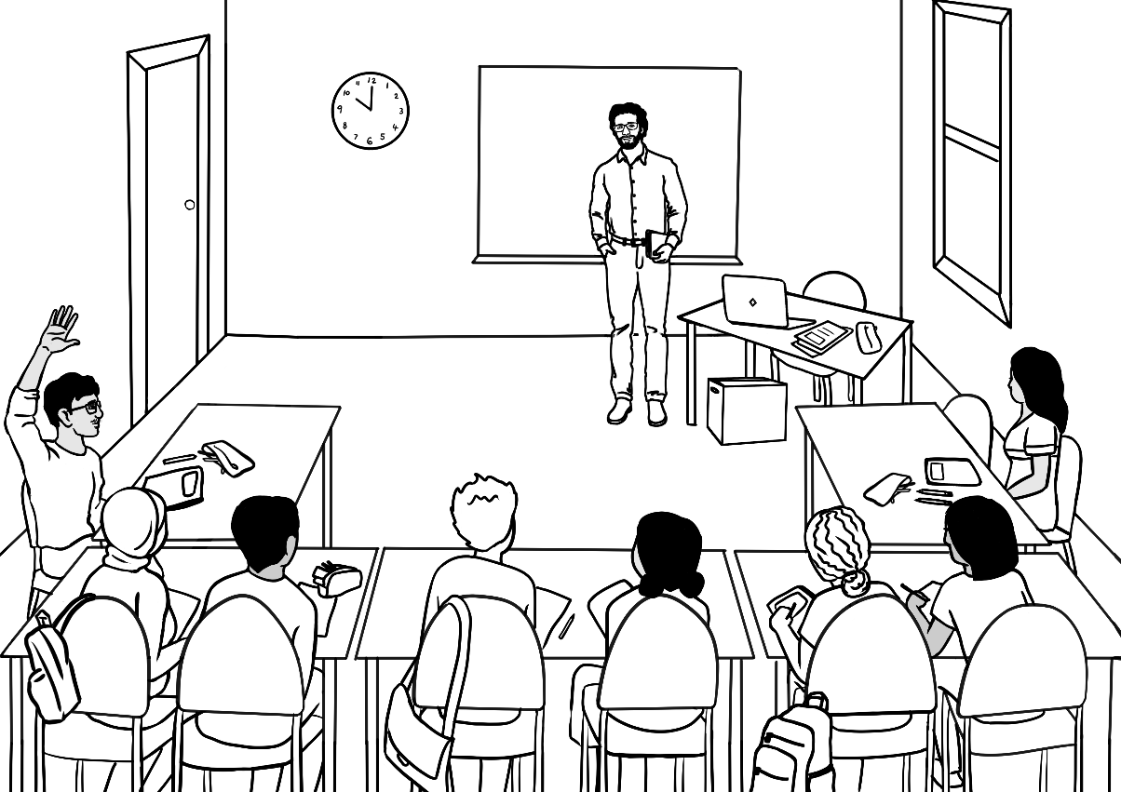
San
Rahim
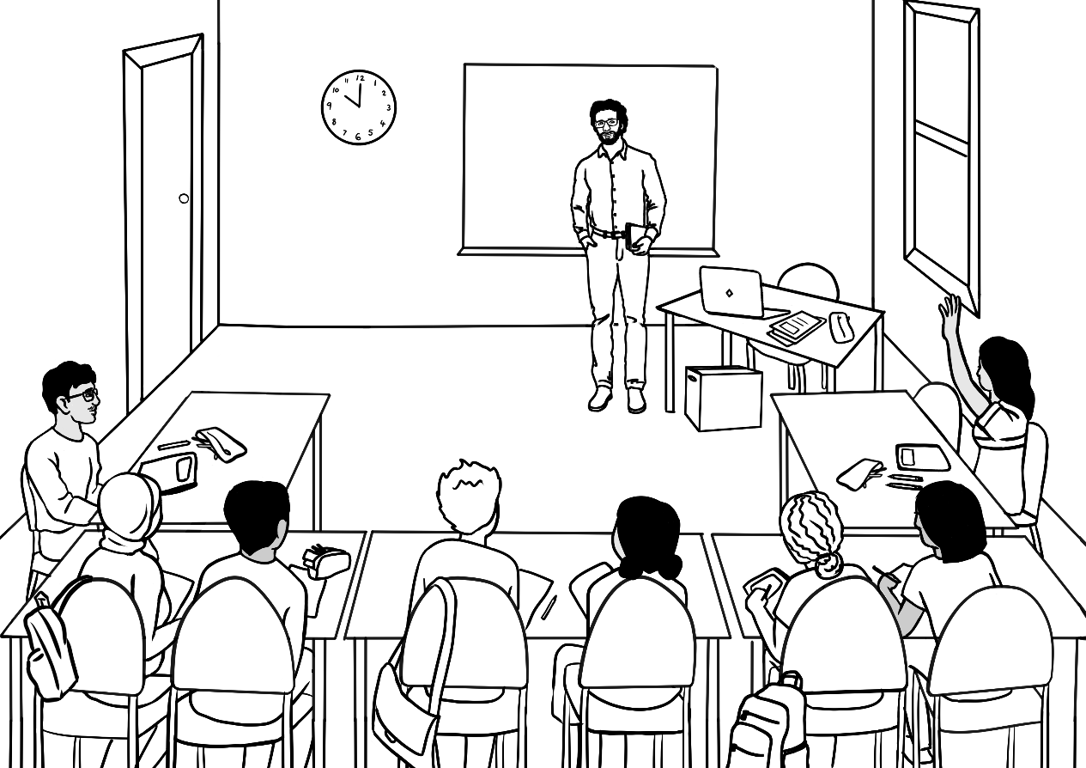

Wendy
Wendy is a Course in Initial and Certificate 1 in EAL teacher.
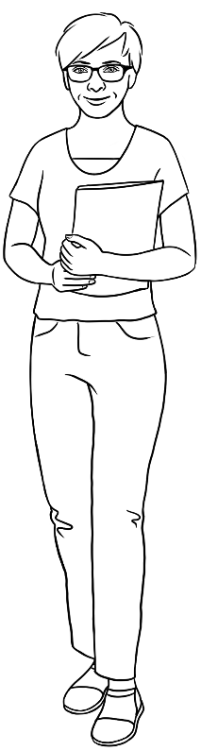 | 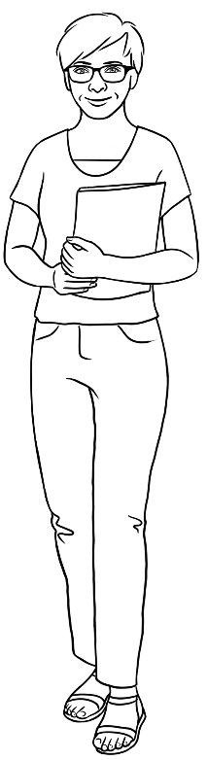 | 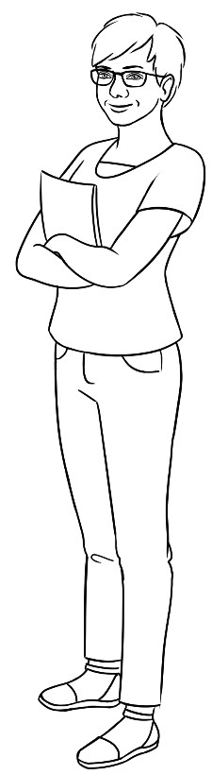 | 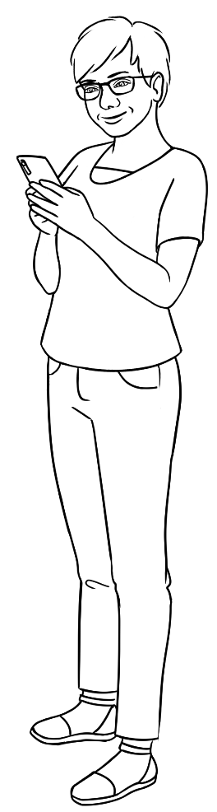
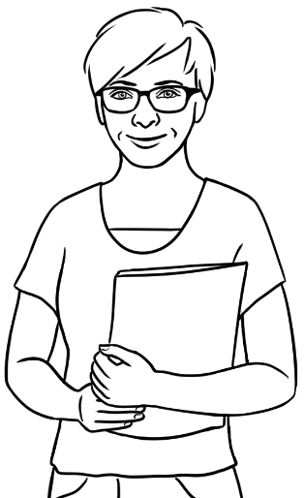 | 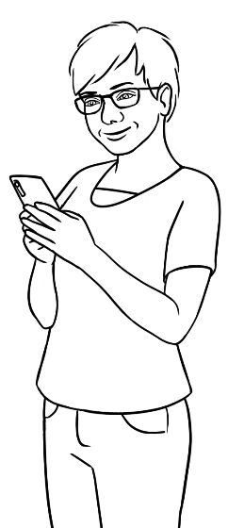 |   Mike – Wendy’s brother
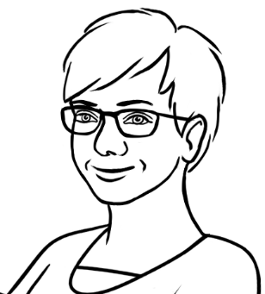 | 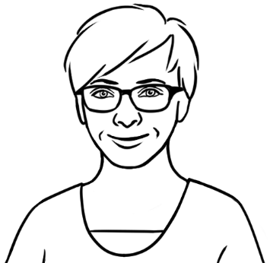 | 

Additional people

Pam
Pam is a neighbour in the units in Baker Road.
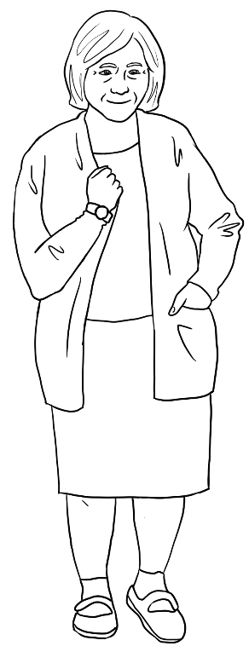
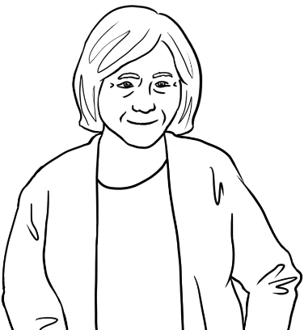
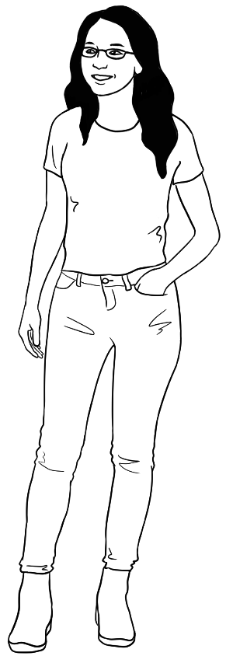  Receptionist at TAFE | 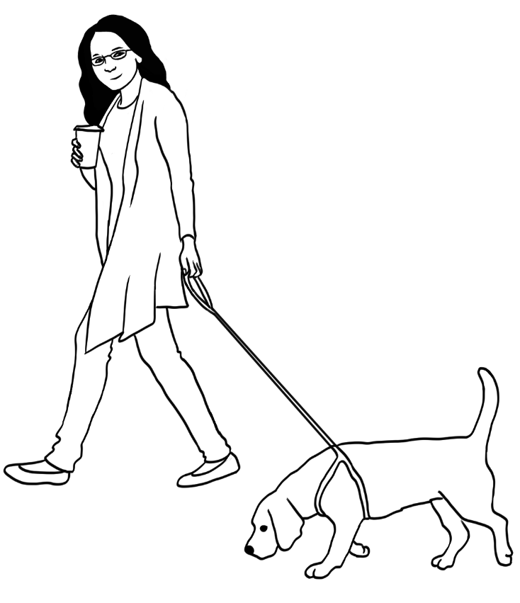

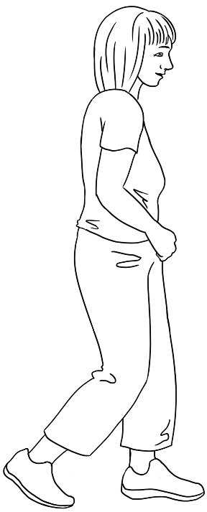
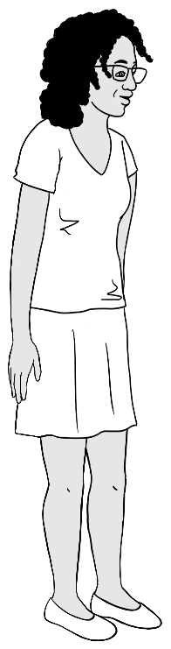
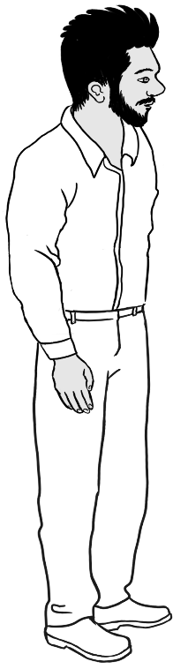
Unnamed students – In Course in EAL classes
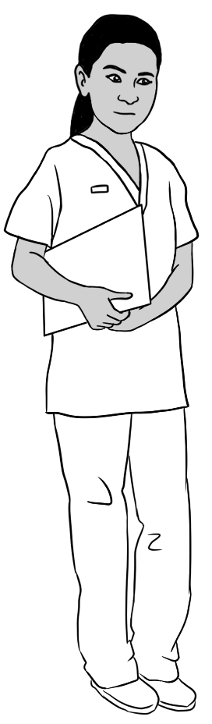  Nurse |   Doctor | 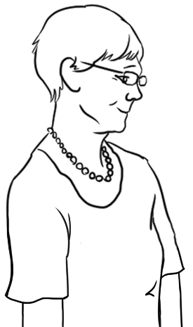  Librarian 1
 | Lifeguard  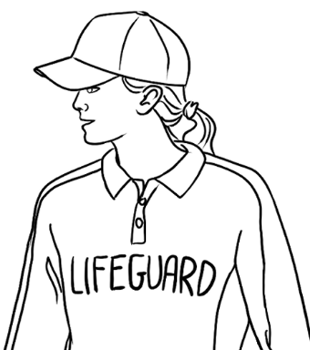 | Librarian 2  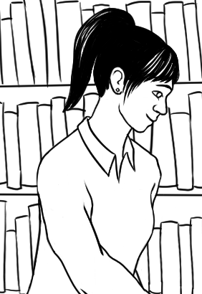

Learning centres, classrooms and learning strategies
See the learning units in the English Ready student workbooks and teacher resources for ideas about using the illustrations in this section.

Learning centres
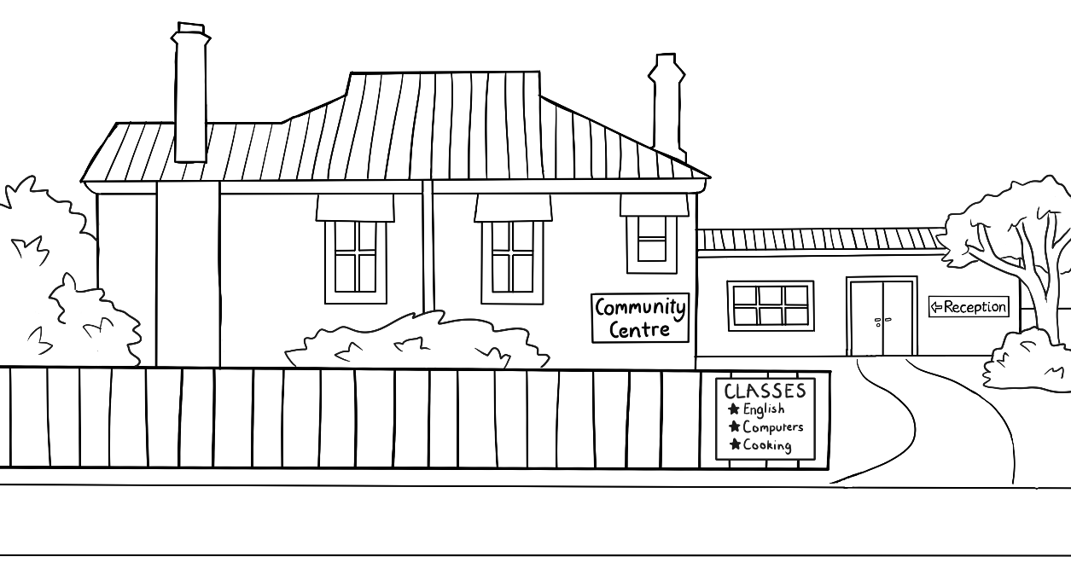
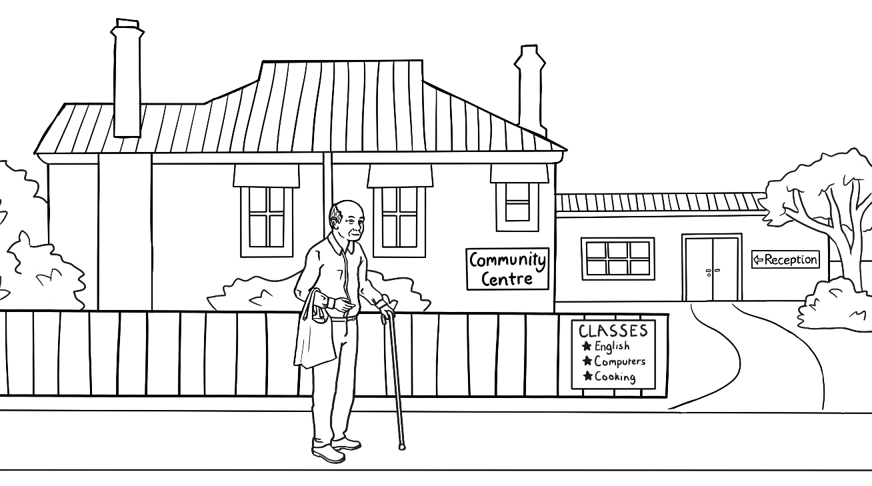

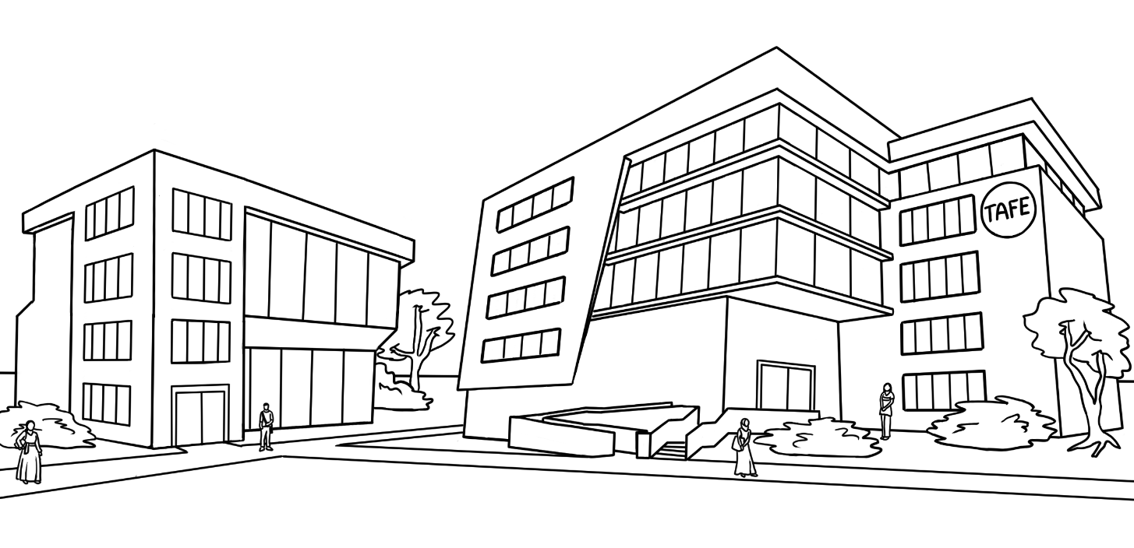

Classrooms
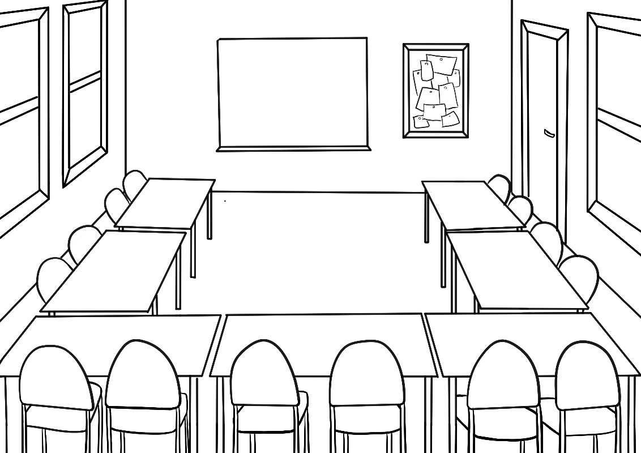
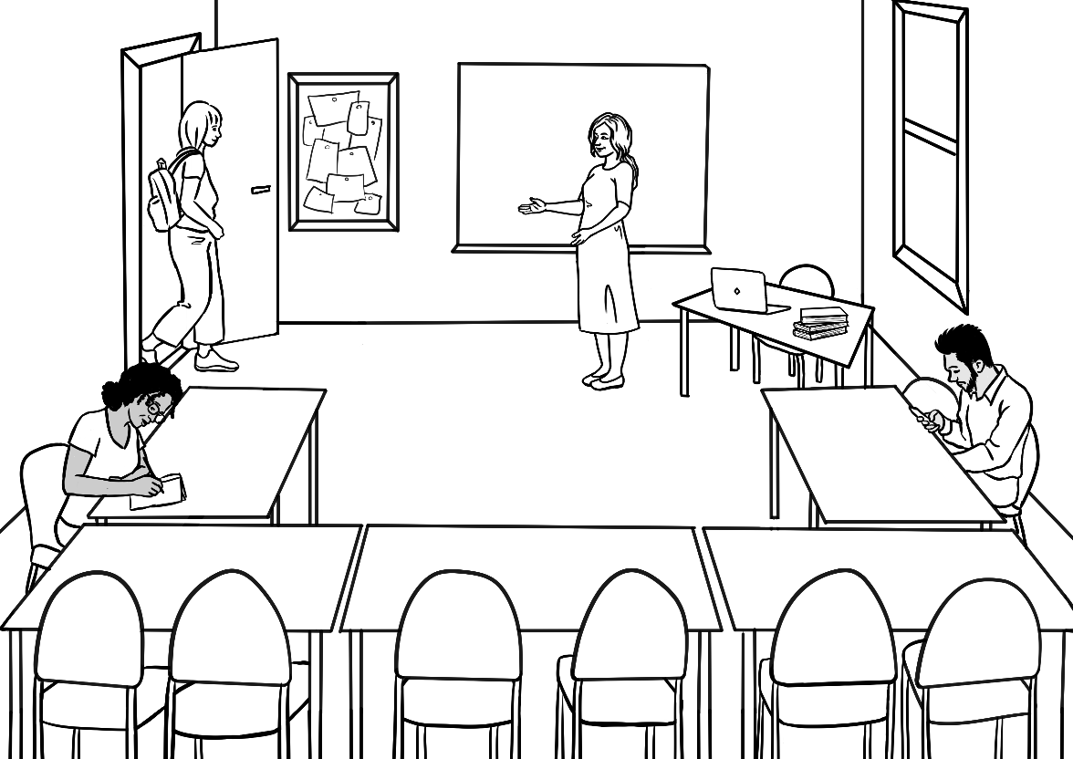

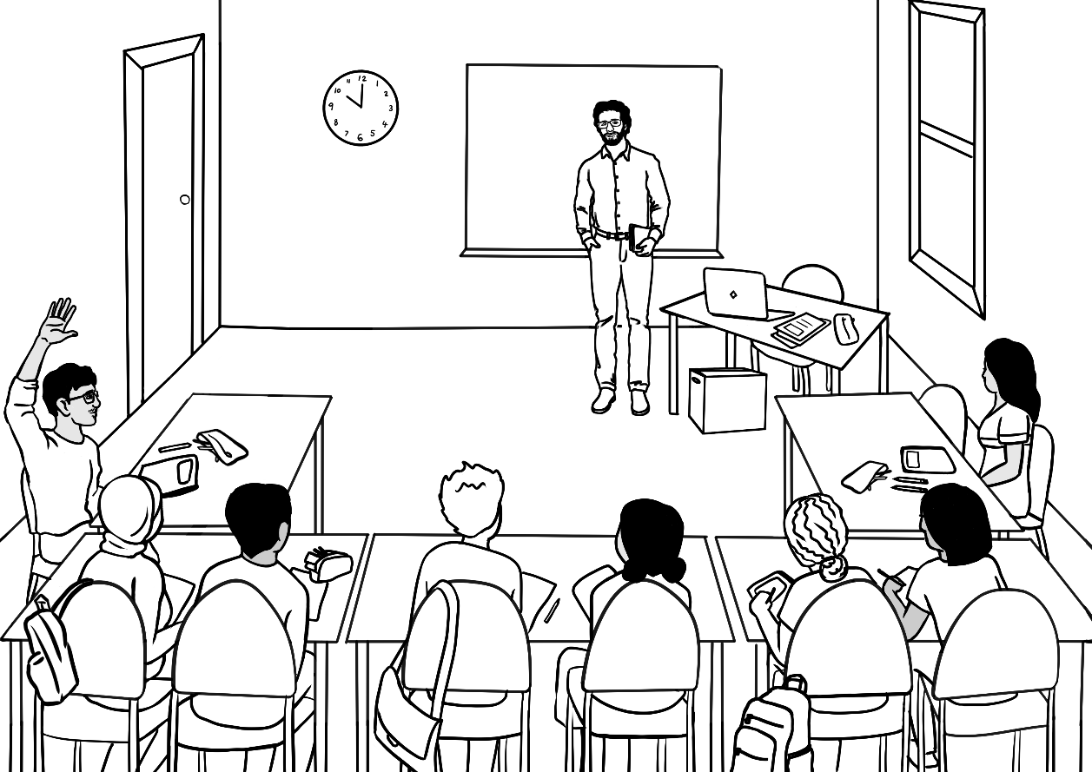
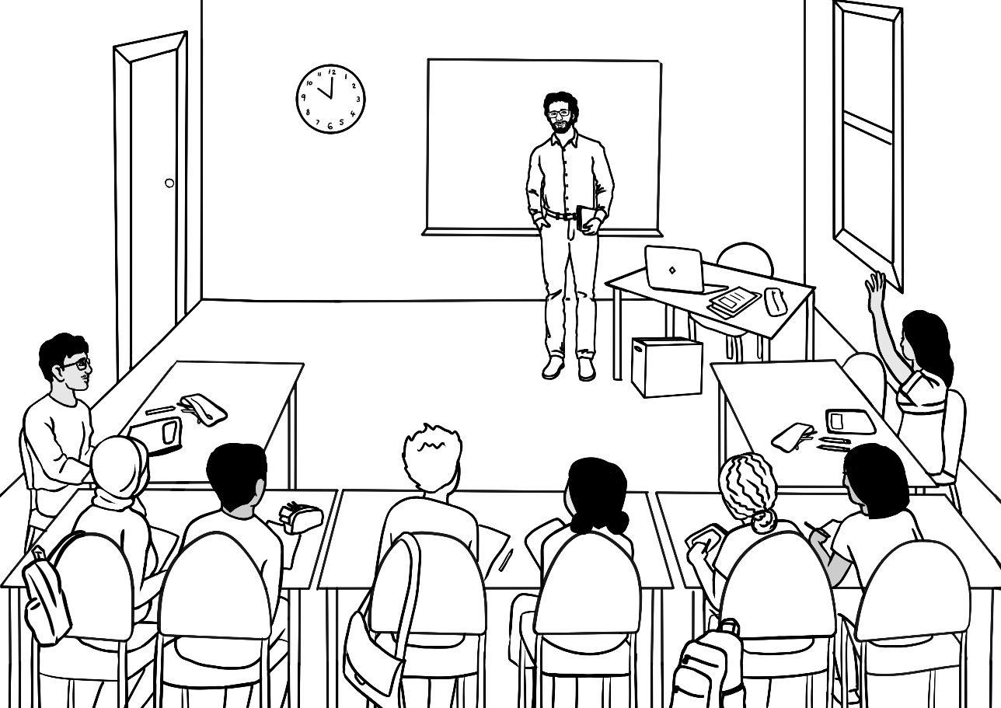

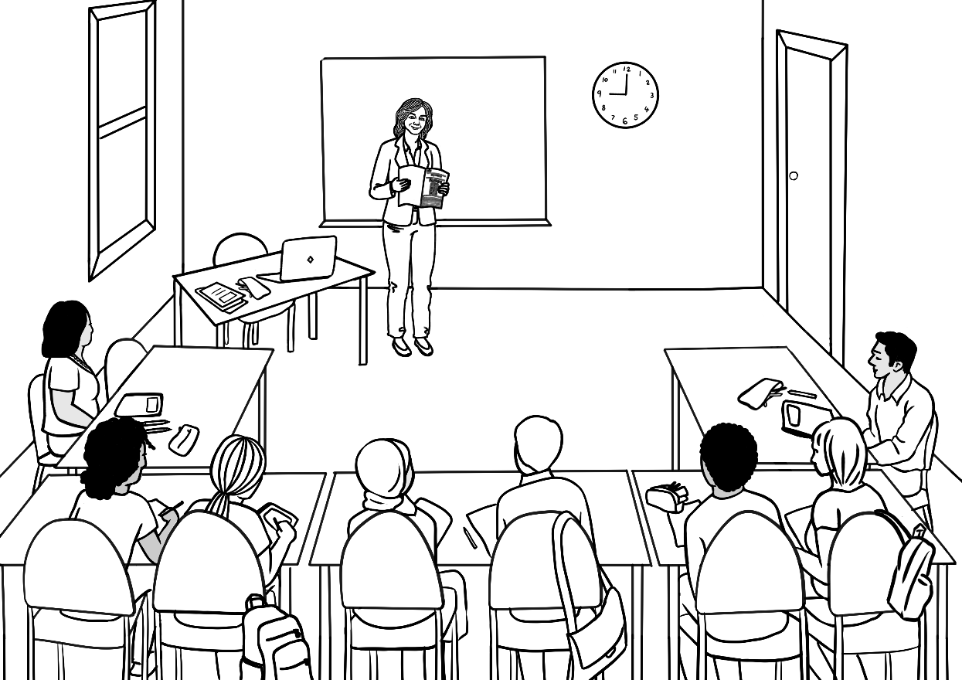
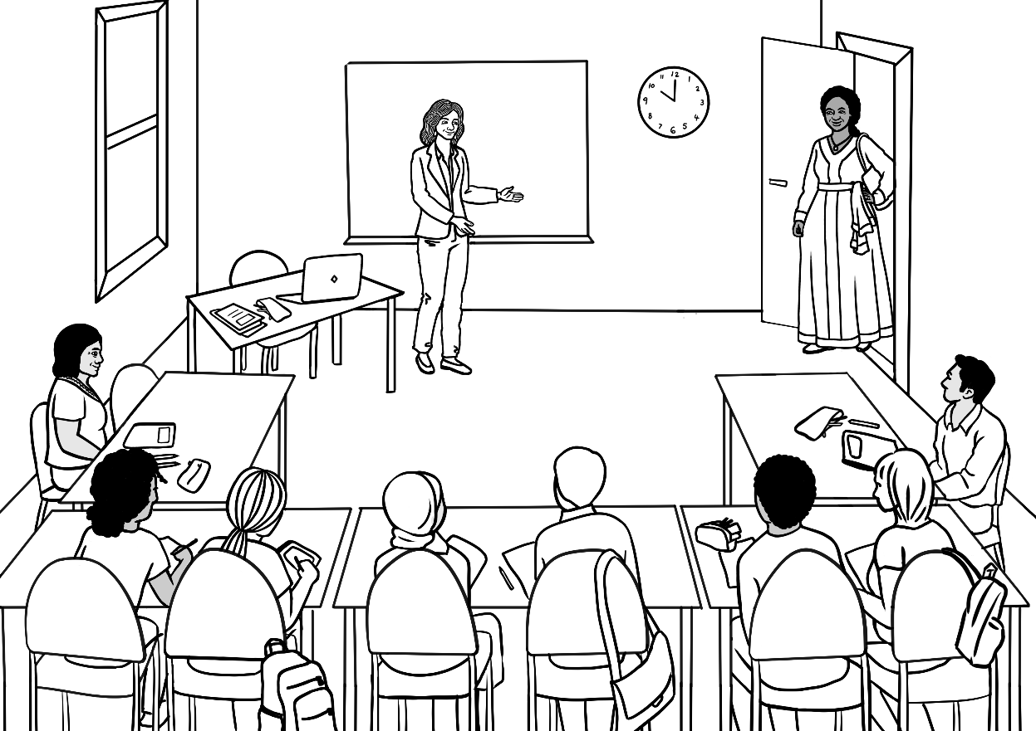

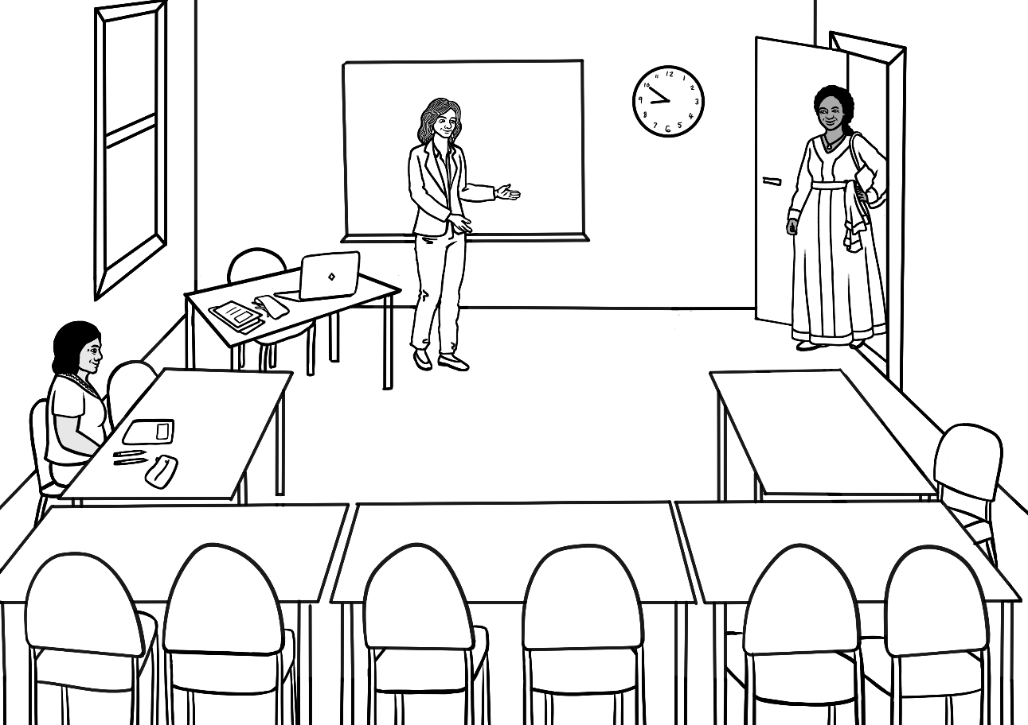

Learning strategies in class time
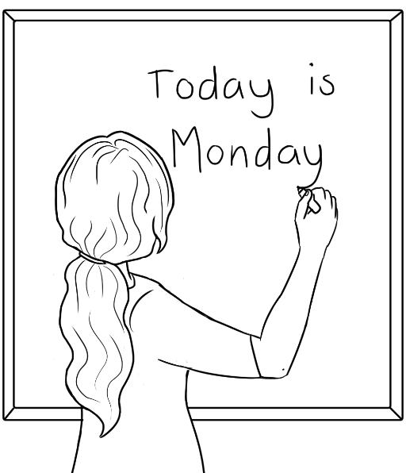 |  | 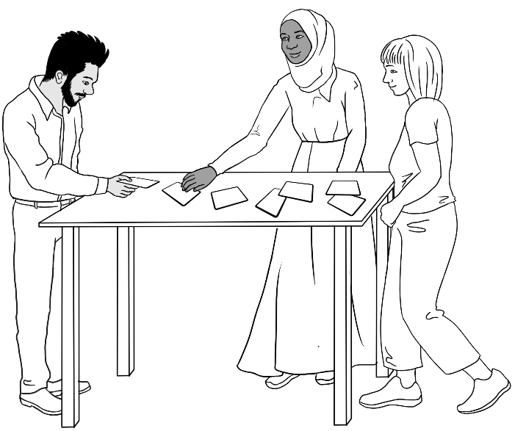
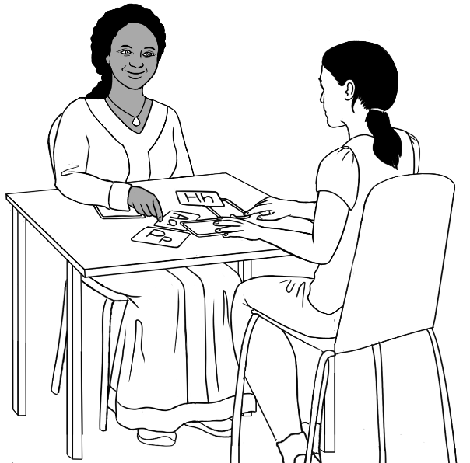 |  | 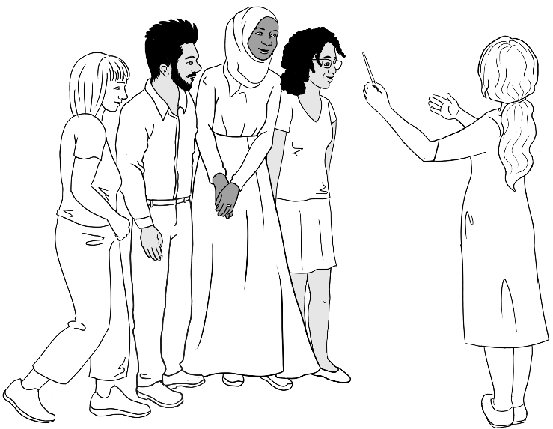
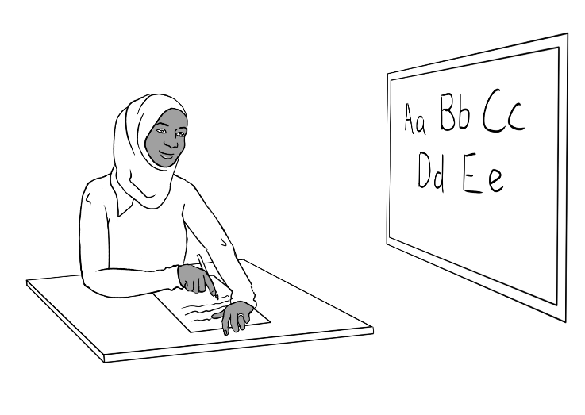 | 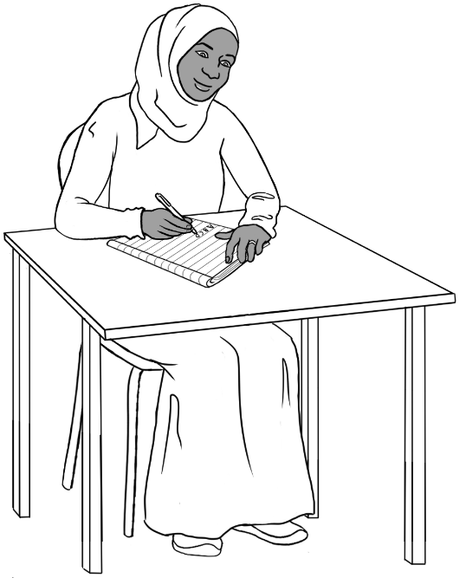

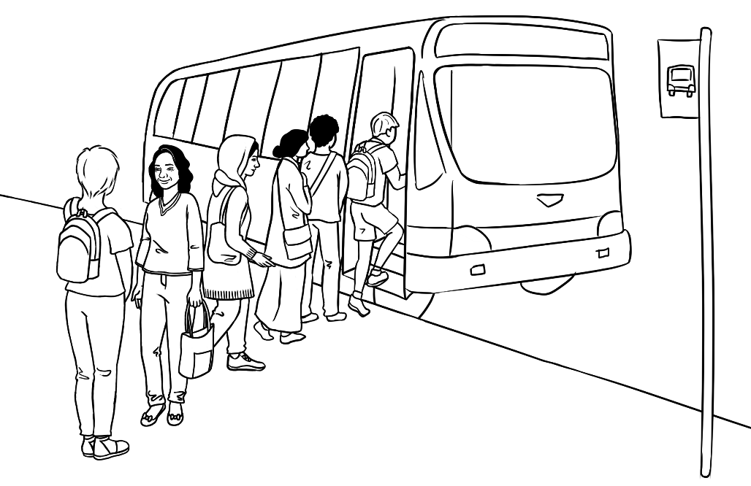
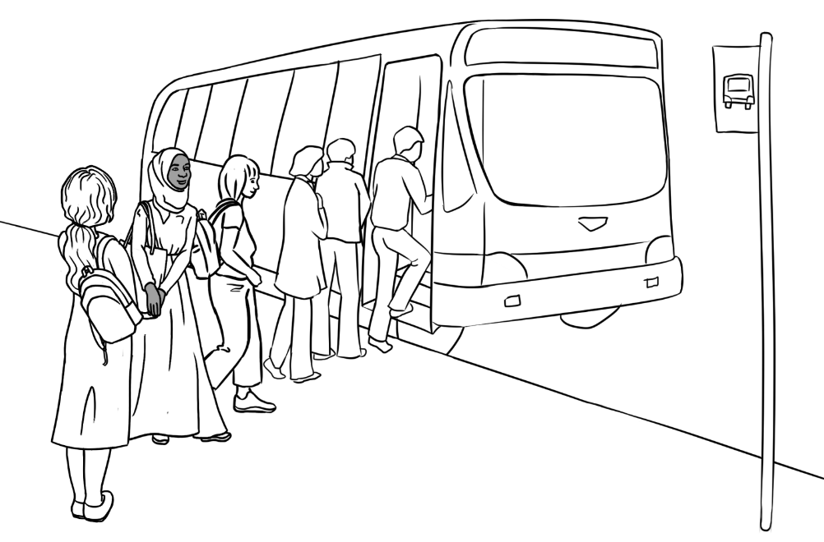
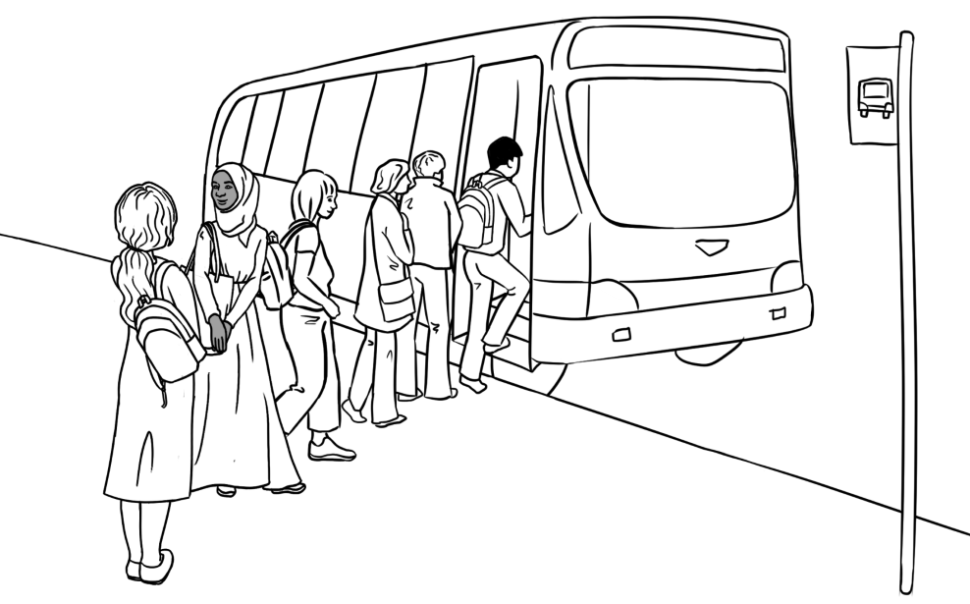

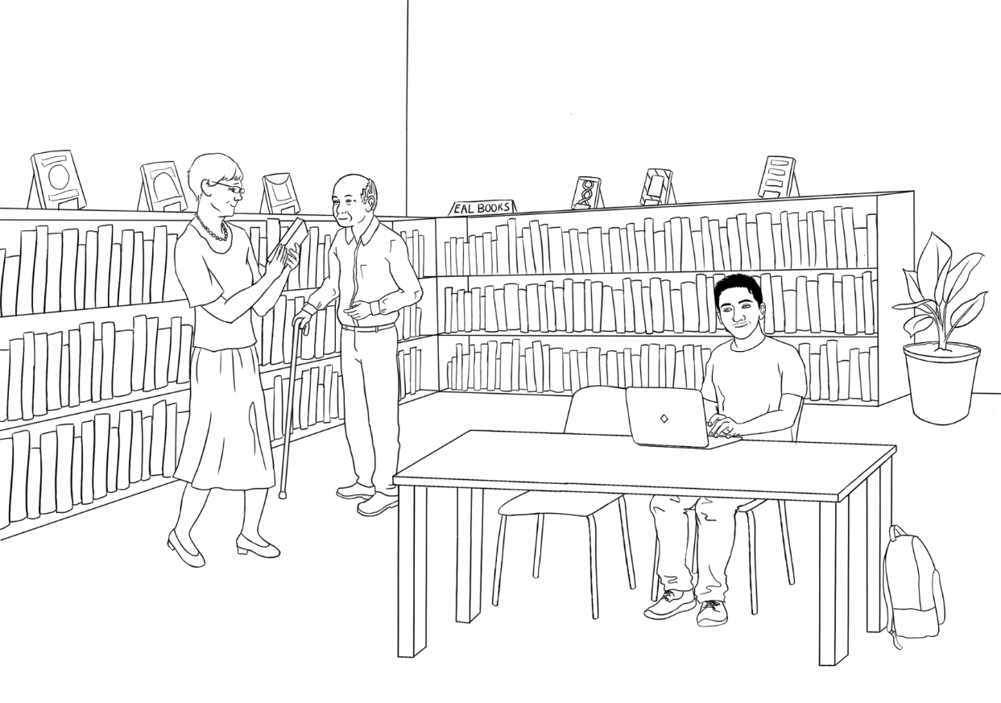
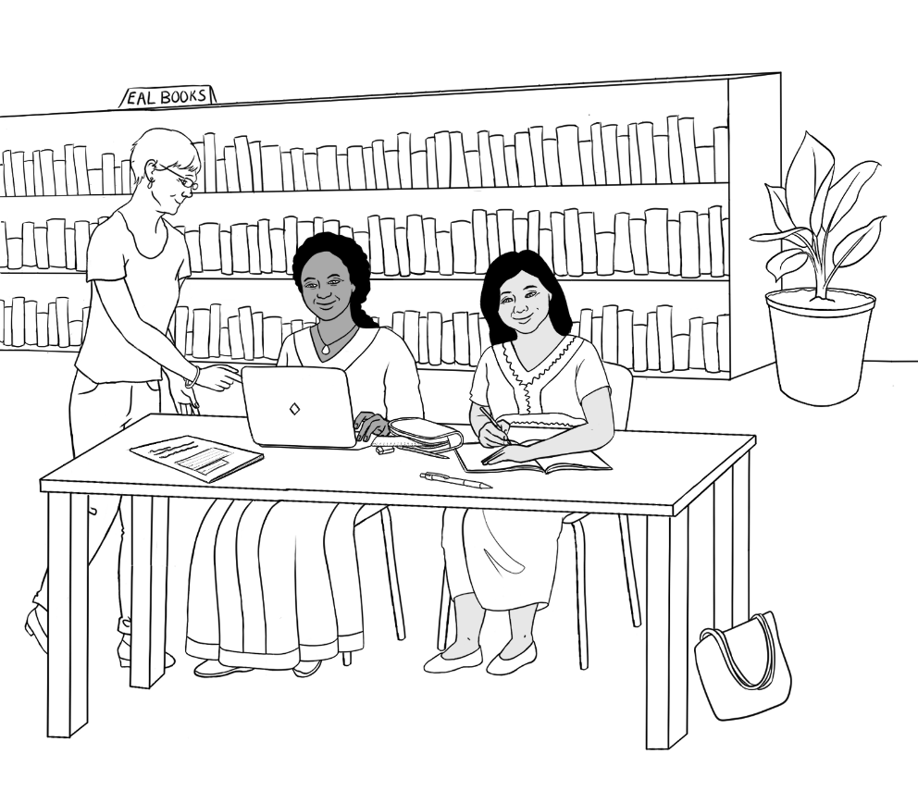

Learning strategies outside class time

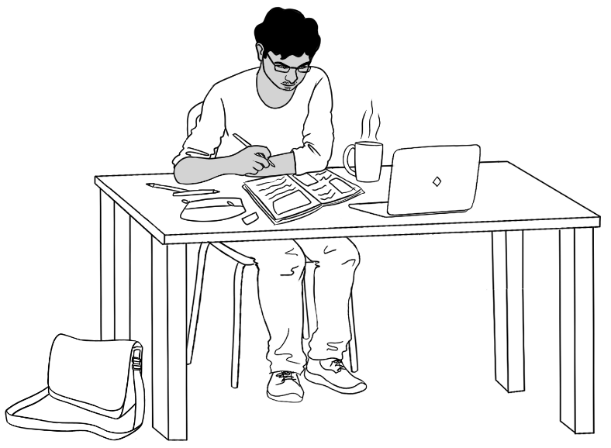 | 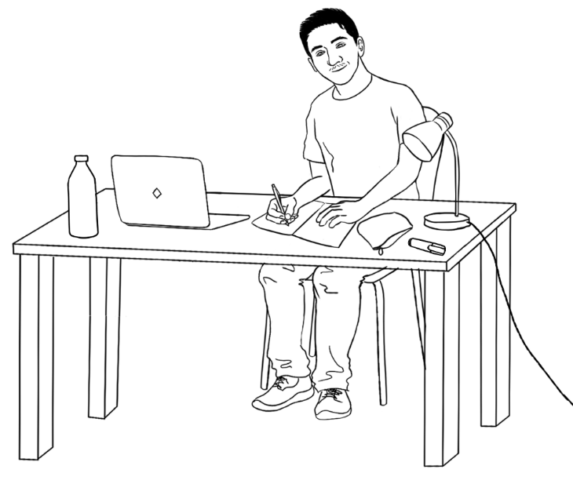
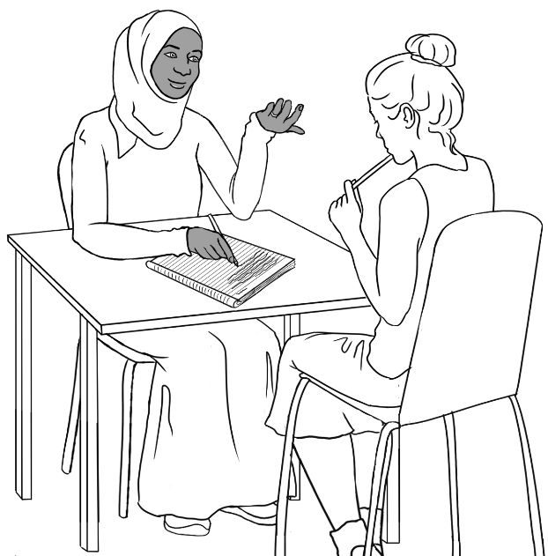
 | 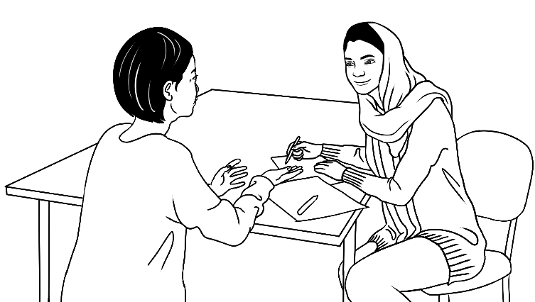

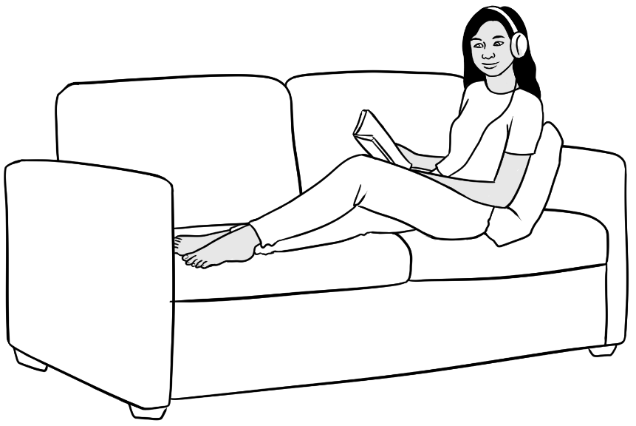 | 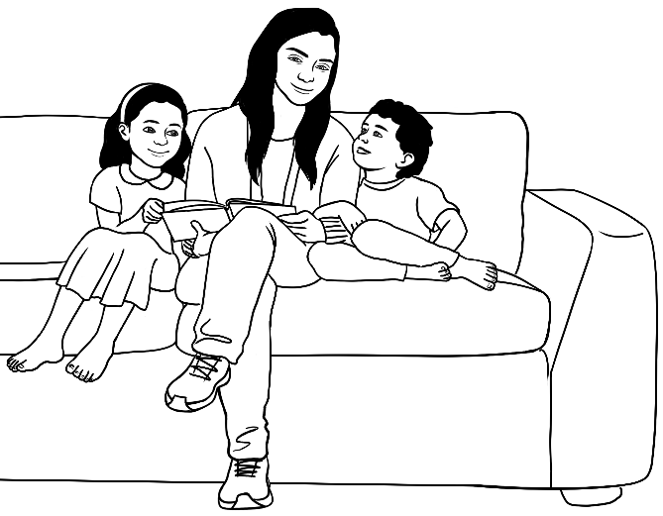
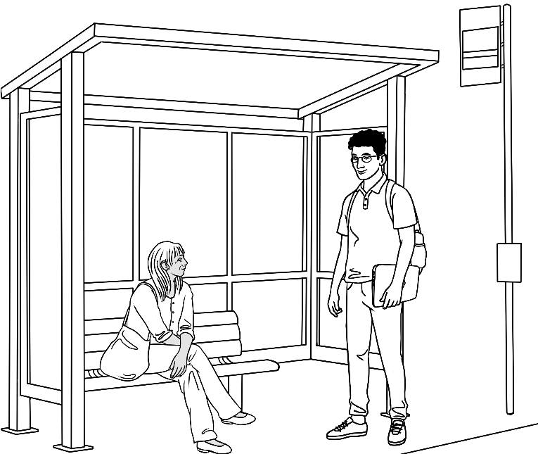 | 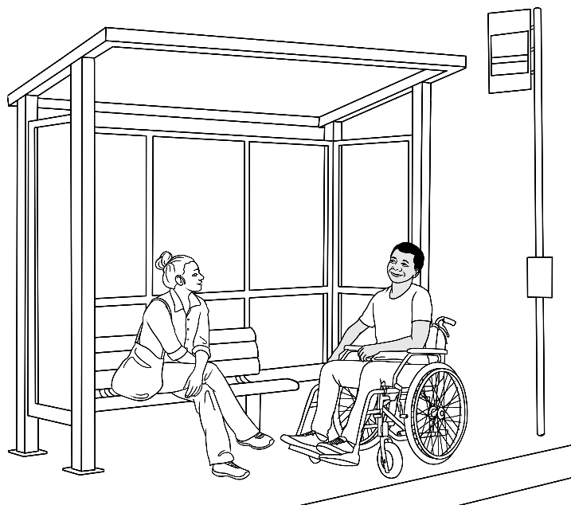
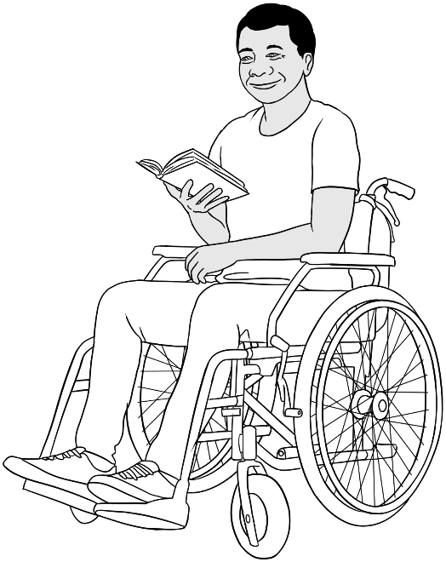 | 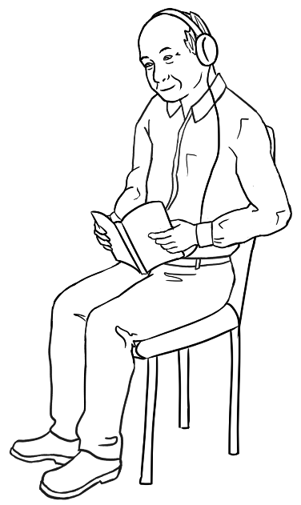

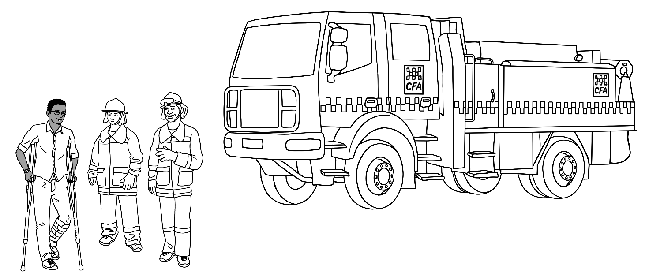
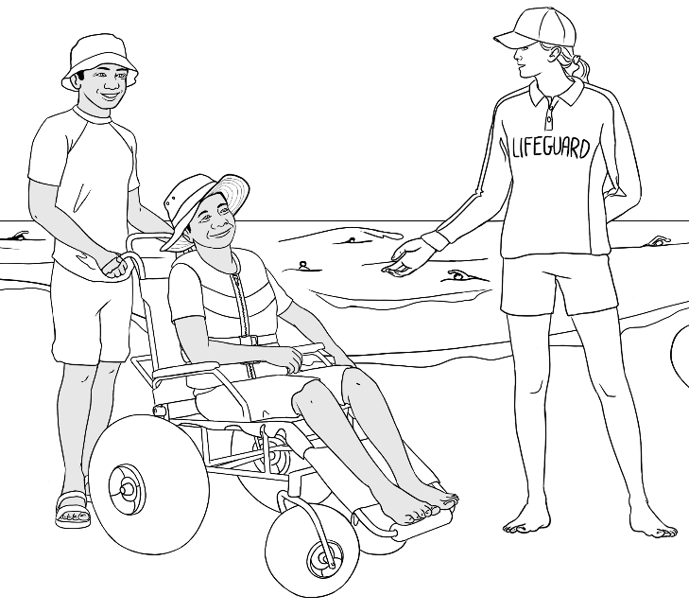 | 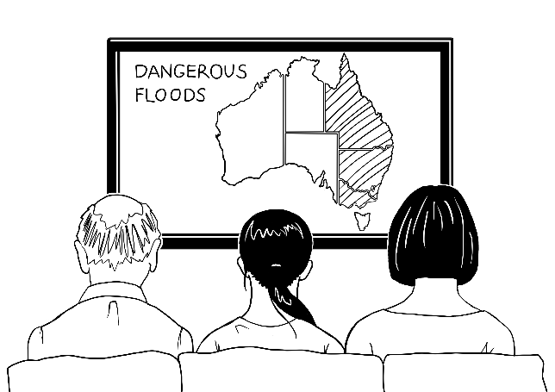

Classroom instructions

  listen |   say | repeat   | 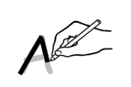  trace
  copy |   write |   read |   spell
  ask a question |   point | 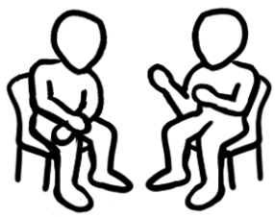  work with  a partner |   work in a group
  colour |   circle | tick |   highlight
  clap | 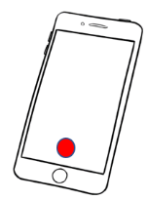  record |   check your work |   ask for help

Workbook instructions

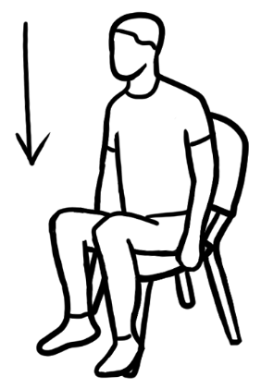  sit down | 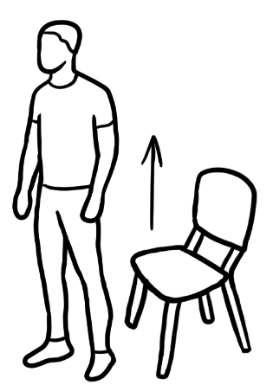  stand up |   stand
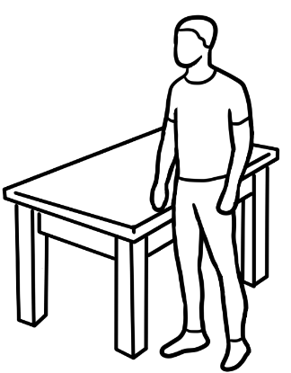  stand next to the table |   walk | 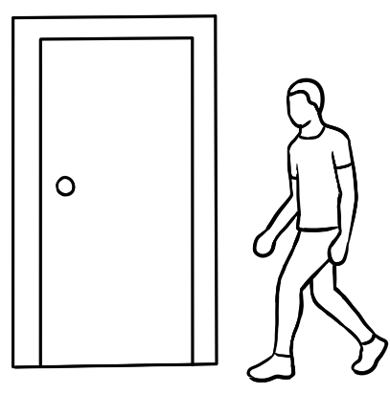  walk to the door
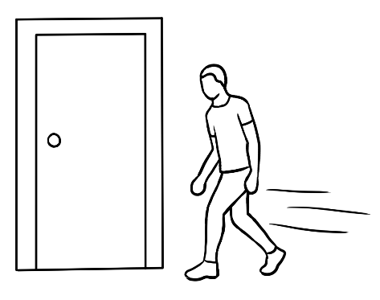  walk quickly  to the door | 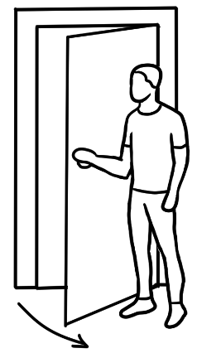  open the door | 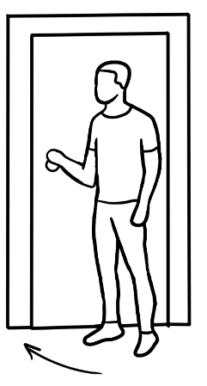  close the door
  stand in a line | 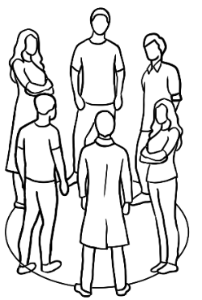  stand in a circle | 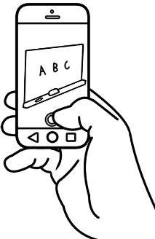  take a photo

General class instructions

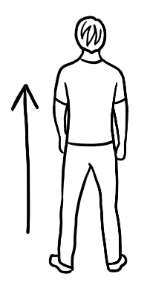  go straight ahead | go right  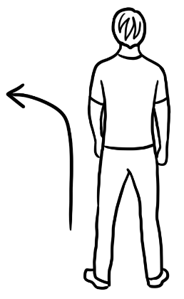 | 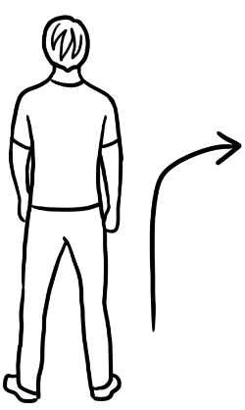  go left
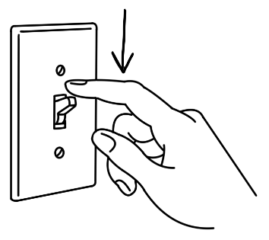  turn on | 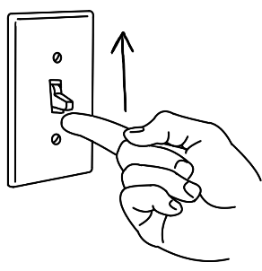  turn off
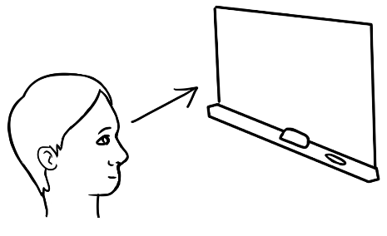  look at the board | 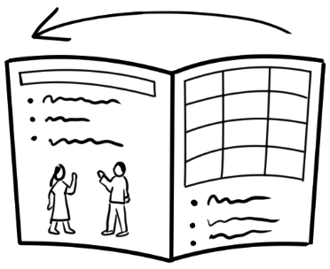  open your workbook | 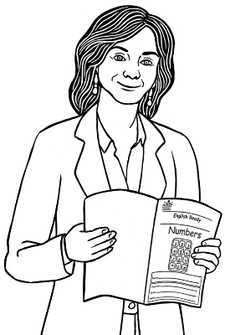  open your workbook
  write on the board | 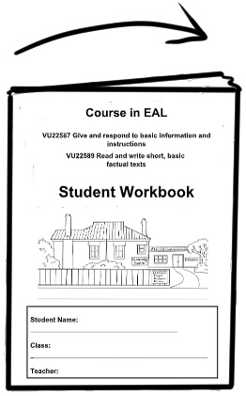  close your workbook | 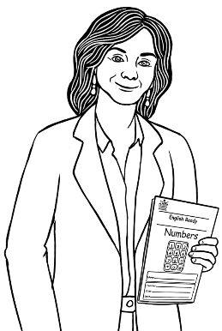  close your workbook

Classroom stationery and equipment

 |  |  | 
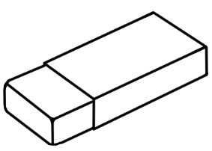 | 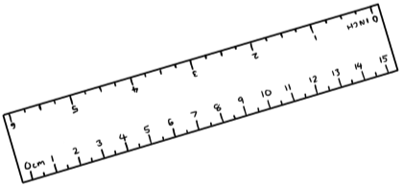 |  | 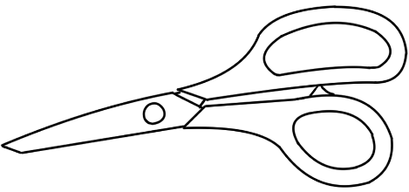
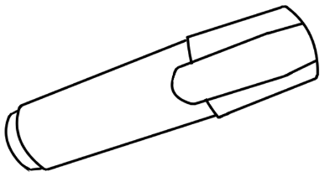 |  |  | 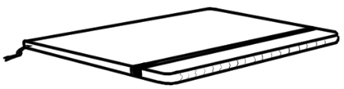
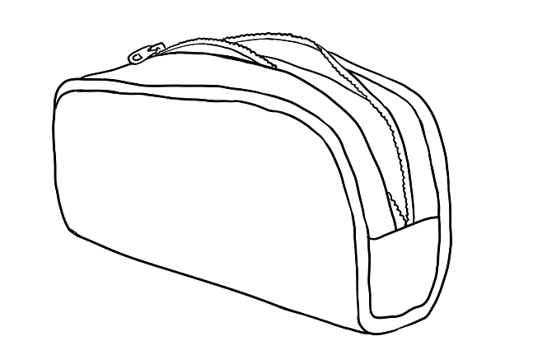 |  | 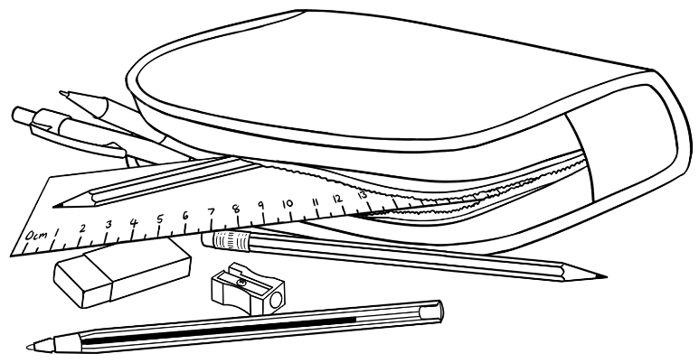

 |  |  |  | 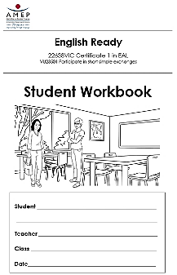
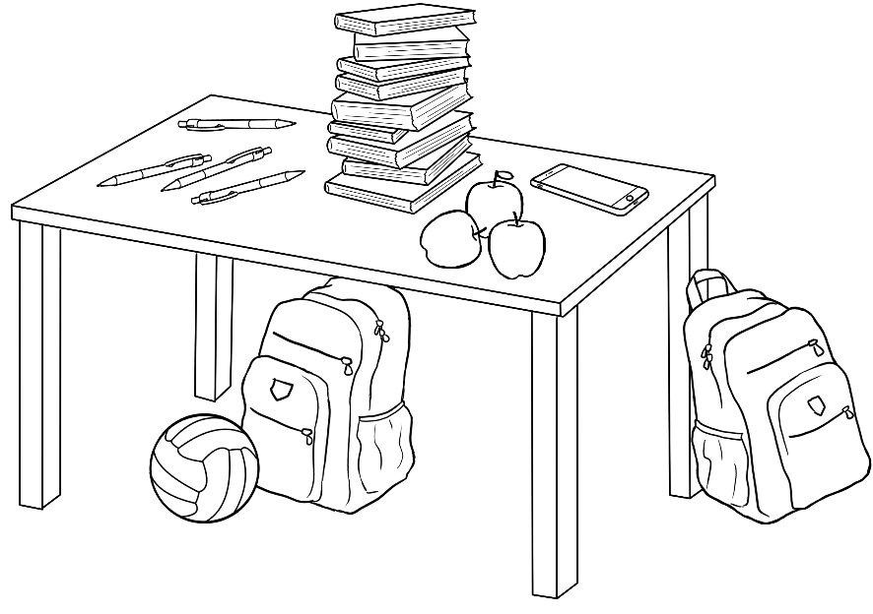 |  |  | 
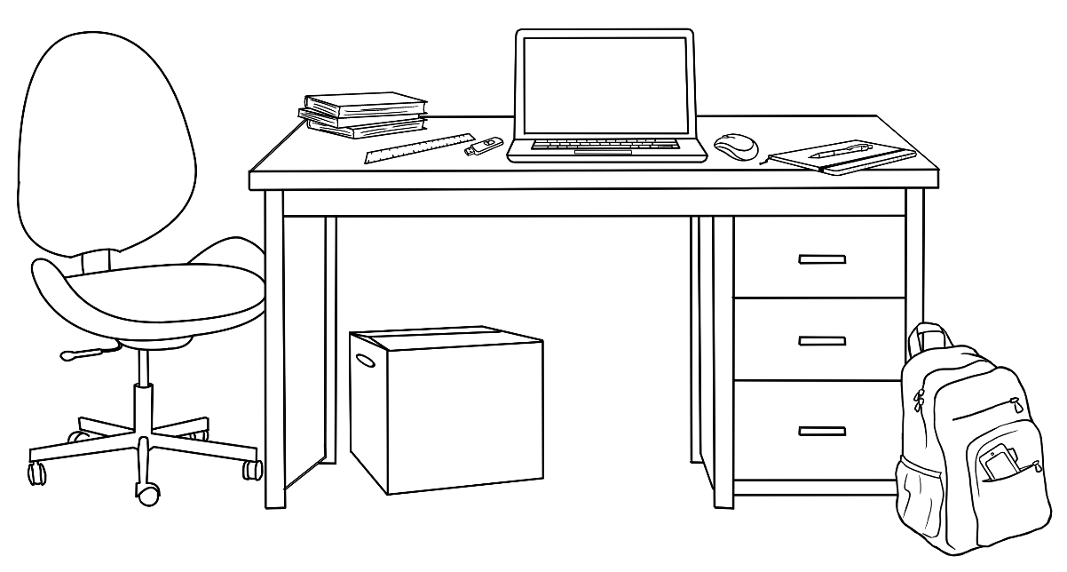

Digital devices, icons and use
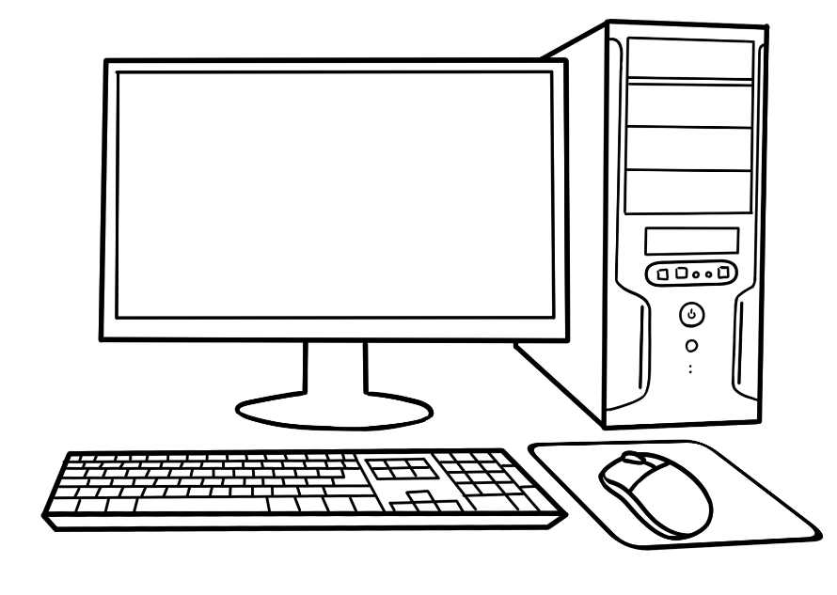 |  | 
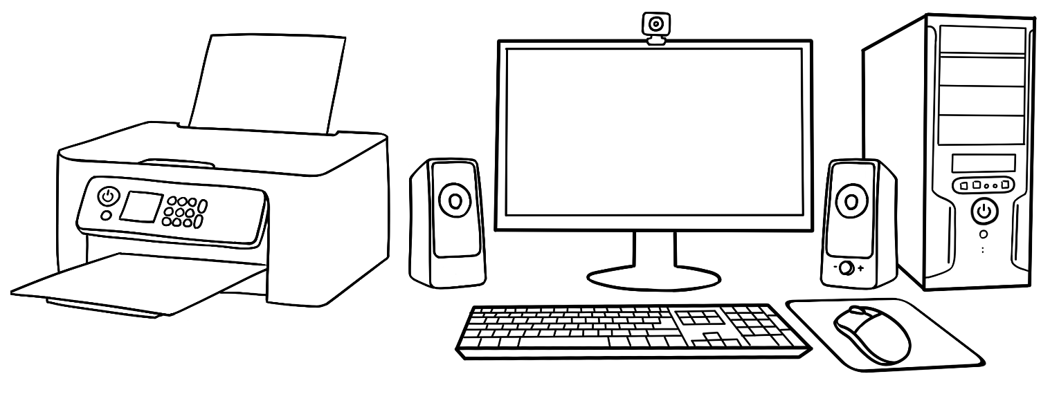
 | 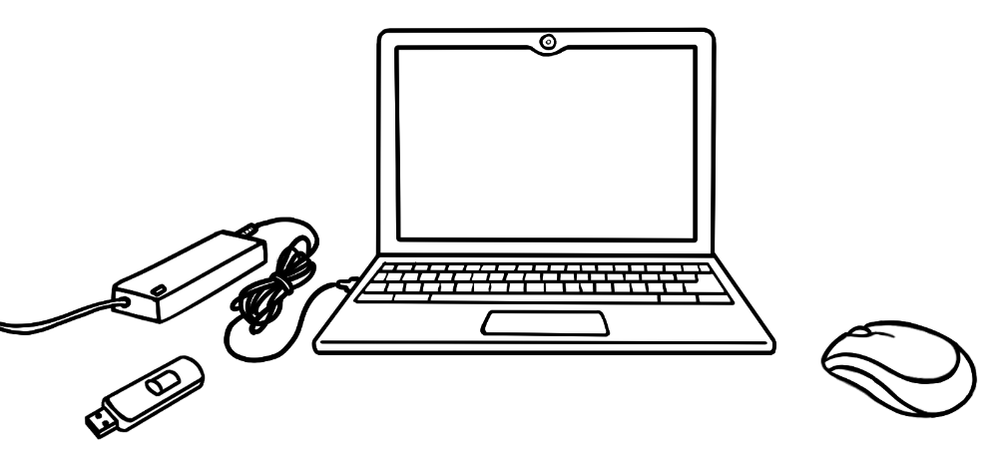

Devices

 |  | 
 | 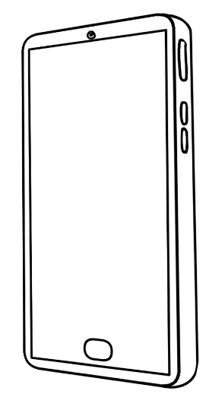 | 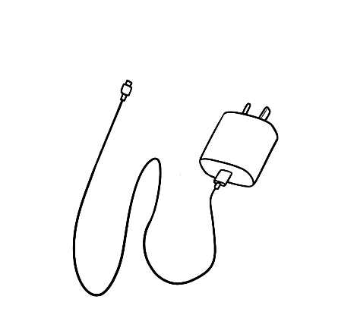
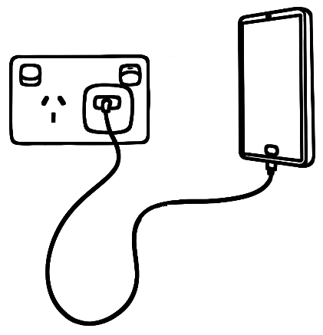 | 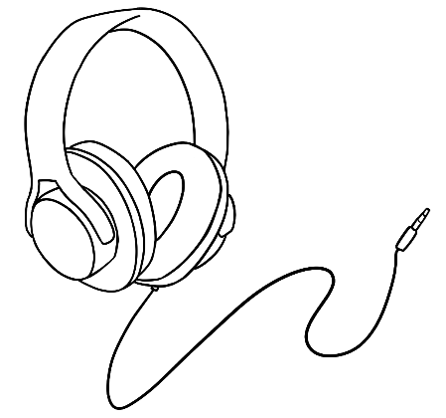 | 

Icons
  phone |   text message |   camera |   photo gallery
  record |   WhatsApp |   Google
  locked |   unlocked

Use
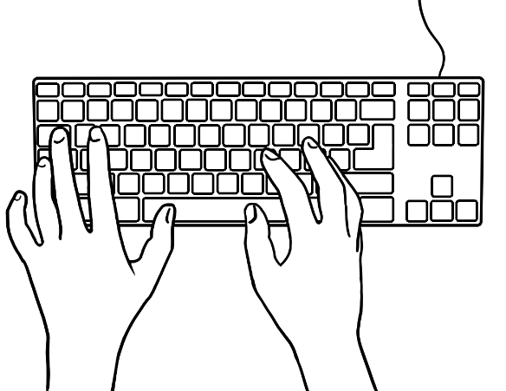  type |   use a desktop computer
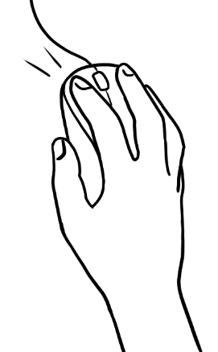  use a mouse a | 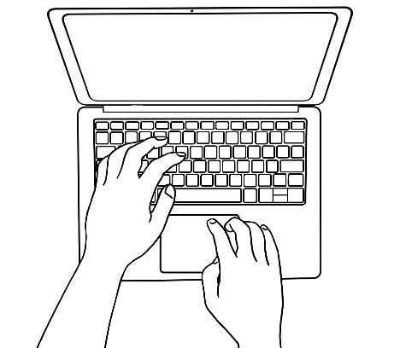  use a laptop
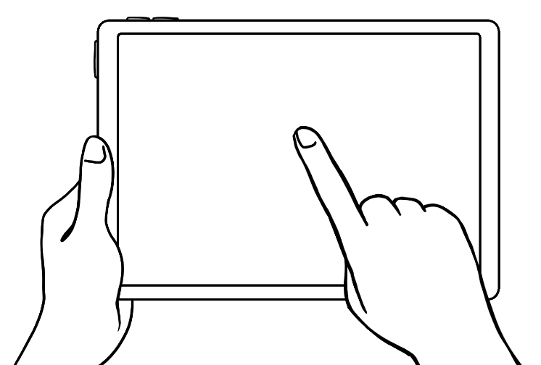  use a tablet | 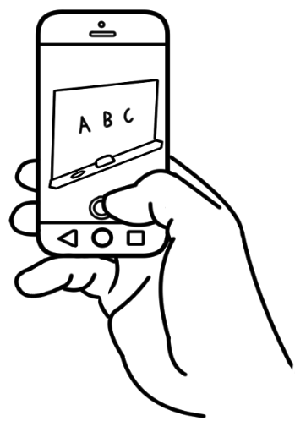  take a photo

  phone keypad  1  4  2  5  0  8  3  6  9  #  *  7  Phone |   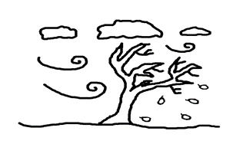      time and weather  8:00
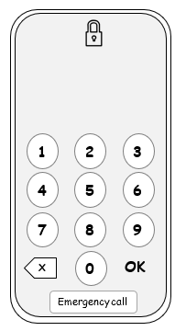  locked phone | 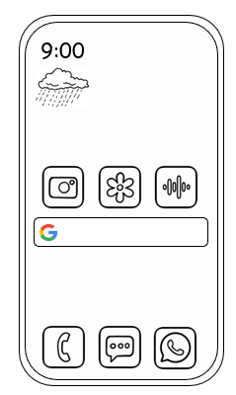  home screen

  Amina | 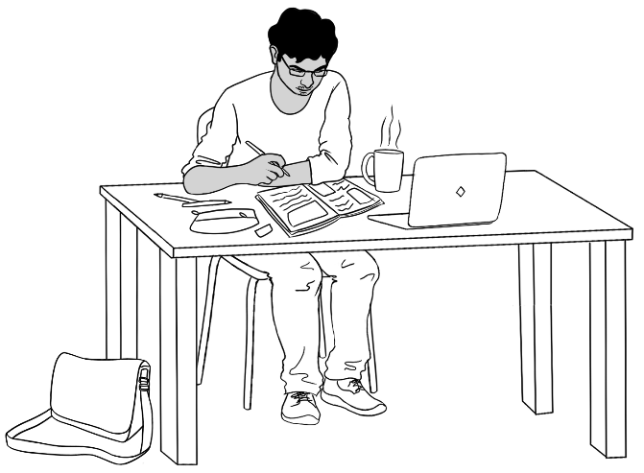  Rahim
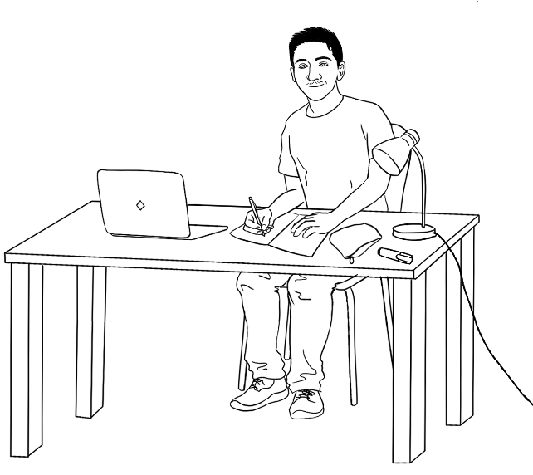  Carim | 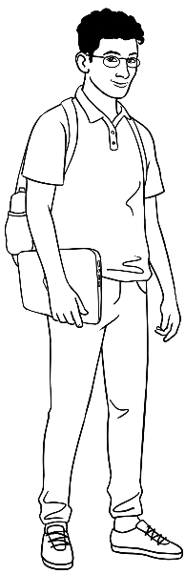  Ahmad
  Anika | 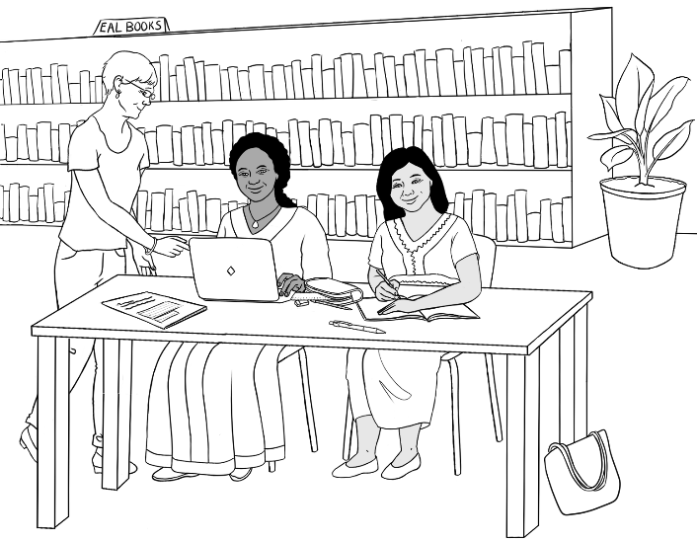  Jamila

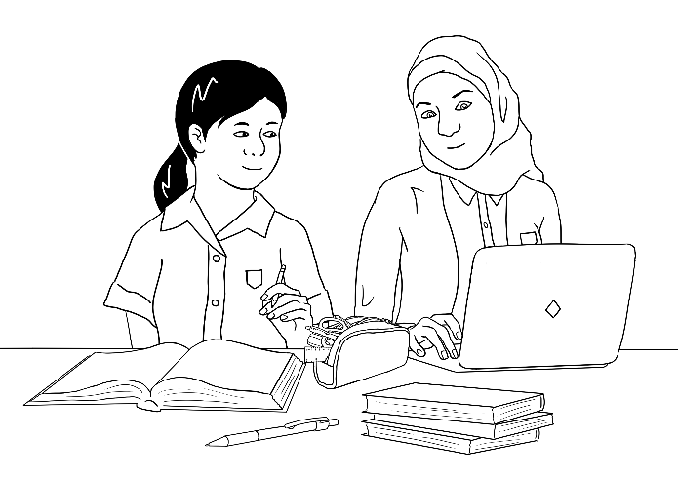  Fatima | 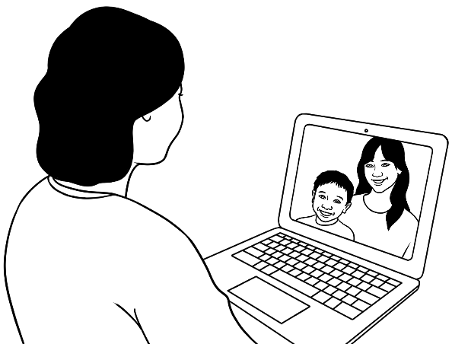  Linh on a video call.
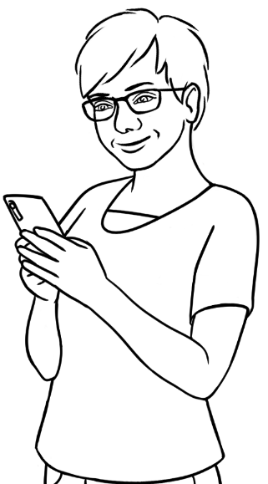  Teacher Wendy |   Teacher Peter
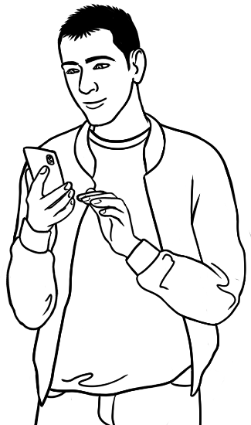  Basam | 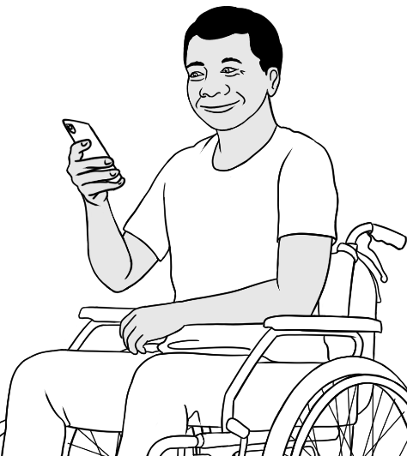  Ko

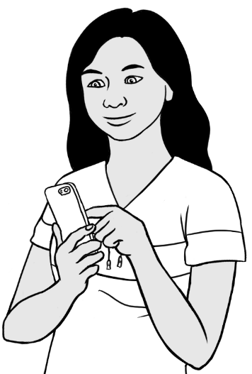  San |  | 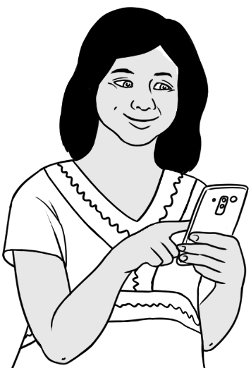  Zarni
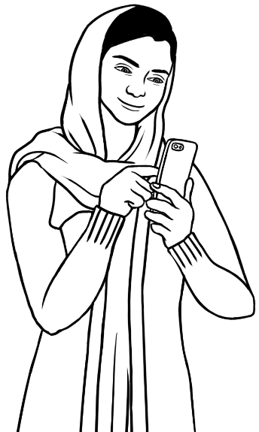  Parwana |  | 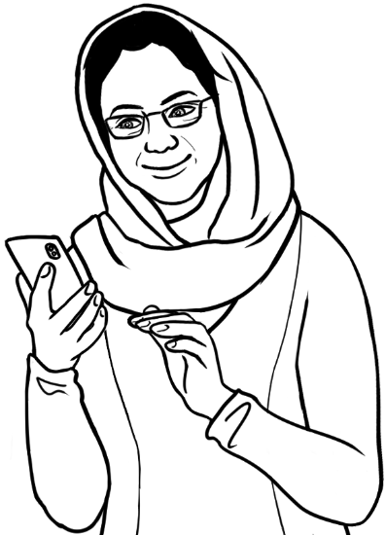  Amina
  Ahmad | Sahra  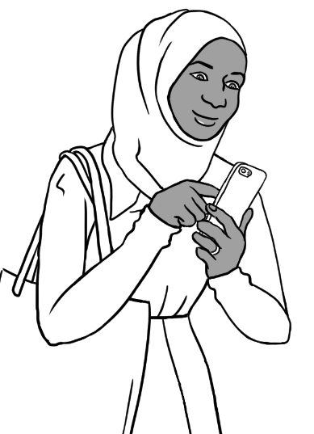  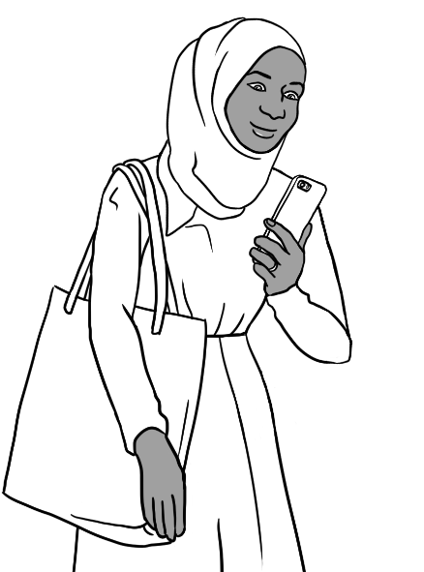

Childcare

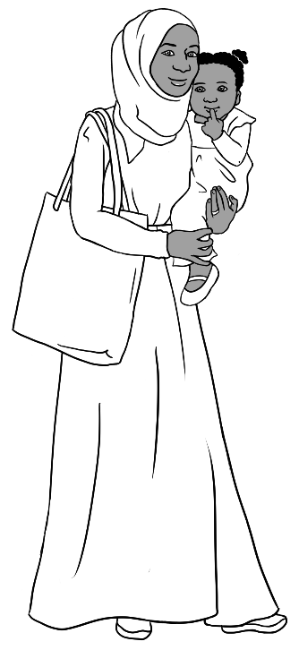 | 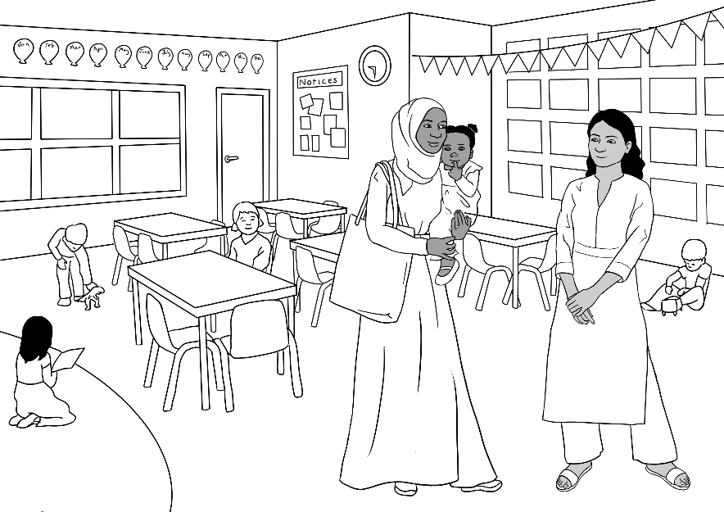
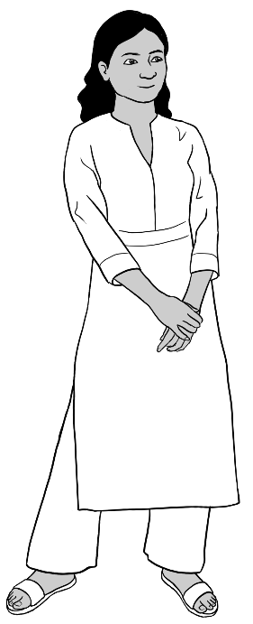 | 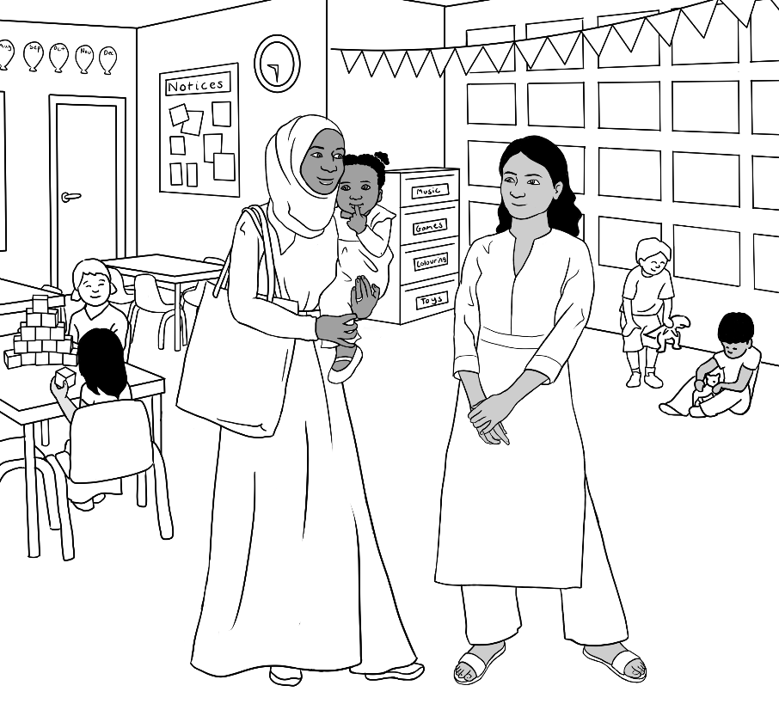

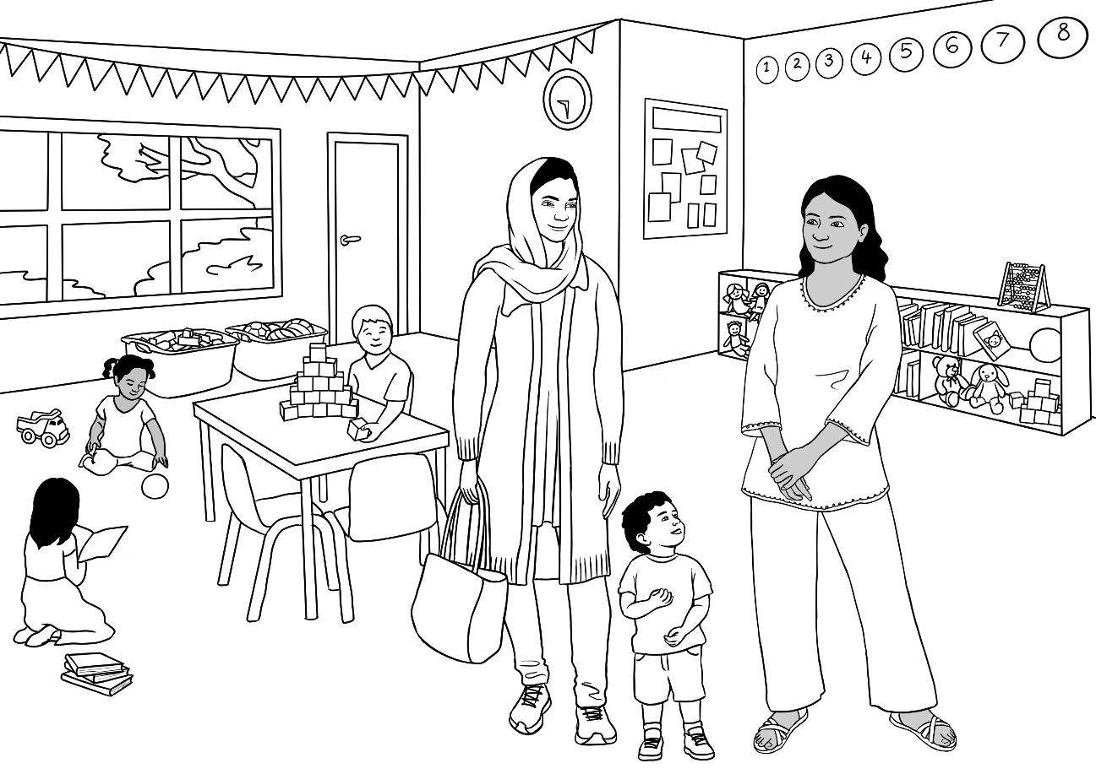
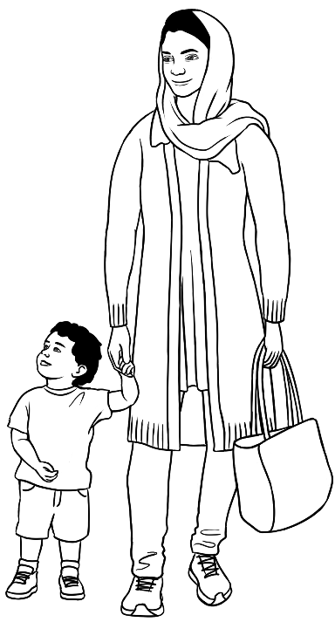 | 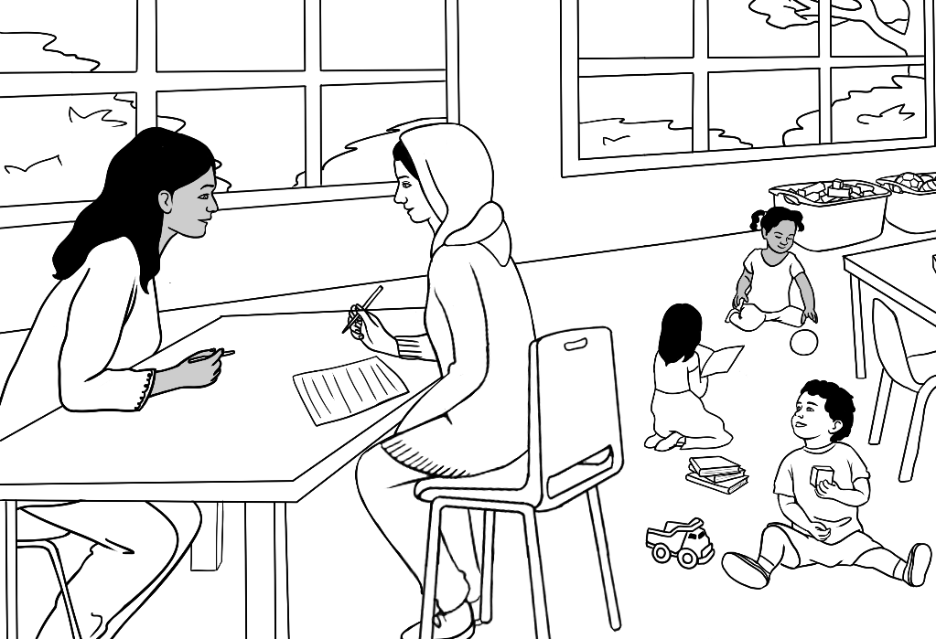

Forms, bills and identity cards

Forms
The details on each form can be altered. A blank form follows
each completed form.

- Enrolment forms
First name | Jamila
Family name | Desta
Address
Street | 56 North Street
Suburb | Kellivale
Postcode | 2421
Phone | 0 | 4 | 0 | 8 |  | 6 | 2 | 9 |  | 5 | 3 | 1
Course in Initial EAL

First name
Family name
Address
Street
Suburb
Postcode
Phone

Course in EAL

TAFE
Student Enrolment Form

PLEASE USE CAPITAL LETTERS.
Tick the box.
- Family name |  | ELMI
- First name |  | SAHRA
- Title |  | Mr | Miss | Mrs | Ms
- Country of birth |  | SOMALIA
- Date of Birth |  | 07. 07. 1996
- Address | Street | UNIT 6, 50 BAKER ROAD
- Address | Suburb | KELLIVALE
- Address | Postcode | 2421
- Phone number |  | 0455 961 259
- Signature |  | Sahra Elmi

TAFE
Student Enrolment Form

PLEASE USE CAPITAL LETTERS.
Tick the box.
- Family name
- First name
- Title |  | Mr | Miss | Mrs | Ms
- Country of birth
- Date of Birth
- Address | Street
- Address | Suburb
- Address | Postcode
- Phone number
- Signature

Certificate 1 in EAL


Student Enrolment Form
Kellivale
Community
Centre

Please use CAPITAL LETTERS. Tick the box.
First name |  |  | PARWANA
Family name |  |  | SAIKAL
Gender |  |  | Male Female Other
Date of birth |  |  | 09 / 05/ 1998
Country of birth |  |  | Afghanistan
Date of arrival in Australia |  |  | 12 / 01/ 2023
Address | Street |  | 48 BAKER ROAD
Address | Suburb/Town |  | KELLIVALE
Address | Postcode |  | 2421
Phone number |  |  | 0476 756 932
Email address |  |  | Parwana27@gmail.com
Signature |  | PSaikal |  | Date | 2023

Kellivale
Community
Centre
Student Enrolment Form

Please use CAPITAL LETTERS.
First name
Family name
Gender |  |  | Male Female Other
Date of birth
Country of birth
Date of arrival in Australia
Address | Street
Address | Suburb/Town
Address | Postcode
Phone number
Email address
Signature |  |  |  | Date

- An application for a volunteer tutor
AMEP
Volunteer Tutor Scheme
Application for a Volunteer Tutor

Use BLOCK LETTERS and a black pen. Tick the box.

Family Name: SAIKAL
Given Name: RAHIM

Gender : Male Female Other

Date of Birth: 7 May 2003
Country of birth: AFGHANISTAN
Language: PASHTO
Address Street: 48 BAKER RD
Suburb: KELLIVALE Postcode: 2421
Phone number: 0469 883 412
Email: rahims003@gmail.com
Emergency Contact Name: AMINA TARUKH
Emergency Contact relationship: MOTHER
Emergency Contact Phone: 0466 379 142

Signature: RSaikal

AMEP
Volunteer Tutor Scheme
Application for a Volunteer Tutor

Use BLOCK LETTERS and a black pen. Tick the box.

Family Name: ____________________________
Given Name: ____________________________

Gender : Male Female Other

Date of Birth: ____________________________
Country of birth: ____________________________
Language: ____________________________
Address Street: ____________________________
Suburb: ____________________________Postcode: _________
Phone number: ____________________________
Email: ____________________________
Emergency Contact Name: ________________________
Emergency Contact relationship: ________________________
Emergency Contact Phone: ________________________

Signature: ________________________

- A hospital patient form [This form contains a deliberate error.]

Kellivale Hospital Patient Form

Write in CAPITAL LETTERS.

Tick the box.

Title Mr Mrs Ms Miss Other _____

Family Name RADI
Given Name BASAM
Date of Birth 05/08/1993
Address Unit 3, 140 Kemp Street
Suburb KELLIVALE Postcode 2421
Phone 0455 328 691
Medicare Number 3023 30453 1 Valid to 06/2031
Signature Basam Radi Date 14 / 10 /2023

Kellivale Hospital Patient Form

Write in CAPITAL LETTERS.

Tick the box.

Title Mr Mrs Ms Miss Other _____

Family Name ____________________________
Given Name ____________________________
Date of Birth ____________________________
Address ____________________________
Suburb ____________________________ Postcode _______
Phone ____________________________
Medicare Number ________________ Valid to _____________
Signature ___________________ Date ______________

- An on-line swimming class enquiry form
Kellivale Swimming Pool - Swimming Lessons

Fill in your details and we will get back to you.
First name Last name
__________________________________ ________________________________________

Phone Email
_________________________________ __________________________________________

You are enquiring about lessons for: babies toddlers children adults

Best day to contact you: Best time to contact you:
M T W Th F S Sun AM PM Anytime
SUBMIT

- A job application form


Please use CAPITALS.
Welcome to our Company
New Employee Form

First Name |  | Last Name |  |  |  | Date of Birth
NABI |  | SAIKAL |  |  |  | 16.11.1975
Mobile Number |  |  |  | Email Address
0462 595 751 |  |  |  | NabSaikal@gmail.com

Tax Details

Tax File Number
758 246 229

Bank Details

Account Name |  | BSB |  | Account Number
NABI SAIKAL |  | 6322 |  | 1019 4793

Superannuation Fund Details

Superannuation Fund Name |  | Member Number
Cbus Super |  | 5629 3311

Emergency Contact
Emergency Contact Name |  | Phone Number
AMINA TARUKH |  | 0498 726 555

Address |  | Relationship
48 BAKER ROAD, KELLIVALE |  | WIFE

I have read and understand the position description and code of conduct.
Signature: Nabi Saikal
Date: 10. 09. 2024

Please use CAPITALS.
Welcome to our Company
New Employee Form

First Name |  | Last Name |  |  |  | Date of Birth
Mobile Number |  |  |  | Email Address

Tax Details

Tax File Number

Bank Details

Account Name |  | BSB |  | Account Number

Superannuation Fund Details

Superannuation Fund Name |  | Member Number

Emergency Contact
Emergency Contact Name |  | Phone Number

Address |  | Relationship

I have read and understand the position description and code of conduct.
Signature: ____________________________________________
Date: _________________________

Bills
The details on each bill can be altered.



Electricity Account
Customer Number 682-3651

Due Date
Amount Due
Mrs L Wu
70 Wattle Street
Kellivale NSW


Electricity Account
Customer Number 687-4189

Due Date 24 Sept 2022
Amount Due $125.00
Mr T Dihoud
6/50 Baker Road
Kellivale NSW


Gas Account
Customer Number 674-6598
Due Date 12 June 2022
Mrs L Wu
70 Wattle Street
Kellivale NSW
Amount Due $128.00


Gas Account Account
Customer Number 676-3077

Due Date 14 June 2022
Mr T Dihoud
6/50 Baker Road
Kellivale NSW
Amount Due $226.00

Identity cards
The details on each ID card can be altered.



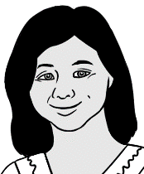

LICENCE NO.
001679284

Expiry Date
29-10-2027
JAMES LEE
76 SOUTH ROAD
KELLIVALE NSW 2421

Licence Type
HR

HEAVY VEHICLE DRIVER LICENCE
New South Wales, Australia
Date of Birth
08-11-1992
James Lee

LICENCE NO.
001563219

Expiry Date
21-02-2025
AHMAD HAMED
260 NORTH ST
KELLIVALE NSW 2421

Licence Type
R

DRIVER LICENCE
New South Wales, Australia
Date of Birth
30-06-2001
Ahmad Hamed

Card No
040369251

Expiry Date
23-11-2026
ZARNI TUN
4 / 50 BAKER ROAD
KELLIVALE NSW 2421

Licence No
020246378

Driver Licence
New South Wales, Australia
Date of Birth
10-04-1978
Zarni Tun
- Driver licences

- Medicare cards

medicare
3056 53521 3
- LAN WU
- MAI WU
- BAO WU
VALID TO 03/2026

3082 245211 4
- JOMEH TAJIK
- PARWANA SAIKAL
- BIBI TAJIK
- MUSTAFA TAJIK
VALID TO 10/2027
medicare



AM6249377

Australian Migration Status
Australian Government ImmiCard

Date of Birth
10-04-1978
Surname
TUN
Given Names
ZARNI
ImmiCard
ImmiCard No
AM6249377

- An ImmiCard

- A healthcare card

NEW SOUTH WALES
EXPIRES
28 FEB
2028
JOMEH TAJIK
48 BAKER ROAD
KELLIVALE 2421

CRN 125_562- 997B
CARD START 28 APR 2023 JS
PARWANA SAIKAL
BIBI TAJIK
MUSTAFA TAJIK

Signature of Card Holder
Australian Government
Department of Human Services
Health
Care Card
This card is NOT transferable humanservices.gov.au/healthcarecard
Issued by the Australian Government Department of Human Services
on behalf of the Department of Social Services

- Library cards


Library Card

Basam Radi
1051356

Library Card

Amina Tarukh
1051180

- A student card

Kellivale TAFE
Student Card
Surname
TUN
Given Name
ZARNI
Student number 58973

Work – Paid and volunteer

Paid work
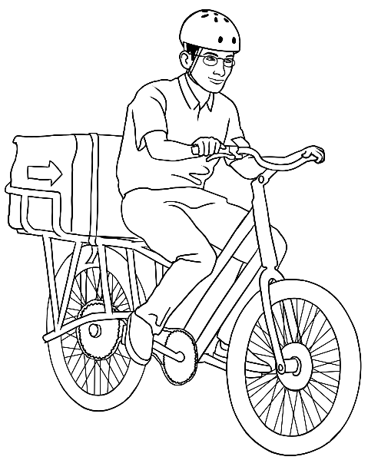  a delivery driver | 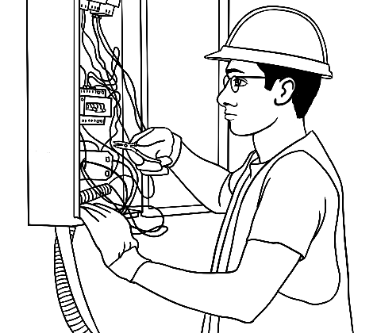  an electrician |  | 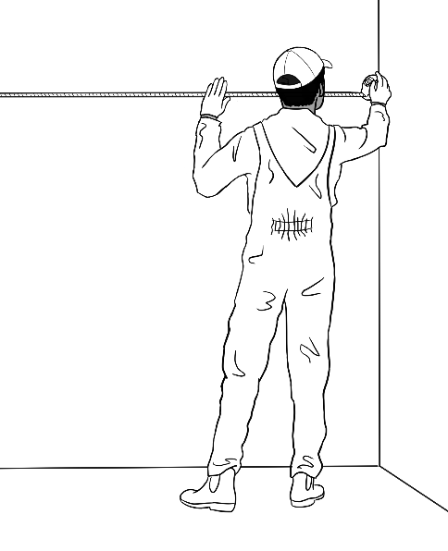  a house painter
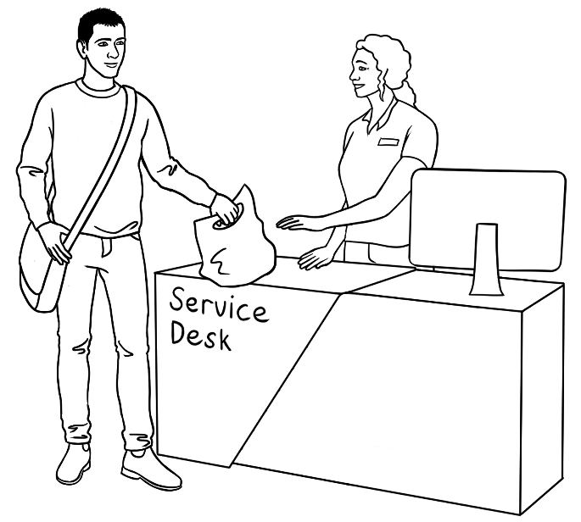  a sales assistant |  | 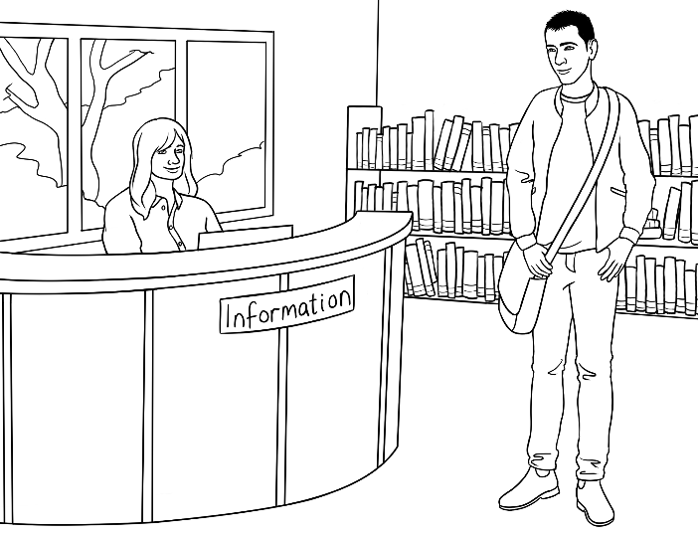  a librarian
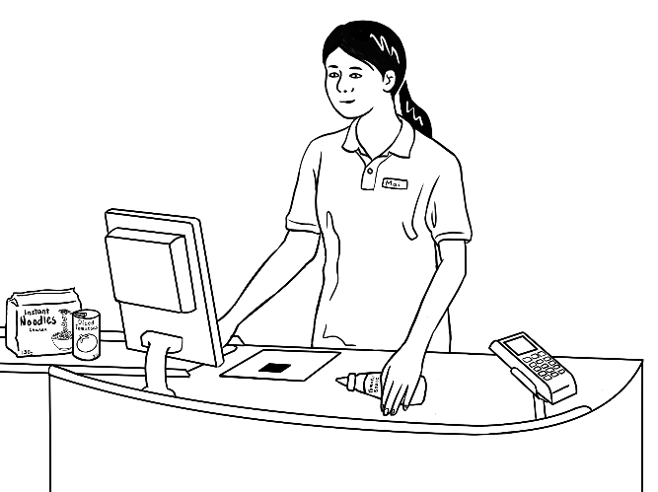  a supermarket worker |  | 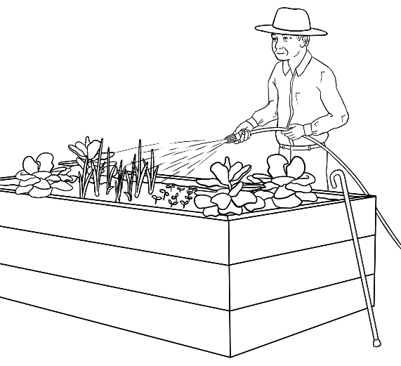  a gardener

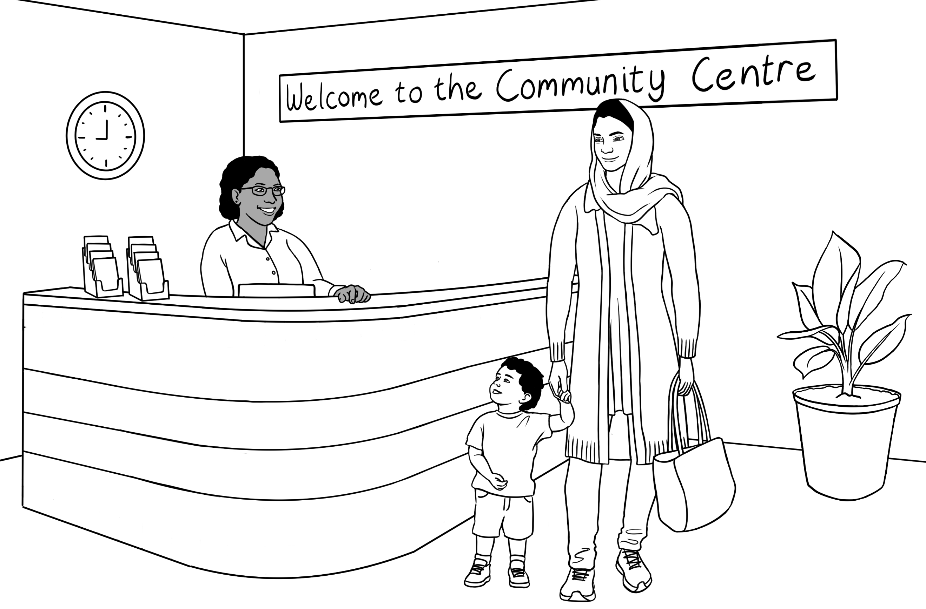  a receptionist |  | 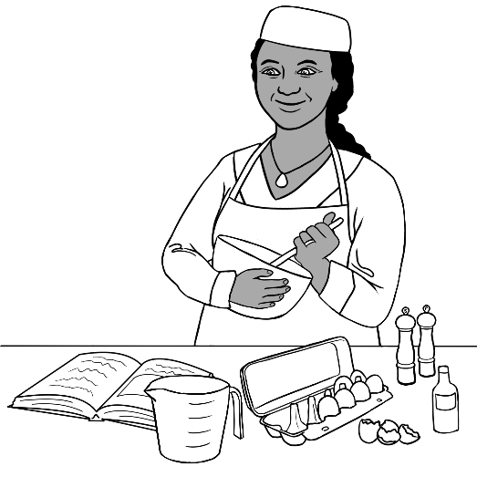  a cook
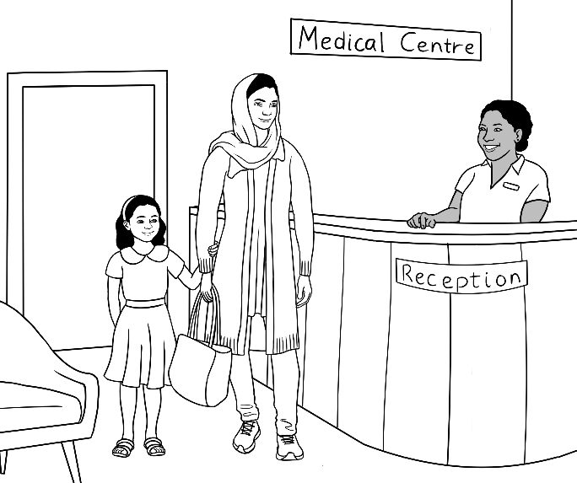  a medical receptionist | 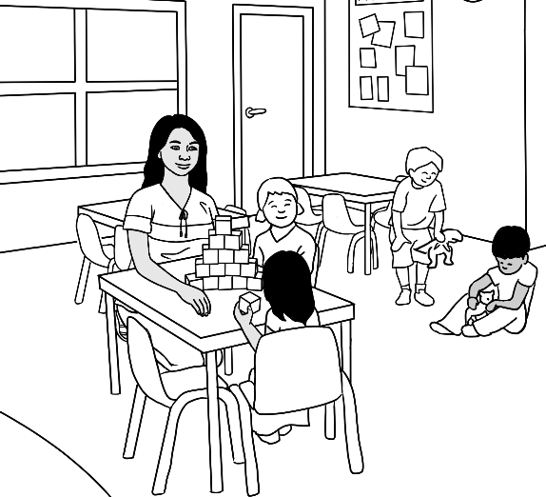  a child care worker
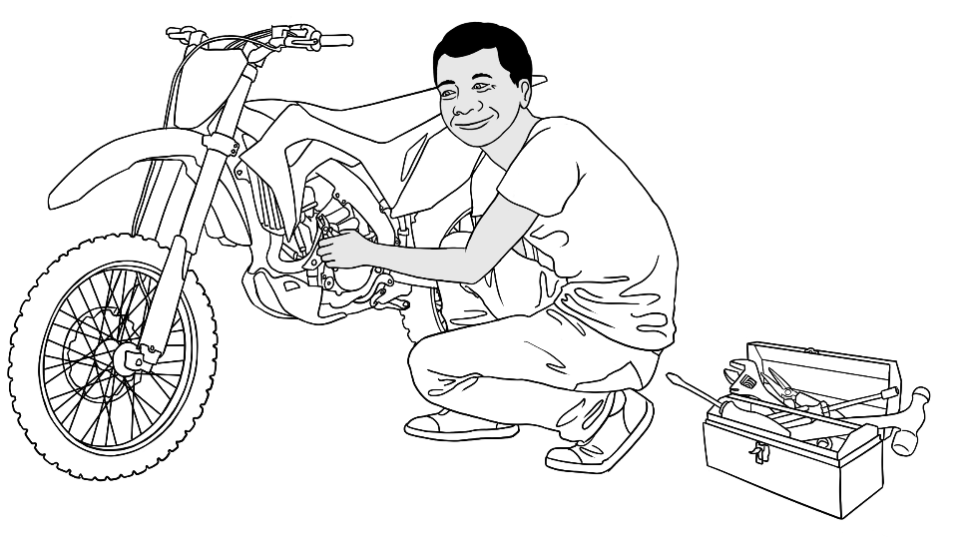  a motor bike repairman |  | 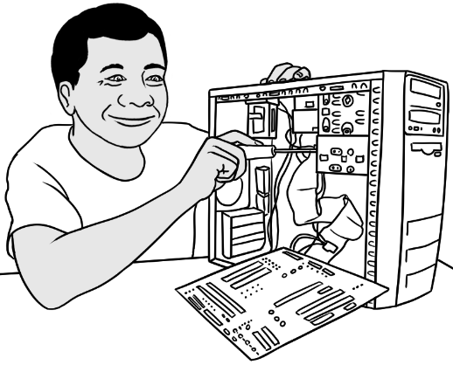  a computer repairman

a lifeguard
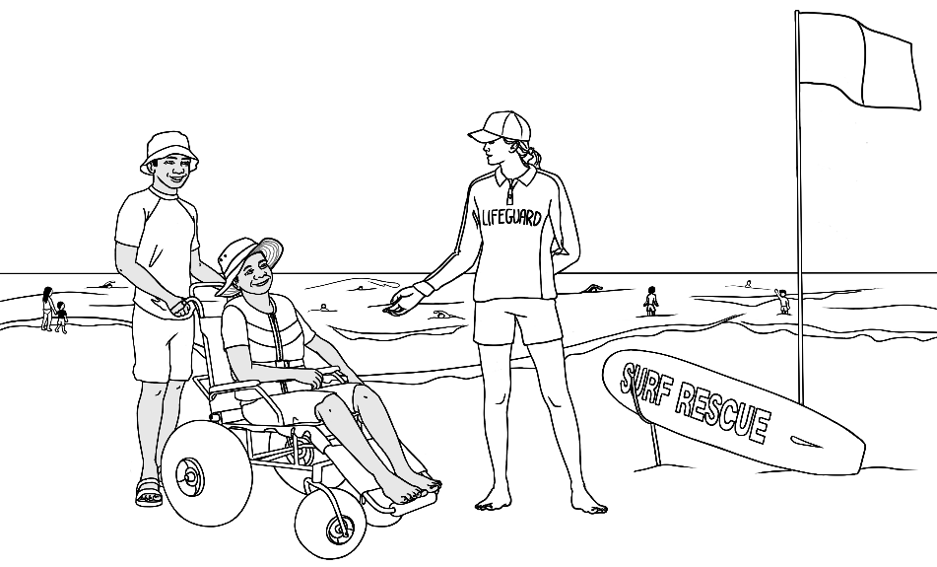
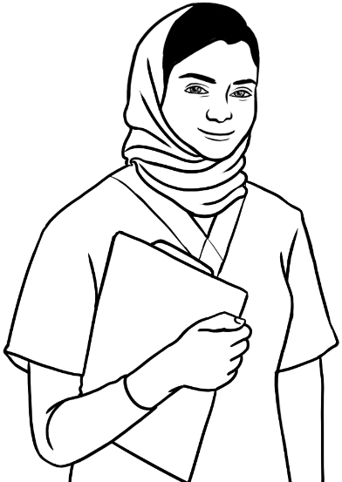  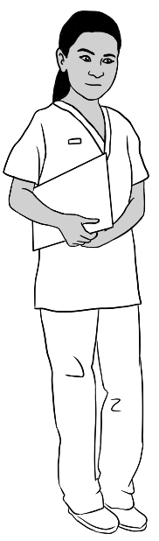  a nurse |   a doctor |  | 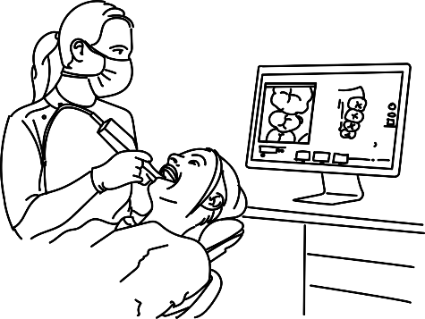  a dentist
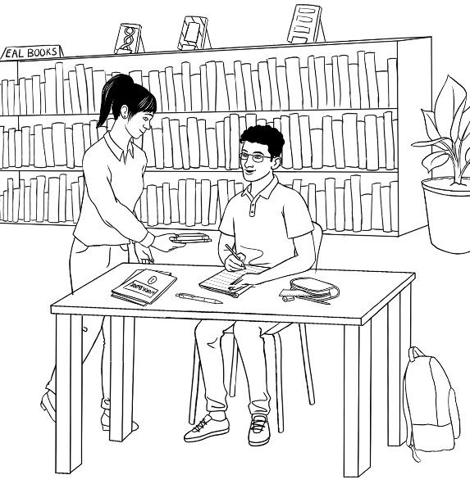  a librarian |  | 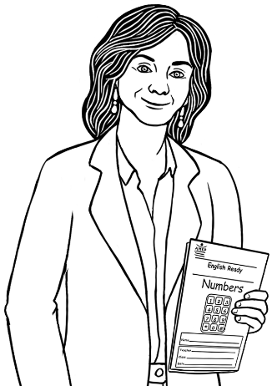  a teacher

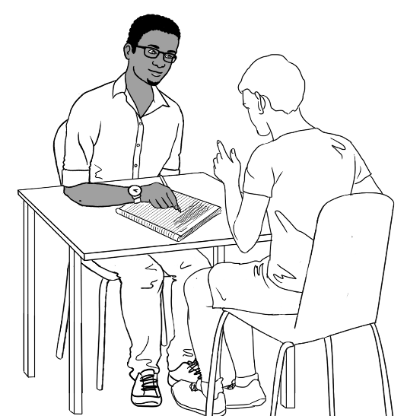
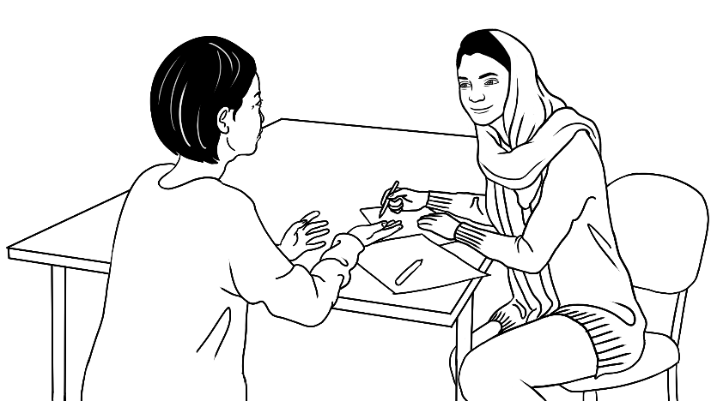
volunteer tutors
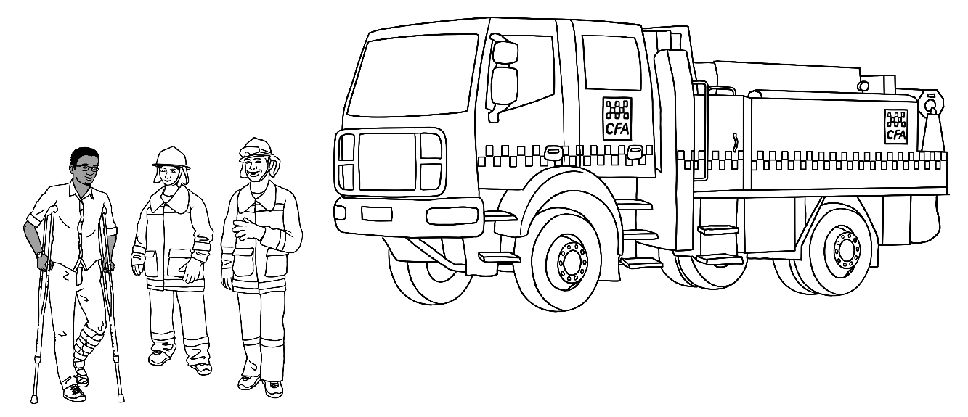
volunteer fire fighters
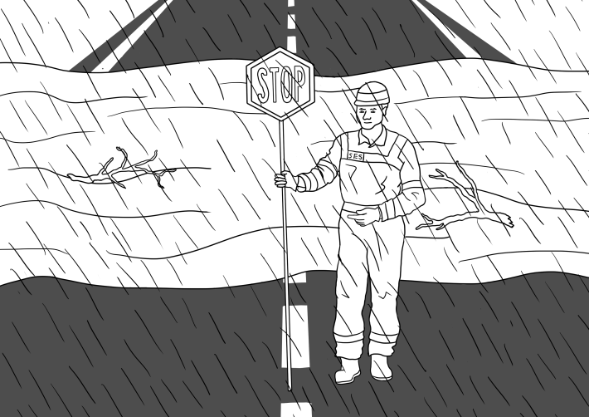  a volunteer SES worker | a volunteer lifesaver  LIFESAVER

Volunteer work

Jobs at home
Unpaid household work
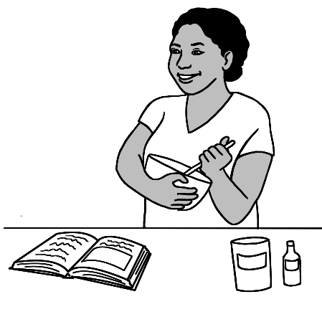 | 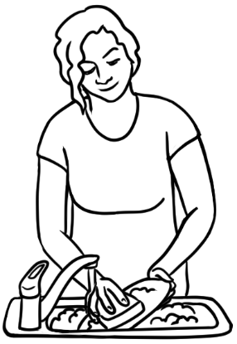 | 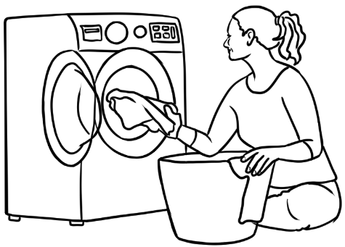
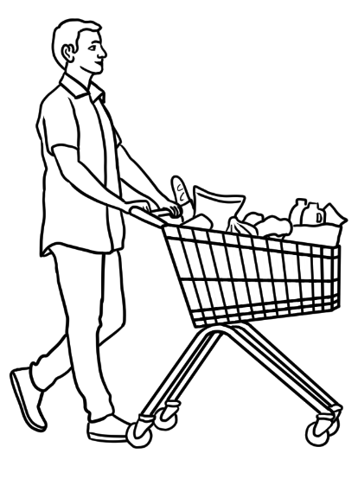  do the shopping | 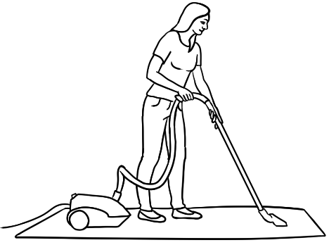 | 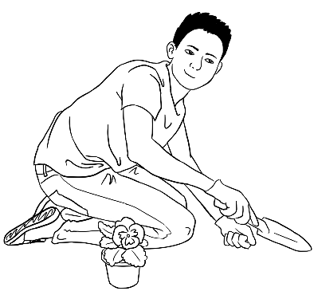
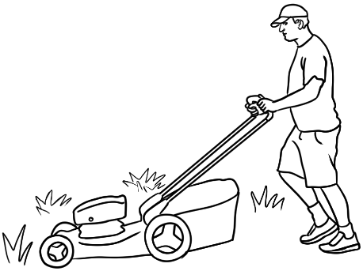 | 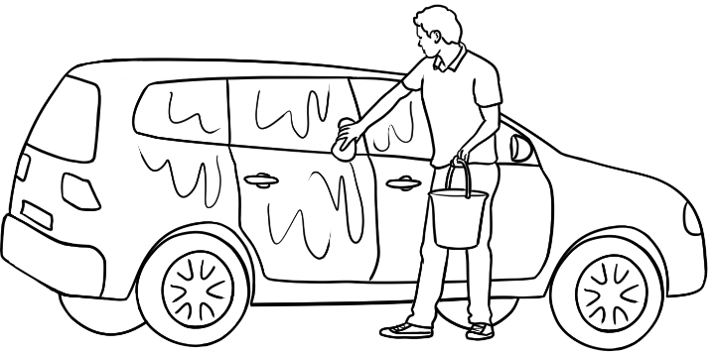

Free-time activities and sport

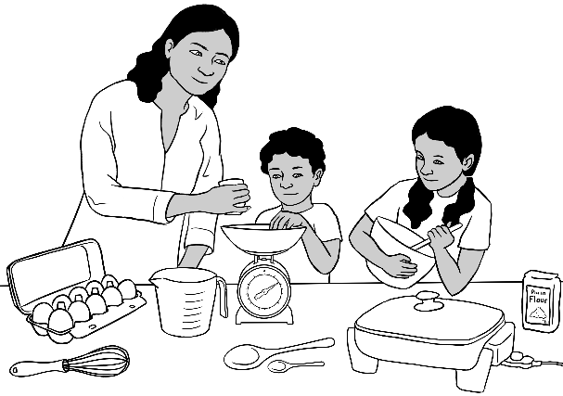  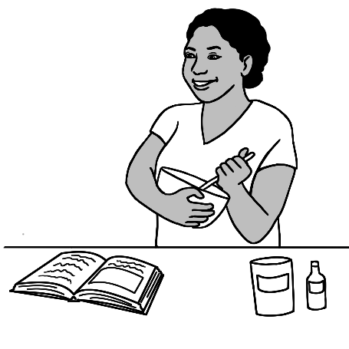  cook |  |  |   run
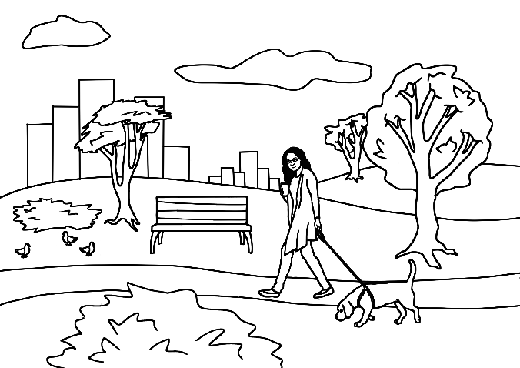  go to the park |  | 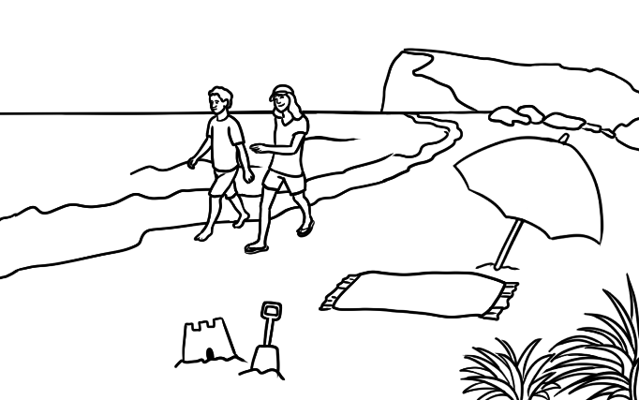  go to the beach
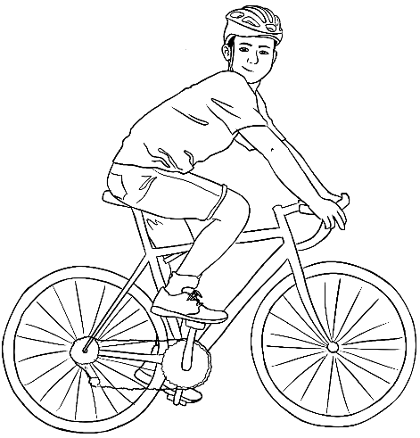  ride a bike | 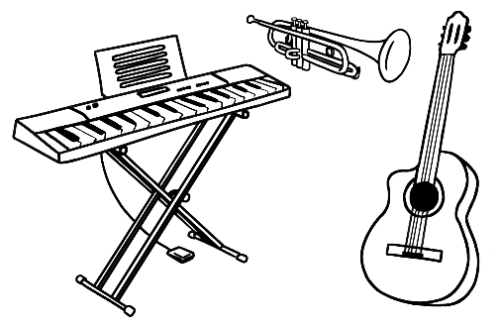  play music |  | 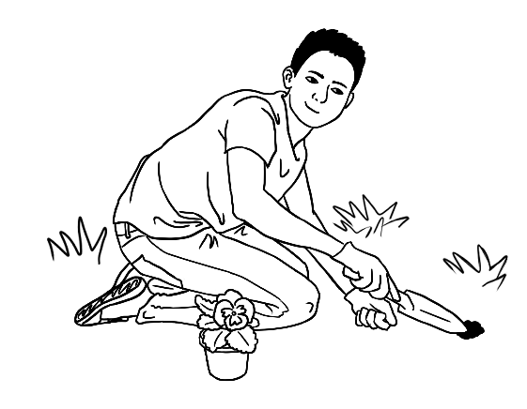  work in the garden

Free time

  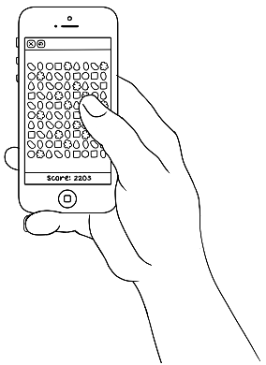  play video games |  |  | 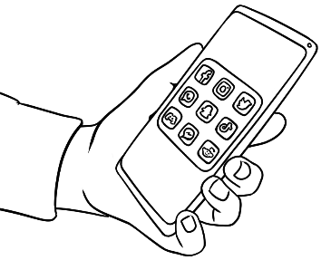  use social media
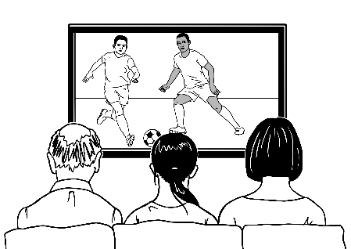  watch TV |   use the computer |  | 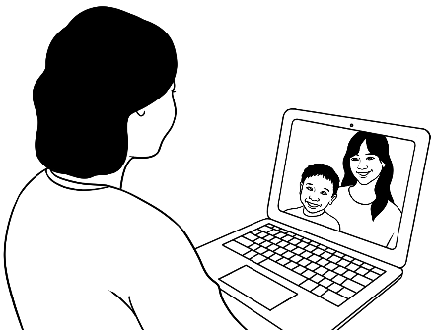  make video calls
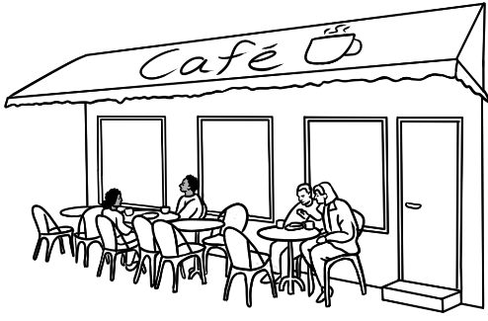  go to a cafe |  |   go to the city |  |   go shopping

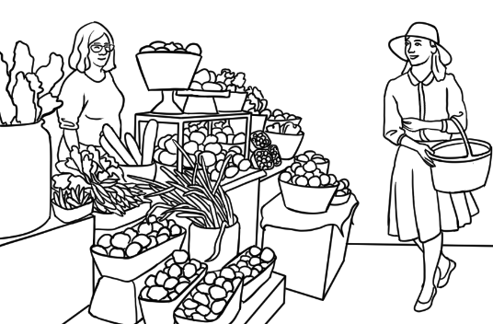  go to the market |  | 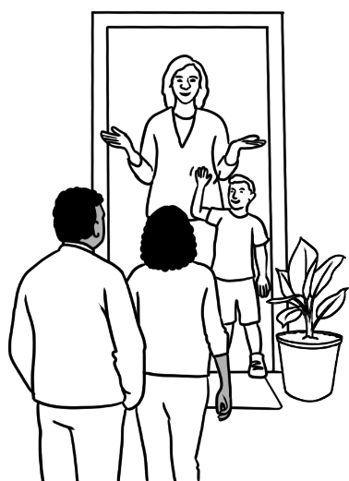  visit friends | 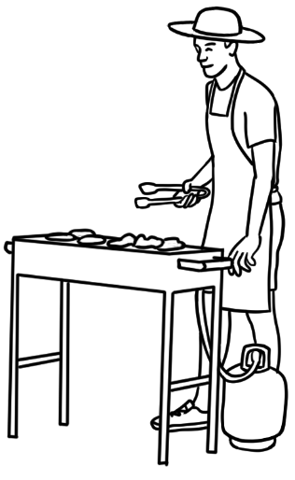  have a BBQ
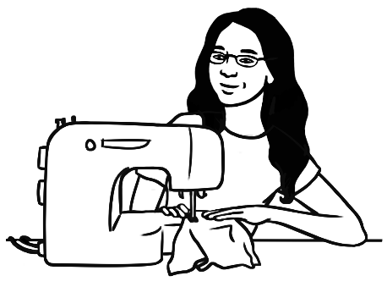  sew |   swim |  |  | 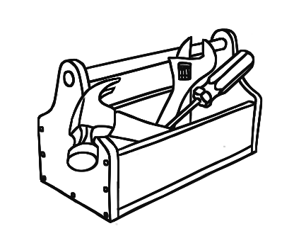  fix things
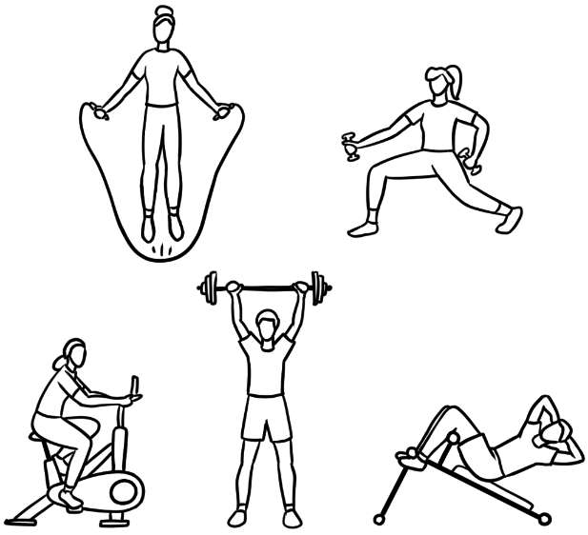  go to the gym  [do exercises] |  | 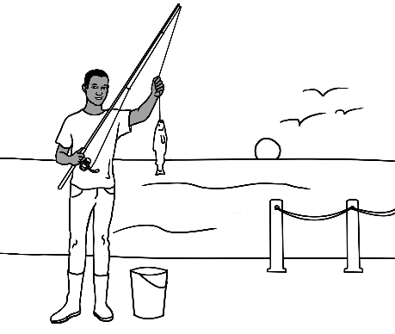  go fishing |  |  | 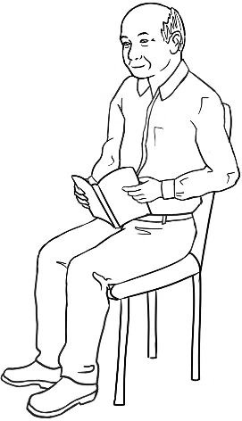  read

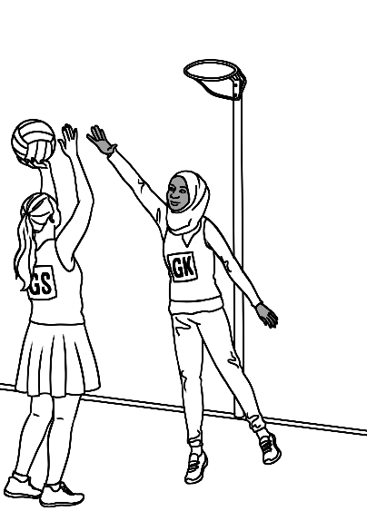  play netball |   play cricket |  | 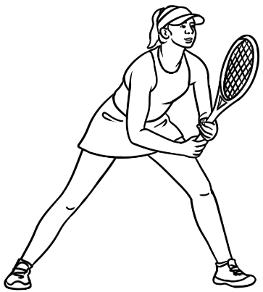  play tennis
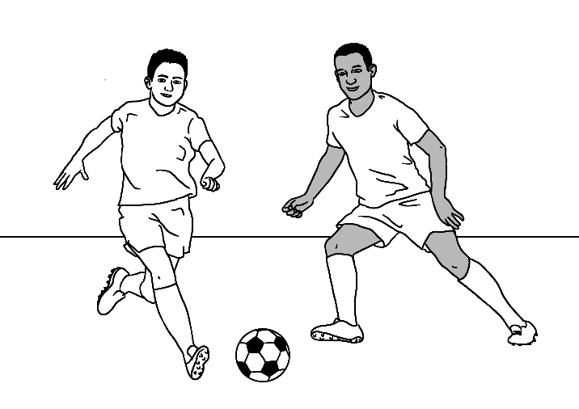  play soccer |  | 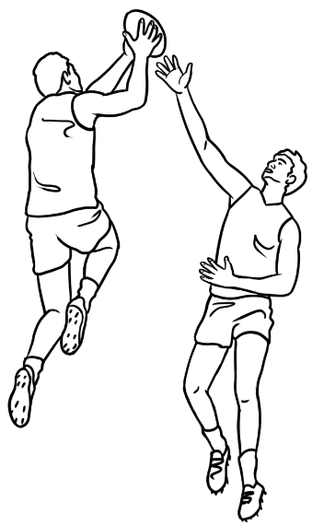  play footy |  | run
cycle |  | swim

Sport

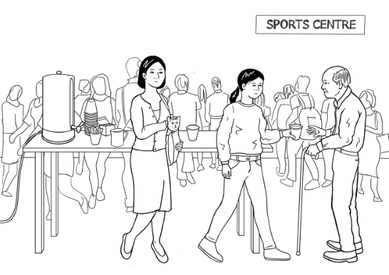

The beach

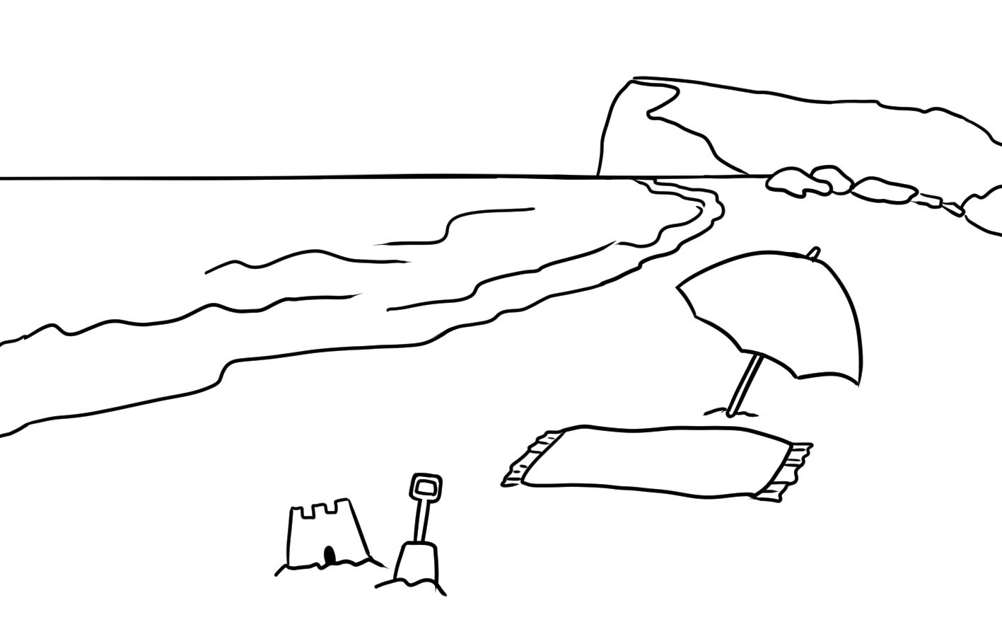
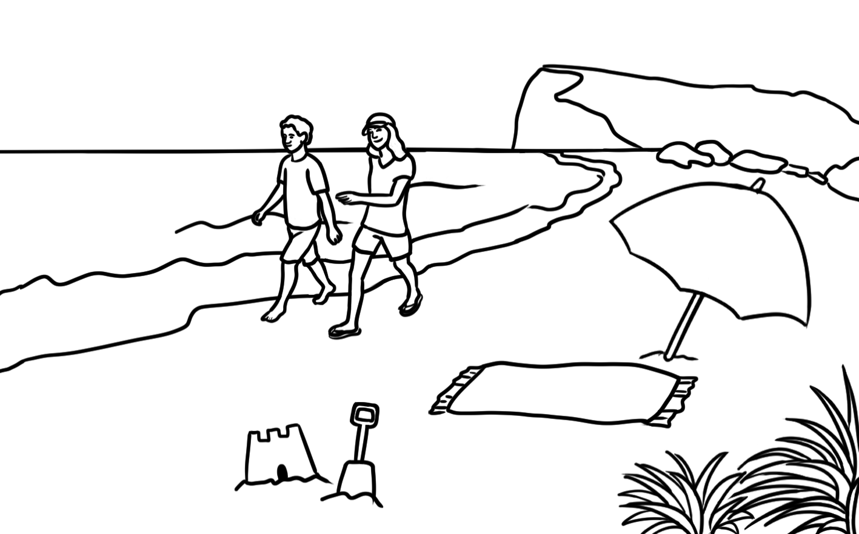

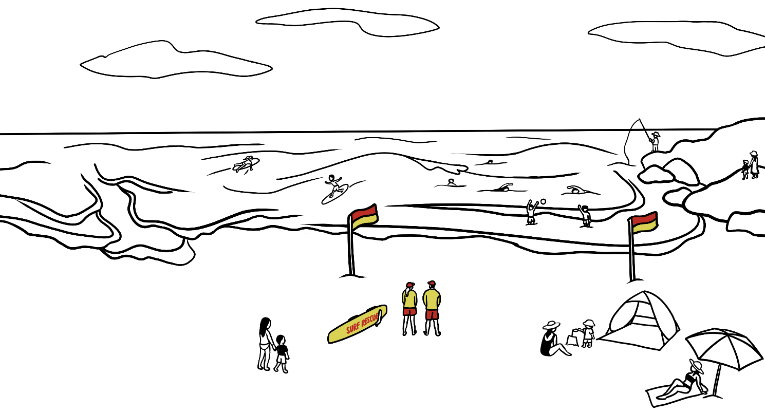
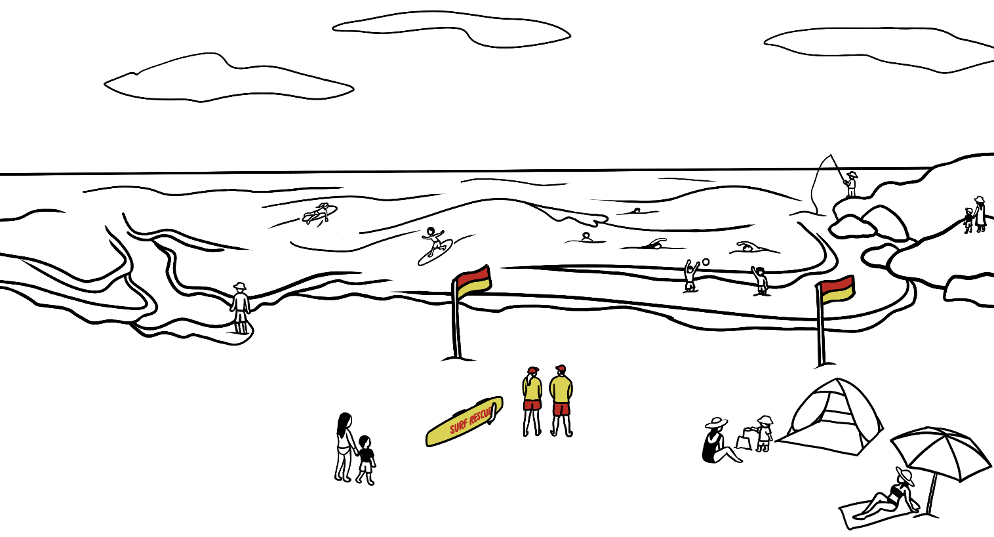

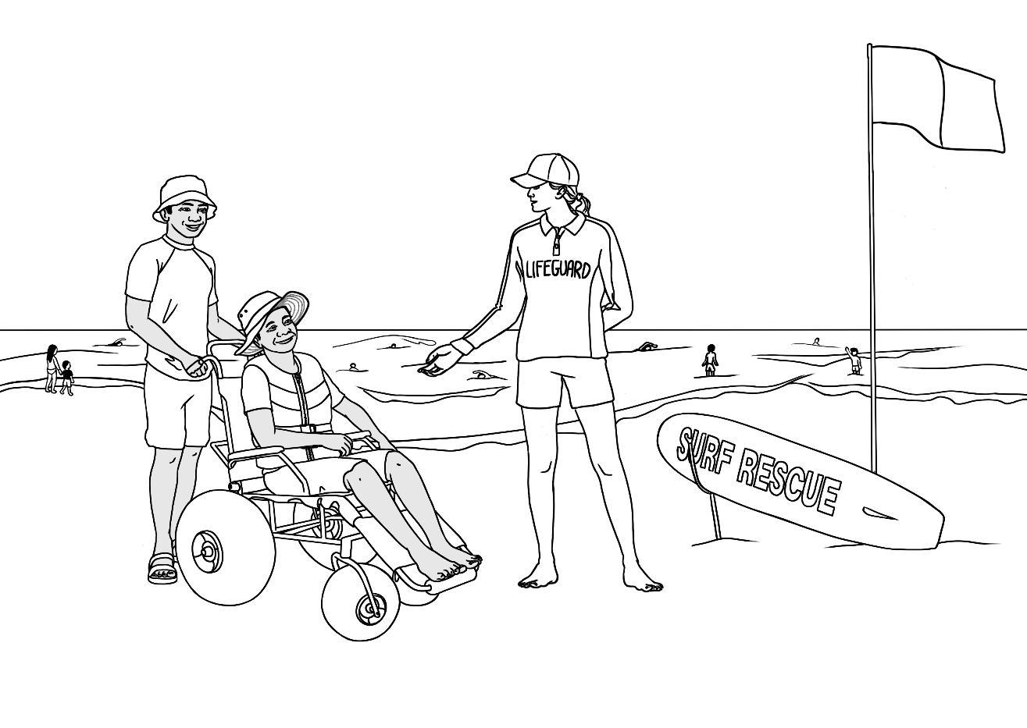
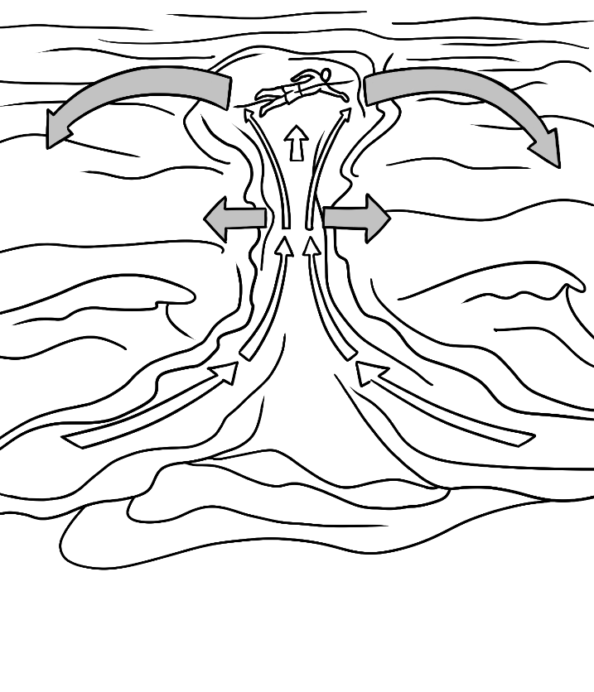
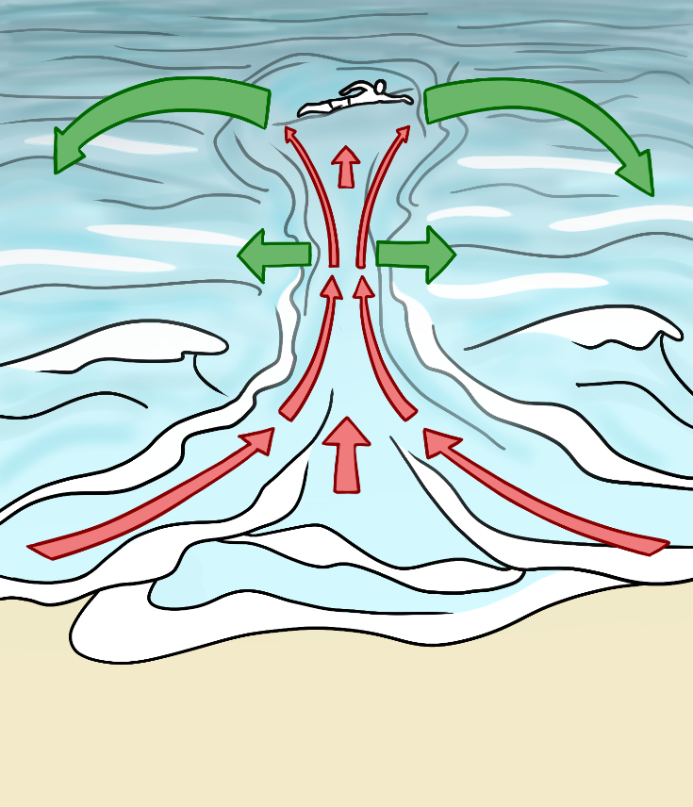

The park

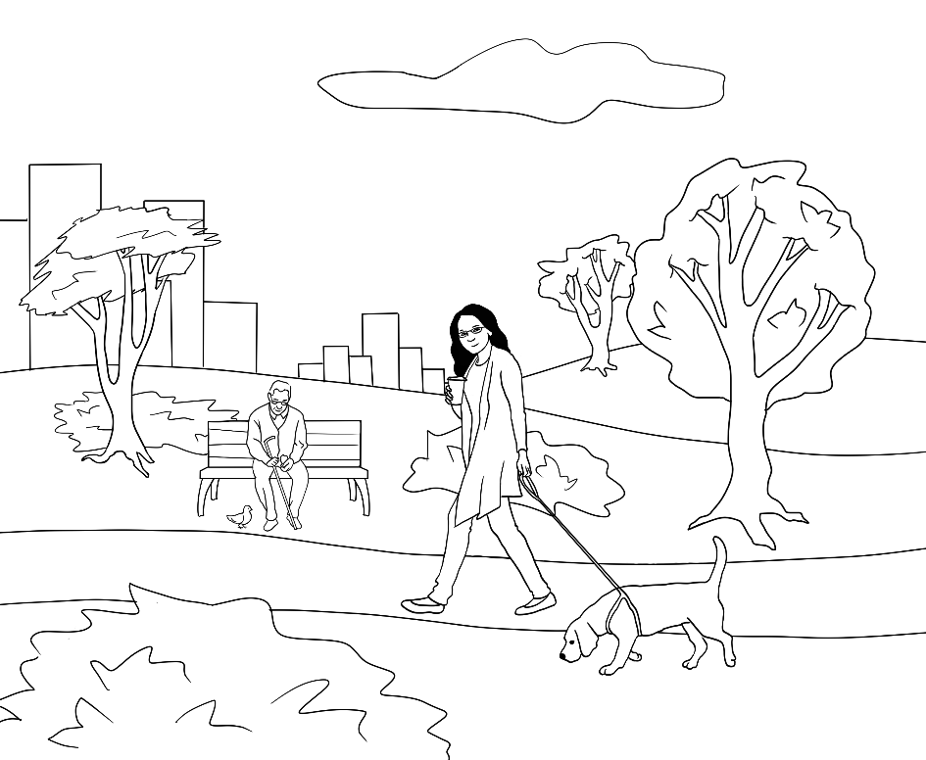 | 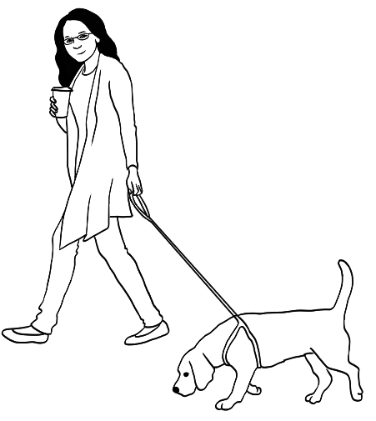
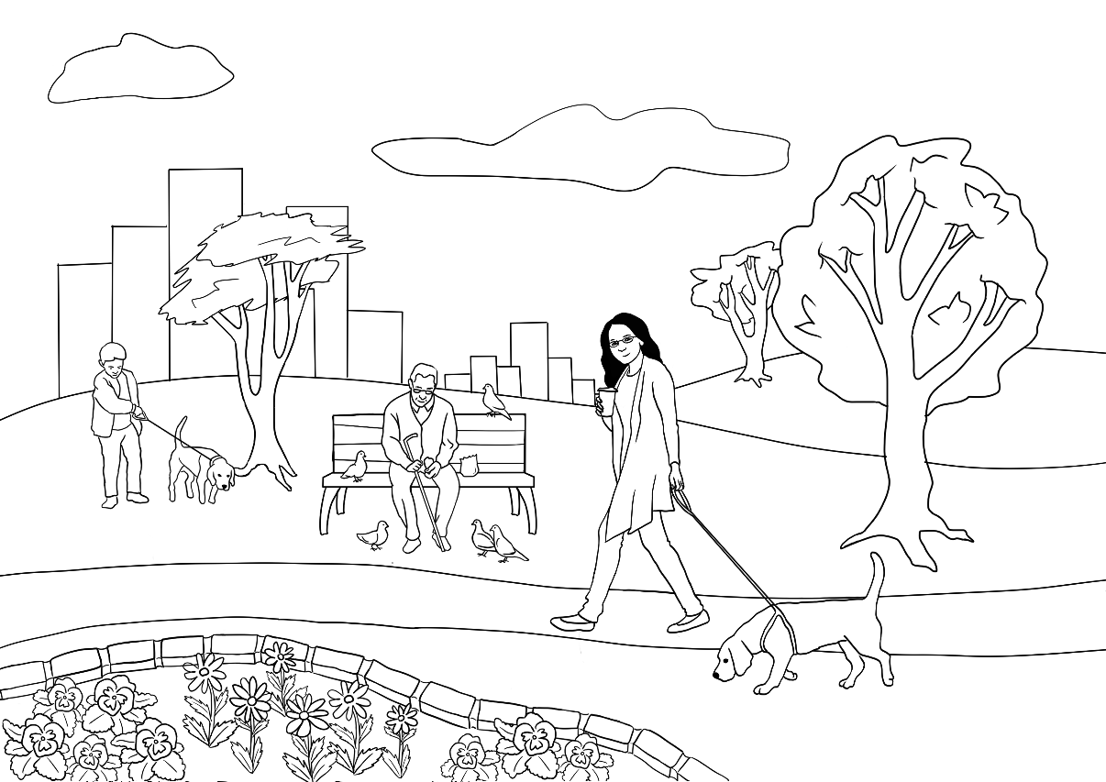
[designed for counting exercises]

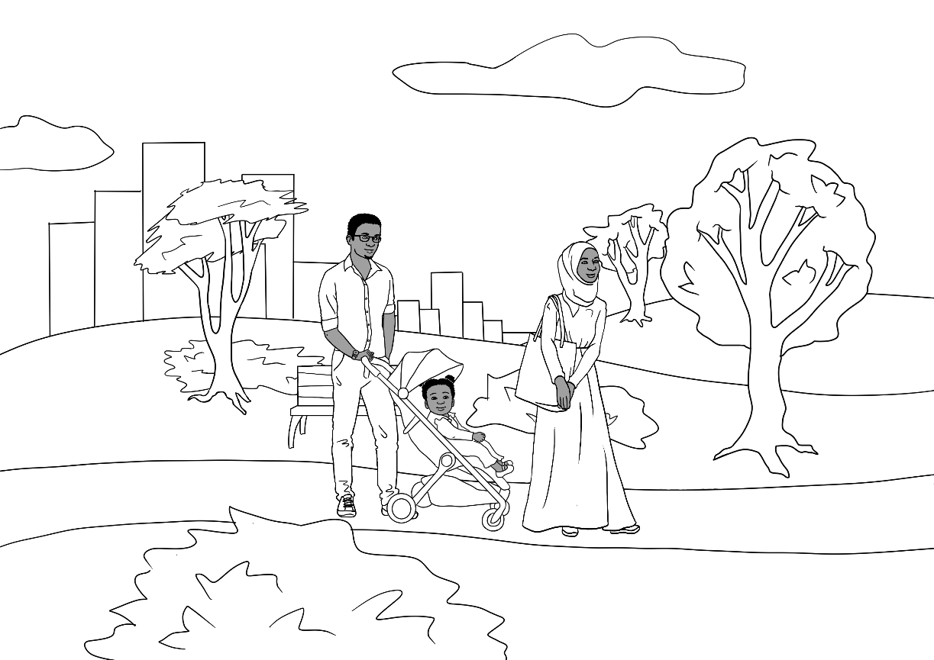 |  | 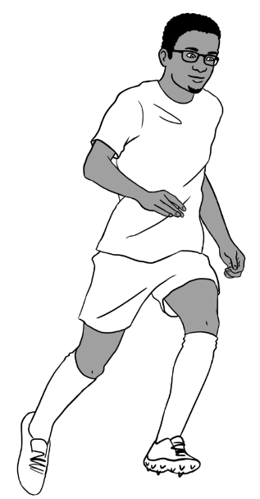
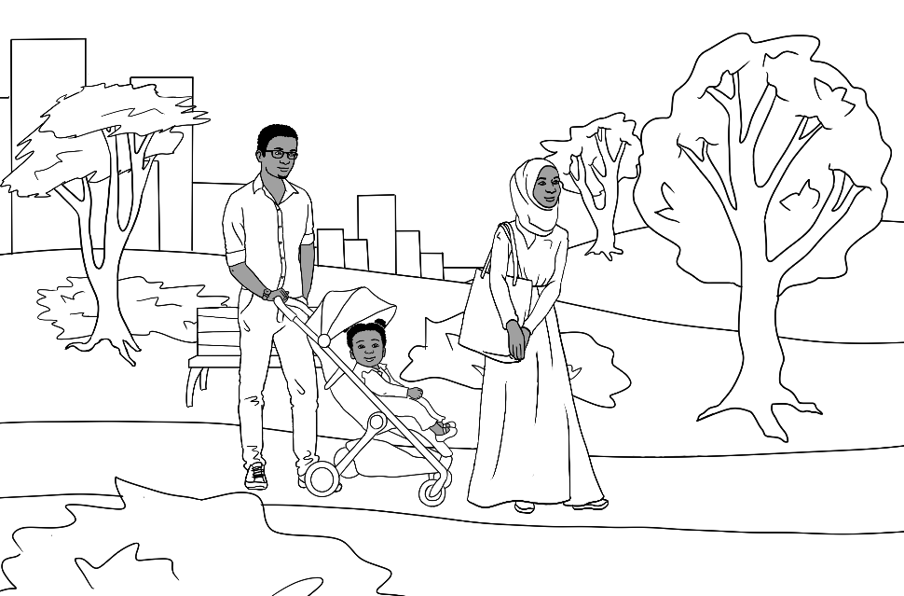 | 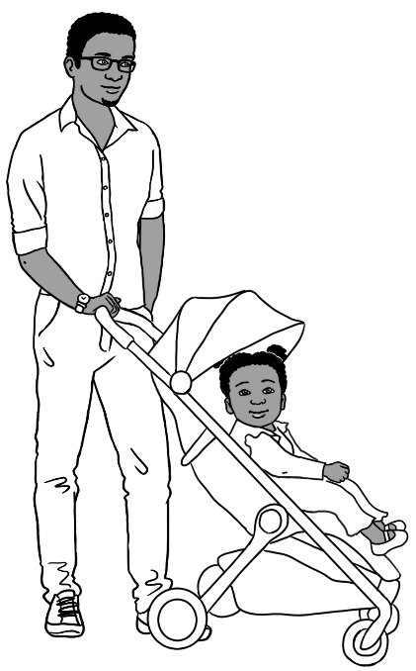

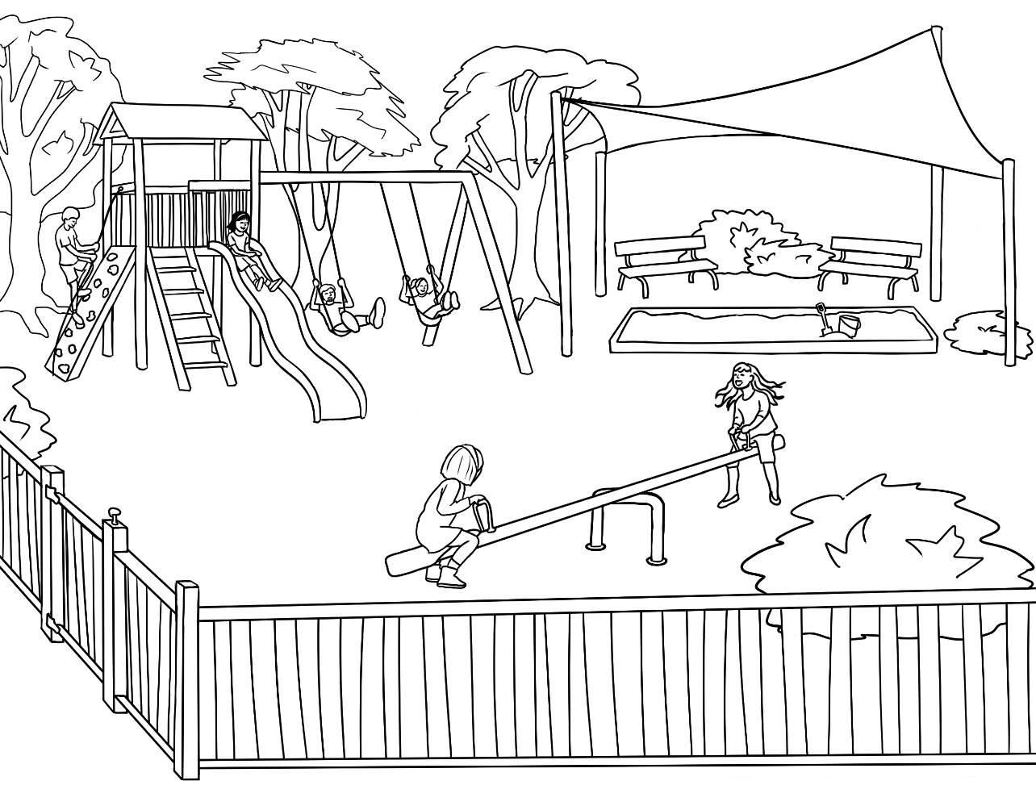
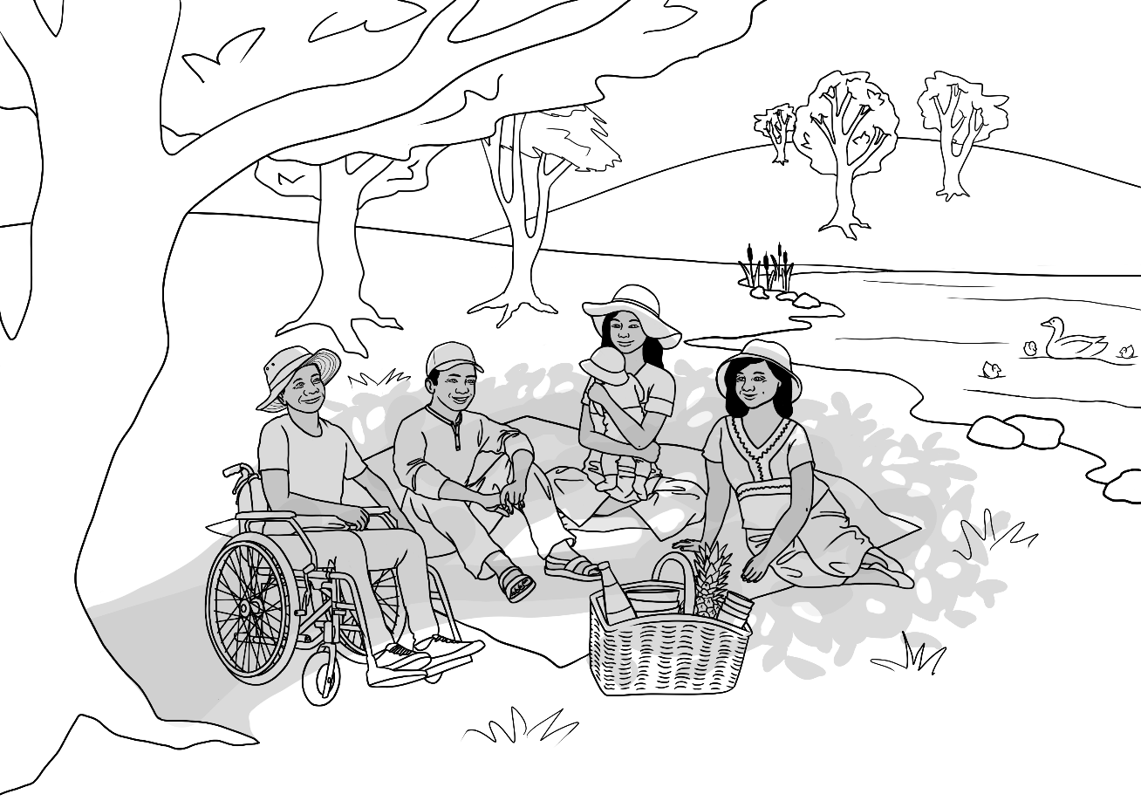

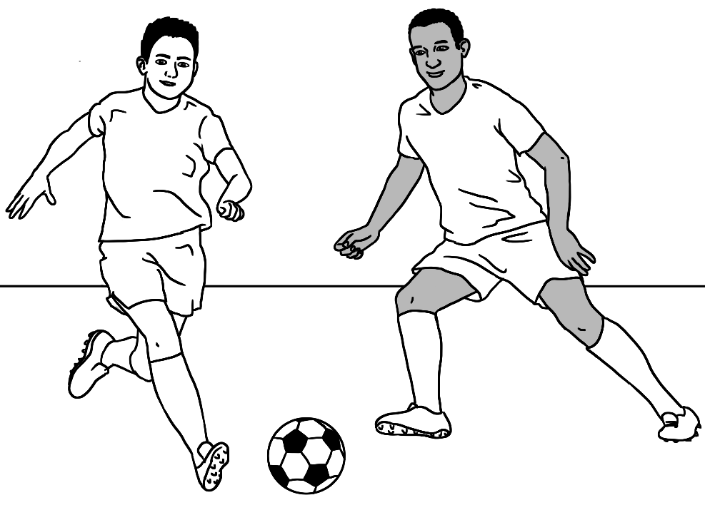
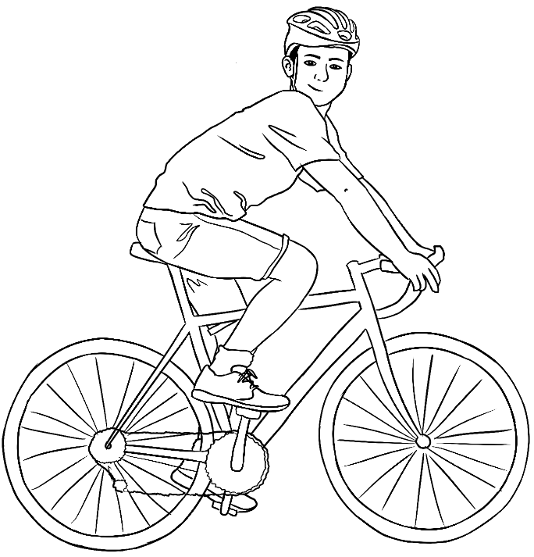

Houses and apartments

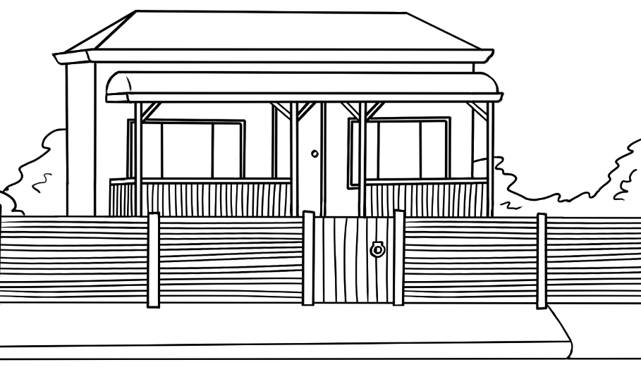 | 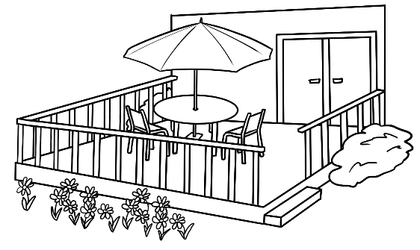
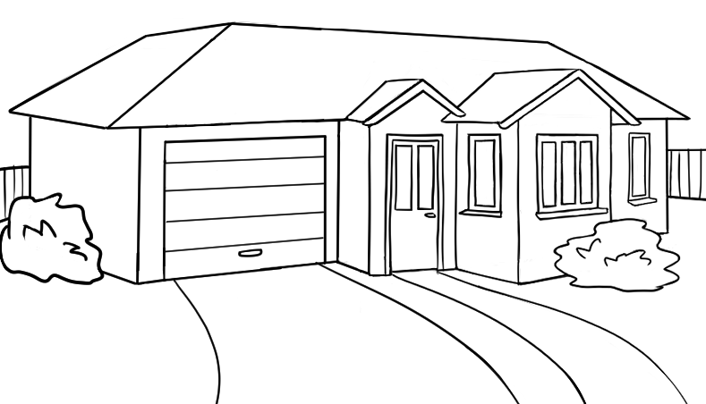
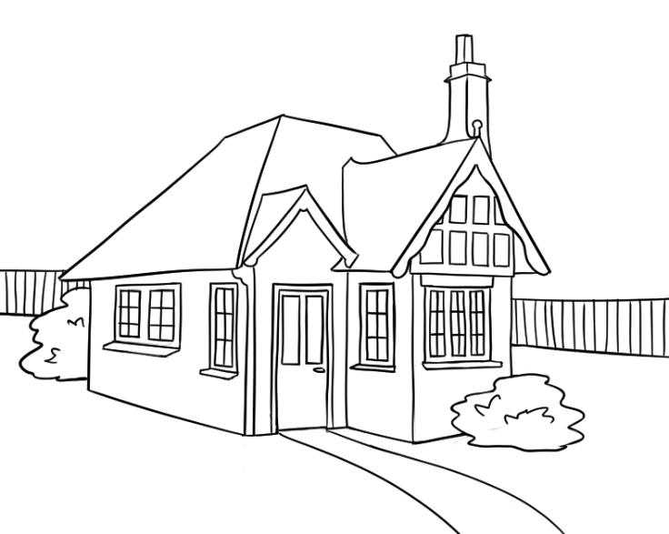

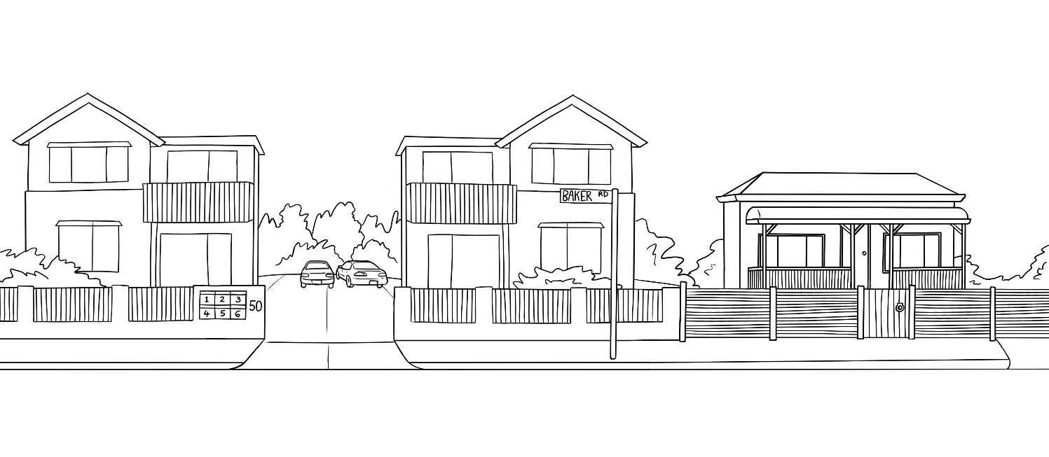
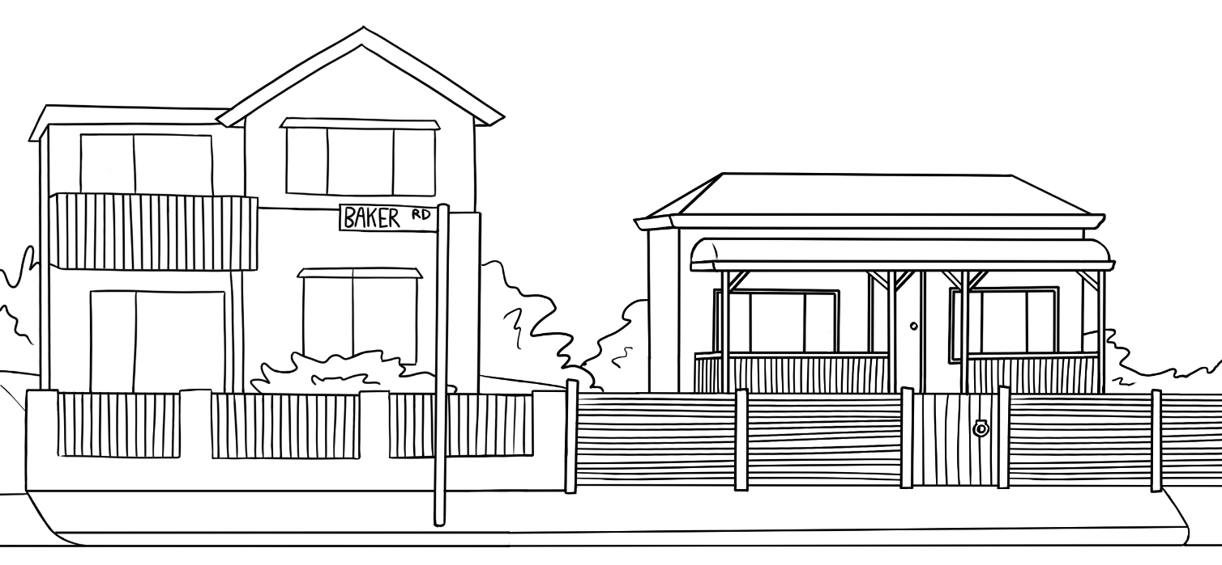

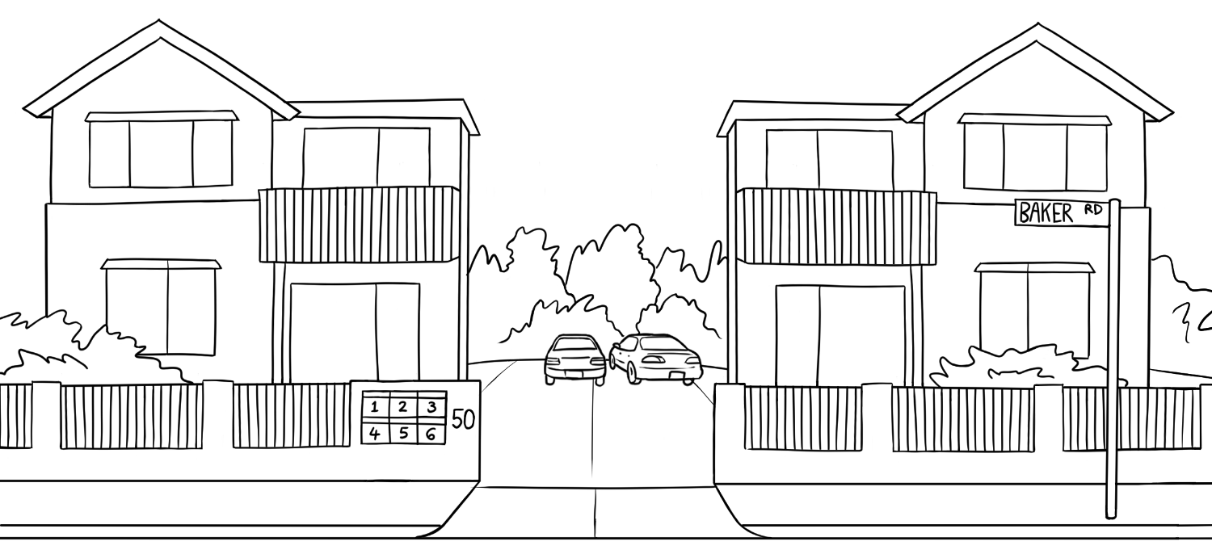
Units
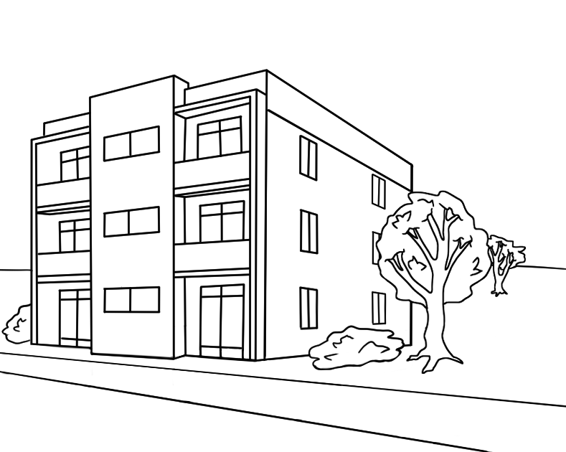
Apartments

Maps
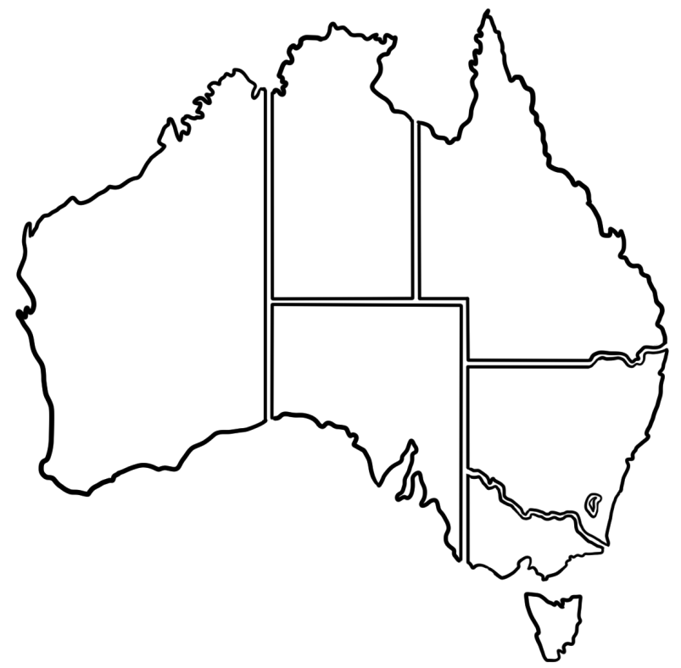

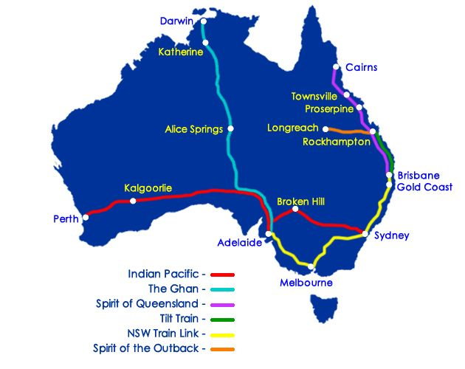

Maps

This file is licensed under the Creative Commons Attribution-Share Alike 3.0 Unported license.
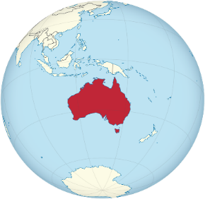


Kellivale map #1











Petrol
Station
North Street
Baker Road
Wattle Street
Kellivale
Park
Swimming
Pool
High School
Medical Centre
Soccer Ground
Childcare Centre
Supermarket
Cafe
Kemp River
Post Office
Fruit Shop


Primary School
Hardware Store
Hot Bread
Bank
Chemist
Kemp Street
Hospital

TAFE College
Community Centre

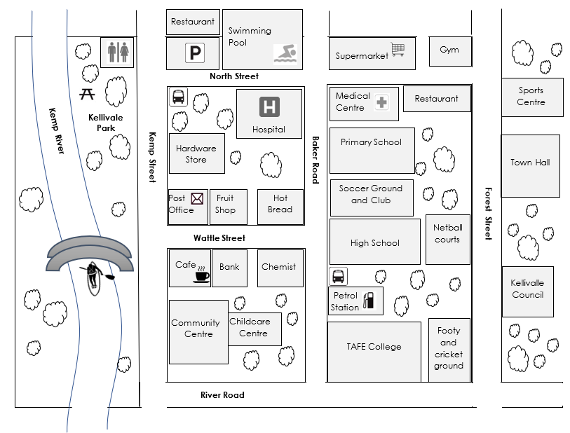
Kellivale
map #2

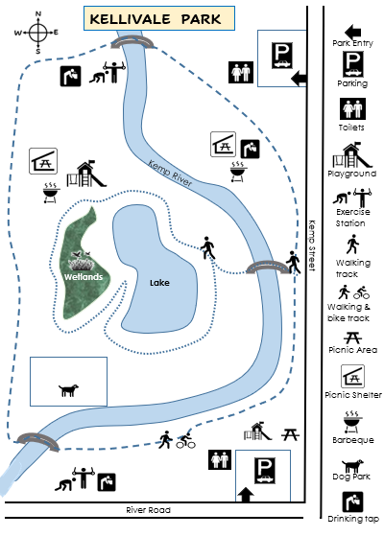

Floor plans

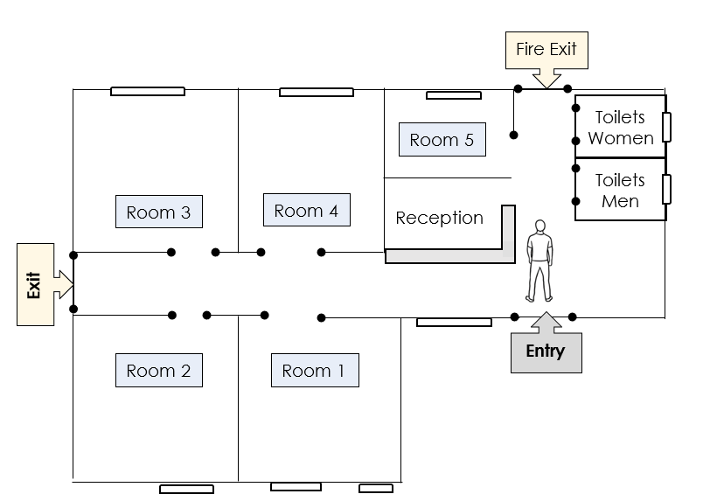
- The community centre

- The supermarket
Checkout
Beauty
Flour, Sugar
4
Sauces
Oil
3
Chocolate
2
Fruit

Vegetables
1
Specials
Entry
Exit
Cleaning
Milk
Frozen Food
Rice
Cereal

Tea
Drinks
Biscuits

Dried Fruit
Tinned Food
Meat
Toilet Paper
Deli
Health food

Eggs

Bread
Baby
Checkout

Directions

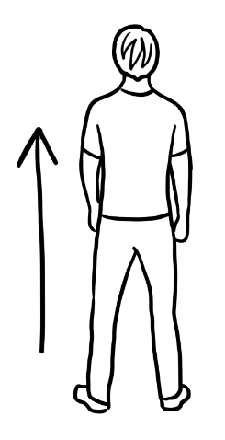  go straight ahead | 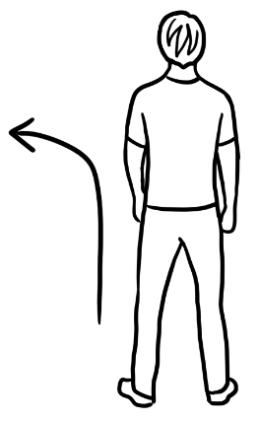  go left | 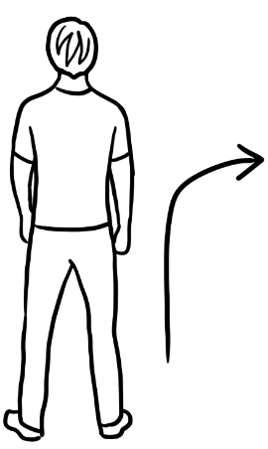  go right
  walk | 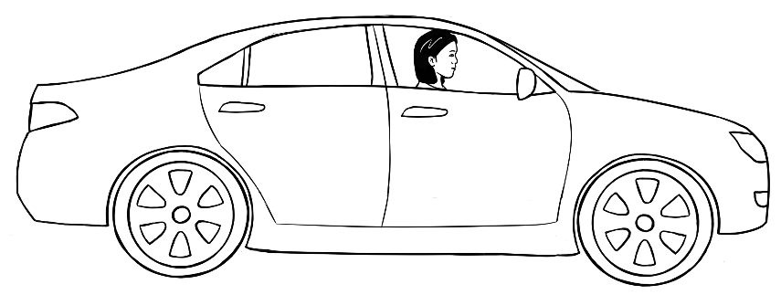  drive

Signs

At the learning centre
  1 | No smoking | 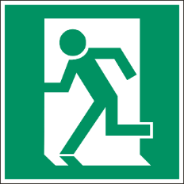  2 | Exit
  3 | Men’s toilet |   4 | Women’s toilet
  5 | No rubbish  in the toilet | 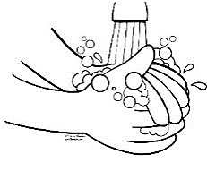  6 | Wash your hands.
  7 | Wet floor |   8 | Wear a face mask.
  9 | Turn off  the sound  on your phone. |   10 | Put rubbish  in the bin.

Road safety signs
 |  |  | 
 |  |  | 
 |  |  | 









 |  |  | 
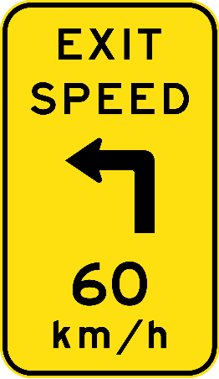 | 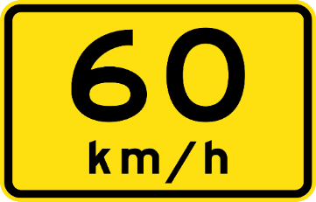 |   
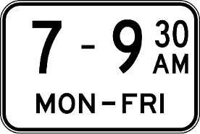 |  |  |  | 

 |  |  |  |  | 
 | 

The weather

Weather icons
sunny | rainy | cloudy
windy |   stormy

Temperature
warm |       hot | very hot
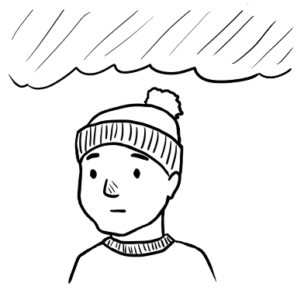  cold | 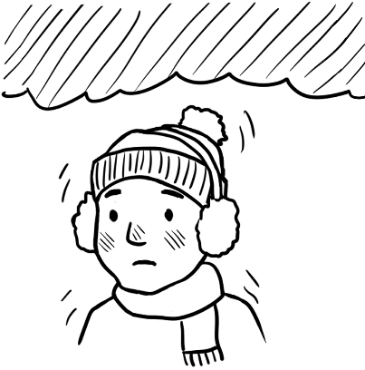  very cold

Weather scenes
Although these scenes are not used in the English Ready resources, they may be useful for supplementary work on the weather. Mai is Ming’s granddaughter. For more materials on heavy rain and floods, go to: https://ameponline.homeaffairs.gov.au/mod/page/view.php?id=84#floods-teaching-materials
1 | 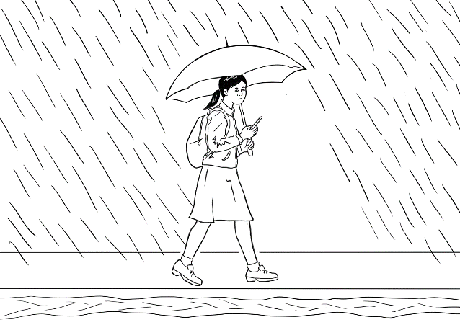  2
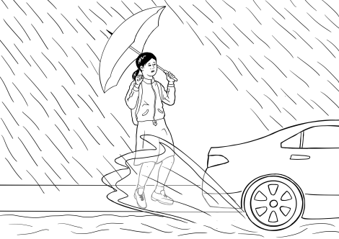  3 | 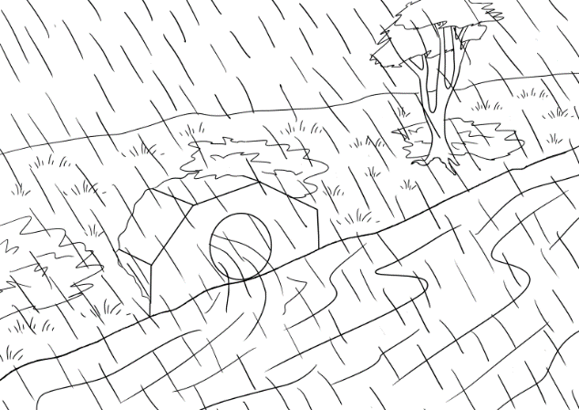  4
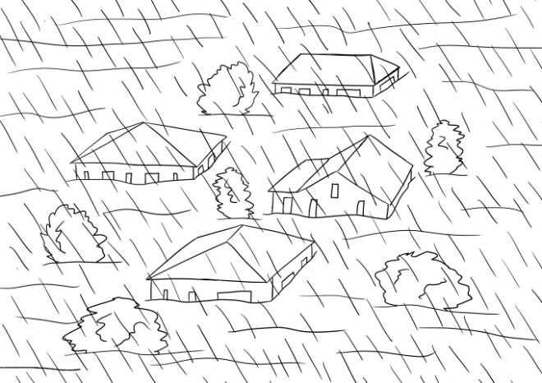  5 | 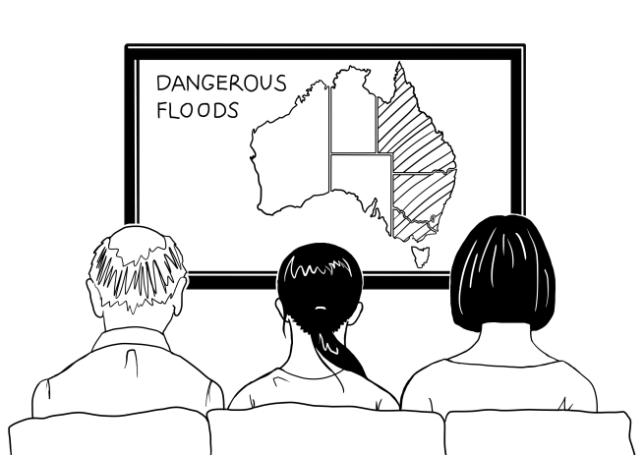  6

Medical

Medical workers
nurse |  | doctor
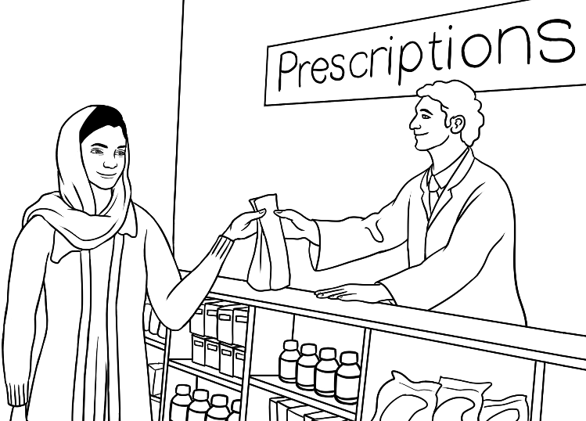  chemist | dentist

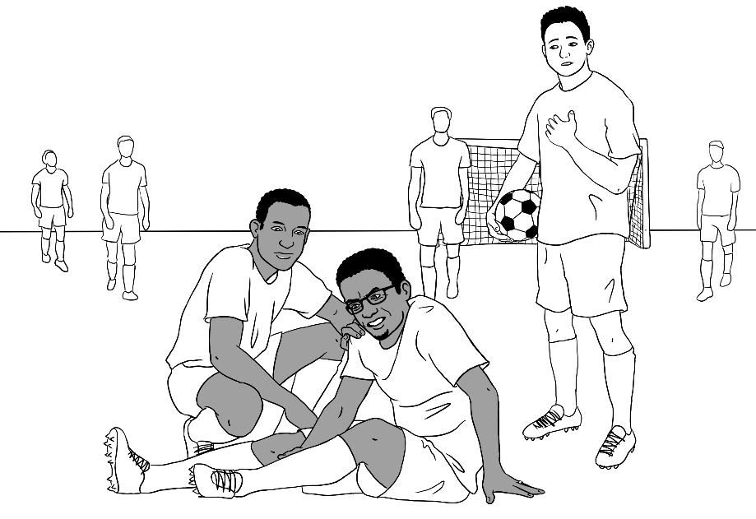
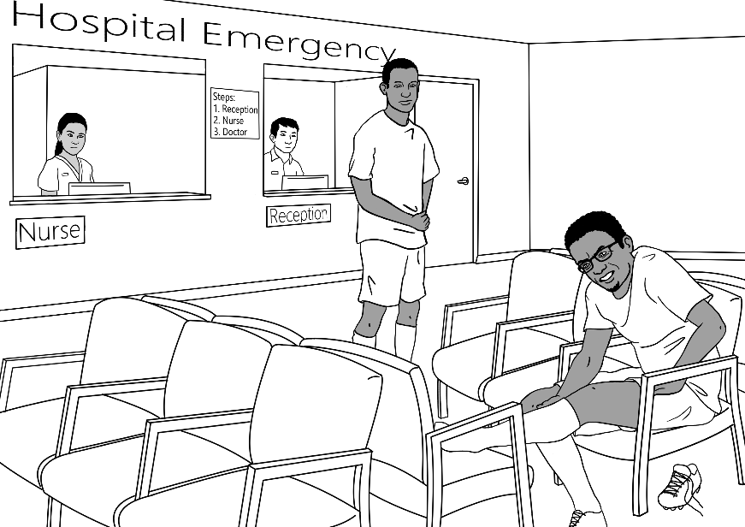
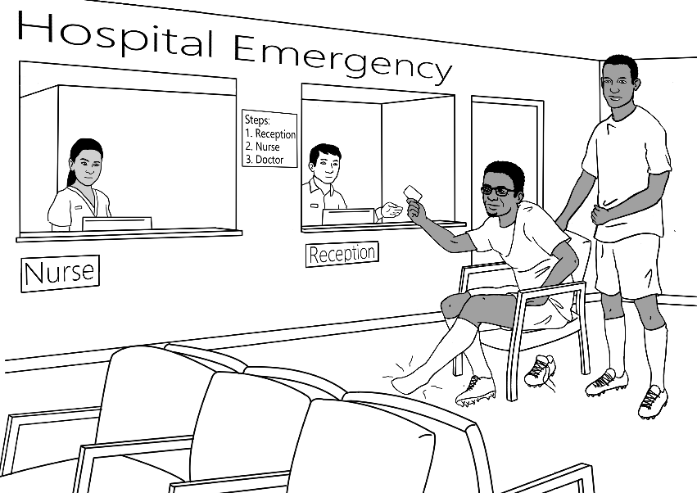 | 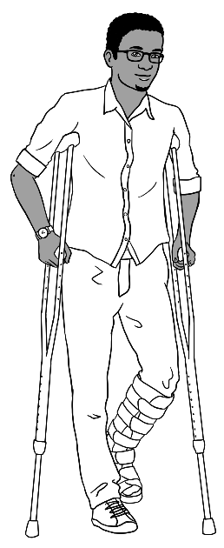

Medical situations

Kellivale Hospital Patient Form

Write in CAPITAL LETTERS.

Tick the box.

Title Mr Mrs Ms Miss Other _____

Family Name ____________________________
Given Name ____________________________
Date of Birth ____________________________
Address ____________________________
Suburb ____________________________ Postcode _______
Phone ____________________________
Medicare Number ________________ Valid to _____________
Signature ___________________ Date ______________

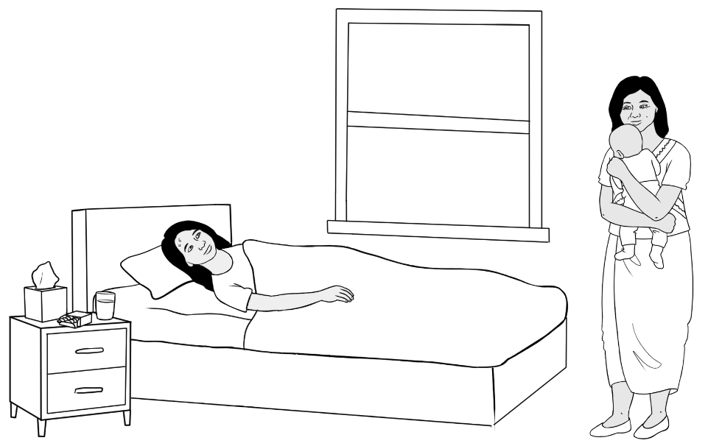
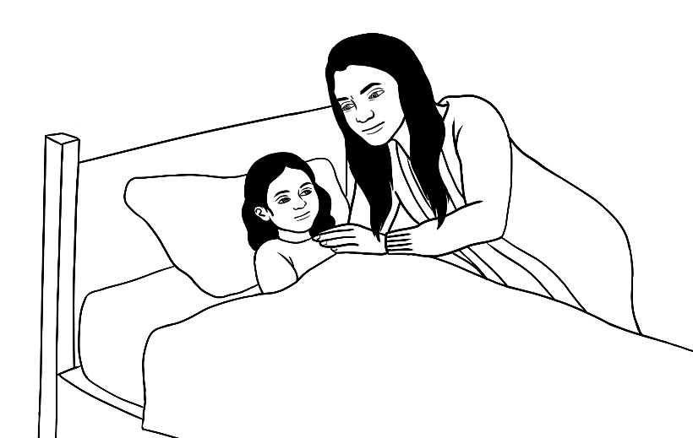
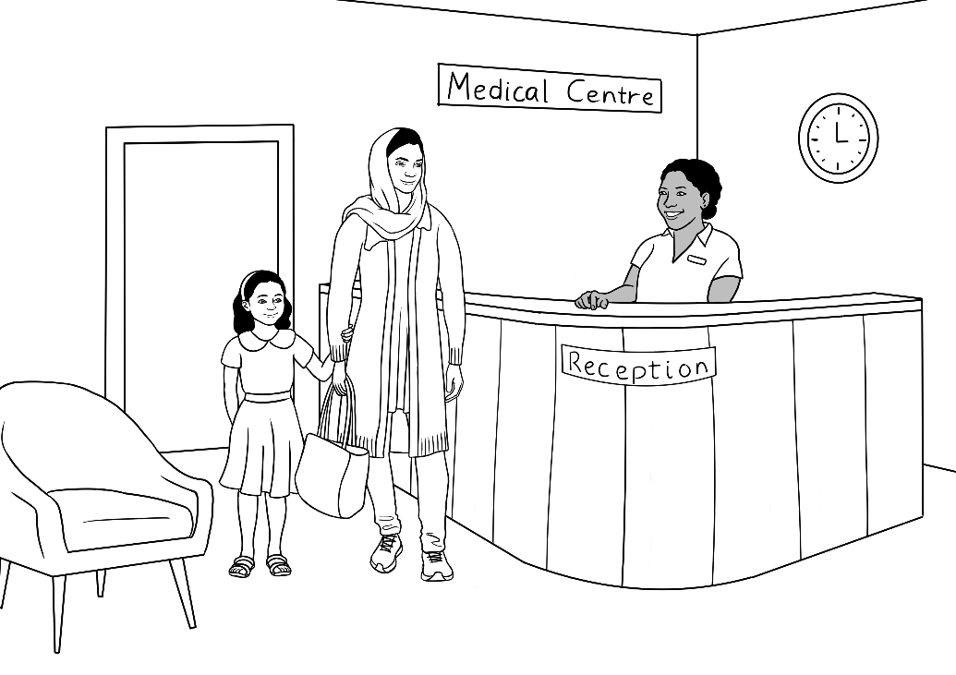

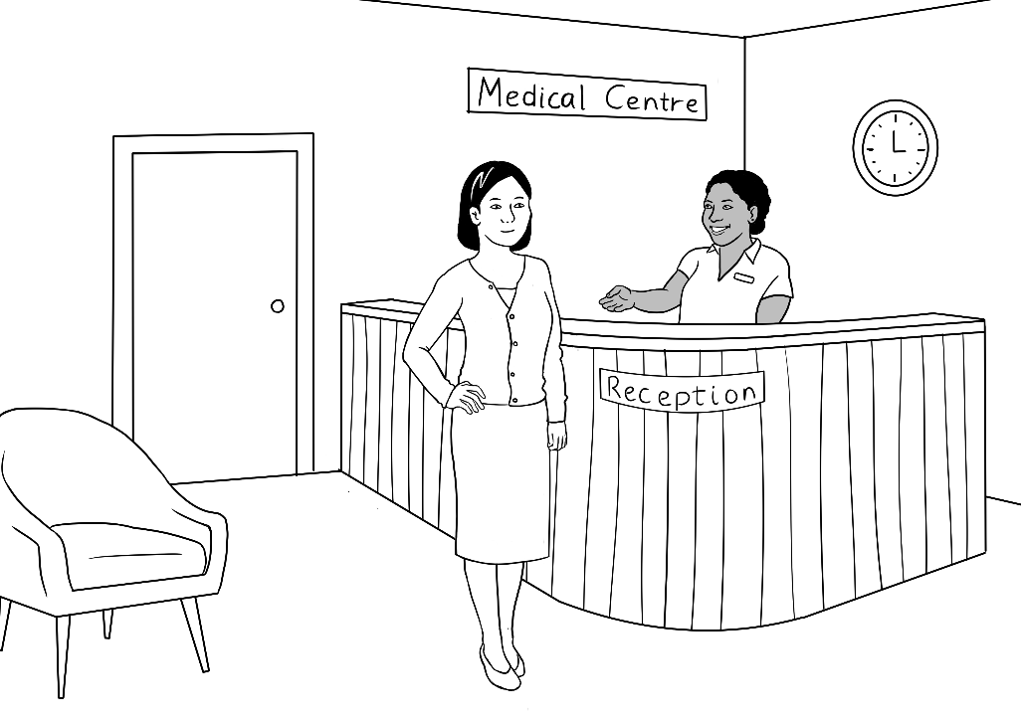
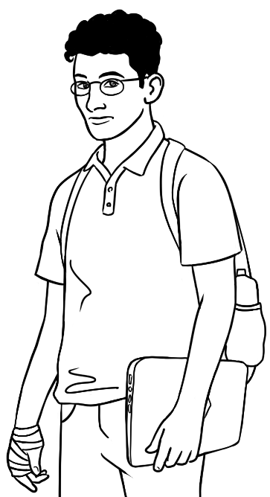
a burnt hand

Thermometers
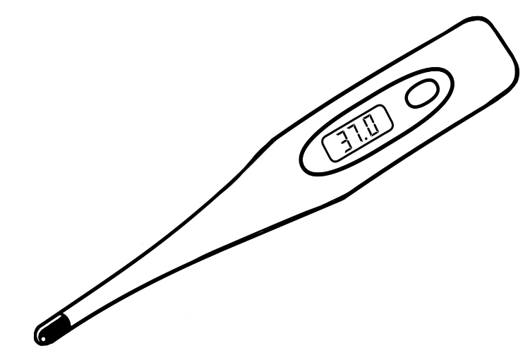


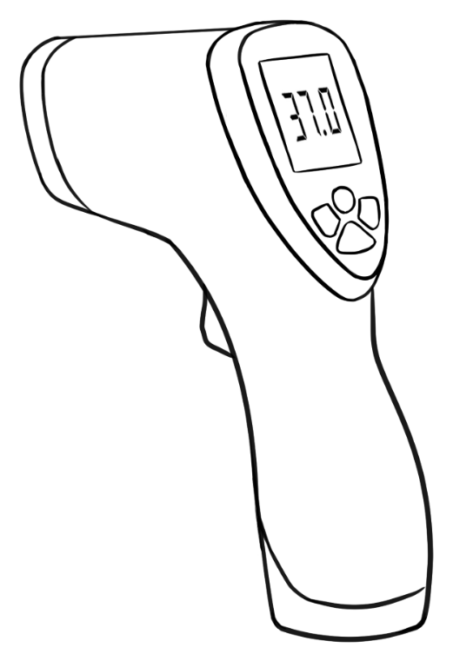

Clothing, shoes, accessories and shopping scenes

Women’s clothes
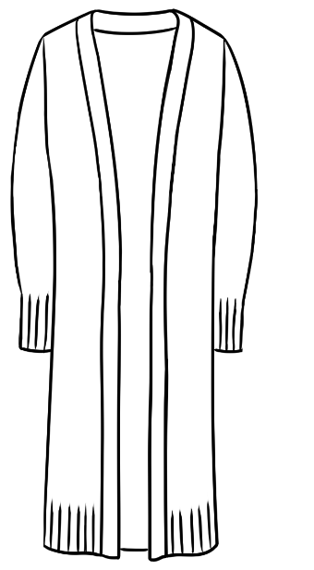 |  | 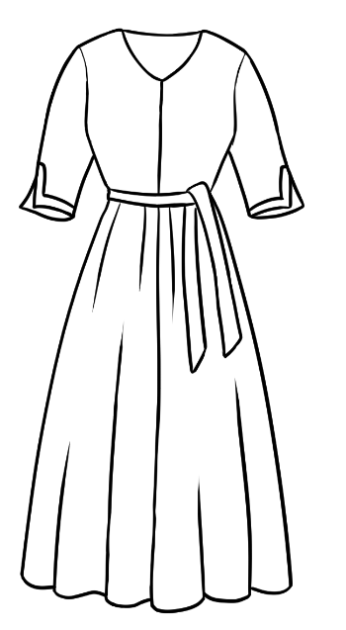
 | 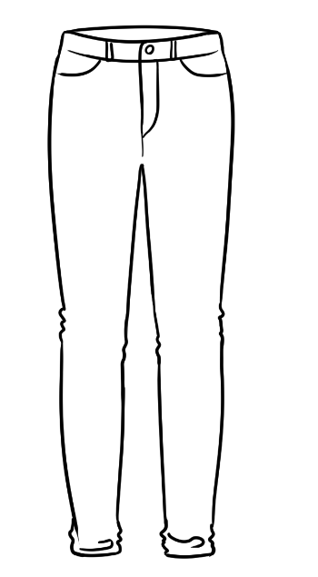 | 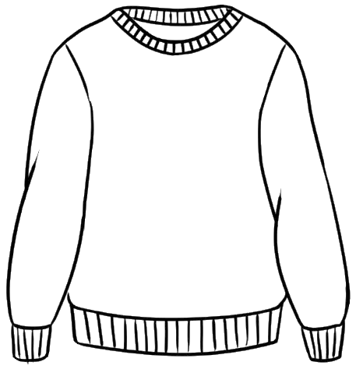
 |  | 

 | 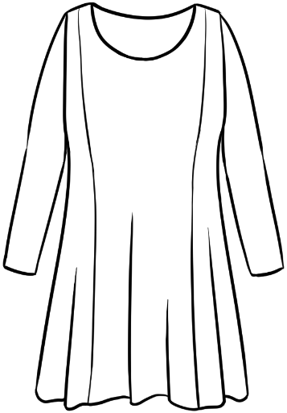 | 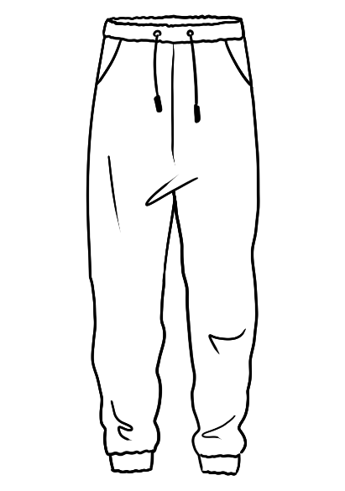

Women’s shoes and accessories
 |  | 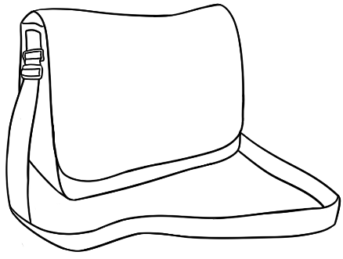
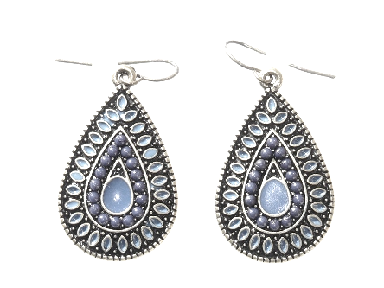 |  |   
 |  | 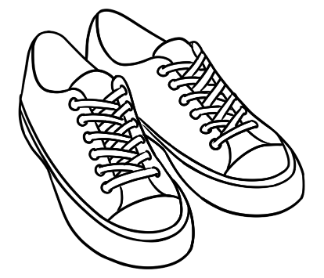

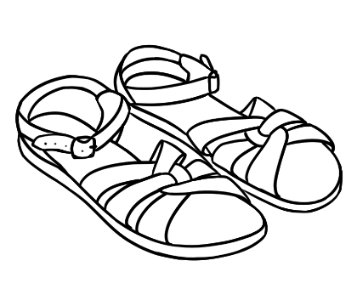 | 
 | 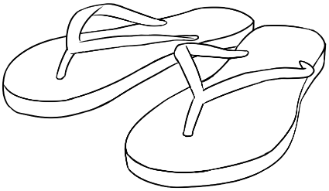



Men’s clothes
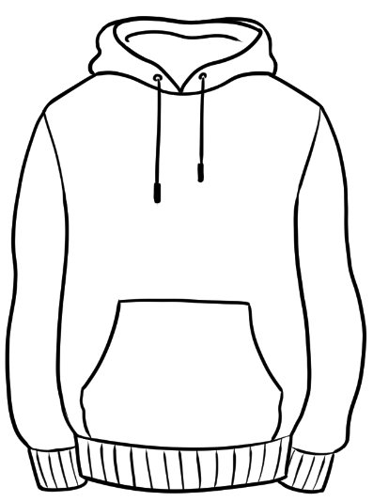 | 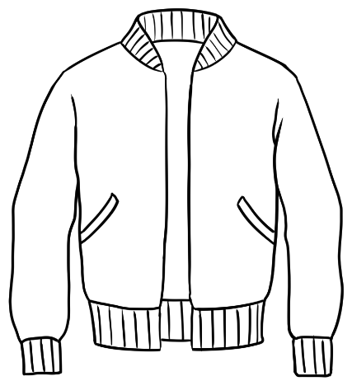 | 
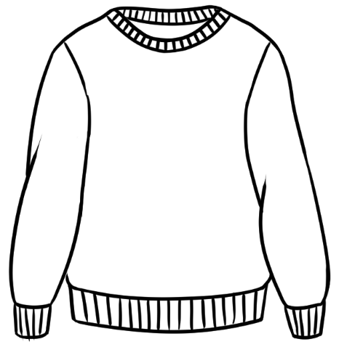 |  | 
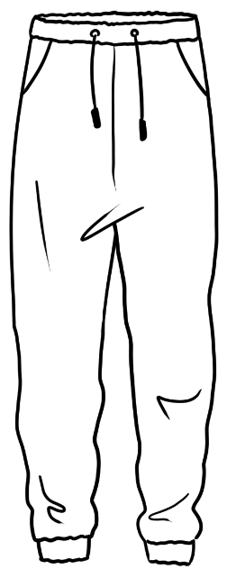 | 

Men’s shoes and accessories
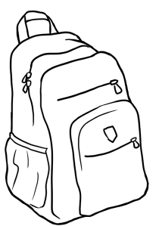 |  | 
 |  | 
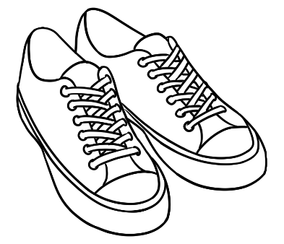 | 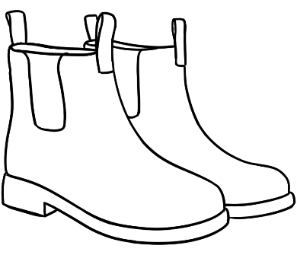

Shopping scenes
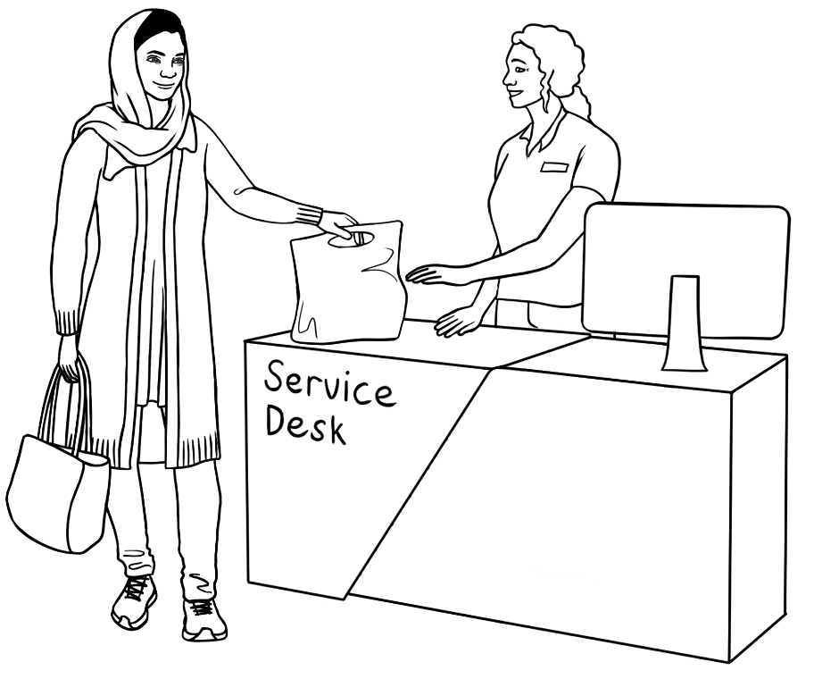
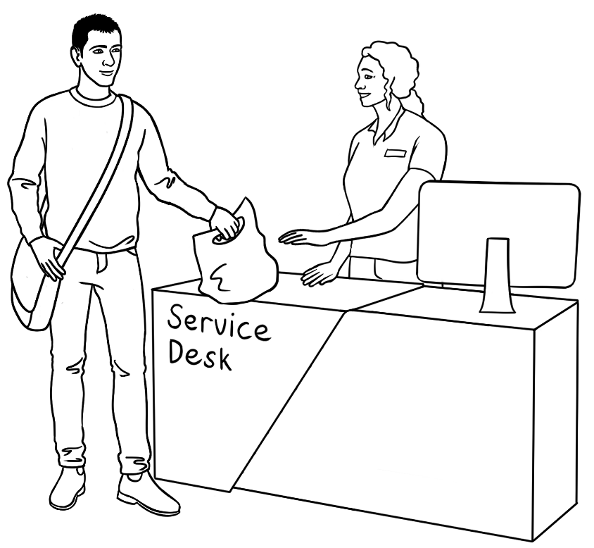



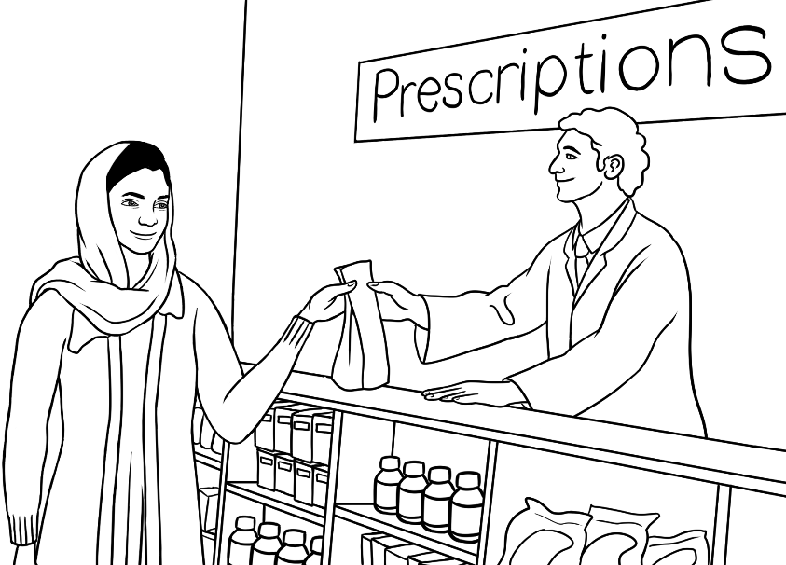
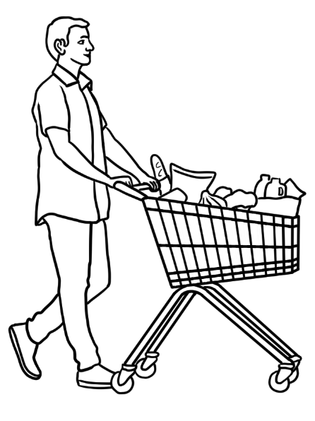 | 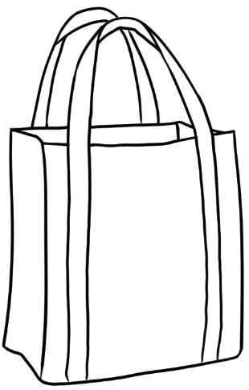 | 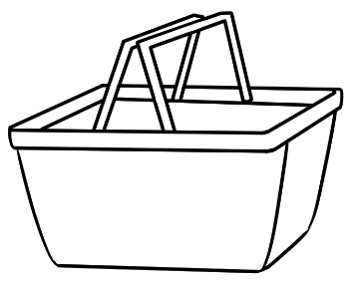
 |  | 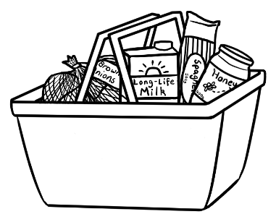

Food

  apple |   avocado |   bananas
  beans | 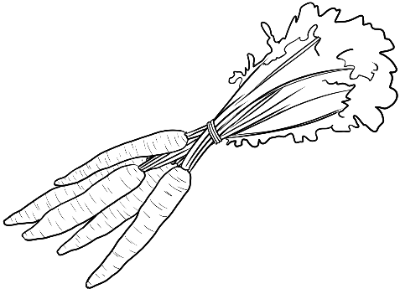  carrots |   coconut
  dates |   eggplant |   fruit

Fruit and vegetables

  garlic | 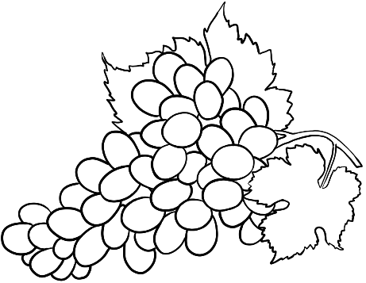  grapes | 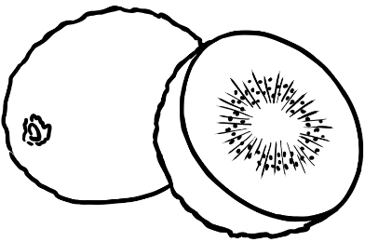  kiwi fruit
  lemon |   mushrooms | onions  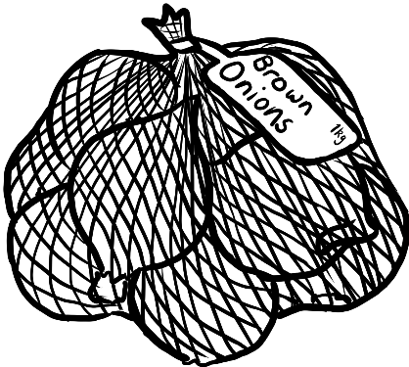
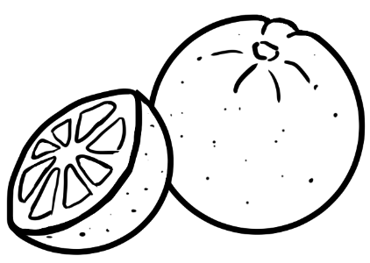  oranges |   potatoes |   quinces

  radish |   spinach |   tomato
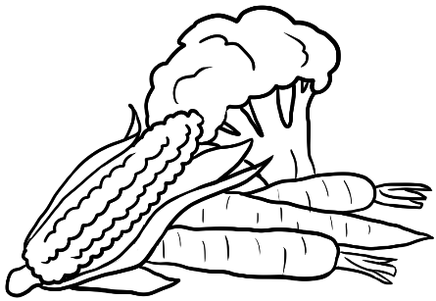  vegetables | 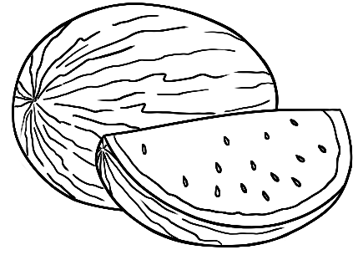  watermelon | 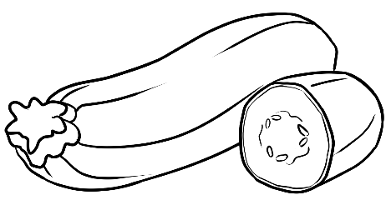  zucchini

Meat, dairy, eggs and tofu
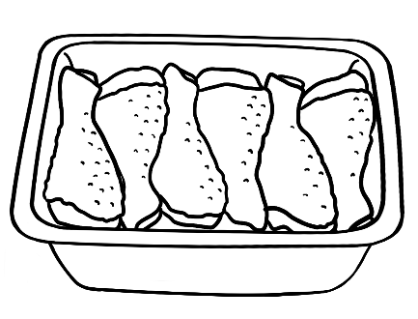  chicken | 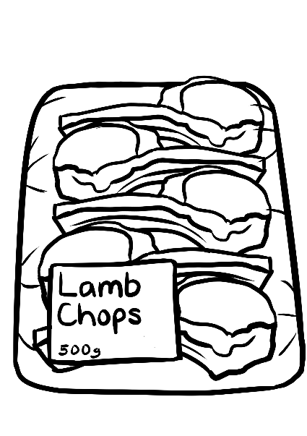 | 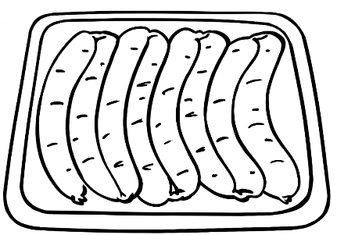  sausages
 | 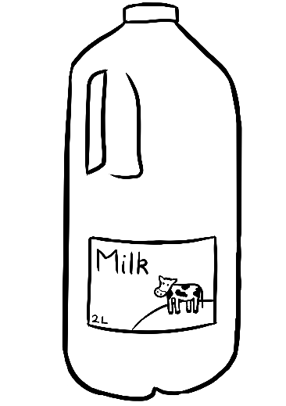 | 
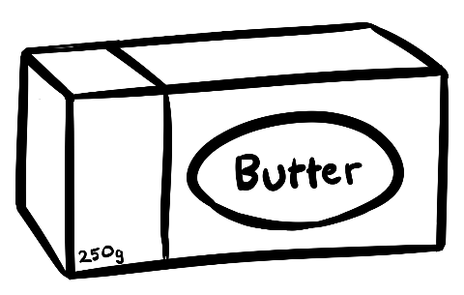 | feta cheese  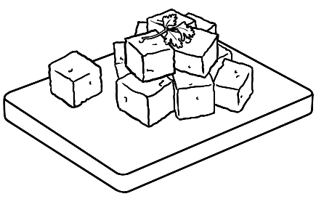 | 

 | 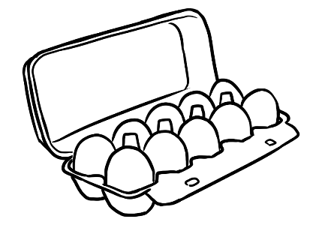 | 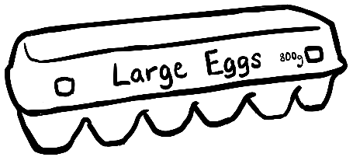


Pantry
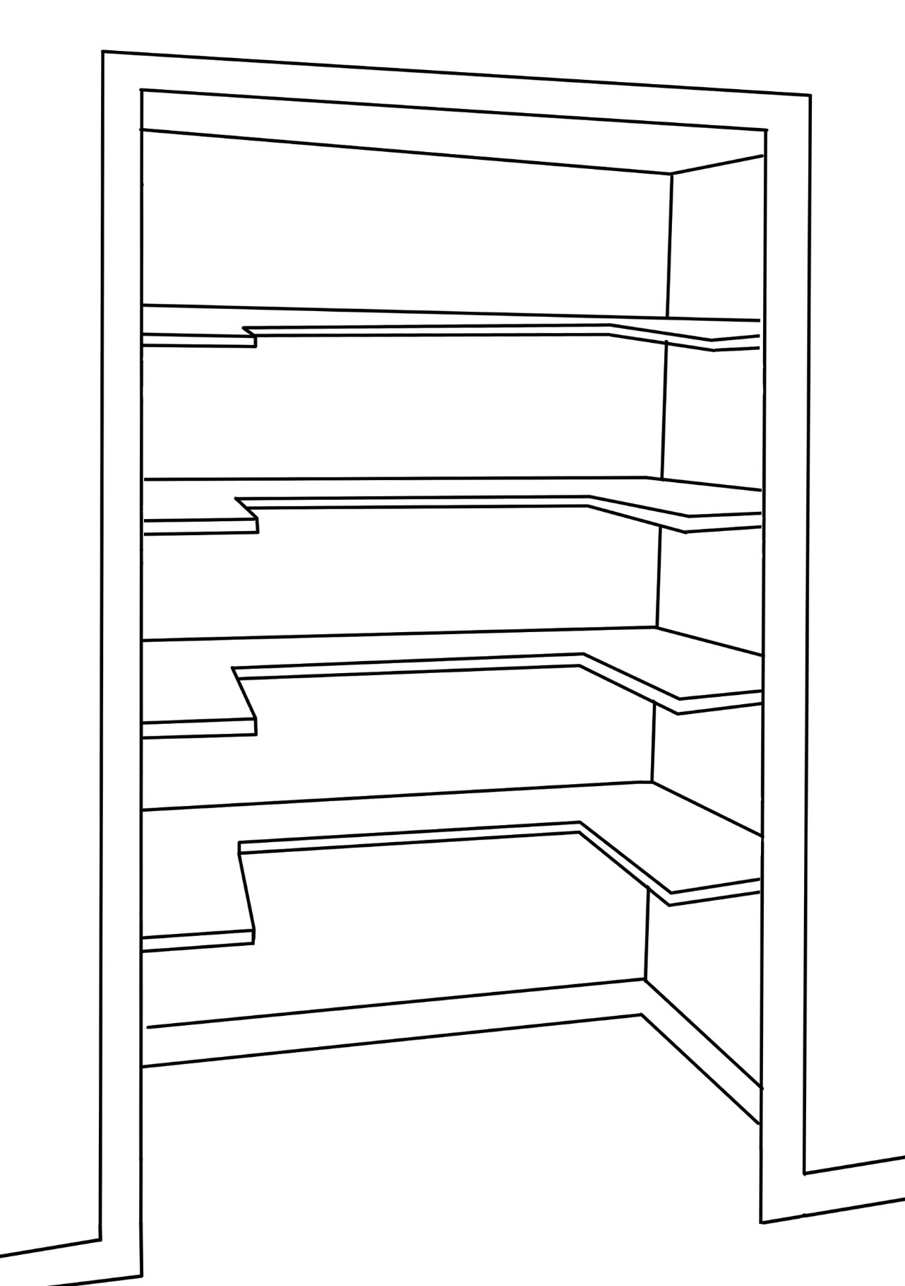

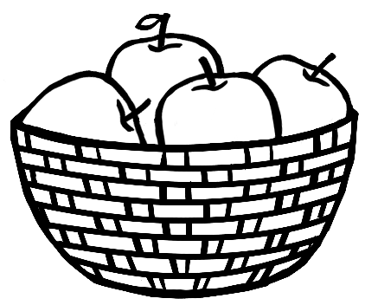 | 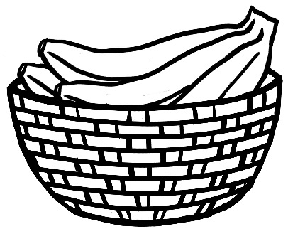 | 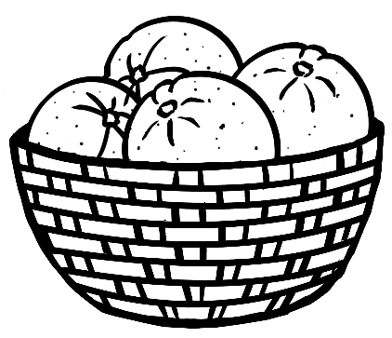
 |  | 
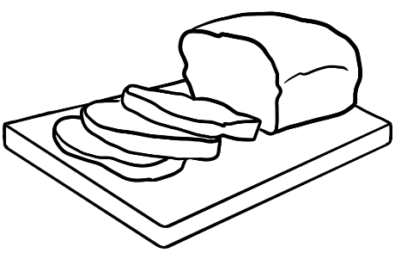 |  | 

Pantry food and goods – labelled

 |  | 
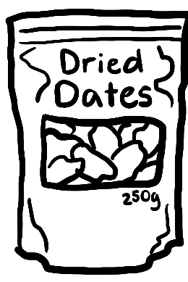 | 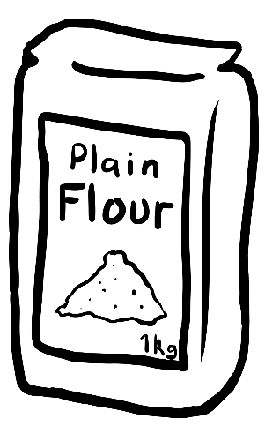 | 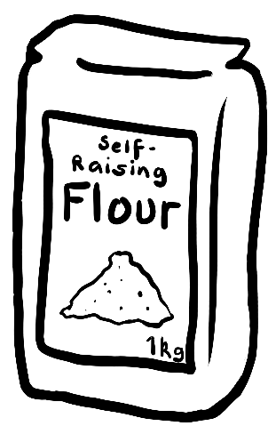
 | 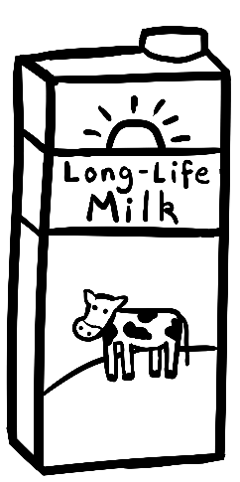 | 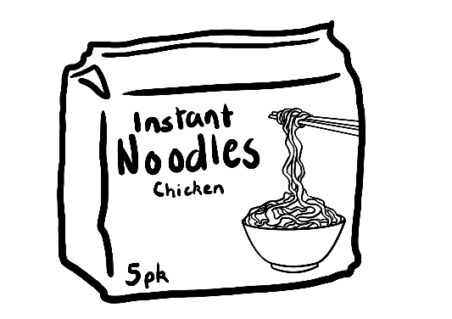

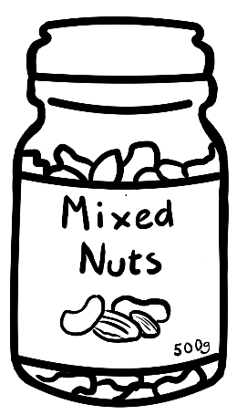 |  | 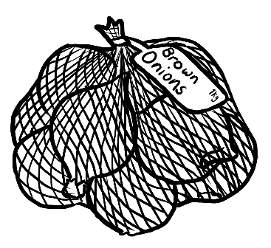
 |  | 
 | 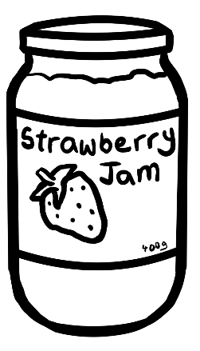 | 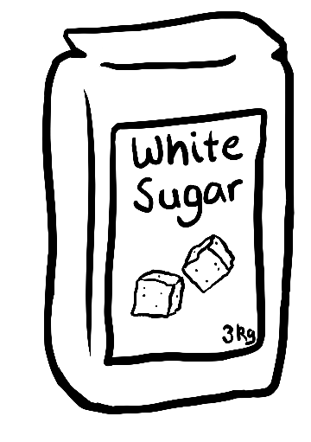

 |  | 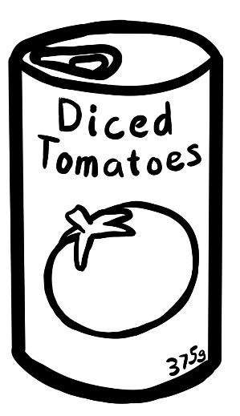
 |  | 
 | 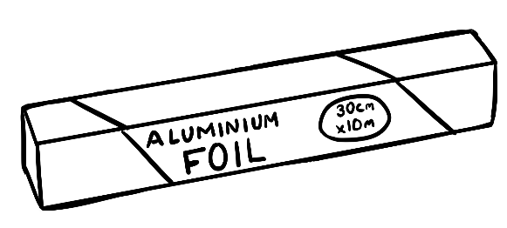
 | 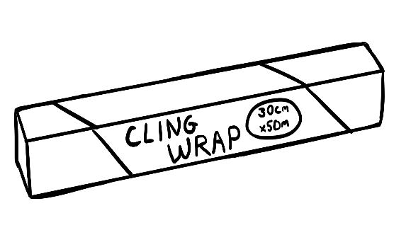

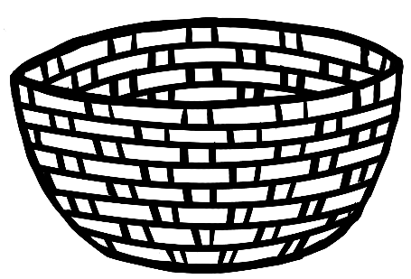  baskets |  | 
  bags | 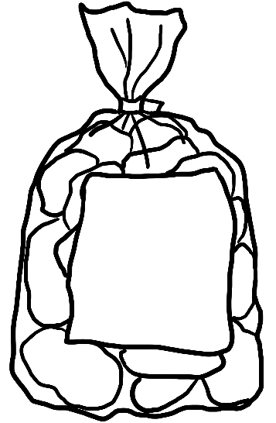  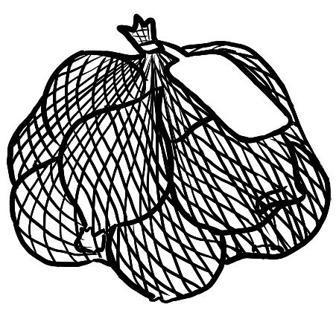
  boxes |  |  |  | 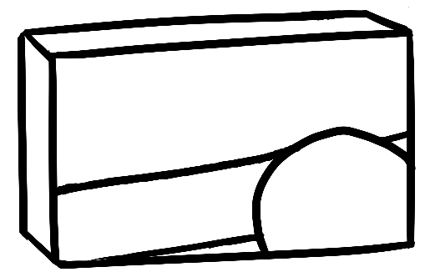

Pantry food containers – unlabelled






bottles

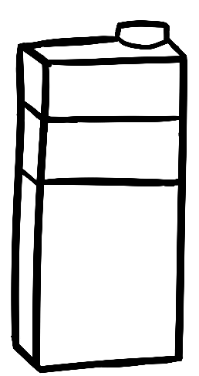
cartons

jars


  packets |   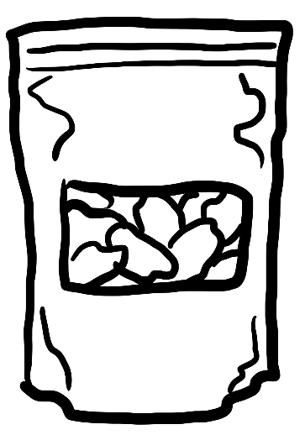
 | 
  tins | 

Cooking - tools, instructions, scenes and dishes

Cooking tools
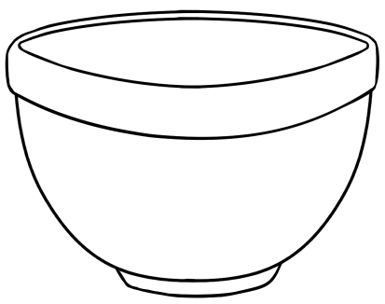 | 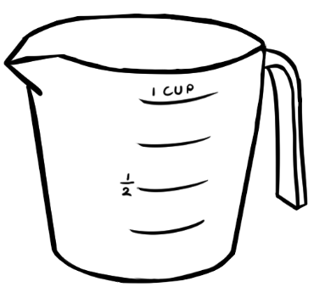 | 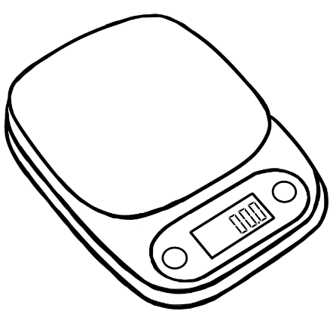
 | 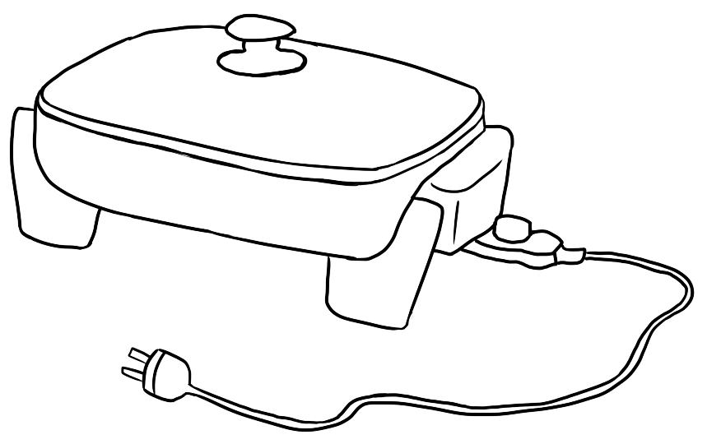
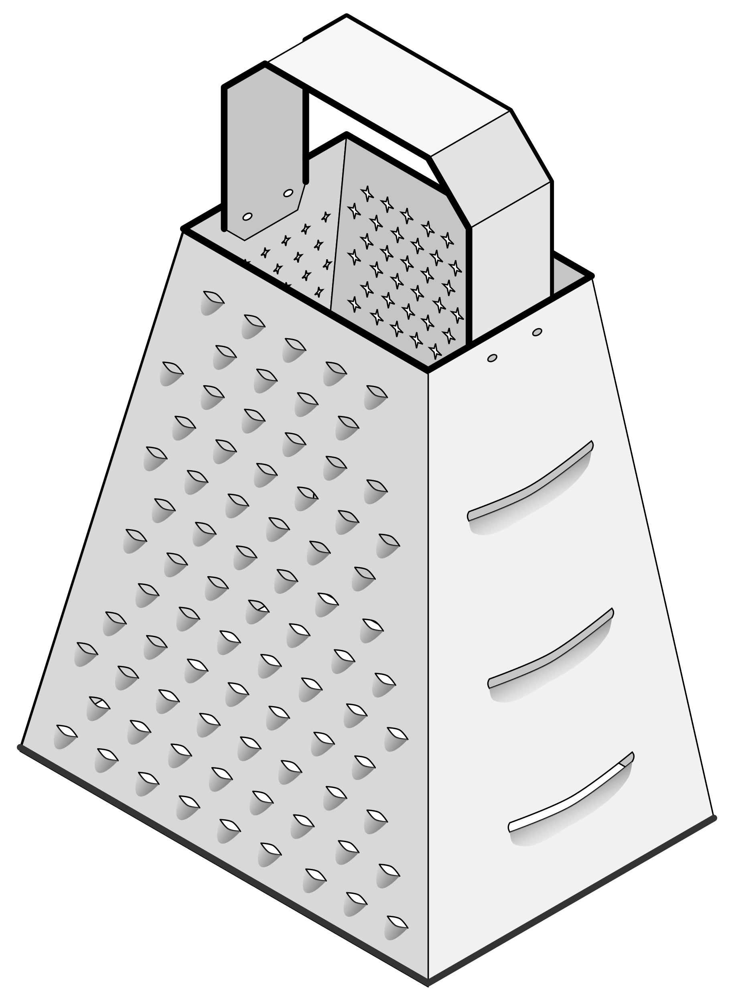 |  | 

 |  | 
 | 

Cooking instructions
Add  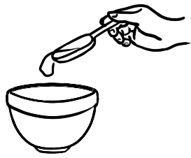 |   Add |   Add
  Add |   Beat |   Break eggs
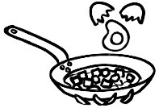  Break eggs | 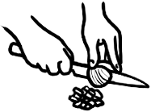  Chop | 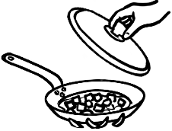  Cover and cook

  Cover and cook |   Cook gently |   Grate
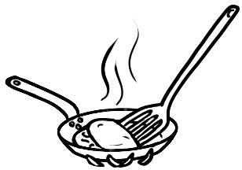  Fold |   Fry |   Heat
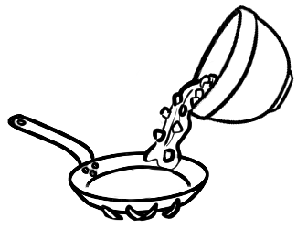
Pour into the pan.

Cooking scenes
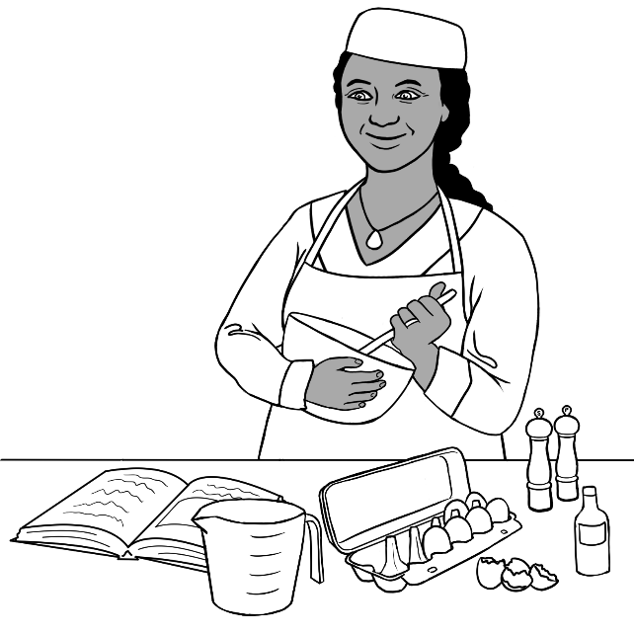 | 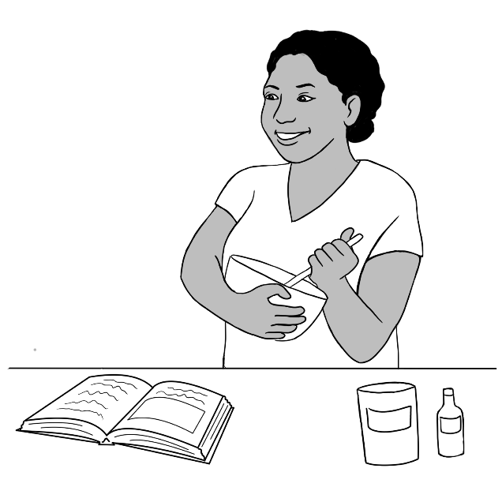
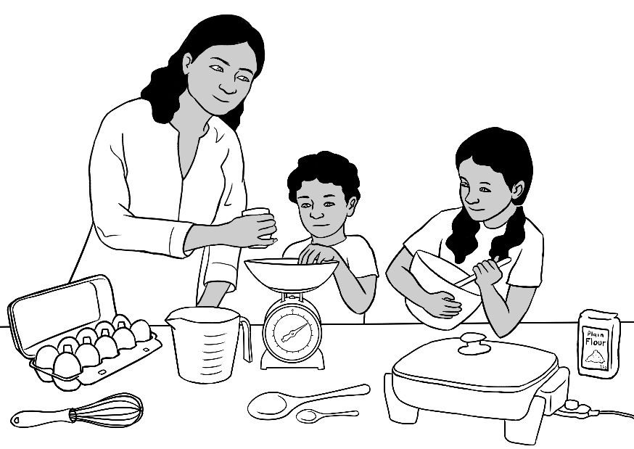
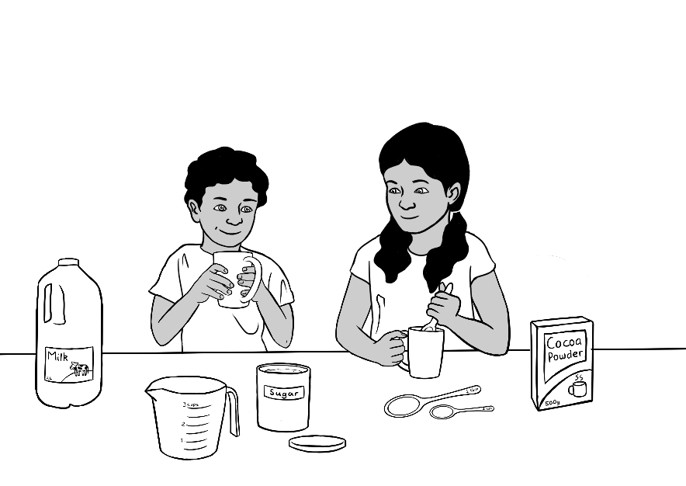

Dishes
Eggs on toast  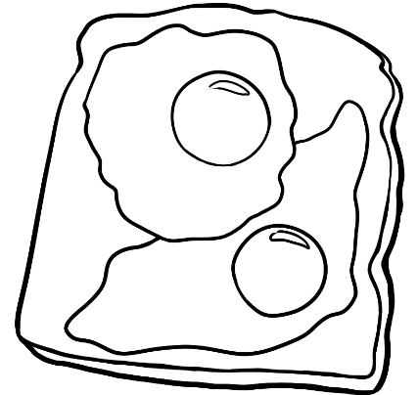 |   Noodles | Omelette  
Afghani omelette  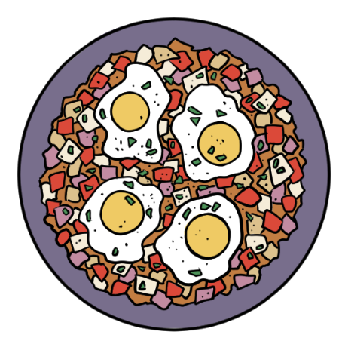 | 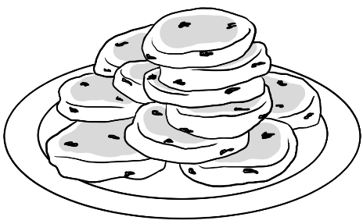  Pikelets | 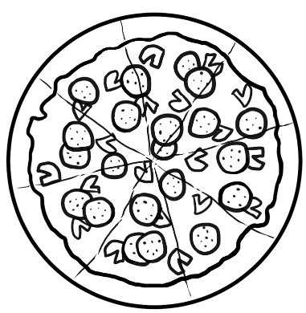  Pizza
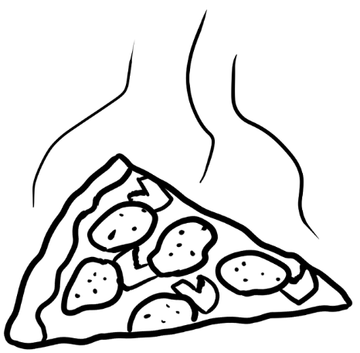  Slice of pizza | 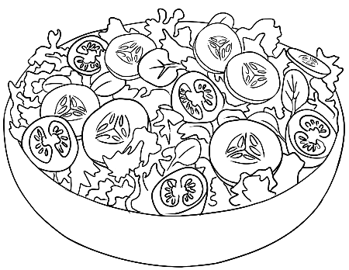  Salad |   Sandwich

Numeracy

Time
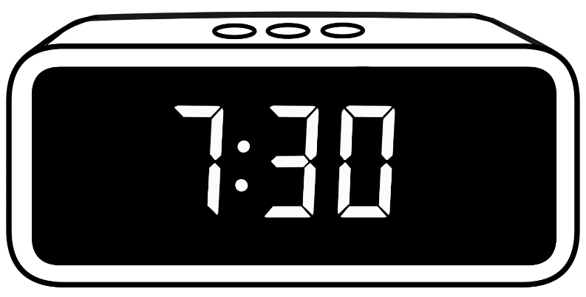
To make changes, click on the times on each clock.
8:30
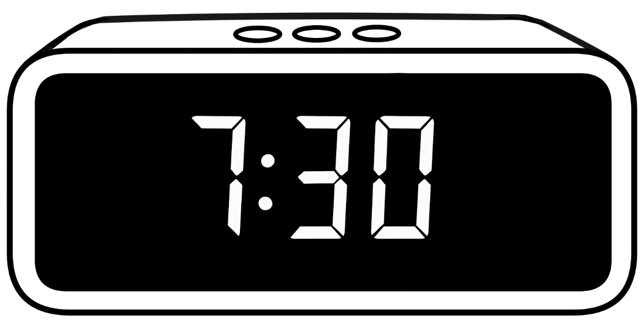
12:00 pm
9:00
Monday 9 May
Sunny Sydney Sydney

To make changes,
click on each detail of
the watch.


To make changes, click on the time.
11:00
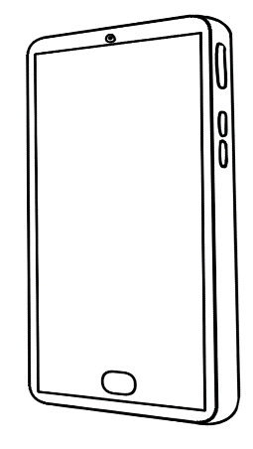
12:00
To adjust the time, move the hands of the clock.
4
1
11
6
3
2
10
9

8
5
7
12
4
1
11
6
3
2
10
9

8
5
7
12
August 2025
Mon | Tues | Wed | Thurs | Fri | Sat | Sun
 |  |  |  | 1 | 2 | 3
4 | 5 | 6 | 7 | 8 | 9 | 10
11 | 12 | 13 | 14 | 15 | 16 | 17
18 | 19 | 20 | 21 | 22 | 23 | 24
25 | 26 | 27 | 28 | 29 | 30 | 31

2025
- January |  |  |  |  |  |  |  | - February |  |  |  |  |  |  |  | - March
M | T | W | T | F | S | S |  | M | T | W | T | F | S | S |  | M | T | W | T | F | S | S
 |  | 1 | 2 | 3 | 4 | 5 |  |  |  |  |  |  | 1 | 2 |  |  |  |  |  |  | 1 | 2
6 | 7 | 8 | 9 | 10 | 11 | 12 |  | 3 | 4 | 5 | 6 | 7 | 8 | 9 |  | 3 | 4 | 5 | 6 | 7 | 8 | 9
13 | 14 | 15 | 16 | 17 | 18 | 19 |  | 10 | 11 | 12 | 13 | 14 | 15 | 16 |  | 10 | 11 | 12 | 13 | 14 | 15 | 16
20 | 21 | 22 | 23 | 24 | 25 | 26 |  | 17 | 18 | 19 | 20 | 21 | 22 | 23 |  | 17 | 18 | 19 | 20 | 21 | 22 | 23
27 | 28 | 29 | 30 | 31 |  |  |  | 24 | 25 | 26 | 27 | 28 |  |  |  | 24 | 25 | 26 | 27 | 28 | 29 | 30
 |  |  |  |  |  |  |  |  |  |  |  |  |  |  |  | 31
- April |  |  |  |  |  |  |  | - May |  |  |  |  |  |  |  | - June
M | T | W | T | F | S | S |  | M | T | W | T | F | S | S |  | M | T | W | T | F | S | S
 | 1 | 2 | 3 | 4 | 5 | 6 |  |  |  |  | 1 | 2 | 3 | 4 |  |  |  |  |  |  |  | 1
7 | 8 | 9 | 10 | 11 | 12 | 13 |  | 5 | 6 | 7 | 8 | 9 | 10 | 11 |  | 2 | 3 | 4 | 5 | 6 | 7 | 8
14 | 15 | 16 | 17 | 18 | 19 | 20 |  | 12 | 13 | 14 | 15 | 16 | 17 | 18 |  | 9 | 10 | 11 | 12 | 13 | 14 | 15
16 | 22 | 23 | 24 | 25 | 26 | 27 |  | 19 | 20 | 21 | 22 | 23 | 24 | 25 |  | 16 | 17 | 18 | 19 | 20 | 21 | 22
28 | 29 | 30 |  |  |  |  |  | 26 | 27 | 28 | 29 | 30 | 31 |  |  | 23 | 24 | 25 | 26 | 27 | 28 | 29
 |  |  |  |  |  |  |  |  |  |  |  |  |  |  |  | 30
- July |  |  |  |  |  |  |  | - August |  |  |  |  |  |  |  | - September
M | T | W | T | F | S | S |  | M | T | W | T | F | S | S |  | M | T | W | T | F | S | S
 | 1 | 2 | 3 | 4 | 5 | 6 |  |  |  |  |  | 1 | 2 | 3 |  | 1 | 2 | 3 | 4 | 5 | 6 | 7
7 | 8 | 9 | 10 | 11 | 12 | 13 |  | 4 | 5 | 6 | 7 | 8 | 9 | 10 |  | 8 | 9 | 10 | 11 | 12 | 13 | 14
14 | 15 | 16 | 17 | 18 | 19 | 20 |  | 11 | 12 | 13 | 14 | 15 | 16 | 17 |  | 15 | 16 | 17 | 18 | 19 | 20 | 21
21 | 22 | 23 | 24 | 25 | 26 | 27 |  | 18 | 19 | 20 | 21 | 22 | 23 | 24 |  | 22 | 23 | 24 | 25 | 26 | 27 | 28
27 | 29 | 30 | 31 |  |  |  |  | 25 | 26 | 27 | 28 | 29 | 30 | 31 |  | 29 | 30
10 October |  |  |  |  |  |  |  | 11 November |  |  |  |  |  |  |  | 12 December
M | T | W | T | F | S | S |  | M | T | W | T | F | S | S |  | M | T | W | T | F | S | S
 |  | 1 | 2 | 3 | 4 | 5 |  |  |  |  |  |  | 1 | 2 |  | 1 | 2 | 3 | 4 | 5 | 6 | 7
6 | 7 | 8 | 9 | 10 | 11 | 12 |  | 3 | 4 | 5 | 6 | 7 | 8 | 9 |  | 8 | 9 | 10 | 11 | 12 | 13 | 14
15 | 16 | 17 | 18 | 17 | 18 | 19 |  | 10 | 11 | 12 | 13 | 14 | 15 | 16 |  | 15 | 16 | 17 | 18 | 19 | 20 | 21
20 | 21 | 22 | 23 | 24 | 25 | 26 |  | 17 | 18 | 19 | 20 | 21 | 22 | 23 |  | 22 | 23 | 24 | 25 | 26 | 27 | 28
27 | 28 | 29 | 30 | 31 |  |  |  | 24 | 25 | 26 | 27 | 28 | 29 | 30 |  | 29 | 30 | 31

Measurement – length
cm

1
2
3
4
5
6
7
8
9
10
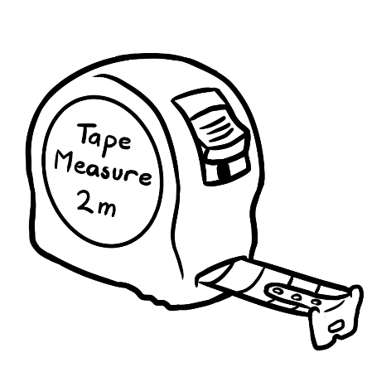 | 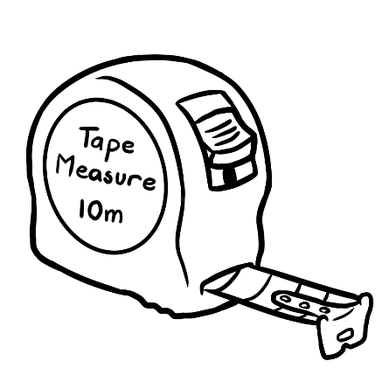 | 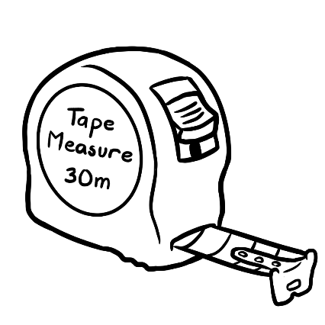
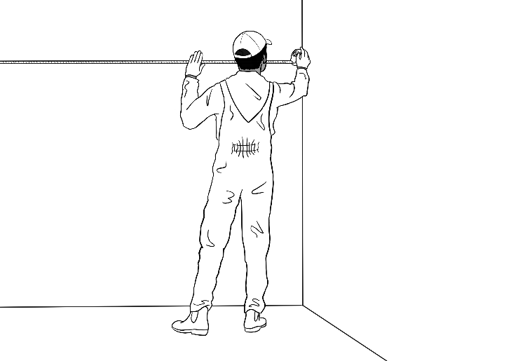
Tahiil measuring with a tape measure

Using the body to measure length
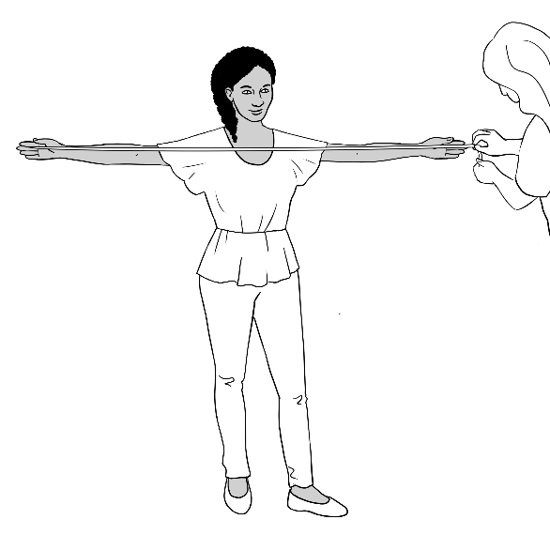  arm span | 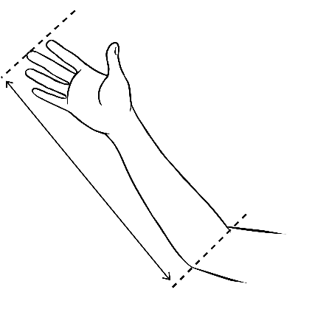  arm length [cubit] | 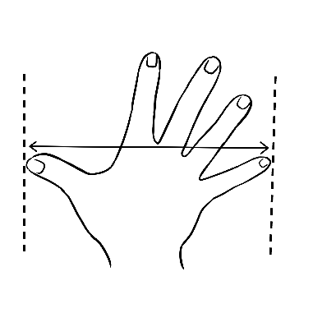  hand span
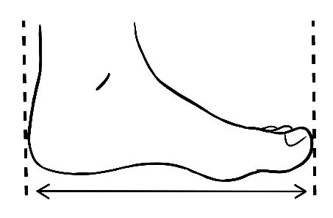  a foot | 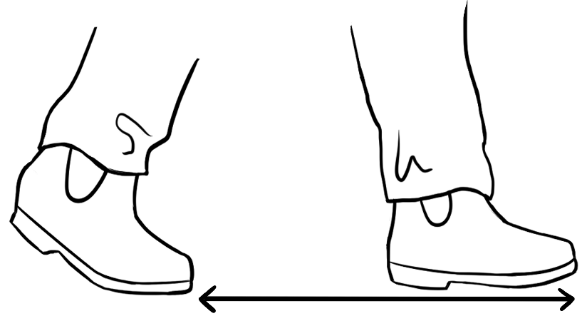  a step
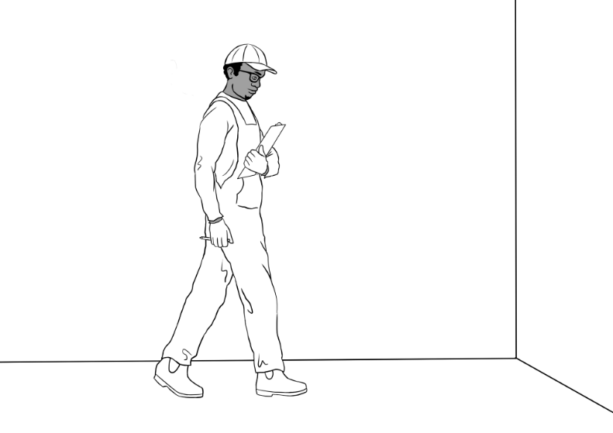
Tahiil measuring by stepping

Objects with lengths
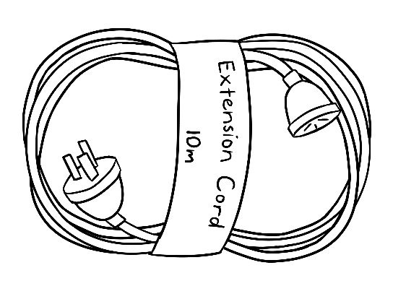
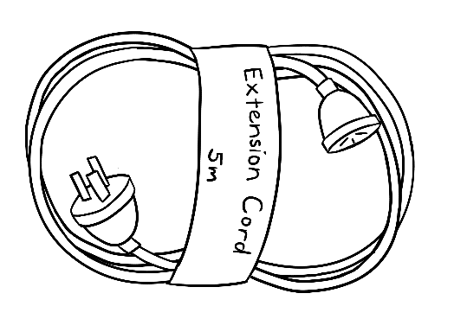
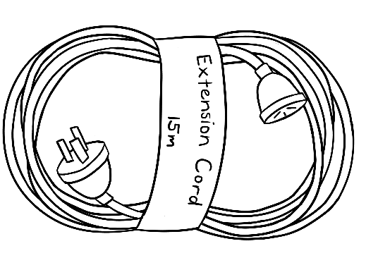
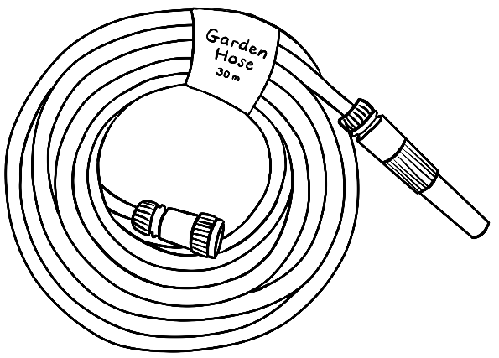
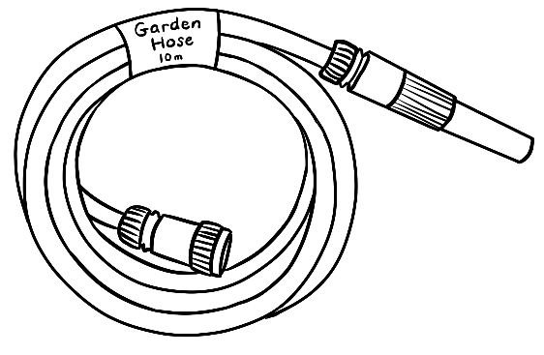
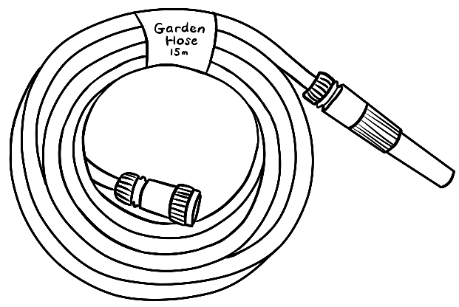
 | 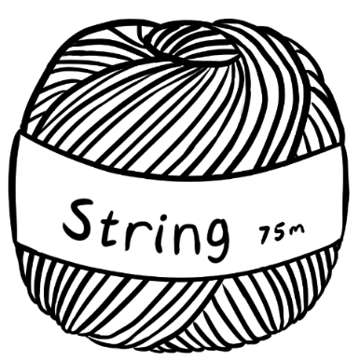 | 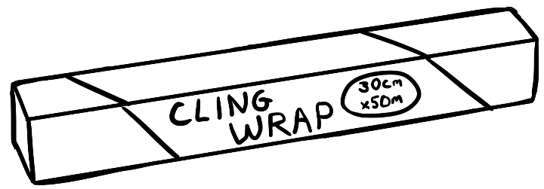
 |  | 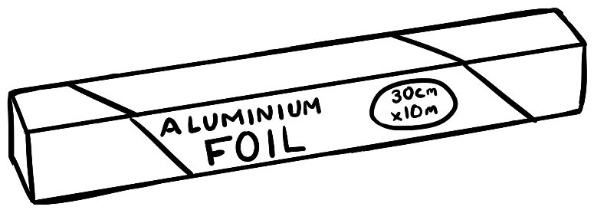

Measurement – weight
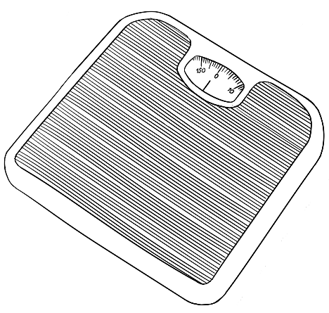 | 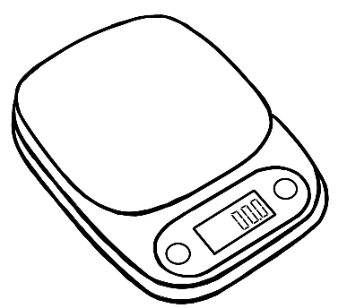 | 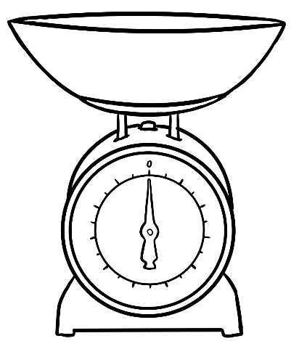
 |  | 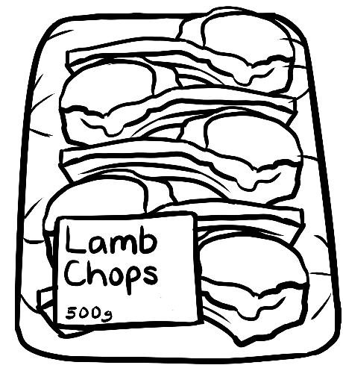
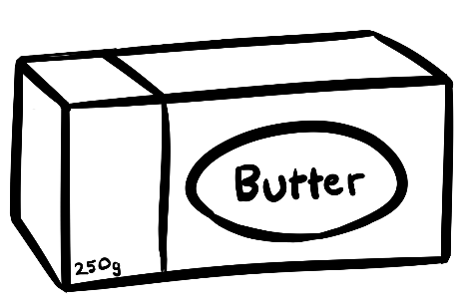 |  | 
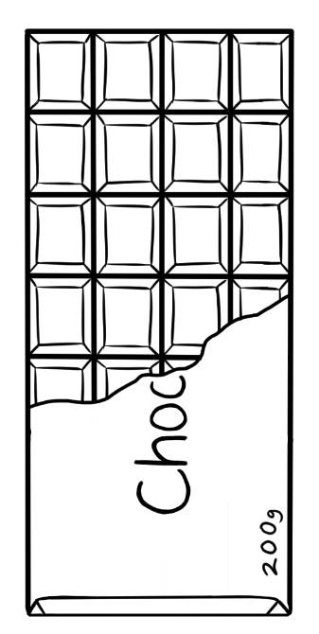

Measurement – litres
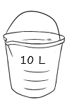 | 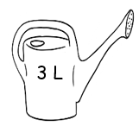 | 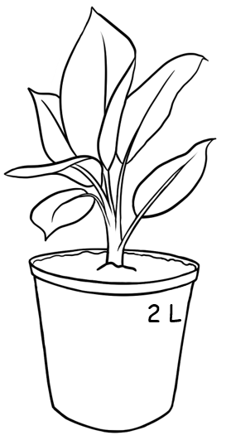
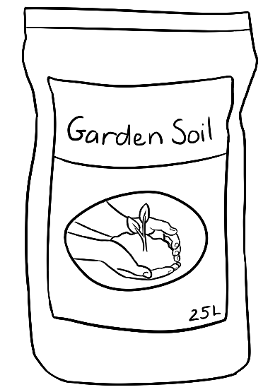 | 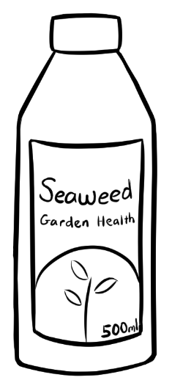 | 
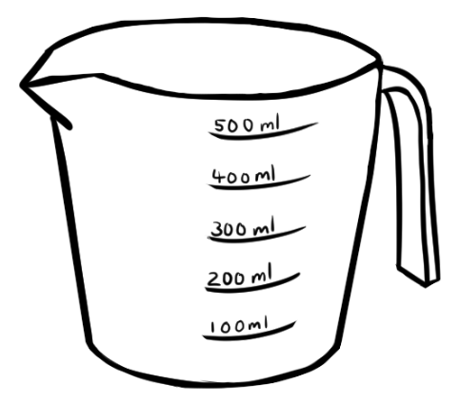 |  | 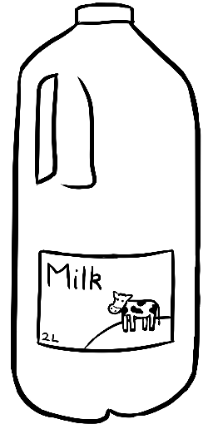

 |  | 
 | 

Measurement – temperature
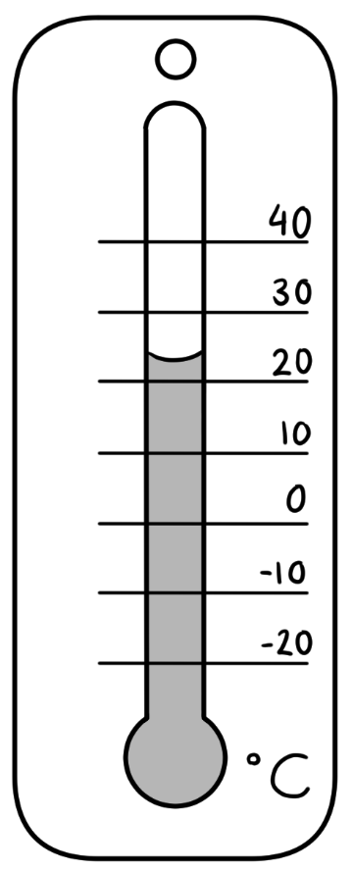

Money
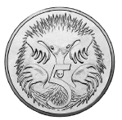 | 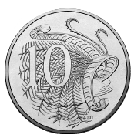 |  | 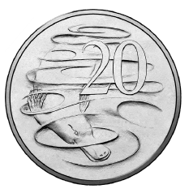
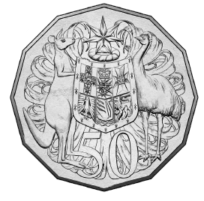 |  |  | 
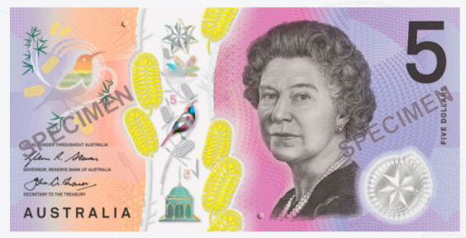 |  | 

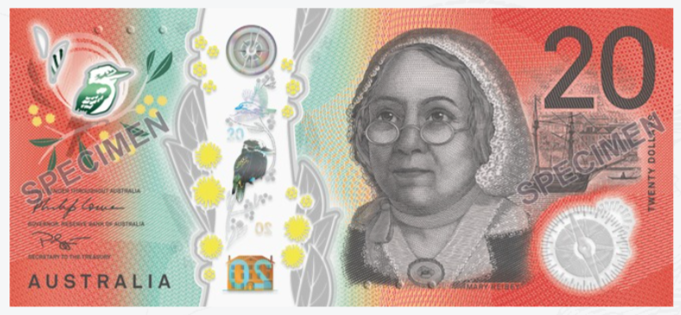 | 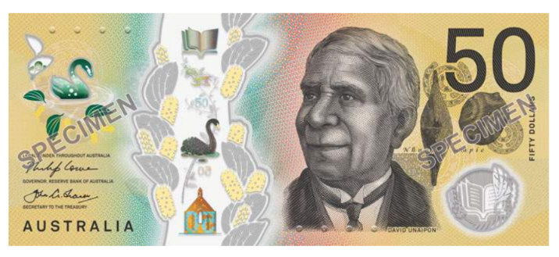
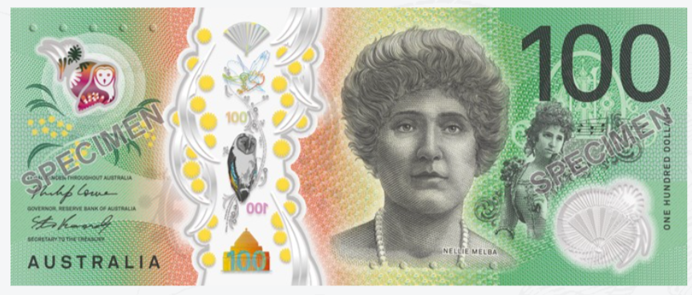

Shapes

Lines
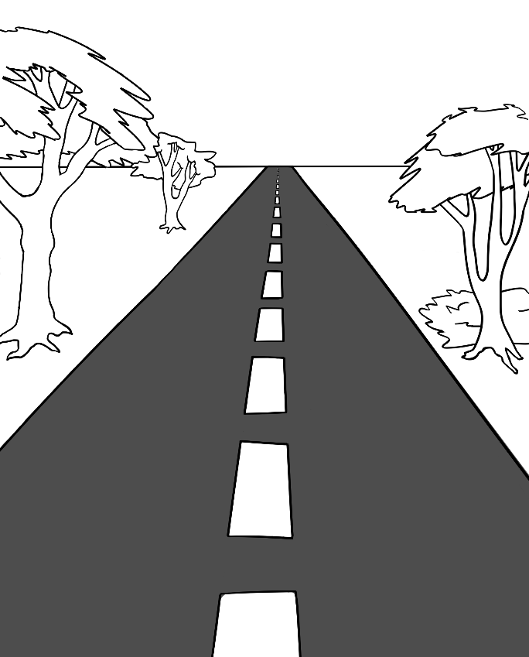  straight | 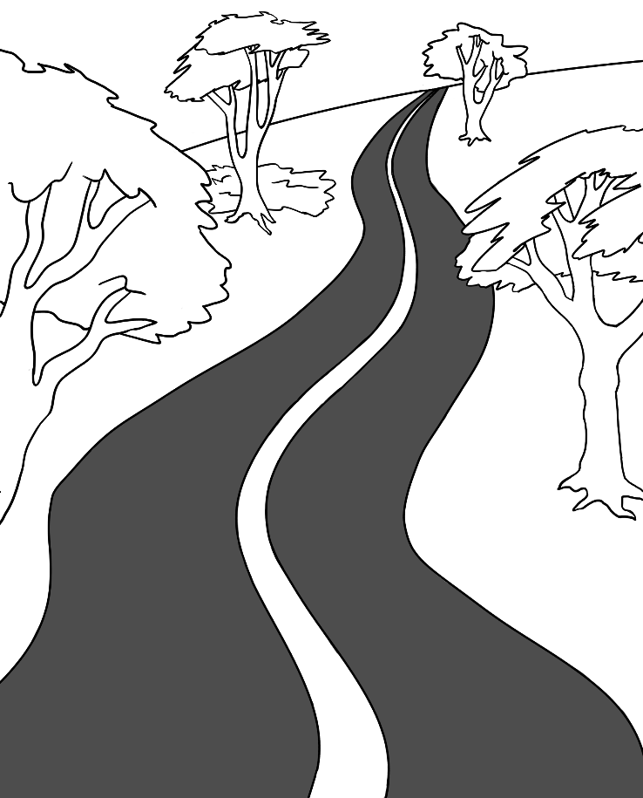  curved

a circle |   a button |   a plate
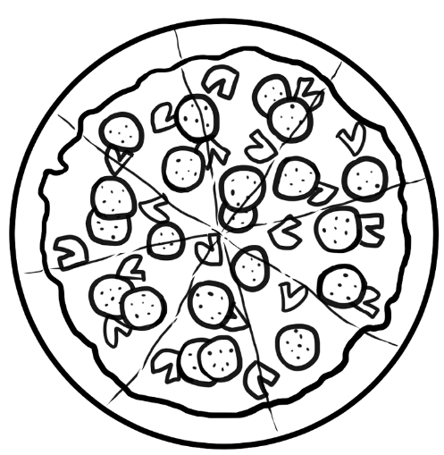  a pizza | road signs
 | 

a square |   a sandwich |   a pizza box
  a biscuit |   a chess board | road signs
 |  | 

a rectangle | 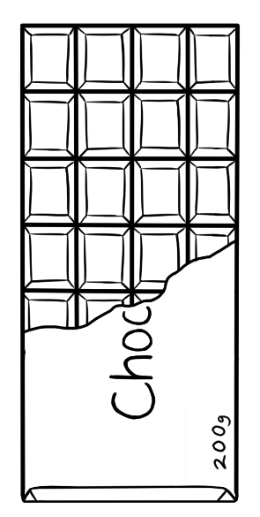  a bar of chocolate | 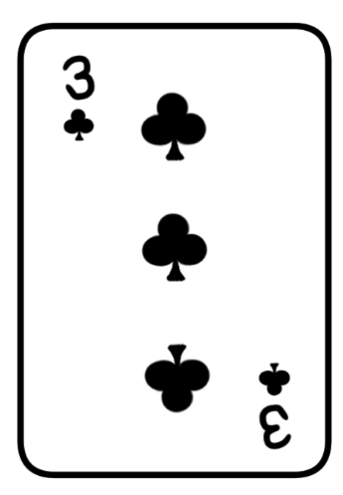  a card |  |   a Weetbix
road signs | 

a triangle |   half a sandwich | a flag
road signs |  | 

Appendix – Character information

The characters in the English Ready materials live in or near the fictional town of Kellivale, which is situated inland, a short distance from the coast in northern NSW.
The tables on the following pages list the characters and specific details about each character mentioned in the Course in Initial EAL, Course in EAL and Certificate 1 in EAL workbooks and Teacher Resources.
Where dates of birth have been used in the booklets, they have been recorded on the tables as exact figures. The age of the characters is most relevant for the younger characters as they either attend childcare, primary school, secondary school or uni.
In recognition of the fact that all materials date, the English Ready resources are available as Word documents for teachers to update and make them more relevant to the time the resource is being used. However, in order to maintain some consistency,
refer to the tables on pages 219 – 221. The student characters studying at each level are coloured green.

Course in Initial EAL – Student characters studying at this level are in green.
Name | Family relationship | Country of origin | Age/  Date of birth | Date of arrival | Address in Kellivale 2421 | Phone
Zarni Tun | San’s mother | Myanmar | 45 yrs  10.04.1978 | - | Unit 4/50 Baker Road | 0407 326 518
San Tun | Zarni’s daughter | Myanmar | 15.11.2001 | - | Unit 4/50 Baker Road | -
Yaza Tun | San’s baby boy | Australia | 6 months  16 April | - | Unit 4/50 Baker Road | -
Jamila Desta | Anika’s mother | Ethiopia | 50 yrs | - | 56 North Street | 0408 629 531
Anika  Desta | Jamila’s daughter | Ethiopia | 30.9.1995 | 15.10.2022 | 56 North Street | 0477 193 286
Rahim | - | Afghanistan | - | - | - | 0469 883 412
Ming | - | China | - | - | - | 0418 335 748
Sahra Omar Elmi | - | Somalia | 07.07.1996 | 09.06.2022 | Unit 6, 50 Baker Rd | 0455 961 259
Tahiil Jama Dihoud | Sahra’s husband | Somalia | 27.06.1994 | 09.06.2022 | Unit 6, 50 Baker Rd | 0400 785 936
Hani Tahiil Jama | Sahra & Tahiil’s daughter | Somalia | 24.06.2021 | 090.6.2022 | Unit 6, 50 Baker Rd | _
Abdi Omar Elmi | Sahra’s brother | Somalia | 04.08.2004 | 13.10.2015 | Unit 1, 50 Baker Rd | 0465 971 356
Pam Neighbour | - | Australia | 02.02.1956 | - | Unit 5, 50 Baker Rd | 0407 165 972
Kim Receptionist | - | Vietnam | 30 yrs | - | - | -
Teacher  Rosie | - | Australia | 45 yrs | - | - | -
Teacher Wendy | - | England | 45 yrs | - | - | -
Teacher Peter | - | Greece | 38 yrs | - | - | -

Name | Family relationship | Country  of origin | Age/  Date of birth | Date  of arrival | Address in Kellivale 2421 | Phone
Sahra Omar Elmi |  | Somalia | 7.7.96 | 9.6.22 | Unit 6,  50 Baker Rd | 0455 961 259
Tahiil Jama Dihoud | Sahra’s husband | Somalia | 27.6.94 | 9.6.22 | Unit 6,  50 Baker Rd | 0400 785 936
Hani Tahiil Jama | Sahra & Tahiil’s daughter | Somalia | 2 years  24.06.21 | 9.6.22 | Unit 6,  50 Baker Rd | _
Abdi Omar Elmi | Sahra’s brother | Somalia | 4.8.04 | 13.10.15 | Unit 1,  50 Baker Rd | 0465 971 356
Ming Wu |  | China | 27.3.1959 | 07.05.19 | 70 Wattle St | 0418 335 748
Lan Wu | Ming’s daughter | China | 6.6.78 | 11.07.14 | 70 Wattle St | 0488 872 951
Bao Wu | Lan’s son | China | 19 yrs  13.05.2004 | 11.07.14 | 70 Wattle St | 0409 188 674
Mai Wu  3065 75221 3  1. Tahiil Jama Dihoud  2. Sahra Omar Elmi  3. Hani Tahiil Jama  VALID 06/2025  medicare | Lan’s daughter | China | 16 yrs  19 April | 11.07.14 | 70 Wattle St | 0487 592 811
Nisha Kumar | Childcare worker | India | 19.01.1978 | 06.04.13 | - | 0411 825 999
Pari Kumar | Nishsa’s daughter | India | 9 yrs | - | - | -
Dev Kumar | Nishsa’s son | India | 7 yrs | - | - | -
Anika |  | Ethiopia | 30.09.1995 | 15.10.22 | 56 North Street | 0477 193 286
Fatima  Khalil Hamed | Carim’s sister | Syria | 15 yrs  13 July | - | 260 North St | -
Carim  Khalil Hamed |  | Syria | 19 yrs | - | 260 North St | 0469 455 218
Teacher  Jenny | - | Australia | - | - | - | -
Pam  Neighbour | - | Australia | 02.02.1956 | - | Unit 5,  50 Baker Rd | 0407 165 972
Paul  Volunteer tutor | - | Australia | - | - | - | 0431 978 352
Course in EAL – Student characters studying at this level are in green.

Name | Family  relationship | Country of origin | Age / Date of birth |  | Date of arrival | Address in Kellivale  2421 | Phone
Linh Nguyen | No family is Aus | Vietnam |  | 60 yrs |  | 56 View St  [new home] | 0567 322 184
Basam Radi | No family in Aus | Iraq |  | 30 yrs  05.08.1993 | 2023 | Unit 3, 140 Kemp St | 0455 328 691
Nabi Saikal | Husband of Amina | Afghanistan  [Pashto] |  | 48 yrs | 2023 | 48 Baker Road | 0462 595 751  NabSaikal @gmail.com
Amina Tarukh | Mother of Parwana and Rahim | Afghanistan  [Pashto] |  | 46 yrs | 2023 | 48 Baker Road | 0466 379 142  ATarukh13@gmail.com
Parwana Saikal | Rahim’s sister |  |  | 25 yrs  09.05.1998 | 12.01.23 | 48 Baker Road | 0476 756 932 Parwana27@gmail.com
Jomeh Tajik | Parwana’s husband | Afghanistan  [Pashto] |  | 27 yrs | 2023 | 48 Baker Road
Bibi Tajik | Parwana and Jomeh’s daughter |  |  | 5 yrs | 2023 | 48 Baker Road
Mustafa Tajik | Parwana and Jomeh’s son |  |  | 2 yrs  30.09.2021 | 2023 | 48 Baker Road
Rahim Saikal | Parwana’s brother |  |  | 19 yrs  07.05.03 | 2023 | 48 Baker Road | 0469 883 412  rahims003@gmail.com
Ahmad Hamed | Brother of Carim  and Fatima | Syria |  | 21 yrs  25.08.2001 | 2022 | 260 North St | 0492 665 732
Ko Tun | Zarni Tun – wife  San Tun – daughter  Thein Myint –  son-in-law  Yaza - grandson | Myanmar |  | 46 yrs | - | 4/ 50 Baker St
Sahra Omar Elmi | Mother of a daughter Hani | Somalia |  | 7.07.96 | 9.6.22 | Unit 6  50 Baker Rd | 0455 961 259
Tahiil | Mother of daughter Hani |  |  | 27.6.94 | 9.6.22 | Unit 6  50 Baker Rd | 0400 785 936
Teacher - Peter | - | Greece |  | 38 yrs |  | Bramby NSW | 0436 924 651
Teacher - Wendy | - | England |  | 45 yrs
Certificate 1 in EAL – Student characters studying at this level are in green.

