English Ready
22636VIC Course in Initial EAL
VU23490 Use extremely familiar strategies to participate in learning
Learn English

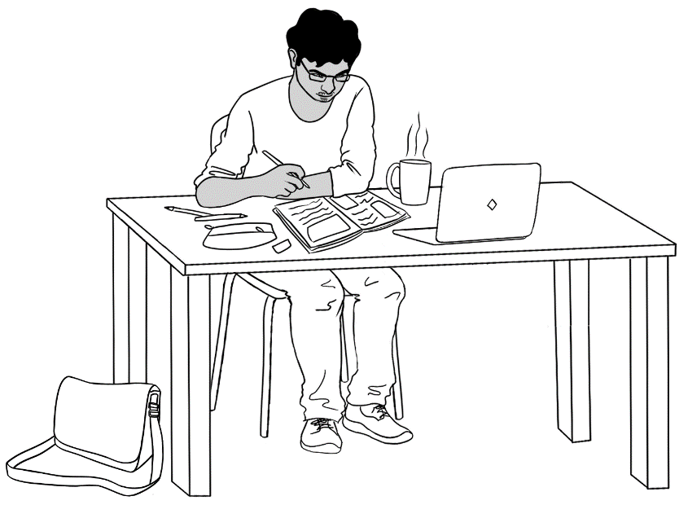

Name _________________________________________________
Teacher _____________________________________________ Class _________________________________________________
Date__________________________________________________

This workbook is designed to be used with the support of a teacher.
Design team: Vicki Hambling, Sue Paull, Frida Dean and Mary Wallace
Illustrations: Madelena Scott
Acknowledgements: The design team would like to thank the AMEP service providers and practitioners who participated in the trial and gave valuable feedback. The team would also like to acknowledge the use of the EAL Framework which underpins the design of this book.

Copyright of the EAL Framework is reserved to the Crown in the right of the State of Victoria. © State of Victoria (Department of Education and Training) 2023.
_________________________________________________________________________________________
This English Ready Resource is licensed under a Creative Commons Attribution-NoDerivs 3.0 Australia licence (More information is available here). You are free to use, copy and distribute to anyone in its original form as long as you attribute Department of Home Affairs as the author and you license any derivative work you make available under the same licence.
© Commonwealth of Australia 2023

With the exception of the Commonwealth Coat of Arms, the department’s logo, any material protected by a trade mark and where otherwise noted all material presented in this document is provided under a Creative Commons Attribution 4.0 International (https://creativecommons.org/licenses/by/4.0/) licence.
The details of the relevant licence conditions are available on the Creative Commons website (accessible using the links provided) as is the full legal code for the CC BY 4.0 licence. (https://creativecommons.org/licenses/by/4.0/legalcode).
Use of all or part of this document must include the following attribution:
© Commonwealth of Australia 2023
As far as practicable, material for which the copyright is owned by a third party will be clearly labelled. The department has made all reasonable efforts to ensure that this material has been reproduced in this document with the full consent of the copyright owners.
Copyright requests and enquiries concerning usage not addressed by the CC BY 4.0 licence should be addressed to: comms@homeaffairs.gov.au at the Department of Home Affairs.
The terms of use for the Commonwealth Coat of Arms are available from the It's an Honour website.
Where a copyright owner, other than the Commonwealth, is identified with respect to this material, please contact that third party copyright owner directly to seek permission.


Table of contents

1 Instructions 1
2 Do you understand? 2
3 Meet the students and teachers. 3
4 What is your name? 4
5 Where do you learn English? 5
6 Who is your teacher? 6
7 I go to class today. 7
8 When do you start class? 13
9 I am sorry. I am late. 15
10 Do you have a pencil? 19
11 I want to learn English. 27
12 Follow instructions. 37
13 I am sick. 43

Instructions
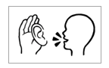
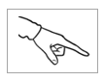

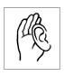  listen | 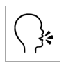  say
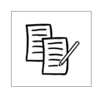  4  copy | 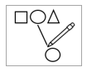  match
  colour | 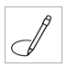  circle
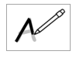  trace | tick
point | 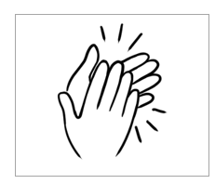  clap

Do you understand?
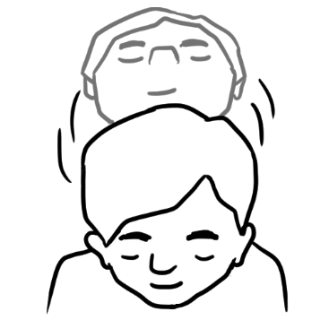
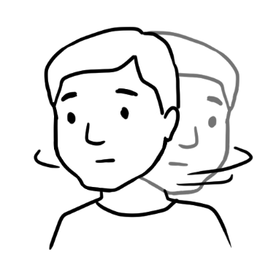
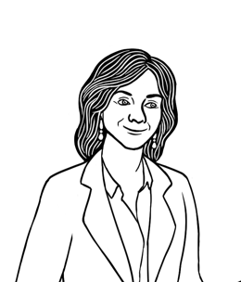
Yes
No
Do you understand?

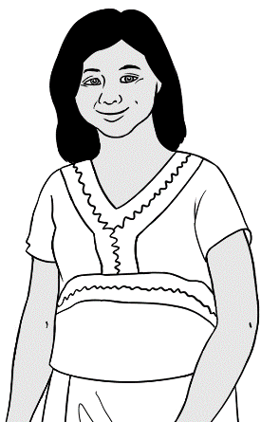
Do you understand?
Yes, I understand.

No, I don’t understand.
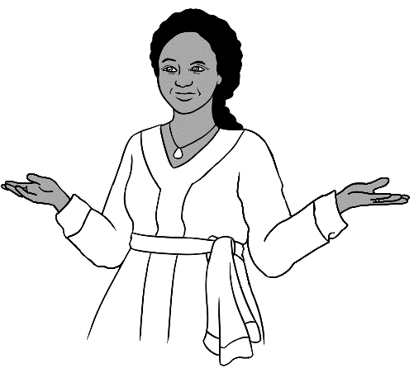
Say it again please?

don’t = do not

Meet the students and teachers.
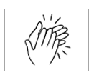
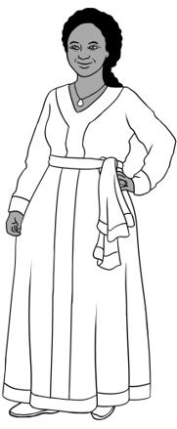
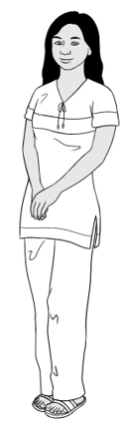
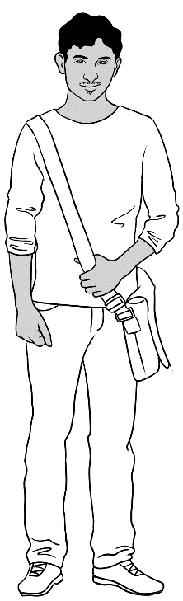
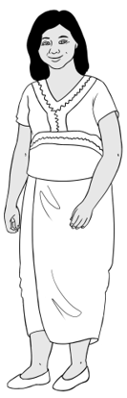
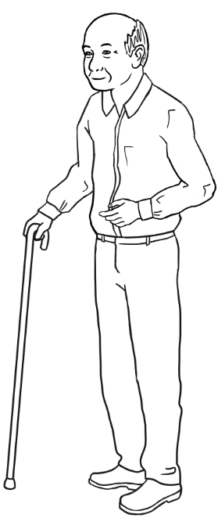
Students
3. Jamila
2. San
4. Rahim
1. Zarni
5. Ming

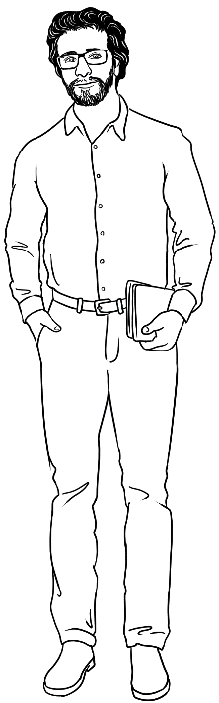
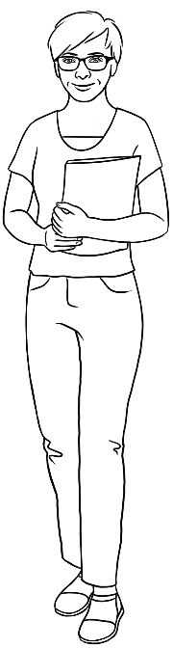
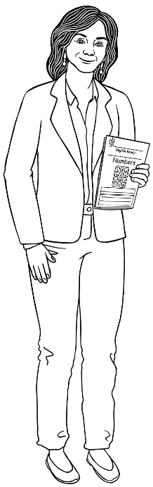
Teachers
6. Rosie
8. Peter
7. Wendy

What is your name?
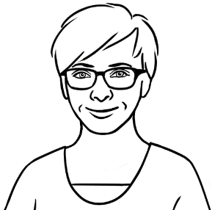
What is your name?

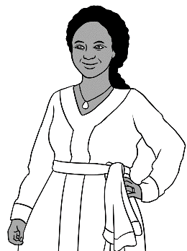
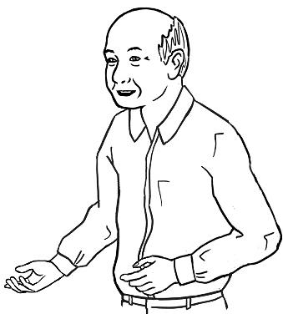
My name is Jamila.
My name is Ming.

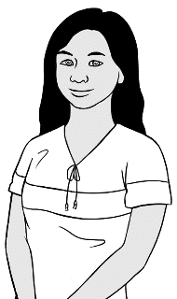
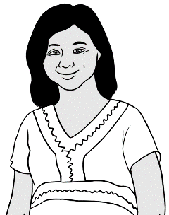
My name is Zarni.
My name is San.

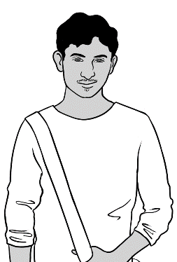
My name is Rahim.
What is your name?

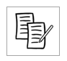

My name is ______________________________________ .

Where do you learn English?
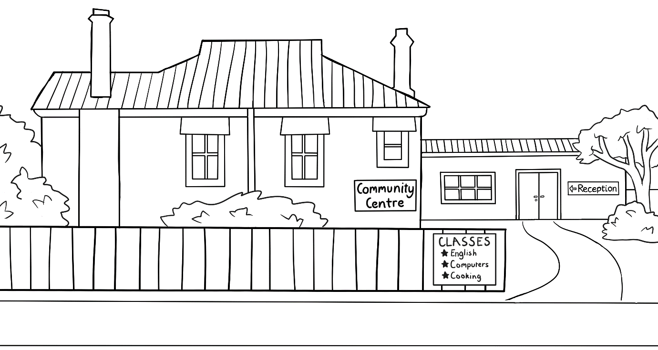

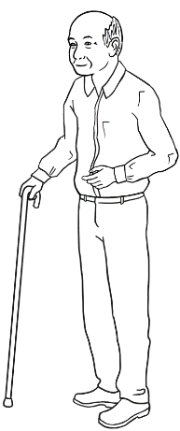
I learn at a community centre.

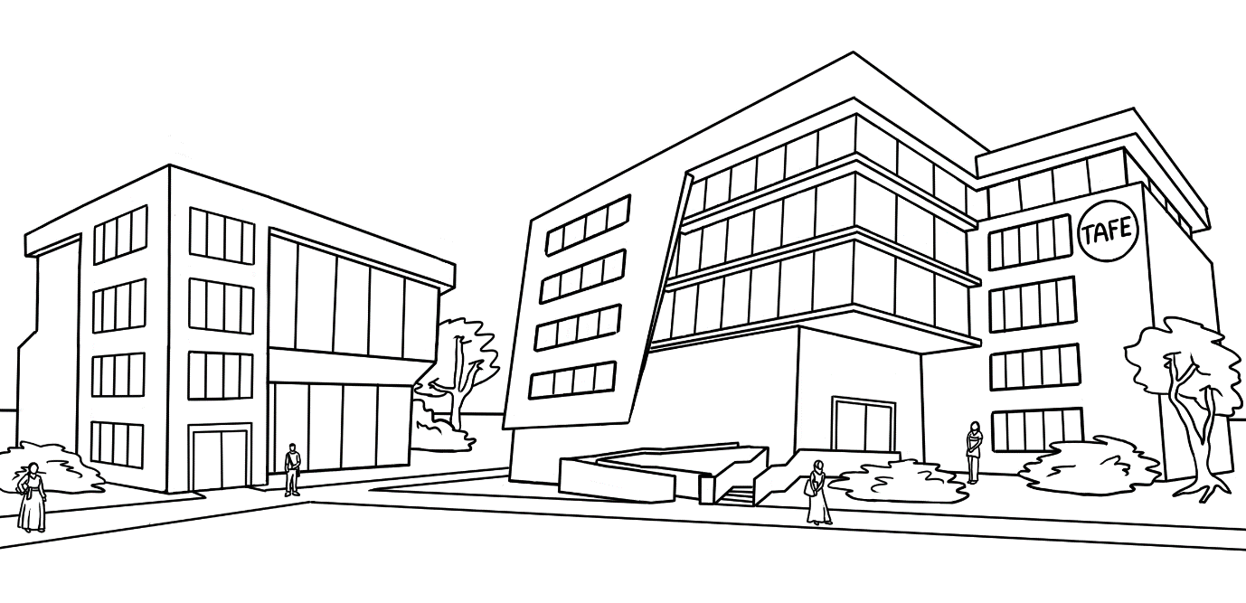

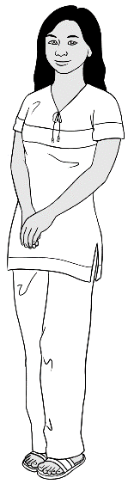
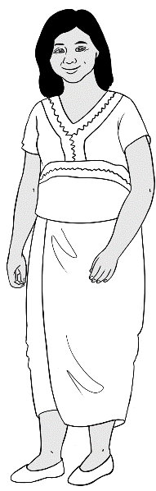
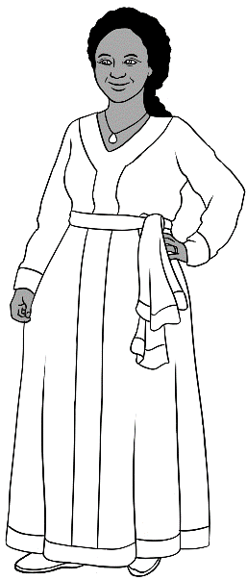

We learn at TAFE.

Where do you learn?

I learn at ____________________________________.

Who is your teacher?
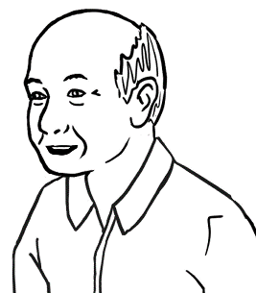
My teacher is Wendy.

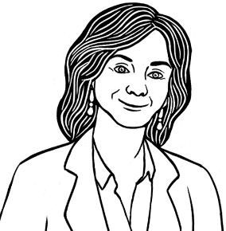
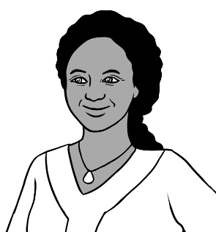
My teacher is Rosie.
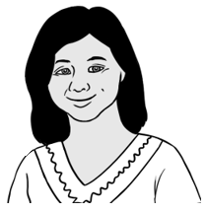

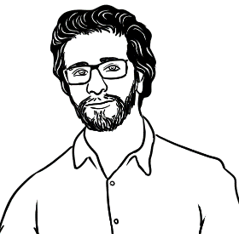
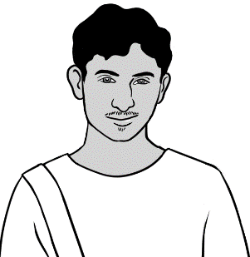
My teacher is Peter.
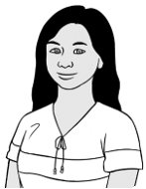

Who is your teacher?

My teacher is _______________________________.

I go to class today.
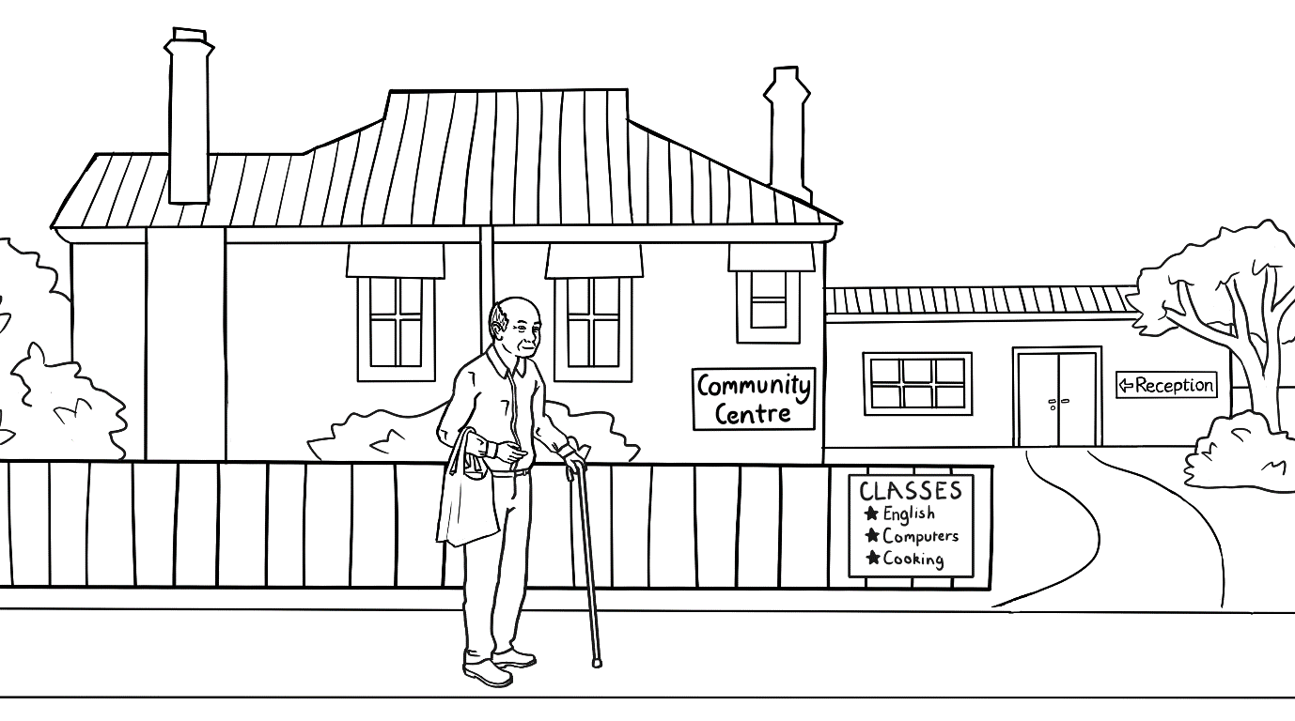
I go to class today.

Monday | Tuesday | Wednesday | Thursday | Friday
 | 9:00 -1:00  Room 4 | 9:00 -1:00  Room 4 |  | 9:00 -1:00  Room 4
This is Ming’s timetable.

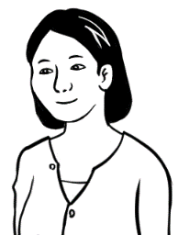
When do you go to class?
I go to class on Tuesday,
Wednesday and Friday.

Day
Monday
Tuesday
Wednesday
Thursday
Friday

Tuesday | Wednesday | Friday
Tuesday | Wednesday | Friday

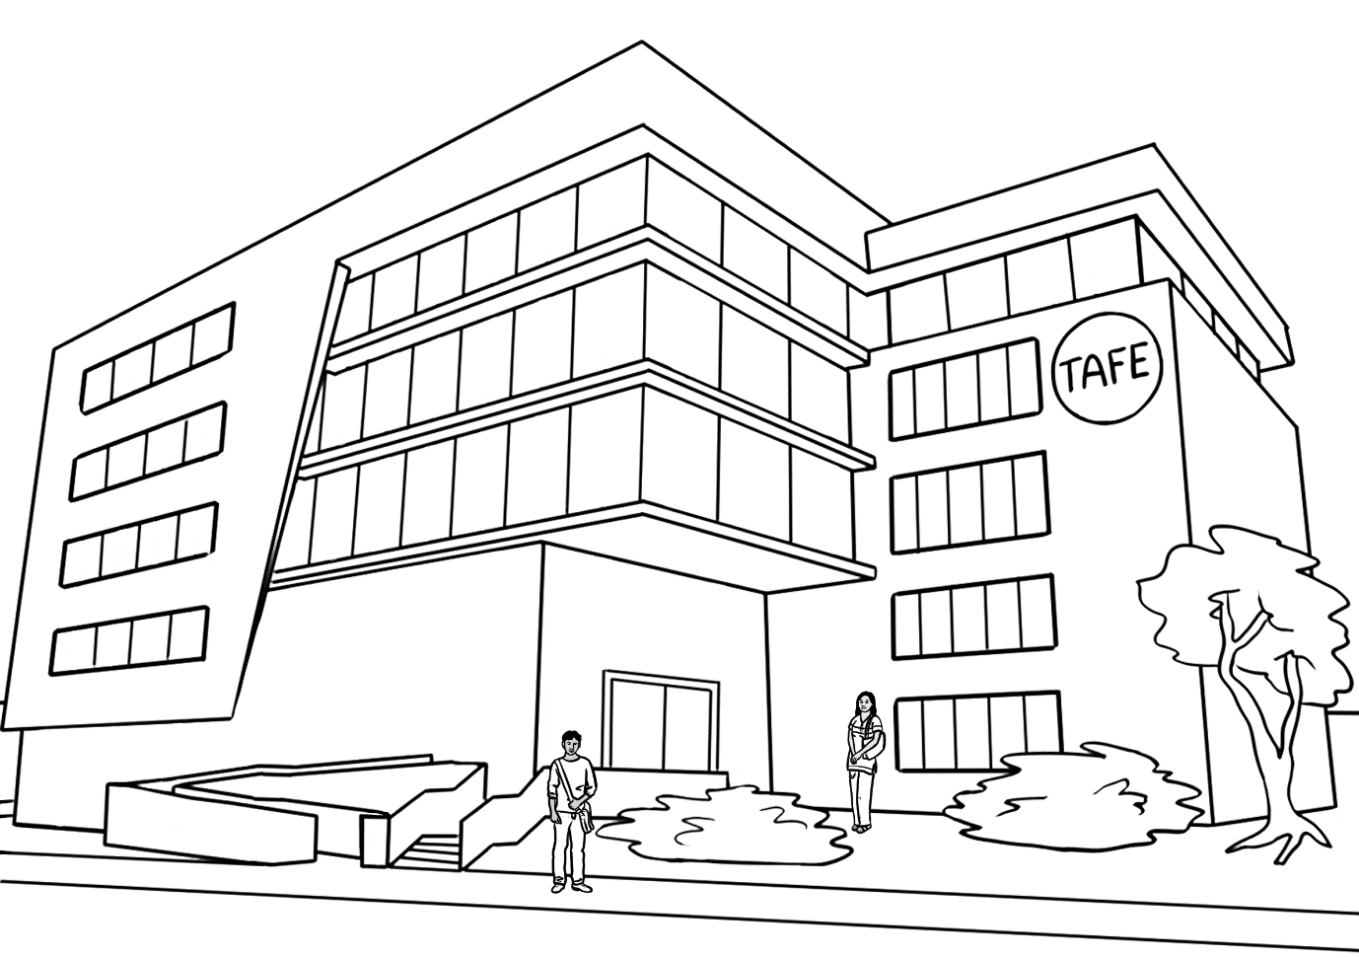
We go to class today.

Monday | Tuesday | Wednesday | Thursday | Friday
9 - 1  Room 40 | 9 - 1  Room 40 | 9 - 1  Room 40 | 9 - 1  Room 40 | 9 - 1  Room 14
This is Rahim and San’s timetable.

When do you go to class San?
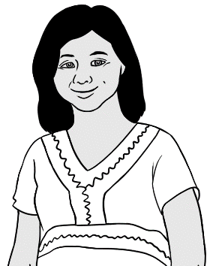
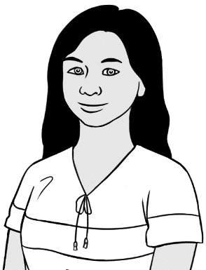
I go to class on Monday, Tuesday, Wednesday, Thursday and Friday.

Day
Monday
Tuesday
Wednesday
Thursday
Friday

Monday | Tuesday
Monday | ___ uesday
Wednesday | Thursday | Friday
___ ednesday | __ __ ursday | __ __ iday

When do you go to class?
Day
Monday
Tuesday
Wednesday
Thursday
Friday

Monday | Tuesday | Wednesday
Monday | _______ day | ______ nesday

Thursday | Friday | Saturday
________ day | _____ day | ______ urday

M | o | n | d | a | y
M | o | n | d | a | y
T | u | e | s | d | a | y
W | e | d | n | e | s | d | a | y
T | h | u | r | s | d | a | y
F | r | i | d | a | y
S | a | t | u | r | d | a | y
S | u | n | d | a | y

When do you start class?
1.

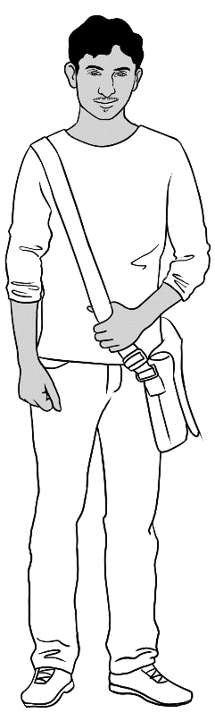
I start class at 9 o’clock.
I finish at 1 o’clock.

Monday
9:00 - 1:00
Room 40

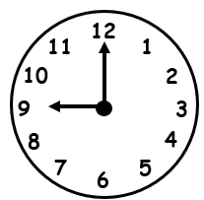
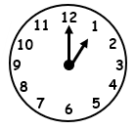
2.
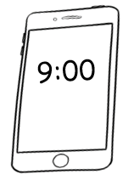
9 o’clock
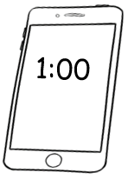
1 o’clock

I start class at 9 o’clock.
I finish at 1 o’clock.

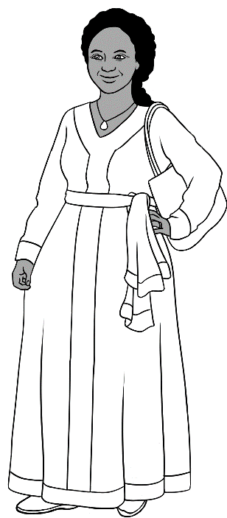

Monday
9:00 - 1:00
Room 16

When do you start class? .
When do you finish? .
I start class at _____ o’clock.
I finish at _____ o’clock.

I am sorry. I am late.
Class starts at 9 o’clock.
.

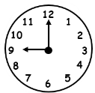
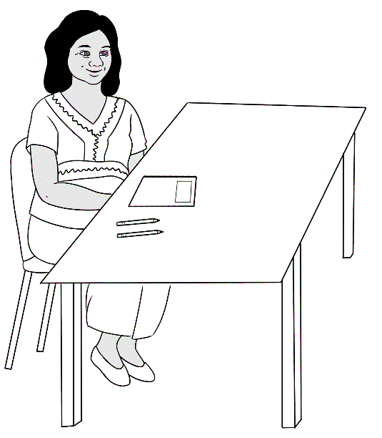

I am ready for class.
Where is Jamila?

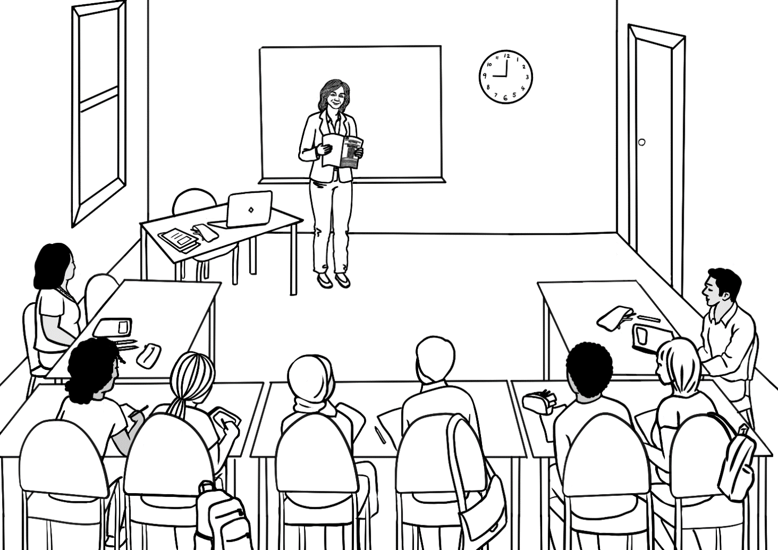
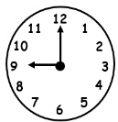
Good morning everyone.
Good morning Rosie.
Good morning Rosie.

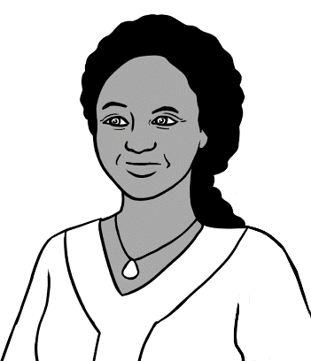
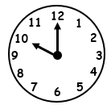
It is 10 o’clock.
I am late.

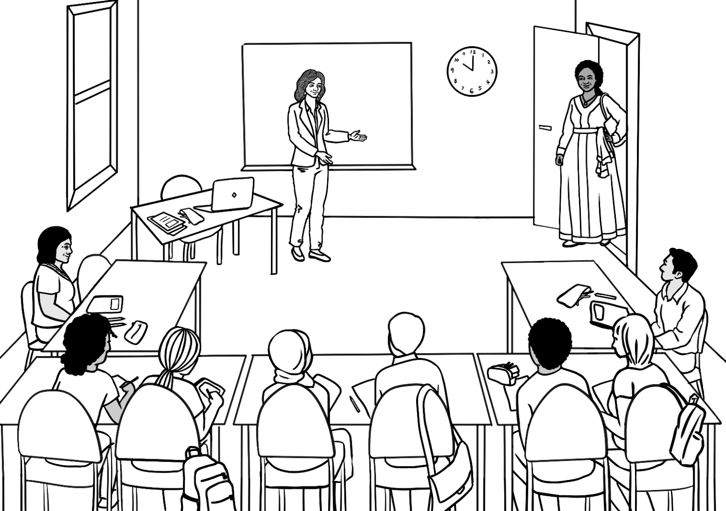
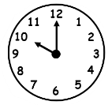
Good morning Rosie.
I am sorry. I am late.
Good morning Jamila.

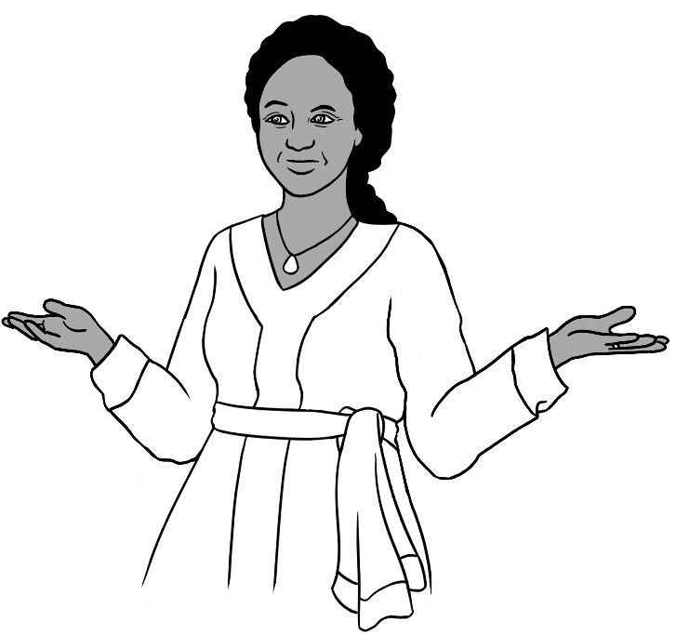
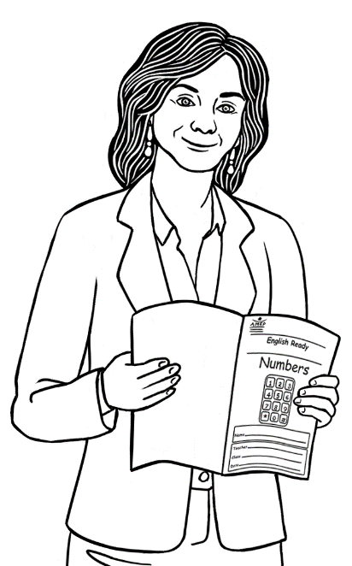
Page 13.
What page Rosie?

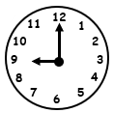

Come on time.
Come on time.
Our class
starts at 9.

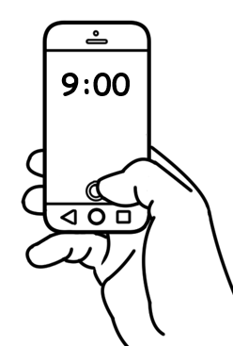

The next day

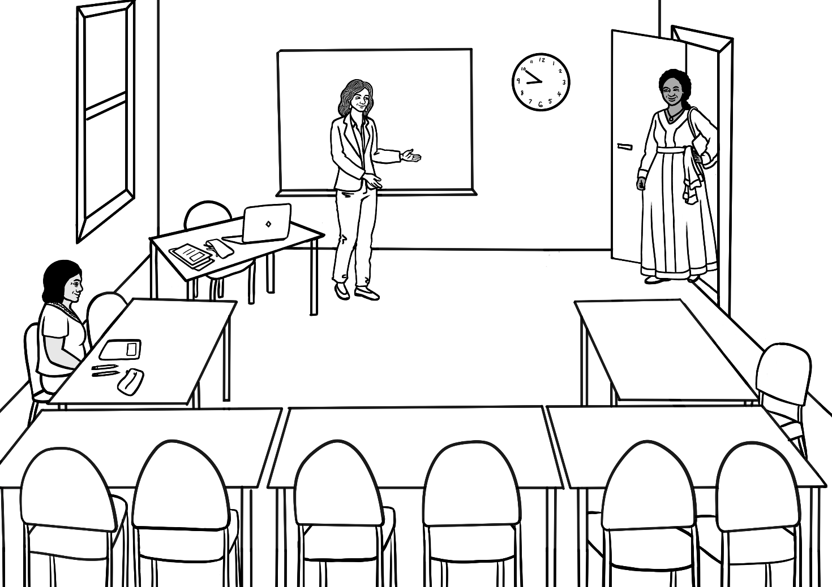
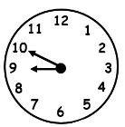
Good morning Jamila.
Good morning Rosie.

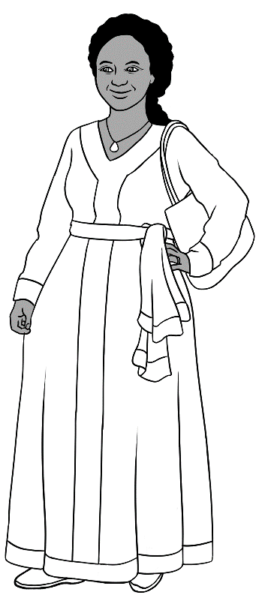
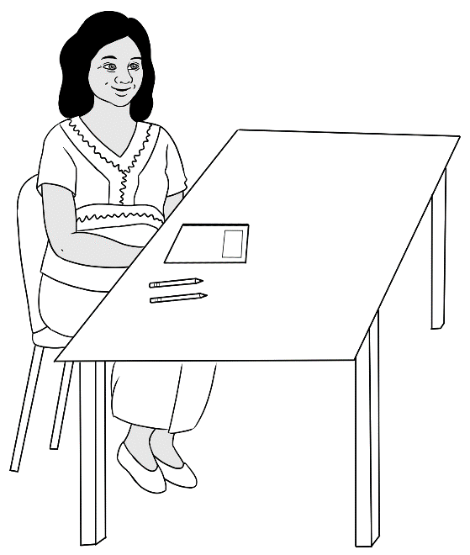

Hi Jamila.
Hello Zarni.
How are you?
Good thanks.

Do you have a pencil?

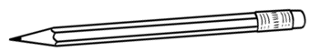  1. | 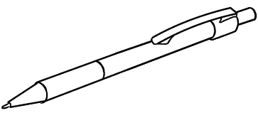  2. | 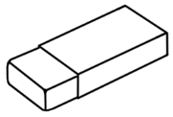  3.
pencil | pen | rubber
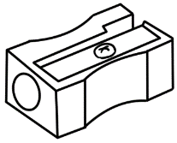  4. | 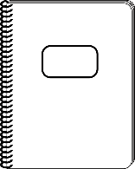  5. | 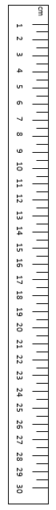  6.
sharpener | notebook | ruler
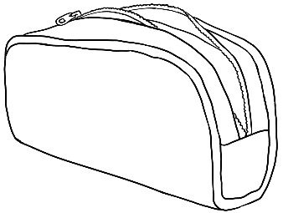  7. | 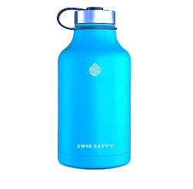  8. |   9.
pencil case | water bottle | glasses

- pencil
- pen
- rubber
- sharpener
- notebook
- ruler
- pencil case
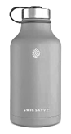
- water bottle

- glasses

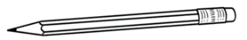


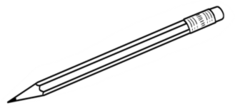
Do you have a pencil?
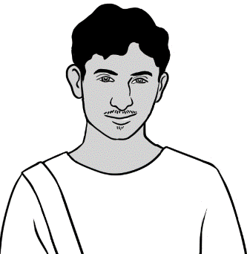
Yes.

Do you have a rubber?
No.

What do you have?

I have a pencil.
I have a rubber.

What do you have?

- I have a pen.
- I have a sharpener.
- I have a notebook.
- I have a ruler.
- I have a pencil case
- I have a water bottle.

- I have glasses.

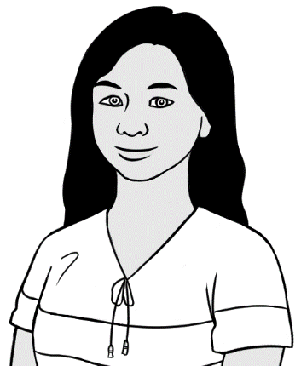

San’s pencil case
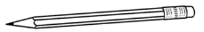
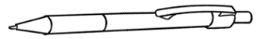
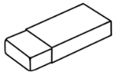
1. pencil
2. pen
3. rubber
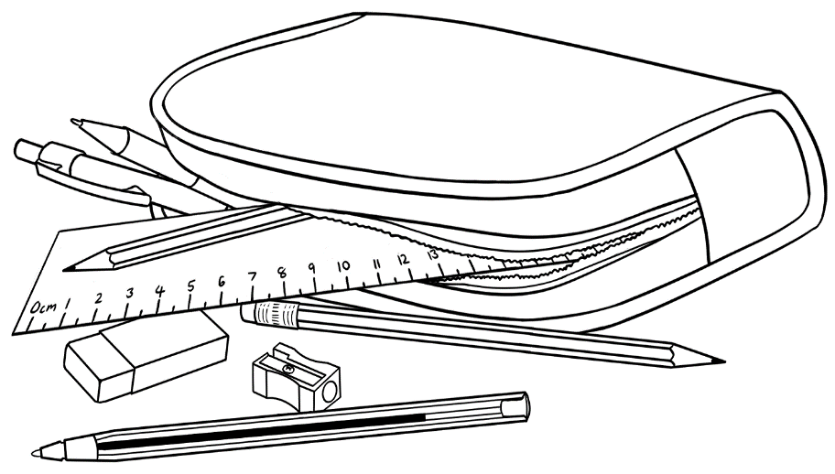

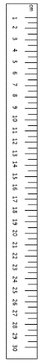
5. sharpener
4. ruler

pencil | pen
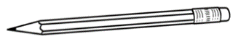  __ encil | 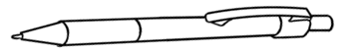  __ en
rubber | ruler
__ ubber | __ uler

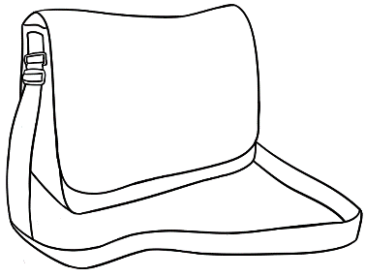
Rahim’s bag
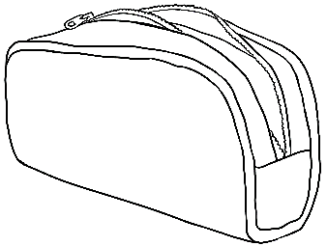
- a pencil case
- a notebook
- a water bottle
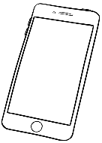
- a phone
- glasses
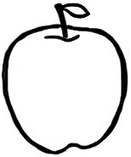
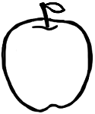
- an apple

- an umbrella

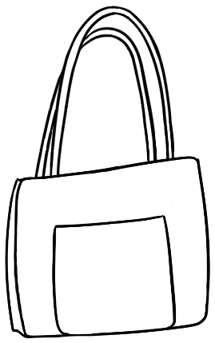

- a pencil case
- a notebook
- a water bottle
- a phone
- glasses
- an apple
- an umbrella
San’s bag

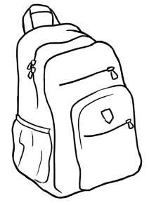

What is in your bag?
- a pencil case
- a notebook
- a water bottle
- a phone
- glasses
- an apple
- an umbrella

I want to learn English.
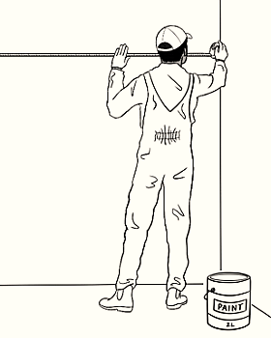
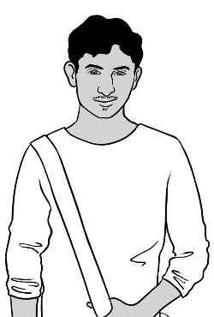

I want to be
a painter.

In class
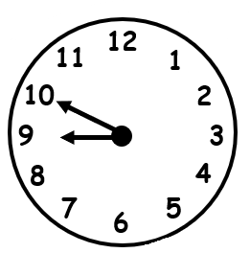
I come to class before 9 o’clock.

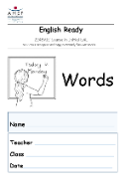
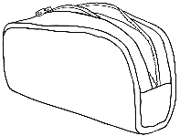

I have

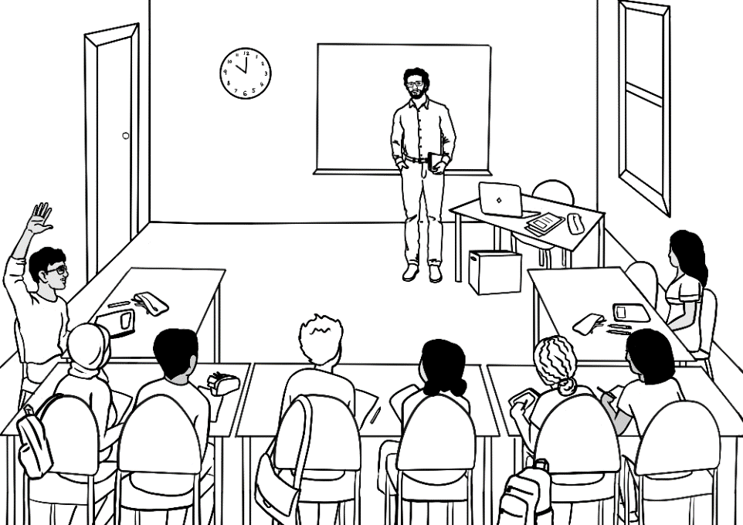
I ask questions.

Say it again please?

After class
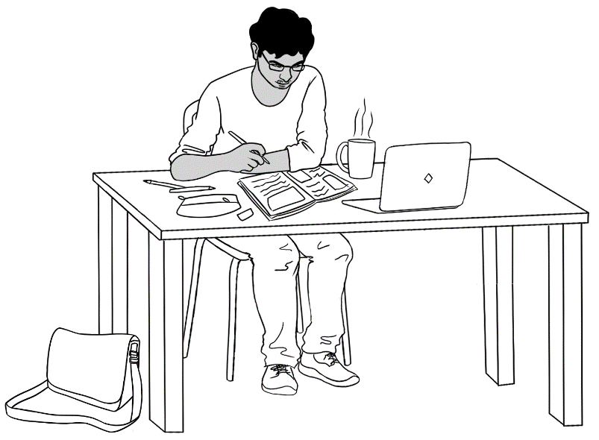
I do my homework.

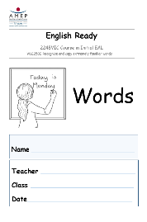
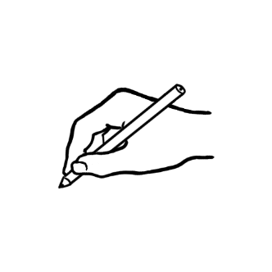
I copy words
into my notebook.

I talk to my friend in English.

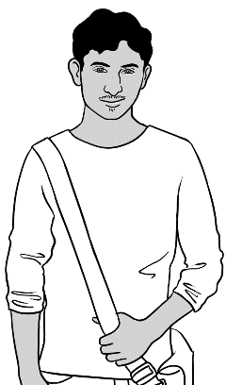
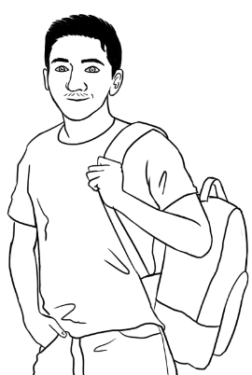
Hi Carim
Hi Rahim. How was
your weekend?
Good thanks.

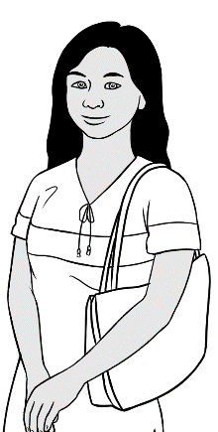
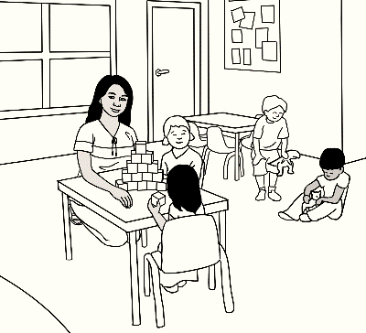

I want to work
with children.

In class
I ask for help.

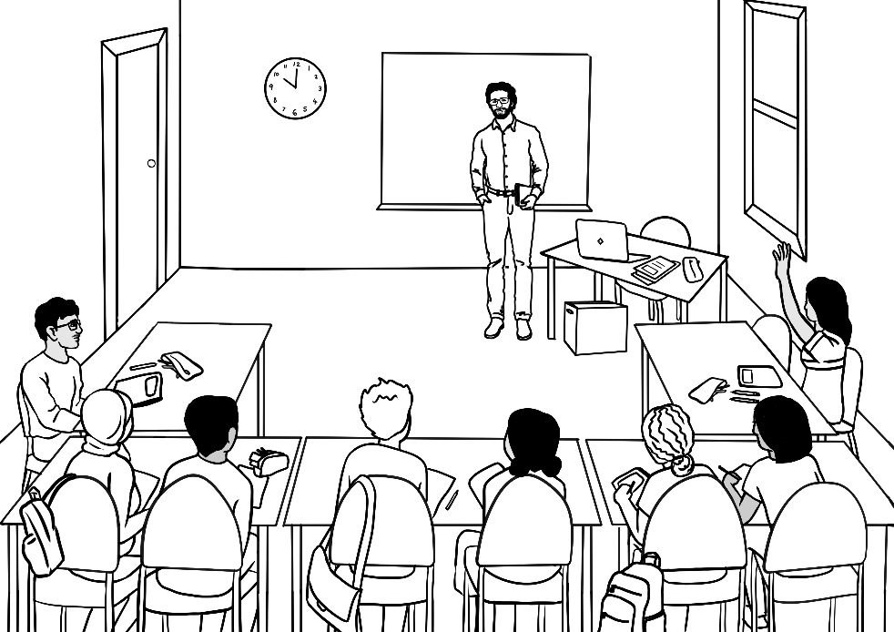
Can you help me
please?

I record the teacher.
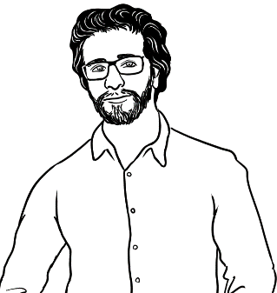
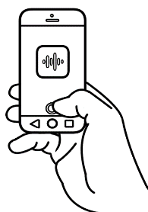
I have a pencil.

After class

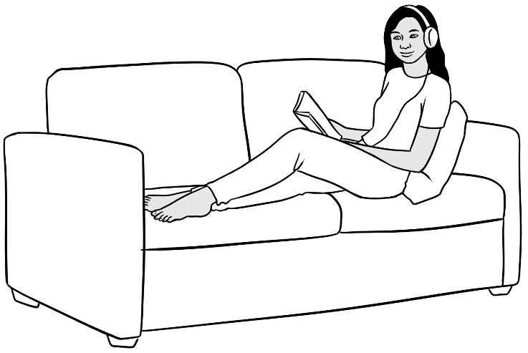
I listen to the teacher.
I repeat the words.
I have a pencil.

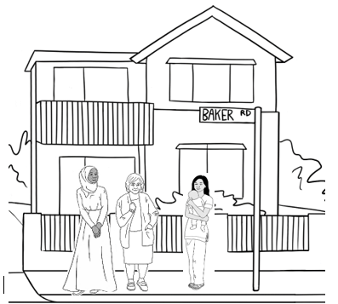
I talk to my neighbours.

I learn new words. day.

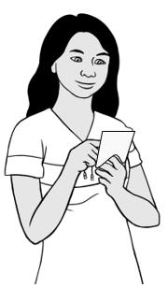
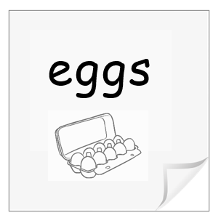
eggs

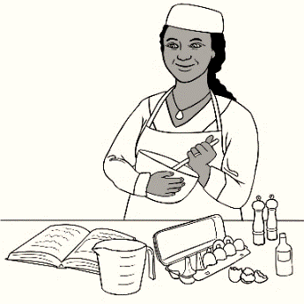
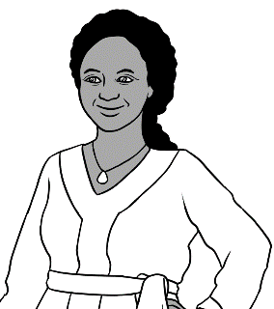

I want to be
a cook.

In class

I say the sounds. I copy the sounds.

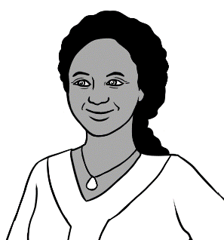
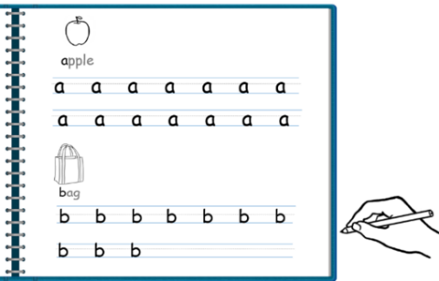
apple a
bag b.

I match the words. I say the words.

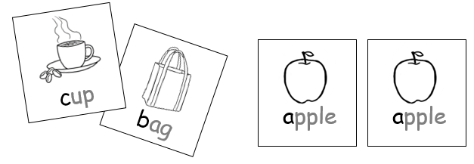
apple
I talk to my friend in English.

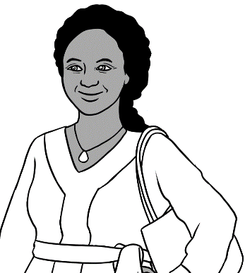
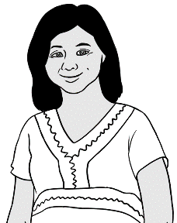
Hi Zarni.
Hi Jamila.
She is sick today.
How is San?

After class

I learn with a volunteer. I learn the sounds.

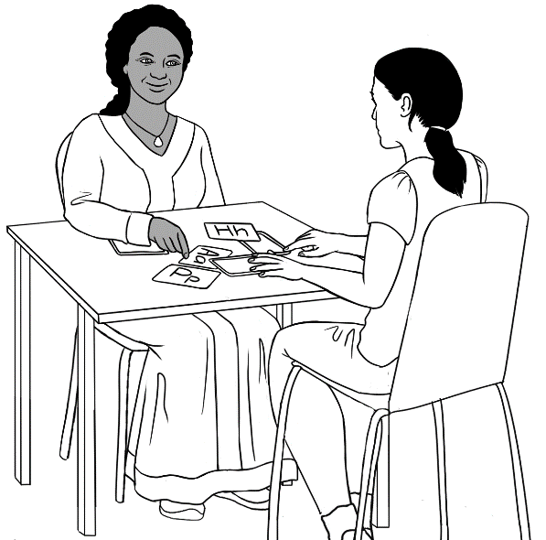
a

I use a laptop in the library.

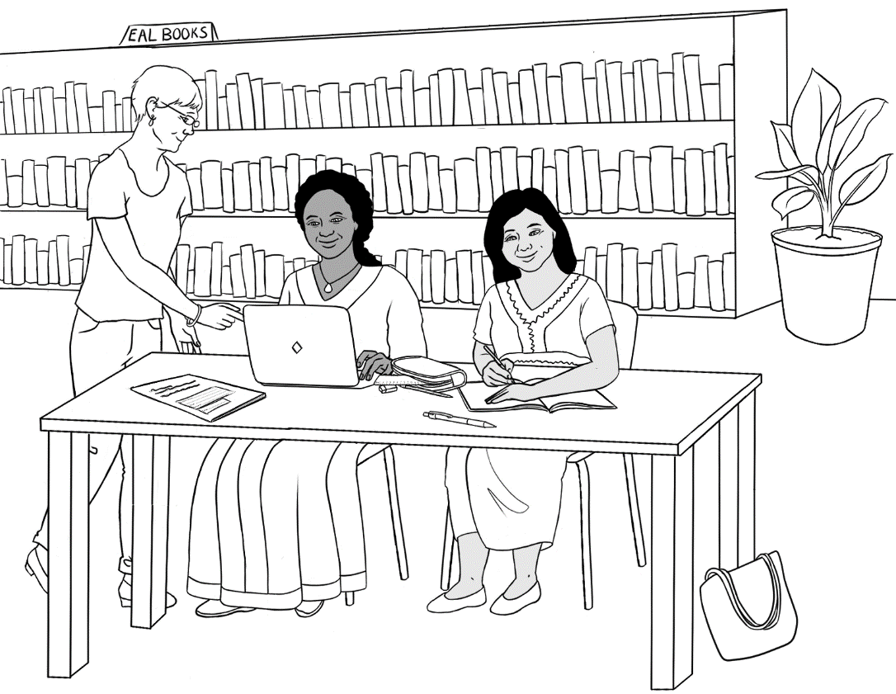
Can you help me please?

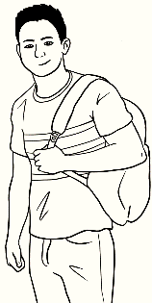
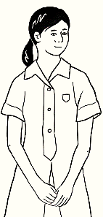
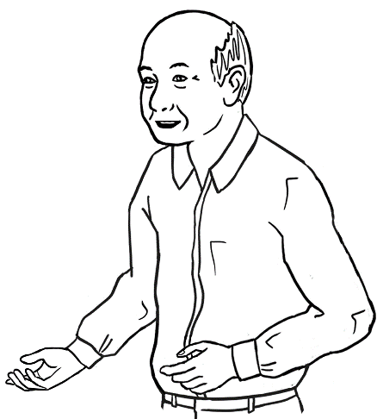

I want to talk to
my grandchildren.

In class

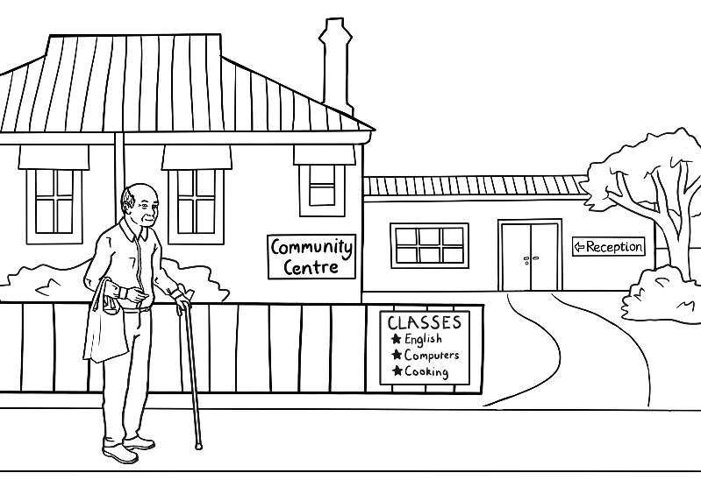
I go to class.

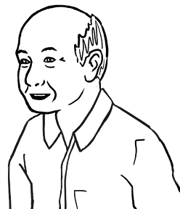
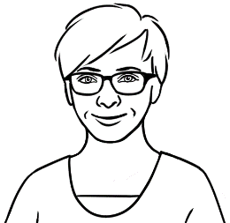
Monday
Monday
I listen and repeat.

I ask for help.

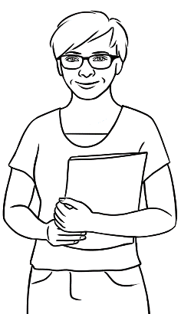
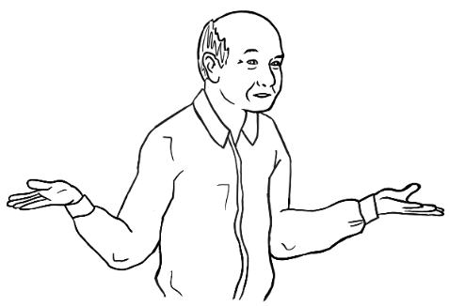
Can you help me
please Wendy?

After class
I go to the library.

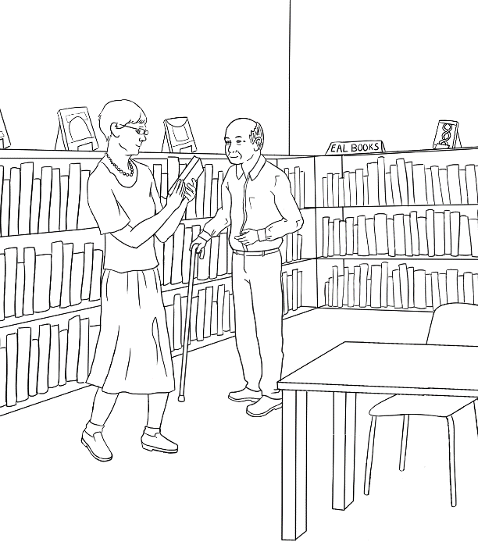
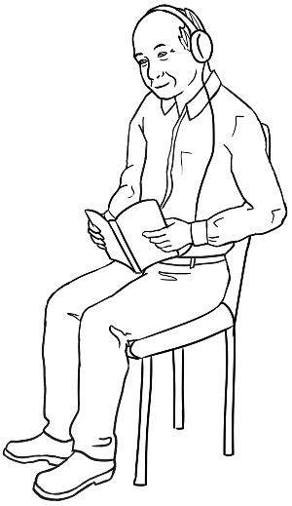

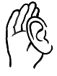
I read
and listen.

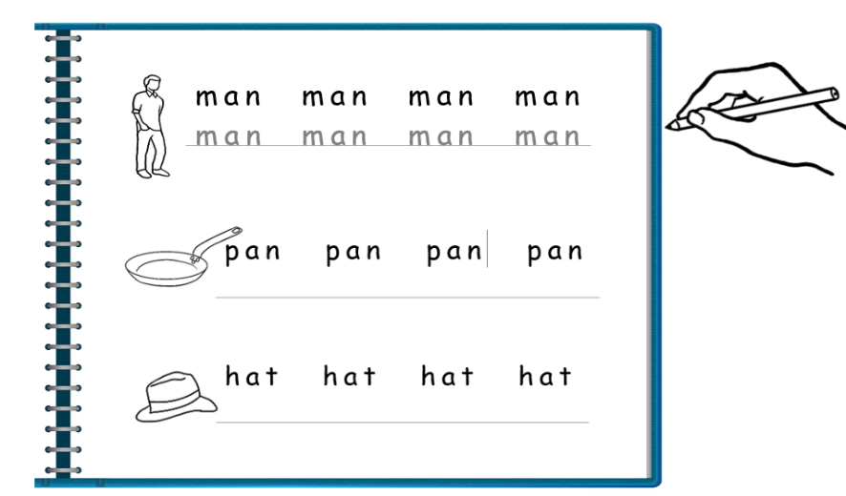

I do my homework.

I talk to my grandchildren.

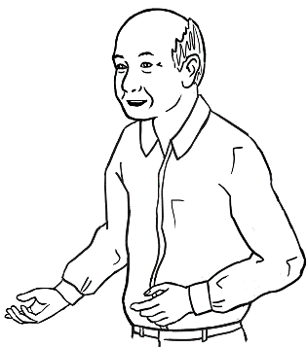
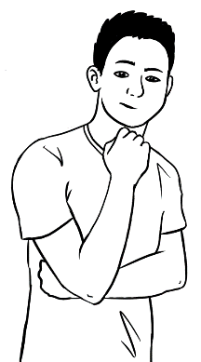
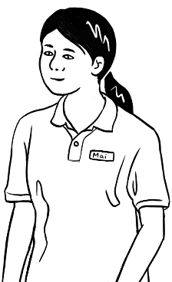
What do you do in class?
I use the computer.

In class

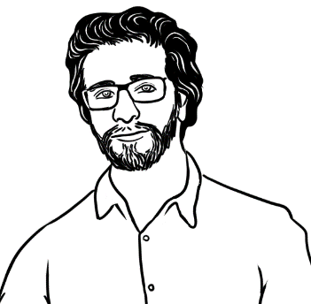
What do you do?
1 | 2
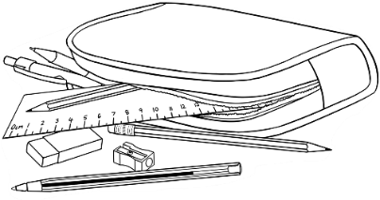  3 | 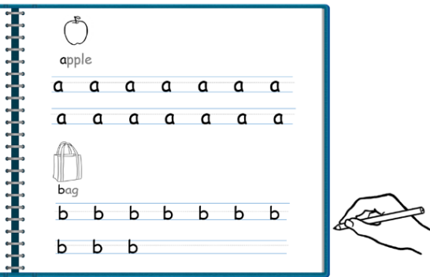  4
5  Say it again please? | 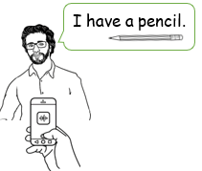  6

After class
What do you do?
1  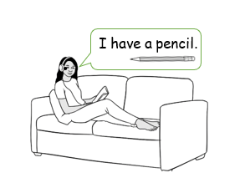 | 2
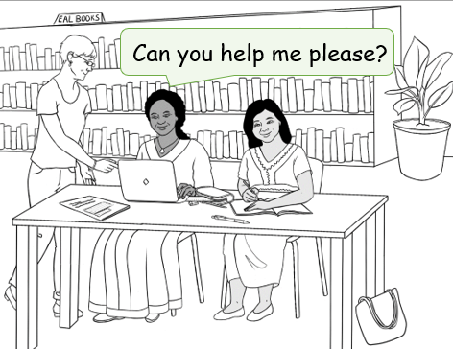  3 | 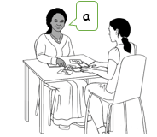  4
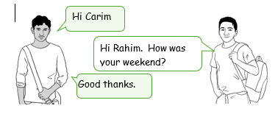  5 | 6

Follow instructions.

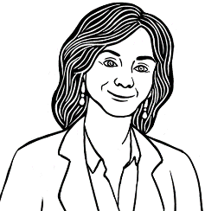
Circle b

a | b | c | d | e | f | g
h | i | j | k | l | m

n | o | p | q | r | s | t
u | v | w | x | y | z

Tick d

a | b | c | d | e | f | g | h | i | j | k | l | m

Tick r

n | o | p | q | r | s | t | u | v | w | x | y | z

Colour F .

A | B | C | D | E | F | G | H | I | J | K | L | M

N | O | P | Q | R | S | T | U | V | W | X | Y | Z

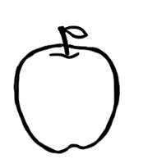
- apple a
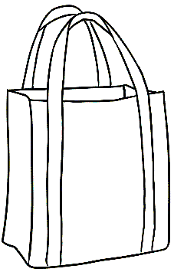
- bag b
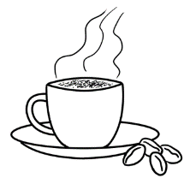
- cup c
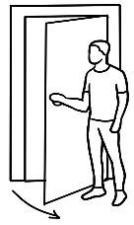
- door d
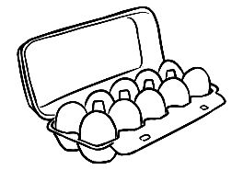
- eggs e
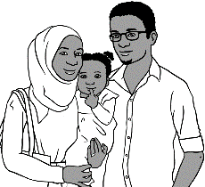
- family f

- glasses g
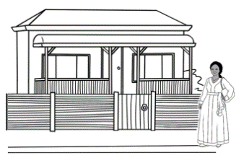
- home h
c
e
a
b
h
f
g
d

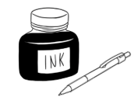  ink  ink | 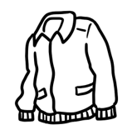  10.  jacket ___acket
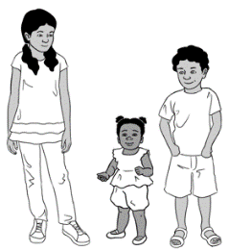  11.  kids  ___ids | 12.  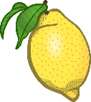  lemon  ___emon
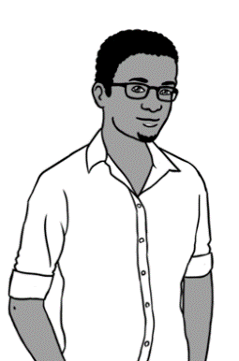  13.  man  ___ an | 14.  no  ___o
15.  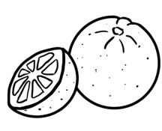  orange  ___range | 16.  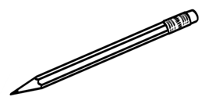  pencil  ___encil
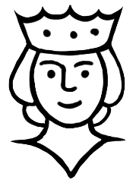  17.  queen  ___ueen | 18.  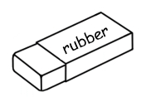  rubber  ___ubber

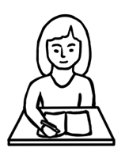
- student s
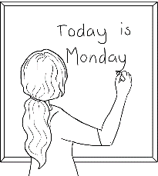
- teacher t

- umbrella u
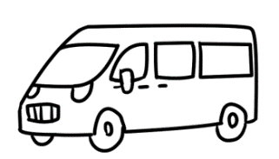
- van v
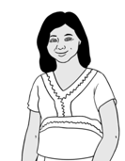
- woman w
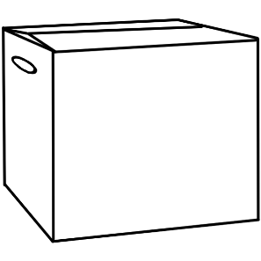
- box x
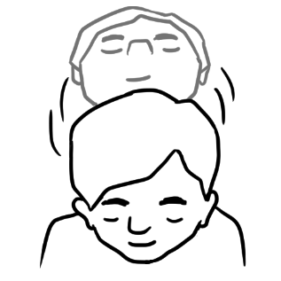
- yes y

- zero z

10.
1 | 2 | 3 | 4 | 5
6 | 7 | 8 | 9 | 10
11 | 12 | 13 | 14 | 15
16 | 17 | 18 | 19 | 20
21 | 22 | 23 | 24 | 25
26 | 27 | 28 | 29 | 30
31 | 32 | 33 | 34 | 35
36 | 37 | 38 | 39 | 40
41 | 42 | 43 | 44 | 45
46 | 47 | 48 | 49 | 50

I am sick.

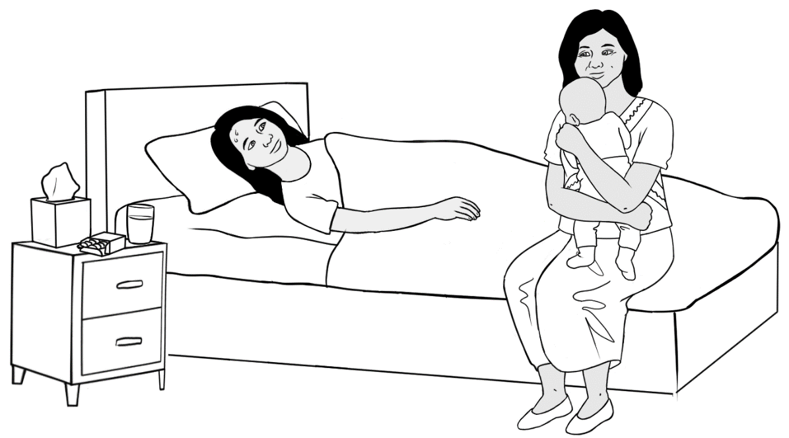
I am sick.

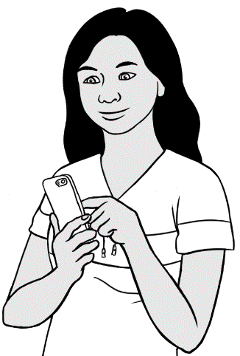
I text my teacher.

Hi Peter
I am sick.
San

Hi Peter
H i __ eter

I am sick.
__ __ m ___ ick.

San
__ an

I am sick.
__ ______ _________ .

I am sick.
__ ______ _________ .
Text the teacher.
0 | 1 | 2 | 3 | 4 | 5 | 6 | 7 | 8 | 9

My teacher’s phone number is

Hi ________________
I am sick.
__________________

Bye.
See you soon.

Bye.
See you later.

Bye.
See you tomorrow.
