English Ready
22636VIC Course in Initial EAL
VU23490 Use extremely familiar strategies to participate in learning

Learn English
Learn Eish
Teacher Resources
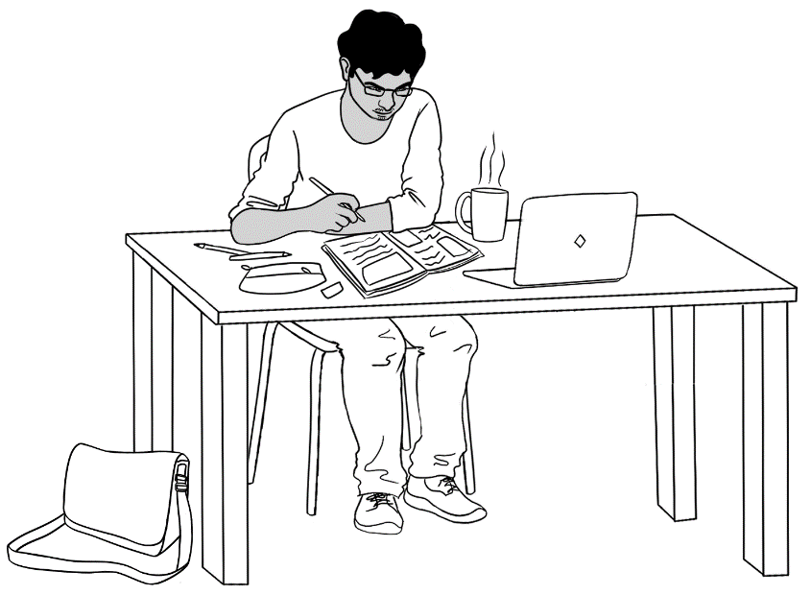

Design team: Vicki Hambling, Sue Paull, Frida Dean and Mary Wallace
Illustrations: Madelena Scott
Acknowledgements: The design team would like to thank the AMEP service providers and practitioners who participated in the trial and gave valuable feedback. The team would also like to acknowledge the use of the EAL Framework which underpins the design of this book.

Copyright of the EAL Framework is reserved to the Crown in the right of the State of Victoria. © State of Victoria (Department of Education and Training) 2023.
__________________________________________________________________________________
This English Ready Resource is licensed under a Creative Commons Attribution-NoDerivs 3.0 Australia licence (More information is available here). You are free to use, copy and distribute to anyone in its original form as long as you attribute Department of Home Affairs as the author and you license any derivative work you make available under the same licence.
© Commonwealth of Australia 2023

With the exception of the Commonwealth Coat of Arms, the department’s logo, any material protected by a trade mark and where otherwise noted all material presented in this document is provided under a Creative Commons Attribution 4.0 International (https://creativecommons.org/licenses/by/4.0/) licence.
The details of the relevant licence conditions are available on the Creative Commons website (accessible using the links provided) as is the full legal code for the CC BY 4.0 licence.(https://creativecommons.org/licenses/by/4.0/legalcode).
Use of all or part of this document must include the following attribution:
© Commonwealth of Australia 2023
As far as practicable, material for which the copyright is owned by a third party will be clearly labelled. The department has made all reasonable efforts to ensure that this material has been reproduced in this document with the full consent of the copyright owners.
Copyright requests and enquiries concerning usage not addressed by the CC BY 4.0 licence should be addressed to: comms@homeaffairs.gov.au at the Department of Home Affairs.
The terms of use for the Commonwealth Coat of Arms are available from the It's an Honour website.
Where a copyright owner, other than the Commonwealth, is identified with respect to this material, please contact that third party copyright owner directly to seek permission.



Introduction to the books

The Teacher Resources
The oral and kinaesthetic activities in this book utilise a variety of senses
to improve memory retention. This is particularly important for students impacted by trauma. The most productive classes are noisy and active. Resources here aim to promote noisy active learning. They include:
- drawings of the characters for use in the design of additional materials
- flashcards for printing
- individual and class activities
- revision and homework exercises
- pronunciation
- extension exercises.
The book is an electronic reference. Print pages as needed.
The Student Workbook
The student book requires teacher direction and is not intended for independent learning. It is also not intended to be the only material used
to teach these units or to be used as an assessment task. It is recommended that students buy and use a notebook for general class work and practice.

The book is available as a Word document so that teachers can:
- localise and update the content
- adjust the material to suit the requirements of particular classes and students
- delete, add and grade materials as required. If you add or deduct pages, be mindful of the layout as the document has been designed
so that particular pages are opposite one another.

NB * A teacher version of the student workbook contains additional guidance for activities and also answers for listening exercises.
* Considering the cost of photocopying, colour has been used sparingly.

Table of contents

1 Instructions 3
2 Do you understand? 9
3 Meet the students and teachers. 12
4 What is your name? 14
5 Where do you learn English? 16
6 Who is your teacher? 17
7 I go to class today. 18
8 When do you start class? 27
9 I am sorry. I am late. 32
10 Do you have a pencil? 33
11 I want to learn English. 37
12 Follow instructions 50
13 I am sick. 53
14 Useful on-line resources 56
15 Appendix 58

Instructions
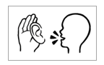
The following table gives a more detailed explanation of the instruction icons and may be a useful reference in developing class materials.
The first two instructions, Listen and Say are usually combined to mean
Listen and Repeat.

This double icon precedes most exercises in the workbooks as it is a key learning strategy at this level. The word ‘repeat’ needs to be introduced to students early in the course.

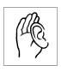  - Listen | Listen carefully to the teacher. |   Good morning.
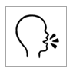  - Say | Repeat what the teacher says or say the words aloud. | 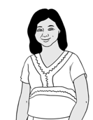  Good morning.
  - Copy | Copy the letters  or words below  the model. | man  _______  man  m_n
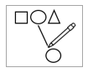  - Match | Match the letters or words. | man
  fan | 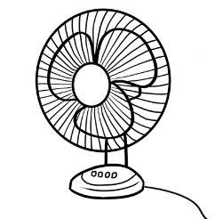
  man | 
  - Colour | Colour the letters.  Colouring strengthens the muscles used in writing; the use of colour aids memory.
  man
  man

  - Circle | Circle the letters or words. | man
  m | f | a | s | n
  - Trace | Trace over the grey lines. | man  man
- Tick | Tick if the answer is yes.
  What do you have?
  I have a pencil.
  I have a pen.
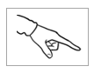  - Point | Point to the word or sound the teacher says. |   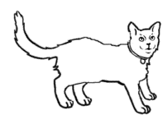  hat cat man
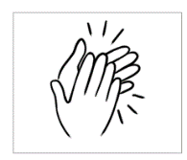  - Clap | Listen to the teacher and clap the syllables; stress the strong syllables. | 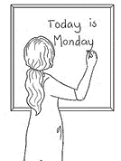  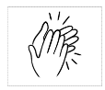    teacher

Workbook instructions flashcards
Due to the student’s level of literacy, icons replace written instructions in the workbooks. Instructions and guidance for all activities must be given by the teacher. Where necessary, some teacher instructions have been given in a small grey font in the teacher version of the student book.
To develop independent learning skills, the class activities below can help students recognise and understand the meaning of the icons.
- Icon flashcards
Enlarge, cut up and introduce the icons gradually without the words as they occur in the workbooks. Blutack the icon cards to the board or walls for reference at different times throughout the class and ensuing classes. Make a power point with the icons and get students to say what they are.
- Matching
When the icons are familiar to the class, introduce the written instructions for matching. Give each student either an icon or a written instruction. Students then walk round the room to find the student with the matching card. Blutack the written instructions next to the icon on the board or wall. This is a useful way to pair students for pair work.

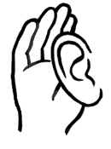 | listen
 | say

 | trace
 | tick
 | colour
 | circle

 | clap
 | copy
 | match
 | point

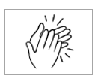
Shaded boxes indicate a two-syllable word.
Ask questions, What’s number 3? etc
- listen
- say
- copy
- match
- colour

- circle
- trace

- tick
- point
- clap

Do you understand?
Make requests for repetition or clarification
Although the requests for clarification and repetition are specific to the speaking unit [VU23492], they are important in all units. Print the requests on the following page, laminate and cut up. Build confidence in using the expressions through regular class practice:
- Project an image using PowerPoint and chant the phrase.
- Give the three expressions to three students. Select the most confident students at first.
- Ask these students to use their expression at least once during the class – initially with the teacher and later with each other.
- Give the expressions to different students in following classes.
- Teach additional expressions when appropriate.

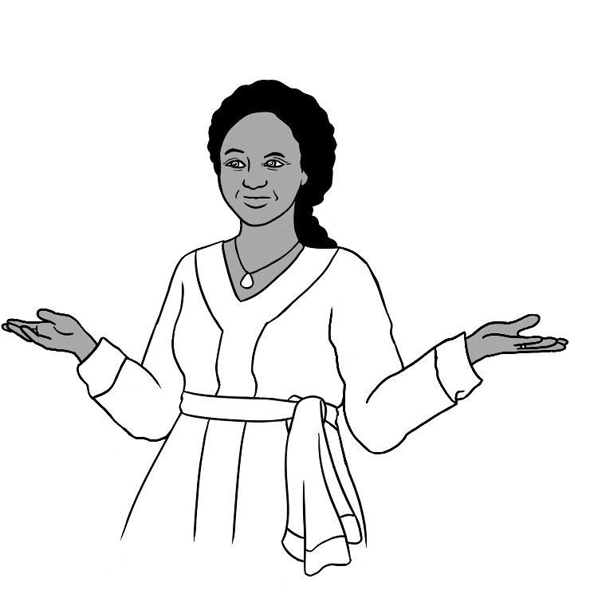
I don’t understand.
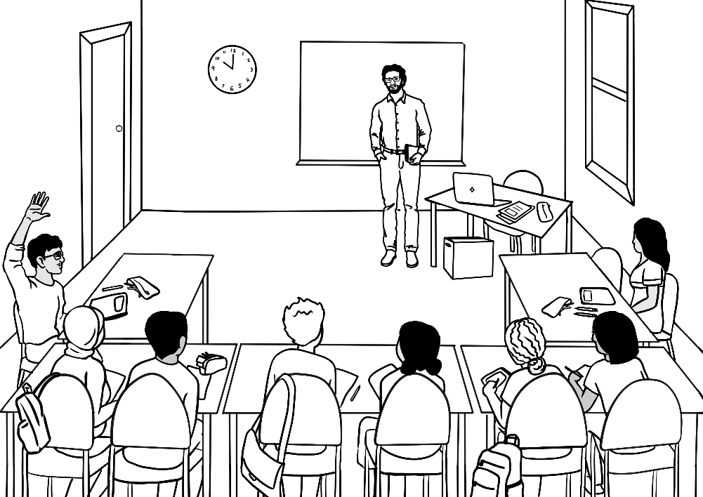
Say it again please?
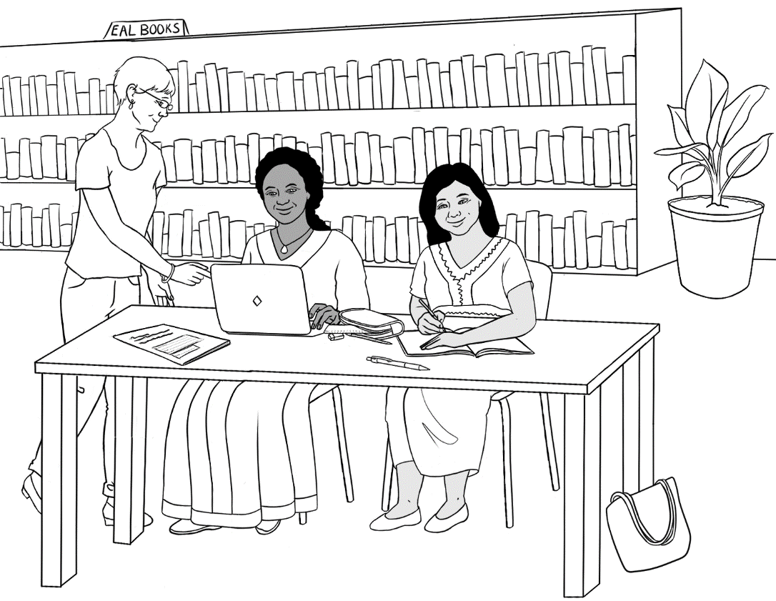
Can you help me please?

Meet the students and teachers.

Drawings of the characters
The characters have been included so that teachers can produce their own materials as needed. The chart with the bio data was created to maintain consistency of information throughout the booklets. Empty boxes on the table indicate that the information hasn’t been introduced in any of the books. It may be useful to update character information to make it more relevant to the time of use.

Name | Country of origin | Date of birth | Date of arrival | Address in Kellivale  2421 | Phone
Zarni Tun | Myanmar | 10. 04. 1978 Age 45 | - | Unit 4, 50 Baker Road | 0407 326 518
San Tun | Myanmar | 15. 11. 2001  Age 22 | - | Unit 4, 50 Baker Road | -
San’s baby son | Australia | Age 4 months | - | Unit 4, 50 Baker Road | -
Jamila Desta | Ethiopia | Age 50 | - | 56 North Street | 0408 629 531
Rahim | Afghanistan | 07. 05. 2003  Age 19 |  |  | 0469 883 412
Ming | China | 27. 03. 1959 |  | 70 Wattle St | 0418 335 748
Teacher  Rosie | Australia | Age 50 | - | - | 0461 239 758
Teacher  Peter | Greece | Age 38 |  |  | 0436 924 651
Teacher  Wendy | England | Age 45

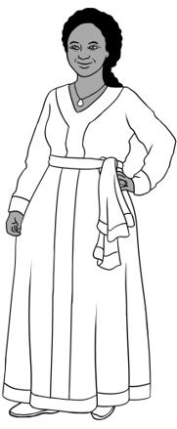
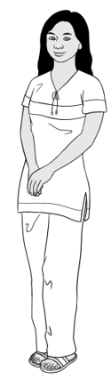
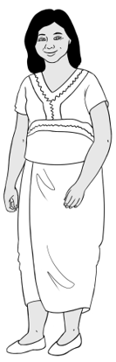
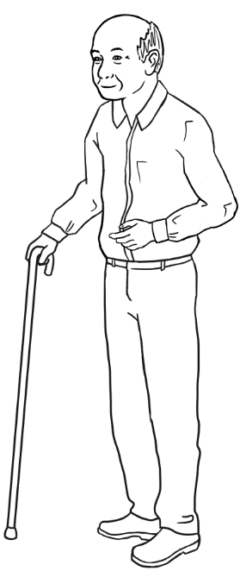

Jamila
2.

1
San
Zarni

Ming
3.
Family relationships
Some of the characters pictured have relatives:
- Zarni is San’s mother.
- Jamila has a daughter Anika [in the Course in EAL books]
- Ming had a daughter Lan and two grandchildren, Mai and Bao.
[in the Course in EAL books]


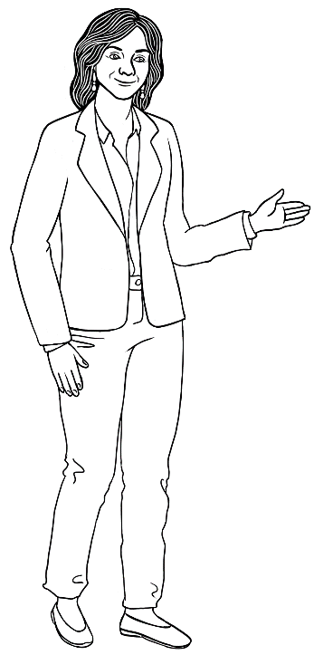

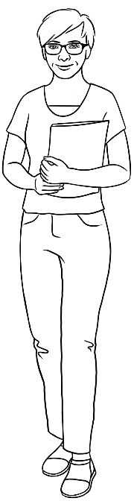

4.
Rahim
Teachers
5.
Wendy
Peter
Rosie

What is your name?
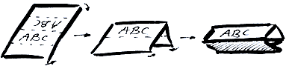
Activities with names
- Word stress
Write student names on the board in lists according to the number of syllables. Mark the stress with a large circle and practise together. Clap, stamp feet or use a rubber band to mark the main stress.
San Zarni Rahim Jamila

- Name cards
Fold and create name cards for each student. The teacher writes each student’s first name on one side of the card or paper, and their family name on the other side. The name cards can be used as a model for students to copy from in class.

- At the beginning of each lesson hand the name cards out to the students. The students put the card at the front of their desk.
- As students learn the alphabet, hold up each card and ask, Whose name begins with …. ? Use it as an opportunity to practise the letter names and later the sounds.
- At some point lay the names out on a table and students pick up their names as they come in.
- Have a list of names at the door and students mark off their names as they come in.
- Start each lesson by flashing a name card and asking ‘Who is this?’

* The spelling of names is very important. Students need to use the spelling
on their passport as this is the legal representation of their name.

3. Chants
Invent chants to teach common expressions and collocations.
e.g. for introductions:

What’s your name? My name is Zarni.
What’s your name? My name is Zarni.
Where are you from? Myanmar
Where are you from? Myanmar

What’s your name? My name is Jamila.
What’s your name? My name is Jamila.
Where are you from? Ethiopia
Where are you from? Ethiopia

4. Photos
If students are agreeable, take photos of each of them. Then:
- Make a wall chart with the student names under the photos
- Attach the photos to the wall around a map with strings to attach the photos to each student’s country of birth.
- Make flashcards of the photos. Give a card at random to each student. Students take turns to hold up the photo and call out
the name of the person.

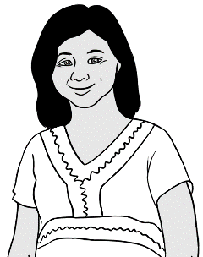


Where do you learn English?

Learning centres - Information

English classes take place in many different spaces:
- TAFE
- Community centres
- Neighbourhood houses
- Libraries
- Church halls
- Leisure centres
- Health centres
- Universities
- etc
Customize this section and insert photos of where classes are held and add key information.

Who is your teacher?
Customise the table for your learning centre and class. Insert photos, names phone numbers and dates.

Insert learning centre photo. | Learning centre:  Phone:
Insert teacher photo. | Name:  Phone:
Interpreter | Name:  Phone:
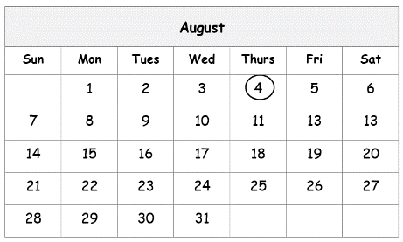  Dates | Term dates:  Holidays:

I go to class today.
The days of the week
Activity 1 – What’s today?

- Hand out multiple copies of flashcards of the days of the week so that each student has a day. [Use either upper or lower-case letter cards]
- Write the day on the board.
- Ask students who have the flashcard with the correct day to hold the card up. Give a clue – the first letter is M. [in Monday]
- *Chant – Today is Monday, Today is Monday, Today is Monday etc.
It is helpful to chant and to walk around the room.
Activity 2 – Identifying the days in upper and lower-case letters
- Hand out copies of both upper and lower-case flashcards of the days of the week so that each student has a day.
- Ask the class to stand on either side of the room in two groups,
students with capital letters on one side and small letters on the other.
- Write the day on the board in both upper and lower-case.
- Ask students who have the flashcard with the correct day to hold the card up. Give a clue – the first sound is Th. [in Thursday]
- *Chant – Today is Thursday, Today is Thursday etc.
It is helpful to chant while walking around the room.

*Chanting is an essential activity at Course in Initial EAL level. Chanting
in a group builds confidence and aids the memory retention of everyday collocations. It also gives shyer students an opportunity to speak in the anonymity of a chorus, builds group connection and creates laughter.
Going on an excursion to the market? Chant the plan: We’re going to the market on Tuesday. We’re going to the market on Tuesday. As you walk to the market, recite the days, Monday, Tuesday etc

Activity 1 & 2 - Flashcards – Days of the week. [Lower-case]
Monday
Tuesday
Wednesday
Thursday
Friday
Saturday
Sunday

Activity 1 & 2 - Flashcards – Days of the week. [Upper-case]
MONDAY
TUESDAY
WEDNESDAY
THURSDAY
FRIDAY
SATURDAY
SUNDAY

Activity 3 - Pronunciation th
The letters th make two different sounds:
- Unvoiced as in Thursday, three
- Voiced as in the.

Both sounds are made by separating the top and bottom teeth with the tip of the tongue and blowing air through the small gap over the tongue.
The unvoiced sound as in Thursday is made by simply blowing air. Demonstrate by saying the word into the palm of the hand to feel the airflow.
The voiced sound as in the is made with the addition of the voice and vocal chords. Demonstrate by placing the palm over the throat to feel the vibrations.

Teach the th words listed below as they arise, beginning with Thursday and other unvoiced th words.

th unvoiced |  | th voiced
Thursday | three | the | that
thanks | thirteen | they | then
 | thirty | them | this

Activity 4 – Word stress – Syllables first
For learners to be able to accurately use word stress, they must first be able to distinguish words that have more than one syllable. Tap your finger on the desk, punch the air, tap your foot, add movement to feel the syllables. [Make sure students don’t add a syllable at the end of a word.
e.g. Come on Mon day. not Mon day ya]


Activity 5 – Word stress
Kinesthetic movement can help learners recall word stress.
- Move to it - Raise your hand and stretch it out for the stressed syllable; lower and draw it back for the unstressed syllable.

- Hum it - Some students find it difficult to hear the stress, so combine humming with the above activity and with hand movement.
MON day - MM – mm
- Show it - Hold your fist next to your face, open your fist when you say the stressed syllable and close it for the unstressed syllable.

- Draw it - Draw circles above the word to show the stress. The stressed syllable has a large circle and the unstressed syllable a small circle.
Monday
- Move objects - Use counters to show stress. Say a word and students lay out a counter for each syllable. Repeat the word. Students move the counter which represents the stressed syllable up. Repeat the word a number of times and exaggerate the stress if students find it difficult. Students repeat the word touching the counters as they say the word out loud.

- Give students pieces of coloured card at different lengths. Say a word and the students place the card to show both syllables and stress.

e.g. Mon day
- Project the following page and clap the syllables and stress.

Stressed syllable
Unstressed syllable

Monday | Mon day
Tuesday | Tues day
Wednesday | Wednes day | 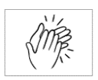
Thursday | Thurs day
Friday | Fri day
Saturday | Sat ur day
Sunday | Sun day

Homework

Monday |  | Tuesday
Monday |  | Tuesday
Monday |  | Tuesday
Monday |  | Tuesday
Monday |  | Tuesday
Wednesday |  | Thursday
Wednesday |  | Thursday
Wednesday |  | Thursday
Wednesday |  | Thursday
Wednesday |  | Thursday

Friday |  | Saturday
Friday |  | Saturday
Friday |  | Saturday
Friday |  | Saturday
Friday |  | Saturday
Sunday |  | today
Sunday |  | today
Sunday |  | today
Sunday |  | today
Sunday |  | today

Homework
Monday  Mon _ _ _ |  | Monday  _ _ _ day
Tuesday  Tues_ _ _ |  | Tuesday  _ _ _ _ day
Wednesday  Wednes _ _ _ |  | Wednesday  _ _ _ nesday
Thursday  Thurs _ _ _ |  | Thursday  _ _ _ _ _ day
Friday  Fri _ _ _ |  | Friday  _ _ _ day
Saturday  Satur _ _ _ |  | Saturday  _ _ _ urday
Sunday  Sun _ _ _ |  | Sunday  _ _ _ day

When do you start class?

Activity 1 – Clock faces
- Make clock faces for or with every student. [See the following page]
Glue the faces onto paper plates or card and use split pins to attach
the hands. Each hand needs to be a different colour.
- Call out a time and ask students to move the hands to that time, then hold up their clocks to be checked.

- Students chant at set times. Use present simple.
e.g. When they arrive, chant:
We start at nine. We start at nine.
At break time, chant:
We have a break, at eleven. We have a break, at eleven.
At the end of class, chant:
We finish at one. We finish at one.

NB. If students chant while doing an activity, change the tense to present continuous: e.g. We are packing up. We are packing up.
Once a chant has been memorised, add to it slowly, maintaining the tense. We are packing up. We are packing up.
We are going home. We are going home.
Although this tense is not part of the unit requirement, students can absorb the grammar in this organic way.

Activity 2 – Matching times
Cards with clock faces, digital clocks and the time on phones can be enlarged and used as flashcards for matching as a class activity or in pairs. They can also be used to create a simple PowerPoint with one clock per slide, and projected as digital flashcards.

Clock face
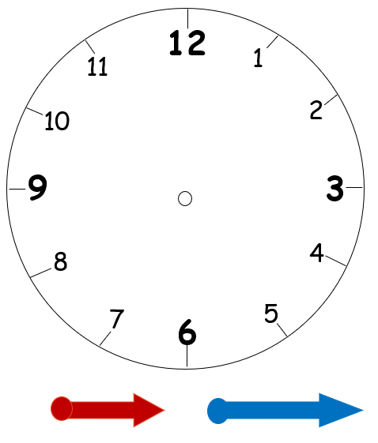

Clock faces, digital clocks and phones
 | 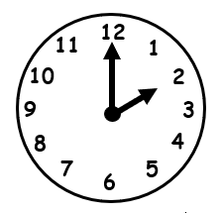 | 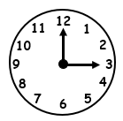
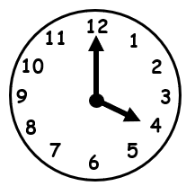 |  | 
 | 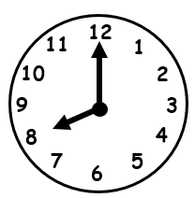 | 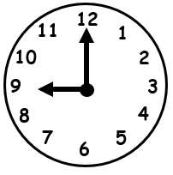
 |  | 

 |  | 
 |  | 
 |  | 
 |  | 

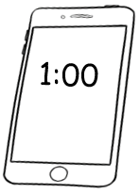 | 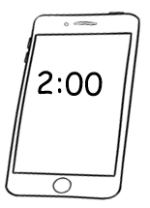 | 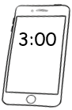
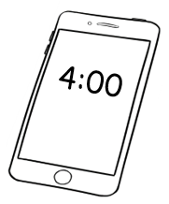 | 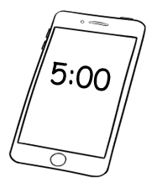 | 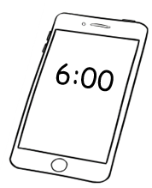
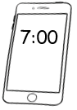 |  | 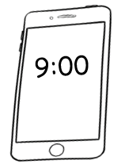
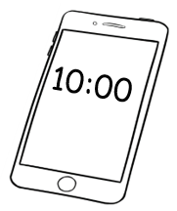 | 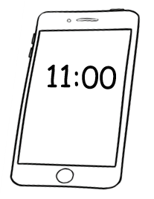 | 

I am sorry. I am late.
- Punctuality
Make students aware that being on time is important and polite in an Australian classroom and in addition, that punctuality has other benefits:
- It makes learning English easier and faster – students have time
to get organised and ready to learn before the class begins.
- Other students in the class are not distracted. The lateness of students disturbs a class at least twice – on their arrival, and then again when the teacher has to re-explain work to late-comers.
- It offers precious time before class for students to engage socially. This helps build relationships and enhances the class dynamic.

- Contractions
To avoid the confusion that can be caused by apostrophes, contractions have been omitted in the student book. However, they are very common in spoken language and could be introduced when appropriate.
Short forms which could be introduced are: I’m, don’t, can’t, what’s, it’s These could be introduced through simple chants such as those below, to be mimed, clapped, repeated many times.

What’s the time?
What’s the time?
It’s 10 o’clock.
It’s 10 o’clock.
I’m late.
I’m late.
I’m sorry I’m late.
I can’t come.
I can’t come.
I can’t come today.
I can come.
I can come.
I can come tomorrow.

Do you understand?
Do you understand?
I don’t understand.
I don’t understand.
Can you help me?
Can you help me?
Can you help me please?

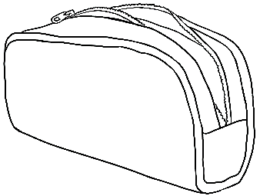
Do you have a pencil?
Classroom items - vocab cards
- Pair work
- Students cut out* the cards.
- They mix and match the words and pictures.
- One student then shows a picture or word to their partner and asks,
What is this? Or What’s this?
- One student shows a picture or word and asks,
Do you have a____________?
*Using scissors is an important fine motor skill which helps develop the muscles needed for good pencil control.

- Copying
Students can copy the words from the cards into their notebooks.
- Game of concentration/memory
In groups of two or three, students mix the words and pictures face-down on the table. The goal is to match the words and pictures. Students take turns to turn over two cards to find a pair. Students say the name of the object when they turn over each card. If they have a match, the student keeps the pair and has another turn. If they don’t have a match, the student turns the cards over in the same place on the table. When all the pairs have been matched, the student with the most pairs is the winner.

pen | pencil
 | 
sharpener | rubber
 | 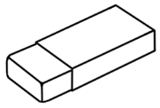

phone | ruler
 | 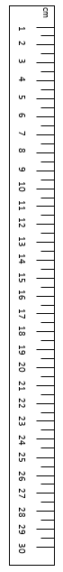
notebook | water bottle
 | 

pencil case | glasses
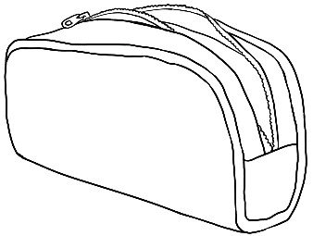 | 
bag | workbook
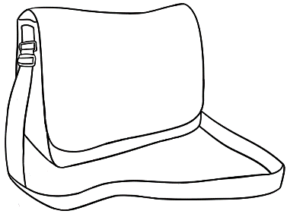 | 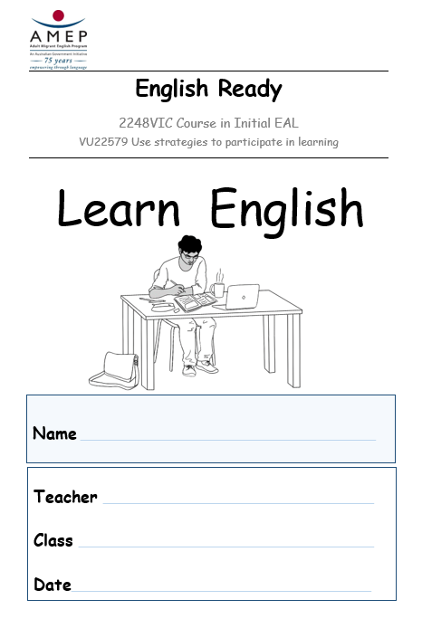

I want to learn English.
Volunteers in the classroom
It may be helpful to use volunteers in the class to sit between and assist two students who are struggling. The task of a volunteer is to help the students understand what is going on in the class, by pointing at things, demonstrating how to do something or working one-to-one with a student. Volunteers need guidance and support.

- Explain that volunteers are there to guide, but not to do the work
for the students.
- Some of the worksheets in this book could be used by the volunteers with a student.
- The volunteer plays the role of the ‘model learner’. The volunteer needs to listen to directions from the teacher. e.g Turn to page 4.
The volunteer follows the instruction, opens their copy of the workbook at page 4 and points to the page number. The student then finds the page in their workbook.
- If the teacher says to listen and repeat, the volunteer can quietly repeat and point to a relevant picture or a word.
- If the teacher says Copy the first letter, the volunteer can point to the example already done in the book by pointing and if necessary, tracing over the first letter.
- The volunteer should point, mime and demonstrate, and talk very little.

A resource for volunteers - Literacy Face to Face [See Section 14 for details]

Active learning
Make it clear to students that they need to study actively both in and after class if they want to learn English and achieve their goals. Although the learning strategies for four characters are listed in the student book, these strategies need to be demonstrated and practised. See the following pages for ways to use Section 11 productively.

Active learning - Rahim
- Vocabulary - Before reading about Rahim, introduce and revise:
- Before and after - Revise the words using the clocks.
- Late and early - Link to Section 9 – I am sorry. I am late.
- The pronoun my
- Verbs: want, come, have, ask, do, copy, talk
- Nouns: painter, homework, friend, weekend
- Collocations – I want to be, into my notebook

- Stationery items - from Section 10
- Hold up each item; students repeat the words, clap the syllables, ask, What’s this?
- Look at the items Rahim brings to class. Ask, Do you have a pencil case? Do you have a workbook? etc Students ask each other these questions.
- Students may not have all the stationery they need. Teach the word need and how to say what students need. e.g. I need a pencil case.
NB. Students may not have the money to buy stationery, nor the capacity to budget. Some sites provide materials and staff and friends may be able to help with stationery supplies. Many teachers have classroom stock for students to borrow.

- Ask questions - Say something to the class and ask students to practise saying, Can you say that again please? Repeat what you said and ask students to repeat their question. Do this several times.

- Copy words - Teach students how to copy from their workbook. Give them a piece of paper, position it under a word in their workbook and ask them to copy. Teach them to check as they complete a word. Move the paper along and copy again saying each letter out aloud as they copy. Students at this level find it hard to carry the letters in their mind. The paper needs to be directly under what they are copying.

- Using a digital device - Rahim has a laptop at home. Teach students to access and use the AMEP online materials.

- Conversation - Organise another class or a group of volunteers to spend 15 minutes with your students to help with their conversation.

- Homework - Some students will do homework, but some don’t understand its importance. If possible, arrive early so that students have an opportunity to complete homework before the class starts. Youth classes respond well to homework clubs which encourage the habit.

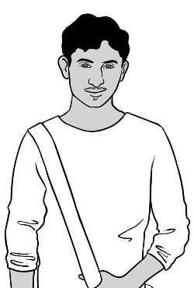

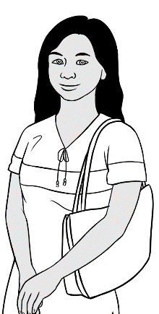
Active learning - San
- Vocabulary -Before reading about San, introduce and revise:
- Verbs: want, work, ask, record, have, talk, listen, repeat, learn
- Nouns: children, teacher, words, neighbours, eggs
- Collocations: I want to work, new words.

Project the words on a PowerPoint or write them on the board. Mime or draw pictures to explain each word, and repeat over and over after the teacher.

- Ask for help
Repeat as a class and then individually - Can you help me please?
Mime going and helping different students after each request.

- Record the teacher
Teach students to record the teacher saying the three requests below, three times each. Leave enough time for students to repeat each sentence.
I don’t understand. Can you say that again please? Can you help me please?
Ask students to replay their recordings; teach them to listen and repeat.

- Conversation
Organise another class or a group of volunteers to spend 15 minutes with your students to help with their conversation. Encourage students to talk with their neighbours.

- Learn new words
Teaching students how to memorise is particularly important at this level.
- Give each student a small card or sticky note with a word written on it. e.g. eggs Draw some eggs on the board. Students draw some eggs on their card - any sort of drawing will assist memorisation.
- Teach students to say and spell the word aloud. Repeat several times.
- Students store the card in their pocket or pencil case.
- During the day, ask students to take out the card; say and spell the word together.
- Towards the end of the lesson, students say, spell and copy the word in their notebooks. Check the spelling. Students copy the word again while spelling each letter aloud. The teacher needs to check again.
- Students take the card home and practise their word at different times. e.g. while waiting for a bus, cooking etc.
- In the next lesson, give the students a new word. There are now two words to learn and to practice. Continue practising the first word until students can spell and write it. Slowly add new words.

Active learning - Jamila
- Vocabulary -Before reading about Jamila, introduce and revise:
- Verbs: want, talk, match, say, copy, learn, use
- Nouns: cook, teacher, words, sounds, volunteer, laptop, library
- Collocations: I want to be

- Matching and saying words
The flashcards printed throughout the teacher resource
books can be cut up by the teacher or students, stored
in envelopes and reused multiple times. The physical handling and movement of the cards assists memory retention.

- Copy the sounds
After the initial sounds have been introduced, give students a word to copy. The word needs to have an illustration, and be short and easily sounded. Students copy the word over and over, saying and sounding the word aloud as they copy. See an example on the following page.

- Learn the sounds
The audio book which accompanies VU23489 Alphabet Sounds has an audio of the sounds. Organise for students to record this on their phones. Teach students to listen, and repeat and read the words and sounds [See the following pages] as they listen. You may need students or volunteers from a higher class to help with this download.

- Learn with a volunteer
Many students often find the concept of volunteering unusual and difficult to understand. Check the AMEP website for information about volunteer service in multiple languages. However, if your students are illiterate, they may need someone who speaks their language to read it for them.

- Using a computer or a laptop in the library
Students need to know where they can use computers for free. Organise an excursion to the places where free computers are available.



Copying

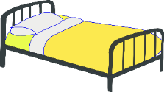
bed bed
__ __ __ __ __ __

bed bed
__ __ __ __ __ __

bed bed
__ __ __ __ __ __

bed bed
__ __ __ __ __ __

bed bed
__ __ __ __ __ __

bed bed
__ __ __ __ __ __

Sound Sheets



b bag
a apple



d door
c cup


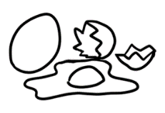
f family
e egg



g glasses
h home



i ink
j jacket


l lemon
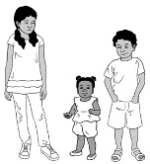
k kids


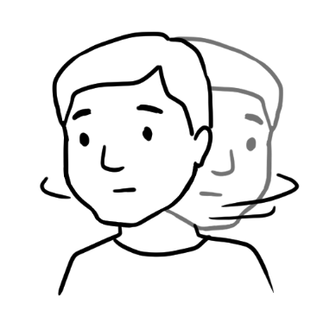
m man
n no

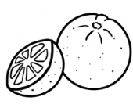

o orange
p pencil

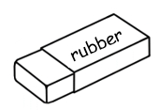
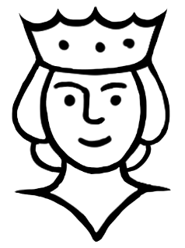
r rubber
q queen

t teacher

s student



v van
u umbrella



x box
w woman

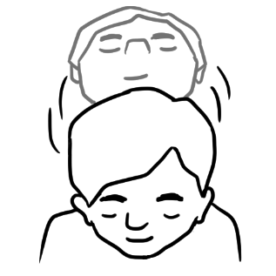
y yes
z zero

Ming
- Vocabulary -Before reading about Ming, introduce and revise:
- Verbs: want, talk, go, listen, repeat, ask, read, listen, do, talk
- Nouns: grandchildren, class, library, homework
- Pronoun: my

- Go to class
Emphasise the importance of regular attendance.

- Listen and repeat
This is the key instruction at Course in Initial EAL level and is incorporated in most learning activities in the student workbook.

- Go to the library
Visit the library regularly. Here students can be introduced to materials at their level such as picture dictionaries, free computer access and helpful librarians.

- Homework
Homework is essential for learning. Rather than handing out pages of worksheets, encourage students to copy letters and words from their workbooks into their notebook. Alternatively, pages from the workbooks could be selected and made into a specific homework book.

- Talk to family and friends in English
Encourage students to speak some English outside class - with other students in the canteen and at home with family and neighbours.



Who, where and when
The following pages help students understand that learning is not an isolated event that only happens in a classroom; it can take place with different people, in different places and at different times.
Project each of the following pages or create a PowerPoint with slides that slowly reveal information. Encourage students to guess what goes into each box and section before it is revealed on the slide.

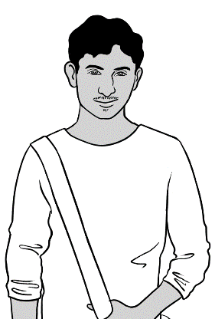
Rahim

Who helps you learn English?
My teacher Peter | My friend Carim
 | 

Where do you learn?
At TAFE | At home
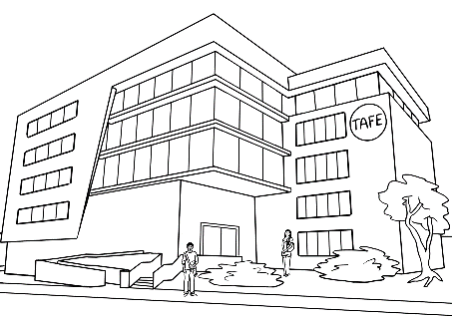 | 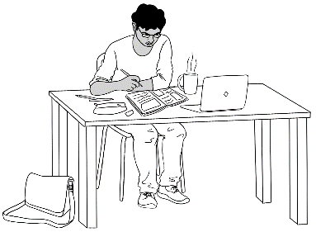 | 

When do you learn?
At TAFE | At home
Monday, Tuesday, Wednesday, Thursday, Friday | Every day

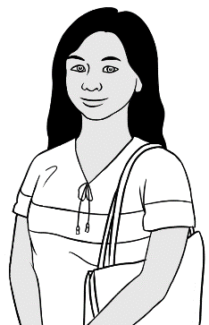
San

Who helps you learn English?
My teacher Peter | My neighbour Pam
 | 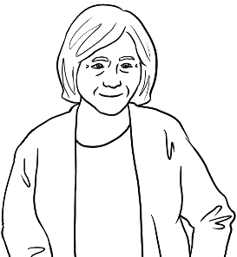

Where do you learn?
At TAFE | At home on my phone
 | 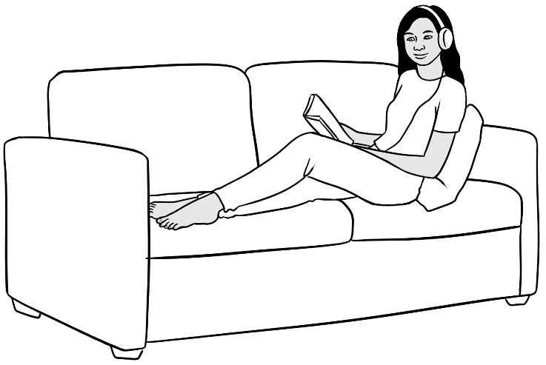

When do you learn?
At TAFE | At home
Monday, Tuesday, Wednesday, Thursday, Friday | Every day


Jamila

Who helps you learn English?
My teacher Rosie | A volunteer | My friend Zarni
 | 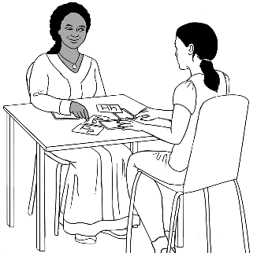 | 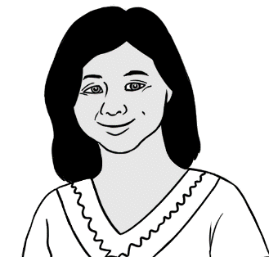

Where do you learn?
At TAFE | In the library
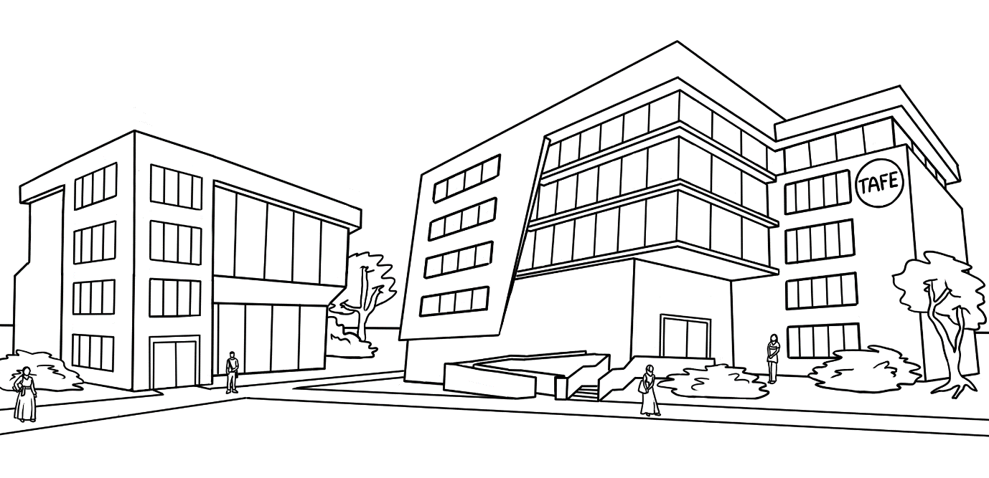 | 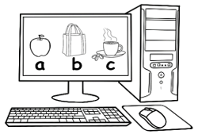

When do you learn?
At TAFE | In the library
Monday, Tuesday, Wednesday, Thursday, Friday | After class


Ming

Who helps you learn English?
My teacher Wendy | The librarian | My family
 | 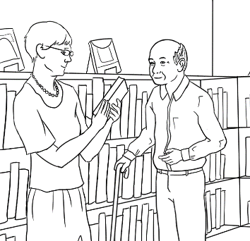 | 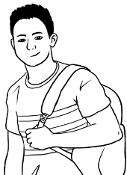  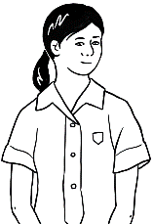  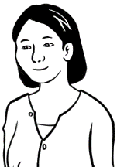

Where do you learn?
At the community centre | In the library | At home
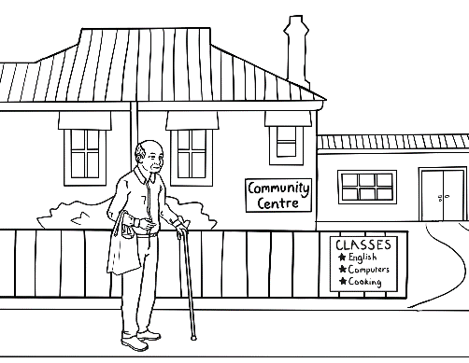 | 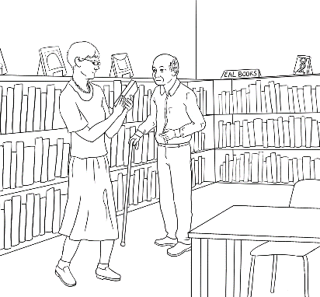 | 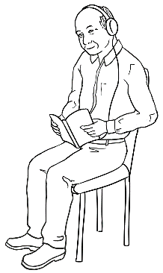

When do you learn?
At the community centre | In the library | At home
Tuesday, Wednesday, Friday | Monday, Thursday | Saturday, Sunday

Follow instructions
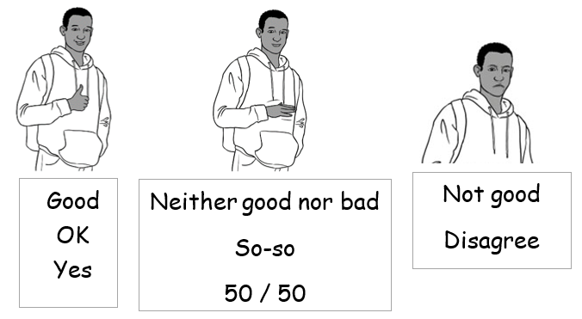
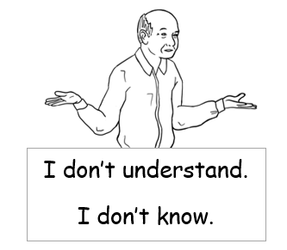
- General classroom instructions
This section in the student workbook contains activities with the instruction icons – listen, say, copy etc. These instructions need to be repeated and mimed until they are memorised. More general classroom instructions can be found on the following pages and introduced when appropriate. The pages or sections of the pages could be projected and the instructions mimed.

- Body language
Body language is extremely important at Course in Initial EAL level both to convey meaning and support memory retention.
- Revise vocabulary by miming words and students then guessing the word.
- Distribute pictures on flashcards and invite students to mime a word for the class to guess.
Body language gestures can have different meanings in different countries. For example, many Sri Lankans shake their heads when they say yes, and some cultures find the action of pointing at a person very offensive.

Be aware that some students will always say yes, even when they don’t understand. Students need to understand the question, Do you understand? and students from a higher class could translate this question if necessary.
The hand actions and facial expressions below could mean different things in different countries, so it is good to teach what they usually mean in Australia. However, depending on the context, their meaning can vary here too.

Students need to understand the e

General classroom instructions

Look at the board.
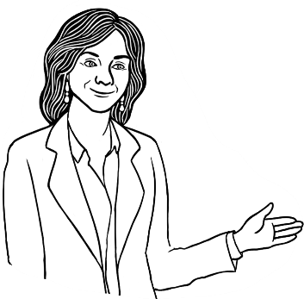


Look at the time.

Look at page 2.
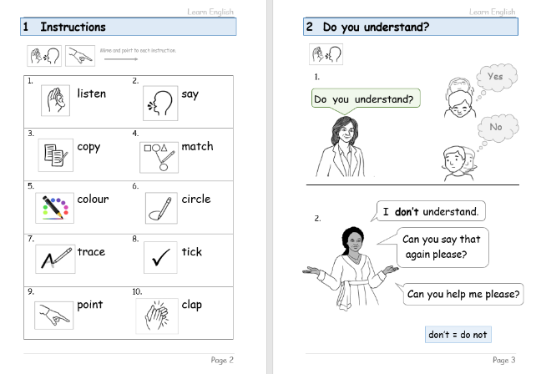
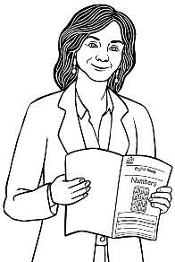

L
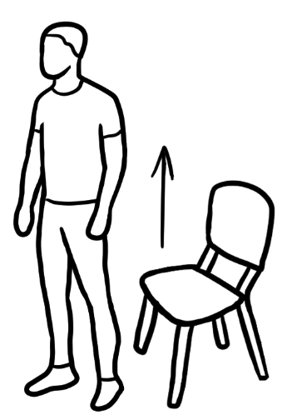
- Stand up.
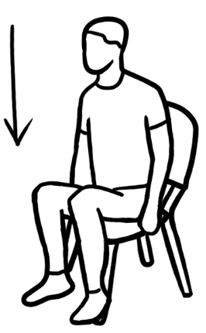
- Sit down.

- Stand in a line.
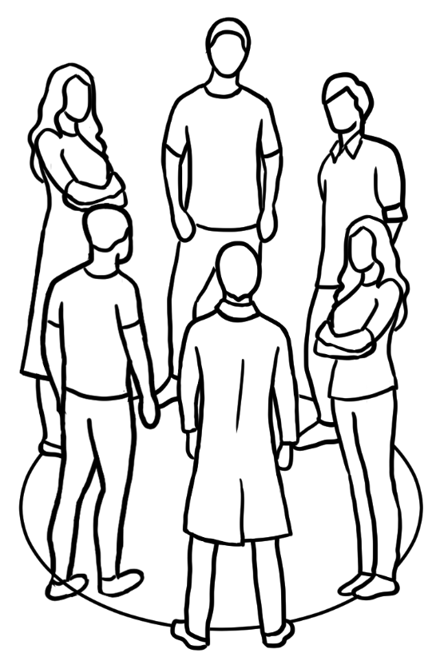
- Stand in a circle.
- Open your book.
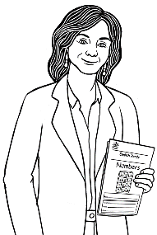
- Close your book.

I am sick.
Informing the learning centre about an absence
For most Course in Initial EAL students, talking on the phone and texting is difficult. However, students need to understand the customs of the learning environment in Australia, and that informing the teacher about an absence is part of it.
- Send a voice message
Students can send a voice message via WhatsApp or message bank.
Build skills gradually in the following way:
- Teach greetings.– Hello, Hi, Good morning
- Teach the pattern for giving names over the phone
Introduction | Repeat the name. | Spell the name. | Repeat the name.
My name is Zarni. | Zarni | Z - A – R – N – I | Zarni
- Practise naming the teacher.
My teacher is ________________.
- Practise the reason for the phone call.
I am sick.
I can’t come today.
- Teach closings everyday as students leave – Bye
All of the above phrases and sentences could be chanted.

- Send a text
Students need a lot of practice copying messages. Additional copying could be given for homework. [See the following pages.]
Students from a higher class could show students how to add the teacher’s and the centre’s phone numbers to their phone and how to type and send a text.

I am sick.

_____________________________________________________________

I am sick.

____________________________________________________________

I am sick.

_____________________________________________________________

I am sick.

____________________________________________________________

I am sick.

_____________________________________________________________

I can’t come today.

I can’t come today.

I can’t come today.

I can’t come today.

I can’t come today.

Useful on-line resources

NB. It is advisable to copy and paste the web addresses in the address box
rather than click on the link.
1 | Hands On! [Canadian]  A collection of ESL literacy activities. A useful site for low-level literacy students | http://en.copian.ca/library/learning/handson/handson.pdf
2 | Page Turners [Australian]  These short, graded, easy-to-read stories for adults are highly recommended to purchase. | https://pageturners.prace.vic.edu.au/
3 | Carringbush readers [Australian]  Free, simple, downloadable stories. Part of the books may suit low level literacy students. | https://drive.google.com/file/d/1wqBxJ-8kZDkGYf3NEUB8hg2tjBDvT9uO/view
4 | Theme based readers [Canadian]  Forty themed-based audio books and print books at 7 levels. | https://globalaccess.bowvalleycollege.ca/esl-literacy-readers
5 | Phonic-based stories and materials [Canadian]  This site contains a wealth of useful stories and literacy materials. | https://literacycentre.immigrant-education.ca/resource-bank/
6 | A digital workbook [US]  A range of literacy resources licensed under Creative Commons | https://atlasabe.org/resources/esl/learner-resources/

7 | Literacy materials [Australian]  Free materials produced by the Smith Family | https://www.thesmithfamily.com.au/programs/previous/home-tutor-scheme/tutor-resources
8 | Live Action English Interactive [US]  This site contains many simple YouTube videos about everyday activities. The clips could be used in many ways.  e.g. The video could be muted, the teacher then relates what is happening and the students repeat. | https://www.youtube.com/playlist?list=PL2fQw92yVTfwABe59Jz83_303Xt1ImE5l
9 | Literacy Face to Face - for volunteers - [Australian]  An excellent resource for volunteers and teachers who want to help someone with their literacy. Available to download free from the Reading and Writing Hotline. This website is designed for adult literacy learners, and the handbook contains useful information which can assist volunteers working with EAL literacy learners. | https://www.readingwritinghotline.edu.au/wp-content/uploads/2023/03/Literacy-Face-to-Face-2nd-Edition.pdf

Appendix
On the following pages:
- Alphabet strips
- Number strips
- Games templates

Aa | Bb | Cc | Dd | Ee | Ff | Gg | Hh | Ii | Jj | Kk | Ll | Mm
Nn | Oo | Pp | Qq | Rr | Ss | Tt | Uu | Vv | Ww | Xx | Yy | Zz
Aa | Bb | Cc | Dd | Ee | Ff | Gg | Hh | Ii | Jj | Kk | Ll | Mm
Nn | Oo | Pp | Qq | Rr | Ss | Tt | Uu | Vv | Ww | Xx | Yy | Zz
Aa | Bb | Cc | Dd | Ee | Ff | Gg | Hh | Ii | Jj | Kk | Ll | Mm
Nn | Oo | Pp | Qq | Rr | Ss | Tt | Uu | Vv | Ww | Xx | Yy | Zz
Aa | Bb | Cc | Dd | Ee | Ff | Gg | Hh | Ii | Jj | Kk | Ll | Mm
Nn | Oo | Pp | Qq | Rr | Ss | Tt | Uu | Vv | Ww | Xx | Yy | Zz
Alphabet strips – Cut up and laminate for students to place on their desks.

Number strips - – Cut up and laminate for students to place on their desks.

1 | 2 | 3 | 4 | 5 | 6 | 7 | 8 | 9 | 10 | 11 | 12 | 13 | 14 | 15 | 16 | 17 | 18 | 19 | 20 | 21 | 22 | 23 | 24 | 25
26 | 27 | 28 | 29 | 30 | 31 | 32 | 33 | 34 | 35 | 36 | 37 | 38 | 39 | 40 | 41 | 42 | 43 | 44 | 45 | 46 | 47 | 48 | 48 | 50
1 | 2 | 3 | 4 | 5 | 6 | 7 | 8 | 9 | 10 | 11 | 12 | 13 | 14 | 15 | 16 | 17 | 18 | 19 | 20 | 21 | 22 | 23 | 24 | 25
26 | 27 | 28 | 29 | 30 | 31 | 32 | 33 | 34 | 35 | 36 | 37 | 38 | 39 | 40 | 41 | 42 | 43 | 44 | 45 | 46 | 47 | 48 | 48 | 50

1 | 2 | 3 | 4 | 5 | 6 | 7 | 8 | 9 | 10 | 11 | 12 | 13 | 14 | 15 | 16 | 17 | 18 | 19 | 20 | 21 | 22 | 23 | 24 | 25
26 | 27 | 28 | 29 | 30 | 31 | 32 | 33 | 34 | 35 | 36 | 37 | 38 | 39 | 40 | 41 | 42 | 43 | 44 | 45 | 46 | 47 | 48 | 48 | 50

1 | 2 | 3 | 4 | 5 | 6 | 7 | 8 | 9 | 10 | 11 | 12 | 13 | 14 | 15 | 16 | 17 | 18 | 19 | 20 | 21 | 22 | 23 | 24 | 25
26 | 27 | 28 | 29 | 30 | 31 | 32 | 33 | 34 | 35 | 36 | 37 | 38 | 39 | 40 | 41 | 42 | 43 | 44 | 45 | 46 | 47 | 48 | 48 | 50
1 | 2 | 3 | 4 | 5 | 6 | 7 | 8 | 9 | 10 | 11 | 12 | 13 | 14 | 15 | 16 | 17 | 18 | 19 | 20 | 21 | 22 | 23 | 24 | 25
26 | 27 | 28 | 29 | 30 | 31 | 32 | 33 | 34 | 35 | 36 | 37 | 38 | 39 | 40 | 41 | 42 | 43 | 44 | 45 | 46 | 47 | 48 | 48 | 50
1 | 2 | 3 | 4 | 5 | 6 | 7 | 8 | 9 | 10 | 11 | 12 | 13 | 14 | 15 | 16 | 17 | 18 | 19 | 20 | 21 | 22 | 23 | 24 | 25
26 | 27 | 28 | 29 | 30 | 31 | 32 | 33 | 34 | 35 | 36 | 37 | 38 | 39 | 40 | 41 | 42 | 43 | 44 | 45 | 46 | 47 | 48 | 48 | 50

Start
Finish

Start
Finish

