English Ready
22636VIC Course in Initial EAL
VU23489 Recognise letters of the alphabet and their sounds in extremely familiar words
Letter names

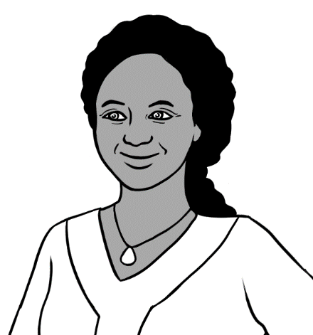
A - B - C - D

Name ____________________________________________________________
Teacher _________________________________________________________
Class _____________________________________________________________
Date_______________________________________________________________

Design team: Vicki Hambling, Sue Paull, Frida Dean and Mary Wallace
This workbook is designed to be used with the support of a teacher.
Illustrations: Madelena Scott
Acknowledgements: The design team would like to thank the AMEP service providers and practitioners who participated in the trial and gave valuable feedback. The team would also like to acknowledge the use of the EAL Framework which underpins the design of this book.

Copyright of the EAL Framework is reserved to the Crown in the right of the State of Victoria. © State of Victoria (Department of Education and Training) 2023.
__________________________________________________________________________________
This English Ready Resource is licensed under a Creative Commons Attribution-NoDerivs 3.0 Australia licence (More information is available here). You are free to use, copy and distribute to anyone in its original form as long as you attribute Department of Home Affairs as the author and you license any derivative work you make available under the same licence.
© Commonwealth of Australia 2023
With the exception of the Commonwealth Coat of Arms, the department’s logo, any material protected by a trade mark and where otherwise noted all material presented in this document is provided under a Creative Commons Attribution 4.0 International (https://creativecommons.org/licenses/by/4.0/) licence.
The details of the relevant licence conditions are available on the Creative Commons website (accessible using the links provided) as is the full legal code for the CC BY 4.0 licence. (https://creativecommons.org/licenses/by/4.0/legalcode).
Use of all or part of this document must include the following attribution:
© Commonwealth of Australia 2023
As far as practicable, material for which the copyright is owned by a third party will be clearly labelled. The department has made all reasonable efforts to ensure that this material has been reproduced in this document with the full consent of the copyright owners.
Copyright requests and enquiries concerning usage not addressed by the CC BY 4.0 licence should be addressed to: comms@homeaffairs.gov.aumailto:AMEPInfo@homeaffairs.gov.au at the Department of Home Affairs.
The terms of use for the Commonwealth Coat of Arms are available from the It's an Honour website.
Where a copyright owner, other than the Commonwealth, is identified with respect to this material, please contact that third party copyright owner directly to seek permission.


Table of contents
1 Instructions 1
2 Say the names of the letters. 2
3 Match the letters. 11
4 The names of the vowels 19
5 The names of the consonants 21
6 Can you spell that please? 23
7 What is your name? 24
8 What is your address? 29
9 Signs 32

Instructions
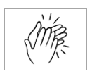
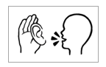

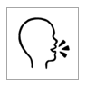
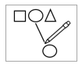
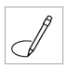
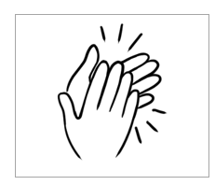
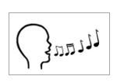
  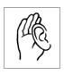 |  | listen |  |  |  | say
 | 4 | copy |  |  |  | match
 |  | colour |  |  |  | circle
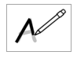 |  | trace |  |  | P | tick
 | 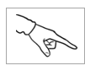 | point |  |  |  | clap
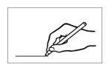 |  | write |  |  |  | sing
 |  | read

Say the names of the letters.

Capital Letters
A B C D E F
G H I J K L
M N O P Q R
S T U V W X
Y Z

Small letters
a b c d e f
g h i j k l
m n o p q r
s t u v w x
y z

Capital letters

A | B | C | D | E | F
G | H | I | J | K | L
M | N | O | P | Q | R
S | T | U | V | W | X
Y | Z
- .

A | B | C | D | E | F
G | H | I | J | K | L
M | N | O | P | Q | R
S | T | U | V | W | X
Y | Z

A
 |  | B |  | C |  |  | S |  |  | V |  |  | Q
 |  |  |  |  |  |  |  |  | T
 | W |  |  | D |  |  | R |  |  |  | U
 |  |  |  |  | E |  |  |  |  |  |  | M
 |  | C |  |  |  | F |  |  |  | D
 |  |  |  | G |  |  |  |  | G
 |  |  |  |  |  |  |  |  |  |  |  | J
 |  | I |  | H |  |  | F
 |  |  |  |  |  |  |  |  |  |  |  |  | Y
 |  | J |  | K |  | L |  |  | Q |  |  | X |  | Z
 |  |  |  |  |  |  | M
 | M |  |  |  |  |  |  |  |  | V |  | W
 |  |  | P |  | O |  | N |  | U
 | T |  |  |  |  |  |  |  |  |  | R
 |  |  | Q |  | R |  | S |  | T
 |  | O |  |  | Q |  |  |  |  | V |  | N
 | S |  |  | D |  | P |  |  | O

A B C D
E F G
H I J K
L M N O P
Q R S
T U V
W X
Y Z
I can say the A B C.
Listen now again to me.



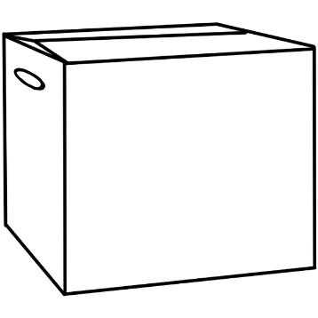


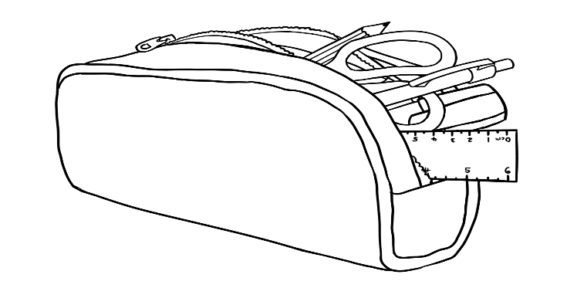
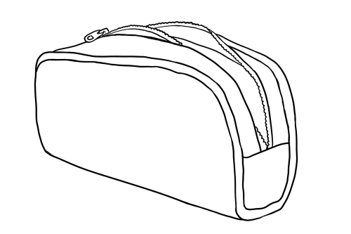
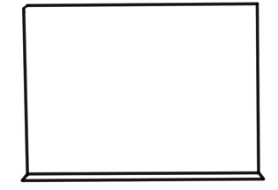
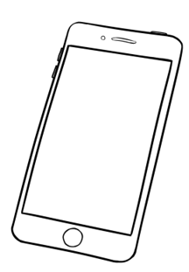
2
F E G
4
M L O P N
V U T
6
7
X W
Z Y
8
1
B D A C
5
J I K H
3

A B C D

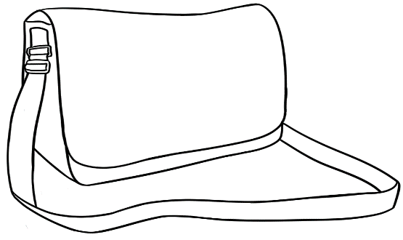
R S Q

Small letters
a | b | c | d | e | f
g | h | i | j | k | l
m | n | o | p | q | r
s | t | u | v | w | x
y | z

a | b | c | d | e | f
g | h | i | j | k | l
m | n | o | p | q | r
s | t | u | v | w | x
y | z

 | b |  | c |  | b |  | c |  | e |  |  | q
 | f |  | d |  | e |  | f |  |  | g |  | t
 | o |  | n |  |  | h |  |  |  | h |  | m
 |  |  | m |  | l |  | k |  |  |  | d
 | p |  |  |  |  |  |  | j |  | i
 |  | q |  | r |  | s |  |  |  |  |  | y
 |  |  |  |  |  |  |  |  |  | j
 | r |  |  | l |  | t |  | u |  |  | k
 |  |  | x |  |  | w |  | v |  |  | l
 | z | y
 |  |  |  |  |  | o |  | n |  |  | m
 |  |  |  |  | q
 |  | p |  | m |  |  | w |  | t |  | n
a

a b c d
e f g
h i j k
l m n o p
q r s
t u v
w x
y z
I can say the a b c.
Listen now again to me.

2
f e g
1
b d a c

a b c d
0
j i k h
3
4
m l o p n

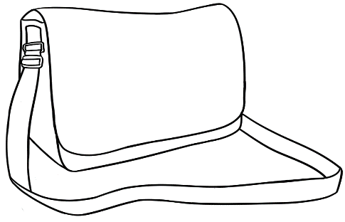
r s q
5
v u t
6

7
x w
z y
8

Match the letters.
Aa | Bb | Cc | Dd | Ee | Ff | Gg

A |  | b
B |  | c
C |  | a
D |  | f
E |  | d
F |  | g
G |  | e

A | B | C | D | E | F | G
A
a | b | c | d | e | f | g

1. | A | c | e | d | a | b
 | B | d | c | b | f | e
 | C | a | d | e | b | c
 | D | d | f | c | e | b
 | E | a | b | e | c | d
 | F | g | f | d | e | c
 | G | f | e | c | d | g



Hh | Ii | Jj | Kk | Ll | Mm | Nn

H |  | j
I |  | h
J |  | k
K |  | i
L |  | n
M |  | l
N |  | m

H | I | J | K | L | M | N
H
h | i | j | k | l | m | n

 | H | i | h |  | l |  | k |  | j
 | I | j | l |  | i |  | m |  | k
 | J | h | i |  | k |  | l |  | j
 | K | l | j |  | m |  | k |  | n
 | L | k | l |  | h |  | n |  | i
 | M | n | k |  | l |  | i |  | m
 | N | m | l |  | j |  | n |  | k

Oo | Pp | Qq | Rr | Ss | Tt

O |  | p
P |  | r
Q |  | t
R |  | o
S |  | q
T |  | s

O | P | Q | R | S | T
O
o | p | q | r | s | t

 | O | p | q |  | r |  | s |  | o
 | P | r | s |  | t |  | p |  | o
 | Q | o | p |  | q |  | r |  | s
 | R | t | r |  | s |  | o |  | p
 | S | s | p |  | r |  | q |  | o
 | T | p | t |  | q |  | r |  | s

Uu | Vv | Ww | Xx | Yy | Zz

U |  | v
V |  | u
W |  | z
X |  | y
Y |  | x
Z |  | w

U | V | W | X | Y | Z
U
u | v | w | x | y | z

 | U | v | w | u | x | z
 | V | u | v | w | y | z
 | W | z | y | x | w | v
 | X | u | z | w | v | x
 | Y | y | u | v | z | w
 | Z | x | y | z | v | u

The names of the vowels

Aa | Bb | Cc | Dd | Ee | Ff
Gg | Hh | Ii | Jj | Kk | Ll
Mm | Nn | Oo | Pp | Qq | Rr
Ss | Tt | Uu | Vv | Ww | Xx
Yy | Zz
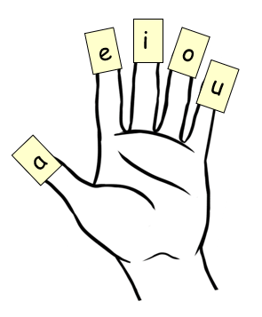

a
_
g_
b_
c_
d_
e
_
f_

_
_

n_
m_
l_
k_
j_
i
_
h_

_

u
_
p_
o
_
t_
s_
r_
q_

_
_

z_
y_
x_
w_
v_

The names of the consonants
Aa | Bb | Cc | Dd | Ee | Ff
Gg | Hh | Ii | Jj | Kk | Ll
Mm | Nn | Oo | Pp | Qq | Rr
Ss | Tt | Uu | Vv | Ww | Xx
Yy | Zz

a | b | e | c | i | d | o | f | u
g | a | h | e | j | i | k | o | l
u | m | a | n | e | p | i | q | o
r | u | s | a | t | e | v | i | w
o | x | u | y | a | z | e | z | i

.

a
_
g_
b_
c_
d_
e
_
f_

_
_
_
_
b_

n_
m_
l_
k_
j_
i
_
h_

_
_
_
_
_
_

u
_
p_
o
_
t_
s_
r_
q_

_
_
_
_
_

z_
y_
x_
w_
v_

_
_
_
_
_

Can you spell that please?

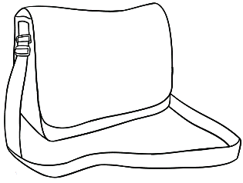
- bag b–a–g
bag _ _ _
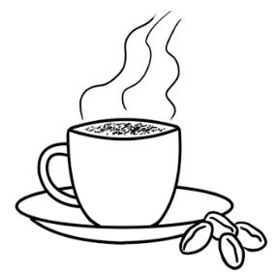

- cup c–u–p
_ _ _ _ _ _

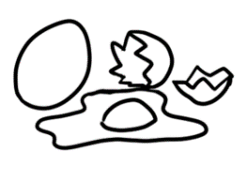
- egg e–g–g
_ _ _ _ _ _
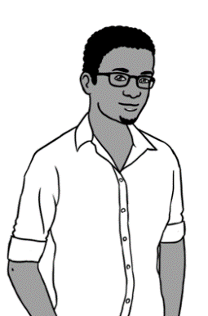
- man m–a–n
_ _ _ _ _ _

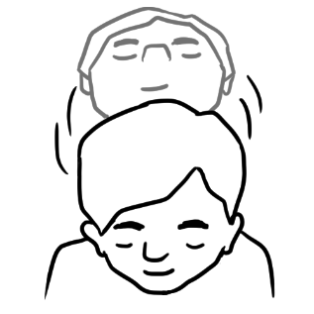
- yes y–e–s
_ _ _ _ _ _

What is your name?

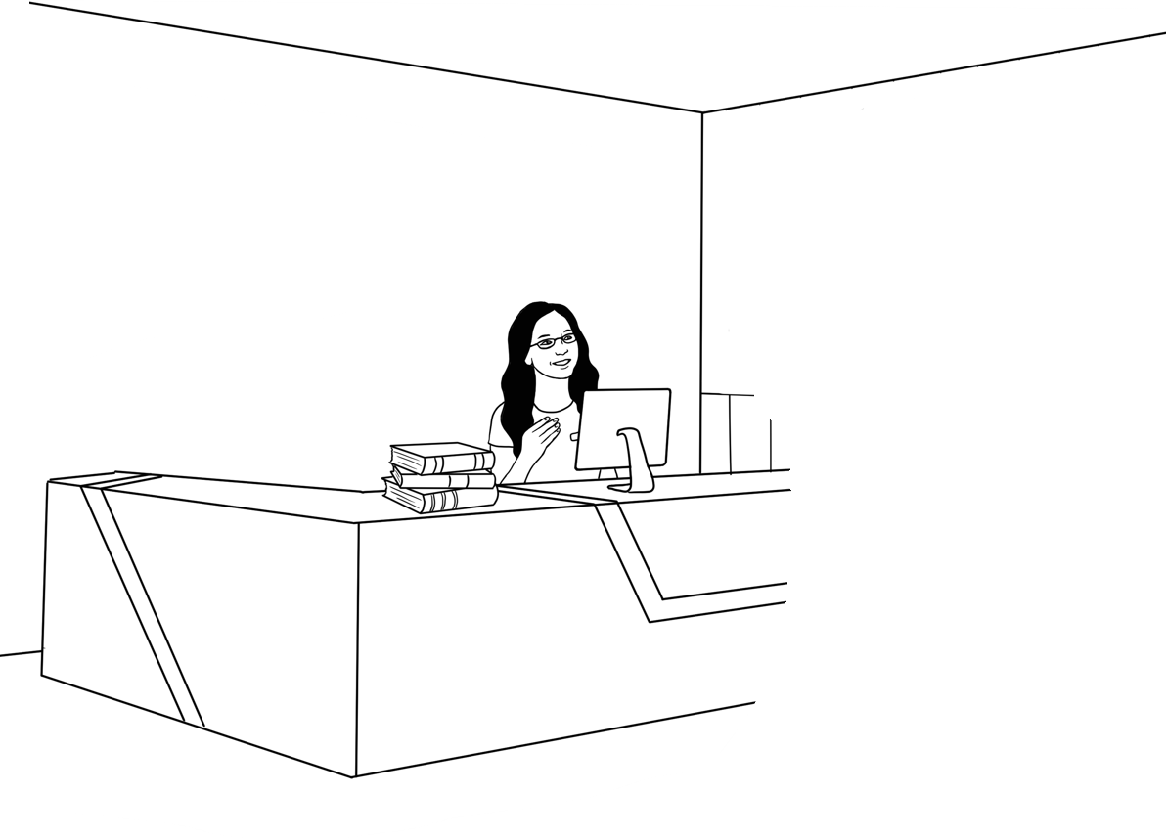
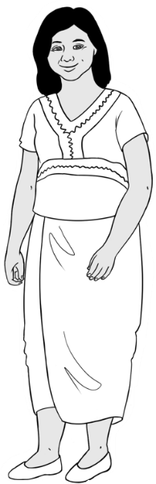
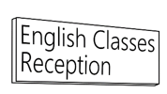
Zarni Tun.
What is your name?

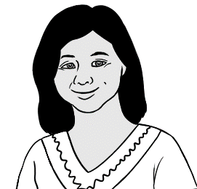

My name is Zarni Tun.
My name is Zarni Tun.
__ y __ame __s Zarni Tun.

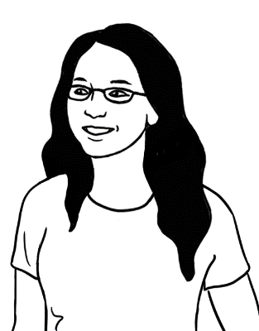
What is your first name?
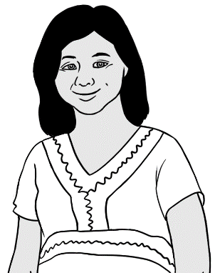
Zarni.

Can you spell that please?

Zarni Z - a - r - n – i.

First name
Zarni

A | B | C | D | E | F | G | H | I | J | K | L | M
N | O | P | Q | R | S | T | U | V | W | X | Y | Z
a | b | c | d | e | f | g | h | i | j | k | l | m
n | o | p | q | r | s | t | u | v | w | x | y | z

- Zarni Zarni Zarni
__ arni Z __ rni Zarn__
You
What is your first name?

Can you spell that please?

First name
_______________________________

A | B | C | D | E | F | G | H | I | J | K | L | M
N | O | P | Q | R | S | T | U | V | W | X | Y | Z
a | b | c | d | e | f | g | h | i | j | k | l | m
n | o | p | q | r | s | t | u | v | w | x | y | z

_______________________________ ________________________________

What is your family name?
Tun.

Can you spell that please?

Tun T – u – n.

Family name
T u n

A | B | C | D | E | F | G | H | I | J | K | L | M
N | O | P | Q | R | S | T | U | V | W | X | Y | Z
a | b | c | d | e | f | g | h | i | j | k | l | m
n | o | p | q | r | s | t | u | v | w | x | y | z

- Tun Tun Tun
__ un T__ n Tu__

You
What is your family name?
.

Can you spell that please?
.

Family name .
_______________________________
A | B | C | D | E | F | G | H | I | J | K | L | M
N | O | P | Q | R | S | T | U | V | W | X | Y | Z
a | b | c | d | e | f | g | h | i | j | k | l | m
n | o | p | q | r | s | t | u | v | w | x | y | z

_______________________________ ________________________________

What is your address?

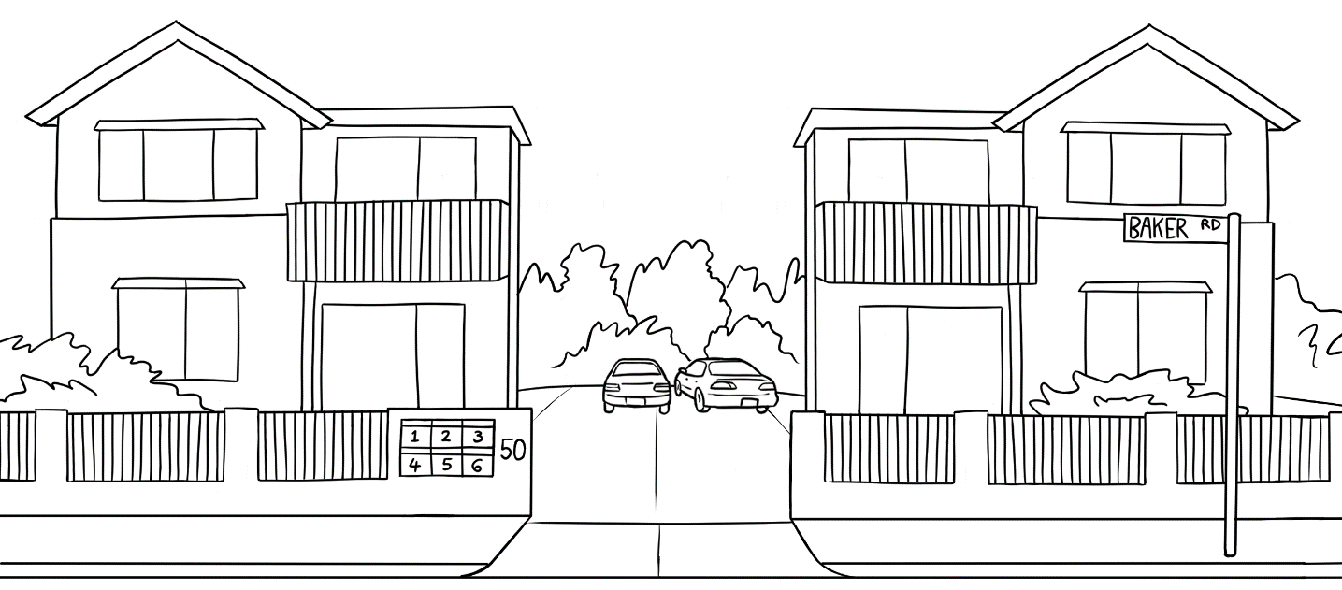
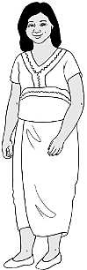
I live here.

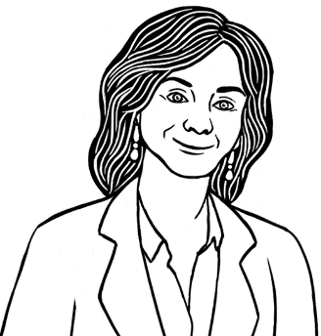
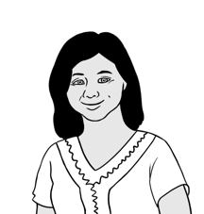
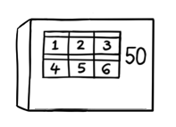
Kellivale
Unit 4,
50 Baker Road.
What is your address?
Where do you live Zarni?

Zarni
Can you spell your street name? .
Baker B – a – k – e – r.
Can you spell your suburb name? .
First name |  | Zarni
Family name |  | Tun
Address | Street | Unit 4  50 Baker Road
 | Suburb | Kellivale
 | Postcode | 2421

Kellivale K – e – l – l – i – v – a – l – e.

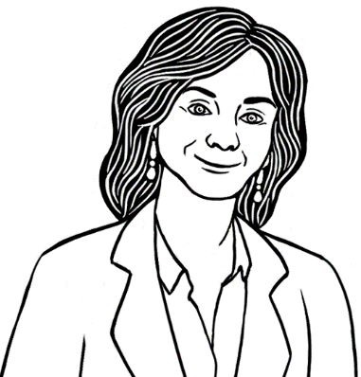
You

Where do you live?

Can you spell your street name?

First name
Family name
Address | Street
 | Suburb
 | Postcode
Can you spell your suburb name?

Signs

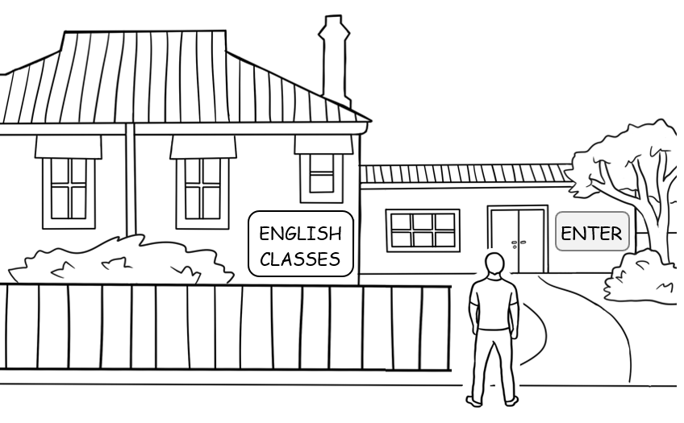

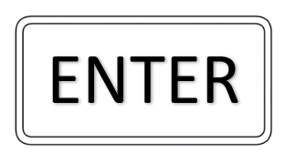 |  | E | N | B | T | G | E | R

___ NTER E ___TER EN ___ ER

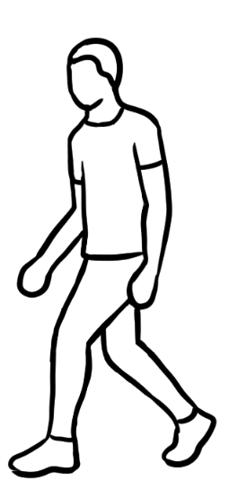
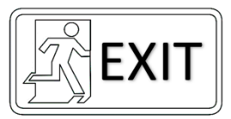
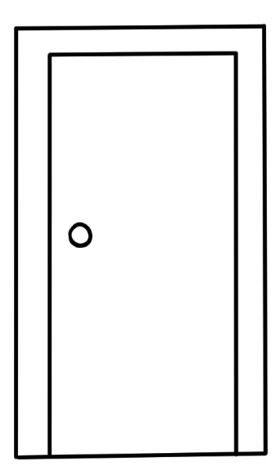

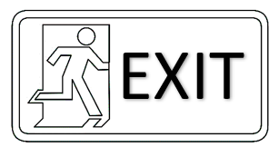 | F | E | D | X | l | S | T

___ XlT E ___ lT EXl ___

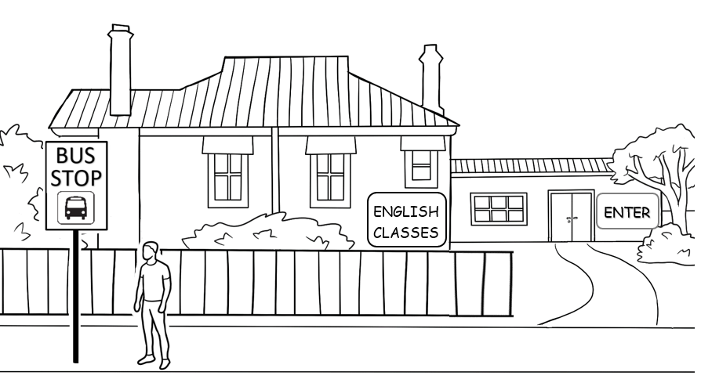

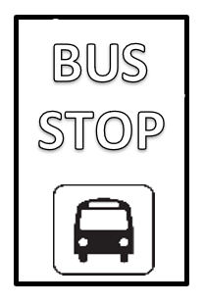

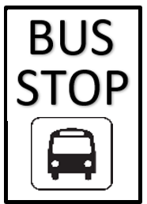
BUS STOP | BUS STOP
__ US __ TOP | BU __ STO __

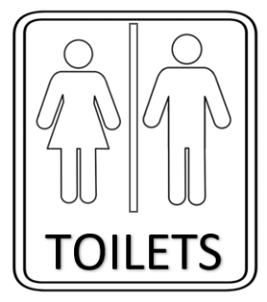
___ OlLETS | TOl ___ ETS | TOlLE ___ S

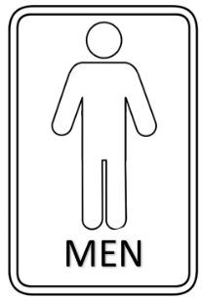
___ EN | ME ___ | M ___ N
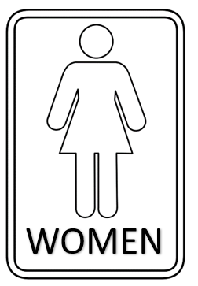
___ OMEN | WO ___ EN | WOME ___

 | EXlT
 | ENTER
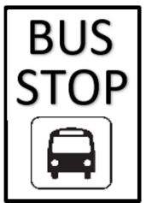 | WOMEN
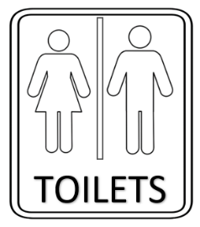 | MEN
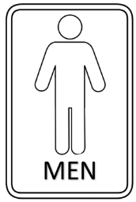 | BUS STOP
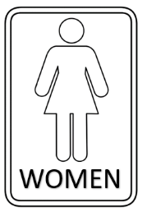 | TOlLETS

