Student book with teacher notes

English Ready
22636VIC Course in Initial EAL
VU23489 Recognise letters of the alphabet and their sounds in extremely familiar words
Letter names

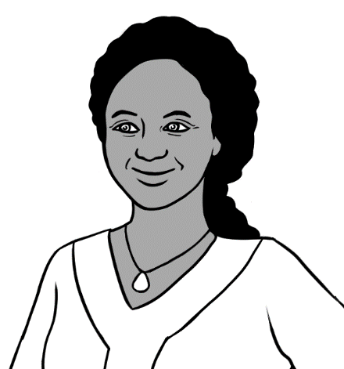
A - B - C - D

Name ____________________________________________________________
Teacher _________________________________________________________
Class _____________________________________________________________
Date_______________________________________________________________

This workbook is designed to be used with the support of a teacher.
This book is supported by additional work on sounds
in the Letter Sounds book.
Design team: Vicki Hambling, Sue Paull, Frida Dean and Mary Wallace
Illustrations: Madelena Scott
Acknowledgements: The design team would like to thank the AMEP service providers and practitioners who participated in the trial and gave valuable feedback. The team would also like to acknowledge the use of the EAL Framework which underpins the design of this book.

Copyright of the EAL Framework is reserved to the Crown in the right of the State of Victoria. © State of Victoria (Department of Education and Training) 2023.
__________________________________________________________________________________
This English Ready Resource is licensed under a Creative Commons Attribution-NoDerivs 3.0 Australia licence (More information is available here). You are free to use, copy and distribute to anyone in its original form as long as you attribute Department of Home Affairs as the author and you license any derivative work you make available under the same licence.
© Commonwealth of Australia 2023

With the exception of the Commonwealth Coat of Arms, the department’s logo, any material protected by a trade mark and where otherwise noted all material presented in this document is provided under a Creative Commons Attribution 4.0 International (https://creativecommons.org/licenses/by/4.0/) licence.
The details of the relevant licence conditions are available on the Creative Commons website (accessible using the links provided) as is the full legal code for the CC BY 4.0 licence. (https://creativecommons.org/licenses/by/4.0/legalcode).
Use of all or part of this document must include the following attribution:
© Commonwealth of Australia 2023
As far as practicable, material for which the copyright is owned by a third party will be clearly labelled. The department has made all reasonable efforts to ensure that this material has been reproduced in this document with the full consent of the copyright owners.
Copyright requests and enquiries concerning usage not addressed by the CC BY 4.0 licence should be addressed to: comms@homeaffairs.gov.au at the Department of Home Affairs.
The terms of use for the Commonwealth Coat of Arms are available from the It's an Honour website.
Where a copyright owner, other than the Commonwealth, is identified with respect to this material, please contact that third party copyright owner directly to seek permission.



Table of contents

1 Instructions 1
2 Say the names of the letters. 2
3 Match the letters. 11
4 The names of the vowels 19
5 The names of the consonants 21
6 Can you spell that please? 23
7 What is your name? 24
8 What is your address? 29
9 Signs 32

Instructions
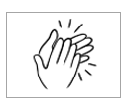
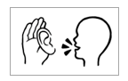
The arrow is a reminder to read from left to right.

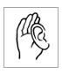

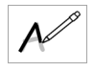
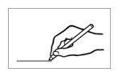

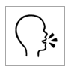
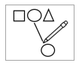
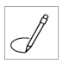
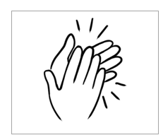
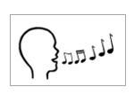
 |  | listen |  |  |  | say
 | 4 | copy |  |  |  | match
 |  | colour |  |  |  | circle
 |  | trace |  |  |  | tick
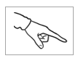 |  | point |  |  |  | clap
 |  | write |  |  |  | sing
 |  | read

Say the names of the letters.
Audio - A female voice and then a male voice read all the letters. A time gap after each letter allows time for students to repeat each letter. Encourage students to record this on their phones. These are the names of the letters, so no pictures have been added. Chanting, singing, and movement are very important to support memory.
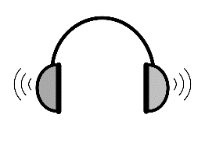

Capital letters
A B C D E F
G H I J K L
M N O P Q R
S T U V W X
Y Z

Small letters
a b c d e f
g h i j k l
m n o p q r
s t u v w x
y z

Capital letters

A | B | C | D | E | F
G | H | I | J | K | L
M | N | O | P | Q | R
S | T | U | V | W | X
Y | Z
- .

A | B | C | D | E | F
G | H | I | J | K | L
M | N | O | P | Q | R
S | T | U | V | W | X
Y | Z

Project and demonstrate how to move through
the maze in alphabetical order.

A
 |  | B |  | C |  |  | S |  |  | V |  |  | Q
 |  |  |  |  |  |  |  |  | T
 | W |  |  | D |  |  | R |  |  |  | U
 |  |  |  |  | E |  |  |  |  |  |  | M
 |  | C |  |  |  | F |  |  |  | D
 |  |  |  | G |  |  |  |  | G
 |  |  |  |  |  |  |  |  |  |  |  | J
 |  | I |  | H |  |  | F
 |  |  |  |  |  |  |  |  |  |  |  |  | Y
 |  | J |  | K |  | L |  |  | Q |  |  | X |  | Z
 |  |  |  |  |  |  | M
 | M |  |  |  |  |  |  |  |  | V |  | W
 |  |  | P |  | O |  | N |  | U
 | T |  |  |  |  |  |  |  |  |  | R
 |  |  | Q |  | R |  | S |  | T
 |  | O |  |  | Q |  |  |  |  | V |  | N
 | S |  |  | D |  | P |  |  | O
Sing to the tune of the traditional ABC song. The final lines differ from the original version to make the song more suitable for adult learners.
A B C D
E F G
H I J K
L M N O P
Q R S
T U V
W X
Y Z
I can say the A B C.
Listen now again to me.
Sing to the tune of the traditional ABC song. The final lines differ from the original version to make the song more suitable for adult learners.


Copy each set of capital letters in alphabetical order.

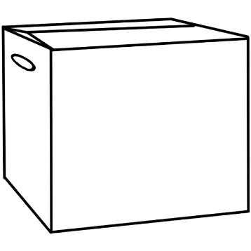


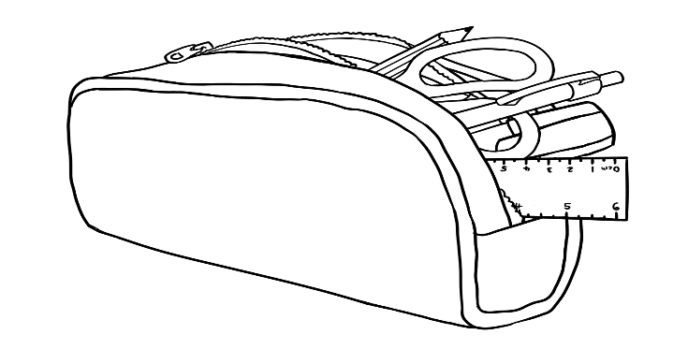
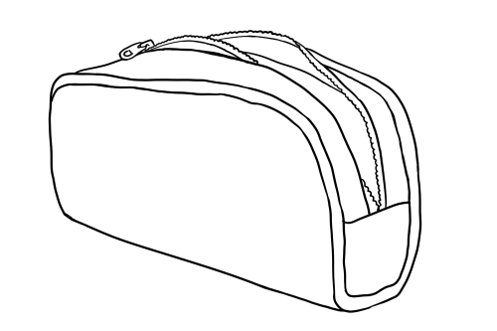
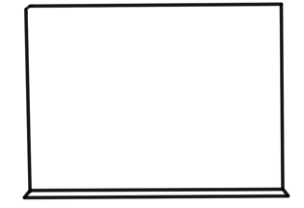
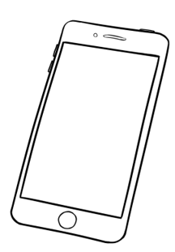
2
F E G
4
M L O P N
V U T
6
7
X W
Z Y
8
1
B D A C
5
J I K H
3

A B C D

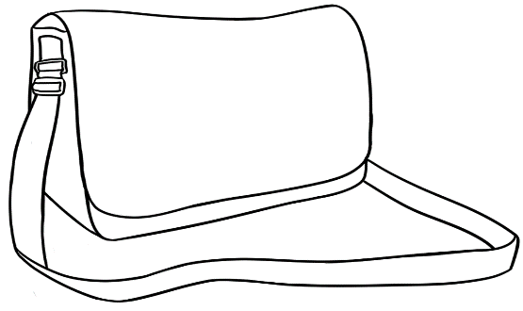
R S Q

Small letters
a | b | c | d | e | f
g | h | i | j | k | l
m | n | o | p | q | r
s | t | u | v | w | x
y | z

a | b | c | d | e | f
g | h | i | j | k | l
m | n | o | p | q | r
s | t | u | v | w | x
y | z

Project and demonstrate how to move through
the maze in alphabetical order.

 |  |  |  |  | a
 | b |  | c |  | b |  | c |  | e |  |  | q
 | f |  | d |  | e |  | f |  |  | g |  | t
 | o |  | n |  |  | h |  |  |  | h |  | m
 |  |  | m |  | l |  | k |  |  |  | d
 | p |  |  |  |  |  |  | j |  | i
 |  | q |  | r |  | s |  |  |  |  |  | y
 |  |  |  |  |  |  |  |  |  | j
 | r |  |  | l |  | t |  | u |  |  | k
 |  |  | x |  |  | w |  | v |  |  | l
 | z | y
 |  |  |  |  |  | o |  | n |  |  | m
 |  |  |  |  | q
 |  | p |  | m |  |  | w |  | t |  | n

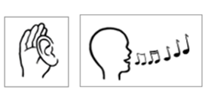
Sing to the tune of the traditional ABC song. The final lines differ from the original version to make the song more suitable for adult learners.

a b c d
e f g
h i j k
l m n o p
q r s
t u v
w x
y z
I can say the a b c.
Listen now again to me.

Copy each set of small letters in alphabetical order.

1
b d a c
2
f e g

a b c d
4
m l o p n
j i k h
3

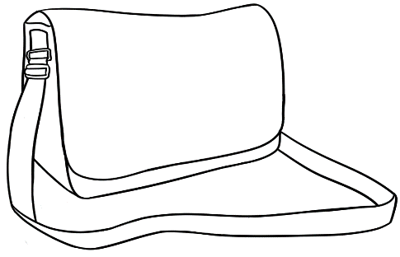
r s q
5
v u t
6

7
x w
z y
8

Match the letters.
Aa | Bb | Cc | Dd | Ee | Ff | Gg
1.
A |  | b
B |  | c
C |  | a
D |  | f
E |  | d
F |  | g
G |  | e
2.

3.
A | B | C | D | E | F | G
A
a | b | c | d | e | f | g

Colour the capitals on pages 13, 15, 17,19.
Students say the letters over and over as they colour.
Colour, sound and movement combine to aid memory.
The productive Initial classroom is a noisy one.

1. | A | c | e | d | a | b
 | B | d | c | b | f | e
 | C | a | d | e | b | c
 | D | d | f | c | e | b
 | E | a | b | e | c | d
 | F | g | f | d | e | c
 | G | f | e | c | d | g



Hh | Ii | Jj | Kk | Ll | Mm | Nn

H |  | j
I |  | h
J |  | k
K |  | i
L |  | n
M |  | l
N |  | m

H | I | J | K | L | M | N
H
h | i | j | k | l | m | n

 | H | i | h |  | l |  | k |  | j
 | I | j | l |  | i |  | m |  | k
 | J | h | i |  | k |  | l |  | j
 | K | l | j |  | m |  | k |  | n
 | L | k | l |  | h |  | n |  | i
 | M | n | k |  | l |  | i |  | m
 | N | m | l |  | j |  | n |  | k

Oo | Pp | Qq | Rr | Ss | Tt

O |  | p
P |  | r
Q |  | t
R |  | o
S |  | q
T |  | s

O | P | Q | R | S | T
O
o | p | q | r | s | t

 | O | p | q |  | r |  | s |  | o
 | P | r | s |  | t |  | p |  | o
 | Q | o | p |  | q |  | r |  | s
 | R | t | r |  | s |  | o |  | p
 | S | s | p |  | r |  | q |  | o
 | T | p | t |  | q |  | r |  | s

Uu | Vv | Ww | Xx | Yy | Zz

U |  | v
V |  | u
W |  | z
X |  | y
Y |  | x
Z |  | w

U | V | W | X | Y | Z
U
u | v | w | x | y | z

 | U | v | w | u | x | z
 | V | u | v | w | y | z
 | W | z | y | x | w | v
 | X | u | z | w | v | x
 | Y | y | u | v | z | w
 | Z | x | y | z | v | u

The names of the vowels

- Ask students to circle different vowels.

Aa | Bb | Cc | Dd | Ee | Ff
Gg | Hh | Ii | Jj | Kk | Ll
Mm | Nn | Oo | Pp | Qq | Rr
Ss | Tt | Uu | Vv | Ww | Xx
Yy | Zz
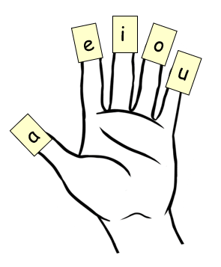
Students say and copy vowels onto sticky notes and attach them to their fingers. On the left hand, each finger will represent a vowel.

.
Ask students to point to different vowels. Then copy the vowels in the boxes.

a
_
g_
b_
c_
d_
e
_
f_

_
_

n_
m_
l_
k_
j_
i
_
h_

_

u
_
p_
o
_
t_
s_
r_
q_

_
_

z_
y_
x_
w_
v_

The names of the consonants
Listen, repeat, and point to different consonants.
Aa | Bb | Cc | Dd | Ee | Ff
Gg | Hh | Ii | Jj | Kk | Ll
Mm | Nn | Oo | Pp | Qq | Rr
Ss | Tt | Uu | Vv | Ww | Xx
Yy | Zz

- Colour the boxes with consonants.
a | b | e | c | i | d | o | f | u
g | a | h | e | j | i | k | o | l
u | m | a | n | e | p | i | q | o
r | u | s | a | t | e | v | i | w
o | x | u | y | a | z | e | z | i

.
Copy the consonants.

a
_
g_
b_
c_
d_
e
_
f_

_
_
_
_
b_

n_
m_
l_
k_
j_
i
_
h_

_
_
_
_
_
_

u
_
p_
o
_
t_
s_
r_
q_

_
_
_
_
_

z_
y_
x_
w_
v_

_
_
_
_
_

Can you spell that please?
Say the word, spell the word, copy the word..

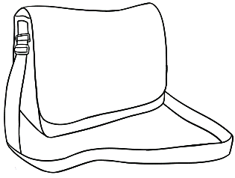
- bag b–a–g
bag _ _ _
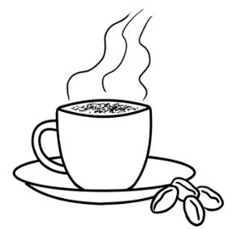

- cup c–u–p
_ _ _ _ _ _

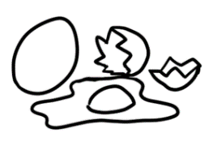
- egg e–g–g
_ _ _ _ _ _
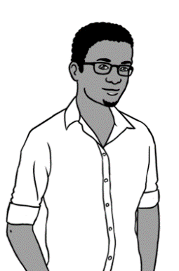
- man m–a–n
_ _ _ _ _ _

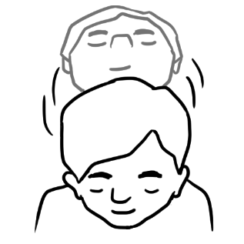
- yes y–e–s
_ _ _ _ _ _

What is your name?

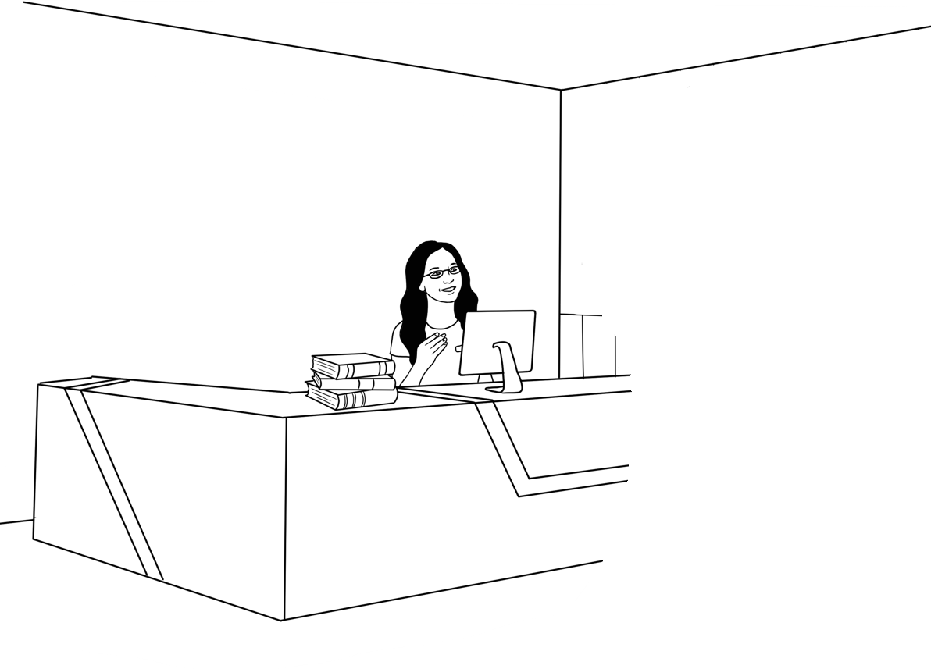
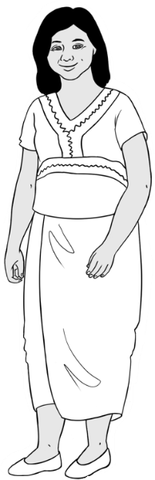
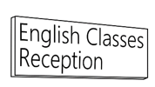
Zarni Tun.
What is your name?

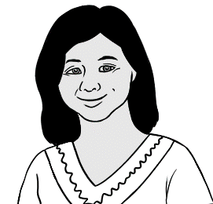

My name is Zarni Tun.
My name is Zarni Tun.
__ y __ame __s Zarni Tun.

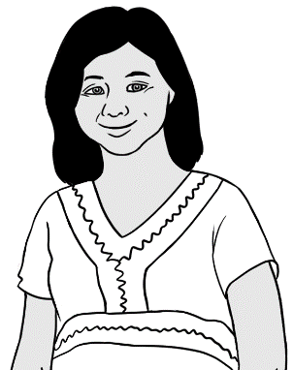
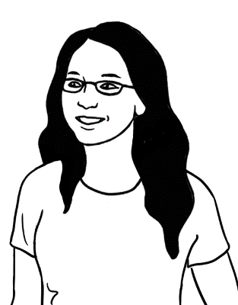
What is your first name?
Zarni.
Can you spell that please?
Zarni Z - a - r - n – i.

Spell Zarni’s first name and copy the letters below.

First name
Zarni

A | B | C | D | E | F | G | H | I | J | K | L | M
N | O | P | Q | R | S | T | U | V | W | X | Y | Z
a | b | c | d | e | f | g | h | i | j | k | l | m
n | o | p | q | r | s | t | u | v | w | x | y | z

- Zarni Zarni Zarni
__arni Z__rni Zarn__
You
What is your first name?

Can you spell that please?

Students say their first name, spell it, copy it and circle the letters.

First name
_______________________________

A | B | C | D | E | F | G | H | I | J | K | L | M
N | O | P | Q | R | S | T | U | V | W | X | Y | Z
a | b | c | d | e | f | g | h | i | j | k | l | m
n | o | p | q | r | s | t | u | v | w | x | y | z
Students copy their first name twice and spell it to their partner.

_______________________________ ________________________________
What is your family name?
Tun.

Can you spell that please?

Tun T – u – n.
Spell Zarni’s family name and copy the letters below.

Family name
T u n

A | B | C | D | E | F | G | H | I | J | K | L | M
N | O | P | Q | R | S | T | U | V | W | X | Y | Z
a | b | c | d | e | f | g | h | i | j | k | l | m
n | o | p | q | r | s | t | u | v | w | x | y | z

- Tun Tun Tun
__un T__n Tu_
1.
You
What is your family name?
.

Can you spell that please?
.

Students say their name, spell it, copy it and circle the letters.

Family name .
_______________________________
A | B | C | D | E | F | G | H | I | J | K | L | M
N | O | P | Q | R | S | T | U | V | W | X | Y | Z
a | b | c | d | e | f | g | h | i | j | k | l | m
n | o | p | q | r | s | t | u | v | w | x | y | z

- Students copy their first name twice and spell it to their partner.

_______________________________ ________________________________

What is your address?

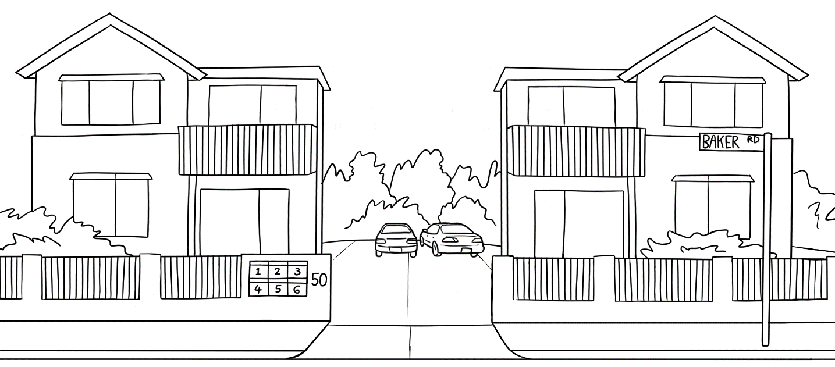
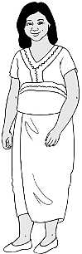
I live here.

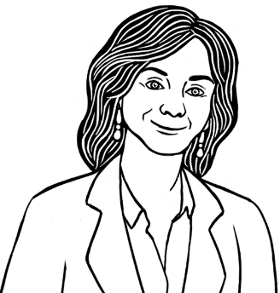
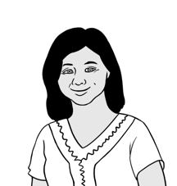
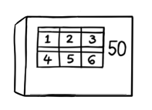
Kellivale
Unit 4,
50 Baker Road.
What is your address?
Where do you live Zarni?

Zarni
Can you spell your street name? .
Baker B – a – k – e – r.
Can you spell your suburb name? .
First name |  | Zarni
Family name |  | Tun
Address | Street | Unit 4  50 Baker Road
 | Suburb | Kellivale
 | Postcode | 2421

Kellivale K – e – l – l – i – v – a – l – e.

Type student details on the template in the Teacher Resources.
Students can then copy their details on the template below.
Ask students to say and spell their address to you.
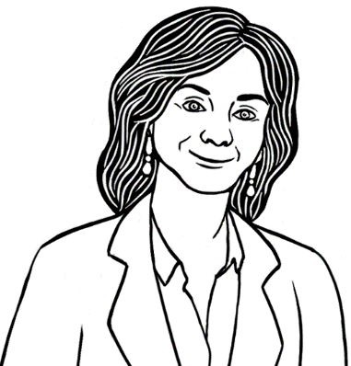

You

Where do you live?

Can you spell your street name?

First name
Family name
Address | Street
 | Suburb
 | Postcode
Can you spell your suburb name?

Signs
Explain that signs are usually written in capital letters.
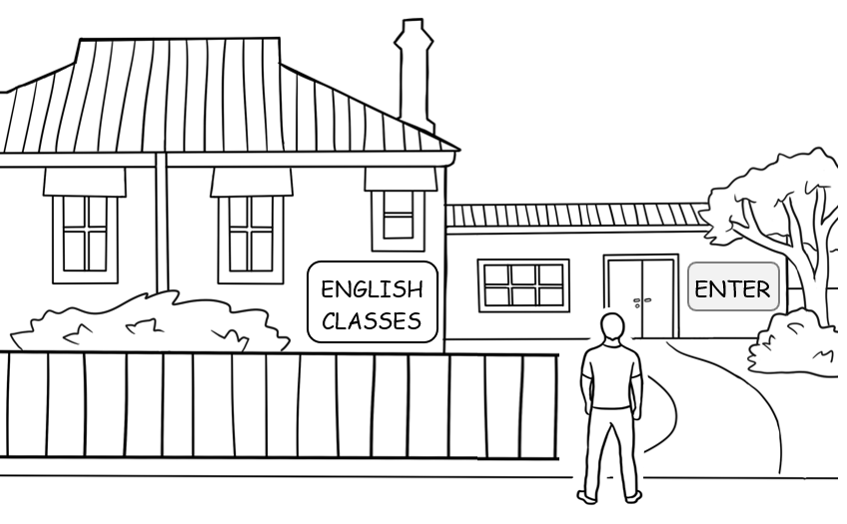

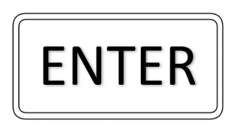 |  | E | N | B | T | G | E | R

___NTER E___TER EN___ER
Colour the sign green.
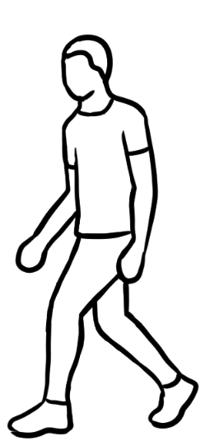
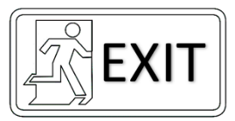
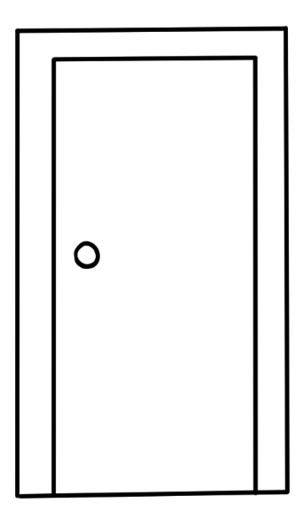

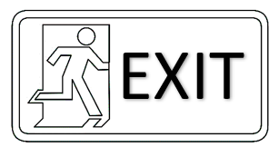 | F | E | D | X | l | S | T

___XlT E___lT EXl___

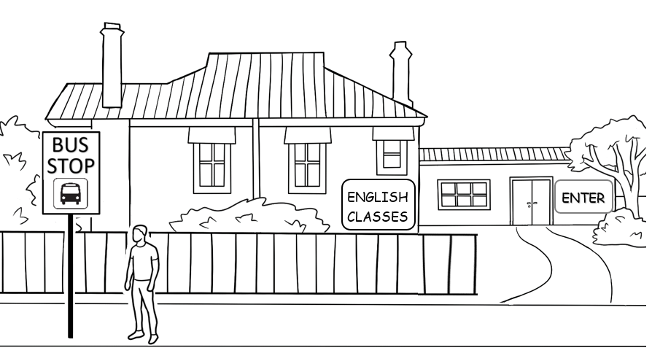

Colour the sign according to those in your local area.
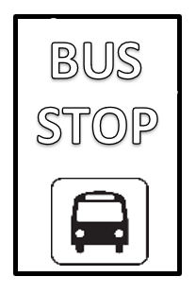

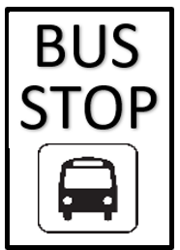
BUS STOP | BUS STOP
__US __TOP | BU__ STO__

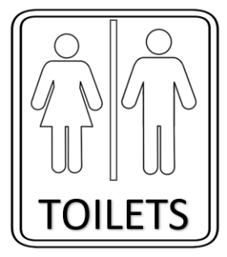
___OlLETS | TOl___ETS | TOlLE___S

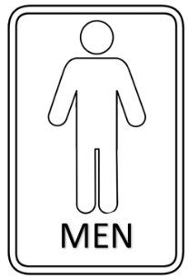
___EN | ME___ | M___N

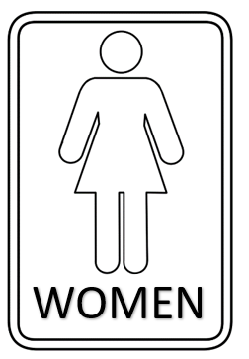
___OMEN | WO___EN | WOME___

Say, spell, say each word.
Clap the syllabes.
Match the words and signs.
.
 | EXlT
 | ENTER
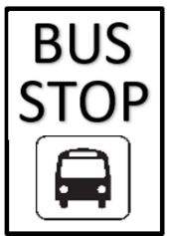 | WOMEN
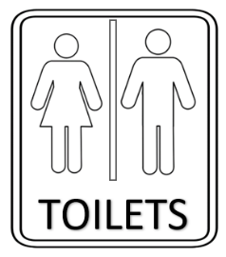 | MEN
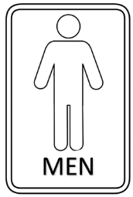 | BUS STOP
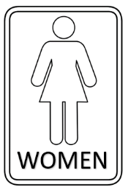 | TOlLETS

