Student book with teacher notes

English Ready
22636VIC Course in Initial EAL
VU23489 Recognise letters of the alphabet and their sounds in extremely familiar words
Letter sounds
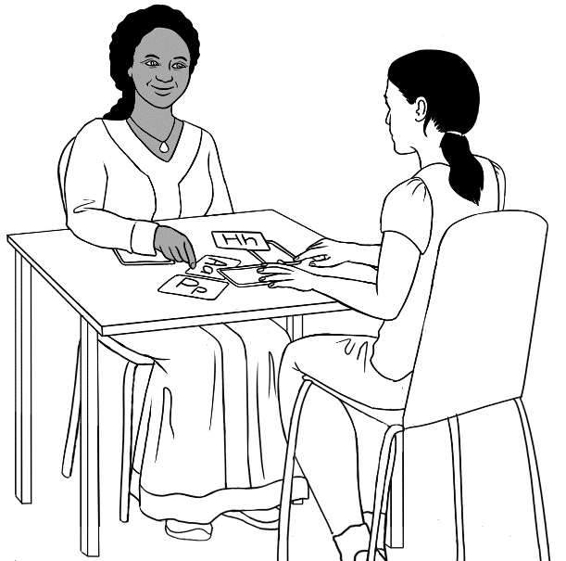
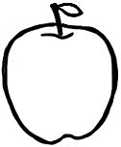
apple a

Name _____________________________________________
Teacher _________________________________________
Class ______________________________________________
Date________________________________________________

Design team: Vicki Hambling, Sue Paull, Frida Dean, Glenise Kleehammer and Mary Wallace
This book is supported by additional work on sounds
in the Letter Sounds book.
This workbook is designed to be used with the support of a teacher.
Illustrations: Madelena Scott
Acknowledgements: The design team would like to thank the AMEP service providers and practitioners who participated in the trial and gave valuable feedback. The team would also like to acknowledge the use of the EAL Framework which underpins the design of this book.

Copyright of the EAL Framework is reserved to the Crown in the right of the State of Victoria. © State of Victoria (Department of Education and Training) 2023.
__________________________________________________________________________________
This English Ready Resource is licensed under a Creative Commons Attribution-NoDerivs 3.0 Australia licence (More information is available here). You are free to use, copy and distribute to anyone in its original form as long as you attribute Department of Home Affairs as the author and you license any derivative work you make available under the same licence.
© Commonwealth of Australia 2023

With the exception of the Commonwealth Coat of Arms, the department’s logo, any material protected by a trade mark and where otherwise noted all material presented in this document is provided under a Creative Commons Attribution 4.0 International (https://creativecommons.org/licenses/by/4.0/) licence.
The details of the relevant licence conditions are available on the Creative Commons website (accessible using the links provided) as is the full legal code for the CC BY 4.0 licence. (https://creativecommons.org/licenses/by/4.0/legalcode).
Use of all or part of this document must include the following attribution:
© Commonwealth of Australia 2023
As far as practicable, material for which the copyright is owned by a third party will be clearly labelled. The department has made all reasonable efforts to ensure that this material has been reproduced in this document with the full consent of the copyright owners.
Copyright requests and enquiries concerning usage not addressed by the CC BY 4.0 licence should be addressed to: comms@homeaffairs.gov.au at the Department of Home Affairs.
The terms of use for the Commonwealth Coat of Arms are available from the It's an Honour website.
Where a copyright owner, other than the Commonwealth, is identified with respect to this material, please contact that third party copyright owner directly to seek permission.


Table of contents
1 Instructions 1
2 The first sounds 2
3 Practise the first sounds. 8
4 Consonant sounds 21
5 Vowel sounds 35
6 Listen to the sounds. 45
7 Consonant blends 47
8 Two consonants make one sound. 56

Instructions
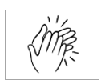
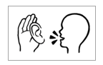
The arrow is a reminder to read from left to right.

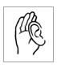  1.  listen | 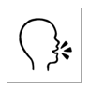  2.  say
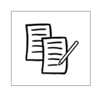  3.  4  copy | 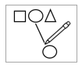  4.  match
  5.  colour | 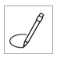  6.  circle
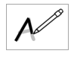  7.  trace | 8.  tick
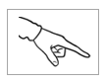  9.  point | 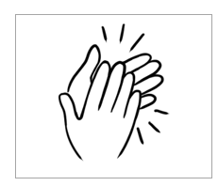  10.  clap

The first sounds
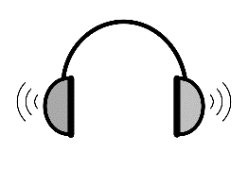
Audio – A female voice and then a male voice reads the sounds of all the letters in the pattern below. A time gap after each sound allows time for students to repeat. Encourage students to record the sounds on their phones.
The vowels are gold, consonants blue.
a | 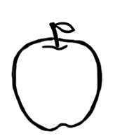  apple | a
b | 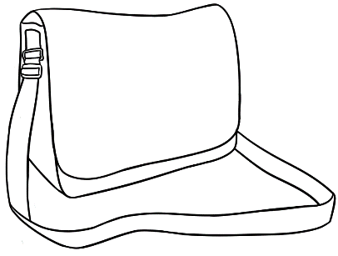  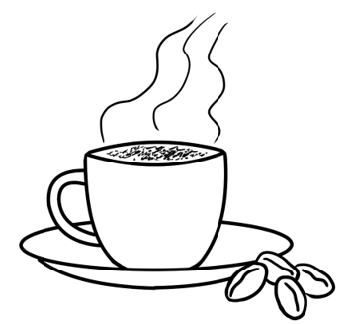  bag | b
c | cup | c
d | 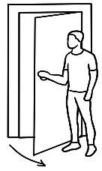  door | d

Introduce the sounds gradually and contextualise them as much as possible.

e | 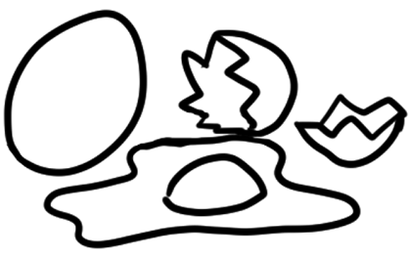  egg | e
f | 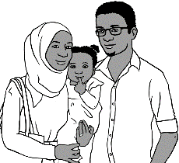  family | f
g | 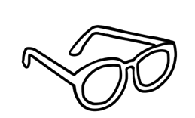  glasses | g
h | 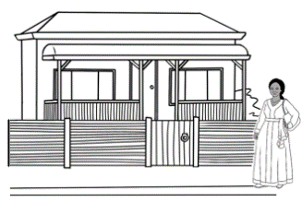  home | h

i |   ink | i
j | 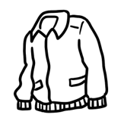  jacket | j
k | 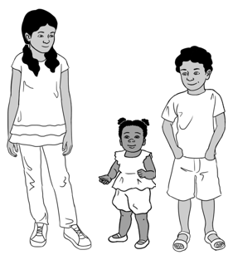  kids | k
l | 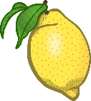  lemon | l
m | 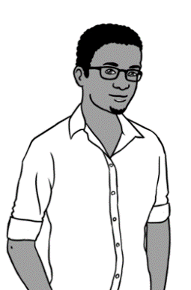  man | m

n | 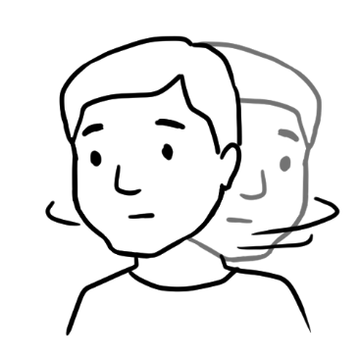  no | n
o | 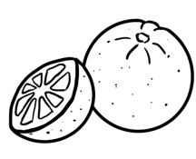  orange | o
p | 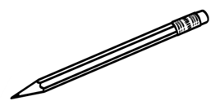  pencil | p
q | 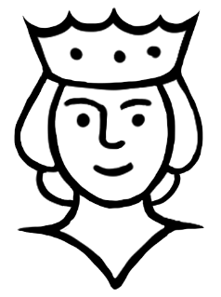  queen | q

r | 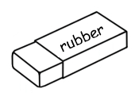  rubber | r
s | 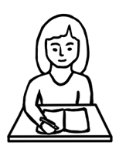  student | s
t | 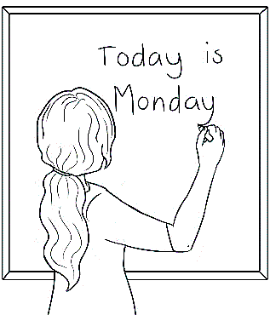  teacher | t
u |   umbrella | u
v | 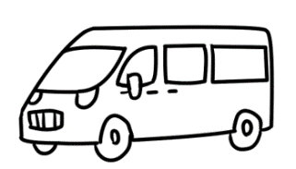  van | v

w | 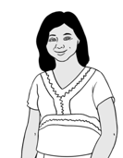  woman | w
x | 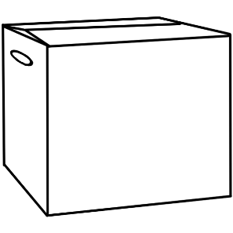  box | x
y | 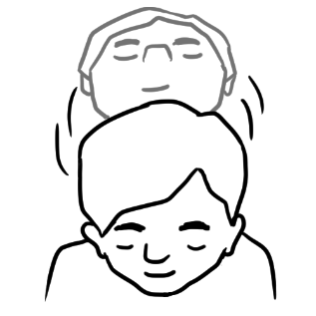  yes  0 | y
z | zero | z

Practise the first sounds.

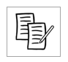
`
Pages 9 – 19
Say and repeat each sound, word and sound 3 times.
In the box, copy the first sound.

a |  | apple | a
b |  | bag | b
c | 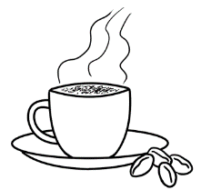 | cup | c

Pages 9 – 19
Say a sound and then the word.
Students circle the sound.

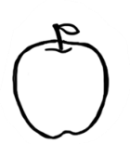  a | b | c

d |  | door | d
e | 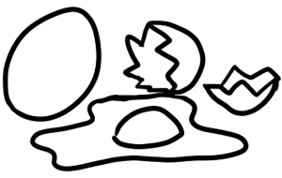 | egg | e
f |  | family | f
g | 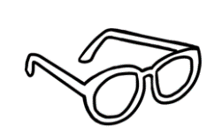 | glasses | g

d | 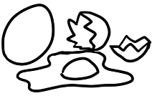  e | f | g

g
f
e
d
c
b
a
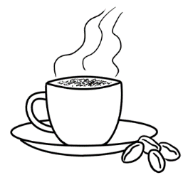
cup
door
apple
bag
family
glasses
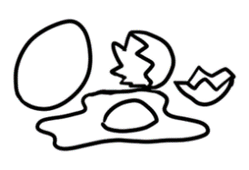
egg

h |  | home | h
i |  | ink | i
j |  | jacket | j
k | 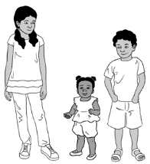 | kids | k

h |   i | j | k

l |  | lemon | l
m | 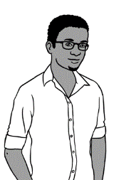 | man | m
n |  | no | n

l | 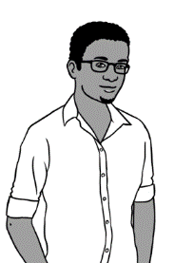  m | n

jacket
lemon
home
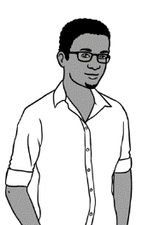
man

ink
no
kids

h
i
j
k
l
m
n

o |  | orange | o
p |  | pencil | p
q | 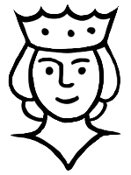 | queen | q

o | p | 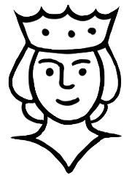  q

r |  | rubber | r
s |  | student | s
t | 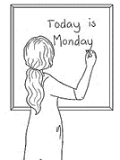 | teacher | t

r | s | t

pencil
rubber
teacher
orange
queen
student

t
o
s
r
q
p

u |  | umbrella | u
v |  | van | v
w |  | woman | w

u | v | w

x |  | box | x
y |  | yes | y
z | 0 | zero | z

x | y |   z

woman
umbrella
box
0
zero
van
yes
y
u
z
x
w
v

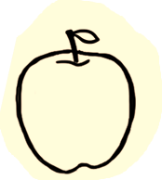  a |  | m | n | 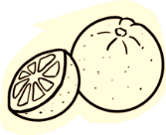  o |  | Finish
b |  | l |  | 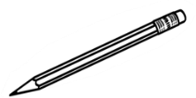  p |  |   z
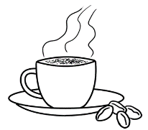  c |  | 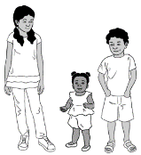  k |  | q |  | y
d |  | j |  | r |  | x
e |  |   i |  | s |  | w
f | 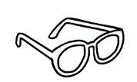  g | h |  | 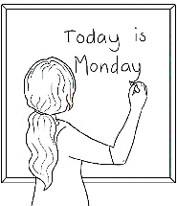  t |   u | v
A game for 2 - 4 students, counters and dice for each group. Students take turns to throw the dice and say the word and the sound where they land.
Start

Consonant sounds

Pages 22, 24, 26, 28, 30, 32 & 34: Say the sound, each word and the sound again. Students repeat. On the board, compile a list of words students already know that begin with the same consonant sound. Copy the sound in the box.
Vowels are introduced in the next section.

b | bag | 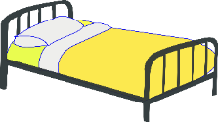  bed
c | cup | 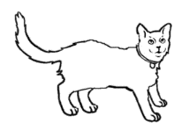  cat
d | door | 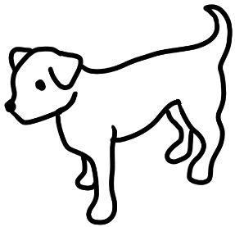  dog

bed | cat | dog
___ ed | ___ at | ___ og
___ ed | ___ at | ___ og
___ ed | ___ at | ___ og
4.
Pages 23, 25, 27, 29, 31, 33 & 35:
Students listen, repeat and copy the initial sound
in the boxes, saying the sound and word as they copy.

5.
Say a word and the sound; students repeat, and point to the picture and sound.
Then match pictures and sounds.

b
c
d

 | family | 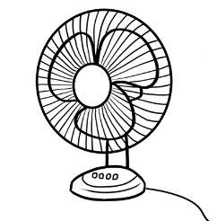  fan
g | glasses  f | 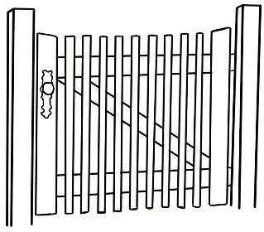  gate
h | home | 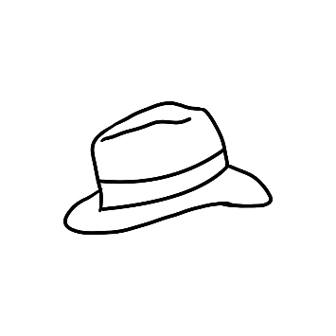  hat

4.
fan | gate | hat
___ an | ___ ate | ___ at
___ an | ___ ate | ___ at
___ an | ___ ate | ___ at

5.

f
g
h

j | jacket | 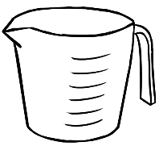  jug
k | kids | 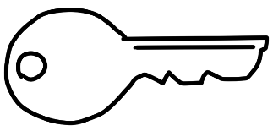  key
l | lemon |  | 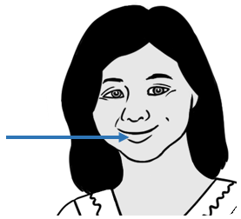  lips

4.
jug | key | lips
___ ug | ___ ey | ___ ips
___ ug | ___ ey | ___ ips
___ ug | ___ ey | ___ ips
5.
j
k
l

m | man | 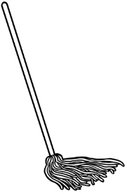  mop
n | no | 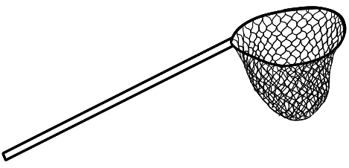  net
p | pencil |  | 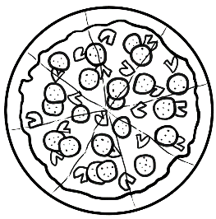  pizza

mop | 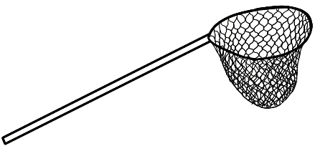  net | pizza
___ op | ___ et | ___ izza
___ op | ___ et | ___ izza
___ op | ___ et | ___ izza
4.

5.
m
n
p

q | queen | 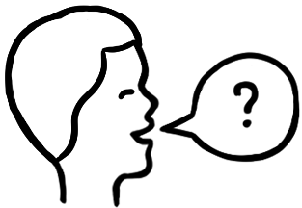  question
r | rubber | 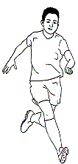  run
s | student |  |   sun

4.
question | run | sun
___ uestion | ___ un | ___ un
___ uestion | ___ un | ___ un
___ uestion | ___ un | ___ un
5.
q
r
s

t | teacher | 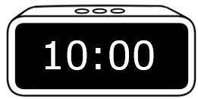  time
v | van | vowels
  a | e | i | o | u
w | woman |  | 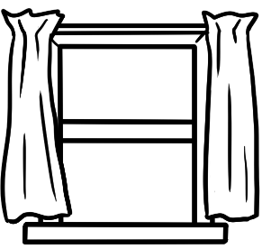  window

4.
time | van | window
___ ime | ___ an | ___ indow
___ ime | ___ an | ___ indow
___ ime | ___ an | ___ indow
5.

t
v
w

a | e | i | o | u

x | box | 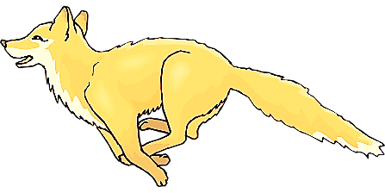  fox
y | yes | 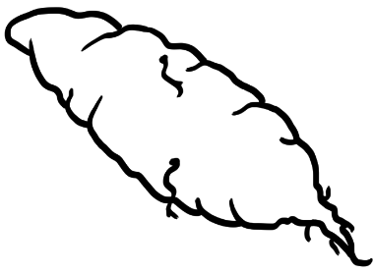  yam
 | 0
z | zero |  | 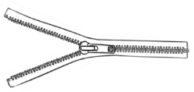  zip

fox | yam | zip
fo ___ | ___ am | ___ ip
fo ___ | ___ am | ___ ip
fo ___ | ___ am | ___ ip
4.
5.
x
y
z
0

Vowel sounds
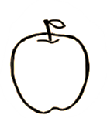
Pages 36, 38, 40, 42 & 44:
Say the word, sound the letters, say the word.
apple a
 | hat | h |  | a |  | t |  | hat
 | cat | c |  | a |  | t |  | cat
 | fan | f |  | a |  | n |  | fan
 | man | m |  | a |  | n |  | man

hat cat
h __ t c__ t
fan man
f__ n m__ n

hat cat
________ ________
fan man
________ _ _________

hat | h | u | a | p | t
cat | e | c | a | d | t
fan | l | r | f | a | n
man | m | a | w | o | n

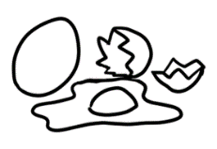
egg e
Colour the shapes red.

 | bed | b |  | e |  | d |  | bed
 | red | r |  | e |  | d |  | red

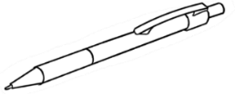 | pen | p |  | e |  | n |  | pen
 | 10
 | ten | t |  | e |  | n |  | ten
2.
bed red
b__ d r__ d
10

pen ten
p__ n t__ n

bed red
________ ________

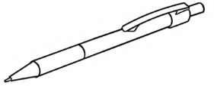

pen ten
_________ ________
bed | l | b | e | r | d
red | r | e | a | d | b
pen | l | p | o | e | n
ten  10 | m | t | e | a | n


ink i

 | 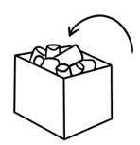  in |  | i |  | n |  | in
 | 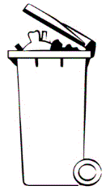  bin | b | i |  | n |  | bin
 | lip | l | i |  | p |  | lip
 | 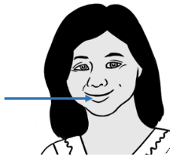
 | zip | z | i |  | p |  | zip

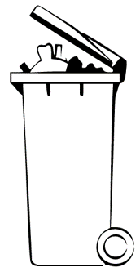
in bin
__ n b__ n
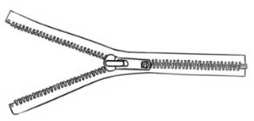
lip zip
l__ p z__ p

in bin
_________ _________
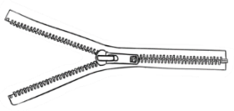
lip zip
_________ __________
in | l | i | a | k | n
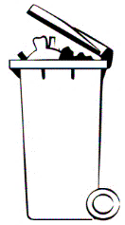  bin | b | c | i | n | d
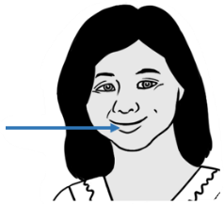  lip | p | f | l | i | p
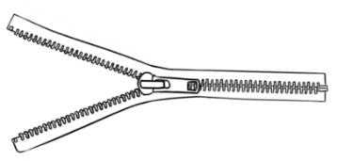  zip | z | i | w | p | n

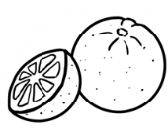
.
orange o
Colour all stop
signs red.

 | old |  |  | o |  | l |  | d |  | old
 | 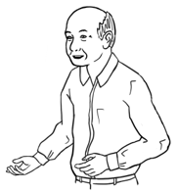
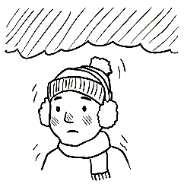 | cold | c |  | o |  | l |  | d |  |  | cold
 | mop |  |  | m |  | o |  | p |  | mop
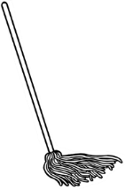
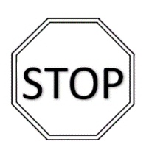 | stop | s |  | t |  | o |  | p |  | stop

old cold
__ld c__ ld
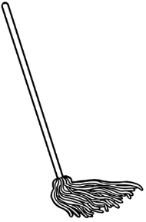
mop stop
m__ p st__ p

old cold
___________ ___________
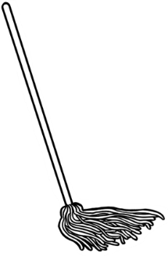

mop stop
___________ _____________

old | a | o | l | p | d
  cold | c | m | o | l | d
mop | l | m | o | a | p
stop | s | t | w | o | p


umbrella u
 | 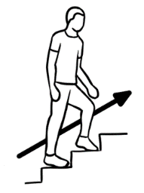  up |  | u |  | p |  | up
 | 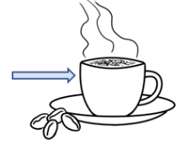  cup | c | u |  | p |  | cup
 | run | r | u |  | n |  | run
 | sun | s | u |  | n |  | sun

up cup
__ p c__ p

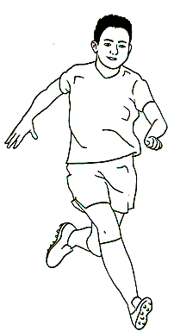
run sun
r__ n s__ n

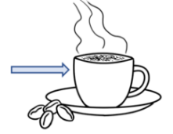
up cup
__________ __________

run sun
___________ __________

up | a | u | v | p | c
cup | c | i | u | d | p
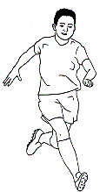  run | s | r | b | u | n
  sun | s | u | m | o | n

Listen to the sounds.
- Listen, point to and repeat every word and
sound about 3 times.
e.g. #1 bag b, bag b, bag b / cup c, cup c, cup c
- Students listen and circle the sound you read.
 | bag  b | cup  c
 | dog  d | family  f
 | gate  g | lemon  l
 | mop  m | door  d
 | 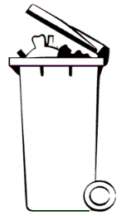  bin  b | rubber  r
 | van  v | cold  c

 | bed  b | hat  h
 | cat  c | red  r
 | run  r | fan  f
 | no  n |   sun  s
 | yam  y | window  w
 | zip  z | man  m

Consonant blends

Sound the consonants separately, then together. Finally say the word. Pages 48, 49, 51, 52, 53 - Fill in the initial consonants with colour to aid memory. Copy the consonants.

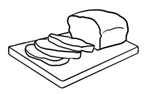

b r
br

 | 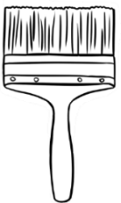
bread | brush | 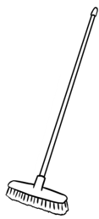  broom
__ __ ead | __ __ ush | __ __ oom
__ __ ead | __ __ ush | __ __ oom
__ __ ead | __ __ ush | __ __ oom
br | br | br | br | br
br
Listen and repeat the words.
Say the sounds while copying.

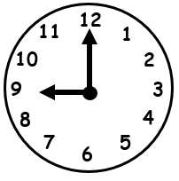
c l
cl
cl | cl | cl | cl | cl
cl

clock | 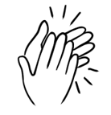  clap | 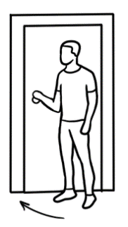  close
__ __ ock | __ __ ap | __ __ ose
__ __ ock | __ __ ap | __ __ ose
__ __ ock | __ __ ap | __ __ ose

The teacher says one word on each line. e.g. clock
The students circle the word.

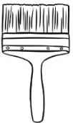  - brush | 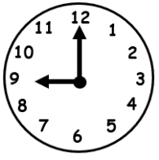  clock
- broom | clap
- bread | close
- broom | clock
- bread | clap

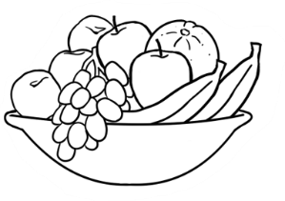
f r
fr

fr | fr | fr | fr | fr
fr
 | 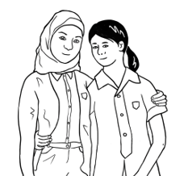
fruit | friend | 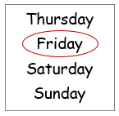  Friday
__ __ uit | __ __ iend | __ __ iday
__ __ uit | __ __ iend | __ __ iday
__ __ uit | __ __ iend | __ __ iday

Colour the stop signs red.

s t
st

st | st | st | st | st
st

stop | 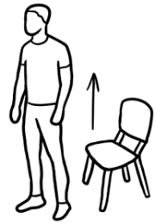  stand | 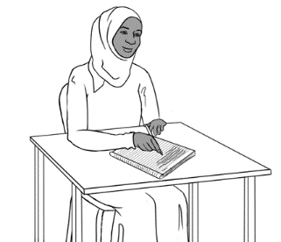  study
__ __ op | __ __ and | __ __ udy
__ __ op | __ __ and | __ __ udy
__ __ op | __ __ and | __ __ udy

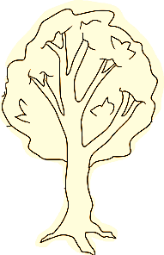

t r
tr

tr | tr | tr | tr | tr
tr

 | 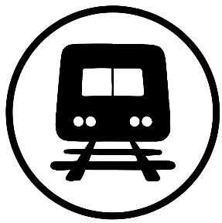 | 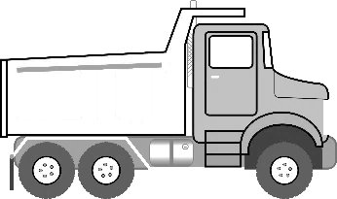
tree | train | truck
__ __ ee | __ __ ain | __ __ uck
__ __ ee | __ __ ain | __ __ uck
__ __ ee | __ __ ain | __ __ uck

The teacher says one word on each line. e.g. friend
The students circle the word.

- friend | 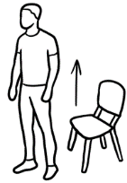  stand
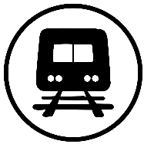  - train | 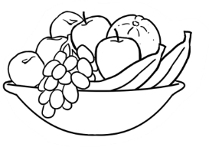  fruit
- stop | truck
- friend | study
- tree | Friday

clock
__ock
tree  __ee | 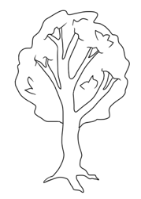
bread
__ead
fruit  __uit | 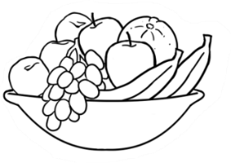
stand  __and | 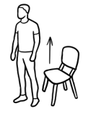

br
cl
st
tr
fr

stop
__op
brush  __ush | 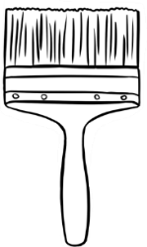
train
__ain
friend
__iend
clap
__ap

br
cl
st
tr
fr

Two consonants make one sound.
Pages 57, 58, 59, 61 & 62:
Make the double consonant sound three times. Finally say the word. Fill in the two consonants with colour to aid memory. Copy the consonants.

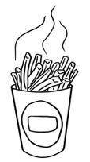
ch
ch
ch

ch | ch | ch | ch | ch
ch
Listen and repeat the words.
Say the sounds while copying.

 |  | 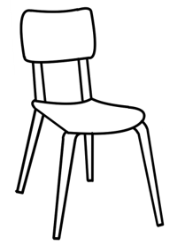
chips | 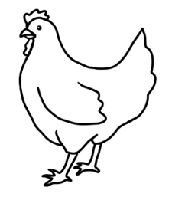  chicken | chair
__ __ ips | __ __ icken | __ __ air
__ __ ips | __ __ icken | __ __ air
__ __ ips | __ __ icken | __ __ air

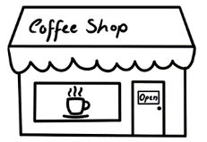

sh
sh
sh

sh | sh | sh | sh | sh
sh

 | 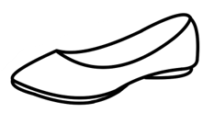 | 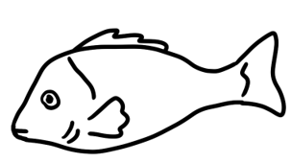
shop | shoe | fish
__ __ op | __ __ oe | fi __ __
__ __ op | __ __ oe | fi __ __
__ __ op | __ __ oe | fi __ __

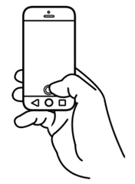
ph
ph
ph

ph | ph | ph | ph | ph
ph

phone | 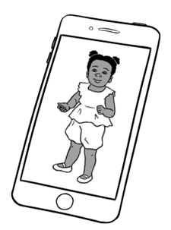  photo
__ __ one | __ __ oto
__ __ one | __ __ oto
__ __ one | __ __ oto

The teacher says one word on each line. e.g. chicken
The students circle the initial consonants in that word.

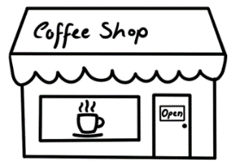  - shop | chicken  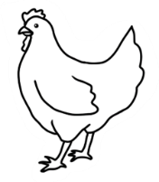
- chips | phone
- fish | chair
- shoe | 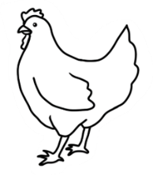  chicken
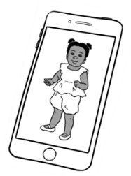  - photo | shop  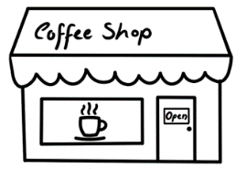

See the Teacher Resources for notes about
the pronunciation of the voiced and unvoiced th.
The th in thirty and Thursday is unvoiced. Additional words are thirteen, thirty and thanks.

3
th
th
th

th | th | th | th | th
th

th | 3 | 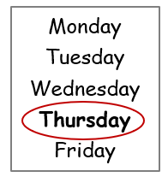
th | three  __ __ ree  __ __ ree  __ __ ree | Thursday  __ __ ursday __ __ ursday  __ __ ursday

ck
ck
ck
ck | ck | ck | ck | ck
ck

 |  | 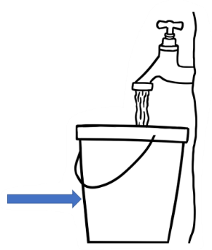
truck | clock | bucket
tru __ __ | clo __ __ | bu__ __et
tru __ __ | clo __ __ | bu__ __et
tru __ __ | clo __ __ | bu__ __et

chips
__ips
phone
__one
shop
__op
clock
clo__
three  __ree | 3

sh
ch
th
ck
ph

photo
__oto
bucket
bu__et
Thursday
__ursday
shoe
__oe
chair
__air
sh
ch
th
ck
ph

