My Dictionary

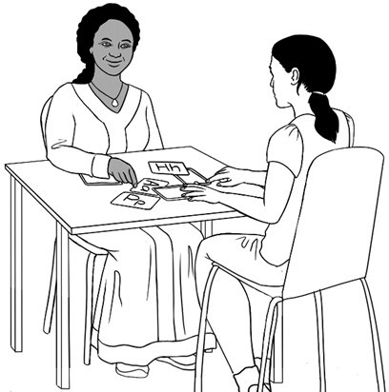

Name: _______________
Class: _______________

Project team
Vicki Hambling, Sue Paull, Frida Dean, Glenise Kleehammer and Mary Wallace

Illustrations
Madelena Scott

This English Ready Resource is licensed under a Creative Commons Attribution-NoDerivs 3.0 Australia licence (More information is available here). You are free to use, copy and distribute to anyone in its original form as long as you attribute Department of Home Affairs as the author and you license any derivative work you make available under the same licence.
© Commonwealth of Australia 2023

With the exception of the Commonwealth Coat of Arms, the department’s logo, any material protected by a trade mark and where otherwise noted all material presented in this document is provided under a Creative Commons Attribution 4.0 International (https://creativecommons.org/licenses/by/4.0/) licence.
The details of the relevant licence conditions are available on the Creative Commons website (accessible using the links provided) as is the full legal code for the CC BY 4.0 licence.(https://creativecommons.org/licenses/by/4.0/legalcode).
Use of all or part of this document must include the following attribution:
© Commonwealth of Australia 2023
As far as practicable, material for which the copyright is owned by a third party will be clearly labelled. The department has made all reasonable efforts to ensure that this material has been reproduced in this document with the full consent of the copyright owners.
Copyright requests and enquiries concerning usage not addressed by the CC BY 4.0 licence should be addressed to: comms@homeaffairs.gov.au at the Department of Home Affairs.
The terms of use for the Commonwealth Coat of Arms are available from the It's an Honour website.
Where a copyright owner, other than the Commonwealth, is identified with respect to this material, please contact that third party copyright owner directly to seek permission.
st stop




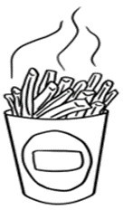
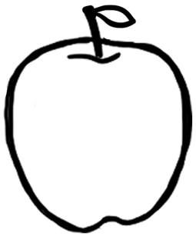
ch chips
Aa app

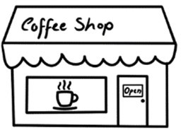
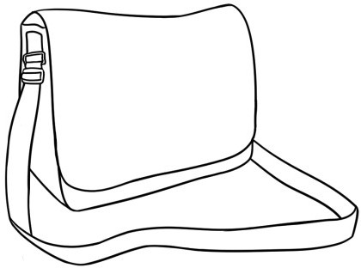
Bb bag
Sh shop

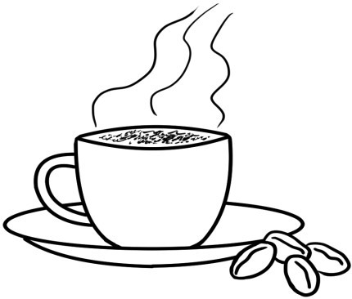
Zz
0
zero

Cc cup

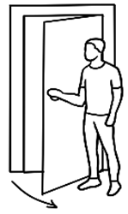
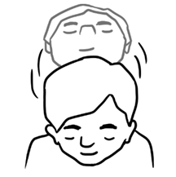
Dd door
Yy yes

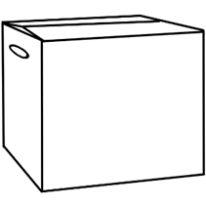
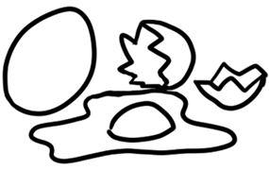
Xx box Ee .eggs

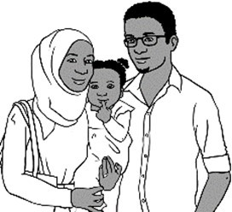
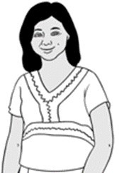
Ff family
Ww woman

Vv 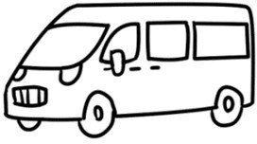 van
Gg 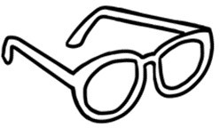 glasses

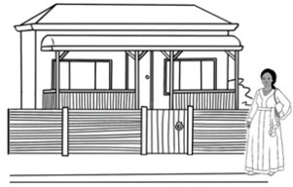

Hh house
Uu umbrella

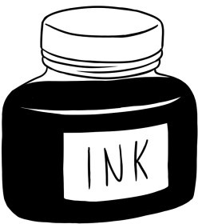
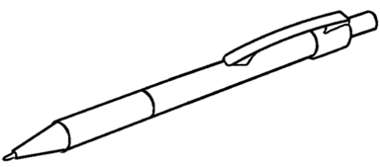
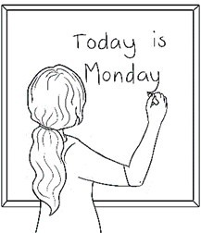
Tt teacher
Ii ink

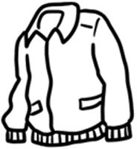
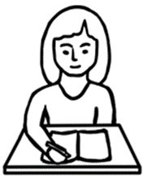
Jj jacket
Ss student

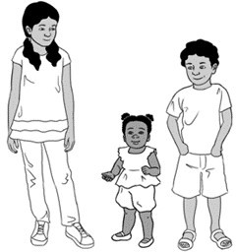
Rr 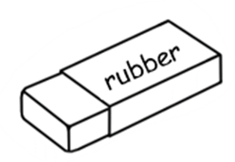 rubber
Kk kids

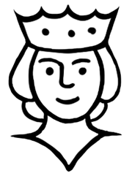
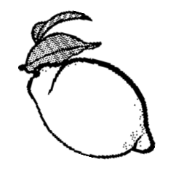
Ll lemon
Qq queen

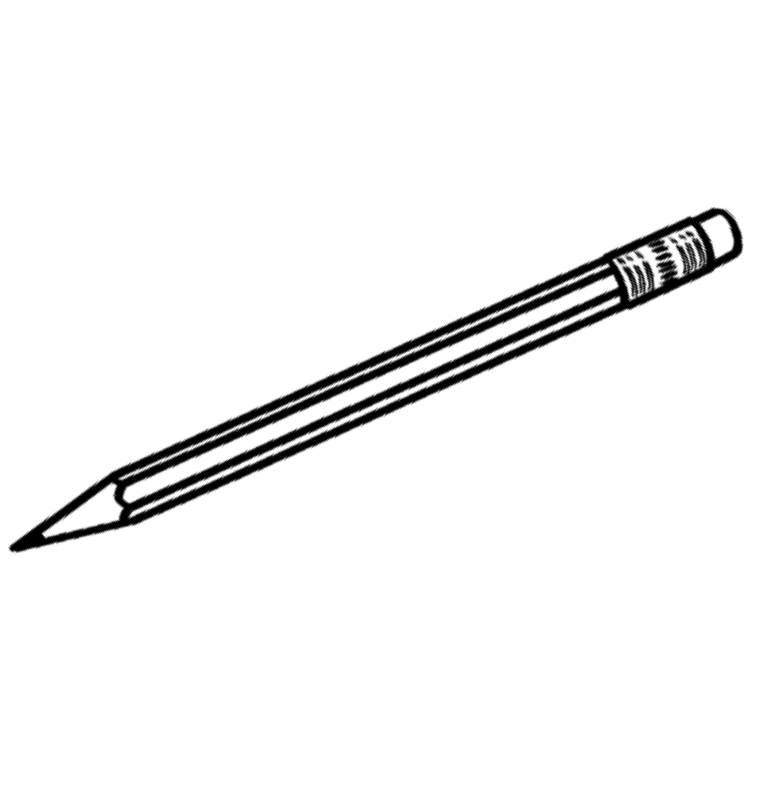
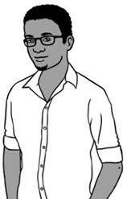
Pp pencil
Mm man

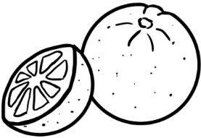
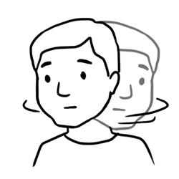
Nn no
Oo orange

