
Numbers
English Ready
22636VIC Course in Initial EAL
VU23493 Recognise, copy and use numbers and money from 1 to 50

1
2
3

0
#
4
5
6
7
8
9

Name __________________________________________________
______________________________________________________________________________________
Teacher______________________________________________
Class _________________________________________________
Date__________________________________________________

Design team: Vicki Hambling, Sue Paull, Frida Dean, Glenise Kleehammer and Mary Wallace
This workbook is designed to be used with the support of a teacher.
Illustrations: Madelena Scott
Image acknowledgements
Australian Currency designs – Permission granted by the Royal Australian Mint, Approval # 9/45/432
Balloons - This Photo by Unknown Author is licensed under CC BY-NC
Australian coat of arms This Photo by Unknown Author is licensed under CC BY-SA

Acknowledgements: The design team would like to thank the AMEP service providers and practitioners who participated in the trial and gave valuable feedback. The team would also like to acknowledge the use of the EAL Framework which underpins the design of this book.

Copyright of the EAL Framework is reserved to the Crown in the right of the State of Victoria. © State of Victoria (Department of Education and Training) 2023.
This English Ready Resource is licensed under a Creative Commons Attribution-NoDerivs 3.0 Australia licence (More information is available here). You are free to use, copy and distribute to anyone in its original form as long as you attribute Department of Home Affairs as the author and you license any derivative work you make available under the same licence.
© Commonwealth of Australia 2023

With the exception of the Commonwealth Coat of Arms, the department’s logo, any material protected by a trade mark and where otherwise noted all material presented in this document is provided under a Creative Commons Attribution 4.0 International (https://creativecommons.org/licenses/by/4.0/) licence.
The details of the relevant licence conditions are available on the Creative Commons website (accessible using the links provided) as is the full legal code for the CC BY 4.0 licence. (https://creativecommons.org/licenses/by/4.0/legalcode).
Use of all or part of this document must include the following attribution:
© Commonwealth of Australia 2023
As far as practicable, material for which the copyright is owned by a third party will be clearly labelled. The department has made all reasonable efforts to ensure that this material has been reproduced in this document with the full consent of the copyright owners.
Copyright requests and enquiries concerning usage not addressed by the CC BY 4.0 licence should be addressed to: comms@homeaffairs.gov.au at the Department of Home Affairs.
The terms of use for the Commonwealth Coat of Arms are available from the It's an Honour website.
Where a copyright owner, other than the Commonwealth, is identified with respect to this material, please contact that third party copyright owner directly to seek permission.



Table of contents

1 Instructions 1
2 Meet the students and teachers. 2
3 Trace and copy numbers. 3
4 Numbers 1 - 10 7
5 Numbers 1 - 12 21
6 Numbers 1 - 20 25
7 Numbers 1 - 30 29
8 Numbers 1 - 50 33
9 My numbers 45

Instructions
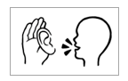

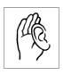  listen | 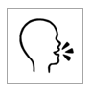  say
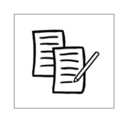  4  copy | 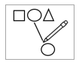  match
  colour | 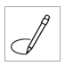  circle
  read | 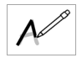  trace
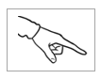  point | 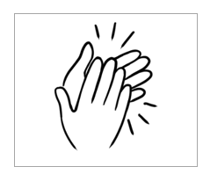  clap

Meet the students and teachers.

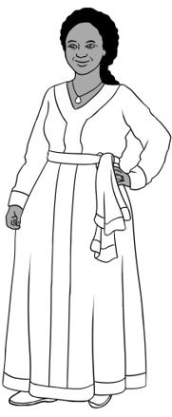
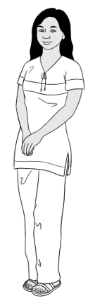
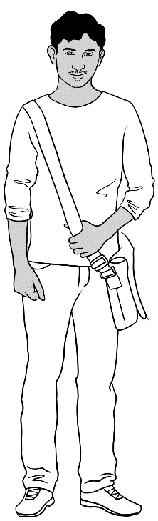
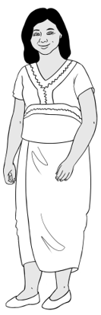
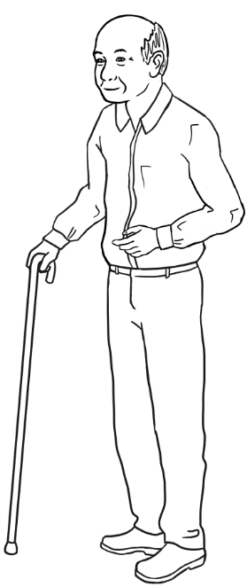
Students
3. Jamila
2. San
4. Rahim
1. Zarni
5. Ming

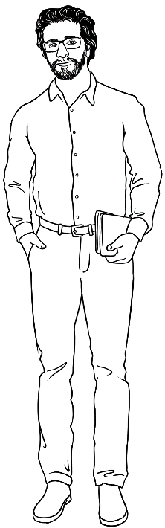
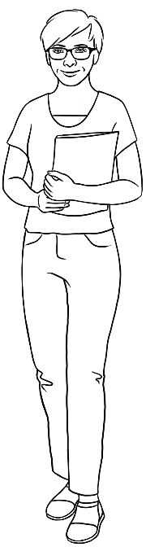
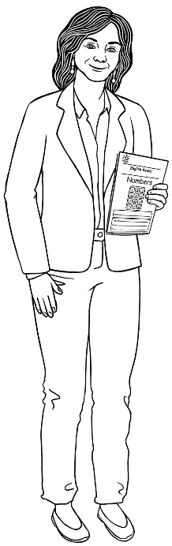
Teachers
6. Rosie
8. Peter
7. Wendy

Trace and copy numbers.

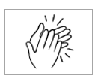
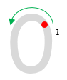
0
1
0
1

0
0
0
0
0
0
0

0

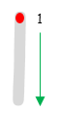
l
1
l
1

l
l
l
l
l
l
l
l

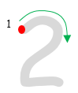
2
1
2
1

2
2
2
2
2
2
2
2

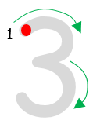
3
1
3
1

3
3
3
3
3
3
3

3

4
1
2
4
1
2

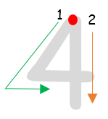

4
4
4
4
4
4
4

4

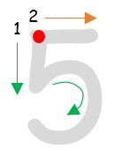
5
1
2
5
1
2

5
5
5
5
5
5
5
5

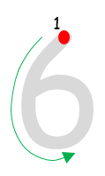
6
1
6
1

6
6
6
6
6
6
6

6

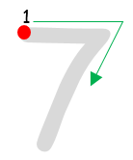
7
1
7
1

7
7
7
7
7
7
7

7

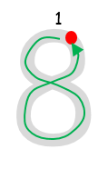
8
1
8
1

8
8
8
8
8
8
8

8
9
1

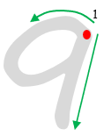

9
9
9
9
9
9
9

9

0
1
l
1

l0
l0
l0
l0
l0
l0
l0
l0

Numbers 1 - 10
How many apples?
0 | 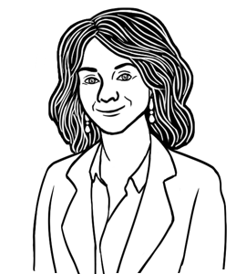
1
2 | 
3
4
5
6
7
8
9
10

0
1
2
3
4
5
6
7
8
9
10

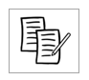

l | 2 | 3 | 4 | 5
l
6 | 7 | 8 | 9 | 10

1
2
3

0
#
4
5
6
7
8
9

2
l
3
4
5

l

6
l0
7
8
9

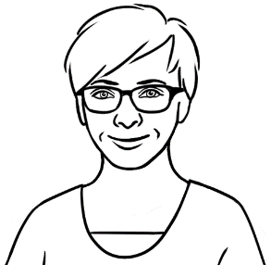
How many dollars?

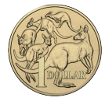 | $1 | one dollar
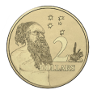 | $2 | two dollars
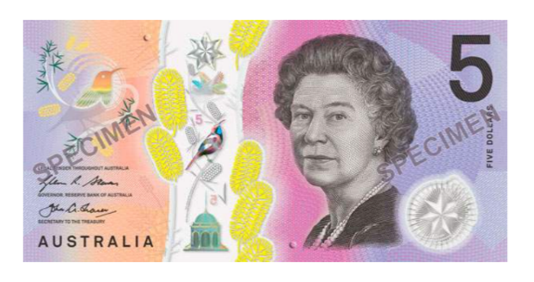 | $5 | five dollars
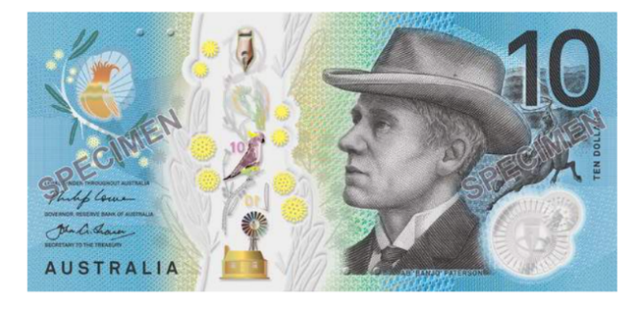 | $10 | ten dollars

$2
$10
$1
$5

$1 | $2 | $5 | $l0
$ l | $____ | $____ | $____

+ | $2  $2
+ | $3  $___
+ | $4  $___
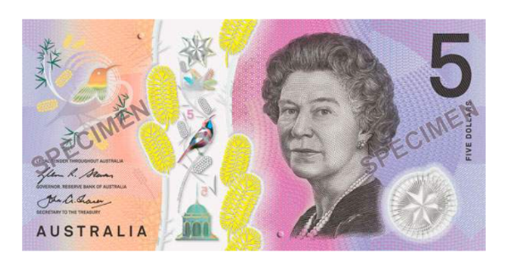 | $5  $___
+ | $6  $___
+ | $7  $___

+
+
+
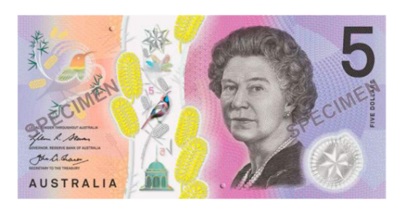
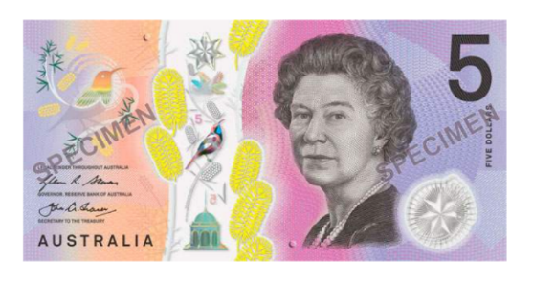
+
+
$3
$4
$5
$6
$2
$7

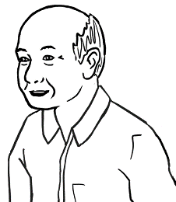
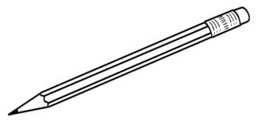

What is number 1?

1. | 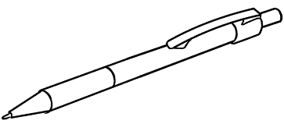  2. | 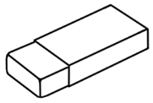  3.
pencil | pen | rubber
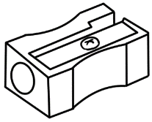  4. | 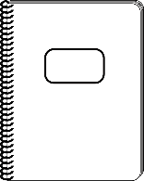  5. | 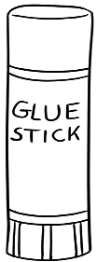  6.
sharpener | notebook | glue
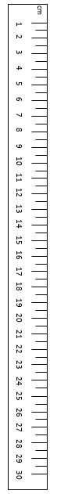  7. | 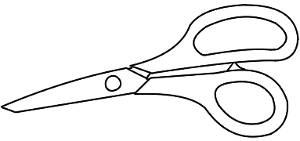  8. | 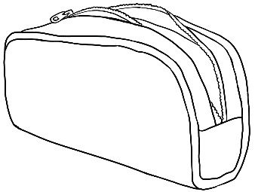  9.
ruler | scissors | pencil case


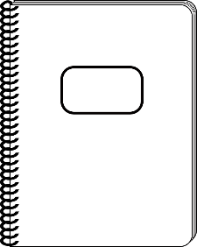
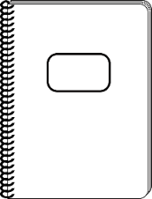
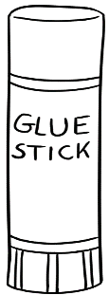
$8
$1
$9
$6
$10
Pen and Pencil
Shop
$5
$7
$4
$2
$3

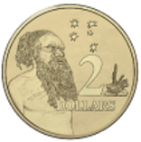
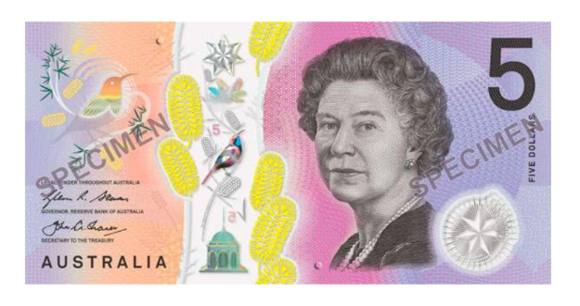
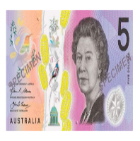
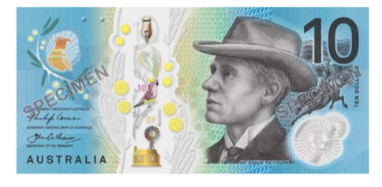
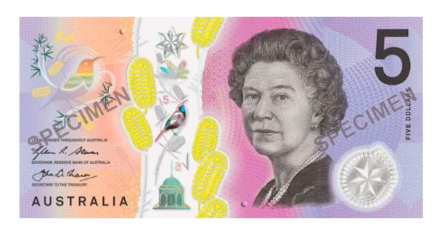

$2
$3
$4
$5
$9
$10

How many dollars?

1. | 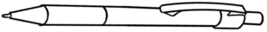  $2  $3 $5
2. | $2  $4 $6
3. | 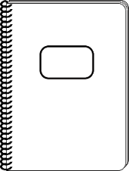  $3  $5 $8
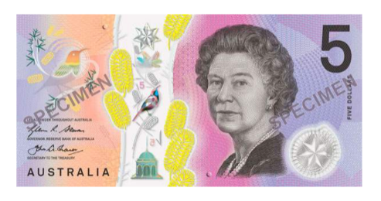
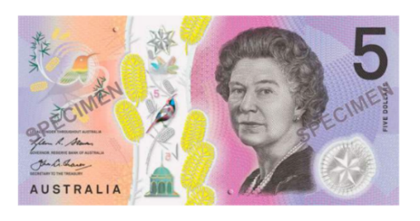

Do you have a pen?
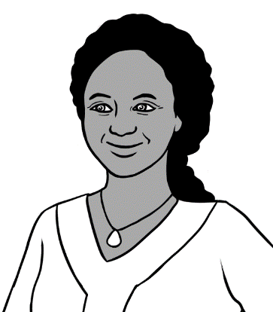

Yes. I have 4 pens.

1
1
2
___
3
___
4
___
5
___

1. | 2  1  3
2. | 2  2  4
3. | 3  2  5

Numbers 1 - 12

1 | 2 | 3 | 4 | 5
6 | 7 | 8 | 9 | 10
11 | 12

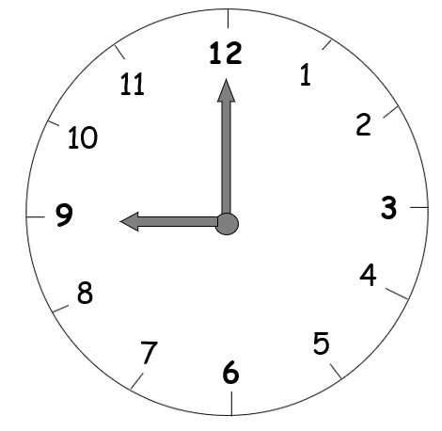

12
6
l
4
5
3
9
l0
ll
8
7
2

1
2
3
4
5
6

1

7
8
9
10
11
12

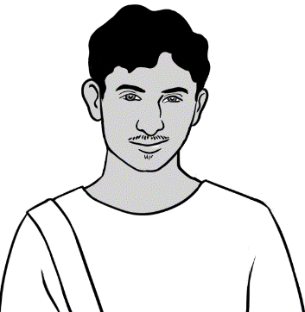
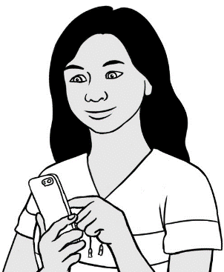
What is the time?
9 o’clock

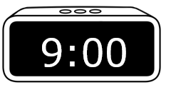
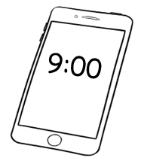
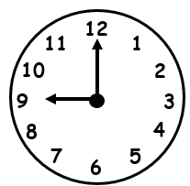

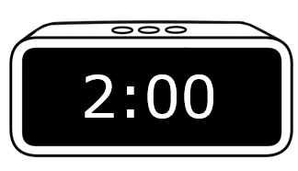
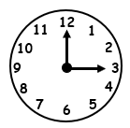
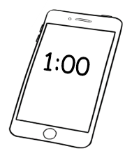

1 o’clock
2 o’clock
3 o’clock

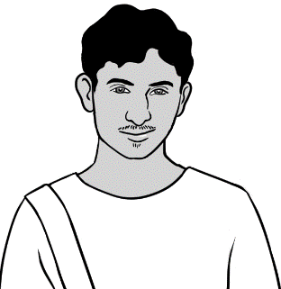
What is the time?

4 o’clock | 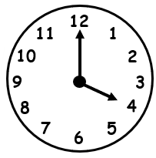
5 o’clock | 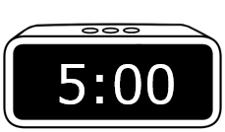
6 o’clock | 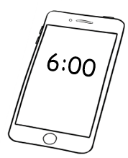
7 o’clock | 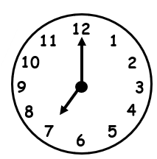
8 o’clock | 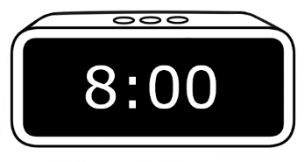
9 o’clock

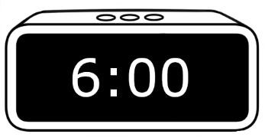

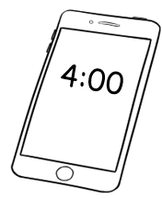

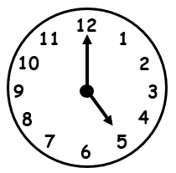

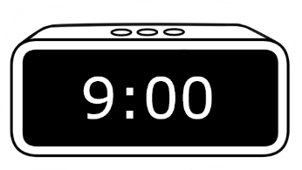

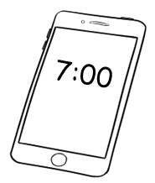

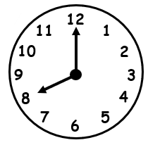

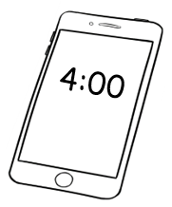
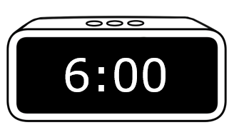

Numbers 1 - 20

1 | 2 | 3 | 4 | 5
6 | 7 | 8 | 9 | 10
11 | 12 | 13 | 14 | 15
16 | 17 | 18 | 19 | 20

11 12 13 14 15
11
16 17 18 19 20

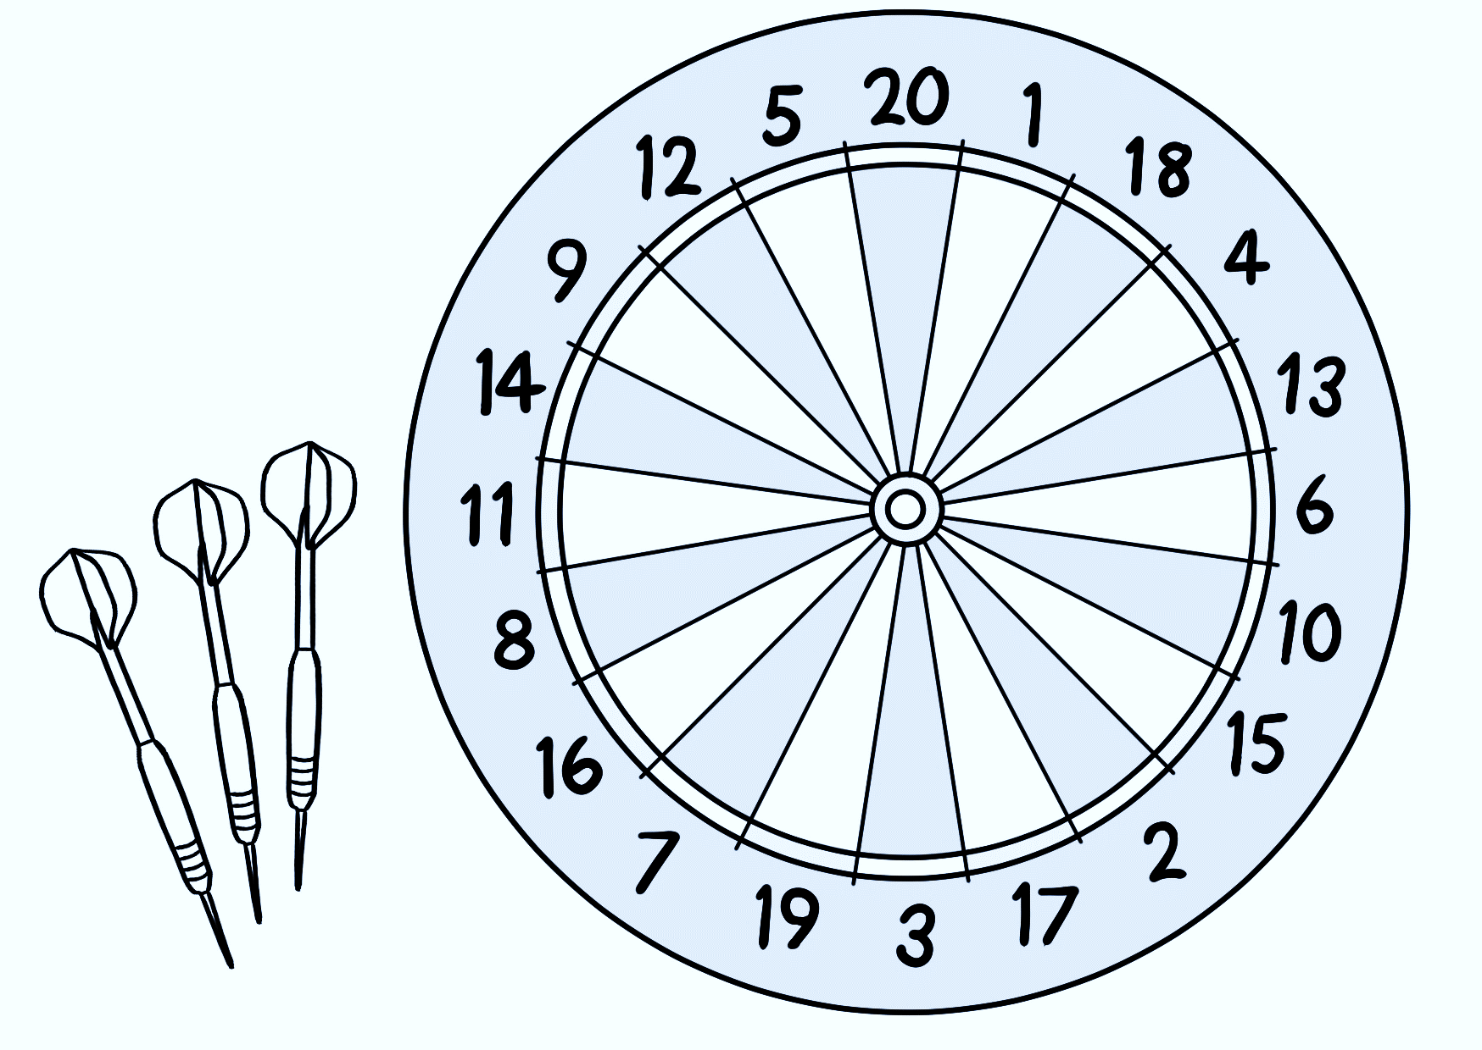

11 | 12 | 13 | 14 | 15
16 | 17 | 18 | 19 | 20

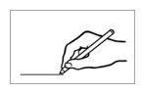
0
 |  | 1 |  | 2 |  |  | 9 |  | 6 |  | 7
 | 4
 |  |  |  | 3 |  | 4 |  | 5 |  |  | 8
 | 5 |  | 6 |  |  |  |  |  |  | 9
 |  |  |  |  | 6 |  | 7
 | 12 |  |  |  |  |  |  |  | 10 |  | 5
 |  |  | 14 |  |  | 13
 |  |  |  |  |  |  | 12 |  | 11
 |  | 15 |  |  |  |  |  |  |  |  | 13
 | 16 |  |  | 18 |  | 7 |  |  | 9
 |  |  |  |  |  |  |  |  |  |  | 14
 | 17 |  | 18 |  |  | 17 |  | 6
 |  |  |  |  |  |  |  |  |  |  | 15
 |  | 8 |  | 19 |  |  | 2
 | 5 |  |  |  |  | 20 |  |  |  |  | 16

1 | 2 | 3 | 4 | 5
1
6 | 7 | 8 | 9 | 10
11 | 12 | 13 | 14 | 15
16 | 17 | 18 | 19 | 20

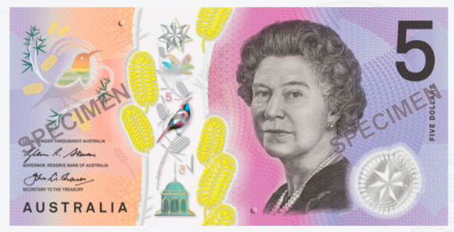

7 Numbers 1 - 30
1 | 2 | 3 | 4 | 5
6 | 7 | 8 | 9 | 10
11 | 12 | 13 | 14 | 15
16 | 17 | 18 | 19 | 20
21 | 22 | 23 | 24 | 25
26 | 27 | 28 | 29 | 30

21 | 22 | 23 | 24 | 25
26 | 27 | 28 | 29 | 30

 |  | 1 |  | 2 |  | 3 |  | 4 |  | 7
 | 4
 |  |  |  | 7 |  | 6 |  | 5 |  |  |  | 8
 | 9 |  | 8 |  |  |  |  |  |  | 9
 |  |  |  |  | 16 |  | 7
 | 10 |  | 11 |  |  |  |  |  | 10 |  |  | 5
 |  |  |  |  | 19
 |  |  | 12 |  |  |  | 16 |  | 17
 | 15 |  |  | 13 |  | 15 |  |  |  | 18
 |  |  |  |  | 14 |  |  |  | 9 |  |  | 19
 | 17
 |  |  | 24 |  | 23 |  | 22 |  | 21 |  |  | 20
 | 25
 |  |  |  | 28 |  | 29 |  | 21 |  |  |  | 27
 | 26 |  | 27 |  |  | 30
0

April
Mon | Tues | Wed | Thurs | Fri | Sat | Sun
 |  | 1 | 2 | 3 | 4 | 5
6 | 7 | 8 | 9 | 10 | 11 | 12
13 | 14 | 15 | 16 | 17 | 18 | 19
20 | 21 | 22 | 23 | 24 | 25 | 26
27 | 28 | 29 | 30
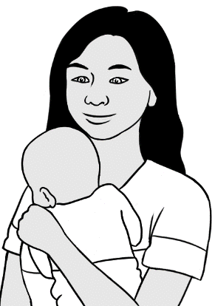
This is my son’s birthday.


before | birthday | after
15 | 16 | 17

May
Mon | Tues | Wed | Thurs | Fri | Sat | Sun
 |  |  |  | 1 | 2 | 3
4 | 5 | 6 | 7 | 8 | 9 | 10
11 | 12 | 13 | 14 | 15 | 16 | 17
18 | 19 | 20 | 21 | 22 | 23 | 24
25 | 26 | 27 | 28 | 29 | 30 | 31

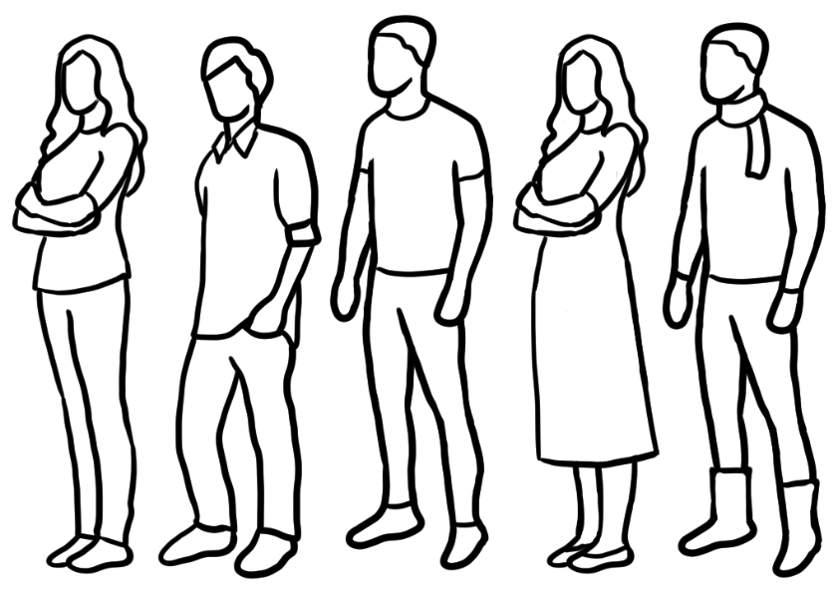

8 Numbers 1 - 50

1 | 2 | 3 | 4 | 5
6 | 7 | 8 | 9 | 10
11 | 12 | 13 | 14 | 15
16 | 17 | 18 | 19 | 20
21 | 22 | 23 | 24 | 25
26 | 27 | 28 | 29 | 30
31 | 32 | 33 | 34 | 35
36 | 37 | 38 | 39 | 40
41 | 42 | 43 | 44 | 45
46 | 47 | 48 | 49 | 50

13 | 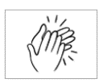 |  | 30
14 |  |  | 40
15 |  |  | 50

13 |  | 30
13
14 |  | 40
15 |  | 50


How many cents?

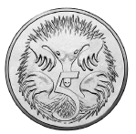 |  | 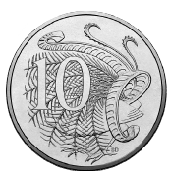
5 cents |  | 10 cents
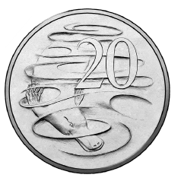 |  | 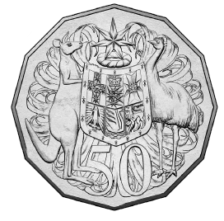
20 cents |  | 50 cents

 |  | 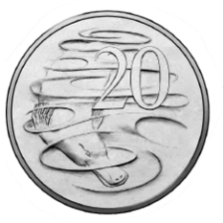 | 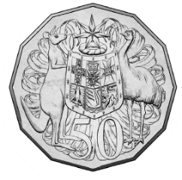
5 | 10 | 20 | 50
5

50 cents
5 cents
10 cents
20 cents

5 | 10 | 20 | 50
5


How many dollars?
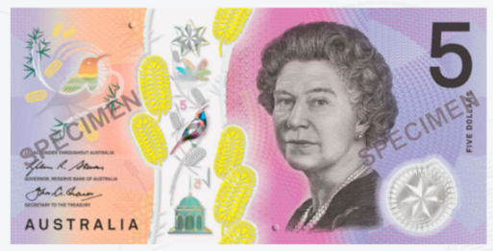  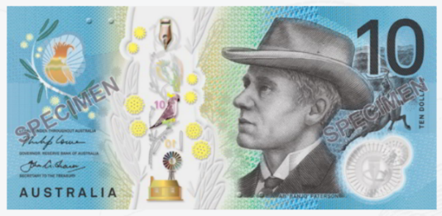  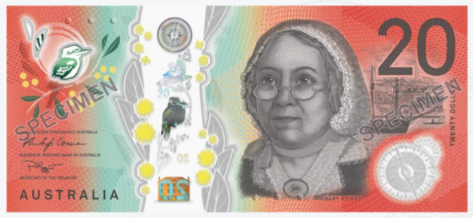  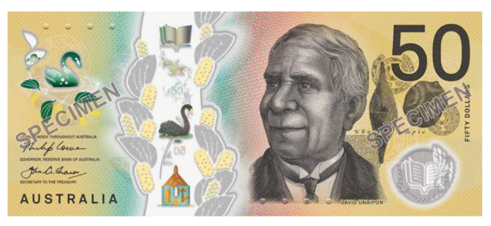 | $1 | one dollar
 | $2 | two dollars
 | $5 | five dollars
 | $10 | ten dollars
 | $20 | twenty dollars
 | $50 | fifty dollars

$1
$___

$2
$___

$5
$___

$10
$____

$20
$____

$50
$____

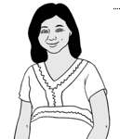
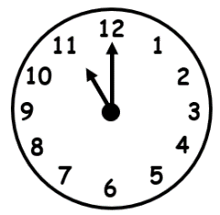
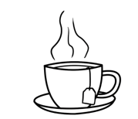

Tea or coffee?
It is break time.

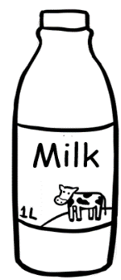
milk
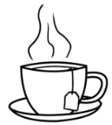
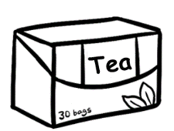
tea
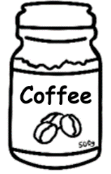
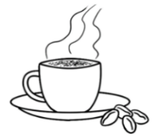
coffee
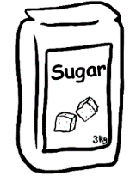
sugar
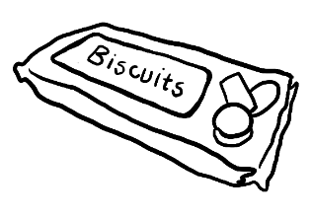
biscuits

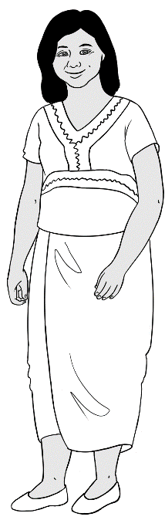
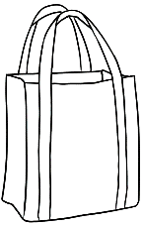
My shopping list
milk
tea
coffee
sugar
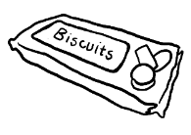
biscuits



$12
$2
Supermarket
$3
$5
$4

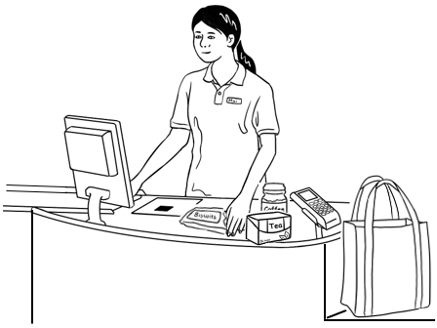
How much is it?
$26


milk $ 2
tea $ 4
coffee $12
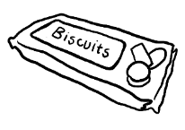
sugar $ 5
biscuits $ 3

TOTAL $26

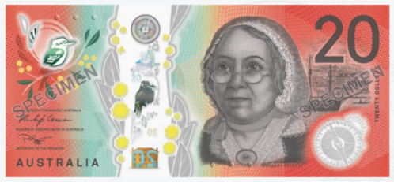
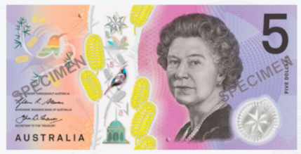
$26
$____

$13
$____
$30
$____
$14
$____
$40
$____
$15
$____
$50
$____
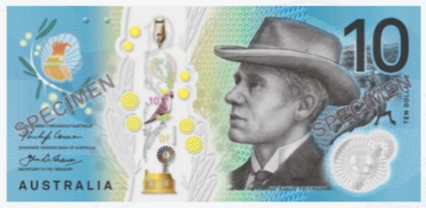
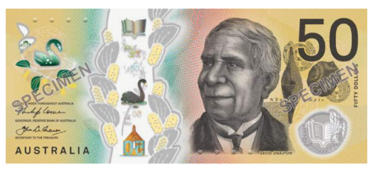

Bills
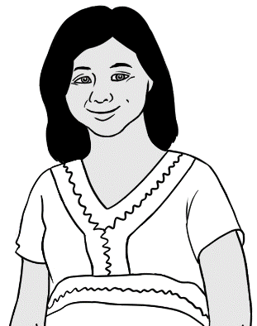

How much is it?

Electricity Account
Customer Number 642-5693

Due Date 15 June 2023
Amount Due $46.00
Mrs Z Tun
4/50 Baker Road
Kellivale
NSW

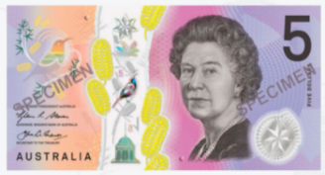
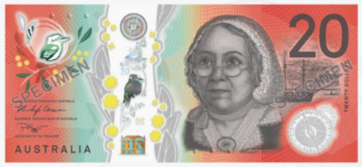

$46.00 | $46.00 | $46.00
$46.00 | $___.00 | ___ 46.___


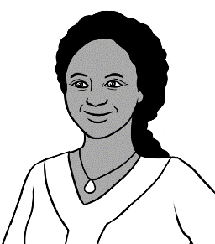
Gas Account
Customer Number 776-3085

Due Date 27 May 2023
Mrs J Desta
56 North Street
Kellivale
NSW
Amount Due $32.00
How much is it?

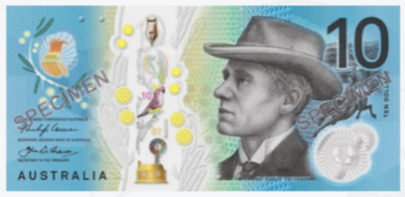
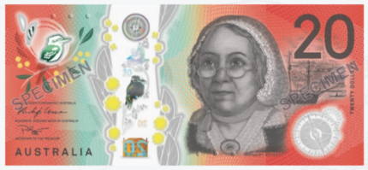

$32.00 | $32.00 | $32.00
$32.00 | $___.00 | ___32. ___

9 My numbers
Phone numbers

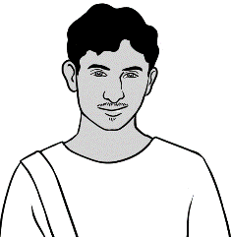
What is your phone number Rahim?
0469 883 412

0 | 4 | 6 | 9 |  | 8 | 8 | 3 |  | 4 | 1 | 2



1
2
3
4
5
6
7
8
9

0
#

Colour the numbers
in Rahim’s phone number.

0 |  | 1 |  | 2 |  | 3 |  | 4 |  | 5 |  | 6 |  | 7 |  | 8 |  | 9
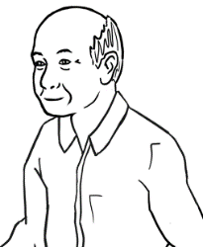
Ming’s phone number

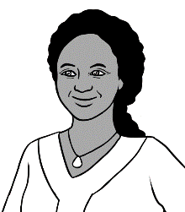
Jamila’s phone number

0 |  | 1 |  | 2 |  | 3 |  | 4 |  | 5 |  | 6 |  | 7 |  | 8 |  | 9

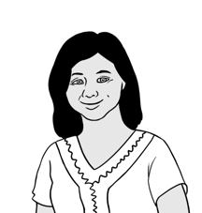

0 |  | 1 |  | 2 |  | 3 |  | 4 |  | 5 |  | 6 |  | 7 |  | 8 |  | 9
Zarni’s phone number

What is your phone number?

My phone number is

1
2
3
4
5
6
7
8
9

0
#

0 |  | 1 |  | 2 |  | 3 |  | 4 |  | 5 |  | 6 |  | 7 |  | 8 |  | 9

My teacher’s phone number

My school phone number
0 |  | 1 |  | 2 |  | 3 |  | 4 |  | 5 |  | 6 |  | 7 |  | 8 |  | 9

My emergency phone number
0 |  | 1 |  | 2 |  | 3 |  | 4 |  | 5 |  | 6 |  | 7 |  | 8 |  | 9

Address

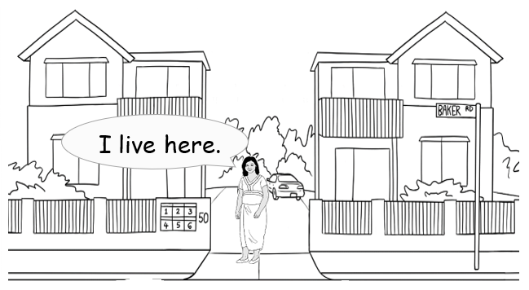

What is your address Zarni?

Unit 4,
50 Baker Road
Kellivale

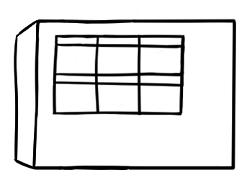
1
2
3
4
5
6
50

Zarni’s address

Number and Street | 4 / 50 Baker Road
Suburb | Kellivale
Postcode | 2421

What is your address?

Number and Street
Suburb
Postcode
My address

Date of birth

10 April 1978
What is your date of birth Zarni?

1 | January |  | 7 | July
2 | February |  | 8 | August
3 | March |  | 9 | September
4 | April |  | 10 | October
5 | May |  | 11 | November
6 | June |  | 12 | December

This is my date of birth.

10 April 1978

10 - 04 - 1978 | 10 / 04 / 1978
____ - 04 - ________ | ____ /____ /________

What is your date of birth?

____ - ____ - ________ | ____ / ____ /________
My date of birth

____ - ____ - ________ | ____ / ____ /________

Age

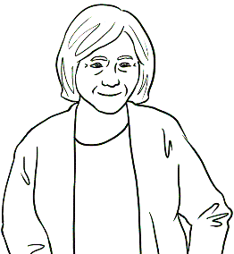
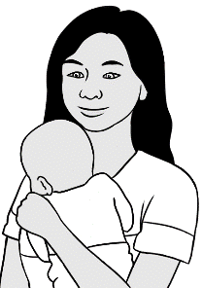
How old is your baby?
4 months old.

22 24
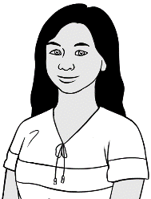
- San is ________ years old.

35 45
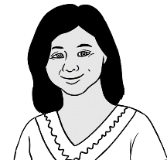
- Zarni is ________ years old.

19 22

- Rahim is ________ years old.

48 50
- Jamila is ________ years old.

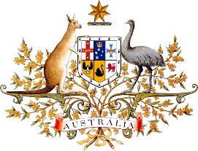
ImmiCard

I have an ImmiCard.

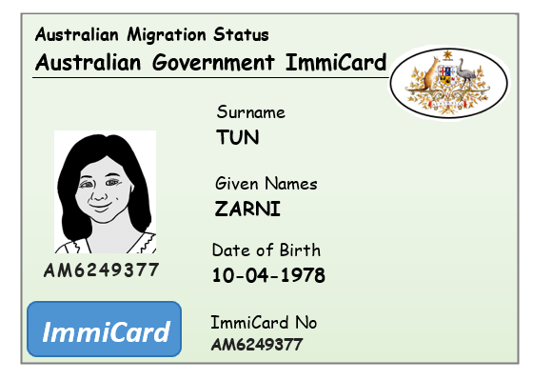

Zarni’s date of birth
10 - 04 - 1978 | 10 / 04 / 1978
____ - 04 - ________ | ____ /____ /________

Medicare Card

I have a Medicare card.

medicare

- 26984 1
1 Zarni Tun

VALID to 06/2031

This is my Medicare number.

3 | 0 | 7 | 5 |  | 2 | 6 | 9 | 8 | 4 |  | 1

