
Student book with teacher notes
Numbers
English Ready
22482VIC Course in Initial EAL
VU23493 Recognise, copy and use numbers and money from 1 to 50

1
2
3

0
#
4
5
6
7
8
9

Name __________________________________________________
______________________________________________________________________________________
Teacher______________________________________________
Class _________________________________________________
Date__________________________________________________

Design team: Vicki Hambling, Sue Paull, Frida Dean, Glenise Kleehammer and Mary Wallace
This workbook is designed to be used with the support of a teacher.
Illustrations: Madelena Scott
Image acknowledgements
Australian Currency designs – Permission granted by the Royal Australian Mint, Approval # 9/45/432
Balloons - This Photo by Unknown Author is licensed under CC BY-NC
Australian coat of arms This Photo by Unknown Author is licensed under CC BY-SA
Acknowledgements: The design team would like to thank the AMEP service providers and practitioners who participated in the trial and gave valuable feedback. The team would also like to acknowledge the use of the EAL Framework which underpins the design of this book.
Copyright of the EAL Framework is reserved to the Crown in the right of the State of Victoria. © State of Victoria (Department of Education and Training) 2023.
This English Ready Resource is licensed under a Creative Commons Attribution-NoDerivs 3.0 Australia licence (More information is available here). You are free to use, copy and distribute to anyone in its original form as long as you attribute Department of Home Affairs as the author and you license any derivative work you make available under the same licence.
© Commonwealth of Australia 2023

With the exception of the Commonwealth Coat of Arms, the department’s logo, any material protected by a trade mark and where otherwise noted all material presented in this document is provided under a Creative Commons Attribution 4.0 International (https://creativecommons.org/licenses/by/4.0/) licence.
The details of the relevant licence conditions are available on the Creative Commons website (accessible using the links provided) as is the full legal code for the CC BY 4.0 licence (https://creativecommons.org/licenses/by/4.0/legalcode).
Use of all or part of this document must include the following attribution:
© Commonwealth of Australia 2023
As far as practicable, material for which the copyright is owned by a third party will be clearly labelled. The department has made all reasonable efforts to ensure that this material has been reproduced in this document with the full consent of the copyright owners.
Copyright requests and enquiries concerning usage not addressed by the CC BY 4.0 licence should be addressed to: comms@homeaffairs.gov.au at the Department of Home Affairs.
The terms of use for the Commonwealth Coat of Arms are available from the It's an Honour website.
Where a copyright owner, other than the Commonwealth, is identified with respect to this material, please contact that third party copyright owner directly to seek permission.


Table of contents

1 Instructions 1
2 Meet the students and teachers. 2
3 Trace and copy numbers. 3
4 Numbers 1 - 10 7
5 Numbers 1 - 12 21
6 Numbers 1 - 20 25
7 Numbers 1 - 30 29
8 Numbers 1 - 50 33
9 My numbers 45

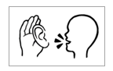
Instructions
Project and mime each instruction.

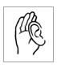  listen | 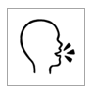  say
  4  copy | 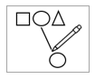  match
  colour |   circle
  read | 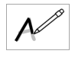  trace
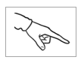  point | 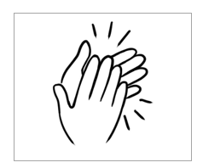  clap

Meet the students and teachers.
Project the page. Students point to the students and teacher. Name the characters. Create sentences.
e.g. Zarni is a student.

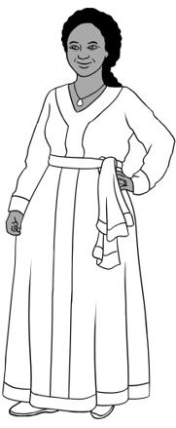
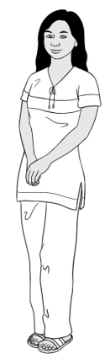
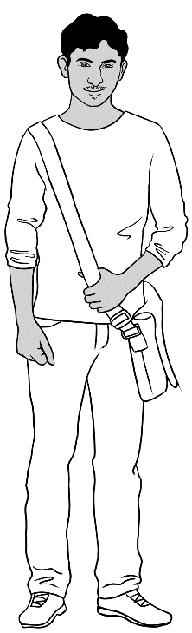
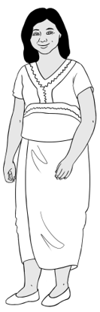
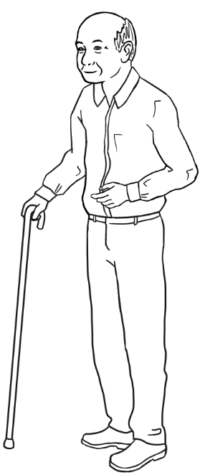
Students
3. Jamila
2. San
4. Rahim
1. Zarni
5. Ming

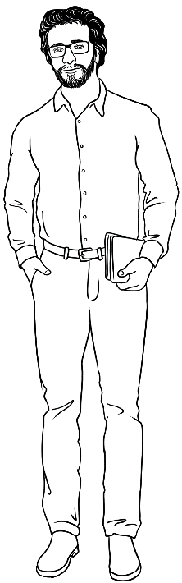
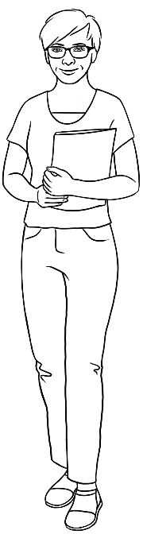
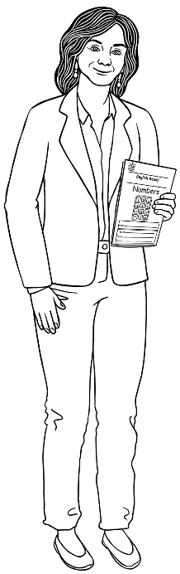
Teachers
6. Rosie
8. Peter
7. Wendy

Trace and copy numbers.

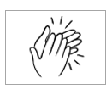
Trace the grey numbers. Copy the numbers on the lines below the traced numbers.
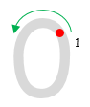
0
1
0
1

0
0
0
0
0
0
0

0


l
1
l
1

l
l
l
l
l
l
l
l

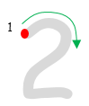
2
1
2
1

2
2
2
2
2
2
2
2

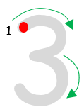
3
1
3
1

3
3
3
3
3
3
3

3

4
1
2

4
1
2
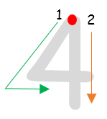

4
4
4
4
4
4
4

4

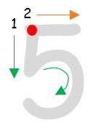
5
1
2
5
1
2

5
5
5
5
5
5
5
5

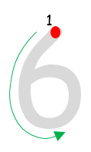
6
1
6
1

6
6
6
6
6
6
6

6

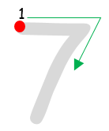
7
1
7
1

7
7
7
7
7
7
7

7

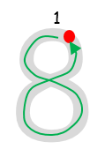
8
1
8
1

8
8
8
8
8
8
8

8
9
1

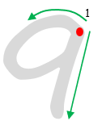

9
9
9
9
9
9
9

9

0
1
l
1

l0
l0
l0
l0
l0
l0
l0
l0

Numbers 1 - 10
How many apples?
0 | 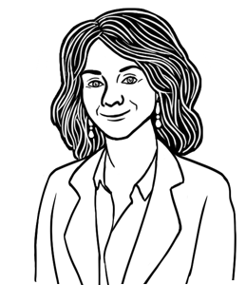
1
2 | 
3
4
5
6
7
8
9
10

Match.
Listen to the teacher and circle different numbers.
0
1
2
3
4
5
6
7
8
9
10

Listen, repeat all numbers.
Count from 1 to 10, 5 to 9 etc.
Point to specific numbers.



Copy and say the numbers aloud.
l | 2 | 3 | 4 | 5
l
6 | 7 | 8 | 9 | 10

Listen, repeat and point to the numbers.

1
2
3

0
#
4
5
6
7
8
9

Say the numbers aloud while copying.
2
l
3
4
5

l

6
l0
7
8
9

Point to different coins and notes.

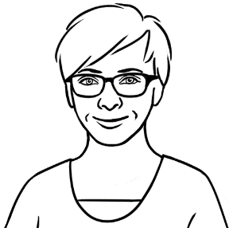
How many dollars?

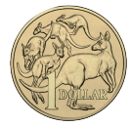 | $1 | one dollar
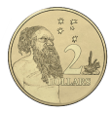 | $2 | two dollars
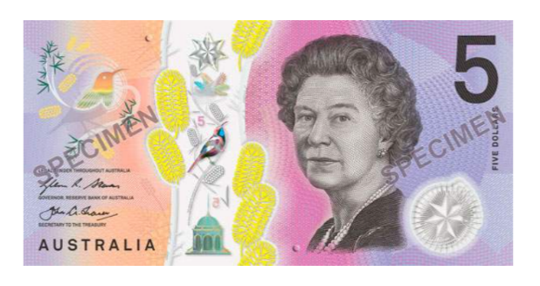 | $5 | five dollars
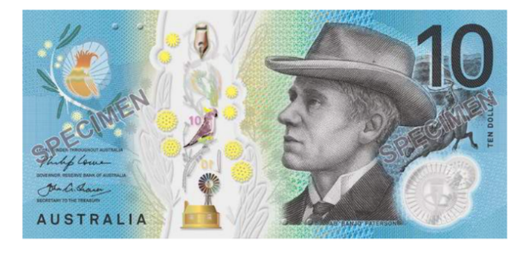 | $10 | ten dollars

Point to the dollar sign.
Note the position of the dollar sign before the number.

$2
$10
$1
$5

$1 | $2 | $5 | $l0
$ l | $____ | $____ | $____

+ | $2  $2
+ | $3  $___
+ | $4  $___
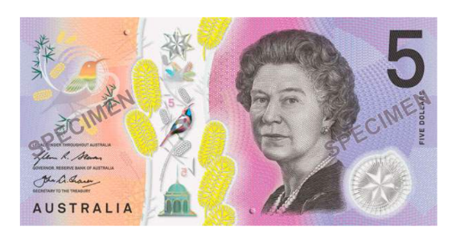 | $5  $___
+ | $6  $___
+ | $7  $___
Introduce the plus symbol.
Read a sum as $1 plus $1 is $2.

+
+
+
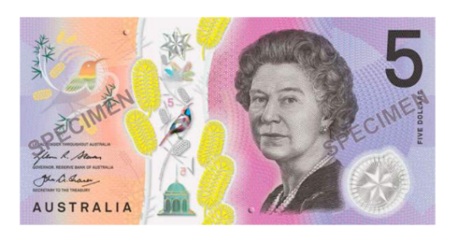
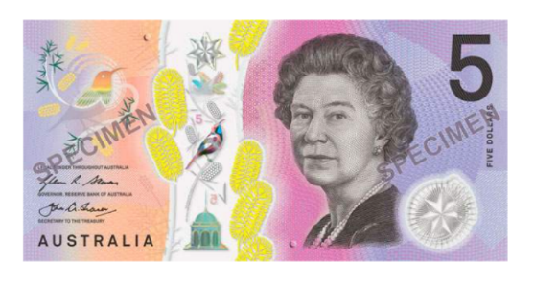
+
+
Point to coins, notes and the dollar symbol.
$3
$4
$5
$6
$2
$7

Teach the items, then ask questions. e.g. What’s number 1? Give colouring instructions. e.g. Colour the pencil blue.
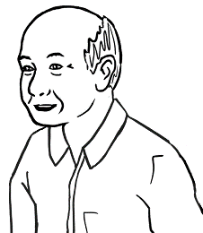
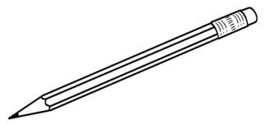

What is number 1?

1. | 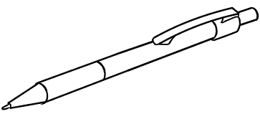  2. | 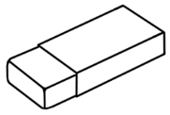  3.
pencil | pen | rubber
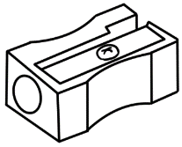  4. |   5. | 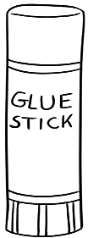  6.
sharpener | notebook | glue
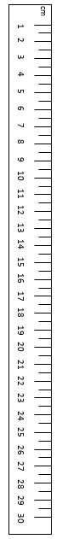  7. | 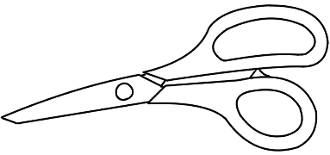  8. | 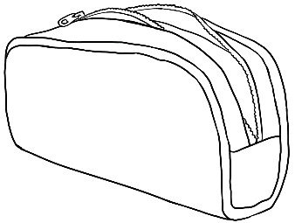  9.
ruler | scissors | pencil case

Point to specific objects and prices; point to the dollar symbol.
Ask questions. e.g. How much is the pen?
How much are the scissors?




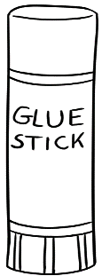
$8
$1
$9
$6
$10
Pen and Pencil
Shop
$5
$7
$4
$2
$3

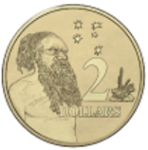
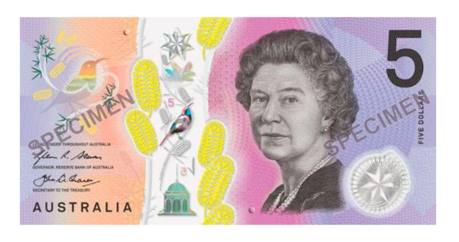
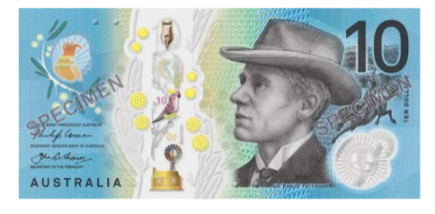
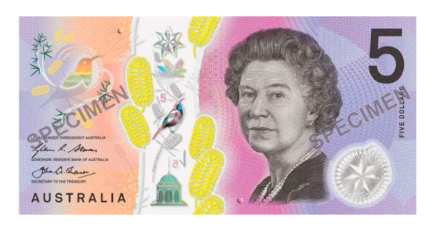

$2
$3
$4
$5
$9
$10

Point to the plus sign.
How many dollars?

1. |   $2  $3 $5
2. | $2  $4 $6
3. |   $3  $5 $8
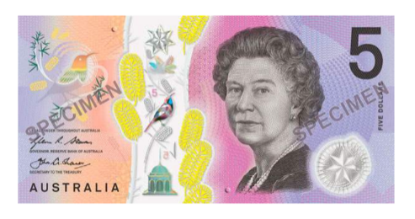
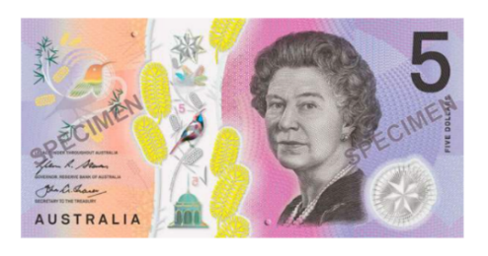
Copy the number of objects.

Do you have a pen?
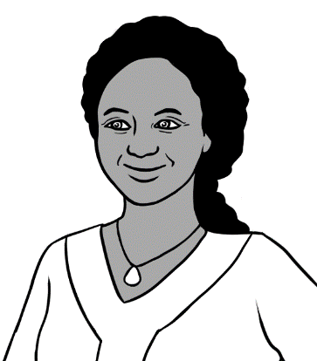

Yes. I have 4 pens.

1
1
2
___
3
___
4
___
5
___

Point to the plus sign.
1. | 2  1  3
2. | 2  2  4
3. | 3  2  5

Numbers 1 - 12
Listen and say the numbers from 1 to 12, 5 to 12,
8 to 12 etc. Point to specific numbers.

1 | 2 | 3 | 4 | 5
6 | 7 | 8 | 9 | 10
11 | 12

Give instructions to circle numbers. e.g. Circle 9.
Count from __ to ___. e.g. Count from 3 to 12.

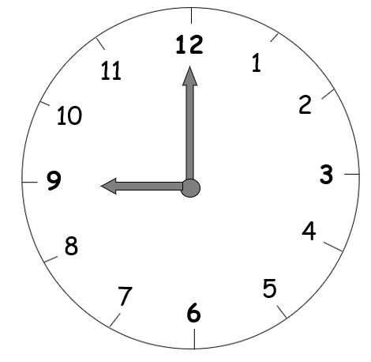

12
6
l
4
5
3
9
l0
ll
8
7
2

Listen, say and point to different numbers. Copy the numbers.

1
2
3
4
5
6

1

7
8
9
10
11
12

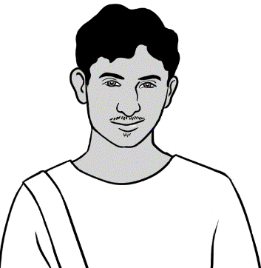
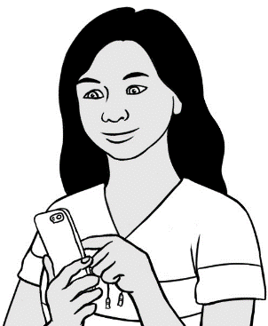
What is the time?
9 o’clock

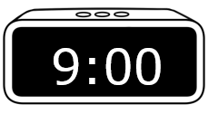
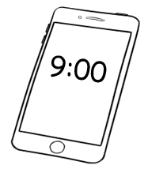
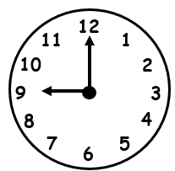

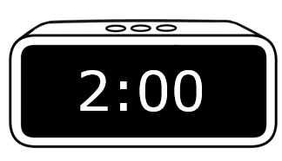
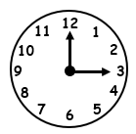
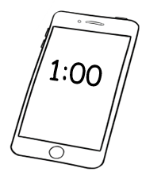

1 o’clock
2 o’clock
3 o’clock

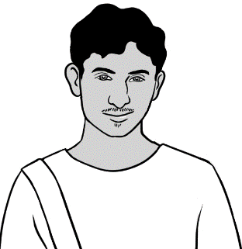
What is the time?

4 o’clock | 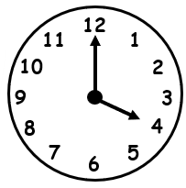
5 o’clock | 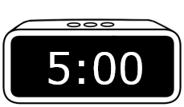
6 o’clock | 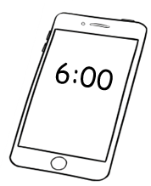
7 o’clock | 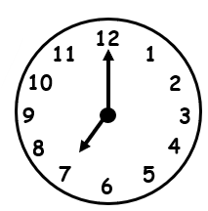
8 o’clock | 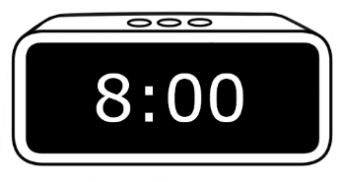
9 o’clock

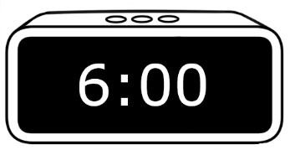

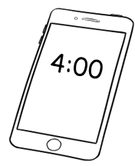

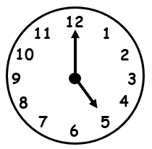

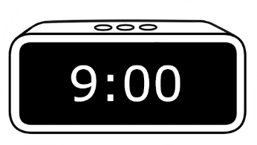

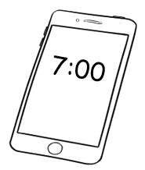

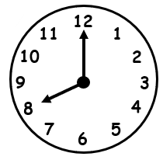

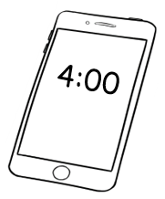
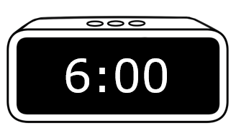

Numbers 1 - 20

Give instructions to colour some boxes.
e.g. Colour box 5.
1 | 2 | 3 | 4 | 5
6 | 7 | 8 | 9 | 10
11 | 12 | 13 | 14 | 15
16 | 17 | 18 | 19 | 20

Say and copy the numbers.

11 12 13 14 15
11
16 17 18 19 20

Give instructions to circle numbers. e.g. Circle 4.

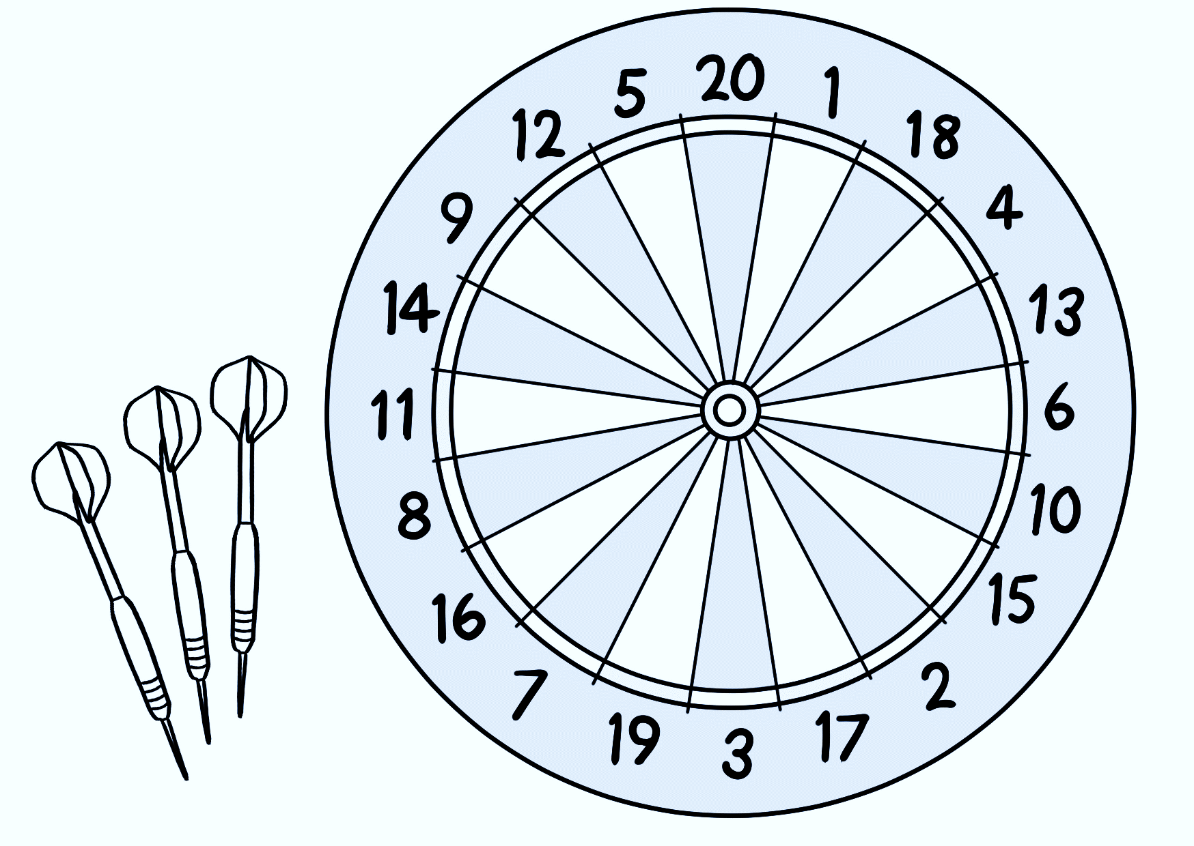

11 | 12 | 13 | 14 | 15
16 | 17 | 18 | 19 | 20

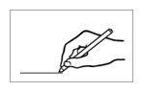
Draw a line joining the numbers 0 – 20. Then say the numbers 0 -20.
0
 |  | 1 |  | 2 |  |  | 9 |  | 6 |  | 7
 | 4
 |  |  |  | 3 |  | 4 |  | 5 |  |  | 8
 | 5 |  | 6 |  |  |  |  |  |  | 9
 |  |  |  |  | 6 |  | 7
 | 12 |  |  |  |  |  |  |  | 10 |  | 5
 |  |  | 14 |  |  | 13
 |  |  |  |  |  |  | 12 |  | 11
 |  | 15 |  |  |  |  |  |  |  |  | 13
 | 16 |  |  | 18 |  | 7 |  |  | 9
 |  |  |  |  |  |  |  |  |  |  | 14
 | 17 |  | 18 |  |  | 17 |  | 6
 |  |  |  |  |  |  |  |  |  |  | 15
 |  | 8 |  | 19 |  |  | 2
 | 5 |  |  |  |  | 20 |  |  |  |  | 16

Copy the numbers.

1 | 2 | 3 | 4 | 5
1
6 | 7 | 8 | 9 | 10
11 | 12 | 13 | 14 | 15
16 | 17 | 18 | 19 | 20

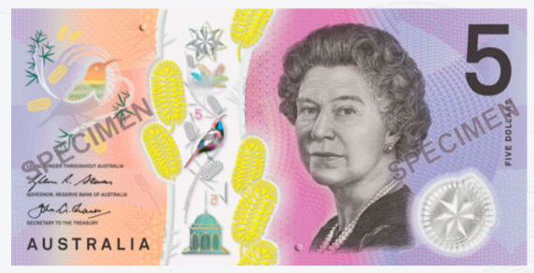

7 Numbers 1 - 30
1 | 2 | 3 | 4 | 5
6 | 7 | 8 | 9 | 10
11 | 12 | 13 | 14 | 15
16 | 17 | 18 | 19 | 20
21 | 22 | 23 | 24 | 25
26 | 27 | 28 | 29 | 30
Give instructions to colour some numbers.
Then count from___ to ___. e.g. from 11 to 20

21 | 22 | 23 | 24 | 25
26 | 27 | 28 | 29 | 30

Draw a line joining the numbers 0 – 30.
Then say the numbers 0 -30.
 |  | 1 |  | 2 |  | 3 |  | 4 |  | 7
 | 4
 |  |  |  | 7 |  | 6 |  | 5 |  |  |  | 8
 | 9 |  | 8 |  |  |  |  |  |  | 9
 |  |  |  |  | 16 |  | 7
 | 10 |  | 11 |  |  |  |  |  | 10 |  |  | 5
 |  |  |  |  | 19
 |  |  | 12 |  |  |  | 16 |  | 17
 | 15 |  |  | 13 |  | 15 |  |  |  | 18
 |  |  |  |  | 14 |  |  |  | 9 |  |  | 19
 | 17
 |  |  | 24 |  | 23 |  | 22 |  | 21 |  |  | 20
 | 25
 |  |  |  | 28 |  | 29 |  | 21 |  |  |  | 27
 | 26 |  | 27 |  |  | 30
0

April
Mon | Tues | Wed | Thurs | Fri | Sat | Sun
 |  | 1 | 2 | 3 | 4 | 5
6 | 7 | 8 | 9 | 10 | 11 | 12
13 | 14 | 15 | 16 | 17 | 18 | 19
20 | 21 | 22 | 23 | 24 | 25 | 26
27 | 28 | 29 | 30
Adapt the calendar to the current month and year. Circle the day before 16. Circle the day after 16.
Count from 5 to 15, 16 to 22 etc
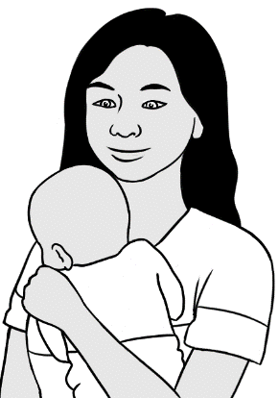
This is my son’s birthday.


before | birthday | after
15 | 16 | 17

Instruct students to point to different numbers.
Then ask, What’s the number after ___?
Repeat many times before asking students to circle
the numbers. Repeat the exercise with numbers before.

May
Mon | Tues | Wed | Thurs | Fri | Sat | Sun
 |  |  |  | 1 | 2 | 3
4 | 5 | 6 | 7 | 8 | 9 | 10
11 | 12 | 13 | 14 | 15 | 16 | 17
18 | 19 | 20 | 21 | 22 | 23 | 24
25 | 26 | 27 | 28 | 29 | 30 | 31

Instruct students to point to, then colour
the man/woman before number 2, after number 4 etc.
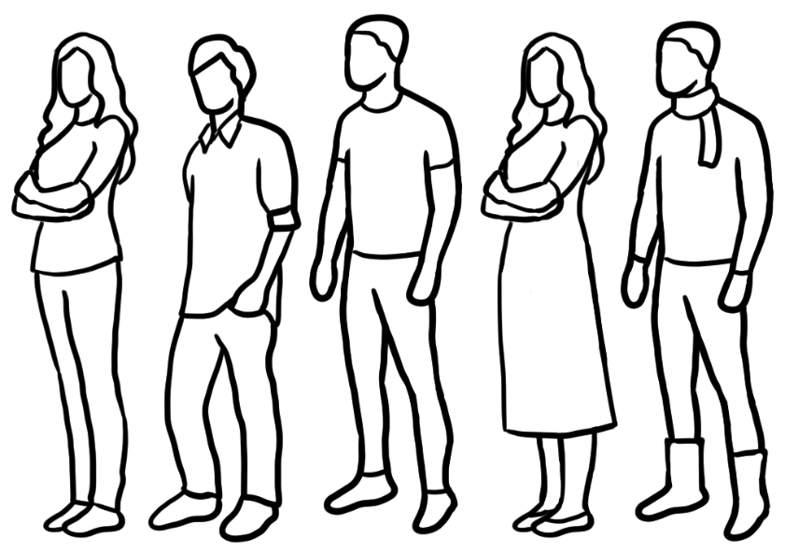

8 Numbers 1 - 50
Read the numbers together. Give instructions
to point to and circle some numbers.
Then count from___ to ___. e.g. from 21 to 35
1 | 2 | 3 | 4 | 5
6 | 7 | 8 | 9 | 10
11 | 12 | 13 | 14 | 15
16 | 17 | 18 | 19 | 20
21 | 22 | 23 | 24 | 25
26 | 27 | 28 | 29 | 30
31 | 32 | 33 | 34 | 35
36 | 37 | 38 | 39 | 40
41 | 42 | 43 | 44 | 45
46 | 47 | 48 | 49 | 50

Say and clap all the teens, then all the tens. Next, read each teen and ten. e.g. 13, 30 etc Once complete, return to p36, read and clap all numbers.
13 | 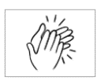 |  | 30
14 |  |  | 40
15 |  |  | 50

13 |  | 30
13
14 |  | 40
15 |  | 50


How many cents?

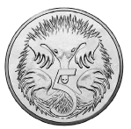 |  | 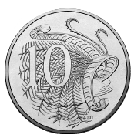
5 cents |  | 10 cents
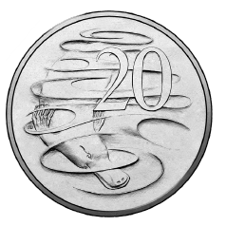 |  | 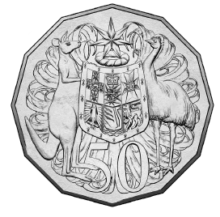
20 cents |  | 50 cents

Copy and say the number of cents.

 |  | 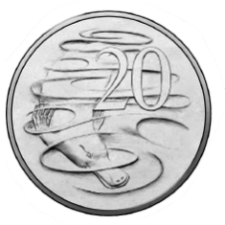 | 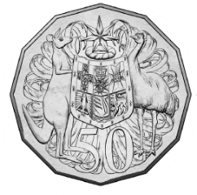
5 | 10 | 20 | 50
5

50 cents
5 cents
10 cents
20 cents

5 | 10 | 20 | 50
5


Point to and note the position
of the dollar sign.
How many dollars?
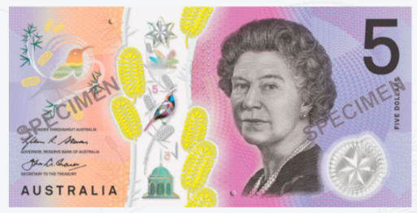  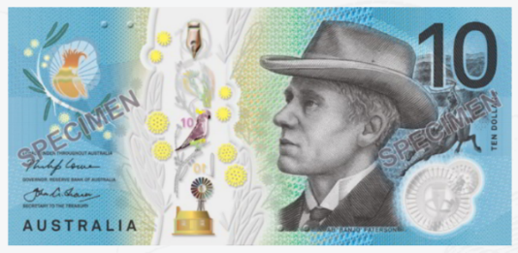  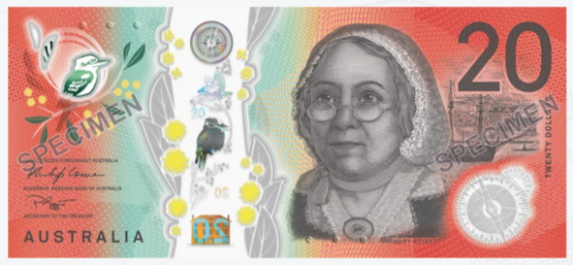  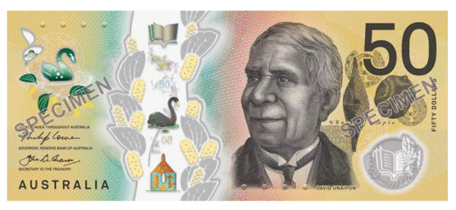 | $1 | one dollar
 | $2 | two dollars
 | $5 | five dollars
 | $10 | ten dollars
 | $20 | twenty dollars
 | $50 | fifty dollars

$1
$___

$2
$___

$5
$___

$10
$____

$20
$____

$50
$____

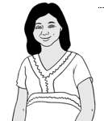
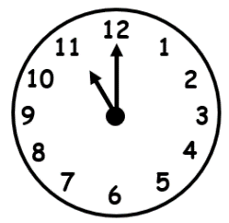


Tea or coffee?
It is break time.

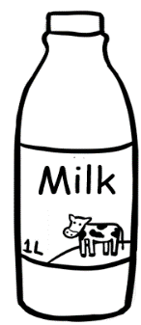
milk

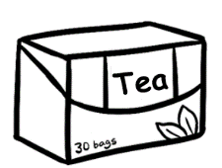
tea
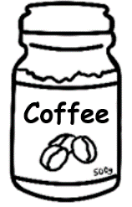

coffee
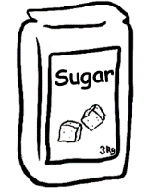
sugar
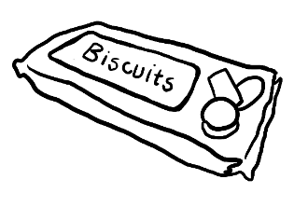
biscuits

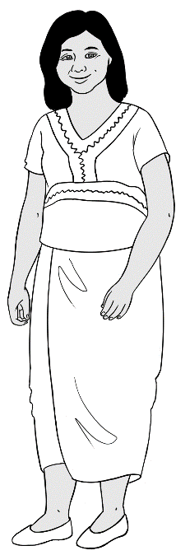
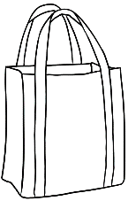
My shopping list
milk
tea
coffee
sugar
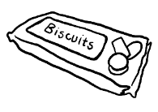
biscuits

Point to different items and prices.
Circle specific prices.



$12
$2
Supermarket
$3
$5
$4

1.
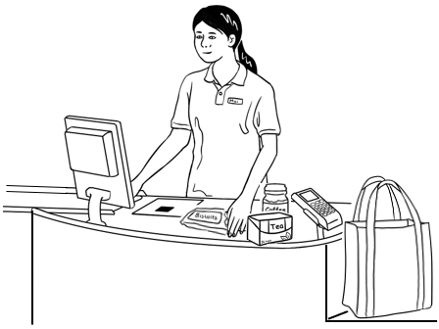
How much is it?
$26

2.


milk $ 2
tea $ 4
coffee $12
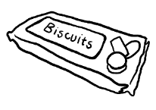
sugar $ 5
biscuits $ 3

TOTAL $26

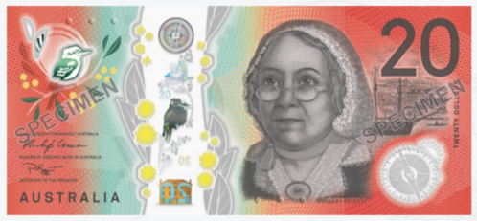
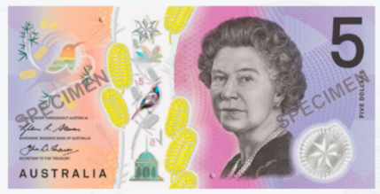
$26
$____

$13
$____
$30
$____
$14
$____
$40
$____
$15
$____
$50
$____
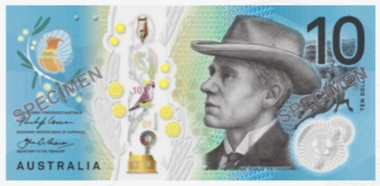
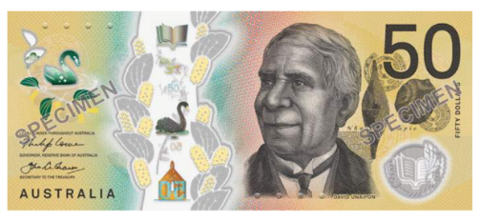

Explain: bill = account Project the page. Instruct students to locate, point to and circle the cost of the bill. See the Teacher resources for extended work on other numbers on the bill. e.g. Zarni’s unit number, the day in June etc
Bills
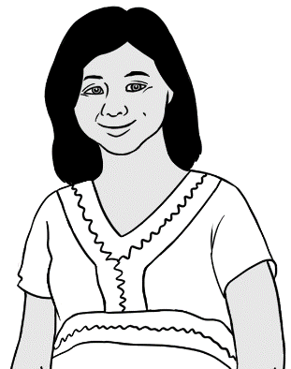

How much is it?

Electricity Account
Customer Number 642-5693

Due Date 15 June 2023
Amount Due $46.00
Mrs Z Tun
4/50 Baker Road
Kellivale
NSW

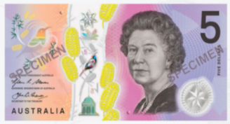
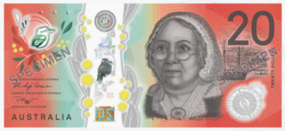

$46.00 | $46.00 | $46.00
$46.00 | $___.00 | ___ 46.___

Project the bill. Ask How much is it? Students locate and circle the cost.

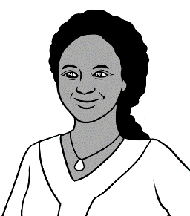
Gas Account
Customer Number 776-3085

Due Date 27 May 2023
Mrs J Desta
56 North Street
Kellivale
NSW
Amount Due $32.00
How much is it?

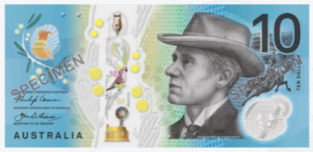
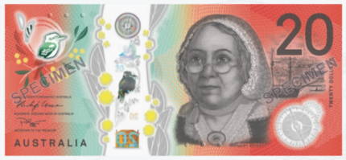

$32.00 | $32.00 | $32.00
$32.00 | $___.00 | ___32. ___

9 My numbers
Phone numbers

Copy Rahim’s number.

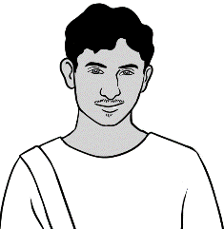
What is your phone number Rahim?
0469 883 412

0 | 4 | 6 | 9 |  | 8 | 8 | 3 |  | 4 | 1 | 2



1
2
3
4
5
6
7
8
9

0
#

Colour the numbers
in Rahim’s phone number.

Listening exercise. Read the phone numbers slowly. The numbers are:
Ming 0418 335 748 Jamila 0408 629 531 Zarni 0407 326 518
The blue lines of numbers are a guide for students.

0 |  | 1 |  | 2 |  | 3 |  | 4 |  | 5 |  | 6 |  | 7 |  | 8 |  | 9
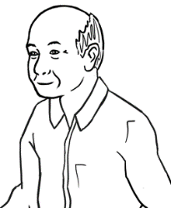
Ming’s phone number

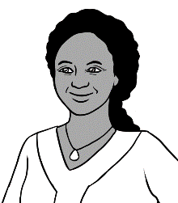
Jamila’s phone number

0 |  | 1 |  | 2 |  | 3 |  | 4 |  | 5 |  | 6 |  | 7 |  | 8 |  | 9

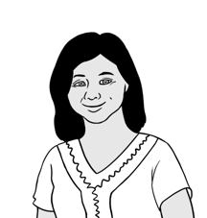

0 |  | 1 |  | 2 |  | 3 |  | 4 |  | 5 |  | 6 |  | 7 |  | 8 |  | 9
Zarni’s phone number

What is your phone number?

My phone number is

Students colour the numbers in their phone number.

1
2
3
4
5
6
7
8
9

0
#

Listening exercise. Read the phone numbers slowly.
For homework students can bring their emergency contact number to class and copy below. The blue lines of numbers are a guide for students.

0 |  | 1 |  | 2 |  | 3 |  | 4 |  | 5 |  | 6 |  | 7 |  | 8 |  | 9

My teacher’s phone number

My school phone number
0 |  | 1 |  | 2 |  | 3 |  | 4 |  | 5 |  | 6 |  | 7 |  | 8 |  | 9

My emergency phone number
0 |  | 1 |  | 2 |  | 3 |  | 4 |  | 5 |  | 6 |  | 7 |  | 8 |  | 9

Address

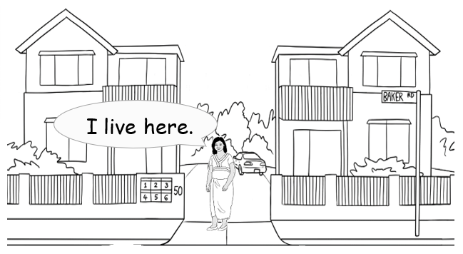

What is your address Zarni?

Unit 4,
50 Baker Road
Kellivale

Circle the unit and street number.
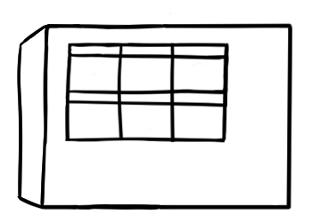
1
2
3
4
5
6
50

Circle the numbers.

Zarni’s address

Number and Street | 4 / 50 Baker Road
Suburb | Kellivale
Postcode | 2421
Copy or paste address from the template in the Teacher Resources.
Circle numbers in the address.

What is your address?

Number and Street
Suburb
Postcode
My address

Date of birth

10 April 1978
What is your date of birth Zarni?

Project the page and practise saying the months and numbers.
Circle the number of Zarni’s birth month.

1 | January |  | 7 | July
2 | February |  | 8 | August
3 | March |  | 9 | September
4 | April |  | 10 | October
5 | May |  | 11 | November
6 | June |  | 12 | December

Copy two ways of writing San’s date of birth.
This is my date of birth.

10 April 1978

10 - 04 - 1978 | 10 / 04 / 1978
____ - 04 - ________ | ____ /____ /________

What is your date of birth?

Copy twice in two ways.

____ - ____ - ________ | ____ / ____ /________
My date of birth

____ - ____ - ________ | ____ / ____ /________

Age
Listening exercise. Before telling students the ages let them try to guess.
Ages: San 22, Zarni 45, Rahim 19, Jamila 50
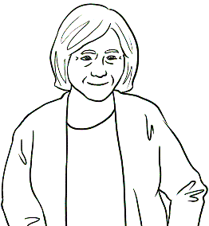
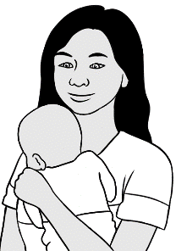
How old is your baby?
4 months old.

22 24
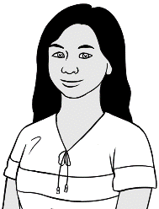
- San is ________ years old.

35 45
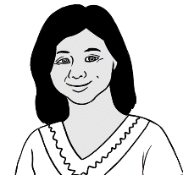
- Zarni is ________ years old.

19 22

- Rahim is ________ years old.

48 50
- Jamila is ________ years old.


ImmiCard

Circle Zarni’s date of birth.

I have an ImmiCard.

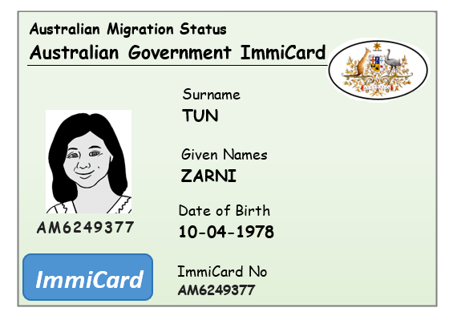

Zarni’s date of birth
10 - 04 - 1978 | 10 / 04 / 1978
____ - 04 - ________ | ____ /____ /________

Medicare Card
Project the card. Point to the medicare number and Zarni’s individual number. Instruct students to circle the numbers.

I have a Medicare card.

medicare

- 26984 1
1 Zarni Tun

VALID to 06/2031

This is my Medicare number.

3 | 0 | 7 | 5 |  | 2 | 6 | 9 | 8 | 4 |  | 1

