
d

English Ready
22636VIC Course in Initial EAL
VU23493 Recognise, copy and use numbers and money from 1 to 50

Numbers

1
2
3

0
#
4
5
6
7
8
9

Teacher Resources

Design team: Vicki Hambling, Sue Paull, Frida Dean, Glenise Kleehammer and Mary Wallace
Illustrations: Madelena Scott

Image acknowledgements:
Australian Currency designs – Permission granted by the Royal Australian Mint, Approval # 9/45/432
Colouring by number #1 & #2 This Photo by Unknown Author is licensed under CC BY-NC-ND
Southern Cross on number plate This Photo by Unknown Author is licensed under CC BY-SA
Tasmanian tiger icon on number plate This Photo by Unknown Author is licensed under CC BY-NC-ND

Acknowledgements: The design team would like to thank the AMEP service providers and practitioners who participated in the trial and gave valuable feedback. The team would also like to acknowledge the use of the EAL Framework which underpins the design of this book.
Copyright of the EAL Framework is reserved to the Crown in the right of the State of Victoria. © State of Victoria (Department of Education and Training) 2023.
This English Ready Resource is licensed under a Creative Commons Attribution-NoDerivs 3.0 Australia licence (More information is available here). You are free to use, copy and distribute to anyone in its original form as long as you attribute Department of Home Affairs as the author and you license any derivative work you make available under the same licence.
© Commonwealth of Australia 2023

With the exception of the Commonwealth Coat of Arms, the department’s logo, any material protected by a trade mark and where otherwise noted all material presented in this document is provided under a Creative Commons Attribution 4.0 International (https://creativecommons.org/licenses/by/4.0/) licence.
The details of the relevant licence conditions are available on the Creative Commons website (accessible using the links provided) as is the full legal code for the CC BY 4.0 licence. (https://creativecommons.org/licenses/by/4.0/legalcode).
Use of all or part of this document must include the following attribution:
© Commonwealth of Australia 2023
As far as practicable, material for which the copyright is owned by a third party will be clearly labelled. The department has made all reasonable efforts to ensure that this material has been reproduced in this document with the full consent of the copyright owners.
Copyright requests and enquiries concerning usage not addressed by the CC BY 4.0 licence should be addressed to: comms@homeaffairs.gov.au at the Department of Home Affairs.
The terms of use for the Commonwealth Coat of Arms are available from the It's an Honour website.
Where a copyright owner, other than the Commonwealth, is identified with respect to this material, please contact that third party copyright owner directly to seek permission.


Introduction to the books

The Teacher Resources
The oral and kinaesthetic activities in this book utilise a variety of senses
to improve memory retention. This is particularly important for students impacted by trauma. The most productive classes are noisy and active. Resources here aim to promote noisy active learning. They include:
- drawings of the characters for use in the design of additional materials
- flashcards for printing
- individual and class activities
- revision and homework exercises
- pronunciation
- extension exercises.
The book is an electronic reference. Print pages as needed.
The Student Workbook
The student book requires teacher direction and is not intended for independent learning. It is also not intended to be the only material used
to teach these units or to be used as an assessment task. It is recommended that students buy and use a notebook for general class work and practice.

The book is available as a Word document so that teachers can:
- localise and update the content
- adjust the material to suit the requirements of particular classes and students
- delete, add and grade materials as required. If you add or deduct pages, be mindful of the layout as the document has been designed
so that particular pages are opposite one another.
NB * A teacher version of the student workbook contains additional guidance for activities and also answers for listening exercises.
* Considering the cost of photocopying, colour has been used sparingly.

Table of contents

1. Instructions 3
2. Meet the students and teachers. 8
3. Trace and copy numbers. 9
4. Numbers 1 - 10 10
5. Numbers 1 - 12 41
6. Numbers 1 - 20 49
7. Numbers 1 - 30 50
8. Numbers 1 - 50 58
9. My numbers 79

Instructions
Activity 1 – Mime and say
Project the instructions images in the student workbook onto the board. Point to different images and ask the class to mime the meaning and say each instruction. Later encourage more confident students to do this individually.

Activity 2 – Word stress
Project the following page and clap the syllables. Put stronger stress on the first syllable in two-syllable instructions.

Activity 3 – Picture Bingo
Use the table of instruction images on page 1 as the Master Sheet to play Picture Bingo.

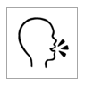
say

read
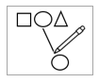
match
 | 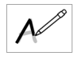  trace | 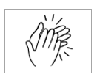
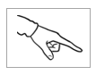
point
 | clap
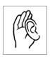
listen

copy
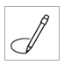
circle

colour
Activity 2 - Word Stress – Project page


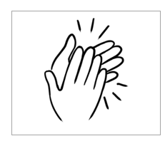
Activity 3 – Picture Bingo - Master sheet

Picture Bingo

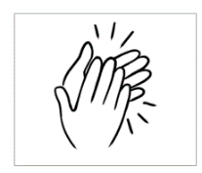

Meet the students and teachers.
Project the page and ask questions. e.g. What number is Zarni?

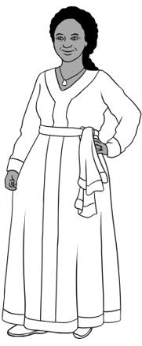
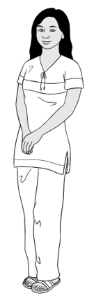
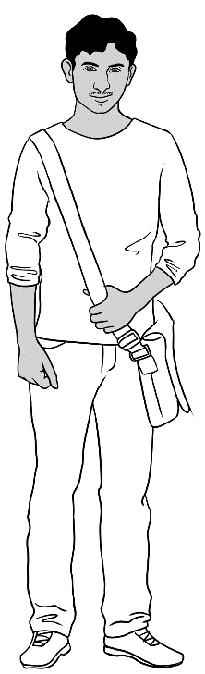
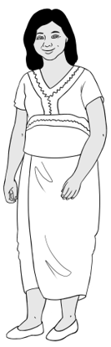
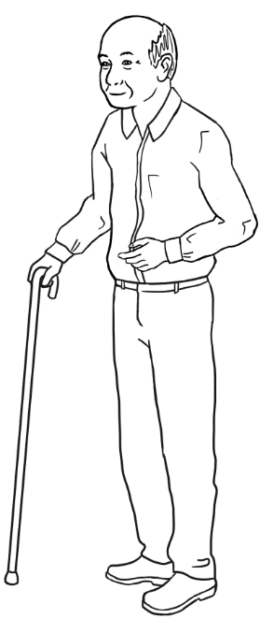
Students
3. Jamila
2. San
4. Rahim
1. Zarni
5. Ming

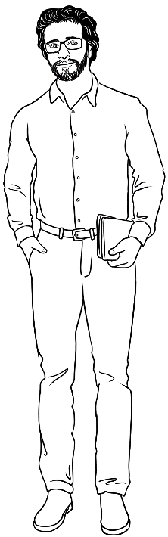
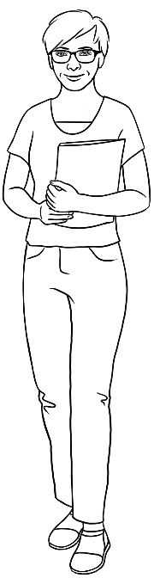
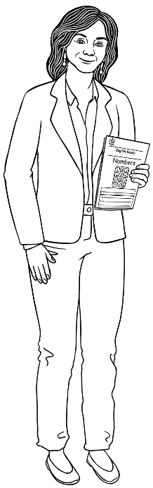
Teachers
6. Rosie
8. Peter
7. Wendy

Trace and copy numbers.

Activity 1 – Write in the air
Write a number on the board so students can write it in the air.

Activity 2 – Write the number on the desk with your finger
Say the numbers while writing them on the desk, palms, knees etc.

Activity 3– Colour and say the numbers
Colour the numbers; say the numbers aloud while colouring.
1 2 3 4 5
6 7 8 9 10
1 2 3 4 5
6 7 8 9 10

Numbers 1 - 10
Activities that support memory retention

A confident understanding of the numbers from zero to ten is essential. The many activities to build confidence in this section could also be adapted and extended to include higher numbers.
- Count in teams or pairs
Students face each other. The first says 1 the second says 2, then 3 and 4 etc, back and forth like a ping pong game.

- Bean bag or ball toss
Divide the class into groups; each group stands in a circle with a bean bag or large ball. They throw the ball from one to another counting as they throw.

- Active counting
Count and tap the desk. Count and clap. Vary the clapping and ask students to first clap their hands, then knees, then hands again as they count.
Clap while walking around the classroom. Repeat again and again.

- Concentration
Make sets of matching number cards 1 - 10. Working in pairs, students spread the cards on their desk in rows. They take turns to turn two cards over to get a match. When a card is turned over, they read the number aloud. Students keep any matched cards and play continues until all cards have been matched.

- Knock down 10 bottles of water (Don’t fill them to the top!)
Each team needs 10 plastic bottles of water and a bean bag. Arrange the bottles as in ten pin bowling and students take turns to knock them down. As the game continues, ask questions. e.g. How many bottles are down?
How many are up?

- Bag of numbers from 1 - 10
Put the numbers 1-10 in a bag or box. Ask a student to pick a number and count to 10 starting from the number picked. Count as a class and later individual students can count. Keep adding numbers to this bag as higher numbers are introduced.

- Counters [Such as plastic bottle tops or buttons]
- Give students 10 counters each. Call out a number and students put that number of counters in a line, counting out loud as they do this.

- Students work in pairs with 55 counters and a set of 1 – 10 flashcards. Students order the flashcards and arrange the corresponding number of counters under each card.

- Flash cards
There are a variety of flashcards on the following pages – numerals, objects, money, and a mixture of these including time and simple addition. The cards can be enlarged and used for whole class activities or pasted onto card, cut out and used for activities and games such as:
- Basic matching or grouping
- Snap
- Concentration

- Domino cards
- Draw a number of objects to match a number
- Cut out domino- style dot cards to place on a grid under the corresponding number.

Number Flashcards

1 | 2
3 | 4
5 | 6
7 | 8
9 | 10



Money Flashcards

$1 | $2
$3 | $4
$5 | $6
$7 | $8
$9 | $10

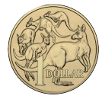 | 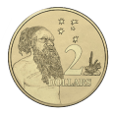
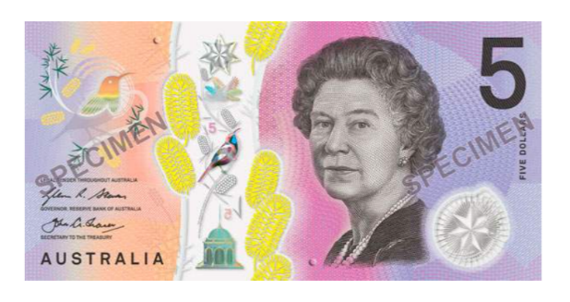 | 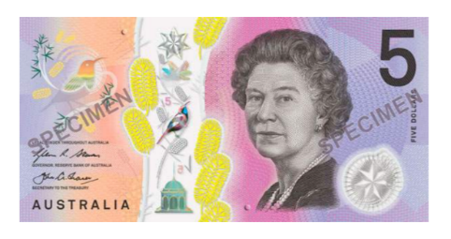
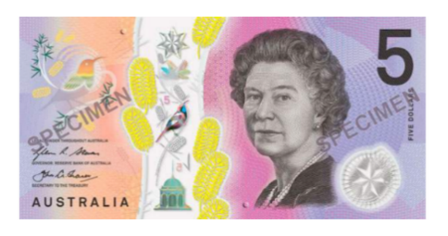 | 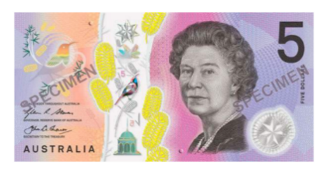
 | 

Flashcards - numbers, objects, money, time and addition
1 |  | 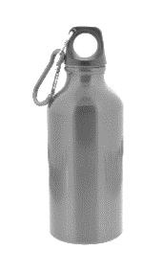
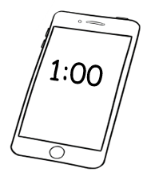 |  | 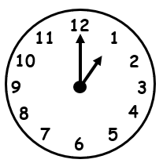

2 | 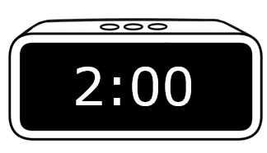 | $2
 | 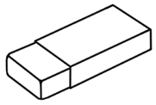

3 | 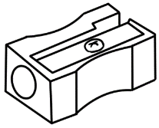
 | 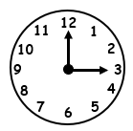 | 2 + 1
4 | 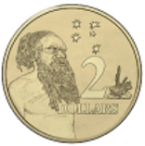 | 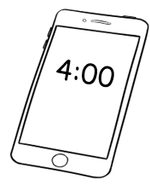
 | 2 + 2

5 | 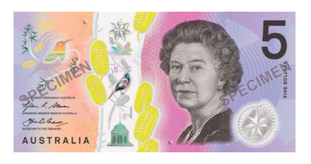 | 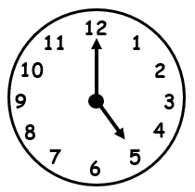
 | 3 + 2

6 |  | 5 + 1
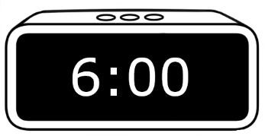 | 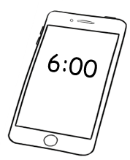 | 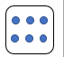

8 |  | 5 + 3
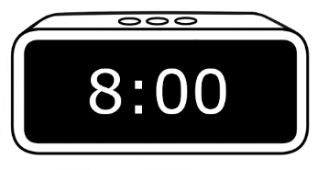 | 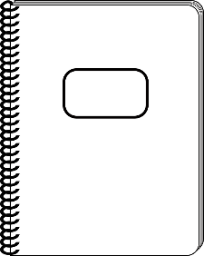  $8 | 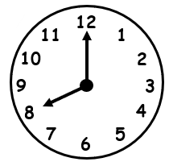
7 |  | 5 + 2
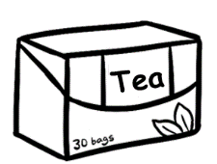  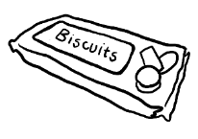  $3 + $4 | 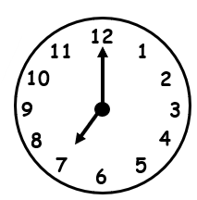

9 | 5 + 4 | 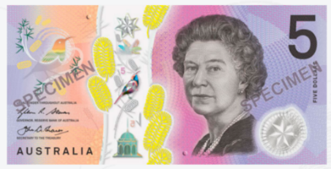
 | 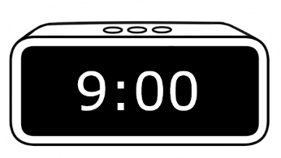 | 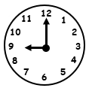
10 | 5 + 5 | 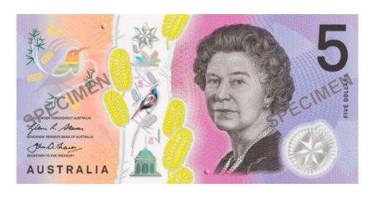
 | 6 + 4 | 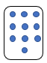

Domino cards – Students draw circles to show the numbers.
l | 2 | 3 | 4 | 5

6 | 7 | 8 | 9 | 10

Domino number cards – Cut out and match.

l | 2 | 3 | 4 | 5
6 | 7 | 8 | 9 | 10

Domino style number cards
Cut out and paste in the correct box on the next page.

1 | 2 | 3 | 4 | 5
6 | 7 | 8 | 9 | 10

Learning numbers with classroom objects

Using classroom objects for counting provides an opportunity for students
to revise both the names of classroom objects and number values.
Some activities:

- Flashcards
- Cut out and match. Students can cut these out.
- Worksheet - The worksheet following the flashcards can be converted into a listening exercise. Cut off the number column on the left, remove the circle and read out any number of objects from 1 to 10. e.g. Circle two sharpeners.

- Memory games
- Game #1 Project the drawing of the desk on page 30. Students count the objects and check with a partner. Minimise/Hide the drawing and ask students - How many apples? How many pencil cases? etc
- Game #2 – Before the game, introduce the vocab – backpack and ball.
- Game #3 - Put numbers of familiar objects on a table. Start simply.
e.g. 1 ruler, 2 pencil cases, 3 rubbers. Give students time to memorise them, cover them and ask - How many rulers? Etc. Repeat the exercise regularly, gradually adding objects.

When students are more confident, and the number of objects is increased, cover the objects and then students can record the number of objects on the recording sheet on page 28.

Classroom objects – matching cards

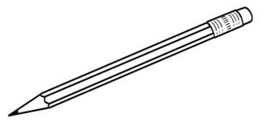 | 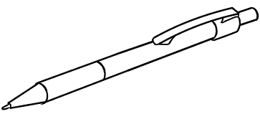
pencil | pen | rubber
 | 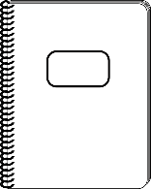 | 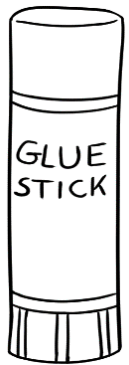
sharpener | notebook | glue

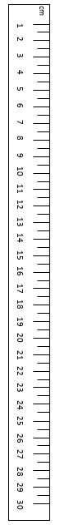 | 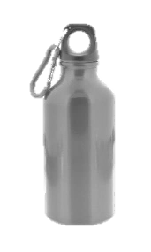 | 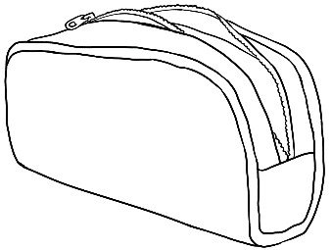
ruler | bottle | pencil case
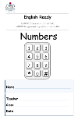 | 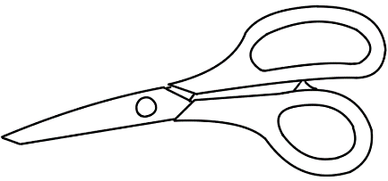 |   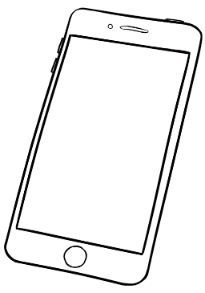
workbook | scissors | phone

Classroom objects worksheet
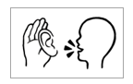

4
7 | 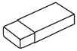
5 | 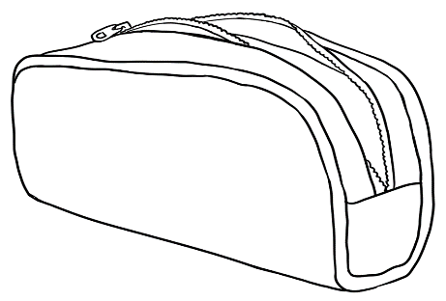
8 | 
2 | 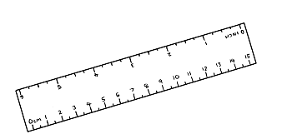
3
10
9 | 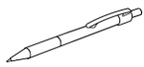
6 | 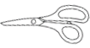
1

Classroom objects memory game #1

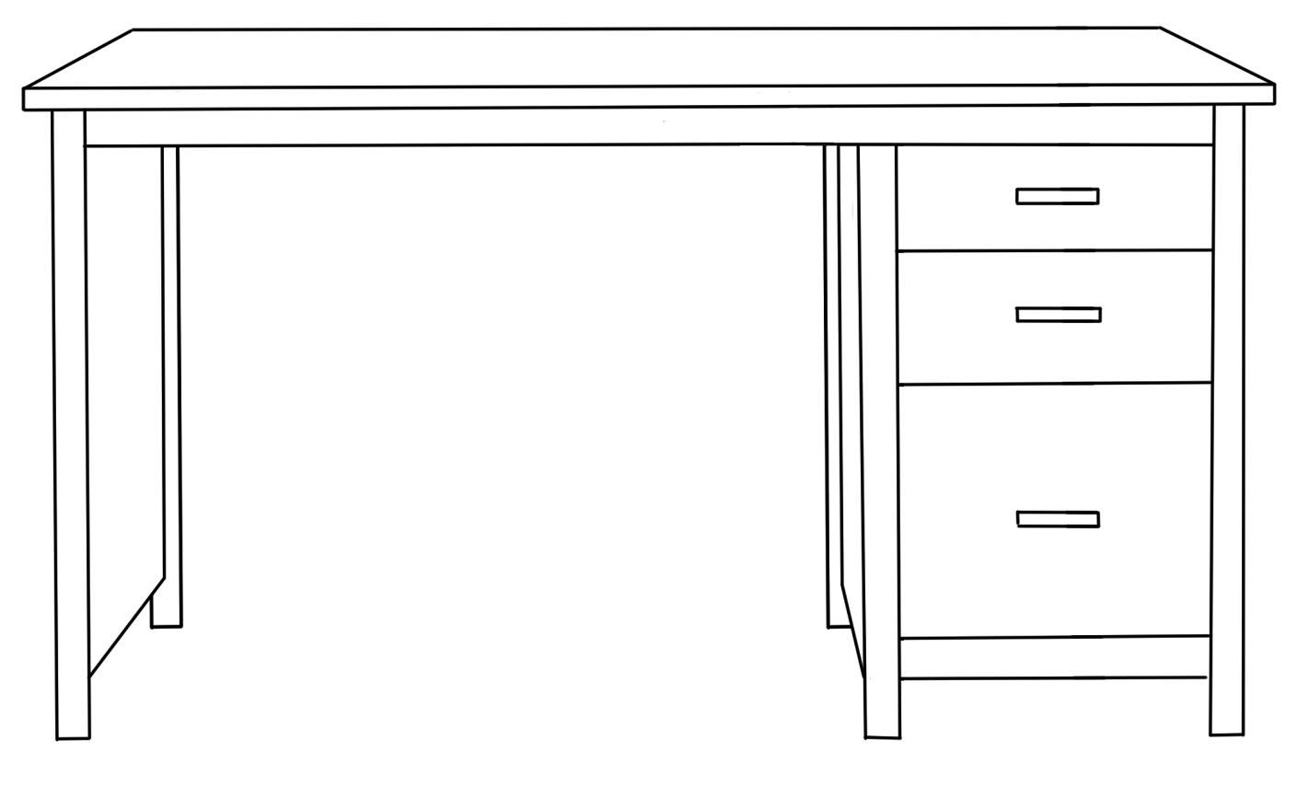
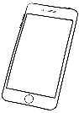
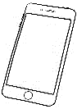

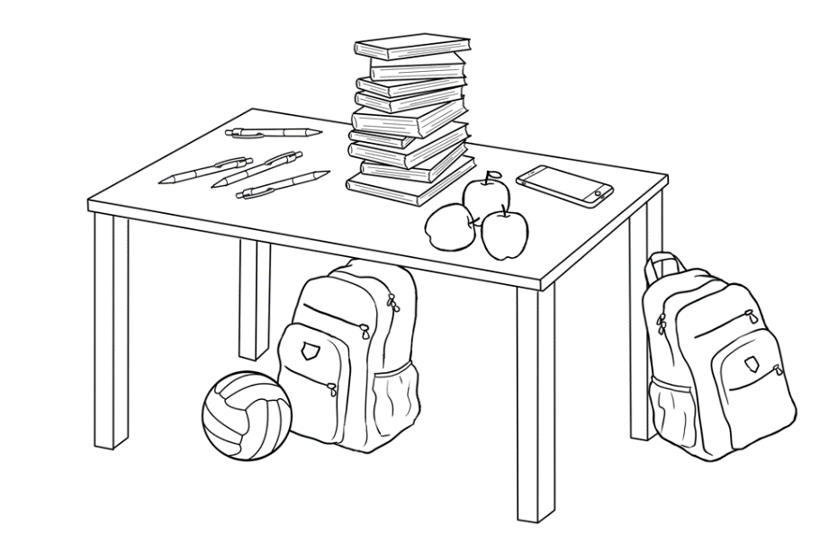
Classroom objects memory game #2

Classroom objects memory game #3 – Recording sheet

1 | 2 | 3 | 4 | 5 | 6 | 7 | 8 | 9 | 10

apples | rubbers  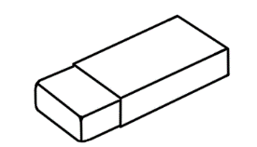 | pencil cases
pencils  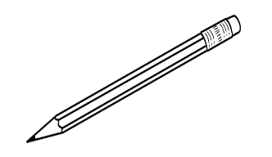 | pens | phones  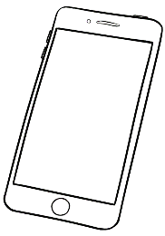
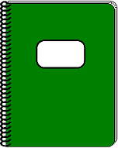  notebooks | workbooks | rulers
sharpeners  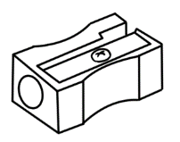 | scissors  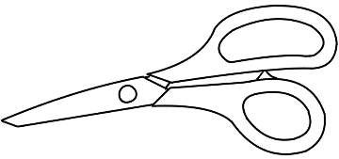 | bottles

Colour by number #1
Colouring is an excellent activity for many students:
- The repetition of the numbers and saying them aloud while colouring strengthens memory retention.
- The use of colour also aids memory.
- It strengthens the fine muscles in the hand needed in writing.
- It is also a relaxing activity for students who may be unused to learning in a classroom and the concentration this environment demands.

The illustration below can be enlarged to make the colouring easier or snipped to make it smaller and less daunting.

Colour by numbers #1

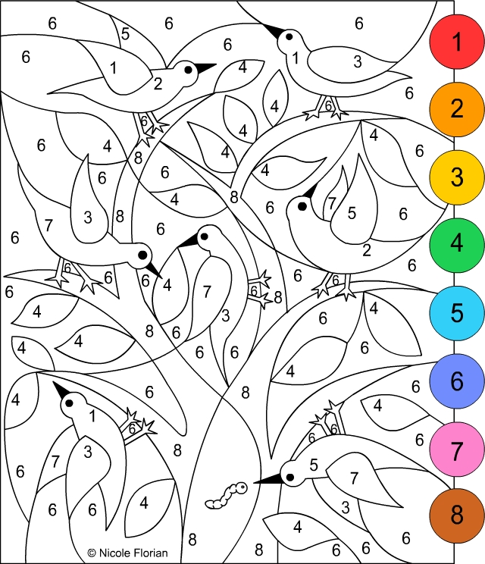

Number position - before and after

- Introduce the vocabulary – before and after in a classroom context. Stand in a line. e.g. Zarni is before Jamila. Jamila is after Zarni.
- Give 10 students a number flashcard. After they have ordered themselves in a line from 1 – 10, they face the class with their numbers visible to the class. Ask questions. e.g. What is the number after 5?
When students are confident with the word after, change the question to include the concept of before. e.g. What is the number before 5?

- To help students learn the names of their classmates, ask questions: Who has the number 5?
Who has the number after 5? The class names the student.

- Repeat oral work until students are familiar with the words.

- Use the worksheet on the following page to consolidate the oral work.
Project the page and complete it together before handing out the worksheet. Students then point to the number before and after the middle number, and say the numbers aloud as they copy.

Worksheet - Project the page and complete together first.

before |  | after
1 | 2 | 3
1
2 | 3 | 4
4 | 5 | 6
6 | 7 | 8
8 | 9 | 10

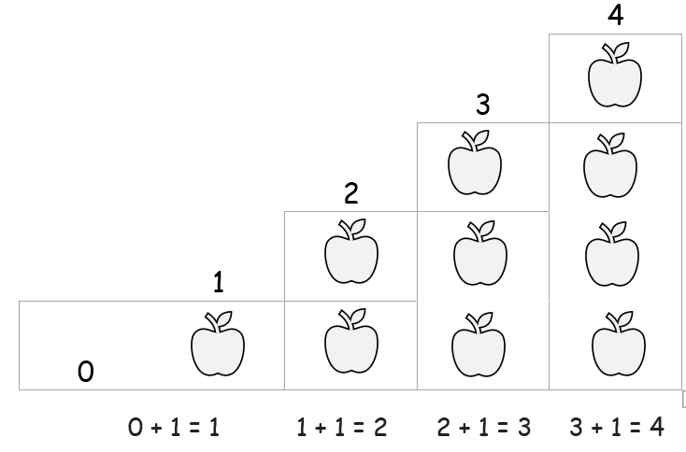

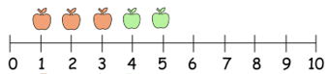

Addition of numbers to 10
Teach students the common combinations that add up to 10. Use counters and objects to demonstrate. Students need to understand that 1 + 2 and 2 + 1 are the same sum with the same answer. Cuisenaire rods are an excellent way to demonstrate this.

- On a grid - Help students understand that counting is a form of adding. Demonstrate this with a grid similar to the one below.

- Number lines
- Give each student a number line similar to the ones on the following page. Enlarge if necessary.
- Use the number line to count forwards and backwards. Students point to the numbers as they count aloud.
- Demonstrate on the whiteboard how to add using the line. e.g. 3 + 2
[Using colour is helpful.]
Zarni has 3 apples.

Jamila has 2 apples.

Ask - How many apples?

- Repeat using different objects and instructing students to use counters
to put on the line and to point to the final number.

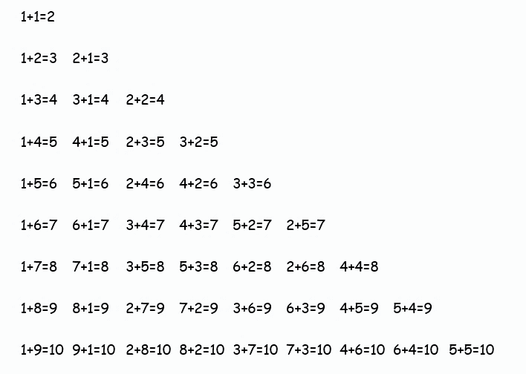
Combinations of numbers to 10 - Teacher reference only

Number lines
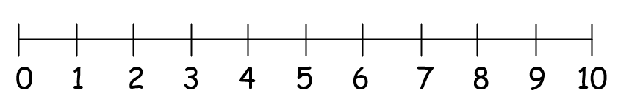

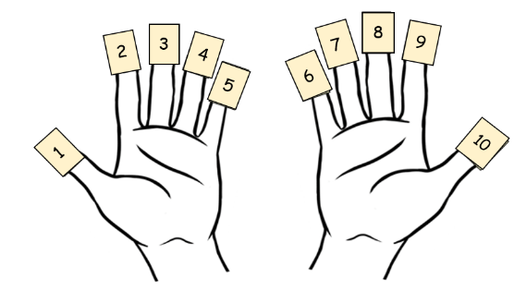

- Bingo addition [There are three levels of cards]
Give the students 10 counters or a number line to assist with addition.
Read the addition of two numbers, without the solution, from the master sheet below. e.g. Two plus one. Repeat each sum and allow time for students to do the calculation and circle the number on their card. Students can use their fingers to count.

Mark each sum to avoid repetition and continue reading the sums until the first student shouts Bingo!
* There are three levels of student cards.

 | Game |  |  |  |  | Game
 | 1 | 2 | 3 |  |  | 1 | 2 | 3
2 + 1 = 3 |  |  |  |  | 3 + 1 = 4
1 + 1 = 2 |  |  |  |  | 4 + 1 = 5
7 + 2 = 9 |  |  |  |  | 4 + 2 = 6
3 + 2 = 5 |  |  |  |  | 4 + 3 = 7
6 + 2 = 8 |  |  |  |  | 5 + 3 = 8
9 + 1 = 10 |  |  |  |  | 6 + 3 = 9
2 + 2 = 4 |  |  |  |  | 1 + 2 = 3
3 + 3 = 6 |  |  |  |  | 2 + 0 = 2
4 + 3 = 7 |  |  |  |  | 5 + 5 = 10

Student Bingo cards - Level 1

2 | 6 |  | 5 | 9
10 | 3 |  | 6 | 2

9 | 3 |  | 10 | 7
4 | 7 |  | 5 | 2

4 | 6 |  | 4 | 9
8 | 5 |  | 10 | 8

4 | 5 |  | 9 | 8
6 | 9 |  | 3 | 10

10 | 6 |  | 4 | 8
7 | 3 |  | 7 | 2

Student Bingo cards - Level 2

2 | 5 |  | 10 | 5
4 | 7 |  | 4 | 3
9 | 8 |  | 6 | 8

5 | 9 |  | 4 | 8
8 | 6 |  | 7 | 5
7 | 10 |  | 6 | 9

2 | 9 |  | 6 | 8
5 | 7 |  | 3 | 9
4 | 6 |  | 4 | 10

6 | 4 |  | 5 | 7
2 | 8 |  | 3 | 4
5 | 9 |  | 8 | 6

Student Bingo cards - Level 3
10 | 6 | 3 |  | 3 | 8 | 6
7 | 2 | 8 |  | 7 | 2 | 9
5 | 9 | 4 |  | 4 | 10 | 5

2 | 5 | 7 |  | 8 | 7 | 6
8 | 3 | 4 |  | 4 | 3 | 10
10 | 6 | 9 |  | 5 | 2 | 9

3 | 8 | 4 |  | 9 | 3 | 8
6 | 10 | 7 |  | 4 | 10 | 5
5 | 9 | 2 |  | 6 | 2 | 7

10 | 5 | 7 |  | 8 | 4 | 7
2 | 6 | 4 |  | 2 | 9 | 3
8 | 3 | 9 |  | 6 | 5 | 10

Numbers 1 - 12
This section was included mainly for the relevance of 12 in measuring time, and for other relics of the imperial system such as the measuring of eggs, bread rolls, dice etc. It also is a gentle increase of numbers after 10.

Activity 1 - Clock face

- Make clock faces for or with every student. [See the following page]
Glue the faces onto paper plates or card and use split pins to attach
the hands. Each hand needs to be a different colour.

- Call out a time and ask students to move the hands to that time, then hold up their clocks to be checked.
- The worksheet on page 43 follows up clock face work.

Activity 2 - Pair work worksheet What’s the time?
- One student points to a clock and asks their partner, What’s the time? Then swap roles.

Activity 3 - Colour by number #2

This is a similar activity to the one in the previous section except here the numbers extend to 12.

Activity 4 - Roll the dice and add [Addition to 12]
- Pair work - two dice, coloured pencils and two grids with numbers 1 to 12.
Students take turns to roll the dice. If they throw a 3 and a 2, they colour in 5. The first to colour every number wins. Number 1 is not relevant and is already coloured.

Activity 5 - Number recognition
Project the pages and complete on the board.

Activity 6 - Egg cartons

This activity helps create visual memory. Collect enough egg cartons so students can work in pairs. Give each pair a small pile of objects. e.g. stones, shells, bottle tops, buttons.
- Instruct students to put a number of items into the carton, one in each egg holder. e.g. three stones.
- Tell them to add two more. Ask, How many? [Answer: 5 stones]
- Add one more and ask, How many? Continue up to 12.

Activity 1 – Clock face

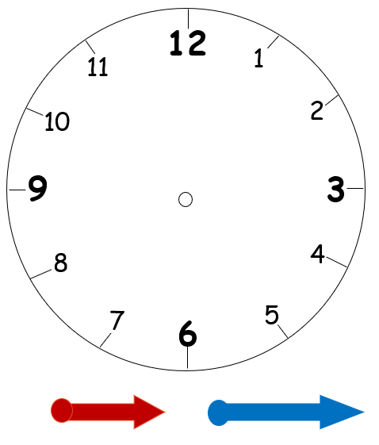


What is the time?

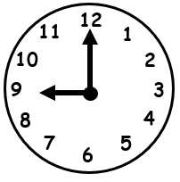 | 8 o’clock  9 o’clock
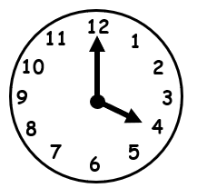 | 4 o’clock  3 o’clock
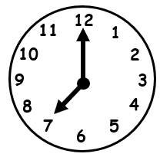 | 2 o’clock  7 o’clock
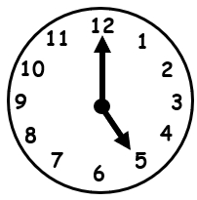 | 5 o’clock  10 o’clock
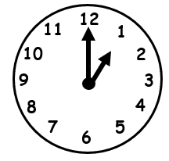 | 2 o’clock  1 o’clock
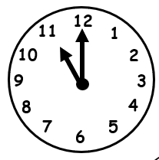 | 12 o’clock  11 o’clock

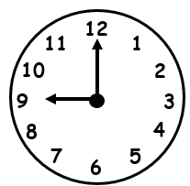 |  | 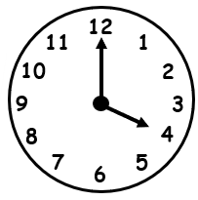
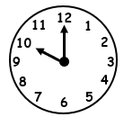 | 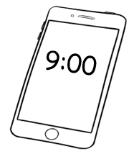  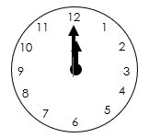 | 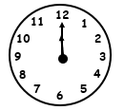
Activity 2 – Pair work What is the time?

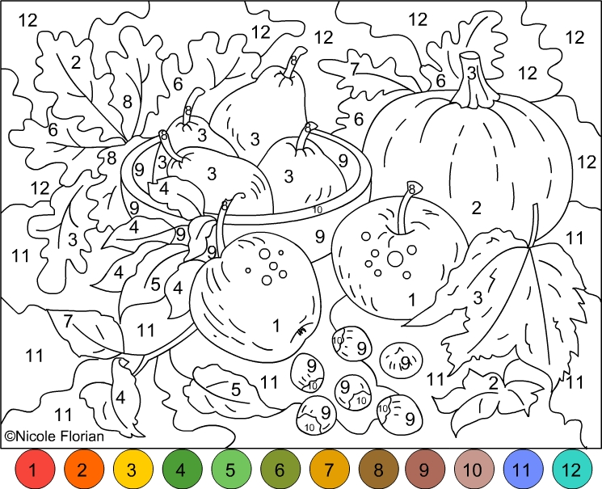
Activity 3 – Colour by number #2

Activity 4 – Roll the dice, add and colour
1 | 2 | 3 | 4 | 5 | 6
7 | 8 | 9 | 10 | 11 | 12

1 | 2 | 3 | 4 | 5 | 6
7 | 8 | 9 | 10 | 11 | 12

1 | 2 | 3 | 4 | 5 | 6
7 | 8 | 9 | 10 | 11 | 12

1 | 2 | 3 | 4 | 5 | 6
7 | 8 | 9 | 10 | 11 | 12

Activity 5 - Number recognition with pictures – #1

4
3 | 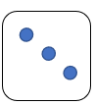 | 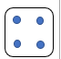
5 |  | 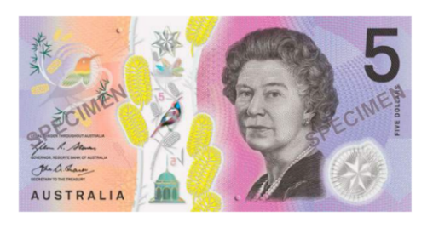
6
8
1

Number recognition with pictures – #2

7
2
10
9
3
5 | 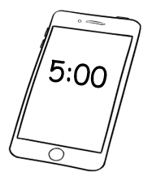

Numbers 1 - 20
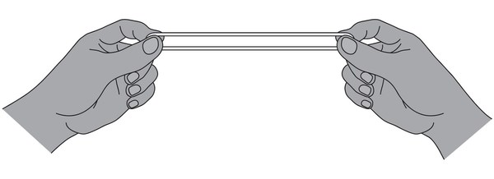
Pronunciation - Stress
Students need to understand that if there is more than one syllable in a word, one of the syllables will be stronger. The use of a large rubber band is an excellent memory technique and enables students to feel the stress. Hold the rubber band between the thumbs and index fingers and stretch it apart on the strong stressed syllable. Make the stressed syllable louder and longer.

Stress patterns in the teens
Before moving onto the 30s and 40s etc, practise with the teens.
- Give each student a rubber band.
- Say the numbers, exaggerating the pronunciation of teen and stretching the rubber band.
- Show the stress using circles over the vowels in each syllable.
Each circle is a syllable and the larger circle shows the stressed syllable.
e.g. thirteen seventeen

Numbers 1 - 30
Activity 1 - Calendar work
- Term calendar for student workbooks – Create a term calendar and insert it in the back of the student book. The month of June template below can be adjusted and the term months customised by adding the dates of the term, public holidays, excursions, special days such as Harmony Day etc. Use symbols such as the ones here to highlight dates. Refer to the calendar frequently to practise days, months, dates.

- Class wall calendar – Enlarge the months of the term and pin them to the wall. Customise the calendar as mentioned above and refer to it daily. Around the calendar could be added - pictures of your centre, the teachers, special event flyers, important information, safety advice etc.
NB. It is easier to teach the idea of the weekend by starting the month with Monday as done below.

June
Mon | Tues | Wed | Thurs | Fri | Sat | Sun
 |  | 1 | 2 | 3 | 4 | 5
6 | 7 | 8 | 9 | 10 | 11 | 12
13 | 14 | 15 | 16 | 17 | 18 | 19
20 | 21 | 22 | 23 | 24 | 25 | 26
27 | 28 | 29 | 30

Master sheets
Activity 3 – Bingo 1 - 30
Read out any number between 1 and 30. Students circle the number if it is on their card. Continue to call out numbers randomly until a student has circled all the numbers on their card, put up their hand and shouted Bingo. Cross out the numbers on the master card as you read them to prevent repetition. Encourage students to repeat the numbers as you call them.
1 | 2 | 3 | 4 | 5 | 6 | 7 | 8 | 9 | 10
11 | 12 | 13 | 14 | 15 | 16 | 17 | 18 | 19 | 20
21 | 22 | 23 | 24 | 25 | 26 | 27 | 28 | 29 | 30

1 | 2 | 3 | 4 | 5 | 6 | 7 | 8 | 9 | 10
11 | 12 | 13 | 14 | 15 | 16 | 17 | 18 | 19 | 20
21 | 22 | 23 | 24 | 25 | 26 | 27 | 28 | 29 | 30

1 | 2 | 3 | 4 | 5 | 6 | 7 | 8 | 9 | 10
11 | 12 | 13 | 14 | 15 | 16 | 17 | 18 | 19 | 20
21 | 22 | 23 | 24 | 25 | 26 | 27 | 28 | 29 | 30

1 | 2 | 3 | 4 | 5 | 6 | 7 | 8 | 9 | 10
11 | 12 | 13 | 14 | 15 | 16 | 17 | 18 | 19 | 20
21 | 22 | 23 | 24 | 25 | 26 | 27 | 28 | 29 | 30

1 | 2 | 3 | 4 | 5 | 6 | 7 | 8 | 9 | 10
11 | 12 | 13 | 14 | 15 | 16 | 17 | 18 | 19 | 20
21 | 22 | 23 | 24 | 25 | 26 | 27 | 28 | 29 | 30

Student sheets
1 | 25 | 9 |  | 2 | 3 | 26
23 | 11 | 17 |  | 27 | 12 | 18
4 | 14 | 21 |  | 13 | 30 | 22

3 | 5 | 23 |  | 4 | 13 | 17
7 | 13 | 26 |  | 12 | 14 | 25
15 | 8 | 23 |  | 3 | 9 | 24

5 | 8 | 2 |  | 6 | 7 | 8
24 | 15 | 18 |  | 4 | 16 | 11
3 | 9 | 25 |  | 14 | 24 | 26

7 | 22 | 9 |  | 8 | 3 | 7
6 | 17 | 14 |  | 19 | 18 | 25
11 | 26 | 27 |  | 15 | 5 | 28

9 | 28 | 21 |  | 10 | 9 | 4
8 | 19 | 6 |  | 6 | 20 | 7
18 | 17 | 29 |  | 14 | 16 | 30

Student sheets
21 | 25 | 9 |  | 28 | 3 | 26
23 | 11 | 17 |  | 17 | 12 | 18
14 | 14 | 29 |  | 13 | 30 | 22

3 | 5 | 23 |  | 4 | 13 | 17
27 | 13 | 26 |  | 12 | 14 | 25
15 | 18 | 23 |  | 30 | 29 | 24

5 | 8 | 21 |  | 30 | 7 | 18
24 | 15 | 18 |  | 4 | 16 | 11
13 | 9 | 25 |  | 14 | 24 | 26

7 | 22 | 19 |  | 8 | 13 | 27
16 | 17 | 14 |  | 19 | 18 | 25
11 | 26 | 27 |  | 15 | 5 | 28

6 | 28 | 21 |  | 10 | 3 | 4
8 | 19 | 4 |  | 6 | 13 | 7
18 | 17 | 29 |  | 14 | 16 | 30

Blank cards - For students to write any numbers between 1 and 30

Activity 4 - Number order
Print the numbers below onto card or paper and cut up for reuse. Give one number card to each student as they arrive. [The numbers must be in order.] At some time in the lesson, ask students to read out their numbers in numerical order. Keep the number 1 aside so you can begin.
Students could form a line, starting with the teacher and with numbers in numerical order. Revise before and after. e.g. What /Who is before number 6? Etc.

1 | 2 | 3 | 4 | 5
6 | 7 | 8 | 9 | 10
11 | 12 | 13 | 14 | 15
16 | 17 | 18 | 19 | 20
21 | 22 | 23 | 24 | 25
26 | 27 | 28 | 29 | 30

Activity 4 – Survey
Count the number of people and objects in the classroom. Before counting, ask students to place all personal items to be counted, on or in front of their tables. Project the chart on the following page and complete the survey in several ways:
- Do it together as a class, counting and recording the people and objects on the projected survey sheet.
- Give each student one of the cards below and let them count the items and record these first on the board and then on the survey sheet. It doesn’t matter if two people are counting the same item; this serves as a check and an opportunity for everyone to check.

  men | 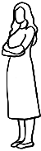  women
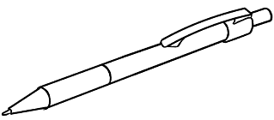  pens | 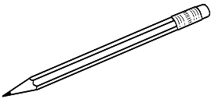  pencils
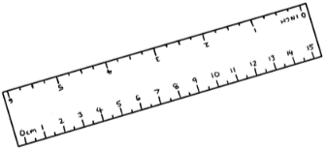  rulers | 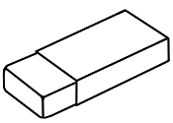  rubbers
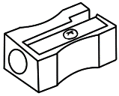  sharpeners | 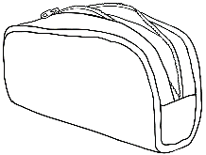  pencil cases
workbooks | 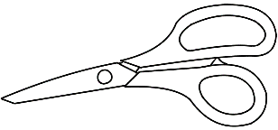  scissors
bottles | 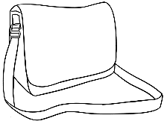  bags

Survey
How many? | Number
men
women
pens
pencils
rulers
rubbers
sharpeners
pencil cases
workbooks
scissors
bottles
bags

Numbers 1 - 50
Activity 1 - Pronunciation – Word stress – thirteen and thirty
- The changing stress pattern between pairs of numbers such as thirteen and thirty need to be practised. Emphasise the stressed syllable by stretching rubber bands as suggested in Section 6, clapping hands or knees, tapping the table, clicking fingers, stamping feet etc. The stressed syllable is said a little louder and longer.

- Show the stress pattern on the board. Write the pairs of numbers with a larger dot above the vowel in the stressed syllable. Students read the numbers aloud, stretching the rubber band, clapping etc on the stressed syllable.

thirteen thirty

fourteen forty

fifteen fifty

Activity 2 – Bingo 1 - 50
Read out any number between 1 and 50. Students circle the number if it is on their card. Continue to call out numbers randomly until a student has circled all the numbers on their card, put up their hand and shouted Bingo. Cross out the numbers on the master card as you read them to prevent repetition. Encourage students to repeat the numbers as you call them.
Master sheets
1 | 2 | 3 | 4 | 5 | 6 | 7 | 8 | 9 | 10
11 | 12 | 13 | 14 | 15 | 16 | 17 | 18 | 19 | 20
21 | 22 | 23 | 24 | 25 | 26 | 27 | 28 | 29 | 30
31 | 32 | 33 | 34 | 35 | 36 | 37 | 38 | 39 | 40
41 | 42 | 43 | 44 | 45 | 46 | 47 | 48 | 49 | 50

1 | 2 | 3 | 4 | 5 | 6 | 7 | 8 | 9 | 10
11 | 12 | 13 | 14 | 15 | 16 | 17 | 18 | 19 | 20
21 | 22 | 23 | 24 | 25 | 26 | 27 | 28 | 29 | 30
31 | 32 | 33 | 34 | 35 | 36 | 37 | 38 | 39 | 40
41 | 42 | 43 | 44 | 45 | 46 | 47 | 48 | 49 | 50

1 | 2 | 3 | 4 | 5 | 6 | 7 | 8 | 9 | 10
11 | 12 | 13 | 14 | 15 | 16 | 17 | 18 | 19 | 20
21 | 22 | 23 | 24 | 25 | 26 | 27 | 28 | 29 | 30
31 | 32 | 33 | 34 | 35 | 36 | 37 | 38 | 39 | 40
41 | 42 | 43 | 44 | 45 | 46 | 47 | 48 | 49 | 50

Student Bingo cards

50 | 15 | 29 |  | 6 | 16 | 26
31 | 24 | 7 |  | 9 | 42 | 18
36 | 30 | 13 |  | 40 | 14 | 11

12 | 22 | 2 |  | 3 | 33 | 13
14 | 44 | 17 |  | 30 | 11 | 21
4 | 40 | 9 |  | 12 | 45 | 19

15 | 7 | 27 |  | 8 | 15 | 29
42 | 13 | 24 |  | 37 | 18 | 5
17 | 50 | 31 |  | 25 | 50 | 14

41 | 7 | 18 |  | 3 | 32 | 16
11 | 14 | 24 |  | 23 | 17 | 27
33 | 48 | 40 |  | 50 | 6 | 15

30 | 7 | 6 |  | 4 | 12 | 22
27 | 13 | 16 |  | 2 | 40 | 14
17 | 31 | 3 |  | 3 | 41 | 43

50 | 15 | 29 |  | 6 | 16 | 26
31 | 24 | 7 |  | 9 | 42 | 18
36 | 30 | 13 |  | 40 | 14 | 11

32 | 22 | 2 |  | 3 | 33 | 23
14 | 43 | 17 |  | 30 | 11 | 21
4 | 40 | 29 |  | 12 | 41 | 19

15 | 9 | 27 |  | 8 | 15 | 26
41 | 13 | 24 |  | 33 | 18 | 5
17 | 50 | 31 |  | 25 | 50 | 14

41 | 7 | 18 |  | 30 | 32 | 16
12 | 14 | 24 |  | 23 | 17 | 27
27 | 48 | 40 |  | 50 | 6 | 15

30 | 9 | 6 |  | 4 | 12 | 23
27 | 13 | 16 |  | 21 | 40 | 14
17 | 31 | 3 |  | 9 | 41 | 43

Blank cards - for students to write any numbers between 1 and 50

Activity 3 - Listening

Say a number and students circle it. There are two levels. In Level 1, the numbers are in order. In Level 2, the numbers are jumbled within their coloured rows. Indicate the colour of the row to give a clue at both levels.

Level 1

1 | 2 | 3 | 4 | 5 | 6 | 7 | 8 | 9 | 10
11 | 12 | 13 | 14 | 15 | 16 | 17 | 18 | 19 | 20
21 | 22 | 23 | 24 | 25 | 26 | 27 | 28 | 29 | 30
31 | 32 | 33 | 34 | 35 | 36 | 37 | 38 | 39 | 40
41 | 42 | 43 | 44 | 45 | 46 | 47 | 48 | 49 | 50

Level 2

1 | 2 | 7 | 3 | 8 | 6 | 9 | 4 | 5 | 10
11 | 15 | 16 | 19 | 12 | 13 | 17 | 14 | 18 | 20
21 | 27 | 25 | 29 | 28 | 22 | 23 | 26 | 24 | 30
31 | 32 | 36 | 34 | 39 | 35 | 33 | 38 | 37 | 40
41 | 45 | 48 | 46 | 42 | 43 | 44 | 47 | 49 | 50

Activity 4 – Listening – Before and After

- Say a number and students circle the number that comes after.
- Say a number and students circle the number that comes before.

This activity could be adapted for any number groupings. e.g 1 – 20, 1 – 30

After |  |  |  |  |  |  |  |  | 0
1 | 2 | 3 | 4 | 5 | 6 | 7 | 8 | 9 | 10
11 | 12 | 13 | 14 | 15 | 16 | 17 | 18 | 19 | 20
21 | 22 | 23 | 24 | 25 | 26 | 27 | 28 | 29 | 30
31 | 32 | 33 | 34 | 35 | 36 | 37 | 38 | 39 | 40
41 | 42 | 43 | 44 | 45 | 46 | 47 | 48 | 49 | 50

Before |  |  |  |  |  |  |  |  | 0
1 | 2 | 3 | 4 | 5 | 6 | 7 | 8 | 9 | 10
11 | 12 | 13 | 14 | 15 | 16 | 17 | 18 | 19 | 20
21 | 22 | 23 | 24 | 25 | 26 | 27 | 28 | 29 | 30
31 | 32 | 33 | 34 | 35 | 36 | 37 | 38 | 39 | 40
41 | 42 | 43 | 44 | 45 | 46 | 47 | 48 | 49 | 50

Activity 5 – Counting

Incorporate counting into class activities. e.g.
- Excursions - Walking somewhere with students? Get the students to count out aloud as they walk. Count houses, cars, poles, stairs, etc
- Morning Coffee - Count the students in class today. How many cups? Add one for the teacher.
- Count steps - How many steps to the door? To the white board? To the back of the room? To the library? etc.

Activity 6 – Listening
- Split the class into pairs. One student is red, the other blue.
Give each pair the large number chart on the following page.
Call red and say a number. The red student circles the number on the chart. Call blue and say a number. The blue student circles the number on the chart. Each time, all students repeat the number aloud.
- Before or After - Call a number and nominate a colour [red or blue].
The nominated student circles the number that comes before or after.

Activity 7 – Number Card Slap [A game in small groups]
- Make cards for numbers zero to fifty. [See following pages]
- Students spread out the cards with the number side up.
- The teacher calls out a number and the first student to say and slap
the appropriate card keeps it. At the end of the game, the winner is
the student with the most cards.
- Simplify the game by writing the number on the whiteboard as it is called.

Variation – Use two fly swats and project the grid on the following page.
Two students stand at the board/screen with the fly swats. A number is called and the first student to hit the number with the swat is the winner.

1 | 2 | 3 | 4 | 5 | 6 | 7 | 8 | 9 | 10
11 | 12 | 13 | 14 | 15 | 16 | 17 | 18 | 19 | 20
21 | 22 | 23 | 24 | 25 | 26 | 27 | 28 | 29 | 30
31 | 32 | 33 | 34 | 35 | 36 | 37 | 38 | 39 | 40
41 | 42 | 43 | 44 | 45 | 46 | 47 | 48 | 49 | 50
Activity 6 - Number Chart

Activity 7 – Number Card Slap

1 | 2
3 | 4
5 | 6
7 | 8
9 | 10
11 | 12
13 | 14
15 | 16
17 | 18
19 | 20
21 | 22
23 | 24
25 | 26
27 | 28
29 | 30
31 | 32
33 | 34
35 | 36
37 | 38
39 | 40
41 | 42
43 | 44
45 | 46
47 | 48
49 | 50

Activity 8 - Number Board Games

The purpose of board game activities is to provide an opportunity to practice recognizing and saying the numbers. Group work develops confidence by allowing students to work independently of the teacher. It is enjoyable, develops friendships and enhances class cohesion.

Equipment – the board game, dice and a token for each player.

Game variations – Players roll the dice, land on a number and:

- say the number.
- say the number after it.
- say the number before it.
- say and circle the same number on a 1 – 50 number grid in front of them.
- say and match the same number to a set of cut up number cards.

NB. Blank versions of the board games are included for the creation of other games.

Activity 8 – Number Board Game #1
Start
1 |  | 15 | 16 | 17 |  | Finish
2 |  | 14 |  | 18 |  | 30
3 |  | 13 |  | 19 |  | 29
4 |  | 12 |  | 20 |  | 28
5 |  | 11 |  | 21 |  | 27
6 |  | 10 |  | 22 |  | 26
7 | 8 | 9 |  | 23 | 24 | 25

Activity 8 – Number Board Game #2

Start |  | 1 | 2 | 3 | 4 | 5 | 6 | 7 | 8
 |  |  |  |  |  |  |  |  | 9
31 | 32 | 33 | 34 | 35 | 36 | 37 | 38 |  | 10
30 |  |  |  |  |  |  | 39 |  | 11
29 |  | 49 | 50 | Finish |  |  | 40 |  | 12
28 |  | 48 |  |  |  |  | 41 |  | 13
27 |  | 47 | 46 | 45 | 44 | 43 | 42 |  | 14
26 |  |  |  |  |  |  |  |  | 15
25 | 24 | 23 | 22 | 21 | 20 | 19 | 18 | 17 | 16

Start
Finish

Start
Finish

My numbers
Activity 1 - Address
Add the address of each student in the template below and on the following page. These can be copied or pasted into the student workbook on page 50. The space on the template for the student’s name is for identification purposes only, and can be cut off before students copy or paste the address.
The slips could also be printed and used for additional practice in writing addresses.

Student Name
Number and Street
Suburb
Postcode



Student Name
Number and Street
Suburb
Postcode

Student Name
Number and Street
Suburb
Postcode

Student Name
Number and Street
Suburb
Postcode

Student Name
Number and Street
Suburb
Postcode

Activity 2 – My numbers

- This activity and worksheet gives students an opportunity to practise saying and writing relevant personal numbers. Students look at their personal ID cards and circle the numbers on the worksheet, then copy their number below.

- Students can cut up their phone number, store in an envelope and practise putting it together in the correct order.

Activity 3 – Car registration number plates
Number plates are useful for learning both letters and numbers. The worksheet on the following page uses Zarni as an example. She has a driver’s licence [see second last page of this book] and a car.
- Project the number plates worksheet first and do the exercise together. Say and repeat the number plates. Show the pattern –three capital letters, two numbers, a capital letter. Read with a break in the middle. On the worksheet, write the numbers and the letters below each number plate. [This is a common pattern on registration plates in New South Wales. Examples of plates from other states have been included in an adaptable format.]
*Draw attention to the similarity between the capital letter O and the number zero, the capital letter I and the number one.

- Follow up – go for a walk around a nearby carpark and read some number plates.

Activity 4 – Bills

The three-page worksheet extends the work on bills in the student book.
Explain that bills = accounts. Project the page and instruct students to locate and point to key numbers on the worksheet. e.g. Zarni’s unit number, date in June etc. Project and discuss the second page.

Activity 5 – Licence, Medicare cards and Healthcare cards

Three new cards are available for additional work if required. These can be projected and attention drawn to key numbers on each card. The expiry date on the Health Care card is very important. Dates can be changed as needed. The Medicare card and licence can be printed and used as worksheets.

Activity 2 - Students can use their cards to assist them.
My numbers

.
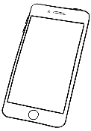

- My phone number
0 | 1 | 2 | 3 | 4 | 5 | 6 | 7 | 8 | 9

- My student number

0 | 1 | 2 | 3 | 4 | 5 | 6 | 7 | 8 | 9

medicare
- My Medicare number
0 | 1 | 2 | 3 | 4 | 5 | 6 | 7 | 8 | 9

Activity 3 – Number plates
Number plates

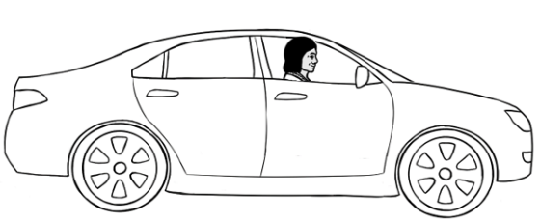
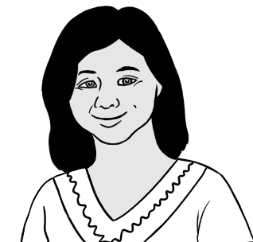
I have a car.


This is my
number plate.

- DAB 56W |   - __________ _________
  - __________ _________ |   - __________ _________
  - __________ _________ |   - __________ _________

Other state car registration plates
Victoria

9OP 8VX
Queensland
9OP 8VX
Tasmania

A 23 ZN 28V
South Australia
PTR 287

Western Australia
5PTR 732 287
Northern Territory
CC 62 ML 287
Australian Capital Territory
YGC 41H

Activity 4 – Bills

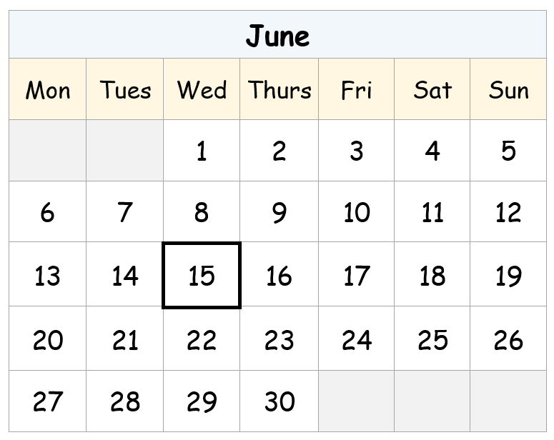

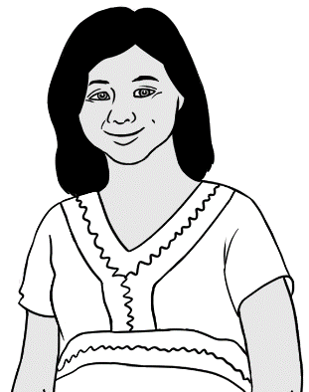
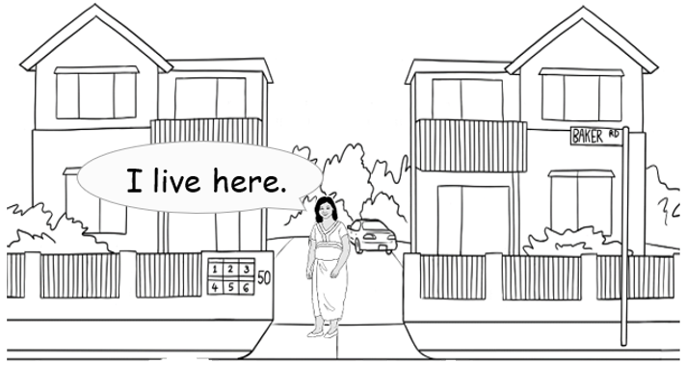
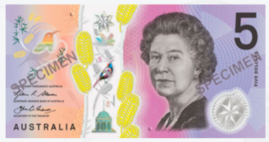

Electricity Account
Customer Number 642-5693

Due Date 15 June 2023
Amount Due $46.00
Mrs Z Tun
4/50 Baker Road
Kellivale
NSW

What? | 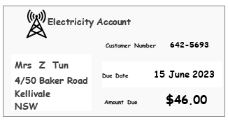  Electricity  Account
Who? | Mrs Zarni Tun
Where? | 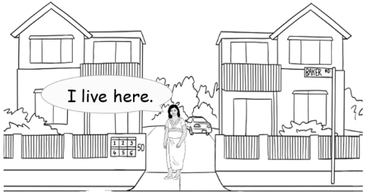  4 / 50 Baker Road Kellivale
When? | 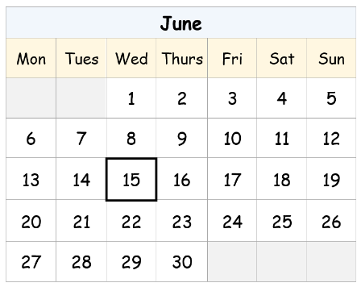  15 June 2023
How much? | 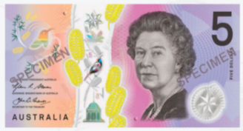  $46.00

Medicare Card

.


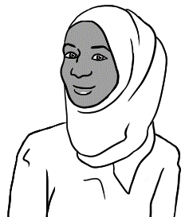
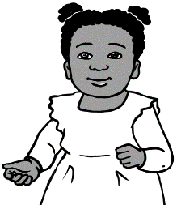
1. Tahiil
2.Sahra
3.Hani

medicare

3056 30687 3
- Tahiil J Dihoud
- Sahra O Elmi
- Hani T Jama
VALID to 06/2031

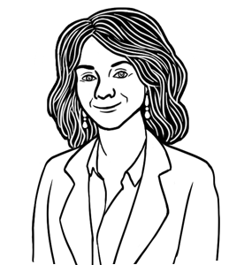

What is Tahiil’s Medicare number?

3 | 0 | 5 | 6 |  | 3 | 0 | 6 | 8 | 7 |  | 3

Driver’s licence

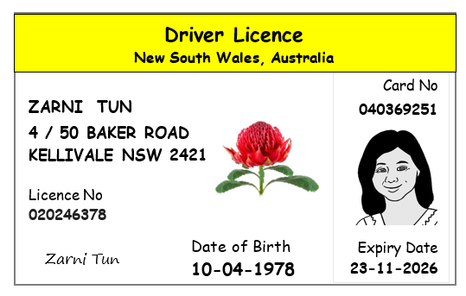
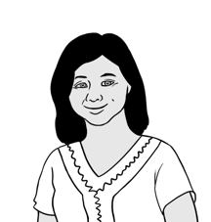
I have a driver’s licence.

Zarni’s date of birth
10 - 04 - 1978 | 10 / 04 / 1978
____ - 04 - ________ | ____ /____ /________

Healthcare Card

