

English Ready
22636VIC Course in Initial EAL
VU23492 Participate in extremely familiar spoken exchanges

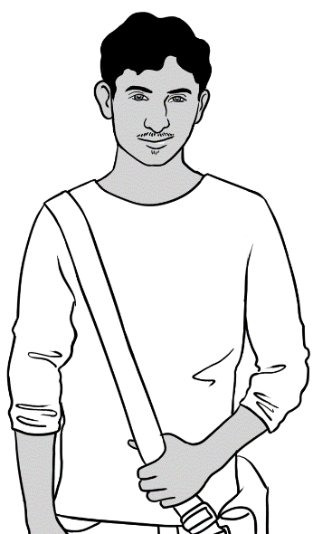
Hi.
Speaking

Name __________________________________________________
Class __________________________________________________
Teacher _____________________________________________
Date_________________________________________________________________

Design team: Vicki Hambling, Sue Paull, Frida Dean, Glenise Kleehammer and Mary Wallace
This workbook is designed to be used with the support of a teacher.
Illustrations: Madelena Scott
Acknowledgements: The design team would like to thank the AMEP service providers and practitioners who participated in the trial and gave valuable feedback. The team would also like to acknowledge the use of the EAL Framework which underpins the design of this book.

Copyright of the EAL Framework is reserved to the Crown in the right of the State of Victoria. © State of Victoria (Department of Education and Training) 2023.
This English Ready Resource is licensed under a Creative Commons Attribution-NoDerivs 3.0 Australia licence (More information is available here). You are free to use, copy and distribute to anyone in its original form as long as you attribute Department of Home Affairs as the author and you license any derivative work you make available under the same licence.
© Commonwealth of Australia 2023

With the exception of the Commonwealth Coat of Arms, the department’s logo, any material protected by a trade mark and where otherwise noted all material presented in this document is provided under a Creative Commons Attribution 4.0 International (https://creativecommons.org/licenses/by/4.0/) licence.
The details of the relevant licence conditions are available on the Creative Commons website (accessible using the links provided) as is the full legal code for the CC BY 4.0 licence. (https://creativecommons.org/licenses/by/4.0/legalcode).
Use of all or part of this document must include the following attribution:
© Commonwealth of Australia 2023
As far as practicable, material for which the copyright is owned by a third party will be clearly labelled. The department has made all reasonable efforts to ensure that this material has been reproduced in this document with the full consent of the copyright owners.
Copyright requests and enquiries concerning usage not addressed by the CC BY 4.0 licence should be addressed to: comms@homeaffairs.gov.au at the Department of Home Affairs.
The terms of use for the Commonwealth Coat of Arms are available from the It's an Honour website.
Where a copyright owner, other than the Commonwealth, is identified with respect to this material, please contact that third party copyright owner directly to seek permission.



Table of contents

1 Instructions 1
2 Meet the people. 2
3 Do you understand? 4
4 Name and address 5
5 English class 9
6 The classroom 14
7 Family 19
8 Neighbours 24
9 I like cooking. 29
10 Tea or coffee? 35

Instructions
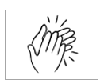
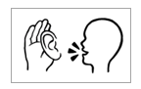

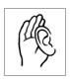  1.  listen | 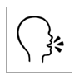  2.  say
  3.  4  copy | 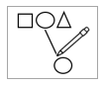  4.  match
  5.  colour |   6.  circle
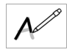  7.  trace | 8.  tick
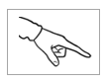  9.  point | 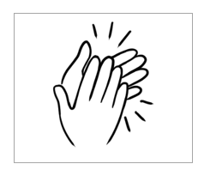  10.  clap

Meet the people.
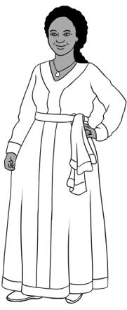
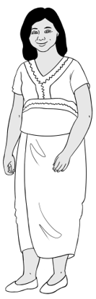
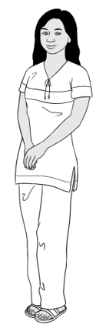
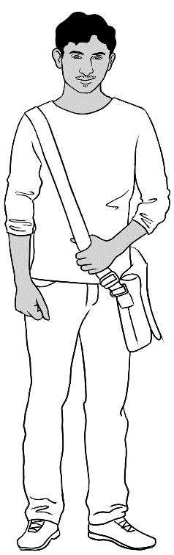

Jamila
1.
Zarni
San
Rahim
Students

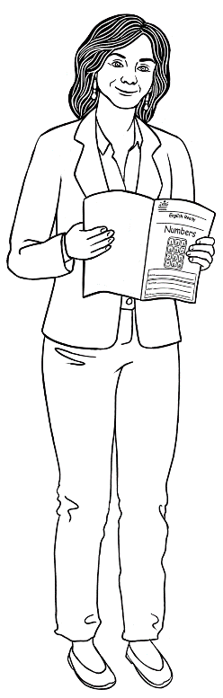

2.
Teacher
Rosie

Receptionist
3.
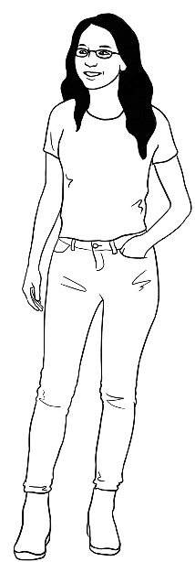

Kim

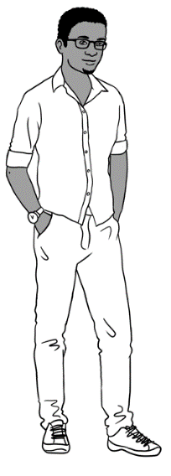
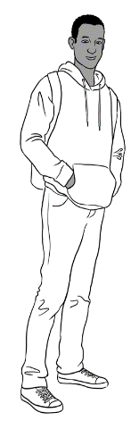
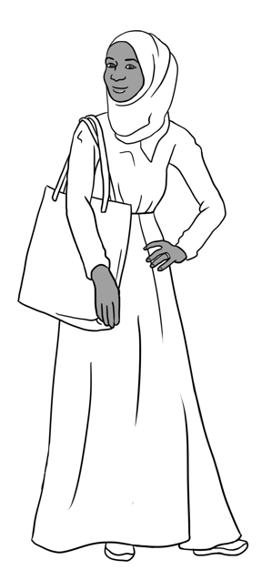
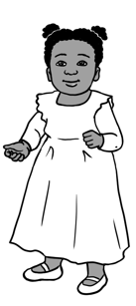

Sahra
Hani
Tahiil
Abdi
4.
Neighbourss


5.
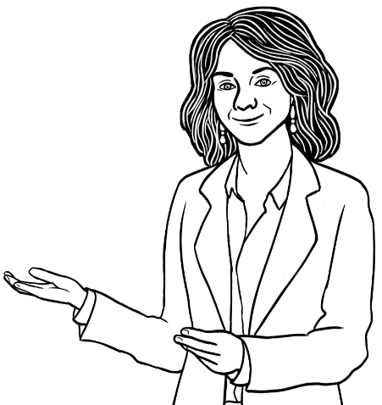
You

____________________

Do you understand?

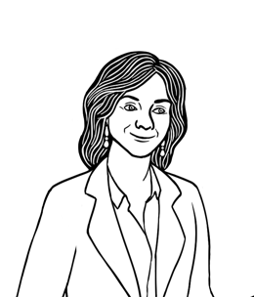
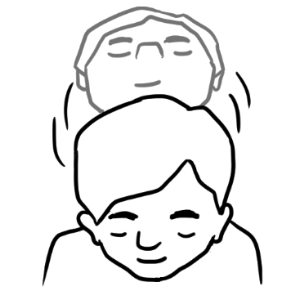
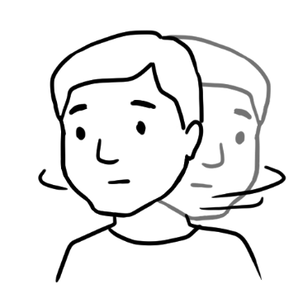
Do you understand?
Yes
No

Do you understand?
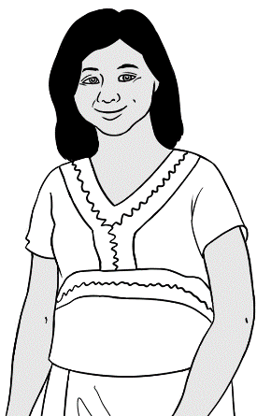
Yes. I understand.
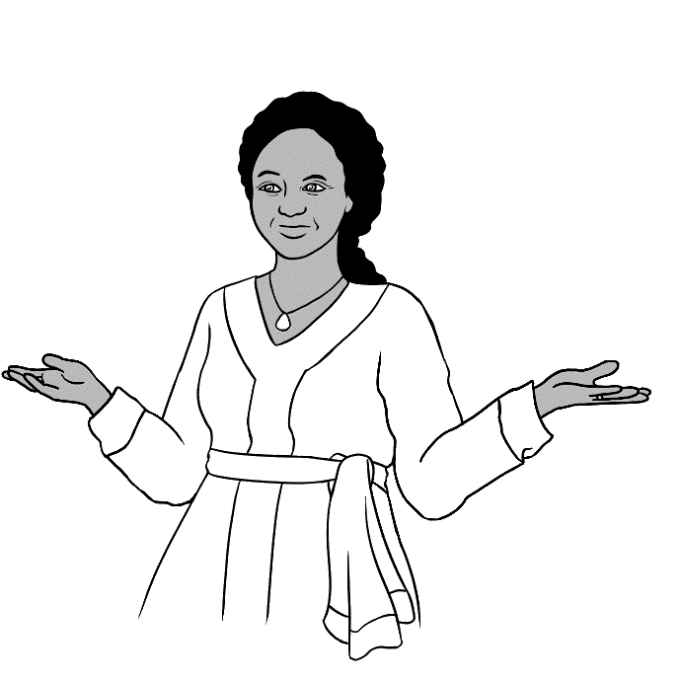
No. I don’t understand.

don’t = do not

Name and address
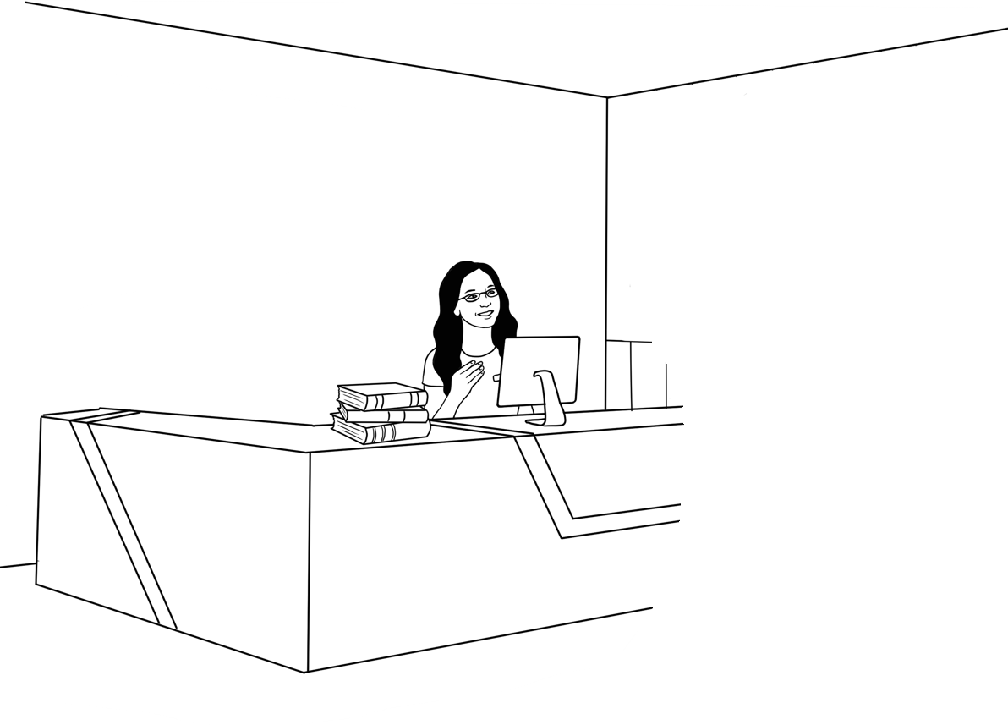
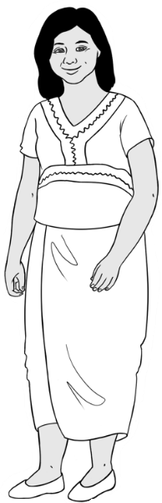
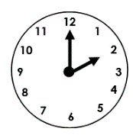
Good afternoon.
Good afternoon.

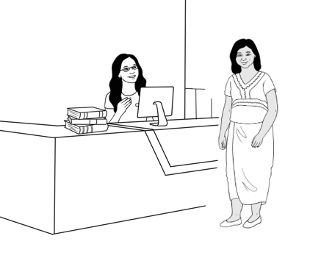
- .
What’s your name?
Zarni Tun.

What’s = What is

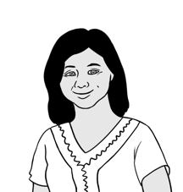
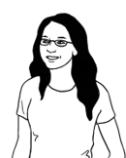
What’s your first name?
Zarni.

What’s your family name?
Tun.

Can you spell that please?
Tun T – u – n.

What’s your address Zarni?
Unit 4,
50 Baker Road
Kellivale.

50 Baker Road?
Yes. 50 Baker Road.

What’s your phone number?
0407 326 518
Thank you Zarni.
Please sit down.

What’s your name?
What’s your name?
What’s your name, name, name?
______________________ ______________________

What’s your first name?
What’s your first name?
What’s your first, first name?
______________________

What’s your family name?
What’s your family name?
What’s your family, family name?

________________________________

English class
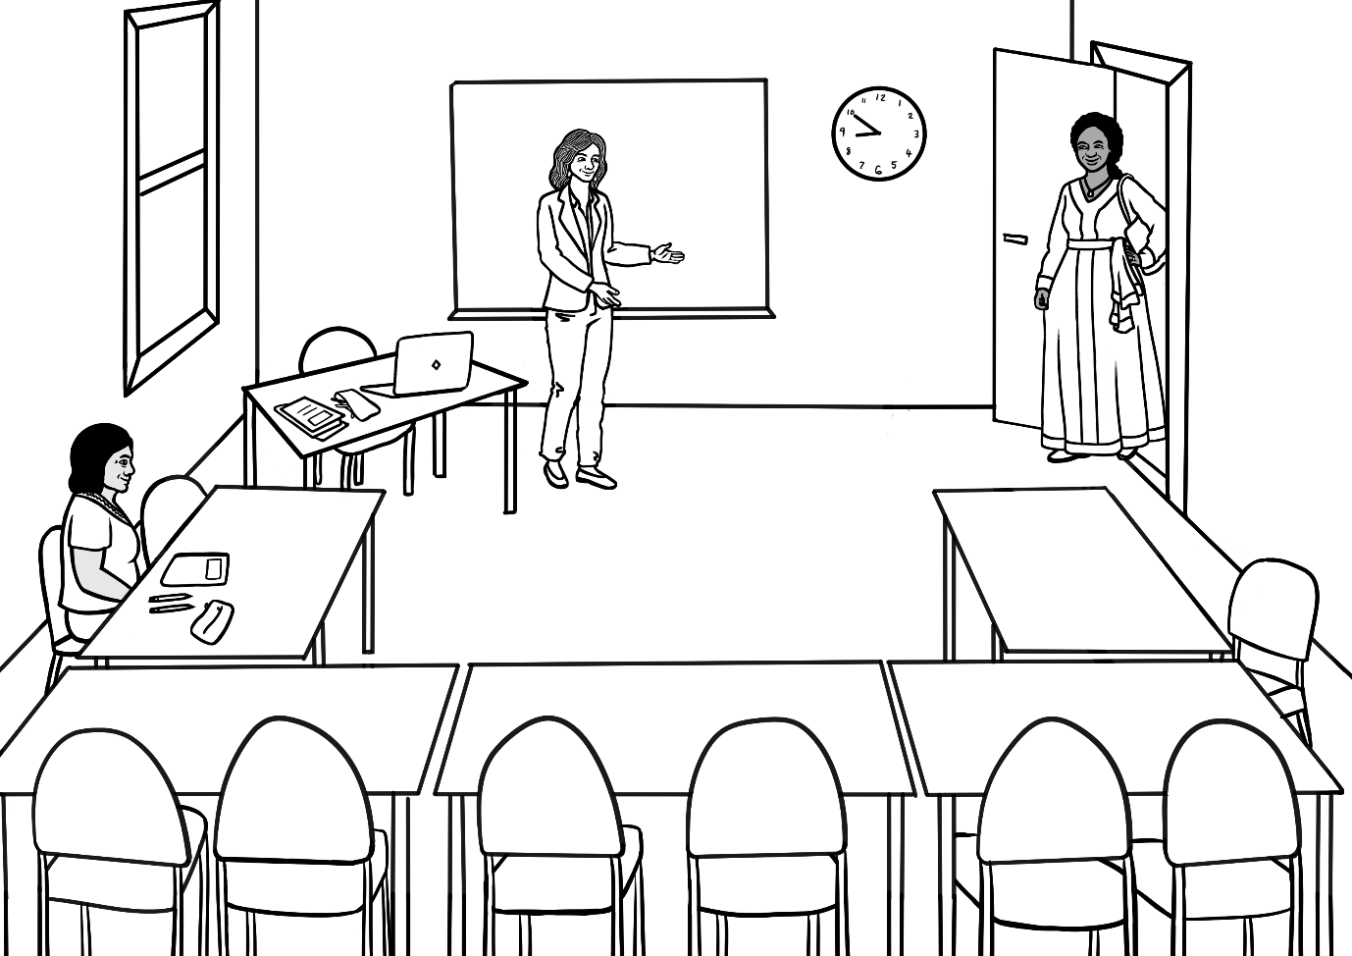
Good morning Rosie.
Good morning Jamila.

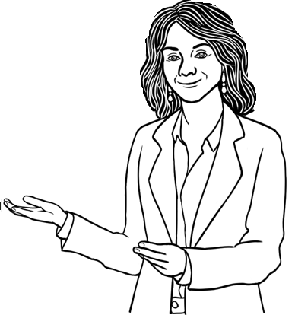
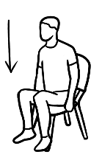
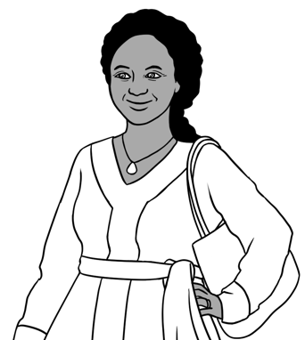
Come in.
Please sit down.

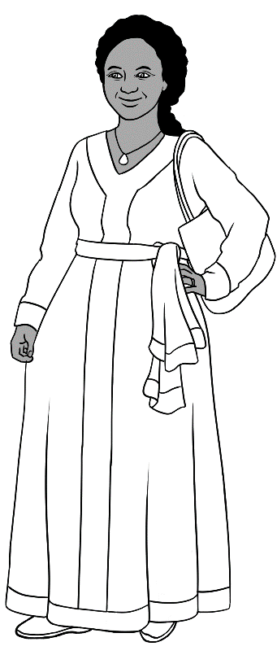
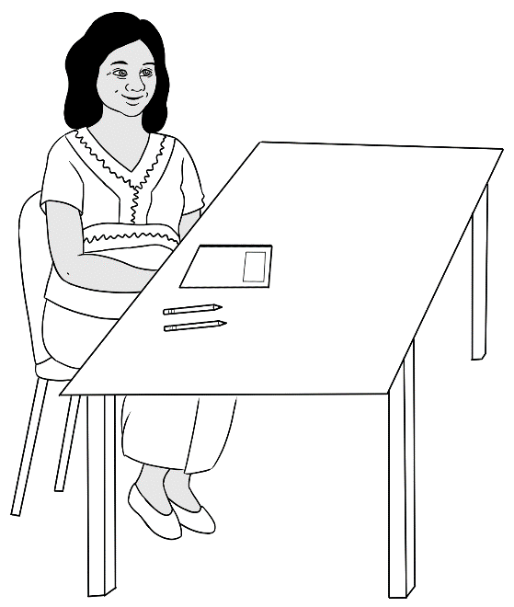
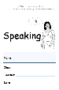
How are you?
Hi Jamila.
Good thanks.
Hello Zarni.

Hi.
Hello. | 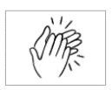
Good morning.
How are you?
Good thanks.

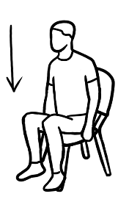 | Sit down.
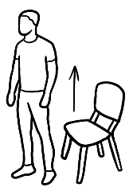 | Stand up.
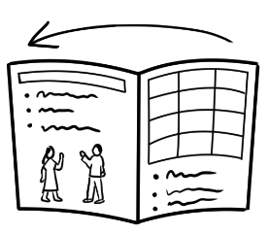 | Open your book.
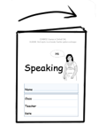 | Close your book.
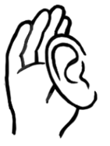 | Listen.
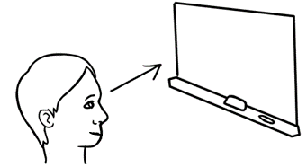 | Look at the board.

- listen
- say
- listen and
repeat
- point
- clap
- copy

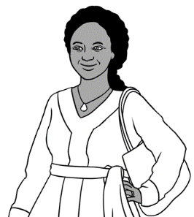
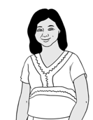
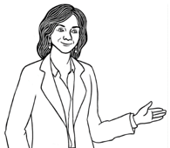
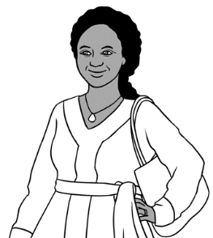
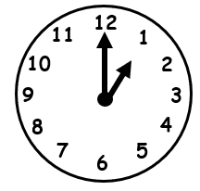
See you later Jamila.

Bye Zarni. Zarni

Goodbye everyone.
Time to go.
Goodbye Rosie.

Bye.
Goodbye.
See you later.

The classroom

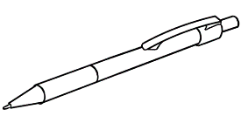 | pen
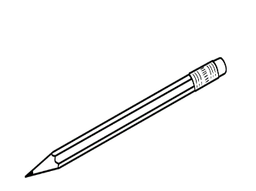 | pencil
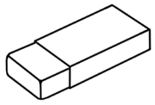 | rubber
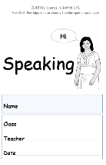 | workbook
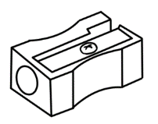 | sharpener
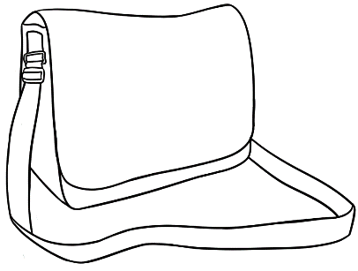 | bag
 | phone
 | laptop

 | pen
 | bag
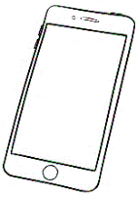 | phone
 | workbook
 | pencil
 | rubber
 | laptop
 | sharpener

Do you have a pencil?
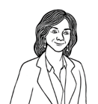
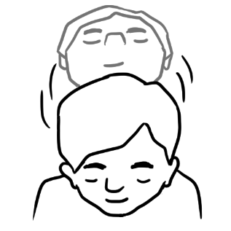
Yes.

Do you have a bag?

Yes.

Do you have a rubber?
No.

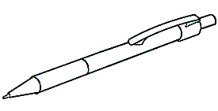
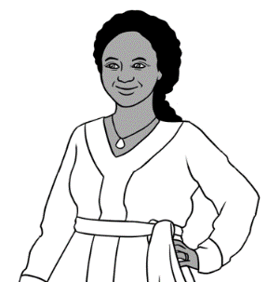
Do you have a pen? .

 | pen
 | pencil
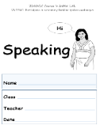 | workbook
 | bag

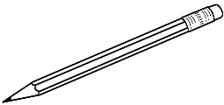
I have a

.
Do you have a rubber? .

rubber
sharpener
phone
laptop

I have a

Family

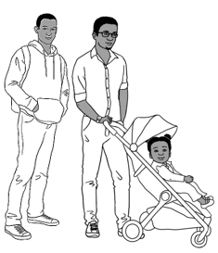
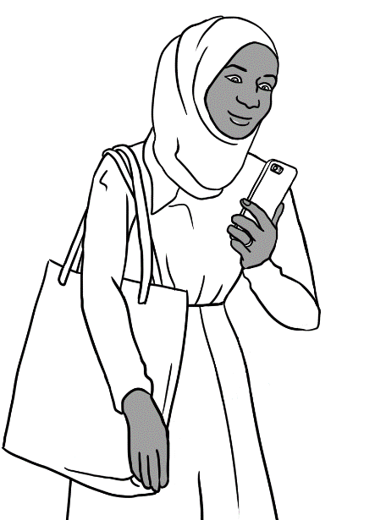

My name is Sahra.

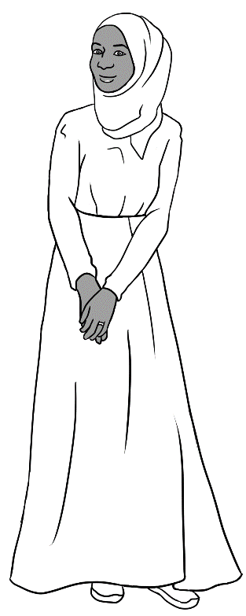
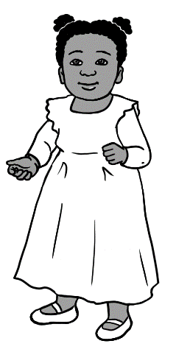
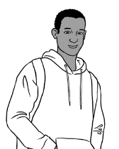
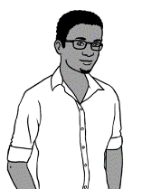
This is my daughter.
This is my brother.
This is my husband.

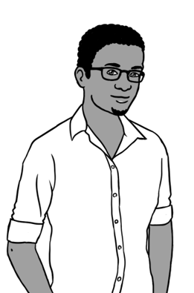
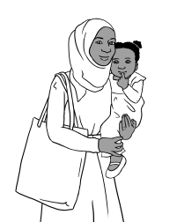
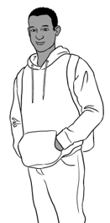
My name is Tahiil.

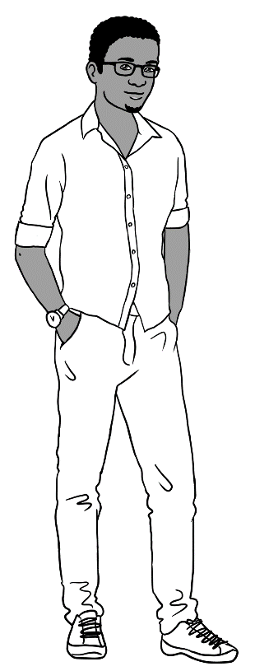
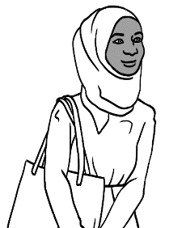
This is my daughter.
This is my brother-in-law.
This is my wife.
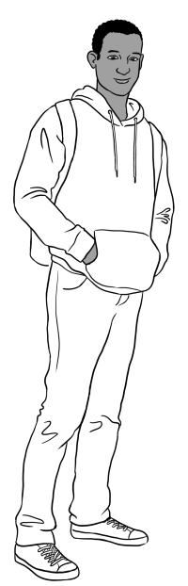
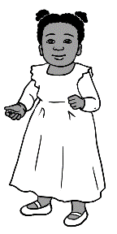
My name is Abdi.
This is my sister.
This is my niece.

This is my brother-in-law.

I am Hani.
My mum.

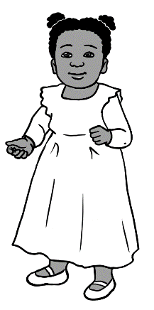
My dad.

My uncle.

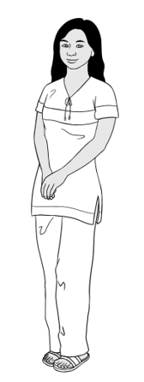
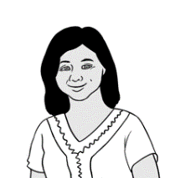
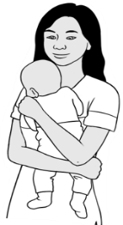
My name is San.
This is my mother.
This is my son.

son
mother | 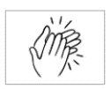
father
daughter
sister
brother

- mother
- father

- daughter
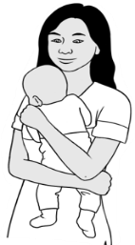
- son
- wife
- husband

Neighbours
Thursday
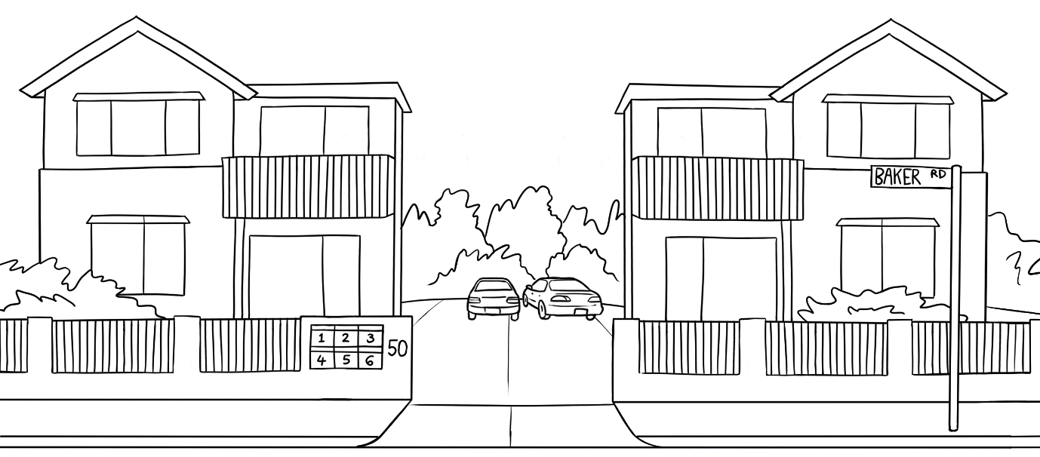
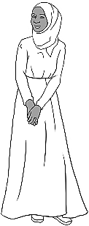
Hi Sahra.
Hello Zarni.

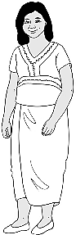

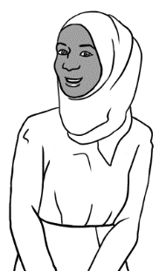
How are you?
Good. And you?

Good thanks.
Bye.
See you later.

Friday

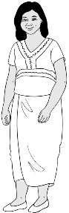
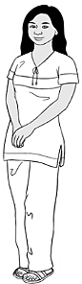
Hello Sahra.
Hi.

This is my daughter San.
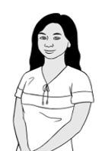
Hello San.

Hello Sahra.
Nice to meet you.

Bye
Bye.
See you later.

Saturday
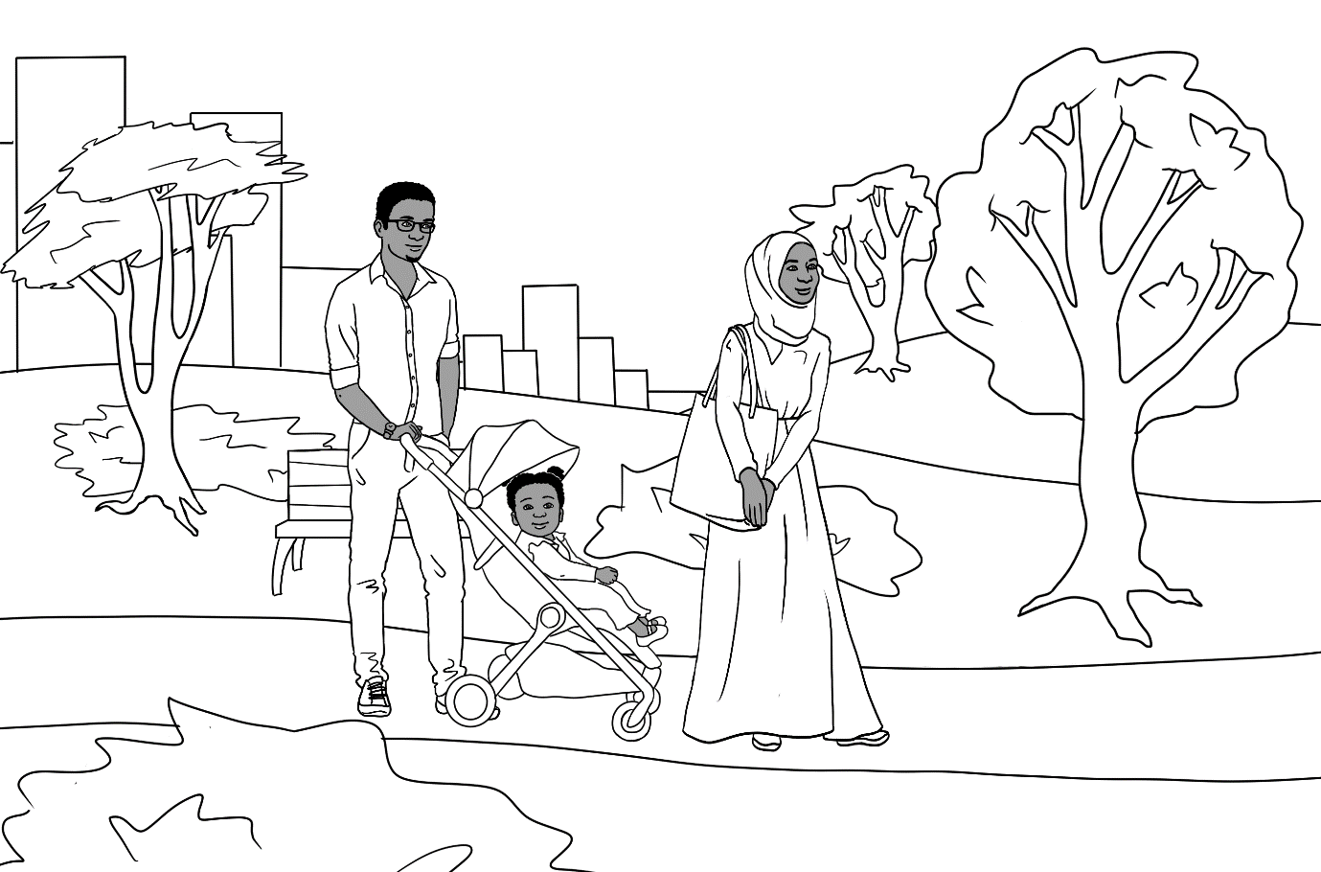
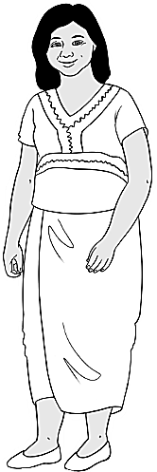
Hi Zarni.
Hi Sahra.

2.
This is my husband Tahiil
and my daughter Hani.

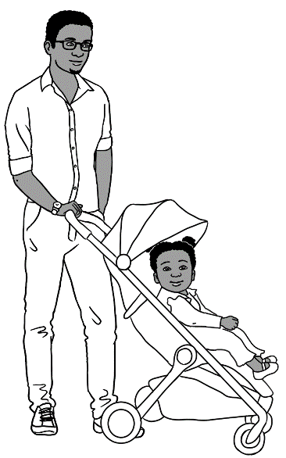
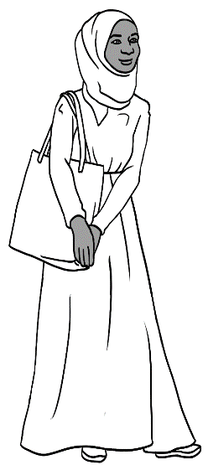
Hello. Nice
to meet you.

Sunday
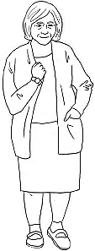
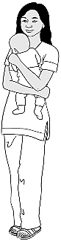
Hello. My name is Pam.
Hi. My name is San.

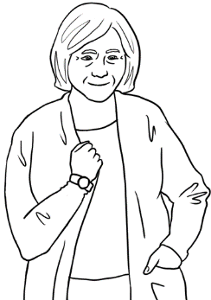
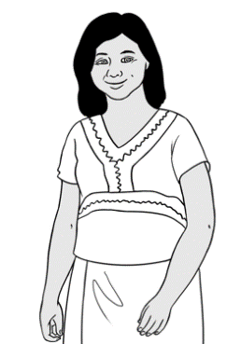
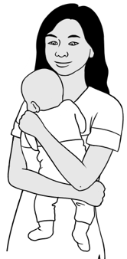
I live in unit 5.
We live in unit 4.

Bye.
This is my mother Zarni
and my baby son.
Nice to meet you. See you later.

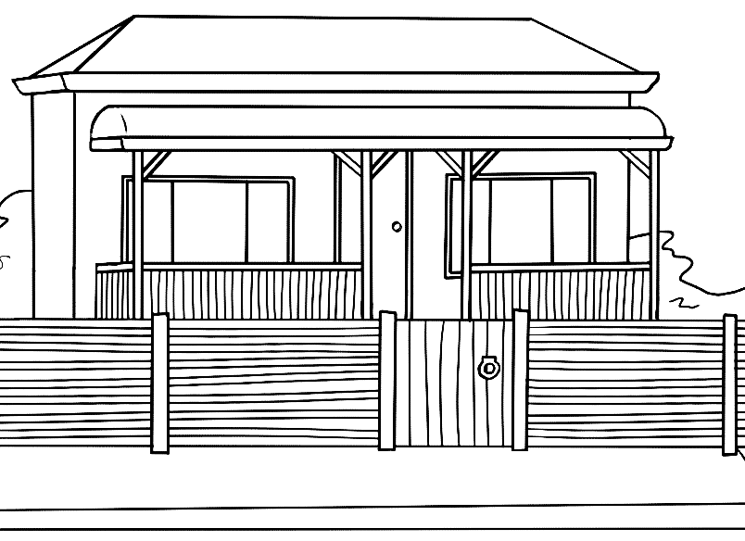
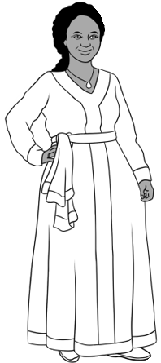
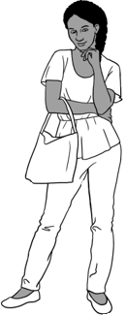
Hi Zarni.
Hi Jamila.

This is my daughter Anika.
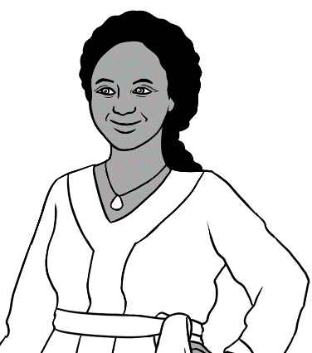
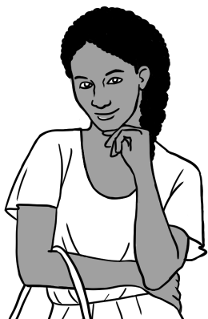
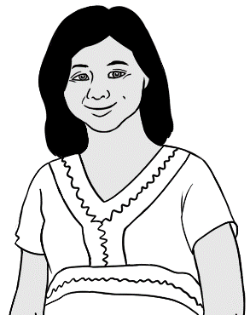
Hello Anika.

Hello Zarni.

Nice to meet you.

I like cooking.
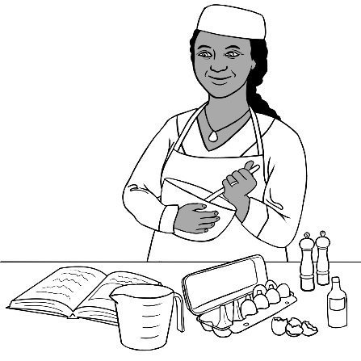  - cooking | 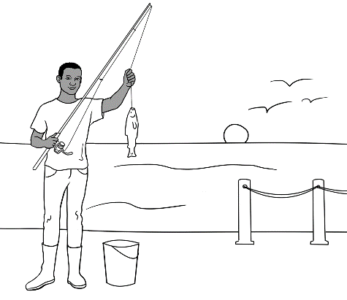  - fishing
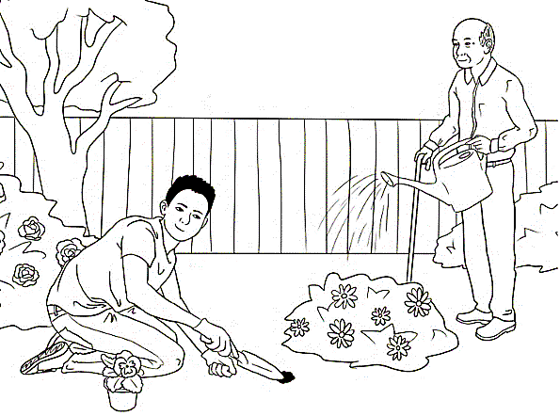  - gardening | 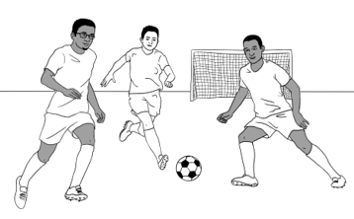  - playing soccer
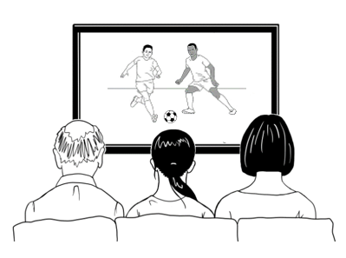  - watching TV | 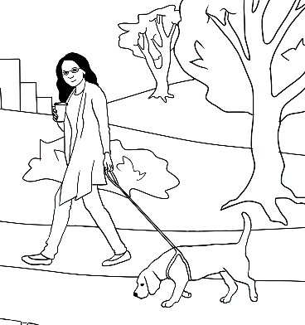  - walking

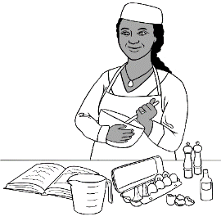
cooking
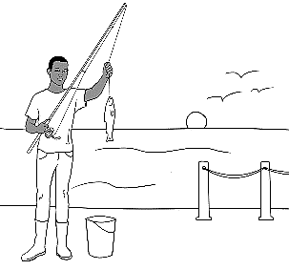
fishing
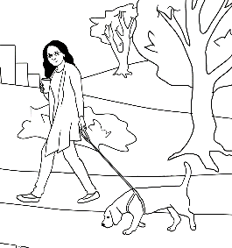
walking
playing
soccer
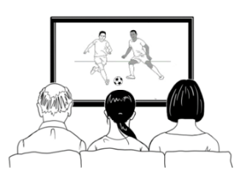
watching
TV
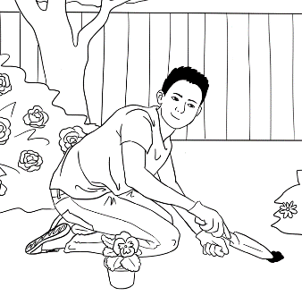
gardening

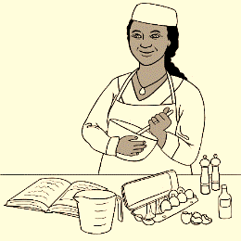
Do you like cooking?
Yes.
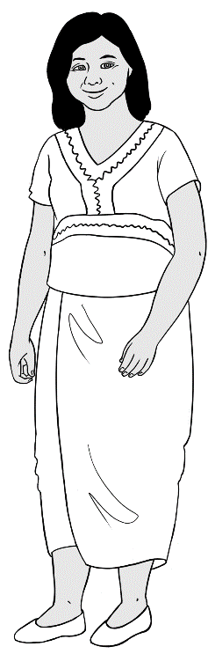
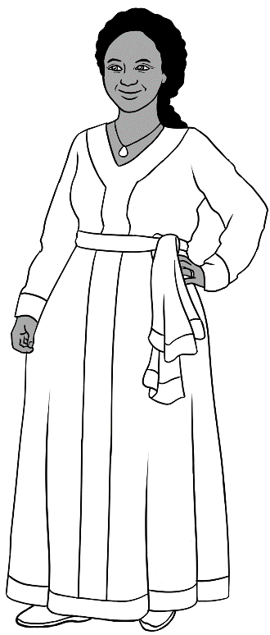

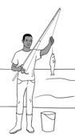
Do you like fishing?
No.

I like fishing.
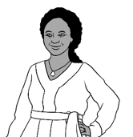
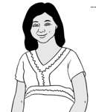
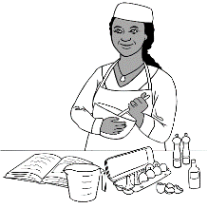
I like cooking.

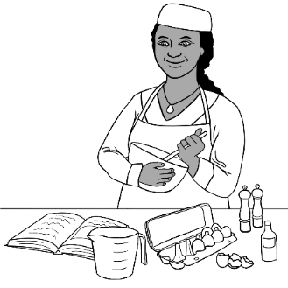
- Do you like cooking?
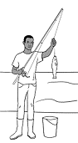
- Do you like fishing?
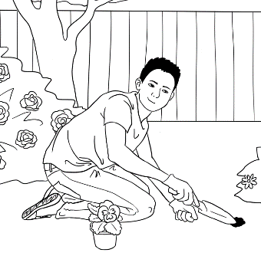
- Do you like gardening?

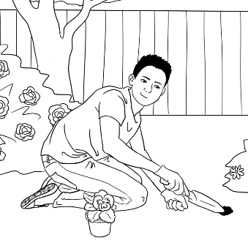
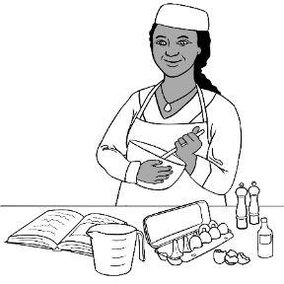
I like

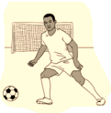
Do you like playing soccer?
Yes.
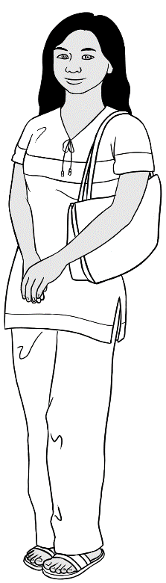
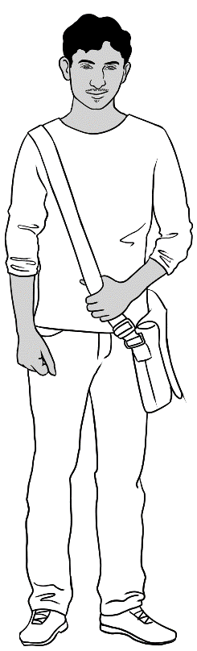
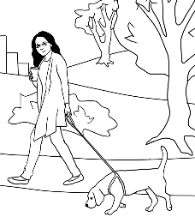
Do you like walking?
No.

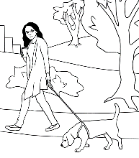
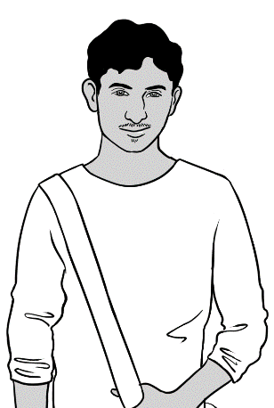
I like walking.
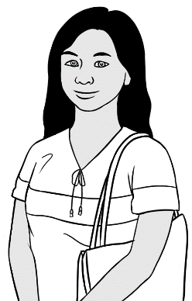
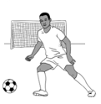
I like playing soccer.

- Do you like playing soccer?
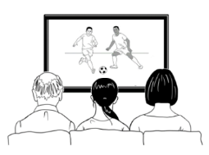
- Do you like watching TV?
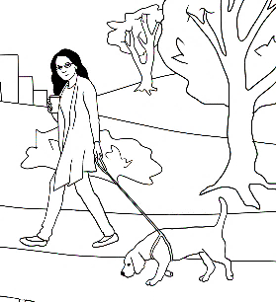
- Do you like walking?

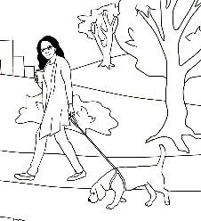

I like

Tea or coffee?
Do you like tea or coffee?



2.
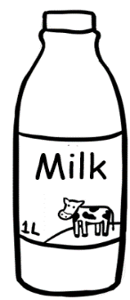
milk
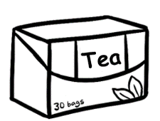

tea


coffee
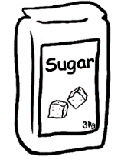
sugar
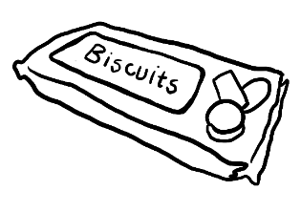
biscuits



Would you like
tea or coffee?
Tea please.

Milk?
Yes please.
Sugar?
No thanks.

Biscuits?
Yes please.

Would you like
tea or coffee?
Coffee please.

Milk?
No thanks.
Sugar?
Yes please.

Biscuits?
No thanks.
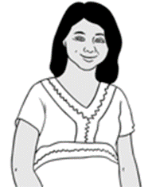

- Would you like tea?
- Would you like coffee?
- Would you like milk?
- Would you like sugar?
- Would you like biscuits?

Would you like tea?
Tea?

No thanks.
Yes, tea.

 | - Would you like coffee? | - Coffee?
 | - Yes, coffee. | - Yes please.
 | - Would you like milk? | - Milk?
 | - Yes, milk. | - No thanks
 | - Would you like sugar? | - Sugar?
 | - Yes, sugar. | - Yes please.

Time to go.

Bye
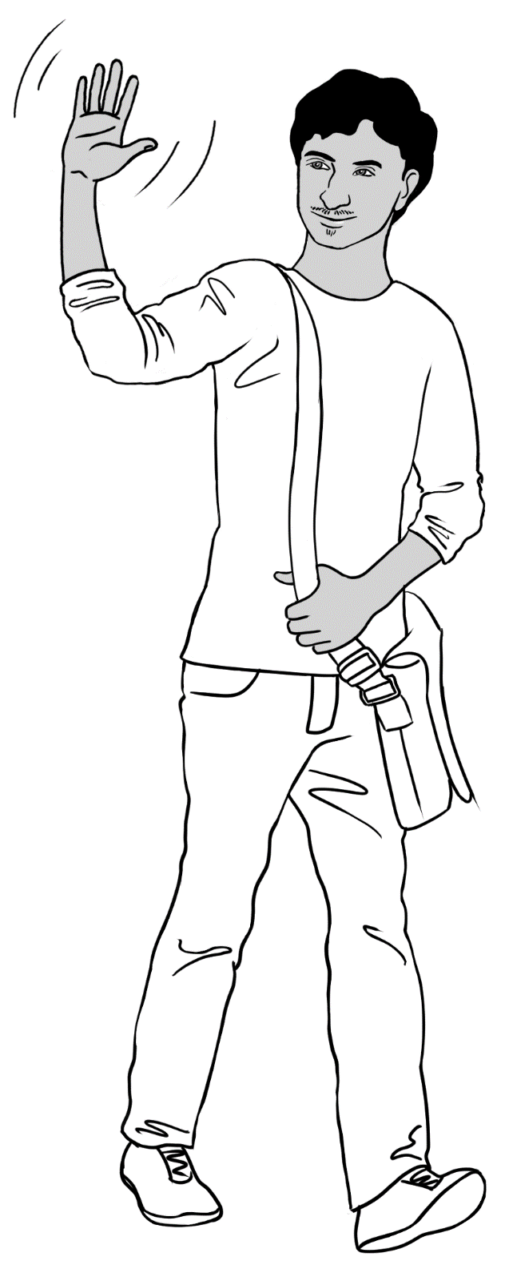
See you soon.
Bye.

Bye
See you later.

Bye
See you tomorrow.

Bye
See you Monday.

