
Student book with teacher notes

English Ready
22636VIC Course in Initial EAL
VU23492 Participate in extremely familiar spoken exchanges

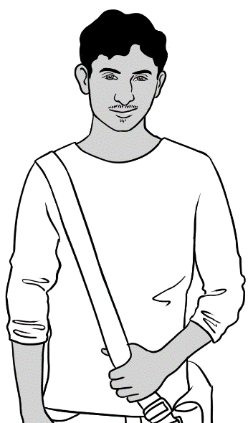
Hi.
Speaking

Name __________________________________________________
Class __________________________________________________
Teacher _____________________________________________
Date_________________________________________________________________

This workbook is designed to be used with the support of a teacher.
Design team: Vicki Hambling, Sue Paull, Frida Dean, Glenise Kleehammer and Mary Wallace
Illustrations: Madelena Scott
Acknowledgements: The design team would like to thank the AMEP service providers and practitioners who participated in the trial and gave valuable feedback. The team would also like to acknowledge the use of the EAL Framework which underpins the design of this book.

Copyright of the EAL Framework is reserved to the Crown in the right of the State of Victoria. © State of Victoria (Department of Education and Training) 2023.
__________________________________________________________________________________
This English Ready Resource is licensed under a Creative Commons Attribution-NoDerivs 3.0 Australia licence (More information is available here). You are free to use, copy and distribute to anyone in its original form as long as you attribute Department of Home Affairs as the author and you license any derivative work you make available under the same licence.
© Commonwealth of Australia 2023

With the exception of the Commonwealth Coat of Arms, the department’s logo, any material protected by a trade mark and where otherwise noted all material presented in this document is provided under a Creative Commons Attribution 4.0 International (https://creativecommons.org/licenses/by/4.0/) licence.
The details of the relevant licence conditions are available on the Creative Commons website (accessible using the links provided) as is the full legal code for the CC BY 4.0 licence. (https://creativecommons.org/licenses/by/4.0/legalcode).
Use of all or part of this document must include the following attribution:
© Commonwealth of Australia 2023
As far as practicable, material for which the copyright is owned by a third party will be clearly labelled. The department has made all reasonable efforts to ensure that this material has been reproduced in this document with the full consent of the copyright owners.
Copyright requests and enquiries concerning usage not addressed by the CC BY 4.0 licence should be addressed to: comms@homeaffairs.gov.au at the Department of Home Affairs.
The terms of use for the Commonwealth Coat of Arms are available from the It's an Honour website.
Where a copyright owner, other than the Commonwealth, is identified with respect to this material, please contact that third party copyright owner directly to seek permission.



Table of contents

1 Instructions 1
2 Meet the people. 2
3 Do you understand? 4
4 Name and address 5
5 English class 9
6 The classroom 14
7 Family 19
8 Neighbours 24
9 I like cooking. 29
10 Tea or coffee? 35

Instructions
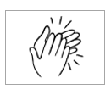
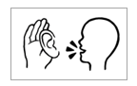
The arrow is a reminder to read from left to right.

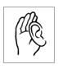  1.  listen | 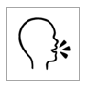  2.  say
  3.  4  copy | 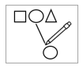  4.  match
  5.  colour |   6.  circle
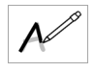  7.  trace | 8.  tick
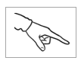  9.  point | 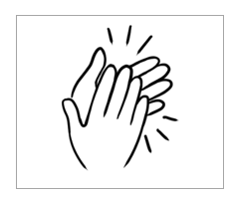  10.  clap

Meet the people.
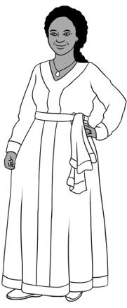
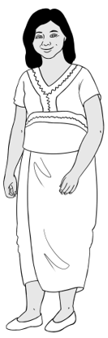
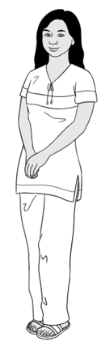
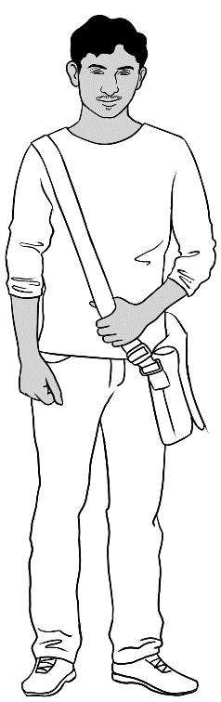

Jamila
1.
Zarni
San
Rahim
Students

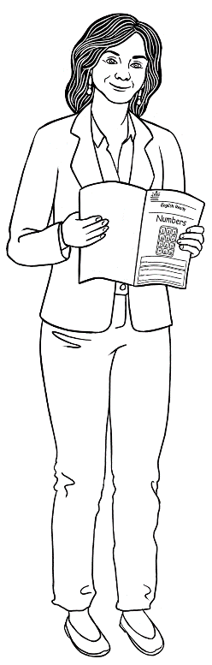

2.
Teacher
Rosie

Receptionist
3.
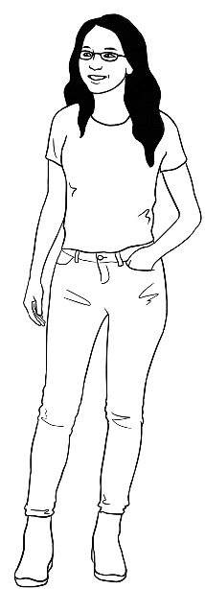

Kim

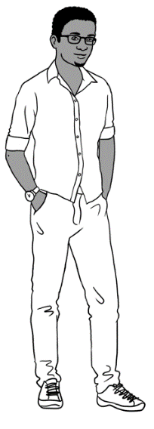
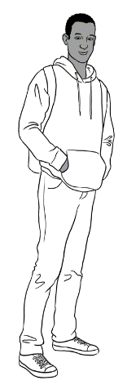
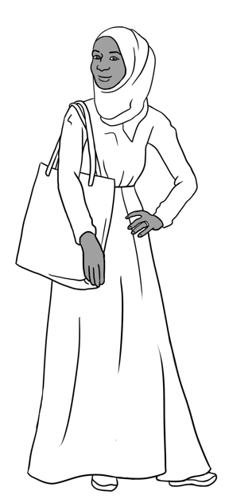
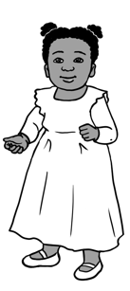
Sahra
Hani
Tahiil
Abdi

4.
Neighbourss


Students copy their first name under the box below.
A student photo could be printed and pasted in the box.
5.
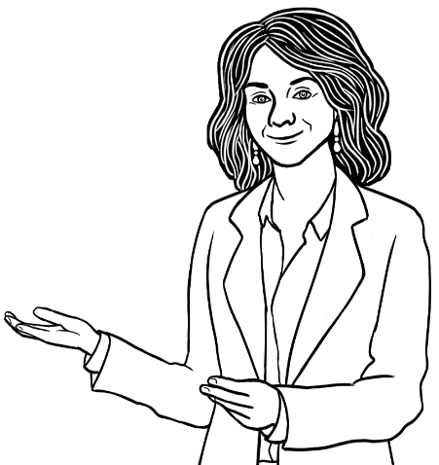
You

____________________

Do you understand?

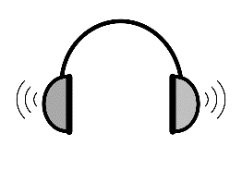
1
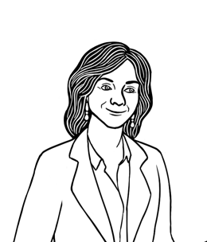
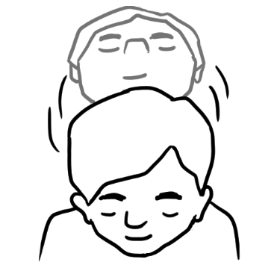
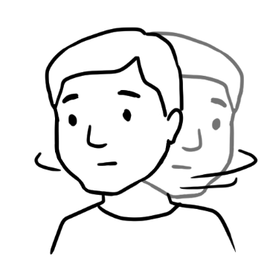
Do you understand?
Yes
No

Do you understand?
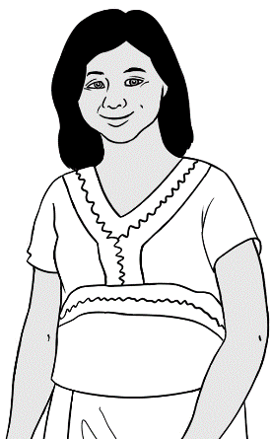
Yes. I understand.
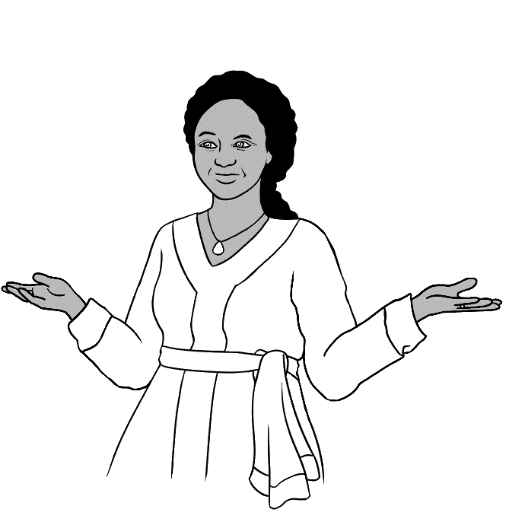
No. I don’t understand.

don’t = do not

Name and address
The audio is broken into three parts.
Part 1 is page 6; Part 2 is page 7; Part 3 is page 8.
2
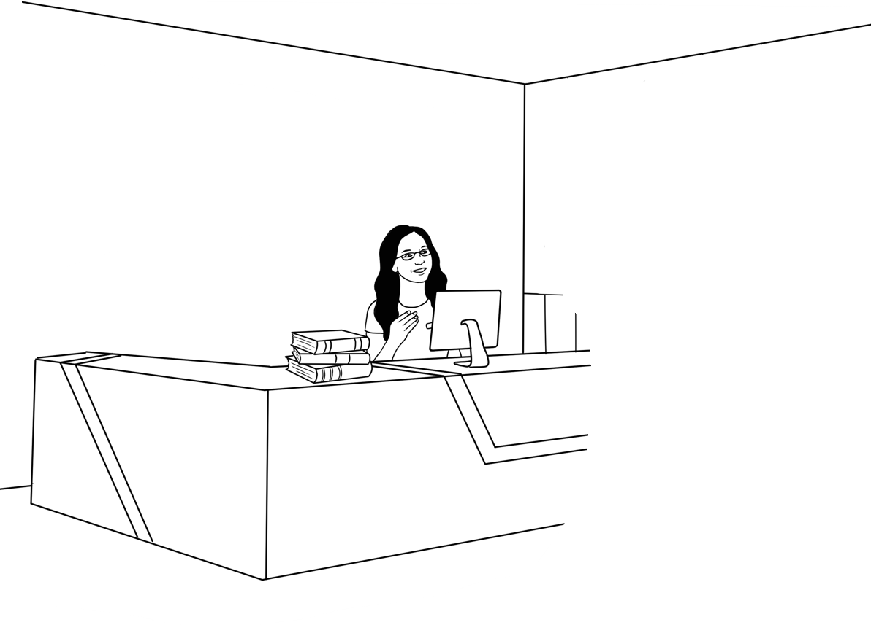
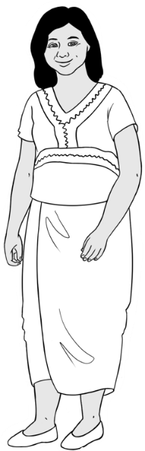
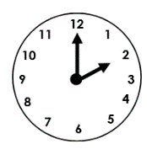
Good afternoon.
Good afternoon.

Zarni’s family name
is omitted on the audio.
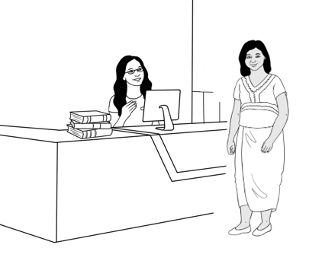
- .
What’s your name?
Zarni Tun.

What’s = What is

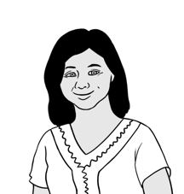
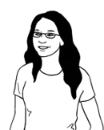
What’s your first name?
Zarni.

What’s your family name?
Tun.

Can you spell that please?
Tun T – u – n.

What’s your address Zarni?
Unit 4,
50 Baker Road
Kellivale.

50 Baker Road?
Yes. 50 Baker Road.

What’s your phone number?
0407 326 518
Thank you Zarni.
Please sit down.

Everyone chants the questions and at the stars everyone responds aloud together, saying their:
- full name on the grey star
- first name on the blue star
- family name on the gold star.
Students can copy their names in the spaces next to the stars.

What’s your name?
What’s your name?
What’s your name, name, name?
______________________ ______________________

What’s your first name?
What’s your first name?
What’s your first, first name?
______________________

What’s your family name?
What’s your family name?
What’s your family, family name?

________________________________

English class
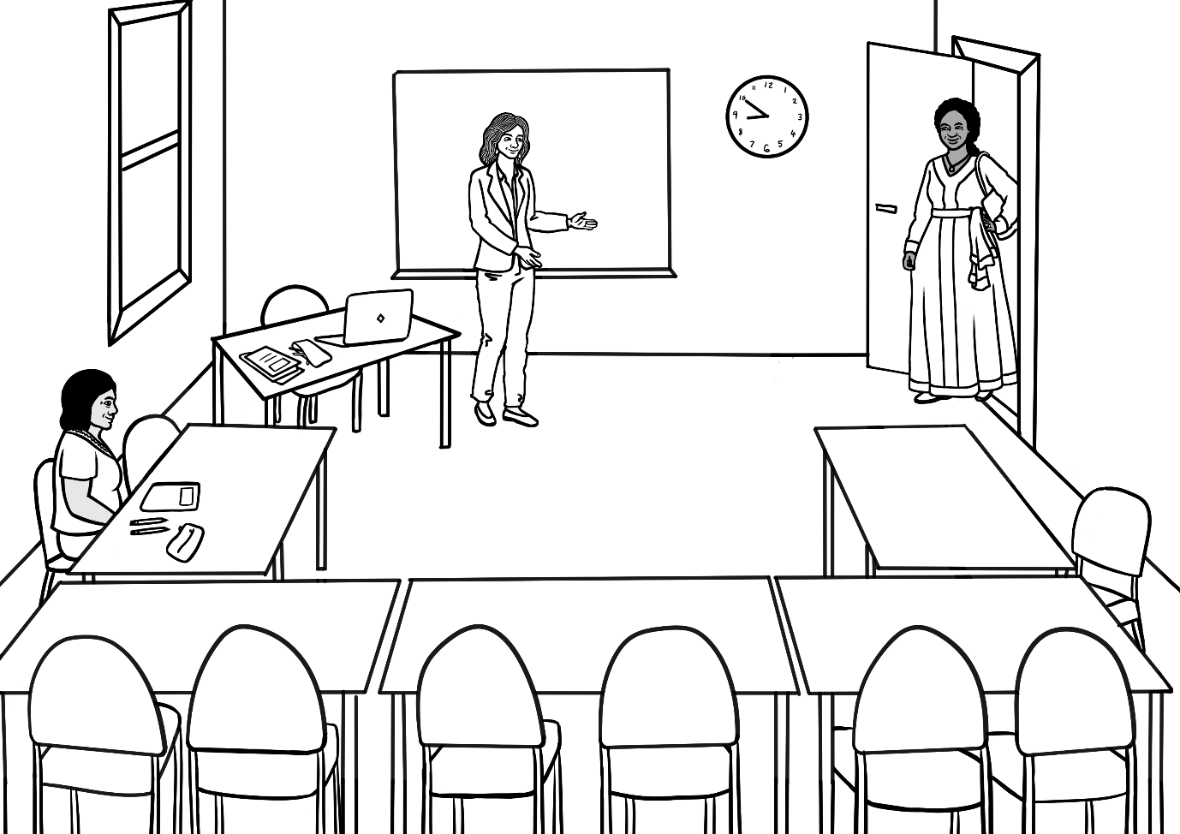
The audio is broken into two parts.
Part 1 is page 10; Part 2 is page 11.
3
Good morning Rosie.
Good morning Jamila.

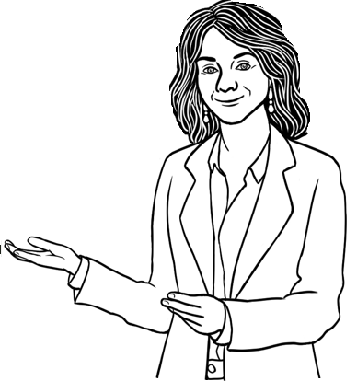
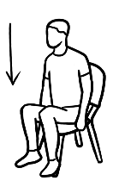
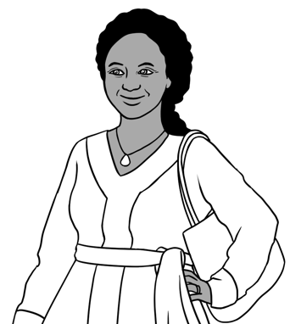
Come in.
Please sit down.

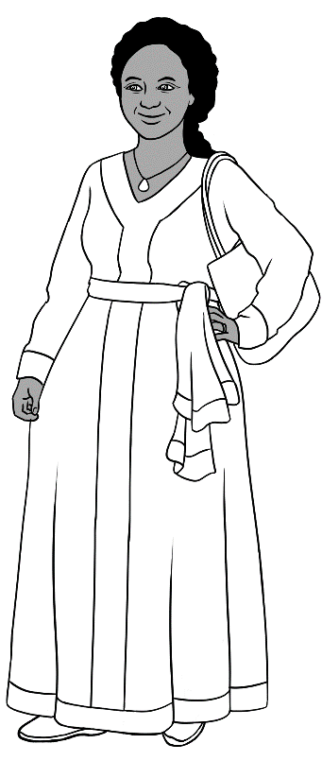
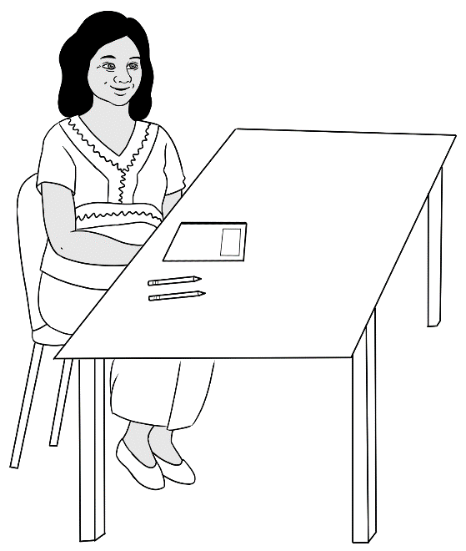
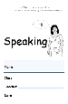
How are you?
Hi Jamila.
Good thanks.
Hello Zarni.

Hi.
Hello. | 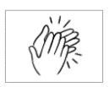
Good morning.
How are you?
Good thanks.

Give instructions, students follow.
4

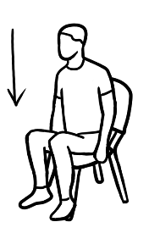 | Sit down.
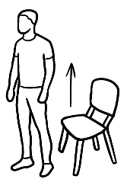 | Stand up.
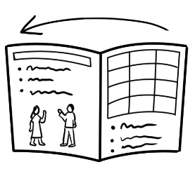 | Open your book.
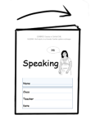 | Close your book.
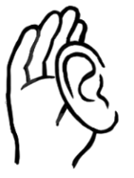 | Listen.
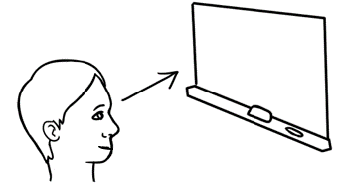 | Look at the board.

- listen
- say
- listen and
repeat
- point
- clap
- copy

5
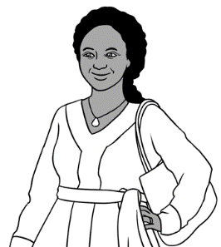
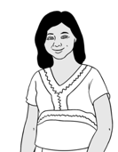
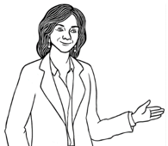
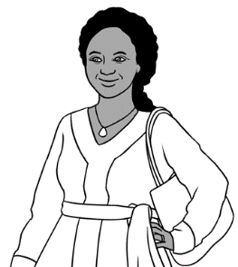
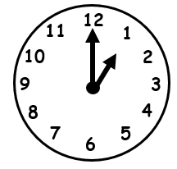
See you later Jamila.

Bye Zarni. Zarni

Goodbye everyone.
Time to go.
Goodbye Rosie.

Bye.
Goodbye.
See you later.

The classroom

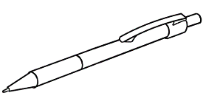 | pen
 | pencil
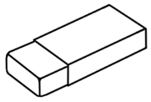 | rubber
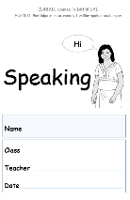 | workbook
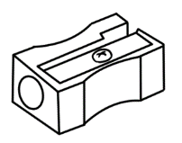 | sharpener
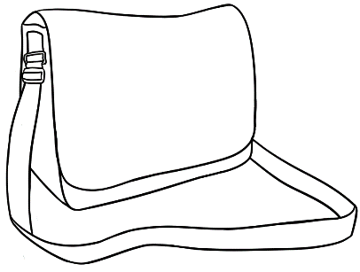 | bag
 | phone
 | laptop

 | pen
 | bag
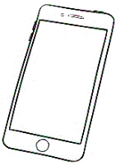 | phone
 | workbook
 | pencil
 | rubber
 | laptop
 | sharpener

6

Do you have a pencil?

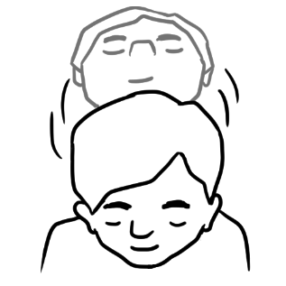
Yes.

Do you have a bag?

Yes.

Do you have a rubber?
No.

Encourage students ask their partner questions
and to use body language.
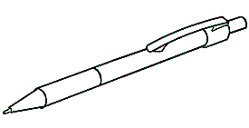
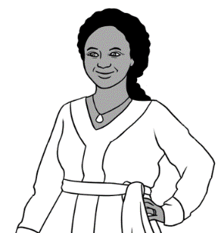
Do you have a pen? .

 | pen
 | pencil
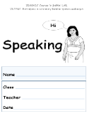 | workbook
 | bag

- Students tell you and their partner what they have.

I have a

Encourage students to ask their partner questions
and to use body language.
Do you have a rubber?

rubber
sharpener
phone
laptop

- Students tell you and their partner what they have.
I have a

Family
The audio is broken into five parts. Part 1 is page 20; Part 2 is page 21; Part 3 & 4 are on page 22; Part 5 is on page 23
7

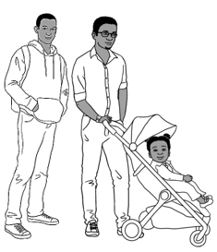
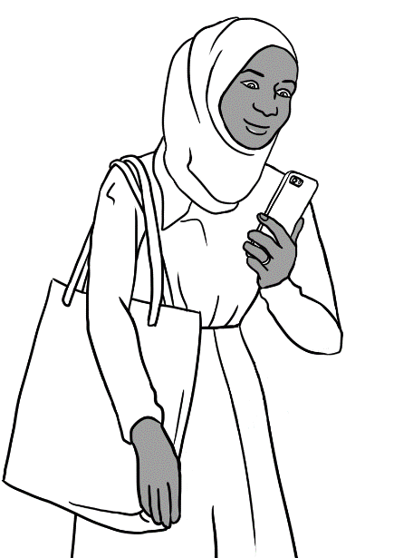

My name is Sahra.

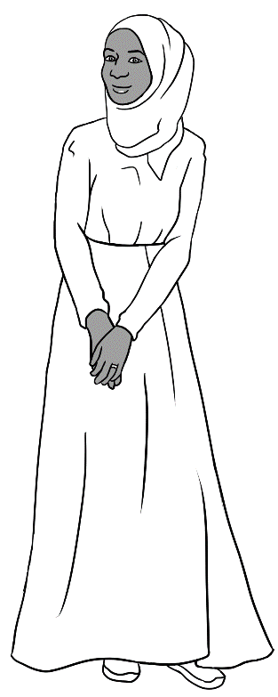
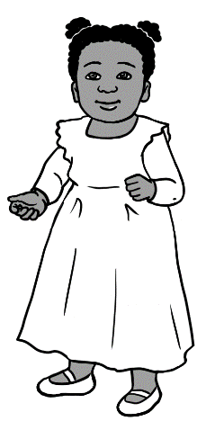
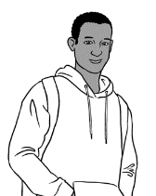
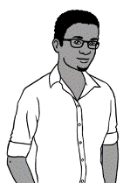
This is my daughter.
This is my brother.
This is my husband.

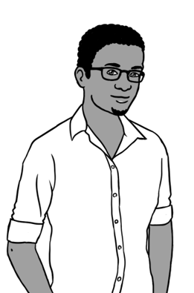
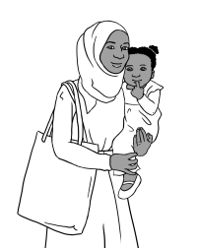
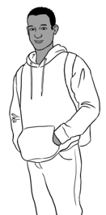
My name is Tahiil.

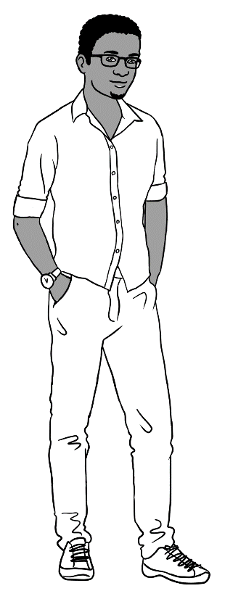
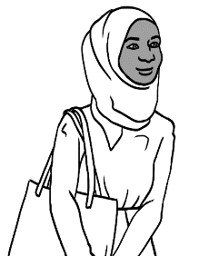
This is my daughter.
This is my brother-in-law.
This is my wife.
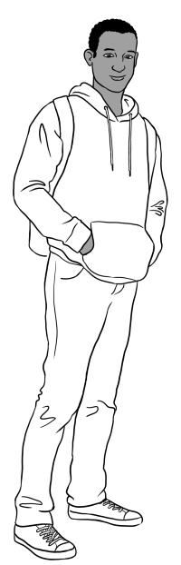
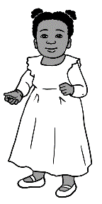
My name is Abdi.
This is my sister.
This is my niece.

This is my brother-in-law.

I am Hani.
My mum.

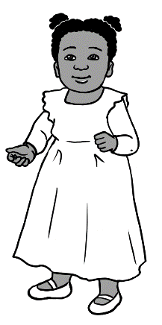
My dad.

My uncle.

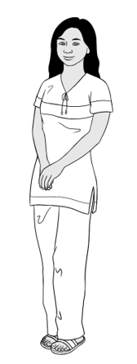
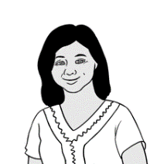
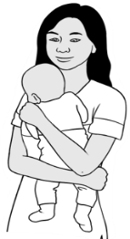
San is pronounced Sahn.
My name is San.
This is my mother.
This is my son.

son
mother | 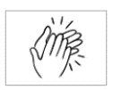
father
daughter
sister
brother

- mother
- father

- daughter
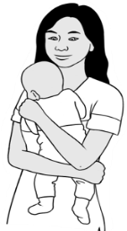
- son
- wife
- husband

Neighbours
8
Thursday
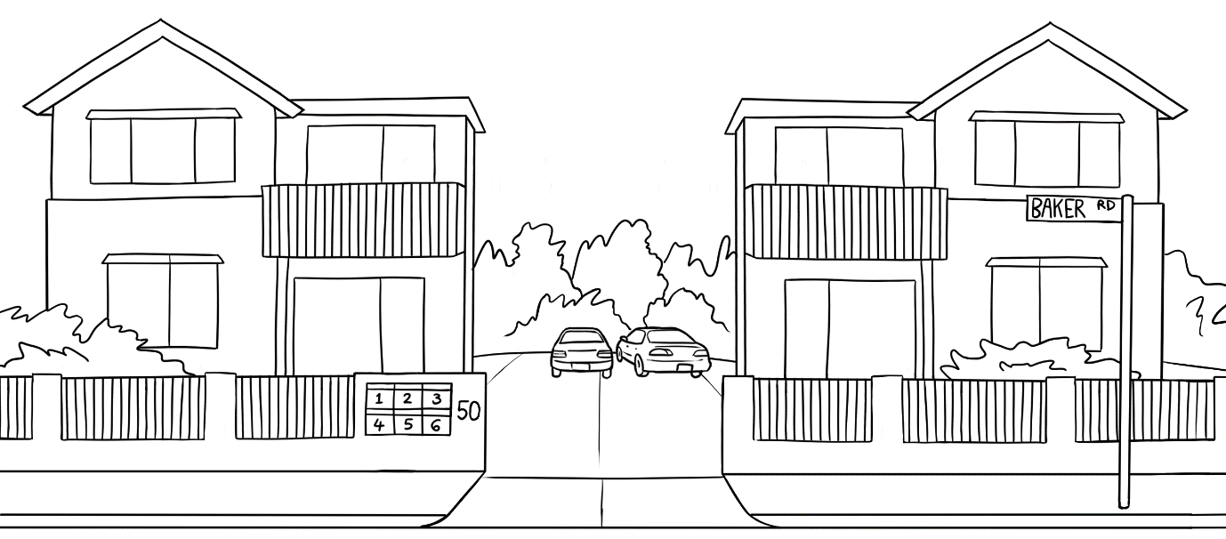
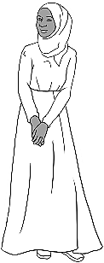
Hi Sahra.
Hello Zarni.

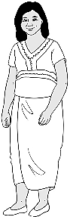

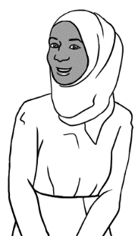
How are you?
Good. And you?

Good thanks.
Bye.
See you later.

9
Friday

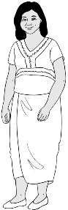
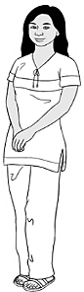
Hello Sahra.
Hi.

This is my daughter San.
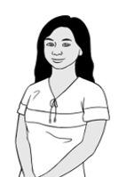
Hello San.

Hello Sahra.
Nice to meet you.

Bye
Bye.
See you later.

Saturday
This is the opening of a conversation.
Extend and add a closing if appropriate.
10
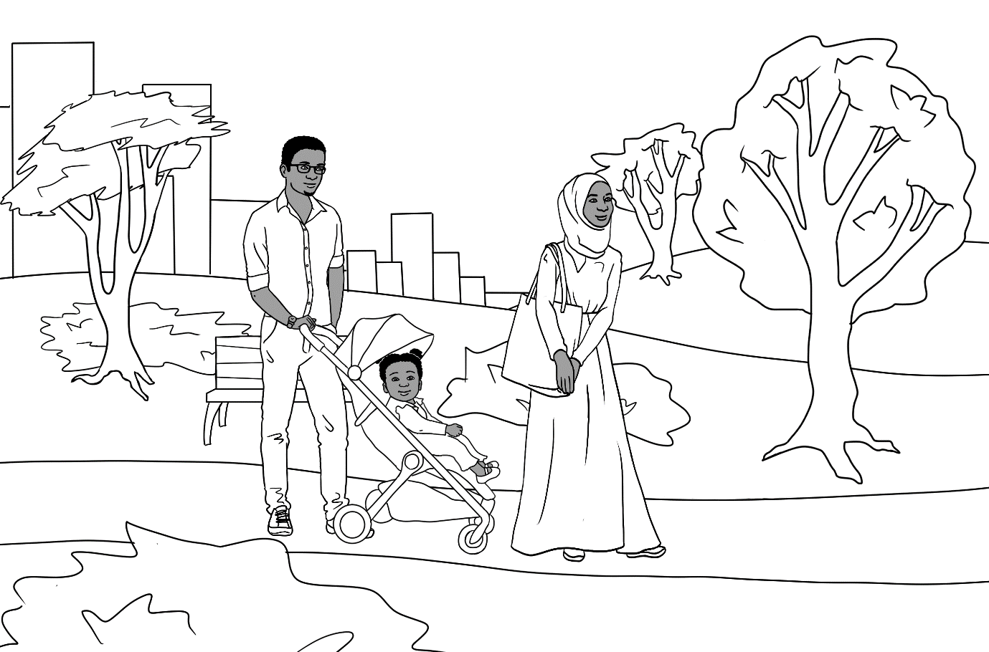
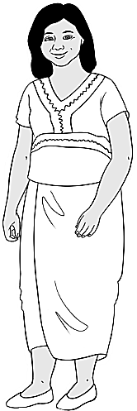
Hi Zarni.
Hi Sahra.

2.
This is my husband Tahiil
and my daughter Hani.

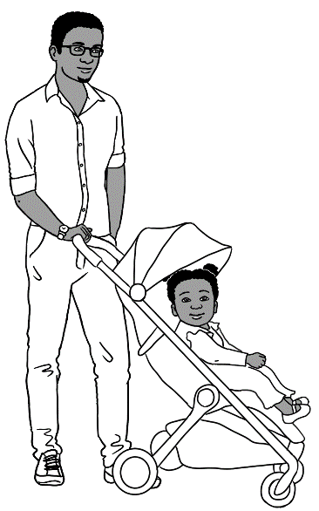
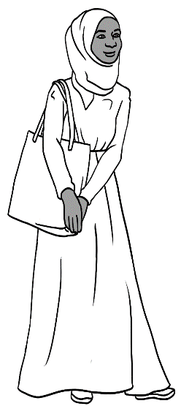
Hello. Nice
to meet you.

Sunday
11
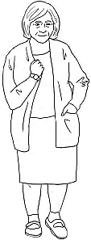
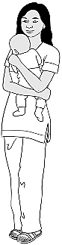
Hello. My name is Pam.
Hi. My name is San.

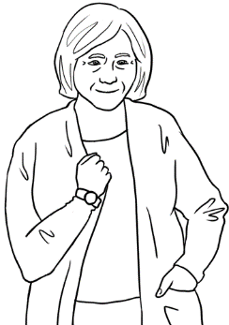
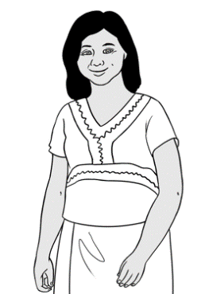
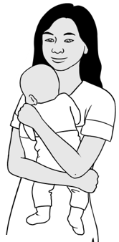
I live in unit 5.
We live in unit 4.

Bye.
This is my mother Zarni
and my baby son.
Nice to meet you. See you later.

This is the opening of a conversation.
Extend and add a closing if appropriate.
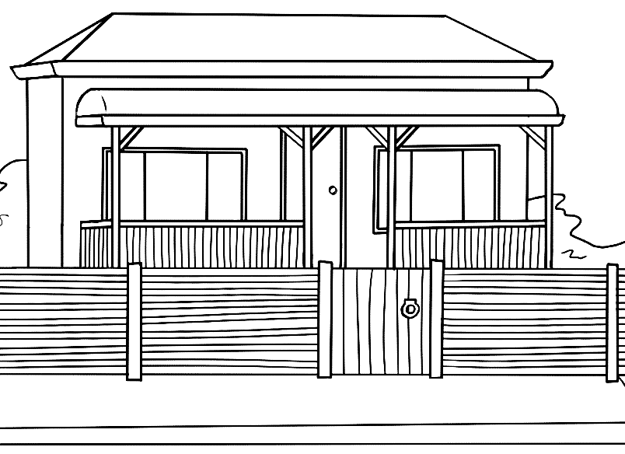
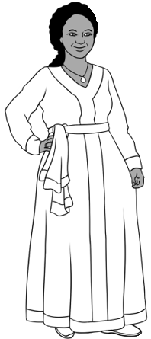
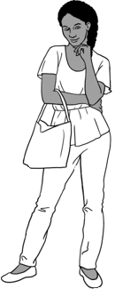
Hi Zarni.
Hi Jamila.

This is my daughter Anika.
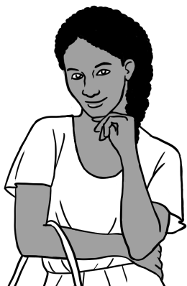
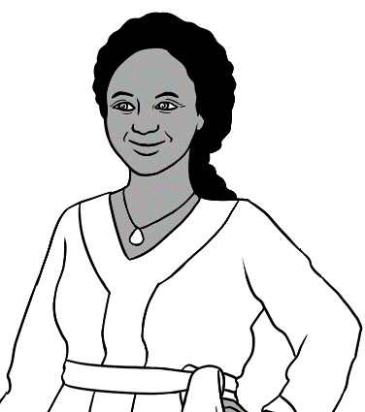
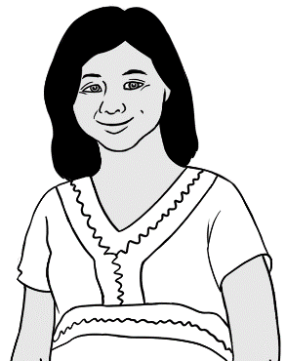
Hello Anika.

Hello Zarni.

Nice to meet you.

I like cooking.
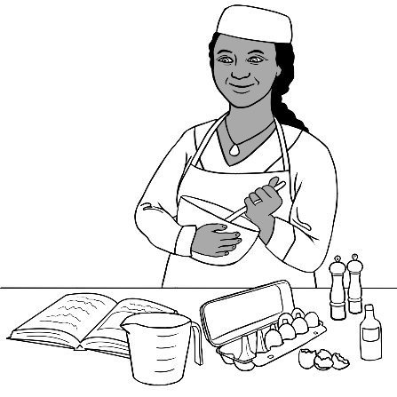  - cooking | 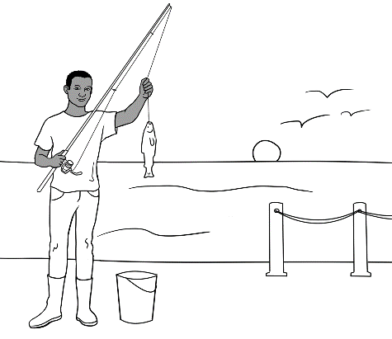  - fishing
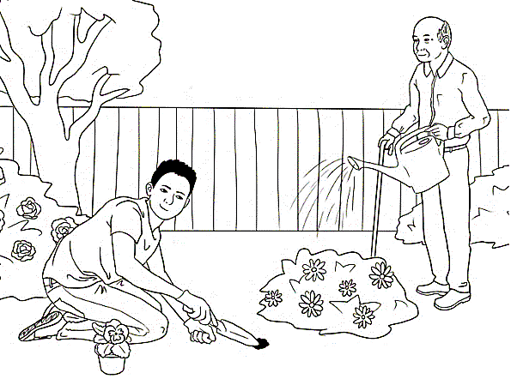  - gardening | 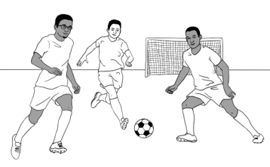  - playing soccer
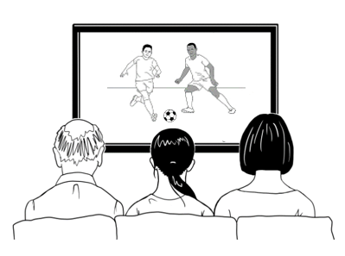  - watching TV | 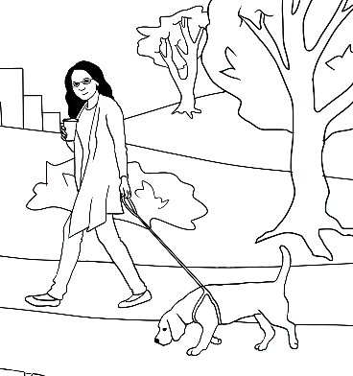  - walking

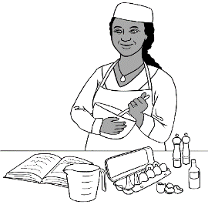
cooking
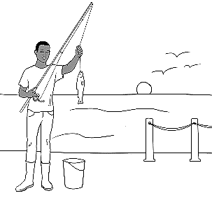
fishing
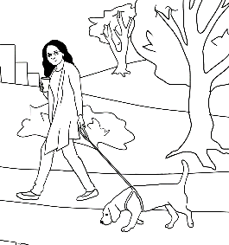
walking
playing
soccer
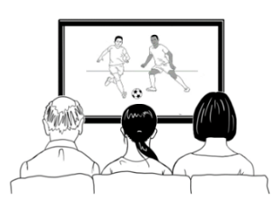
watching
TV
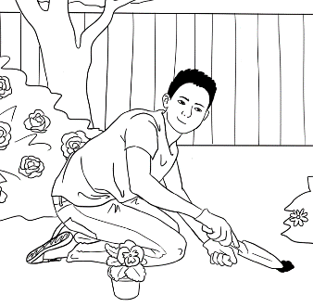
gardening

12

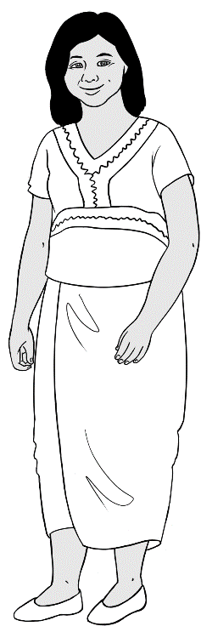
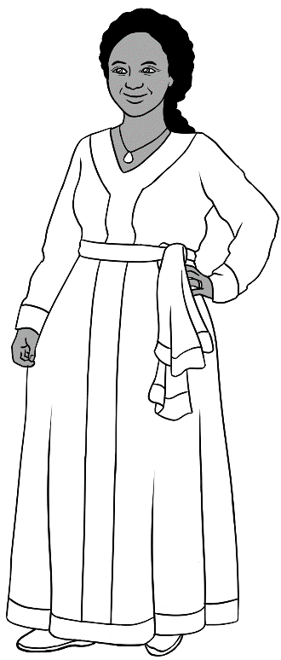
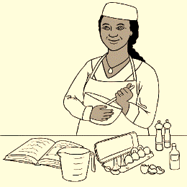
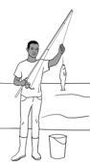
Do you like fishing?
Do you like cooking?
No.
Yes.

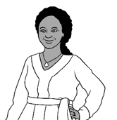
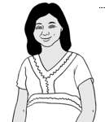
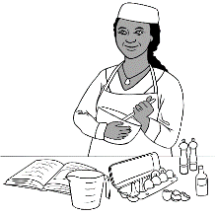
I like fishing.
I like cooking.

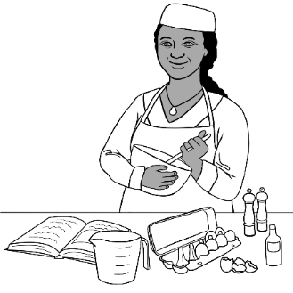
- Do you like cooking?
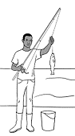
- Do you like fishing?
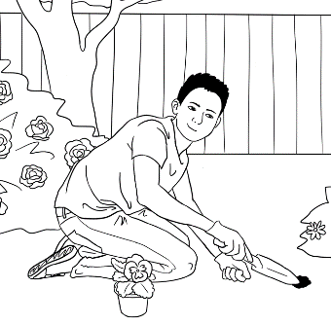
- Do you like gardening?

Ask students to tick and then tell you and
their partner what they like.
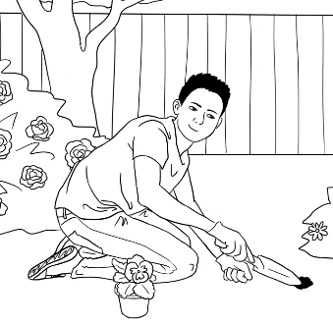
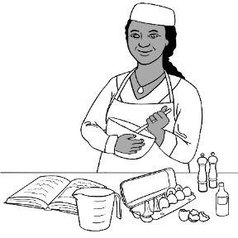
I like

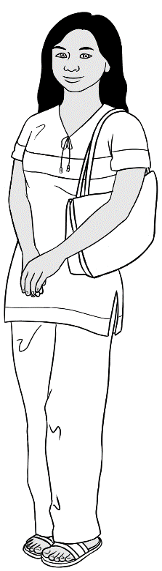
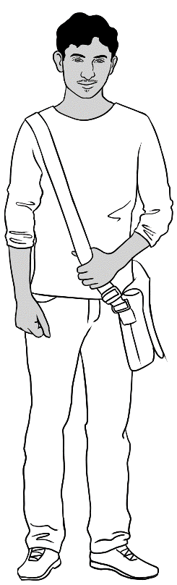
Do you like playing soccer?

Yes.
No.
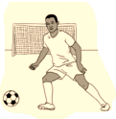

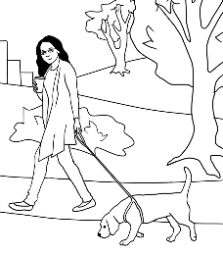
Do you like walking?

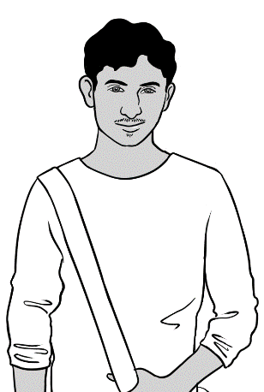
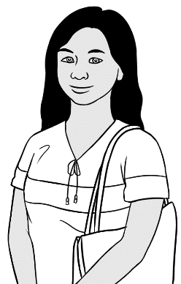
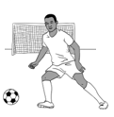
I like playing soccer.
I like walking.

ncourage body language.
- Do you like playing soccer?
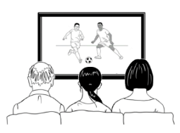
- Do you like watching TV?
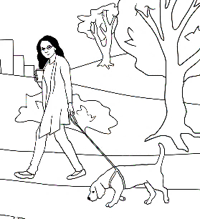
- Do you like walking?

Ask students to tick and then tell you and
their partner what they like.

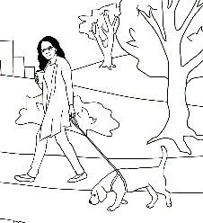

I like

Tea or coffee?
Do you like tea or coffee?



2.

milk
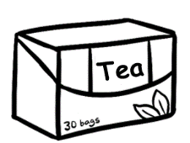

tea


coffee
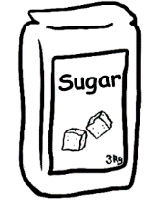
sugar
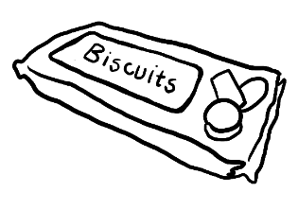
biscuits

13


Would you like
tea or coffee?
Tea please.

Yes please.
No thanks.
Milk?
Sugar?

Biscuits?
Yes please.

14
Would you like
tea or coffee?
Coffee please.

Sugar?
Milk?
No thanks.
Yes please.

Biscuits?
No thanks.

- Would you like tea?
- Would you like coffee?
- Would you like milk?
- Would you like sugar?
- Would you like biscuits?

Correctional stress - Chant in two teams.
15

Would you like tea?
Tea?

No thanks.
Yes, tea.

 | - Would you like coffee? | - Coffee?
 | - Yes, coffee. | - Yes please.
 | - Would you like milk? | - Milk?
 | - Yes, milk. | - No thanks
 | - Would you like sugar? | - Sugar?
 | - Yes, sugar. | - Yes please.

This chant could be said at the end of every class.
Time to go.

Bye
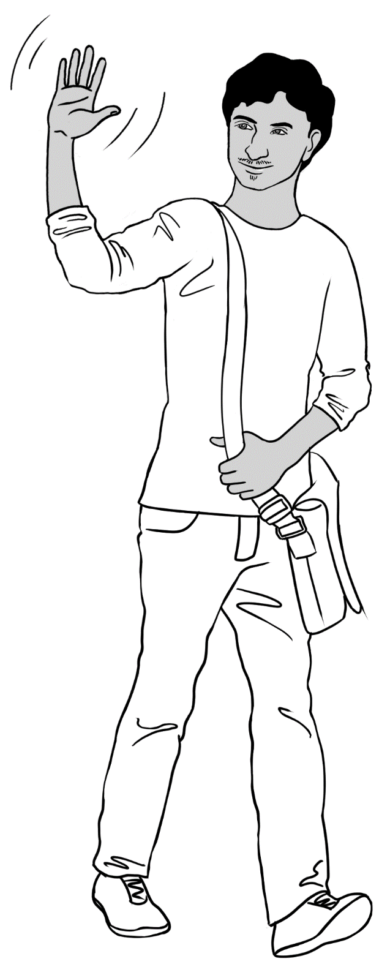
See you soon.
Bye.

Bye
See you later.

Bye
See you tomorrow.

Bye
See you Monday.

