English Ready
22636VIC Course in Initial EAL
VU23489 Recognise letters of the alphabet and their sounds in extremely familiar words VU23491 Recognise and copy extremely familiar words
VU23492 Participate in extremely familiar spoken exchanges
Teacher Resources


A - B - C - D

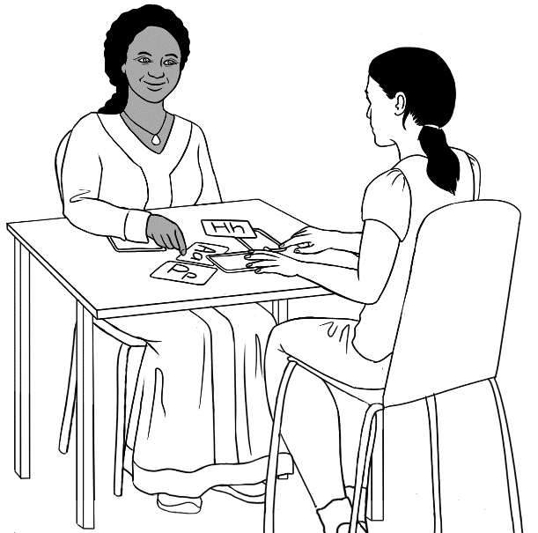
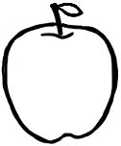
apple a

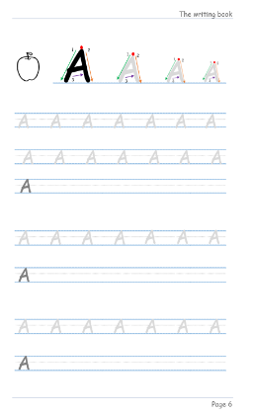


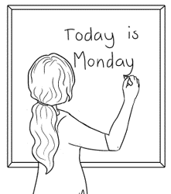
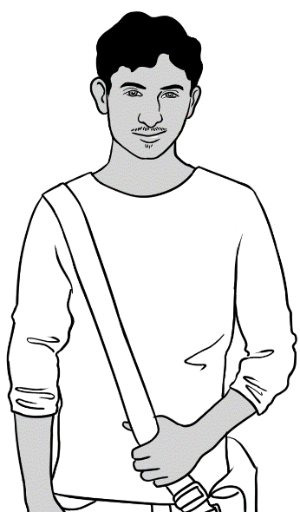
Hi.

Design team: Vicki Hambling, Sue Paull, Frida Dean, Glenise Kleehammer and Mary Wallace
Illustrations: Madelena Scott
Acknowledgements: The design team would like to thank the AMEP service providers and practitioners who participated in the trial and gave valuable feedback. The team would also like to acknowledge the use of the EAL Framework which underpins the design of this book.

Copyright of the EAL Framework is reserved to the Crown in the right of the State of Victoria. © State of Victoria (Department of Education and Training) 2023.
__________________________________________________________________________________
This English Ready Resource is licensed under a Creative Commons Attribution-NoDerivs 3.0 Australia licence (More information is available here). You are free to use, copy and distribute to anyone in its original form as long as you attribute Department of Home Affairs as the author and you license any derivative work you make available under the same licence.
© Commonwealth of Australia 2023

With the exception of the Commonwealth Coat of Arms, the department’s logo, any material protected by a trade mark and where otherwise noted all material presented in this document is provided under a Creative Commons Attribution 4.0 International (https://creativecommons.org/licenses/by/4.0/) licence.
The details of the relevant licence conditions are available on the Creative Commons website (accessible using the links provided) as is the full legal code for the CC BY 4.0 licence (https://creativecommons.org/licenses/by/4.0/legalcode).
Use of all or part of this document must include the following attribution:
© Commonwealth of Australia 2023
As far as practicable, material for which the copyright is owned by a third party will be clearly labelled. The department has made all reasonable efforts to ensure that this material has been reproduced in this document with the full consent of the copyright owners.
Copyright requests and enquiries concerning usage not addressed by the CC BY 4.0 licence should be addressed to: comms@homeaffairs.gov.aumailto:AMEPInfo@homeaffairs.gov.au at the Department of Home Affairs.
The terms of use for the Commonwealth Coat of Arms are available from the It's an Honour website.
Where a copyright owner, other than the Commonwealth, is identified with respect to this material, please contact that third party copyright owner directly to seek permission.



Table of contents
1. Introduction VU23489, VU23491, VU23492 2
2. Meet the people VU23489, VU23491, VU23492 4
3. Workbook instructions VU23489, VU23491, VU23492 8
4. Speaking - Body Language VU23492 14
5. Letters - The names VU23489 18
6. Letters - Upper and lower-case VU23489 22
7. Letters - Alphabetical order VU23489 29
8. Letters - The sounds VU23489 34
9. Words – Handwriting VU23491 79
10. Speaking - Greetings and information VU23492 86
11. Speaking - Classroom items VU23492 89
12. Speaking - Follow instructions VU23492 99
13. Important words – Names VU23489, VU23491 108
14. Letters - Word identification strategies VU23489 113
15. Teach in context. 125
16. Audio transcripts 129

Introduction VU23489, VU23491, VU23492

The Teacher Resources
The oral and kinaesthetic activities in this book utilise a variety of senses
to improve memory retention. The most productive classes are noisy and active. Resources here aim to promote noisy active learning. They include:
- drawings of the characters to use for the design of additional materials
- flashcards for printing
- individual and class activities
- revision and homework
- pronunciation
- extension exercises
- audio transcripts. Audio Mp3 files are saved in a separate file.

The book is an electronic reference and all materials can be adapted and then printed as needed. Worksheets have teacher notes that can be removed prior to printing.

The Student Workbook
The student book requires teacher direction and is not intended for independent learning. It is also not intended to be the only material used
to teach these units or to be used as an assessment task. It is highly recommended that students buy and use a notebook for general class work and practice.

The book is available as a Word document so that teachers can:
- localise and update the content
- adjust the material to suit the requirements of particular classes and students
- delete or add materials as required. If you add or deduct pages, be mindful of the layout as the document has been designed so that particular pages are opposite one another.

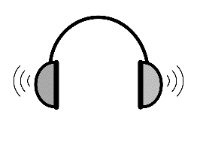
NB. Teacher versions of the student workbooks contain notes to guide activities and also answers for some listening exercises.
This icon is used to indicate audio Mp3 files.
There are seven books to address the three units:
VU23489
1. Letter Names - develops the ability to recognise and reproduce the names of the letters and also highly familiar words.

2. Letter Sounds - develops awareness in recognising and producing the foundational sounds of English.
3. My Dictionary – is a template for consolidating and extending vocabulary; it can be adapted and extended for individual, home and class work.

VU23491
3. Writing - includes detailed instruction and practice of handwriting. The entire book or individual pages can be copied for students who require additional writing practice.

4. Words - gives practice in recognising and copying letters, common letter combinations and familiar words.

VU23492
5. Speaking - provides a framework for students to learn simple greetings, participate in a classroom and respond to requests for basic information.

A special note:
In daily life we generally spend about 80% of our time listening and speaking a language and about 20% of our time reading and writing it. That’s a good ballpark figure to keep in mind when you plan lessons. (Literacy Network)

Meet the people VU23489, VU23491, VU23492
Drawings of the characters
The characters have been included so that teachers can produce their own materials as needed. The chart with the bio data was created to maintain consistency of information throughout the booklets. It may be useful to update character information to make it more relevant to the time of use.

Name | Country of origin | Date of birth | Date of arrival | Address in Kellivale  2421 | Phone
Zarni Tun | Myanmar | Age 45  10. 04. 1978 | - | Unit 4, 50 Baker Road | 0407 326 518
San Tun | Myanmar | 15.11.2001 | - | Unit 4, 50 Baker Road | -
San’s baby son | Australia | Age  4 months | - | Unit 4, 50 Baker Road | -
Jamila Desta | Ethiopia | Age 50 | - | 56 North Street | 0408 629 531
Anika  Desta | Ethiopia | 30. 09. 1995 | 15.10.22 | 56 North Street | 0477 193 286
Sahra Omar Elmi | Somalia | 07. 07. 96 | 9.6.22 | Unit 6, 50 Baker Rd | 0455 961 259
Tahiil Jama Dihoud | Somalia | 27. 06. 94 | 9.6.22 | Unit 6, 50 Baker Rd | 0400 785 936
Hani Tahiil Jama | Somalia | 24. 06. 21 | 9.6.22 | Unit 6, 50 Baker Rd | _
Abdi Omar Elmi | Somalia | 04. 08. 04 | 13.10.15 | Unit 1, 50 Baker Rd | 0465 971 356
Pam | Australia | 02. 02. 1956 | - | Unit 5, 50 Baker Rd | 0407 165 972
Receptionist  [Kim] | Vietnam | Age 30 | - | - | -
Teacher  Rosie | Australia | Age 45 | - | - | -
Characters shaded are introduced in the Course in Initial EAL books.
Characters unshaded are also in the Course in EAL books.

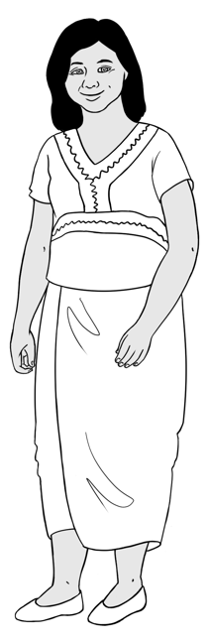 | 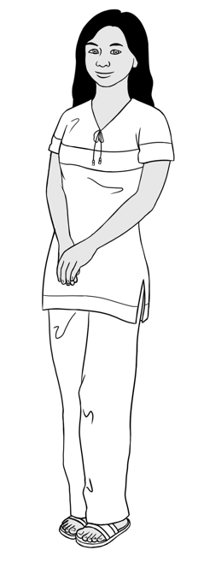 | 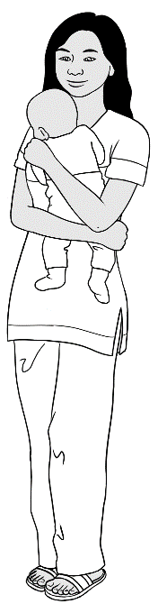 | 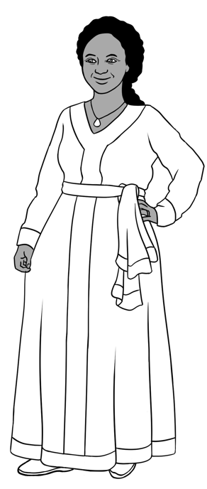 | 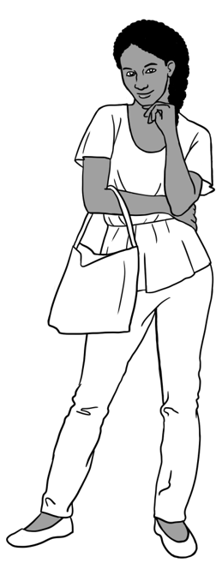
Zarni Tun | San Tun | San’s  baby son | Jamila Desta | Anika Desta

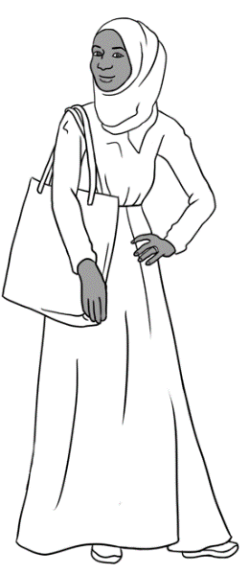 | 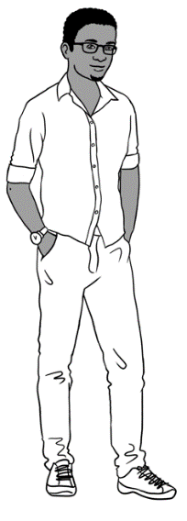 | 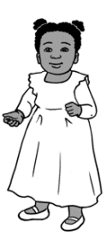 | 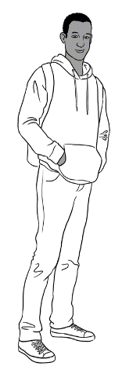
Sarah Elmi | Tahiil Dihoud | Hani Jama | Abdi Elmi

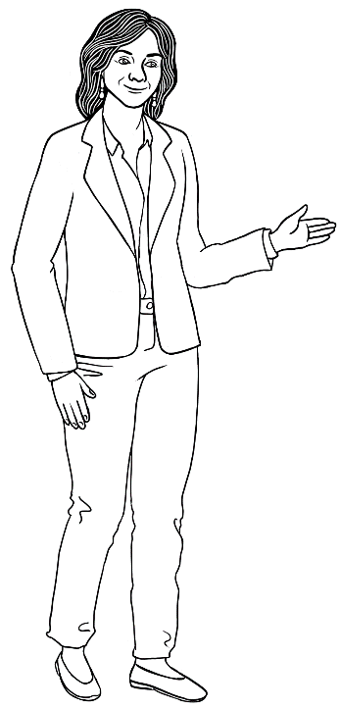

Teacher - Rosie

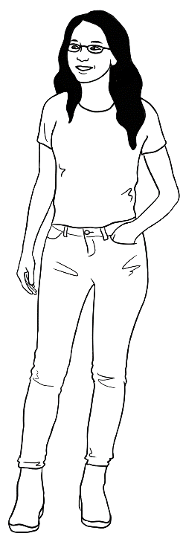
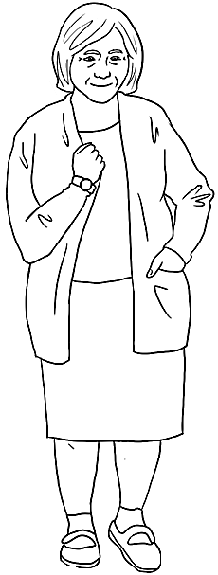

Neighbour - Pam
Receptionist - Kim

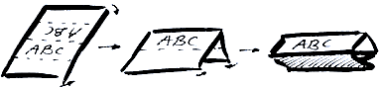
Activities with names
- Word stress
Write student names on the board in lists according to the number of syllables. Mark the stress with a large circle and practise together. Clap, stamp feet or use a rubber band to mark the main stress.

San Zarni Anika Jamila

- Name cards
Fold and create name cards for each student. The teacher writes each student’s first name on one side of the card or paper, and their family name on the other side. * The name cards can be used to copy from in class.

- At the beginning of each lesson hand the name cards out to the students. The students put the card at the front of their desk.
- As students learn the alphabet, hold up each card and ask, Whose name begins with …. ? Use it as an opportunity to practise the letter names and later the sounds.
- Lay the names out on a table, and students pick up their names as they come in.
- Have a list of names at the door and students mark off their names as they come in.
- Start each lesson by flashing a name card and asking ‘Who is this?’

* The spelling of names is very important. Students need to use the spelling
on their passport as this is the legal representation of their name.

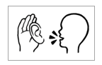
Workbook instructions VU23489, VU23491, VU23492
The following table gives a more detailed explanation of the instruction icons and may be a useful reference in developing class materials.
The first two instructions, Listen and Say are usually combined to mean
Listen and Repeat.

This double icon is the first instruction for most exercises in the workbooks as it is a key learning strategy at this level. The word ‘repeat’ needs to be introduced to students early in the course.

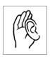  - Listen | Listen carefully to the teacher. |   Good morning.
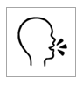  - Say | Repeat what the teacher says. | 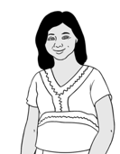  Good morning.
  - Copy | Copy the letters  or words below  the model. | man  _______  man  m_n
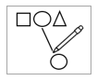  - Match | Match the letters or words. | man
  fan | 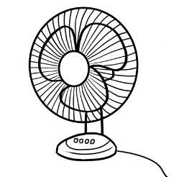
  man | 

  - Colour | Colour the letters.  Colouring strengthens the muscles used in writing and the use of colour aids memory.
  man
  man
  - Circle | Circle the letters or words. | man
  m | f | a | s | n
- Tick  P | Tick the words or sentences. | 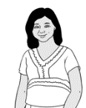  What do you have? have
  pen
  pencil
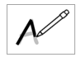  - Trace | Trace over the grey letters. | man  man
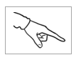  - Point | Point to the word/ sound the teacher says. |   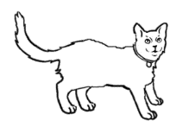  hat cat man
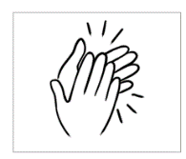  - Clap | Listen to the teacher and clap the syllables; stress the strong syllables. | 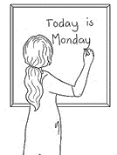  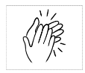  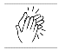  teacher

Workbook instructions flashcards
Due to the students’ level of literacy, icons replace written instructions in the workbooks. Instructions and guidance for all activities must be given by the teacher. Where necessary, some teacher instructions have been given in a small grey font.
To develop independent learning skills, the class activities below can help students recognise and understand the meaning of the icons.
- Icon flashcards
Enlarge, cut up and introduce the icons gradually without the words as they occur in the workbooks. Blutack the icon cards to the board or walls for reference at different times throughout the class and ensuing classes.
- Matching
When the icons are familiar to the class, introduce the written instructions for matching. Give each student either an icon or a written instruction. Students then walk round the room to find the student with the matching card. Blutack the written instructions next to the icon on the board or wall. This is a useful way to pair students for pair work.

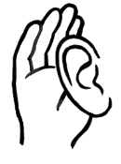 | listen
 | say

P | tick
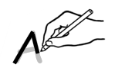 | trace
 | colour
 | circle

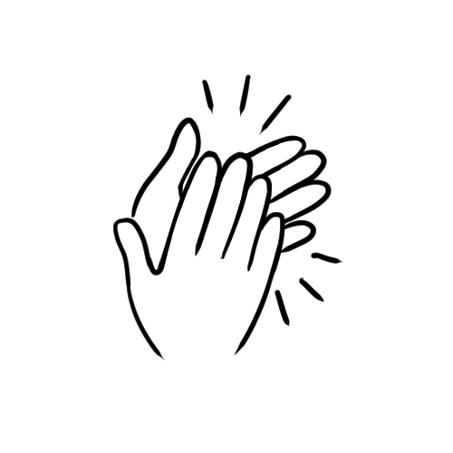 | clap
 | copy
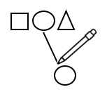 | match
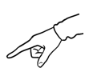 | point
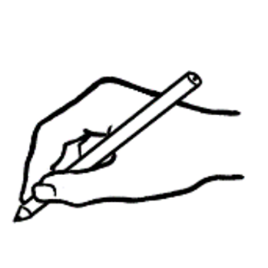 | write
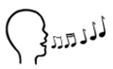 | sing
 | read

Speaking - Body Language VU23492
Activity 1 - Make requests for repetition or clarification
Although the requests for clarification and repetition are specific to the speaking unit [VU23492], they are important in all units. Print the requests below, laminate and cut up. Build confidence by modelling the expressions and through regular class practice:
- Give the three expressions to three students. Select the most confident students at first.
- Ask these students to use their expression at least once during the class – initially with the teacher and later with each other.
- Give the expressions to different students in following classes.
- Teach additional expressions when appropriate.

I don’t understand.
Can you help me please?
Can you spell that please?

Activity 2 - Body language
Activities
- Use body language to convey and support meaning. Get students to repeat the workbook instructions and copy the body language. This supports memory retention. e.g. listen, say, circle, point, copy,
- Revise vocabulary by miming a word and students guess the word.
- Distribute pictures from the books and invite students to mime a word for the class to guess.
- Nouns: apple, umbrella, hat, door, bag, lip
- Verbs: dig, stop, stand, read, fish, listen etc.
General
Body language gestures can have different meanings in different countries. For example, many Sri Lankans shake their heads when they say yes, and some cultures find the action of pointing at a person very offensive.

The hand actions and facial expressions below could mean different things in different countries, so it is good to teach what they usually mean in Australia. However, depending on the context, their meaning can vary here too.

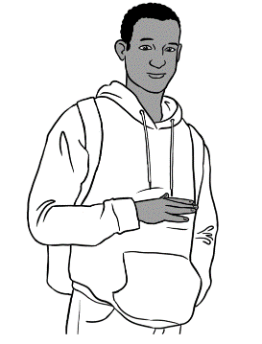

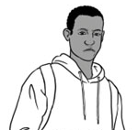

Not good
Disagree
Neither good nor bad
So-so
50 / 50
Good
OK
Yes


I don’t understand.
I don’t know.

Numbers
Use different situations to contextualise signing numbers. e.g. prices for shopping items. The At the supermarket exercise on the following page relates to shopping for a morning tea at the end of the Speaking workbook.
Teachers need to demonstrate hand signs for the numbers 0 - 10, and be aware that students may have used different signs in their country of birth.
e.g.

Activity – Numbers at the supermarket
- Practise the hand and finger signs for the numbers 0 – 10.
- Project the following page onto the board or a screen with a data projector or make copies for each student.
- Teach the vocabulary on the shopping list and clap the syllables.
- Ask the questions and students use their hands and fingers to show the price.
Extend this activity by using the hands and fingers to indicate the price
of other low-priced familiar objects. e.g. classroom items, fruit and veg etc

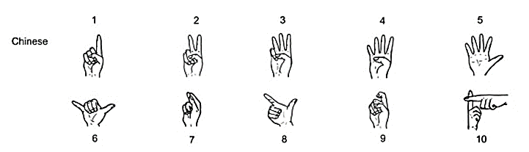

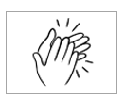
At the supermarket
My shopping list.
  milk | $3
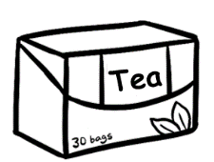  tea | $5
  coffee | $8
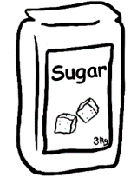  sugar | $4
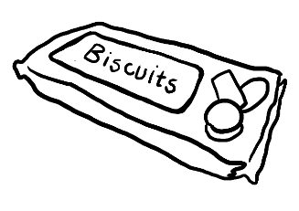  biscuits | $6
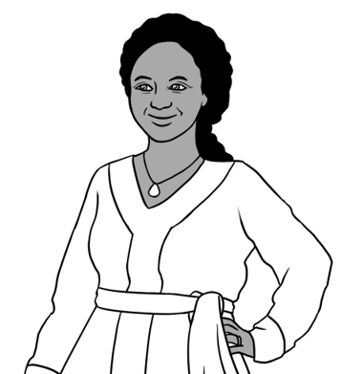

How much is the milk?
How much is the tea?

How much is the coffee?

How much is the sugar?

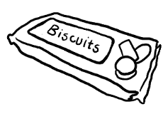
How much are the biscuits?

Letters - The names VU23489
Memorisation of the letter names – Some ideas
- Write the alphabet at the top of the board at the start of every class. The students need to watch the formation and say the name of each letter.

- Cut up and laminate the alphabet strips on page 21 for each student to place on their desks.
- Insert the alphabet at the top of any additional worksheets.
- Get the students to record the audio recording of the alphabet on their phones. There is a time gap after each letter which allows students to repeat the letter.
- Use tactile experiences such as taste, movement and sound as well as visual experiences. e.g. to teach the word lemon:
- Throw a lemon to students and each time you throw it, students say lemon.
- Cut up a lemon and get students to smell and taste it.
- Say the word and get students to clap the syllables.
- Get students to copy the word and say each letter as they write and say the word.
- Match the letter l with lemon.
Revision, repetition and kinesthetic approaches
Repetition, revision and moving slowly are extremely important for literacy learners. Build on the students’ current learning strength which is usually oral competency.
- Before teaching a new letter go back to the beginning and revise the letters done and then add new letters. The technique is revise and add, revise and add.
- Air writing – write letters in the air to support letter formation.
- Trace the letter with a finger on the table before writing it. Students say the name of the letter out loud as they write each letter.

- Tactile experience of forming letters in playdough or sand or paste confetti onto a letter, so that the students can trace and feel the letter shape.
- Students colour the letters to support visual recognition.
- Cut a letter into 3 or 4 pieces to make a jigsaw.
- Teach students to clap their hands and then clap their thighs. Use these actions while saying the letters so there is both movement and sound. e.g. A clap hands B clap thighs C clap hands D clap thighs etc. Alternatively students could tap their shoulders and desks.
- Ask students to stand up and walk around the room repeating the letters you are teaching.
- Students point to the letters on the alphabet strips as the teacher randomly calls them.
- Students write about ten letters on a page. Show the class a letter and students circle it on their paper.
- Practise minimal pairs
e.g. V and B, E and I, R and L, Q and U, J and K
- Find, point to and say the names of letters in words around the room.
- Cut out specified letters from magazines or supermarket catalogues and create a class or group collage. Students repeat the names of the letters as they cut and paste.

Alphabet bingo
- Print copies of the bingo card templates on the next page.
- Give each student a card.
- Into the five spaces on the card, students copy any letters from their alphabet strip.
- Use an alphabet strip as the master sheet to call the letters.
- Teacher calls out a letter. Students mark off the matching letter on their card with a pencil or bits of paper.
- With all letters marked off their card, the winner calls out ‘Bingo’.
- The same cards can be used for multiple games if bits of paper or counters are used.

A confident student could be the caller in later games.

Alphabet bingo cards
Bingo

Bingo

Bingo

Alphabet strips Copy, cut up and laminate. Enlarge and print onto A3 paper if required.
Aa | Bb | Cc | Dd | Ee | Ff | Gg | Hh | Ii | Jj | Kk | Ll | Mm
Nn | Oo | Pp | Qq | Rr | Ss | Tt | Uu | Vv | Ww | Xx | Yy | Zz
Aa | Bb | Cc | Dd | Ee | Ff | Gg | Hh | Ii | Jj | Kk | Ll | Mm
Nn | Oo | Pp | Qq | Rr | Ss | Tt | Uu | Vv | Ww | Xx | Yy | Zz
Aa | Bb | Cc | Dd | Ee | Ff | Gg | Hh | Ii | Jj | Kk | Ll | Mm
Nn | Oo | Pp | Qq | Rr | Ss | Tt | Uu | Vv | Ww | Xx | Yy | Zz
Aa | Bb | Cc | Dd | Ee | Ff | Gg | Hh | Ii | Jj | Kk | Ll | Mm
Nn | Oo | Pp | Qq | Rr | Ss | Tt | Uu | Vv | Ww | Xx | Yy | Zz

Letters - Upper and lower-case VU23489

Note: In the student books, upper and lower-case letters are referred to as
capitals and small letters as these are more commonly used terms.
Upper and lower-case letter tiles
Print the pages of letter tiles, enough for each student to cut up and have their own set. Distribute envelopes in which to store the tiles for future use.
Ideas for use:
- Individual or Pair work
  - Two sets of lower-case alphabet cards [each set a different colour]- students match the same letters together.
  - Two sets of upper-case alphabet cards [each set a different colour to the lower-case] – students match the same letters together.
  - One set of upper-case and one set of lower-case alphabet cards – students match the same letters together.
- Students work in pairs with one set of either capitals or small letters. They put their letters into alphabetical order. One student turns their back and the other removes one letter, and pushes the cards together to disguise the gap. The other student must say which letter is missing.

- Class work
        - Give students one upper or lower-case letter and ask them to find their partner.
        - Say the name of a letter; students hold up the letter or place it on their desk.

- Group work
Lay out the alphabet cards on a table in a row, not necessarily in alphabetical order. Students work in groups and roll a dice to move along the path. Each time they stop, they say the letter. If they make a mistake, they move back two places.

Games
- Memory [Groups of 2 – 4]
Use the first 13 letters of two sets of alphabet tiles. Place them face down on the table. Students take turns to turn two cards over and find a pair. As they turn each card over, they say the names of the letters. The student with the most pairs wins.
- Letters Smack [Two teams]
Use two new different-coloured flyswats for this game. Write the alphabet randomly on the board. Choose a volunteer from each team and give each a fly swat. Call out a letter. The first to swat the letter wins a point for their team. Continue till everyone has a turn.
- Pick a letter [Groups of 2 – 4]
Students put sets of letters in small tubs and take turns to pull out and name a letter.
- Musical Letters [Whole class]
Arrange alphabet flashcards in a circle on the floor. Students make a circle around the cards. Play some music. When the music stops, students identify the letter nearest them. An extension for more capable students would be to say a word starting with the letter.
- Alphabet Fish [Groups of 2 – 3 players]
The aim of the game is to collect pairs of cards with the same-letter. Use two sets of alphabet tiles to make the game easier.
- Shuffle the cards and deal out seven cards to each player, leaving the rest in a deck face down in the centre.
- Students check their cards for pairs with the same letter and put these cards on the table in front of them.
- The first student asks the student on their left if they have a particular card e.g. ‘Do you have a t?’
- If that student has a t, he/she says ‘Yes I do,’ and hands the card over. The student puts the pair of cards on the table in front of them for counting later.
- If the student doesn’t have a t, he/she says ‘No I don’t. Fish!’ The first player takes a card from the deck. The turn goes to the next player who asks the person on the left for a card.
- The game continues until one player is left with no cards in their hand.
- To score: Students count their pairs. The winner has the most pairs.

A | B | C
a | b | c
D | E | F
d | e | f

G | H | I
g | h | i
J | K | L
j | k | l

M | N | O
m | n | o
P | Q | R
p | q | r

S | T | U
s | t | u
V | W | X
v | w | x

Y | Z
y | z

Letters - Alphabetical order VU23489
Whole class activities
- The disappearing alphabet - Write the alphabet in order on the whiteboard. Read with the students. Rub out one or two letters and put a line in place of the letter. Ask the class to read again saying the missing letters. Slowly rub out most of the letters while students read the letters, including the missing ones. Finally, rewrite the letters as the students read.

- Round the class - The teacher begins by saying A, the next student says B, the next C and so on.

- Three teams - Students line up in teams in front of the board. When the teacher says Go, a student from each team writes A, the next student writes B and so on. The first team to complete the alphabet in the correct order wins.

- A class alphabet - Each student is given a letter tile and lines up in alphabetical order. Then students read their letter aloud in order.

- Missing letter - Print and cut up enough of the cards on the following page so that each student has one card. Students write the missing letter, either in upper or lower-case. They then arrange the cards in alphabetical order on the whiteboard using magnets or Blutack. Students then read the letters aloud in order.

Pair work
- Use one set of alphabet tiles for each pair. Mix them up and the students put them in order. Each student reads the letters aloud to their partner. This can also be done as an individual activity.

Cards for the Missing letter activity
A |  | C
D |  | F

G |  | I

J |  | L

M |  | O

P |  | R

S |  | U

V |  | X

Y

a |  | c

d |  | f

g |  | i

j |  | l

m |  | o

p |  | r

s |  | u

v |  | x

y

Letters - The sounds VU23489
Introduction
As much as possible, sounds need to be taught in context. Teaching in themes e.g. classroom, family, food, shopping, health, beach, park etc.
is an excellent approach, but is limited by students’ grasp of oral vocabulary.
See Section 15 for an example of this.
The teaching of sound/letter relationships needs to be done with words that the students already know orally so there is a cognitive hook.

- Pronunciation
Distribute handheld mirrors so students can look at their mouths and lips as they make the sounds. Model the sound first and exaggerate it so the students can clearly see the movement of the mouth as the sound is made. This activity can help learners improve their pronunciation.
The following video may be a useful reference for teachers:
Bill Hansberry – The 44 sounds of the English language – Australian accent
The 12-minute video aims to develop some phonemic awareness. After the introduction [at 5 mins 45 secs] the speaker gives a guide to the 44 sounds in a clear Australian accent. https://youtu.be/HGQoS4SZez0

Pronunciation - Short vowels
The short vowels are the first vowel sounds taught and learnt. However, they are difficult to distinguish and need regular practise. The following hand gestures may be helpful memory prompts.
a - As you say the sound, pretend to bite an apple.
e - Make a narrow V-shape with the middle and index fingers.
Hold the fingers horizontally in front of the mouth when saying the
sound. This is a reminder not to open the mouth too wide.
i - This sound is very short; tap the side corner of the mouth with
the shortest finger.
o - Drop the jaw a little and circle the mouth with a finger.
u - Say u u u while pointing up with the index finger on each sound.

Pronunciation th
The letters th make two different sounds:
- Unvoiced as in Thursday, three, thanks
- Voiced as in the, then, mother.

Both sounds are made by separating the top and bottom teeth with the tip of the tongue. Blow air through the small gap over the tongue.
- The unvoiced sound as in Thursday is made by simply blowing air. Demonstrate by saying the word into the palm of the hand to feel the airflow.
- The voiced sound as in the is made with the addition of the voice and vocal chords. Demonstrate by placing the palm over the throat to feel the vibrations.

Teach the th words listed below as they arise, beginning with Thursday and other unvoiced th words.

th unvoiced |  | th voiced
Thursday | three | the | that
thanks | thirteen | they | then
 | thirty | them | this

2. Activities with initial sounds and blends

- Round the table [Groups of 3 – 4]
Students lay out a set of alphabet tiles around the edge of their table. Play music. Students walk around their table. When the music stops, the teacher says a word. The students try to be the first to pick up the first letter of the word.

- Using students’ sets of alphabet cards
- Students lay out their cards on the table. The teacher asks,
What is the first sound in _________? e.g. pencil
Students hold up p.
- Write a word on the board e.g. _ encil.
Read the word and students hold up the first letter

- An alphabet initial sounds dictionary
Students can add their own words and pictures to the dictionary.
A volunteer would be of great assistance in creating this book.

- Word bank sound sheets
Create word bank sound sheets for the wall, noticeboard or whiteboard. [See the template on page 41.]
Start with consonant blends, two consonants = one sound, and introduce long vowels and diphthongs when appropriate. Show students how these letters can be found at the beginning, the middle and the end of words. e.g. shoe and fish, chair and teacher, clock and bucket,
- Use light cardboard or paper.
- Enlarge the sound tiles on the following page and paste a tile at
the top of each sheet.
- Add new words to the sheets as they are introduced in class.
If possible, leave the sheets on the walls for easy revision and to aid visual memorisation. However, if the sheets need to be removed at the end of class, use magnets to attach one or two of the sheets to the whiteboard in following classes so that the words and sounds are revised regularly.

e. Game - Race against the clock: a is for apple
You need:
- A set of alphabet cards and a set of picture cards for each pair of students. Use a small number of cards and pictures when first playing the game.
- An egg timer or timer on a phone.

Instructions:
- Students work in pairs with a set or part of a set of alphabet cards.
- Give the corresponding letter and picture cards to each student pair.
- Set the timer to a time appropriate to student ability.
- Students match the letter and picture cards.
- Everyone stops when the time is up.
- The pair that beats the clock or with the most matched cards wins.
For writing practice and to aid memory, students can copy the words on the cards into their notebooks.

Extension
Create cards with new words and pictures as they are introduced in class.

Initial sound tiles for alphabet sound dictionaries or wall charts.
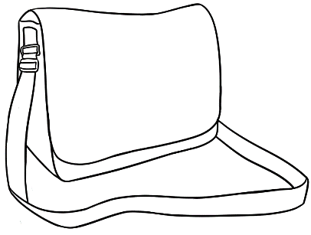
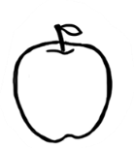
b bag
a apple

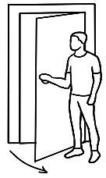

d door
c cup


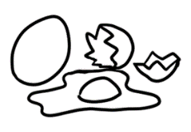
f family
e egg


g glasses
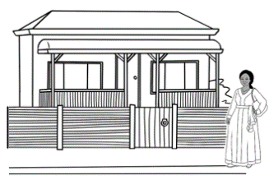
h home



j jacket
i ink


l lemon
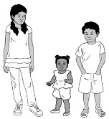
k kids


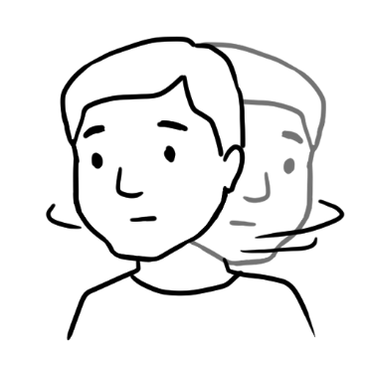
m man
n no

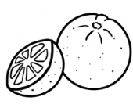

o orange
p pencil

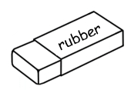
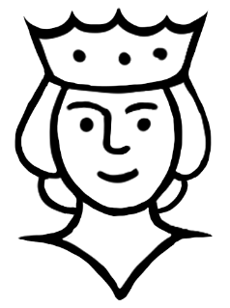
r rubber
q queen

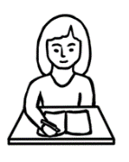
t teacher
s student

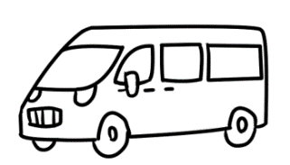

v van
u umbrella

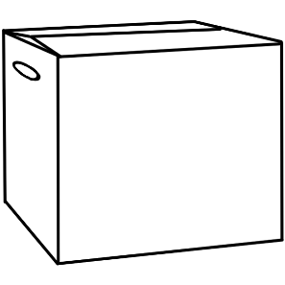

x box
w woman

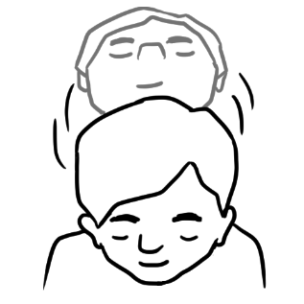
z zero
y yes

Consonant blends sound tiles
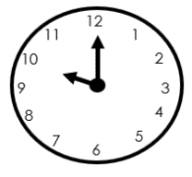
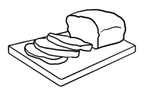
clock
bread


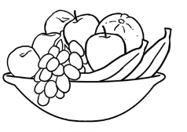
stop
fruit


tree

Two consonants = one sound tiles
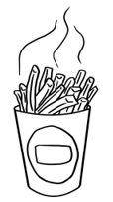
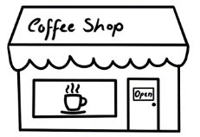
chips

shop

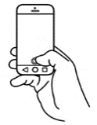
three

3
phone

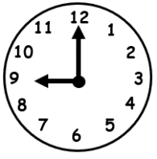
clock

shop

Template for a wall chart

apple | bag | cup
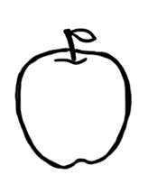 |  | 
door | egg | family
 | 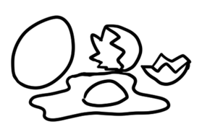 | 
Initial sounds – Cards for activities

glasses | home | ink
 |  | 
jacket | kids | lemon
 | 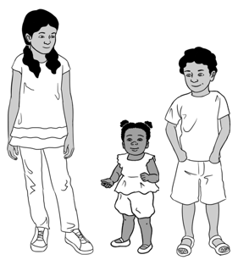

man | no | orange
 |  | 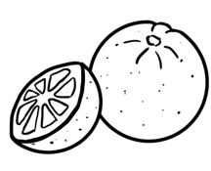
pencil | queen | rubber

student | teacher | umbrella
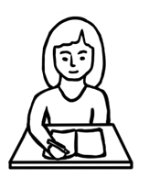 |  | 
van | woman | box

yes | zero
 | 0

Consonant blends and two consonants = one sound - cards
br | br | br
bread | 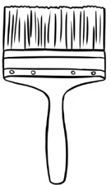  brush |   broom
cl | cl | cl
clock |   clap | 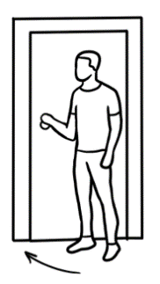  close

fr | fr | fr
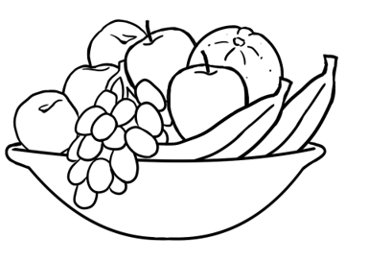  fruit | 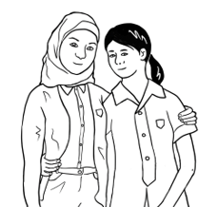  friend | Friday  Thursday  Friday  Saturday  Sunday
st | st | st
stop | 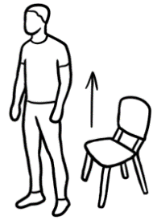  stand | 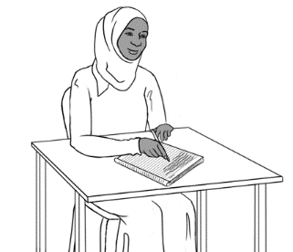  study

tr | tr | tr
  tree |   train | 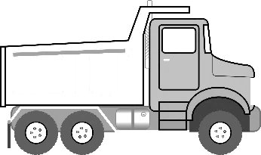  truck
sh | sh | sh
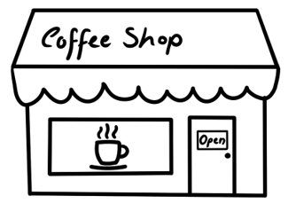  shop | 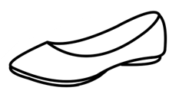  shoe | 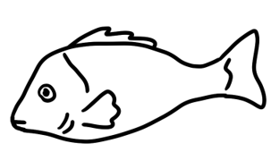  fish

ch | ch | ch
chips | 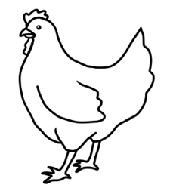  chicken | 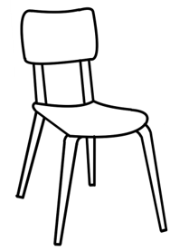  chair
ph | ph
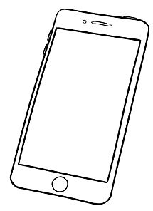  phone | 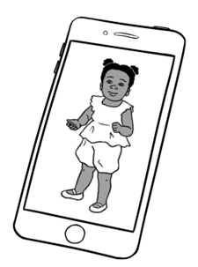  photo

th | th | th
three  3 | thirteen  13 | 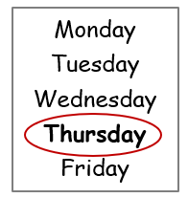  Thursday
ck | ck | ck
clock | truck | 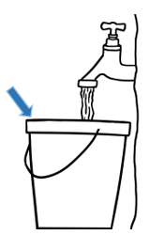  bucket

Short vowel words - cards
hat | cat | fan
man | bed | red
 | 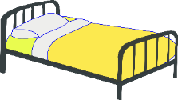 | 

pen | ten | in
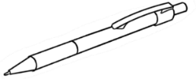 | 10 | 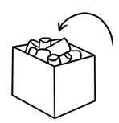
bin | lip | zip
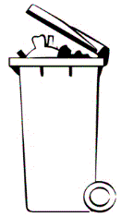 | 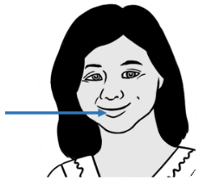 | 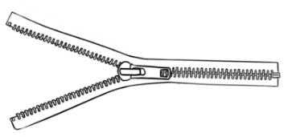

old | cold | mop
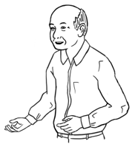 | 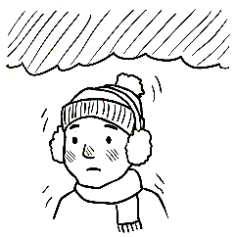 | 
stop | up | cup
 | 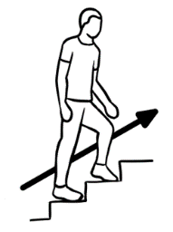 | 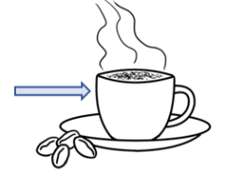

run | sun
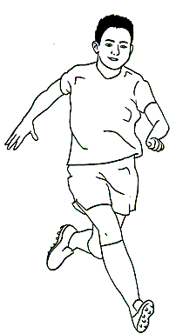 | 

Spare cards for new words

3. Long vowels

Long vowel exercises have not been included in the student book, but have been added here for extension work.
Show the difference between short and long vowels in a physical way. Separate your thumb and index finger a little to indicate a short vowel sound. Then stretch the gap out slowly between your thumb and index finger to indicate a longer vowel sound. The students do the same.
The following worksheets introduce long vowel sounds. These sounds are easier for students to hear than the short vowels.
Explain to students that:
- The long vowel sound is the name of the first of the two vowels.
e.g. ai = A as in train
ea = E as in tea
i_e = I as in rice
oa = O as in boat
u_e = U as in cute*
- The second vowel is silent.

Introduce the sounds gradually over several days or weeks and revise regularly. One way to do this could be to:
- project one long vowel sound worksheet from the pages following the letter tiles.
- say the sound and each word several times, with students repeating.
- explain the activities on the worksheet and then distribute.
[Remove the text boxes with teacher notes on the worksheets
before printing.]
- Introduce the next sound when appropriate.
The final worksheet is a listening activity which can be done when all the long vowels have been introduced.
*The long u has not been included in the worksheets on the following pages as there are fewer words with this sound and the words are less important at Initial level. The words cute and ute could be introduced if they are relevant for the class, but the long u patterns in words such as new, due are too difficult.

Long vowels sound tiles


train

rain

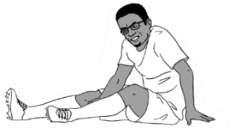
pain



read
tea

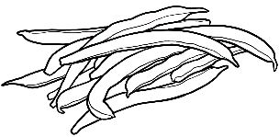
beans


rice
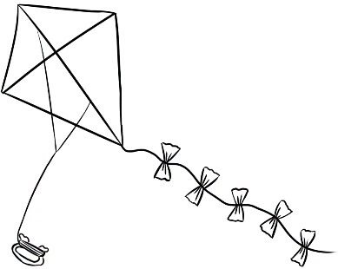
kite

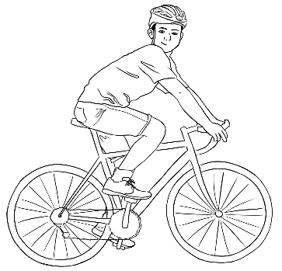
bike

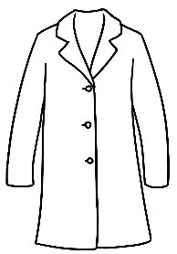
boat
coat
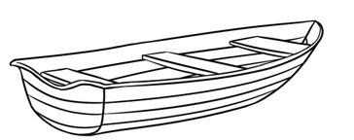


road
The long vowel sound is the name of the letter and can be written in different ways.
The three examples below are the most common ways to write the long a sound.

A
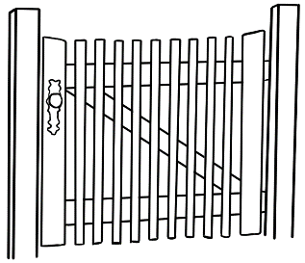  gate | rain | 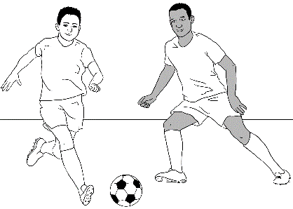  play

gate
rain
play

play

gate

rain

Words with ai are more familiar at Initial level.
Listen and repeat the words. Colour the ai and repeat
the long vowel sound while colouring. Then copy the letters.

ai
 |  | 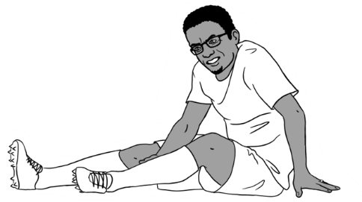
rain | train | pain
rain | train | pain
r__n | tr__n | p__n

Say the word, sound the word, say the word.

r | ai | n
rain rain
tr | ai | n
train train
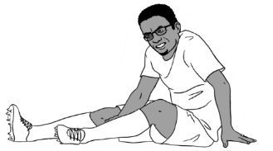
p | ai | n
pain pain
The long vowel sound is the name of the letter and can be written in different ways.
The three examples below are the most common ways to write the long e sound.

E
  tree |   tea | 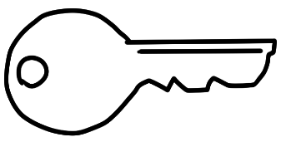  key

tree
tea
key

tea
key

tree

Words with ea are more familiar at Initial level.
Listen and repeat the words. Colour the ea and repeat
the long vowel sound while colouring. Copy the letters.

ea
tea |   read | 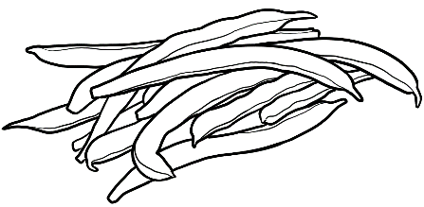  beans
tea | read | beans
t__ | r__d | b__ns

Say the word, sound the word, say the word.

tea | t | ea | tea

read | r | ea | d | read
beans | b | ea | ns | beans
The long vowel sound is the name of the letter and can be written in different ways.
The three examples below are the most common ways to write the long i sound.
I
  rice | 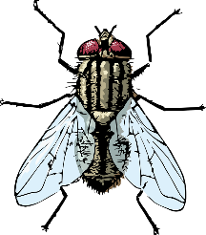  fly | 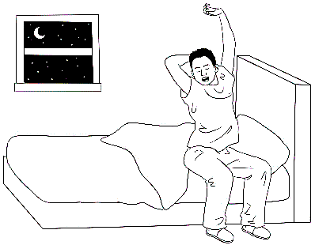  night

rice
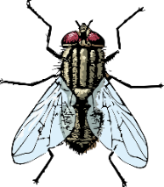
fly
night

night
rice

fly

Words with i_e are more familiar at Initial level.
Listen and repeat the words. Colour the i_e and repeat
the long vowel sound while colouring. Copy the letters.
i___e
rice | kite | bike
rice | kite | bike
r_c_ | k_t_ | b_k_

The final e is not sounded.

rice | r | i | c | e | rice

kite | k | i | t | e | kite

bike | b | i | k | e | bike

The long vowel sound is the name of the letter and can be written in different ways.
The three examples below are the most common ways to write the long o sound.

O
home | 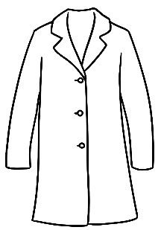  coat | 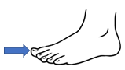  toe

home
coat
toe

coat
toe
home

Words with oa are more familiar at Initial level.
Listen and repeat the words. Colour the oa and repeat the long vowel sound while colouring. Copy the letters.

oa
coat | boat | 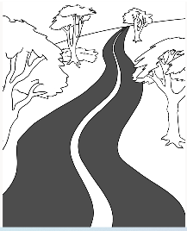  road
coat | boat | road
c__t | b__t | r__d

c | oa | t
coat coat
b | oa | t

boat boat
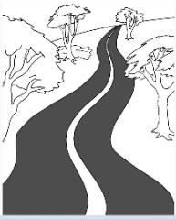
r | oa | d
road road

Listening exercise. The teacher says one word on each line.
e.g. train. Students circle the word.
  - train | rain
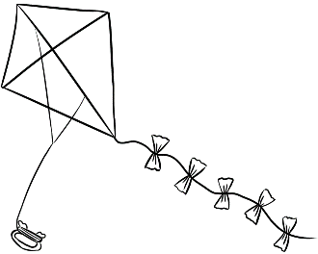  - kite | rice
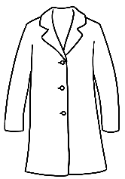  - coat | boat
- tea | read
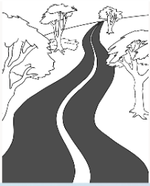  - road | coat

4. Diphthongs
Diphthongs have been included for extension work.

Diphthongs are vowel sounds made by sliding two letters together to make one sound and one syllable. Three of the most common diphthongs are shown on the worksheets following the long vowel sound worksheets. Introduce them one at a time, over different days.
- Project the first diphthong on the following page.
- Say the sound, the three words and the sound again.
- Say again many times while the students repeat.
- Give out the relevant worksheet for students to complete.
Project the revision sheet after all diphthongs have been introduced.

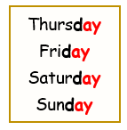

Diphthong sound tiles
day
say

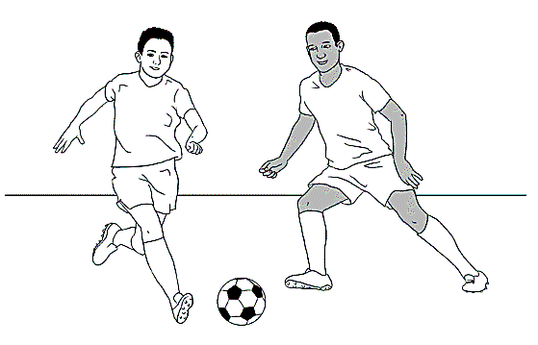
play


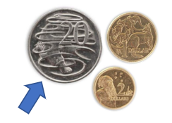
oil
coin

point


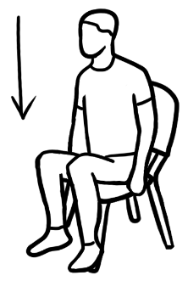
cow
down


clown

ay

day | say | play
Thursday  Friday  Saturday  Sunday | 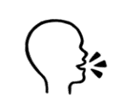 | 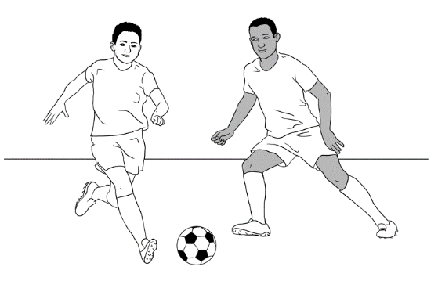
day | say | play

Thursday
Friday
Saturday
Sunday
day | say | play
d__ | s__ | pl__

oi

coin | oil | point
 | 
coin | oil | point

 | 
coin | oil | point
c__n | __l | p__nt

ow

cow | down | clown
 | 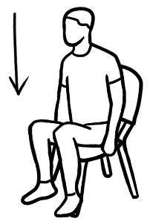 | 
cow | down | clown

This Photo by Unknown Author is licensed under CC BY-NC
cow | down | clown
c__ | d__n | cl__n

Revision sheet to project
Say the word, sound the letters and the diphthong, say the word.

s | ay
- say say

Thursday
Friday
Saturday
Sunday
d | ay
- day day

c | oi | n
- coin coin

oi | l

- oil oil

This Photo by Unknown Author is licensed under CC BY-NC
c | ow
- cow cow

d | ow | n
- down down

5. Word identification strategies - The shape of words
English has 44 different sounds and these sounds can be written in more than 650 ways. It is important students don’t rely solely on learning initial sounds, but to build a bank of sight words. The shape of a word assists word recognition.
- Write several familiar words in lower-case on the board and draw a line around each word shape. Then rub out the words to clearly show the shapes.
- Project the following pages and follow the instructions.
- The worksheets can be printed for homework.

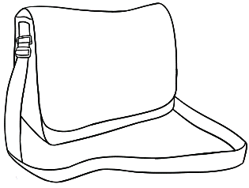
- apple bag
a | p | p | l | e
b | a | g


c | u | p
cup door
d | o | o | r


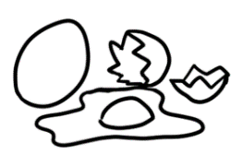
f | a | m | i | l | y
egg family
e | g | g

- glasses home
g | l | a | s | s | e | s
h | o | m | e



- ink jacket
j | a | c | k | e | t
i | n | k


- kids lemon
k | i | d | s
l | e | m | o | n

m | a | n
man no
n | o

orange pencil
o | r | a | n | g | e
p | e | n | c | i | l

queen rubber
r | u | b | b | e | r
q | u | e | e | n

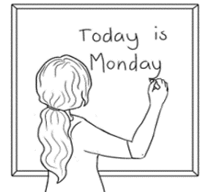
student teacher
s | t | u | d | e |  | n |  | t
t | e | a | c | h | e | r

u | m | b | r |  | e |  | l |  | l |  | a
umbrella van
v | a | n

woman box
w | o | m | a | n
b | o |  | x

0
yes zero
y | e | s
z | e | r | o

Match the word to its shape.

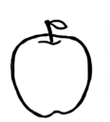
- apple
- cup
- family
- home
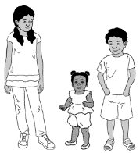
- kids

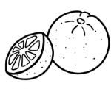
- orange
- woman
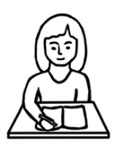
- student

Words – Handwriting VU23491
Writing fonts – some tips
- If you make your own worksheets use a simple font such as Comic Sans MS and a large font size. We have generally used font size 22, 24 or 26.
- Be mindful of the way a and g look in different fonts, and also how each font varies in size. Note the fonts below in size 14:
Calibri a & g, Comic Sans MS a & g, Century Gothic a & g,
Verdana a & g, Cavolini a & g, Arial a & g,
Tadoma a & g

- A free Teaching Print Font with dotted lines for tracing can be downloaded from the internet from this site:
https://www.fontspace.com/category/dotted-lines
NB. It was not possible to use dotted lines for tracing in the books as the font needs to be downloaded before it can be transferred and seen on other computer screens.
Some teachers may wish to purchase the NSW Foundation Font.
The NSW package includes fonts with sequenced strokes to assist
letter formation.

Writing the letters in formation groups
It may suit beginner writers to practise the letters in formation groups rather than alphabetical order. The letter formation groups are:
- Anticlockwise - a, c, d, g, q, e, o, f, s
- Clockwise - m, n, r, x, z, h, k, p, b
- i family - i, t, l, j
- u family - u, y, v, w

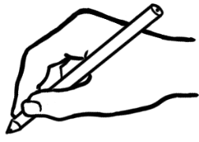

Important points to guide writing:
- Letter formation
- Write some letters in large size on the board. Emphasise:
- Letter starting and finishing points.
Vocabulary - start, left, right, up, down, around, end
- Number of strokes
Vocabulary - one, two, three
Encourage students to practise forming the letters in the air,
on their hands and desks.

- Project a page from the Writing book and demonstrate the meaning of the guiding symbols:
  - Red dot = start
  - Green arrow = 1st stroke
  - Yellow arrow = 2nd stroke
  - Purple arrow = 3rd stroke
- Letter position
Show students that all letters touch the writing line. This is especially important for Arabic speakers. Also important:
- The body of the letter sits on the line, the head extends up from the body, and the tail hangs down below the writing line.
- There are spaces between words and sentences.

- Pencil grip [right-handed]
- Hold the pencil between the thumb and top-bone of the middle finger, about two centimetres from the point of the pencil.
- Rest the index finger on the shaft of the pencil.
- Rest the shaft of the pencil on the webbing between the thumb and index finger.
- Curl the ring finger and small finger loosely under the middle finger to rest on the paper.
- Left-hand grip differs slightly to ensure visibility of writing.

Correct posture for handwriting
Correct sitting position and posture are important to optimise students’ ability to write comfortably. Demonstration by the teacher and checks of students’ posture can help students correct poor posture. Correct posture diagrams easily visible around the room provide ready reminders for students to check their sitting posture. The diagram below is also in the Writing and Words student workbooks.
Some basic correct posture features are:
- Sit fully back against the chair back
- Feet flat on the floor
- Knees at a 90-degree angle
- Back straight, the body leaning towards the desk
- Forearms resting on the desk with elbows level with desk
- Paper held steady with the non-writing hand
- Paper tilted up to the right. (for right-handers)

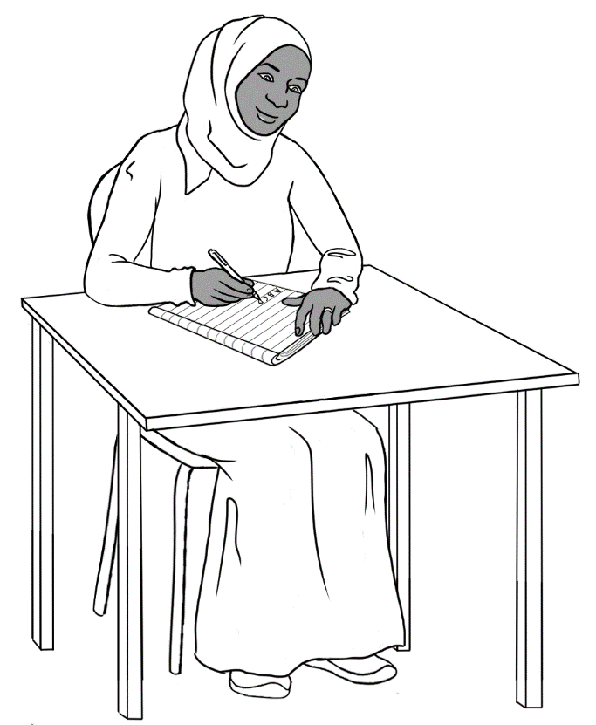
Correct sitting posture for handwriting

Handwriting activities
- Absolute beginner writers
Absolute beginner writers could practise pre-writing strokes on the back of recycled paper:
- Lines - vertical, horizontal and diagonal
- Circles-clockwise and anti- clockwise
- wavy lines from left to right
- curves-opening up ( for u, y, v, w), and opening down ( for m, n).
Make sure students are using correct pencil grip.
2. Beginner writers
Beginner writers need many and varied practise exercises after formation instruction. The following exercises need to be modelled by the teacher.
- Trace the letter with a finger on the table, on the hand or in the air before writing it.
- Copy single letters in various sizes repeatedly on scrap paper; later progress to copying words.
- Progress from copying to writing letters on a line; then copying words on a line and in boxes as on forms.
- In pairs:
- Student A selects and dictates a letter from a set of Letter flash cards for Student B to write. Both students then check the letter formation. Swap roles.
- Student A writes a letter and asks Student B to identify the letter by naming and/or pointing to it on the Alphabet Letter Strip provided. Student A could ask Student B to write the letter. Swap roles.
- Student A writes/copies their own name onto scrap paper: Student B copies the name while saying each letter.
Swap roles.
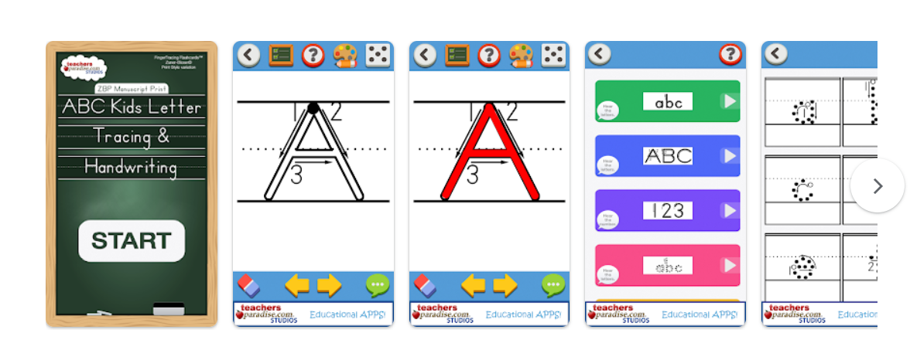
3. More confident writers
- Pair work – Student A selects and dictates a familiar word from a set of Word flash cards for Student B to write. Both students then check the spelling using chosen card. Swap roles.
- When writing words on the board:
- identify vowels and consonants
- say the name and sound of the letters [when word can be sounded]
- Give additional practice in copying
- name and address from cards typed by the teacher either into notebooks, or onto templates such as the ones on the following page.
- family members’ names
- vocab cards
- words from workbooks

4. Technology Option: iPad letter tracing

Free iPad apps can be downloaded to develop letter formation, and awareness of letter names and sounds. Although these are designed for pre-school children, some are suitable for adult learners. Search for letter tracing or alphabet tracing. Select apps with no ads, a simple interface and clear sound quality.
One recommended app is Finger tracing flashcards on 123s ABCs Kids Handwriting PRO TeachersParadise.com
The app is free on an i-pad, but there would be a small cost to download on Android mobile phones or tablets. This is an example of some pages from the app.

Name and address template for the Words book. [pages 44 & 46]
The templates can be used by the teacher to type or print each student’s name and address for copying or pasting in the student’s book.

First name | ________________________________
Family name | ________________________________

Address
Street | _______________________________________________
Suburb | ___________________________________________
Postcode | _____________________
Phone

Name and address template for the Letter Names book. [page 31]
First name
Family name
Address | Street
 | Suburb
 | Post code

Speaking - Greetings and information VU23492
Greetings and closings

Circle Activity

- Instruct half the class to form a circle and give each student the Student A dialogue.
- Instruct the other half to form another circle outside the first circle and give each student the Student B dialogue. [Example 1 on the next page]
- The inner and outer circle students need to face each other and read their card.
- After reading their cards, the students in the outer circle move one place to the left and repeat their dialogue with the next student in the inner circle. Repeat as many times as appropriate.
- Swap roles.

Repeat the Circle Activity with further topics for conversation practice included in the Speaking Workbook and listed in the table below. When students become more confident, they could substitute their own. information in place of the scripted details.

Topics | Dialogues
Name and address | What’s your address? I live in _________.
Greeting vocabulary | Good morning. Good morning.  Good afternoon. Good afternoon.  Hi. Hello.
Closing vocabulary | Goodbye. Bye.  See you later. Bye.
Classroom items | Do you have a pencil? Yes/ No.
Photos of family  [On phone or actual photos] | This is my husband/daughter etc.
Activities | Do you like cooking?/fishing? etc Yes/No.
Beverages | Would you like tea or coffee?  Yes please/No thanks.

Conversation card examples for the circle activity

Student A | Student B
Hi. I’m ___________. | 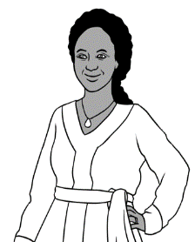  Hello. I’m ___________.

Student A | Student B
How are you? | Good thanks.

Student A | Student B
Bye | See you later

Student A | Student B
Hi. I’m ________________.  How are you? | Hello. I’m ______________.  Good thanks.

Giving information - Names
- First names of people
See activities for practising the first names of students and teachers
on page 7.

- Suburbs or Towns

Syllables
- Elicit the names of the suburbs or towns where students live and write suburbs on the board in columns according to the number of syllables.
- Clap the syllables.

Word stress
- Organise the names of the suburbs or towns in columns on the board according to their stress patterns.
- Mark the main stress above the word with a large circle.
- Clap, stamp feet or stretch a rubber band to feel the stress.
- Choose one suburb. Ask students to move around the room saying the name of the suburb, stressing the strong syllable.

- Street names
Repeat the above exercises for street names.

Speaking - Classroom items VU23492
Classroom items - vocab cards
Pair work
- Students cut out* the cards.
- They mix and match the words and pictures.
- One student then shows a picture or word to their partner and asks,
What is this? Or What’s this?
- One student shows a picture or word and asks,
Do you have a____________?
Additional words and pictures can be added to the set of items introduced in the Speaking book as students gain more confidence.
*Using scissors is an important fine motor skill, which helps develop the muscles needed for good pencil control.

Copying
The words on these cards can be copied into the students’ notebooks.
Game of concentration/memory
In groups of two or three, students mix the words and pictures face-down on the table. The goal is to match the words and pictures. Students take turns to turn over two cards and form a pair. If they have a match, the student keeps the pair and has another turn. If they don’t have a match, the student turns the cards over in the same place on the table. When all the pairs have been matched, the student with the most pairs is the winner.

bag | pencil
 | 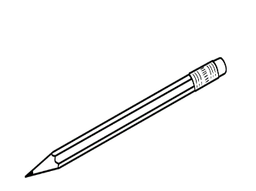
sharpener | rubber
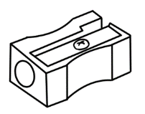 | 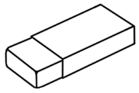

laptop | phone
 | 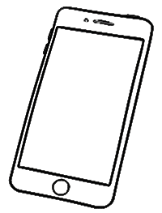
workbook | pen
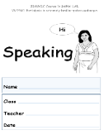 | 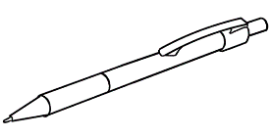

Additional items [not introduced in the booklets.]
scissors | pencil case
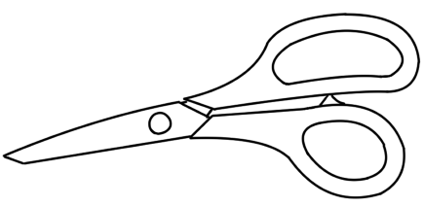 | 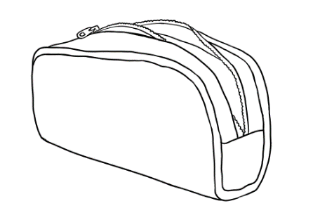
ruler | glue
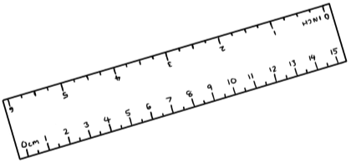 | 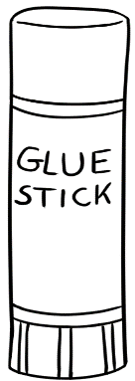

Classroom items – Bingo
Preparation:
- Cut up the student bingo cards. [Print on card and laminate for reuse.]
- Give each student a card and 5 tokens. [buttons, pieces of paper or card etc]
Game
- Demonstrate how to play.
- Encourage students to call out Bingo when all their objects are covered.
- When first playing the game, hold up flashcards of the pictures and words as you call each item. Also, allow students to use the same card for additional games.
A confident student could later replace the teacher as the Bingo caller.

Master Card
pen | pencil | rubber | sharpener
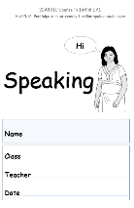  workbook | phone | laptop | bag

Student Bingo cards
Card 1
workbook | BINGO | pen
laptop | rubber | pencil

sharpener | pencil | phone
bag | workbook | BINGO
Card 2

Card 3
rubber | phone | laptop
BINGO | workbook | pen

Card 4
bag | sharpener | BINGO
laptop | pencil | rubber

Card 5
BINGO | pen | bag
workbook | laptop | phone

Card 6
workbook | sharpener | pencil
rubber | BINGO | bag

Card 7
pencil | pen | phone
rubber | sharpener | BINGO

Card 8
bag | BINGO | laptop
phone | workbook | pen

Card 9
pencil | laptop | workbook
bag | pen | BINGO

Card 10
workbook | pencil | sharpener
BINGO | phone | rubber

Speaking - Follow instructions VU23492
Classroom instructions
- Flash cards
Create flashcards as new instructions are introduced. Mime each instruction and students copy the action. Once students are familiar with the instructions, the class can play Bingo.

- Bingo
Preparation:
- Cut up the student bingo cards [Print on card and laminate for reuse.]
- Give each student a card and 5 tokens [buttons, pieces of paper/card etc]
Game
- Demonstrate how to play. Mime and emphasise the instruction verbs when reading the instructions. e.g. Sit down.
- Students call out Bingo when all their instructions are covered.
- When first playing the game, hold up flashcards of the pictures and words as you call each instruction. Also, allow students to use the same card for additional games.

Master Sheet for Instructions Bingo.
Sit down | Stand up | Open your book | Close your book
Look at the board | Listen | Tick | Point
Say | Listen and repeat | Clap | Copy

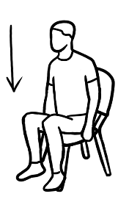 | 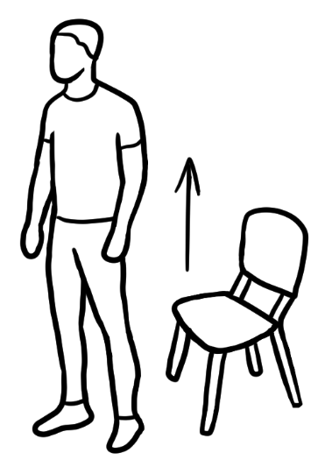
Sit down | Stand up
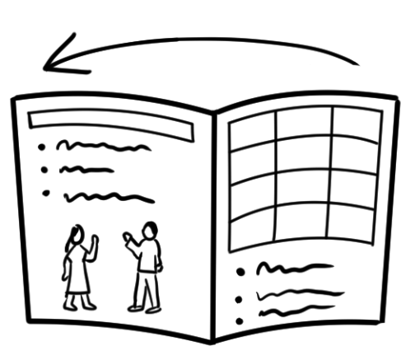 | 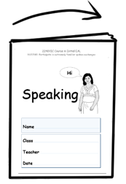
Open  your book | Close  your book
Flash cards- Enlarge and cut out.

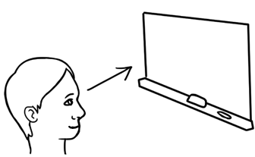 | 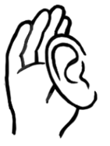
Look at the board | Listen
P | 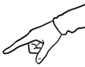
Tick | Point


Say | Listen and  Repeat
 | 
Clap | Copy

Bingo Cards
Card 1
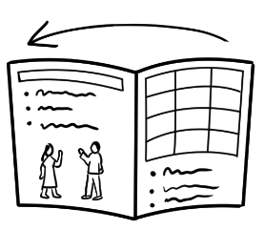  Open | BINGO | Listen
Listen  Repeat | 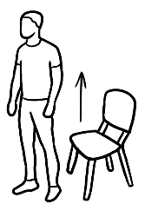  Stand up | Clap

Close | Say | Look
Listen  Repeat | 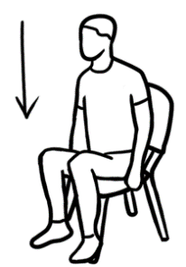  Sit down | BINGO
Card 2

Card 3
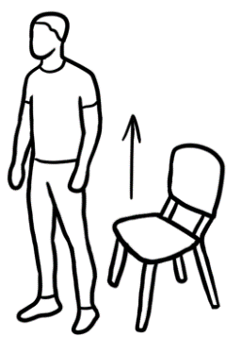  Stand up | Say | P  Tick
BINGO | Open | Listen

Card 4
Sit down | Close | Point
Listen  Repeat | Look | BINGO

Card 5
Look | BINGO | Listen  Repeat
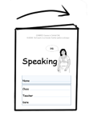  Close | Sit down | Say

Card 6
Look | Close | Clap
BINGO | Stand up | Point

Card 7
Tick  P | Look | Say
Stand up | Close | BINGO

Card 8
Listen  Repeat | BINGO | Copy
Sit down | Open | Listen

Card 9
Clap | Copy | Tick  P
Listen  Repeat | Listen | BINGO

Card 10
Open | Clap | Tick  P
BINGO | Point | Stand up

Important words – Names VU23489, VU23491
Personal information - Names
- Cut multiple copies of the letters below and on the following pages into strips and spread on tables at the front of the class.
- Students come and cut off the letters they need to make their first name.
- They colour the letters and then paste the letters onto the back cover of their workbook. Encourage students to say each letter aloud as it is coloured.
This can be repeated with the names of students’ streets and suburbs.

A A A A
B B B B
C C C C
D D D D
E E E E
F F F F
G G G G
H H H H
I I I I
J J J J
K K K K
L L L L
M M M M
N N N N
O O O O
P P P P
Q Q Q Q
R R R R
S S S S
T T T T
U U U U
V V V V
W W W
X X X X
Y Y Y Y
Z Z Z Z

Letters - Word identification strategies VU23489
Performance Criteria 3.2  Word identification strategies may include: | - sounding out letters  - blending sounds together  - memorising simple words  - using the shapes of letters and words  - matching pictures and words  - segmenting word  - isolating target sound

These criteria are addressed throughout the student books in a number
of ways.
Powerpoints
An excellent way to teach and revise any element in the units is to create simple powerpoints. The worksheets in the student books can be adapted for powerpoint slides.
Use transitions to move pictures, letters and finally words onto each slide.
In the example below, students say the word and then sound each letter as it transitions into view. e.g.

Slide 1 Slide 2 Slide 3 Slide 4 Slide 5

hat
h
ha
hat

Slide 1 Slide 2 Slide 3 Slide 4 Slide 5
stop
st
sto
stop

Examples of how the criteria are addressed in the student books:
- Sounding out letters | Learn the initial sounds.
- Sounding out letters | Sound out simple words where the sounds are regular.  f  h  Look at the picture, say the word, sound the word,  say the word. Repeat.  h  a  t  hat hat  f  a  n  fan fan
- Sounding out letters | Look at the picture, say the word, sound and circle the letters, say the word. Repeat.
  hat | b h g a t
  fan | f b a g n

- Blending sounds together | Blend consonant sounds. Sound each letter of the blend, then slide the consonants together, say the word.  st st stop  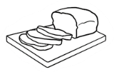  br br bread
- Blending sounds together | Group blends together.  clock clock
  cl | o | ck
- Blending sounds together |   Match a blended consonant to a word.  train  st  stop

- Memorising simple words  [See further strategies on following pages] | Listening, repeating, copying, colouring and studying the shape of words aids memory retention. Copying under the words is easier for beginner learners.    tea tea  t__ ___  tea tea
bag

egg
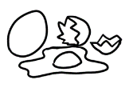
Activities and games with flash cards. These cards are located in Section 8.

- Using the shapes of letters and words | It’s important to print in lower-case to see the shape and size of words. With fingers, trace around words printed in a large font. Trace the letters, colour the shape.    apple
  a | p | p |  | l |  |  | e
- Matching pictures and words | Initially students need to match words with words and pictures. When the words are more familiar, match pictures and words.  hat bed    bed hat

- Segmenting words | Group words according to the number of syllables. Mark the stress with a large dot above the vowel in the stressed syllable. Clap the syllables.  milk  tea  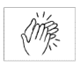  coffee  sugar

- Isolating the target sound | Match the sounds in words.  hat    a  ink  bed
- Isolating the target sound | Listen and repeat the target sound, listen and repeat the words, copy and colour the target sound while saying the sound aloud.  br    bread brush broom  _ _ead _ _ush _ _oom  bread brush broom

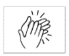
Strategies for learning vocabulary
A variety of techniques are used in the workbooks to teach and help students memorise vocabulary. Below are some additional ways to teach new words. e.g. family.
- Colour the picture and as students colour, encourage them to repeat the word family over and over out loud.
- Clap the syllables in the word while saying the word.
- Add movement while spelling the word.
- Say the word family
- While spelling the word, clap and say f, hit the thighs and say a, clap and say m etc This particularly supports kinaesthetic learners.
- Finally say the word family again.

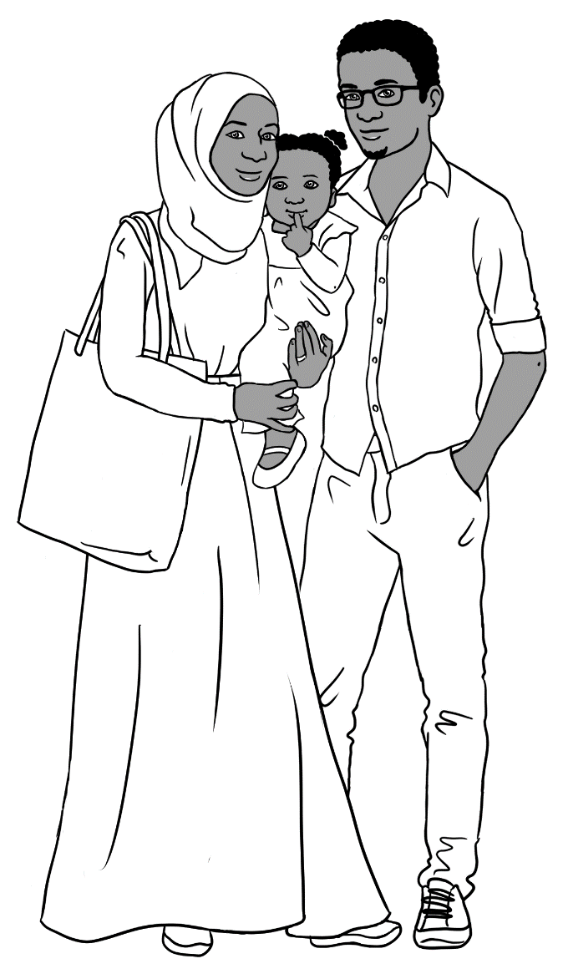

Strategies for learning vocabulary [continued]
Make sets of cards for students to match. Vary the cards according to each students’ level of literacy.
- Match a word with the word and a picture.
family | family

- Match the first letter with a word and a picture.
f | family

- Match a word with the first letter and a picture.
family | f


Strategies for learning vocabulary [continued]
- Match the word shape with the word and picture.
 | family
  f | a | m | i | l | y

- Listen to the teacher say the word, write the word on the board
without the first letter __amily. Students say and write the letter.

- Draw a picture on the board of a family.
- Ask ‘What is it?’
- Draw dashes for each letter. _ _ _ _ _ _
- Say the word and ask the students what letters they can hear. Write in the letters.
- Spell the word together several times while you point to each letter.
- Rub out the first letter and ask students to spell the word.
Then rub out another letter and ask students to spell the word. Depending on the students, this could be continued until all letters are rubbed out.
- Then together write the letters back.

- Use PowerPoint to help teach and revise vocabulary.

- Tracing and copying help support memory. Create worksheets where the students copy or trace under the word rather than next to it.
 | family | family
 | family
 | family | family
 | family

Encourage students to say the letters and the words aloud
as they write.

Graded Vocabulary tests
When students are sure of the words, give graded vocab tests where no-one can fail. Give tests to students according to their level. Students trace or copy the missing letters:

Level 1: family

Level 2: family

Level 3: family

family
Level 4: ___amily

family
Level 5: ___ ___ ___ ily



Strategies for learning vocabulary [continued]
Small whiteboards and markers
These are useful tools, especially at Initial level:
- Words can be easily erased.
- The markers are thicker and easier to hold.
- The word itself is the focus rather than skilful letter formation.
- They add a kinaesthetic element to a lesson.
- Students learn from each other.
- Student work is easy to check.

Activities
- Write the word

- The teacher calls out a letter of a familiar word, students write it down on the whiteboard [or piece of paper].
- When all have finished, students pass the whiteboard to the person on their right.
- The teacher calls out another letter. Students write it and pass the board/paper again.
- Continue until the word has been written.
- The teacher writes the word on the board and students check to make sure the word is correct.

- Short word memorisation
- Write a short familiar word from the workbook on the board. e.g. up, in, man etc
- Listen, repeat, note the word shape, spell the letters, sound the word, cover the word.
- Students write the word on their boards. [Cheating is fine.]
- Uncover the word, and students check their work.

Sets of alphabet letter cards

Students use their set of alphabet letters to spell a word.
- The teacher says a word, and slowly spells it.
- Students find the letters to make the word.
- They then scramble the word and put it back correctly.

Flash cards – Family words

family

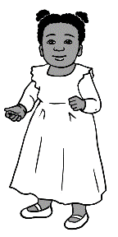
mother

father
wife
husband
daughter
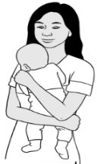
son

Blank flash card templates

Teach in context.

Introduction
All language needs to be relevant and useful, so as much as possible, teach new vocabulary in context.

An appropriate context at beginner level is food. Going shopping, preparing and sharing food is familiar territory for most students, so it builds on their personal skills and knowledge. In addition, the sensory tasting, smelling and handling of food provides a cognitive hook to aid memory. Below is an example of how to build language around this theme.

Activity: Prepare a fruit salad

- Teach the vocabulary and language.
- Project pictures of the fruit on a PowerPoint.
e.g. apple, banana, lemon, orange, grapes, watermelon etc
- Project pictures of the kitchen utensils required. e.g. knife, chopping board, large and small bowls and spoons etc
- Say the words together, clap the words.
- Teach singular and plural.
- Revise the colours: yellow, green, red etc
- Revise numbers: Ask How many students? How many apples/bananas etc? How many bowls?
- Teach collocations: We need 4 apples. We need 20 bowls. etc

- Create an alphabetical list with pictures. [See page 127.] The list includes ingredients for a simple fruit salad, but could be added to as new food is introduced in other recipes.
A separate list of kitchen utensils and verbs associated with food preparation could also be created.

- Go shopping – Prior to an excursion to the local market, role play
and practise:

  - Simple dialogues.
  - The vocabulary of money
and relevant language.
e.g. How much are the apples? They cost $3 a kilo.

- Food preparation
Teach the names of the utensils and useful verbs. Say and repeat over and over what students are doing as they prepare the food.
- We are making a fruit salad. We are making a fruit salad.
We are making a fruit salad.
- We are chopping the apples. We are chopping the apples.
We are chopping the apples. etc.

- Sharing the fruit salad and cleaning up
Teach the vocabulary and useful language.
- Vocabulary e.g. table cloth, serviettes, small bowls, spoons.
- Language e.g. Would you like some fruit salad? Can I help? etc
Note: Pictures are essential in the teaching of vocabulary at this level. All drawings are available for free use in the English Ready Illustration Book in the English Ready, Teacher Resources on AMEPOnline. However, if additional pictures are required, hundreds can be downloaded free from Creative Commons. See page 127 for the steps to access these.

Fruit – an alphabetical list for the wall.
a |   apple |  | n
b |   banana |  | o | 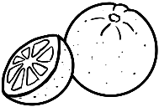  orange
c |  |  | p |   pineapple
d |  |  | q
e |  |  | r
f |   fruit |  | s |   strawberry
g |   grapes |  | t
h |  |  | u
i |  |  | v
j |  |  | w | 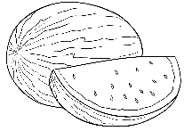  watermelon
k | 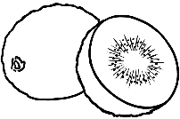  kiwi fruit |  | x
l | lemon |  | y
m |  |  | z
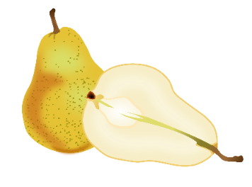
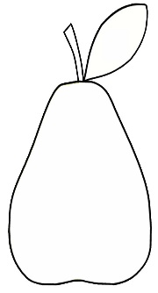
Copyright-free photos or drawings from the internet
Download Creative Commons images in Word.
Example image: a pear
Steps:
- Click on: Insert on the Menu ribbon.
- Click: Pictures

- Select: Online Pictures
- Type in the search box: pear [for a photo], drawing of a pear [for a coloured drawing], black and white drawing – pear [This allows students
to colour the image.]
- Click on one or more images
- Click: Insert
- Resize if needed.
- To position the image: Right click on the image, click wrap text,
select in front of image.
- Some images need no acknowledgement.
e.g.

Others need an acknowledgement. Cut the acknowledgement box
and add to the footer or somewhere inobtrusive in the document.
e.g.

This Photo by Unknown Author is licensed under CC BY-NC



Audio transcripts
Letter names
A female voice reads the names of the 26 letters. A male voice reads the names of the 26 letters.
There are two recordings of both voices.
A time gap after each letter allows time
for students to repeat the letter.

Page 2

A B C D E F
G H I J K L
M N O P Q R
S T U V W X
Y Z

A female voice reads the initial sounds following the pattern below. A male voice reads the initial sounds in the same way.
There are two recordings of both voices. A time gap after each sound group allows time for students to repeat.

Letter sounds

Pages 2 – 7
a apple a  b bag b  c cup c  d door d  e egg e  f family f  g glasses g  h home h  i ink i  j jacket j  k kids k  l lemon l  m man m |  | n no n  o orange o  p pencil p  q queen q  r rubber r  s student s  t teacher t  u umbrella u  v van v  w woman w  x box x  y yes y  z zero z

Speaking

NB This recording is slightly different to what is written in the student book.
1
Do you understand?

Page 5 | Teacher | Do you understand?
Page 5 | Jamila | I don’t understand.

This conversation is in three parts.
Each part is repeated.

Speaking
2
At the reception desk
Part 1  Page 6 | Receptionist  Zarni | Good afternoon  Good afternoon
Part 1  Page 6 | Receptionist  Zarni | What’s your name?  Zarni
Part 2  Page 7 | Receptionist  Zarni | What’s your first name?  Zarni
Part 2  Page 7 | Receptionist  Zarni | What’s your family name?  Tun
Part 2  Page 7 | Receptionist  Zarni | Can you spell that please?  Tun T U N
Part 3  Page 8 | Receptionist  Zarni | What’s your address Zarni?  Unit 4, 50 Baker Road, Kellivale.
Part 3  Page 8 | Receptionist  Zarni | 50 Baker Road?  Yes. 50 Baker Road
Part 3  Page 8 | Receptionist  Zarni  Receptionist | What’s your phone number?  0407 326 518  Thank you Zarni  Please sit down.

Speaking
3
English class - Greetings
Part 1  Page 10 | Teacher  Jamila | Good morning Jamila  Good morning Rosie
Part 1  Page 10 | Teacher | Come in.  Please sit down.
Part 2  Page 11 | Zarni  Jamila  Zarni  Jamila | Hi Jamila  Hello Zarni  How are you?  Good thanks

Two voices, a female and then a male read all the instructions including the numbers.
4
Classroom instructions
Page 12 | - Sit down.  - Stand up.  - Open your book.  - Close your book.  - Listen.  - Look at the board.

Speaking

5
English class - Time to go
Page 14 | Teacher  Jamila & Zarni | Time to go.  Goodbye everyone  Goodbye Rosie.
Page 14 | Zarni  Jamila | See you later Jamila  Bye Zarni

6
The classroom
Page 17 | Teacher  Student  Teacher  Student  Teacher  Student | Do you have a pencil?  Yes  Do you have a bag?  Yes  Do you have a rubber?  No

Speaking
There are five parts in this section. Each part is repeated.
7
Family

Part 1  Sahra  Page 20 | My name is Sahra.  This is my husband.  This is my daughter.  This is my brother.
Part 2  Tahiil  Page 21 | My name is Tahiil.  This is my wife.  This is my daughter.  This is my brother-in-law.
Part 3  Abdi  Page 22 | My name is Abdi.  This is my sister.  This is my niece.  This is my brother-in-law.
Part 4  Hani  Page 22 | I am Hani.  My mum.  * Abdi’s name is absent in the student book.  My dad.  My Uncle Abdi.*
Part 5  San*  Page 23 | My name is San.*  * San is pronounced Sahn  This is my mother.  This is my son.

Speaking
8
Neighbours - Thursday
Page 25 | Sahra  Zarni  Sahra  Zarni | Hi Zarni  Hi Sahra  This is my husband Tahiil  and my daughter Hani.  Hello. Nice to meet you

9
Neighbours – Friday
Page 26 | Zarni  Sahra  Zarni  Sahra  San  Sahra  San & Zarni  Sahra | Hello Sahra  Hi  This is my daughter San.  Hello San  Hello Sahra  Nice to meet you  Bye  See you later

Speaking
10
Neighbours - Saturday
Page 27 | Sahra  Zarni  Sahra  Zarni | Hi Zarni  Hi Sahra  This is my husband Tahiil  and my daughter Hani.  Hello. Nice to meet you

11
Neighbours - Sunday
Page 28 | Pam  San  Pam  San  Pam  San | Hello.  My name is Pam.  Hi  My name is San.  I live in unit 5.  We live in unit 4.  This is my mother Zarni  and my baby son.  Nice to meet you  See you later  Bye

Speaking
12
I like cooking
Page 32 | Jamila:  Zarni:  Jamila:  Zarni:  Jamila:  Zarni: | Do you like cooking?  Yes  Do you like fishing?  No  I like fishing.  I like cooking.

13
Tea or coffee – Conversation 1
Page 37 | Jamila:  Zarni:  Jamila:  Zarni:  Jamila:  Zarni:  Jamila:  Zarni: | Would you like tea or coffee?  Tea please  Milk?  Yes please  Sugar?  No thanks  Biscuits?  Yes please

Speaking
14
Tea or coffee – Conversation 2
Page 38 | Zarni:  Jamila:  Zarni:  Jamila:  Zarni:  Jamila:  Zarni:  Jamila: | Would you like tea or coffee?  Coffee please  Milk?  No thanks  Sugar?  Yes please  Biscuits?  No thanks

Speaking
15
Tea or coffee - Chant
Page 40 | Teacher  Jamila  Teacher  Jamila | Would you like tea?  Tea?  Yes tea.  No thanks.
Page 40 | Teacher  Jamila  Teacher  Jamila | Would you like coffee?  Coffee?  Yes coffee.  Yes please.
Page 40 | Teacher  Jamila  Teacher  Jamila | Would you like milk?  Milk?  Yes milk.  No thanks.
Page 40 | Teacher  Jamila  Teacher  Jamila | Would you like sugar?  Sugar?  Yes sugar.  Yes please.

