English Ready
22637VIC Course in EAL
VU23494 Use strategies to develop language learning with support

Learning Steps
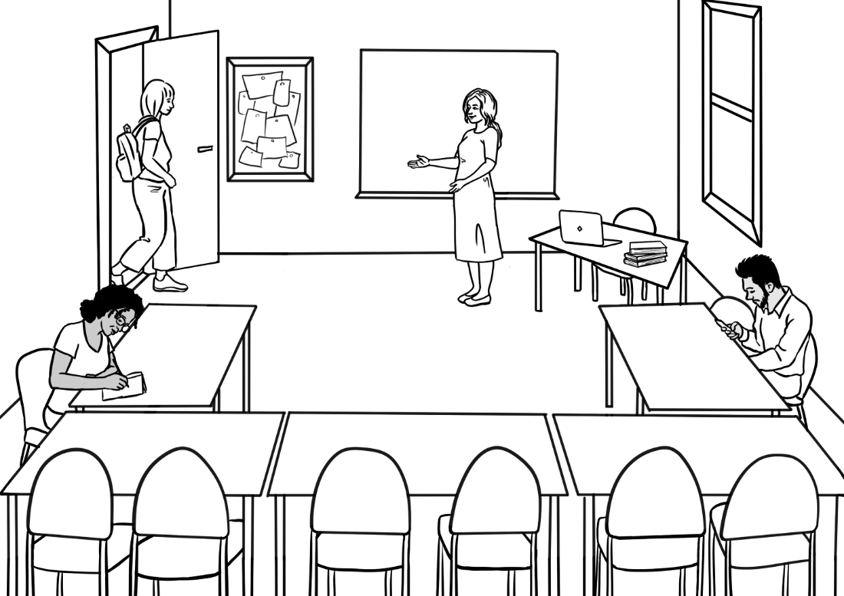

Student ___________________________________________________
Teacher ___________________________________________________
Class ______________________________________________________
Date ______________________________________________________

This workbook is designed to be used with the support of a teacher.
Design team: Vicki Hambling, Sue Paull, Frida Dean, Janice Langley, Glenise Kleehammer and Mary Wallace
Illustrations: Madelena Scott
Acknowledgements: The design team would like to thank the AMEP service providers and practitioners who participated in the trial and gave valuable feedback. The team would also like to acknowledge the use of the EAL Framework which underpins the design of this book.
Copyright of the EAL Framework is reserved to the Crown in the right of the State of Victoria. © State of Victoria (Department of Education and Training) 2023.
_________________________________________________________________________________________
This English Ready Resource is licensed under a Creative Commons Attribution-NoDerivs 3.0 Australia licence (More information is available here). You are free to use, copy and distribute to anyone in its original form as long as you attribute Department of Home Affairs as the author and you license any derivative work you make available under the same licence.
© Commonwealth of Australia 2023

With the exception of the Commonwealth Coat of Arms, the department’s logo, any material protected by a trade mark and where otherwise noted all material presented in this document is provided under a Creative Commons Attribution 4.0 International (https://creativecommons.org/licenses/by/4.0/) licence.
The details of the relevant licence conditions are available on the Creative Commons website (accessible using the links provided) as is the full legal code for the CC BY 4.0 licence (https://creativecommons.org/licenses/by/4.0/legalcode).
Use of all or part of this document must include the following attribution:
© Commonwealth of Australia 2023
As far as practicable, material for which the copyright is owned by a third party will be clearly labelled. The department has made all reasonable efforts to ensure that this material has been reproduced in this document with the full consent of the copyright owners.
Copyright requests and enquiries concerning usage not addressed by the CC BY 4.0 licence should be addressed to:
comms@homeaffairs.gov.au at the Department of Home Affairs.
The terms of use for the Commonwealth Coat of Arms are available from the It's an Honour website.
Where a copyright owner, other than the Commonwealth, is identified with respect to this material, please contact that third party copyright owner directly to seek permission.



Table of Contents

1. Instructions 1
2. Meet the people 2
3. English class 4
4. Sahra can’t come to class today. 7
5. What do you need in class? 8
6. Can you ask for help? 9
7. Writing basics 10
8. School 12
9. What can you do? 14
10. What do you want to learn? 16
11. Who can help you learn? 18
12. Where can you learn? 20
13. What helps you learn? 21
14. Learning steps 23
15. At the end of the term. 25

Instructions

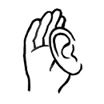

 |   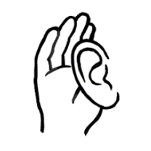  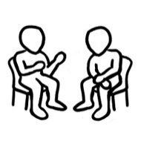    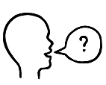  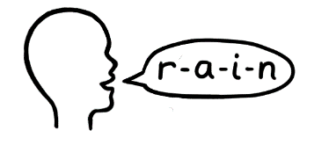 | listen |  |  | 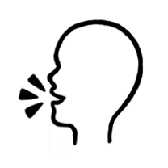  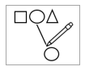      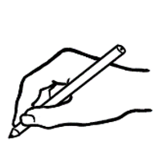   | say
 |  | copy |  |  |  | match
 |  | read |  |  |  | circle
 |  | ask |  |  |  | tick
 |  | spell |  |  |  | record
 |  | work with a partner |  |  |  | write

Meet the people

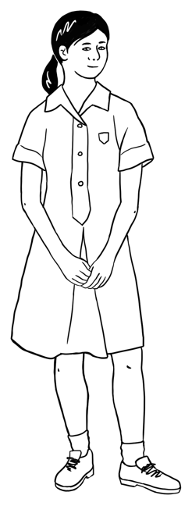
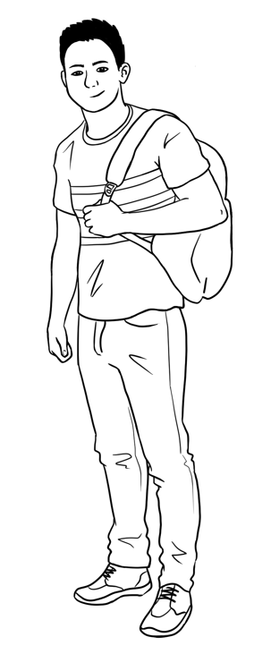
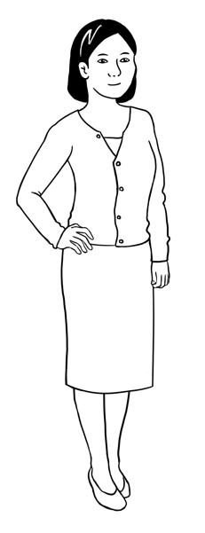
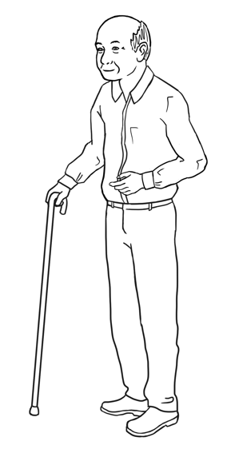

This is Ming. This is Lan. This is Mai. This is Bao.
Ming’s family

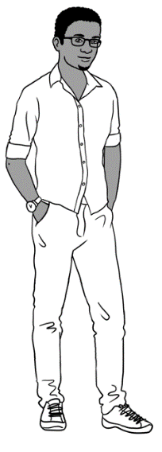
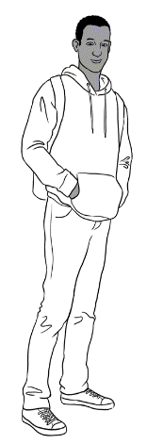
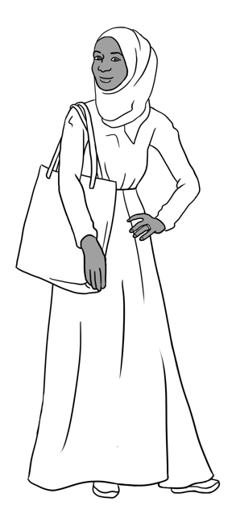
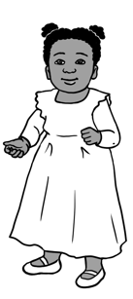

Sahra’s family
This is Sahra.
This is Hani.
This is Tahiil.
This is Abdi.

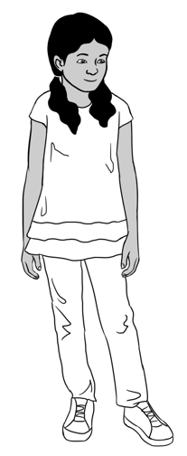
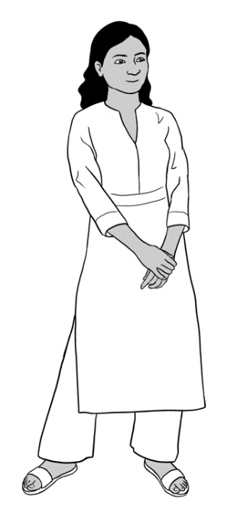
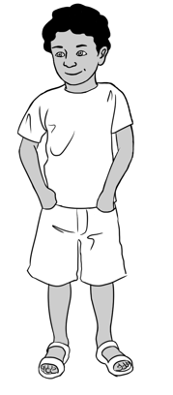
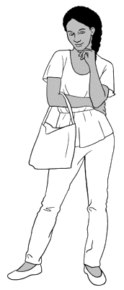

Nisha’s family
This is Nisha. This is Pari. This is Dev.

Anika
This is Anika.

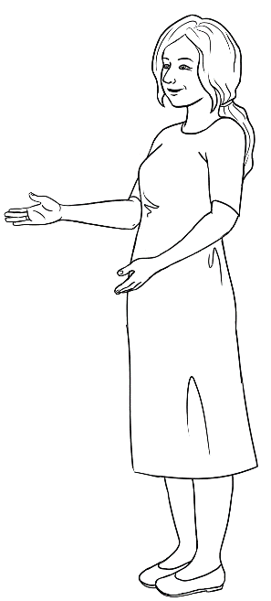

Jenny is a teacher.
This is Jenny.
Carim’s family

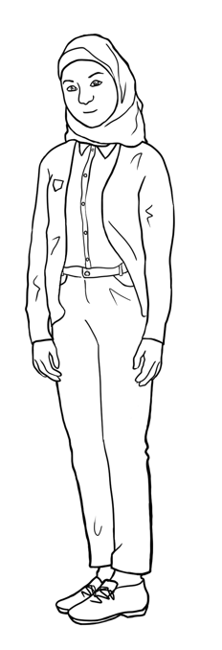
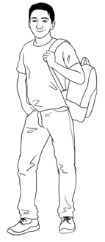

This is Carim. This is Fatima.

English class
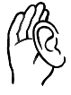
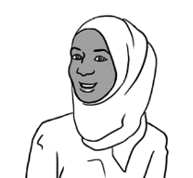
When do you go to class?
  Copy the days. |  | Monday  Monday
Tuesday  _______________ | Wednesday  ________________ | Thursday  ________________
Friday  ________________ | Saturday  _________________ | Sunday  _________________

Tick the days. |  | Monday
Tuesday | Wednesday | Thursday
Friday | Saturday | Sunday
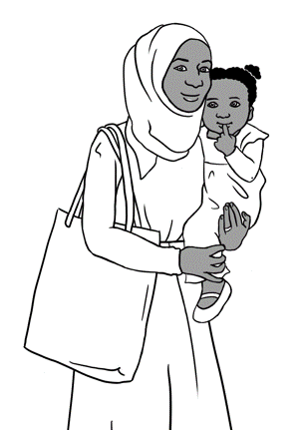
I go to class on Monday and Tuesday.
Hani goes to childcare.
Childcare is free.

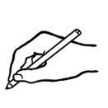

Sahra goes to class on Monday and __________________.
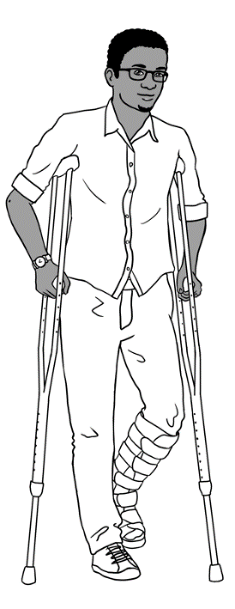
I have a broken foot.
I can’t go to my evening class.
I do Distance Learning on my laptop.
I have a volunteer tutor on Thursday.

Childcare is free.

Tahiil has a volunteer tutor on_________________.

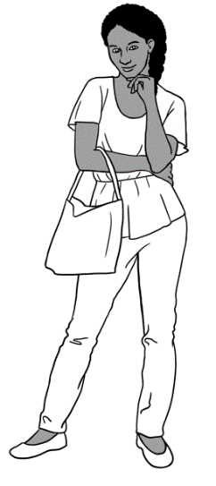
I want a job.
I want to learn quickly.
I go to school on Monday, Tuesday, Wednesday and Thursday.

Anika goes to class on ___________________,
____________________, ____________________
and ___________________.
When do you go to class?

I go to class on __________________________________________
___________________________________________________________.

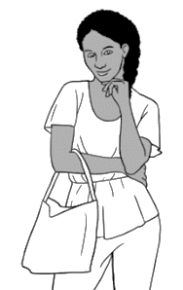
I go to class four days a week.
My class starts at 9:00 on Monday.
My class finishes at 2:30.

This is your timetable.

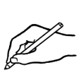

Day | Monday | Tuesday | Wednesday | Thursday | Friday
Start
Finish
Room
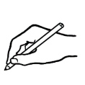
The last day of term is _____________________________________.
The public holidays are ___________________________________
__________________________________________________________.
The special days are ______________________________________.
Our excursion day is _______________________________________.

Sahra can’t come to class today.
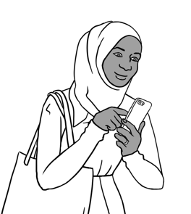
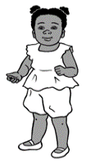

Why can’t Sahra come to class?
Hani is sick today.
Sahra sends a message
to the childcare centre and her teacher.
Hi Nisha,
Hani is sick today.
Sahra Elmi
Hi Teacher,
I can’t come to class today.
Sahra Elmi

________________________________________________________________________________________________________________________________________________________________________________________________________________________________________________________

Hi Teacher,
I can’t come to class today.

_____________

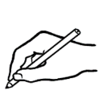

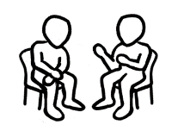

Hi Nisha,
Hani is sick today.
Sahra Elmi

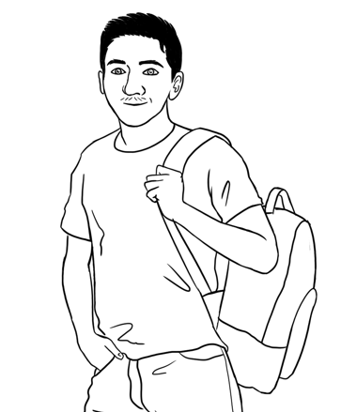
What do you need in class?
It’s Monday.
I’m ready for class.
I have 12 things in my backpack.

  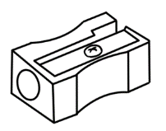  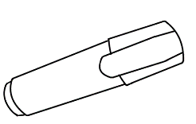      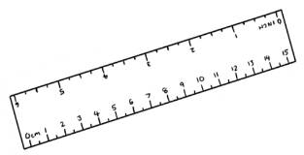    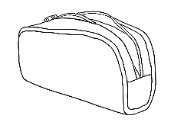  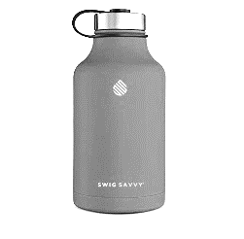  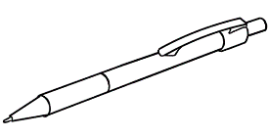  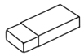  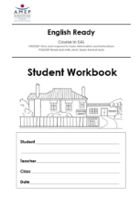  a pencil  Rubber | a rubber | a sharpener | a pencil case
a highlighter | a pen | a workbook | a notebook
a ruler | a phone | glasses | water

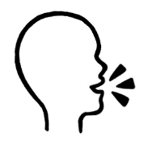
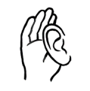
I have a pencil, a rubber,
a pencil case, a workbook,
a notebook and a phone.

Can you ask for help?

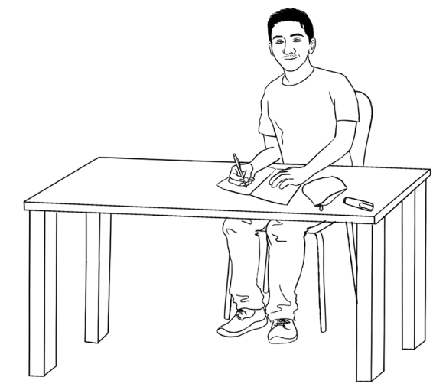
Can you say that again please?
Can you check
my work please?
Can you help me please?
I don’t understand.

1 | I don’t understand .
2 | Can you say that __________________please?
3 | Can you help me ___________________?
4 | Can you _________________my work please?
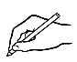

1 | again | please? |  |  | say |  | you |  |  | Can |  | that
Can you say that again please?
2 | please? |  | help |  |  | me |  | Can |  |  | you
3 | understand. |  |  | I |  |  |  |  | don’t
4 | check | Can |  |  | you |  | please? |  |  | work |  | my

Writing basics

Capital letters
A B C D E F G H I J K
L M N O P Q R S T U V
W X Y Z

Small letters
a b c d e f g h i j k
l m n o p q r s t u v
w x y z
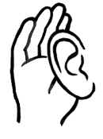


A B C D E F G H I J K
L M N O P Q R S T U V
W X Y Z
a b c d e f g h i j k
l m n o p q r s t u v
w x y z

A |  | B
C |  | D
E |  | F
G |  | H
I |  | J
K |  | L
M |  | N
O |  | P
Q |  | R
S |  | T
U |  | V
W |  | X
Y |  | Z

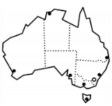
School
School in Australia

Pari Dev | Pari is 9 years old.  Dev is 7 years old.  They go to primary school.
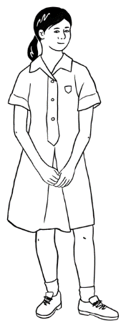  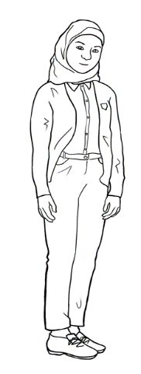  Mai Fatima | Mai and Fatima are 15.  They go to secondary school.
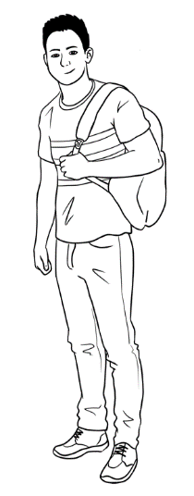  Bao Abdi | Bao and Abdi are 19.  They go to university.

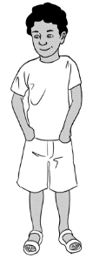
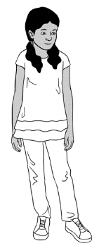
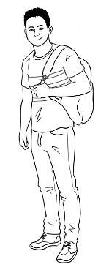
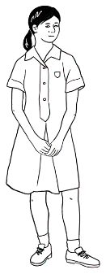
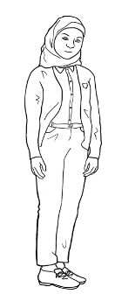

primary school
secondary school
university
Pari
Dev
Bao
Abdi
Fatima
Mai
School in Australia

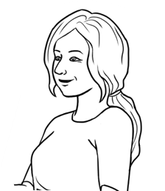
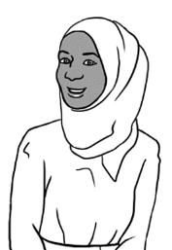
Did you go to school in your country Sahra?
Yes. I went to primary school.
Did you learn English?
No, I didn’t.
School in your country

 | Yes | No
- Did you go to primary school?
- Did you go to secondary school?
- Did you go to university?
- Did you learn English?

Did you go to school in your country?


What can you do?
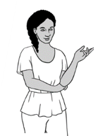
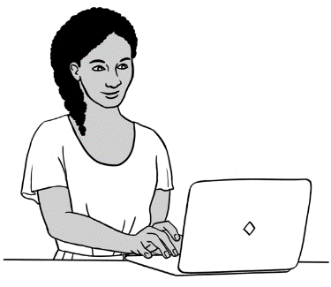
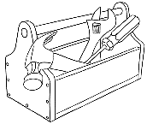
I can use
a computer.

I can repair things.
What can you do?
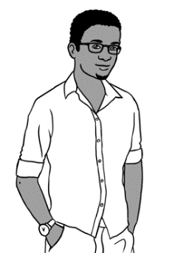

1  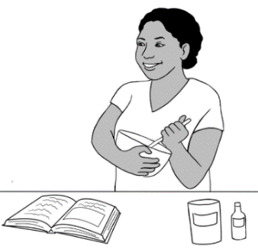  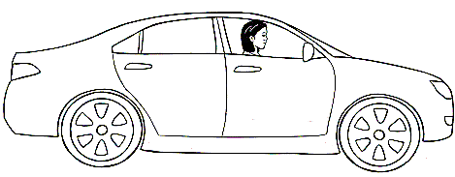  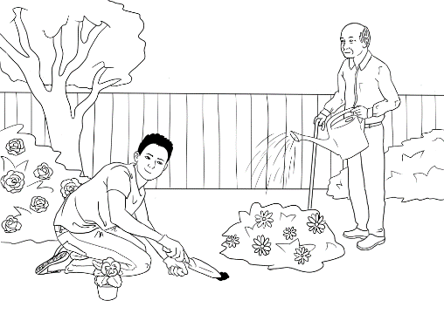  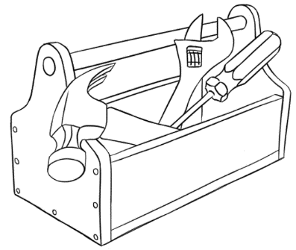  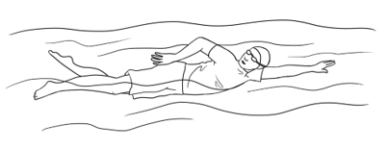  I can drive a car. | 2  I can cook. | 3  I can use a computer.
4  I can garden. | 5  I can swim. | 6  I can repair things.

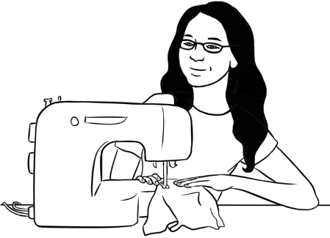  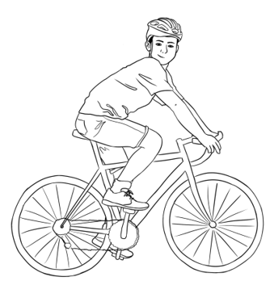  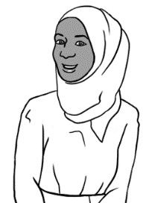  7  Oromo  Somali  Arabic | 8 | 9
I can sew. | I can speak  other languages. | I can ride a bike.
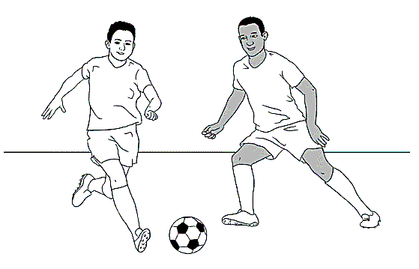  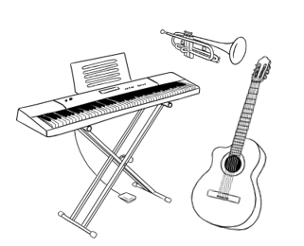  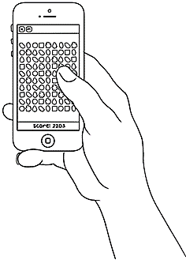  10 | 11 | 12
I can play soccer. | I can play games. | I can play  an instrument.
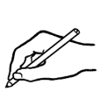
- I can ______________________________________________________.
- ____________________________________________________________.
- ____________________________________________________________.
What can you do?
My partner can ______________________________________________, ______________________________ and ___________________________
.

What do you want to learn?

    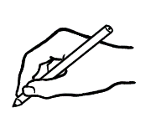  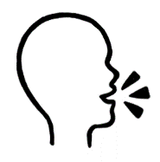  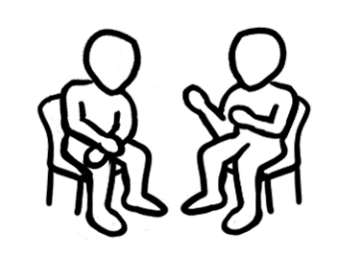  Hello.  Hi. | to listen |  | to speak clearly
 | to read |  | to write
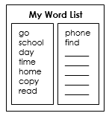 | to learn  new words |  |  | to spell
 | to use  a computer |  |  | to have conversations
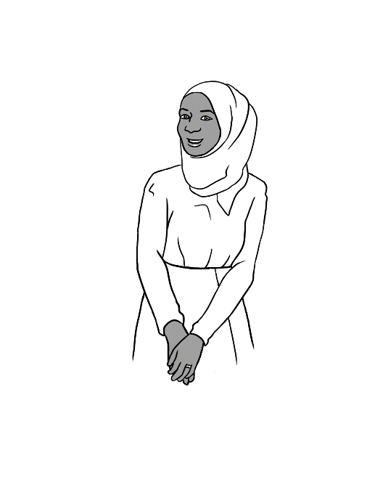
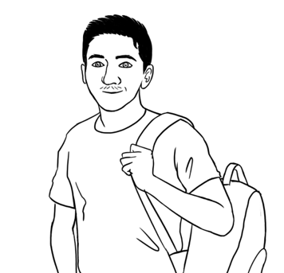
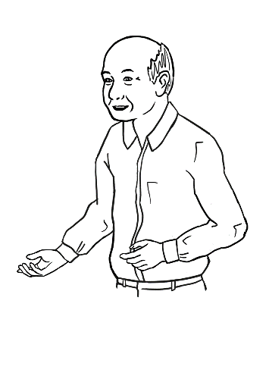
I want to have conversations in English.
I want to write in English.
I want to read books in English.

What is very important to you?

 | I want to listen to English.
 | I want to speak English.
 | I want to read in English.
 | I want to write in English.
 | I want to learn new English words.
 | I want to spell English words.
 | I want to use a computer.
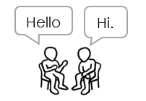 | I want to have conversations.

Who can help you learn?

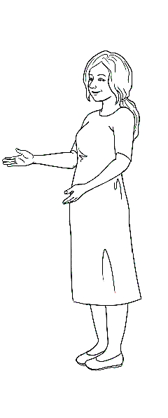
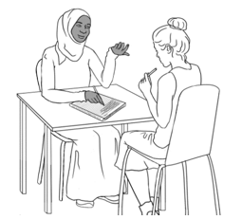
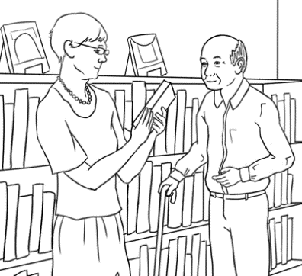
my teacher | my classmates | the librarian
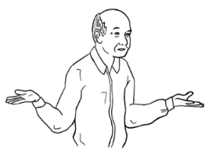  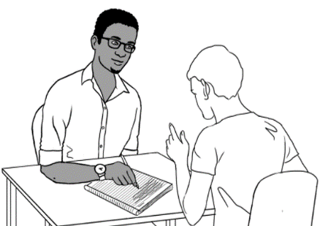  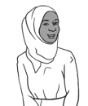  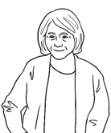 | 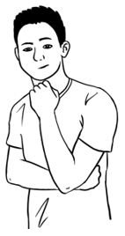
my neighbour | my family |  | my volunteer tutor

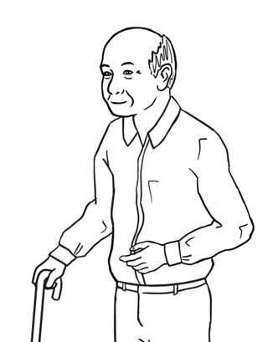
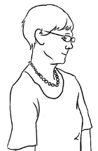
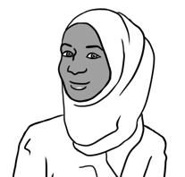
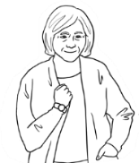
The librarian
can help me learn.
My friend Pam
can help me learn.

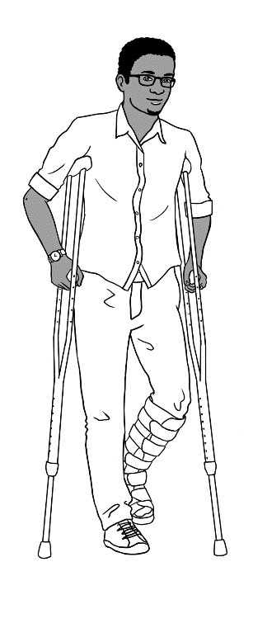
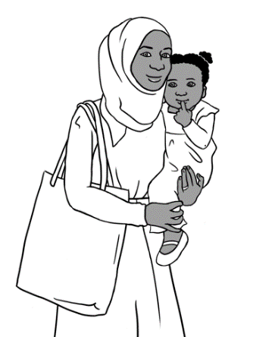
Who can help me learn?
Who can help you learn?
Who can help me learn?

Who can help? | Sahra | Tahiil | You
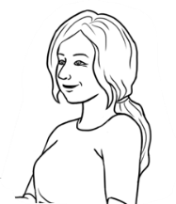
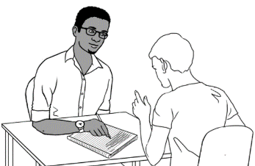
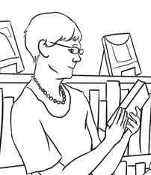
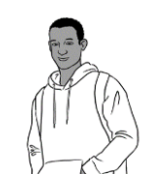
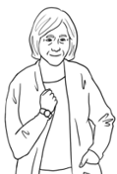
the teacher
a volunteer tutor
the librarian
family
a neighbour
Who can help you learn?

Where can you learn?

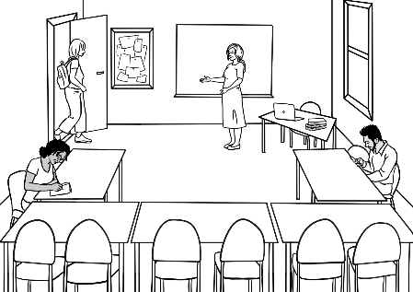  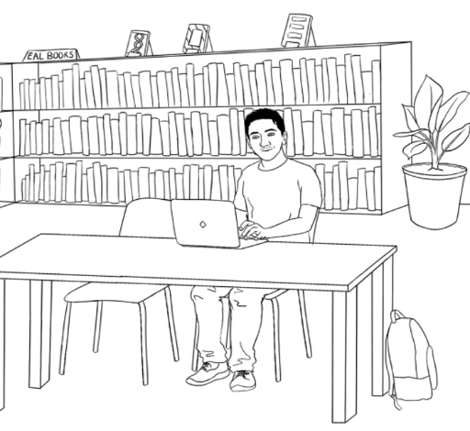  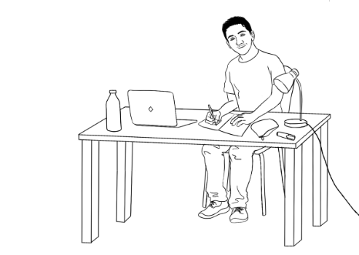  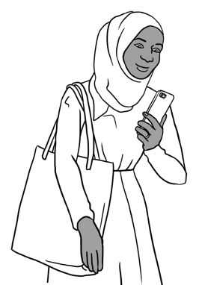  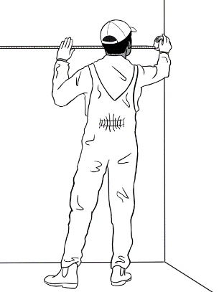  1 | 2
I can learn in class. | I can learn in the library.
3 | 4
I can learn at home. | I can learn on the computer.
5 | 6
I can learn on my phone. | I can learn at work.
Where can you learn?

What helps you learn?
What helps you learn in class?
In class

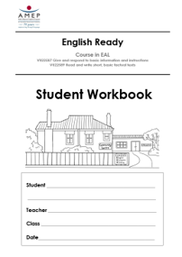  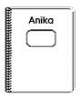  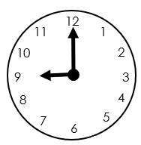  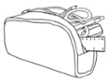  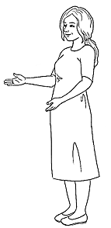  1  Listen. | 2 | 3
I come to class  on time. | I bring my books  and pencil case. | I listen to  the teacher.

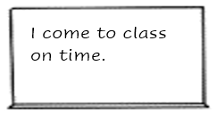
Today is Tuesday.
I copy from  the board. | I ask for help. | I copy new words.
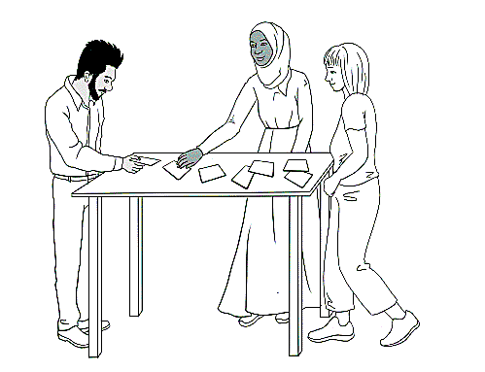
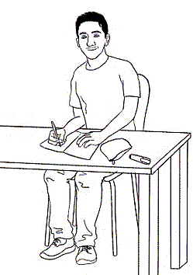
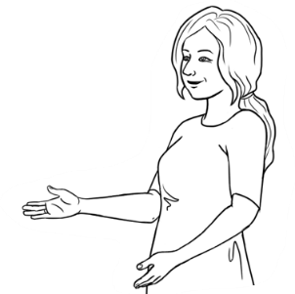
What does this word mean?
I don’t understand.
I ask questions. | I work with my classmates. | I record my teacher.
What helps you learn after class?
After class

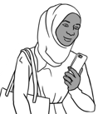
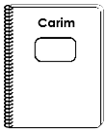
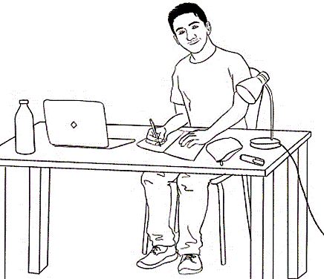

What’s
the time?
What’s
the time?

I work at home. | I read my workbooks. | I copy words.
I listen to the teacher  on my phone. | I listen and repeat. | I use AMEP online.
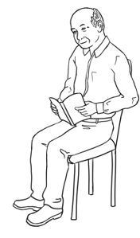
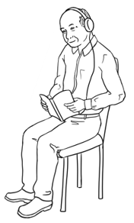
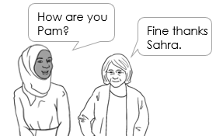

I talk to friends. | I read books. | I listen to the audio.
What helps you learn?

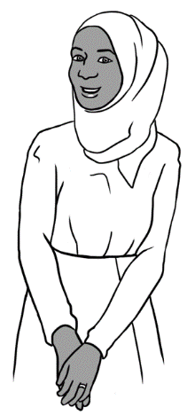
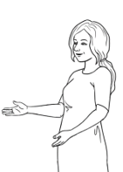
Learning steps
How can you learn?
I want to have conversations in English.
What do you want to learn Sahra?

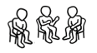  1 | I talk to my teacher and my classmates.
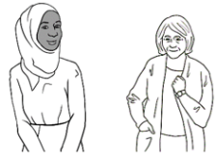  2 | I talk to my neighbour.
3 | I record my teacher on my phone.
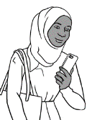  4 | I listen and repeat at home.

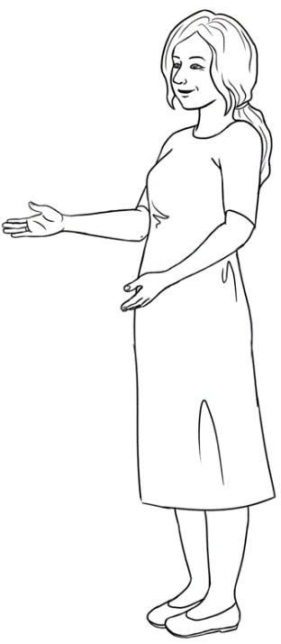
Can you say this please?
Can I record you on my phone please?
I live at Unit 6
50 Baker Road
Kellivale.

- Sahra asks her teacher,

- Sahra records her teacher.
- She listens and repeats at home.

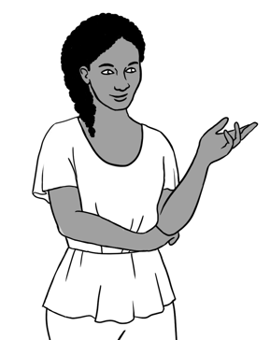
I want to learn new words.
How can you learn?
What do you want to learn Anika?

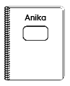    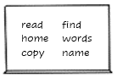  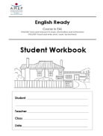  1 | I copy words from the board  in my notebook.
2 | I copy words from my workbook  again and again.
3 | I write new words on my word list.

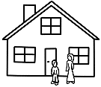      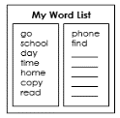  read | home | copy
read
read
read
find | words | phone

At the end of the term.
Now, what do you do in class?

 |  | Yes | No
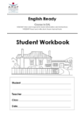  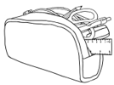    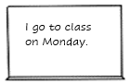  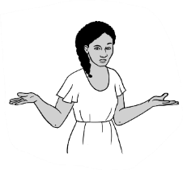 | - Do you ask questions?
 | - Do you ask for help?
 | - Do you copy from the board?
- Do you copy new words
on your word list?
- Do you record your teacher
on your phone?
 | - Do you work with your classmates?
- Do you bring your books
and pencil case?
 | - Do you come to class on time?
Now, what do you do after class?

 |  | Yes | No
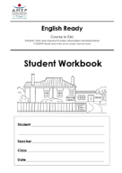  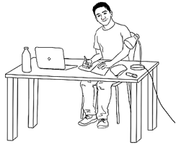  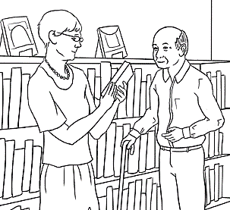  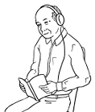 | - Do you work at home?
 | - Do you borrow books from the library?
- Do you read the books?
Do you listen to the audio?
- Do you read your workbook
and notebook?
- Do you listen to your teacher
on your phone?
- Do you copy words on your
word list?
 | - Do you use AMEP online?

Can you check my work please?

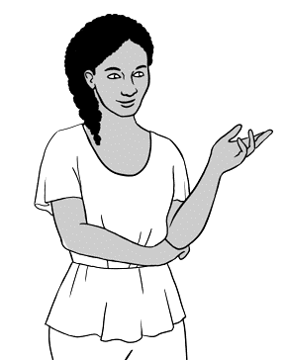
I need to practise my writing.
What do you need to practise next?

I need to practise my ____________________________.

When | Anika’s plan | Your plan
Today | Copy sentences from the board.
Tomorrow | Ask the teacher  to check my work.
Next week | Copy sentences from my workbook.
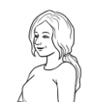
Don’t forget.

class
time
help
check

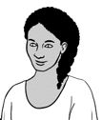  Come to class .  Can you ____________  my work please?  on __________. | Ask for ___________. | Ask the teacher

