English Ready
22637VIC Course in EAL
VU23494 Use strategies to develop language learning with support
Learning Steps
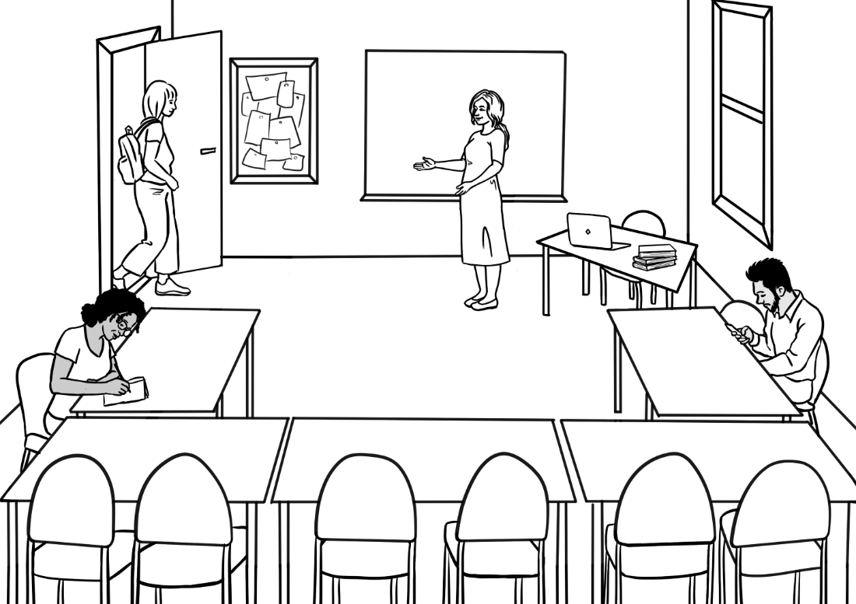

Teacher Resources

Design team: Vicki Hambling, Sue Paull, Frida Dean, Janice Langley, Glenise Kleehammer and Mary Wallace
Illustrations: Madelena Scott
Acknowledgements: The design team would like to thank the AMEP service providers and practitioners who participated in the trial and gave valuable feedback. The team would also like to acknowledge the use of the EAL Framework which underpins the design of this book.

Copyright of the EAL Framework is reserved to the Crown in the right of the State of Victoria. © State of Victoria (Department of Education and Training) 2023.
_________________________________________________________________________________________
This English Ready Resource is licensed under a Creative Commons Attribution-NoDerivs 3.0 Australia licence (More information is available here). You are free to use, copy and distribute to anyone in its original form as long as you attribute Department of Home Affairs as the author and you license any derivative work you make available under the same licence.
© Commonwealth of Australia 2023

With the exception of the Commonwealth Coat of Arms, the department’s logo, any material protected by a trade mark and where otherwise noted all material presented in this document is provided under a Creative Commons Attribution 4.0 International (https://creativecommons.org/licenses/by/4.0/) licence.
The details of the relevant licence conditions are available on the Creative Commons website (accessible using the links provided) as is the full legal code for the CC BY 4.0 licence (https://creativecommons.org/licenses/by/4.0/legalcode).
Use of all or part of this document must include the following attribution:
© Commonwealth of Australia 2023
As far as practicable, material for which the copyright is owned by a third party will be clearly labelled. The department has made all reasonable efforts to ensure that this material has been reproduced in this document with the full consent of the copyright owners.
Copyright requests and enquiries concerning usage not addressed by the CC BY 4.0 licence should be addressed to:
comms@homeaffairs.gov.au at the Department of Home Affairs.
The terms of use for the Commonwealth Coat of Arms are available from the It's an Honour website.
Where a copyright owner, other than the Commonwealth, is identified with respect to this material, please contact that third party copyright owner directly to seek permission.



Introduction
The Teacher Book
This book is an electronic reference. Print pages as only needed. It includes materials and activities for:
- pair work and class work
- revision and homework
- pronunciation
- extension.

The Student Workbook
This book requires teacher direction and is not intended for independent learning. It is also not intended to be the only material used to teach these units. The activities included are not suitable to be used for assessment.
The book is available as a Word document so that teachers can:
- localise and update the content
- adjust the material to suit the requirements of particular classes
- delete or add materials as required

Table of Contents

1. Instructions 3
2. Meet the people 6
3. English class 7
4. Sahra can’t come to class today. 10
5. What do you need in class? 12
6. Can you ask for help? 15
7. Writing basics 17
8. School 21
9. What can you do? 22
10. What do you want to learn? 25
11. Who can help you learn? 26
12. Where can you learn? 28
13. What helps you learn? 29
14. Learning steps 32
15. At the end of the term 35

Instructions

Activity 1
Project the workbook icons on the board and elicit the instruction.
Slide the yellow textbox down to reveal the instruction as shown for Read below. [To do this, you will need to open this activity in the Word document rather than the PDF.]
Activity 2
Copy icons and words without the yellow text boxes for students to cut up and match.
Activity 3
- Enlarge and cut up the icons.
- Hand them out to 12 students and ask them to take turns to stand and mime the instruction for the class to guess.
- Repeat the activity the next day with different students.



read

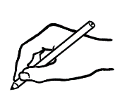

write



copy



circle



listen


say

tick

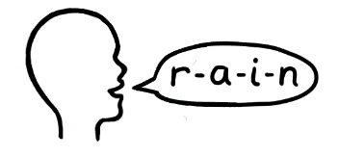
spell

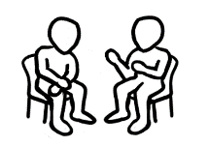

Work with
a partner.


Ask questions.

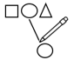

match


record

Meet the people
Activity

Use the names of the characters to focus on word stress.
Sort the names into columns on the whiteboard according to their stress pattern. e.g:
Ming Sahra Carim Fatima
Lan Hani Anika
Mai Tahiil
Bao Abdi
Dev Nisha
Pari

Read and clap the stressed syllable. Add student names to the lists.

English class
Activity 1 - Syllables
Use the words on the timetable page to introduce syllables.
- Create a table on the board similar to the one below, initially without the words in the columns.
- Begin by slowly adding each key word on page 4 and page 6 in the student book.
- Demonstrate the syllables physically by:

  - tapping your hand, a pen or a ruler on the table
  - clapping
  - punching the air
  - stamping your feet
  - taking a step for each syllable.

- Ask students to repeat each word with an action several times, counting the syllables while clapping etc
- In later classes:
- the words could be enlarged and written on paper. Students could attach the words to the board with magnets or copy the words into the columns.
- Repeat the process with the stationery items - ‘What do you need in class?’ on page 12.

Syllables
1 | 2 | 3 | 4
start  room  day  date  term  last | Monday  Tuesday  Wednesday*  Thursday  Friday  Sunday  finish  public  special | Saturday  holiday  excursion
* Wednesday has two syllables when spoken. To learn the spelling of the word,
it’s helpful to clap the silent third syllable as well.

Activity 2 - Listening
Print the worksheet on the next page. Slowly read the following sentences:
- Sahra goes to class on Monday and Tuesday.
- Tahill goes to class on Tuesday and Thursday evening and Saturday morning.
- Ming goes to class on Tuesday, Wednesday and Friday
- Anika goes to class on Monday, Tuesday, Wednesday and Thursday.
- Carim goes to class on Monday, Tuesday, Wednesday, Thursday and Friday.



When do they go to class?

Day | Sahra | Tahiil | Ming | Anika | Carim | You
Monday
Tuesday
Wednesday
Thursday
Friday
Saturday


- Sahra goes to class on Monday and Tuesday .
- Tahiil goes to class on _________________ and _______________
evening and ________________ morning.
- Ming goes to class on _________________, ___________________
and _________________.
- Anika goes to class on _________________, __________________,
______________________ and ____________________.
- Carim goes to class on ____________________, _______________, __________________, __________________ and ________________.
- I go to class on ___________________________________________
_________________________________________________________.

Sahra can’t come to class today.
Activity – Text messages
Use the templates on the following page to practise writing simple text messages.
- Write a text message on the board.
e.g.

- Students copy the message onto one of the phone templates
on the next page.
- They then type the text on their phone and send the text message
to the teacher.
Note: Punctuation in text messages is especially flexible, but it’s important students are aware of the rules before they adapt them. For that reason, a comma has been added after the greeting here and also in the student book.

Hi ________________,
^{teacher’s name}
My daughter is sick.
I’m sorry. I can’t come to class.

^{student’s name}

______________________________________________________________________________________________________________________________________________________________________________________________________
______________________________________________________________________________________________________________________________________________________________________________________________________
______________________________________________________________________________________________________________________________________________________________________________________________________
______________________________________________________________________________________________________________________________________________________________________________________________________

What do you need in class?
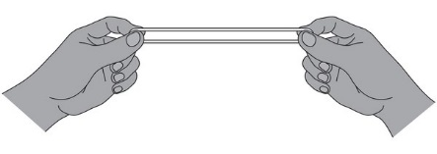
Activity 1 – Word Stress
Follow up work on syllables with regular work on word stress.
- Create a table on the board similar to the one on the following page, initially without the words in the columns.
- Say each stationery item, placing clear stress on the strong syllable. Clap or tap the table more loudly on the strong syllable.
Large rubber bands are useful to demonstrate and help students remember the stressed syllable. Give each student a rubber band, hold with the fingers, stretch the band out on the stressed syllable and bring the fingers together on the unstressed one. The stressed syllable is said a little louder and longer.

- Write each stationery item in the correct column on the table.
- Add the timetable vocabulary to the table.
- Add the stress pattern dots over all new words when first introduced.
e.g. student names.

Word stress
case  pen  phone | pencil  rubber  workbook  notebook  ruler  glasses  water |  | sharpener  highlighter

Activity 2 – Sound dictation
- Print the worksheet on the following page for each student.
- Read the dictation to the class; read again phrase by phrase and students repeat; students read the dictation in pairs.
- Students underline or highlight the bolded sounds.
- Ask students to fold over or cover the dictation.
[Cheating if necessary is perfectly fine!]
- Read the text slowly while students add the missing sounds.
- Read again before the students check their work against the original text.

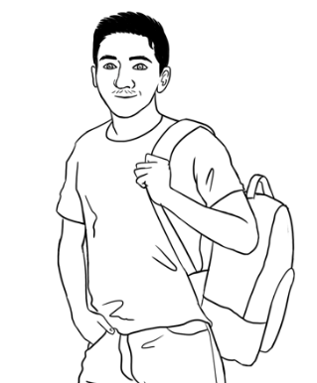
Carim is ready.

It’s Monday. Carim is ready for class.

He has 10 things in his backpack today.

He has a pencil, a rubber, a sharpener, a highlighter,

a pen, a workbook, a notebook, a ruler, glasses and water.
a | b | c | d | e | f | g | h | i | j | k | l | m
n | o | p | q | r | s | t | u | v | w | x | y | z
_ _ _ _ _ _ _ _ _ _ _ _ _ _ _ _ _ _ _ _ _ _ _ _ _ _ _ _ _ _ _ _

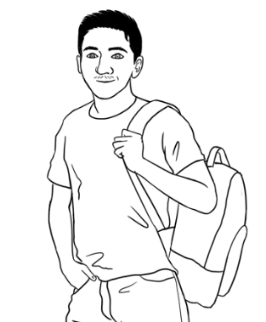

Dictation
It’s Monday. Carim is _eady for __ass.
He _as 10 __ings in his _ackpa__ today.
He _as a _encil, a _ubber, a __arpener,
a _ighlighter, a _en, a _orkbook,
a _otebook, a _uler, _lasses and _ater.

Can you ask for help?
Activity 1 - Make requests for repetition or clarification
- Teach students the requests for clarification and repetition
- Print these three requests [in grey, on the following page], laminate and cut up.
- Build confidence in using the expressions through regular class practice:
- Give the three expressions to three students. Select the most confident students at first.
- Ask these students to use their expression at least once during the class – initially with the teacher and later with each other.
- Give the expressions to different students in following classes.
- Teach the additional expressions when appropriate.

I don’t understand.
Can you help me please?
Can you say that again please?
Can I record you on my phone please?
Can you speak slowly please?

Writing basics
Activity 1 - The letters of the alphabet – spoken
Copy the worksheet below. Read one of the three letters in each group and the students circle the letter. Do two rows in each class.

Aa Bb Cc Dd Ee Ff Gg Hh Ii Jj Kk Ll Mm
Nn Oo Pp Qq Rr Ss Tt Uu Vv Ww Xx Yy Zz

 | A | B | C | D | E
 | A L M | S K T | B R Z | M L J | P F E
 | O D W | G L V | X H J | Q G P | O W Z
 | Q T M | G C K | S C L | M E D | K S V
 | Q O C | F M N | P B Z | O E A | Z S X
 | J G P | E C O | X F S | G J D | W V T

 | m n o | k c s | j g q | l e p | r i w
 | a e i | o u y | u a e | y o a | e y u
 | b p d | t y u | d b k | w v t | p b g
 | s c x | k c t | k g d | t d v | s z c
 | f v d | t g v | s z v | f s c | g d v

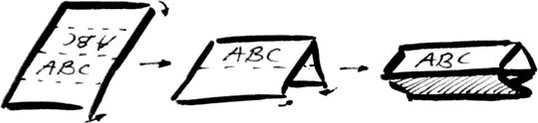

Activity 2 - Introductions and learning names
Student names provide a practical vocabulary for building many skills.
- Word stress – When recording student and teacher names in alphabetical order on page 11 in the student book, repeat the stress activity done with the character names on page 4 in this book. Write student names on the board in lists according to the number of syllables and the stress pattern. Mark the stressed syllable with a large circle and the unstressed syllable with a small circle. e.g.
Thi Zainab Kristina

- Build class connection by learning names - name cards
- With ½ A4 page, fold and create name cards for each student.

Mark the stress pattern on the cards and collect at the end of class.

- Teach how to introduce someone.
- Write on the board, ‘My name is___________.’ Go round the class, with students introducing themselves.
- Next, on the board write, ‘My name is______________, and this is ______________.’ Demonstrate how to introduce someone with an outstretched hand towards the person, palm up. Round the class, students introduce themselves and the person next to them. This introduction can be extended to add where a student comes from, their likes and dislikes, favourite colour etc.
- A ball is needed for this activity. Get students to stand in a circle. The student with the ball introduces themselves, then says ‘and this is ______________’ and throws the ball to the student named.
Activity 3 - Handwriting guide A practice writing book is available at Initial level.

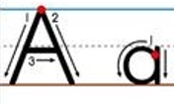

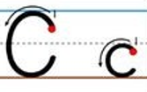
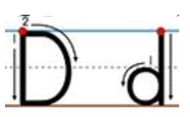
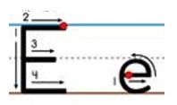

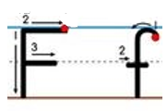

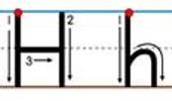
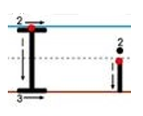


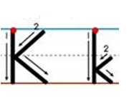
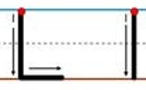
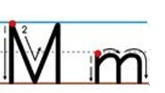
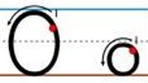
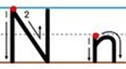

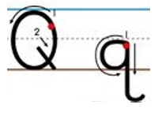
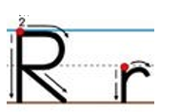
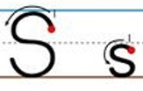
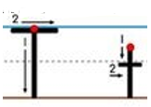




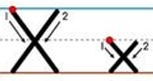

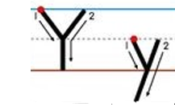
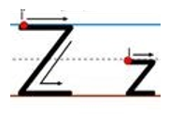

……………………………………………………………………………………………………………..

……………………………………………………………………………………………………………..

……………………………………………………………………………………………………………..

……………………………………………………………………………………………………………..

……………………………………………………………………………………………………………..

……………………………………………………………………………………………………………..

……………………………………………………………………………………………………………..

……………………………………………………………………………………………………………..

……………………………………………………………………………………………………………..

……………………………………………………………………………………………………………..

School
Activity
- Project the drawings on the whiteboard. Students refer to their books to answer questions about each character:
How old is _____? Where does he/she study?

- Practise and clap the stress patterns of:

Primary school secondary school university

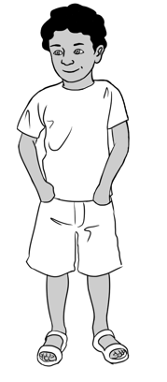  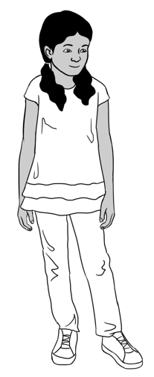 | Pari is _____ years old.  Dev is ____ years old.  They go to ___________ ______.
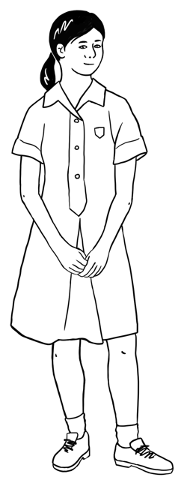  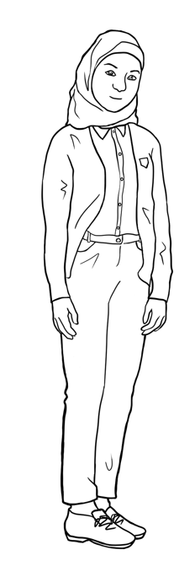 |  | Mai and Fatima are ______.  They go to ___________ _________.
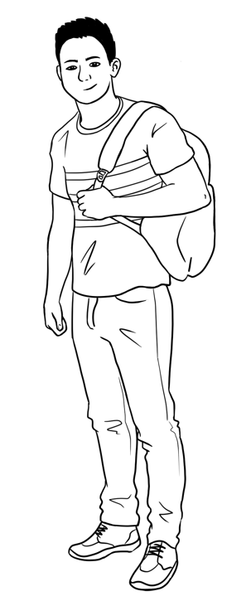  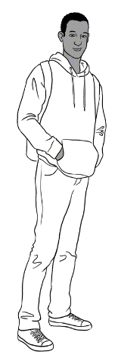 |  | Bao and Abdi are ______.  They go to ________________.

What can you do?

Activity
- Enlarge and copy a class set of the activities – it doesn’t matter if some students have a similar activity.
- Give each student a drawing of an activity.
- Students practise all the questions by repeating each after the teacher.
- Students then walk round the room asking different students their own question.
- Finally each student asks the teacher their question.
The two spare boxes allow for the addition of activities relevant to the student group.

  Can you drive a car? | 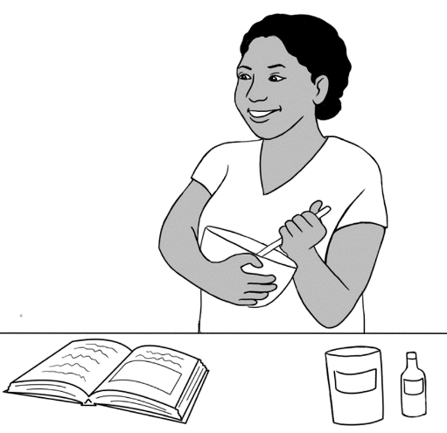  Can you cook?

Can you garden?  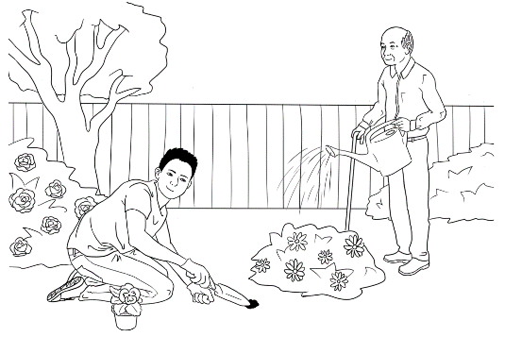 | Can you use a computer?  
Can you speak other languages?  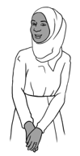  Oromo  Somali  Arabic | 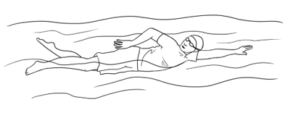  Can you swim?
  Can you sew? | 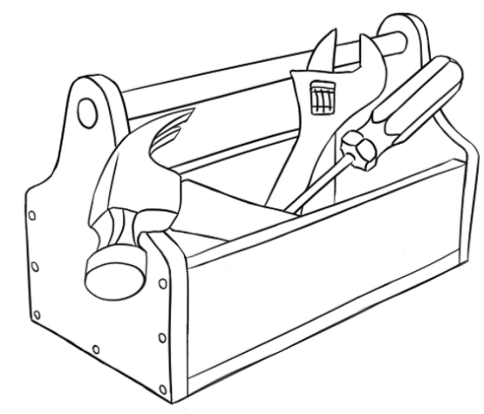  Can you repair things?
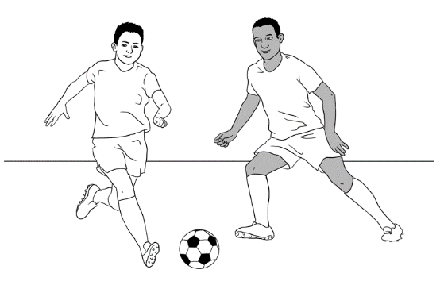  Can you play soccer? | 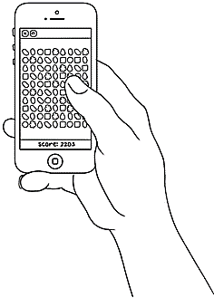  Can you play games?
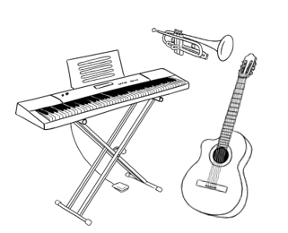  Can you play  an instrument? | 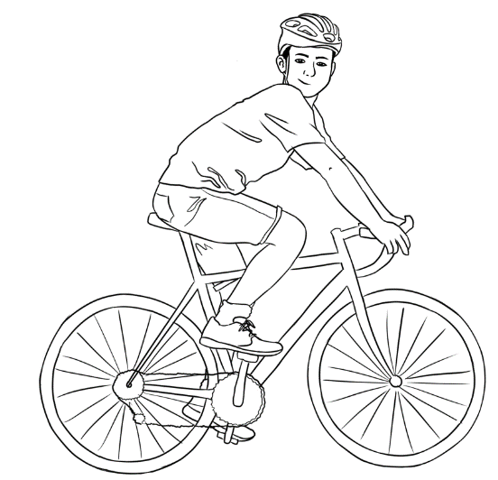  Can you ride a bike?
Can you ____________? | Can you ______________?

What do you want to learn?
Common class objectives
The objectives selected by the students in their workbook [Page 17] need to be validated by a clear focus on those skills in class work. A summary of student objectives can be done by:
- Projecting the table below onto the whiteboard
- Inviting students to come to the board and tick [in the text boxes] the three objectives they’ve selected in their workbooks.
This summary will reveal common class objectives, and make students aware of the objectives of their classmates.

 | listen |  | speak clearly
 | read |  | write
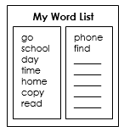 | learn new words | 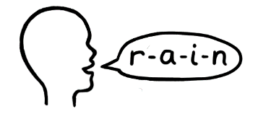 |  | spell
 | use a computer | 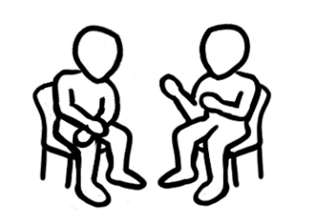  Hello.  Hi. |  | have conversations

Who can help you learn?
Activity
Project the images below on the whiteboard. Students refer to their books to answer questions about who can help with learning. Point to a picture and ask:
Who can help you learn?

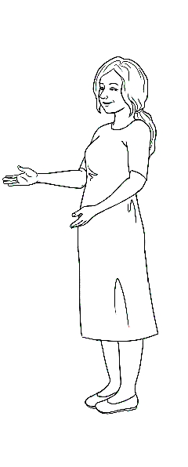 | 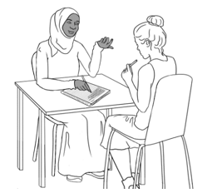 | 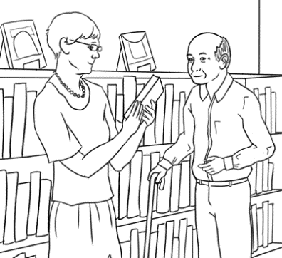
   |   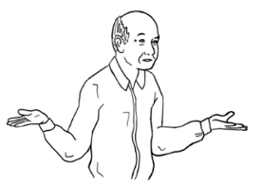 | 

People who may be able to assist students learn English outside the formal learning environment
Extend students awareness of the range of people who can help. Make
a short list initially and add to this at appropriate times. The list may include:
Family members - children, grandchildren, siblings, parents, aunts etc
Friends - classmates, neighbours
Local library - librarians, conversation groups
Community groups - playgroups, neighbourhood houses, community centres, church or other faith groups, sports teams, local school parents and friends organisations etc

Where can you learn?
Activity
Project the images below on the whiteboard. Students refer to their books to answer questions about where they can learn. Point to a picture and ask:
Where can you learn?

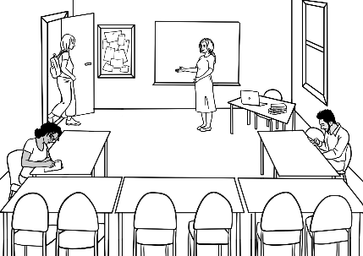 | 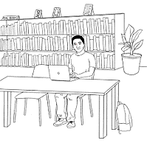 | 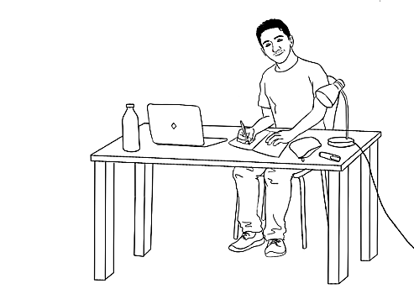
 | 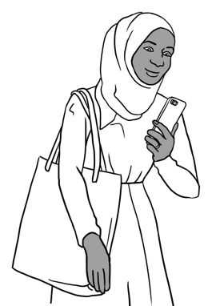 | 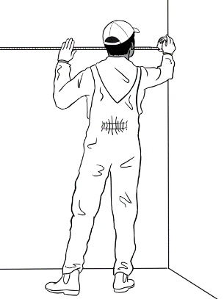

What helps you learn?
AMEP resources
Students need to be made aware of the useful resources offered by the AMEP. Check the AMEP website for information and links to these services.
- Volunteer tutor service.
- Distance learning program.
- On-line units.
- Free childcare
- Youth classes
- Classes for mothers
- Conversation clubs

Activity – How different things aid learning
Project the following and demonstrate how the timetable, the library, the computer and the phone can assist learning.

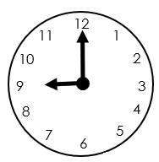
  Mon | 9 am- 3 pm school
  Tues | 9 am – 3 pm school
  Wed | 9 am - 3 pm school
  Thurs | 10 am Doctor
  Fri | Shopping
  Centrelink
  Wednesday at 4pm
  Doctor
  Thursday at 10 am
I come to class on time. | I plan my week. | I make my appointments.

- The timetable helps me.

- The library helps me.
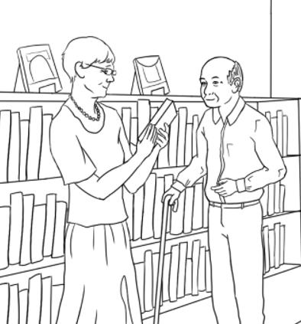 | 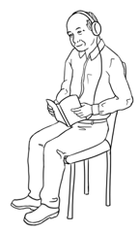
I borrow books. | I listen to the audio. | I use the computer.

 | 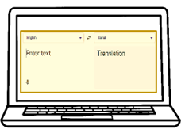 | 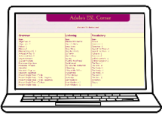
I use AMEP online. | I find new words. | I use English programs.
- The computer helps me.

- My phone helps me.
 | 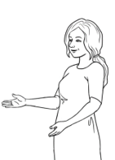  I have  a pencil. |   I have  a pencil.
I use AMEP online. | I record my teacher. | I listen to my teacher.

Learning steps
Activity 1
The worksheet about Sahra includes practice in recording the teacher’s voice so that students can listen and repeat the words or sentences at home. Adapt the sentences in the student workbook to suit the class.
Activity 2
The worksheet about Ming and Anika could be used for homework.
The worksheet gives an opportunity to build a word list.

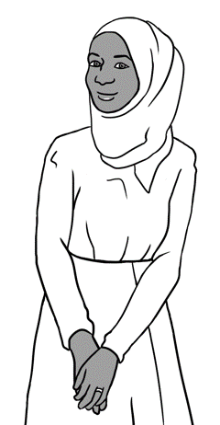
How can Sahra learn to have conversations in English?

These are my steps.

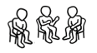  1 |  | 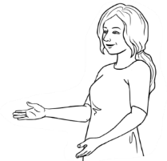  I talk to my classmates  and my _______________.
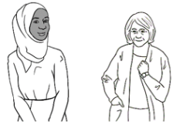  2 | I talk to my _____________________.
3 | I record my _____________________  on my ______________.
  4 | I listen and repeat at ____________.

neighbour
phone
classmates
teacher
teacher
home

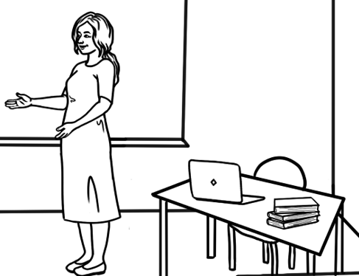
Put your phone on the teacher’s table.
Press record.
Record the teacher.

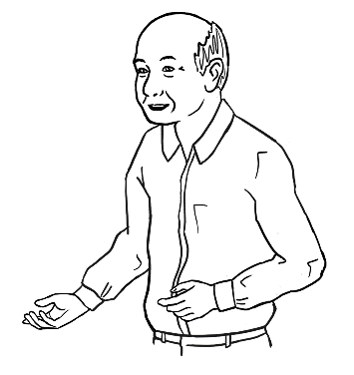
How can Ming learn to read?
These are my steps.

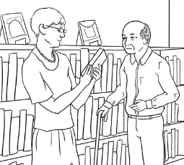  1 | I borrow books from the library.
  2 | I read and listen to the audio.
3 | I read and listen every day.

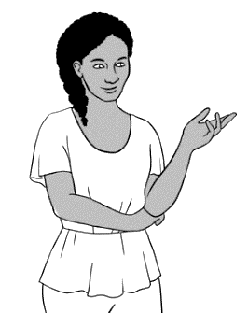
How can Anika learn new words?

These are my steps.

  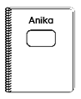  1 | I copy words from the board into my __________________.
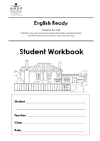  2 | I copy ____________ from my workbook again and _________.
3 | I write _______ words  on my word list.

words
words
notebook
again
new

Write new words on your wordlist.
My Word List

At the end of the term
Post review interview

If a student has made limited progress through the term, a one-to-one interview could reveal the student’s particular difficulties and open a discussion about ways to overcome any barriers to learning.
Possible interview topics and questions:
- Class environment - Are you happy in the class?
- Transport - Is it easy to get to class on time?
Do you drive?
Do you catch a bus/train?
Do you walk here?
- Study at home – Can you study at home? –
Do you have a quiet place to study?
Do you have time to study at home?
Do you have a computer?
Do you have the internet?

Developing independent study skills at home
Some students may need structured guidance to develop independent learning skills. The following pages could be given to such students as a ‘Homework Book’ which could provide a framework to develop effective study practice outside the classroom.
The teacher may initially need to guide this practice by prescribing the words to be learned, sentences to be copied or the formation of letters to be practised for homework.
When practising spelling, the copying of words is easier if students copy down rather than across. Saying the word aloud each time when copying will also support memory retention.

Homework
1
Name _______________________________________________
Day and date _______________________________________
Copy the capital letters from your workbook.

Read the capital letters aloud.
Spell Copy 3 words from your workbook.

New words Write 2 new words.
English | Your language

Ask the teacher
Can you check my work please?
Homework
Name _______________________________________________
Day and date _______________________________________
2
Copy the small letters from your workbook.

Read the small letters aloud.
Spell Copy 3 words from your workbook.

New words Write 2 new words.
English | Your language
Ask the teacher
Can you check my work please?
Homework
Name _______________________________________________
Day and date _______________________________________
3
Copy a sentence from your workbook again and again.

Read the sentence aloud 4 times.
Spell Copy 3 words from your book.

New words Write 2 new words.
English | Your language
Ask the teacher
Can you check my work please?
Homework
Name _______________________________________________
Day and date _______________________________________

4
Copy a sentence from your workbook again and again.

Read the sentence aloud 4 times.
Spell Copy 3 words from your book.

New words Write 2 new words.
English | Your language
Can you check my work please?
Ask the teacher
Homework
Name _______________________________________________
Day and date _______________________________________

5
Copy a sentence from your workbook again and again.

Read the sentence aloud 4 times.
Spell Copy 3 words from your book.
New words Write 2 new words.
Can you check my work please?
English | Your language
Ask the teacher

