English Ready
22637VIC Course in EAL
VU23495 Begin language learning with support

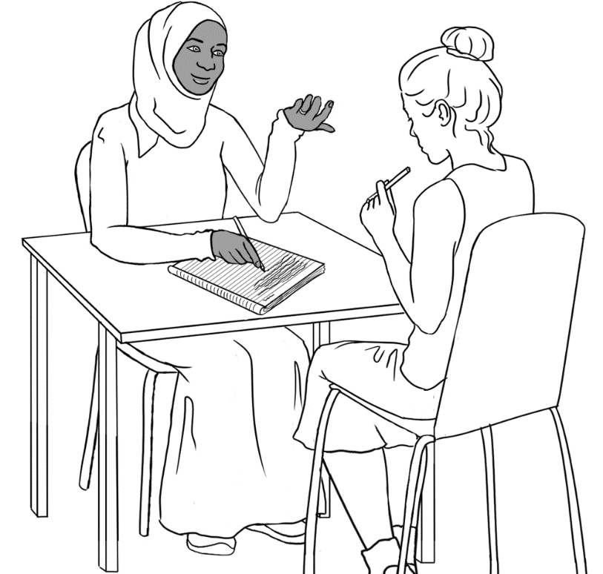
Learn English

Student ___________________________________________________
Teacher ___________________________________________________
Class ______________________________________________________
Date ______________________________________________________

This workbook is designed to be used with the support of a teacher.
Design team: Vicki Hambling, Sue Paull, Frida Dean, Janice Langley, Glenise Kleehammer and Mary Wallace
Illustrations: Madelena Scott
Image acknowledgements:
Police logo - Standards Australia, CC BY 3.0 AU <https://creativecommons.org/licenses/by/3.0/au/deed.en>, via Wikimedia Commons
Toilet sign - This Photo by Unknown Author is licensed under CC BY
Acknowledgements: The design team would like to thank the AMEP service providers and practitioners who participated in the trial and gave valuable feedback. The team would also like to acknowledge the use of the EAL Framework which underpins the design of this book.
Copyright of the EAL Framework is reserved to the Crown in the right of the State of Victoria. © State of Victoria (Department of Education and Training) 2023.
_________________________________________________________________________________________
This English Ready Resource is licensed under a Creative Commons Attribution-NoDerivs 3.0 Australia licence (More information is available here). You are free to use, copy and distribute to anyone in its original form as long as you attribute Department of Home Affairs as the author and you license any derivative work you make available under the same licence.
© Commonwealth of Australia 2023

With the exception of the Commonwealth Coat of Arms, the department’s logo, any material protected by a trade mark and where otherwise noted all material presented in this document is provided under a Creative Commons Attribution 4.0 International (https://creativecommons.org/licenses/by/4.0/) licence.
The details of the relevant licence conditions are available on the Creative Commons website (accessible using the links provided) as is the full legal code for the CC BY 4.0 licence (https://creativecommons.org/licenses/by/4.0/legalcode).
Use of all or part of this document must include the following attribution:
© Commonwealth of Australia 2023
As far as practicable, material for which the copyright is owned by a third party will be clearly labelled. The department has made all reasonable efforts to ensure that this material has been reproduced in this document with the full consent of the copyright owners.
Copyright requests and enquiries concerning usage not addressed by the CC BY 4.0 licence should be addressed to:
comms@homeaffairs.gov.au at the Department of Home Affairs.
The terms of use for the Commonwealth Coat of Arms are available from the It's an Honour website.
Where a copyright owner, other than the Commonwealth, is identified with respect to this material, please contact that third party copyright owner directly to seek permission.



Table of Contents

1. Instructions 1
2. Meet the people. 2
3. The alphabet 5
4. The sounds of the alphabet 11
5. Important words 15
6. Learning in Australia 18
7. My word list 21

Instructions
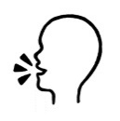
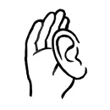

 | 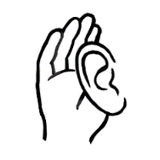 | listen |  |  |  | 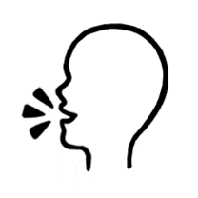 |  | say
 |  | copy |  |  |  | 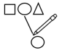 |  | match
 |  | read |  |  |  | 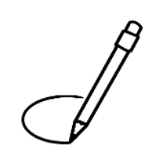 |  | circle
 | 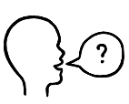 | ask |  |  |  |  |  | tick
 | 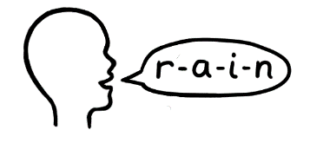 | spell |  |  |  |  |  | record
 | 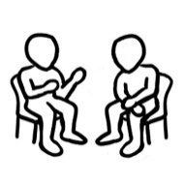 | work with a partner |  |  | 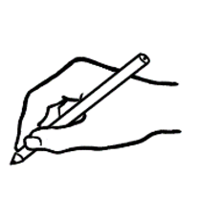 |  | write

Meet the people.

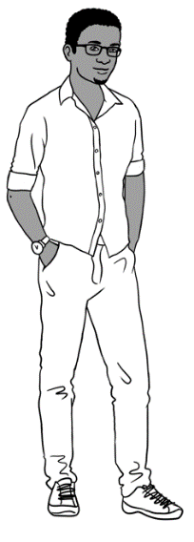
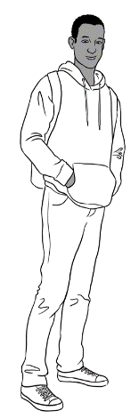
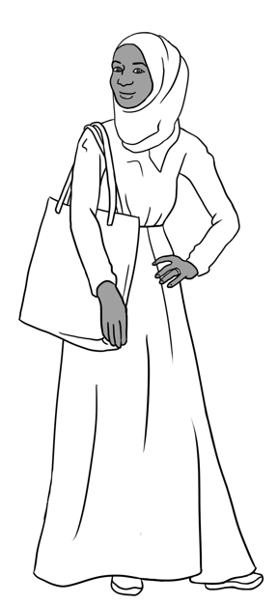
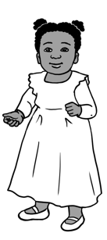
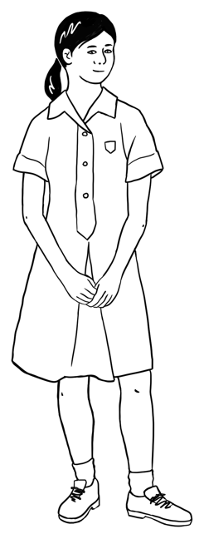
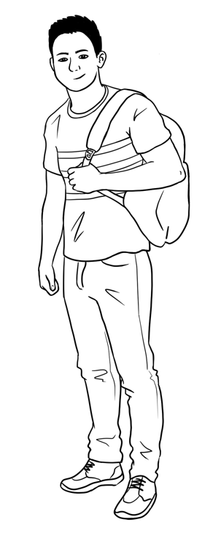
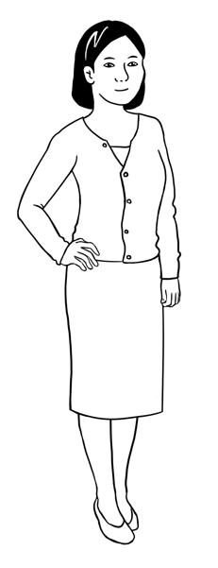
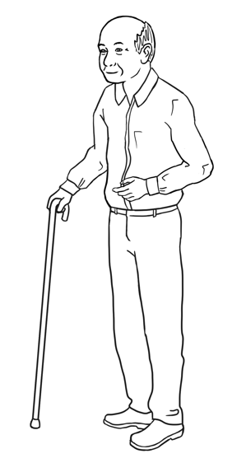

Sahra’s family comes from Somalia.
This is Sahra.
This is Hani.
This is Tahiil.
This is Abdi.
This is Ming. This is Lan. This is Mai. This is Bao.
Ming’s family comes from China.

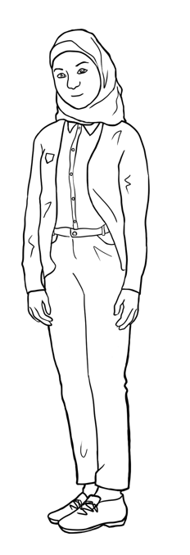
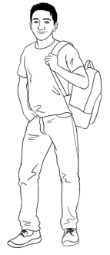
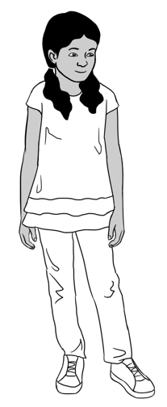
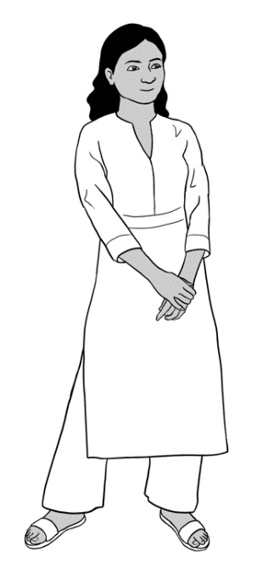
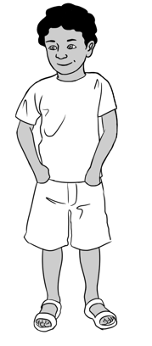
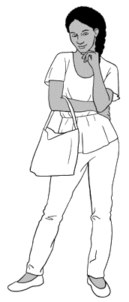
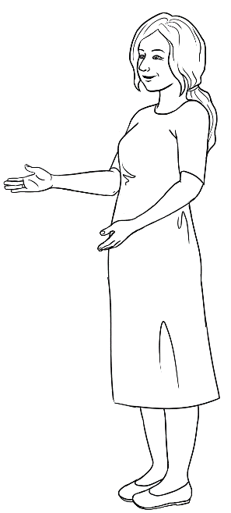
Carim’s family comes from Syria.
This is Carim.
This is Fatima.

Nisha’s family comes from India.
This is Nisha. This is Pari. This is Dev.

Anika comes from Ethiopia.
This is Anika.

Jenny is a teacher.
She is from Australia.
This is Jenny.

This is Carim. This is Fatima.

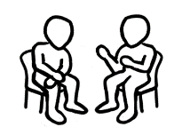

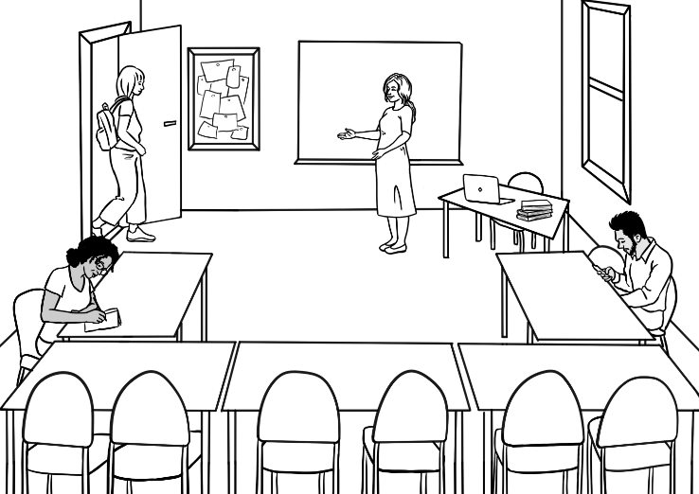
In the classroom
Come in.

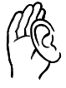

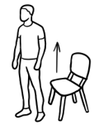  Stand up.  1 | 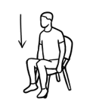  Sit down.  2
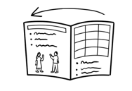  Open your workbook.  3 | 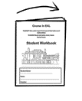  Close your workbook.  4
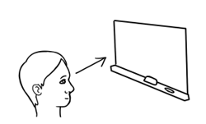  Look at the board.  5 | 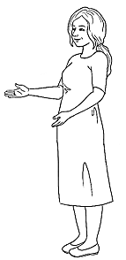  Listen to  the teacher.  Listen.  6
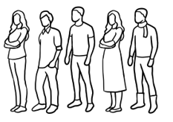  Stand in a line.  7 | 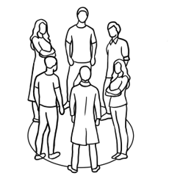  Stand in a circle.  8

The alphabet
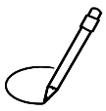

A | B | C | D | E | F | G | H | I | J | K | L | M
N | O | P | Q | R | S | T | U | V | W | X | Y | Z
Capital letters


 | A | B | C | D | E | F | G | H | I | J | K | L | M
1 | A | B |  | D | E |  | G | H |  | J | K |  | M
2 | A |  | C |  |  | F |  |  | I |  |  | L
3

 | N | O |  | P | Q | R | S | T | U | V | W | X | Y | Z
4 | N |  |  | P | Q | R |  | T | U |  | W |  | Y | Z
5 |  | O |  |  |  |  | S |  |  | V |  | X
6

Small letters
a | b | c | d | e | f | g | h | i | j | k | l | m
n | o | p | q | r | s | t | u | v | w | x | y | z

 | a | b | c | d | e | f | g | h | i | j | k | l | m
1 | a | b |  | d | e |  | g | h |  | j | k |  | m
2 |  |  | c |  |  | f |  |  | i |  |  | l
3

 | n | o | p | q | r | s | t | u | v | w | x | y | z
4 | n |  | p | q | r |  | t | u |  | w |  | y | z
5 |  | o |  |  |  | s |  |  | v |  | x
6

A a | B b | C c | D d | E e | F f | G g
H h | I i | J j | K k | L l | M m | N n
O o | P p | Q q | R r | S s | T t | U u
V v | W w | X x | Y y | Z z
Capital and small letters

A | b |  | N | p
B | d |  | O | n
C | a |  | P | t
D | c |  | Q | o
E | g |  | R | s
F | e |  | S | q
G | f |  | T | w
H | k |  | U | r
I | m |  | V | x
J | l |  | W | u
K | h |  | X | z
L | i |  | Y | v
M | j |  | Z | y

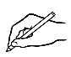
A a | B | C | D | E | F | G
H | I | J | K | L | M | N
O | P | Q | R | S | T | U
V | W | X | Y | Z
a A | b | c | d | e | f | g
h | i | j | k | l | m | n
o | p | q | r | s | t | u
v | w | x | y | z

b | d | b | p | q
f | h | k | f | l
m | n | w | m | u
y | u | v | w | y
x | s | c | x | z
p | t | b | p | r
k | c | v | k | t
a | o | u | v | a
g | y | g | j | q
The computer keyboard

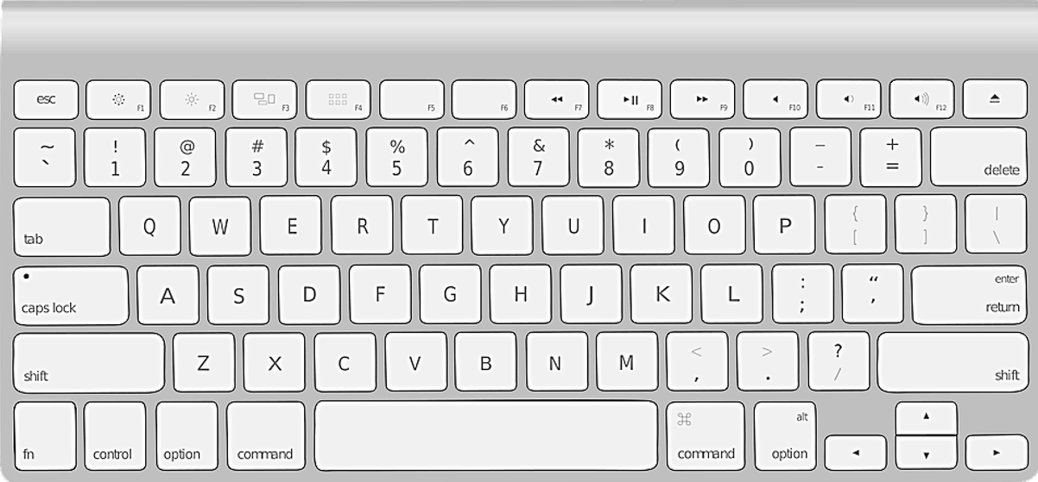

G
W
E
R
T
Y
U
I
O
P
D
A
S
Q
F
H
R
Q
X
C
B
N
M

V
Z
K
J
L

G
W
E
R

Y

I

P
D
A

Q

R
Q

C
B

M

Z

J
L

A | B | C | D | E | F | G | H | I | J | K | L | M
N | O | P | Q | R | S | T | U | V | W | X | Y | Z

 |  | 3. | 4. | 5. | 6.

7. | 8. | 9. | 10. | 11. | 12.

a | b | c | d | e | f | g | h | i | j | k | l | m
n | o | p | q | r | s | t | u | v | w | x | y | z

1. | 2. | 3. | 4. | 5. | 6.

7. | 8. | 9. | 10. | 11. | 12.

The sounds of the alphabet

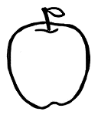  A a  apple | 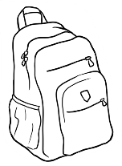  B b  backpack |   C c  computer
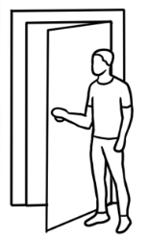  D d  door | 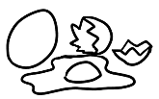  E e  eggs |   F f  five
  G g  glasses | 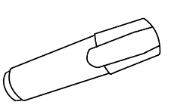  H h  highlighter | 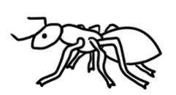  I i  insect
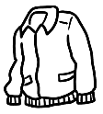  J j  jacket | 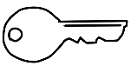  K k  key |   L l  lamp

 | apple |  | backpack
 | eggs |  | door | 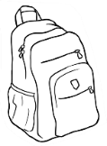
 | insect |  | glasses | 
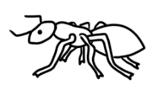 | highlighter |  | computer | 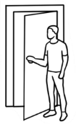

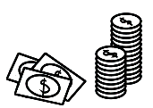  M m  money |   N n  notebook | 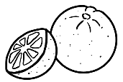  O o  orange
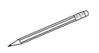  P p  pencil | 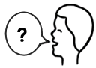  Q q  question | 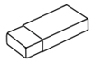  R r  Rubber  rubber
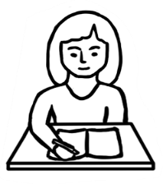  S s  student | 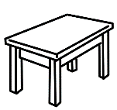  T t  table |   U u  umbrella
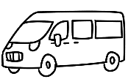  V v  van | 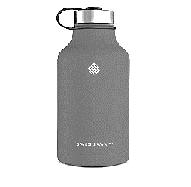  W w  water | 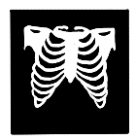  X x  x-ray
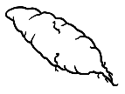  Y y  yam |   Z z  zero

 | orange |  | pencil
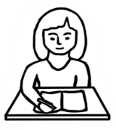 | umbrella |  | rubber | 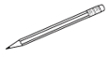
 | student |  | table | Rubber

1 | c computer | s student | z zero
2 | p pencil | b backpack | 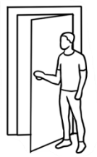  d door
3 | k key | g glasses | j jacket
4 | n notebook | m money | h highlighter
5 | i insect | a apple | e eggs
6 | u umbrella | 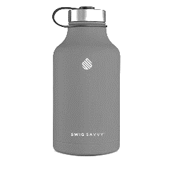  w water | v van

sh | 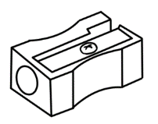  sharpener | 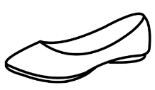  shoe | 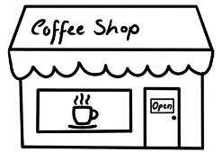  shop
sh |   shirt | 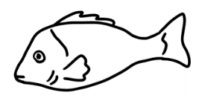  fish | 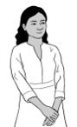  Nisha
ch | child | 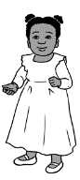  children | 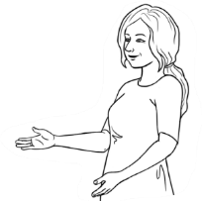  teacher
ch | 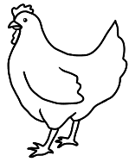  chicken | 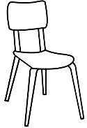  chair | 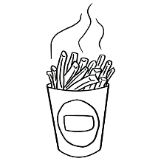  chips
th | three  3 | thirteen  13 | thirty  30
th | Thursday  Wednesday  Thursday  Friday  Saturday | 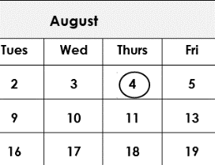  fourth | 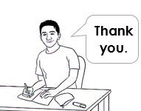  thank

Important words

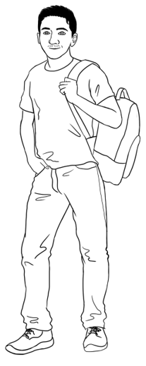
Carim’s important words
First name | Carim
Family name | Hamed
Street | North Street
Town / Suburb | Kellivale

First name
Family name
Street
Town / Suburb
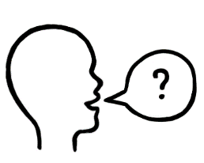
Can you check my spelling please?
Can you say the name of my street and suburb please?

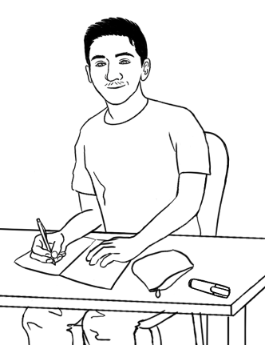
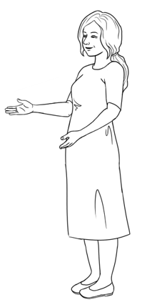
Can you spell your name please Carim?
Carim C - a - r - i - m

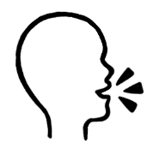
Learn your important words.

First Name | Family Name
Street | Town / suburb

Signs

1  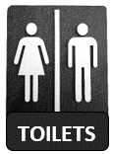 |  |   2 |  | 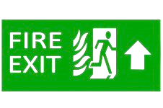  3
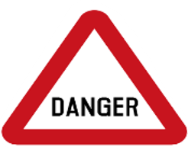  4 |   5 |  |   6 |  |   7
Aa Bb Cc Dd Ee Ff Gg Hh Ii Jj Kk Ll Mm
Nn Oo Pp Qq Rr Ss Tt Uu Vv Ww Xx Yy Zz
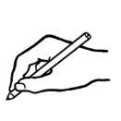

TOILETS | RECEPTION | FIRE EXIT
toilets. | __________________ | __________________
DANGER | STOP | HOSPITAL
__________________ | __________________ | __________________

Learning in Australia
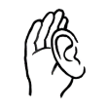
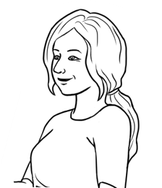
Is learning in Australia the same as
learning in your country?

Learning in Australia |  |  | In your country
 |  |  | Yes | No
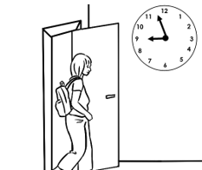 | Students come  to class on time.
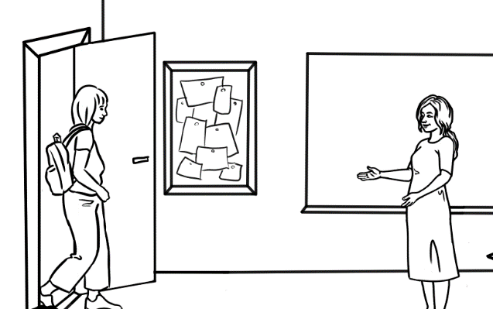
Good morning Alina.
Good morning Jenny.

Teachers and
students use
their first names.
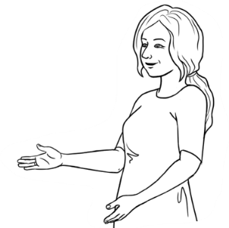  Do you understand? |  | The teacher says,  Do you understand?
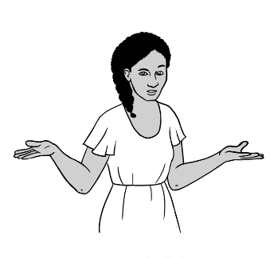
Sorry. I don’t
understand.

Students say,
Sorry.
I don’t understand.

Learning in Australia |  |  |  | In your  country
 |  |  |  | Yes | No
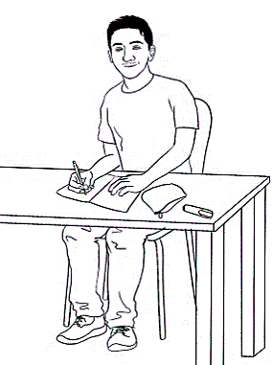  Thank you.  Can you  help me please? |  |  | Teachers and students say please and thank you.
Students ask questions. |  | 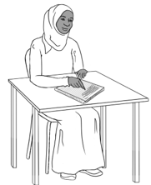  Excuse me.  What is this word?
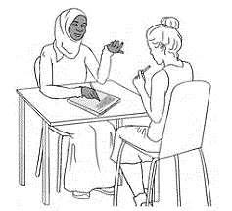 | Students work  with a partner.
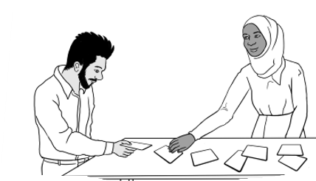
Men and women
work together.

Learning in Australia |  |  |  | In your  country
 |  |  |  | Yes | No
Students work  in groups. | 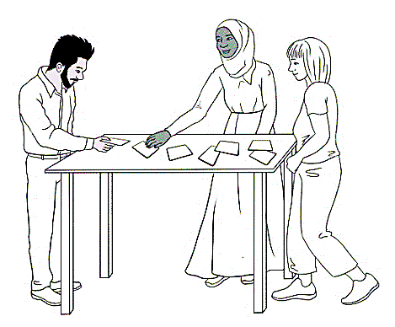
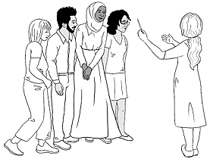 |  |  | Students and  teachers work  together.
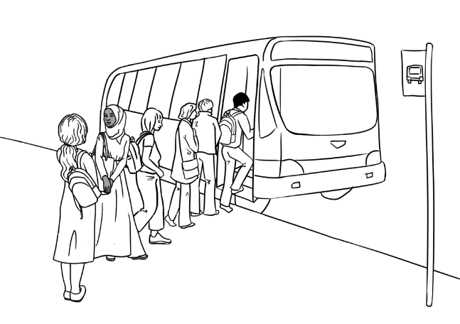

Students
go on excursions.

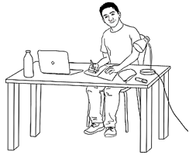 |  | Students study  at home.

7. My word list

