English Ready
22637VIC Course in EAL
VU23495 Begin language learning with support

Learn English
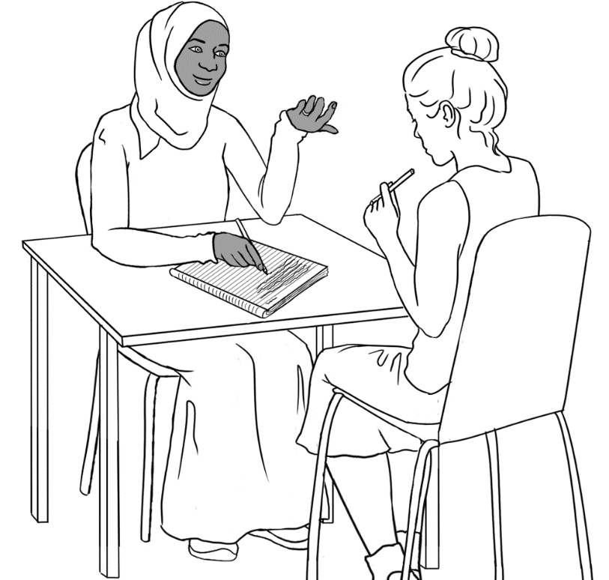

Teacher Resources

Design team: Vicki Hambling, Sue Paull, Frida Dean, Janice Langley, Glenise Kleehammer and Mary Wallace
Illustrations: Madelena Scott
Image acknowledgements:
Keyboard - Blank generic keyboard vector image | Free SVG Creative Commons — CC0 1.0 Universal
Acknowledgements: The design team would like to thank the AMEP service providers and practitioners who participated in the trial and gave valuable feedback. The team would also like to acknowledge the use of the EAL Framework which underpins the design of this book.

Copyright of the EAL Framework is reserved to the Crown in the right of the State of Victoria. © State of Victoria (Department of Education and Training) 2023.
_________________________________________________________________________________________
This English Ready Resource is licensed under a Creative Commons Attribution-NoDerivs 3.0 Australia licence (More information is available here). You are free to use, copy and distribute to anyone in its original form as long as you attribute Department of Home Affairs as the author and you license any derivative work you make available under the same licence.
© Commonwealth of Australia 2023

With the exception of the Commonwealth Coat of Arms, the department’s logo, any material protected by a trade mark and where otherwise noted all material presented in this document is provided under a Creative Commons Attribution 4.0 International (https://creativecommons.org/licenses/by/4.0/) licence.
The details of the relevant licence conditions are available on the Creative Commons website (accessible using the links provided) as is the full legal code for the CC BY 4.0 licence (https://creativecommons.org/licenses/by/4.0/legalcode).
Use of all or part of this document must include the following attribution:
© Commonwealth of Australia 2023
As far as practicable, material for which the copyright is owned by a third party will be clearly labelled. The department has made all reasonable efforts to ensure that this material has been reproduced in this document with the full consent of the copyright owners.
Copyright requests and enquiries concerning usage not addressed by the CC BY 4.0 licence should be addressed to:
comms@homeaffairs.gov.au at the Department of Home Affairs.
The terms of use for the Commonwealth Coat of Arms are available from the It's an Honour website.
Where a copyright owner, other than the Commonwealth, is identified with respect to this material, please contact that third party copyright owner directly to seek permission.



Introduction
The Teacher Book
This book is an electronic reference. Print pages as only needed. It includes materials and activities for:
- pair work and class work
- revision and homework
- pronunciation
- extension.

The Student Workbook
This book requires teacher direction and is not intended for independent learning. It is also not intended to be the only material used to teach these units. The activities included are not suitable to be used for assessment.
The book is available as a Word document so that teachers can:
- localise and update the content
- adjust the material to suit the requirements of particular classes
- delete or add materials as required

Table of Contents

1. Instructions 3
2. Meet the people. 9
3. The alphabet 12
4. The sounds of the alphabet 30
5. Important words 43
6. Learning in Australia 51

Instructions
Activity 1 – Workbook instructions
- Project the table below with the instruction symbols and the words
on the board. Read the instructions and ask students to repeat.
- Project the table on the following page with only the instruction symbols, and ask students to guess the instruction.

 | 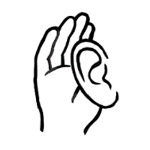 | listen |  |  |  | 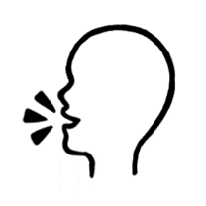 |  | say
 |  | copy |  |  |  | 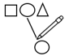 |  | match
 |  | read |  |  |  | 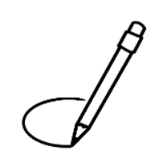 |  | circle
 | 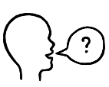 | ask |  |  |  |  |  | tick
 | 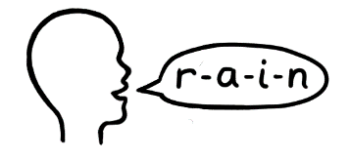 | spell |  |  |  |  |  | record
 | 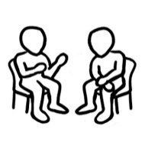 | work with a partner |  |  | 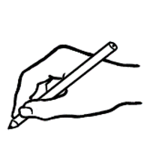 |  | write

 | 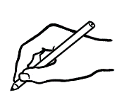
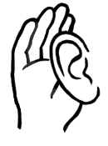

 | 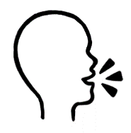
 | 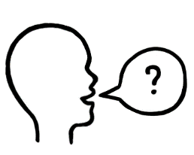
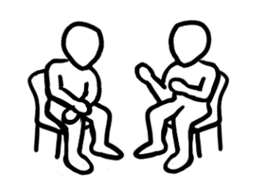

Activity 2– Following workbook instructions
Read each instruction slowly. Students follow and complete each instruction on the numbered table on the following page.

- Circle the eggs.

- Write your first name.

- Copy the word - student.

- Tick yes or no. Is it hot today?

- [Write address on the board.]
Read the word on the board.
Write the missing letters.

- Circle the letter m.

- Tick yes or no. Is it Monday today?

- Copy the word - teacher

- Ask your partner. Please spell your name.
Write your partner’s name.

Instructions

- read | - listen | - match | - tick
 |  | 
- copy | - write | - spell | - say
- Work with a partner. | - circle | - ask | - record
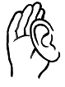
Follow the instructions.
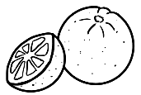  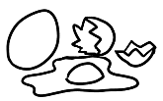  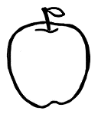 | __________________ | 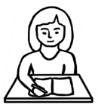  student  ________________
Yes  No | a__dr___ss | n a m e
Yes  No | 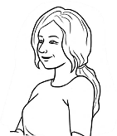  Teacher  __________________ | Please spell your first name.  _________________

Activity 3 – Classroom instructions
- Listening to instructions
- Read the instruction. Students listen and follow the instruction.
- Ask a student to choose and read an instruction. Students listen and follow the instruction.

- Extending the use of the instruction verbs
- Project the following page.
- Brainstorm one or two instructions often used in the classroom
for each verb and write them on the board. e.g.

- open the door, open the window
- close the door, close the window
- listen to your partner, listen to me, listen to the song
- look at your workbook, look at the clock
- stand here, stand there, stand next to me
- come in, come to me, come to the desk etc
- Give students the following page.
- Students write one or two different classroom instructions
for each verb.
- Practise these variations in following classes.

[Additional verbs could be added to the list e.g. bring and borrow, turn on and turn off]

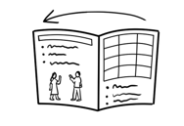
open
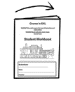
close
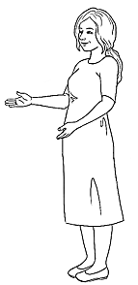
listen
Listen.

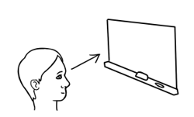
look
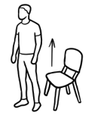
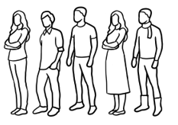
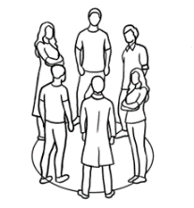
stand
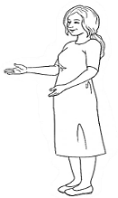
come
Come in.

Meet the people.

Activity
Project the drawings of the families on the whiteboard. Students refer to their books to answer questions about each character and family:
Who is this? Where do they come from?

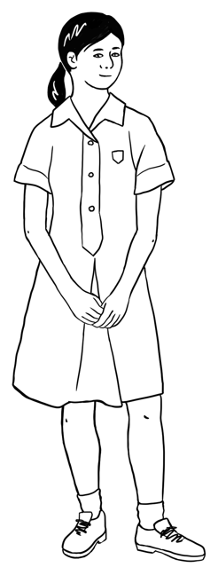
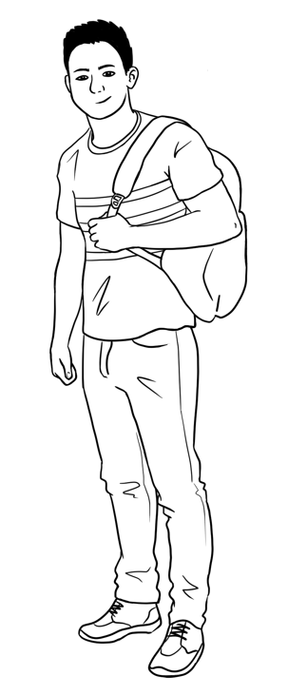
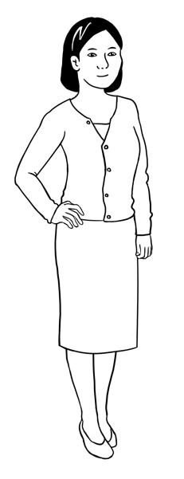
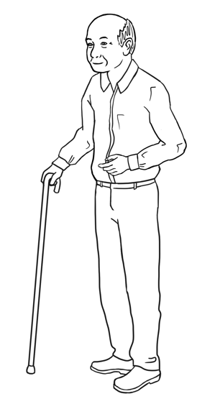

This is ______. This is _____. This is ______. This is _____.
Ming’s family comes from ______.

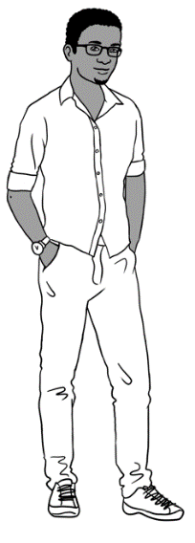
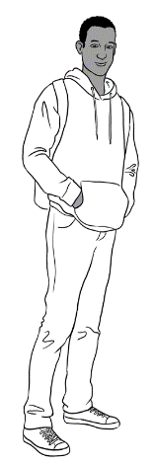
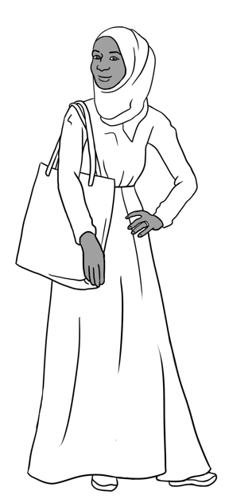
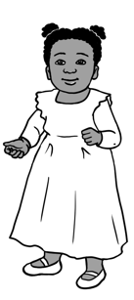

Sahra’s family comes from ___________.
This is ______.
This is _____.
This is ______.
This is _____.

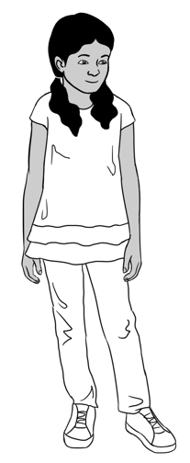
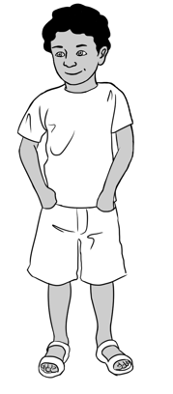
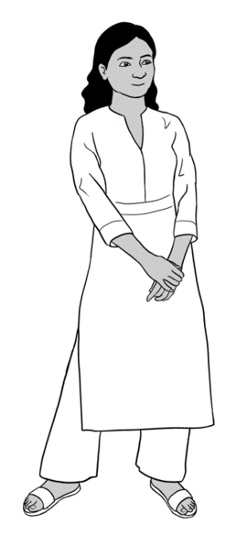

This is ________. This is _______. This is ______.
Nisha’s family comes from __________.

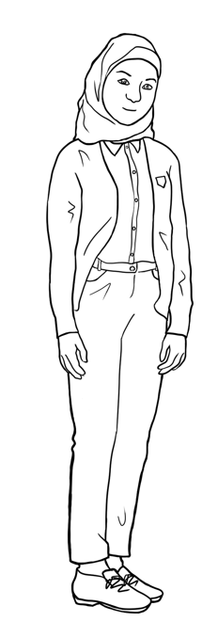
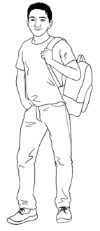
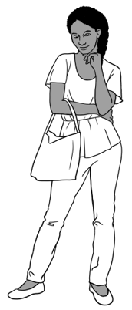

Carim’s family comes from _____.
This is _______. This is ______.

This is ________.
Anika’s family comes
from ____________.

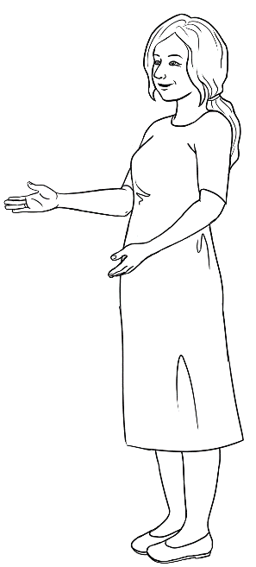

Jenny is a teacher.
She is from ___________.
This is Jenny.

The alphabet
- Upper and lower-case letter tiles
Print the four pages of letter tiles, enough for each student to cut up and have their own set. Distribute envelopes for students to store their tiles for regular use. Some ideas for use:
- Students match upper and lower-case letters.
- Say the name of a letter [or a letter sound] ; students hold it up or place it on their desk.
- Ask, What is the first letter in a word? eg. computer Students hold up C
- Write a word on the board e.g. _ encil. Read the word; students hold up the first letter.
- Lay out the alphabet cards on a table in a row. Students work in groups and roll a dice to move along the path. Each time they stop they say the letter. If they make a mistake, they move back 2 places.
- Spell a word and students find the letters and make the word. They then scramble the word and put it back correctly.
- Students work in pairs with one set of either capitals or small letters. They put their letters into alphabetical order. One student turns their back and the other removes one letter, and pushes the cards together to disguise the gap. The other student must say which letter is missing.
- Separate the vowels [in grey] from the consonants. Write a number of familiar words from the sound chart or classwork on the board. Students use their tiles to assemble the words. Show that in every word there is a vowel, or a y playing the role of a vowel.
- Game of concentration/memory – in groups of three or four, students mix a set of upper and lower-case letters face-down on the table. The goal is to form pairs of letters. Students take turns to turn over two cards to form a pair. If the letters match, the student keeps the pair and has another turn. If the letters don’t match, the student turns the letters over in the same place on the table. When all the pairs have been matched, the student with the most pairs is the winner.
- The game of ‘Go Fish’ – Create sets of alphabet tiles. Students play in small groups following the rules of the old card game. The game can be adapted with the alphabet pictures, number and vocab tiles, or a mixture of tiles.

- Print grids similar to the ones below. Each student in a group is given a grid with two different pictures. Working with three or four sets of lower- case letter tiles turned face down, students take turns to select a letter. They need to spell out the words on their grid. [They can use their workbooks to check the spelling.] If they can’t use a letter, they return it to a space next to the pile face up. The next student can pick a new letter or the discarded one. The first to complete their two words wins.

e.g.
 | s | t |  |  |  |  | t
 | e

 | f |  | v | e
 | o

 | a | p |  | l
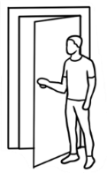 |  | o

A | B | C | D
E | F | G | H
I | J | K | L
M | N | O | P
Q | R | S | T
U | V | W | X
Y | Z

a | b | c | d
e | f | g | h
i | j | k | l
m | n | o | p
q | r | s | t
u | v | w | x
y | z

2. Bingo – Upper-case letters
Teacher call chart
A | B | C | D | E | F | G | H | I | J
K | L | M | N | O | P | Q | R | S | T
U | V | W | X | Y | Z
Student Bingo cards

A | F | B |  | K | U | O
M | E | I |  | Z | G | A
P | H | G |  | T | D | X

Z | T | K |  | N | M | D
B | A | O |  | E | F | J
I | J | P |  | R | L | I

E | J | I |  | Q | A | G
T | C | H |  | P | H | I
L | F | S |  | M | K | B

F | M | P |  | Y | E | L
Z | A | W |  | F | D | J
Y | B | E |  | H | Z | M
S | J | I |  | R | I | E
V | G | H |  | L | H | N
L | E | P |  | M | C | G

C | U | I |  | E | Y | P
E | S | J |  | M | B | U
Q | M | F |  | V | O | H

T | Y | V |  | H | H | T
E | A | M |  | J | E | L
H | J | W |  | K | M | V

W | S | U |  | F | R | P
B | C | P |  | M | H | I
R | O | D |  | Y | A | J

A | T | P |  | Y | U | P
D | F | I |  | L | F | M
U | G | H |  | Q | O | T

E | X | H |  | E | X | S
J | B | K |  | J | C | Z
G | I | M |  | N | I | A

3. Bingo – Lower-case letters
Teacher call chart
a | b | c | d | e | f | g | h | i | j
k | l | m | n | o | p | q | r | s | t
u | v | w | x | y | z

Student bingo cards
a | f | b |  | k | u | o
m | e | i |  | z | g | a
p | h | g |  | t | d | x

z | t | k |  | n | m | d
b | a | o |  | e | f | j
i | j | p |  | r | l | i

e | j | i |  | q | a | g
t | c | h |  | p | h | i
l | f | s |  | m | k | b

f | m | p |  | y | e | l
z | a | w |  | f | d | j
y | b | e |  | h | z | m

s | j | i |  | r | i | e
v | g | h |  | l | h | n
l | e | p |  | m | c | g

c | u | i |  | e | y | p
e | s | j |  | m | b | u
q | m | f |  | v | o | h

t | y | v |  | h | h | t
e | a | m |  | j | e | l
h | j | w |  | k | m | v

w | s | u |  | f | r | p
b | c | p |  | m | h | i
r | o | d |  | y | a | j

a | t | p |  | y | u | p
d | f | i |  | l | f | m
u | g | h |  | q | o | t

e | x | h |  | e | x | s
j | b | k |  | j | c | z
g | i | m |  | n | i | a

Student Bingo cards - Blank

4. Handwriting guide A practice writing book is available at Initial level.
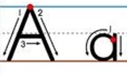
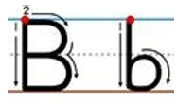
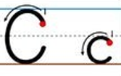
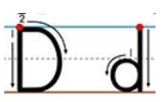
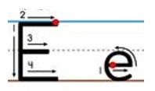

……………………………………………………………………………………………………………..

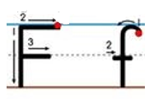
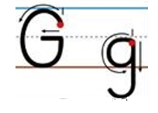
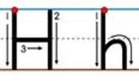
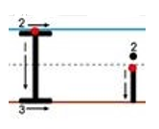
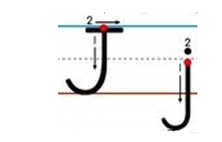

……………………………………………………………………………………………………………..

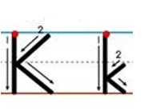
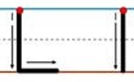
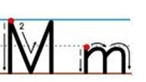
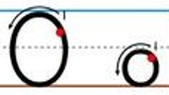
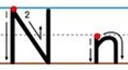

……………………………………………………………………………………………………………..

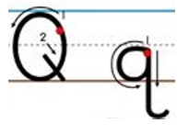
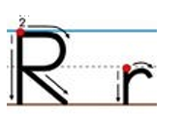
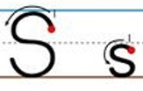
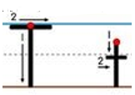
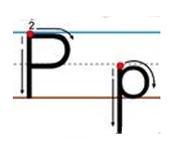
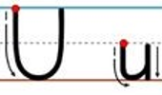

……………………………………………………………………………………………………………..

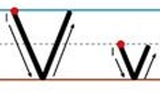
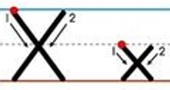
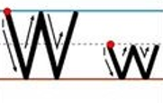
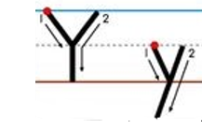
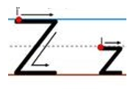

……………………………………………………………………………………………………………..

4. Dictation of letters [Pair work]
This is a student-to-student dictation.
- Print a page of either the upper or lower-case table for each student.
- Students work in pairs and sit back-to-back. They each need a pencil and a pen.
- In the first dictation, use a pencil.
- Student A begins at the first row and calls out the number of the row and then one letter in the row. Student A circles the letter on their table with a pencil.
- Student B listens and circles the letter on their table with a pencil.
- Student A & B continue in this way to the final row of pictures.
- Student A nominates one of the pictures to circle.
- Student B checks their table with Student A’s table to see the correct letters have been circled.
- Swap roles and in the second dictation, use a pen to circle the letters.

 | S | W | A | B | T
 | N |  | T | M |  | Q
 | D | K | B | G | Z | L
 | A | O |  | J | C | S
 | Z | I | F | D | H | R
 | X |  | U | Y | T | F
 | M | H | J | W | I | E
 | P | C | B | L |  | Y
 |  | S | O | A | G
 | C | F | N | B | R | V
 | Q | U | E | V | Z | A
 |  |  | 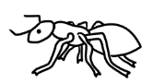 |  | 
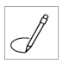
Start

Start

 | s | w | a | b | t
 | n |  | t | m |  | q
 | d | k | b | g | z | l
 | a | o |  | j | c | s
 | z | e | i | d | h | r
 | x |  | u | y | t | f
 | m | h | j | w | i | e
 | p | c | b | l |  | y
 |  | s | o | a | g
 | c | f | n | b | r | v
 | q | u | e | v | z | a
5. The Computer Keyboard
On paper
- Print the keyboards on the following page and repeat the activity in Student Book using different letters of the alphabet

- Print the large keyboard on Page 29 and ask students to write the keyboard letters [or copy the letters from their workbook]
On a computer
- Choose 10 words from the student book and write on whiteboard
- Students type in upper-case – 5 times
- Students type in lower-case – 5 times
- Students type in upper and lower-case – 5 times
- Repeat activity daily or weekly using different words

- Typing practise https://www.typing.com/student/lessons

Note: Additional computer activities are on pages 47 - 50.

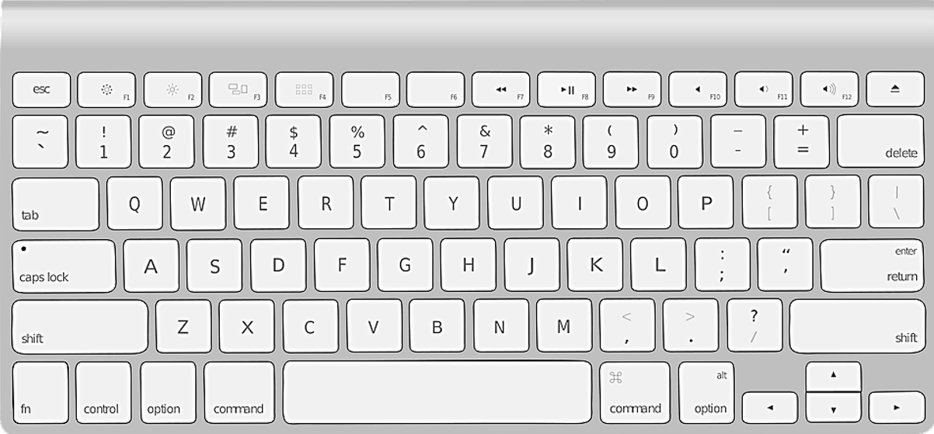

The computer keyboard
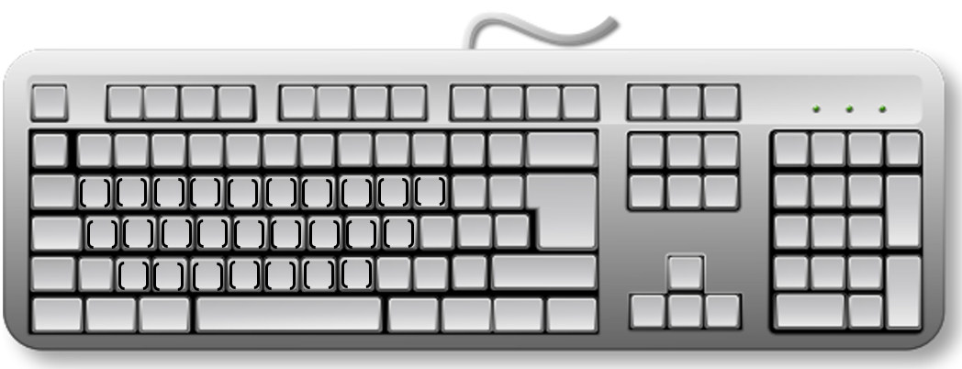

The sounds of the alphabet
A book that covers the sounds in more detail is available at Initial level.

Activity 1 – Matching initial sounds
The following pictures, initial sounds and words can be printed and cut up by the students and used for a variety of class and pair work.

 | 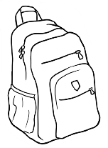 |  | 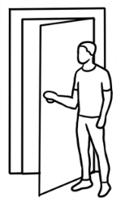
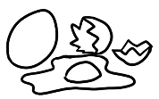 |  | 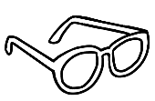 | 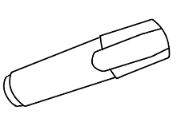
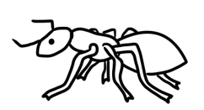 | 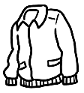 | 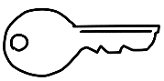 | 
 |  |  | 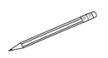
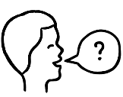 | 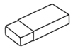  Rubber | 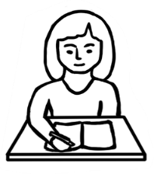 | 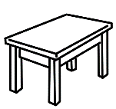
 | 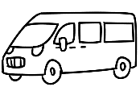 | 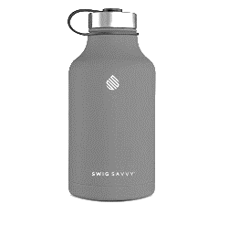 | 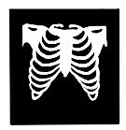
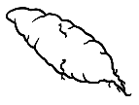 | 

a | b | c | d
e | f | g | h
i | j | k | l
m | n | o | p
q | r | s | t
u | v | w | x
y | z

apple | backpack | computer | door
eggs | five | glasses | highlighter
insect | jacket | key | lamp
money | notebook | orange | pencil
question | rubber | student | table
umbrella | van | water | x-ray
yam | zero

Activity 2 – Listening for single initial sounds
- Print the worksheet on the following page, one for each student.
It’s a variation of a similar worksheet in the student book.
- If possible, project the worksheet for easy correction.
- Say a sound for each line of pictures; students circle the sound. The first sound c is circled as an example.
- Repeat the activity at other times choosing different sounds.


Listen to the teacher. Circle the sound.
1 | s student | y yam | c computer
2 | f five | v van | 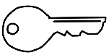  k key
3 | o orange | u umbrella | a apple
4 | z zero | s student | j jacket
5 | l lamp  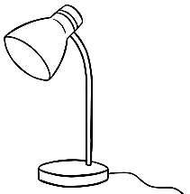 | t table | 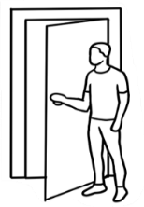  d door
6 | e eggs | a apple | u umbrella

Activity 3 – Consonant blends
Some of the words in the worksheet are taken from other units at this level.
- Print the worksheets on the following two pages, back-to-back,
one for each student.
- If possible, project the worksheet for easy correction.
- The first example is completed on each sheet.

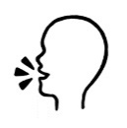
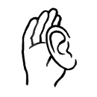
Two letters
Underline the sound.
bl | black | blue | table
br | brown | 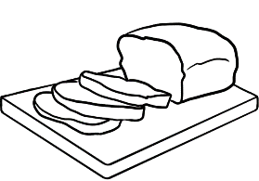  bread | umbrella
ck | tick | jacket | 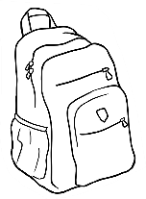  backpack
cl | 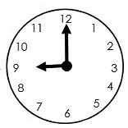  clock |   clap |   cloudy
fr | Friday  Wednesday  Thursday  Friday  Saturday | 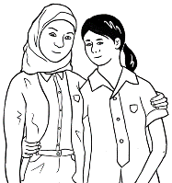  friends |   fruit
pl | 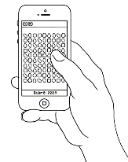  play |   plate | apple
st |   stop | 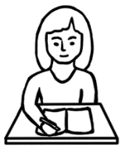  student | stand
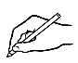
Write the letters.

bl | b l ack | _ _ue | ta_ _e
br | _ _ own | _ _ead | um_ _ella
ck | ti_ _ | ja_ _et | ba_ _pa_ _
cl | _ _ock | _ _ap | _ _oudy
fr | _ _iday  Wednesday  Thursday  Friday  Saturday | _ _riends | _ _uit
pl | _ _ay | _ _ate | ap_ _e
st |   _ _op | _ _udent | _ _and
Activity 4 – Two letters = one sound
Some of the words in the worksheet are taken from other units at this level.
- Print the worksheet on the following page, one for each student.
- If possible, project the worksheet for easy correction.
- Read the word and student listen for the sound.
- The first example is completed as a guide for student.

Two letters = one sound
Listen and circle the sound.
1 | sh sharpener  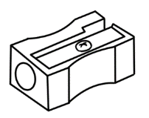 | th three  3 | ch child
2 | 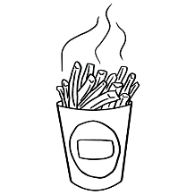  ch chips | 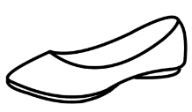  sh shoe | th Thursday  Wednesday  Thursday  Friday  Saturday
3 |   th thank | 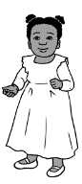  ch children |   sh shop
4 | ch chicken | sh shirt  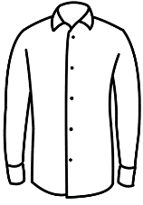  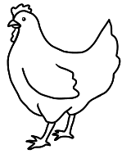 | th thirteen  13
5 | 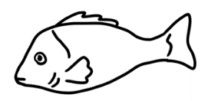  sh fish | 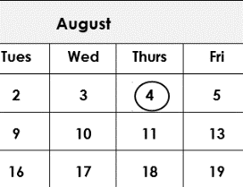  th fourth | 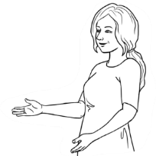  ch teacher

Important words
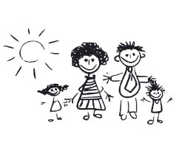
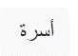
Teach students different ways to memorise new words.
- Copy and say the word three times, translate it, draw a picture. e.g.
word | translation | 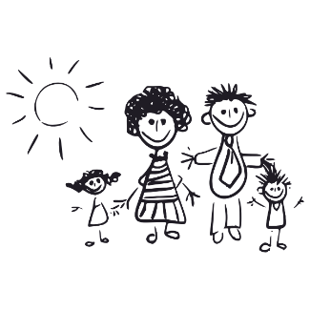
family
family
family

- Make a word card. On one side write the word in English and on the other side, write the word in your language or put a picture.
e.g.

- Learn five new words.
- At the end of the lesson, write 5 new words on the board e.g.

- Students copy the words on a small card or sticky note.
- Read each word and spell it aloud together.
- Students put their phones on the front desk to record
the words. Read each word twice leaving time for
students to be able to repeat the words at home.
- Encourage students to look at the card as often
as they can through the day. Look and say the words.
When saying the words use movement to aid memory.
e.g. clap hands or slap the thighs for each syllable.

- Learning to spell words
- Students can create a spelling list at the back of their notebooks. Add the new words to this list.
- Go over the technique suggested in the student book - Say the word, Copy the word, Spell aloud.
- Copy each word three times, and repeat every day for at least four days.

family
name
address
phone
country
family
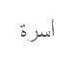

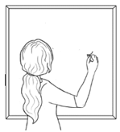

Activity – Following workbook instructions, Part A & B
Read each instruction slowly. Students follow and complete each instruction on their numbered table on page 46.

Part A - Teacher instructions
Instructions (to be read in no particular order)
- Write the number 3 in the circle.
- Write your family name on the line.
- Copy the word pencil.
- Write capital R on the board.
- Put a tick in the box.
- Put a cross in the box.
1 | 2 | 3
 | Elmi . | pencil  pencil .
4 | 5 | 6

R

x

Part B - Teacher instructions
Instructions (to be read in no particular order)
- Write number 1 in the listen box.
- Write number 2 in the read box
- Write number 3 in the spell box.
- Write number 4 in the circle box.
- Write number 5 in the write box.
- Write number 6 in the say box.

  4 | 3 | 5
1 | 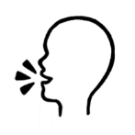  6 | 2

Classroom instructions – Student
A
1 | 2 | 3
 | ______________ | pencil  ____________
4 | 5 | 6

B

Computer instructions – Part 1
- Print the keyboard on the following page, one for each student.
- Project the keyboard if possible, to guide the students
- Give the following instructions:

- Write left in the box on the top left.
- Write right in the box on the top right.
- Circle these keys:
- 4
- 7
- Space bar
- Delete
- Enter /return
- Shift on the left
- Shift on the right
- The arrow to the left
- The arrow to the right
- The arrow going up
- The arrow going down
- Show students the finger to use on the mouse and
instruct students to follow these mouse movements on their table:
- Click
- Double click
- Click and hold
- Click, hold and drag down
- Click, hold and drag up
- Click, hold and drag to the left
- Click, hold and drag to the right

Left

Right


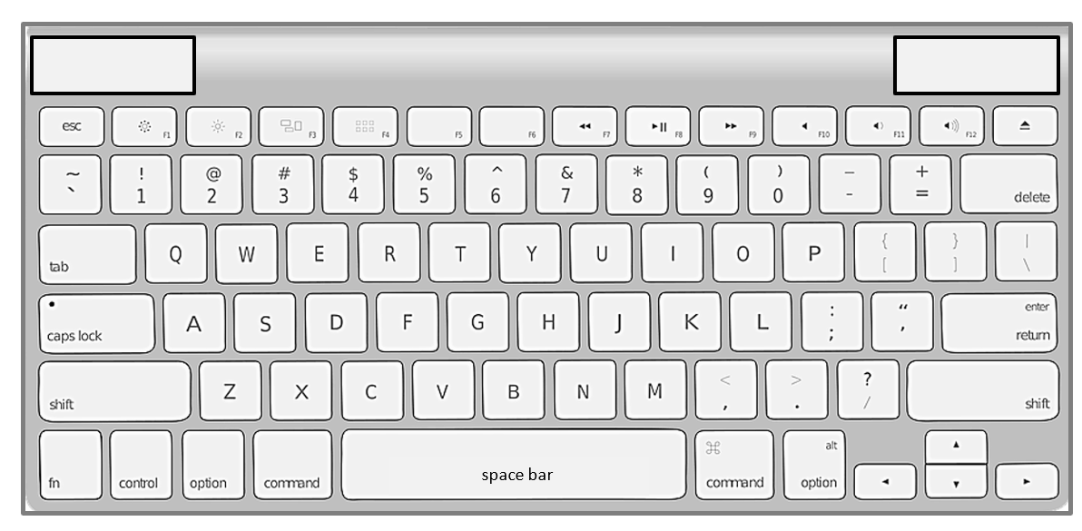
Computer instructions – Part 2
Print the icons and instructions on the following page. The first two activities below can be done in the classroom; the third requires access to computers.
- Syllable work
- Draw a table on the board such as the one below
- Clap words with students
- Ask students to count the syllables
1 syllable | 2 syllables | 3 syllables
click | scroll down | double click
- Concentration game
- Cut up 2 sets of images,(Laminate if possible) enough for students to play in groups of 3 or 4.
- Students spread the cards face down on the table and take turns
to turn over 2 cards to find a match.
- If they find a match, they keep the pair and have another turn.
If they don’t find a match, the turn passes to the next student.

- Listening to Instructions
- Write the instructions below on the board
- Read the instructions to the students
- Students listen and follow instructions.
- Ask a student to read an instruction. Students listen and follow.
- Click the mouse |  | 8. Press Delete
- Hold your finger on the mouse |  | 9. Press Enter
- Hold and drag your mouse |  | 10. Press the space bar
- Hold and scroll down the page |  | 11. Hold the shift key down and type a letter e.g. letter A
- Left click on your mouse |  | 12. Arrow left
- Type your name |  | 13. Arrow right
- Press Backspace

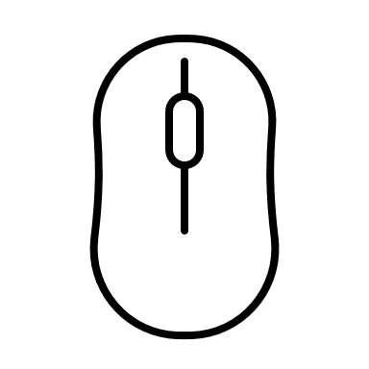  left click | double left click | scroll up  scroll down
  hold | left click, hold and drag |     type
Backspace  Backspace | Delete  Delete | Enter  Enter
space bar | Shift key  Shift | 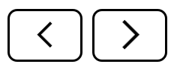  arrow left/ right
Computer instructions

Learning in Australia

Activity
The pictures and text can be printed and then:
- Students cut them up and match them in pairs.
- Each student is given either a picture or the text. Students then find the student with the matching picture/text. This can be an alternative way for students to find a partner for pair-work.

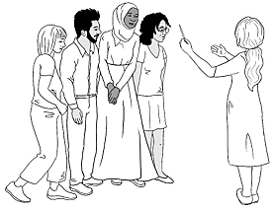 |  |  | 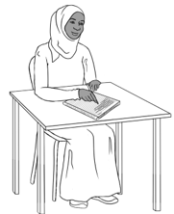  Excuse me.  What does this mean?
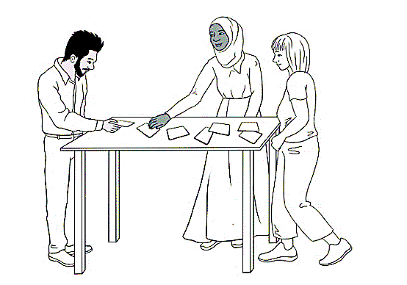 |  | 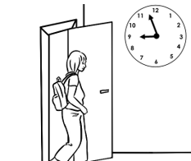
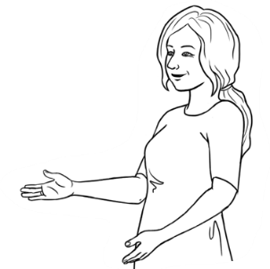  Do you understand? |  | 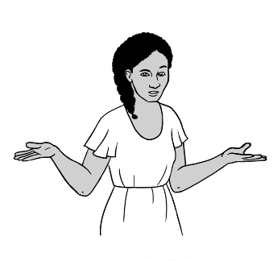  Sorry. I don’t  understand.
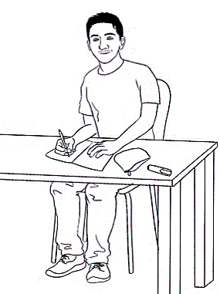  Thank you.  Can you  help me please? | 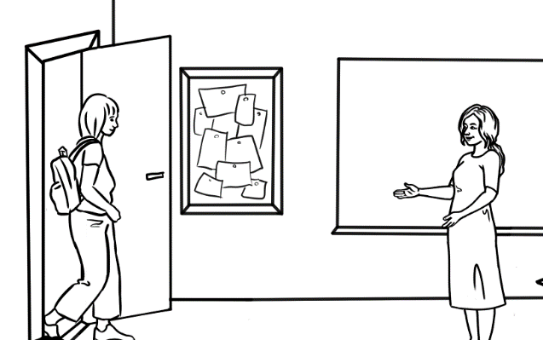  Good morning Alina.  Good morning Jenny.

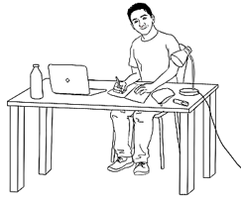 | 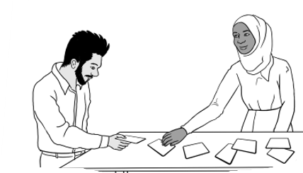
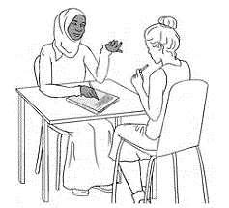 | 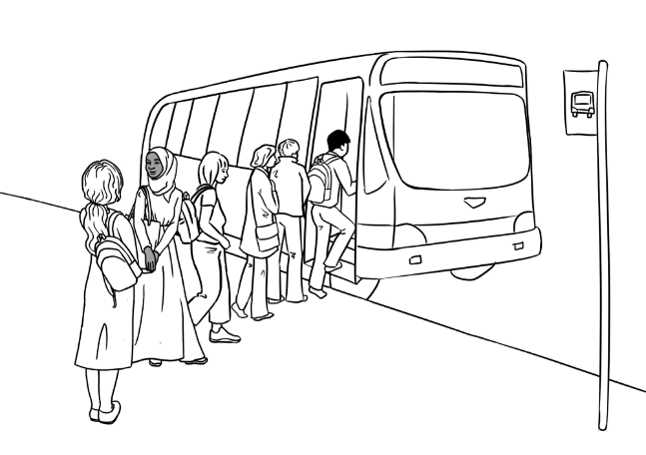

Teachers and students  say please and thank you. | Students work  in groups.
Men and women  work together. | Students and teachers work together.
Students say,  Sorry. I don’t understand. | Students  go on excursions.
The teacher says,  Do you understand? | Students study at home.

Teachers and  students use  their first names. | Students ask questions.
Students come to class  on time. | Students work  with a partner.

