Student book with teacher notes

English Ready
22637VIC Course in EAL
VU23495 Begin language learning with support

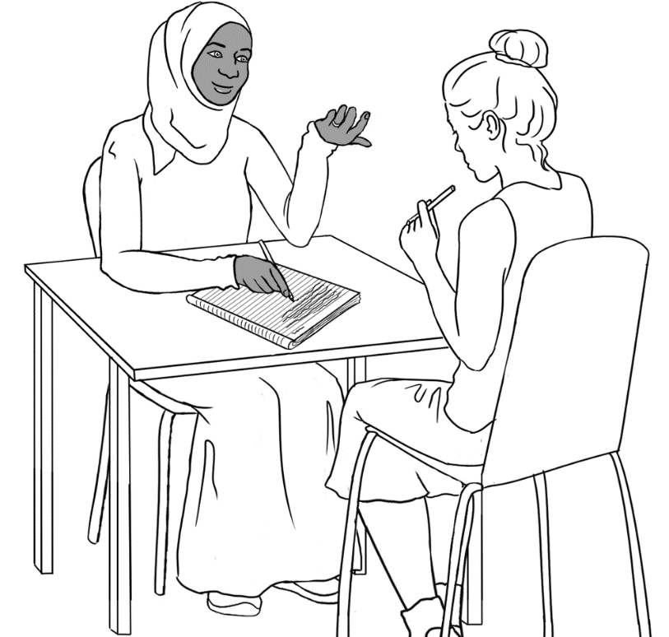
Learn English

Student ___________________________________________________
Teacher ___________________________________________________
Class ______________________________________________________
Date ______________________________________________________

Design team: Vicki Hambling, Sue Paull, Frida Dean, Janice Langley, Glenise Kleehammer and Mary Wallace
This workbook is designed to be used with the support of a teacher.
Illustrations: Madelena Scott
Image acknowledgements:
Police logo - Standards Australia, CC BY 3.0 AU <https://creativecommons.org/licenses/by/3.0/au/deed.en>, via Wikimedia Commons
Toilet sign - This Photo by Unknown Author is licensed under CC BY
Acknowledgements: The design team would like to thank the AMEP service providers and practitioners who participated in the trial and gave valuable feedback. The team would also like to acknowledge the use of the EAL Framework which underpins the design of this book.
Copyright of the EAL Framework is reserved to the Crown in the right of the State of Victoria. © State of Victoria (Department of Education and Training) 2023.
_________________________________________________________________________________________
This English Ready Resource is licensed under a Creative Commons Attribution-NoDerivs 3.0 Australia licence (More information is available here). You are free to use, copy and distribute to anyone in its original form as long as you attribute Department of Home Affairs as the author and you license any derivative work you make available under the same licence.
© Commonwealth of Australia 2023

With the exception of the Commonwealth Coat of Arms, the department’s logo, any material protected by a trade mark and where otherwise noted all material presented in this document is provided under a Creative Commons Attribution 4.0 International (https://creativecommons.org/licenses/by/4.0/) licence.
The details of the relevant licence conditions are available on the Creative Commons website (accessible using the links provided) as is the full legal code for the CC BY 4.0 licence (https://creativecommons.org/licenses/by/4.0/legalcode).
Use of all or part of this document must include the following attribution:
© Commonwealth of Australia 2023
As far as practicable, material for which the copyright is owned by a third party will be clearly labelled. The department has made all reasonable efforts to ensure that this material has been reproduced in this document with the full consent of the copyright owners.
Copyright requests and enquiries concerning usage not addressed by the CC BY 4.0 licence should be addressed to:
comms@homeaffairs.gov.au at the Department of Home Affairs.
The terms of use for the Commonwealth Coat of Arms are available from the It's an Honour website.
Where a copyright owner, other than the Commonwealth, is identified with respect to this material, please contact that third party copyright owner directly to seek permission.


Table of Contents

1. Instructions 1
2. Meet the people. 2
3. The alphabet 5
4. The sounds of the alphabet 11
5. Important words 15
6. Learning in Australia 18
7. My word list 21

Instructions
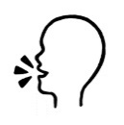
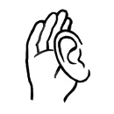
Project and mime each instruction.

 | 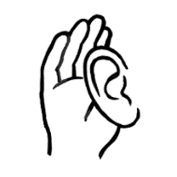 | listen |  |  |  | 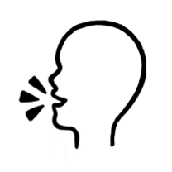 |  | say
 |  | copy |  |  |  | 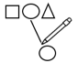 |  | match
 |  | read |  |  |  | 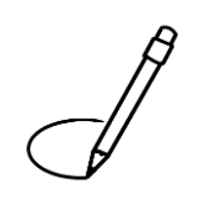 |  | circle
 | 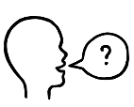 | ask |  |  |  |  |  | tick
 | 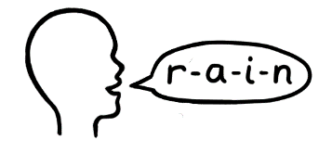 | spell |  |  |  |  |  | record
 | 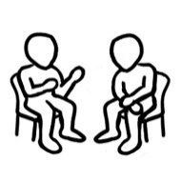 | work with a partner |  |  | 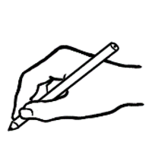 |  | write

Meet the people.
Project the page. Students point to the students and teacher. Name the characters. Create sentences.
e.g. Ming is a student.

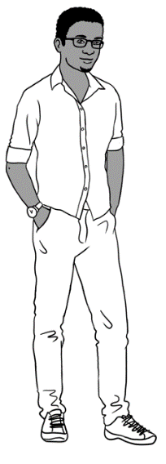
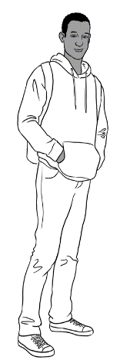
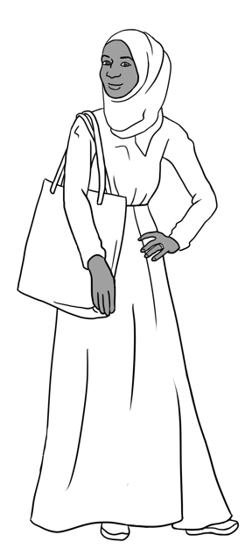
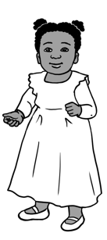
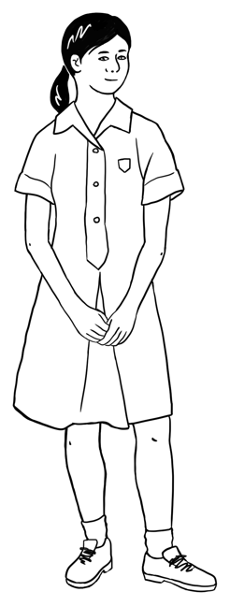
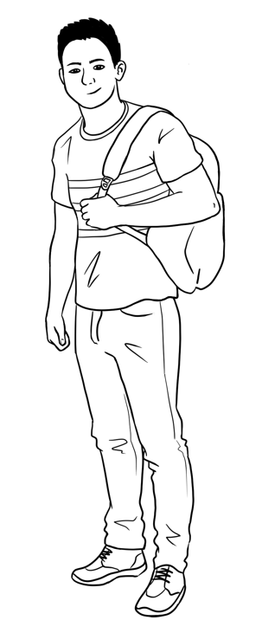
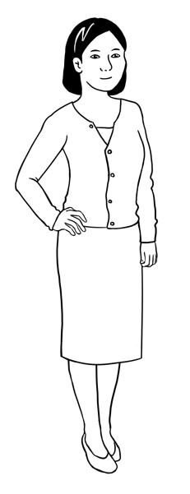
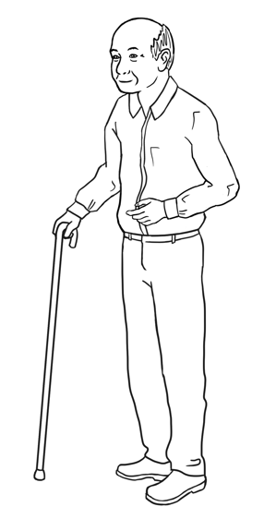

Sahra’s family comes from Somalia.
This is Sahra.
This is Hani.
This is Tahiil.
This is Abdi.
This is Ming. This is Lan. This is Mai. This is Bao.
Ming’s family comes from China.

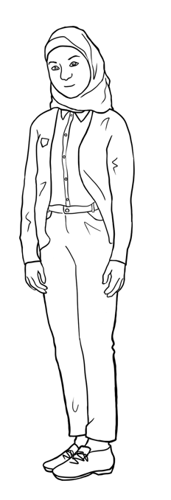
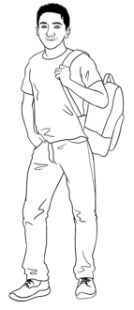
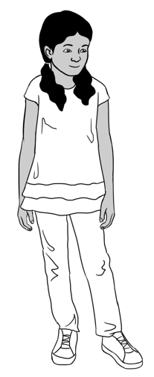
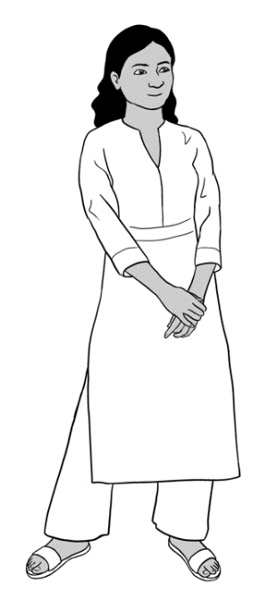
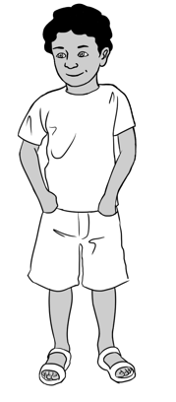
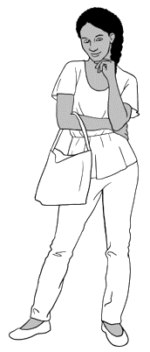
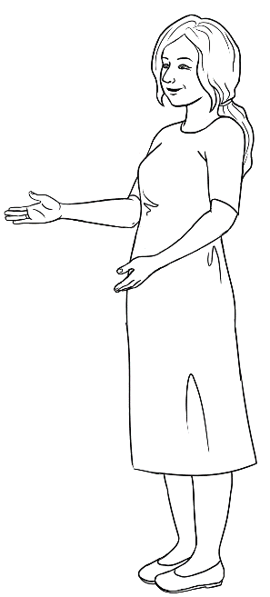
Carim’s family comes from Syria.
This is Carim.
This is Fatima.

Nisha’s family comes from India.
This is Nisha. This is Pari. This is Dev.

Anika comes from Ethiopia.
This is Anika.

Jenny is a teacher.
She is from Australia.
This is Jenny.

This is Carim. This is Fatima.

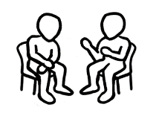
Project this page. Read the instructions below and mime them in class. Check understanding by asking students to follow the instructions.

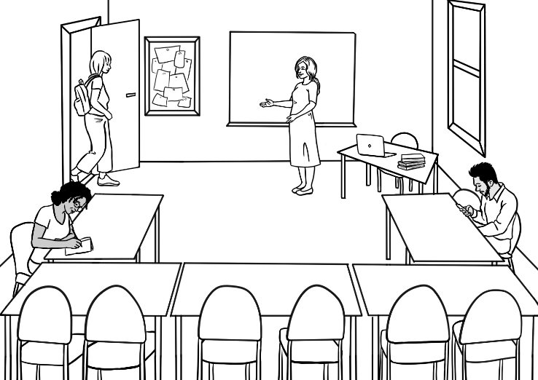
In the classroom
Come in.

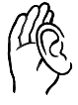

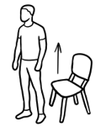  Stand up.  1 | 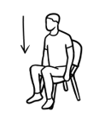  Sit down.  2
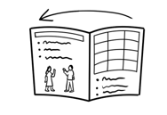  Open your workbook.  3 | 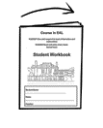  Close your workbook.  4
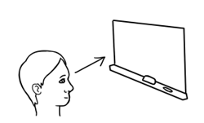  Look at the board.  5 | 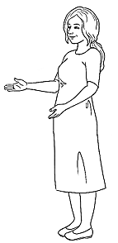  Listen to  the teacher.  Listen.  6
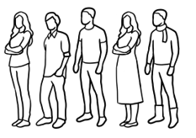  Stand in a line.  7 | 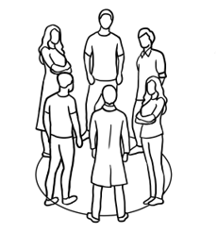  Stand in a circle.  8

The alphabet
Read the alphabet and ask students to repeat after you. Point to the vowels (A, E, I, O and U in bold). Explain that these are capital letters. Read out selected letters randomly and ask students to circle them. More activities on ‘The Alphabet’ can be found in Course in Initial Teacher resources units VU23489, VU23491 and VU23492.
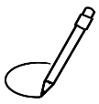

A | B | C | D | E | F | G | H | I | J | K | L | M
N | O | P | Q | R | S | T | U | V | W | X | Y | Z
Capital letters

Ask students to copy the capital letters in the spaces provided.

 | A | B | C | D | E | F | G | H | I | J | K | L | M
1 | A | B |  | D | E |  | G | H |  | J | K |  | M
2 | A |  | C |  |  | F |  |  | I |  |  | L
3

 | N | O |  | P | Q | R | S | T | U | V | W | X | Y | Z
4 | N |  |  | P | Q | R |  | T | U |  | W |  | Y | Z
5 |  | O |  |  |  |  | S |  |  | V |  | X
6

Encourage students to read the letters with a partner.
Read the alphabet and ask students to repeat after you. Point to the vowels (A, E, I, O and U in bold). Explain that these are small letters. Read out selected letters randomly and ask students to circle them.

Small letters
a | b | c | d | e | f | g | h | i | j | k | l | m
n | o | p | q | r | s | t | u | v | w | x | y | z

Ask students to copy the small letters in the spaces provided.

 | a | b | c | d | e | f | g | h | i | j | k | l | m
1 | a | b |  | d | e |  | g | h |  | j | k |  | m
2 |  |  | c |  |  | f |  |  | i |  |  | l
3

 | n | o | p | q | r | s | t | u | v | w | x | y | z
4 | n |  | p | q | r |  | t | u |  | w |  | y | z
5 |  | o |  |  |  | s |  |  | v |  | x
6
Encourage students to read the letters with a partner.

A a | B b | C c | D d | E e | F f | G g
H h | I i | J j | K k | L l | M m | N n
O o | P p | Q q | R r | S s | T t | U u
V v | W w | X x | Y y | Z z
Capital and small letters
Ask students to match the capital and small letters.

A | b |  | N | p
B | d |  | O | n
C | a |  | P | t
D | c |  | Q | o
E | g |  | R | s
F | e |  | S | q
G | f |  | T | w
H | k |  | U | r
I | m |  | V | x
J | l |  | W | u
K | h |  | X | z
L | i |  | Y | v
M | j |  | Z | y

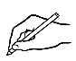
Ask students to write the small letter.
A a | B | C | D | E | F | G
H | I | J | K | L | M | N
O | P | Q | R | S | T | U
V | W | X | Y | Z
Ask students to write the capital letter.
a A | b | c | d | e | f | g
h | i | j | k | l | m | n
o | p | q | r | s | t | u
v | w | x | y | z

Ask students to circle the same letter.
b | d | b | p | q
f | h | k | f | l
m | n | w | m | u
y | u | v | w | y
x | s | c | x | z
p | t | b | p | r
k | c | v | k | t
a | o | u | v | a
g | y | g | j | q
Point to the letter arrangement on the keyboard. Read out selected letters randomly and ask students to circle them. This activity can be extended to computer classes where the teacher can ask the students to type each letter.
The computer keyboard

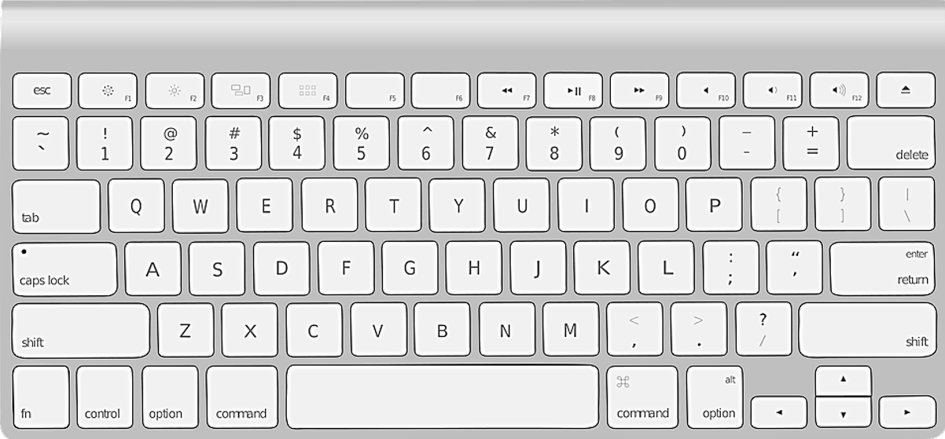

G
W
E
R
T
Y
U
I
O
P
D
A
S
Q
F
H
R
Q
X
C
B
N
M

V
Z
K
J
L

Ask students to write the missing capital letters. Encourage students to check with their partner using the top keyboard as an example.

G
W
E
R

Y

I

P
D
A

Q

R
Q

C
B

M

Z

J
L

Encourage students to read the letters with a partner.
A | B | C | D | E | F | G | H | I | J | K | L | M
N | O | P | Q | R | S | T | U | V | W | X | Y | Z

Point to capital letters in the table above. Read out selected letters randomly and ask students to write capital letters.

 |  | 3. | 4. | 5. | 6.

7. | 8. | 9. | 10. | 11. | 12.

a | b | c | d | e | f | g | h | i | j | k | l | m
n | o | p | q | r | s | t | u | v | w | x | y | z

Point to small letters in the table above. Read out selected letters randomly and ask students to write small letters.

1. | 2. | 3. | 4. | 5. | 6.

7. | 8. | 9. | 10. | 11. | 12.

The sounds of the alphabet
Project the page. Point to the picture, say the letters, sounds and words and ask students to repeat.
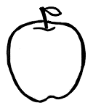  A a  apple | 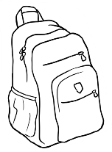  B b  backpack |   C c  computer
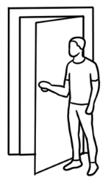  D d  door | 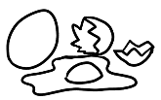  E e  eggs |   F f  five
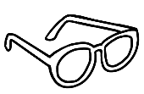  G g  glasses | 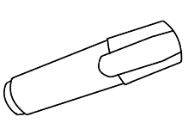  H h  highlighter | 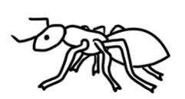  I i  insect
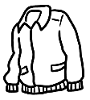  J j  jacket | 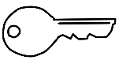  K k  key | 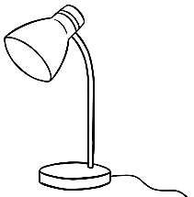  L l  lamp

Ask students to match the words and the pictures.

 | apple |  | backpack
 | eggs |  | door | 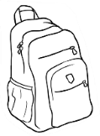
 | insect |  | glasses | 
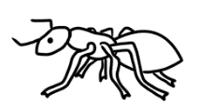 | highlighter |  | computer | 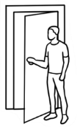

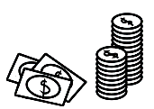  M m  money | 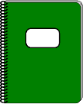  N n  notebook | 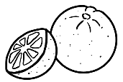  O o  orange
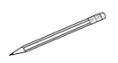  P p  pencil | 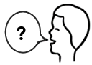  Q q  question | 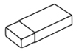  R r  Rubber  rubber
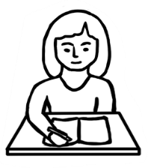  S s  student | 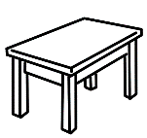  T t  table |   U u  umbrella
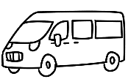  V v  van | 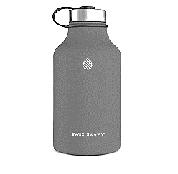  W w  water | 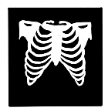  X x  x-ray
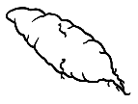  Y y  yam |   Z z  zero
Ask students to match the words and the pictures.

Project the page. Point to the picture, say the letters, sounds and words and ask students to repeat.

 | orange |  | pencil
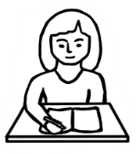 | umbrella |  | rubber | 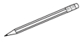
 | student |  | table | Rubber

Read the word and say the letter. Ask students to repeat and circle the first letter as you read it.
1 | c computer | s student | z zero
2 | p pencil | b backpack | 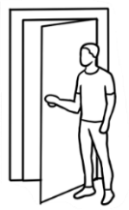  d door
3 | k key | g glasses | j jacket
4 | n notebook | m money | h highlighter
5 | i insect | a apple | e eggs
6 | u umbrella | 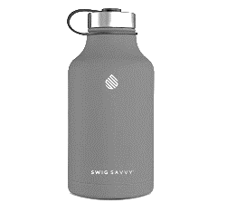  w water | v van

Point to the diagraphs ‘sh’, ‘ch’ and ‘th’ and say the sound. Read the words and ask students to repeat. Ask students to circle the diagraph, e.g. ‘sh’ in ‘shop’.
sh | 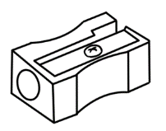  sharpener | 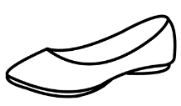  shoe | 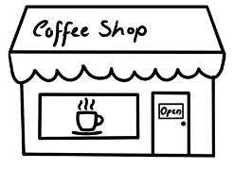  shop
sh | 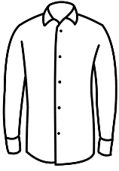  shirt | 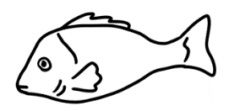  fish | 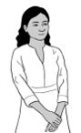  Nisha
ch | child | 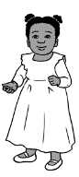  children | 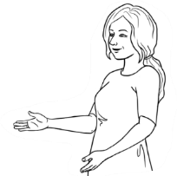  teacher
ch | 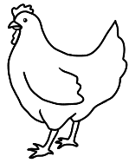  chicken | 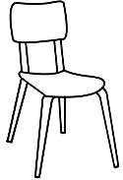  chair | 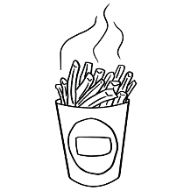  chips
th | three  3 | thirteen  13 | thirty  30
th | Thursday  Wednesday  Thursday  Friday  Saturday | 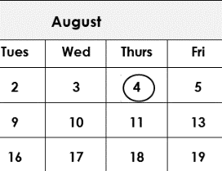  fourth | 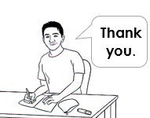  thank

Important words
Point to the table and explain personal information. As an example, the teacher can complete the table with their own information if they feel comfortable.

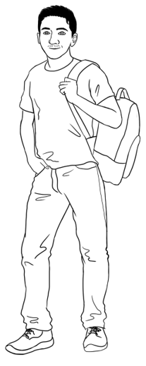
Carim’s important words
First name | Carim
Family name | Hamed
Street | North Street
Town / Suburb | Kellivale

Ask students to complete the table with their personal information.
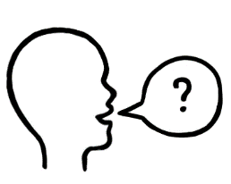
Can you check my spelling please?
Can you say the name of my street and suburb please?
First name
Family name
Street
Town / Suburb

Encourage students to ask the teacher to check their work.

Show students how to use their phones to record the teacher’s voice. Ask the students to record as you check the spelling of the street and suburbs. Encourage them to listen to their recording at home.

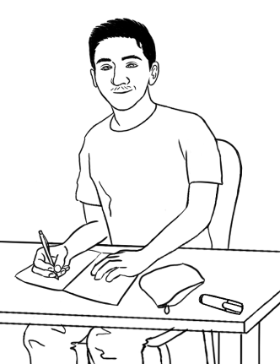
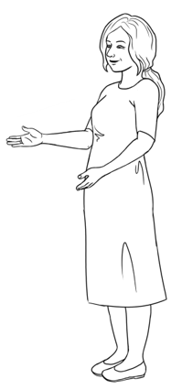
Can you spell your name please Carim?
Carim C - a - r - i - m

Point to the picture and read the dialogue.
The teacher can say, spell and write their own name on the board and practice with a student.
Encourage students to say, copy and spell their first name, family name and address in the table below. Students can use an ID card to spell their street and suburb or ask their teacher for help.
Explain to students what important words are by giving the examples of name, address and phone number.

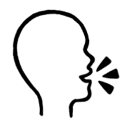
Learn your important words.

First Name | Family Name
Street | Town / suburb

Signs
Project the signs on this page. Read the signs in a random order and ask students to repeat and tick the signs as they hear them.

1  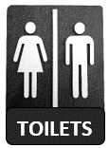 |  | 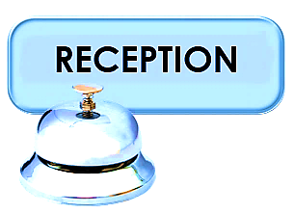  2 |  | 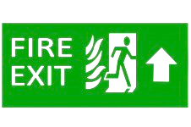  3
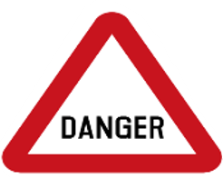  4 |   5 |  | 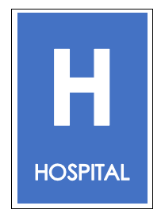  6 |  |   7
Aa Bb Cc Dd Ee Ff Gg Hh Ii Jj Kk Ll Mm
Nn Oo Pp Qq Rr Ss Tt Uu Vv Ww Xx Yy Zz
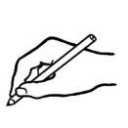
Ask students to write the sign words using small letters.

TOILETS | RECEPTION | FIRE EXIT
toilets. | __________________ | __________________
DANGER | STOP | HOSPITAL
__________________ | __________________ | __________________

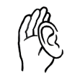
Learning in Australia
Is learning in Australia the same as
learning in your country?

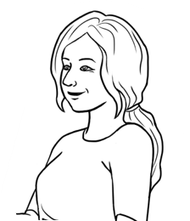

Project pages 18 to 20 and discuss learning in Australia by showing the pictures and reading the sentences. Ask students about learning in their country. Ask them to tick ‘Yes’ or ‘No’ as they hear the sentences.

Learning in Australia |  |  |  |  |  |  | In your country
 |  |  |  |  |  |  | Yes |  | No
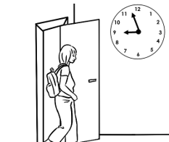 | Students come  to class on time.
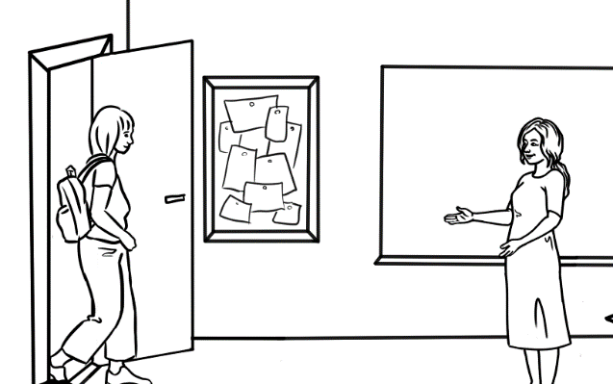
Good morning Alina.
Good morning Jenny.

Teachers and
students use
their first names.
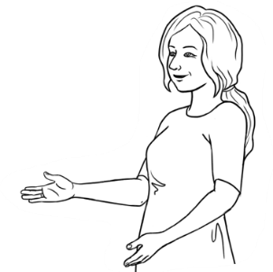  Do you understand? |  |  |  |  | The teacher says,  Do you understand?
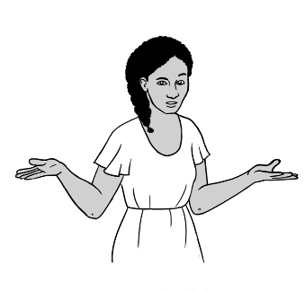
Sorry. I don’t
understand.

Students say,
Sorry.
I don’t understand.
Learning in Australia |  |  |  |  |  | In your  country
 |  |  |  |  |  | Yes |  | No
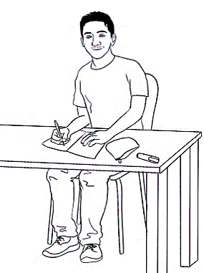  Thank you.  Can you  help me please? |  |  |  | Teachers and students say please and thank you.
Students ask questions. |  |  | 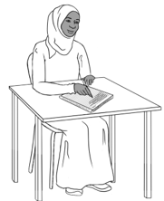  Excuse me.  What is this word?
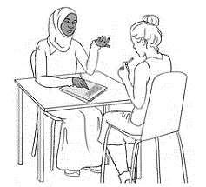 |  | Students work  with a partner.
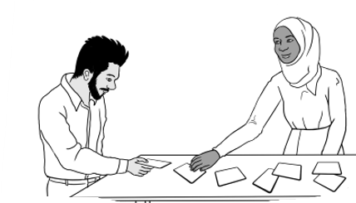
Men and women
work together.

Learning in Australia |  |  |  | In your  country
 |  |  |  | Yes | No
Students work  in groups. | 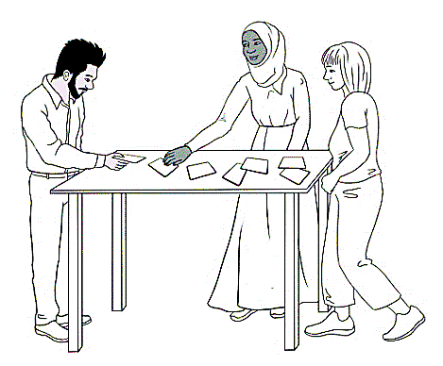
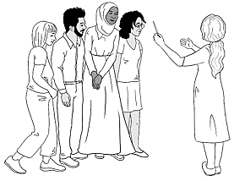 |  |  | Students and  teachers work  together.
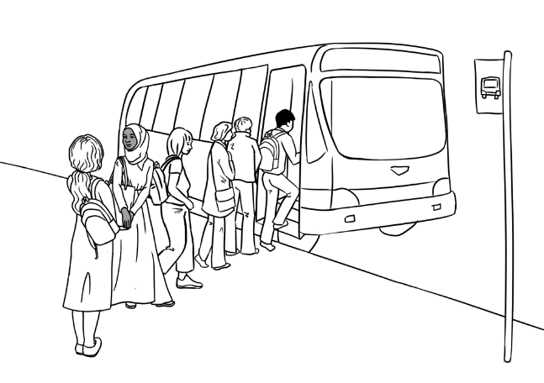

Students
go on excursions.

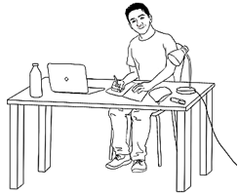 |  | Students study  at home.

7. My word list

