

Student book with teacher notes

English Ready
22637VIC Course in EAL
VU23496 Communicate basic personal details and needs
VU23498 Read and write short highly familiar messages and forms

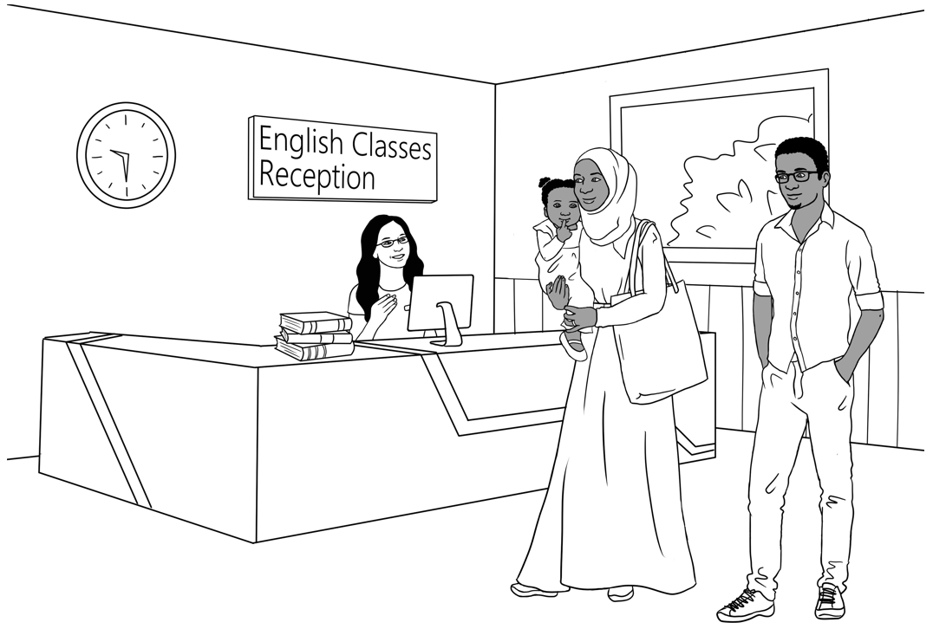
Conversation, Messages and Forms

Student ___________________________________________________
Teacher ___________________________________________________
Class ______________________________________________________
Date ______________________________________________________

This workbook is designed to be used with the support of a teacher.
Design team: Vicki Hambling, Sue Paull, Frida Dean, Janice Langley, Glenise Kleehammer
and Mary Wallace
Illustrations: Madelena Scott

Acknowledgements: The design team would like to thank the AMEP service providers and practitioners who participated in the trial and gave valuable feedback. The team would also like to acknowledge the use of the EAL Framework which underpins the design of this book.

Copyright of the EAL Framework is reserved to the Crown in the right of the State of Victoria. © State of Victoria (Department of Education and Training) 2023.
_________________________________________________________________________________________
This English Ready Resource is licensed under a Creative Commons Attribution-NoDerivs 3.0 Australia licence (More information is available here). You are free to use, copy and distribute to anyone in its original form as long as you attribute Department of Home Affairs as the author and you license any derivative work you make available under the same licence.
© Commonwealth of Australia 2023

With the exception of the Commonwealth Coat of Arms, the department’s logo, any material protected by a trade mark and where otherwise noted all material presented in this document is provided under a Creative Commons Attribution 4.0 International (https://creativecommons.org/licenses/by/4.0/) licence.
The details of the relevant licence conditions are available on the Creative Commons website (accessible using the links provided) as is the full legal code for the CC BY 4.0 licence (https://creativecommons.org/licenses/by/4.0/legalcode).
Use of all or part of this document must include the following attribution:
© Commonwealth of Australia 2023
As far as practicable, material for which the copyright is owned by a third party will be clearly labelled. The department has made all reasonable efforts to ensure that this material has been reproduced in this document with the full consent of the copyright owners.
Copyright requests and enquiries concerning usage not addressed by the CC BY 4.0 licence should be addressed to: comms@homeaffairs.gov.au at the Department of Home Affairs.
The terms of use for the Commonwealth Coat of Arms are available from the It's an Honour website.
Where a copyright owner, other than the Commonwealth, is identified with respect to this material, please contact that third party copyright owner directly to seek permission.



Table of Contents
1. Instructions 1
2. Meet the people. 2
3. Do you understand? 4
4. Introductions 5
5. The alphabet 6
6. Have a conversation. 9
7. English class 13
8. When, where, who, what, why? 14
9. People in a family 15
10. Break words into syllables. 19
11. What do you like? 21
12. Months of the year 25
13. Syllables – strong and weak 27
14. Words on forms 28
15. An English class for Sahra 29
16. The days 33
17. The time 35
18. Messages 37
19. Two letter sounds 40
20. How many? 41
21. What colour? 42
22. At the childcare centre 43
23. Tahiil’s week 47
24. Tahiil plays soccer. 48
25. Signs at the Hospital 54
26. Don’t come to class 56
27. Where and when? 59
28. Word Lists 61

1. Instructions

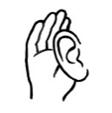
Project and mime each instruction.

1. |             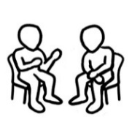      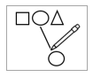      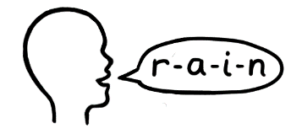         | Listen | 2. |  | Say
3. |  | Read | 4. |  | Write
5. |  | Ask | 6. |  | Spell
7. |  | Work with a partner | 8. |  | Clap
9. |  | Copy | 10. |  | Match
11. |  | Tick | 12. |  | Circle
13. |  | Point | 14. |  | Record
15. |  | Colour | 16. |  | Underline
17. |  | Notebook

2. Meet the people.
Project the page. Students point to the students and teacher. Name the characters. Create sentences.
e.g. Ming is a student.

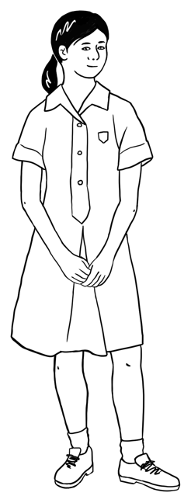
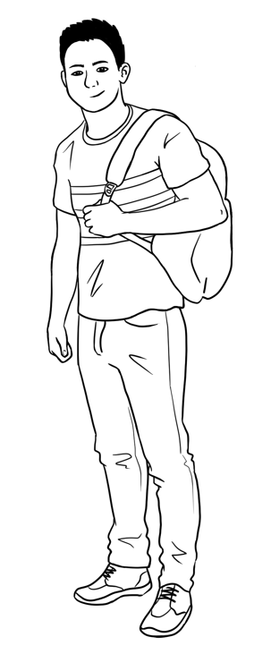
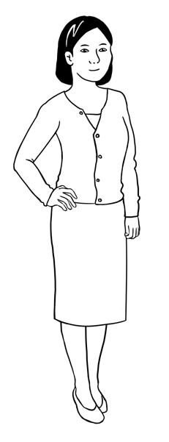
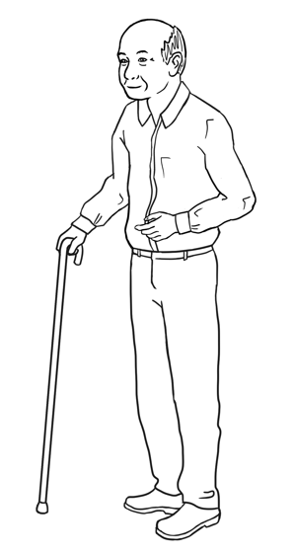

Ming’s family comes from China.
This is Ming. This is Lan. This is Bao. This is Mai.

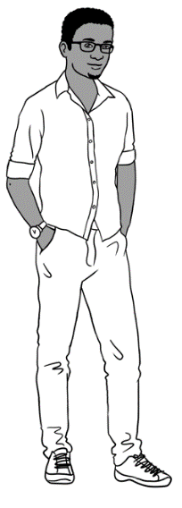
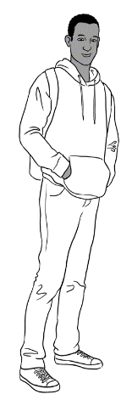
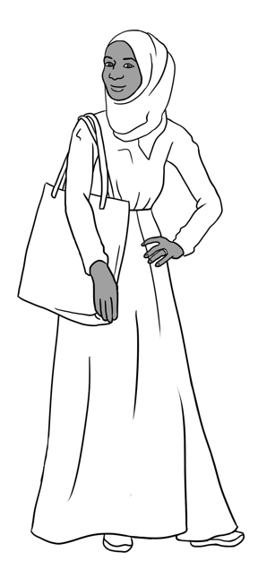
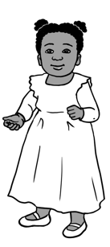

Sahra’s family comes from Somalia.
This is Sahra.
This is Hani.
This is Tahiil.
This is Abdi.

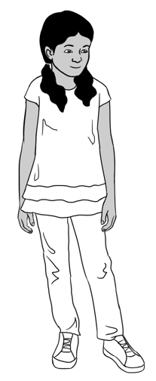
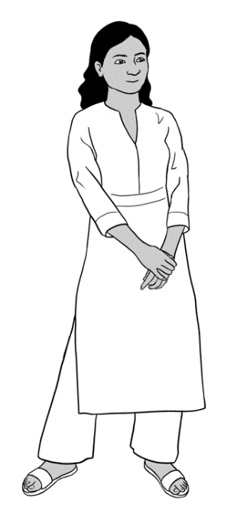
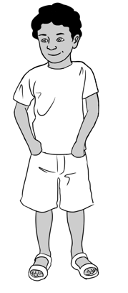
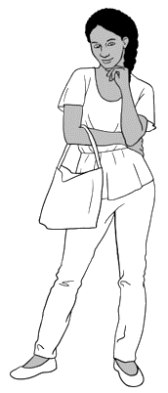

Nisha’s family comes from India.
This is Nisha. This is Pari. This is Dev.

Anika comes from Ethiopia.
This is Anika.

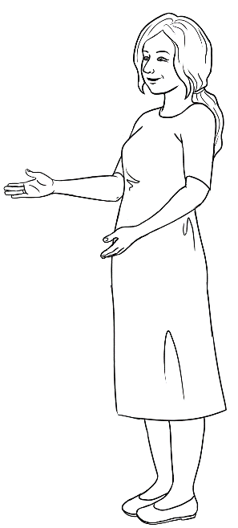
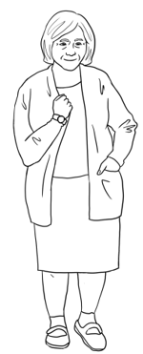

Jenny is a teacher.
She is from Australia
This is Jenny.

Pam is from Australia. neighboureighbourneigh
This is Pam.

3. Do you understand?
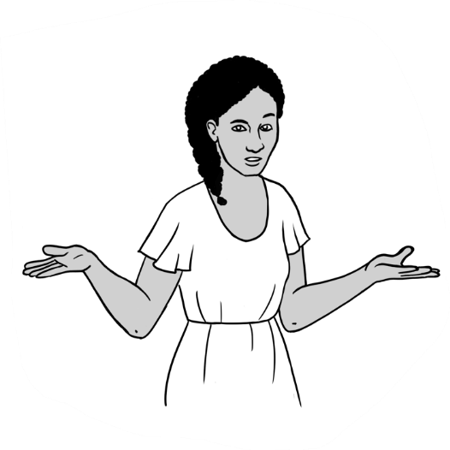
Ask students to listen to the sentences and repat them.
Sorry. I don’t understand.
Can you say that again please?
Can you speak slowly please?
Can you help me please?

- Sorry. |  | that again please?
- Can you speak |  | I don’t understand.
- Can you say |  | please?
- Can you help me |  | slowly please?
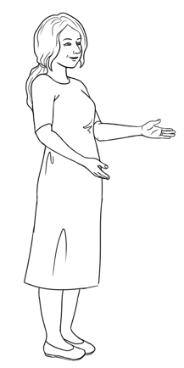
Do you understand?
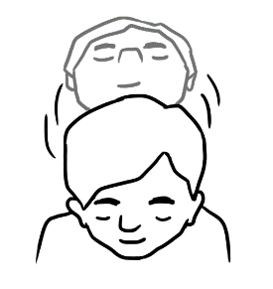

Yes
Nod your head.

Explain to students that they can use body language e.g. nodding their head would mean Yes and shaking their head would mean No. Practice this in class.
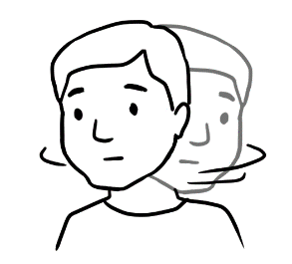

No
Shake your head.

4. Introductions
Ask students to listen to the sentences and repeat them.

Hello. My name is Tahiil.
What’s your name?

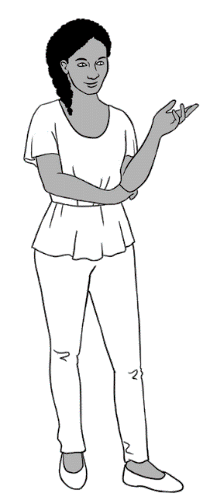
Hi. My name is Anika.
Nice to meet you.

Nice to meet you too.

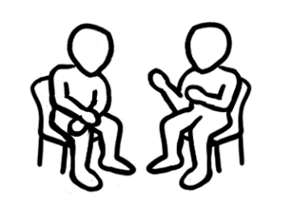
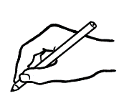
Ask students to work with their partner and write their names on the form.
You Hello. My name is
^{your name}
What’s your name?

Partner Hi. My name is
^{your partner’s name}
You Nice to meet you.
Partner Nice to meet you too.

Encourage students to read the form with their partners.

5. The alphabet
The Alphabet activities in this book are for revision. More activities can be found in Course in Initial Teacher resources units VU23489, VU23491 and VU23492.
Capital letters = BLOCK letters

A | B | C | D | E | F | G | H | I | J | K | L | M
N | O | P | Q | R | S | T | U | V | W | X | Y | Z
Small letters
a | b | c | d | e | f | g | h | i | j | k | l | m
n | o | p | q | r | s | t | u | v | w | x | y | z

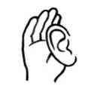
Read out selected capital and small letters randomly and ask students to circle them.

A B C D E F G H I J K L M
N O P Q R S T U V W X Y Z

a b c d e f g h i j k l m
n o p q r s t u v w x y z

Read out selected letters randomly and ask students to circle only the capital letters or small letters. e.g. small k or capital M.

A b c D e F g H i J k L M
n O p Q r s T U v W x Y z

Show students how to use their phones to record the teacher’s voice. Ask the students to record as you read the words. Encourage them to listen to their recording at home. Ask students to write a word with the same first sound in the spaces provided on the table.

The sounds of the alphabet |  |  | 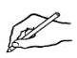  Write a word with  the same first sound.
a | 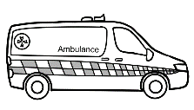 | ambulance |   apple
b |  | ball
c | 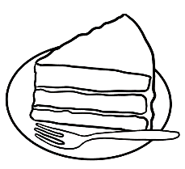 | cake
d |  | down
e | 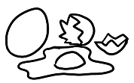 | eggs
f | 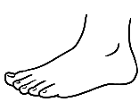 | foot
g | 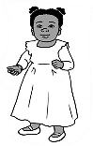 | girl
h |  | home
i | 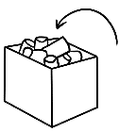 | in
j | 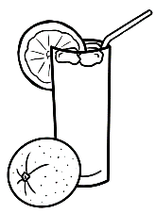 | juice
k | 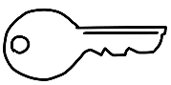 | key
l |  | lamp

m |  | man
n |  | no
o |  | office
p | 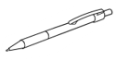 | pen
q |   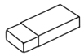  Rubber | question
r |  | rubber
s |  | student
t |    | tea
u |  | up
v | 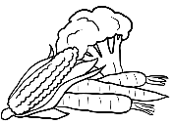 | vegetables
w | 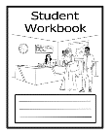 | workbook
x |  | x-ray
y |  | yes
z |  | zero

6. Have a conversation.

Encourage students to practice the conversation with their partners.

- Greeting

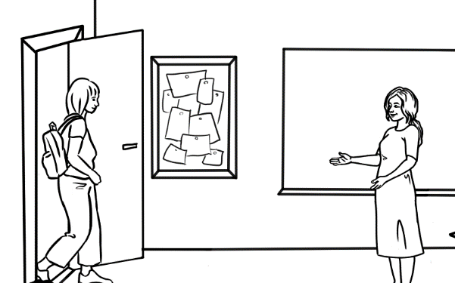
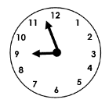
Good morning
Alina.
Good morning.
A

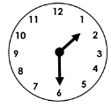
Good afternoon.
.
Good afternoon
Jenny.
B

C
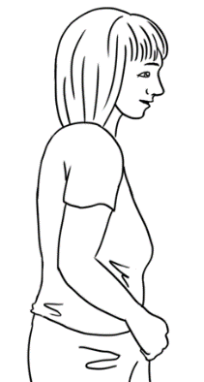
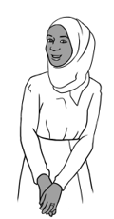
Hello.
Hi Sahra.

- Talk about the weather.

Point to the opening and closing of a conversation.
Point to talking about the weather. Read the statements to the class, emphasising ‘very’. Ask students to practice the conversation with a partner. Emphasise the bolded words.

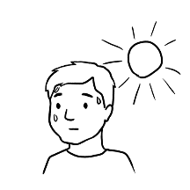

It’s hot today,
isn’t it?
Yes, it is.

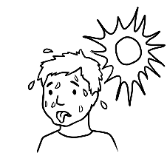  - It’s very hot today, isn’t it? | Yes, it is.
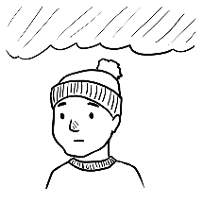  - It’s cold today, isn’t it? | Yes, it is.
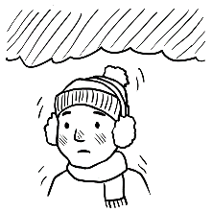  - It’s very cold today, isn’t it? | Yes, it is.
  - It’s a beautiful day isn’t it? | Yes, it is.

- End the conversation.
Nice to see you Alina.

See you later.

Bye for now.

Bye Sahra.

Project pages 11 and 12 and read conversations 1,2,3 and 4. Point to the opening and closing of each conversation and check students’ understanding. Encourage students to practice conversations 1, 2, 3 and 4 with a partner.

1
Bao Hello. My name’s Bao.
What’s your name?
Tahiil I’m Tahiil.
I come from Somalia.
Where are you from?
Bao I come from China.
Nice to meet you.
Tahiil Nice to meet you too.

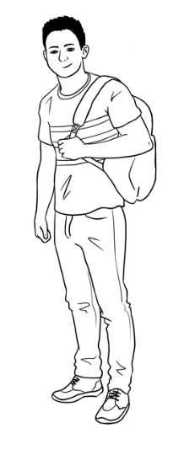

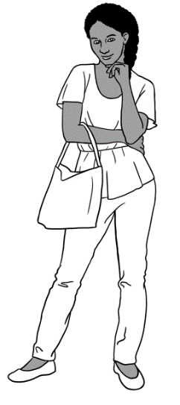
Tahiil Hi Anika. How are you?
Anika Fine thanks Tahiil.
And you?
Tahiil I’m fine too.
See you later.
Anika See ya.
2

ya = you

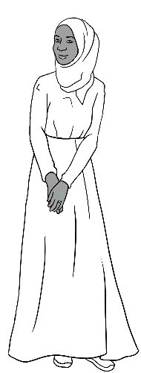
Pam Hello Sahra.
Sahra Hi Pam.
Pam It’s cold today, isn’t it?
Sahra Yes, it is.
Pam Nice to see you Sahra.
Sahra Nice to see you too.
Pam Bye for now.
Sahra Bye.
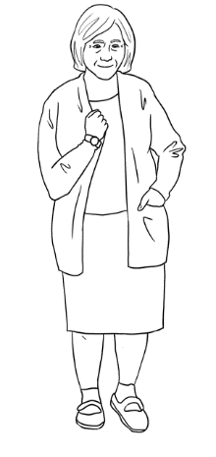
3

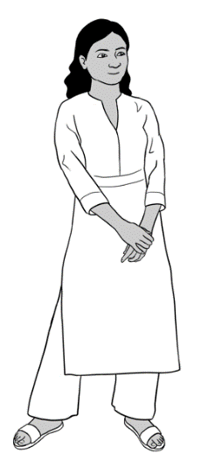
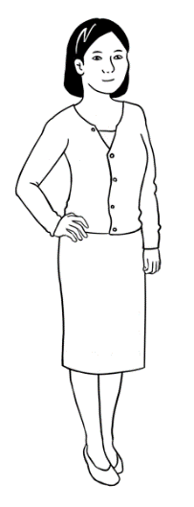
Nisha Hello Lan.
Lan Hi Nisha. How are you?
Nisha Fine thanks and you?
Lan Good thanks.
Nisha It’s a beautiful day, isn’t it? Lan Yes, it is.
Nisha See you later Lan.
Lan Bye Nisha.
4

Ask students to fill in the blanks with their partners.

Give instruction to work with a partner and write the names.
Greeting | You Hello ___________________________.  ^{your partner’s name}  Partner Hi ______________________________. How are you?  ^{your name}  You Fine thanks and you?  Partner Good thanks.
Talk about the weather. | You It’s a beautiful day, isn’t it?  Partner Yes, it is.
End the conversation. | You See you later .  ^{your partner’s name}  Partner Bye _____________________________.  ^{your name}
 | Encourage students to read the conversation with their partner.

7. English class
Point to the stationary items and say the words. Ask students to repeat and copy them. The activities below reinforce the need to come prepared to class.
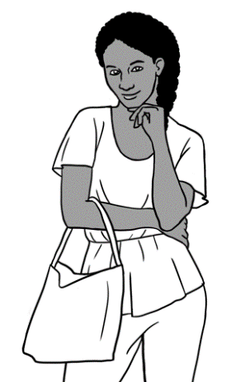

I’m ready for class.
I have 9 things in my bag.
Ask students to show the teacher or each other what they have brought for class, stating the name of each item.


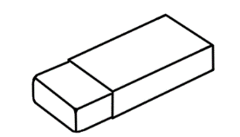

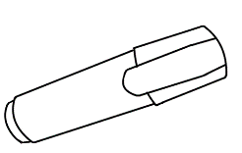
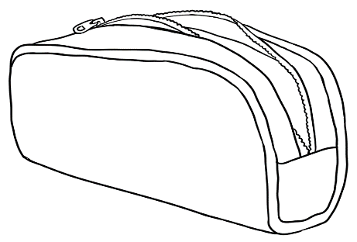
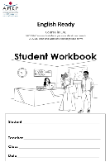
pencil  pencil . | rubber  ___________ | sharpener  ___________ | pencil case _______________
highlighter  ___________ | pens  ___________ | workbook  ___________ | notebook  ______________

Encourage students to read the conversation and practice with their partner.

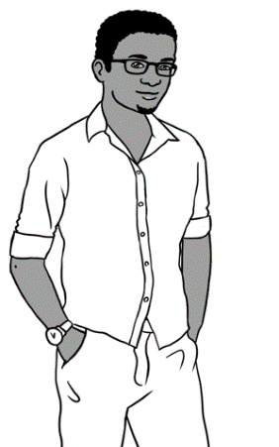
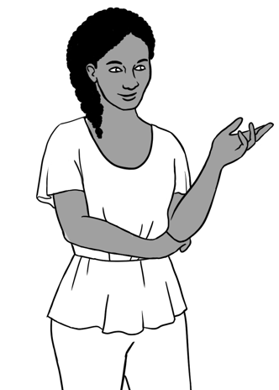
Tahiil needs to borrow a pen and a pencil.
Yes. Here’s a pen.
Anika. Can I borrow a pen please?
Can I borrow a pencil too?
Thanks a lot.
Oh no. Sorry Tahiil.

8. When, where, who, what, why?
Give instruction to listen and repeat.
Ask students to and write answers in the five rectangles and then compare answers with their partner. Finally, check the answers with the class as a whole.

When do you go to school? | Monday | Tuesday | Wednesday
When do you go to school? | Thursday | Friday | Saturday
Where is this?  Australia  the garden  the park✓ | 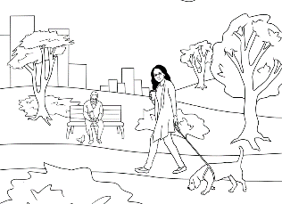  the park . | 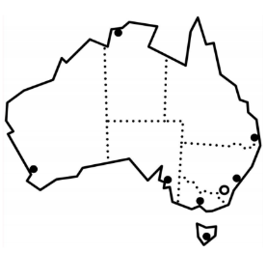  ______________ | 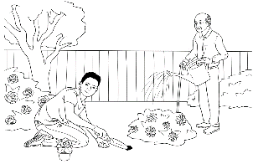  ______________
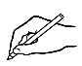

Who is this?  Bao  Mai  Lan | 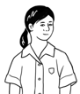  ____________ | 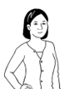  _____________ | 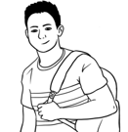  ____________
What do you  have in your bag? |   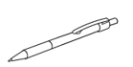  

Why do you learn English? | to work | to study |     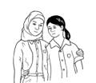  to make friends

9. People in a family

Project conversations on pages 15, 16 and 17. Ask students to listen to these conversations as you read them. Point to the family words on page 15. Encourage students to find family words on pages 16 and 17 and to practice the conversations with a partner.
Ming talks about his family

My name’s Ming.
This is my daughter Lan.

I am a grandfather.
This is my granddaughter Mai
and my grandson Bao.

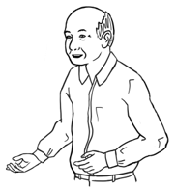
My name’s Lan.
Ming is my father.

I am a mother.
This is my daughter Mai
and my son Bao.

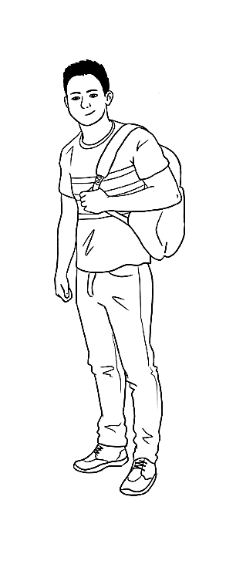
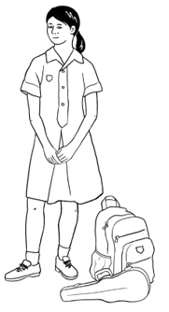
My name’s Bao.
Mai is my sister.
My name’s Mai.
Bao is my brother.

f

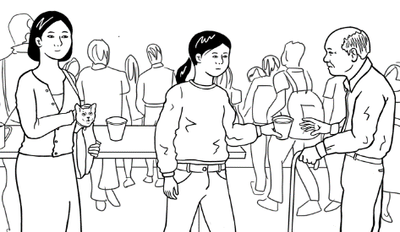

Bao talks about
his family.

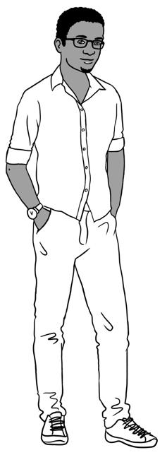
Yes.
This is my grandfather Ming,
my sister Mai and my mother Lan.

Is your sister’s name Mai?

Is this your family Bao?
Yes. Her name is Mai.

Ask students to write Bao’s family words.

mother
family 
sister
grandfather
    - This is my family .
    - This is my _______________________ Ming.
    - This is my _______________________ Lan.
    - This is my _______________________Mai.
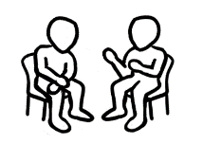

Ask students to read the conversation with a partner and copy in their notebook.
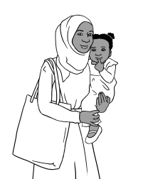
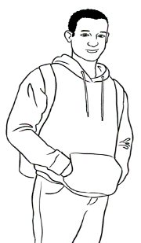

Tahiil talks about
his family.

Is this your family Tahiil?
Yes.
This is my wife Sahra and
my daughter Hani.
Abdi is Sahra’s brother.

Ah. Abdi is Sahra’s brother?
Yes. He is.

Ask students to write Tahiil’s family words.

daughter
family 
brother
wife
- This is my family .
- This is my ___________________ Sahra.
- This is my ___________________ Hani.
- This is Sahra’s ___________________ Abdi.
Ask students to read the conversation with a partner and copy in their notebook. Encourage students to write about themselves and read with a partner if they are comfortable to do so.

Point to the family words, read them and ask students to repeat after you. Ask students to copy the words on the lines.
Family words

father  . | father . | mother | mother .
son | ____________ | daughter | ____________
grandfather | _______________ | grandmother | ________________
grandson | _____________ | granddaughter | ________________
husband | ____________ | wife | ____________
brother | ____________ | sister | ____________
uncle | ____________ | aunt | ____________
cousin | ____________ | cousin | ____________
Ask students to find and circle the family words in the table. All the words are horizontal.

u | n | c | l | e | a | b | m | o | t | h | e | r | c
d | g | r | a | n | d | d | a | u | g | h | t | e | r
s | o | n | e | f | g | r | a | n | d | s | o | n | g
h | u | s | b | a | n | d | h | s | i | s | t | e | r
b | r | o | t | h | e | r | i | f | a | t | h | e | r
j | w | i | f | e | k | l | c | o | u | s | i | n | m
n | d | a | u | g | h | t | e | r | o | a | u | n | t
g | r | a | n | d | f | a | t | h | e | r | p | q | r
s | t | u | g | r | a | n | d | m | o | t | h | e | r

10. Break words into syllables.
Word | student
Break |   stu dent
Syllables | stu dent  ¹ ²

Listen and say the words. Clap the syllables. Point to the syllables in each word. Encourage students to clap with you.
Sahra Tahiil Hani Mai Bao Anika Abdi

 | How many syllables?
Names | 1 | 2 | 3 | 4
Sahra |  | Sahra
Tahiil |  | Tahiil
Hani |  | Hani
Mai | Mai
Bao | Bao
Anika |  |  | Anika
Abdi |  | Abdi
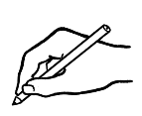
Ask students to write their name, say it and clap each syllable. They could also do this with their partner’s name.

Your name: __________________. My name has ________ syllables.
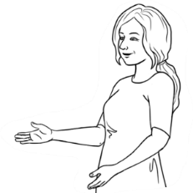
How many syllables?
Say the words.
Clap the syllables.
Listen and say the words. Ask students to clap the syllable. Point to the syllables in each word.

 | Syllables
Word | 1 | 2 | 3
pencil |  | pencil
pen
sharpener
workbook
wife
husband
son
daughter
grandfather
grandmother
brother
sister
uncle
aunt
cousin

11. What do you like?
 |  |  | to like | to not like | 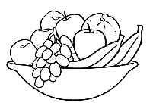  Explain simple expressions of like or dislike by pointing to ‘like’, ‘likes’, ‘don’t like’ and ‘doesn’t like’. ‘Subject-Verb’ agreement can also be explained by pointing to ‘s’ in ‘likes’ and comparing ‘don’t’ and ‘doesn’t’.  fruit.
I |  |  | like | don’t like
You |  |  | like | don’t like
He, She, It |  |  | likes | doesn’t like
We |  |  | like | don’t like
They |  |  | like | don’t like
Tick what you like. Cross what you don’t like.

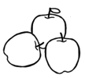  apples |   bananas |   ice cream  X
  tea |   coffee | orange juice
cake | 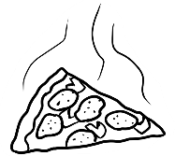  pizza | 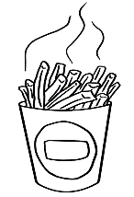  hot chips
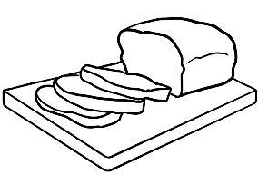  bread |   rice |   noodles
I like _______________________ and ______________________.
I don’t like _______________________.
Encourage students to talk about what they like or don’t like to their partners.

Students listen, repeat and point to the words. Suggestion for more advanced students: Students could add one more thing to this set of food that they like. The teacher can model this: I like tea. I like chicken. I like …
apples | bananas | ice cream
tea | coffee | orange juice
cake | pizza | hot chips
bread | rice | noodles

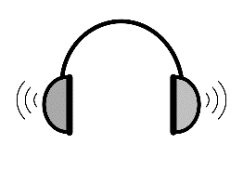
1
Tick what people like.  X |  |  | Cross what people don’t like.  Ask students to pay attention to ‘tick and cross’. Point to ‘like’ and ‘don’t like’ and check understanding. Play Audio 1 and ask students to tick or cross as they listen.

1 | ice cream |  |  | coffee | Tea
2 | rice |  |  | cake | Coffee
3 | noodles |  |  | hot chips | Rice
4 | coffee |  |  | cake | bananas
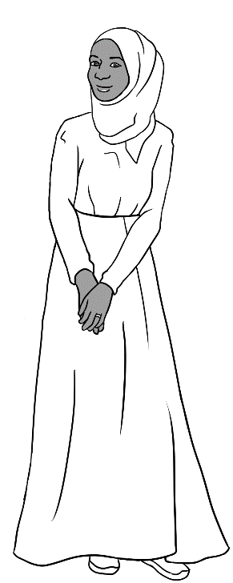
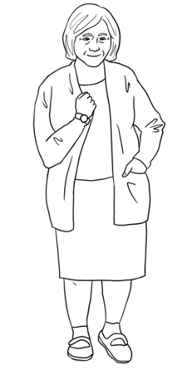
Yes, I do.
Sahra. Do you like reading?
No. I don’t.
Do you like gardening?
What do you like doing?
Ask students to listen to the conversations on pages 23 and 24. Point to use of gerunds after the verb ‘like’ to express like or dislike.

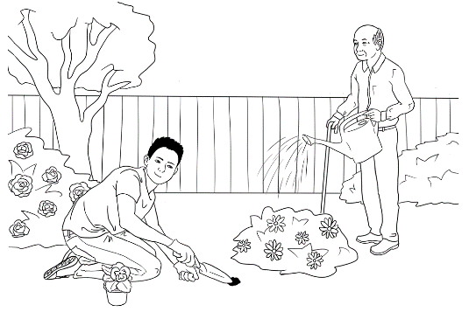   | 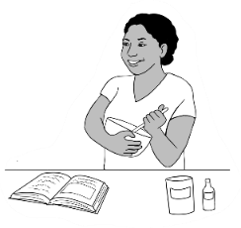  X | 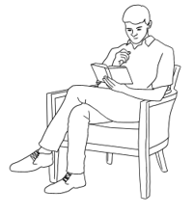
gardening. | cooking | reading
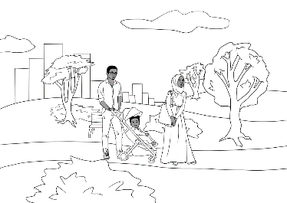 | 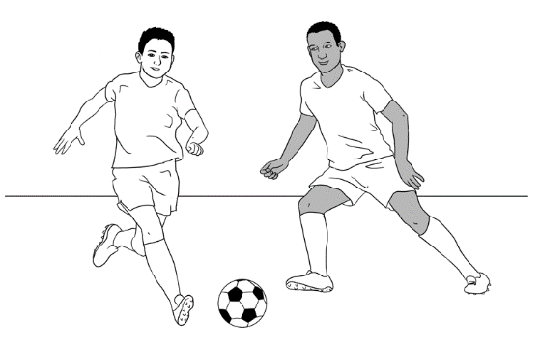 | 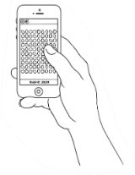
walking in the park | playing soccer | playing games
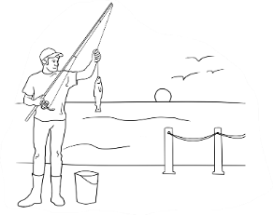 | 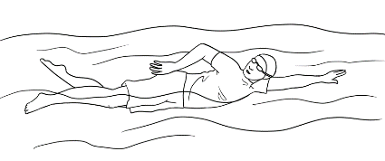 | 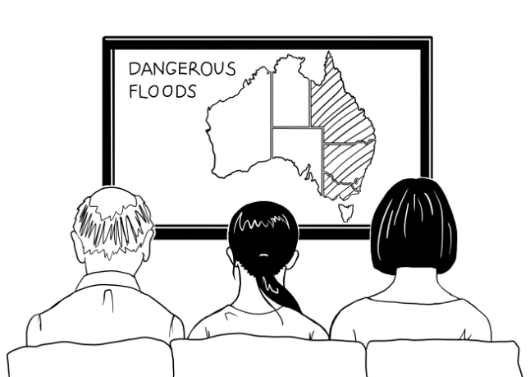
fishing | swimming | watching TV
Tick what you like. Cross what you don’t like.
Ask students to complete the sentences about themselves.
I like .
I don’t like .
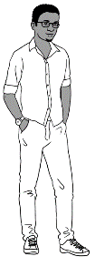
Bao. Do you like gardening?
Yes. I do.
No. I don’t.
Do you like swimming?

Ask students to work with their partners and ask the questions and complete the table below.
Tick yes or no. |   Yes. I do. |   No.  I don’t.
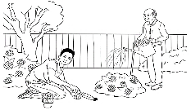
- Do you like gardening?
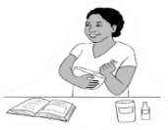

- Do you like cooking?
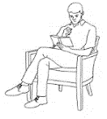
- Do you like reading?
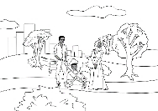
- Do you like walking in the park?
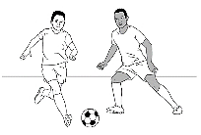
- Do you like playing soccer?
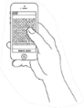
- Do you like playing games?
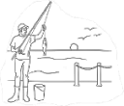
- Do you like fishing?

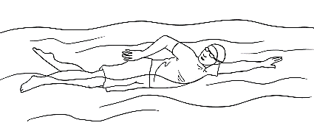
- Do you like swimming?
- Do you like watching TV?
Ask students to complete the sentences about their partners.

My partner likes ________________________________________ .
He / She doesn’t like ___________________________________ .

12. Months of the year
Practice saying the months and numbers. Point to the short and long words and mention that months start with capital letter. Students repeat after you ‘January, Jan, February, Feb’ etc then practice in pairs.

The number of the month | Copy the long words. | Short words
 | January January . | Jan
 | February | Feb
 | March | Mar
 | April | Apr
 | May | May
 | June | June
 | July | July
 | August | Aug
 | September | Sept
 | October | Oct
 | November | Nov
 | December | Dec
Ask students to match the short form of the month to its number.
Jan | 5
Feb | 1
Mar | 6
Apr | 4
May | 2
June | 3
July | 8
Aug | 11
Sept | 10
Oct | 7
Nov | 12
Dec | 9

 | Point to the two ways of writing the date. | Day |  | Month |  | Year
This is the full date. |  | 21 |  | July |  | 2022
This is the date in numbers. |  | 2 | 1 | 0 | 7 | 2 | 0 | 2 | 2
Ask students to match the full date to the date in numbers.
Dates in numbers

Full date |  | Date in numbers
25 December 2016 |  | 19. 01.1978
15 September 2022 |  | 13. 05.2023
19 January 1978 |  | 15. 09.2022
21 October 2006 |  | 21. 10.2006
13 May 2023 |  | 25. 12.2016
24 June 2021 |  | 13. 02.1986
13 February 1986 |  | 24. 06.2021

Encourage the students to write the dates and read them. Students can also write their birthday (if they know it) or today’s date.
  Full date | Day. Month. Year
9 May 1986 | 09.05.1986
19 September 1995
6 June 2023
18 March 1970
- February 2015

13. Syllables – strong and weak
Some syllables are strong.
Some syllables are weak.

Point to the strong syllables, clap and say the words. Ask students to repeat.

walking | gardening | reading | cooking
playing | fishing | swimming | watching


Ask students to underline the strong syllables in the words. Encourage them to read, clap and circle the strong syllables.
Monday | Tuesday | Saturday | January | April
July | August | September | thirteen | thirty
fourteen | forty | sixteen | sixty | hundred

Ask students to read the sentences with a partner and copy them in their notebooks.


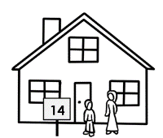
- Today is Tuesday.
- My birthday is in August.
- My house number is fourteen, not forty.

14. Words on forms
This is an introduction to words on forms. Ask students to record your voice as you read the words on the form. Ask students to translate these words in their own language and write in the spaces.

Family Name [Surname]
First Name [Given name]
Title
Country of birth
Date of birth
Address
Street
Suburb
Postcode
Phone number
Signature
Point to the instructions. Point to ‘Capital’ and ‘Block’ letters and ‘black pen’.


Instructions on forms
A B C D E F G H I J K L M N O P Q R S T U V W X Y Z
1. PLEASE USE CAPITAL LETTERS.
2. PLEASE USE BLOCK LETTERS.
3. Please use a black pen.
4. Tick the box.
Please note for the first activity if the student is preliterate or building literacy, they will need assistance from a volunteer or another student with the same language background. If that is not possible, student can use the recording to translate and get help from friends or family after class.

15. An English class for Sahra
Project the page and point to the picture. Read the sentence and check understanding.

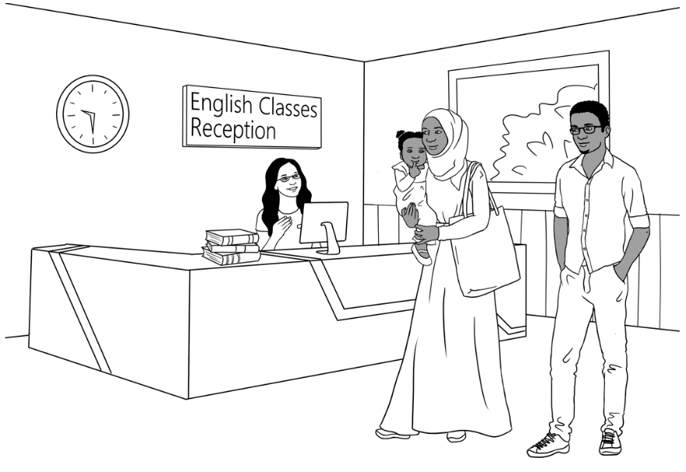
Tahiil, Sahra and Hani go to the TAFE College.

2
Play Audio 2 and ask students to match the two parts of the sentences.
- Hello. My name | my wife Sahra.
- This is | is Tahiil.
- She needs | childcare?
- We have | an English class.
- Do you have | a daughter.

Play Audio 2 again and ask students to fill the blanks with the correct words from the box.
2
meet | fill | here | help | have
name | wife | Yes | class | have

Tahiil | Hello. My name is Tahiil.  This is my __________ Sahra.  She needs an English _____________.
Receptionist | Hello. Nice to _____________ you.  You can enrol in an English class __________.
Tahiil | Thank you. We ____________ a daughter.  Do you ___________ childcare?
Receptionist | Yes, we have childcare.  Can you ________ in this form please Sahra?
Sahra | Mmm. Can you __________ me please?
Receptionist | __________. I can.

Encourage student to practice reading the conversation with their partner.
Explain general information needed for filling a form. Point to information on Sahra’s form e.g. Family name, First name etc.
Sahra’s form

TAFE
Student Enrolment Form

PLEASE USE CAPITAL LETTERS.
 Tick the box.
- Family name |  | ELMI
- First name |  | SAHRA
- Title |  | Mr | Miss | Mrs | Ms
- Country of birth |  | SOMALIA  
- Date of Birth |  | 07. 07. 1996
- Address | Street | UNIT 6, 50 BAKER ROAD
- Address | Suburb | KELLIVALE
- Address | Postcode | 2421
- Phone number |  | 0455 961 259
- Signature |  | Sahra Elmi


Ask students to find and circle the information from the box in the form.

Country of birth | Date of birth | Postcode

This is your form.
Point to the instructions.

Point to the instructions. Ask students to complete the form with their information.

TAFE
Student Enrolment Form

PLEASE USE CAPITAL LETTERS.
 Tick the box.
- Family name
- First name
- Title |  | Mr | Miss | Mrs | Ms
- Country of birth
- Date of Birth
- Address | Street
- Address | Suburb
- Address | Postcode
- Phone number
- Signature
Encourage peer correction by getting students to ask their partners to check their work.
Can you check my work please?
Can you check my work please?

16. The days
 | Practice saying the days. Point to the short and long words and mention that days of the week start with capital letter.
Ask students to circle the days of the week.

Full word | Short word
Monday | Mon
Monday . | Mon .
Tuesday | Tues
______________ | ________
Wednesday | Wed
______________ | ________
Thursday | Thurs
______________ | ________
Friday | Fri
______________ | ________
Saturday | Sat
______________ | ________
Sunday | Sun
______________ | ________
Tuesday
October
January
Wednesday
June
Monday
December
July
Saturday
April
Thursday
November
Sunday
February
March
Friday

Ask students to use their phones to record as you read the words. Explain that they can listen again in class or at home.
Sahra’s week

Monday  | Tuesday | Wednesday | Thursday
Friday | Saturday | Sunday

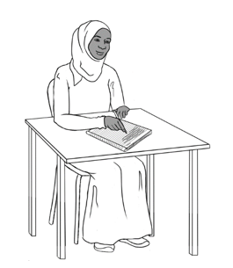

- On Monday I go to English class.
- On ___________________ I go to English class.
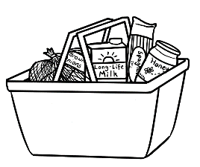
- On ___________________ I do my homework.
- On ___________________ I like cooking.
- On ___________________ I go shopping.
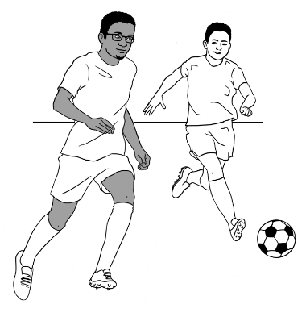
- On ___________________ I walk in the park.
- On ___________________ I watch soccer.
Ask students to complete the sentences about themselves.

About you.
- On __________________ I go to English class.
- On ___________________ do my homework.
- On ___________________ I watch TV.
- On ___________________ I _____________________________.
Encourage students to read the completed sentences to their partners and then copy in their notebooks.

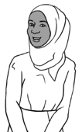
17. The time
Point to the days and times on the timetable. Explain about the start and finish times and room numbers.
This is my timetable.
I go to class on Monday and Tuesday.

 | Mon | Tues | Wed | Thurs | Fri
Morning  Start  Finish | 9:00  12:00  Room 3 | 9:30  12.30  Room 4
Lunch break
Afternoon  Start  Finish | 12:30  2:30  Room 3 | 1:00  3:00  Room 4
- I go to class | on Monday.
- I am in Room 3 | 9:00 on Monday morning.
- I am in Room 4 | on Monday and Tuesday.
- I start at | 2:30 on Monday afternoon.
- I finish at | on Tuesday.
Ask students to match first part of the sentence to the second part.

Ask students to complete the sentences about themselves.

I go to class on ________________________________________________________.

Students match the times with the pictures. At the start and end of the class over the next few days, use the classroom clock to check the time and reinforce the start and finish time of class.
12  1  11  6  3  2  10  9  8  5  7  4  12  1  11  6  3  2  10  9  8  5  7  4  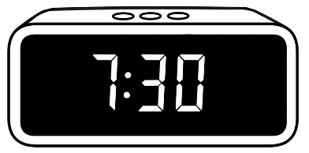  1:00    9:30 am  Mon 7 Sept  20°C | Monday morning  9:00  12:00  Monday afternoon  12:30  2:30  Tuesday morning  9:30  12:30  Tuesday afternoon  1:00  3:00 | 9:00  12:30 pm  Mon 7 Sept  20°C  12  1  11  2  10  3  9  8  4  5  7  6  12  1  11  6  3  2  10  9  8  5  7  4
Ask students to complete the sentences about themselves.
Today I start class at ___________________ .
Today I finish class at ___________________ .
Encourage students to read the sentences with their partners.
On Monday Sahra starts class at 9:00 in the morning.
She finishes at 2:30 in the afternoon.

18. Messages
A message from the teacher
Project the message. Point to the greeting and ending in a message. Read the message for the students and ask follow-up questions.

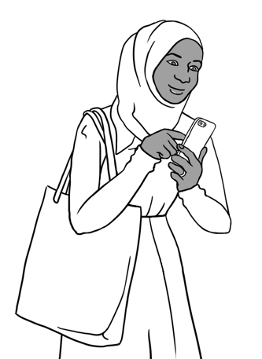
Hello Sahra,
Your class starts on Monday 13 July.
Please come to Room 3 at 9:00.
Your teacher Jenny
Greeting
Ending


Circle the greeting. the ending.

Tick one.

This is a form.

a text message.

a Medicare card.

Ask students to read the message and write the answers.
- Who is this message to?
- Who is this message from?
- When does Sahra’s class start?
Date ___________________________ Time __________________
Project the message. Read the message for the students and ask follow-up questions.

A message from Sahra

Hi Jenny,
I can’t come to class tomorrow. Sorry.
My baby is sick.
Sahra Elmi

Encourage students to write a message to their teacher, explaining why they can’t come to class.

You can’t come to class tomorrow.
_______________________________________________________________________________________________________________________________________________________________________________________________________________
- Tick why.
- I am sick.
- My child is sick.
- My mother is sick.
- I have a doctor’s appointment.





- Write a message
to your teacher here.
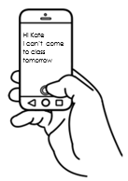
- Copy your message
on your phone.

- Send the message
to your teacher.
Project and read the note in class. Ask students follow-up questions about the note.
A note on the door of Room 4



Tuesday 22 July

Hello students

Our class is in Room 3 today.
Your teacher Jenny
Room change


Tick.

- Who is the note for? |  | Jenny |  | students
- Who is the note from? |  | Jenny |  | students
- Who is Jenny? |  | a student |  | a teacher
- Where is the class today? |  | Room 3 |  | Room 4
- Where is the note? |  | on the door  of Room 3 |  | on the door of Room 4

Ask students to ask and answer the questions with their partners.

19. Two letter sounds
Point to the digraphs and read the sounds and the words. Ask students to repeat the sounds and the words. Ask students to circle the words in the sentences.

Sounds | Words |   Circle the words.
ch | change | There is a room change today.
sh | she | She reads the note.
th (1) | three | Please go to room three.
th (2) | the | The note is on the door.
wh | What  Where | What is the room number today?  Where is the note?
ph | phone | What’s your phone number?
The
the
change
what
phone
where
three
she
Ask students to complete the sentences using the words from the box. Encourage the students to put a tick next to the word that they have used.

- There is a room change today.
- __________ reads the note.
- Our class is in room _______________.
- __________ note is on ___________ door.
- ___________ is the room number today?
- ____________ is the note?
- What ’s your _______________ number.
Encourage students to read the completed sentences to their partners and then copy in their notebooks.

20. How many?
Point to the picture and drill the words from the box. Ask students to count them e.g. tree and write the numbers. Read the numbers and point to the letter and number format.

seat | dog | tree
cloud  | bird | flower

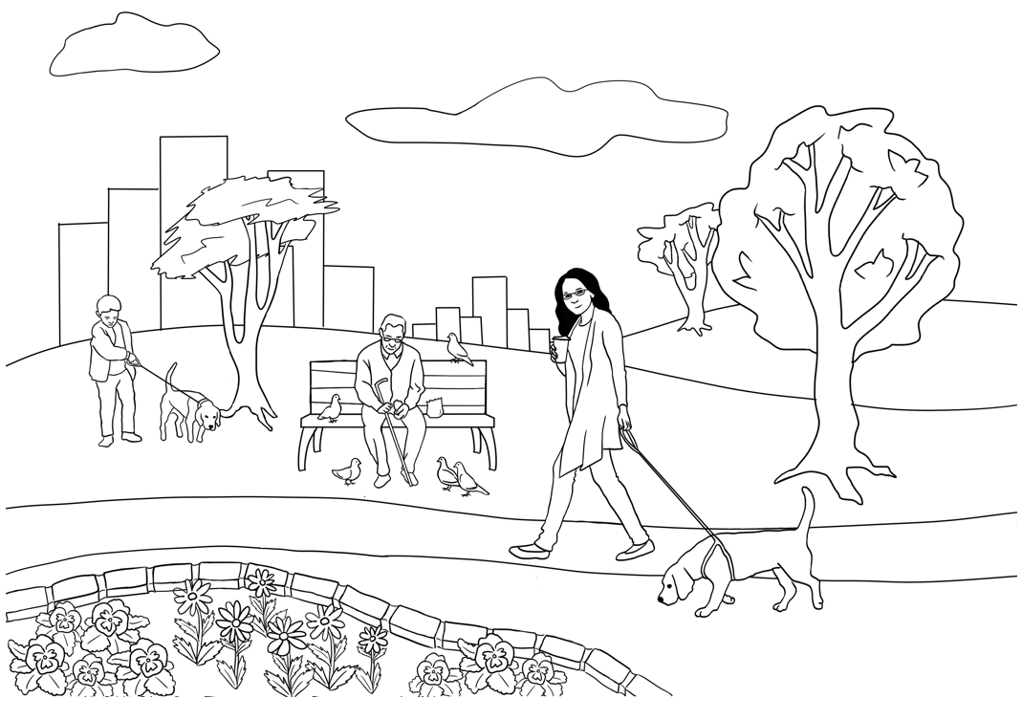
cloud

1  Ask students to complete the sentences using the words from the box. Encourage the students to put a tick next to the word that they have used. |  one |  | 8 | eight
2 | two |  | 9 | nine
3 | three |  | 10 | ten
4 | four |  | 11 | eleven
5 | five |  | 12 | twelve
6 | six |  | 13 | thirteen
7 | seven |  | 14 | fourteen
There is _____one seat.
There are ____________ dogs.
There are ____________clouds.
There are ____________ trees.
There are _______________ birds.
There are _______________ flowers.

21. What colour?
Ask students to colour the boxes and then the picture below.
black |  |  | light blue
white |  |  | dark blue
grey |  |  | yellow
red |  |  | orange
pink |  |  | light green
Purple |  |  | Dark green
Colouring helps student develop the fine motor skills required for pencil grip.
Write sentences
with numbers and colours in your notebook.

One dog is _______________________.
Two birds are _____________________.
Three flowers are _________________.

22. At the childcare centre
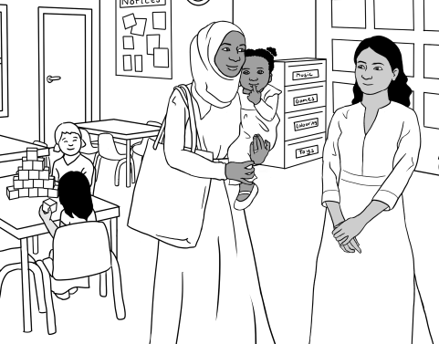
Ask students to listen and record as you read the conversation.

Sahra meets Nisha
at the childcare centre.

Encourage students to read the conversation by themselves and/ or in pairs and record their voice.

Nisha Hi. Can I help you?
Sahra Can I have childcare for my daughter please?
Nisha Yes, you can. What’s your daughter’s name?
Sahra Hani Jama
Nisha How old is your daughter?
Sahra Two
Nisha What’s her date of birth?
Sahra 24th June 2021
Nisha Good. What days do you need?
Sahra Monday and Tuesday
Nisha Do you have a Medicare card?
Sahra Mmm yes. Here it is.
Nisha Thank you. Can you fill in this form please?
Sahra Oh. Can you help me please?

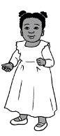

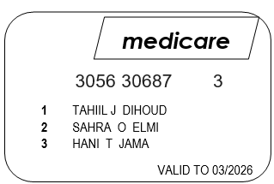

Say the bold words strongly.
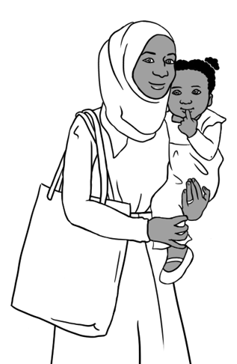
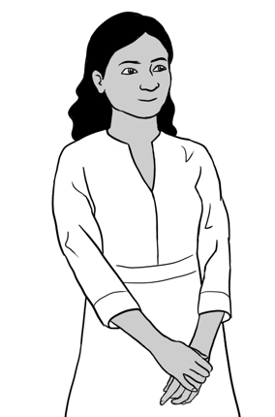

Can I help you?
What’s her name?
How old is your daughter?
What’s her date of birth?
What days do you need?
Do you have a Medicare card?
Can you fill in this form please?
Ask students to write Sahra’s answers. Encourage students to practice reading the conversation with a partner.

Nisha | Sahra
Can I help you? | Can I have childcare for my daughter please?
What’s her name?
How old is your daughter?
What’s her date of birth?
What days do you need?
Do you have a Medicare card?
Can you fill in this form please?

Ask students to put the words in order and then write the sentences.

you??
Can
1.
help
I

Can I help you? .
What’s
name?
her
2.

______________________________________________________.
daughter?
is
old
How
your
3.
________________________________________________________
date
What’s
4.
birth?
of
her

_________________________________________________________
5.
need?
daysq
What
do
you

_________________________________________________________.
card?
you
Medicare
a
have
Do
6.

_________________________________________________________.
please?
fill
7.
this
form
in
Can
you

_________________________________________________________
A message from Sahra

Project the message. Point to the greeting and ending in the message.
Read the message for the students and ask follow-up questions.
Hello Nisha,

Hani is sick.
She can’t come
to childcare today.
Sahra Elmi


Circle the greeting. the ending.
Ask students to write the answers and match the greeting and ending words.

1. Who is the message to? _________________________
2. Why does Sahra send the message?
3. Hani is ____________________.
- See you | next week.
- Good | soon.
- Good | later.
- See you | morning.
- See you | afternoon.
4. She can’t come to _______________________ today.

23. Tahiil’s week
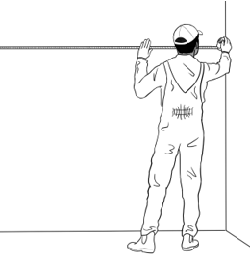
work

Explain that this is Tahiil’s week. Point to the days of the week and Tahiil’s actions. Encourage students to read with a partner.

- I work on Monday.

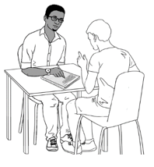
- I work and study on Tuesday.
study

- I work on Wednesday.

- I work and study on Thursday.

- I work on Friday.

- I study on Saturday morning.
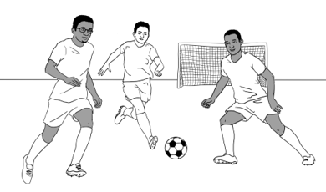
soccer
- I play soccer on Sunday.

24. Tahiil plays soccer.
Read the conversation below. Point to the beginning and ending of the conversation. Encourage students to read the conversation.

In the morning before soccer
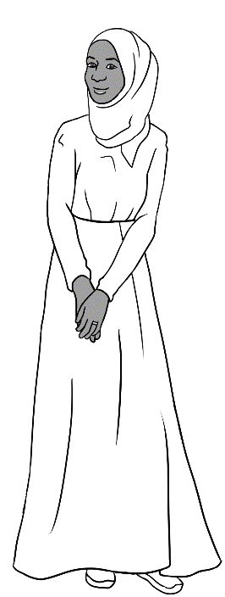
Pam Good morning Sahra.
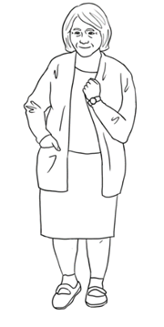
Sahra Good morning Pam.
Pam It’s a beautiful day, isn’t it?
Sahra Yes, it is.
My husband Tahiil plays soccer today.
Pam It’s a good day for soccer.
Nice to see you Sahra.
Sahra Yes. See you soon Pam.
Ask students to complete the sentences using the words from the box. Encourage the students to put a tick next to the word that they have used.

Pam Good morning Sahra.
husband
morning
Good
soccer
is
day
soon
you

Sahra _________ morning Pam.
Pam It’s a beautiful _______, isn’t it?
Sahra Yes, it _____.
My _____________Tahiil plays soccer today.
Pam It’s a good day for _____________.
It’s nice to see _______ Sahra.
Sahra Yes. See you _________ Pam.
Encourage students to read the completed conversation with their partners.

Point to the new words and encourage students to copy them. Read the conversation below. Encourage students to read the conversation with a partner.

In the afternoon at soccer

to run  to run . | 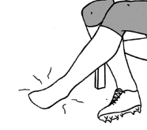  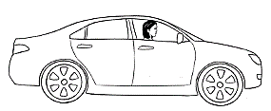  painful
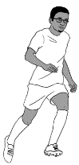  to trip | to drive
to fall over |   hospital

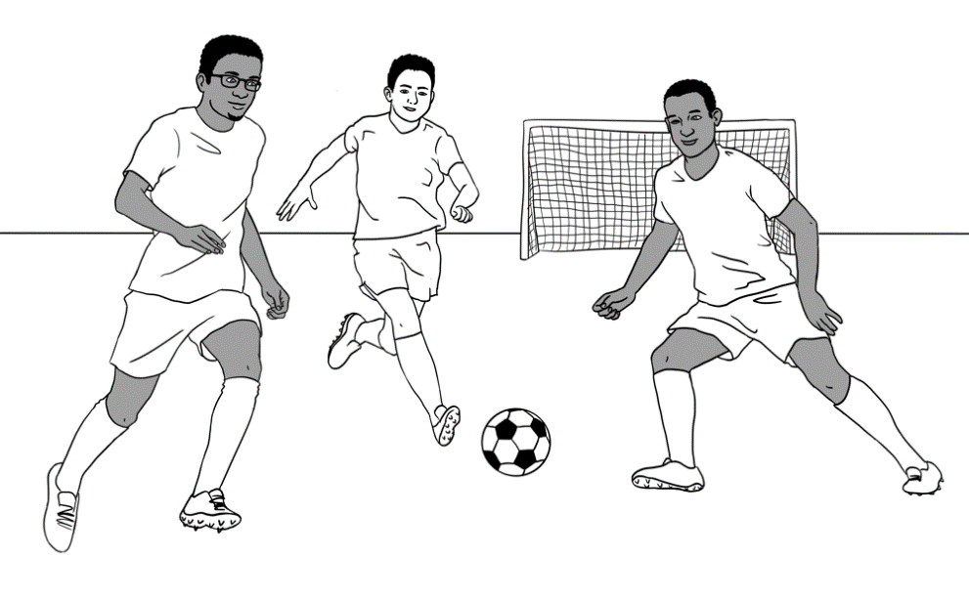

Tahiil plays soccer on Sunday.
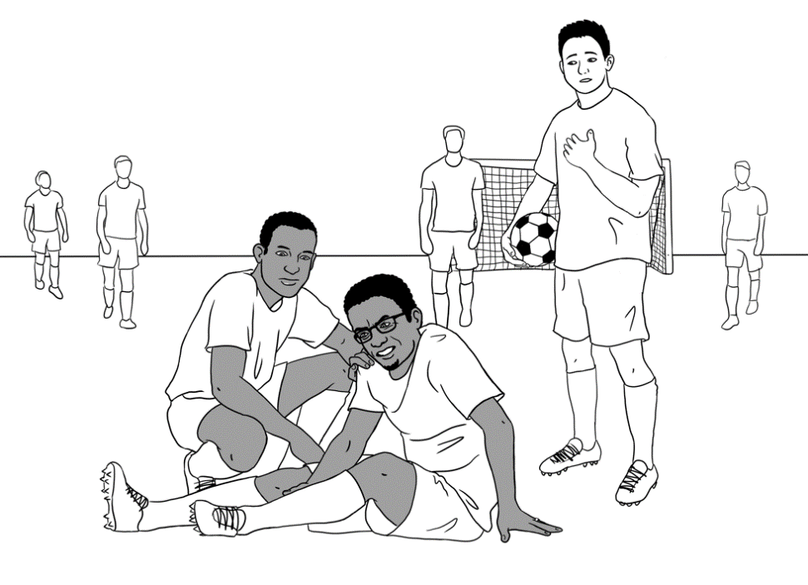
Tahiil runs after the ball.
He trips and falls over.
Can I help?
Are you OK Tahiil?
Oh. My foot is very painful.
Can you drive me to the hospital?

The Hospital Emergency
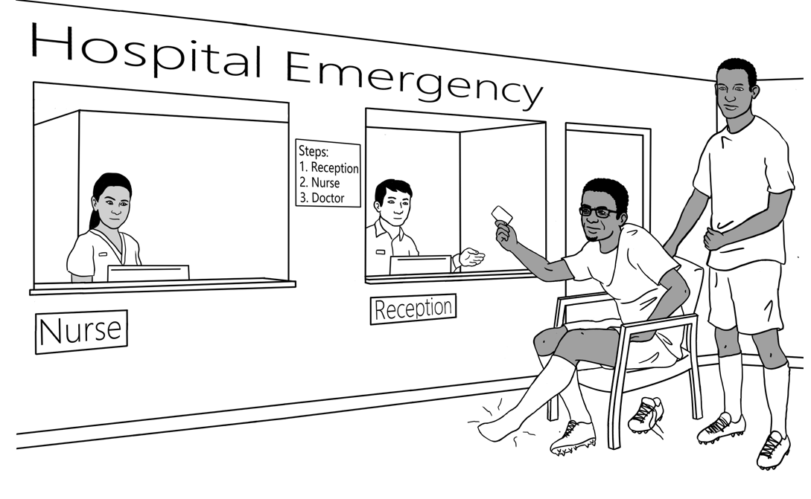

Read the sentences and point to the order of events, e.g. ‘first’ and ‘then’.

Abdi drives Tahiil to the hospital emergency.
First, they go to reception.
Then Tahiil speaks to the nurse.
Then they wait for the doctor.
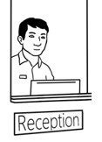
reception.
to
go
they
First,

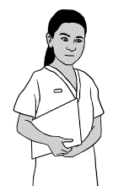
First, they go to reception. .
nurse.
Tahiil
to
the
speaks
Then


______________________________________________________________
doctor.
the
they
Then
wait
for

______________________________________________________________
At the reception desk
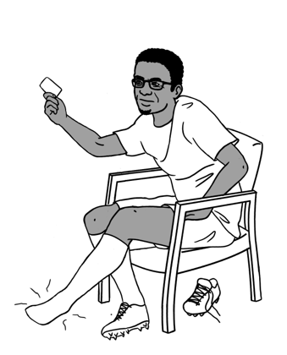
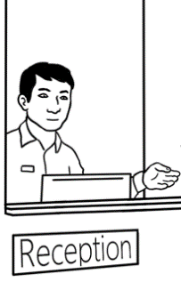
problem problem .
a lot of
to wait

Ask students to record as you read the conversation. Encourage students to read the conversation with a partner and record their own voice as they are reading.

Reception Hello. What’s the problem?
Tahiil I hurt my foot playing soccer.
Reception Can you tell me your family name?
Tahiil Dihoud D – I – H – O – U - D
Reception What’s your first name?
Tahiil Tahiil T – A – H – I – I – L
Reception Do you have a Medicare card?
Tahiil Yes. Here it is.
Reception Are you in a lot of pain?
Tahiil Sorry, can you say that again, please?
Reception Is your foot painful?
Tahiil Yes. Very painful.
Reception Please sit there.
Fill in this form for the nurse.
Tahiil Thank you.
Ask students to complete the sentences using the words from the box. Encourage the students to put a tick next to the word that they have used.

first
problem 
foot
card
name
pain
your
fill in
sit
say
is
Reception Hello. What’s the problem ?
Tahiil I hurt my ________ playing soccer.
Reception Can you tell me your family ___________?
Tahiil Dihoud D – I – H – O – U - D
Reception And your __________ name?
Tahiil Tahiil T – A – H – I – I - L
Reception Do you have a Medicare ___________?
Tahiil Yes. Here it is.
Reception Are you in a lot of _________?
Tahiil Sorry, can you ________ that again, please?
Reception Is _______foot painful?
Tahiil Yes. My foot _______ very painful.
Reception Please ________ there.
_____ _____ this form for the nurse.
Tahiil Thank you.

Encourage students to read the completed conversation with their partners.

Point to the information on the form and check understanding.

Tahiil fills in a form.

Hospital Patient Form

Write in CAPITAL LETTERS.
Tick the boxes


Title Mr Mrs Ms Miss

Family Name DIHOUD
Given Name TAHIIL JAMA
Date of Birth 27/06/1994
Address UNIT 6, 50 BAKER ROAD
Suburb KELLIVALE Postcode 2421
Phone 0400 785 936
Medicare Number 3056 30687 3 Valid to 06/2031


Ask students to circle the information from the form and put a tick next to the correct box.


- Tahiil needs to fill in the form
for Centrelink for the hospital for TAFE classes
- Tahiil needs to fill in his
signature Medicare number title
email phone address country
Can you check my work please?
Encourage peer correction by getting students to ask their partners to check their work.

25. Signs at the Hospital
Project the signs on this page. Read the signs and ask students to repeat them. Ask the students to tick the signs they can see in their English Centre.
1 | Hospital | 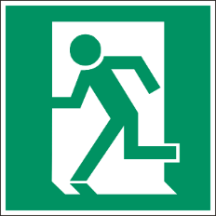  2 | Exit
  3 | No Entry |   4 | First Aid
  5 | Men’s toilet |   6 | Women’s toilet
  7 | No Smoking | 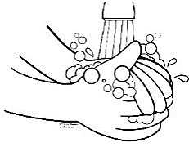  8 | Wash your hands.
  9 | Wet floor |   10 | Wear a face mask.

Tick the signs in your English centre.


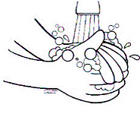

 | No smoking
 | Wet floor
 | Hospital
 | Men’s toilet
 | Wear a face mask
 | No Entry
 | Women’s toilet
 | First Aid
 | Exit
 | Wash your hands

26. Tahiil can’t come to class
Tahiil sends a message to his teacher.

A message from Tahiil to his teacher David.
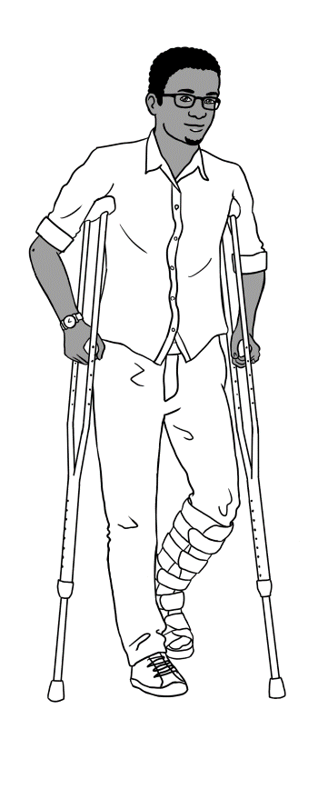
Hi David,
I hurt my foot.
I can’t walk.
I can’t come to class for 8 weeks.
I am very sorry.
Tahiil Dihoud

Project the message.
Read the message for the students and ask follow-up questions.


Circle the greeting. the ending.
foot
Tahiil
David
8
walk
Write.
- This message is to David .
- This message is from _______________
- Tahiil hurt his ________________.
- He can’t __________________.
- He can’t come to class for ______ weeks.

Tick one.
Why does Tahiil write this message?
He can’t come to class for 3 weeks.
He can’t come to class tomorrow.
He can’t come to class for 8 weeks.
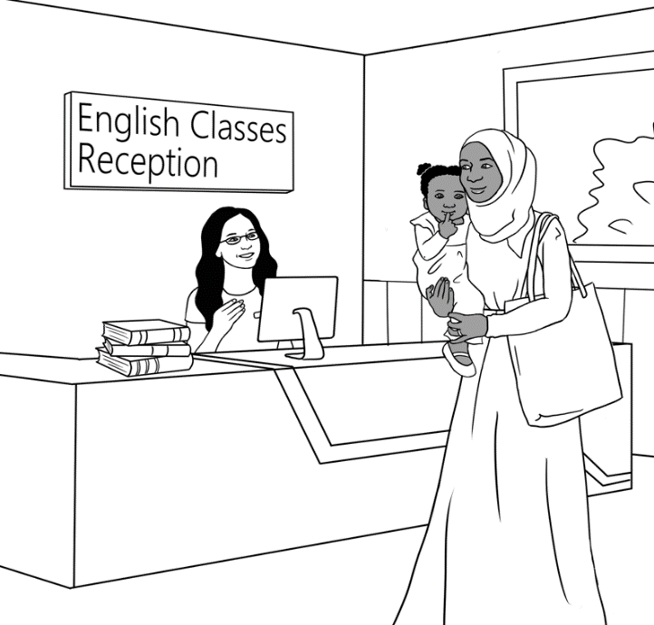

Sahra at TAFE

Project the conversation and read in class. Point to greeting and ending. Ask follow-up questions. Encourage students to read and practice the conversation with their partner and copy in their notebook.

Sarah Good morning.
Receptionist Good morning Sahra.
How are you?
Sahra I’m fine thanks.
Tahiil can’t come to class.
Receptionist Oh? Why?
Sahra He hurt his foot.
He can’t walk.
He can’t come to class for eight weeks.
Receptionist That’s not good.
Sahra I have his form for a volunteer tutor.
Receptionist Ah. Good. Thank you Sahra.
Sahra Thank you.

Ask students to complete the sentences using the words from the box. Encourage the students to put a tick next to the word that they have used.

you
Why
walk
morning

weeks
come
Thank
foot
form
not

Sarah Good morning.
Receptionist Good morning Sahra.
How are _________?
Sahra I’m fine thanks.
Tahiil can’t _________ to class.
Receptionist Oh? ________?
Sahra
He hurt his ___________.
He can’t ____________.
He can’t come to class
for eight _____________.

Receptionist That’s ________ good.
Sahra I have his __________ for
a volunteer tutor.
Receptionist Ah. Good. _____________ you Sahra.
Sahra Thank you.
Ask the students to copy the conversation in their notebooks.

27. Where and when?
Explain that ‘Wh’ questions such as Where and When are used when we want to ask for more information. Explain that ‘Where’ is used to ask about a place. Then read the sentences and emphasize the place. Ask students follow up questions to check understanding.
Where?
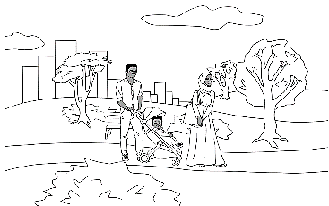
walking
in the park.
They
like
1.

They like walking in the park. .
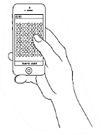
playing
on the phone.
He
games
likes
2.

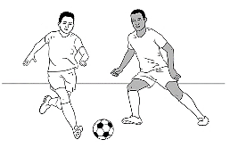
soccer
in the park.
They
playing
like
3.

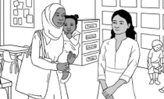
Sahra
to childcare.
her
takes
daughter
4.

Bao’s
from China.
comes
family
5.

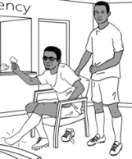
Abdi
to the hospital.
Tahiil
drives

6.

Explain that ‘Wh’ questions such as Where and When are used when we want to ask for more information. Explain that ‘When’ is used to ask about time. Then read the sentences and emphasize the time. Ask students follow up questions to check understanding.
When?
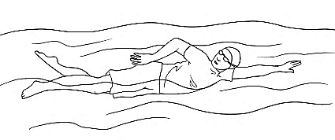
on Saturday.
morning
swimming
likes
He
1.

He likes swimming on Saturday morning. .
We
in the afternoon.
watch cccocouchcouchcouch
TV
2.

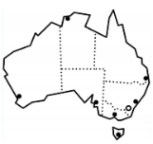
in March 2016.
came cccocouchcouchcouch
to
I
Australia
3.

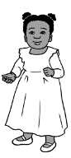
4.
on 24 June 2021.
was cccocouchcouchcouch
born
Hani

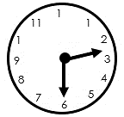
on Monday.
finishes
Sahra
at 2:30
5.
class

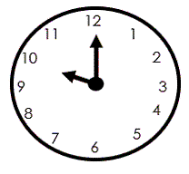
at 10
can
on Tuesday.
come
Anika
6.

28. Word Lists
Family | Instructions | Adjectives
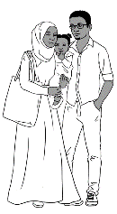  wife  husband  daughter  son  mother  father  sister  brother  uncle  aunt  cousin  ________________  granddaughter  grandson  grandmother  grandfather  boy  girl  baby  child | read  write  say  ask  listen  point  spell  repeat  record  ________________  copy  check  circle  underline  clap  tick  colour | hot  warm  cold  beautiful  nice  fine  good    __________________  colour  black  white  grey  red  pink  purple  light blue  dark blue  yellow  orange  light green  dark green

School | When | Where
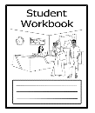  workbook  notebook  pen  pencil  pencil case  rubber  sharpener  highlighter | 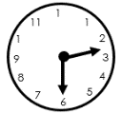  time  year  month  week  day  morning  afternoon  today  tomorrow  next week |   home  school  English class  reception desk  room  childcare  the garden  the park  hospital  Australia

Polite words | Food | Work and study
excuse me  please  thank you  sorry | fruit  apples  bananas  bread  cake  coffee  hot chips  ice cream  noodles  orange juice  pizza  rice  tea |   student  teacher  receptionist  doctor  nurse  painter  volunteer tutor

Verbs |  | Words on forms
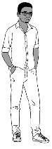    to meet  to come  to do  to have  to go  to be  to like  to live  to learn    _________________  to study  to work  to understand  to borrow  to need  to start  to finish  to send | to play  to walk  to run  to trip  to fall  to break  to hurt  to drive  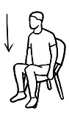  _______________  to sit  to wait  to see  to fill in  to watch  to cook  to swim  to fish | full name  first name  given name  family name  surname  title  place of birth  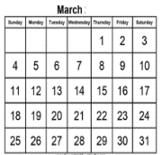  date of birth  age  country  language  _______________  address  street  suburb  postcode  phone number  email  signature  married  emergency






