

English Ready
22637VIC Course in EAL
VU23496 Communicate basic personal details and needs
VU23498 Read and write short highly familiar messages and forms

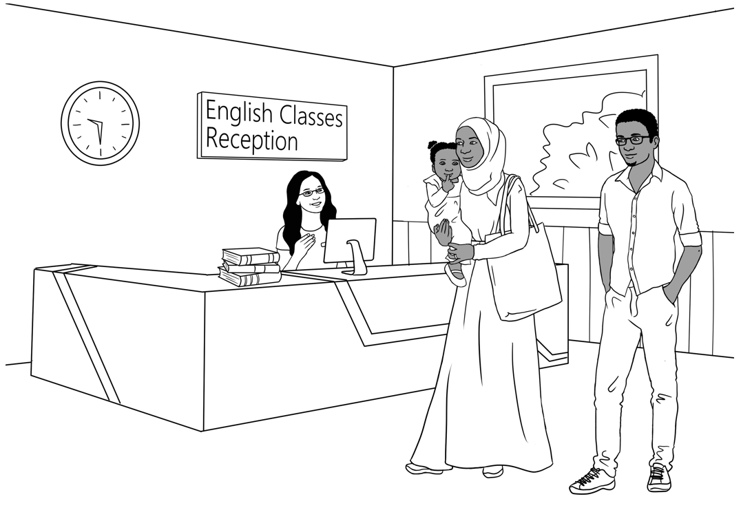
Conversation, Messages and Forms
Teacher Resources

Design team: Vicki Hambling, Sue Paull, Frida Dean, Janice Langley, Glenise Kleehammer
and Mary Wallace
Illustrations: Madelena Scott

Acknowledgements: The design team would like to thank the AMEP service providers and practitioners who participated in the trial and gave valuable feedback. The team would also like to acknowledge the use of the EAL Framework which underpins the design of this book.

Copyright of the EAL Framework is reserved to the Crown in the right of the State of Victoria. © State of Victoria (Department of Education and Training) 2023.
_________________________________________________________________________________________
This English Ready Resource is licensed under a Creative Commons Attribution-NoDerivs 3.0 Australia licence (More information is available here). You are free to use, copy and distribute to anyone in its original form as long as you attribute Department of Home Affairs as the author and you license any derivative work you make available under the same licence.
© Commonwealth of Australia 2023

With the exception of the Commonwealth Coat of Arms, the department’s logo, any material protected by a trade mark and where otherwise noted all material presented in this document is provided under a Creative Commons Attribution 4.0 International (https://creativecommons.org/licenses/by/4.0/) licence.
The details of the relevant licence conditions are available on the Creative Commons website (accessible using the links provided) as is the full legal code for the CC BY 4.0 licence (https://creativecommons.org/licenses/by/4.0/legalcode).
Use of all or part of this document must include the following attribution:
© Commonwealth of Australia 2023
As far as practicable, material for which the copyright is owned by a third party will be clearly labelled. The department has made all reasonable efforts to ensure that this material has been reproduced in this document with the full consent of the copyright owners.
Copyright requests and enquiries concerning usage not addressed by the CC BY 4.0 licence should be addressed to: comms@homeaffairs.gov.au at the Department of Home Affairs.
The terms of use for the Commonwealth Coat of Arms are available from the It's an Honour website.
Where a copyright owner, other than the Commonwealth, is identified with respect to this material, please contact that third party copyright owner directly to seek permission.



Introduction
The Teacher Book
This book is an electronic reference. Print pages as only needed. It includes materials and activities for:
- pair work and class work
- revision and homework
- pronunciation
- extension
The book also contains audio transcripts and links to the audio MP3 files.

The Student Workbook
This book requires teacher direction and is not intended for independent learning. It is also not intended to be the only material used to teach these units. The activities included are not suitable to be used for assessment. The book is available as a Word document so that teachers can:
- localise and update the content
- adjust the material to suit the requirements of particular classes
- delete or add materials as required


At the back of the book are two emojis to give feedback to the teacher. Students can hold up the emoji which best reflects how they feel about an activity or a lesson.

Table of Contents
1. Meet the people 3
2. Do you understand? 7
3. Introductions 9
4. Instructions in the workbook 10
5. The Alphabet 11
6. Have a conversation 21
7. English class 23
8. When, where, who, what, why? 26
9. People in a family 29
10. Break words into syllables 32
11. What do you like? 33
12. Months of the year 37
13. Syllables – strong and weak 45
14. Words on Forms 46
15. An English Class for Sahra 53
16. The Days 65
17. The Time 67
18. Messages 69
19. Two-letter sounds 70
20. How many? 72
21. What colour? 78
22. At the Childcare Centre 81
23. Tahiil’s week 87
24. Tahiil plays soccer 88
25. The Hospital Emergency 90
26. Tahiil can’t come to class 99
27. Where and when? 103
28. Audio files and transcripts 108

Meet the people
Drawings of the characters
The characters and scenes have been included so that teachers can produce their own materials as needed. A chart with the bio data [pages 5-6] was created to maintain consistency of information throughout the booklets. It may be useful to update character information to make it more relevant to the time of use.

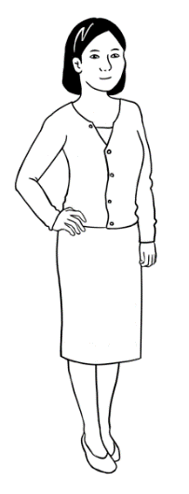
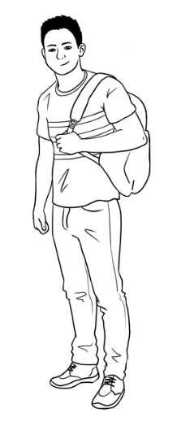
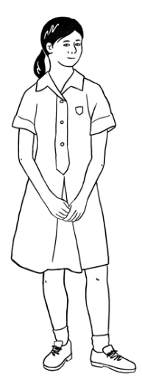
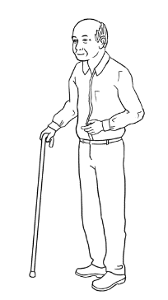
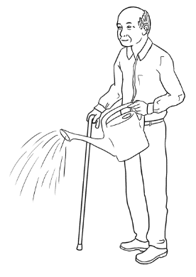
Bao
Mai
Lan
Ming

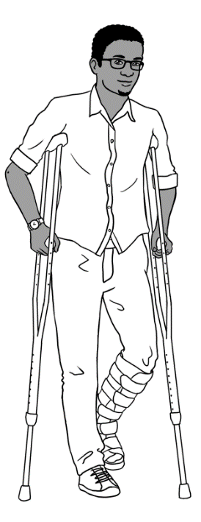
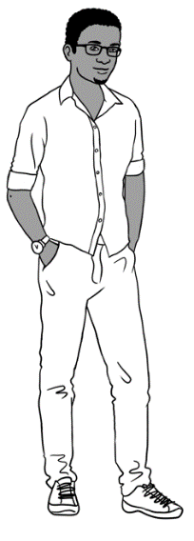
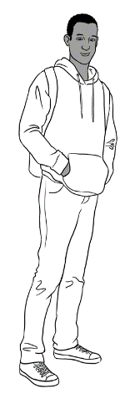
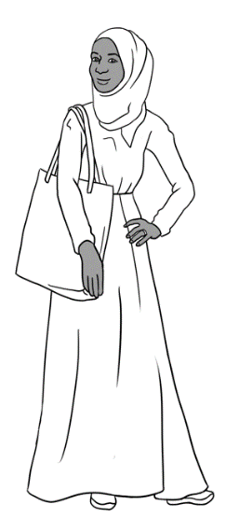
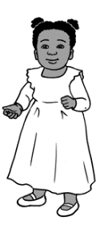
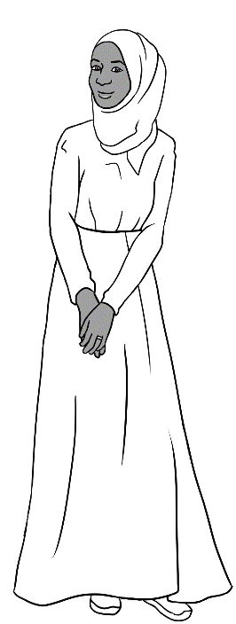
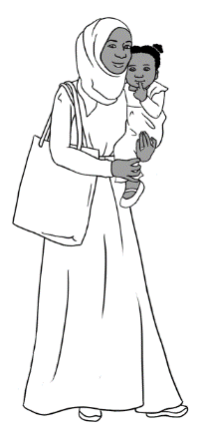
Sahra
Hani
Tahiil
Abdi

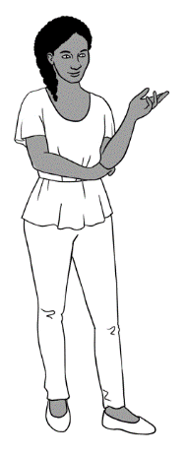
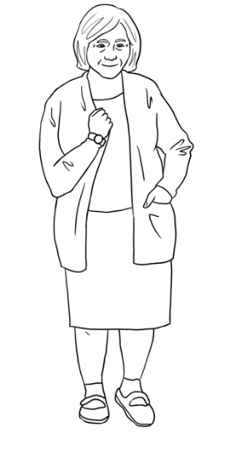
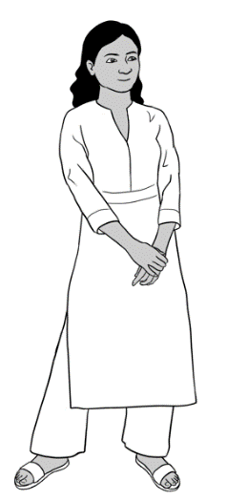
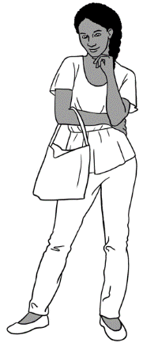
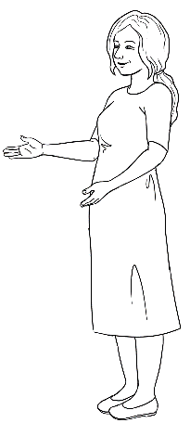
Anika
Nisha
Pam
Jenny

_______________________________________________________________________
Characters in scenes
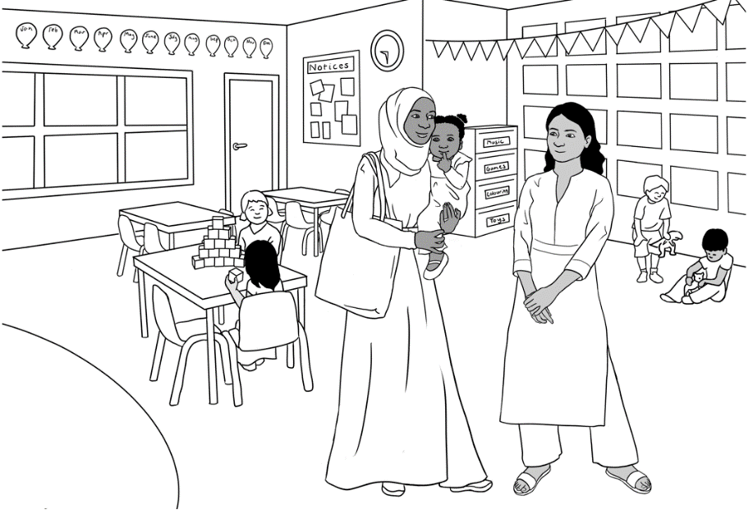
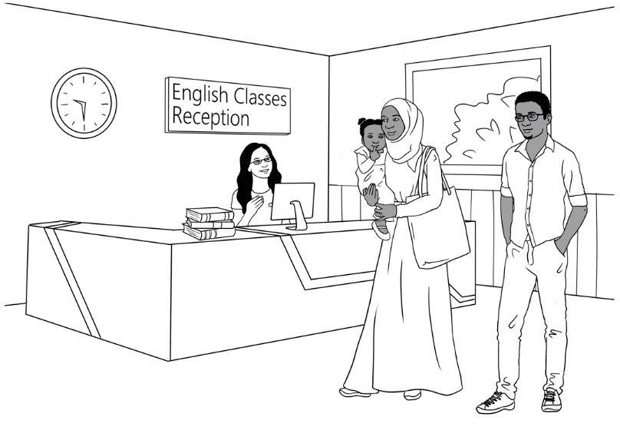
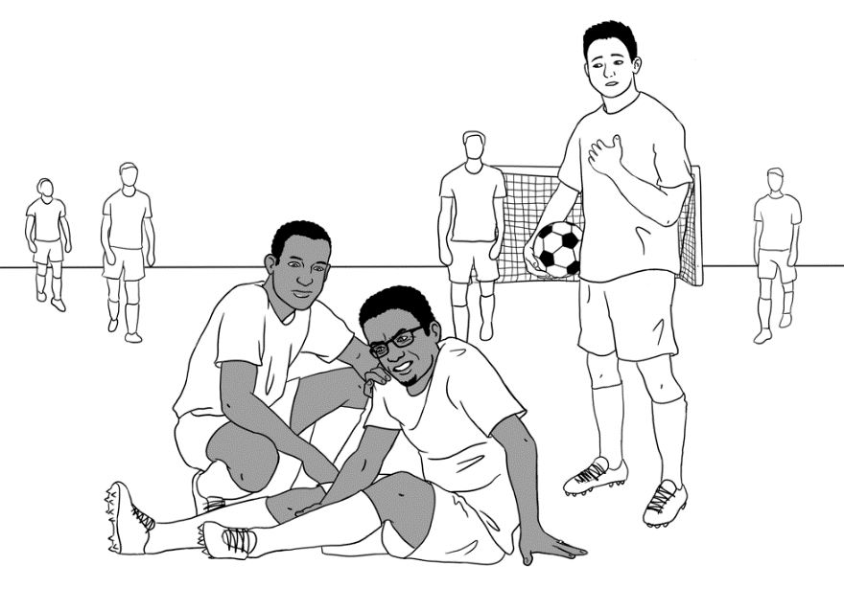
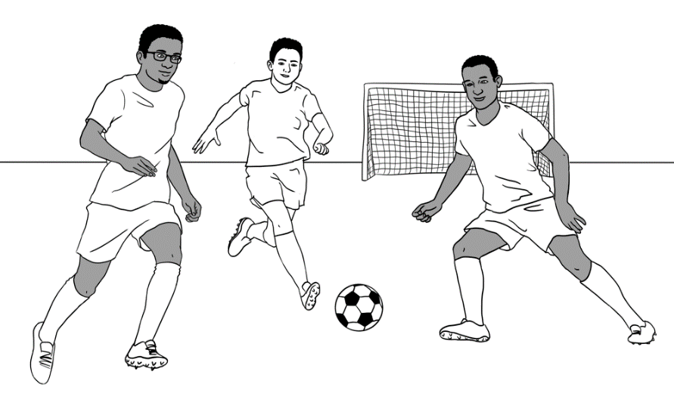
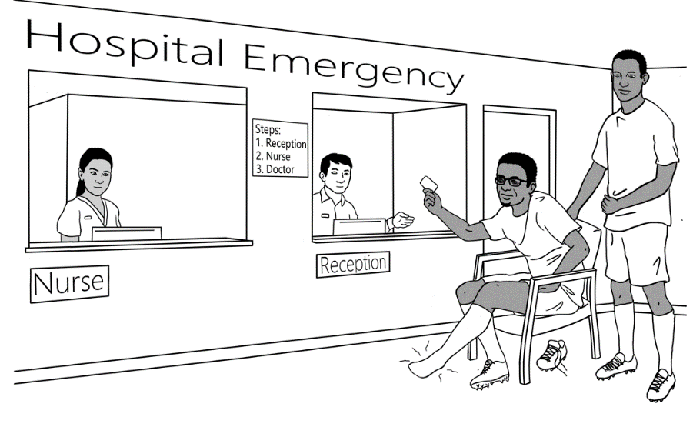

w

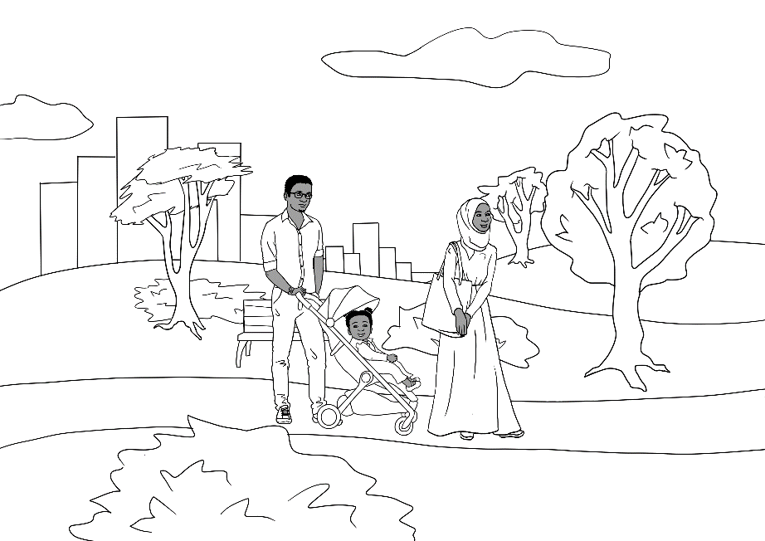
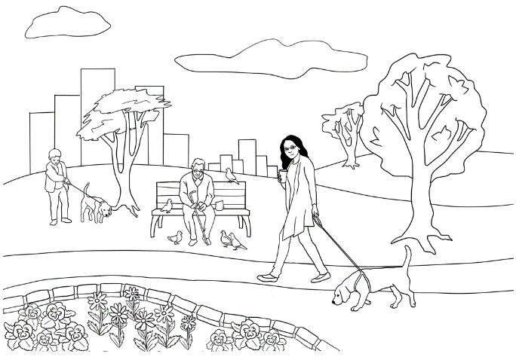

Personal details of the characters
Name | Country  of origin | *Age &/or Date  of birth | Date  of arrival | Address in Kellivale | Phone
Tahiil Jama Dihoud | Somalia | 27.6.94 | 09.06.22 | Unit 6,  50 Baker Rd | 0400 785 936
Sahra Omar Elmi | Somalia | 7.7.96 | 09.06.22 | Unit 6,  50 Baker Rd | 0455 961 259
Hani Tahiil Jama | Somalia | 2 years  24.06.21 | 09.06.22 | Unit 6,  50 Baker Rd | _
Abdi Omar Elmi | Somalia | 4.8.04 | 13.10.15 | Unit 1,  50 Baker Rd | 0465 971 356
Ming Wu | China | 27.3.1959 | 07.05.19 | 70 Wattle St | 0418 335 748
Lan Wu | China | 6.6.78 | 11.07.14 | 70 Wattle St | 0488 872 951
Bao Wu | China | 19 years  13.05.2004 | 11.07.14 | 70 Wattle St | 0409 188 674
Mai Wu  3065 75221 3  1. Tahiil Jama Dihoud  2. Sahra Omar Elmi  3. Hani Tahiil Jama  VALID 06/2025  medicare | China | 16 years  19 April | 11.07.14 | 70 Wattle St | 0487 592 811

Personal details of the characters [continued]
Nisha Kumar | India | 19.01.1978 | 06.04.13 | 56 North St | 0411 825 999
Pari Kumar | India | 9 years |  | 56 North St
Dev Kumar | India | 7 years |  | 56 North St
Anika | Ethiopia | 30.09.1995 | 15.10.22 | 56 North Street | 0477 193 286
Fatima  Khalil Hamed | Syria | 15 years  13 July | 16.11.2008 | 260 North St
Carim  Khalil Hamed | Syria | 19 years | 30.06.2004 | 260 North St | 0469 455 218
Jenny  [Teacher] | Australia | - | - | - | -
Pam  [Sahra’s  neighbour] | Australia | 02.02.1956 | _ | Unit 5,  50 Baker Rd | 0407 165 972
Paul  [VTS] | Australia | _ | _ | _ | 0431 978 352
*Note 1: Where dates of birth have been used in the booklets, they have been recorded here as exact figures. The age of the characters is relevant for the younger characters as they either attend childcare, primary school, secondary school or uni. All dates may be adjusted to make them more relevant to the time the resource is being used.

Note 2: Characters shaded in this colour are not introduced in this booklet.

Do you understand?
Activity - Make requests for repetition or clarification
- Teach students the requests for clarification and repetition introduced in the student workbook
- Print the requests on the following page, laminate and cut up. [The request in greyscale is not in the workbook]
- Build confidence in using the expressions through regular class practice:
- Give the five expressions to five students. Select the most confident students at first.
- Ask these students to use their expression at least once during the class – initially with the teacher and later with each other.
- Give the expressions to different students in following classes.
- Teach additional expressions when appropriate.

Sorry. I don’t understand.
Can you help me please?
Can you say that again please?
Can you speak slowly please?
Can you spell that please?

Introductions
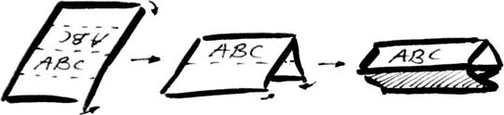
Introductions and learning names
Student names provide a practical vocabulary for building many skills:
- Word stress – Write student names on the board in lists according to the number of syllables. Mark the stress and practise together. Clap, stamp feet or use a rubber band to mark the main stress with a large circle.
_{Mai} _{Abdi} _{Anika}

- Build class connection by learning names - name cards
- With ½ A4 page, fold and create name cards for each student.

Mark the stress pattern on the cards and collect at the end of each class.
- Teach how to introduce someone.
- Write on the board, ‘My name is___________.’ Go round the class, with students introducing themselves.
- Next, on the board write, ‘My name is______________, and this is ______________.’ Demonstrate how to introduce someone with an outstretched hand towards the person, palm up. Round the class, students introduce themselves and the person next to them. This introduction can be revised when a new student joins the class, and extended to include where a student comes from, their likes and dislikes, favourite colour etc.

- Use a ball for a different activity. Ask students to stand in a circle. The student with the ball introduces themself, and then says
‘and this is ______________’ and throws the ball to the student named. Continue the game till most students have introduced themselves.

Instructions in the workbook

 | read | 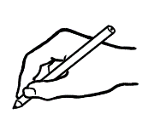 | write
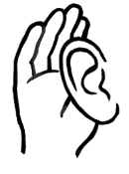 | listen |  | say
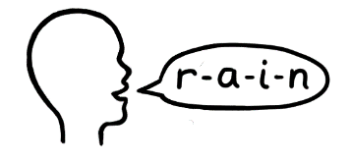 | spell |  | Ask questions.
 | tick |  | Colour
 | circle |  | underline
 | point |  | copy
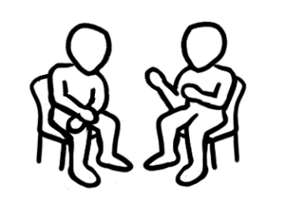 | Work with  a partner. |  | Record
 | Clap | 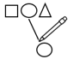 | Match
 | Notebook

The Alphabet
Alphabet pictures
The following pictures may be cut up by the students and matched to their initial sounds. There are two pictures for each sound. Words for the first set of pictures are in the student workbook on pages 7 & 8. Words for both set of pictures are on the following pages. Students can add the words for the second set of pictures to the table in their workbook.

Picture set 1 – These pictures are in the student workbook.
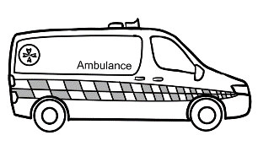 |  | 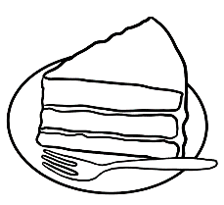
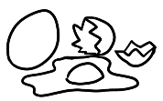 | 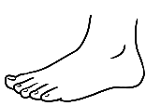 | 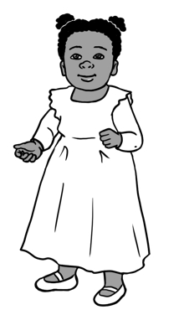 | 
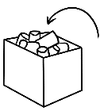 | 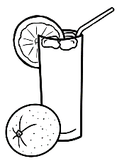 |  | 
 | 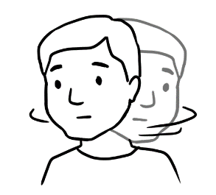 |  | 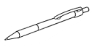
 | 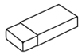  Rubber |  | 
 | 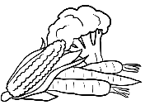 | 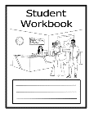 | 
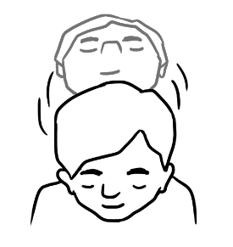 | 

Picture set 1 – These words are in the student workbook.
ambulance | ball | cake | down
eggs | foot | girl | home
in | juice | key | lamp
man | no | office | pen

question | rubber | student | tea
up | vegetables | workbook | x-ray
yes | zero

Picture set 2- New pictures not in the student workbook
 |  |  | 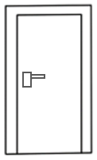
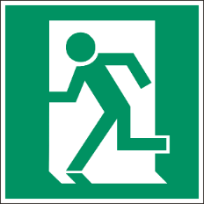 | 5 |  | 
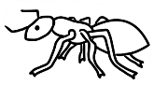 |  | 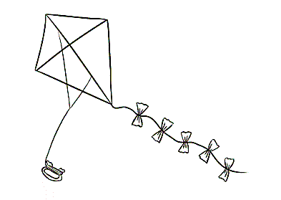 | 
 | 9 | 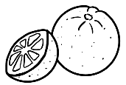 | 

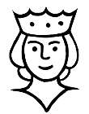 |  |  | 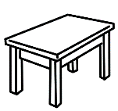
 | 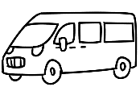 | 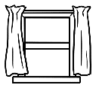
 | 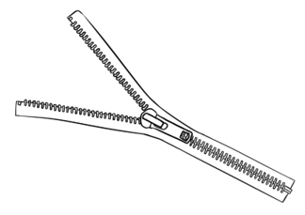

Set 2 words – These words can be added to the student workbook.
apple | banana | car | door
exit | five | glasses | hat
insect | jacket | kite | leg
mouse | nine | orange | pencil

queen | rain | strawberry | table
umbrella | van | window
yellow | zipper

a | b | c | d
e | f | g | h
i | j | k | l
m | n | o | p
q | r | s | t
u | v | w | x
y | z

Have a conversation
Activity 1 – A short conversation for role play and sequencing
Activity 2 – How to be polite
The following page can be projected and used for a class exercise.

Bao: G’day Abdi.
How’s it going?
Abdi: Great. How about you?
Bao: I’m OK.
Do you wanna play soccer today?
Abdi: Sorry. I can’t play today.
I can play tomorrow.
Bao: OK. See ya tomorrow.
Abdi: See ya.

wanna = want to

G’day Abdi.
How’s it going?
Great. How about you?
I’m OK.
Do you wanna play soccer today?
Sorry. I can’t play today.
I can play tomorrow.
OK. See ya tomorrow.
See ya.

How to be polite
Greeting | Good morning / Good afternoon
End the conversation. | Nice to see you. Bye.
Ask a question. | Hi. How are you?  Good thanks, and you?
Say ‘please’. | Can you shut the door please?
Say ‘thank you’. | Yes. Thank you.
Say ‘Excuse me’. | Excuse me, can I sit here?
What is polite? Tick.
1 | 2
Nice to meet you. | Yes.
Open the door. | Can you open the door please?
Can you give me the rubber please? | Give me the rubber.
Speak slowly. | Can you speak slowly please?
Excuse me, can you  repeat that please? | What?

English class
Activity – ‘Can I borrow________? Pair work
Preparation
- Copy the page of classroom objects so each pair of students has:
- a set of cards
- a master sheet with all the objects.

- Pre-teach the new additions to those in the student book, a pair of scissors, a pair of glasses, a ruler, a USB and an umbrella. Also teach the use of your in front of notebook and workbook,
- Revise the questions and responses in the workbook.
Activity
- Students cut up the cards and put them in a pile face down.
- Each student selects three cards only, leaving six cards unselected.
- Students look at their cards and the list of objects on the master sheet.
They then take turns to ask their partner:
- Can I borrow a/an _____________ please?
- Can I borrow your ______________ please?
Their partner responds:
- Yes, here’s a/an______________.[Then gives their partner the object.]
^{object}
or
- Oh no. Sorry _______________.
^{name of partner}

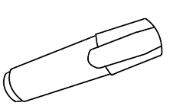  a highlighter |   an umbrella
    three pencils | 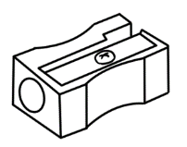  a sharpener
a rubber | 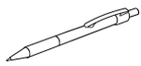  two pens
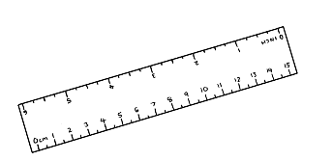  a ruler | 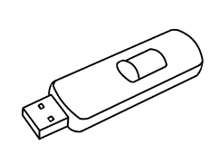  a USB
  your notebook | 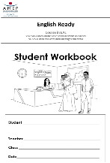  your workbook
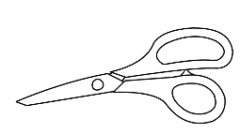  a pair of scissors | a pair of glasses
Object cards

Master sheet with all objects
a highlighter | your workbook
three pencils | a sharpener
a rubber | two pens
a ruler | a USB
a notebook | an umbrella
a pair of scissors | a pair of glasses

When, where, who, what, why?

Activity 1 – Worksheet – When did you come to Australia?
This worksheet uses the past tense which is not required at Course level.
However, it’s a question low-level students are often asked. The worksheet includes an oral activity in which students mix and interview a number of classmates. [the word classmates may need to be introduced.]

Activity 2 – Worksheet – Where do you come from?
The worksheet includes an oral activity in which students mingle and interview a number of classmates.

1. When did you come to Australia?
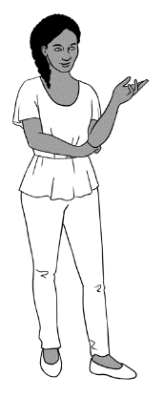
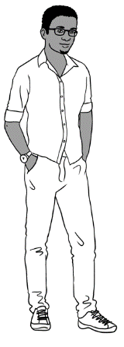
When did you come to Australia Tahiil?
I came to Australia in June 2022.


I came to Australia in
^{month} ^{year}
When did you come to Australia?

Month | Tick the months.
January
February
March
April
May
June
July
August
September
October
November
December


2. Where do you come from?
?

I come from ___________________________.
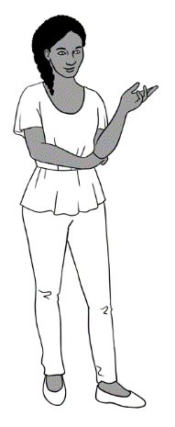
Where do you come from Tahiil?

I come from Somalia.
How do you spell Somalia?

Somalia S-O-M-A-L-I-A

What’s your name? | Where do you come from?

Aa | Bb | Cc | Dd | Ee | Ff | Gg | Hh | Ii | Jj | Kk | Ll | Mm
Nn | Oo | Pp | Qq | Rr | Ss | Tt | Uu | Vv | Ww | Xx | Yy | Zz

People in a family

Activity – Introduce your family
As some students in the class may have suffered trauma, family loss and separation in their previous homeland or in Australia, there are two options for introducing a family. Students may choose to introduce:
- Mai’s family [This can be used as a model and completed together.]
- their own family
Copy enough of each worksheet so that students can choose the option with which they feel most comfortable.
The teacher can explain instructions to the students.

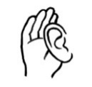
Mai’s family
grandfather
grandmother
grandson
granddaughter
mother
father
son
daughter
brother
sister
husband
wife
uncle
aunt
cousin

Show this picture of Mai’s family.
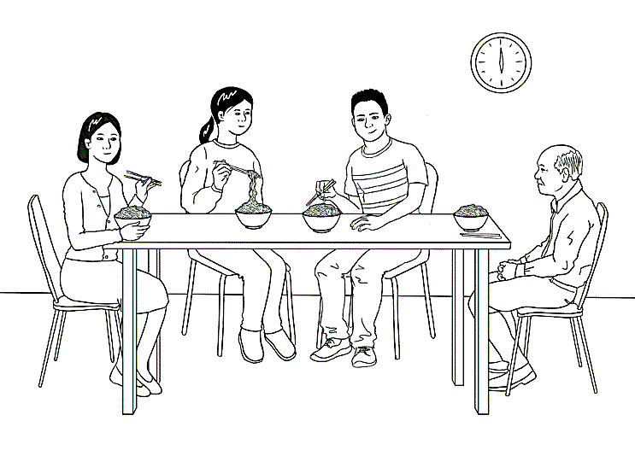

This is Mai’s family.


This is her_______________________.

This is her_____________________________.
This is her__________________________.
They come from China.

Introduce Mai’s family to your partner.
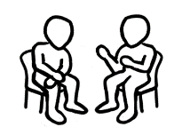 | 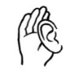 | 

mother | grandfather | brother
mother

grandfather
grandmother
grandson
granddaughter
mother
father
son
daughter
brother
sister
husband
wife
uncle
aunt
cousin
My family
Show a photo of your family.


about three people in your family.
This is my family.
This is my _________________________________.
This is my___________________________________.
This is my___________________________________.
We come from _____________________________.
Introduce your family to your partner.

Break words into syllables
Teaching syllables
- Say a word from the list below or any words introduced in class.
Repeat it, breaking it into syllables.

- Demonstrate the syllables physically by:

  - tapping your hand, a pen or a ruler on the table
  - clapping
  - punching the air
  - stamping your feet
  - taking a step for each syllable.

- Ask students to repeat the word with the action several times.
- Count the syllables as you clap or tap etc
- Create a table on the board similar to the one below. Write the word in the correct column.
- Repeat the process with the remaining words.

In a later class, the words could be enlarged and written on paper. Students could then attach the words to the board in the right column using magnets or copy the words in the column.

Syllables
1 | 2 | 3
read | copy | afternoon
write | circle | tomorrow
spell | workbook | understand
clap | notebook | underline
tick | classmates | syllable
 | question
 | answer
 | morning
 | student

What do you like?

Activity 1 –Vowels
This section provides some basic words to focus on vowels.
Activity 2 – Using body language – Pair work
Student A & B have different questions to ask. Students need to use body language to convey meaning – no words. Demonstrate the activity with a confident student.

Aa | Bb | Cc | Dd | Ee | Ff | Gg | Hh | Ii | Jj | Kk | Ll | Mm
Nn | Oo | Pp | Qq | Rr | Ss | Tt | Uu | Vv | Ww | Xx | Yy | Zz
1. Vowels
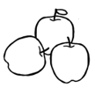  apples |   bananas | cake | orange  juice
  noodles |   rice | 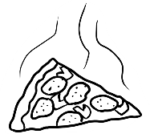  pizza |   coffee
  ice cream |   tea | 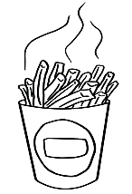  hot chips | 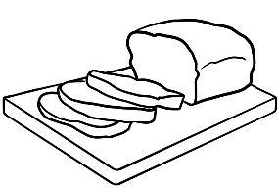  bread
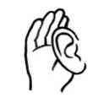 |  |  | a e i o u

_ ppl _ s | b _ n _ n _ s | c _ k _ | _ r _ ng _  j _ _ c _
n _ _ dl _ s | r_ c _ | p_ zz _ | c _ ff _ _
_c_  cr_ _ m | t_ _ | h _ t  ch _ ps | br _ _ d

2. Use body language – Pair work
Student A
Body Language
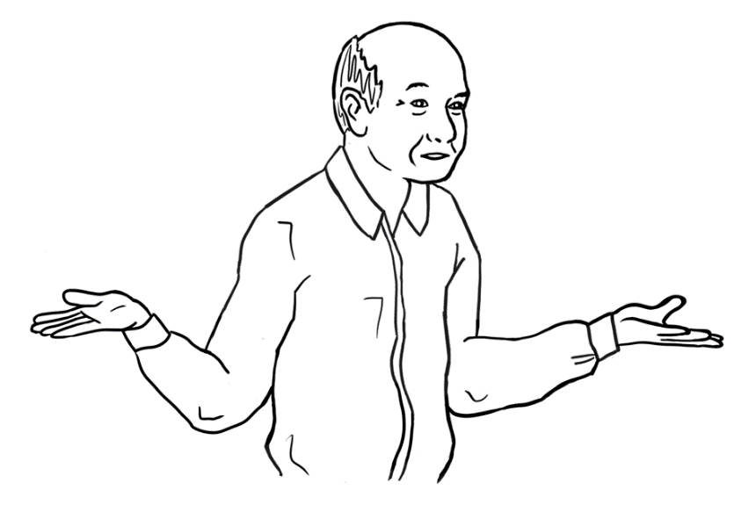  ?  Yes, I do. | I’m not sure. | No, I don’t.

Do you like ________________?

bread |  |  | hot chips |  |  | coffee
Yes | ? | No | Yes | ? | No | Yes | ? | No

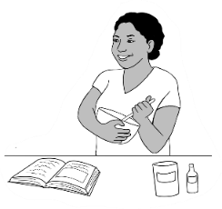  cooking |  |  | 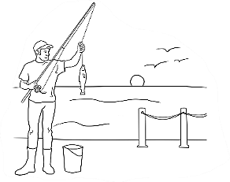  fishing |  |  | 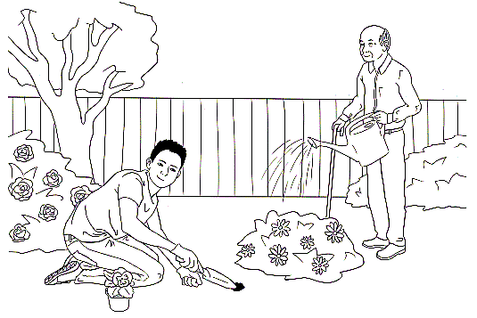  gardening
Yes | ? | No | Yes | ? | No | Yes | ? | No

My partner likes _____________________ and _____________________.
My partner doesn’t like ________________ and ____________________.
Student B
Body Language
Yes, I do. | ?  I’m not sure. | No, I don’t.

Do you like ________________?

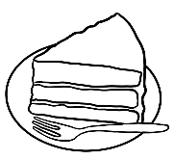  cake |  |  | orange juice |  |  |   bananas
Yes | ? | No | Yes | ? | No | Yes | ? | No

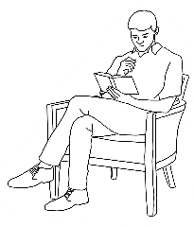  reading |  |  | 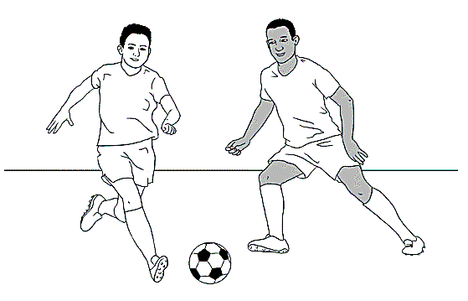  playing soccer |  |  | 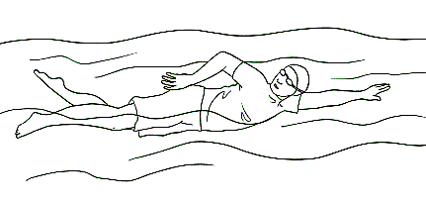  swimming
Yes | ? | No | Yes | ? | No | Yes | ? | No

My partner likes _____________________ and _____________________.
My partner doesn’t like ________________ and ____________________.

Months of the year
Activity 1 – The months - long and short forms
The strips can be cut up and used for matching and ordering.

January | February
March | April
May | June
July | August
September | October
November | December
Jan | Feb
Mar | Apr
May | June
July | Aug
Sept | Oct
Nov | Dec

Activity 2 - Ordinals
Teach the patterns:
- Numbers ending with one, two and three are irregular
e.g.1 first, 2 second and 3 third - 21 twenty first, 22 twenty second, 23 twenty third etc
Exceptions to this rule -11 eleventh, 12 twelfth and 13 thirteenth.
- Multiples of 10 are pronounced differently - twentieth and thirtieth
Practise activities:
- Matching – enlarge on A3 paper and cut up. Practise saying the numbers.

- Memory/concentration game – use a portion of the numbers
e.g. 1-10.

- Write the word for the ordinal number on the board e.g. first, and ask a question using the ordinal number
e.g. ‘What’s your first name? or What’s the first month of the year?
- Use a calendar and ask students to point to the thirtieth day of November or point to a day and ask, ‘What day is this?’

- Bingo – Play first as a class. Then play in small groups. One student to say the numbers for the group.

1 | first | 1st |  | 
2 | second | 2nd |  | 17 | seventeenth | 17th
3 | third | 3rd |  | 18 | eighteenth | 18th
4 | fourth | 4th |  | 19 | nineteenth | 19th
5 | fifth | 5th |  | 20 | twentieth | 20th
6 | sixth | 6th |  | 21 | twenty first | 21st
7 | seventh | 7th |  | 22 | twenty second | 22nd
8 | eighth | 8th |  | 23 | twenty third | 23rd
9 | ninth | 9th |  | 24 | twenty fourth | 24th
10 | tenth | 10th |  | 25 | twenty fifth | 25th
11 | eleventh | 11th |  | 26 | twenty sixth | 26th
12 | twelfth | 12th |  | 27 | twenty seventh | 27th
13 | thirteenth | 13th |  | 28 | twenty eighth | 28th
14 | fourteenth | 14th |  | 29 | twenty ninth | 29th
15 | fifteenth | 15th |  | 30 | thirtieth | 30th
16 | sixteenth | 16th |  | 31 | thirty first | 31st

 | 
When you have nine circles on your card: |  |  |  |  | 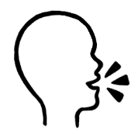  Bingo.
Bingo

Card 1 |  |  |  |  | Card 2
31st | 22nd | 15th |  | 4th | 5th | 2nd
11th | 24th | 9th |  | 30th | 3rd | 28th
12th | 5th | 16th |  | 1st | 29th | 26th
 | Card 3 |  |  |  | Card 4
13th | 19th | 29th |  | 3rd | 18th | 14th
6th | 10th | 21st |  | 27th | 8th | 20th
12th | 7th | 26th |  | 17th | 23rd | 25th

Activity 3 – Write and say the date - Pair work
Revise the difference between writing and saying the date.
Write the date 13 February [or 13th February]
Say the date
- Explain the grid system if this is new for the class.
- Demonstrate the activity with a confident student. The first example is done for both Student A & B.

Activity 4 – Dates and months game [page 44]

the thirteenth of February

Student A
January | Jan |  | July | July
February | Feb |  | August | Aug
March | Mar |  | September | Sept
April | Apr |  | October | Oct
May | May |  | November | Nov
June | June |  | December | Dec

 | What date is in B1?
 | The thirteenth of February | 

 | A | B | C | D
1 | 2 Aug | 13 Feb |  | 12 Jan
2 |  |  | 9 Mar | 11 Nov
3 |  | 5 Oct |  | 7 Feb
4 | 1 May |  | 22 June

Student B
January | Jan |  | July | July
February | Feb |  | August | Aug
March | Mar |  | September | Sept
April | Apr |  | October | Oct
May | May |  | November | Nov
June | June |  | December | Dec
What date is in A1?
The second of August.

 | A | B | C | D
1 | 2 August | 13 Feb | 5 April
2 | 4 Nov | 1 Jan
3 | 10 June |  | 15 Nov
4 |  | 12 July |  | 3 Mar

FINISHST

What month is before November?

What is the first month?

What is the date tomorrow?
Can you say 10th January 2015?

What year is it?

Dates and Months Game
What is the 5th month?

What is the date today?
When is your birthday?

What month is your birthday?

What month is after April?

What is the 2nd month?

Spell January.

Can you say 16th August 2023?

What month is after June?

Spell March.

Can you say all the months?
START

Syllables – strong and weak
Extension work on syllables – Add words introduced during classwork.


Clap the strong syllable strongly.

  Word | How many syllables? |   Copy the word.  Underline the strong syllable.
granddaughter | 3 | granddaughter
grandson
father
mother

Words on Forms
Activity 1 – A record of important personal information
On the form on the following page, students can record their important personal information. Check all the student’s details are correct and the spelling of names is the same as on their passport. Students can take a photo of their details, or cut it out for safe-keeping. The completed form can be used for accurate copying and checking of information in a variety of situations both inside and outside the classroom.
Activity 2 – Class exercise - Common information questions
Copy and cut up the questions on page 48, enough so that each student has a question. Students walk round the room asking other students their question.

Activity 3 – A game with wh questions
Copy and cut up the question cards from activity 2. Add more questions if necessary. Students play in groups of 3 or 4.
Activity 4 – Ask your teacher questions.
- Read through the questions together
- Set a time limit e.g. 10 minutes.
- The student asks you as many questions as they can in the time limit given. Write the answers on the board for the students to copy.
- The students can also add their own questions in the space provided.

Activity 5 – Pair work – Dates of birth and phone numbers
The information activity on page 51 & 52 gives students an opportunity to practise reading, saying and writing dates and phone numbers. Using the personal details of the characters in the workbook removes the privacy problem of students needing to share their own personal details.
Pre teaching:
- practise the questions together. Note that Student A asks questions about women and Student B asks questions about men. This focuses on the use of her and his.
- Demonstrate the activity with a confident student.

My information
1

First Name
Family Name
Address Street
Suburb _____________________________ Postcode _________
Date of Birth
Country
Phone Number
Emergency contact name:
Emergency contact number
Can you check my work please?

First Name __________________________________________________
Family Name: _________________________________________________
Address Street _______________________________________________
Suburb __________________________ Postcode _________
Date of Birth ___________________________________________________
Country _______________________________________________________
Phone Number _______________________________________________
Emergency contact name ____________________________________
Emergency contact number __________________________________
Can you check my work please?


Class exercise – common information questions
What’s your given name?
2
What’s your first name?
What’s your family name?
What’s your surname?
Where were you born?
What month were you born in?
What languages do you speak?
When did you come to Australia?
What’s your post code?
Do you have children?

1
START
2
?
3
4
?

5
6
?

7
8
?
26
END
25
24
?

23
?
22
9
10
11
?

12
?

21
?

20
19
18
?

17
?

16

?

Red - Miss a go.

Pick up a card and answer the question.

Green - Go forward 2 spaces.
15
?

13
14
?

3

Ask your teacher questions.
4

Question | Answer
Where do you come from?
Where do you live? What suburb?
When did you come to Australia?
Do you have children?
Do you drive to school?
What food do you like?
What do you do on the weekend?

Digital option:
- Transfer the questions to one of the following sites:
https://wordwall.net/ - choose Random wheel *
https://wheeldecide.com/wheels/board-games/scattegories-spinner/
- Send link to student via text, WhatsApp etc. Students can take turns asking other students questions.
* The 10-minute video below gives a step-by-step guide on how to use Wordwall. Instructions about the Random Wheel starts at 7 minutes into the video.
https://www.teachertrainingvideos.com/complete_wordwall

Student A
5
What’s Nisha’s date of birth?

What’s her phone number?

 | 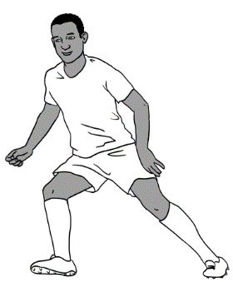  Abdi | 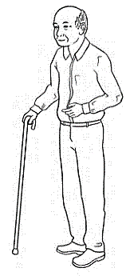  Ming | 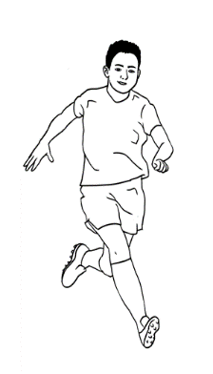  Bao
Date of birth | 04.08.2004 | 27.03.1959 | 13.05.2004
Phone number | 0465 971 356 | 0418 335 748 | 0409 188 674
 | Nisha | 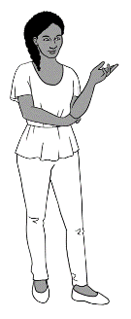  Anika | 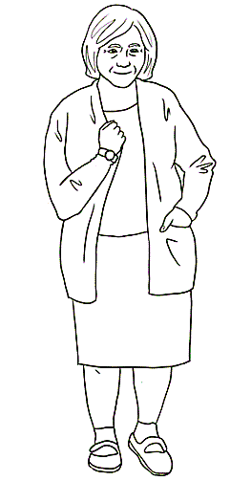  Pam
Date of birth
Phone number

Student B
What’s Abdi’s date of birth?

What’s his phone number?

 | Abdi | Ming | Bao
Date of birth
Phone number
 | Nisha | 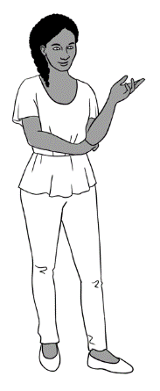  Anika | Pam
Date of birth | 19.01.1978 | 30.09.1995 | 02.02.1956
Phone number | 0411 825 999 | 0477 193 286 | 0407 165 972

Can you check my work please?

An English Class for Sahra

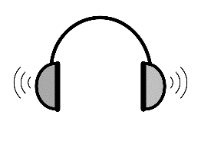

Activity 1 – Exercises for audio in the student book
There are two listening exercises:
- Cutting up and ordering the conversation in pairs.
- A cloze exercise

Activity 2 – Audio The receptionist helps Sahra
This conversation is an extension exercise. The language in the conversation and the cloze on the form may be too difficult for some students. There are three listening exercises to follow up the conversation audio.
- Cut up the questions and answers. Order with a partner.
- Cloze with question words
- Word order for questions

Activity 3 - Sahra’s Form

Activity 4 – Can and can’t
- Practise questions with can in a variety of contexts, and the short answers Yes, I can. No, I can’t.
- There are two scenarios. Students take turns to play the role of the receptionist and the student.
- Copy scenario 1 and cut it in half.
- The available days for classes are in white and the unavailable days
in grey.
- Divide the class into pairs and give each student half the worksheet.
- Demonstrate the information gap activity with a confident student.
The first example is completed for both students.

3


Listening Exercise 1
Cut up the sentences.

Tahiil | Thank you. We have a daughter.  Do you have childcare?
Receptionist | Yes. I can.
Tahiil | Hello. My name is Tahiil.  This is my wife Sahra.  She needs an English class.
Receptionist | Yes, we have child care.  Can you fill in this form please Sahra?
Sahra | Mmm. Can you help me please?
Receptionist | Hello. Nice to meet you.  You can enrol in English class here.

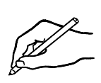
Listening Exercise 2

meet | fill | nice | help | please
name | enrol | please | English | have
Tahiil | Hello. My ____________ is Tahiil.  This is my wife Sahra.  She wants to _________ in an _________class.
Receptionist | Hello. __________ to _____________ you.  You can enrol in English class here.
Tahiil | Thank you. We have a daughter.  Do you __________ childcare?
Receptionist | Yes, we have child care.  Can you ________ in this form ____________ Sahra?
Sahra | Mmm. Can you ________ me __________?
Receptionist | Yes, I can.


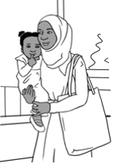
The receptionist helps Sahra.
3

Listen to the conversation.
Receptionist: What’s your full name?
Sahra: My name is Sahra Omar Elmi.
Receptionist: Where were you born?
Sahra: I was born in Somalia.
Receptionist: When were you born?
Sahra: I was born on the 7th of July 1996.
Receptionist: What languages do you speak?
Sahra: I speak Somali and Arabic.
Receptionist: When did you arrive in Australia?
Sahra: Sorry. Can you say that again please?
Receptionist: When did you come to Australia?
Sahra: Umm. On the 9th of June 2022.
Receptionist: Are you married or single?
Sahra: I am married.
Receptionist: How many children do you have?
Sahra: I have one child.
Receptionist: What is your address and phone number?
Sahra: Mmm. It’s here on my card.
Receptionist: Oh yes. Thank you Sahra.
Please sign the form here.

Sahra: Yes. Thank you


Listening exercise 1
Cut up the sentences.

Receptionist: What’s your full name?
Sahra: I was born in Somalia.
Receptionist: Where were you born?
Sahra: My name is Sahra Omar Elmi.
Receptionist: When did you come to Australia?
Sahra: I was born on the 7th of July 1996.
Receptionist: What languages do you speak?
Sahra: Sorry. Can you say that again please?
Receptionist: When did you arrive in Australia?

Sahra: I am married.
Receptionist: When did you come to Australia?
Sahra: I have one child.
Receptionist: How many children do you have?
Sahra: I speak Somali and Arabic.
Receptionist: Oh yes. Thank you Sahra.
Please sign the form here.
Sahra: Um. On the 9th of June 2021.
Receptionist: What is your address and phone number?
Sahra: Mm. It’s here on my card.
Receptionist: Are you married or single?
Sahra: Yes. Thank you.
Listening exercise 2

How | When | What | Are you | Where
When | What | Please | What | When

Receptionist: ______________is your full name?
Sahra: My name is Sahra Omar Elmi.
Receptionist: _________________ were you born?
Sahra: I was born in Somalia.
Receptionist: ___________________ were you born?
Sahra: I was born on the 7th of July 1996.
Receptionist: ______________ languages do you speak?
Sahra: I speak Somali and Arabic.
Receptionist: ___________________ did you arrive in Australia?
Sahra: Sorry. Can you say that again please?
Receptionist: ______________ did you come to Australia?
Sahra: Um. On the 9th of June 2021.
Receptionist: _______ _______ married or single?
Sahra: I am married.
Receptionist: ___________________ many children do you have?
Sahra: I have one child.
Receptionist: _____________ is your address and phone number?
Sahra: Mmm. It’s here on my card.
Receptionist: Oh yes. Thank you Sahra.
________________ sign the form here.
Sahra: Yes. Thank you.
Listening exercise 3
name?
What
is
full
your

What is your full name? .
born?
Where
were
you

__________________________________________________________
you
What
speak?
do
languages

_______________________________________________________________
arrive
you
did
in
Australia?
When

____________________________________________________________________
or
single?
married
Are
you

____________________________________________________________________
number?
your
phone
and
is
address
What

________________________________________________________________________

This is Sahra’s form.
3

TAFE
Student Enrolment Form

PLEASE USE CAPITAL LETTERS.

Tick the box.

Full Name: SAHRA OMAR ELMI
Country of birth: SOMALIA
Date of Birth:
Languages: SOMALI, ARABIC
Date of arrival in Australia:
Marital Status: Married Single
Number of children:
Address: UNIT 6, 50 BAKER ROAD
Suburb : KELLIVALE Postcode: 2421
Phone number: 0455 961 259
Signature: Sahra Elmi

For the doctor? For childcare? for English class?
Can you check my work please?
Can you check my work please?
Can and can’t
4
Scenario 1
Can you come to class
on Monday afternoon?
Receptionist

 | Monday | Tuesday | Wednesday | Thursday | Friday | Saturday
morning |  | class | class | class | class | class
afternoon | class | class |  | class
evening | class |  | class


Yes, I can.
No, I can’t.
Student
Student
 | Monday | Tuesday | Wednesday | Thursday | Friday | Saturday
morning |  | No | No |  | No
afternoon |  | No | No |  | No
evening

Scenario 2
Can you come to class
on Monday morning?
Receptionist

 | Monday | Tuesday | Wednesday | Thursday | Friday | Saturday
morning | class | class | class | class |  | class
afternoon | class | class |  | class | class
evening |  | class | class
No, I can’t.
Yes, I can.
Student

 | Monday | Tuesday | Wednesday | Thursday | Friday | Saturday
morning |  |  |  | No
afternoon |  |  | No | No | No
evening | No | No | No |  | No

The Days

Intonation
Demonstrate how the voice rises at the end of closed yes/no questions
and falls at the end of open wh questions and also at the end of answers and statements.
- Project the following page.
- Read each question and response clearly showing the intonation; use hand movements to show the rise and fall. Students repeat each question and response using similar hand movements.
- Divide the class in two, with one section reading Nisha’s questions and the other reading Sahra’s responses.
- Swap roles.

Intonation
What do you do on Monday?
On Monday? I go to class.

Nisha | Sahra
What do you do on Monday? | On Monday?  I go to class.
What do you do on Tuesday? | On Tuesday?  I go to class.
What do you do on Wednesday? | On Wednesday?  I study at home.
What do you do on Thursday? | On Thursday?  I clean the house.
What do you do on Friday? | On Friday?  I go shopping.
What do you do on Saturday? | On Saturday?  I go to the park.
What do you do on Sunday? | On Sunday?  I watch soccer.

The Time
Activity 1 – Correctional stress – class activity
Write about 10 words, letters or numbers on the whiteboard – a mix of what’s been already covered in class. e.g. numbers, letters, names, weather, days, months, times, colours.

These words, letters, numbers on the board provide the correct answers
to the questions the teacher will ask. When introducing this activity, point to the answer after asking the question. Students answer, placing stress on the corrected word.
 | Teacher questions | Student answers
1 | Today is Tuesday. [It’s Monday.] | No, it’s Monday.
2 | It’s 11 o’clock. [It’s 12 o’clock.] | No, it’s 12 o’clock.
3 | This is Hani. [Holds up a picture of Sahra.] | No, it’s Sahra.
4 | This is green. [Holds up something red.] | No, it’s red.
5 | It’s hot today, isn’t it? [It’s a cold day.] | No, it’s cold.
6 | This is a small e. [Holds up capital E.] | No, it’s a capital E.
7 | This is thirteen. [Holds up the number 30.] | No, it’s thirty.

Activity 2 – What time do you get up on Monday?
The worksheet includes a short survey of students.

January
Monday
Sahra
red
12 o’clock
E
30

5 June
2022
cold

I get up at 6:30.
What time do you get up on Monday?

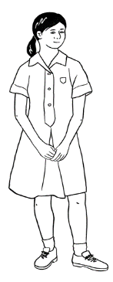
I get up at 7:00.
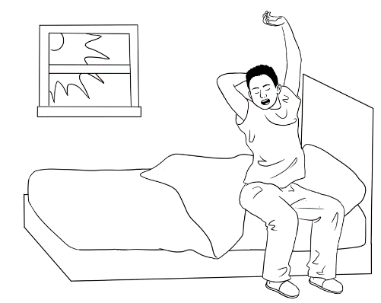
I get up at 8:30.

I get up at _____________ on Monday.
What time do you get up on Monday?

Student name | Write the time.

Write how many.
___________ students get up at ____________ on Monday.
___________ students get up at ____________ on Monday.
___________ students get up at ____________ on Monday.
___________ students get up at ____________ on Monday.

Messages

Activity – A writing model
- Write the message on the board with the students. Read it together a number of times. Ask the students to copy it.

- Ask which words could be changed for a different message. Underline those words in the original text. e.g Teacher, Tuesday, doctor’s appointment, 2:30, Sahra
- Students write a message to you using the model. Write on paper, then on the phone and show you. Ask students not to send the message. This is the reason for the message:

- An extension is to send a message to a classmate to ask them
to tell the teacher they can’t come to class. This would require
a new model for students to work from.
Hi Teacher
I can’t come to class on Tuesday.
I have a doctor’s appointment at 2.30pm.
Sahra

I can’t come to class on Thursday.
I have an appointment at Centrelink at 9.30.

Two-letter sounds
Activity – Pronunciation th
The letters th make two different sounds:
- Unvoiced as in three
- Voiced as in the.
Both sounds are made by separating the top and bottom teeth with the tip of the tongue and blowing air through the small gap over the tongue.
The unvoiced sound as in three is made by simply blowing air. Demonstrate by saying the word into the palm of the hand to feel the airflow.
The voiced sound as in the is made with the addition of the voice and vocal chords. Demonstrate by placing the palm over the throat to feel the vibrations.

Say each th word listed below, and ask students if the word is voiced or unvoiced. Write the word in the correct column.

th unvoiced |  | th voiced
three | thirteen | the | that
thirty | third | they | then
thanks | Thursday | them | this

Two-letter consonant sounds reference lists
The two-letter consonant sounds on the reference lists can be found throughout the Student Book. The lists can be used for a variety of activities and expanded as new words are introduced.

Two-letter consonant sounds picture reference list
chips | 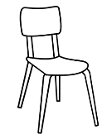  chair | 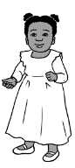  child
black | blue
black | tick
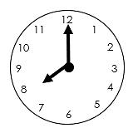  clock | clap |   cloud
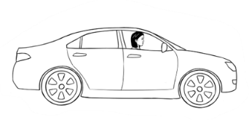  drive | 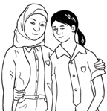  friend | 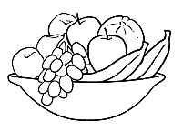  fruit
  phone | 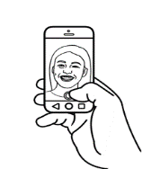  photo | 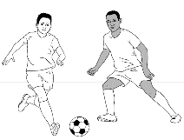  play
sharpener |   shop | 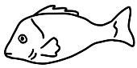  fish
  stop | 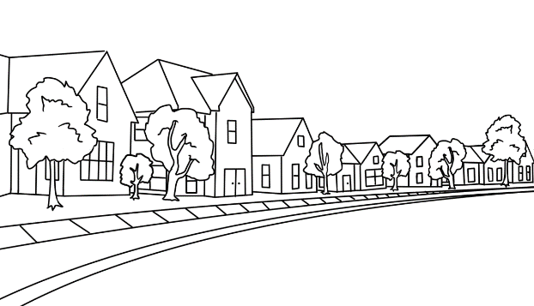  street | 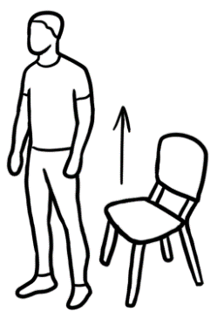  stand
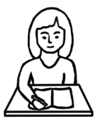  student | 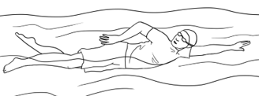  swim
three  3 |   tree
Sounds | Two-letter consonant words
bl | black, block, blue
br | brother, break, bring, brick, bread
ch | child, chips, childcare, change, China, children
ck | black, block, tick, brick, sick
cl | class, cloud, clap
cr | cross
dr | drive
fr | fruit, from, friends, Friday
gr | grandson, great, grey, greeting
ph | phone, photo
pl | please, play
pr | practise, problem
sh | shake, sharpener, she, shop, fish, fishing
sl | slowly
sm | small
sp | spell
st | stop, student, study, start, street
sw | swim, swap
th (1) | three, things, Thursday
th (2) | the, this
tr | tree, trip
wh | what, when, white

How many?
Pronunciation b and p [Commonly confused by Arabic speakers]
It’s a good idea to do some pronunciation practice on the sounds p and b in this section.
Give each student a tissue to demonstrate the difference between the sounds b and p. Both sounds are made by pressing the lips together, then pushing them open with a puff of air. Show the lip formation and demonstrate the movement of air by holding a tissue in front of the mouth.
- The sound p is unvoiced as in play. P produces a puff of air and the tissue moves.
- The sound b is voiced as in baby. B is made by the addition of the voice and vocal chords. B does not produce a strong puff of air, so there is little to no movement of the tissue.
Say each b or p word listed below, and ask students if the word is voiced or unvoiced. Write the word in the correct column.
p unvoiced |  | b voiced
partner | park | banana | bus
please | problem | boy | brother
play | pizza | ball | baby
point | purple | black | borrow
pen | pink | bread | blue
pencil | practise

- Level A - pictures and words
- Level B - words and no pictures.
Students need to remember to add an s when necessary.

Activity 1– Plurals memory game #1
- Give each student a picture of one of the objects on the following page.
- Project the image on page 76 and give students a minute to count their objects. Close the image.
- Elicit the numbers of each object from the relevant students.

Activity 2 – Plurals memory game #2
Repeat the exercise by projecting the image on page 77. This has the same objects, but different numbers of each. Hand out either a level A or level B worksheet once the objects are no longer visible. Depending on their level, students can add the number of objects to either:
- Level A - pictures and words
- Level B - words and no pictures.
Students need to remember to remove an s when necessary.

Pictures of objects to cut up and distribute.
ball | apple | banana
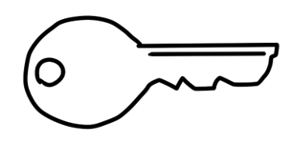 | 
key | ice cream | student
 |  | 
rubber | pen | pencil
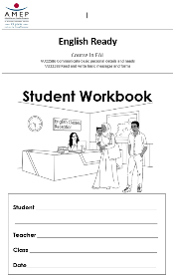 |  | 
workbook | notebook | phone

Plurals Memory Game #1



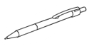

Plurals Memory Game #2

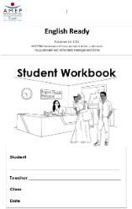

How many?
Level A

balls | notebooks | keys | pens
students | bananas | rubbers | apples
phones | workbooks | ice creams | pencils
  balls | notebooks | keys | pens
students | bananas | rubbers | apples
phones | 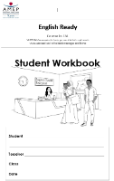  workbooks |   ice creams |   pencils
Level B
How many?

What colour?
Activity – a colour dictation
This is a listening and speaking exercise to revise the colours and vocabulary introduced in this section and section 20.
- Divide the class into pairs.
- Project Student A’s worksheet and explain that the six instructions in grey boxes need to be given to Student B. Student B must follow the instructions to colour thepicture at the top of the page.
- Once the six instructions have been given and Student B has completed colouring, the roles are reversed. Student A must then colour the picture at the bottom of the page by following Student B’s instructions.


Student A

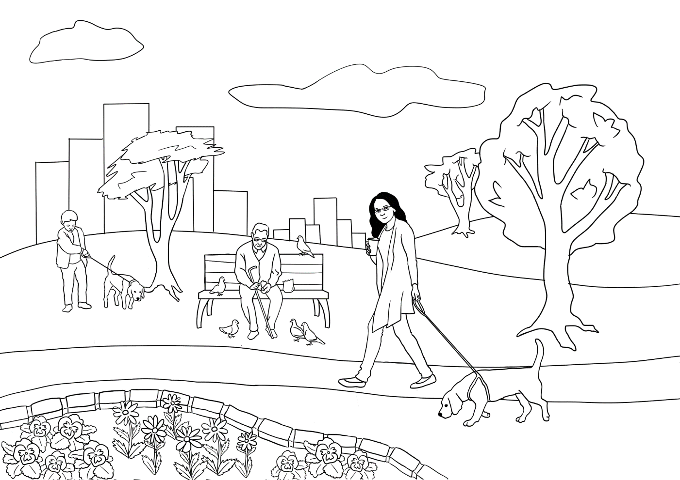
5. Colour 6 flowers yellow.
- Colour the seat red.
2. Colour the tree light green.
3. Colour her jacket pink.
6. Colour 3 birds dark blue.
4. Colour the dog black.

__________________________________________________________

Student B

_________________________________________________________

5. Colour 6 flowers orange.
- Colour the seat yellow.
2. Colour the tree dark green.
3. Colour her jacket purple.
6. Colour 3 birds light blue.
4. Colour the dog grey.

At the Childcare Centre
Activity 1 – Conversations at the childcare centre
The following conversations would be particularly helpful for mothers with children in childcare. After listening, students can cut up and sequence each conversation. Some students may also be able to copy the dialogues into their notebooks. There is audio for both conversations.
- Conversation 1 – In the morning at the childcare centre - Audio

- Conversation 2 – In the afternoon – Audio

Activity 2 – Asking for clarification - ‘I don’t understand’
On page 87, there are three conversations in which students can practise asking for clarification when they don’t understand.
4
5

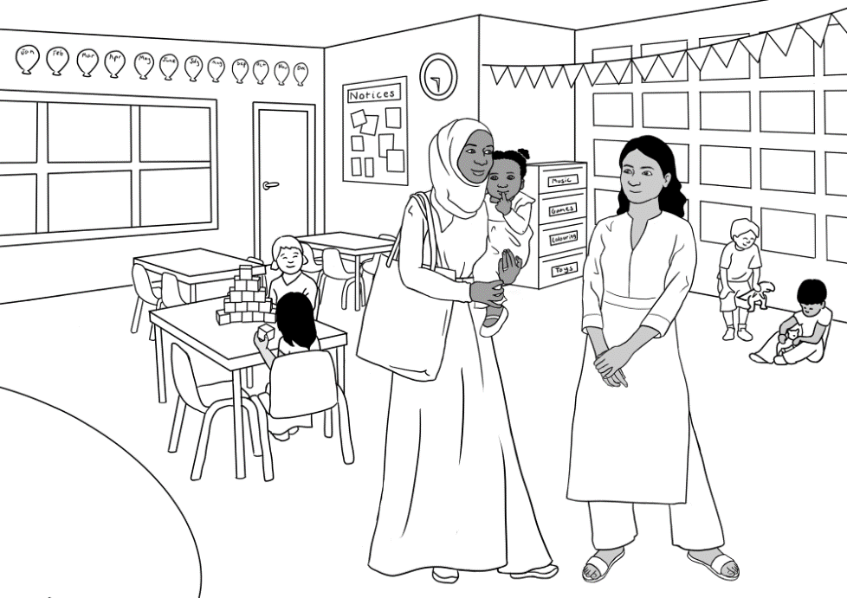
- In the morning at the childcare centre

Listen.
4
Nisha: Good morning Sahra. How are you?
Sahra: Good thanks Nisha.
Nisha: Sahra, do you have
Hani’s bag and water bottle?
Sahra: Yes, here they are.
Nisha: Can you put them here please?
Sahra: Ok. Here’s Hani’s hat.
Nisha: Good. Put her hat on now.
Sahra: Ok. Have a good day.
Nisha: You too. See you later.

In the morning
Good morning Sahra.  How are you? | Ok. Here’s Hani’s hat.
Sahra, do you have Hani’s bag and water bottle? | Yes, here they are.
Can you put them here please? | Ok, have a good day.
Good. Put her hat on now. | Good thanks Nisha.
You too. See you later.

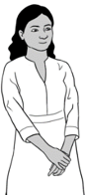
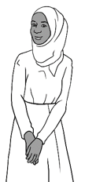
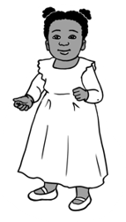
- In the afternoon at the childcare centre

5
Listen.

Nisha: Hi Sahra. How was your day?
Sahra: Good thanks.
Nisha: Hani is very happy today.
Sahra: She loves playing with the children.
Nisha: Does she like fruit?
Sahra: Sorry. What do you mean?
Nisha: Does she like apples?
Sahra: Yes, she likes apples and bananas.
Nisha: Ok, thank you. See you tomorrow.
Sahra: See you tomorrow.
- In the afternoon

Hi Sahra.  How was your day? | She loves playing with the children.
Hani is very happy today. | Yes, she likes apples and bananas.
Does she like fruit? | See you tomorrow.
Does she like apples? | Good thanks.
Ok thank you.  See you tomorrow. | Sorry. What do you mean?

I don’t understand.

1 | 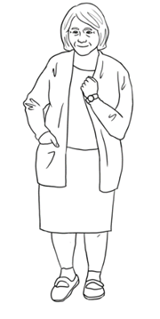 | Pam | Does it get hot in Somalia?
1 |  | Sahra | Sorry, can you say that again please?
1 |  | Pam | Is it hot in Somalia?
1 |  | Sahra | The weather in Somalia is beautiful.

2 | Receptionist | When did you arrive  in Australia?
 | Sahra | Sorry. Can you say that  again please?
 | Receptionist | When did you come  to Australia?
 | Sahra | Um. On the 9th of June 2022.

3 | Nisha | Does Hani like fruit?
 | Sarah | Sorry. What do you mean?
 | Nisha | Does she like apples?
 | Sahra | Yes, she likes apples and bananas.

Tahiil’s week
Activity - Dictation
This short dictation tests the work in section 23 in the Student Book.
All words are provided for students to copy – either from the column of days on the side or within the dictation itself. More confident students can fold or cover the column of days.

Aa | Bb | Cc | Dd | Ee | Ff | Gg | Hh | Ii | Jj | Kk | Ll | Mm
Nn | Oo | Pp | Qq | Rr | Ss | Tt | Uu | Vv | Ww | Xx | Yy | Zz

I work on _ o _ _ _ _. | Monday
I _ _ _ _ and study on _ u e _ _ _ _. | Tuesday
_ _ _ _ _ _ _ _ _ d _ e _ _ _ _. | Wednesday
I work and study on _ _ u r _ _ _ _. | Thursday
_ _ _ _ _ on _ r _ _ _ _. | Friday
I _ _ _ _ _ _ _  _ _ _ u r _ _ _ morning. | Saturday
I play soccer _ _ _ _ _ _ _ _. | Sunday

Tahiil plays soccer
Vocabulary revision
The vocabulary lists below include words introduced in previous sections and are grouped according to grammar or topic. The words can be given to students for homework to practice prior to the game below:
The Fly Slap Game
* You will need two new different coloured fly swats and a whiteboard.
- Divide the class into two teams, named after the colours of the swats.
- Write the revision words randomly over the board. Say the words as you write and ask students to repeat. Elicit sentences with each word.
- A student from each team stands at the board holding their team’s swat.
- Students in the class take turns to call out a word. The first student at the board to slap the word wins a point for their team.
- Rotate students after about four words until everyone [if possible] has had a turn with the swats.
- Keep score on the board.
Extension: An extra point can be won if a team creates a sentence containing the word.

beautiful | good | dark | orange
painful | black | light | nice
hot | cold | blue | green
play | trip | run | break
fall | help | drive | work
study | come | see | send
soccer | ball | hospital | message
form | room | door | note
phone | school | baby | student
wife | daughter | son | husband
brother | sister | mother | father
uncle | grandson | granddaughter | grandfather

The Hospital Emergency
Activity 1 – Conversations with the nurse and the doctor
The following conversations, which include audio, continue the hospital scenario in the student workbook. Both dialogues include exercises.
Conversation 1 : The nurse Audio

Conversation 2: The doctor Audio

Activity 2 – Ask questions about words on forms
This activity includes the hospital form in the student workbook with some added details. It gives students some questions to ask when they don’t understand the language used on forms.

Activity 3 – A text message from the hospital outpatients
The message includes some common abbreviations on more formal text messages.
Activity 4 – A get well card
This provides a model for students to write a get-well card.
6
7

The nurse
6
Listen.
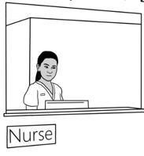
Nurse Tahiil Dihoud?
Tahiil Yes.
Nurse What’s the problem Tahiil?
Tahiil I hurt my foot at soccer today.
Nurse Can you walk?
Tahiil No. It’s very painful.
Nurse OK. Please wait to see a doctor.
Tahiil Thank you.
Match.
What’s |  | walk?
I hurt my foot |  | very painful.
Can you |  | the problem Tahiil?
No. It’s |  | at soccer today.
OK. Please wait |  | to see the doctor.

Student A | Student B
What’s the problem? | I hurt my foot.
What’s the problem? | I hurt my hand.
What’s the problem? | I feel sick.
What’s the problem? | I have a bad headache.


7
The doctor
Listen.
Doctor _____________. I’m the doctor.
________name’s Elena.
What’s your __________?
name
foot
My
need
problem
wait
Hello

Tahiil Tahiil Dihoud
Doctor What’s the ____________ Tahiil?
Tahiil I hurt my _________ at soccer.
Doctor We __________ to x-ray your foot.
Tahiil OK.
Doctor Please ________ here.

___________________________________________________________________________________________________________________________________________________________________________________________________________________________________
After the x-ray
you
school
walk
don’t
break
work
foot
go
weeks
eight

Doctor: Tahiil, your foot has a bad __________.
Do ________ work?
Tahiil: I’m a house painter.
I go to _____________too.
Doctor: You can’t __________.
You can’t __________.
You can’t __________ to school.
Tahiil: I _____________understand.
Doctor: Your ________ has a very bad break.
You can’t walk for __________ weeks.
Tahiil: Eight ____________? Oh no!

With the doctor
Cut up the sentences.
Order the sentences with a partner.
Listen again.

Doctor: We need to x-ray your foot.
Tahiil: I hurt my foot at soccer.
Doctor: Please wait here.
Tahiil: Tahiil Dihoud
Doctor: Hello. I’m the doctor.
My name’s Elena.
What’s your name?
Tahiil: OK.
Doctor: What’s the problem Tahiil?

After the x-ray
Cut up the sentences.
Order the sentences with a partner.
Listen again.

Doctor: You can’t walk.
You can’t work.
You can’t go to school.
Tahiil: I’m a house painter.
I go to school too.
Doctor: Your foot has a very bad break.
You can’t walk for eight weeks.
Tahiil: I don’t understand.
Doctor: Tahiil, your foot has a bad break.
Do you work?
Tahiil: Eight weeks? Oh no!

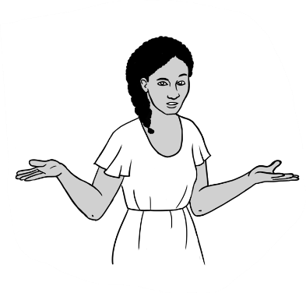
Ask questions about words on forms.
I don’t understand the words on the form.

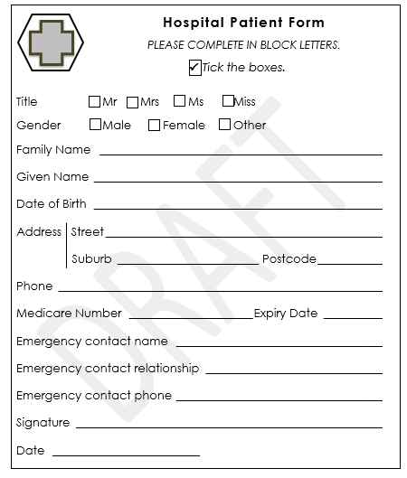
Excuse me. What does this mean?
Sorry. I don’t understand this word.
I don’t understand this.
Can you help me please?
Can you explain
this please?

Learn the questions for homework.
How many?
Hospital Patient Form
PLEASE COMPLETE IN BLOCK LETTERS.

Tick the boxes.

Title Mr Mrs Ms Miss
Gender Male Female Other

Family Name
Given Name
Date of Birth
Address Street
Suburb Postcode
Phone
Medicare Number Expiry Date
Emergency contact name
Emergency contact relationship
Emergency contact phone
Signature
Date
Can you check my work please?
Can you check my work please?

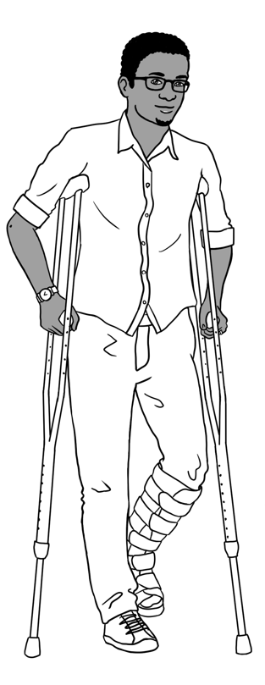
Tahiil gets a text message from the hospital.
Reminder
Mr Tahiil Dihoud
Your appt
at Kellivale Outpatients is
at 9.30am
on Mon12 Feb
Reply Y or N

Kellivale Outpatients
reminder
am = before midday

Y = yes

N = no

appt = appointment

Match the answers to the questions.
Questions | Answers
- What is this? | Mr Tahiil Dihoud
- Who is the message to? | 9.00am
- Who is the message from? | a text message
- When is the appointment? | Kellivale Outpatients
- What time is the appointment? | Mon 12 Feb
- What does Y mean? | No
- What does N mean? | Yes

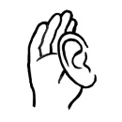
A get-well card

The English class writes a get-well card to Tahiil.


Dear Tahill
We are sorry about your foot.
Get well quickly.
Come back to class.
We miss you.
Your classmates

Write a get-well card for your classmate Hassan.
He has a bad break in his arm.
He can’t come to school.

Tahiil can’t come to class
These activities have not been included in the student workbook due to their added complexity. However, it’s necessary for students to be aware of the Home Tutor scheme and how they can access it if necessary. Activities here include:

- A volunteer tutor application form with comprehension questions

- A text message from the home tutor to Tahiil arranging the day and times for tutor sessions

A volunteer tutor

Tahiil can’t walk.
He can’t go to his English class.
VTS
Application for a Volunteer Tutor

Use BLOCK LETTERS and a black pen. Tick the box.

Family Name DIHOUD
Given Name TAHIIL JAMA

Gender Male Female Other

Date of Birth 27 JUNE 1994
Languages SOMALI, ARABIC
Address Street UNIT 6, 50 BAKER RD
Suburb KELLIVALE Postcode: 2421
Phone number 0400 785 936
Email tjdihoud27@gmail.com
Emergency Contact Name SAHRA ELMI
Emergency Contact Phone 0455 961 259
Signature TJ Dihoud
He fills in a form for a volunteer tutor.

What are the instructions on the form?
- Use __________________ LETTERS and a ___________ pen.
- _____________ the box.

- What is Tahiil’s date of birth? _________________________
- What languages does he speak?
___________________________ _________________________
- Who is his emergency contact? _________________________

Tick one.

- Why does Tahiil fill in the form?
- He needs a doctor.
- He needs childcare for his daughter.
- He needs a volunteer tutor.

- What is this? TJDihoud27@gmail.com
      - an email address
      - a phone number
      - a house address
Ask the teacher
Can you check my work please?
A message from a volunteer tutor
Hi Tahiil,
I am a volunteer tutor.
My name is Paul.
I can work with you for one hour a week.
What day and time is OK for you?
Please text me on
0431 978 352.
Paul



Circle the greeting.
the ending.
Write answers.
- Who is the message to?
- Who is it from?
- Who is Paul?
- What’s Paul’s phone number?
Tick one.

Paul asks Tahiil about the day and time
to play soccer. to learn English. to work.

Where and when?
Worksheets – Places to study
The worksheets in this section aim to:
- emphasise the importance of learning beyond the classroom.
- alert the students to the learning opportunities available through the AMEP.
Select the worksheets relevant to your students.
Alternatively, use the characters below to create your own worksheets to meet the requirements of your site. These characters have no developed storyline within the books. The girl on the left has been called ‘Alina’ in some scenes.

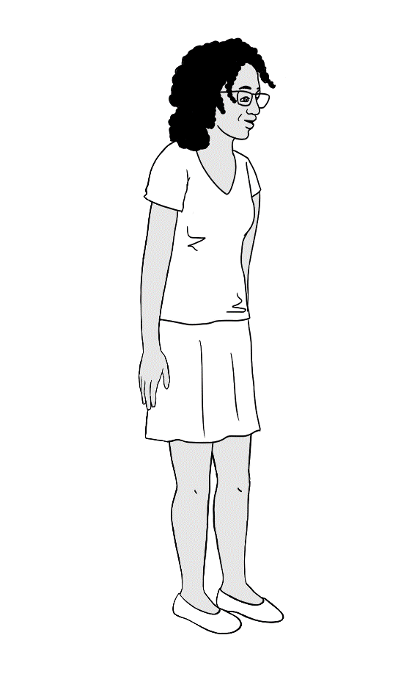
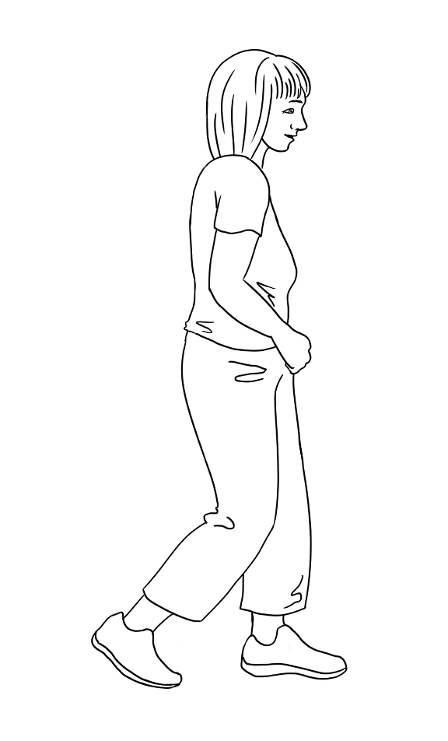
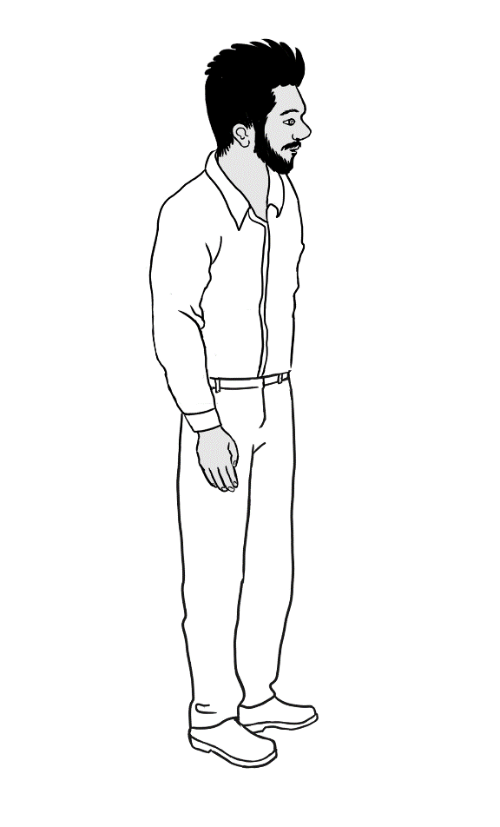

Where and when?

Tahill breaks his foot.
He can’t walk.
He can’t go to class.
Where can he learn English?
Thursday | Monday Tuesday Wednesday
 | 
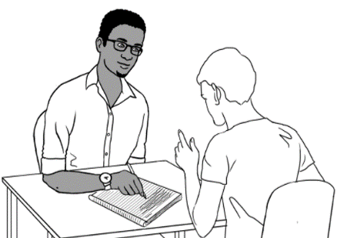  Tahiil learns at home  with a volunteer tutor. | He learns online.

- On __________________________, Tahiil learns at home
with a volunteer tutor.
- He learns online on ___________________, ____________________ and ____________________________.

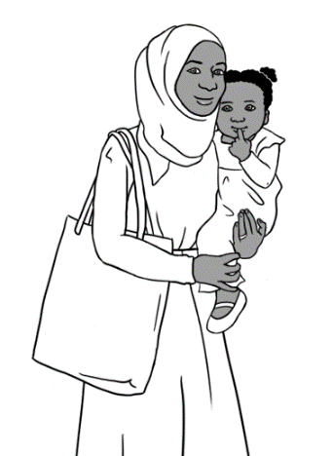

Sahra has a little girl.
She can go to class part-time.
Where can she learn English?

Monday Tuesday | Wednesday | Saturday
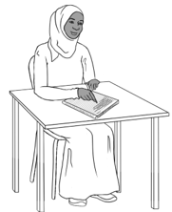  Excuse me.  What does this mean? | 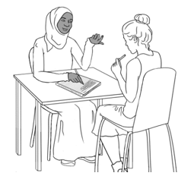 |   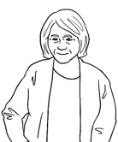
Sahra goes to class. | She learns with  a friend. | She talks with  her neighbour.

- Sahra goes to class on ________________________ and __________________________.
- On __________________________ she learns with a friend.
- On __________________________ she talks with her neighbour.

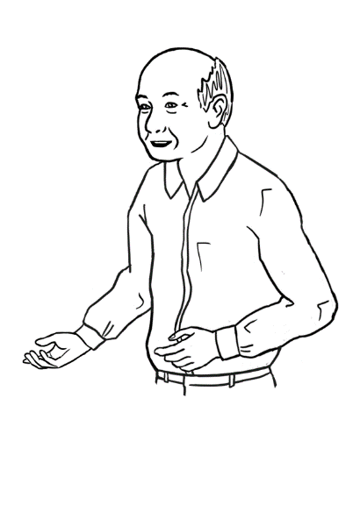
My name is Ming.
Where can I learn English?

Tuesday morning  Friday morning Wednesday afternoon | Monday  Thursday  Saturday | Sunday
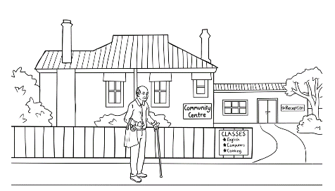 | 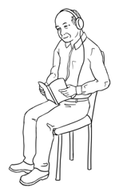 | 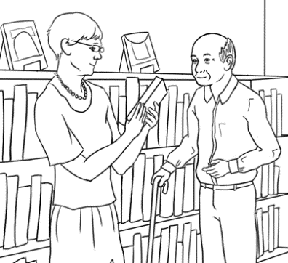
Ming learns at the community centre. | He learns  at home. | Ming goes to the library.

- Ming learns at the community centre on _____________________
and _______________________ morning.
- He learns at the community centre on ________________________ afternoon.
- He learns at home on ___________________, ____________________ and _______________________.
- Ming goes to the library on _________________________.

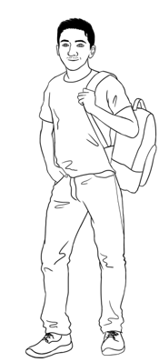
My name is Carim.
Where can I study?

study = learn

Monday to Friday | Saturday Sunday | after class
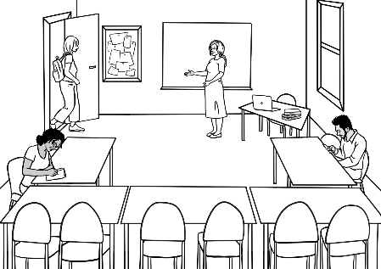 | 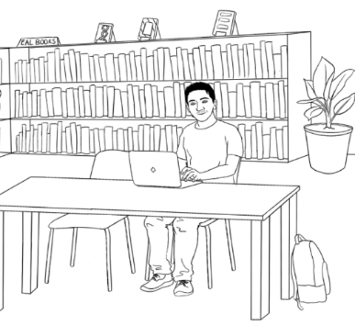 | 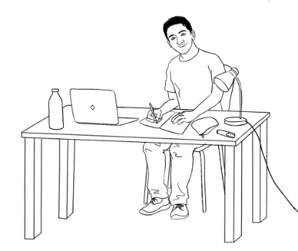
Carim studies  full time at TAFE. | Carim studies  in the library. | Carim studies  at home.

- Carim studies full time from ____________________ to
____________________.
- He studies in the library on _____________________ and
______________________.
- He studies at home ________________ __________________.

Audio files and transcripts
1
What food do you like? [Student Book - Section 11, Page 22]
MP3 files
Transcripts

Conversation 1
Pam Sahra, what food do you like?
Sahra I like bananas and icecream.
Pam Do you like tea?
Sahra No. I don’t like tea. I like coffee.

Conversation 2
Tahiil Anika, what food do you like
Anika I like pizza and cake.
Tahiil Do you like orange juice?
Anika No. I don’t like orange juice. I like coffee.

Conversation 3
Lan Nisha, what food do you like?
Nisha I like noodles and rice.
Lan Do you like bread? .
Nisha No. I don’t like bread. I like hot chips.

Conversation 4
Abdi Bao, what food do you like?
Bao I like pizza and coffee.
Abdi Do you like cake?
Bao No. I don’t like cake. I like bananas.

An English class for Sahra [Student Book - Section 15, Page 29]
2
MP3 files
Tahiil | Hello. My name is Tahiil.  This is my wife Sahra.  She needs an English class.
Receptionist | Hello. Nice to meet you.  You can enrol in an English class here.
Tahiil | Thank you. We have a daughter.  Do you have childcare?
Receptionist | Yes, we have childcare.  Can you fill in this form please Sahra?
Sahra | Mmm. Can you help me please?
Receptionist | Yes. I can.
Transcript

3
The receptionist helps Sahra. [Teacher resources Section 15, Page 56]
MP3 files
Receptionist What’s your full name?
Sahra My name is Sahra Omar Elmi.
Receptionist Where were you born?
Sahra I was born in Somalia.
Receptionist When were you born?
Sahra I was born on the 7th of July 1996.
Receptionist What languages do you speak?
Sahra I speak Somali and Arabic.
Receptionist When did you arrive in Australia?
Sahra Sorry. Can you say that again please?
Receptionist When did you come to Australia?
Sahra Umm. On the 9th of June 2022.
Receptionist Are you married or single?
Sahra I am married.
Receptionist How many children do you have?
Sahra I have one child.
Receptionist What is your address and phone number?
Sahra Mmm. It’s here on my card.
Receptionist Oh yes. Thank you Sahra.
Please sign the form here.
Transcript

4
At the childcare centre in the morning
[Teacher resources – Section 22, Page 83]
MP3 files
Nisha Good morning Sahra. How are you?
Sahra Good thanks Nisha.
Nisha Sahra, do you have .
Hani’s bag and water bottle?
Sahra Yes, here they are.
Nisha Can you put them here please?
Sahra Ok. Here’s Hani’s hat.
Nisha Good. Put her hat on now.
Sahra Ok. Have a good day.
Nisha You too. See you later.
Transcript

5
At the childcare centre in the afternoon
[Teacher resources – Section 22, Page 85]
Nisha Hi Sahra. How was your day?
Sahra Good thanks.
Nisha Hani is very happy today.
Sahra She loves playing with the children.
Nisha Does she like fruit?
Sahra Sorry. What do you mean?
Nisha Does she like apples?
Sahra Yes, she likes apples and bananas.
Nisha Ok, thank you. See you tomorrow.
Sahra See you tomorrow.

MP3 files
Transcript

6
Tahiil and the nurse [Teacher resources – Section 25, Page 92]
MP3 files
Nurse Tahiil Dihoud?
Tahiil Yes.
Nurse What’s the problem Tahiil?
Tahiil I hurt my foot at soccer today.
Nurse Can you walk?
Tahiil No. It’s very painful.
Nurse OK. Please wait to see a doctor.
Tahiil Thank you.
Transcript

7
Tahiil and the doctor [Teacher resources – Section 25, Page 93]
MP3 files

Transcript

Before the x-ray
Doctor Hello. I’m the doctor. My name’s Elena.
What’s your name?
Tahiil Tahiil Dihoud
Doctor What’s the problem Tahiil?
Tahiil I hurt my foot at soccer.
Doctor We need to x-ray your foot.
Tahiil OK.
Doctor Please wait here.

Transcript

After the x-ray
Doctor Tahiil, your foot has a bad break.
Do you work?
Tahii: I’m a house painter. I go to school too.
Doctor You can’t walk.
You can’t work.
You can’t go to school.
Tahiil I don’t understand.
Doctor Your foot has a very bad break.
You can’t walk for eight weeks.
Tahii: Eight weeks? Oh no!

