English Ready
22637 VIC Course in EAL
VU23497 Give and respond to short highly familiar information
VU23499 Read and write short, highly familiar factual texts

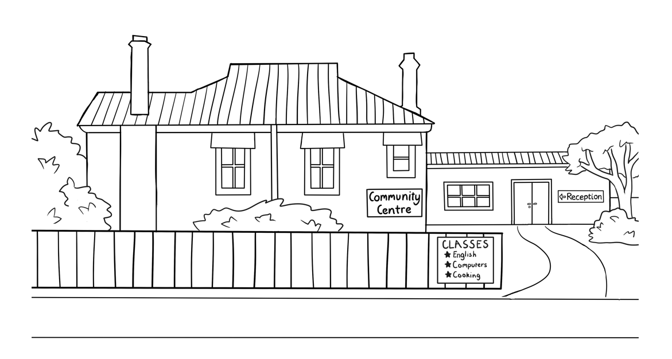
Information and Instructions
Teacher resources

Design team: Vicki Hambling, Sue Paull, Frida Dean, Janice Langley, Glenise Kleehammer
and Mary Wallace
Illustrations: Madelena Scott
Image acknowledgements:
Australian Currency designs – Permission granted by the Royal Australian Mint, Approval # 9/45/432
Coin with the Queen’s head - This Photo by Unknown Author is licensed under CC BY-SA-NC

Acknowledgements: The design team would like to thank the AMEP service providers and practitioners who participated in the trial and gave valuable feedback. The team would also like to acknowledge the use of the EAL Framework which underpins the design of this book.

Copyright of the EAL Framework is reserved to the Crown in the right of the State of Victoria. © State of Victoria (Department of Education and Training) 2023.
_________________________________________________________________________________________
This English Ready Resource is licensed under a Creative Commons Attribution-NoDerivs 3.0 Australia licence (More information is available here). You are free to use, copy and distribute to anyone in its original form as long as you attribute Department of Home Affairs as the author and you license any derivative work you make available under the same licence.
© Commonwealth of Australia 2023

With the exception of the Commonwealth Coat of Arms, the department’s logo, any material protected by a trade mark and where otherwise noted all material presented in this document is provided under a Creative Commons Attribution 4.0 International (https://creativecommons.org/licenses/by/4.0/) licence.
The details of the relevant licence conditions are available on the Creative Commons website (accessible using the links provided) as is the full legal code for the CC BY 4.0 licence (https://creativecommons.org/licenses/by/4.0/legalcode).
Use of all or part of this document must include the following attribution:
© Commonwealth of Australia 2023
As far as practicable, material for which the copyright is owned by a third party will be clearly labelled. The department has made all reasonable efforts to ensure that this material has been reproduced in this document with the full consent of the copyright owners.
Copyright requests and enquiries concerning usage not addressed by the CC BY 4.0 licence should be addressed to:
comms@homeaffairs.gov.au at the Department of Home Affairs.
The terms of use for the Commonwealth Coat of Arms are available from the It's an Honour website.
Where a copyright owner, other than the Commonwealth, is identified with respect to this material, please contact that third party copyright owner directly to seek permission.



Introduction
The Teacher Book
This book is an electronic reference. Print pages as only needed. It includes materials and activities for:
- pair work and class work
- revision and homework
- pronunciation
- extension
The book also contains audio transcripts and links to the audio MP3 files.

The Student Workbook
This book requires teacher direction and is not intended for independent learning.
It is also not intended to be the only material used to teach these units. The activities included are not suitable to be used for assessment. The book is available as a Word document so that teachers can:
- localise and update the content
- adjust the material to suit the requirements of particular classes
- delete or add materials as required


At the back of the book are two emojis to give feedback to the teacher. Students can hold up the emoji which best reflects how they feel about an activity or a lesson.

Table of Contents

1. Instructions 1
2. Meet the people 2
3. Do you understand? 7
4. Introductions 9
5. The Alphabet 10
6. Numbers 26
7. The days 35
8. The time 36
9. The months 42
10. English class 45
11. Get ready for class 49
12. How many? 55
13. Instructions in class 60
14. The community centre 65
15. Signs in the community centre 68
16. A class timetable 69
17. Talk about family and friends 71
18. The weather 76
19. The Medical Centre 83
20. Audio files and transcripts 87

Instructions

 | read | 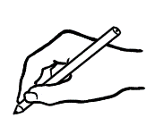 | write
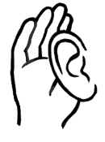 | listen |  | say
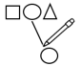 | match | 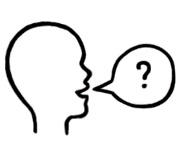 | ask
 | tick | 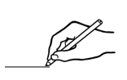 | draw
 | circle |  | colour
 | point |  | copy
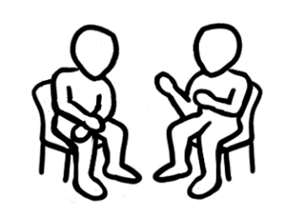 | Work with  a partner. |  | record

Meet the people
Scenes with the characters
Scenes from the student and teacher books have been included so that teachers can produce their own materials as needed. A chart with the bio data was created to maintain consistency of information throughout the book.
It may be useful to update character information.

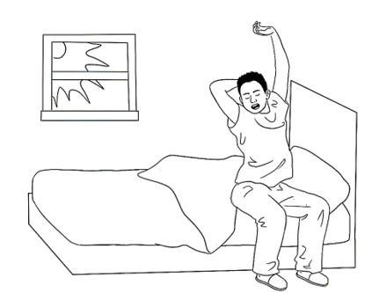
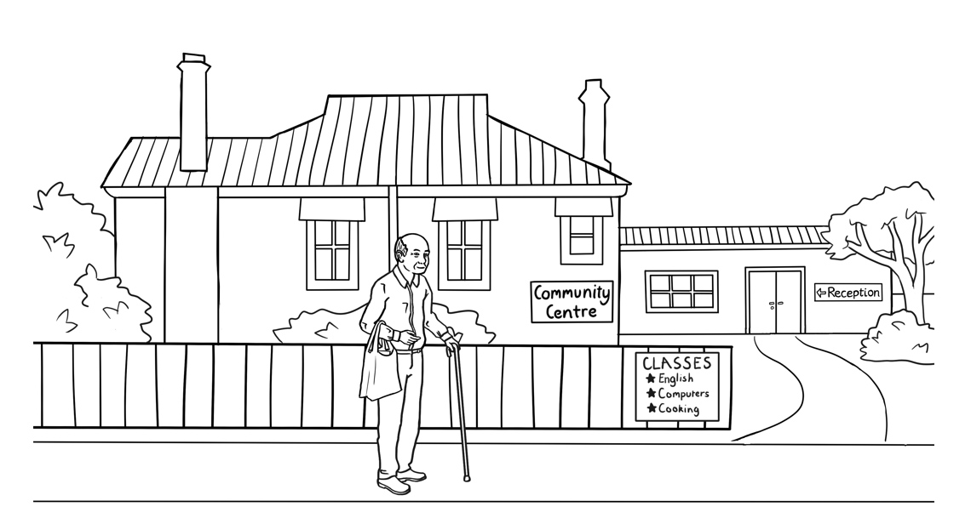
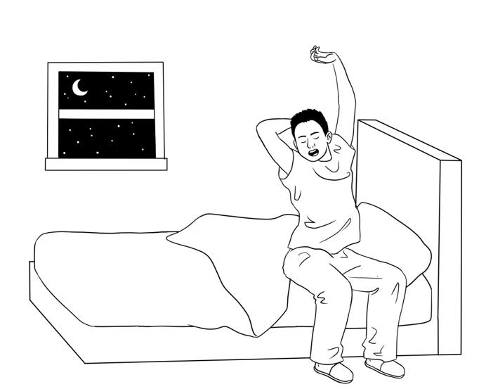

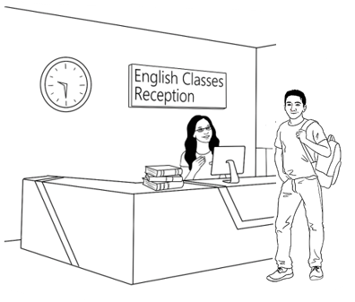
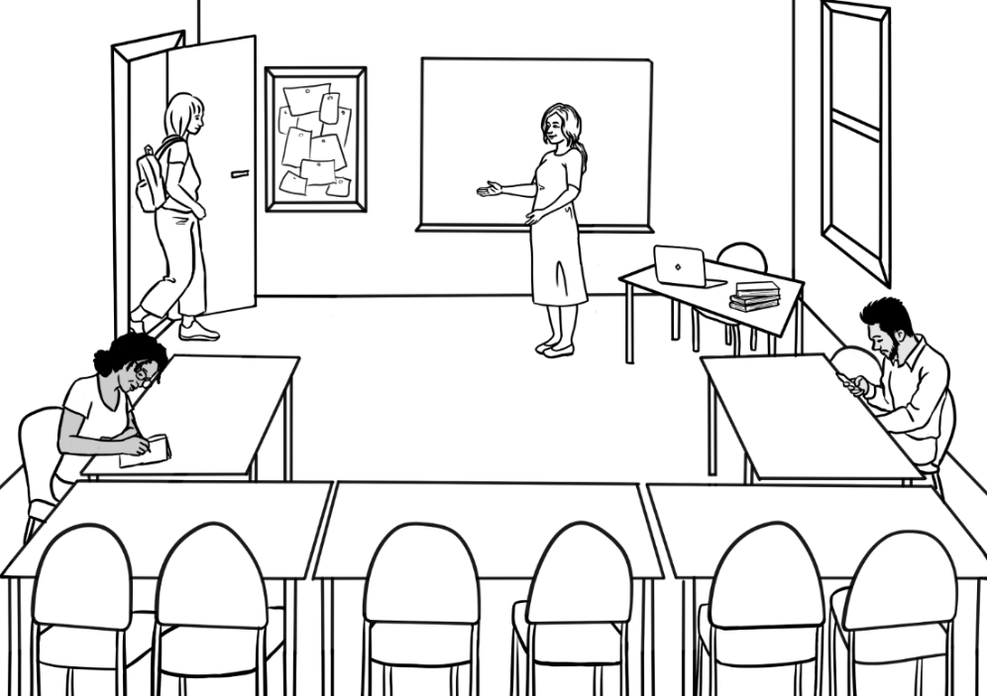
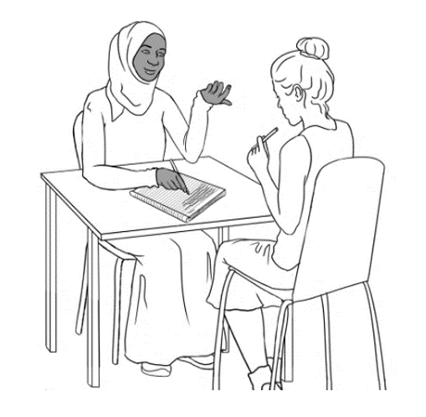
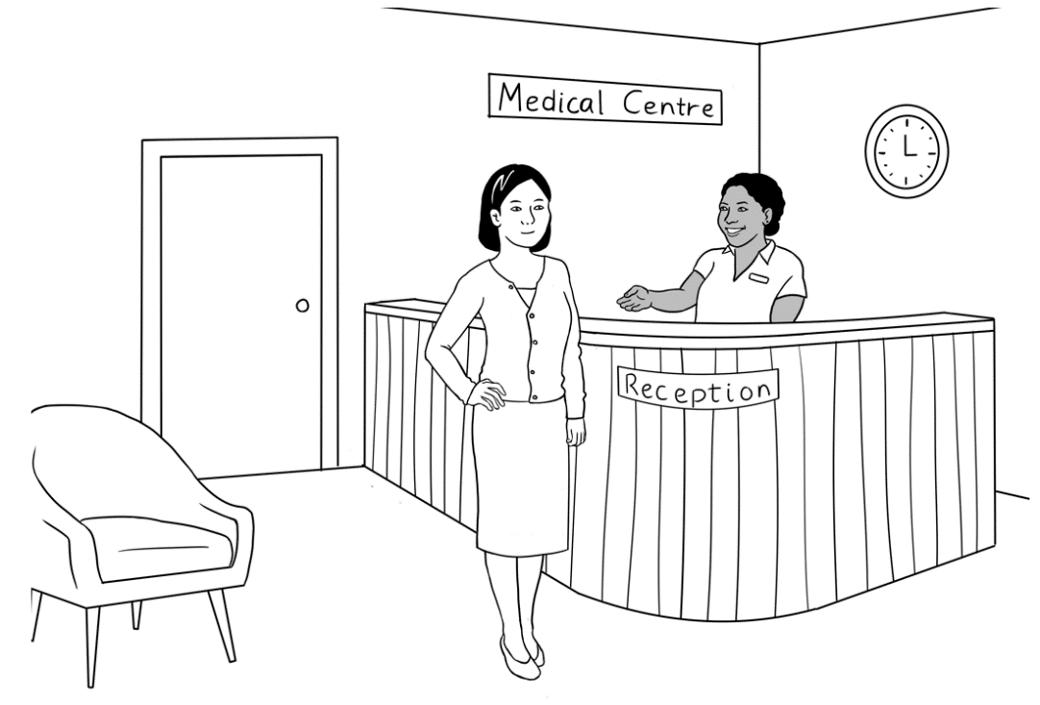

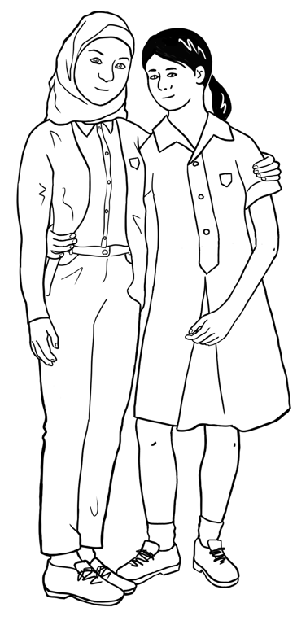
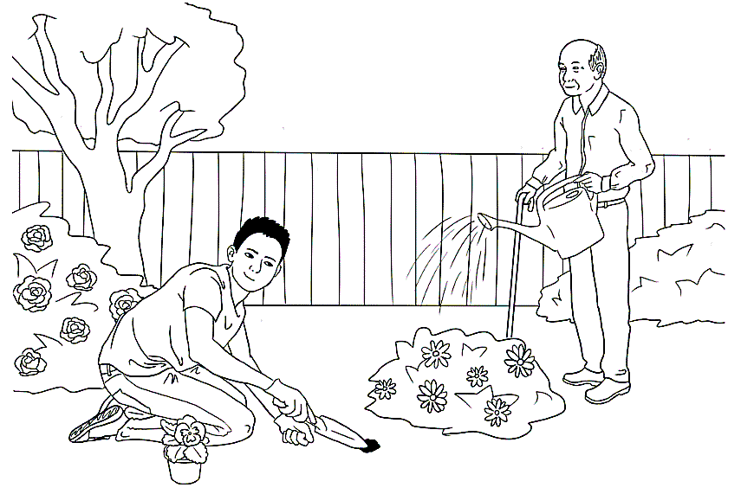
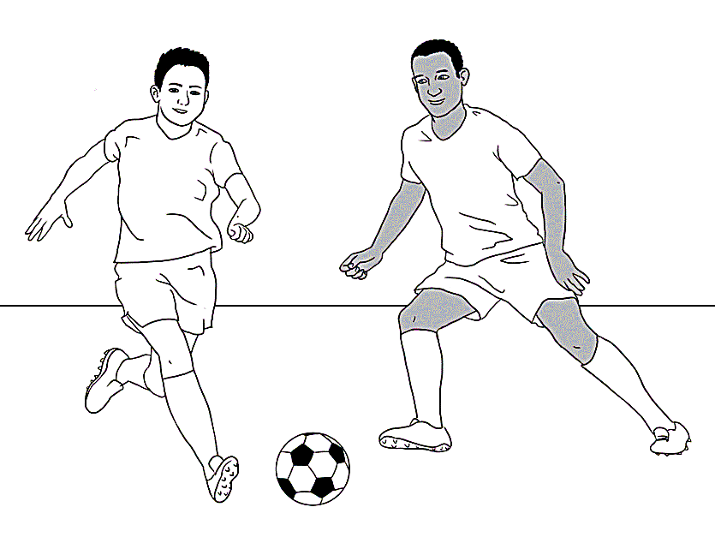
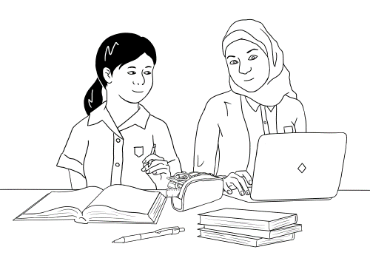

Personal details of the characters
Name | Country  of origin | *Age &/or Date of birth | Date  of arrival | Address in Kellivale | Phone
Tahiil Jama Dihoud | Somalia | 27.6.94 | 9.6.22 | Unit 6,  50 Baker Rd | 0400 785 936
Sahra Omar Elmi | Somalia | 7.7.96 | 9.6.22 | Unit 6,  50 Baker Rd | 0455 961 259
Hani Tahiil Jama | Somalia | 2 years  24.06.21 | 9.6.22 | Unit 6,  50 Baker Rd | _
Abdi Omar Elmi | Somalia | 4.8.04 | 13.10.15 | Unit 1,  50 Baker Rd | 0465 971 356
Ming Wu | China | 27.3.1959 | 07.05.19 | 70 Wattle St | 0418 335 748
Lan Wu | China | 6.6.78 | 11.07.14 | 70 Wattle St | 0488 872 951
Bao Wu | China | 19 years  13.05.2004 | 11.07.14 | 70 Wattle St | 0409 188 674
Mai Wu  3065 75221 3  1. Tahiil Jama Dihoud  2. Sahra Omar Elmi  3. Hani Tahiil Jama  VALID 06/2025  medicare | China | 16 years  19 April | 11.07.14 | 70 Wattle St | 0487 592 811

Personal details of the characters [continued]
Nisha Kumar | India | 19.01.1978 | 06.04.13 | 56 North St | 0411 825 999
Pari Kumar | India | 9 years |  | 56 North St
Dev Kumar | India | 7 years  26 August |  | 56 North St
Anika | Ethiopia | 30.09.1995 | 15.10.22 | 56 North Street | 0477 193 286
Fatima  Khalil Hamed | Syria | 15 years  13 July | 16/11/2008 | 260 North St
Carim  Khalil Hamed | Syria | 19 years | 30/06/2004 | 260 North St | 0469 455 218
Jenny  [Teacher] | Australia | - | - | - | -
Pam  [Sahra’s  neighbour] | Australia | 02.02.1956 | _ | Unit 5,  50 Baker Rd | 0407 165 972
Paul  [VTS] | Australia | _ | _ | _ | 0431 978 352

*Note 1: Where dates of birth have been used in the booklets, they have been recorded here as exact figures. The age of the characters is relevant for the younger characters as they either attend childcare, primary school, secondary school or uni. All dates may be adjusted to make them more relevant to the time the resource is being used.
Note 2: Characters shaded in this colour are not introduced in this booklet.

Do you understand?
Activity - Make requests for repetition or clarification
- Teach students the requests for clarification and repetition introduced in the student workbook.
- Print the expressions on the following page, laminate and cut up.
- Build confidence in using the expressions through regular class practice:
- Give the four expressions to four students. Select the most confident students at first.
- Ask these students to use their expression at least once during the class – initially with the teacher and later with each other.
- Give the expressions to different students in following classes.
- Teach the additional expression when appropriate.

Sorry. I don’t understand.
Can you help me please?
Can you say that again please?
Can you speak slowly please?
Can you spell that please?

Introductions
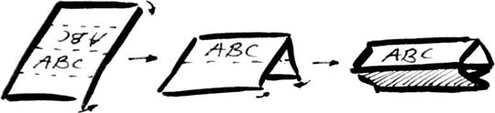
Introductions and learning names
Student names provide a practical vocabulary for building many skills:
- Word stress – Write student names on the board in lists according to the number of syllables. Mark the stress and practise together. Clap, stamp feet or stretch a rubber band to show the main stress with a large circle.
_{Mai} _{Abdi} _{Anika}

- Build class connection by learning names - name cards
- With ½ A4 page, fold and create name cards for each student.

Mark the stress pattern on the cards and collect at the end of each class.
- Teach how to introduce someone.
- Write on the board, ‘My name is___________.’ Go round the class, with students introducing themselves.
- Next, on the board write, ‘My name is______________, and this is ______________.’ Demonstrate how to introduce someone with an outstretched hand towards the person, palm up. Round the class, students introduce themselves and the person next to them. This introduction can be revised when a new student joins the class, and extended to include where a student comes from, their likes and dislikes, favourite colour etc.

- Use a ball for a different activity. Ask students to stand in a circle. The student with the ball introduces themself, and then says ‘and this is ______________’ and throws the ball to the student named. Continue the game till most students have introduced themselves.

The Alphabet
- Initial sounds of the alphabet - pictures and words
The following pictures may be cut up by the students and matched to their initial sounds. There are two sets of pictures and words for each sound. Students could add the words for the second set of pictures to the table in their workbook.

Picture set 1 – These pictures are in the student workbook on pages 12 & 13.
 | 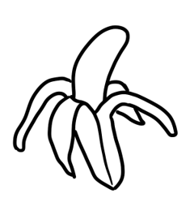 |  | 
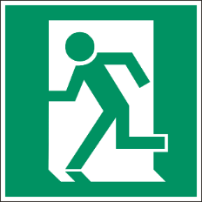 | 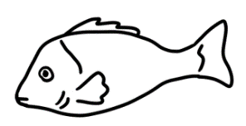 |  | 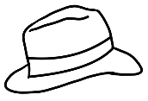
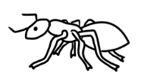 |  | 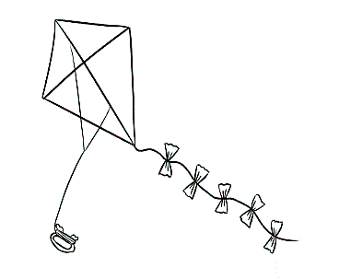 | 
 | 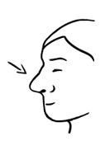 | 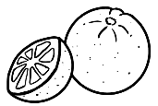 | 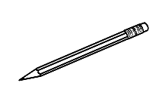
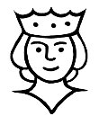 |  |  | 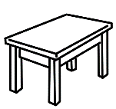
 | 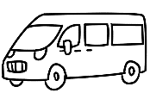 | 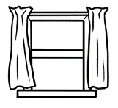 | 
 | 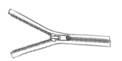

Picture set 1 – These words are in the student workbook.

apple | banana | car | dog
exit | fish | glasses | hat
insect | jacket | kite | lemon
money | nose | orange | pencil

queen | rain | star | table
umbrella | van | window | x-ray
yam | zip

Picture set 2- New pictures not in the student workbook

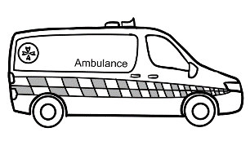 |  | 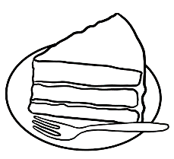
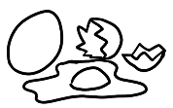 | 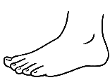 | 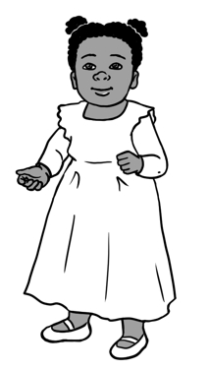 | 
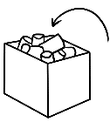 | 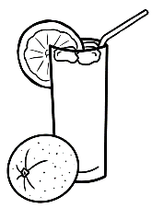 | 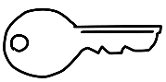 | 
 | 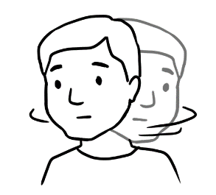 |  | 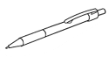
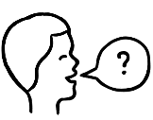 | 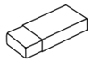  Rubber |  | 
 | 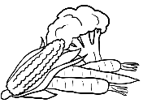 | 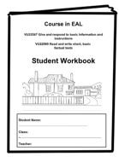
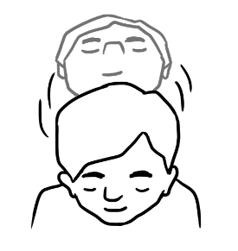 | 

Set 2 words – These words could be added to the student workbook on p9 - 10.

ambulance | ball | cake | down
eggs | foot | girl | home
in | juice | key | lamp
man | no | office | pen

question | rubber | student | tea
up | vegetables | workbook
yes | zero

Upper and lower-case letters

A | B | C | D
E | F | G | H
I | J | K | L
M | N | O | P
Q | R | S | T
U | V | W | X
Y | Z

a | b | c | d
e | f | g | h
i | j | k | l
m | n | o | p
q | r | s | t
u | v | w | x
y | z

Sound chart
The sounds of the alphabet
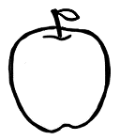  A a  apple |   B b  banana |   C c  car
  D d  dog | 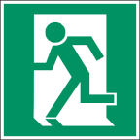  E e  exit | 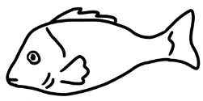  F f  fish
G g  glasses |   H h  hat | 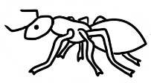  I i  insect
  J j  jacket | 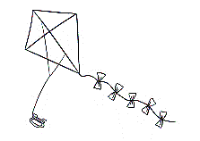  K k  kite | L l  lemon
  M m  money | 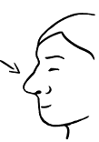  N n  nose | O o  orange
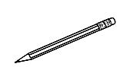  P p  pencil | 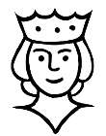  Q q  queen |   R r  rain
S s  star | T t  table |   U u  umbrella
V v  van | 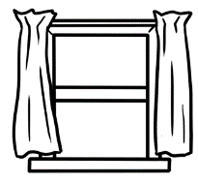  W w  window |   X x  x-ray
  Y y  yam | Z z  zip
2. Handwriting guide A practice writing book is available at Initial level.
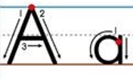
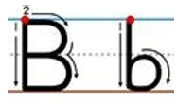
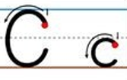
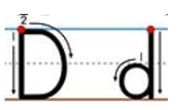
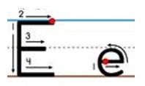

……………………………………………………………………………………………………………..

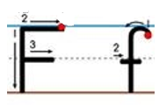
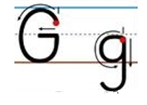
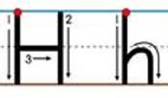
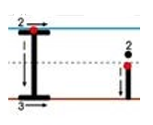
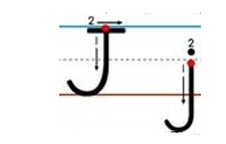

……………………………………………………………………………………………………………..

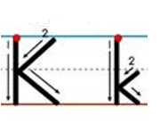
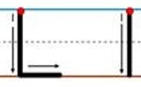
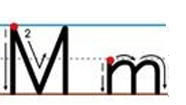
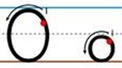
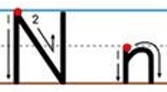

……………………………………………………………………………………………………………..

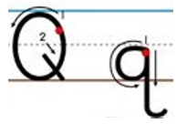
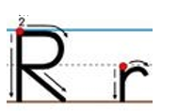
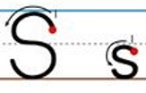
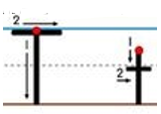
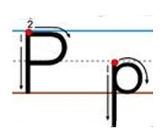
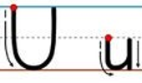

……………………………………………………………………………………………………………..

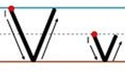
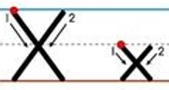
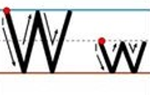
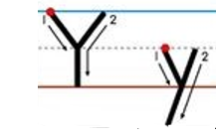
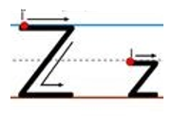

……………………………………………………………………………………………………………..

Lined page for handwriting practice

……………………………………………………………………………………………………………..

……………………………………………………………………………………………………………..

……………………………………………………………………………………………………………..

……………………………………………………………………………………………………………..

……………………………………………………………………………………………………………..

……………………………………………………………………………………………………………..

……………………………………………………………………………………………………………..

……………………………………………………………………………………………………………..

……………………………………………………………………………………………………………..

……………………………………………………………………………………………………………..

……………………………………………………………………………………………………………..

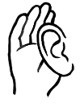
3. Listening to the letters – names or initial sounds

Listen. Circle the letter.
1 |   G D E |  | 2 | S C Z
3 | F K H |  | 4 | M N B
5 | L I Y |  | 6 | T C B
1 | B P C |  | 2 | Q K H
3 | C S X |  | 4 | A H K
5 | B D P |  | 6 | V W U
1 | y w u |  | 2 | d b p
3 | g j k |  | 4 | v c w
5 | i e a |  | 6 | e a i
1 | a o e |  | 2 | r a j
3 | k g j |  | 4 | g j k
5 | x s c |  | 6 | a i e

Numbers
- Pronunciation and word stress of numbers
Distinguish between similar-sounding pairs such as 13 - 30, 14 -40, etc.
Say the numbers, exaggerating the pronunciation of 'teen' of each number and the unstressed 'y' on the 'tens'. Give each student a large rubber band to hold between their thumbs, and as they say the numbers with ‘teen’, they stretch the rubber band to show the stress. Then teach the students to say the numbers naturally.
12 - 20
13 - 30
14 - 40
15 - 50
16 - 60
17 - 70
18 - 80
19 – 90
If a word has more than one syllable, one of the syllables will be stressed. To show stress do one or more or the following:
- Make it louder
- Make it longer
- Make it higher in tone

Show stress using circles. Each circle is a syllable and the larger circle indicates the stressed syllable. Place the circles over the vowel in each syllable. e.g.

On the thirtieth of August.

The thirteenth?

No the thirtieth.
Teach repetition as a way of checking understanding.

2. Numbers tiles
1 | 2 | 3 | 4
5 | 6 | 7 | 8
9 | 10 | 11 | 12
13 | 14 | 15 | 16
17 | 18 | 19 | 20

one | two
three | four
five | six
seven | eight
nine | ten
3. Numbers maze
This is a student-to-student dictation of numbers.
- Students work in pairs, sitting back-to-back, each with a copy of the maze, a pencil and a pen.
- In the first dictation, use a pencil.
- Student A begins at number one, and calls out each number slowly
as he/she moves in any direction along the lines through the maze, marking the route with a pencil.
- Student B listens, finds the number and draws the route on his/her maze.
- Continue in this way until the final row of pictures.
- When Student A identifies the picture he/she has landed on, both students check to see if their marked routes on the maze match.
- Swap roles and in the second dictation, use a pen to draw the route.

Numbers Maze
Start

47
1
22
35
15
39
27
16
45
30
11
38
8
29
44
21
7
9
3
49
4
34
9
32
22
18
35
13
7
28
6
36
25
26
23
12
7
22
41
20
2
5
40
31
42
17
37
22
43
10
24
48
14
28
19
13
33
50
46
22

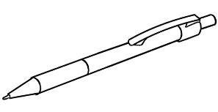
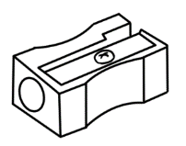

4. Money
The following notes and coins can be projected on the board or copied and used for matching exercises.

$5
$10
$20
$50
$100

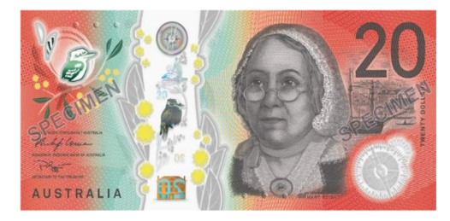


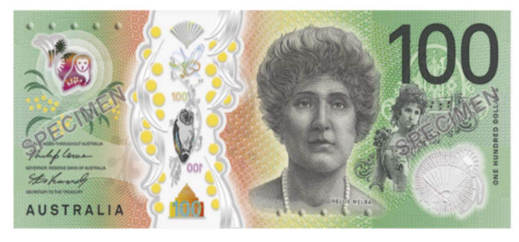

 | 5c |  | 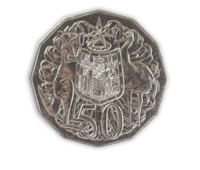 | 50c
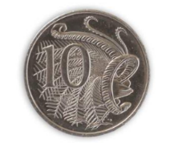 | 10c |  | 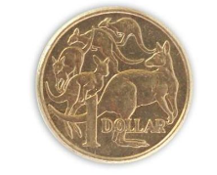 | $1
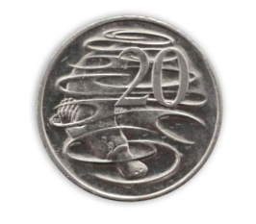 | 20c |  | 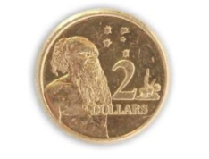 | $2

5. Listening and speaking – the years
Activity – Worksheet
Before the activity, demonstrate and practise saying the years in the following way:
2022 20 22
2021 20 21
2020 20 20
Copy the worksheet on the following page for each student.
Part A – Read the years as shown above; students circle the year.
Part B – You may need to remind students to bring some coins to class in preparation for this activity. Ask students to take out some coins, find the years on the coins and write the years next to the coins on the worksheet. Students then read the years to their partner.

Years
Listen. Circle the year.
1  A |   2023 | 2022 | 2021
2 | 2016 | 2018 | 2019
4 | 2010 | 2012 | 2011
5 | 2013 | 2015 | 2014
6 | 1990 | 1980 | 1970
7 | 1960 | 1950 | 1940
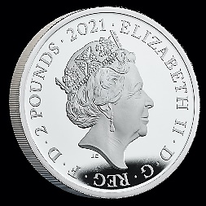
B
Look at some coins.
Write the years of the coins below.
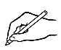  Coin | Year | Year

5c
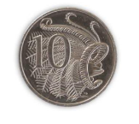
10c
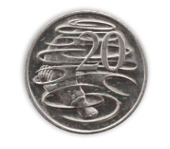
20c
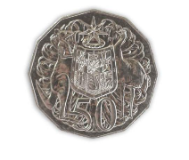
50c
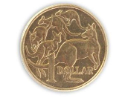
$1
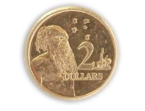
$2
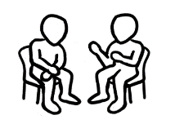
Read the years to your partner.
Monday
Tuesday
Wednesday
Thursday
Friday
Saturday
Sunday
weekend
today
tomorrow

The days
Days tiles -For matching, spelling and writing activities.

Mon
Tues
Wed
Thurs
Fri
Sat
Sun

The time
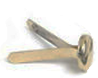
Activity 1 – Reading an analogue clock
Materials
- Copies of the clock faces on the following page. [Enough for the class.]
- Pins to attach the hands.
- A class set of scissors.
- Light cardboard
- Glue
Activity
- Each student makes a clock.
- Call out a time.
- Students turn the hands to show the time.
- They then hold up their clock to be checked.
* This is a great activity to break up a long lesson.

Activity 2 – Writing and reading the time
Two worksheets for pair work – hours and half hours.

Activity 3 – What time do you go to bed?
This worksheet is a mirror image of the activity in the student workbook on page 14, but covers evening bedtime.

Activity 4 – Prepositions of time

This demonstrates a visual way to teach and for students to remember the three key prepositions of time – in, on, at.

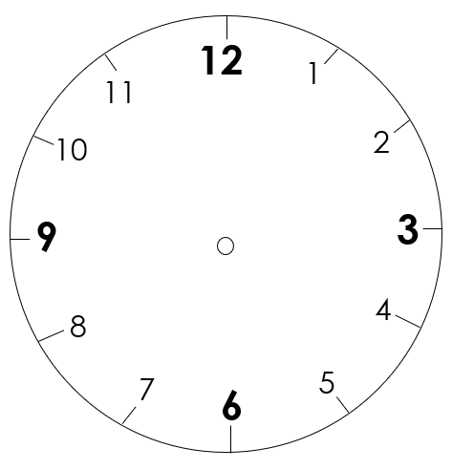
1.

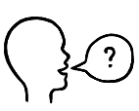
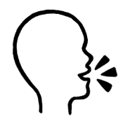
2.
Write the time.
Point to a clock. Ask

What’s the time?
It’s 1 o’clock.

12
1
11
6
3
2
10
9

8
5
7
4
1:00
12
1
11
6
3
2
10
9

8
5
7
4

12
1
11
6
3
2
10
9

8
5
7
4

12
1
11
6
3
2
10
9

8
5
7
4

12
1
11
6
3
2
10
9

8
5
7
4

12
1
11
6
3
2
10
9

8
5
7
4

12
1
11
6
3
2
10
9

8
5
7
4

12
1
11
6
3
2
10
9

8
5
7
4

12
1
11
6
3
2
10
9

8
5
7
4

12
1
11
6
3
2
10
9

8
5
7
4

12
1
11
6
3
2
10
9

8
5
7
4

12
1
11
6
3
2
10
9

8
5
7
4

12.00
11.00
10.00

12
1
11
6
3
2
10
9

8
5
7
4
12
1
11
6
3
2
10
9

8
5
7
4
Write the time.
Point to a clock. Ask

What’s the time?
It’s half past one. o’clock.

12
1
11
6
3
2
10
9

8
5
7
4

12
1
11
6
3
2
10
9

8
5
7
4

12
1
11
6
3
2
10
9

8
5
7
4
1:30

12
1
11
6
3
2
10
9

8
5
7
4

12
1
11
6
3
2
10
9

8
5
7
4

12
1
11
6
3
2
10
9

8
5
7
4

12
1
11
6
3
2
10
9

8
5
7
4

12
1
11
6
3
2
10
9

8
5
7
4

12
1
11
6
3
2
10
9

8
5
7
4

12
1
11
6
3
2
10
9

8
5
7
4

12
1
11
6
3
2
10
9

8
5
7
4

12
1
11
6
3
2
10
9

8
5
7
4

3.
It is Monday night.


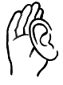
Listen and repeat.

I am tired.
It’s half past ten.

St eight.

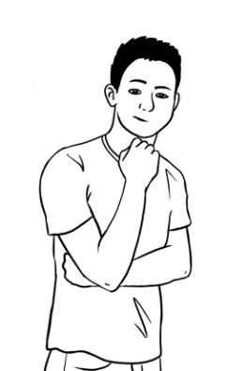
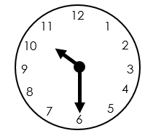 | pm = afternoon  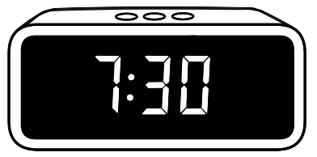  11:000 |   11:30 pm  Mon 8 Feb  25°C
It’s half past ten.  It’s ten thirty.  It’s 10:30 pm. | It’s 11 o’clock.  It’s 11 pm. | It’s half past eleven.  It’s eleven thirty.  It’s 11:30 pm.

I go to bed at half past ten on Monday.
What time do you go to bed?

Write about you.
I go to bed at ___________________ on Monday.
Ask your partner
What time do you go to bed?

St eight.
Activity 4 - Prepositions of time
Prepositions of time can be shown on three concentric circles which can work as a visual memory prompt.
- The larger outside circle represents in, usually for longer lengths of time
- months, years, seasons, decades, morning, afternoon and evening.
- The smaller middle circle represents on, for shorter periods of time
- days of the week, the weekend and dates
- The smallest circle represents at for precise times
- 9 o’clock, festivals, night
The circles could be enlarged to poster-size and new lengths of time could be added to the circles as they are introduced. See examples below.

The final diagram
in
at
on
Sunday
the weekend
March
summer
2001
the morning
the 80s
5 November
5 o’clock
8pm
night

The months
Activity 1 – The months
Tiles for matching, spelling and writing activities

January | February
March | April
May | June
July | August
September | October
November | December

Jan | Feb
Mar | Apr
May | June
July | Aug
Sept | Oct
Nov | Dec

Activity 2 - Capitals and basic punctuation
A basic understanding of the rules for capital letters and punctuation
needs to be developed and students’ attention regularly drawn to their use.
At this level, students need to know these basic rules:

e.g. It rains in July.
I go to class on Monday.
Mai lives in Kellivale.

Activity

Write sentences similar to the ones below on the board and ask students to come out and add the capital letters and the full stops.

- it rains in september
- it is sunny in january
- i go to class on tuesday
- it is cold in hobart
- the weekend is saturday and sunday
- my name is jack

A Capital letter is the first letter of:
- a sentence
- a day
- a month
- your name
- a country, state, city, suburb
- the pronoun I

A full stop comes at the end of a sentence.

English class

Activity - Spelling Dictation

In this activity, the same words are read to the whole class, but each level has support, and each student gets the dictation appropriate to their skills.

Level A
This dictation teaches students to look for clues. The words are on the page and can be copied, but the students have to locate the letters to copy. Initially, some students may need help with this, and the teacher could underline in red the parts to copy.

Level B
At this level, the difficult sounds have been provided. If the teacher pronounces the word slowly, the students should be able to hear the missing sounds. The answers are below so students can also copy.

Level C
At this level, a student can try to either write the word or they can copy. Allowing students this option and to later check their work removes any fear associated with having a go.

Level A - Spelling Dictation
Days of the week
Monday  __ o n d a y | Tuesday  __ u e s __ __ __
Wednesday  __ ednes__ __ __ | Thursday  Thurs __ __ __
Friday  __ ri __ __ __ | Saturday  __ atur__ __ __
Sunday
__ un__ __ __

Level B - Spelling Dictation
A a | B b | C c | D d | E e | F f | G g | H h | I i | J j | K k | L l | M m
N n | O o | P p | Q q | R r | S s | T t | U u | V v | W w | X x | Y y | Z z

Days of the week
- _ o _ _ _ _
- _ u e _ _ _ _
- _ e d _ e _ _ _ _
- _ _ u r _ _ _ _
- _ r _ _ _ _
- _ _ _ u r _ _ _
- _ _ _ _ _ _
Fold
Check your spelling
Monday | Tuesday | Wednesday | Thursday
Friday | Saturday | Sunday

Level C - Spelling Dictation
A a | B b | C c | D d | E e | F f | G g | H h | I i | J j | K k | L l | M m
N n | O o | P p | Q q | R r | S s | T t | U u | V v | W w | X x | Y y | Z z

Days of the week

- __________________________________________________
- __________________________________________________
- __________________________________________________
- __________________________________________________
- __________________________________________________
- __________________________________________________
- __________________________________________________
Fold

Check your spelling.
Monday | Tuesday | Wednesday | Thursday
Friday | Saturday | Sunday

Get ready for class
Question inflection
Activity 1 - What is in your pencil case?
- Demonstrate inflection:
- downward for wh questions
- upward for simple yes/no questions.
- Project the next page and ask the questions in the activity on the next page. Point your finger to show the up and down inflection.

- Ask students to repeat.
- If possible, create more examples on the board and practise.
- Students practise in pairs or small groups using the pictures of stationery
in the Student Book.

Yes, no questions
wh questions

Question inflection
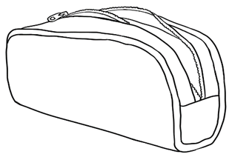
Wh questions
What’s in your pencil case?
Answers
I have two pens, a pencil and a rubber.
I have a pencil, a rubber, a sharpener and a pen.
Simple yes/no questions
A pencil?
Coloured pens?
A ruler?
A highlighter?
An apple?
Answers
No.
Yes.

Activity 2 – The Office Shop catalogue – Listening and writing activity
- Ask students to predict the prices of the items on the catalogue on the following page.
- The teacher nominates prices for each item; students listen and write the prices on the worksheet.

Activity 3 – Prices on a catalogue - Pair work
Students use their Student A or B page and ask each other questions about the prices of items on their page.
- Students look at their page and the objects in their catalogue.
They then take turns to ask their partner:
- How much is the _____________?
Their partner responds:
- It’s $______________.

- Each student writes the prices on their sheet.

Activity 2
The Office Shop catalogue
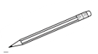
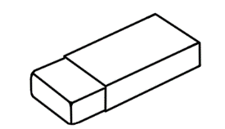
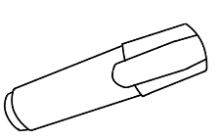
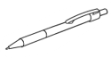
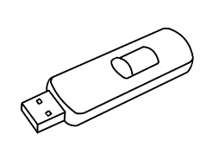
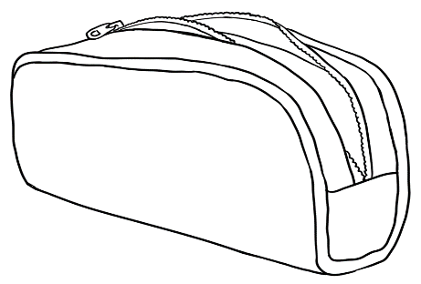



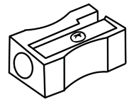
The Office Shop
Pencil

Get ready to learn
Date: February ________
Highlighter

Notebook

Sharpener

USB

Ruler

Rubber

pen
Pencil case

Phone

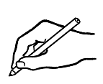
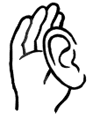
Listen to the teacher.
Write the prices.

Student A
Listen to your partner.
Say the prices.
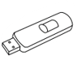
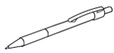
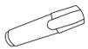
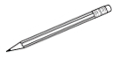
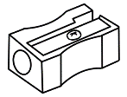
Pencil
$1.15

Get ready for class
Date: January 13

Highlighter
$1.20
Notebook
$2.50

Sharpener
$1.50
USB
$12
Ruler
80c
Rubber
$1

Pen
$2
The School Shop
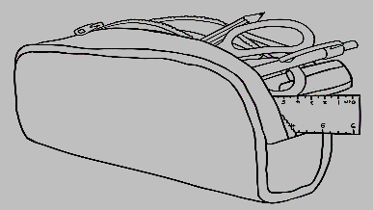

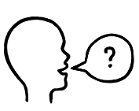
How much is the _____________?
Ask your partner
Write the prices.

Pencil

Get ready to learn
Date: January 13

Highlighter
Notebook

Sharpener
USB

Ruler

Rubber

Pen
The Office
Shop

How much is the _________?
Student B
Ask your partner
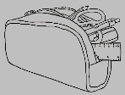
Write the prices.
The School Shop
Pencil

Get ready for class
Date: January 13

Highlighter
Notebook

Sharpener
USB

Ruler

Rubber

Pen


Listen to your partner. Say the prices.
The Office Shop
Pencil
90c
Get ready to learn
Date: January 13

Highlighter
$1.50
Notebook
$4.50

Sharpener
$2
USB
$15.00
Ruler
$1.20
Rubber
$1.30

Pen
$3

How many?
Activity 1 - Where are the items?
Before handing out the worksheet, demonstrate the location of items:
- Put multiples of familiar classroom objects on, under and next to a table.
- Ask students questions about the location of items stressing the preposition. e.g.:
- Is the pen on the table?
Yes, it is.
- Are the rubbers next to the table?
No, they are on the table.
- Is the ruler under the table?
No, it’s next to the table.

on under next to

on
under
next to

There are two hats next to the box.
There is one hat under the box.
There is one hat on the box.

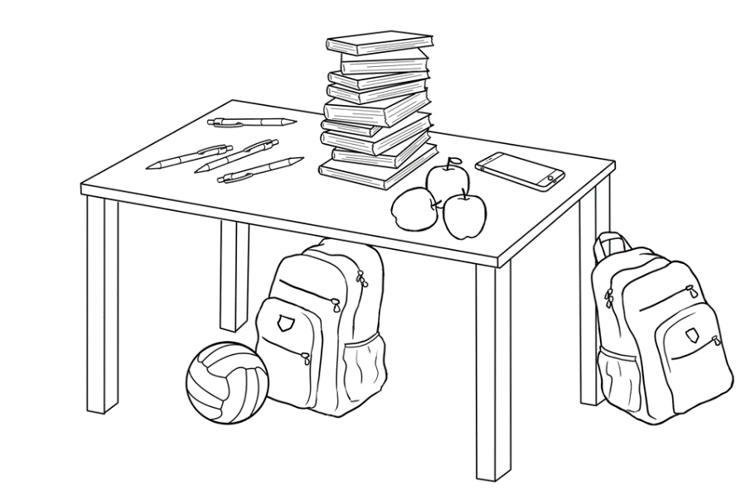
bag
book
phone
apple
pen
ball

Write sentences.
There is one phone on the table.
There are three apples on the table.
______________________________________________________________________________________________________________________________________________________________________________________________________________________________________________________________________________________________________________________________________________________________________________________________________________________________________________________________________________________________________________________________
Activity 2 - Plurals Memory game
Put different quantities numbers of 6 familiar objects on a table. Give students a minute to count them and commit to memory. Then cover them.
What can the students recall?
The activity can be graded. Students can write the numbers of objects on any of the three worksheets:
- Level A - a list with 6 pictures and words
- Level B - a list with 8 words and pictures [It could include objects not on the table]
- Level C - a list with 12 words and pictures [It could include objects not on the table]

How many?
Level A

______ phones  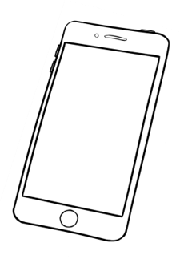 | 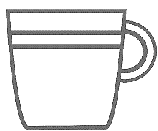  _______ mugs | _____ pencil cases
  _____ pairs of glasses | 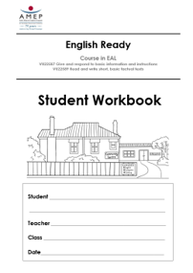  _____workbooks | _____ highlighters  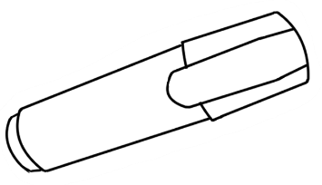

How many?
Level B

______phones | _______mugs | _____pencil cases | 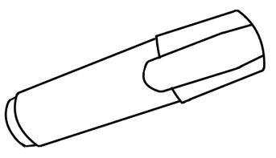  _____highlighters
_____pairs  of glasses | 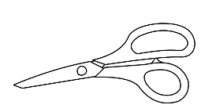  _____pairs  of scissors | _______rulers | _____workbooks

How many?
Level C

______phones | _______mugs | _____pencil cases | 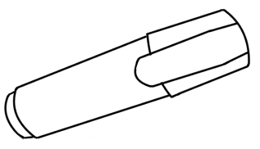  _____highlighters
_____ pairs  of glasses | _____ pairs  of scissors | ______ rulers | _____workbooks
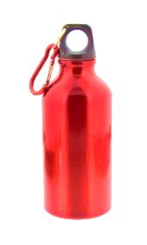  _____ bottles  of water | _____ packets of chips   | ______ apples |   _____ notebooks

Instructions in class

Activity 1 – Classroom instructions
Cut up the instructions on the following two pages. Introduce these gradually to the class. Keep in a box, and as they are introduced, students can take one and instruct a partner, a small group or the whole class. Repeat until students are familiar with all the instructions.

Activity 2 – A polite version of the game ‘Simon says’

Substitute Please for Simon says, so that students only follow the instructions if it is prefaced with Please. Vary some of the instructions to include familiar vocabulary. e.g. stand up, turn right, walk around your chair, sit down, open your book, pick up your pen, look at the teacher, open your bag etc

Activity 3 - Pair Work - Give and follow instructions

Activity 1
Please stand up. | Please sit down.
Turn on the light. | Turn off the light.
Look at the board. | Look at me.
Look to your left. | Look to your right.
Open  your workbook. | Close  your workbook.
Open the door. | Close the door.
Walk slowly  to the door. | Walk quickly  to the door.
Please stand  in a circle. | Please stand  in a line.
Write your name  on the board. | Write number 9  on the board.
Smile. | Take a photo.
Walk slowly  to the window. | Ask your teacher  to check.

Activity 3
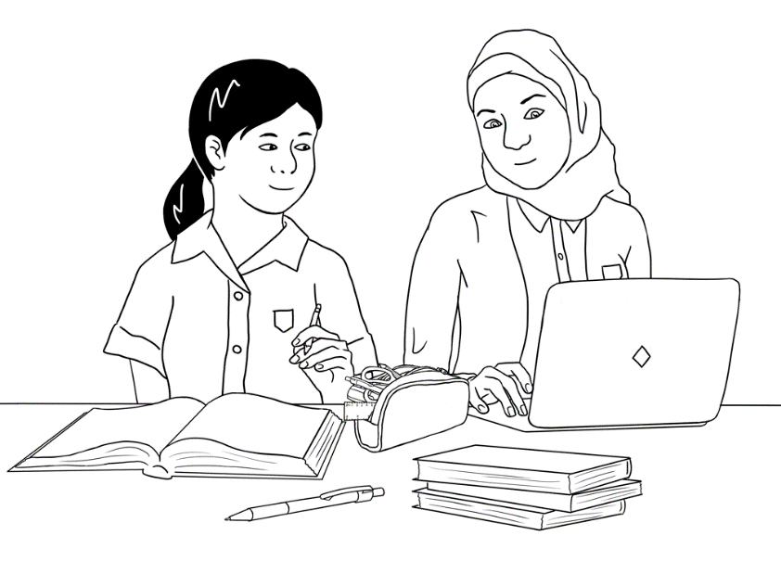
Give instructions to your partner.
Student A
- Circle the pen.
- Colour the pencil case blue.
- Underline the word students.

- Colour the three books yellow.
2. Write your name next to the laptop.
We are students.

Fold
Listen to your partner.
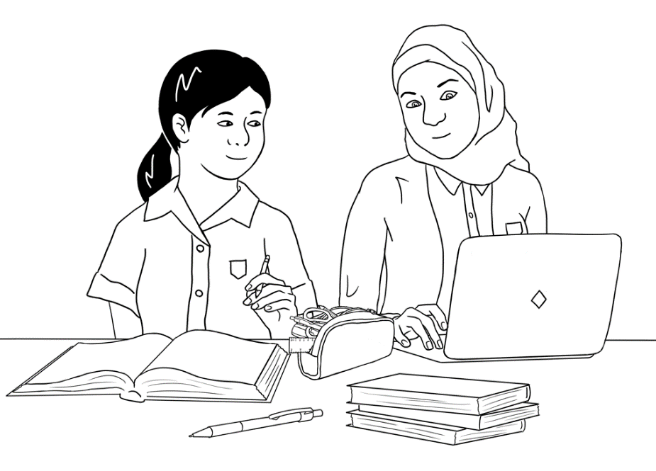
We are good friends.

Listen to your partner.
Student B
We are students.

Fold
Give instructions to your partner.
- Circle the three books.
- Colour Mai’s book green.
- Underline the word good.
4. Colour the pen red.
2. Write your name on the laptop.
We are good friends.

The community centre

Activity 1 – Punctuation – capitals and full stops
This worksheet is an introduction to reading a floor plan and a revision of work on basic punctuation. Before giving out the worksheet:
- Project the floor plan.
- Ask open and closed questions about what is represented on the plan. [Draw attention to the rising and falling intonation in the questions.]
e.g. How many rooms? Fire exits? Toilets?
What room is next to room2? etc
Is there a canteen? A reception? A library? etc
- Revise the use of capitals and full stops.
- On the worksheet, ask students to point to particular rooms and places on the plan.
- Students copy the sentences, adding capitals and full stops.

Activity 2 – Information about my learning centre.
Preparation
- Copy the ‘My learning centre’ page.
- Write the required information on the board.
- Say the relevant words and students repeat:
centre’s name, address, phone number, start and finish times, teacher’s name, class name, class days.
- Students copy the information from the board and read the completed information with a partner.

The community centre floor plan
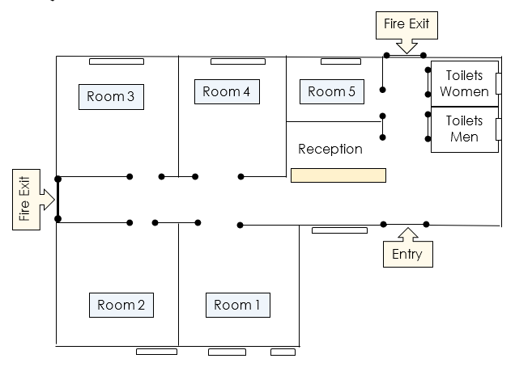
Listen to the teacher.
Point to places on the plan.

Write the sentences with capitals and full stops.
- on tuesday morning ming is in room 4
On Tuesday morning Ming is in room 4. .
- on wednesday afternoon ming is in room 4
_________________________________________________________
- on friday morning ming is in room 3
_________________________________________________________
- on thursday morning the centre is closed
_________________________________________________________
- on thursday afternoon the centre is closed
_________________________________________________________
My learning centre


Copy from the board.

Centre name ______________________________________________
Address ______________________________________________
______________________________________________
Phone ______________________________________________

Centre Hours
Monday ________________________________
Tuesday ________________________________
Wednesday ________________________________
Thursday ________________________________
Friday ________________________________
Saturday ________________________________
Sunday ________________________________

My teacher’s name ____________________________________________

My class name _____________________________________________

My timetable
Write the times.
Mon | Tues | Wed | Thurs | Fri | Sat

Signs in the community centre
Where are these signs in the community centre?


 |  |  | 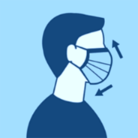 | 
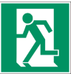 |  |  |  | 
 |  |  |  | 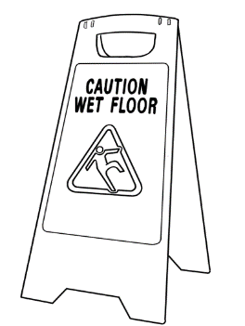

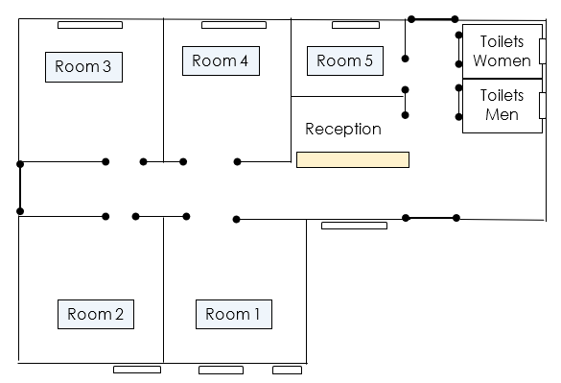

A class timetable
Activity - Reading Carim’s timetable.
- Copy the worksheet on following page.
- Introduce new vocab - computers, room numbers e.g. A31.
- Project the timetable.
- Focus on a day and ask questions about start and finish times, room numbers etc.
- Give students a copy of the worksheet, read the introductory sentences and ask some additional questions about the days and times on the timetable.
- Students complete the yes/no exercise and copy the sentences into their notebooks.
*Confident students can be encouraged to use the model to construct sentences about their own timetable.

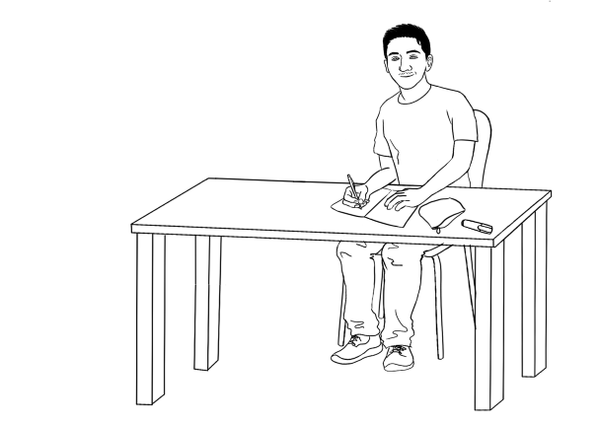
Carim’s timetable
Listen to the teacher.

Carim learns English at TAFE.
This is his timetable.

 | Mon | Tues | Wed | Thurs | Fri
Morning  Start  Finish | Room A31  9:00  12:00 | Room B4  9:30  12.30 | Room H6  9:00  12:00 | Room A31  8:30  12:00 | Room H6 9:00  1:00
Lunch break
Afternoon  Start  Finish | Computers  12:30  2:30 | Room B4  1:00  3:00 | Room H6  1:00  4:00 | Room A31  1:00  3:00
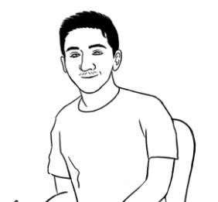
I start class at 9 o’clock on Monday.

 | 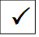  Tick. | Yes | No
1 | I start class at 9:00 on Monday.
2 | I start class at 9:00 on Tuesday.
3 | I finish class at 4:30 on Wednesday.
4 | I have lunch at 12:30 on Thursday.
5 | I finish class at 4:00 on Thursday.
6 | I finish class at 1:00 on Friday.


Copy the sentences into your notebook.

Talk about family and friends
Activity - Description dictation

There are two dictations at two levels. Dictate only one section at a time.
Remind students to use capital letters at the beginning of a sentence, and for the first letter in a country and the day of a week. Before the dictations, practise the initial blends included in the texts: fr, sh, bl, st, pl, th

- Dictation 1: Students can refer back to soccer, they, play and
the words are introduced in the student book.
- Dictation 2: She is spelt in the text once. After that, students need to refer back to the original she and copy.
- Encourage students to check their work.

- Bao and Abdi play soccer.
They play soccer on the weekend.
They play at the park.
Bao and Abdi play soccer on sunny days.

- Fatima is my friend.
She comes from Syria.
She is short.
She has blue eyes.
Fatima is a Year 9 student.
She plays netball on Friday.
She is hard-working and friendly.

At the end of each dictation, students could copy the sentences either under the original ones or in their notebooks.

Dictation 1- Level A

Bao and Abdi play _ occer.
They _ _ _ _ _ occer on the _ eekend.
_ _ _ _ _ _ _ _ at the _ark.
A a | B b | C c | D d | E e | F f | G g | H h | I i | J j | K k | L l | M m
N n | O o | P p | Q q | R r | S s | T t | U u | V v | W w | X x | Y y | Z z
Bao and Abdi _ _ _ _ _ occer on _ unny _ ays.

pl th
Dictation 1 - Level B

Bao and Abdi play _occer.
They _ _ _ _ _ occ _ _ on the _ eekend.
_ _ ey _ _ _ _ at _ _e _ark.
Bao and Abdi _ _ ay _ occ_ _ _ _ _ unny _ ays.

A a | B b | C c | D d | E e | F f | G g | H h | I i | J j | K k | L l | M m
N n | O o | P p | Q q | R r | S s | T t | U u | V v | W w | X x | Y y | Z z

Dictation 2 - Level A

  - Fatima is _y _ riend.
  - She _ omes _ rom _ yria.
  - _____ is shor_.
  - _____ has _ lue eyes.
  - Fatima is a Year 9 __tudent.
  - _____ _ lays _ etball on _ riday.
A a | B b | C c | D d | E e | F f | G g | H h | I i | J j | K k | L l | M m
N n | O o | P p | Q q | R r | S s | T t | U u | V v | W w | X x | Y y | Z z
  - _____ is hard-working and _ riendly.

Dictation 2 - Level B
fr sh bl st pl

  - Fatima is _y _ _ ien_.
  - She _ omes _ _ om _ yria.
  - _ _ _ is _ _ or _.
  - _ _ _ ha_ _ _ ue eye_.
  - Fatima i_ a Year 9 _ _uden_.
  - _ _ _ play_ _ etbal_ on _ _ iday.
A a | B b | C c | D d | E e | F f | G g | H h | I i | J j | K k | L l | M m
N n | O o | P p | Q q | R r | S s | T t | U u | V v | W w | X x | Y y | Z z
  - _ _ _ is _ard-working and _ _ iendly.

Homework
Copy the sentences here and into your notebook.
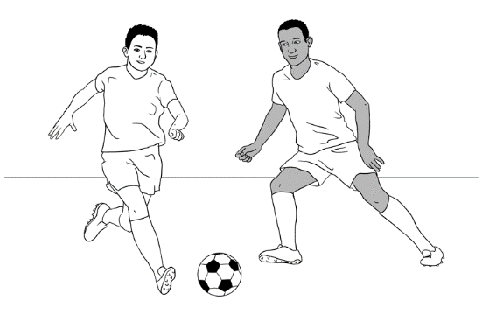
- Bao and Abdi play soccer.
_________________________________________________
- They play on the weekend.
_____________________________________________________________
- They play at the park.
_____________________________________________________________
- They play soccer on sunny days.
_____________________________________________________________

Copy the sentences here and into your notebook.
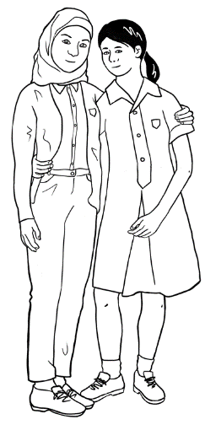
- Fatima is my friend.
_________________________________________________
- She comes from Syria.
_____________________________________________________________
- She is short.
_____________________________________________________________
- She has blue eyes.
_____________________________________________________________

The weather
Activity 1 - A weather chart – Pair work

What’s the weather like in Sydney?
Student A
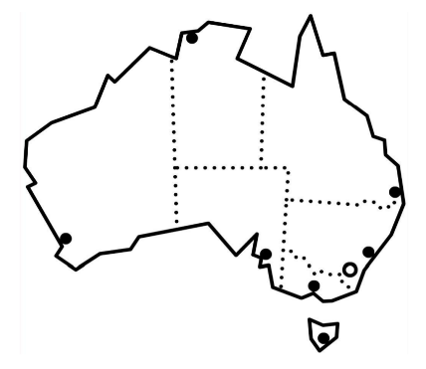
Sydney

  sunny |   cloudy |   windy |   rainy |   stormy

What’s the weather like on Monday?
Ask your partner
Write on the chart.
Sydney weather
Monday | Tuesday | Wednesday | Thursday
______________ | rainy | ______________ | sunny
Friday | Saturday | Sunday
_____________ | windy | ____________

What’s the weather like in Sydney?
Student B
Sydney

sunny | cloudy | windy | rainy | stormy

What’s the weather like on Tuesday?
Ask your partner
Write on the chart.
Sydney weather
Monday | Tuesday | Wednesday | Thursday
sunny | _____________ | rainy | ____________
Friday | Saturday | Sunday
cloudy | ___________ | stormy

Activity 2 - A weather chart with temperatures – Pair work
Draw this table on the board.
 | windy | sunny | rainy | cloudy | stormy
Mon |  | 19
Tues
Wed
Thur
Fri
Sat

- Students need to listen, tick the box and write the temperature.
- Demonstrate the exercise by reading and asking students to come to the board, tick the appropriate box on the chart and write temperature.
Read: On Monday the weather is sunny. Tick under sunny.
It’s 19 degrees on Monday. Write 19.
On Tuesday it’s cloudy. Tick under cloudy.
It’s 9 degrees on Tuesday. Write 9.
On Wednesday it’s rainy. Tick under rainy.
It’s 12 degrees on Wednesday. Write 12.
Encourage students to show their understanding.
Don’t understand?  Can you say that again please?  Did you say sunny?  Did you say 19?  Did you say Monday?  Shake your head. | Understand.  Yes.  Ah ha.  Ok.  Good.  Nod your head.

Student A
Are you ready?
Ask your partner

Read slowly to your partner.

On Monday it’s windy. Tick under windy.
It’s 11 degrees on Monday. Write 11.
On Tuesday it’s rainy. Tick under rainy.
It’s 9 degrees on Tuesday. Write 9.
On Wednesday it’s windy. Tick under windy.
It’s 10 degrees on Wednesday. Write 10.
 | rainy | stormy | cloudy | windy | sunny
Mon |  |  |  | 11
Tues | 9
Wed |  |  |  | 10
Thur
Fri
Sat

Listen to your partner.
Write on the chart.
Student B
Listen to your partner.
Write on the chart.
 | rainy | stormy | cloudy | windy | sunny
Mon
Tues
Wed
Thur |  | 8
Fri |  |  | 12
Sat |  |  |  |  | 15
Read slowly to your partner.

On Thursday the weather is stormy. Tick under stormy.
It’s 8 degrees on Thursday. Write 8.
On Friday it’s cloudy. Tick under cloudy.
It’s 12 degrees on Friday. Write 12.
On Saturday it’s sunny. Tick under sunny.
It’s 15 degrees on Saturday. Write 15.
Check your work with your partner.
Activity 3 – Talking about the weather using connectives – and, but
Project the two charts. Divide the class in two and read like a chant. Swap roles.

Student A | Student B
What’s the weather like? | 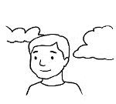  It’s cloudy and warm.
What’s the weather like? | 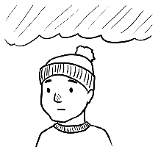    It’s windy and cold.
What’s the weather like? |   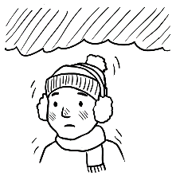  It’s rainy and very cold.
What’s the weather like? | 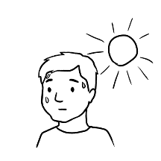  It’s stormy and hot.
What’s the weather like? | 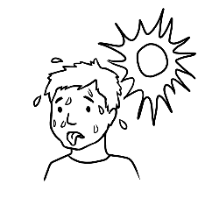    It’s sunny and very hot.

Student A | Student B
What’s the weather like? |   It’s cloudy but not rainy.
What’s the weather like? | It’s windy but not cold.
What’s the weather like? |   It’s sunny but not hot.
What’s the weather like? | It’s stormy but not cold.
What’s the weather like? | 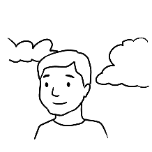  It’s sunny but not warm.

The Medical Centre
Dr Kim Tran
35 North Road, Kellivale
Phone: 6527 8344
Mr Tom Dean
has an appointment
at 9:30 am
on Thursday 7 June

Read the appointment card.

Match questions and answers.
Questions |  | Answers
- What is this card? |  | Mr Tom Dean
- Who is the appointment for? |  | 35 North Road, Kellivale
- Who is the doctor? |  | an appointment card
- What is the doctor’s address? |  | Dr Kim Tran
- What is the telephone number? |  | 9:30 am
- What day is the appointment? |  | 7 June
- What time is the appointment? |  | 6527 8344
- What date is the appointment? |  | Thursday
Read the questions and answers with a partner.
Matching dates and times

 | 1 February 2021 |  | 30. 9. 52
 | 19 April 2015 |  | 8. 6. 98
 | 30 September 1952 |  | 1. 2 . 21
 | 5 October 1941 |  | 9. 11. 77
 | 8 June 1998 |  | 15. 1. 65
 | 21 May 1989 |  | 19. 4. 15
 | 15 January 1965 |  | 21. 5. 89
 | 9 November 1977 |  | 14. 12. 02
 | 14 December 2002 |  | 16. 8. 49
 | 16 August 1949 |  | 5 / 10 /41
Match the dates.

Match the times.
 | One o’clock |  | 7:00
 | Three thirty |  | 12:30
 | Seven o’clock |  | 2:30
 | Nine thirty |  | 1:00
 | Twelve thirty |  | 5:30
 | Six o’clock |  | 9:30
 | Two thirty |  | 12:00
 | Eleven thirty |  | 3:30
 | Five thirty |  | 6:00
 | Twelve o’clock |  | 11:30

Read the medical centre instructions.
- Do not enter if you have COVID -19 symptoms .
- Do not come late.
- You must check in.
- Have your Medicare card ready.
- Sit down and wait for the doctor.

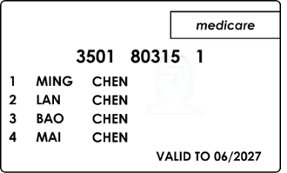


Tick one.

These instructions are at the medical centre for the patient.

for the doctor.
Write the words.
Number the instructions.
1

Sit down and wait for the ________________.

You must ______________ ______________.

Do ______________ enter if you have COVID-19 symptoms.

Have your Medicare ______________ ready.

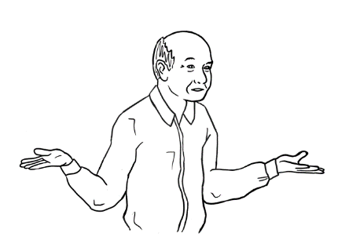
Do not ______________ late.

Sorry. I don’t understand.

Can you check my work please?
Ask your partner

Audio files and transcripts
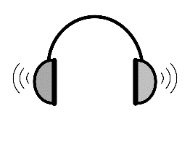
1
Where is the Community Centre?
[Student Book Section 14, Pages 29-30]

MP3 files

Transcript
Student A Excuse me, where is the Community Centre?
Student B The Community Centre? Oh, it’s in Kemp Street.
It’s an old building. It has a red roof
and a brown fence.
There’s a small tree near the front door.
Student A Did you say a red roof?
Student B Yes, that’s right and a brown fence.
Student A Ok. thank you.

2
Mai talks about Fatima [Student Book Section 17, Page 43]

MP3 files

Fatima is my friend.
She comes from Syria.
She is short.
She has blue eyes.
Fatima is a Year 9 student.
She plays netball on Friday.
She is hard-working and friendly.
Transcript

3
Lan talks about Nisha [Student Book Section 17, Page 44]

Transcript
MP3 files

Nisha is my friend.
She comes from India.
She works in a childcare centre.
Nisha is tall.
She has long, wavy hair.
She likes reading.
Nisha is a good friend.

4
Bao talks about Abdi [Student Book Section 17, Page 45]

MP3 files

Abdi is my friend.
He comes from Somalia.
He goes to uni.
Abdi is tall.
He has short, curly hair.
He likes playing soccer.
Abdi is a good friend.
Transcript

