English Ready
22637VIC Course in EAL
VU23577 - Recognise and use numbers and money from 50 to 100
for highly familiar activities

Numbers and money
50 - 100
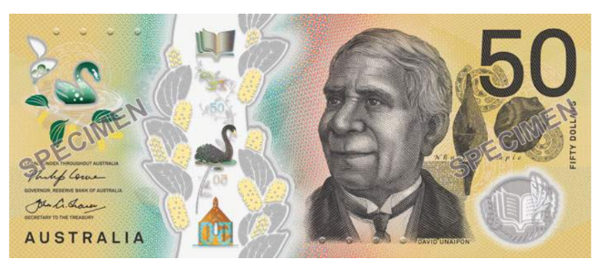
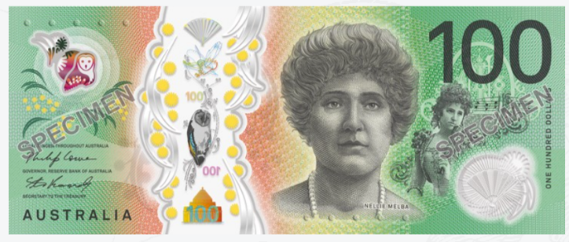

Teacher _______________________________________________________________
Class ___________________________________________________________________
Date____________________________________________________________________

Name __________________________________________________________________
This workbook is designed to be used with the support of a teacher.

Design team: Sue Paull, Vicki Hambling, Nikeh Shariatian, Bernie Miles and Mary Wallace
Illustrations: Madelena Scott
Image acknowledgements:
Biscuits This Photo by Unknown Author is licensed under CC BY-NC
Box with sticky tape - a href="https://www.freepik.com/free-vector/sticker-design-with-empty-box-closed-isolated_
100th birthday cake - This Photo by Unknown Author is licensed under CC BY-NC-ND
Cake box - <a href="https://www.freepik.com/icon/cake-box_6680318">Icon by small.smiles</a>

Acknowledgements: The design team would like to acknowledge the use of the EAL Framework which underpins the design of this book.
Copyright of the EAL Framework is reserved to the Crown in the right of the State of Victoria. © State of Victoria (Department of Education and Training) 2023.
_________________________________________________________________________________________
This English Ready Resource is licensed under a Creative Commons Attribution-NoDerivs 3.0 Australia licence (More information is available here). You are free to use, copy and distribute to anyone in its original form as long as you attribute Department of Home Affairs as the author and you license any derivative work you make available under the same licence.
© Commonwealth of Australia 2024

With the exception of the Commonwealth Coat of Arms, the department’s logo, any material protected by a trade mark and where otherwise noted all material presented in this document is provided under a Creative Commons Attribution 4.0 International (https://creativecommons.org/licenses/by/4.0/) licence.
The details of the relevant licence conditions are available on the Creative Commons website (accessible using the links provided) as is the full legal code for the CC BY 4.0 licence (https://creativecommons.org/licenses/by/4.0/legalcode).
Use of all or part of this document must include the following attribution:
© Commonwealth of Australia 2023
As far as practicable, material for which the copyright is owned by a third party will be clearly labelled. The department has made all reasonable efforts to ensure that this material has been reproduced in this document with the full consent of the copyright owners.
Copyright requests and enquiries concerning usage not addressed by the CC BY 4.0 licence should be addressed to:
comms@homeaffairs.gov.au at the Department of Home Affairs.
The terms of use for the Commonwealth Coat of Arms are available from the It's an Honour website.
Where a copyright owner, other than the Commonwealth, is identified with respect to this material, please contact that third party copyright owner directly to seek permission.



Contents
1. Instructions 4
2. Meet the students and teachers. 5
3. Numbers 1 - 50 6
4. Numbers 50 - 100 8
5. Did you say 15 or 50? 14
6. Before and after 16
7. Add the numbers. 18
8. Money 20
9. Morning tea 26
10. At a café 30
11. At a men’s clothes shop 34
12. At an office shop 38
13. Let’s go out. 42

Instructions
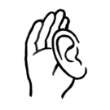
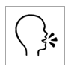
 | 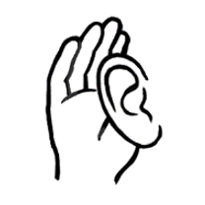 | listen |  |  | say
 |  | read |  | 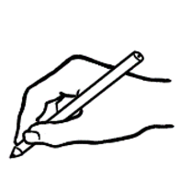 | write
 | 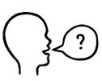 | ask |  |  | copy
 | 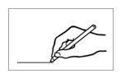 | match |  | 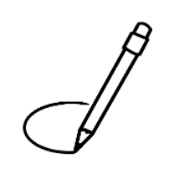 | circle
 |  | highlight |  |  | tick
 | 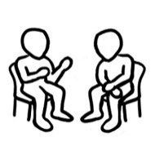 | work with  a partner |  | 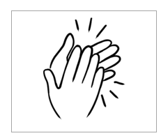 | clap

Meet the students and teachers.

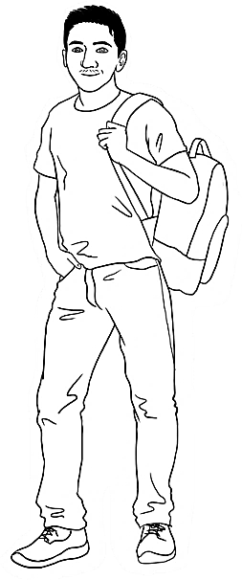
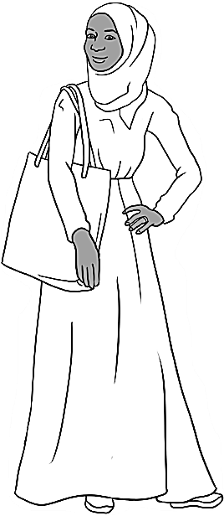
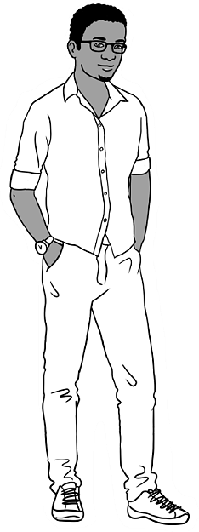
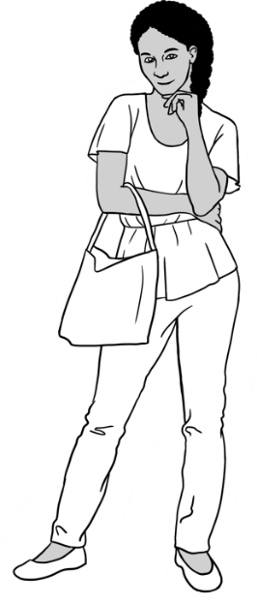
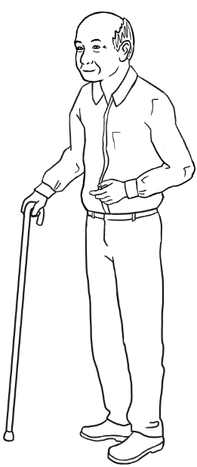
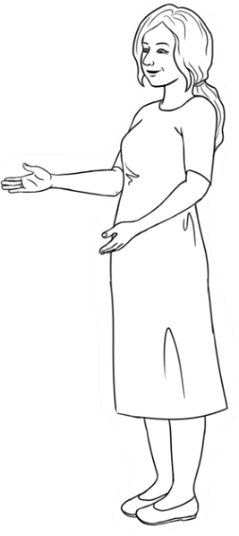
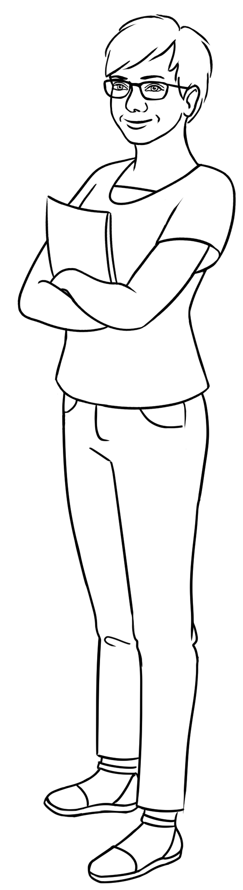
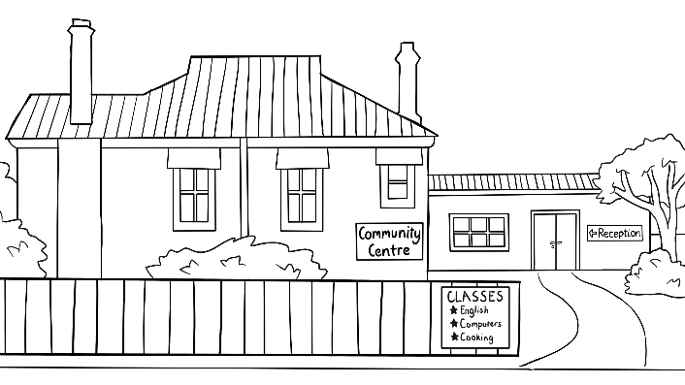
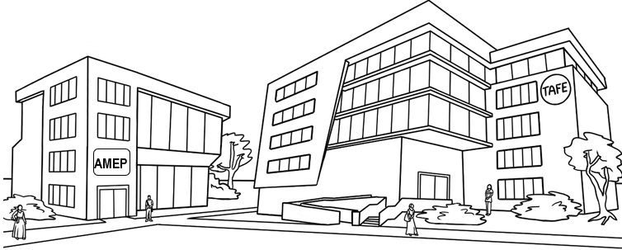
Carim Sahra Tahiil Anika Ming
The students
The teachers
Jenny Wendy
The learning centres

Numbers 1 - 50
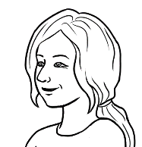
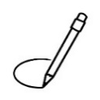
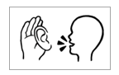
Circle 5.

Row a.
Highlight 8 and 14.
0 | 1 | 2 | 3 | 4 | 5 | 6 | 7 | 8 | 9
10 | 11 | 12 | 13 | 14 | 15 | 16 | 17 | 18 | 19
20 | 21 | 22 | 23 | 24 | 25 | 26 | 27 | 28 | 29
30 | 31 | 32 | 33 | 34 | 35 | 36 | 37 | 38 | 39
40 | 41 | 42 | 43 | 44 | 45 | 46 | 47 | 48 | 49
50
2.
a. | 2 | 4 | 6 | 8 | 10 | 12 | 14 | 16 | 18 | 20
b. | 3 | 6 | 9 | 12 | 15 | 18 | 21 | 24 | 27 | 30
c. | 4 | 8 | 12 | 16 | 20 | 24 | 28 | 32 | 36 | 40
d. | 5 | 10 | 15 | 20 | 25 | 30 | 35 | 40 | 45 | 50
e. | 6 | 12 | 18 | 24 | 30 | 36 | 42 | 48



0 | 1 | 2 | 3 | 4 | 5 | 6 | 7 | 8 | 9
1
10 | 11 | 12 | 13 | 14 | 15 | 16 | 17 | 18 | 19
20 | 21 | 22 | 23 | 24 | 25 | 26 | 27 | 28 | 29
30 | 31 | 32 | 33 | 34 | 35 | 36 | 37 | 38 | 39
40 | 41 | 42 | 43 | 44 | 45 | 46 | 47 | 48 | 49
50

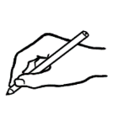
0 | 1 | 2 |  | 4 | 5 | 6 |  | 8
10 |  | 12 | 13 |  | 15 |  | 17 | 18
 | 21 |  | 23 | 24 |  | 26 | 27 |  | 29
30 |  | 32 |  | 34 | 35 | 36 |  | 38 | 39
 | 41 |  | 43 |  | 45 |  | 47 | 48
50

Numbers 50 - 100
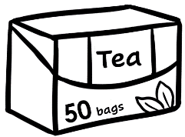 | 
50 | 51 | 52 | 53 | 54 | 55 | 56 | 57 | 58 | 59
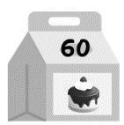 | 
60 | 61 | 62 | 63 | 64 | 65 | 66 | 67 | 68 | 69
Circle 56.
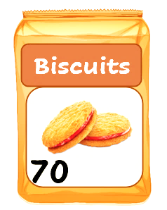 | 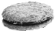
70 | 71 | 72 | 73 | 74 | 75 | 76 | 77 | 78 | 79
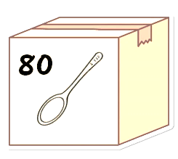 | 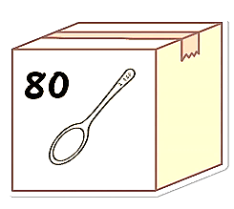   | 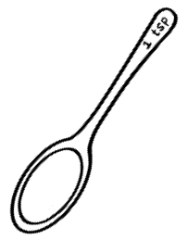 |  | 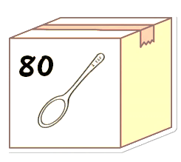
80 | 81 | 82 | 83 | 84 | 85 | 86 | 87 | 88 | 89
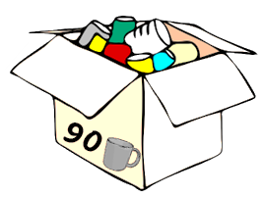 |  |  |  |  |  |  |  |  | 
90 | 91 | 92 | 93 | 94 | 95 | 96 | 97 | 98 | 99
100
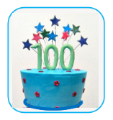

Circle 52.

50 | 51 | 52 | 53 | 54 | 55 | 56 | 57 | 58 | 59
60 | 61 | 62 | 63 | 64 | 65 | 66 | 67 | 68 | 69
70 | 71 | 72 | 73 | 74 | 75 | 76 | 77 | 78 | 79
80 | 81 | 82 | 83 | 84 | 85 | 86 | 87 | 88 | 89
90 | 91 | 92 | 93 | 94 | 95 | 96 | 97 | 98 | 99
100

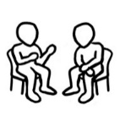
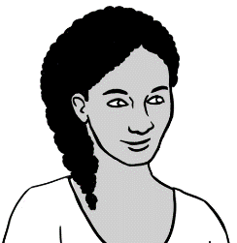
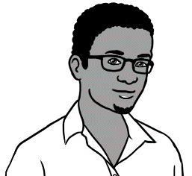
What’s that number?
76.
What’s = What is

- 4.

50 | 51 | 52 | 53 | 54 | 55 | 56 | 57 | 58 | 59
60 | 61 | 62 | 63 | 64 | 65 | 66 | 67 | 68 | 69
70 | 71 | 72 | 73 | 74 | 75 | 76 | 77 | 78 | 79

50  50 | 51 | 52 | 53 | 54 | 55 | 56 | 57 | 58 | 59
60 | 61 | 62 | 63 | 64 | 65 | 66 | 67 | 68 | 69
70 | 71 | 72 | 73 | 74 | 75 | 76 | 77 | 78 | 79
80 | 81 | 82 | 83 | 84 | 85 | 86 | 87 | 88 | 89
90 | 91 | 92 | 93 | 94 | 95 | 96 | 97 | 98 | 99
100
50 | 51 | 52 |  | 54 |  | 56 | 57 |  | 59
60 | 61 |  | 63 |  | 65 | 66 |  | 68
 | 71 | 72 |  | 74 | 75 |  | 77 |  | 79
80 |  | 82 | 83 | 84 |  | 86 |  | 88 | 89
90 | 91 |  | 93 |  | 95 |  | 97 | 98

a. | 66 | 67 | 68 |  | b. | 71 | 72 | ______
c. | ______ | 75 | 76 |  | d. | 69 | ______ | 71
e. | ______ | 58 | 59 |  | f. | 79 | 80 | ______
g. | 48 | ______ | 50 |  | h. | 88 | ______ | 90
i. | 62 | ______ | 64 |  | j. | 50 | 51 | ______
k. | 89 | ______ | 91 |  | l. | ______ | 56 | 57
m. | 70 | ______ | 72 |  | n. | 40 | ______ | 42
- 2.
73 |  | 67 |  | 49 |  | 57 |  | 70 |  | 74 |  | 89
81 |  | 63 |  | 52 |  | 90 |  | 71 |  | 55 |  | 41

- 2.

 | 50 |  | 51 | 58 |  | 59 |  | 65 |  | 73 |  |  | 75
 | 53 |  | 52 |  | 60 |  |  |  | 74 |  | 72 |  | 71
 |  |  |  |  |  |  | 58
 | 54 |  |  | 61 |  | 57 |  | 75 |  | 69 |  |  | 70
 |  |  | 62 |  |  |  |  |  |  |  | 89
 | 55 |  |  | 56 |  |  | 76 |  |  | 96 |  | 85
 |  |  |  |  |  |  |  |  | 68
 | 64 |  | 63 | 59 |  | 67 |  |  |  |  | 84
 |  |  | 54 |  |  |  | 77
 | 65 |  |  | 66 |  |  | 78 |  | 83 |  |  | 81 | 86
 | 67 |  |  |  | 79
 |  |  | 96 |  | 80 |  | 81 |  | 82 |  | 87
 | 97 |  |  |  |  |  | 89 |  |  |  |  |  | 78
 |  | 92 | 95 |  | 94 |  |  | 99 |  | 91 |  | 88
 | 98 |  |  |  | 96 |  | 93
 |  |  | 99 |  |  |  |  |  | 92 |  | 90 |  | 89
 |  |  |  |  |  |  | 100

Did you say 15 or 50?

 | 13 | 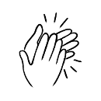 |  | 30
 | 14 |  |  | 40
 | 15 |  |  | 50
 | 16 |  |  | 60
 | 17 |  |  | 70
 | 18 |  |  | 80
 | 19 |  |  | 90

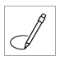
In a,
circle 13.

a. | 13 | 30 |  | b. | 14 | 40
c. | 15 | 50 |  | d. | 16 | 60
e. | 17 | 70 |  | f. | 18 | 80
g. | 19 | 90 |  | h. | 15 | 50
i. | 16 | 60 |  | j. | 17 | 70
k. | 18 | 80 |  | l. | 19 | 90

Under a,
write 50.
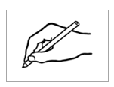

a. | b. | c. | d. | e. | f.
50
g. | h. | i. | j. | k. | l.

Before and after
What’s the number before 57
and the number after 57?

before | 57 | after
56 | 57 | 58

before | the number | after
- 49 | 50 | 51
 | 65
 | 74
 | 88
 | 91
 | 69
 | 70
 | 99

Write the number before 54.

- 53

Write the number after 67.

- 68

a. 54 52 53 | b. 60 58 59 | c. 67 66 68
. 52 . . 53 54 . | ___ ___ ___ | ___ ___ ___
d. 71 73 72 | e. 86 85 84 | f. 100 98 99
___ ___ ___ | ___ ___ ___ | ____ ___ ___

Add the numbers.
- 2.
a. | 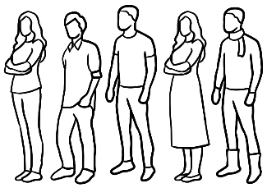  5 people | + |  | 5 people |  | = 10 people
b. | 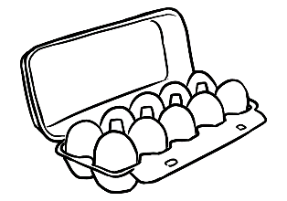  10 eggs | + | 10 eggs |  | = 20 eggs
c. | 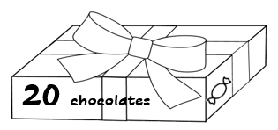  20 chocolates | + | 20 chocolates |  | = 40 chocolates
d. | 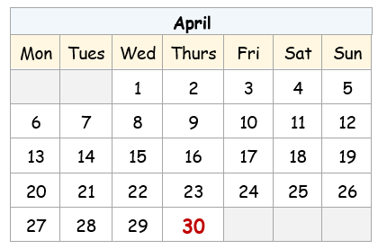  30 days | + | 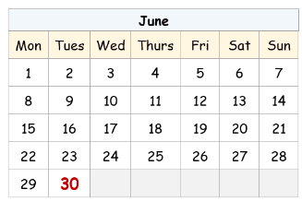  30 days |  | = 60 days
e. | 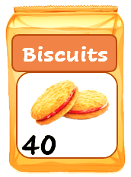  40 biscuits | + | 40 biscuits |  | = 80 biscuits
f. | 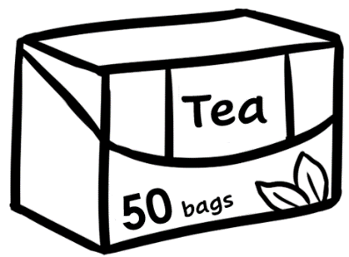  50 tea bags | + | 50 tea bags |  | = 100 tea bags

How many is that?
a.a. | . 50 . teabags | + |   . 3 . teabags | = . 53 . teabags
b. | 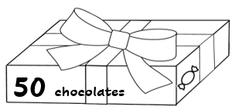  _____ chocolates | + | 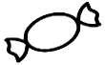  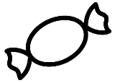  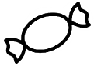  _____ chocolates | = _____ chocolates
c. | 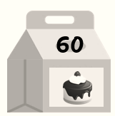  _____ cakes | + |           _____ cakes | = _____ cakes
d. | 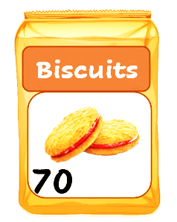  _______ biscuits | + | 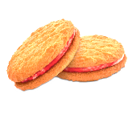  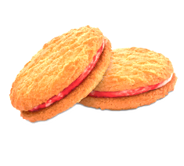  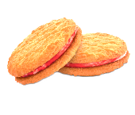  _____ biscuits | = _____ biscuits
e. | _____ spoons | + | 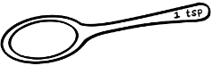  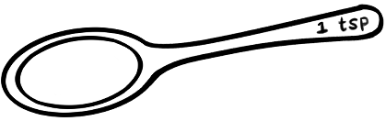  _____ spoons | = _____ spoons
f. | 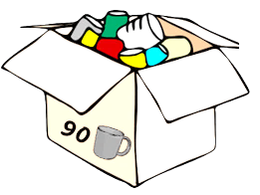  _____ mugs | + |     _____ mugs | = ______ mugs
- 2.

Money
How many cents?
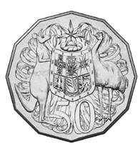 | 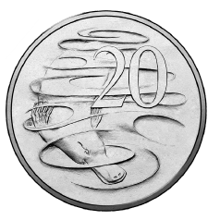 | 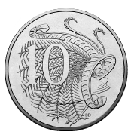 | 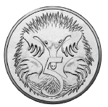
50 cents | ______ cents | ______ cents | ______ cents
c = cents

- 15 c |  | - _______c
- ______ c |  | - ______ c
- ______ c |  | - ______ c

How many dollars?
- 2.

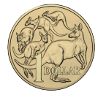
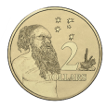
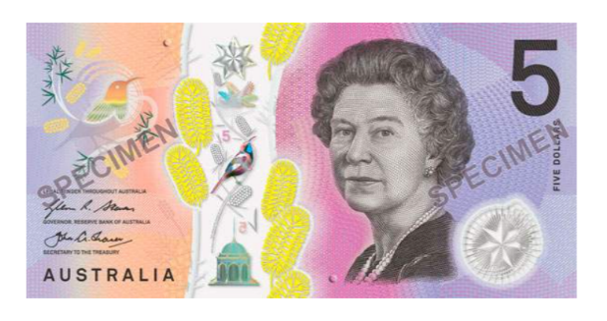
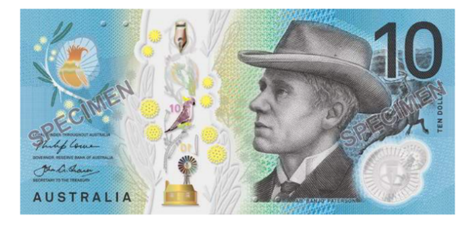
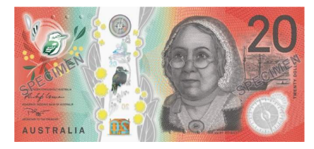
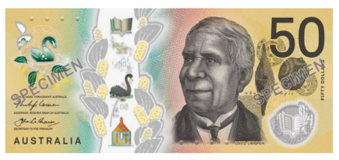
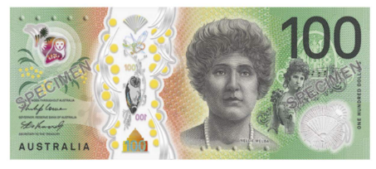
$ = dollar
$2
$2
$10
_____
$50
_____
$1
_____
$100
_____
$20
_____
$5
_____

That’s $10.50
- 2.
 | 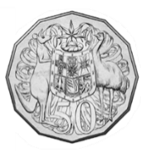  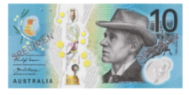 | $10.50
 | 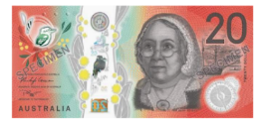 | ___________
 | 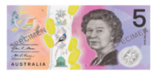 | _________
 | 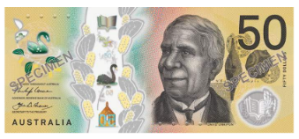 | _________
 |  | _________
 |  | _________
 |  | _________
 |  | _________

- 2.
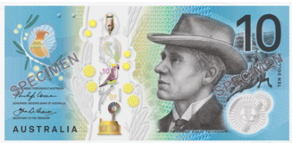 |  | 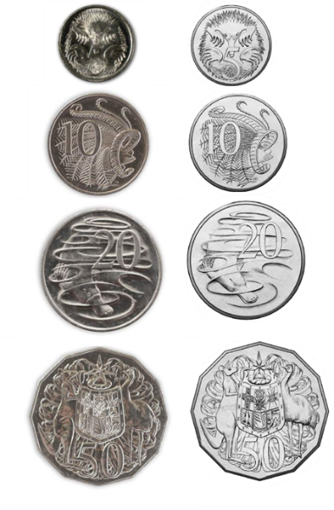
$10 | + | 50c | = | $10.50
________ | ___ | ________ | ___ | __________
b.
$20 | + | 50c | = | $20.50
_______ | ___ | _______ | ___ | __________
c.

$20 | + | $5 | = | $25
_______ | ___ | _______ | ___ | __________
d.
$50 | + | 50c | = | $50.50
______ | ___ | ______ | ___ | ________
e.
$50 | + | $1 | = | $51
______ | ___ | ______ | ___ | ______

 |  |  |  | How much is that?
$50 | + | $2 | = | $52
b.
$50 | + | $5 | = | _______
c.

$50 | + | $10 | = | _______
$50 | + | $20 | = | _______
$50 | + | $50 | = | ________

a.
$20 | + | $50 | = | $70
b.
 | + |  | =
c.

 | + |  | =
d.
 | + |  | =
 | + |  | =

Morning tea
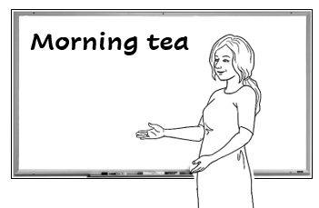
Let’s have morning tea
with another class
next Tuesday.

What do we need
for morning tea?
2.
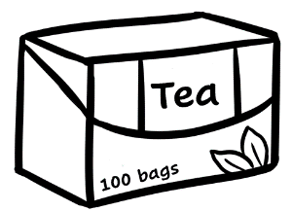  tea bags | 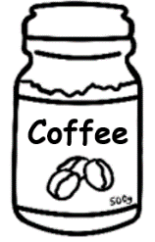  coffee | 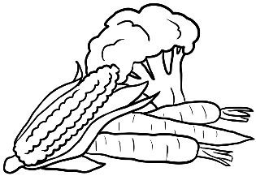  vegetables | 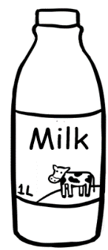  milk
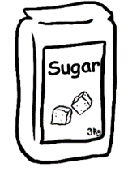  sugar | 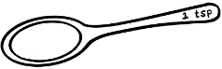  spoons |   biscuits |       cakes
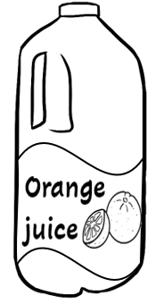  juice | 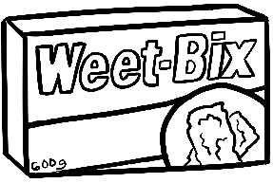  cereal | mugs | 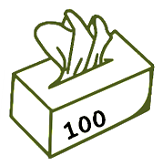  tissues
cereal = breakfast food
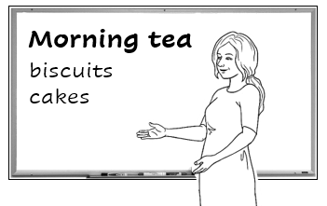
Who can make some biscuits and cakes? We need enough
for 50 people.

enough =
What do we need to buy?

We have |  |  | We need
Aa | 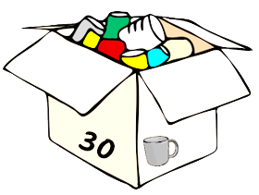  30 mugs |  | _____ mugs
bb | 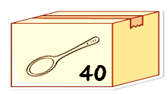  40 spoons |  | _____ spoons
Cc | No milk |  | _____ litres of milk
Dd | No tea bags |  | _____ box of tea bags
ee | No coffee |  | _____ jars of coffee
d  f | No sugar |  | _____ kilos of sugar
Eg | 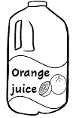  No juice |  | _____ litres of juice
hh |   No tissues |  | _____ box of tissues

There’s a sale at the supermarket.


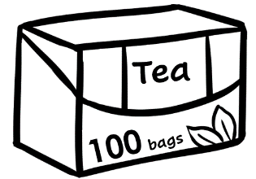
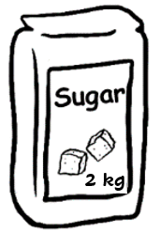
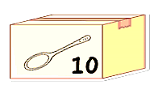

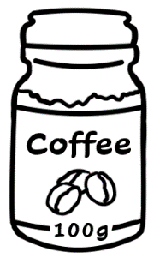
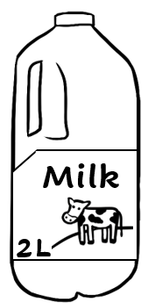
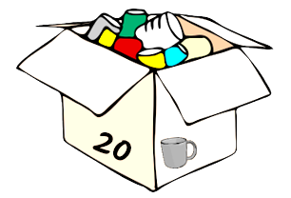

Supermarket

______

2 for
______

10 for ______

______

2 for
______

20 for ______

2 for
______

How much are the mugs?
How much is the coffee?
2 for $26
$12


coffee $ 26 .
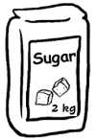
sugar $ 3 .

Total $29 .
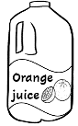
juice $_____
tissues $ _____

Total $ .

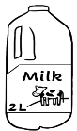
tea $_____
milk $ _____

Total $ .
spoons $_____
mugs $ _____
Total $ .


I’ll buy the coffee
and sugar.


I’ll buy the juice
and tissues.

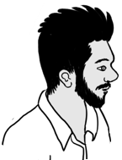
I’ll buy the tea
and milk.

I’ll buy the spoons
and mugs.

At a café
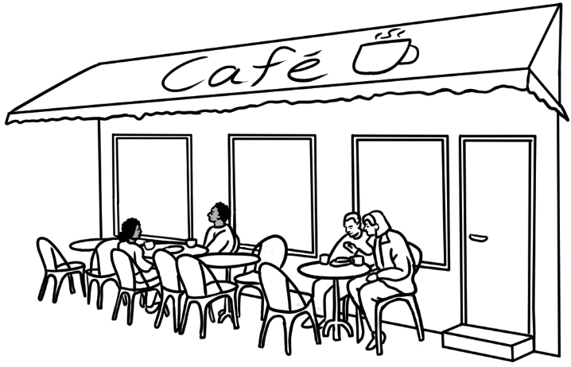
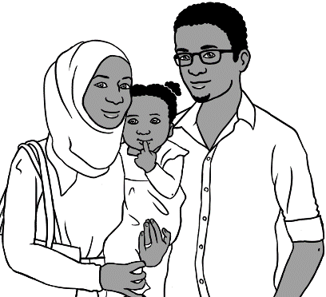
Let’s go to a café for lunch.
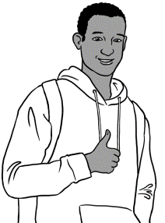
Good idea.

Food Drinks
Sandwich $12.00 Tea $4.00

Salad $10.50 Coffee $5.00

Pizza $22.00 Orange
juice $5.50

Eggs $11.00

Noodles $14.00 Cakes

Chips $6.00 Cake $7.00

Café Menu

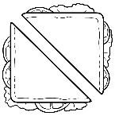
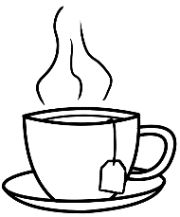

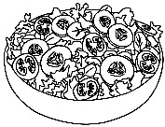
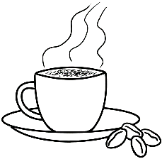

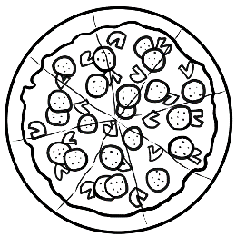
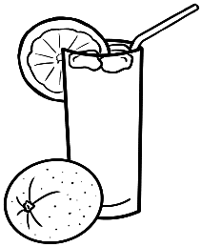

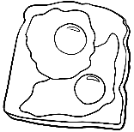

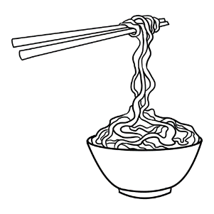

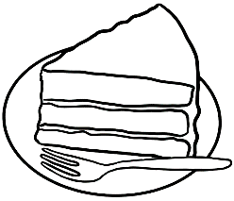
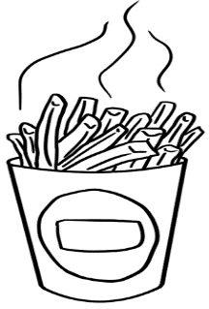

How much is the sandwich?
$12.00
$6.000
How much are the chips?

 |  | _$4.00__
 |  | _______
 |  | _______
 |  | _______
 | 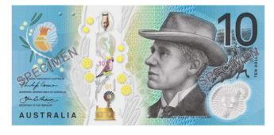 | _______
 |  | _______
 |  | _______
 |  | _______
 |  | _______
 |  | _______
- 2.

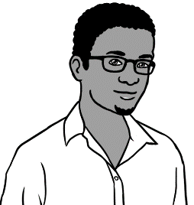
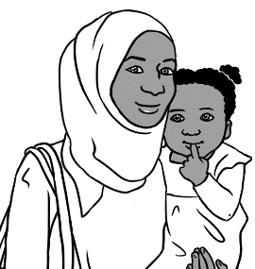
Let’s have a pizza and a salad.
Ok.
 | a pizza | $_______
 | a salad  Total | + $_______  __________
Hani can have some noodles and an orange juice.

b. | noodles | $ _______
 | an orange juice  Total | + $ _______  _________
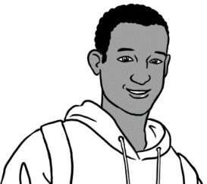
I’ll have a sandwich and a coffee.

c.  a sandwich  a coffee  Total |  | $_______
+ $_______
_________

Do you have enough money?
 |  |  | Yes | No
- $11.00 | + $5.50 | 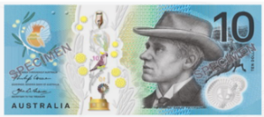  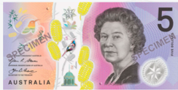  =
- ______ | + ______ | =
- ______ | + ______ | =
- ______ | + ______ | =
- ______ | + ______ | =
- ______ | + ______ | =

At a men’s clothes shop
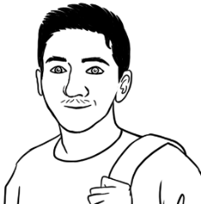
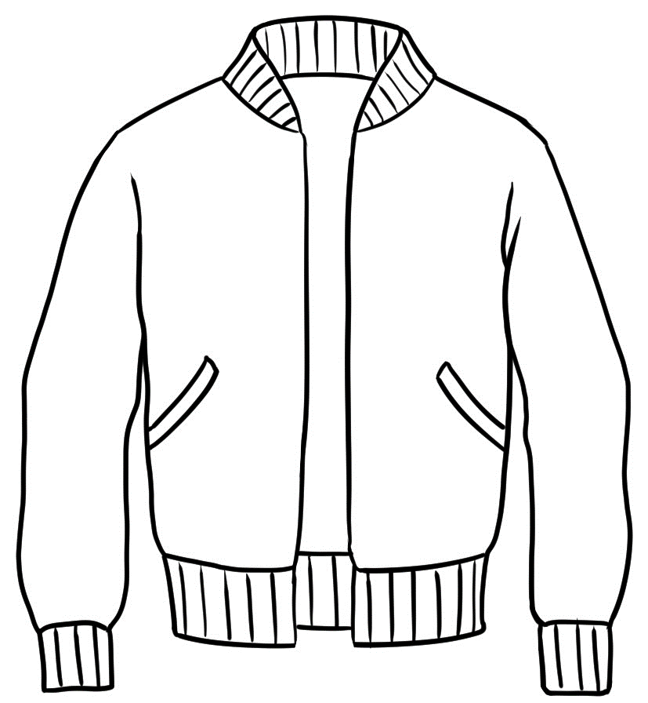
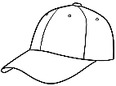
I need a jacket
and a cap.

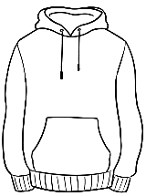
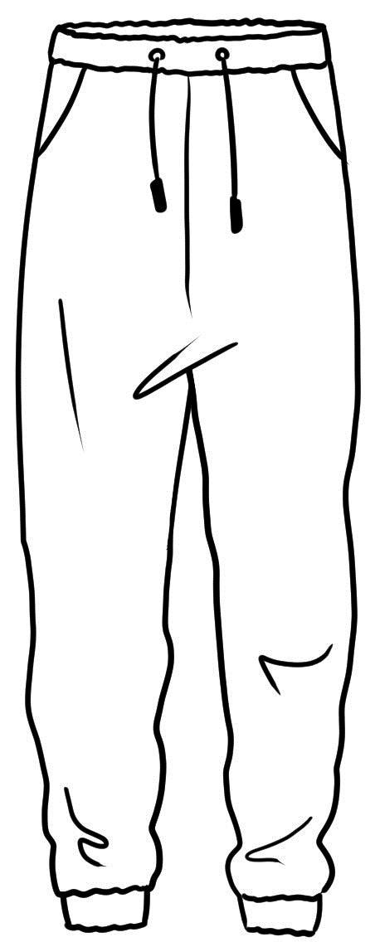
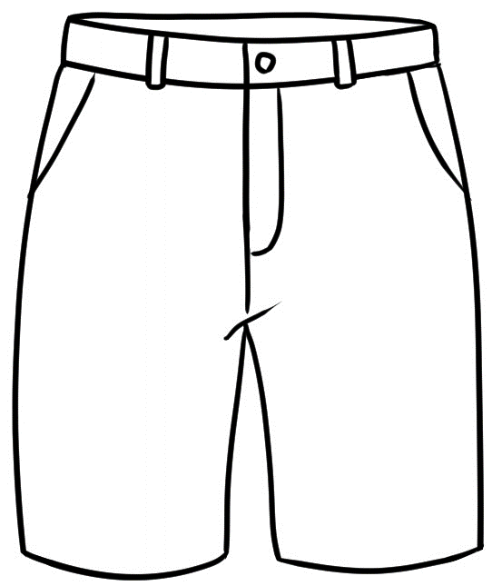
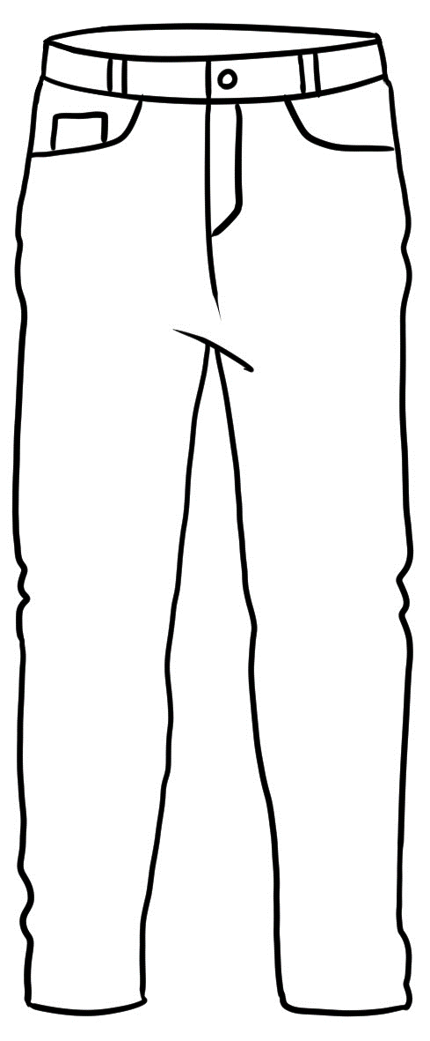
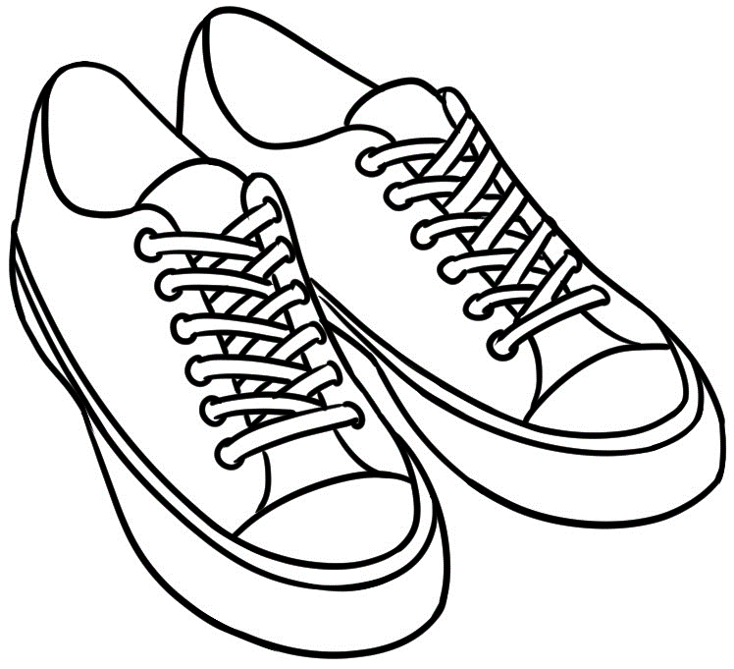
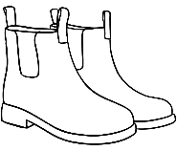
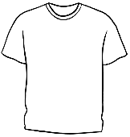
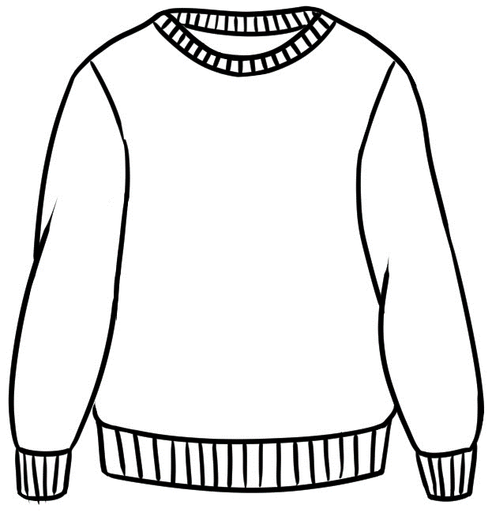
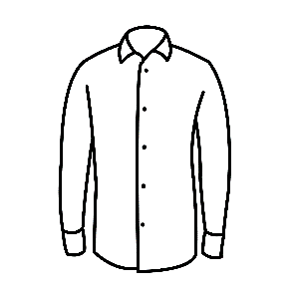
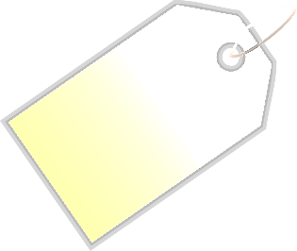
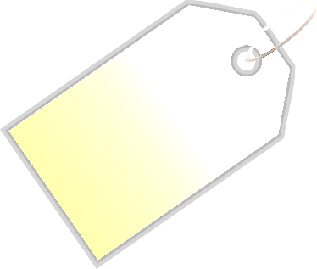
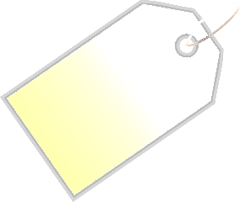
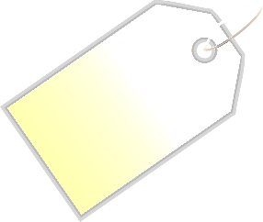
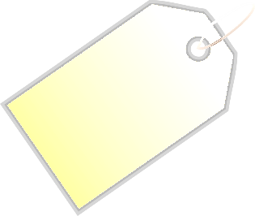
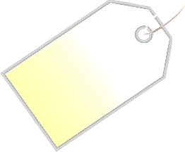
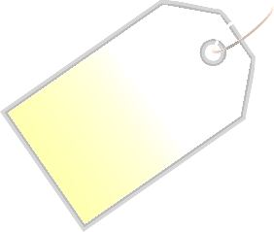
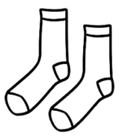

jacket
$70.50
jumper
$59

hoodie
$60
track pants
$35.50
jeans
$65
shirt
$50
t-shirt
$30
runners
$80
cap
$20
shorts
$40.50
boots
$90
socks
$9

How much is the jacket?
$70.50
How much are the runners?
$80

$9
$20
$30
$35.50
$40.50
$50
$59
$60
$65
$70.50
$80
$90

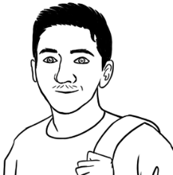
I need a jacket
and a cap.

 | a jacket | $70.50
 | a cap  Total | + $20.00  $90.50 .
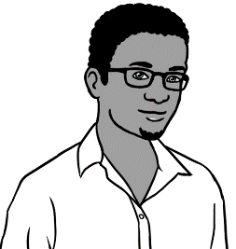
I need a hoodie and some track pants.
 | a hoodie | $ _______
 | track pants  Total | + $ _______  _________
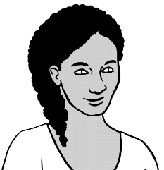
My friend needs some shorts and
a shirt.
 | shorts | $_______
 | a shirt  Total | + $_______  _________

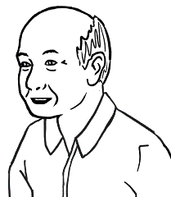
My grandson needs
some jeans and a t-shirt.

 | a t-shirt | $_______
 | jeans  Total | + $_______  ________
I need some boots
and socks.
b. | boots | $ _______
 | socks  Total | + $ _______  __________
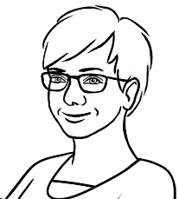
My husband needs
a jumper and a cap.
c.  a jumper  a cap  Total |  | $_______
+ $_______
_________

At an office shop

How much is the keyboard?
How much are the ear buds?

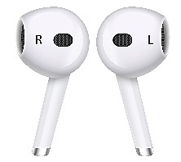
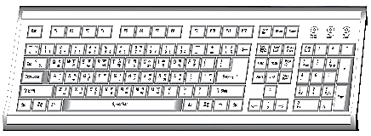
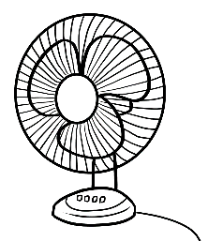
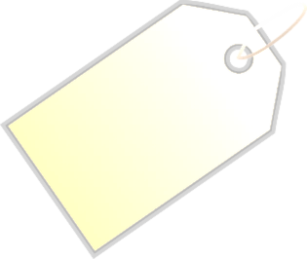
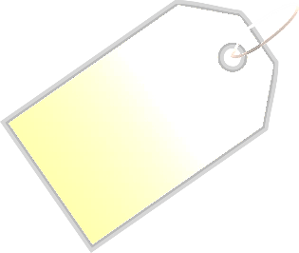


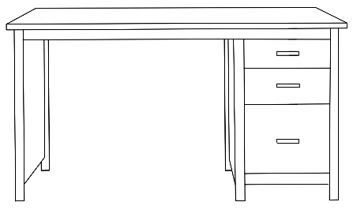
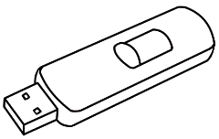
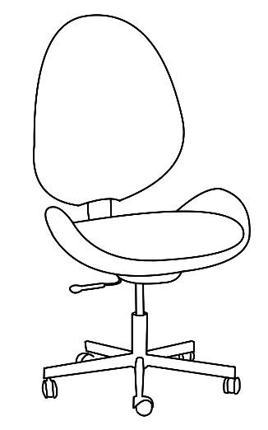
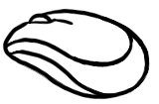
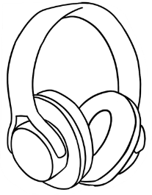
desk
_______

chair
_______

mouse
________

ear buds
_______

USB
_____

lamp
_______

fan
_______

The Office Warehouse
headphones
_________

keyboard
_________

_

 |  | __$15__
 |  | _______
 |  | _______
 |  | _______
 | 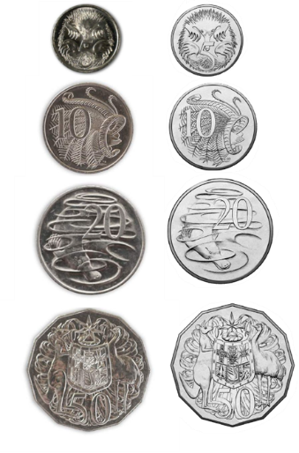 | _______
 |  | _______
 |  | _______
 |  | _______
 |  | _______
- 2.

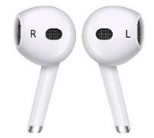

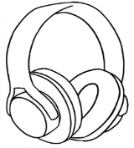

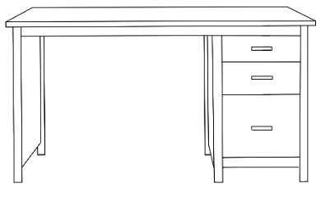 | a desk | $_______
 | a USB  Total | + $_______  ________
I need a mouse and some headphones.
b. | a mouse | $ _______
 | 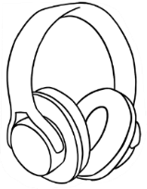  headphones  Total | + $ _______  __________
I need some ear buds and a fan.

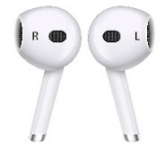  c.  ear buds  a fan  Total |  | $_______
+ $_______
________

I need a desk
and a USB.

Do you have enough money?

 |  |  | Yes | No
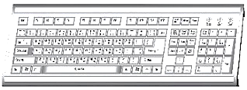  - $40 | + $55 | 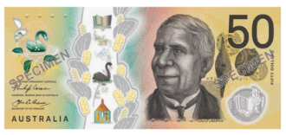  =
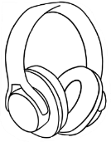  - ______ | 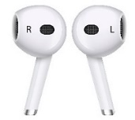  + ______ | 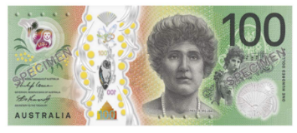  =
- ______ | + ______ | 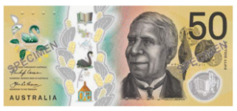  =
- ______ | + ______ | =
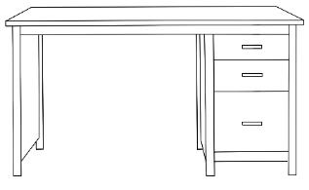  - ______ | + ______ | =
- ______ | 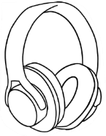  + ______ | =

Let’s go out.
expensive = not cheap

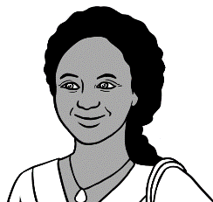
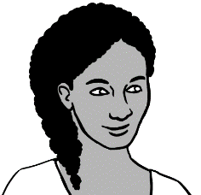
How much is
a zoo ticket?
Is it expensive?
Let’s go to the zoo
on Saturday.

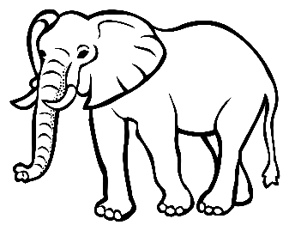

WILDLIFE ZOO

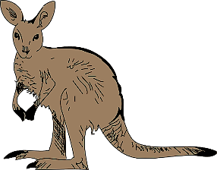

Prices | 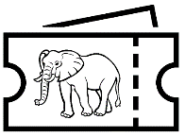  Zoo  tickets | 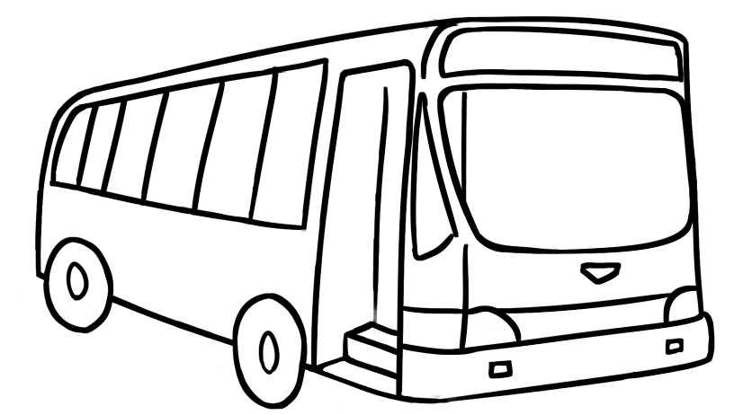  Bus  tickets
  Adult | $41.00 | $6.00
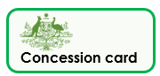  Concession | $30.00 | $4.00
  Child | $21.00 | $3.50
  Family | $85.00 | $13.00

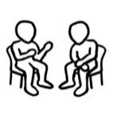
$30
How much is a concession
zoo ticket?
$3.50
How much is a child’s
bus ticket?

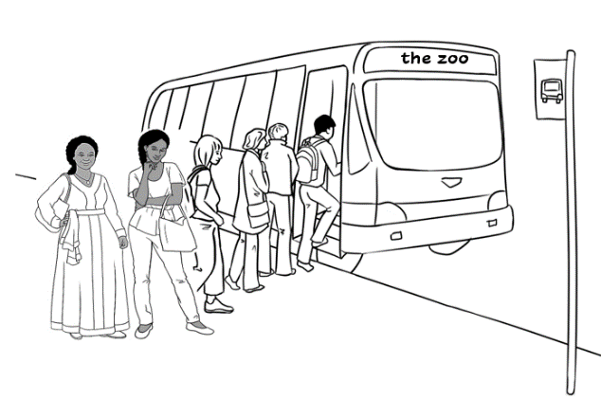
Anika and her mother
catch the bus to the zoo on Saturday.
3.

4.
- How much are 2 concession bus tickets?
$6.00 |  | $8.00 | $13.00
- What money do they need?
- How much are 2 concession zoo tickets?
$82.00 |  | $50.00 | $60.00
- What money do they need?
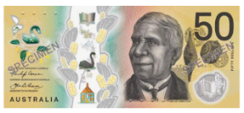
 | bus tickets  zoo tickets  Total |  |  | $____________  $____________  $____________
 | 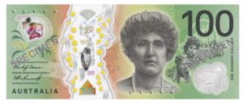  They have $100.  Do they have enough? |  |  | _______ ______  ^{yes no}

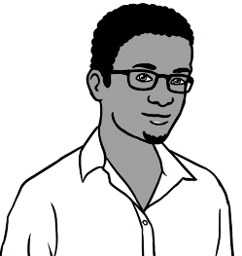
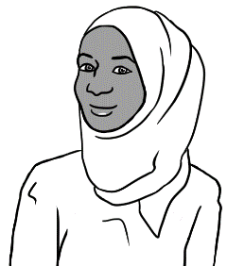
Let’s go to the zoo.
The tickets are cheap this Sunday.
this Sunday.
How much are the tickets?

WILDLIFE ZOO

Prices | Zoo  tickets | Bus  tickets
Adult
Concession
Child
Family

Cheap prices this Sunday!!

$70
How much is a family
zoo ticket?
$4
How much is an adult bus ticket?

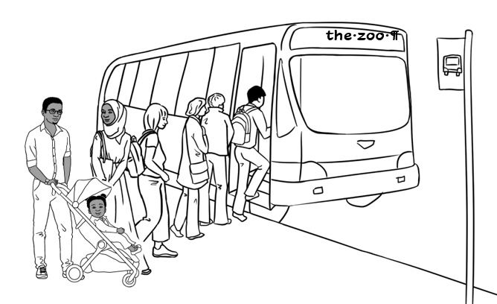
Sahra and her family
catch the bus
to the zoo on Sunday.
3.

4.
- How much is a family bus ticket?
$9.00 |  | $9.50 |  | $10.00 |  |  | $10.50
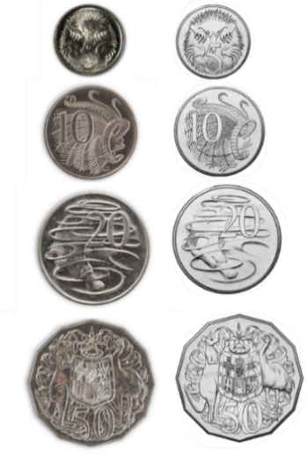
- What money do they need?
- How much is a family zoo ticket?
$85.00 |  |  | $80.00 |  | $70.00
- What money do they need?
 | bus ticket  zoo ticket  Total |  |  |  |  | $____________  $____________  $____________
 | They have $100.  Do they have enough? |  |  |  |  | _______ ______  ^{yes no}

More places to go



Swimming Pool
Prices | Tickets
Adult
Concession
Child
Family

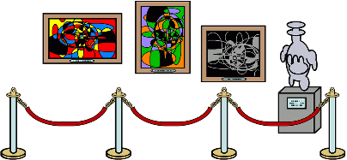
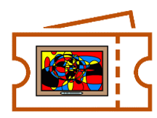
Art Gallery
Prices | Tickets
Adult
Concession
Child
Family

