Student book with teacher notes

English Ready
22637VIC Course in EAL
VU23577 - Recognise and use numbers and money from 50 to 100
for highly familiar activities

Numbers and money
50 - 100

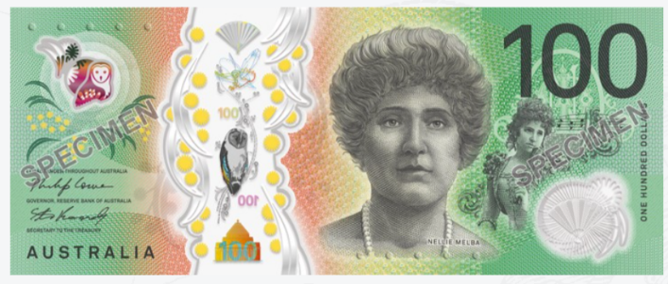

Teacher _______________________________________________________________
Class ___________________________________________________________________
Date____________________________________________________________________

Name __________________________________________________________________
This workbook is designed to be used with the support of a teacher.

Design team: Sue Paull, Vicki Hambling, Nikeh Shariatian, Bernie Miles and Mary Wallace
Illustrations: Madelena Scott
Image acknowledgements:
Biscuits This Photo by Unknown Author is licensed under CC BY-NC
Box with sticky tape - a href="https://www.freepik.com/free-vector/sticker-design-with-empty-box-closed-isolated_
100th birthday cake - This Photo by Unknown Author is licensed under CC BY-NC-ND
Cake box - <a href="https://www.freepik.com/icon/cake-box_6680318">Icon by small.smiles</a>

Acknowledgements: The design team would like to acknowledge the use of the EAL Framework which underpins the design of this book.
Copyright of the EAL Framework is reserved to the Crown in the right of the State of Victoria. © State of Victoria (Department of Education and Training) 2023.
_________________________________________________________________________________________
This English Ready Resource is licensed under a Creative Commons Attribution-NoDerivs 3.0 Australia licence (More information is available here). You are free to use, copy and distribute to anyone in its original form as long as you attribute Department of Home Affairs as the author and you license any derivative work you make available under the same licence.
© Commonwealth of Australia 2024

With the exception of the Commonwealth Coat of Arms, the department’s logo, any material protected by a trade mark and where otherwise noted all material presented in this document is provided under a Creative Commons Attribution 4.0 International (https://creativecommons.org/licenses/by/4.0/) licence.
The details of the relevant licence conditions are available on the Creative Commons website (accessible using the links provided) as is the full legal code for the CC BY 4.0 licence (https://creativecommons.org/licenses/by/4.0/legalcode).
Use of all or part of this document must include the following attribution:
© Commonwealth of Australia 2023
As far as practicable, material for which the copyright is owned by a third party will be clearly labelled. The department has made all reasonable efforts to ensure that this material has been reproduced in this document with the full consent of the copyright owners.
Copyright requests and enquiries concerning usage not addressed by the CC BY 4.0 licence should be addressed to:
comms@homeaffairs.gov.au at the Department of Home Affairs.
The terms of use for the Commonwealth Coat of Arms are available from the It's an Honour website.
Where a copyright owner, other than the Commonwealth, is identified with respect to this material, please contact that third party copyright owner directly to seek permission.



Contents
1. Instructions 4
2. Meet the students and teachers. 5
3. Numbers 1 - 50 6
4. Numbers 50 - 100 8
5. Did you say 15 or 50? 14
6. Before and after 16
7. Add the numbers. 18
8. Money 20
9. Morning tea 26
10. At a café 30
11. At a men’s clothes shop 34
12. At an office shop 38
13. Let’s go out. 42

Instructions
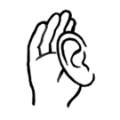
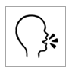
Project and mime each instruction.
 | 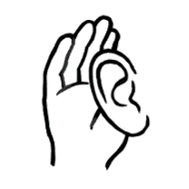 | listen |  |  | say
 |  | read |  | 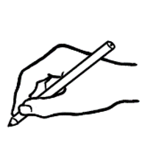 | write
 | 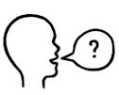 | ask |  |  | copy
 | 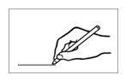 | match |  | 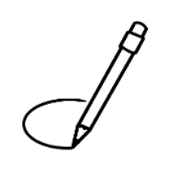 | circle
 |  | highlight |  |  | tick
 | 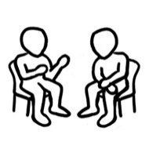 | work with  a partner |  | 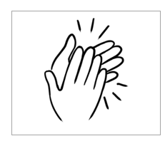 | clap

Meet the students and teachers.

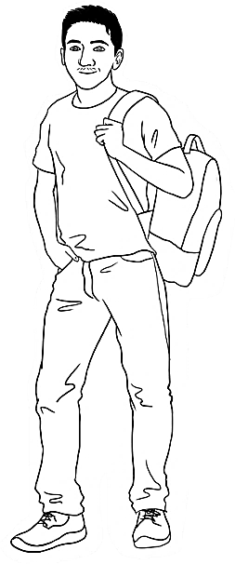
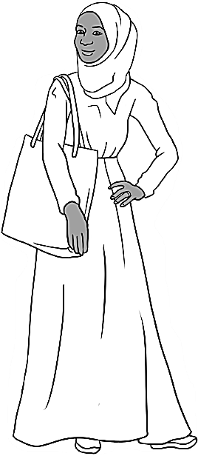
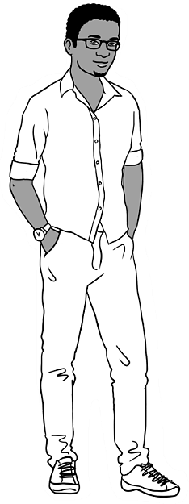
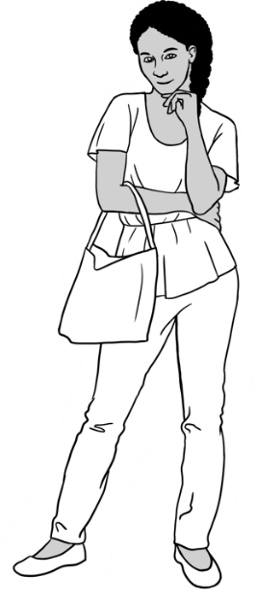
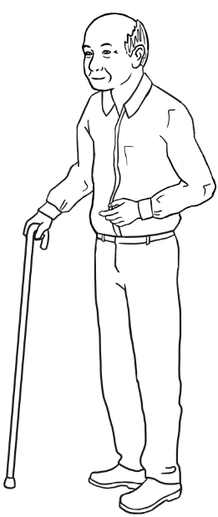
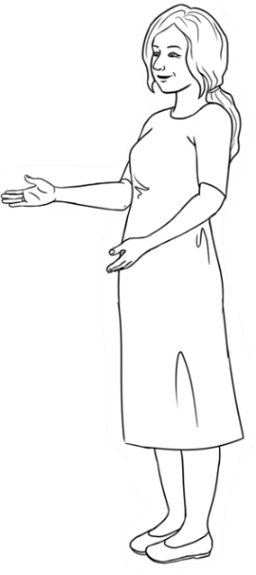
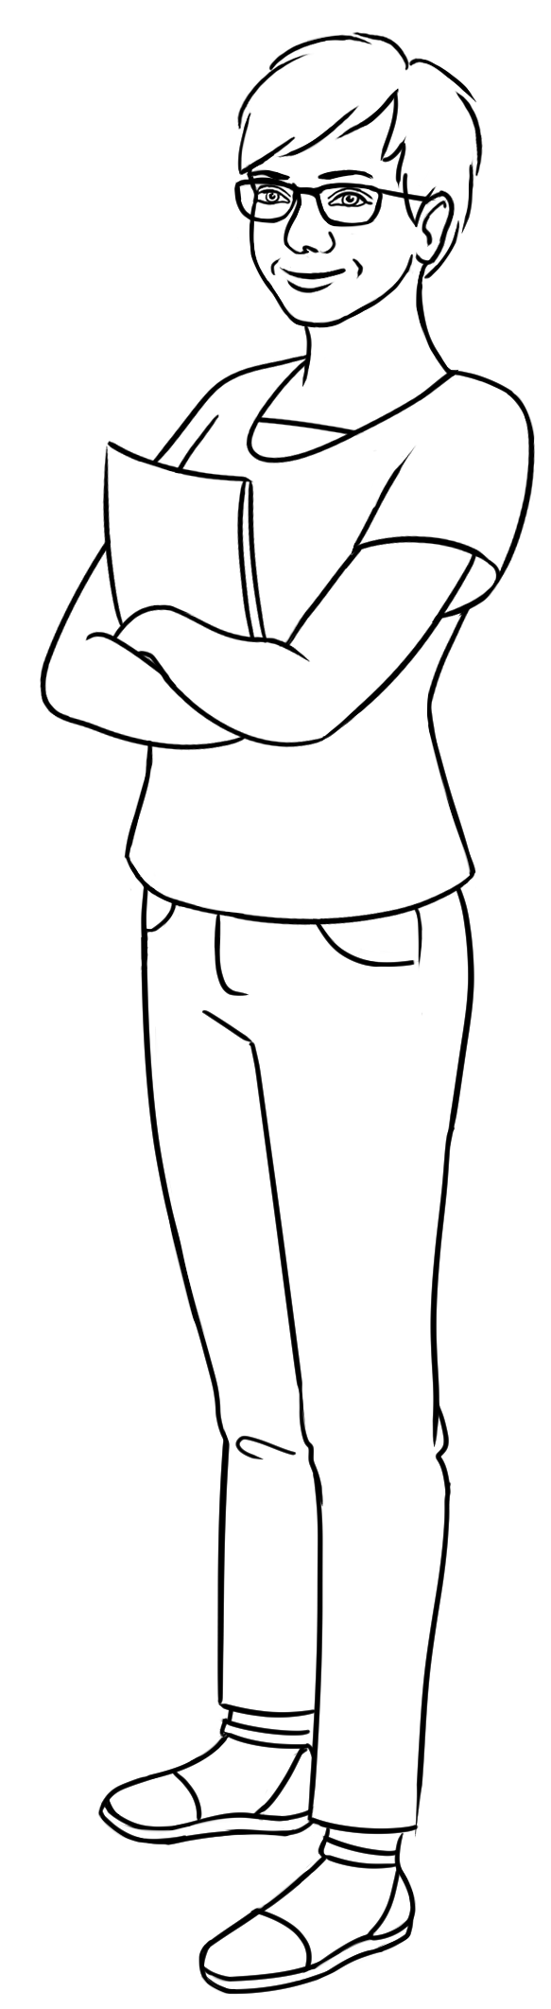
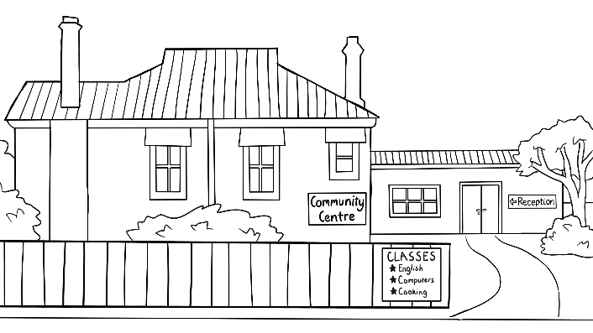
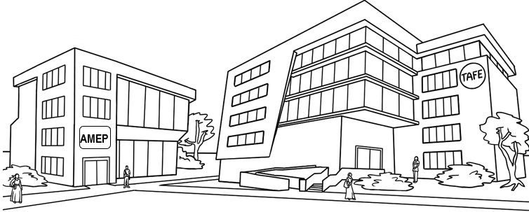
Carim Sahra Tahiil Anika Ming
The students
The teachers
Jenny Wendy
The learning centres

Numbers 1 - 50
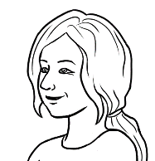
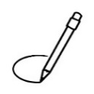
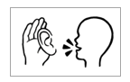
Circle 5.
Give instructions to circle
some numbers.

See the Course in Initial Student Workbook, VU23493 Numbers
for extended work on the numbers from 1 – 50. The exercises on these two pages are revision work only.

Row a.
Highlight 8 and 14.
0 | 1 | 2 | 3 | 4 | 5 | 6 | 7 | 8 | 9
10 | 11 | 12 | 13 | 14 | 15 | 16 | 17 | 18 | 19
20 | 21 | 22 | 23 | 24 | 25 | 26 | 27 | 28 | 29
30 | 31 | 32 | 33 | 34 | 35 | 36 | 37 | 38 | 39
40 | 41 | 42 | 43 | 44 | 45 | 46 | 47 | 48 | 49
50
Give instructions to highlight two or more numbers in each row.

2.
a. | 2 | 4 | 6 | 8 | 10 | 12 | 14 | 16 | 18 | 20
b. | 3 | 6 | 9 | 12 | 15 | 18 | 21 | 24 | 27 | 30
c. | 4 | 8 | 12 | 16 | 20 | 24 | 28 | 32 | 36 | 40
d. | 5 | 10 | 15 | 20 | 25 | 30 | 35 | 40 | 45 | 50
e. | 6 | 12 | 18 | 24 | 30 | 36 | 42 | 48


For guidance in the formation of numbers see the Course in
Initial Student Workbook, VU23493 Numbers pages 3 – 6.
Note the formation of the numbers 1, 7 and 9. Many printed numbers vary from font to font.

Copy the numbers.
0 | 1 | 2 | 3 | 4 | 5 | 6 | 7 | 8 | 9
1
10 | 11 | 12 | 13 | 14 | 15 | 16 | 17 | 18 | 19
20 | 21 | 22 | 23 | 24 | 25 | 26 | 27 | 28 | 29
30 | 31 | 32 | 33 | 34 | 35 | 36 | 37 | 38 | 39
40 | 41 | 42 | 43 | 44 | 45 | 46 | 47 | 48 | 49
50

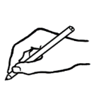
Write the missing numbers.
0 | 1 | 2 |  | 4 | 5 | 6 |  | 8
10 |  | 12 | 13 |  | 15 |  | 17 | 18
 | 21 |  | 23 | 24 |  | 26 | 27 |  | 29
30 |  | 32 |  | 34 | 35 | 36 |  | 38 | 39
 | 41 |  | 43 |  | 45 |  | 47 | 48
50

Numbers 50 - 100
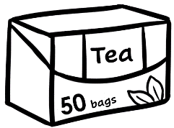 | 
50 | 51 | 52 | 53 | 54 | 55 | 56 | 57 | 58 | 59
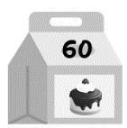 | 
60 | 61 | 62 | 63 | 64 | 65 | 66 | 67 | 68 | 69
Circle 56.
See this section in the Teacher Resources for
a range of activities to consolidate and extend the work on pages 8 – 9.
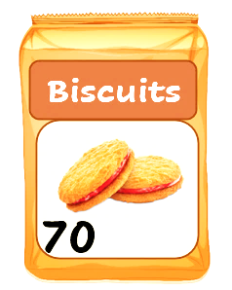 | 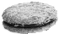
70 | 71 | 72 | 73 | 74 | 75 | 76 | 77 | 78 | 79
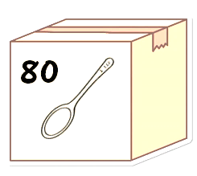 | 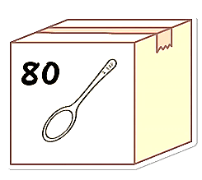   | 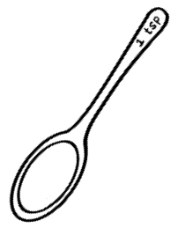 |  | 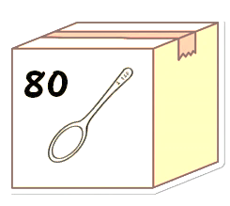
80 | 81 | 82 | 83 | 84 | 85 | 86 | 87 | 88 | 89
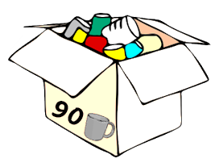 |  |  |  |  |  |  |  |  | 
90 | 91 | 92 | 93 | 94 | 95 | 96 | 97 | 98 | 99
100
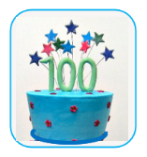

Circle 52.
A revision exercise - Read aloud together and then give instructions to circle some numbers.

50 | 51 | 52 | 53 | 54 | 55 | 56 | 57 | 58 | 59
60 | 61 | 62 | 63 | 64 | 65 | 66 | 67 | 68 | 69
70 | 71 | 72 | 73 | 74 | 75 | 76 | 77 | 78 | 79
80 | 81 | 82 | 83 | 84 | 85 | 86 | 87 | 88 | 89
90 | 91 | 92 | 93 | 94 | 95 | 96 | 97 | 98 | 99
100 |  |  |  |  |  |  |  |  | Project the table above, point to a number and ask students, What’s that number? [Stress that.] The whole class say the number. Students then work with a partner, and  take turns to point to a number and ask, What’s that number? e.g. Anika points to 76.

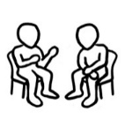
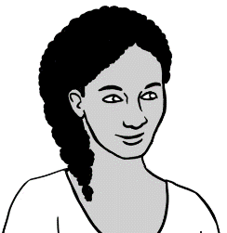
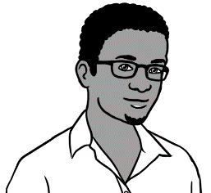
What’s that number?
76.
What’s = What is

Play Bingo. Students highlight any five numbers on the table below. Then read out numbers at random. Students circle their highlighted numbers as they hear them.
Once their five numbers are called, they shout, Bingo!
- 4.

50 | 51 | 52 | 53 | 54 | 55 | 56 | 57 | 58 | 59
60 | 61 | 62 | 63 | 64 | 65 | 66 | 67 | 68 | 69
70 | 71 | 72 | 73 | 74 | 75 | 76 | 77 | 78 | 79

Copy the numbers.
50  50 | 51 | 52 | 53 | 54 | 55 | 56 | 57 | 58 | 59
60 | 61 | 62 | 63 | 64 | 65 | 66 | 67 | 68 | 69
70 | 71 | 72 | 73 | 74 | 75 | 76 | 77 | 78 | 79
80 | 81 | 82 | 83 | 84 | 85 | 86 | 87 | 88 | 89
90 | 91 | 92 | 93 | 94 | 95 | 96 | 97 | 98 | 99
100
Write the missing numbers.
For an extra challenge, students could cover the table above.
50 | 51 | 52 |  | 54 |  | 56 | 57 |  | 59
60 | 61 |  | 63 |  | 65 | 66 |  | 68
 | 71 | 72 |  | 74 | 75 |  | 77 |  | 79
80 |  | 82 | 83 | 84 |  | 86 |  | 88 | 89
90 | 91 |  | 93 |  | 95 |  | 97 | 98

Use the numbers from the grey boxes to complete the number sequences.
Read the number sequences aloud with a partner.
a. | 66 | 67 | 68 |  | b. | 71 | 72 | ______
c. | ______ | 75 | 76 |  | d. | 69 | ______ | 71
e. | ______ | 58 | 59 |  | f. | 79 | 80 | ______
g. | 48 | ______ | 50 |  | h. | 88 | ______ | 90
i. | 62 | ______ | 64 |  | j. | 50 | 51 | ______
k. | 89 | ______ | 91 |  | l. | ______ | 56 | 57
m. | 70 | ______ | 72 |  | n. | 40 | ______ | 42
- 2.
73 |  | 67 |  | 49 |  | 57 |  | 70 |  | 74 |  | 89
81 |  | 63 |  | 52 |  | 90 |  | 71 |  | 55 |  | 41

Take turns to read the numbers
aloud with a partner.
Draw a line joining
the numbers 50 - 100.
- 2.

 | 50 |  | 51 | 58 |  | 59 |  | 65 |  | 73 |  |  | 75
 | 53 |  | 52 |  | 60 |  |  |  | 74 |  | 72 |  | 71
 |  |  |  |  |  |  | 58
 | 54 |  |  | 61 |  | 57 |  | 75 |  | 69 |  |  | 70
 |  |  | 62 |  |  |  |  |  |  |  | 89
 | 55 |  |  | 56 |  |  | 76 |  |  | 96 |  | 85
 |  |  |  |  |  |  |  |  | 68
 | 64 |  | 63 | 59 |  | 67 |  |  |  |  | 84
 |  |  | 54 |  |  |  | 77
 | 65 |  |  | 66 |  |  | 78 |  | 83 |  |  | 81 | 86
 | 67 |  |  |  | 79
 |  |  | 96 |  | 80 |  | 81 |  | 82 |  | 87
 | 97 |  |  |  |  |  | 89 |  |  |  |  |  | 78
 |  | 92 | 95 |  | 94 |  |  | 99 |  | 91 |  | 88
 | 98 |  |  |  | 96 |  | 93
 |  |  | 99 |  |  |  |  |  | 92 |  | 90 |  | 89
 |  |  |  |  |  |  | 100
See this section in the Teacher Resources on page 24 for a slightly harder maze.

Did you say 15 or 50?
Listen, say and clap all the teens, then all the tens.
Next, read each teen and ten, e.g. 13, 30 etc. Once complete, read and clap all numbers.

 | 13 | 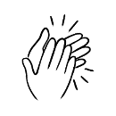 |  | 30
 | 14 |  |  | 40
 | 15 |  |  | 50
 | 16 |  |  | 60
 | 17 |  |  | 70
 | 18 |  |  | 80
 | 19 |  |  | 90

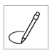
Dictate one number in each pair. Emphasise the stressed syllable. Students circle the number.
In a,
circle 13.

a. | 13 | 30 |  | b. | 14 | 40
c. | 15 | 50 |  | d. | 16 | 60
e. | 17 | 70 |  | f. | 18 | 80
g. | 19 | 90 |  | h. | 15 | 50
i. | 16 | 60 |  | j. | 17 | 70
k. | 18 | 80 |  | l. | 19 | 90

Under a,
write 50.
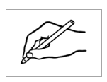
Dictate any of the numbers above. Students write the numbers under the letters.

a. | b. | c. | d. | e. | f.
50
g. | h. | i. | j. | k. | l.

Before and after
What’s the number before 57
and the number after 57?

before | 57 | after
56 | 57 | 58
See this section in the Teacher Resources for a similar exercise to prepare students for this one, or to provide further practice.

before | the number | after
- 49 | 50 | 51
 | 65
 | 74
 | 88
 | 91
 | 69
 | 70
 | 99

Read any number between 50 – 100 and
students write the number
before it.
Write the number before 54.

- 53

Read any number between 50 -100 and
students write the number
after it.
Write the number after 67.

- 68

Write the numbers in the correct sequence.

a. 54 52 53 | b. 60 58 59 | c. 67 66 68
. 52 . . 53 54 . | ___ ___ ___ | ___ ___ ___
d. 71 73 72 | e. 86 85 84 | f. 100 98 99
___ ___ ___ | ___ ___ ___ | ____ ___ ___

Add the numbers.
Project the page. Read the additions aloud together. Ask students to highlight the plus and equals signs.
For an extension activity, see this section in the Teacher Resources on pages 43-45.
- 2.
a. | 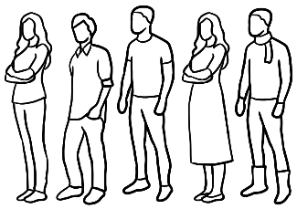  5 people | + |  | 5 people |  | = 10 people
b. | 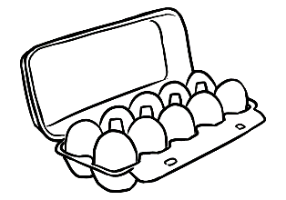  10 eggs | + | 10 eggs |  | = 20 eggs
c. | 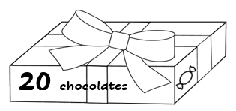  20 chocolates | + | 20 chocolates |  | = 40 chocolates
d. | 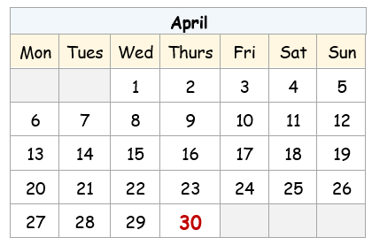  30 days | + | 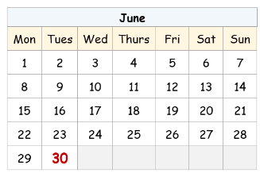  30 days |  | = 60 days
e. | 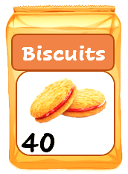  40 biscuits | + | 40 biscuits |  | = 80 biscuits
f. | 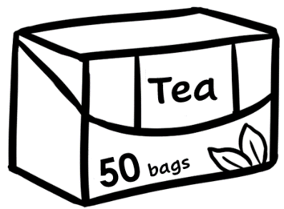  50 tea bags | + | 50 tea bags |  | = 100 tea bags

How many is that?
a.a. | . 50 . teabags | + |   . 3 . teabags | = . 53 . teabags
b. | 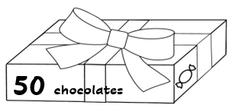  _____ chocolates | + | 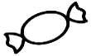  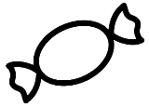  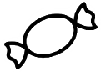  _____ chocolates | = _____ chocolates
c. | 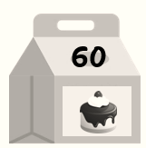  _____ cakes | + |           _____ cakes | = _____ cakes
d. | 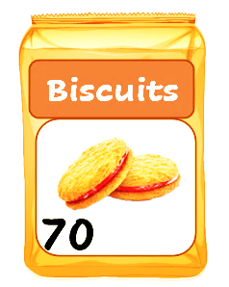  _______ biscuits | + | 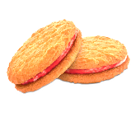  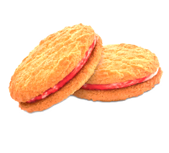  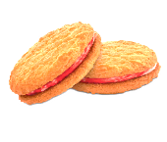  _____ biscuits | = _____ biscuits
e. | _____ spoons | + | 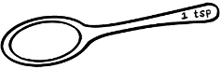  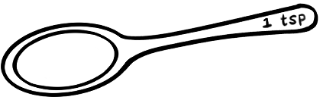  _____ spoons | = _____ spoons
f. | 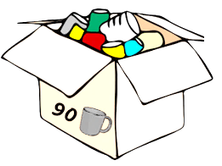  _____ mugs | + |     _____ mugs | = ______ mugs
- 2.
Complete the additions as a class or individually. Read together once completed.

Money
How many cents?
Say and copy the value of the coins. See this section in the Teacher Resources for further work on the recognition, values and addition of money.
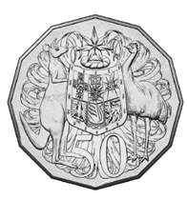 | 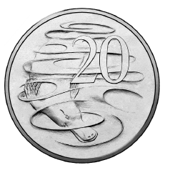 | 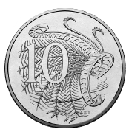 | 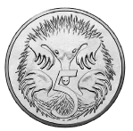
50 cents | ______ cents | ______ cents | ______ cents
Write the value of the two coins.
c = cents

- 15 c |  | - _______c
- ______ c |  | - ______ c
- ______ c |  | - ______ c

How many dollars?
- 2.
Say and copy the dollar values.
Note: singular - one dollar
plural - two dollars

Match the dollar values.
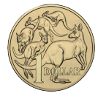
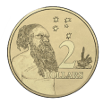
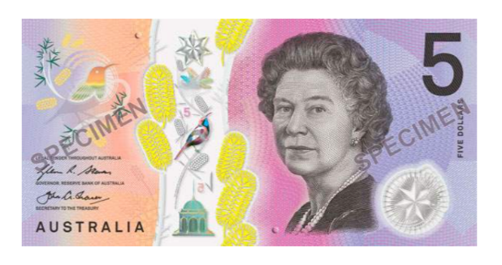
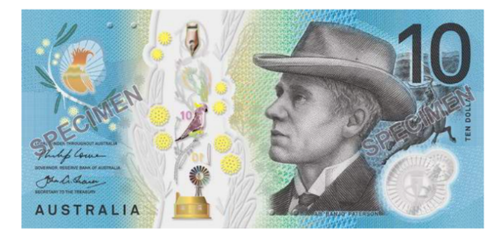
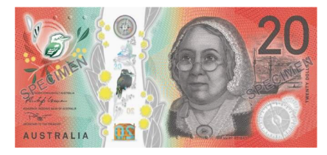
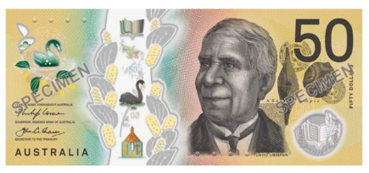
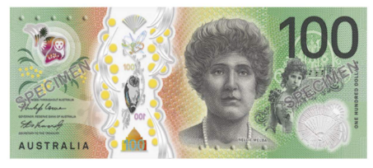
$ = dollar
$2
$2
$10
_____
$50
_____
$1
_____
$100
_____
$20
_____
$5
_____

Students take turns to point to and read the amounts.
e.g. That’s $10.50
That’s $10.50
- 2.
 | 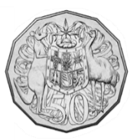  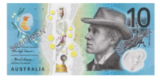 | $10.50
 | 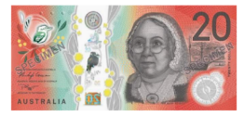 | ___________
 | 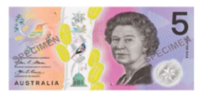 | _________
 | 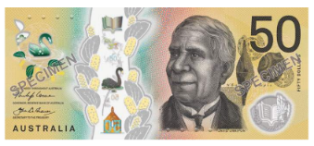 | _________
 |  | _________
 |  | _________
 |  | _________
 |  | _________

Point to the +, = and $ signs. Copy the money amounts
and the + and = signs on the lines below. Read the additions to a partner. e.g. Ten dollars plus fifty cents equals ten dollars fifty cents.
- 2.
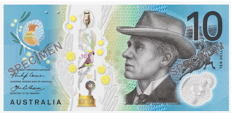 |  | 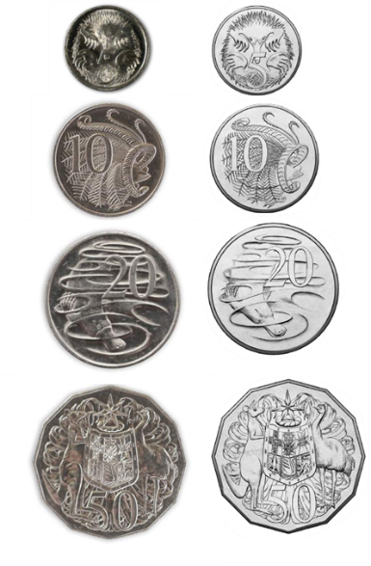
$10 | + | 50c | = | $10.50
________ | ___ | ________ | ___ | __________
b.
$20 | + | 50c | = | $20.50
_______ | ___ | _______ | ___ | __________
c.

$20 | + | $5 | = | $25
_______ | ___ | _______ | ___ | __________
d.
$50 | + | 50c | = | $50.50
______ | ___ | ______ | ___ | ________
e.
$50 | + | $1 | = | $51
______ | ___ | ______ | ___ | ______

Write the money totals.
 |  |  |  | How much is that?
$50 | + | $2 | = | $52
b.
$50 | + | $5 | = | _______
c.

$50 | + | $10 | = | _______
$50 | + | $20 | = | _______
$50 | + | $50 | = | ________
Read the additions to a partner.

Write the money additions.

a.
$20 | + | $50 | = | $70
b.
 | + |  | =
c.

 | + |  | =
d.
 | + |  | =
 | + |  | =

Read the additions to a partner.

Morning tea
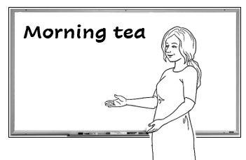
Let’s have morning tea
with another class
next Tuesday.

Read the list of things needed for a morning tea – tea, coffee, milk, sugar, biscuits, cakes, juice, spoons, mugs and tissues. Students tick each item.
What do we need
for morning tea?
2.
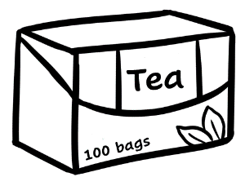  tea bags | 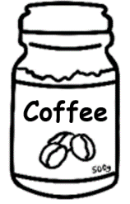  coffee | 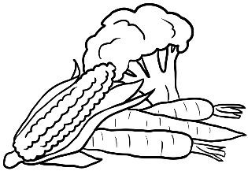  vegetables | 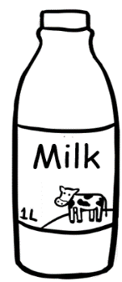  milk
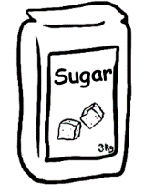  sugar | 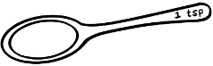  spoons |   biscuits |       cakes
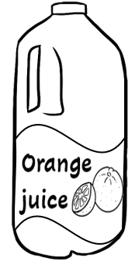  juice | 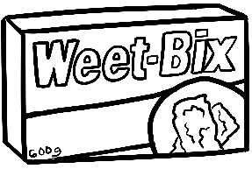  cereal | mugs | 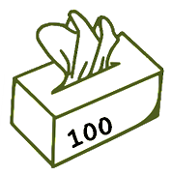  tissues
cereal = breakfast food
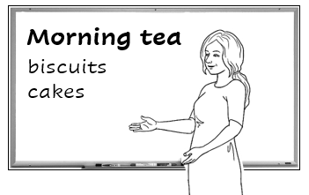
Who can make some biscuits and cakes? We need enough
for 50 people.
Organise a morning tea with another class. Ask your class to help by making the biscuits and cakes. See this section in the Teacher Resources for an activity to buy ingredients for baking.
enough =
Students write enough in their language in the blue box.

The exercise below is a model for a morning tea. 1. Work out what you have and what you need. Ask, Do we have enough mugs? spoons? etc.
2. Dictate the amounts in red below.
The answers are not in the student workbook.
What do we need to buy?

We have |  |  | We need
Aa | 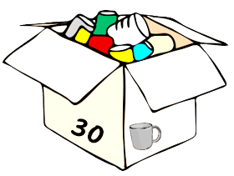  30 mugs |  | __20___ mugs
bb | 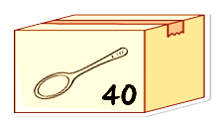  40 spoons |  | __10___ spoons
Cc | No milk |  | ___4__ litres of milk
Dd | No tea bags |  | ___1__ box of tea bags
ee | No coffee |  | ___2__ jars of coffee
d  f | No sugar |  | ___2__ kilos of sugar
Eg | 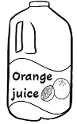  No juice |  | ___2__ litres of juice
hh |   No tissues |  | ___1__ box of tissues

Ask students to guess the prices of the supermarket products. Then dictate the prices. Adjust these to more current prices if necessary. The prices below are not in the student workbook.
There’s a sale at the supermarket.


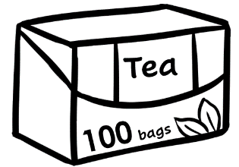
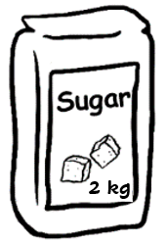
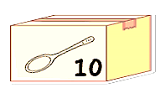


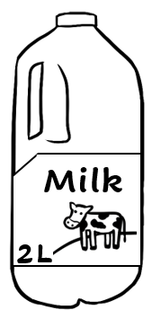
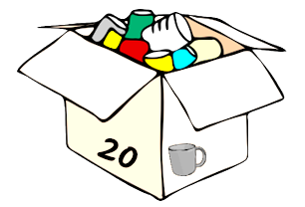

Supermarket
$12
$3
2 for
$6
10 for $15
$4
2 for
$26
20 for $60
2 for $10

How much are the mugs?
How much is the coffee?
2 for $26
$12


coffee $ 26 .
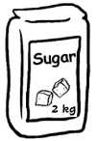
sugar $ 3 .

Total $29 .
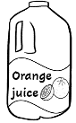
juice $_____
tissues $ _____

Total $ .

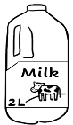
tea $_____
milk $ _____

Total $ .
spoons $_____
mugs $ _____
Total $ .


I’ll buy the coffee
and sugar.

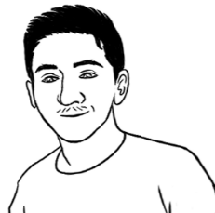
I’ll buy the juice
and tissues.

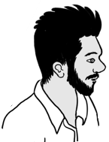
I’ll buy the tea
and milk.

This is an unnamed student
in the class. If necessary, students could choose
a name for him.

I’ll buy the spoons
and mugs.

At a café
Project the page and introduce new vocabulary. See this section in the Teacher Resources for an information gap activity.
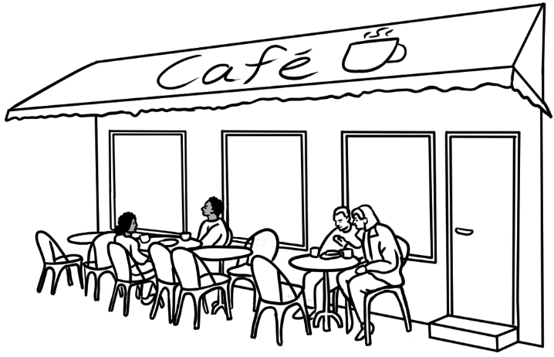
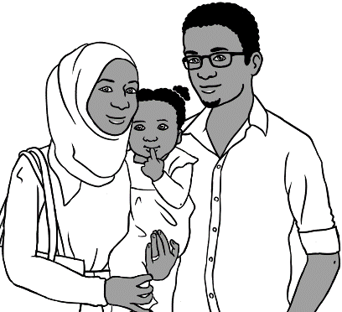
Let’s go to a café for lunch.
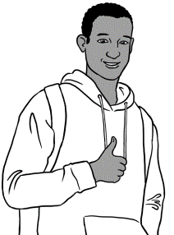
Good idea.

This is Sahra’s brother, Abdi. He features in other Course in EAL, English Ready books.

Food Drinks
Sandwich $12.00 Tea $4.00

Salad $10.50 Coffee $5.00

Pizza $22.00 Orange
juice $5.50

Eggs $11.00

Noodles $14.00 Cakes

Chips $6.00 Cake $7.00

Café Menu

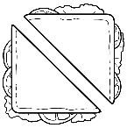


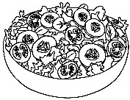


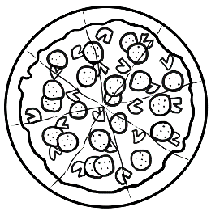
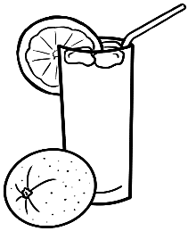

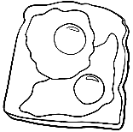

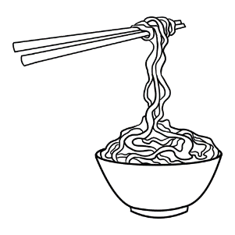

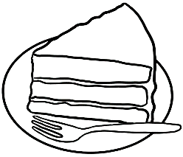
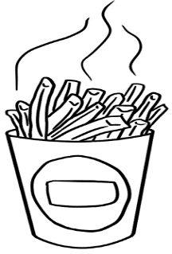

How much is the sandwich?
$12.00
$6.000
How much are the chips?
Students take turns to ask their partner the price of food on the menu.
Note the use of is and are when talking about singular and plural items.

 |  | __$4.00__
 |  | _______
 |  | _______
 |  | _______
 | 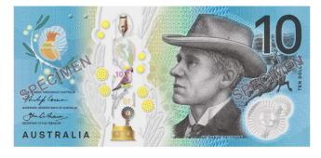 | _______
 |  | _______
 |  | _______
 |  | _______
 |  | _______
 |  | _______
- 2.
Match the prices and items.
Write the prices.

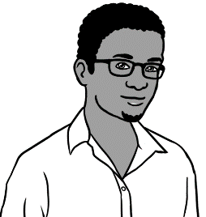
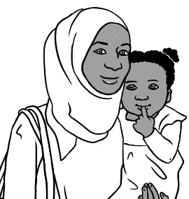
Let’s have a pizza and a salad.
Ok.
 | a pizza | $_______
 | a salad  Total | + $_______  __________
Hani can have some noodles and an orange juice.

b. | noodles | $ _______
 | an orange juice  Total | + $ _______  _________
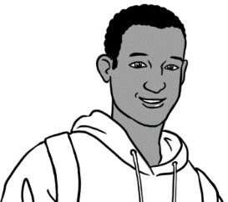
I’ll have a sandwich and a coffee.

c.  a sandwich  a coffee  Total |  | $_______
+ $_______
_________

The red ticks are not in the student version of the workbook.
Do you have enough money?
 |  |  | Yes | No
- $11.00 | + $5.50 | 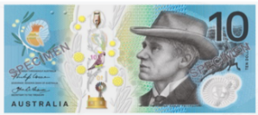  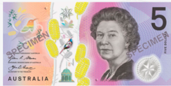  =
- ______ | + ______ | =
- ______ | + ______ | =
- ______ | + ______ | =
- ______ | + ______ | =
- ______ | + ______ | =

At a men’s clothes shop
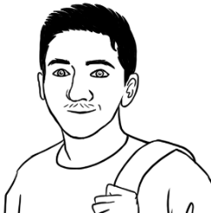
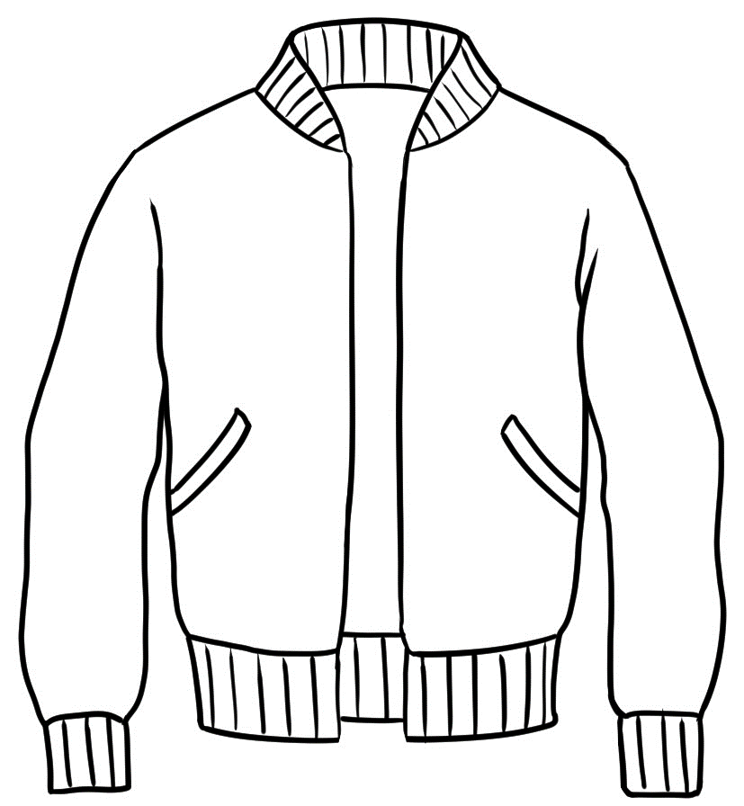
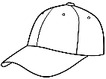
See this section in the Teacher Resources for an introduction to the vocabulary here including plural forms for pairs of jeans etc. There is also a parallel exercise with a women’s clothes shop.
I need a jacket
and a cap.

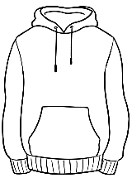
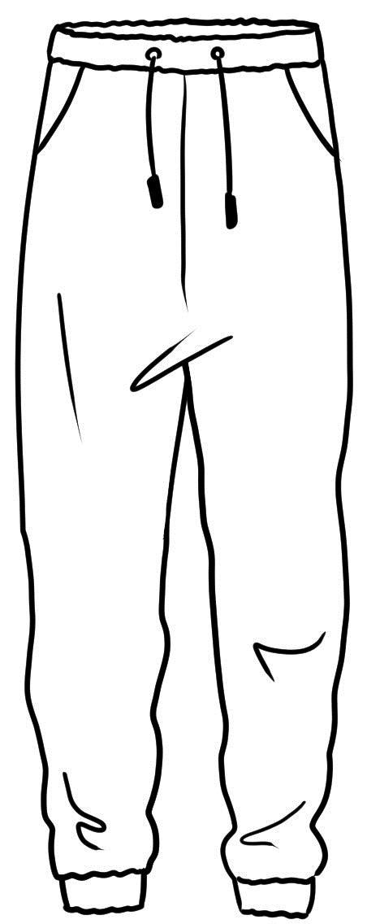
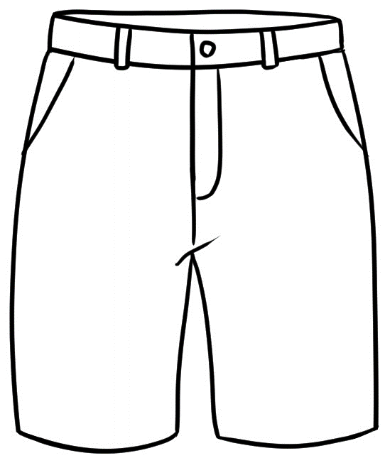
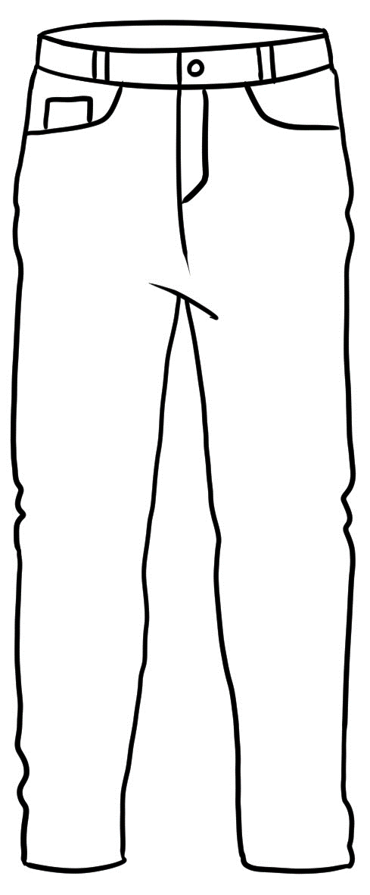
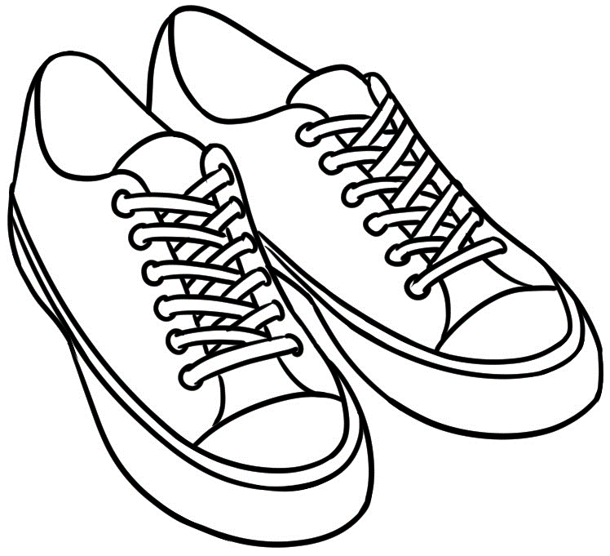
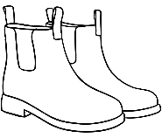
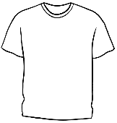
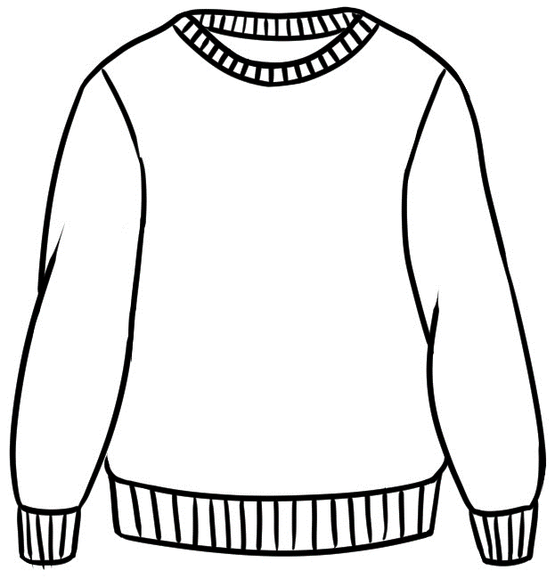
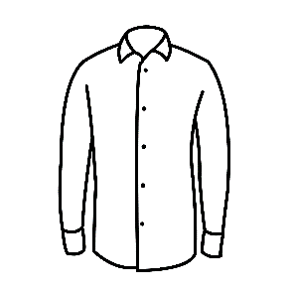
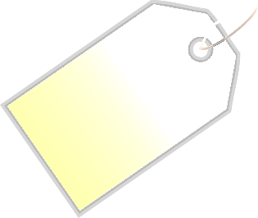
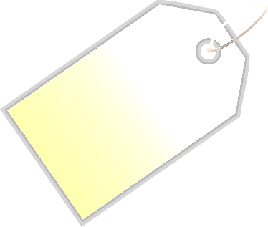
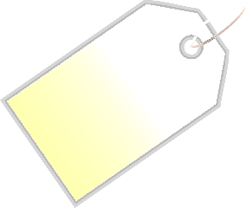
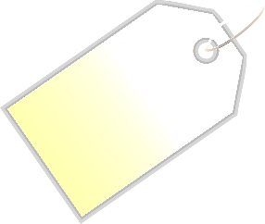
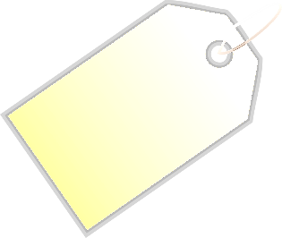
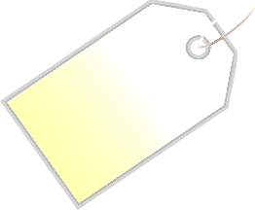
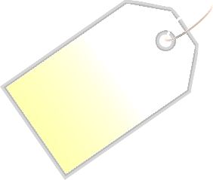
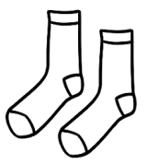

jacket
$70.50
jumper
$59

hoodie
$60
track pants
$35.50
jeans
$65
shirt
$50
t-shirt
$30
runners
$80
cap
$20
shorts
$40.50
boots
$90
socks
$9

How much is the jacket?
Students take turns to ask their partner the price of the clothes.
Note the use of is and are when talking about singular and plural items.

$70.50
How much are the runners?
$80

Draw a line to match the items to their prices.
$9
$20
$30
$35.50
$40.50
$50
$59
$60
$65
$70.50
$80
$90

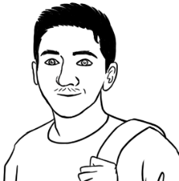
I need a jacket
and a cap.

 | a jacket | $70.50
 | a cap  Total | + $20.00  $90.50 .
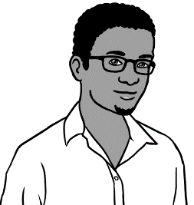
I need a hoodie and some track pants.
 | a hoodie | $ _______
 | track pants  Total | + $ _______  _________
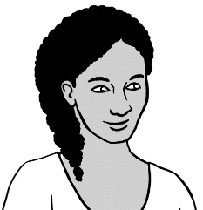
Note the addition of s
for Present Simple,
3rd person singular.
My friend needs some shorts and
a shirt.
 | shorts | $_______
 | a shirt  Total | + $_______  _________

Note the common use of some in speech as
a substitute for a pair of.

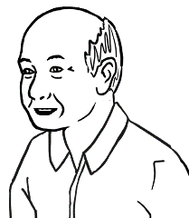
My grandson needs
some jeans and a t-shirt.

 | a t-shirt | $_______
 | jeans  Total | + $_______  ________
I need some boots
and socks.
b. | boots | $ _______
 | socks  Total | + $ _______  __________
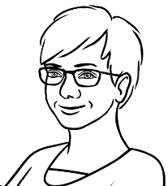
My husband needs
a jumper and a cap.
c.  a jumper  a cap  Total |  | $_______
+ $_______
_________

At an office shop
See this section in the Teacher Resources for an introduction to the vocabulary here.

Students take turns to ask the teacher the price of each item and then to write the price next to the items in the ad below. Note the use of the definite article when referring to specific objects.
The red prices are not in the student version of the workbook.
How much is the keyboard?
How much are the ear buds?

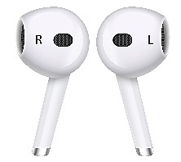
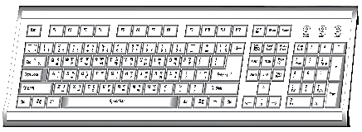
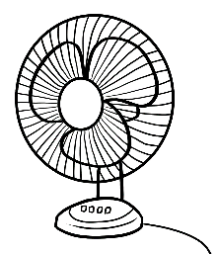
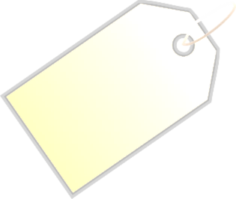
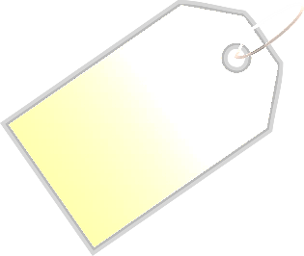

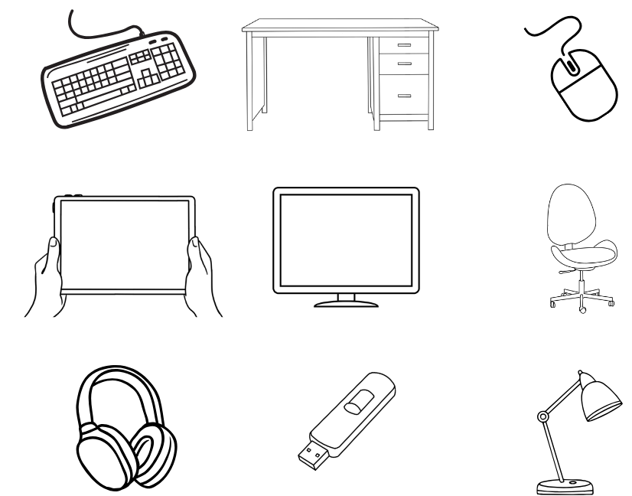
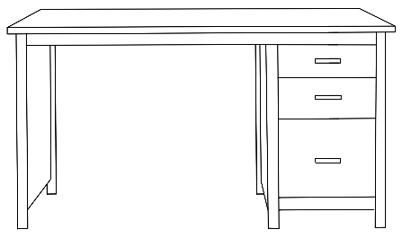
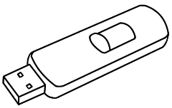
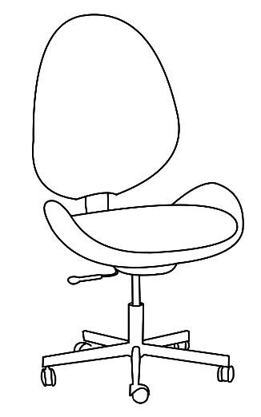
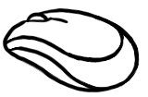
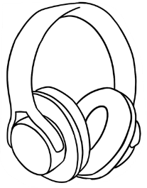
desk
$80
chair
$70
mouse
$25
ear buds
$55
USB
$15
lamp
$50.50
fan
$30
The Office Warehouse
headphones
$60
keyboard
$40

See this section in the Teacher resources for activities and exercises around a Kitchen Shop.
_

 |  | __$15__
 |  | _______
 |  | _______
 |  | _______
 | 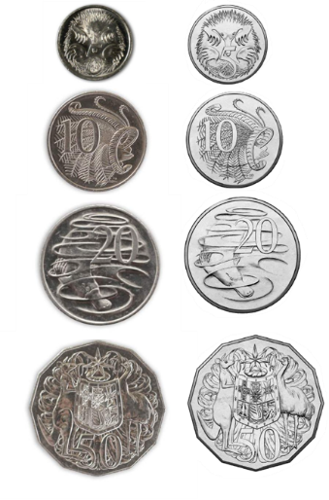 | _______
 |  | _______
 |  | _______
 |  | _______
 |  | _______
- 2.
Match the prices and items.
Write the prices.

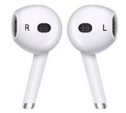
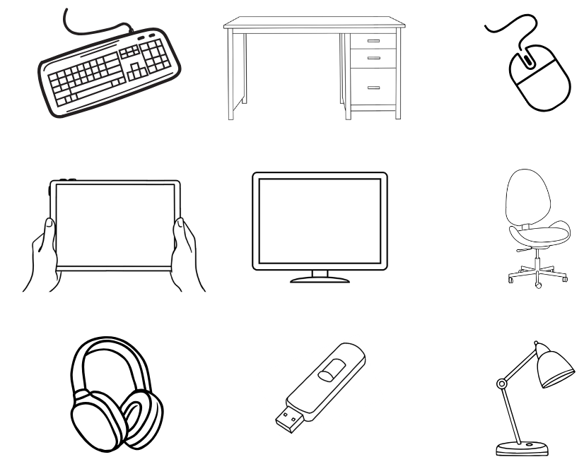
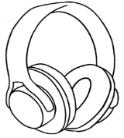

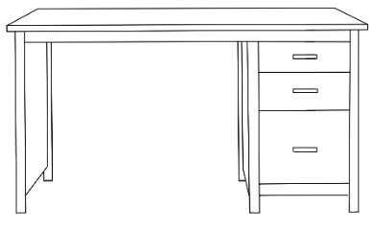 | a desk | $_______
 | a USB  Total | + $_______  ________
I need a mouse and some headphones.
Note the use of some as a common substitute for a set of or a pair of.
b. | a mouse | $ _______
 | 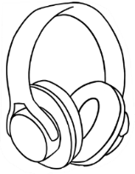  headphones  Total | + $ _______  __________
I need some ear buds and a fan.

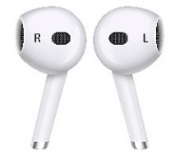  c.  ear buds  a fan  Total |  | $_______
+ $_______
________

I need a desk
and a USB.

The red ticks are not in the student version of the workbook.
Do you have enough money?

 |  |  | Yes | No
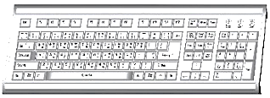  - $40 | + $55 | 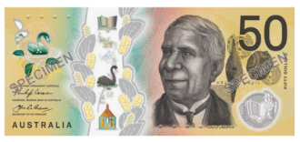  =
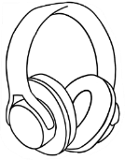  - ______ | 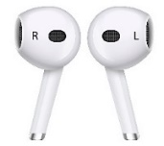  + ______ | 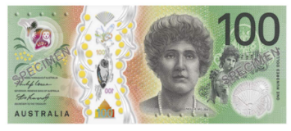  =
- ______ | + ______ | 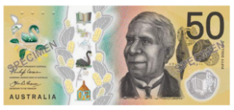  =
- ______ | + ______ | =
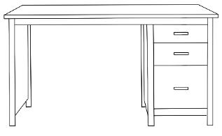  - ______ | + ______ | =
- ______ | 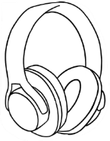  + ______ | =

Let’s go out.
expensive
= not cheap
Organise an excursion to a place of interest and use
the prices of tickets, food etc as a numeracy exercise.
A group student booking would reduce prices.

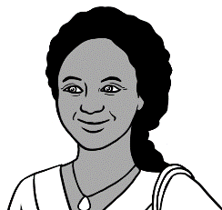
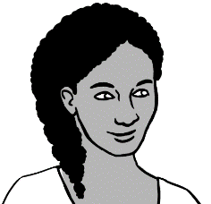
How much is
a zoo ticket?
Is it expensive?
Let’s go to the zoo
on Saturday.

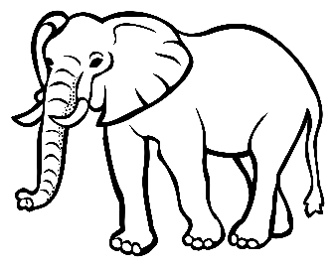

WILDLIFE ZOO

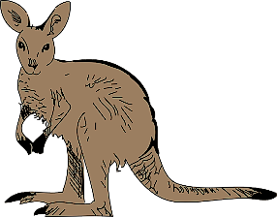

Prices | 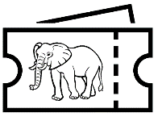  Zoo  tickets | 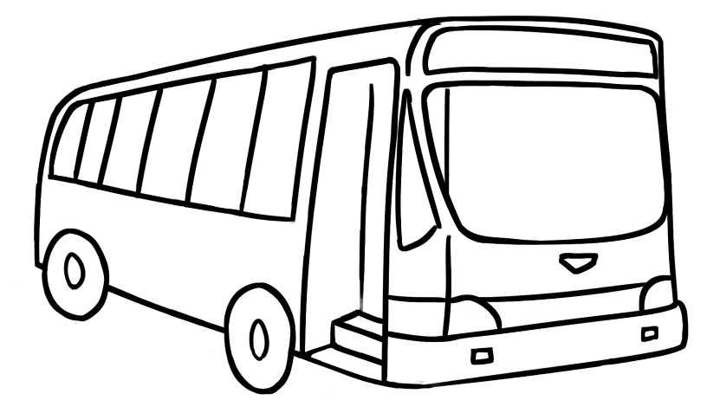  Bus  tickets
  Adult | $41.00 | $6.00
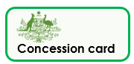  Concession | $30.00 | $4.00
  Child | $21.00 | $3.50
  Family | $85.00 | $13.00

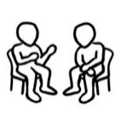
Students take turns to ask their partner the price of the zoo and bus tickets.
$30
How much is a concession
zoo ticket?
$3.50
How much is a child’s
bus ticket?

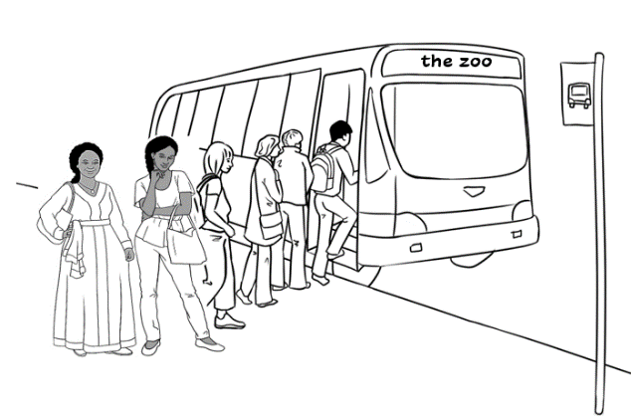
Anika and her mother
catch the bus to the zoo on Saturday.
3.

Students circle
the answers.

4.
- How much are 2 concession bus tickets?
$6.00 |  | $8.00 | $13.00
- What money do they need?
- How much are 2 concession zoo tickets?
$82.00 |  | $50.00 | $60.00
- What money do they need?
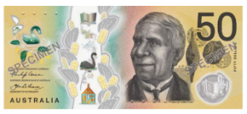
 | bus tickets  Students write and add the sums.  zoo tickets  Total |  |  | $____________  $____________  $____________
 | 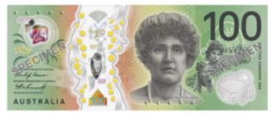  They have $100.  Do they have enough? |  |  | _______ ______  ^{yes no}

Dictate the prices for students to write.
The prices are not in the student version of the workbook.

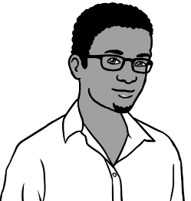
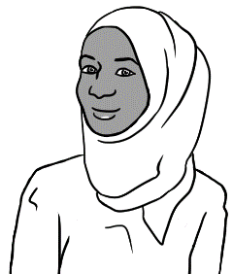
Let’s go to the zoo.
The tickets are cheap this Sunday.
this Sunday.
How much are the tickets?

WILDLIFE ZOO

Prices | Zoo  tickets | Bus  tickets
Adult | $35.00 | $4.00
Concession | $25.00 | $3.00
Child | $15.00 | $2.50
Family | $70.00 | $10.00

Cheap prices this Sunday!!

Students take turns to ask their partner the price of the zoo and bus tickets.
$70
How much is a family
zoo ticket?
$4
How much is an adult bus ticket?

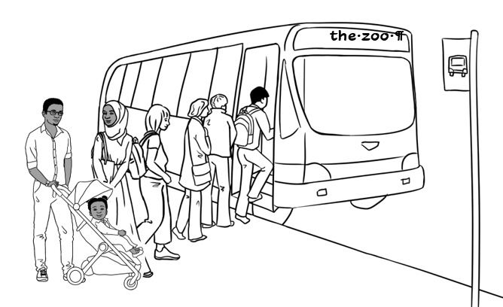
Sahra and her family
catch the bus
to the zoo on Sunday.
3.

Students write and add the sums.
4.
- How much is a family bus ticket?
$9.00 |  | $9.50 |  | $10.00 |  |  | $10.50
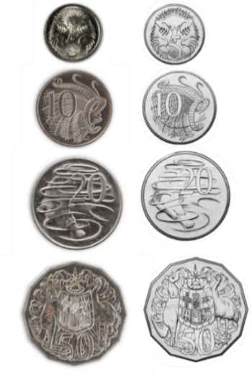
- What money do they need?
- How much is a family zoo ticket?
$85.00 |  |  | $80.00 |  | $70.00
- What money do they need?
 | bus ticket  Students write and add the sums.  zoo ticket  Total |  |  |  |  | $____________  $____________  $____________
 | They have $100.  Do they have enough? |  |  |  |  | _______ ______  ^{yes no}

More places to go



Swimming Pool
Prices | Tickets
Adult | $9.50
Concession | $7.00
Child | $6.50
Family | $25.00

Dictate the prices for students to write.

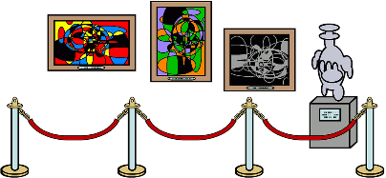

Art Gallery
Prices | Tickets
Adult | $25.00
Concession | $20.00
Child | $13.00
Family | $63.00

Explain that most art galleries are free, but people need to pay to see special exhibitions.

