English Ready
22637VIC Course in EAL
VU23577 - Recognise and use numbers and money from 50 to 100
for highly familiar activities

Numbers and money 50 - 100

Teacher resources

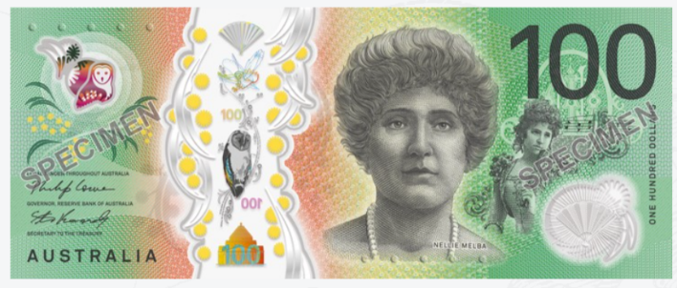

Design team: Sue Paull, Vicki Hambling, Nikeh Shariatian, Bernard Miles and Mary Wallace
Illustrations: Madelena Scott
Image acknowledgements:
Biscuits, chocolate box, cinema logo These Photos by Unknown Author is licensed under CC BY-NC
Box with sticky tape - a href="https://www.freepik.com/free-vector/sticker-design-with-empty-box-closed-isolated_
100th birthday cake, chocolate - These Photos by Unknown Author is licensed under CC BY-NC-ND
Cake box - "https://www.freepik.com/icon/cake-box_6680318">Icon by small.smiles</a>
Swimming goggles This Photo by Unknown Author is licensed under CC BY-SA-NC
Museum logo This Photo by Unknown Author is licensed under CC BY-SA
Kitchen appliances – Photos by permission of Big Stock

Acknowledgements: The design team would like to acknowledge the use of the EAL Framework which underpins the design of this book.

Copyright of the EAL Framework is reserved to the Crown in the right of the State of Victoria. © State of Victoria (Department of Education and Training) 2023.
___________________________________________________________________________________
This English Ready Resource is licensed under a Creative Commons Attribution-NoDerivs 3.0 Australia licence (More information is available here). You are free to use, copy and distribute to anyone in its original form as long as you attribute Department of Home Affairs as the author and you license any derivative work you make available under the same licence.
© Commonwealth of Australia 2024

With the exception of the Commonwealth Coat of Arms, the department’s logo, any material protected by a trade mark and where otherwise noted all material presented in this document is provided under a Creative Commons Attribution 4.0 International (https://creativecommons.org/licenses/by/4.0/) licence.
The details of the relevant licence conditions are available on the Creative Commons website (accessible using the links provided) as is the full legal code for the CC BY 4.0 licence (https://creativecommons.org/licenses/by/4.0/legalcode).
Use of all or part of this document must include the following attribution: © Commonwealth of Australia 2023
As far as practicable, material for which the copyright is owned by a third party will be clearly labelled. The department has made all reasonable efforts to ensure that this material has been reproduced in this document with the full consent of the copyright owners.
Copyright requests and enquiries concerning usage not addressed by the CC BY 4.0 licence should be addressed to:
comms@homeaffairs.gov.au at the Department of Home Affairs.
The terms of use for the Commonwealth Coat of Arms are available from the It's an Honour website.
Where a copyright owner, other than the Commonwealth, is identified with respect to this material, please contact that third party copyright owner directly to seek permission.



Introduction to the books
The Teacher Resources
The oral and kinaesthetic activities in this book utilise a variety of senses to improve memory retention. This is particularly important for students impacted by trauma.
The most productive classes are noisy and active. Resources here aim to promote
noisy active learning. They include:
- drawings for use in the design of additional materials
- flashcards for printing
- individual and class activities
- revision and homework exercises
- extension exercises.
The book is an electronic reference. Print pages as needed.

The Student Workbook
The student book requires teacher direction and is not intended for independent learning. It is also not intended to be the only material used to teach these units or
to be used as an assessment task. It is recommended that students buy and use a notebook for general class work and practice.
The book is available as a Word document so that teachers can:
- localise and update the content
- adjust the material to suit the requirements of particular classes and students
- delete, add and grade materials as required. If you add or deduct pages, be mindful of the layout of the document.
Note:
- A teacher version of the student workbook contains additional notes and guidance for activities.
- Considering the cost of photocopying, colour has been used sparingly in the Student Workbook and the Teacher Resources.
- The illustrations drawn by Madelena Scott are copyright-free and can be used in the creation of additional materials. The few drawings in the books from Creative Commons can be also used, but need to be acknowledged in the way that they are acknowledged on the inside cover page of each book.

Contents
1. Instructions 2
2. Meet the students and teachers. 6
3. Numbers 1 - 50 8
4. Numbers 50 - 100 19
5. Did you say 15 or 50? 37
6. Before and after 40
7. Add the numbers. 43
8. Money 51
9. Morning tea 65
10. At a café 70
11. At a clothes shop 73
12. At an office shop and a kitchen shop 81
13. Let’s go out. 88

Instructions
Instruction icons
The icons used in the numeracy units are similar to those used in all units in the Course in EAL. They aim to simplify the instructions, support the teacher instructions and develop independence in learning.

Activity 1 – Word stress in instruction words
Project the following page and clap the syllables. In the two-syllable instructions
the stress falls on the first syllable. Clap the stressed syllable harder.

Activity 2 – Bingo
The aim of this game is to familiarise students with hearing and recognising the instructions.
- Print and cut up the bingo sheets on pages 4-5.
- Read out the instructions in any order.
- Students circle the instructions as they hear them and shout bingo, when
all their instructions have been called.

Activity 1 – Word stress
  say | 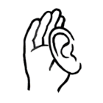  listen
  read |   copy
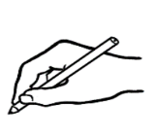  write |   circle
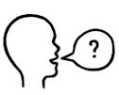  ask |   highlight
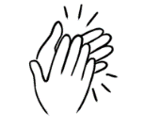  clap | 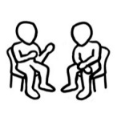  partner

tick
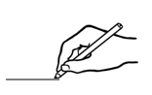
match

Activity 2 – Bingo cards

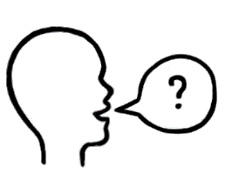 |  |  | 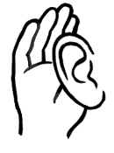
 | Bingo
 | 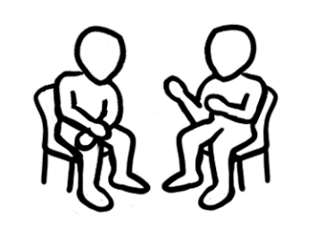
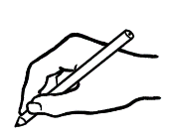 |  |  | 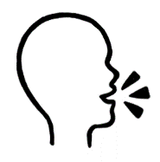
 | Bingo

 | Bingo
 | Bingo

Activity 2 – Bingo cards - [Continued]
Bingo
Bingo
Bingo
Bingo

Meet the students and teachers.
Project the following page and introduce the students and teachers who feature in the workbook. More detailed information about the characters can be found in the other Course in EAL units including a chart of personal details. See the Teacher Resources for the following units:
- VU23496 & VU23498
- VU23497 & VU23499

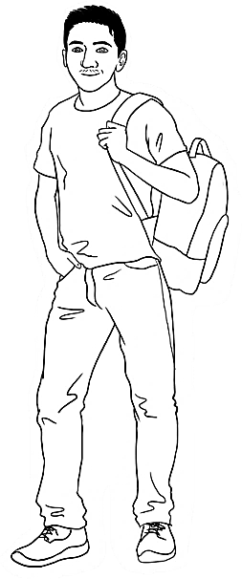
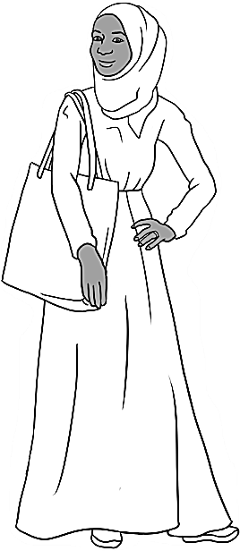
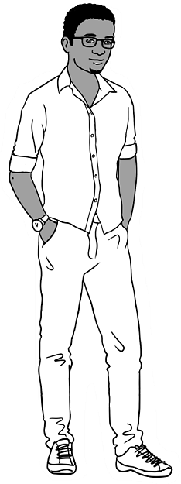
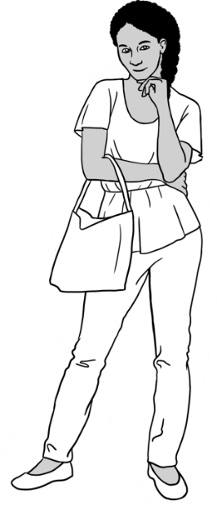
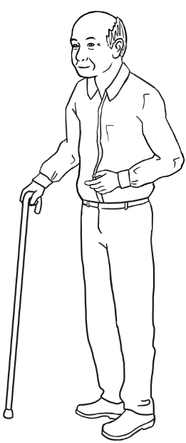
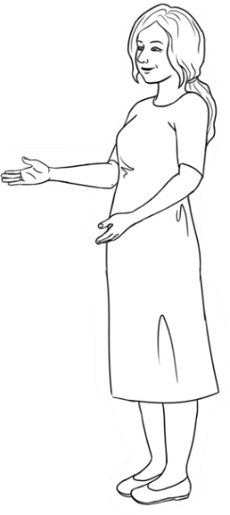
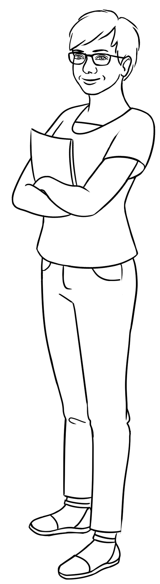
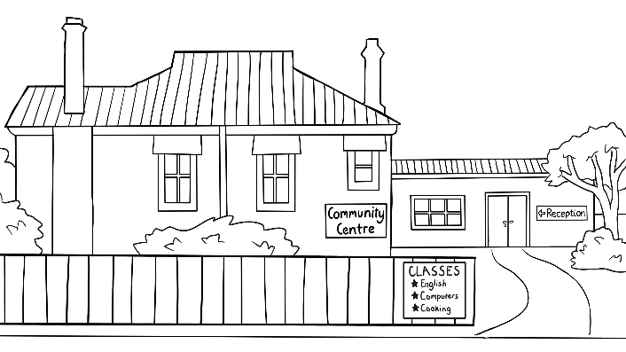
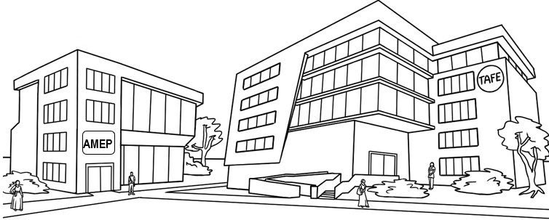
Carim Sahra Tahiil Anika Ming
The students
The teachers
Jenny Wendy
The learning centres

Numbers 1 - 50
Revision
The numbers from 1 – 50 are introduced in Course in Initial EAL, unit VU23493 Recognise, copy and use numbers and money from 1 – 50. However, it is helpful to revise these lower numbers before moving onto higher ones. The work on numbers
1 - 50 would be particularly important for students who may not have completed the Course in Initial EAL.
Activity 1 – Counting Class activities
Incorporate counting into class activities. e.g.
- Count the students in class today. Record the number on the board.
- Excursions - Walking somewhere with students? Get the students to count aloud as they walk - houses, cars, poles, stairs etc
- Count steps - How many steps to the door/ the white board/ the library? etc.
- A competition in teams or 3 or 4. Make a list on the board of countable objects such as windows, tables and chairs in the classroom, doors in the hallway, posters. Each team makes a copy of the items, and when they are ready, the students count and record the number of each item. The first team to finish with the correct answers wins.
Activity 2 – Listening Pair work
- Organise the class into pairs. Give each pair the number chart on the page 9.
- Warm up with some counting. Count numbers aloud together. Write on the board the numbers to start from and to count to. e.g. Count from 5 to 22, count from 19 and 39. Count backwards from 45 to 32.
- Allocate a colour to each person in a pair. One student is red, the other blue.
- Call red and say a number. The red student circles the number on the chart.
Call blue and say a number. The blue student circles the number on the chart. Each time, all students repeat the number aloud.
Activity 3 – Number Card Slap A game in small groups
- Make cards for numbers zero to fifty on pages 10-15, a set for each group.
- Students spread out and sequence the cards.
- The teacher calls out a number and the first student to say and slap that number card keeps it. The winner is the student with the most cards at the end of the game.
- Simplify the game by writing the number on the whiteboard as it is called.
Variation – Use two fly swats and project the grid on the following page.
Two students stand at the board/screen with the fly swats. A number is called and the first student to hit the number with the swat is the winner.

 | 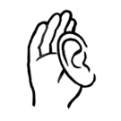   |  |  |  |  |  |  |  | 0
1 | 2 | 3 | 4 | 5 | 6 | 7 | 8 | 9 | 10
11 | 12 | 13 | 14 | 15 | 16 | 17 | 18 | 19 | 20
21 | 22 | 23 | 24 | 25 | 26 | 27 | 28 | 29 | 30
31 | 32 | 33 | 34 | 35 | 36 | 37 | 38 | 39 | 40
41 | 42 | 43 | 44 | 45 | 46 | 47 | 48 | 49 | 50

Activity 2 – Listening

Activity 3 – Number Card Slap
0 | 1
2 | 3
4 | 5
6 | 7
8 | 9

10 | 11
12 | 13
14 | 15
16 | 17
18 | 19

Activity 3 – Number Card Slap [Continued]

Activity 3 – Number Card Slap [Continued]
20 | 21
22 | 23
24 | 25
26 | 27
28 | 29

Activity 3 – Number Card Slap [Continued]
30 | 31
32 | 33
34 | 35
36 | 37
38 | 39

Activity 3 – Number Card Slap [Continued]
40 | 41
42 | 43
44 | 45
46 | 47
48 | 49

50

Activity 3 – Number Card Slap [Continued]
Activity 4 – Bingo 1 – 50 Class activity
- Print, cut up and give each student a bingo card.
- Read out any number between 1 and 50. Students circle the number if it is on their card. Encourage students to repeat the numbers as you call them.
- Cross out the numbers on the master card as you read to prevent repetition.
- Continue to call out numbers until a student has circled all the numbers on their card and shouted Bingo.

Variation - Students can create their own bingo cards using the blank bingo templates on page 18. Student write 8 numbers on their card using the number grid on page 6 in the student workbook.

Bingo master sheets
1 | 2 | 3 | 4 | 5 | 6 | 7 | 8 | 9 | 10
11 | 12 | 13 | 14 | 15 | 16 | 17 | 18 | 19 | 20
21 | 22 | 23 | 24 | 25 | 26 | 27 | 28 | 29 | 30
31 | 32 | 33 | 34 | 35 | 36 | 37 | 38 | 39 | 40
41 | 42 | 43 | 44 | 45 | 46 | 47 | 48 | 49 | 50

1 | 2 | 3 | 4 | 5 | 6 | 7 | 8 | 9 | 10
11 | 12 | 13 | 14 | 15 | 16 | 17 | 18 | 19 | 20
21 | 22 | 23 | 24 | 25 | 26 | 27 | 28 | 29 | 30
31 | 32 | 33 | 34 | 35 | 36 | 37 | 38 | 39 | 40
41 | 42 | 43 | 44 | 45 | 46 | 47 | 48 | 49 | 50

0 | 16 | 32 |  | 1 | 17 | 33
48 | Bingo | 6 |  | 49 | Bingo | 7
24 | 40 | 8 |  | 25 | 41 | 9
2 | 18 | 34 |  | 3 | 19 | 35
50 | Bingo | 8 |  | 1 | Bingo | 9
26 | 42 | 10 |  | 27 | 43 | 11
4 | 20 | 36 |  | 5 | 21 | 37
2 | Bingo | 10 |  | 3 | Bingo | 11
28 | 44 | 12 |  | 29 | 45 | 13
6 | 22 | 38 |  | 7 | 23 | 39
4 | Bingo | 12 |  | 5 | Bingo | 13
30 | 46 | 14 |  | 31 | 47 | 15

Activity 4 – Bingo 1 – 50 Student cards

Activity 4 – Bingo 1 – 50 Student cards Blank templates
 | Bingo |  |  |  | Bingo
 | Bingo |  |  |  | Bingo
 | Bingo |  |  |  | Bingo
 | Bingo |  |  |  | Bingo

Numbers 50 - 100
Activity 1 – One, two, three counting game Class activity
- Choose a number to count to. e.g. 78
- Round the class, students take turns counting to 78. Students can say one, two or three numbers when it is their turn.
- The student who has to say the last number [78] is out of the game.
- Then choose another number to count to. Continue the game in this way.

Variation - Rather than count forward, count backwards.

Activity 2 – Listening Worksheet
Exercise 1 Teacher directed
- Give each student the worksheet on the next page.
- Say a number and students circle the number on their grid. Each time, all students repeat the number aloud.
- Continue in this way until enough numbers have been circled.
Exercise 2 Pair work
- In the second number grid, students work in pairs. Each student highlights any 10 numbers, making sure they don’t show their numbers to their partner.
- Students take turns to dictate their highlighted numbers for their partner to circle on the table and write below.
- Swap roles. When both students have finished circling and writing the numbers, they check that the numbers circled and written are correct.

Activity 3 – Make a new number. A game for pairs or small groups
You will need a pair of 10-sided dice for each group. Alternatively use an on-line dice or spinner phone application. e.g. University of Cambridge Dice and Spinners Interactive Dice & Spinners Interactive | NRICH (maths.org) On this site, you can select two dice or spinners with an option to see dots or numerals on the dice.

- Organise students into pairs or small groups and give each group a copy of the recording sheet on page 21.
- Project the recording sheet and demonstrate the game to the class.
- Roll the two dice. Write one number on the dice in the ten’s column, and the other number in the unit’s column. Write the same numbers in that order in the New number column. [See the example on page 21.] Say the number together.
- Students take turns to roll the dice and record the numbers on the sheet.
- At the end of the game, each group reads out their list of new numbers.
- Record the new numbers on the board. Circle or tick repeated numbers.

Activity 2 – Listening - Exercises 1 & 2

50 | 51 | 52 | 53 | 54 | 55 | 56 | 57 | 58 | 59
60 | 61 | 62 | 63 | 64 | 65 | 66 | 67 | 68 | 69
70 | 71 | 72 | 73 | 74 | 75 | 76 | 77 | 78 | 79
80 | 81 | 82 | 83 | 84 | 85 | 86 | 87 | 88 | 89
90 | 91 | 92 | 93 | 94 | 95 | 96 | 97 | 98 | 99
100

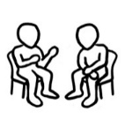
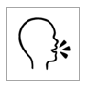
10 numbers
50 | 51 | 52 | 53 | 54 | 55 | 56 | 57 | 58 | 59
60 | 61 | 62 | 63 | 64 | 65 | 66 | 67 | 68 | 69
70 | 71 | 72 | 73 | 74 | 75 | 76 | 77 | 78 | 79
80 | 81 | 82 | 83 | 84 | 85 | 86 | 87 | 88 | 89
90 | 91 | 92 | 93 | 94 | 95 | 96 | 97 | 98 | 99
100
- 3.
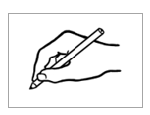
4. _____ _____ _____ _____

_____ _____ _____ _____ _____ _____

Activity 3 – Make a new number.
 | 10 | 1 | New number
a | 8 | 4 | 84
b
c
d
e
f
g
h
i
j
k
l
m
n
o

Activity 4– Sequencing maze
The maze on page 24 is a little more difficult than the one in this section in the student workbook. Once students have drawn the path through the maze, they could highlight the squares on the path. More advanced students may like to do the maze backwards, from 100 to 50.

Activity 5 – Number and values cards 50 – 100
These cards can be printed and used for a variety of activities.

- Matching numbers and values Individual or pair work
Print and cut up sets of both cards for matching. This would be helpful for students with limited formal maths experience.

- Dictate the numbers Pair work.
- You will need two sets of values cards if there are more than 16 students.
- Put the cut-up cards in a container.
- One student in each pair selects any six cards.
- Without showing their partner the cards, the student dictates each number value to their partner who writes it down.
- Once the six numbers have been dictated, the students check their work
by comparing the cards and the numbers written.
- The cards are returned to the container and the second student selects six cards and repeats the exercise.

- Sequencing #1 Class activity

- Use one set of the number cards and give the 50s cards to 10 students.
- These students bring the cards out to the board and attach them in order
with magnets.

- Then give out the 60s cards to another ten students who sequence their cards in a line under the 50s.
- Once all the cards are on the board, read them together as a class.
- Gradually remove a few numbers drawing a line in the space left, and read together again.
- Continue removing numbers in this way and reading in sequence.
- When enough numbers have been removed, ask some students to write the missing numbers in their spaces on the board.
50
51
52
53
54
55
56
57
58
59

- Sequencing #3 Class activity
- Use one set of the number cards.
- Give each student any one of the numbers from 50 to 100 and ask them
to stand in a line, in order from the lowest to the highest number.
- Once in order, students read their numbers. As there won’t be 50 students
in the class, there will be gaps in this order, making the exercise a little more complex.
Variation - The class counts from 50 to 100 and when each student’s number is called, they hold up their card.
- Sequencing #4 Pair work
- Print enough copies of the number cards, so that each pair of students has
a complete set.
- Students sequence the numbers in rows and read aloud together as they order the numbers.

Activity 4 – Sequencing maze

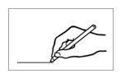
1. 2.
50 | 56 | 57 | 60 | 55 | 59 | 63 | 72 | 81
51 | 52 | 61 | 54 | 65 | 56 | 54 | 51 | 63
71 | 70 | 53 | 78 | 57 | 58 | 70 | 60 | 61
72 | 75 | 69 | 67 | 83 | 65 | 59 | 89 | 62
77 | 73 | 68 | 90 | 66 | 61 | 64 | 63 | 83
80 | 91 | 74 | 75 | 77 | 78 | 81 | 82 | 84
95 | 92 | 90 | 76 | 88 | 79 | 80 | 85 | 81
97 | 93 | 94 | 89 | 96 | 87 | 86 | 99 | 90
90 | 91 | 92 | 95 | 99 | 97 | 98 | 92 | 100

Activity 5 – Number cards 50 – 100
50 | 51
52 | 53
54 | 55
56 | 57
58 | 59

Activity 5 – Number cards 50 – 100 [Continued]
60 | 61
62 | 63
64 | 65
66 | 67
68 | 69

Activity 5 – Number cards 50 – 100 [Continued]
70 | 71
72 | 73
74 | 75
76 | 77
78 | 79

Activity 5– Number cards 50 – 100 [Continued]
80 | 81
82 | 83
84 | 85
86 | 87
88 | 89

Activity 5 – Number cards 50 – 100 [Continued]

90 | 91
92 | 93
94 | 95
96 | 97
98 | 99

Activity 5 – Number cards 50 – 100 [Continued]
100

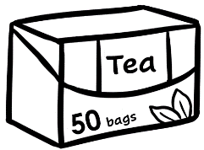 |  |  | 
Activity 5 – Number values 50 – 100

Activity 5 – Number values 50 – 100 [Continued]
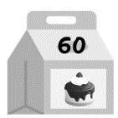 |  |  | 

Activity 5 – Number values 50 – 100 [Continued]
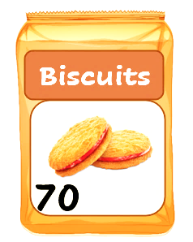 |  |  | 

Activity 5 – Number values 50 – 100 [Continued]
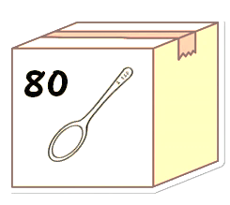 |  |  | 
 |  | 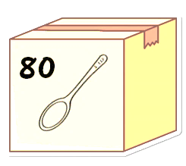

Activity 5 – Number values 50 – 100 [Continued]
 |  |  | 

Activity 5 – Number values 50 – 100 [Continued]

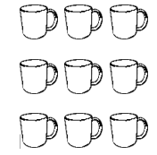

Did you say 15 or 50?
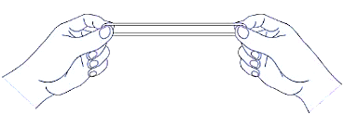
Pronunciation – Word stress patterns in numbers
The changing stress pattern between pairs of numbers such as thirteen and thirty can confuse new learners and kinaesthetic techniques can make them more aware of the stress pattern and help them to remember it.

Activity 1 – Using action to remember stress patterns
- Project the next page which shows large and small dots to indicate the stressed and unstressed syllables respectively.
- Large rubber bands are useful to demonstrate and help students remember the stressed syllable. Give each student a rubber band to hold between the thumbs and index fingers of each hand.

Stretch the band out on the stressed syllable and bring the fingers together
on the unstressed one. The stressed syllable is said a little louder and longer.
A rubber band has the advantage of being both a visual as well as a tactile aid. Once students have used the rubber band, you can mime the movement showing the stressed syllable without using the rubber band.
- Alternatively, students can clap their hands, stamp their foot, tap the table or click their fingers to make the stronger stress.

Activity 2 – Number stress Bingo
- Print, cut up and give each student a bingo card on page 39 and slowly read the numbers on the master sheet below, circling the numbers as you read them.
As you read, emphasise the stress patterns.
- Students circle each number on their card as it is called, and shout Bingo when all their numbers are circled.

Activity 2 – Number stress Bingo - Master sheet
14 | 95 | 85 | 97 | 13 | 79 | 16 | 80 | 59 | 75
89 | 18 | 57 | 40 | 70 | 15 | 59 | 67 | 17 | 60
65 | 90 | 69 | 50 | 96 | 19 | 47 | 38 | 30 | 83

Activity 1 – Using actions to remember stress patterns

13 |  | 30
14 |  | 40
15 |  | 50
16 |  | 60
17 |  | 70
18 |  | 80
19 |  | 90

Activity 2 – Number stress Bingo - Student cards
14 |  | 57 |  | 80 |  | 40 | 83 |  | 18
13 |  | Bingo |  | 95 |  | 90 | Bingo |  | 13
65 |  | 60 |  | 69 |  | 15 | 67 |  | 59
59 |  | 13 |  | 38 |  | 14 | 30 |  | 79
96 |  | Bingo |  | 50 |  | 19 | Bingo |  | 89
19 |  | 60 |  | 47 |  | 96 | 60 |  | 57
70 |  | 16 |  | 38 |  | 19 | 85 |  | 50
18 |  | Bingo |  | 69 |  | 75 | Bingo |  | 67
97 |  | 85 |  | 90 |  | 15 | 17 |  | 80

Before and after
The following worksheets could be printed back-to-back and completed together in preparation for, or as an extension of the work on pages 16 – 17 in the student workbook.
Activity 1 – Numbers before and after. Worksheet 1
Print copies of the worksheet for each student.
Exercise 1
- Ask students to circle a number either before or after a number you nominate.
e.g. Circle the number before 72.
- Ask, What’s the number? Students tell you the number.
- Continue in this pattern, asking students to circle numbers before or after particular numbers.
Exercise 2
- In this exercise, students need to draw a line to connect short number sequences. Demonstrate by writing several similar sequences on the board and asking students to match them
- When students have completed the exercise, read the sequences together.

Activity 2 – Write the numbers before and after. Worksheet 2
The exercise on the worksheet is similar to the one in the student workbook on page 16. It could be projected and completed as a class before students do the one in their workbook. Alternatively it could be given as additional work afterwards.

Activity 1 – Numbers before and after Worksheet 1

50 | 51 | 52 | 53 | 54 | 55 | 56 | 57 | 58 | 59
60 | 61 | 62 | 63 | 64 | 65 | 66 | 67 | 68 | 69
70 | 71 | 72 | 73 | 74 | 75 | 76 | 77 | 78 | 79
80 | 81 | 82 | 83 | 84 | 85 | 86 | 87 | 88 | 89
90 | 91 | 92 | 93 | 94 | 95 | 96 | 97 | 98 | 99
100
53 54 55 |  | 62 63 64
59 60 61 |  | 82 83 84
66 67 68 |  | 96 97 98
72 73 74 |  | 56 57 58
79 80 81 |  | 98 99 100
87 88 89 |  | 75 76 77
93 94 95 |  | 69 70 71
95 96 97 |  | 90 91 92

2.

Activity 2 – Write the numbers before and after. Worksheet 2
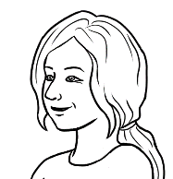
What’s the number before 64
and the number after 64?

before | 64 | after
63 | 64 | 65

before | the number | after
- 54 | 55 | 56
 | 61
 | 79
 | 83
 | 99
 | 67
 | 80
 | 91

Add the numbers.
Activity 1 – Addition cards Pair and class work
The cards on the following two pages are an extension of the work on page 18 in the student workbook. The aim of the exercises below is to familiarise students with the addition and equals signs and the ordering of simple additions.
Pair work
- Print the following two pages.
- Cut off and retain the blue total strip before giving the pages to each pair
of students to cut up into small cards.
- Students assemble the cards in the addition order shown on page 18 in their workbook.
- Each pair works out the total of the sums and writes down their answers.
- Check the answers by asking students to read their additions aloud, emphasising the maths vocabulary.
e.g. Five people plus 10 people equals 15 people.
- Give out the answers for students to cut up and place at the end of each sum.
- Students can then copy the additions into their notebooks.
- Store the cards in individual envelopes for later revision.
Class work
- Print the following two pages on A3 and cut up.
Note: Keep the equal signs and totals connected for this activity.
- Give each student a card - either a quantity, a plus sign, or an equal sign with a total.
- Ask the class to mingle and form a group of three to create the additions.
- Students take turns to read out their sums. The sums could also be ordered on the board with magnets.
- This grouping of three students can then play the game in Activity 3 – How many is that? on page 49-50.

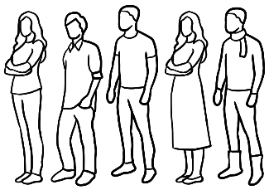  5 people |  | 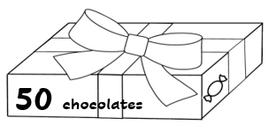  50 chocolates
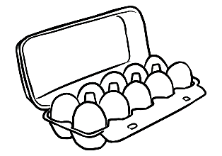  10 eggs |  | 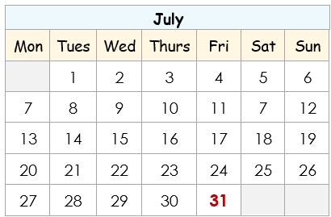  31 days
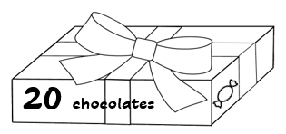  20 chocolates |  | 10 people
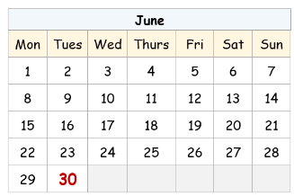  30 days |  | 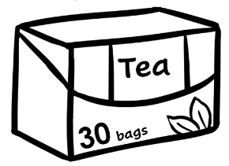  30 tea bags
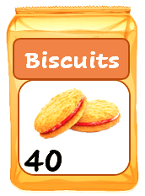  40 biscuits |  | 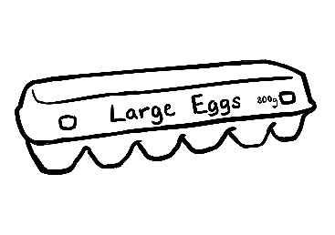  12 eggs
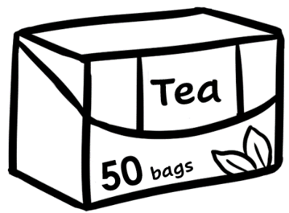  50 tea bags |  | 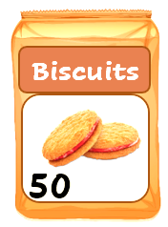  50 biscuits

+ |  | = |  |  |  | 15  people
+ |  | = |  |  |  | 22  eggs
+ |  | = |  |  |  | 70  chocolates
+ |  | = |  |  |  | 61  days
+ |  | = |  |  |  | 90  biscuits
+ |  | = |  |  | 80  tea bags


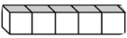
Activity 2 – Cuisenaire rods 50 – 100 Class and individual activity
For students who have had a limited educational background, Cuisenaire rods can help to develop a more concrete understanding of maths. At Course in EAL, the rods provide a visual image of number values and simple addition. Although the wooden Cuisenaire rods don’t show the unit lines, they have been added to the rods on the following pages to clearly show the value of each rod.
- one
- five
- ten
Students can see and count the 10 single units in 10, then add the 5 to make 15. In this way, the rods can develop a visual understanding of basic addition.
- Project the following two pages.
- Point to and count the 10s rods in Row a.
- Read the example addition, pointing to the numbers, the plus and equals signs and the total.
- Work through the rows, asking students to write the numbers of each addition on the board.
- Chant the totals – 55, 60, 65, 70 etc.
- Individual work - Print the following two pages. Students write the numbers on the worksheet, then copy the additions into their notebooks.

Activity 3 – How many is that? A game for small groups
- Organise students into groups of 3 or 4. Enlarge and print copies of the game on page ____on A3 paper, enough so each group has a copy. Give each group
a dice and 3 or 4 counters, buttons, stones etc.
- Print a copy of the answers.
- Students take turns to throw the dice and move round the board. When they land on a space, they need to add the numbers and give the total. If they are right, they stay on the space, but if they are wrong, they move back two spaces.
- Keep the copy of the answers at the front of the room, so students can come and check their answers if they are unsure.
- The first player to finish is the winner.

Activity 2 – Cuisenaire rods 50 – 100
a | 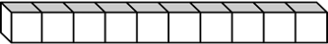 | . 50 . | + | 5 . | = | . 55 .
b |  | ______ | + | ______ | = | ______
c | 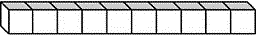 | ______ | + | ______ | = | ______
d |  | ______ | + | ______ | = | ______
e |  | ______ | + | ______ | = | ______
f |  | ______ | + | ______ | = | ______

Activity 2 – Cuisenaire rods 50 – 100 [Continued]

g |  | ._________. | + | ______ | = | ______.
h |  | ______ | + | ______ | = | ______
i |  | ______ | + | ______ | = | ______
j |  | ______ | + | ______ | = | ______
k | 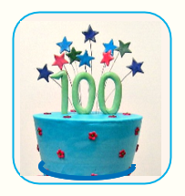  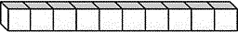  _______

Activity 3 – How many is that?

How many is that?
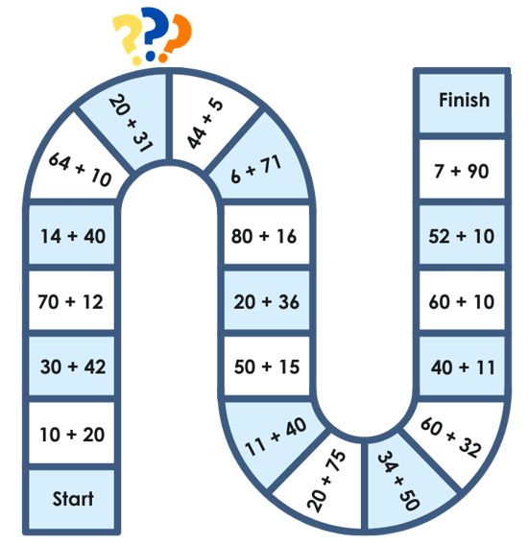

Activity 3 – How many is that? Answers
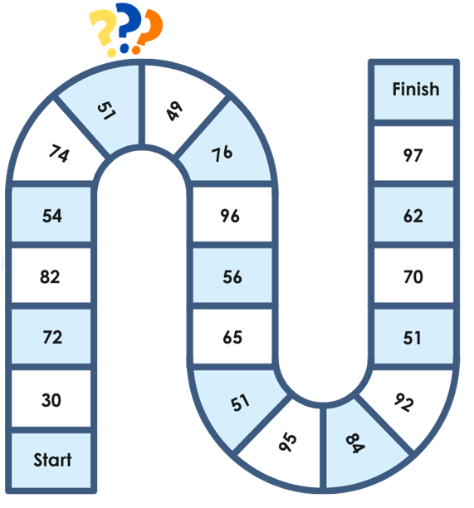

Money
The first two matching activities support students who are unfamiliar with Australian currency. Either print and cut up the cards for students to assemble, or provide scissors so students can cut them up.
Note: For students who have had little formal education, using scissors can help to develop the fine motor skills in the hands and wrists necessary for writing.
Activity 1 – Matching basic coins and notes to their amounts
Activity 2 – Matching combinations of coins and notes to their amounts

Activity 3 – Money bingo
- Give each student a bingo card and slowly read money amounts on the master sheet on page 60, circling the amounts as you read them.
- Students circle each number on their card as it is called, and shout Bingo when all their numbers are circled.
Activity 4 – How much is that? Game in small groups
- Organise students into groups of 3 or 4. Enlarge and print copies of the game on page 62 on A3 paper, enough so each group has a copy. Give each group
a dice and 3 or 4 counters. [ buttons, stones etc. ]
- Print a copy of the answers.
- Students take turns to throw the dice and move round the board. When they land on a space, they need to add up the money and give the total. If they are right, they stay on the space, but if they are wrong, they move back two spaces.
- Keep the copy of the answers at the front of the room, so students can come and check their answers if they are unsure.
- The first player to finish is the winner.
Note - The blank game template on page 64 can be used to create a new game with different simple additions.

Activity 1 – Matching basic coins and notes to their amounts
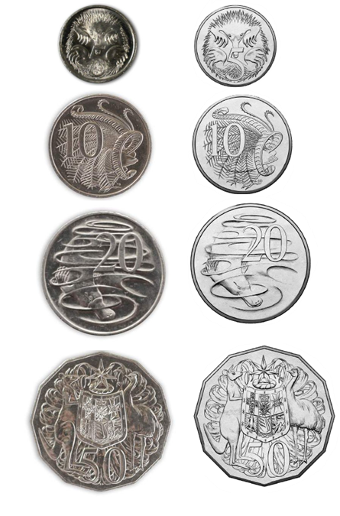
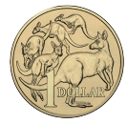 | 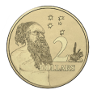


 | 

Activity 1 – Matching basic coins and notes to their amounts [Continued]
5c | 10c
20c | 50c
$1 | $2
$5 | $10
$20 | $50
$100

Activity 2 – Matching combinations of coins and notes to their amounts

Activity 2 – Matching combinations of coins and notes to their amounts [Continued]
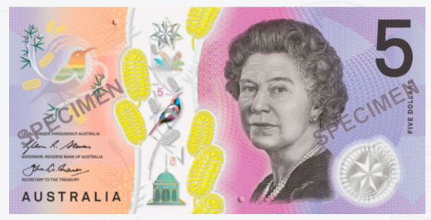

Activity 2 – Matching combinations of coins and notes to their amounts [Continued]

Activity 2 – Matching combinations of coins and notes to their amounts [Continued]
55c | 60c
70c | $1
$1.50 | $2
$2.10 | $2.50

Activity 2 – Matching combinations of coins and notes to their amounts [Continued]

$3 | $4
$7 | $10
$15 | $20
$25 | $30

Activity 2 – Matching combinations of coins and notes to their amounts [Continued]

$40 | $55
$60 | $70
$100

Activity 3 – Money bingo Teacher call charts
$55 | $84 | $30 | $92
$61.50 | $60 | $77 | $25
$90.50 | $20 | $70 | 60c
$10 | $2.50 | $61 | $100
55c | $40 | $85 | $36
$55 | $84 | $30 | $92
$61.50 | $60 | $77 | $25
$90.50 | $20 | $70 | 60c
$10 | $2.50 | $61 | $100
55c | $40 | $85 | $36
$55 | $84 | $30 | $92
$61.50 | $60 | $77 | $25
$90.50 | $20 | $70 | 60c
$10 | $2.50 | $61 | $100
55c | $40 | $85 | $36

Activity 3 – Money bingo cards
$85 | $84 | $60 |  | $90.50 | $77 | $85
$100 | Bingo | 55c |  | $20 | Bingo | $61.50
$55 | 60c | $77 |  | $30 | $2.50 | $36
$77 | $60 | $25 |  | $36 | $10 | $60
$92 | Bingo | 55c |  | $84 | Bingo | $90.50
$90.50 | $4 | $2.50 |  | $55 | $2.50 | $20
$92 | $30 | $85 |  | $40 | $61.50 | $10
$36 | Bingo | $70 |  | $100 | Bingo | $61
55c | $25 | $61.50 |  | $30 | 60c | $25

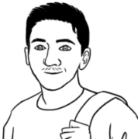
Activity 4 – How much is that?
How much is that?

Start |  | $50 + $4 |  | $72 + $5 |  | $81 + $8 |  | $66 + $3
$20
+$10
$54 + $32 |  | $50 + $28 |  | $35 + $43 |  | $65 + $4 |  |  | $20  +$10
$12  +$73 |  |  |  |  |  |  | $25  $24 |  | $13  +$10
$12  +$73 |  | $100 + 0 |  | Finish |  |  | $25  $24 |  | $13  +$10
$64  +$33 |  | $62  +$37 |  |  |  |  | $61  +$38 |  | $33  +$44
$64  +$33 |  | $62  +$37 | $11 + $68 |  | $17 + $22 |  | $61  +$38 |  | $33  +$44
$42  +$37 |  |  |  |  |  |  |  |  | $82  +$12
$42  +$37 | $73 + $24 |  | $44 + $25 |  | $78 + $11 |  | $63+ $22 |  | $82  +$12

Activity 4 – How much is that? Answers
Start |  | $54 |  | $77 |  | $89 |  | $69
 |  |  |  |  |  |  |  |  | $30
$86 |  | $78 |  | $78 |  | $69 |  |  | $30
$85 |  |  |  |  |  |  | $49 |  | $23
$85 |  | $100 |  | Finish |  |  | $49 |  | $23
$97 |  | $99 |  |  |  |  | $99 |  | $77
$97 |  | $99 | $79 |  | $39 |  | $99 |  | $77
$79 |  |  |  |  |  |  |  |  | $94
$79 | $97 |  | $69 |  | $89 |  | $85 |  | $94

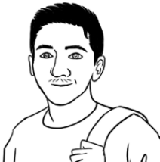
Activity 4 – How much is that? Template for a new game
How much is that?

Start
Finish

Morning tea
A morning tea with another class not only creates situations for the practice of skills in numeracy, but also provides opportunities for developing:
- conversation skills
- class cohesion in the planning and hosting of the event
- friendships and communication with a wider range of students
- student confidence.
Activity – Buying the ingredients for biscuits and cakes
- Project the vocabulary list on the following page. The list includes food items commonly used in baked goods. Revise or introduce the vocabulary.
- Print the two pages of the worksheet back-to-back and give each student a copy.
- The worksheet extends the exercise in this section of the student workbook:
- The students ask the teacher, How much is the flour? How much is the sugar? etc.
- The teacher dictates the prices for students to write next to each item. Students need to write the dollar signs as well as the dollar values.
- Students then complete the additions on the second page.
- Correct this together by writing the additions with their totals on the board for students to check their work.

Activity – Buying the ingredients for biscuits and cakes Vocabulary

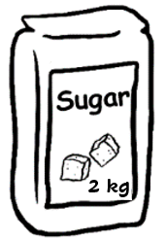  sugar | 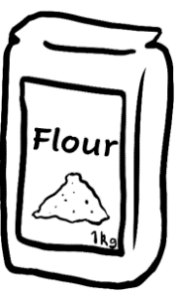  flour | 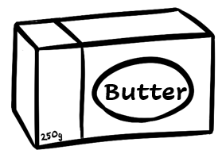  butter
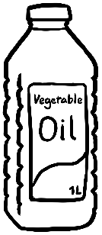  oil | 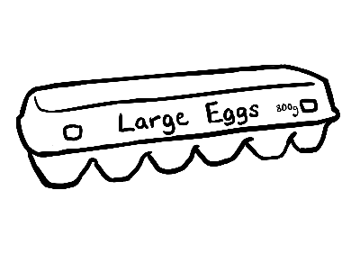  eggs | 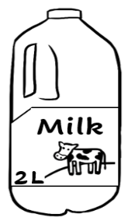  milk
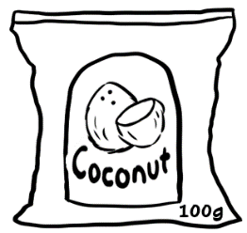  coconut | 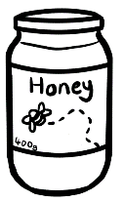  honey |   dates

Activity – Buying the ingredients for biscuits and cakes

Worksheet answers

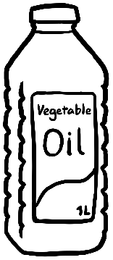
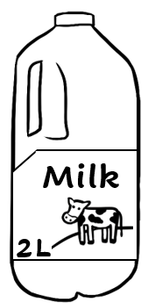
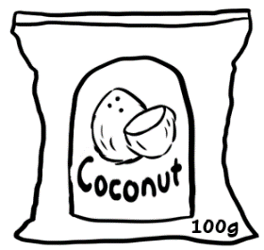
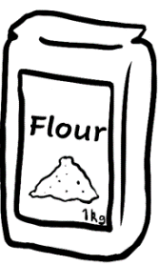

Supermarket

$6
$5.50
$2
$3
$3.50
$5
$2.50
$6.50
$7

Activity – Buying the ingredients for biscuits and cakes Worksheet page 1
How much are the eggs?
How much is the flour?
1.

Supermarket

_______
_______
_______
_______
_______
_______
_______
_______
_______


flour $. 2 .
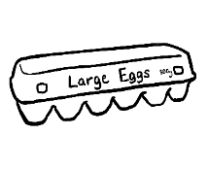
eggs $ . 5.50 .

Total $ 7.50
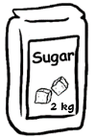
sugar $______
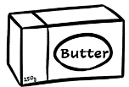
butter $ ______

Total $ .

dates $______
coconut $ ______

Total $ .
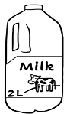
milk $______
honey $ ______
Total $ .
Activity – Buying the ingredients for biscuits and cakes Worksheet page 2


I need some flour and eggs.

a.


I need some sugar and butter.

b.


I need some dates and coconut.

c.

I need some milk and honey.

d.

At a café
Activity 1 - What’s for lunch? Pair work
- Project the pictures below and revise the vocabulary.
- Ask students to guess how much each food item costs.
- Divide the class into pairs – Student A and Student B.
- Print and cut the worksheet in half. Give each student a copy of their section.
- Demonstrate how to do the exercise with a confident student.

Note - The star indicates the student who asks the first question.
The grammar: How much is the orange juice?
How much are the chips?
- Encourage students to use polite forms to ask for repetition when they don’t understand. e.g. Can you say that again please?
Activity 2 - What’s for lunch? Pair work
This activity is the same as Activity 1 except that the students make up their own prices. Student A write their prices in the yellow boxes and Student B in the blue boxes. It doesn’t matter if the prices are unrealistic, as this is part of the fun.
However, no price can be over $100. In this game, Student B asks the first question.

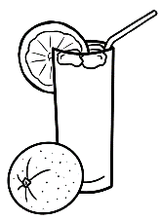 |  |  | 
orange juice | pizza | sandwich | banana
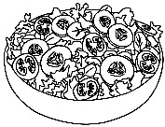 | 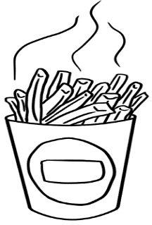 | 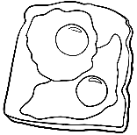 | 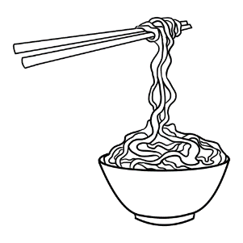
salad | chips | eggs | noodles

Activity 1 - What’s for lunch?
How much is the ____ ?
Student A
Can you say that
again please?

a. | How much is the orange juice? |  | ______
b. | How much is the pizza? |  | $6.00
c. | How much is the sandwich? |  | ______
d. | How much is the banana? |  | $1.00
e. | How much is the salad? |  | $8.50
f. | How much are the chips? |  | ______
g. | How much are the eggs? |  | $12.50
h. | How much are the noodles? |  | ______

How much is the ____ ?
Student B
Can you say that
again please?

a. | How much is the orange juice? |  | $5.00
b. | How much is the pizza? |  | ______
c. | How much is the sandwich? |  | $10.50
d. | How much is the banana? |  | ______
e. | How much is the salad? |  | ______
f. | How much are the chips? |  | $6.50
g. | How much are the eggs? |  | ______
h. | How much are the noodles? |  | $12.00
Activity 2 - What’s for lunch?

Student A
1.
How much is the ____ ?
2.

a. | How much is the orange juice?
b. | How much is the pizza? |  | ______
c. | How much is the sandwich?
d. | How much is the banana? |  | ______
e. | How much is the salad?
f. | How much are the chips? |  | ______
g. | How much are the eggs? |  | ______
h. | How much are the noodles?

Student B

How much is the ____ ?

a. | How much is the orange juice? |  | _______
b. | How much is the pizza?
c. | How much is the sandwich? |  | _______
d. | How much is the banana?
e. | How much is the salad? |  | ______
f. | How much are the chips?
g. | How much are the eggs?
h. | How much are the noodles? |  | _______

At a clothes shop
Activity 1 - Pairs of clothes
The introduction of vocabulary for the men’s and women’s shops can also cover
the use a pair of. In the student workbook, the word some is used instead of
a pair of, as some is more commonly used in casual speech.
In the two grids on the following pages, the clothing that comes in pairs is shaded in grey. You could expand on other clothes and objects that come in pairs using the pictures below if appropriate.

Activity 2 – What’s that? Vocabulary at the Men’s clothes shop
Project page 74 and introduce the vocabulary students will need to do the exercises in Section 11 in the student workbook.
Activity 3 - What’s that? Vocabulary at the Women’s clothes shop
Project page 75 and introduce the vocabulary students will need to do the exercises about the women’s shop on pages 77 – 80.
Activity 4 – Women’s fashion
This 4-page activity about a women’s clothing shop is a parallel activity to the men’s shop in Section 11 in the student workbook. However in the exercise here, the students ask the teacher the prices of each item. The teacher dictates the prices and students write them on the advertisement.
The activity can be done in stages, and used as extension work or homework.

Activity 1 - Pairs of clothes

a pair of ___________
  glasses |   goggles | 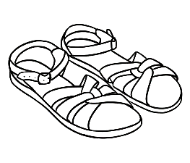  sandals | 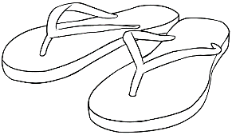  thongs
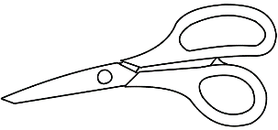  scissors | 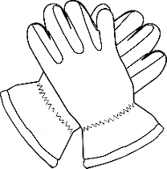  gloves | 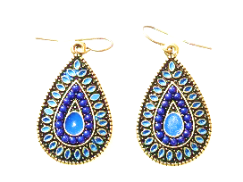  earrings | 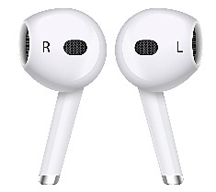  ear buds

Activity 1 – What’s that? Vocabulary at the Men’s clothes shop

1 | 2 | 3
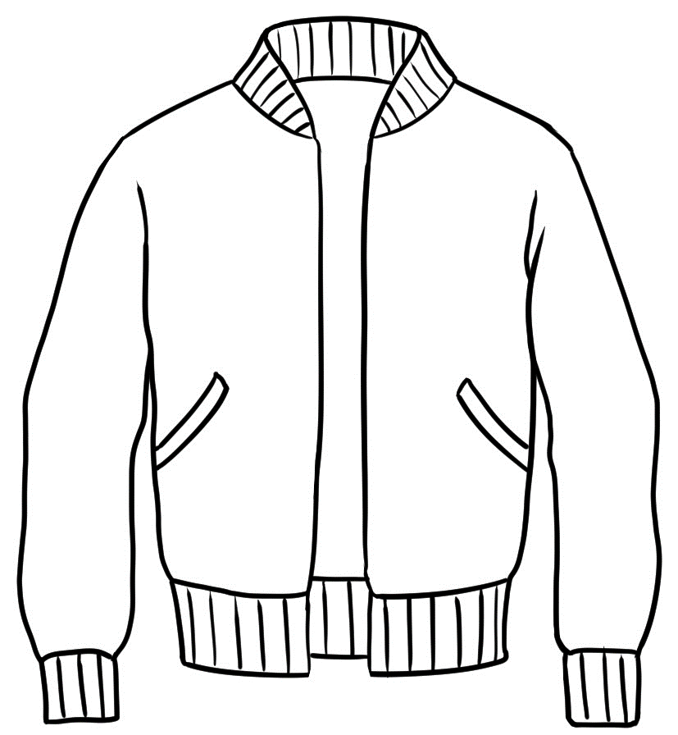  a jacket | 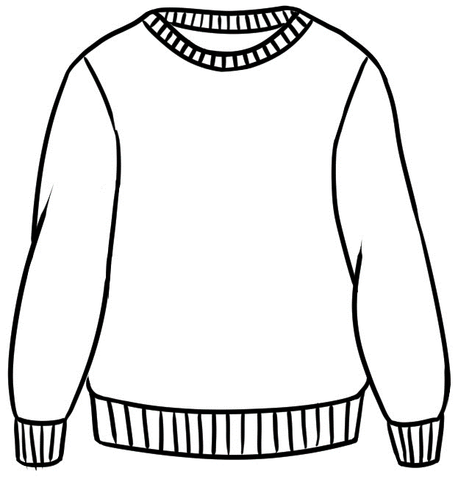  a jumper | 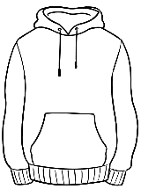  a hoodie
4 | 5 | 6
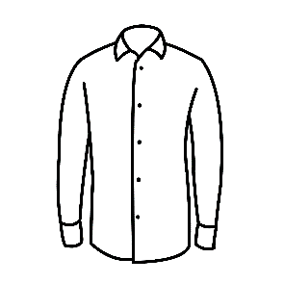  a shirt | 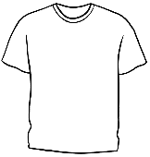  a t-shirt | 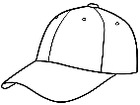  a cap
7 | 8 | 9
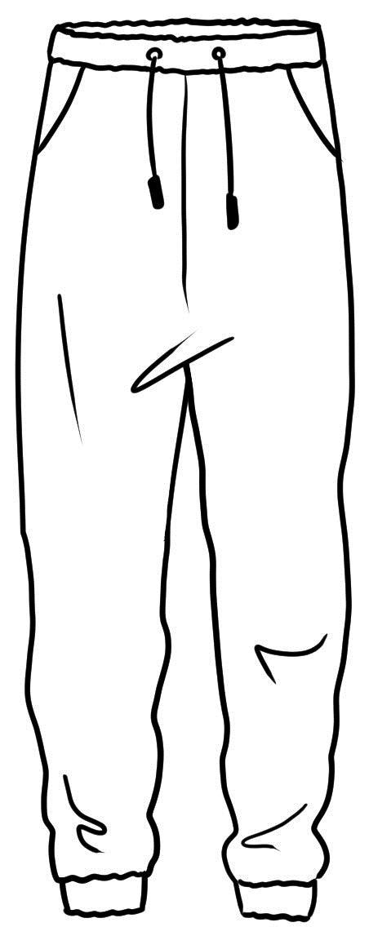  track  pants | 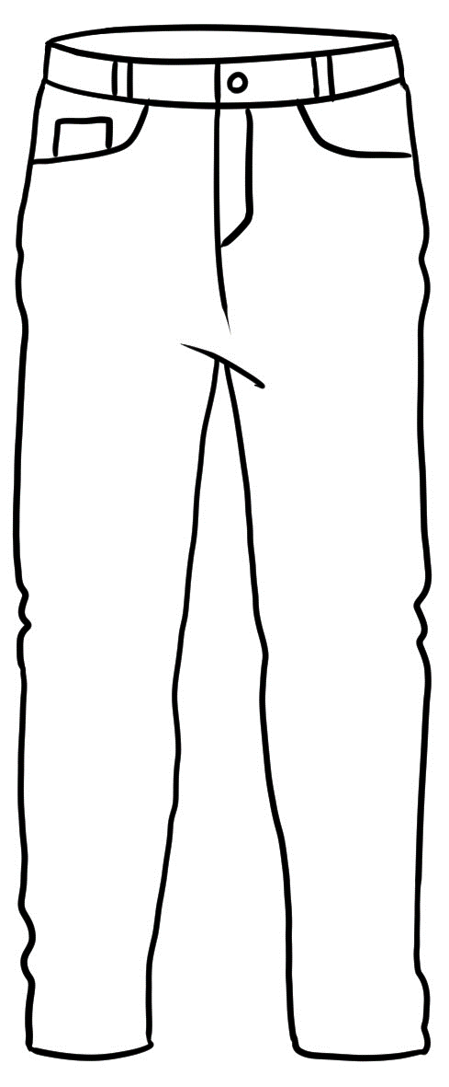  jeans | 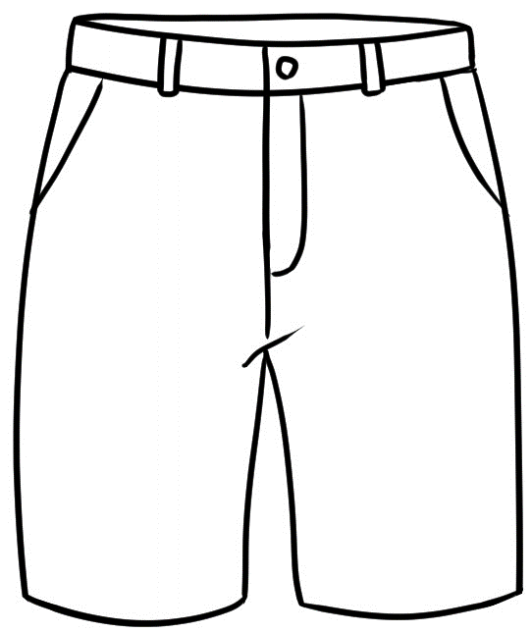  shorts
10 | 11 | 12
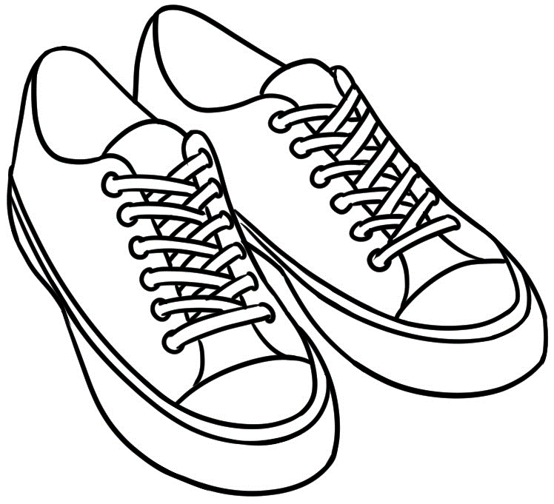  runners | 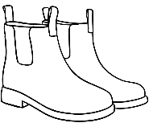  boots | 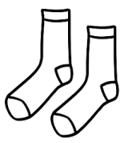  socks

Activity 2 - What’s that? Vocabulary at the Women’s clothes shop

1 | 2 | 3
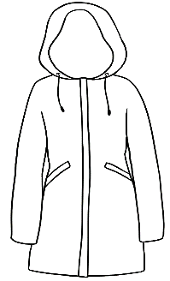  a raincoat | 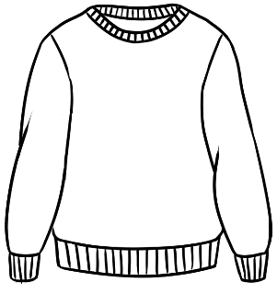  a jumper |   a scarf
4 | 5 | 6
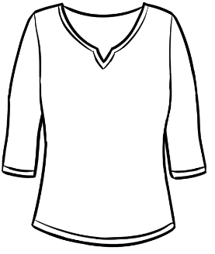  a short top | 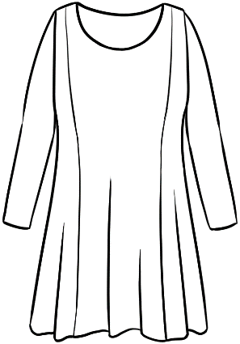  a long top |   a hat
7 | 8 | 9
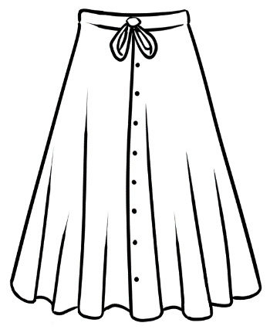  a skirt | 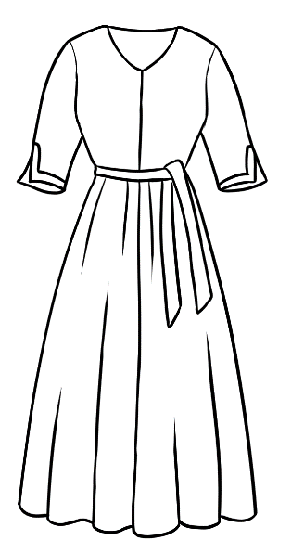  a dress | 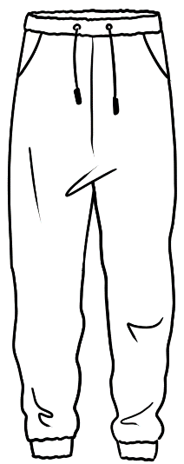  track  pants
10 | 11 | 12
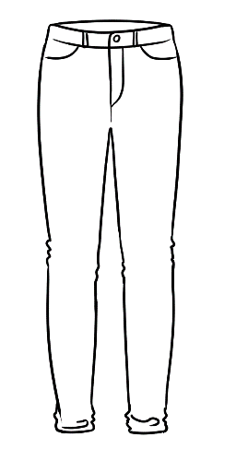  jeans | runners | 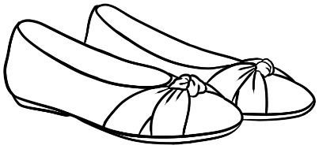  shoes

Activity 4 – Women’s fashion Answers

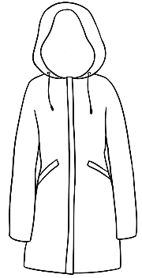
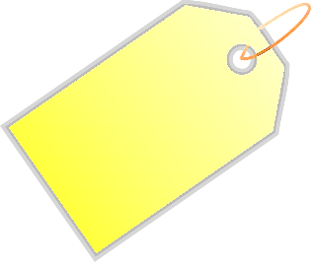
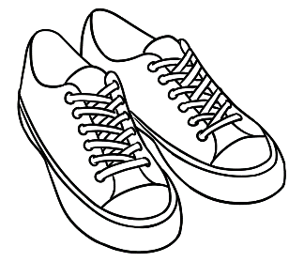
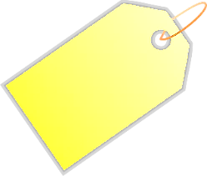

raincoat
$60
jumper
$30

track pants
$18.50
short top
$16
skirt
$54.50
dress
$65
runners
$80
hat
$15
long top
$44
shoes
$62.50
jeans
$52
scarf
$12.50

Activity 4 – Women’s fashion
How much is the jumper?
How much are the shoes?

raincoat
________
jumper
_______
track pants
__________
short top
_______
skirt
_______
dress
_______
runners
______
hat
______
long top
________
shoes
_______
jeans
______
scarf
______

$12.50
$15
$16
$18.50
$30
$44
$52
$54.50
$60
$62.50
$65
$80

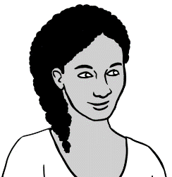
I need a jumper and some shoes.

 | a jumper | $30.00
 | shoes  Total | + $62.50  $92.50 .

I need some track pants and some runners.
 | track pants | $ _______
 | runners  Total | + $ _______  _________
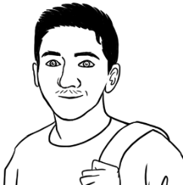
My sister needs
a raincoat and
a scarf.
 | a raincoat | $ _______
 | a scarf  Total | + $ _______  _________

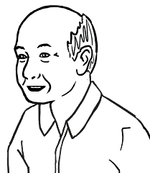
My granddaughter needs
a short top and some jeans.

 |  | a short top | $ _______
 |  | jeans  Total | + $ _______  _________
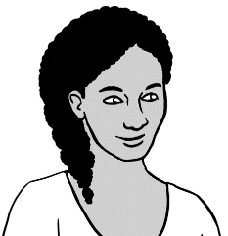
My mother needs a hat and a long top.
b. |  | a hat | $ _______
 |  | a long top  Total | + $ _______  _________
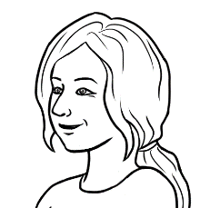
I need a hat
and a skirt.
c. | a hat  a skirt  Total |  | $ _______
c. |  |  | + $ _______  _________

At an office shop and a kitchen shop
Activity 1 – What’s that? Vocabulary at an office shop
Project the next page and introduce the vocabulary students will need to do the exercises in Section 12 in the student workbook.
Note – The grey boxes contain items that are plural and which can be preceded by some [used commonly in speech], a set of or a pair of.

Activity 2 - At a Kitchen Shop How much does it cost? Pair work
This kitchen shop activity provides extension work and does not appear in the student work book.
- Project the appliances on page 84 and introduce new vocabulary.
- Print the pictures of appliances and the page of prices for students to cut up
in pairs.
- Students have a guess and match the appliances to their prices.
- Finally read out the prices for students to check and adjust.
- Give each student a copy of the worksheet with the appliances on page 88,
so they can write the prices including the dollar signs.
Activity 3 – How much does it cost? Addition worksheet
Student complete the additions on page 87.

Activity 1 – What’s that? Vocabulary at an office shop

1 | 2 | 3
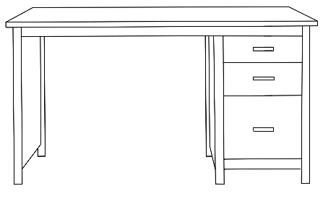  a desk | 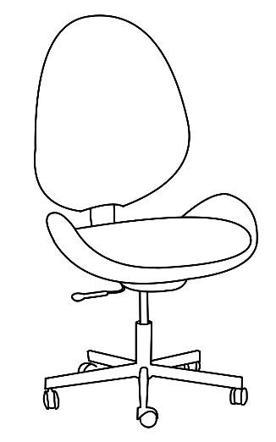  a chair |   a lamp
4 | 5 | 6
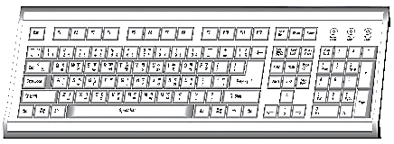  a keyboard | 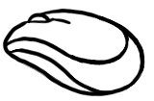  a mouse | 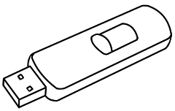  a USB
7 | 8 | 9
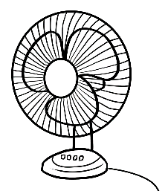  a fan | 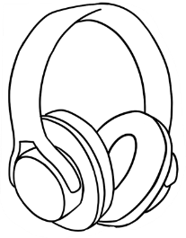  headphones | 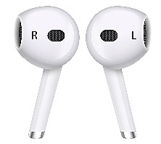  ear buds

Activity 2 - At a Kitchen Shop How much does it cost? Answers


An electric kitchen
- a kettle | - an iron | - a rice cooker
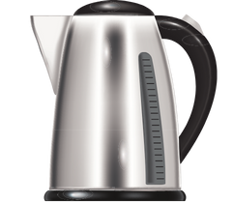 | 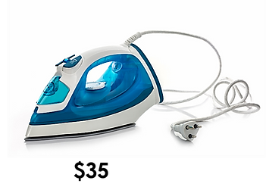 | 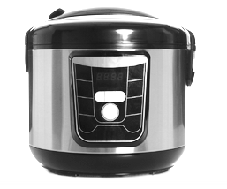
$42.00 | $34.50 | $50.00
- a sandwich toaster | - a blender | - a small vacuum cleaner
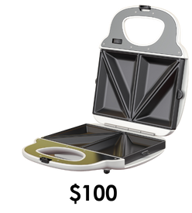 | 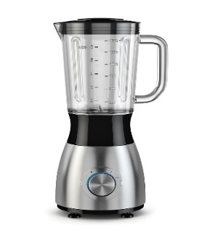 | 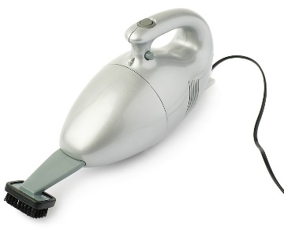
$23.50 | $70.00 | $51.00
- a toaster | - a mixer | - scales
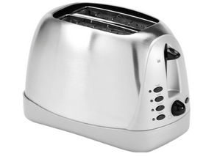 | 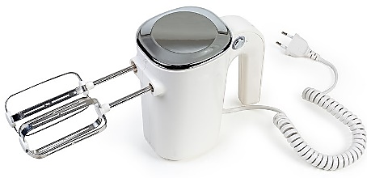 | 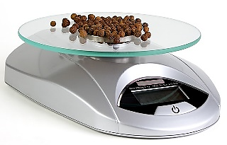
$60.00 | $44.00 | $25.50

Activity 2 - At a Kitchen Shop How much does it cost?
a kettle | an iron | a toaster
a rice cooker | a sandwich  toaster | a mixer
a blender | a vacuum  cleaner | scales

$70.00 | $23.50 | $42.00
$50.00 | $60.00 | $25.50
$44.00 | $34.50 | $51.00
Activity 2 - At a Kitchen Shop How much does it cost? [Continued]

Activity 2 - At a Kitchen Shop How much does it cost? Worksheet

An electric kitchen
- a kettle | - an iron | - a rice cooker
________ | _________ | _________
- a sandwich toaster | - a blender | - a small vacuum cleaner
_________ | _________ | _________
- a toaster | - a mixer | - scales
_________ | _________ | _________

Activity 3 - At a Kitchen Shop How much does it cost? Addition worksheet
 | 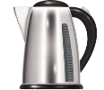  a kettle | $_______
 | 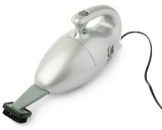  a vacuum cleaner  Total | + $_______  ________
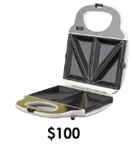  b. | a sandwich toaster | $ _______
 | a rice cooker  Total | + $ _______  __________
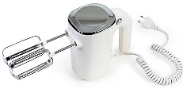  c.  a mixer  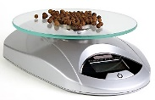  scales  Total |  | $_______
+ $_______
________
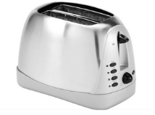  a toaster |  | $_______
an iron  Total |  | + $_______  ________
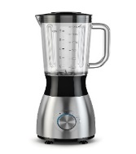  a blender |  | $_______
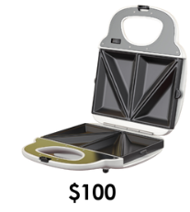  a sandwich toaster  Total |  | + $_______  ________

Let’s go out.
On the following page are two additional places to consider for an excursion. Explain that most museums and art galleries in Australia have free entry, but charge a fee for special exhibitions. Also many cinemas have cheaper prices on particular days, such as on Mondays and Tuesdays and offer discounts for group bookings.
Activity – The museum and cinema
- Print a worksheet for each student.
- Students could ask questions such as, How much is an adult ticket?
- Dictate the prices from the answer sheet below for students to write.

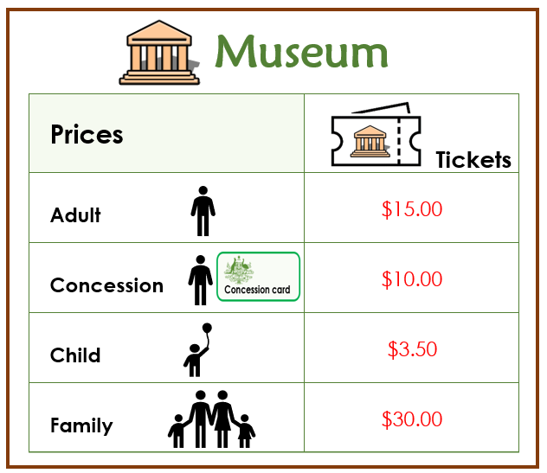
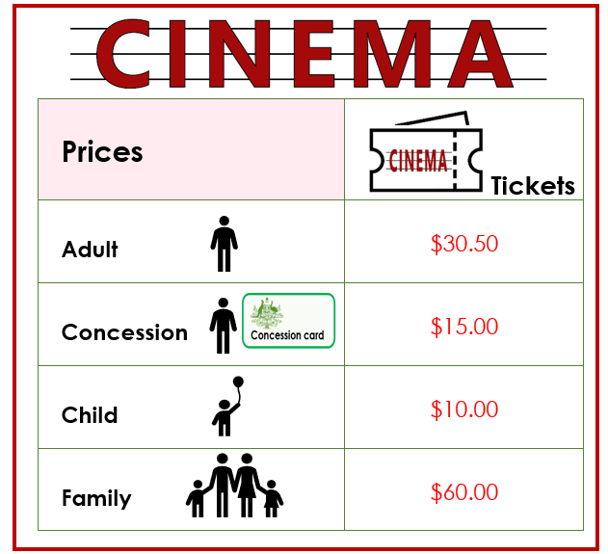

Activity – The museum and cinema


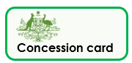




1.
Museum
Prices | Tickets
Adult | _________
Concession | _________
Child | _________
Family | _________

2.




Prices | Tickets
Adult | _________
Concession | _________
Child | _________
Family | _________

