English Ready
22637VIC Course in EAL
VU23578 - Recognise and use time in highly familiar situations

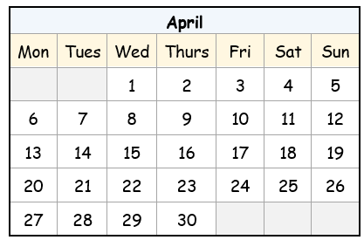
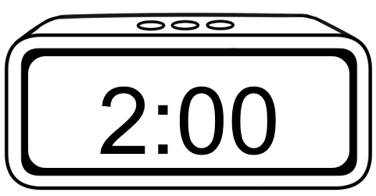
Times and dates

Name __________________________________________________________________
Teacher _______________________________________________________________
Class ___________________________________________________________________
Date____________________________________________________________________

This workbook is designed to be used with the support of a teacher.

Design team: Sue Paull, Vicki Hambling, Nikeh Shariatian, Bernie Miles, and Mary Wallace
Illustrations: Madelena Scott
Image acknowledgements:
Student studying, shopping trolley, birthday banner, Christmas tree and lights - These Photos by Unknown Author is licensed under CC BY-NC

Acknowledgements: The design team would like to acknowledge the use of the EAL Framework which underpins the design of this book.
Copyright of the EAL Framework is reserved to the Crown in the right of the State of Victoria. © State of Victoria (Department of Education and Training) 2023.
_________________________________________________________________________________________
This English Ready Resource is licensed under a Creative Commons Attribution-NoDerivs 3.0 Australia licence (More information is available here). You are free to use, copy and distribute to anyone in its original form as long as you attribute Department of Home Affairs as the author and you license any derivative work you make available under the same licence.
© Commonwealth of Australia 2024

With the exception of the Commonwealth Coat of Arms, the department’s logo, any material protected by a trade mark and where otherwise noted all material presented in this document is provided under a Creative Commons Attribution 4.0 International (https://creativecommons.org/licenses/by/4.0/) licence.
The details of the relevant licence conditions are available on the Creative Commons website (accessible using the links provided) as is the full legal code for the CC BY 4.0 licence (https://creativecommons.org/licenses/by/4.0/legalcode).
Use of all or part of this document must include the following attribution:
© Commonwealth of Australia 2023
As far as practicable, material for which the copyright is owned by a third party will be clearly labelled. The department has made all reasonable efforts to ensure that this material has been reproduced in this document with the full consent of the copyright owners.
Copyright requests and enquiries concerning usage not addressed by the CC BY 4.0 licence should be addressed to:
comms@homeaffairs.gov.au at the Department of Home Affairs.
The terms of use for the Commonwealth Coat of Arms are available from the It's an Honour website.
Where a copyright owner, other than the Commonwealth, is identified with respect to this material, please contact that third party copyright owner directly to seek permission.



Contents
1. Instructions 4
2. Meet the students and teachers. 5
3. What day is it? 6
4. Sahra is busy this week. 10
5. What time is it? 12
6. What time do you get up? 16
7. Morning and afternoon 22
8. What month is it? 26
9. What’s the date? 30
10. Special dates 34

Instructions
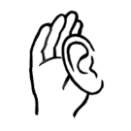
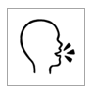

 | 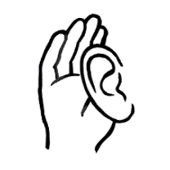 | listen |  |  | say
 |  | read |  | 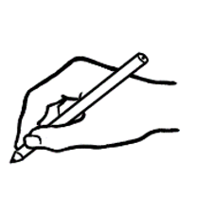 | write
 | 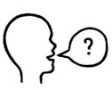 | ask |  |  | copy
 | 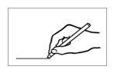 | match |  |  | circle
 |  | highlight |  |  | tick
 | 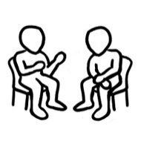 | work with  a partner |  | 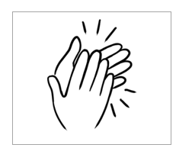 | clap

Meet the students and teachers.
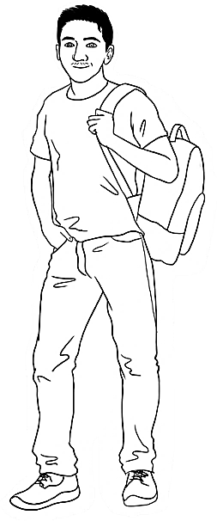
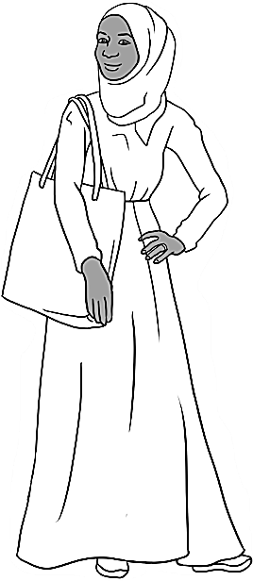
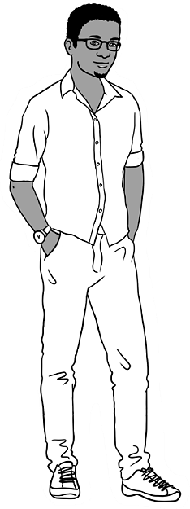
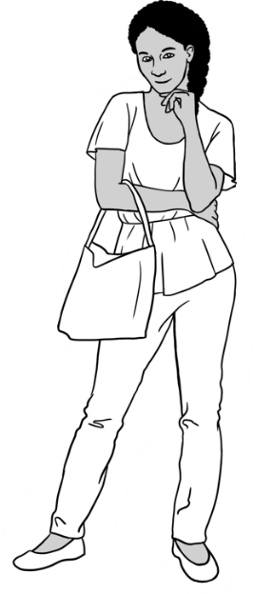
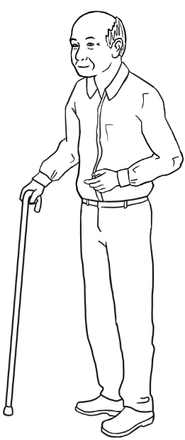
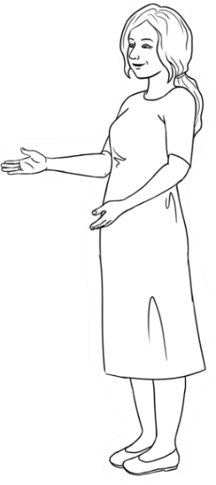
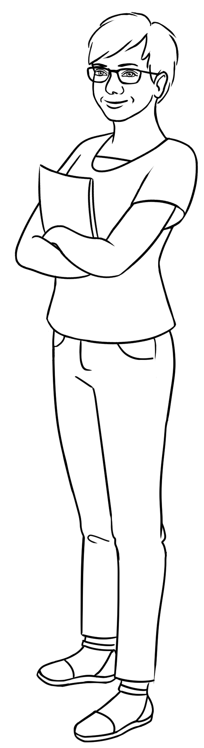
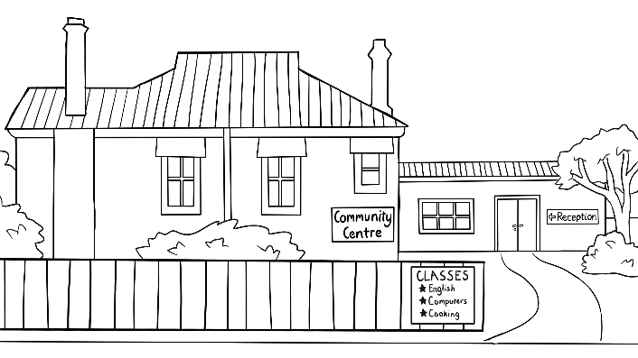
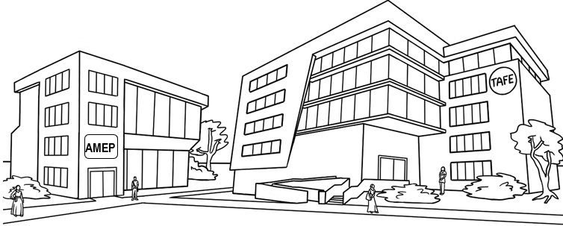
Carim Sahra Tahiil Anika Ming
The students
The teachers
Jenny Wendy
The learning centres

What day is it?
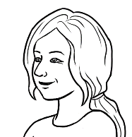
What day is it today?
- 2.
 | 1 | Monday | weekdays
 | 2 | Tuesday | weekdays
 | 3 | Wednesday | weekdays
 | 4 | Thursday | weekdays
 | 5 | Friday | weekdays
 | 6 | Saturday | the weekend
 | 7 | Sunday | the weekend


3.
weekdays |  |  | the weekend
1 | Monday |  | 6 | Saturday
1 | Monday |  | 6
2 | Tuesday |  | 7 | Sunday
3 | Wednesday
4 | Thursday |  |  | There are 7 days  in a week.
5 | Friday

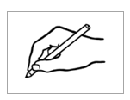
- .

Yesterday | Today | Tomorrow
The day before today | ____________________ | The day after today
____________________ | ____________________ | ___________________

What’s the day before Tuesday?
4.

a. | Monday | Tuesday | Wednesday
b. | Thursday | Friday | Saturday
c. | Sunday | Monday | Tuesday
d. | Wednesday | Thursday | Friday
e. | Saturday | Sunday | Monday
f. | Tuesday | Wednesday | Thursday
g. | Friday | Saturday | Sunday
h. | Monday | Tuesday | Wednesday
i. | Thursday | Friday | Saturday
j. | Sunday | Monday | Tuesday

Monday |  | Tuesday |  | Wednesday |  | Thursday
Friday |  | Saturday |  | Sunday

- Tuesday | Wednesday | Thursday .
b. ___________________ | Tuesday | Wednesday
c. ___________________ | Saturday | Sunday
d. Monday | Tuesday | ___________________
e. Thursday | Friday | ___________________
f. ___________________ | Monday | Tuesday
g. ___________________ | Wednesday | Thursday

The days of the week are Monday , __________________________, _____________________________, _________________________, _________________________,

___________________________ and ___________________________.
Long word |  | Short word
Monday |  | Tues
Tuesday |  | Wed
Wednesday |  | Sun
Thursday |  | Mon
Friday |  | Sat
Saturday |  | Thurs
Sunday |  | Fri
3.


4.
Is the market open on Monday?

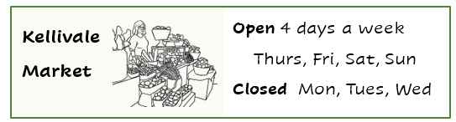

- The market is open on ________, _________, __________ and _________.

- The market is closed on ________, _________ and __________.

Sahra is busy this week.
I’m busy this week.
- Monday | 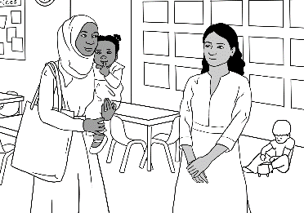  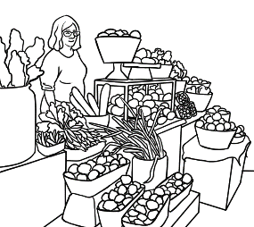  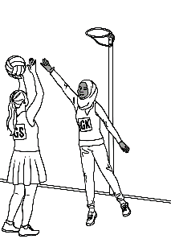  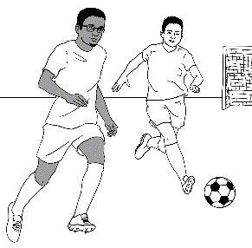  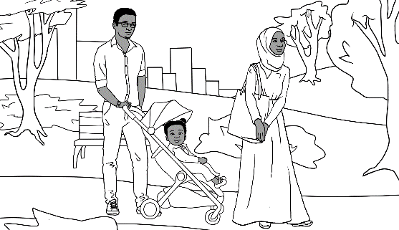  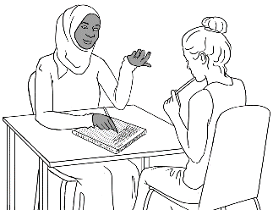  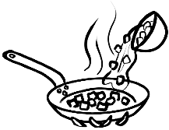  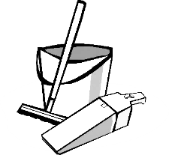 |   I go to class on Monday  and Tuesday .
- Tuesday |  | My daughter Hani goes to childcare on ______________ and ________________.
- Wednesday |  | I clean and cook  on ___________________.
- Thursday |  | I go to the market  on _______________.
- Friday |  | We go to the park  on ________________.
- Saturday |  | Tahiil and I play sport  on ________________ and _________________.
- Sunday

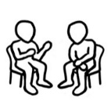

on Monday
on Tuesday
on Wednesday
on Thursday
on Friday
on Saturday
on Sunday

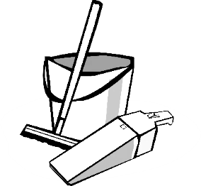

What time is it?
What time is it?
a. It’s 1 o’clock. | b. It’s 2 o’clock. | c. It’s 3 o’clock.
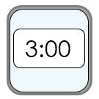  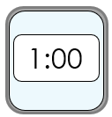  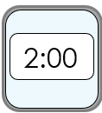  1:00 | ________ | ________
d. It’s 4 o’clock. | e. It’s 5 o’clock. | f. It’s 6 o’clock.
________ | ________ | 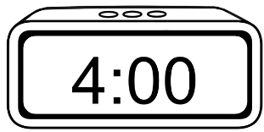  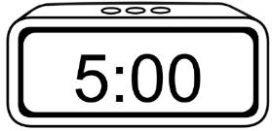  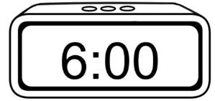  ________
g. It’s 7 o’clock. | h. It’s 8 o’clock. | i. It’s 9 o’clock.
________ | ________ | 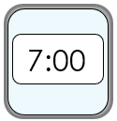  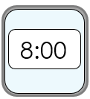  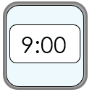  ________
j. It’s 10 o’clock. | k. It’s 11 o’clock. | l. It’s 12 o’clock.
________ | ________ | 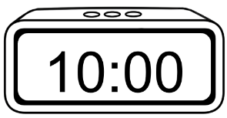  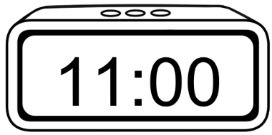  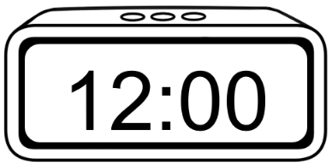  ________
- 2.
It’s = It is

- It’s 1 o’clock.
- It’s 2 o’clock.
- It’s 3 o’clock.
- It’s 4 o’clock.
- It’s 5 o’clock.
- It’s 6 o’clock.
- It’s 7 o’clock.
- It’s 8 o’clock.
- It’s 9 o’clock.
- It’s 10 o’clock.
- It’s 11 o’clock.
- It’s 12 o’clock.

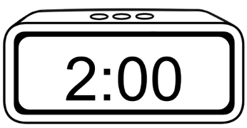
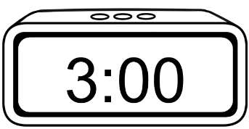
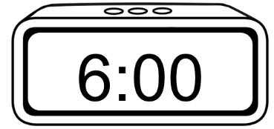
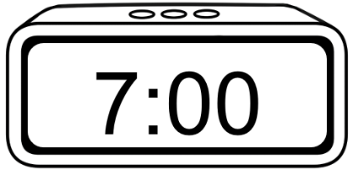
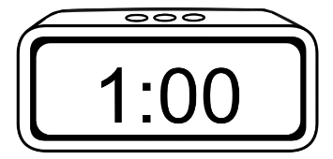
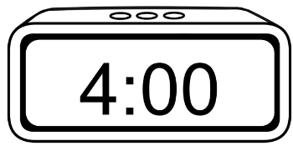
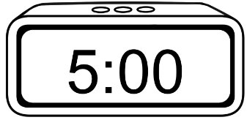
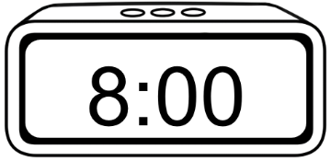
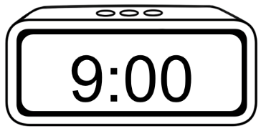
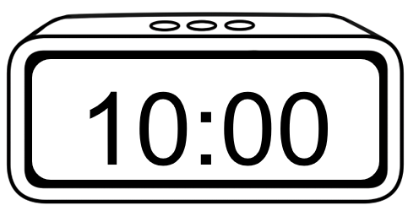


What time is it?
It’s 1 o’clock.
2.
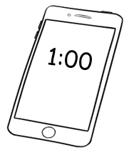  a. | b.  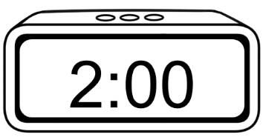 | 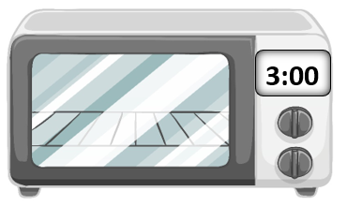  c.
It’s 1:00.  It’s 1 o’clock. | It’s 2:00.  It’s ___ o’clock. | It’s 3:00.  It’s ___ o’clock.
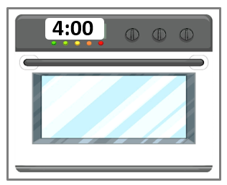  d. | e.   | 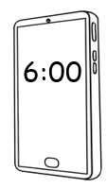  f.
It’s 4:00.  It’s ___ o’clock. | It’s s 5:00.  It’s ___ o’clock. | It’s 6:00.  It’s __ o’clock.
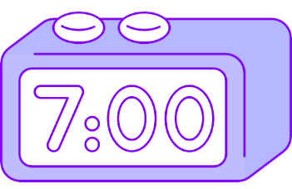  g. | 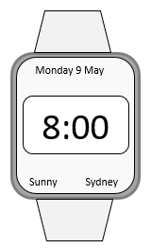  h. | 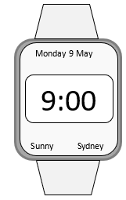  i.
It’s 7:00.  It’s __ o’clock. | It’s 8:00.  It’s __ o’clock. | It’s 9:00.  It’s __ o’clock.

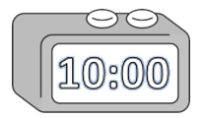  j. |   k. | 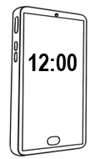  l.
It’s 10:00.  It’s ___ o’clock. | It’s 11:00.  It’s ___ o’clock. | It’s 12:00.  It’s ___ o’clock.
It’s 4 o’clock.

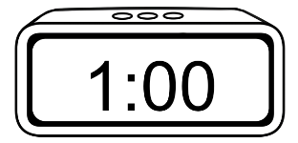  a. | 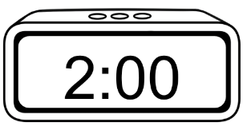  b. | 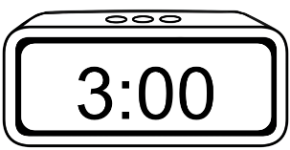  c.
d. | 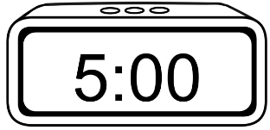  e. | 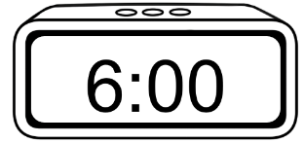  f.
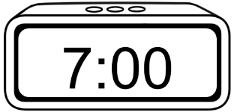  g. | 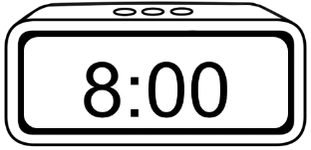  h. | 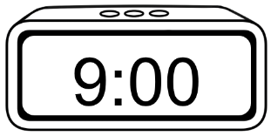  i.
j.  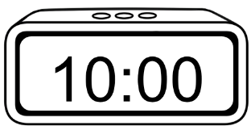 | 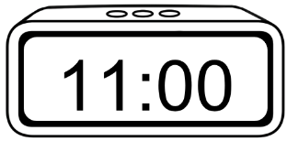  k. | 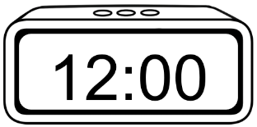  l.

What time do you get up?
- 2. 3.

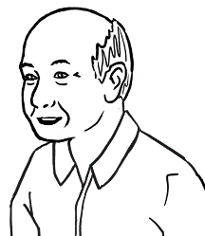
What time do you get up
on Tuesday Ming?
At 6 o’clock.

On Tuesday
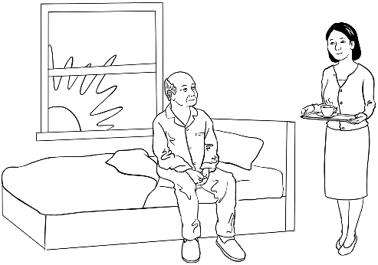 | 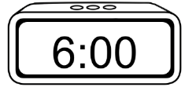 | I get up at 6 o’clock.  at 6 o’clock_
   | 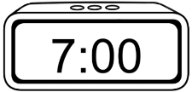 | I have breakfast  at 7 o’clock.  ____________
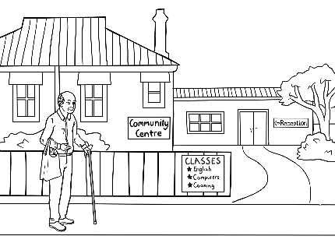 | 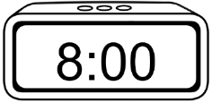 | I get to the Community Centre at 8 o’clock.  _____________
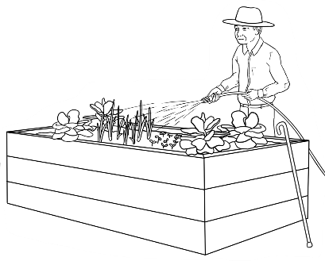 | 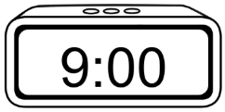 | I work in the community garden for an hour.  I start class at 9 o’clock.  _____________

- 2.
On Tuesday
Ming’s family
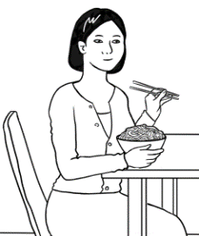

- Lan is his daughter.
I have lunch at 1:00.
_________
I get up at 6:00.
at_6:00__.
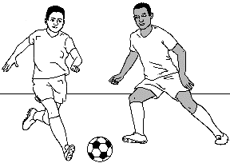

- Bao is his grandson.
I play soccer at 4:00.
________
I get up at 8:00.
________
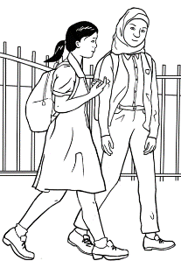
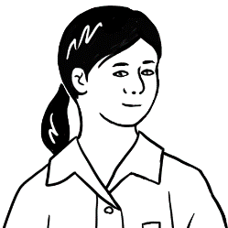
- Mai is his granddaughter.
I start school at 9:00.
__________
I finish at 3:00.
__________
- The family has dinner together.
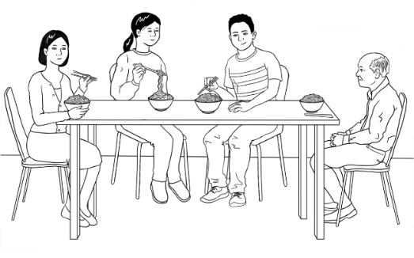
We have dinner at 6:00.
__________

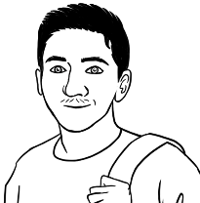
I get up at 7:00
on Monday.
- 2.

On Monday
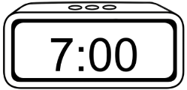    a. |  |  | 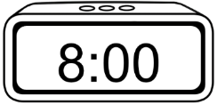  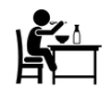  b.
I get up __at_7:00_. |  |  | I have breakfast _____________.
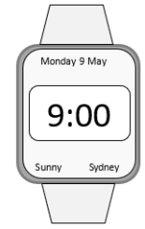    c. |  |  | 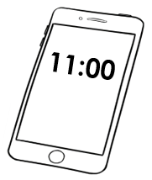    d.  have a break =  stop work  for a short time
I start class _____________. |  |  | I have a break _____________.
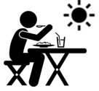  e. |  |  | 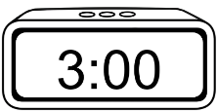  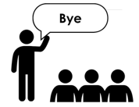  f.
I have lunch _____________. |  |  | I finish class _____________.
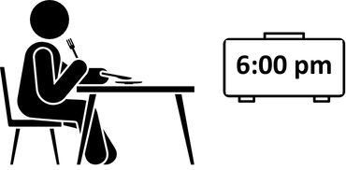

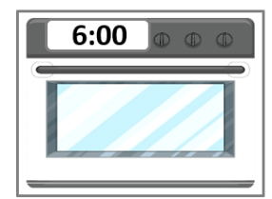
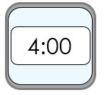  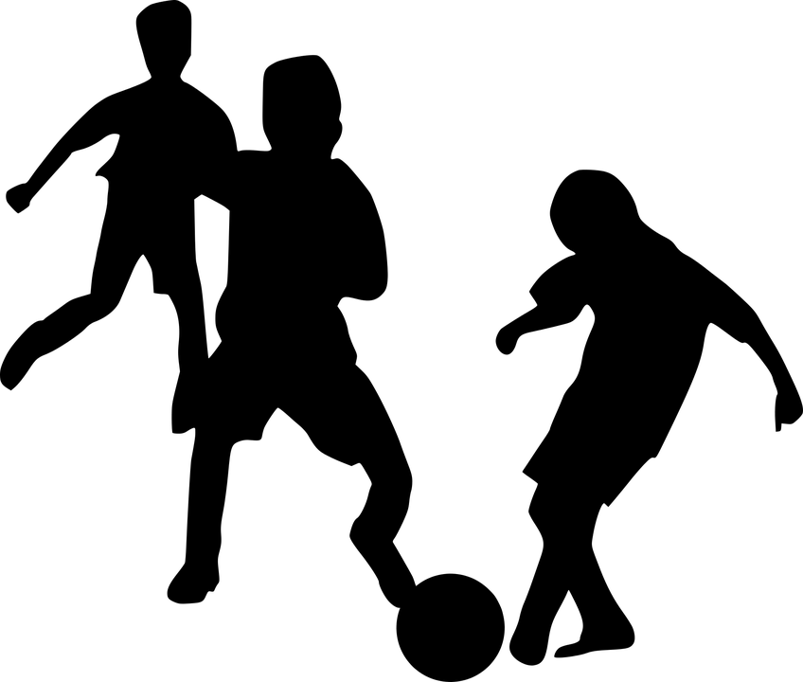  g. |  |  | h.
I play soccer _____________. |  |  | I eat dinner _____________.
  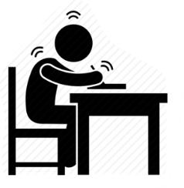  i. |  |  | 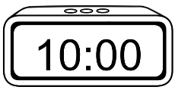  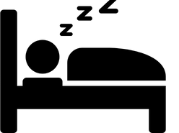  j.
I study English _____________. |  |  | I go to bed _____________.

Is it true or false?

 | True | False
- I get up at 6:00.
- I have breakfast at 8:00.
- I start class at 9:00.

- I have a break at 10:00.
- I have lunch at 12:00.
- I finish class at 3:00.
- I play soccer at 5:00.
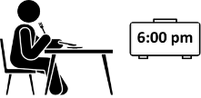
- I have dinner at 6:00.
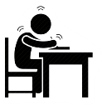
- I study English at 8:00.
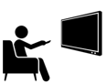  - I watch TV at 9:00. | ? | ?
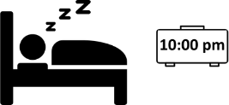
- I go to bed at 10:00.
Carim’s Monday
What time do you get up
on ___________________?
On ____________________
a. |  |  | b.
I get up at ________. |  |  | I have breakfast at ________.
c. |  |  | d.
I start class at ________. |  |  | I have a break at ________.
e. |  |  | f.
I have lunch at ________. |  |  | I finish class at ________.
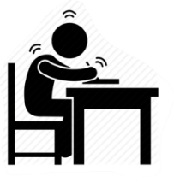  g. |  |  | h.
I study English at ________. |  |  | I eat dinner at ________.
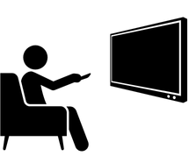  i. |  |  | j.
I watch TV at ________. |  |  | I go to bed at ________.

What time do you get up
on ____________________?
- 2.

On ___________________

My partner is ___________________________ Time
 | What time do you get up? |  | at _________
 | What time do you have breakfast? |  | at _________
 | What time do you start class? |  | at _________
 | What time do you have a break? |  | at _________
 | What time do you have lunch? |  | at _________
 | What time do you finish class? |  | at _________
 | What time do you have dinner? | 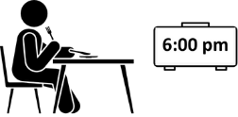 | at _________
 | What time do you study English? | 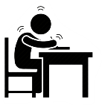 | at _________
 | What time do you watch TV? |  | at _________
 | What time do you go to bed? | 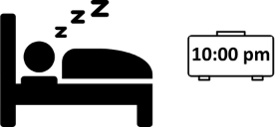 | at _________

Morning and afternoon
I start class in the morning.
I finish class in the afternoon.

morning = am |  | afternoon = pm
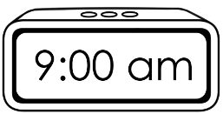 |  | 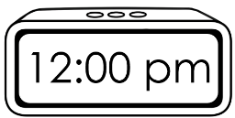
 |  | 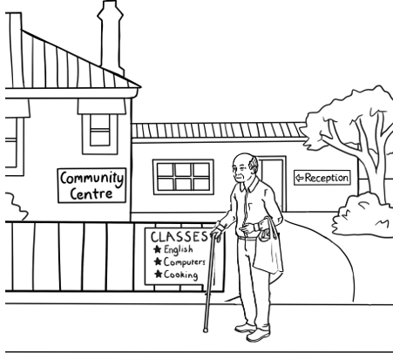



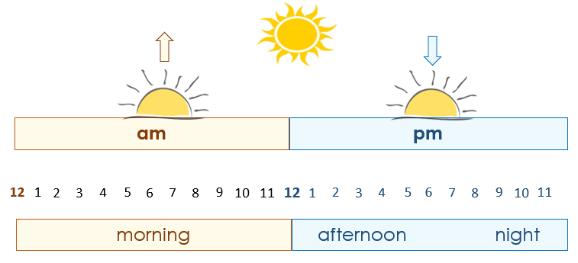

This is my class timetable.
1.

Day | Monday | Tuesday | Wednesday | Thursday | Friday
Start |  | 9:00 am | 9:00 am |  | 10:00 am
Finish |  | 12:00 pm | 12:00 pm |  | 1:00 pm
Room |  | 4 | 4 |  | 3
2. 3.

I start class at 9:00 am on Tuesday and Wednesday.
I finish class at __________ .
I start class at __________ on Friday.
I finish class at __________ .

4.
afternoon
morning

Ming starts class in the ________________________.

He finishes class in the ________________________.

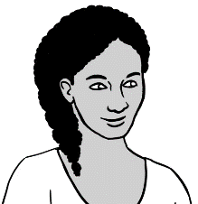
This is my class timetable.
5.

Day | Monday | Tuesday | Wednesday | Thursday | Friday
Start | 9:00 am | 9:00 am | 12:00 pm | 12:00 pm
Finish | 1:00 pm | 1:00 pm | 3:00 pm | 3:00 pm
Room | 6 | 4 | 4 | 7
6. 7.
I start class at ___________ on Monday and Tuesday.
I finish class at ___________ .
I start class at __________ on Wednesday and Thursday.
I finish class at __________ .
Day | Monday | Tuesday | Wednesday | Thursday | Friday
Start
Finish
Room

My class timetable
8.

What time does
the supermarket
open today?


Supermarket
Opening Hours
Mon - Fri | 7 am – 9 pm
Sat | 8 am – 9 pm
Sun | 8 am – 8 pm

- Today is ________________.

- The supermarket opens
at ___________ today.
- It closes at ____________.

2.
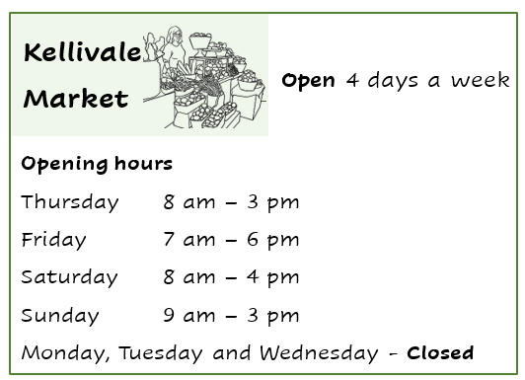
Is the market
open today?

Yes / No

- The market opens at ___________ on Thursday.

- It closes at ___________ on Thursday.

- The market opens at ___________ on Friday.

- It closes at ___________ on Friday.

- The market opens at ___________ on Saturday.

- It closes at ___________ on Saturday.

What month is it?
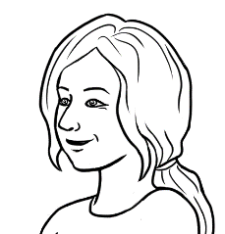
Circle the number
for April.

- 2.

Long words |  |  |  | Short words
1 |  | January |  | Jan
2 |  | February |  | Feb
3 |  | March |  | Mar
4 |  | April |  | Apr
5 |  | May |  | May
6 |  | June |  | Jun
7 |  | July |  | Jul
8 |  | August |  | Aug
9 |  | September |  | Sep
10 |  | October |  | Oct
11 |  | November |  | Nov
12 |  | December |  | Dec

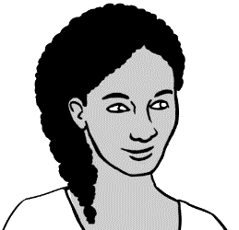
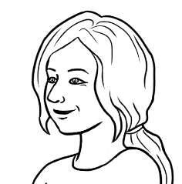
____ months
How many months
are in a year?

3.

March  May  June | April  August |  | July
January  February |  | September  October  November  December

January |  | February
March |  | April
May |  | June
July |  | August
September |  | October
November |  | December

1. 2.

January  1 |  | February
__January____ |  | _______________
March |  | April
_______________ |  | _______________
May |  | June
_______________ |  | _______________
July |  | August
_______________ |  | _______________
September |  | October
_________________ |  | ________________
November |  | December
_________________ |  | __________________
3.

Circle July.

January | February | March
April | May | June
July | August | September
October | November | December
January | ___________________ | March
_________________ | May | _________________
July | _________________ | September
_________________ | November | _________________
_________________ | February | _________________
April | _________________ | June
_________________ | August | _________________
October | _________________ | December

What’s the date?

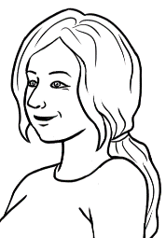
What’s the date today?
24 June
Say:
the 24th
of June

June 2025
Mon | Tues | Wed | Thurs | Fri | Sat | Sun
1 | 2 | 3 | 4 | 5 | 6 | 7
8 | 9 | 10 | 11 | 12 | 13 | 14
15 | 16 | 17 | 18 | 19 | 20 | 21
22 | 23 | 24 | 25 | 26 | 27 | 28
29 | 30

 | Day | Month | Year
- The date today | 24 | June | 2025
- The date today in numbers | 24 | 06 | 2025
 | 24 / 06 / 2025

February |  | 01 |  | 07 |  | September
April |  | 02 |  | 08 |  | October
January |  | 03 |  | 09 |  | July
June |  | 04 |  | 10 |  | December
March |  | 05 |  | 11 |  | August
May |  | 06 |  | 12 |  | November

Happy birthday
Hani.
It’s my daughter’s birthday
today. Her name is Hani.

June 2025
Mon | Tues | Wed | Thurs | Fri | Sat | Sun
1 | 2 | 3 | 4 | 5 | 6 | 7
8 | 9 | 10 | 11 | 12 | 13 | 14
15 | 16 | 17 | 18 | 19 | 20 | 21
22 | 23 | 24 | 25 | 26 | 27 | 28
29 |   30  Birthdays

a. | 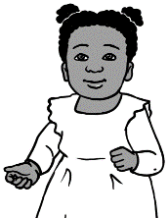  Hani’s birthday | 24 June 2021 | 24 / 06 / 2021  24 / 06 / 2021 .
b. |   Tahiil’s birthday | 27 June 1994 | 27 / 06 / 1994  __________________
c. | Sahra’s birthday | 7 July 1996 | 07 / 07 / 1996  __________________

a. | 24 June 2021 |  | 07 / 07 / 1996
b. | 27 June 1994 |  | 24 / 06 / 2021
c. | 7 July 1996 |  | 27 / 06 / 1994

 | The date before | Birthdays | The date after
a. | 23 June 2021  23 / 06 / 2021  _________________ | Hani’s birthday  24 June 2021  24 / 06 / 2021 | 25 June 2021  25 / 06 / 2021  _________________
b. | 26 June 1994  26 / 06 / 1994  __________________ | Tahiil’s birthday  27 June 1994  27 / 06 / 1994 | 28 June 1994  28 / 06 / 1994  __________________
c. | 6 July 1996  06 / 07 / 1996  __________________ | Sahra’s birthday  7 July 1996  07 / 07 / 1996 | 8 July 1996  08 / 07 / 1996  __________________

________________________ ____________
Mon | Tues | Wed | Thurs | Fri | Sat | Sun

Circle todays’ date.

a. | Today ____________________
b. | Tomorrow ____________________
c. | Yesterday ____________________
d. | Next Saturday ____________________
e. | _________________________ ____________________
f. | _________________________ ____________________
g. | _________________________ ____________________

Dates

Special dates

The start of
the holidays.
What’s a special date
for you Carim?

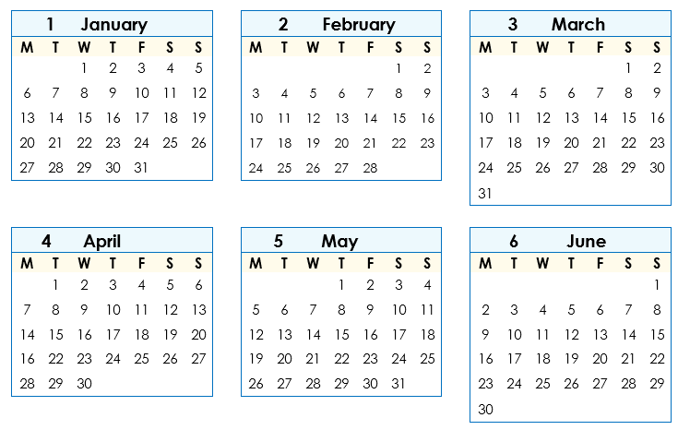

- 3.

Class terms | Start | End
Term 1 | 3 February 2025  03 / 02 / 2025  03 / 02 / 2025 . | 11 April 2025  11 / 04 / 2025  _______________
Term 2 | 28 April 2025  28 / 04 / 2025  ________________ | 4 July 2025  05 / 07 / 2025  ______________

This is your January to June calendar. Circle some special dates.

a. Class terms | Start | End
Term 1 | ________________________ | _______________________
Term 2 | ________________________ | _______________________


b. New Year’s Day ____________________
c. ANZAC Day ____________________
d. _________________________________ ____________________
e. _________________________________ ____________________
f. _________________________________ ____________________
This is your July to December calendar. Circle some special dates.

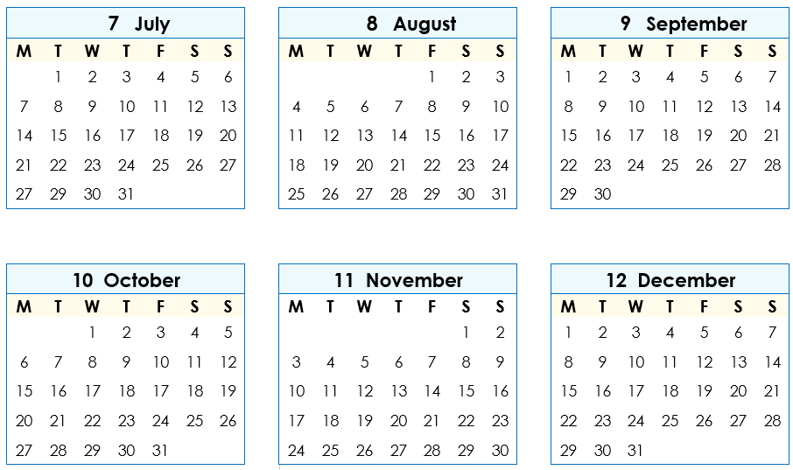

a. Class terms | Start | End
Term 3 | ________________________ | _______________________
Term 4 | ________________________ | _______________________


b. Melbourne Cup Day ____________________
c. Christmas Day ____________________
d. Boxing day _____________________
e. _________________________________ ____________________
f. _________________________________ ____________________
Write your special dates.

My special dates
- Birthdays
____ My birthday_____________ ________________________
__________________________________ ________________________
__________________________________ ________________________
__________________________________ ________________________
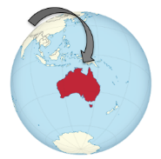
- Arrival in Australia __________________________
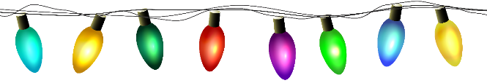
- Special days
__________________________________ ________________________
__________________________________ ________________________
__________________________________ ________________________
__________________________________ ________________________
__________________________________ ________________________

