Student book with teacher notes

English Ready
22637VIC Course in EAL
VU23578 - Recognise and use time in highly familiar situations

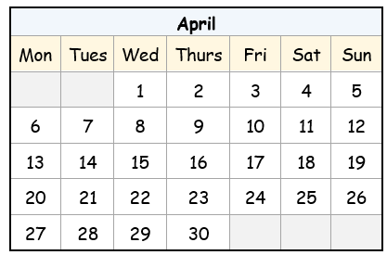
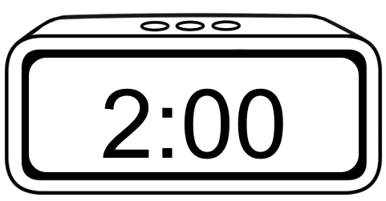
Times and dates

Name __________________________________________________________________
Teacher _______________________________________________________________
Class ___________________________________________________________________
Date____________________________________________________________________

This workbook is designed to be used with the support of a teacher.

Design team: Sue Paull, Vicki Hambling, Nikeh Shariatian, Bernie Miles, and Mary Wallace
Illustrations: Madelena Scott
Image acknowledgements:
Student studying, shopping trolley, birthday banner, Christmas tree and lights - These Photos by Unknown Author is licensed under CC BY-NC

Acknowledgements: The design team would like to acknowledge the use of the EAL Framework which underpins the design of this book.
Copyright of the EAL Framework is reserved to the Crown in the right of the State of Victoria. © State of Victoria (Department of Education and Training) 2023.
_________________________________________________________________________________________
This English Ready Resource is licensed under a Creative Commons Attribution-NoDerivs 3.0 Australia licence (More information is available here). You are free to use, copy and distribute to anyone in its original form as long as you attribute Department of Home Affairs as the author and you license any derivative work you make available under the same licence.
© Commonwealth of Australia 2024

With the exception of the Commonwealth Coat of Arms, the department’s logo, any material protected by a trade mark and where otherwise noted all material presented in this document is provided under a Creative Commons Attribution 4.0 International (https://creativecommons.org/licenses/by/4.0/) licence.
The details of the relevant licence conditions are available on the Creative Commons website (accessible using the links provided) as is the full legal code for the CC BY 4.0 licence (https://creativecommons.org/licenses/by/4.0/legalcode).
Use of all or part of this document must include the following attribution:
© Commonwealth of Australia 2023
As far as practicable, material for which the copyright is owned by a third party will be clearly labelled. The department has made all reasonable efforts to ensure that this material has been reproduced in this document with the full consent of the copyright owners.
Copyright requests and enquiries concerning usage not addressed by the CC BY 4.0 licence should be addressed to:
comms@homeaffairs.gov.au at the Department of Home Affairs.
The terms of use for the Commonwealth Coat of Arms are available from the It's an Honour website.
Where a copyright owner, other than the Commonwealth, is identified with respect to this material, please contact that third party copyright owner directly to seek permission.



Contents
1. Instructions 4
2. Meet the students and teachers. 5
3. What day is it? 6
4. Sahra is busy this week. 10
5. What time is it? 12
6. What time do you get up? 16
7. Morning and afternoon 22
8. What month is it? 26
9. What’s the date? 30
10. Special dates 34

Instructions
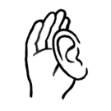
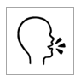
Project and mime each instruction.

 | 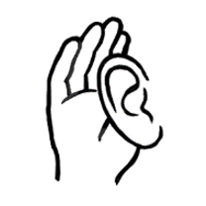 | listen |  |  | say
 |  | read |  | 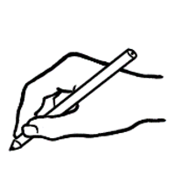 | write
 | 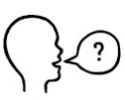 | ask |  |  | copy
 | 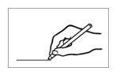 | match |  |  | circle
 |  | highlight |  |  | tick
 | 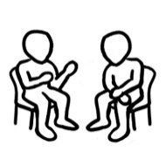 | work with  a partner |  | 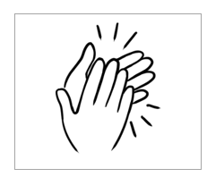 | clap

Meet the students and teachers.
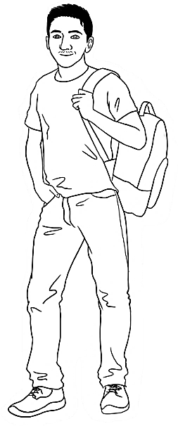
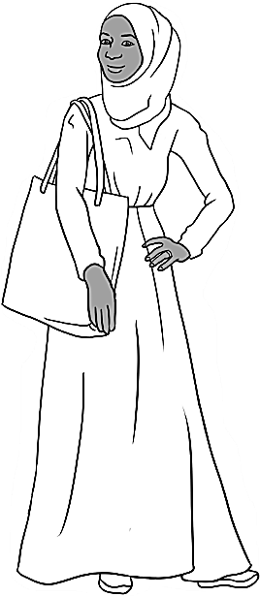
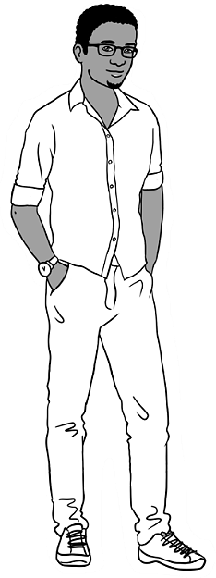
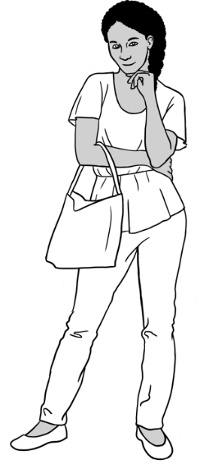
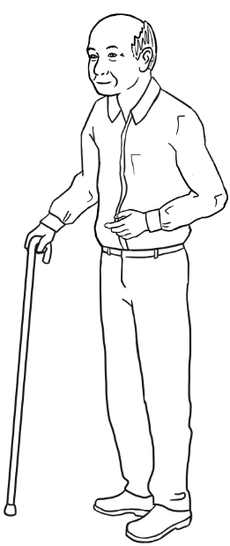
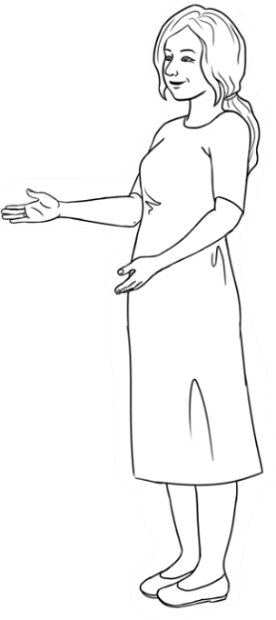
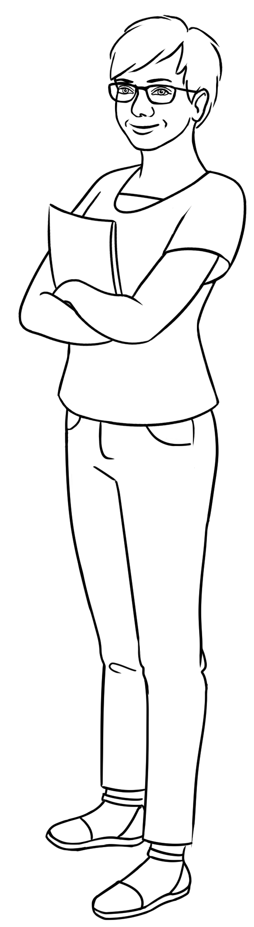
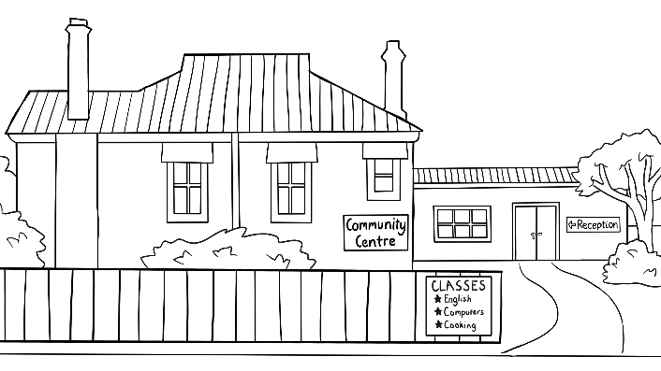
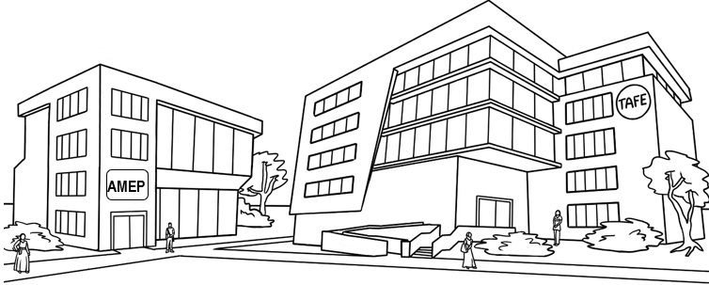
Carim Sahra Tahiil Anika Ming
The students
The teachers
Jenny Wendy
The learning centres

What day is it?
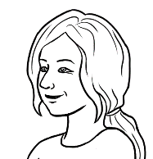
What day is it today?
- 2.
 | 1 | Monday | weekdays
 | 2 | Tuesday | weekdays
 | 3 | Wednesday | weekdays
 | 4 | Thursday | weekdays
 | 5 | Friday | weekdays
 | 6 | Saturday | the weekend
 | 7 | Sunday | the weekend

Listen and say the days. Students tick the current day.

Note: The stress
falls on the first syllable in every day and every day has two syllables except Wednesday and Saturday. However, Wednesday when spoken has only two syllables - we say Wensday.


Copy the days.
3.
weekdays |  |  | the weekend
1 | Monday |  | 6 | Saturday
1 | Monday |  | 6
2 | Tuesday |  | 7 | Sunday
3 | Wednesday
4 | Thursday |  |  | There are 7 days  in a week.
5 | Friday

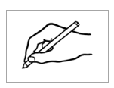
Write the current day, the day before and after today below.
- .

Yesterday | Today | Tomorrow
The day before today | ____________________ | The day after today
____________________ | ____________________ | ___________________
Ask students to highlight a day in each row - either the day before
or the day after the middle grey-shaded days.
the middle
What’s the day before Tuesday?
4.

a. | Monday | Tuesday | Wednesday
b. | Thursday | Friday | Saturday
c. | Sunday | Monday | Tuesday
d. | Wednesday | Thursday | Friday
e. | Saturday | Sunday | Monday
f. | Tuesday | Wednesday | Thursday
g. | Friday | Saturday | Sunday
h. | Monday | Tuesday | Wednesday
i. | Thursday | Friday | Saturday
j. | Sunday | Monday | Tuesday

Write the missing days in the three-day sequences.

Monday |  | Tuesday |  | Wednesday |  | Thursday
Friday |  | Saturday |  | Sunday

- Tuesday | Wednesday | Thursday .
b. ___________________ | Tuesday | Wednesday
c. ___________________ | Saturday | Sunday
d. Monday | Tuesday | ___________________
e. Thursday | Friday | ___________________
f. ___________________ | Monday | Tuesday
g. ___________________ | Wednesday | Thursday

Write the days in the correct order.

The days of the week are Monday , __________________________, _____________________________, _________________________, _________________________,

___________________________ and ___________________________.
Long word |  | Short word
Monday |  | Tues
Tuesday |  | Wed
Wednesday |  | Sun
Thursday |  | Mon
Friday |  | Sat
Saturday |  | Thurs
Sunday |  | Fri
3.
Match the long
and short forms.


Is the market open on Monday?
4.

Write the short forms of the days.
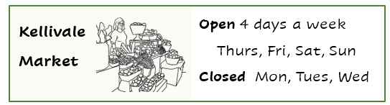

- The market is open on ________, _________, __________ and _________.

- The market is closed on ________, _________ and __________.

Sahra is busy this week.
I’m busy this week.
See this section in the Teacher Resources for an activity to prepare for or to revise the work in this section.
- Monday | 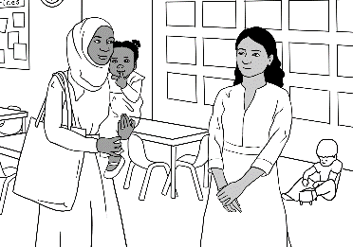  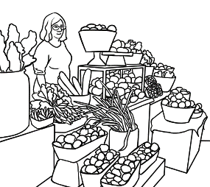  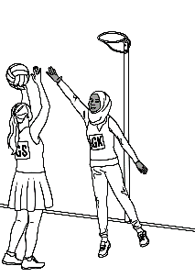  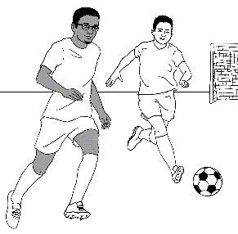  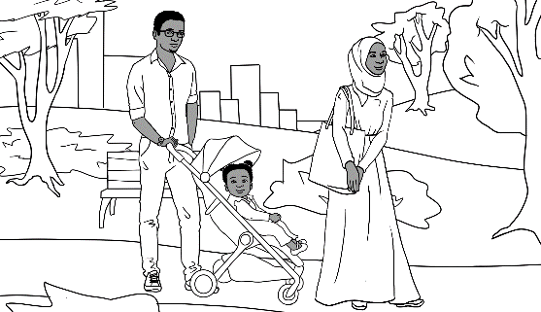  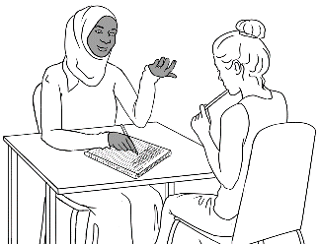     |   I go to class on Monday  and Tuesday .
- Tuesday |  | My daughter Hani goes to childcare on ______________ and ________________.
- Wednesday |  | I clean and cook  on ___________________.
- Thursday |  | I go to the market  on _______________.
- Friday |  | We go to the park  on ________________.
- Saturday |  | Tahiil and I play sport  on ________________ and _________________.
- Sunday

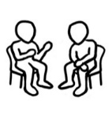
Students work with a partner and read aloud the sentences on the previous page about Sahra’s busy week.

If students are confident, elicit what Sahra does on each day using the Present Simple 3rd person singular form of the verbs.
e.g. Sahra goes to class on Monday and Tuesday. She cleans and cooks on Wednesday.
Note: The proposition on before days.
Match the days and activities.

on Monday
on Tuesday
on Wednesday
on Thursday
on Friday
on Saturday
on Sunday

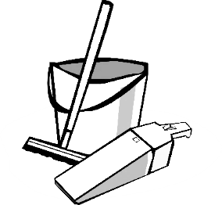

What time is it?
What time is it?
Listen and say together. Copy the times with the colons and zeros.
The hour is stressed.
a. It’s 1 o’clock. | b. It’s 2 o’clock. | c. It’s 3 o’clock.
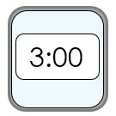  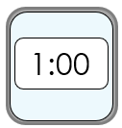  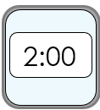  1:00 | ________ | ________
d. It’s 4 o’clock. | e. It’s 5 o’clock. | f. It’s 6 o’clock.
________ | ________ | 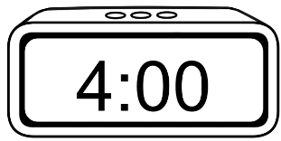  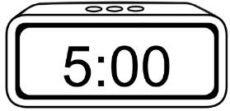  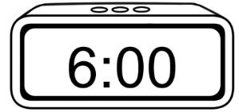  ________
g. It’s 7 o’clock. | h. It’s 8 o’clock. | i. It’s 9 o’clock.
________ | ________ | 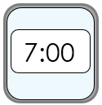  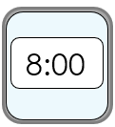  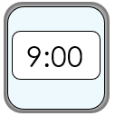  ________
j. It’s 10 o’clock. | k. It’s 11 o’clock. | l. It’s 12 o’clock.
________ | ________ | 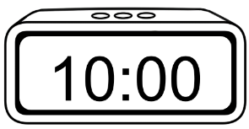  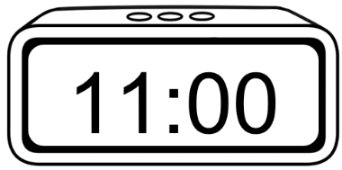  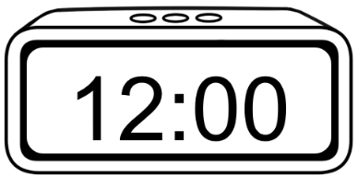  ________
- 2.
It’s = It is

- It’s 1 o’clock.
- It’s 2 o’clock.
- It’s 3 o’clock.
- It’s 4 o’clock.
- It’s 5 o’clock.
- It’s 6 o’clock.
- It’s 7 o’clock.
- It’s 8 o’clock.
- It’s 9 o’clock.
- It’s 10 o’clock.
- It’s 11 o’clock.
- It’s 12 o’clock.
Match and say the times.

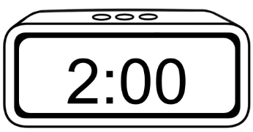
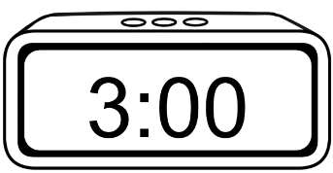
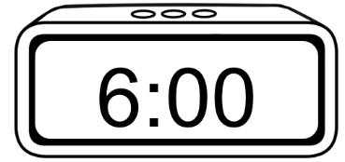
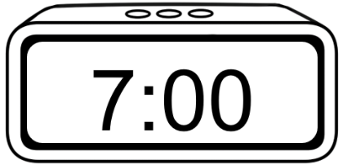
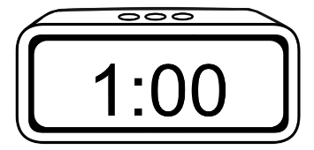
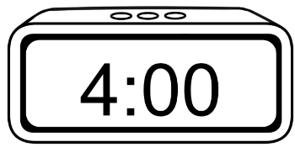
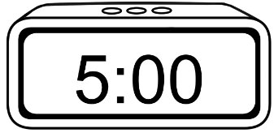
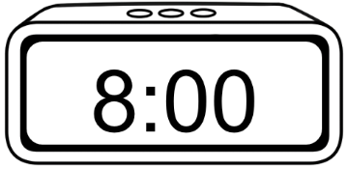
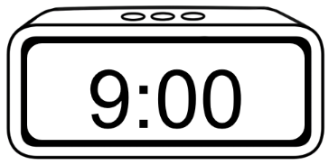
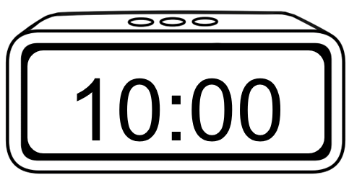


What time is it?
It’s 1 o’clock.

Read the times aloud together.
Copy the hours without the zeros and colons.
are omitted when writing the time with o’clock.
2.
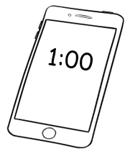  a. | b.  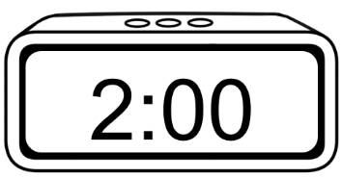 | 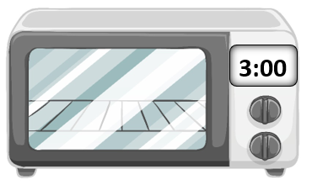  c.
It’s 1:00.  It’s 1 o’clock. | It’s 2:00.  It’s ___ o’clock. | It’s 3:00.  It’s ___ o’clock.
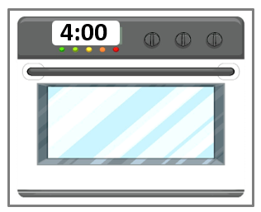  d. | e.   | 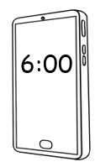  f.
It’s 4:00.  It’s ___ o’clock. | It’s s 5:00.  It’s ___ o’clock. | It’s 6:00.  It’s __ o’clock.
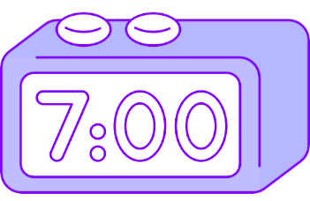  g. | 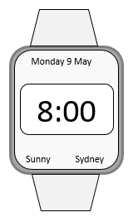  h. | 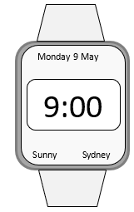  i.
It’s 7:00.  It’s __ o’clock. | It’s 8:00.  It’s __ o’clock. | It’s 9:00.  It’s __ o’clock.

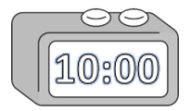  j. |   k. | 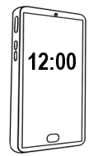  l.
It’s 10:00.  It’s ___ o’clock. | It’s 11:00.  It’s ___ o’clock. | It’s 12:00.  It’s ___ o’clock.
Project the table on page 14 and above, point to a time and ask students,
What time is it? The whole class say the time. e.g. It’s 1:00. or It’s 1 o’clock. Students then work with a partner, and take turns to point to a time and ask, What time is it? Note. The question can also be, What’s the time?
It’s 4 o’clock.
Give instructions to tick some times.
e.g. It’s 4 o’clock.
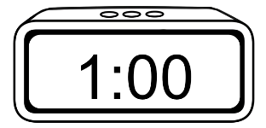  a. | 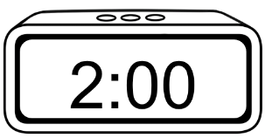  b. | 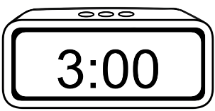  c.
d. | 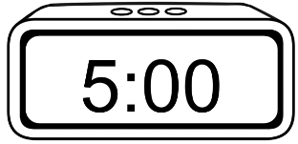  e. | 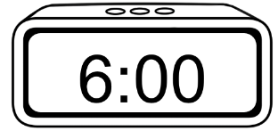  f.
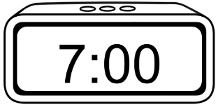  g. | 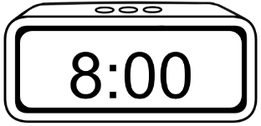  h. | 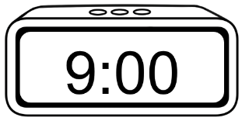  i.
j.  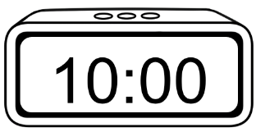 | 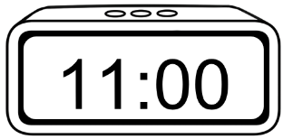  k. | 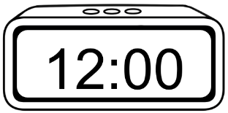  l.

What time do you get up?
Note the use of the preposition at when talking about the time of particular activities.
- 2. 3.

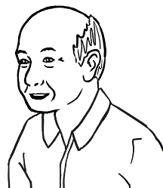
What time do you get up
on Tuesday Ming?
At 6 o’clock.

On Tuesday
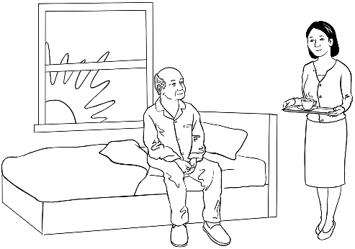 | 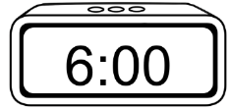 | I get up at 6 o’clock.  at 6 o’clock_
   | 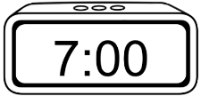 | I have breakfast  at 7 o’clock.  ____________
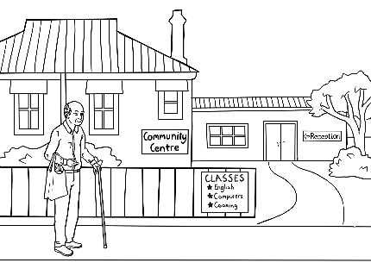 | 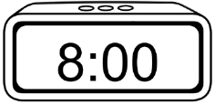 | I get to the Community Centre at 8 o’clock.  _____________
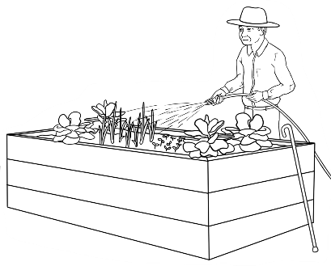 | 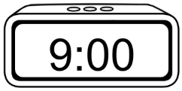 | I work in the community garden for an hour.  I start class at 9 o’clock.  _____________

Copy the times, and then students read about Ming’s family in pairs. Note The time can be spoken more simply without adding o’clock.
- 2.
On Tuesday
Ming’s family


- Lan is his daughter.
I have lunch at 1:00.
_________
I get up at 6:00.
at_6:00__.
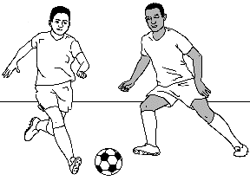

- Bao is his grandson.
I play soccer at 4:00.
________
I get up at 8:00.
________
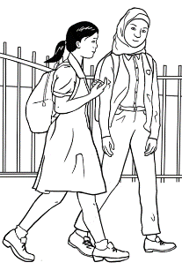
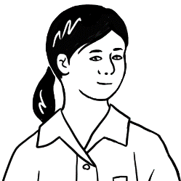
- Mai is his granddaughter.
I start school at 9:00.
__________
I finish at 3:00.
__________
- The family has dinner together.
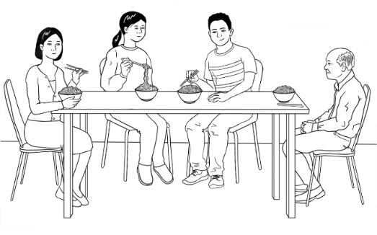
We have dinner at 6:00.
__________

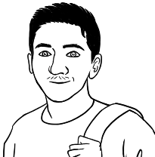
I get up at 7:00
on Monday.
- 2.

On Monday
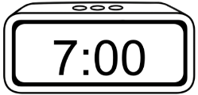  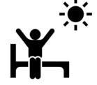  a. |  |  | 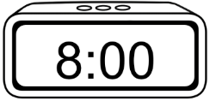  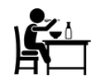  b.
I get up __at_7:00_. |  |  | I have breakfast _____________.
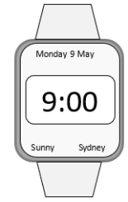    c. |  |  | 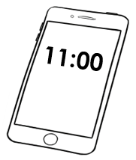    d.  have a break =  stop work  for a short time
I start class _____________. |  |  | I have a break _____________.
  e. |  |  | 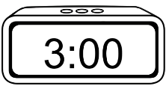  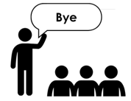  f.
I have lunch _____________. |  |  | I finish class _____________.
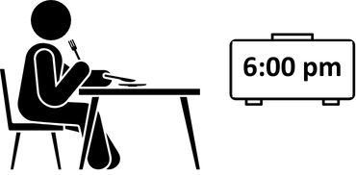

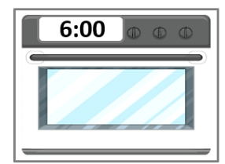
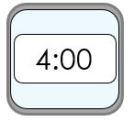  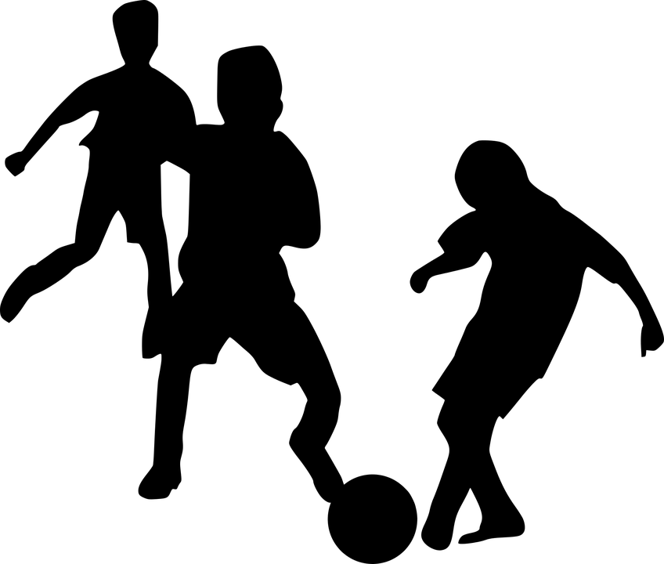  g. |  |  | h.
I play soccer _____________. |  |  | I eat dinner _____________.
    i. |  |  | 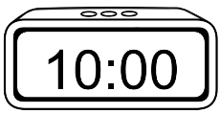  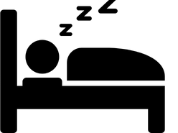  j.
I study English _____________. |  |  | I go to bed _____________.

Note – Watch TV is not included in Carim’s activities, but added here to prepare for the exercise on the following page.
Is it true or false?

Carim’s Monday | True | False
- I get up at 6:00.
- I have breakfast at 8:00.
- I start class at 9:00.

- I have a break at 10:00.
- I have lunch at 12:00.
- I finish class at 3:00.
- I play soccer at 5:00.
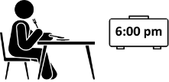
- I have dinner at 6:00.
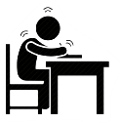
- I study English at 8:00.
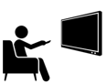  - I watch TV at 9:00. | ? | ?
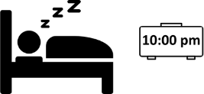
- I go to bed at 10:00.

Students write the current day in the speech bubble and the box. They need only write the times for activities they do on the current day as some activities may not be relevant. Use the number, colon, double zero format.
Once complete, students may suggest additional activities and times.
What time do you get up
on ___________________?
On ____________________
a. |  |  | b.
I get up at ________. |  |  | I have breakfast at ________.
c. |  |  | d.
I start class at ________. |  |  | I have a break at ________.
e. |  |  | f.
I have lunch at ________. |  |  | I finish class at ________.
  g. |  |  | h.
I study English at ________. |  |  | I eat dinner at ________.
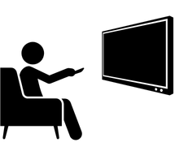  i. |  |  | j.
I watch TV at ________. |  |  | I go to bed at ________.

What time do you get up
on ____________________?
- 2.
Students write the current day in the yellow box and their partner’s name at the top of the table. Practise the questions for each statement before students work with their partner. When speaking about their partner’s activities, students need to use the 3rd person singular form. e.g. He/she gets up at 7:00.

On ___________________

My partner is ___________________________ Time
 | What time do you get up? |  | at _________
 | What time do you have breakfast? |  | at _________
 | What time do you start class? |  | at _________
 | What time do you have a break? |  | at _________
 | What time do you have lunch? |  | at _________
 | What time do you finish class? |  | at _________
 | What time do you have dinner? | 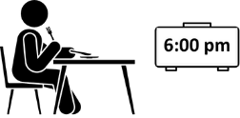 | at _________
 | What time do you study English? | 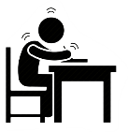 | at _________
 | What time do you watch TV? |  | at _________
 | What time do you go to bed? | 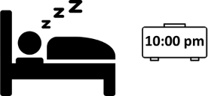 | at _________

Morning and afternoon
I start class in the morning.
I finish class in the afternoon.

morning = am |  | afternoon = pm
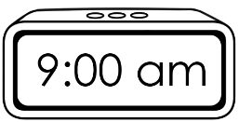 |  | 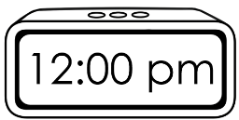
 |  | 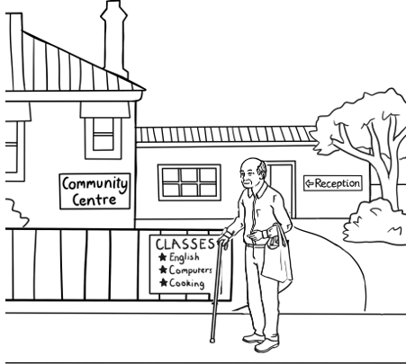


Project the timeline or draw it on the board. Explain:
- the difference between am and pm
- the words sunrise, sunset.
- Add midnight and midday to the timeline if appropriate.
- Night is defined as when the sky is completely dark. This will vary depending on the time of year and location. Mark when night begins
for the current time of year.
Ask students to refer to page 16, and circle both when Ming gets up and when he starts class.

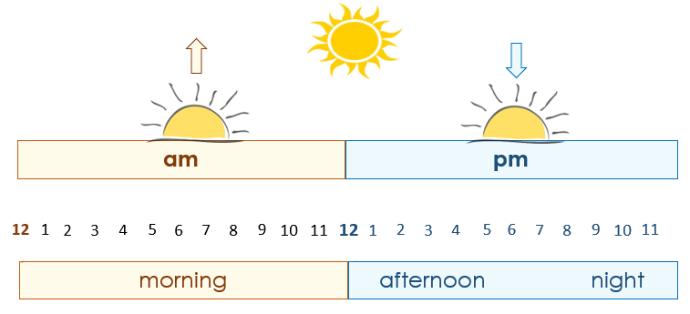

This is my class timetable.
1.

Day | Monday | Tuesday | Wednesday | Thursday | Friday
Start |  | 9:00 am | 9:00 am |  | 10:00 am
Finish |  | 12:00 pm | 12:00 pm |  | 1:00 pm
Room |  | 4 | 4 |  | 3
2. 3.

I start class at 9:00 am on Tuesday and Wednesday.
I finish class at __________ .
I start class at __________ on Friday.
I finish class at __________ .

4.
afternoon
morning

Ming starts class in the ________________________.
Note the Present Simple,
3rd person singular verbs
– starts, finishes

He finishes class in the ________________________.

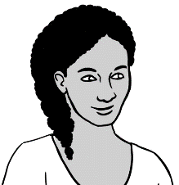
This is my class timetable.
5.

Day | Monday | Tuesday | Wednesday | Thursday | Friday
Start | 9:00 am | 9:00 am | 12:00 pm | 12:00 pm
Finish | 1:00 pm | 1:00 pm | 3:00 pm | 3:00 pm
Room | 6 | 4 | 4 | 7
6. 7.
I start class at ___________ on Monday and Tuesday.
I finish class at ___________ .
I start class at __________ on Wednesday and Thursday.
I finish class at __________ .
Day | Monday | Tuesday | Wednesday | Thursday | Friday
Start
Finish
Room

Students need to tick the days they attend class and write their start, finish times and room numbers.
My class timetable
8.

What time does
the supermarket
open today?
Ask the students about opening and closing hours on other days.


Supermarket
Opening Hours
Mon - Fri | 7 am – 9 pm
Sat | 8 am – 9 pm
Sun | 8 am – 8 pm

- Today is ________________.

- The supermarket opens
at ___________ today.
- It closes at ____________.

Ask students to circle yes or no to Anika’s question. Then ask them to circle the opening and closing times on different days.
2.
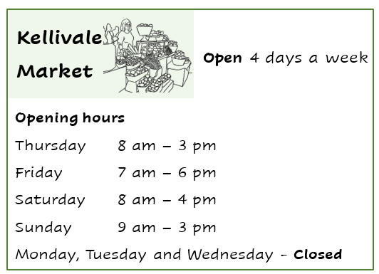
Is the market
open today?

Yes / No

- The market opens at ___________ on Thursday.

- It closes at ___________ on Thursday.

- The market opens at ___________ on Friday.

- It closes at ___________ on Friday.

- The market opens at ___________ on Saturday.

- It closes at ___________ on Saturday.

What month is it?
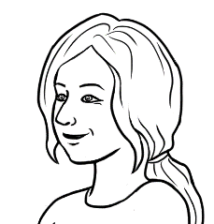
Circle the number
for April.

- 2.
Students listen and repeat the months together. You then read aloud the months at random; students circle the number.
Long words |  |  |  | Short words
1 |  | January |  | Jan
2 |  | February |  | Feb
3 |  | March |  | Mar
4 |  | April |  | Apr
5 |  | May |  | May
6 |  | June |  | Jun
7 |  | July |  | Jul
8 |  | August |  | Aug
9 |  | September |  | Sep
10 |  | October |  | Oct
11 |  | November |  | Nov
12 |  | December |  | Dec

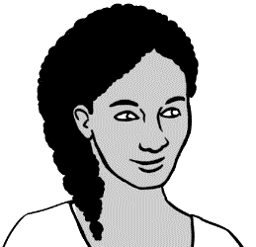
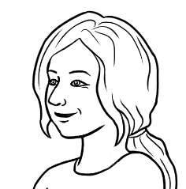
____ months
How many months
are in a year?

3.

Listen, say and clap the stressed syllables longer and stronger.

March  May  June | April  August |  | July
January  February |  | September  October  November  December

Listen, say and clap the months in order. The stressed syllables are in bold.

January |  | February
March |  | April
May |  | June
July |  | August
September |  | October
November |  | December

Students copy the months and write the number of each month in the boxes.
1. 2.

January  1 |  | February
__January____ |  | _______________
March |  | April
_______________ |  | _______________
May |  | June
_______________ |  | _______________
July |  | August
_______________ |  | _______________
September |  | October
_________________ |  | ________________
November |  | December
_________________ |  | __________________
3.
Students read the months aloud with a partner.

Circle July.
Give instructions to circle different months. As you do, ask questions about the order of the months. e.g. What’s the month before/after July?

January | February | March
April | May | June
July | August | September
October | November | December
Write the missing months.
January | ___________________ | March
_________________ | May | _________________
July | _________________ | September
_________________ | November | _________________
 | Write the missing months.
_________________ | February | _________________
April | _________________ | June
_________________ | August | _________________
October | _________________ | December

What’s the date?
This unit requires students to read and write the date only, so teaching the ordinals is unnecessary. However, it’s practical for students to be able to say
a number of dates. e.g. the day’s date, birthdate, date of arrival in Australia. This would require teaching the ordinals. See this section in the Teacher Resources.

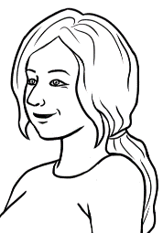
Say:
the 24th
of June
What’s the date today?
24 June

June 2025
Mon | Tues | Wed | Thurs | Fri | Sat | Sun
1 | 2 | 3 | 4 | 5 | 6 | 7
8 | 9 | 10 | 11 | 12 | 13 | 14
15 | 16 | 17 | 18 | 19 | 20 | 21
22 | 23 | 24 | 25 | 26 | 27 | 28
29 | 30

 | Day | Month | Year
- The date today | 24 | June | 2025
- The date today in numbers | 24 | 06 | 2025
Explain that a zero is added before months and days with a single digit, when writing the date in numbers. | 24 / 06 / 2025
Check, copy and say the dates on everyday items.
e.g. ATM and Medicare cards, driver licences, use-by dates on food.

February |  | 01 |  | 07 |  | September
April |  | 02 |  | 08 |  | October
January |  | 03 |  | 09 |  | July
June |  | 04 |  | 10 |  | December
March |  | 05 |  | 11 |  | August
May |  | 06 |  | 12 |  | November

Happy birthday
Hani.
It’s my daughter’s birthday
today. Her name is Hani.

June 2025
Mon | Tues | Wed | Thurs | Fri | Sat | Sun
1 | 2 | 3 | 4 | 5 | 6 | 7
8 | 9 | 10 | 11 | 12 | 13 | 14
15 | 16 | 17 | 18 | 19 | 20 | 21
22 | 23 | 24 | 25 | 26 | 27 | 28
29 |   30  Birthdays

Students need only copy the digital date format. Remind students that zeros must be added before months and days with a single digit.

a. | 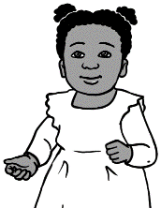  Hani’s birthday | 24 June 2021 | 24 / 06 / 2021  24 / 06 / 2021 .
b. |   Tahiil’s birthday | 27 June 1994 | 27 / 06 / 1994  __________________
c. | Sahra’s birthday | 7 July 1996 | 07 / 07 / 1996  __________________

Match the dates.

a. | 24 June 2021 |  | 07 / 07 / 1996
b. | 27 June 1994 |  | 24 / 06 / 2021
c. | 7 July 1996 |  | 27 / 06 / 1994

Copy the digital dates before and after the birthdays.

 | The date before | Birthdays | The date after
a. | 23 June 2021  23 / 06 / 2021  _________________ | Hani’s birthday  24 June 2021  24 / 06 / 2021 | 25 June 2021  25 / 06 / 2021  _________________
b. | 26 June 1994  26 / 06 / 1994  __________________ | Tahiil’s birthday  27 June 1994  27 / 06 / 1994 | 28 June 1994  28 / 06 / 1994  __________________
c. | 6 July 1996  06 / 07 / 1996  __________________ | Sahra’s birthday  7 July 1996  07 / 07 / 1996 | 8 July 1996  08 / 07 / 1996  __________________

Project the grid. Add the current month’s details for the students to copy on the empty grid below. Include the month, year and dates.

________________________ ____________
Mon | Tues | Wed | Thurs | Fri | Sat | Sun

Circle todays’ date.
As well as circling the current day’s date on the grid above, ask students to circle other dates.
e.g the day after today/ tomorrow, the day before today/ yesterday, next Saturday, next Monday, special days

On the board, write in digital format all or some of the dates students have circled. Students copy the dates on the lines below, adding the names of other days circled.
Students copy them below.

a. | Today ____________________
b. | Tomorrow ____________________
c. | Yesterday ____________________
d. | Next Saturday ____________________
e. | _________________________ ____________________
f. | _________________________ ____________________
g. | _________________________ ____________________

Dates

Special dates
This is the 2025 calendar. See the Teacher Resources for a blank template to complete for the current year.

The start of
the holidays.
What’s a special date
for you Carim?

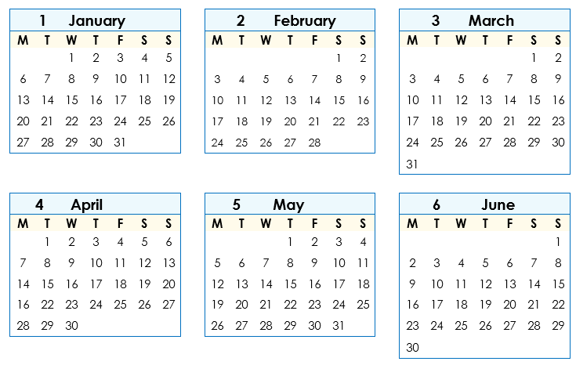

Circle the class terms 1 & 2
start and end dates on the calendar. These are the 2025 NSW dates.
Copy the digital dates. Ask, When do the April holidays start? When do the holidays end?
- 3.

Class terms | Start | End
Term 1 | 3 February 2025  03 / 02 / 2025  03 / 02 / 2025 . | 11 April 2025  11 / 04 / 2025  _______________
Term 2 | 28 April 2025  28 / 04 / 2025  ________________ | 4 July 2025  05 / 07 / 2025  ______________

Talk about and circle special dates such as public holidays, excursions, local events, celebrations etc
This is your January to June calendar. Circle some
special dates.

Write the start and end dates for each term on the board in digital form for students to copy. Circle the dates on the calendar.

a. Class terms | Start | End
Term 1 | ________________________ | _______________________
Term 2 | ________________________ | _______________________


b. New Year’s Day ____________________
On the board, write the dates of public holidays, excursions, local events and celebrations such as Easter, Chinese New Year, Ramadan. Students copy the events and dates.
c. ANZAC Day ____________________
d. _________________________________ ____________________
e. _________________________________ ____________________
f. _________________________________ ____________________
This is your July to December calendar. Circle some special dates.
Talk about and circle special
dates.

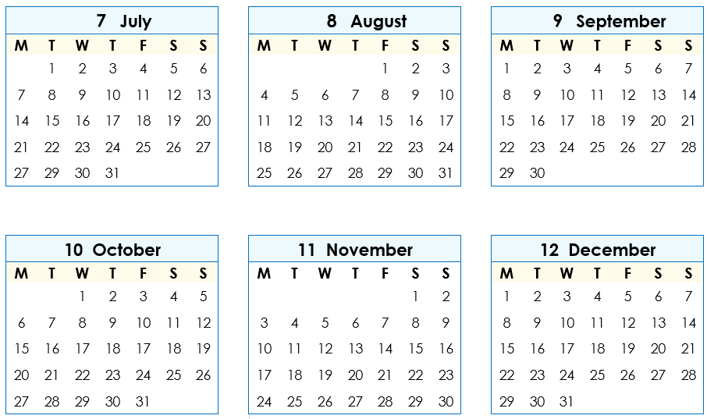

Write the start and end dates for each term on the board in digital form for students to copy. Circle the dates on the calendar..

a. Class terms | Start | End
Term 3 | ________________________ | _______________________
Term 4 | ________________________ | _______________________

On the board, write the dates of public holidays, excursions, local events and celebrations.. Students copy the events and dates.

b. Melbourne Cup Day ____________________
c. Christmas Day ____________________
d. Boxing day _____________________
e. _________________________________ ____________________
f. _________________________________ ____________________
Write your
special dates.
Students will need support completing
this page and their work checked on completion. The dates of some special days can be copied from previous pages.

My special dates
- Birthdays
Students write the birthdates of children, other family and/or friends.
____ My birthday_____________ ________________________
__________________________________ ________________________
__________________________________ ________________________
__________________________________ ________________________
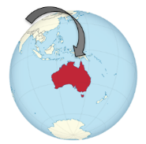
- Arrival in Australia __________________________
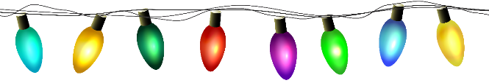
- Special days
__________________________________ ________________________
__________________________________ ________________________
__________________________________ ________________________
__________________________________ ________________________
__________________________________ ________________________

