English Ready
22636VIC Course in EAL
VU23578 Recognise and use time in highly familiar situations

Times and Dates
Teacher Resources
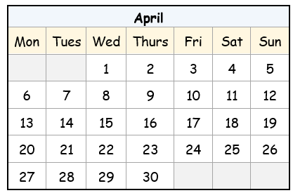


Design team: Sue Paull, Vicki Hambling, Nikeh Shariatian, Bernie Miles, and Mary Wallace
Illustrations: Madelena Scott

Image acknowledgements:
Box of chocolates - This Photo by Unknown Author is licensed under CC BY-NC

Acknowledgements: The design team would like to acknowledge the use of the EAL Framework which underpins the design of this book.

Copyright of the EAL Framework is reserved to the Crown in the right of the State of Victoria. © State of Victoria (Department of Education and Training) 2023.
___________________________________________________________________________________
This English Ready Resource is licensed under a Creative Commons Attribution-NoDerivs 3.0 Australia licence (More information is available here). You are free to use, copy and distribute to anyone in its original form as long as you attribute Department of Home Affairs as the author and you license any derivative work you make available under the same licence.
© Commonwealth of Australia 2024
With the exception of the Commonwealth Coat of Arms, the department’s logo, any material protected by a trade mark and where otherwise noted all material presented in this document is provided under a Creative Commons Attribution 4.0 International (https://creativecommons.org/licenses/by/4.0/) licence.
The details of the relevant licence conditions are available on the Creative Commons website (accessible using the links provided) as is the full legal code for the CC BY 4.0 licence (https://creativecommons.org/licenses/by/4.0/legalcode).
Use of all or part of this document must include the following attribution: © Commonwealth of Australia 2023
As far as practicable, material for which the copyright is owned by a third party will be clearly labelled. The department has made all reasonable efforts to ensure that this material has been reproduced in this document with the full consent of the copyright owners.
Copyright requests and enquiries concerning usage not addressed by the CC BY 4.0 licence should be addressed to: comms@homeaffairs.gov.aumailto:AMEPInfo@homeaffairs.gov.au at the Department of Home Affairs.
The terms of use for the Commonwealth Coat of Arms are available from the It's an Honour website.
Where a copyright owner, other than the Commonwealth, is identified with respect to this material, please contact that third party copyright owner directly to seek permission.



Introduction to the books
The Teacher Resources
The oral and kinaesthetic activities in this book utilise a variety of senses to improve memory retention. This is particularly important for students impacted by trauma.
The most productive classes are noisy and active. Resources here aim to promote
noisy active learning. They include:
- drawings for use in the design of additional materials
- flashcards for printing
- individual and class activities
- revision and homework exercises
- extension exercises.
The book is an electronic reference. Print pages as needed.

The Student Workbook
The student book requires teacher direction and is not intended for independent learning. It is also not intended to be the only material used to teach these units or
to be used as an assessment task. It is recommended that students buy and use a notebook for general class work and practice.
The book is available as a Word document so that teachers can:
- localise and update the content
- adjust the material to suit the requirements of particular classes and students
- delete, add and grade materials as required. If you add or deduct pages, be mindful of the layout of the document.
Note:
- A teacher version of the student workbook contains additional notes and guidance for activities.
- Considering the cost of photocopying, colour has been used sparingly in the Student Workbook and the Teacher Resources.
- The illustrations drawn by Madelena Scott are copyright-free and can be used in the creation of additional materials. The few drawings in the books from Creative Commons can be also used, but need to be acknowledged in the way that they are acknowledged on the inside cover page of each book.

Contents
1. Instructions 2
2. Meet the students and teachers. 6
3. What day is it? 7
4. Sahra is busy this week. 10
5. What time is it? 19
6. What time do you get up? 23
7. Morning and afternoon 25
8. What month is it? 33
9. What’s the date? 39
10. Special dates 48

1. Instructions
Instruction icons
The icons used in the numeracy units are similar to those used in all units in the Course in EAL. They aim to simplify the instructions, support the teacher instructions and develop independence in learning.

Activity 1 – Word stress in instruction words
Project the following page and clap the syllables. In the two-syllable instructions the stress falls on the first syllable. Clap the stressed syllable harder.

Activity 2 – Bingo
The aim of this game is to familiarise students with hearing and recognising the instructions.
- Print and cut up the bingo sheets on pages 4 – 5. Use the following Word Stress page as a master sheet.
- Read out the instructions in any order.
- Students circle the instructions on their card as they hear them and shout Bingo, when all their instructions have been called.

        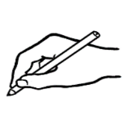  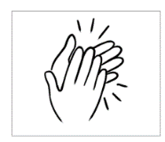    say |  | 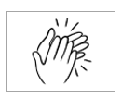
read
write
ask
clap
tick
match





listen
copy
circle
highlight
partner
Activity 1 – Word stress

 | Bingo | 
 | Bingo
 | Bingo | 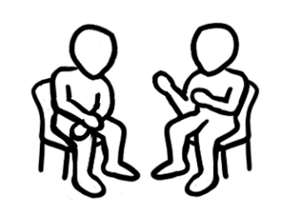
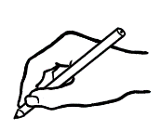 | Bingo | 
 | Bingo
 | Bingo
 | Bingo
 | Bingo
Activity 2 – Bingo cards

Activity 2 – Bingo cards - continued
Bingo
Bingo
Bingo
Bingo

2. Meet the students and teachers.
Project page 5 in the student workbook and introduce the students and teachers who feature in the workbook. More detailed information about the characters can be found in the other Course in EAL units including a chart of personal details.
See the Teacher Resources for units:
- VU23496 & VU23498
- VU23497 & VU23499

3. What day is it?
Activity 1 – Order the days of the week
Print the days of the week on the following page for students to cut up and order in a line in front of them. Once the days are in order, ask students to hold up and say:
- a particular day e.g. Monday, Tuesday
- today, yesterday, tomorrow
- the day before/after a particular day
- the weekend days
- a favourite day. [Students could put this in a sentence.
e.g. My favourite day is Friday. ]
Continue to the following activity or clip the days together and collect them for activity 2 at another time.

Activity 2 – Match the long and short forms of the days.
Students will need the cut-up long forms of the days in Activity 1, and a copy of the short form of the days on page 9. Students cut up the short forms and match both forms of the days. Once again, put the days in order.

Activity 1 – Order the days of the week

Days of the week |  | Sunday
Thursday |  | Saturday
Wednesday |  | Monday
Friday |  | Tuesday

Activity 2 – Match the long and short forms of the days.

Days of the week |  | Fri
Thurs |  | Sun
Tues |  | Wed
Sat |  | Mon

4. Sahra is busy this week.

Activity 1 – Sahra’s week – Sequencing Pair work
The sequencing cards on the following three pages include the pictures and sentences about Sahra from Section 4 in the student workbook. The cards could
be used to introduce the work in the section or as revision. Sahra’s story uses the Present Simple, first person singular and plural and one sentence in the 3rd person
– Hani goes to childcare.
- Print the pages, enough for each pair of students.
- Give out pages one by one for students to cut up and sequence:
- The days – once sequenced, students read as a class and then in pairs.
- The pictures – Students match the activities to the days.
Slowly read what Sahra does on each day to the class. [On page 10 in the student workbook]
- The sentences - Students match the sentences to the days and pictures. Read the sentences again to the class.
- Finally read the sentences with the days together. Explain that the day
[i.e. expressions of time] can go at the beginning or end of the sentence.
e.g. On Monday I go to class.
I go to class on Monday. Practise both ways for all the days.

Activity 2 – Tahiil’s week - Sequencing Pair work
Tahiil’s week follows a similar pattern to Sahra’s week except it is written in
the third person singular. It introduces new vocabulary and is included as extension work for more confident learners.
- Print the pages, enough for each pair of students.
- Give out the picture pages first for students to cut up:
- Students sequence the pictures according to the days.
Note: The introduction to Tahiil’s week is in grey - Tahiil is a painter. He works five days a week. There are two activities for all days except Sunday.
- After the pictures have been sequenced, slowly read what Tahiil does on each day to the class.
- Give out the sentences for students to cut up. Read the sentences to the class and students match the sentences to the pictures.
- Finally read the sentences in pairs. Explain that the day [i.e. expressions of time] can go at the beginning or end of the sentence.
e.g. On Monday he works.
He works on Monday.

Activity 1 – Sahra’s week - Sequencing the days

on Sunday |  | on Thursday
on Wednesday |  | on Saturday
on Friday |  | on Monday
on Tuesday

Activity 1 – Sahra’s week - Sequencing the pictures

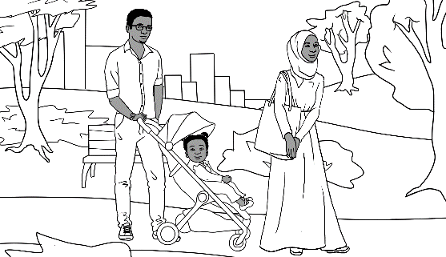 |  | 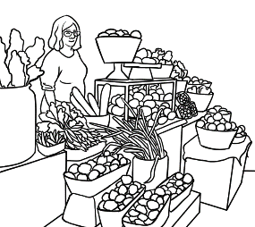
 |  | 
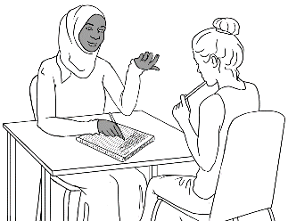 |  | 
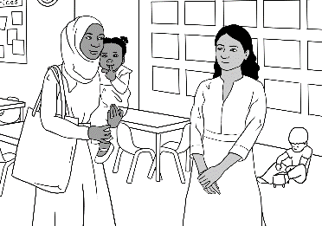 |  | 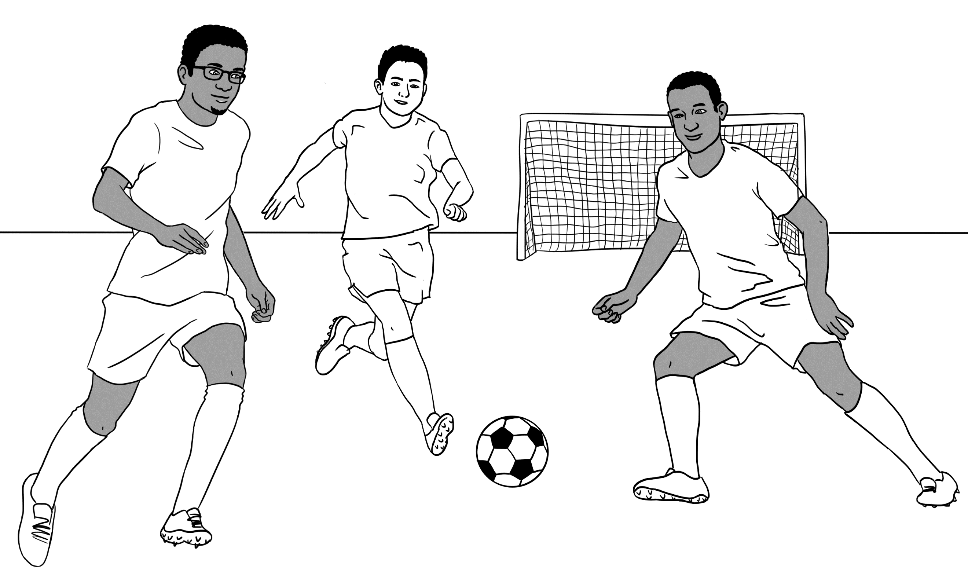

Activity 1 – Sahra’s week - Sequencing the sentences

Sahra’s week |  | Tahiil and I play sport.
We go to the park. |  | I go to the market.
I clean and cook. |  | I go to class.
My daughter Hani goes to childcare.

Activity 2 –Tahiil’s week – Sequencing Script
Tahiil’s week

Tahiil is a house painter.
He works five days a week.

He works on Monday.
After work he takes Hani to the park.

He works on Tuesday.
After work he learns English.

He works on Wednesday.
After work he runs in the park.

He works on Thursday.
After work he learns English.

He works on Friday.
After work he has a barbecue with his family.

He studies on Saturday.
After study he goes to the park with Sahra and Hani.

He plays soccer on Sunday.

Activity 2 –Tahiil’s week - Sequencing the pictures
 |  | 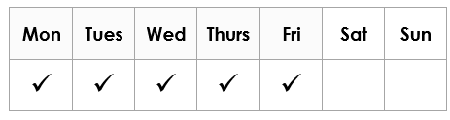
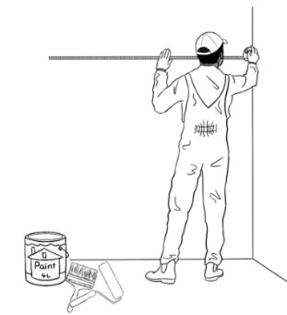  on Thursday |  | 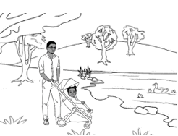  on Monday
on Tuesday |  | 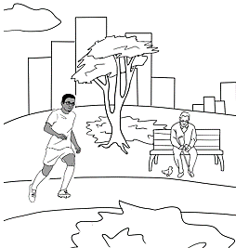  on Wednesday
on Friday |  | 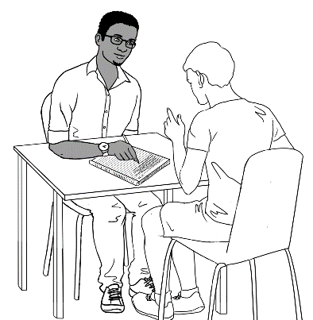  on Tuesday

on Monday |  | on Saturday
on Wednesday |  | on Thursday
  on Saturday |  | on Sunday
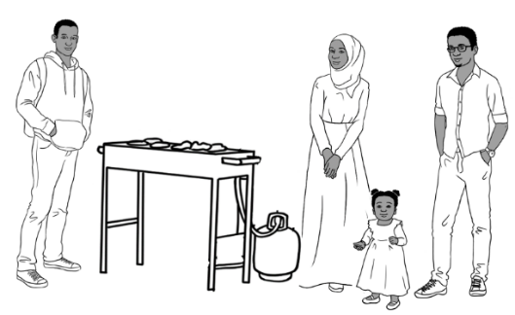
on Friday
Activity 2 –Tahiil’s week - Sequencing the pictures [continued]

Activity 2 –Tahiil’s week - Sequencing the sentences
Tahiil is a painter. |  | He works five days  a week.
He works. |  | He works.
He works. |  | He works.
He works. |  | After work  he learns English.

Activity 2 –Tahiil’s week - Sequencing the sentences [continued]
After work  he learns English. |  | After study, he goes  to the park with Sahra and Hani.
After work  he runs in the park. |  | He plays soccer.
He studies. |  | After work, he has  a barbecue  with his family.
After work, he takes
Hani to the park.

5. What time is it?
Activity – Matching time cards
The cards on the following three pages can be used for activities such as:
- Matching the times with a partner or individually.
- Playing games such as Snap and Concentration.

Activity – Matching time cards - #1
  a. | b.  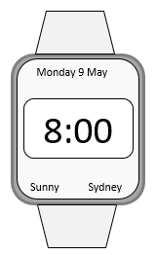 |   c.
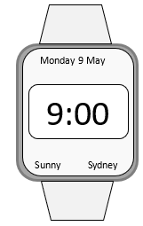  d. | e.   |   f.
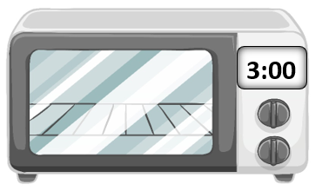  g. |   h. | 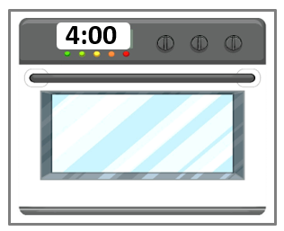  i.
  j. |   k. |   l.

Activity – Matching time cards - #2

It’s 8 o’clock. | It’s 7 o’clock. | It’s 1 o’clock.
It’s 12 o’clock. | It’s 10 o’clock. | It’s 2 o’clock.
It’s 11 o’clock. | It’s 3 o’clock. | It’s 9 o’clock.
It’s 5 o’clock. | It’s 4 o’clock. | It’s 6 o’clock.

Activity 1 – Matching time cards - #3

It’s 9:00. | It’s 2:00. | It’s 7:00.
It’s 11:00. | It’s 5:00. | It’s 10:00.
It’s 4:00. | It’s 8:00. | It’s 3:00.
It’s 6:00. | It’s 12:00. | It’s 1:00.

6. What time do you get up?
Activity – A survey of regular times
The survey includes content covered in the Course in EAL student workbooks, and consolidates the use of Present Simple for regular habits. Bao is the model character in the survey. He is a character in other Course in EAL books, but does not feature in the numeracy books.

- Project the survey on the next page and practise the two questions students need to ask. Write the current day or another day in the blue box for students to copy.
- Set a time limit and students walk around the room, interviewing five other students and recording names and times on the grid.
- When the time limit is up or when students have completed the survey,
record the times that Bao gets up and goes to bed below the survey.
- Students then record the names and times of three students they have interviewed.
- Students can read these sentences aloud in pairs or to the class.
- Repeat the survey with different days and activities.

On ___________________ | 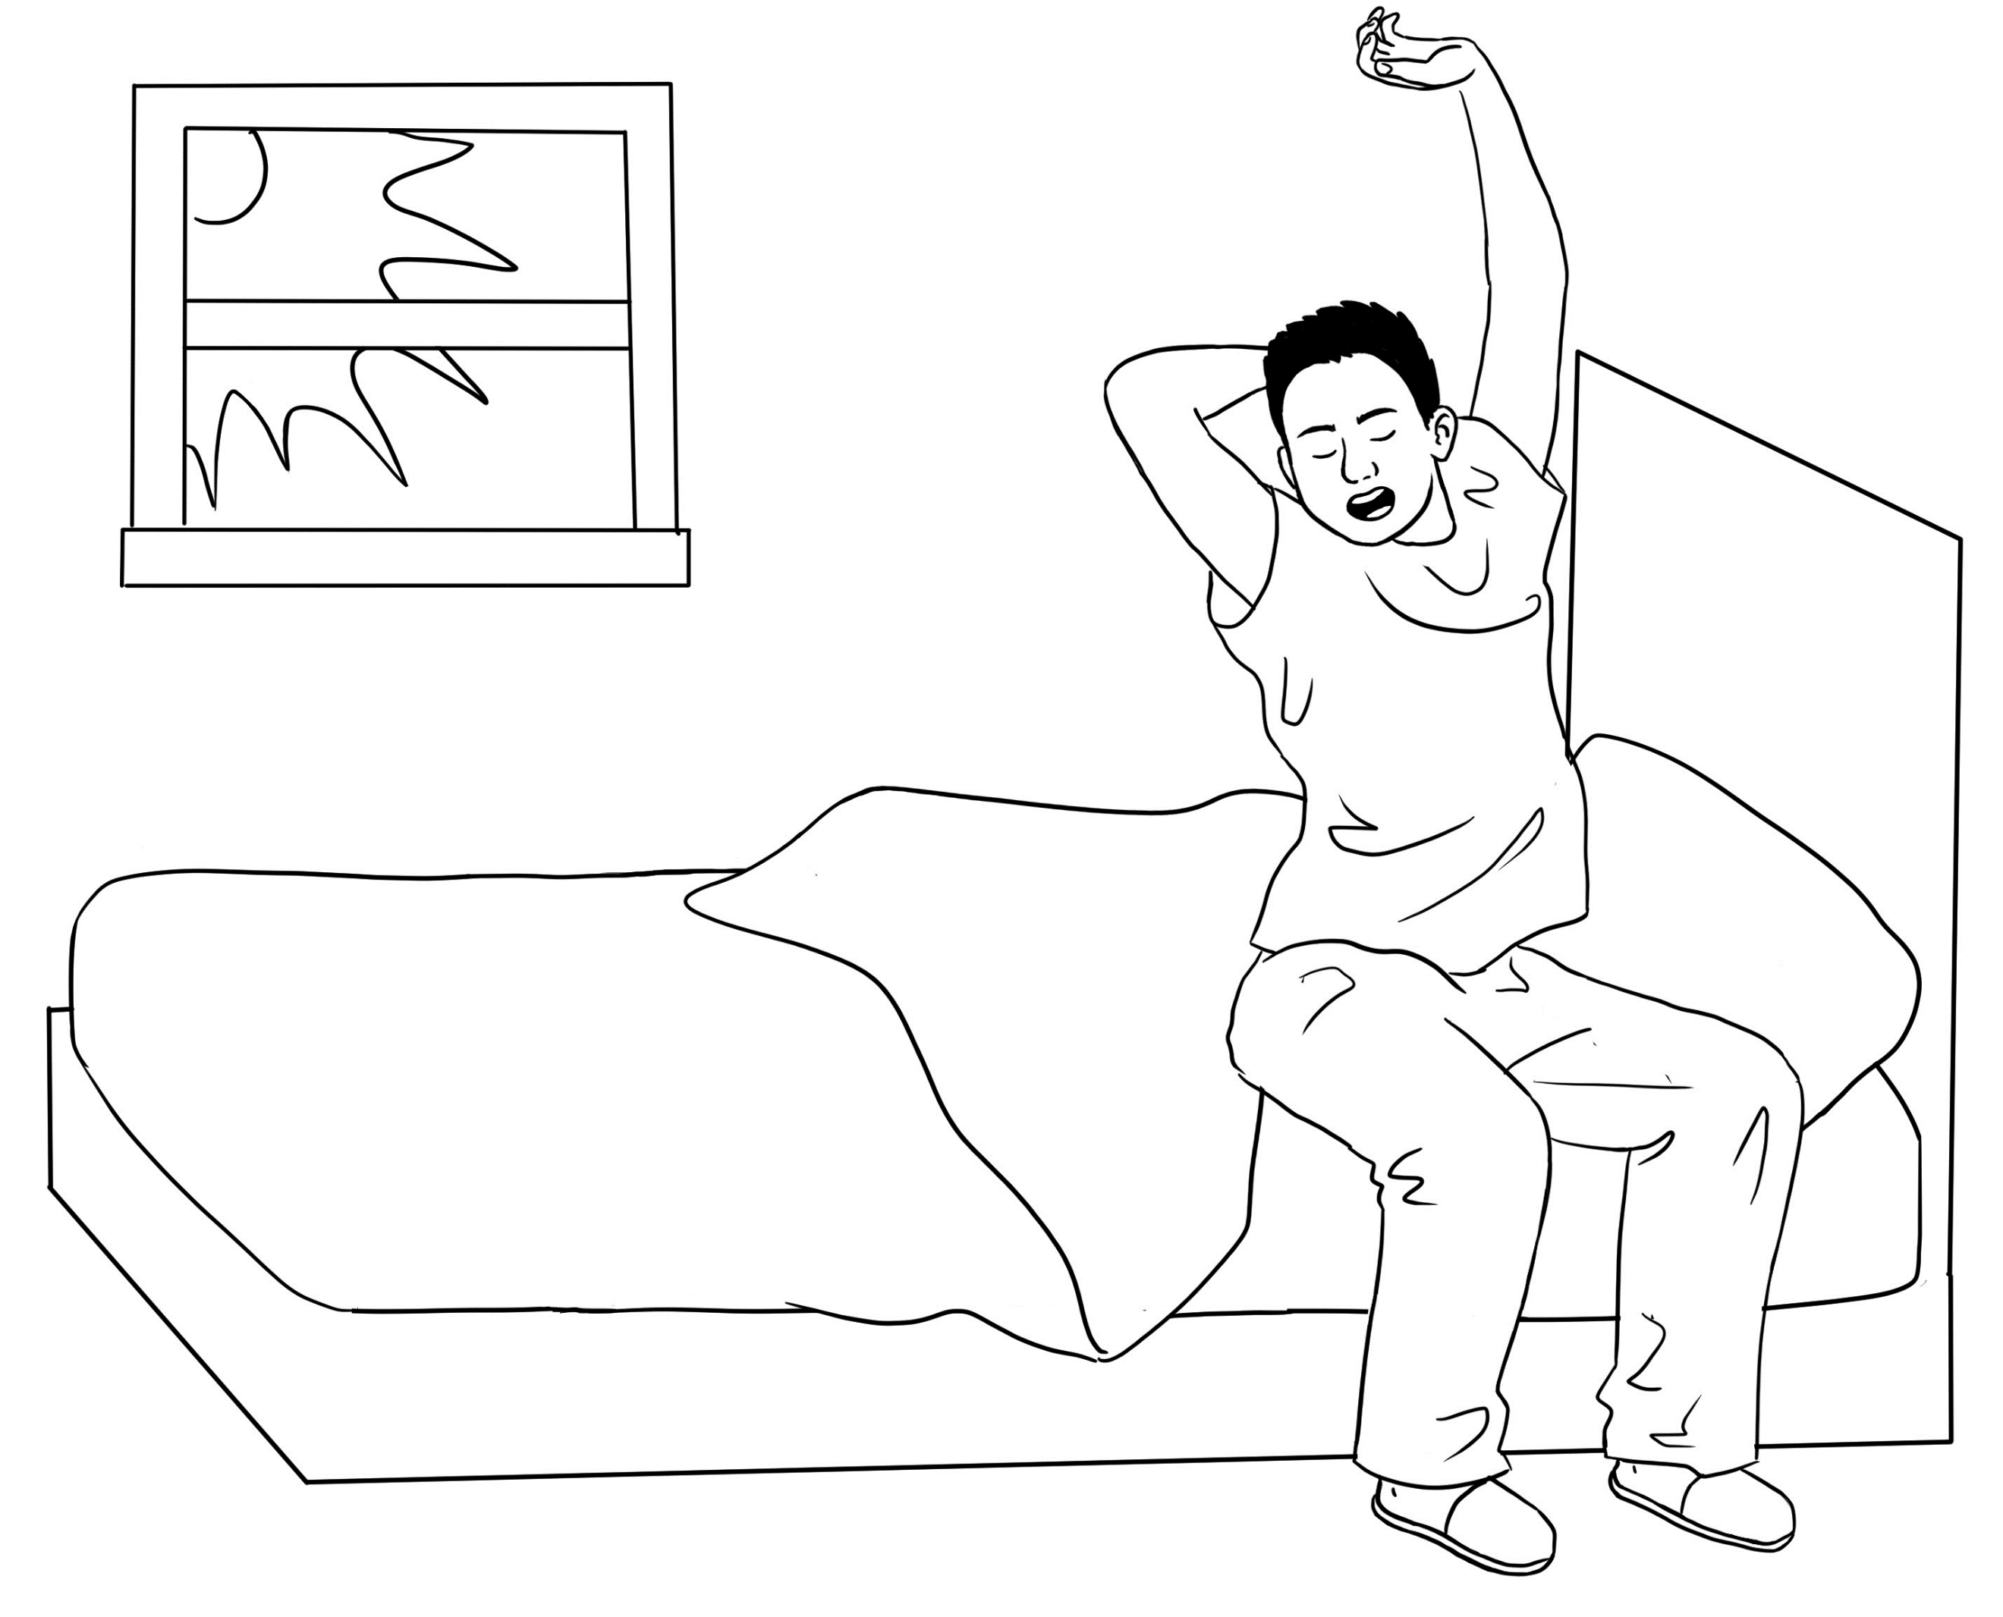 | 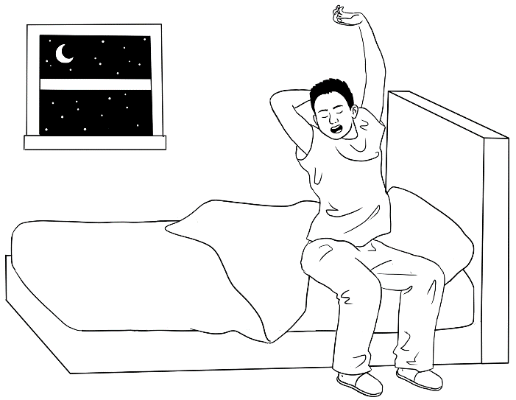
Names | What time do you get up? | What time do you go to bed?
Bao | 7:00 | 11:00
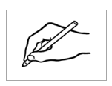
Activity – A survey of regular times


- 3.

- Bao gets up at __________ and goes to bed at __________.

- ___________________ gets up at __________ and goes to bed at __________.
^{name}

- ___________________ gets up at __________ and goes to bed at __________.
^{name}
- ____________________gets up at __________ and goes to bed at __________.
^{name}

7. Morning and afternoon

Activity 1 – Is it am or pm?
- Print and cut up the coloured cards for am and pm on the following page.
- Give each student an am and a pm card.
- Ask students to open their workbook on page 22 or project the image with the timeline below. Mark when night begins at the current time of year.
- Read out a variety of times, and students hold up the appropriate card.
e.g. 5 o’clock in the morning, 3 o’clock in the afternoon, 5 o’clock in the afternoon, 11 o’clock at night, 1 o’clock in the morning

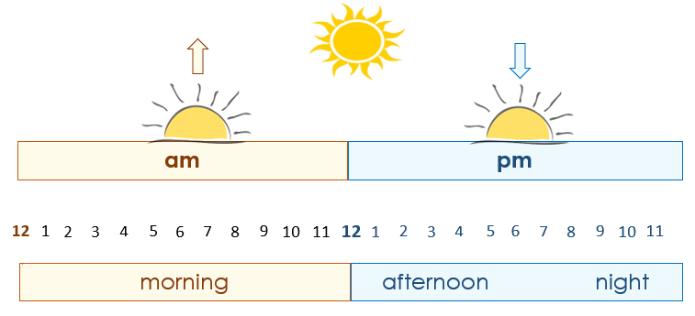

am | pm
am | pm
am | pm
am | pm
am | pm
am | pm
am | pm
am | pm
am | pm
Activity 1 – Is it am or pm?

Activity 2 – Train timetables – A whole class listening exercise
The places and train times on the timetables can be changed to suit your location. Using the train lines all over Australia helps to familiarise new arrivals with capital cities and major towns.
- Project the map below and point to and name major cities and towns.
Students repeat the names. Emphasise the first letter of each town or city.
This will support students recognising places on their worksheet.
- Print the timetable worksheets on pages 29 - 30 back-to-back. and give each student a page.
- Read out the places and times in each row, and point to the route on the map.
e.g. a. The train from Melbourne to Adelaide.
The train leaves Melbourne at 8 am.
It arrives in Adelaide at 6 pm.
- Students write the missing times, which are highlighted on the answer sheet.

Note: Consider using timetables relevant to your students such as local ferry, train, tram and bus timetables.

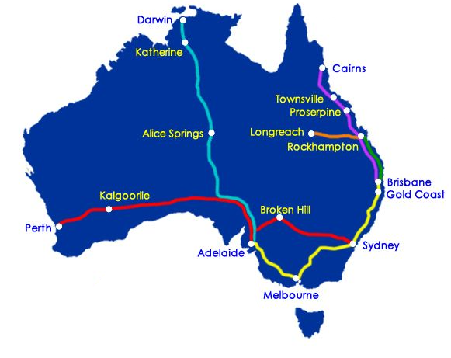

https://www.australian-trains.com/journey-planner.html
Activity 4 – Train timetables – Answers
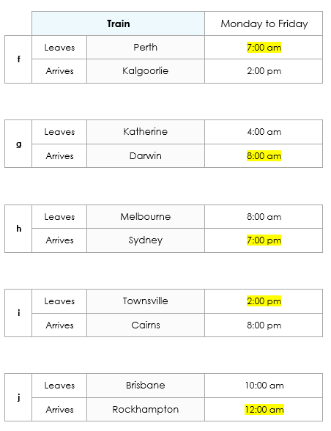
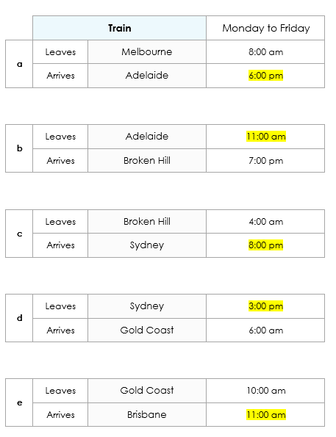

Activity 4 – Train timetables – Worksheet #1
 | Train |  | Monday to Friday
a | Leaves | Melbourne | 8:00 am
a | Arrives | Adelaide | ____________
b | Leaves | Adelaide | ____________
b | Arrives | Broken Hill | 7:00 pm
c | Leaves | Broken Hill | 4:00 am
c | Arrives | Sydney | ____________
d | Leaves | Sydney | ____________
d | Arrives | Gold Coast | 6:00 am
e | Leaves | Gold Coast | 10:00 am
e | Arrives | Brisbane | ____________

Activity 4 – Train timetables – Worksheet #2
 | Train |  | Monday to Friday
f | Leaves | Perth | ____________
f | Arrives | Kalgoorlie | 2:00 pm
g | Leaves | Katherine | 4:00 am
g | Arrives | Darwin | ____________
h | Leaves | Melbourne | 8:00 am
h | Arrives | Sydney | ____________
i | Leaves | Townsville | ____________
i | Arrives | Cairns | 8:00 pm
j | Leaves | Brisbane | 10:00 am
j | Arrives | Rockhampton | ____________

Activity 3 – Tahiil’s working week Pair work
Tahiil’s working week times varies from week to week. This is an example of one week and the activity could be repeated for different weeks and times using the grid below.
- Print the worksheet on the following page, one for each pair of students.
Cut it in half.
- Project Tahiil’s week below. Practise the questions students will need to ask in the activity. e.g.
  - When does Tahiil start work on __________?
  - When does Tahiil finish work on __________?
- Give each student in each pair, either the A or B worksheet. Students must not show their worksheet to their partner.
- Demonstrate the exercise again. Ask all Student As to read the first question and then all Student Bs to give the answer – 6:00 am. All the Student As write the answer on their timetable. Repeat with Student Bs asking their question and writing their answer.
- Students take turns to ask a question and write the times dictated by their partner on their timetable.

 | Mon | Tues | Wed | Thurs | Fri | Sat | Sun
Start | 6:00 am | 7:00 am | 8:00 am | 7:00 am | 6:00 am
Finish | 2:00 pm | 3:00 pm | 4:00 pm | 3:00 pm | 2:00 pm

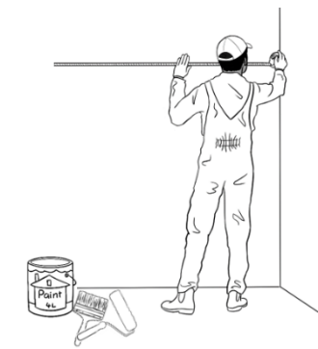

Tahiil’s week

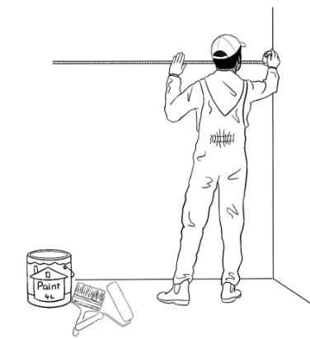
Activity 3 – Tahiil’s working week - Student A and B
When does Tahiil start work
on Monday?

When does Tahiil finish work on Tuesday?
2.
 | Mon | Tues | Wed | Thurs | Fri | Sat | Sun
Start | _________ | 7:00 am | _________ | 7:00 am | _________
Finish | 2:00 pm | _________ | 4:00 pm | _________ | 2:00 pm
Student A

When does Tahiil finish work
on Monday?

When does Tahiil start work on Tuesday?
Student B
 | Mon | Tues | Wed | Thurs | Fri | Sat | Sun
Start | 6:00 am | _________ | 8:00 am | _________ | 6:00 am
Finish | _________ | 3:00 pm | _________ | 3:00 pm | _________

8. What month is it?

Activity 1 – Order the months Class activity
- Enlarge and print the long form of the months on the following two pages, enough so that each student can be given a month.
- The students stand up and arrange themselves with their month in the correct order. [Two people with the same month, can stand side by side.]
- Chant the months. Say the months together in order, then down the line with each student saying the name of their month.
- Ask students to hold up and show you different months.
e.g. Hold up the month of May. Hold up the month before May. Hold up the month after May.
- Ask students, Are you holding your birthday month? Students would answer, yes or no. Some more confident students may say,
This is my daughter’s/husband’s/ friend’s birthday month.
- Students pin their month cards together and collect these for later use.

Activity 2 – Birthday months
- Use one set of the months and place them around the room.
- Ask students to stand next to their birthday month.
- Ask questions such as, How many birthdays are in March /April etc?
Who has a birthday in July /August etc? [One student names the student/s]

Activity 3 – Order and number the months Pair work
- Print the months and the numbers of the months on the following three pages.
- Students work in pairs, cut up the months and sequence the numbers and months.
- Ask students questions about the order of the months. e.g. What month is before March? What month is after September? What is this month?
Extension – What is this month? What is next month? What was last month?

Activity 4 – The short form of the months

The short form of the months on pages 37 – 38 can be cut up and substituted for the long form of the months in Activity 1. The short form can be added to the pair work matching in Activity 3.

Activity 1, 2 & 3 – Order and number the months

January |  | February
March |  | April
May |  | June
July |  | August

Activity 1, 2 & 3 – Order and number the months [continued]

September |  | October
November |  | December

Activity 3 – Order and number the months
1 |  | 2
3 |  | 4
5 |  | 6
7 |  | 8
9 |  | 10
11 |  | 12

Activity 4 – The short form of the months

Jan |  | Feb
Mar |  | Apr
May |  | Jun
Jul |  | Aug

Activity 4 – The short form of the months [continued]

Sept |  | Oct
Nov |  | Dec

9. What’s the date?

Activity 1 – Circle and write dates in August 2025
- Copy the worksheet on the following page for each student and then project it.
- Students come and point to the dates on each of the five texts, and point to the corresponding dates on the calendar.
- Revise how to write the dates digitally and where to write the dates under each text.
- Give each student a worksheet to complete.
- After they have completed the worksheet, ask students about the dates before and after each of the dates.
Note: Questions could also be asked about the times on each text.

Activity 2 – Write the dates digitally - Worksheet
The worksheet provides additional practice in writing dates digitally. It could be copied on the back of the worksheet for Activity 1.

August 2025
Mon | Tues | Wed | Thurs | Fri | Sat | Sun
 |  |  |  | 1 | 2 | 3
4 | 5 | 6 | 7 | 8 | 9 | 10
11 | 12 | 13 | 14 | 15 | 16 | 17
18 | 19 | 20 | 21 | 22 | 23 | 24
25 | 26 | 27 | 28 | 29 | 30 | 31

Activity 1 – Circle and write dates in August 2025


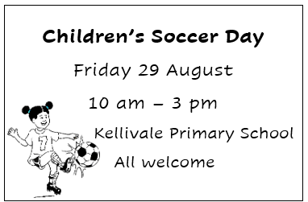

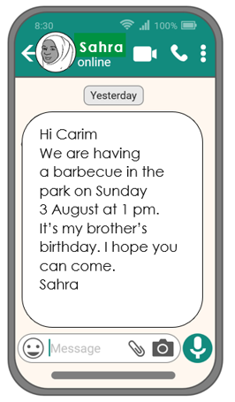


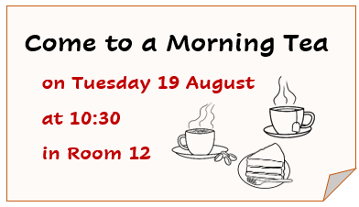

Activity 2 – Write the dates digitally - Worksheet

a. | 1 January 1980 |  | b. | 8 February 1993
c. | 17 March 1998 |  | d. | 24 April 2002
e. | 9 May 2005 |  | f. | 29 June 2010
g. | 19 July 2012 |  | h. | 3 August 2015
i. | 14 September 2018 |  | j. | 5 October 2021
k. | 16 November 2023 |  | l. | 21 December 2024

Ordinals
Ordinals are not part of the knowledge and skills required for this unit, but it is helpful to have a basic understanding of ordinals if students need to say a date
rather than write it.

Activity 3 – An introduction to ordinals
- Names - Write your three names on the board. Point to your first name, and write first. Point to your second and third names and write the ordinals.
- A queue - Cut out the ten ordinals on the following page. Ask 10 students to come to the front of the class and give each student any ordinal. Ask them to order themselves in a queue according to their number from one to ten. Ask, Who is first on the queue? Who is second? etc. Ask students to say the ordinals in order as you point to each person.
- A race - Project the people in the running race on page 44. Ask students to come to the front and point to various runners in the race. e.g. Point to the first person. Point to the fifth person. The student then needs to say and point to the correct ordinal in the yellow square.

Activity 4 – A calendar month
- Project the month of August on page 45 or fill in the blank template with the current month on page 46.
- Say each day in order and students repeat.
- Point to different days and ask, ‘What day is this?’
- Show that the date is written - Tuesday 15 August,
but we say, Tuesday the fifteenth of August.
- Repeat with other dates.

Activity 5 – A calendar month - Ordinals bingo
- Give each student a calendar strip on page 47 and ask them to circle five dates.
- Randomly call out the days and dates. [Use a calendar strip as your master sheet].
e.g. Thursday the seventh of August, Friday the first of August
Students tick the date if they have circled it.
- The first student to get all their circled dates called and ticked, shouts bingo.
Note the patterns:
- Numbers ending with one, two and three are irregular:
first, second and third - twenty first, twenty second, twenty third etc
Exceptions to this rule - eleventh, twelfth and thirteenth.
- Multiples of 10 are pronounced differently - twentieth and thirtieth

Activity 3 – An introduction to ordinals – A queue
1  first | 2  second
3  third | 4  fourth
5  fifth | 6  sixth
7  seventh | 8  eighth
9  ninth | 10  tenth

Activity 3 – An introduction to ordinals – A race



1  first | 2  second | 3  third | 4  fourth | 5  fifth

6  sixth | 7  seventh | 8  eighth | 9  ninth | 10  tenth


Activity 4 – A calendar month
Say the date.
Tuesday the fifteenth of August

August
Mon | Tues | Wed | Thurs | Fri | Sat | Sun
 |  |  |  | 1  first | 2  second | 3  third
4  fourth | 5  fifth | 6  sixth | 7  seventh | 8  eighth | 9  ninth | 10  tenth
11  eleventh | 12  twelfth | 13  thirteenth | 14  fourteenth | 15  fifteenth | 16  sixteenth | 17  seventeenth
18  eighteenth | 19  nineteenth | 20  twentieth | 21  twenty-first | 22  twenty-second | 23  twenty-third | 24  twenty-fourth
25  twenty-fifth | 26  twenty-sixth | 27  twenty-seventh | 28  twenty-eighth | 29  twenty-ninth | 30  thirtieth | 31  thirty-first

Activity 4 – A calendar month Blank template
Mon | Tues | Wed | Thurs | Fri | Sat | Sun

August
Mon | Tues | Wed | Thurs | Fri | Sat | Sun
 |  |  |  | 1 | 2 | 3
4 | 5 | 6 | 7 | 8 | 9 | 10
11 | 12 | 13 | 14 | 15 | 16 | 17
18 | 19 | 20 | 21 | 22 | 23 | 24
25 | 26 | 27 | 28 | 29 | 30 | 31
August
Mon | Tues | Wed | Thurs | Fri | Sat | Sun
 |  |  |  | 1 | 2 | 3
4 | 5 | 6 | 7 | 8 | 9 | 10
11 | 12 | 13 | 14 | 15 | 16 | 17
18 | 19 | 20 | 21 | 22 | 23 | 24
25 | 26 | 27 | 28 | 29 | 30 | 31
August
Mon | Tues | Wed | Thurs | Fri | Sat | Sun
 |  |  |  | 1 | 2 | 3
4 | 5 | 6 | 7 | 8 | 9 | 10
11 | 12 | 13 | 14 | 15 | 16 | 17
18 | 19 | 20 | 21 | 22 | 23 | 24
25 | 26 | 27 | 28 | 29 | 30 | 31
Activity 5 – A calendar month - Ordinals bingo

10. Special dates
Activity 1 - A class calendar
The calendar on the following page can be adjusted if the year is not 2025. However, it may be easier to source a calendar for a different year on the web. Enlarge the calendar to create a wall poster. Circle, highlight or use stickers to mark:
- the start and end of terms
- term holidays
- public holidays
- special days - Harmony Day, International Women’s Day etc.
- excursion dates
- visitors – speakers, volunteers etc.
- birthdays
- sporting events – AFL Grand Final, Olympics etc.
Use the calendar to practise writing important dates in digital format. e.g. Write the date of an excursion/ a public holiday/ the end of term.

Activity 1 – A class calendar
2025
- January |  |  |  |  |  |  |  | - February |  |  |  |  |  |  |  | - March
M | T | W | T | F | S | S |  | M | T | W | T | F | S | S |  | M | T | W | T | F | S | S
 |  | 1 | 2 | 3 | 4 | 5 |  |  |  |  |  |  | 1 | 2 |  |  |  |  |  |  | 1 | 2
6 | 7 | 8 | 9 | 10 | 11 | 12 |  | 3 | 4 | 5 | 6 | 7 | 8 | 9 |  | 3 | 4 | 5 | 6 | 7 | 8 | 9
13 | 14 | 15 | 16 | 17 | 18 | 19 |  | 10 | 11 | 12 | 13 | 14 | 15 | 16 |  | 10 | 11 | 12 | 13 | 14 | 15 | 16
20 | 21 | 22 | 23 | 24 | 25 | 26 |  | 17 | 18 | 19 | 20 | 21 | 22 | 23 |  | 17 | 18 | 19 | 20 | 21 | 22 | 23
27 | 28 | 29 | 30 | 31 |  |  |  | 24 | 25 | 26 | 27 | 28 |  |  |  | 24 | 25 | 26 | 27 | 28 | 29 | 30
 |  |  |  |  |  |  |  |  |  |  |  |  |  |  |  | 31
- April |  |  |  |  |  |  |  | - May |  |  |  |  |  |  |  | - June
M | T | W | T | F | S | S |  | M | T | W | T | F | S | S |  | M | T | W | T | F | S | S
 | 1 | 2 | 3 | 4 | 5 | 6 |  |  |  |  | 1 | 2 | 3 | 4 |  |  |  |  |  |  |  | 1
7 | 8 | 9 | 10 | 11 | 12 | 13 |  | 5 | 6 | 7 | 8 | 9 | 10 | 11 |  | 2 | 3 | 4 | 5 | 6 | 7 | 8
14 | 15 | 16 | 17 | 18 | 19 | 20 |  | 12 | 13 | 14 | 15 | 16 | 17 | 18 |  | 9 | 10 | 11 | 12 | 13 | 14 | 15
16 | 22 | 23 | 24 | 25 | 26 | 27 |  | 19 | 20 | 21 | 22 | 23 | 24 | 25 |  | 16 | 17 | 18 | 19 | 20 | 21 | 22
28 | 29 | 30 |  |  |  |  |  | 26 | 27 | 28 | 29 | 30 | 31 |  |  | 23 | 24 | 25 | 26 | 27 | 28 | 29
 |  |  |  |  |  |  |  |  |  |  |  |  |  |  |  | 30
- July |  |  |  |  |  |  |  | - August |  |  |  |  |  |  |  | - September
M | T | W | T | F | S | S |  | M | T | W | T | F | S | S |  | M | T | W | T | F | S | S
 | 1 | 2 | 3 | 4 | 5 | 6 |  |  |  |  |  | 1 | 2 | 3 |  | 1 | 2 | 3 | 4 | 5 | 6 | 7
7 | 8 | 9 | 10 | 11 | 12 | 13 |  | 4 | 5 | 6 | 7 | 8 | 9 | 10 |  | 8 | 9 | 10 | 11 | 12 | 13 | 14
14 | 15 | 16 | 17 | 18 | 19 | 20 |  | 11 | 12 | 13 | 14 | 15 | 16 | 17 |  | 15 | 16 | 17 | 18 | 19 | 20 | 21
21 | 22 | 23 | 24 | 25 | 26 | 27 |  | 18 | 19 | 20 | 21 | 22 | 23 | 24 |  | 22 | 23 | 24 | 25 | 26 | 27 | 28
27 | 29 | 30 | 31 |  |  |  |  | 25 | 26 | 27 | 28 | 29 | 30 | 31 |  | 29 | 30
10 October |  |  |  |  |  |  |  | 11 November |  |  |  |  |  |  |  | 12 December
M | T | W | T | F | S | S |  | M | T | W | T | F | S | S |  | M | T | W | T | F | S | S
 |  | 1 | 2 | 3 | 4 | 5 |  |  |  |  |  |  | 1 | 2 |  | 1 | 2 | 3 | 4 | 5 | 6 | 7
6 | 7 | 8 | 9 | 10 | 11 | 12 |  | 3 | 4 | 5 | 6 | 7 | 8 | 9 |  | 8 | 9 | 10 | 11 | 12 | 13 | 14
15 | 16 | 17 | 18 | 17 | 18 | 19 |  | 10 | 11 | 12 | 13 | 14 | 15 | 16 |  | 15 | 16 | 17 | 18 | 19 | 20 | 21
20 | 21 | 22 | 23 | 24 | 25 | 26 |  | 17 | 18 | 19 | 20 | 21 | 22 | 23 |  | 22 | 23 | 24 | 25 | 26 | 27 | 28
27 | 28 | 29 | 30 | 31 |  |  |  | 24 | 25 | 26 | 27 | 28 | 29 | 30 |  | 29 | 30 | 31

Activity 2 – Birthdates Happy birthday! - Class activity
The aim of this activity is for students to practise writing and recognising important birthdates. Some students may be shy about revealing their year of birth, so this activity practises writing the birthdates of their partner, children, other relatives or friends.
Note: Students who have suffered trauma may find an exercise like this distressing, as it may remind them of loved ones they have lost. Some characters in the student workbook and their birthdates can be found on the following page. Print the page and cut up and make available for those students to select a character to use, rather than a family member or friend’s birthdate.
Preparation:
- You will need two small containers.
- Print and cut up the birthdate strips on page 52 or use any scrap paper strips, one for each student. Put the strips into a container.
- Print and cut up the three pages of gifts on pages 53 – 55.
Put the gifts into a container.

- Students take a birthdate strip from the container. On the board, write the words students need to copy on their strip. e.g. my husband, my wife,
my daughter, my friend [or a character’s name without the pronoun my]
- Students write the person and their birthdate in digital format –
day / month / year on their paper strip. Demonstrate on the board.
e.g.

- Students return their strips to the container. The strips are mixed up and each student takes a strip, making sure it is not their own.
- They then draw out a gift from the container.
- Explain that the students need to find the person who wrote the birthdate and give them the gift. Practise the language:
- the question students will need ask. Change the pronoun my to your and ask, Is this the birthdate of your husband/wife/daughter/friend? etc.
- the short answers, Yes it is./ No it isn’t.
- the birthday wishes,
Happy birthday to your husband/wife/daughter/friend etc.
- Students walk round the class to find the person whose birthdate they have drawn. When they do, they give the student the gift and their birthday wishes.
- Once all the gifts have been given you can discuss what students think about the gifts. e.g Will your relative/friend like the gift? What’s the best gift?

This is the birthdate of my husband .
05/02/1984 .

Activity 2 – Birthdates Happy birthday! Workbook characters

 |  | 
Tahiil  27 / 06 / 1994 | Sahra  07 / 07 / 1996 | Hani  24 / 06 / 2021
 |  | 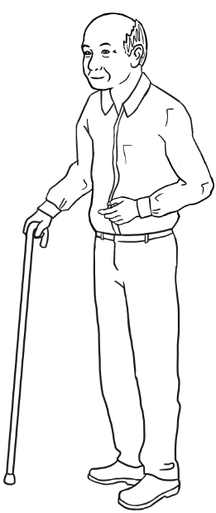
Abdi  04 / 08 / 2004 | Anika  30 / 09 / 1995 | Ming  27 / 03 / 1959

Activity 2 - Birthdates Happy birthday! Birthdate strips
This is the birthdate of _______ ____________________________.

______________________________________
This is the birthdate of _______ ____________________________.

______________________________________
This is the birthdate of _______ ____________________________.

______________________________________
This is the birthdate of _______ ____________________________.

______________________________________
This is the birthdate of _______ ____________________________.

______________________________________
This is the birthdate of _______ ____________________________.

______________________________________

Activity 2 - Birthdates Happy birthday! Gifts
  chocolates |   a dictionary
  a hat |   earrings
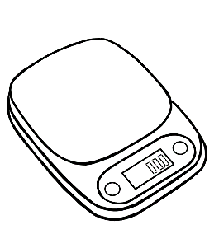  scales | 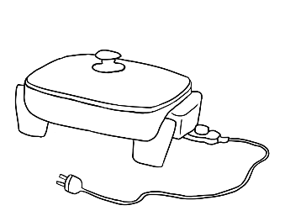  a frypan
  ear buds |   a mouse

Activity 2 - Birthdates Happy birthday! Gifts [Continued]
  a plant |   a cake
  $50 |   $100
  an umbrella | 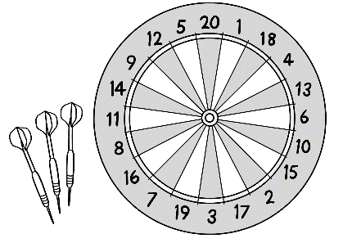  a dart board
  a fan |   a water bottle

Activity 2 - Birthdates Happy birthday! Gifts [Continued]
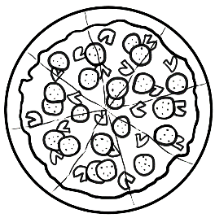  a pizza |   a lamp
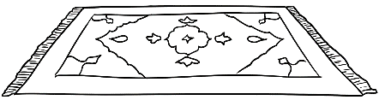  a rug | 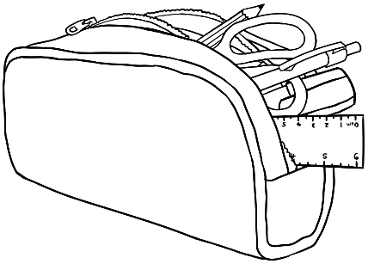  a pencil case
  a microwave |   honey
  a USB |   a backpack

