
Student book with teacher notes

English Ready
22636VIC Course in Initial EAL
VU23491 Recognise and copy extremely familiar words

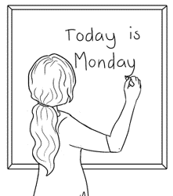
Words

Name _______________________________________________
Teacher____________________________________________
Class________________________________________________
Date________________________________________________

This book is supported by additional writing exercises
in the Writing book.
This workbook is designed to be used with the support of a teacher.
Design team: Vicki Hambling, Sue Paull, Frida Dean, Glenise Kleehammer and Mary Wallace
Illustrations: Madelena Scott
Image Acknowledgements:
Peg This Photo by Unknown Author is licensed under CC BY-SA
Pig - This Photo by Unknown Author is licensed under CC BY-SA-NC
Tag This Photo by Unknown Author is licensed under CC BY-NC
Acknowledgements: The design team would like to thank the AMEP service providers and practitioners who participated in the trial and gave valuable feedback. The team would also like to acknowledge the use of the EAL Framework which underpins the design of this book.
opyright of the EAL Framework is reserved to the Crown in the right of the State of Victoria. © State of Victoria (Department of Education and Training) 2023.
__________________________________________________________________________________
This English Ready Resource is licensed under a Creative Commons Attribution-NoDerivs 3.0 Australia licence (More information is available here). You are free to use, copy and distribute to anyone in its original form as long as you attribute Department of Home Affairs as the author and you license any derivative work you make available under the same licence.
© Commonwealth of Australia 2023

With the exception of the Commonwealth Coat of Arms, the department’s logo, any material protected by a trade mark and where otherwise noted all material presented in this document is provided under a Creative Commons Attribution 4.0 International (https://creativecommons.org/licenses/by/4.0/) licence.
The details of the relevant licence conditions are available on the Creative Commons website (accessible using the links provided) as is the full legal code for the CC BY 4.0 licence. (https://creativecommons.org/licenses/by/4.0/legalcode).
Use of all or part of this document must include the following attribution:
© Commonwealth of Australia 2023
As far as practicable, material for which the copyright is owned by a third party will be clearly labelled. The department has made all reasonable efforts to ensure that this material has been reproduced in this document with the full consent of the copyright owners.
Copyright requests and enquiries concerning usage not addressed by the CC BY 4.0 licence should be addressed to: comms@homeaffairs.gov.au at the Department of Home Affairs.
The terms of use for the Commonwealth Coat of Arms are available from the It's an Honour website.
Where a copyright owner, other than the Commonwealth, is identified with respect to this material, please contact that third party copyright owner directly to seek permission.


Table of contents

1 Instructions 1
2 The alphabet letters 2
3 Match the letters 4
4 Trace and copy. 7
5 Short vowel words 13
6 Consonant blends 21
7 Two consonants make one sound. 31
8 Numbers 40
9 Name 42
10 Address 44
11 Today is Monday. 46

Instructions
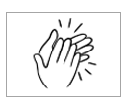
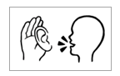
The arrow is a reminder to read from left to right.
  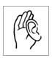  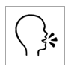  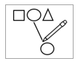      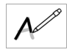  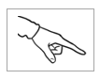  1.  listen | 2.  say
3.  4  copy | 4.  match
5.  colour | 6.  circle
7.  trace | 8.  tick
9.  point | 10.  clap

The alphabet letters

- Capital Letters
A B C D E F
G H I J K L
M N O P Q R
S T U V W X
Y Z

- Small letters
a b c d e f
g h i j k l
m n o p q r
s t u v w x
y z

1.
A B C D E F
G H I J K L
M N O P Q R
S T U V W X
Y Z
2.
a b c d e f
g h i j k l
m n o p q r
s t u v w x
y z

Match the letters
Aa Bb Cc Dd Ee Ff
Gg Hh Ii Jj Kk Ll
Mm Nn Oo Pp Qq Rr
Ss Tt Uu Vv Ww Xx
Yy Zz

A |  | b | a | c
B |  | d | a | b
C |  | e | c | f
D |  | d | a | g

H |  | e | g | h
I |  | a | i | l
J |  | h | b | j
K |  | k | c | h

E |  | f | c | e
F |  | e | f | h
G |  | g | p | f

L |  | i | k | l
M |  | j | a | m
N |  | n | m | h
O |  | k | o | p
P |  | p | l | n

Q |  | o | p | q
R |  | b | r | s
S |  | s | t | u

T |  | r | f | t
U |  | o | u | i
V |  | w | t | v

W |  | x | w | y
X |  | v | z | x

Y |  | y | w | m
Z |  | v | z | x

Trace and copy.
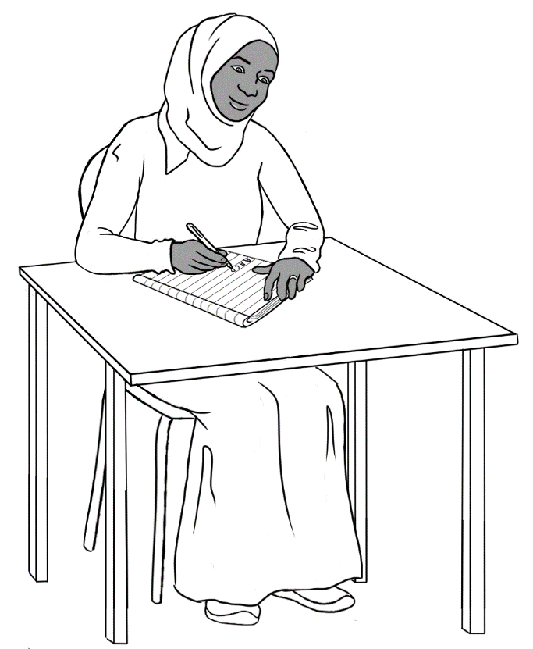
Explain the correct writing posture, pencil grip and letter formation. The colour of the arrows is a guide:
green = 1st stroke, orange = 2nd stroke, purple = 3rd stroke.

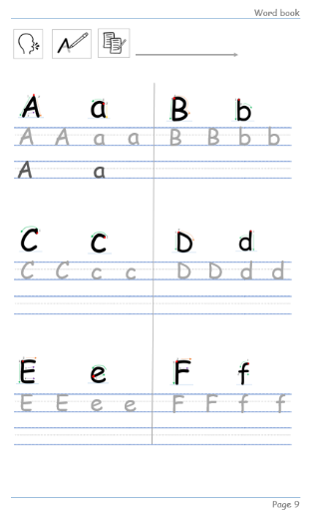
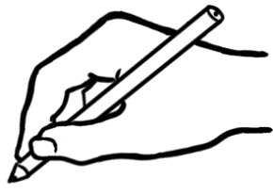

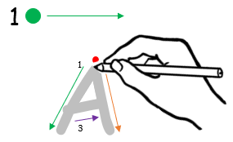 | 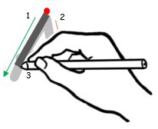
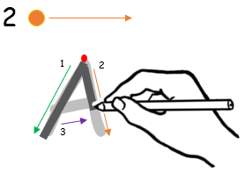 | 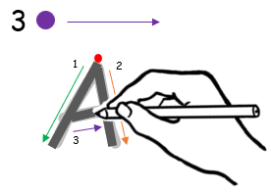


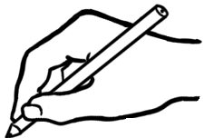
A
A
a
A
A
a
a

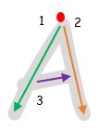
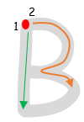
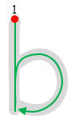

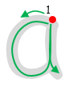

B
b
b
B
a
A
a
A

A
a

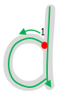
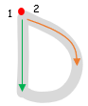
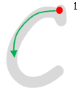
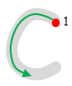

D
D
d
d
c
c
C
C

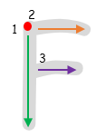
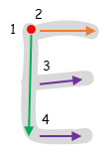
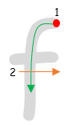



F
E
f
f
F
e
e
E

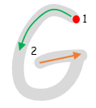
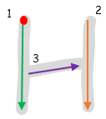
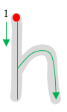
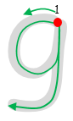

g
g
h
H
h
H
G
G

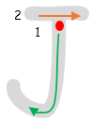
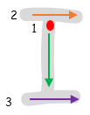
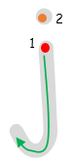


I
j
j
J
J
I
i
i

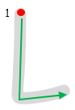
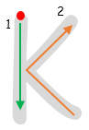

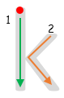

L
l
l
L
k
k
K
K

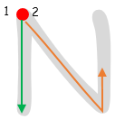
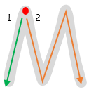

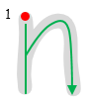
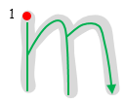

m
n
n
N
N
m
M
M

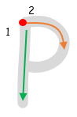
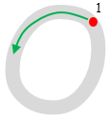
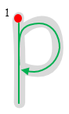
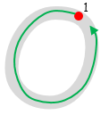

o
P
pk
pk
P
o
O
O

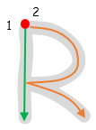
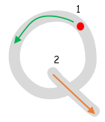
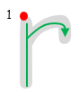
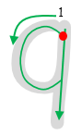

r
r
R
R
q
q
Q
Q

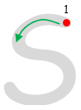
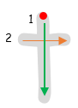
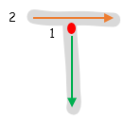


t
t
T
T
s
s
S
S

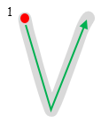
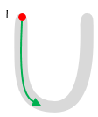
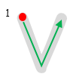
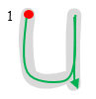

V
V
v
v
u
u
U
U

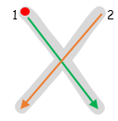
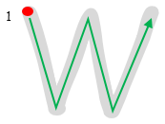
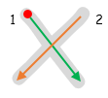


x
x
X
X
w
w
W
W

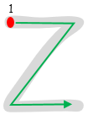
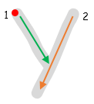
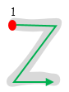
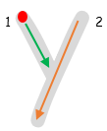

Y
z
z
Z
Z
y
y
Y

More practise in number formation in the writing book.

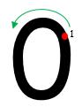
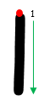
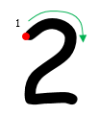
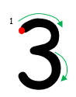
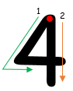

0

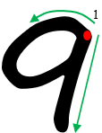
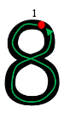
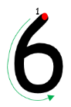
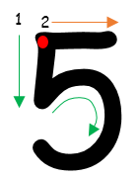
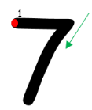

Vowels are in gold boxes, the consonants blue.

a
_
g_
b_
c_
d_
e
_
f_

_
a_
_
_
_
_
_

n_
m_
l_
k_
j_
i
_
h_

_
_
_
_
_
_
_

u
_
p_
o
_
t_
s_
r_
q_

_
_
_
_
_
_
_

z_
y_
x_
w_
v_

_
_
_
_
_

Short vowel words

Explain that the short vowel sound can come
at the beginning or in the middle of a word.

a | 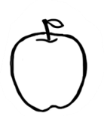  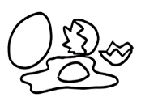  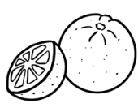    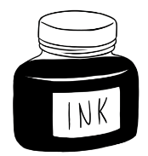  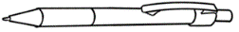 | apple
e |  | egg
i |  | ink
o |  | orange
u |  | umbrella

a | e | i | o | u
a

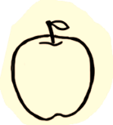
a

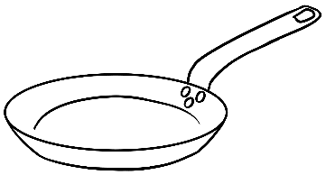
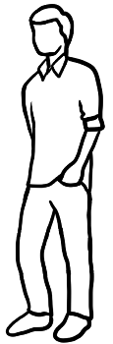


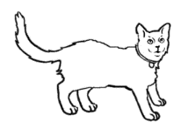
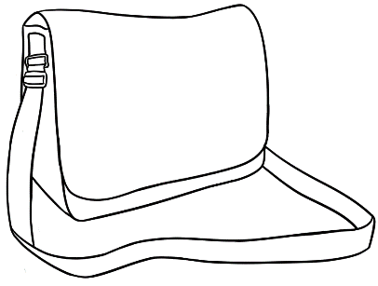
- hat cat
hat __________

- man pan
__________ __________

3. bag tag
__________ __________

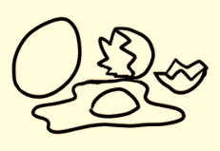
e

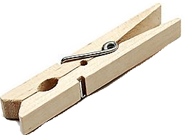
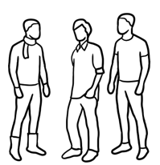
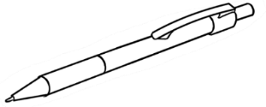
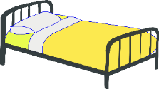
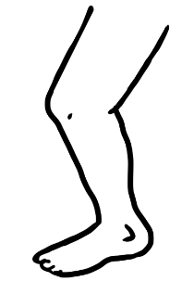

- bed red
bed __________

- pen men
__________ __________

- peg leg
__________ __________

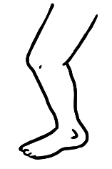 | hat | pan
 | pan | hat
 | man | men
 | men | man
 | pen | leg
 | leg | bed
 | bed | pen

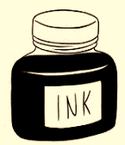
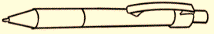
i

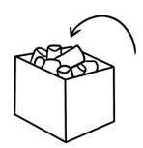

- in bin
in __________

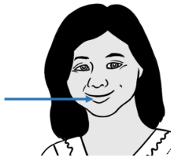
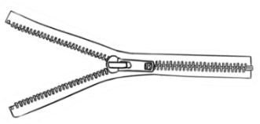
- lip zip
__________ __________

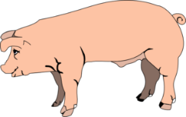
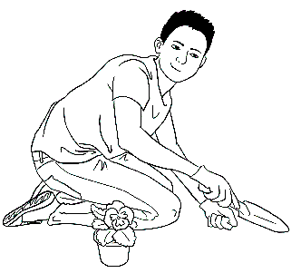
- pig dig
__________ __________

Colour the stop sign red.

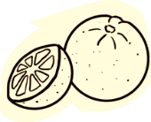
o


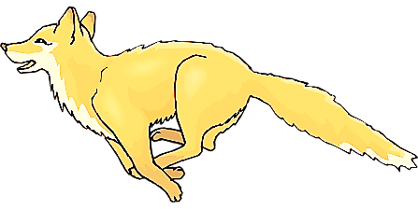
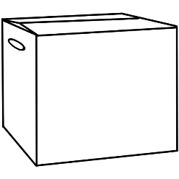

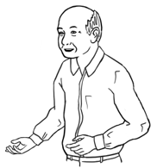
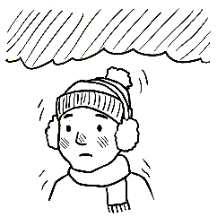
1. old cold
old __________

2. mop stop
__________ __________

3. box fox
__________ __________


u

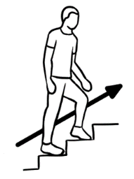
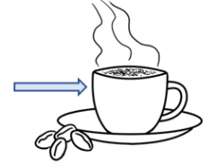
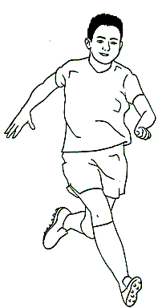

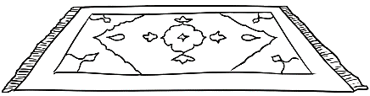

- up cup
up __________

- run sun
__________ __________

- mug rug
__________ __________

 | bin | pig  bin  zip
 | zip
 | pig
 | mop | mop  sun  mug  box
 | box
 | sun
 | mug
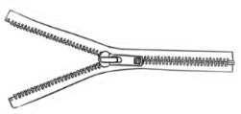
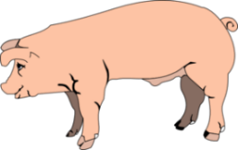
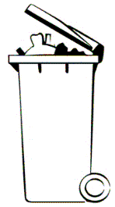

Consonant blends
Say the consonants separately.
Then blend, colour and copy them.

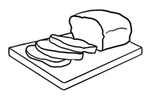
br
b r

br | br | br | br | br
br

br |  | 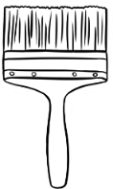
br | bread  __ __ ead  __ __ ead  __ __ ead | brush  __ __ ush  __ __ ush  __ __ ush


tr
t r

tr | tr | tr | tr | tr
tr

tr |  | 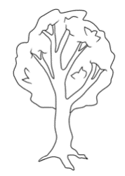
tr | train  __ __ ain  __ __ ain  __ __ ain | tree  __ __ ee  __ __ ee  __ __ ee

tree
brush
train
bread

br
tr

Pages 23, 26 & 29 - Say a word stressing the blend.
Students tick the blend.

bread brush train tree

Say the consonants separately.
Then blend, colour and copy them.

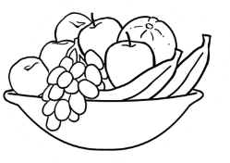
fr
f r

fr | fr | fr | fr | fr
fr

fr |  | 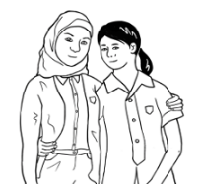
fr | fruit  __ __ uit  __ __ uit  __ __ uit | friend  __ __ iend  __ __ iend  __ __ iend

- Colour all stop signs red.
st
s t

st | st | st | st | st
st

st |  | 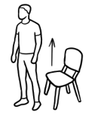
st | stop  __ __ op  __ __ op  __ __ op | stand  __ __ and  __ __ and  __ __ and

fruit
stop
friend
stand

fr
st

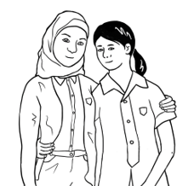

fruit friend stop stand

Say the consonants separately.
Then blend, colour and copy them.
Colour the shapes black or blue.
Identify objects that are black or blue.

bl
b l

bl | bl | bl | bl | bl
bl

bl
bl | black  __ __ ack  __ __ ack  __ __ ack | blue  __ __ ue  __ __ ue  __ __ ue

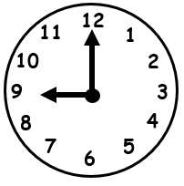
cl
c l

cl | cl | cl | cl | cl
cl

cl |  | 
cl | clock  __ __ ock  __ __ ock  __ __ ock | clap  __ __ ap  __ __ ap  __ __ ap

blue

clap
clock
black

bl
cl


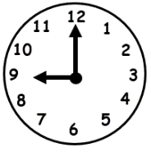

black blue clock clap

Listening exercise - Say the blended sound in the box and then the two words. Students circle the word with the blended sound. The first word is brush.

br | 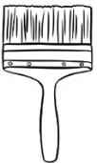  brush | 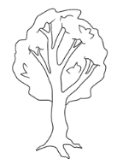  tree
tr | 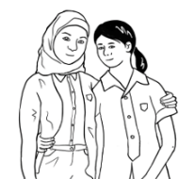  friend |   train
fr | blue | 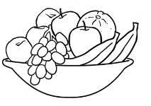  fruit
st | 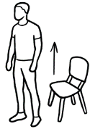  stand | clock
bl | stop | black
cl | 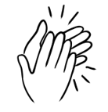  clap | bread

Two consonants make one sound.
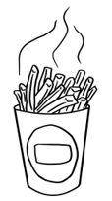
ch
ch
ch

ch | ch | ch | ch | ch
ch

ch |  | 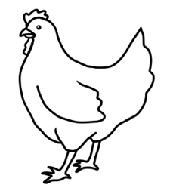
ch | chips  __ __ ips  __ __ ips  __ __ ips | chicken  __ __ icken  __ __ icken  __ __ icken

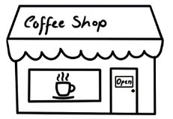
sh
sh
sh

sh | sh | sh | sh | sh
sh

sh |  | 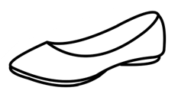
sh | shop  __ __ op  __ __ op  __ __ op | shoe  __ __ oe  __ __ oe  __ __ oe

shoe
chips
shop
chicken

ch
sh

Say a word stressing the bolded sound.
Students tick the sound.

chips chicken shop shoe

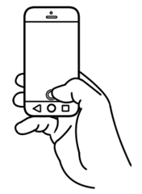
ph
ph
ph

ph | ph | ph | ph | ph
ph

ph |  | 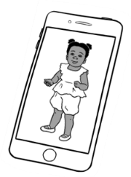
ph | phone  __ __ one  __ __ one  __ __ one | photo  __ __ oto  __ __ oto  __ __ oto

See the Teacher Resources for notes about
the pronunciation of the voiced and unvoiced th.
The th in thirty and Thursday is unvoiced. Additional words are thirteen, thirty and thanks.

3
th
th
th

th | th | th | th | th
th

th | 3 | 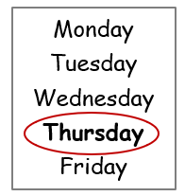
th | three  __ __ ree  __ __ ree  __ __ ree | Thursday  __ __ ursday __ __ ursday  __ __ ursday

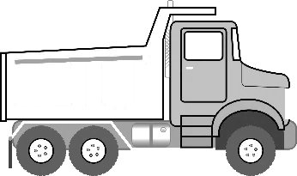
ck
ck
ck

ck | ck | ck | ck | ck
ck

ck |  | 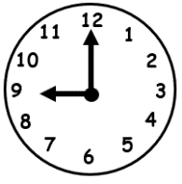
ck | truck  tru__ __  tru__ __  tru__ __ | clock  clo__ __  clo __ __  clo __ __

Say the double-letter sound and the two words.
Students circle the word with the double-letter sound.

ch  sh  ph  th  ck | 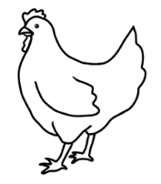  chicken |  | 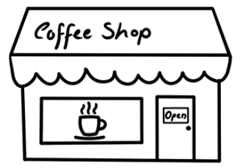  shop
 | shoe | phone
 | photo | clock
 | chips | Thursday
 | 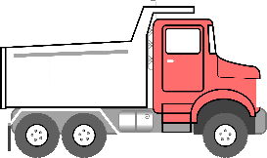  truck | three  3

ch  sh  ph  th  ck |  | chips
ch  sh  ph  th  ck |  | chicken | 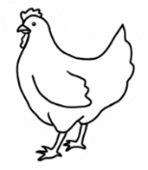
 |  | shop
 |  | shoe
 |  | phone | 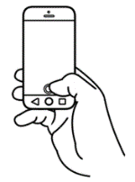
 |  | photo | 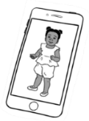
 |  | three | 3
 |  | Thursday
 |  | clock
 |  | truck

Say the word, sound the word, say the word.
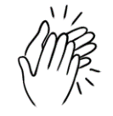

cl | a | p
- clap clap
cl | o | ck
- clock clock
tr | u | ck
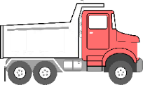
- truck truck
sh | o | p
- shop shop
br | u | sh
- brush brush
ch | i | p | s
- chips chips

clap clock truck
clap _________ _________
shop brush chips
_________ __________ _________

Numbers
0 | 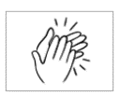

1

2
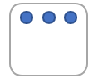
3

4

5
  6 | 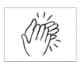
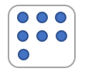
7

8
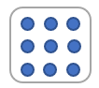
9

0 | 1 | 2 | 3 | 4
0
5 | 6 | 7 | 8 | 9
Students dial their number on the phone keyboard.
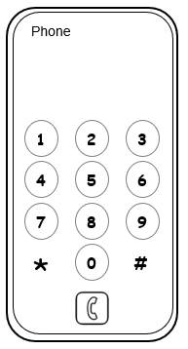
What is your phone number?


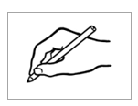

Name
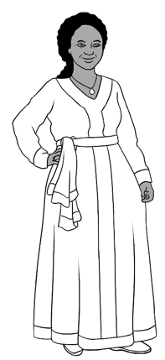
My first name is Jamila.
My family name is Desta.

My first name is Jamila.
My family name is Desta.

First name | Jamila
Family name | Desta
You

What is your first name?
What is your family name?

Students can copy their names from a card
with their personal details.

My first name is _____________________.

My family name is _____________________.

First name | ________________________________
Family name | ________________________________

Address
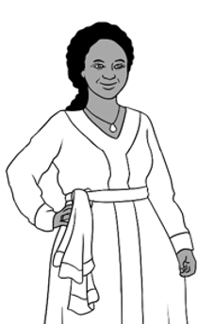
I live in Kellivale.
I live at 56 North Street.
My phone number is
0408 629 531.

Address
Street | 56 North Street
Suburb | Kellivale
Postcode | 2421
Phone | 0 | 4 | 0 | 8 |  | 6 | 2 | 9 |  | 5 | 3 | 1

Students can copy their address and phone number from a card with their personal details.
You
Where do you live?
What is your phone number?

Address
Street | _______________________________________________
Suburb | ___________________________________________
Postcode | _____________________
Phone

Today is Monday.
Monday
Tuesday
Wednesday
Thursday
Friday
Saturday
Sunday

- Today is Monday.
Monday
- Today is Tuesday.
Tues________
- Today is Wednesday.
Wednes________
- Today is Thursday.
Thurs________
- Today is Friday.
Fri________
- Today is Saturday.
Satur_______
- Today is Sunday.
______________

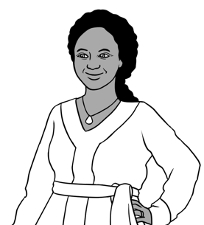
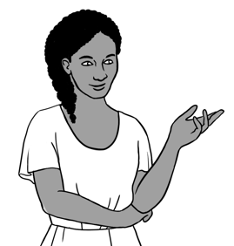
When is your class?

Monday, Tuesday
and Thursday.

 | Jamila | You
Monday
Tuesday
Wednesday
Thursday
Friday
Saturday
Sunday
- Students tick Jamila’s days and their class days.

