
English Ready
22636VIC Course in Initial EAL
VU23491 Recognise and copy extremely familiar words

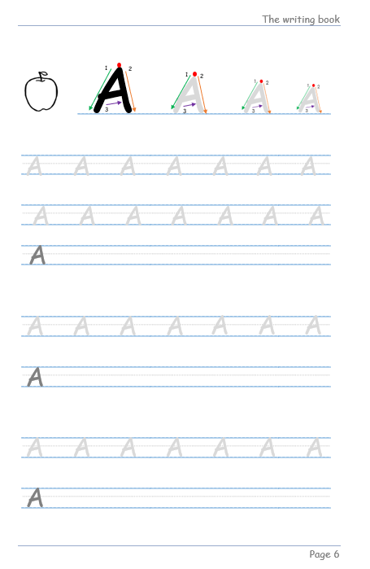
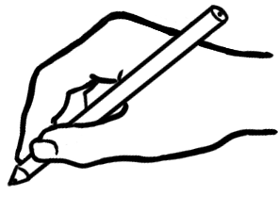
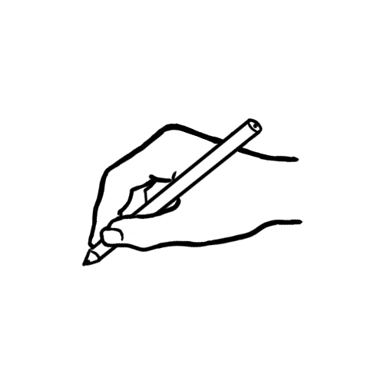

Writing

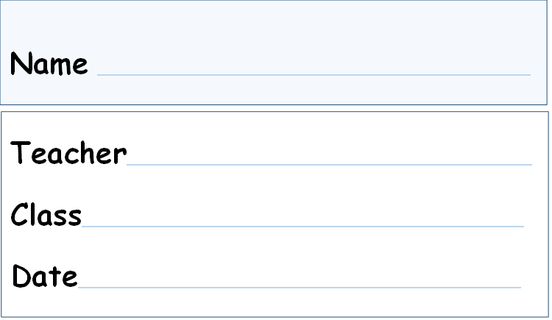
This workbook is designed to be used with the support of a teacher.
This book provides additional writing exercises to support the Words book.
Design team: Vicki Hambling, Sue Paull, Frida Dean, Glenise Kleehammer and Mary Wallace
Illustrations: Madelena Scott
Acknowledgements: The design team would like to thank the AMEP service providers and practitioners who participated in the trial and gave valuable feedback. The team would also like to acknowledge the use of the EAL Framework which underpins the design of this book.

Copyright of the EAL Framework is reserved to the Crown in the right of the State of Victoria. © State of Victoria (Department of Education and Training) 2023.

This English Ready Resource is licensed under a Creative Commons Attribution-NoDerivs 3.0 Australia licence (More information is available here). You are free to use, copy and distribute to anyone in its original form as long as you attribute Department of Home Affairs as the author and you license any derivative work you make available under the same licence.
© Commonwealth of Australia 2023

With the exception of the Commonwealth Coat of Arms, the department’s logo, any material protected by a trade mark and where otherwise noted all material presented in this document is provided under a Creative Commons Attribution 4.0 International (https://creativecommons.org/licenses/by/4.0/) licence.
The details of the relevant licence conditions are available on the Creative Commons website (accessible using the links provided) as is the full legal code for the CC BY 4.0 licence. (https://creativecommons.org/licenses/by/4.0/legalcode).
Use of all or part of this document must include the following attribution:
© Commonwealth of Australia 2023
As far as practicable, material for which the copyright is owned by a third party will be clearly labelled. The department has made all reasonable efforts to ensure that this material has been reproduced in this document with the full consent of the copyright owners.
Copyright requests and enquiries concerning usage not addressed by the CC BY 4.0 licence should be addressed to: comms@homeaffairs.gov.au at the Department of Home Affairs.
The terms of use for the Commonwealth Coat of Arms are available from the It's an Honour website.
Where a copyright owner, other than the Commonwealth, is identified with respect to this material, please contact that third party copyright owner directly to seek permission.


Table of contents

1 Get ready to write. 2
2 Trace and copy letters. 3
3 Copy numbers. 56

Get ready to write.

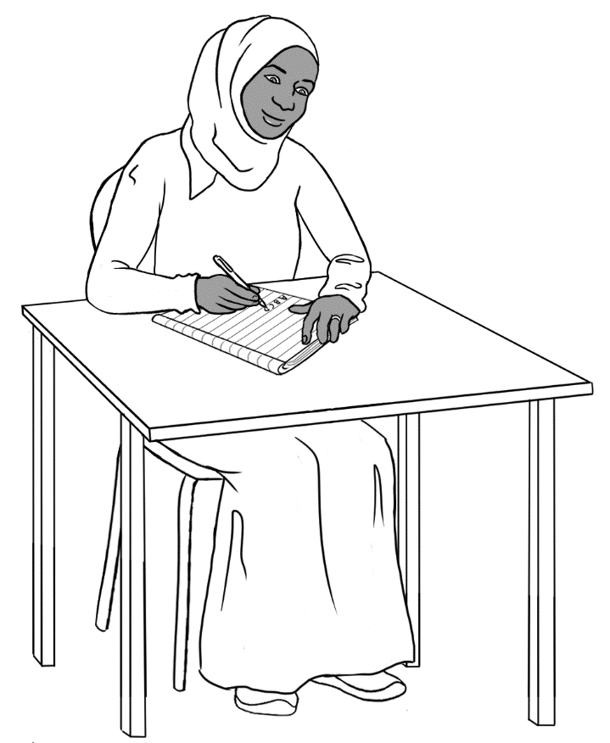

Trace and copy letters.
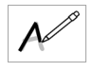

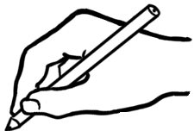  1  3  2  A  1 | 1  3  A  2
2  1  3  A  2 | 1  3  A  2  3



A
A
A
A
A
A
A

A
A
A
A

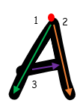
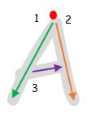
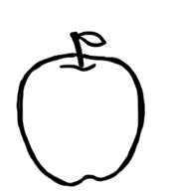

A
A
A
A
A
A
A

A
A
A
A
A
A
A

A

A
A
A
A
A
A
A

A

A
A
A
A
A
A
A

A

apple

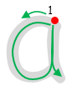
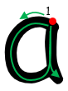

a
a
a
a
a
a
a

a
a
a
a
a
a
a

a

a
a
a
a
a
a
a

a

a
a
a
a
a
a
a

a

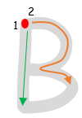
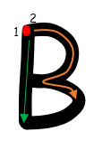

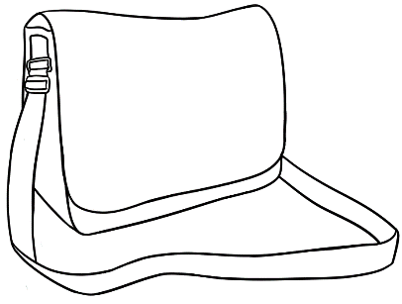

B
B
B
B
B
B
B

B
B
B
B
B
B
B

B

B
B
B
B
B
B
B

B

B
B
B
B
B
B
B

B




bag

b
b
b
b
b
b
b

b
b
b
b
b
b
b

b

b
b
b
b
b
b
b

b

b
b
b
b
b
b
b

b

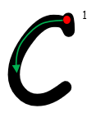
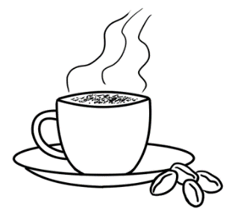
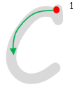

C
C
C
C
C

C
C
C
C
C
C

C

C

C
C
C
C
C
C

C

C
C
C
C
C
C

C

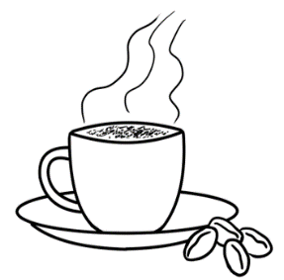
cup
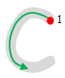


c
c
c
c
c
c

c
c
c
c
c
c

c

c
c
c
c
c
c

c

c
c
c
c
c
c

c

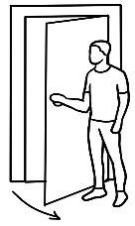
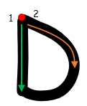
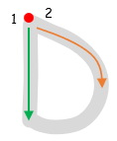

D
D
D
D
D
D
D

D
D
D
D
D
D
D

D

D
D
D
D
D
D
D

D

D
D
D
D
D
D
D

D

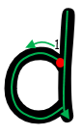
door
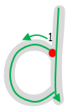

d
d
d
d
d
d
d

d
d
d
d
d
d
d

d

d
d
d
d
d
d
d

d

d
d
d
d
d
d
d
d

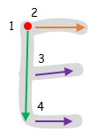
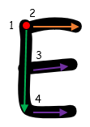
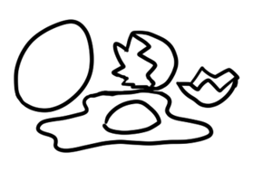

E
E
E
E
E
E
E
E
E
E
E
E
E

E

E

E
E
E
E
E
E
E

E

E
E
E
E
E
E
E

E

egg



e
e
e
e
e
e
e

e
e
e
e
e
e
e

e

e
e
e
e
e
e
e

e

e
e
e
e
e
e
e

e

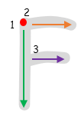
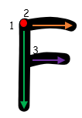
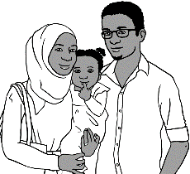

F
F
F
F
F
F
F

F
F
F
F
F
F
F

F

F
F
F
F
F
F
F

F

F
F
F
F
F
F
F

F

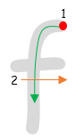
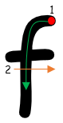
familyg

f
f
f
f
f
f
f

f
f
f
f
f
f
f

f

f
f
f
f
f
f
f

f

f
f
f
f
f
f
f

f

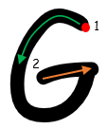
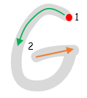


G
G
G
G
G
G
G

G
G
G
G
G
G
G

G

G
G
G
G
G
G
G

G

G
G
G
G
G
G
G

G

glasses

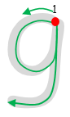

g
g
g
g
g
g
g

g
g
g
g
g
g
g

g

g
g
g
g
g
g
g

g

g
g
g
g
g
g
g

g

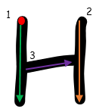
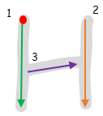
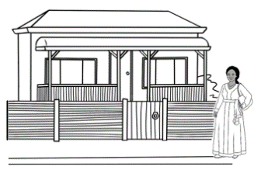

H
H
H
H
H
H
H

H
H
H
H
H
H
H

H

H
H
H
H
H
H
H

H

H
H
H
H
H
H
H

H

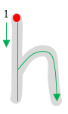
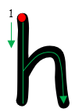
home

h
h
h
h
h
h
h

h
h
h
h
h
h
h

h

h
h
h
h
h
h
h

h

h
h
h
h
h
h
h

h

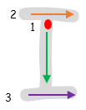
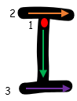
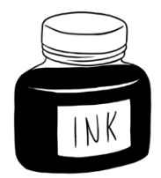

I
I
I
I
I
I
I

I
I
I
I
I
I
I

I

I
I
I
I
I
I
I

I

I
I
I
I
I
I
I

I



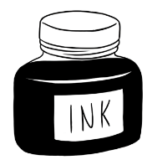
ink

i
i
i
i
i
i
i

i
i
i
i
i
i
i

i

i
i
i
i
i
i
i

i

i
i
i
i
i
i
i

i

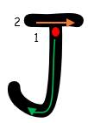
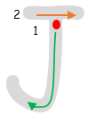
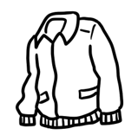

J
J
J
J
J
J
J

J
J
J
J
J
J
J

J

J
J
J
J
J
J
J

J

J
J
J
J
J
J
J
J



jacket

j
j
j
j
j
j
j

j
j
j
j
j
j
j
j

j
j
j
j
j
j
j

j

j
j
j
j
j
j
j
j

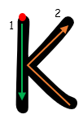
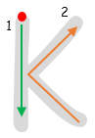
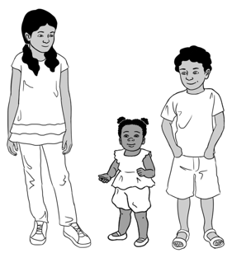

K
K
K
K
K
K
K

K
K
K
K
K
K
K

K

K
K
K
K
K
K
K

K

K
K
K
K
K
K
K

K

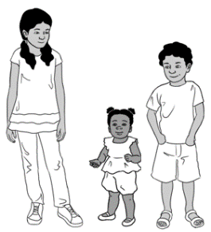
kids
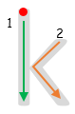
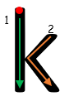

k
k
k
k
k
k
k

k
k
k
k
k
k
k

k

k
k
k
k
k
k
k

k

k
k
k
k
k
k
k

k

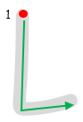
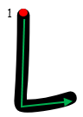
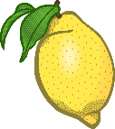

L
L
L
L
L
L
L

L
L
L
L
L
L
L

L

L
L
L
L
L
L
L

L

L
L
L
L
L
L
L

L



lemon

l
l
l
l
l
l
l

l
l
l
l
l
l
l

l

l
l
l
l
l
l
l

l

l
l
l
l
l
l
l

l

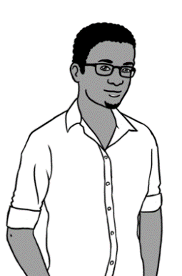
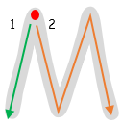
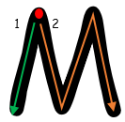

M
M
M
M
M
M
M

M
M
M
M
M
M
M

M

M
M
M
M
M
M
M

M

M
M
M
M
M
M
M

M

man




m
m
m
m
m
m
m

m
m
m
m
m
m
m

m

m
m
m
m
m
m
m

m

m
m
m
m
m
m
m

m

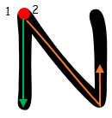
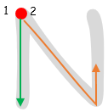
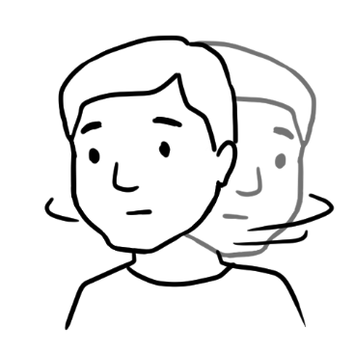

N
N
N
N
N
N
N

N
N
N
N
N
N
N

N

N
N
N
N
N
N
N

N

N
N
N
N
N
N
N

N

no
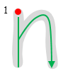
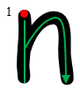

n
n
n
n
n
n
n

n
n
n
n
n
n
n
n

n
n
n
n
n
n
n

n

n
n
n
n
n
n
n

n

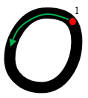
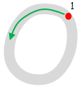
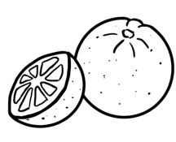

O
O
O
O
O
O
O

O
O
O
O
O
O
O

O

O
O
O
O
O
O
O

O

O
O
O
O
O
O
O

O

orange
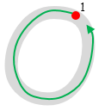
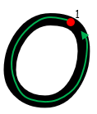

o
o
o
o
o
o
o

o
o
o
o
o
o
o

o

o
o
o
o
o
o
o

o

o
o
o
o
o
o
o

o

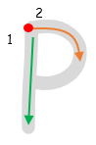
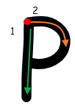
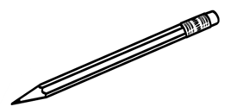

P
P
P
P
P
P
P
P
P
P
P
P
P
P
P

P
P
P
P
P
P
P

P

P
P
P
P
P
P
P

P

pencil
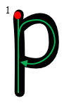
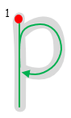

p
p
p
p
p
p
p

p
p
p
p
p
p
p

p

p
p
p
p
p
p
p

p

p
p
p
p
p
p
p

p

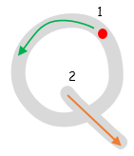
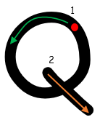
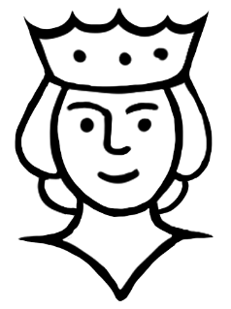

Q
Q
Q
Q
Q
Q
Q
Q
Q
Q
Q
Q
Q
Q
Q

Q
Q
Q
Q
Q
Q
Q

Q

Q
Q
Q
Q
Q
Q
Q
Q

queen
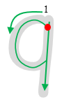
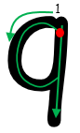

q
q
q
q
q
q
q
q
q
q
q
q
q
q

q

q
q
q
q
q
q
q

q

q
q
q
q
q
P
q
q

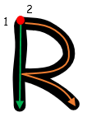
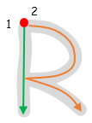
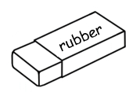

R
R
R
R
R
R
R

R
R
R
R
R
R
R

R

R
R
R
R
R
R
R

R

R
R
R
R
R
R
R

R

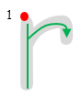
rubber


r
r
r
r
r
r
r
r
r
r
r
r
r
r
r

r
r
r
r
r
r
r

r

r
r
r
r
r
r
r

r


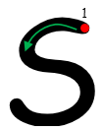
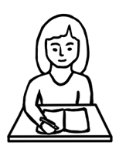

S
S
S
S
S
S
S
S
S
S
S
S
S
S
S

S
S
S
S
S
S
S

S

S
S
S
S
S
S
S

S

student




s
s
s
s
s
s
s
s
s
s
s
s
s

s

s

s
s
s
s
s
s
s

s

s
s
s
s
s
s
s

s

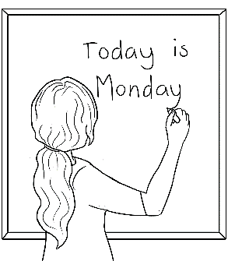
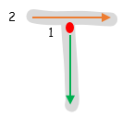
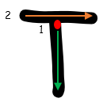

T
T
T
T
T
T
T
T
T
T
T
T
T
T
T

T
T
T
T
T
T
T

T

T
T
T
T
T
T
T

T

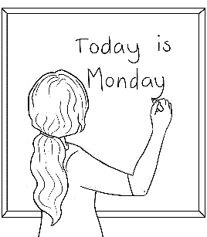
teacher

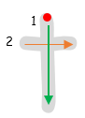
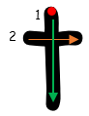

t
t
t
t
t
t
t
t
t
t
t
t
t
t
t

t
t
t
t
t
t
t

t

t
t
t
t
t
t
t
t

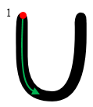

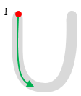

U
U
U
U
U
U
U
U

U
U
U
U
U
U
U

U
U
U
U
U
U
U

U

U
U
U
U
U
U
U
U

umbrella

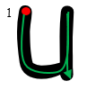
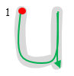

u
u
u
u
u
u
u
u
u
u
u
u
u
u
u

u
u
u
u
u
u
u

u

u
u
u
u
u
u
u

u

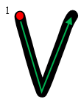
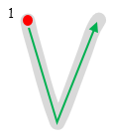

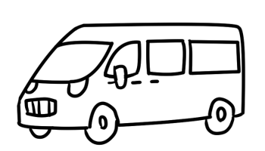

V
V
V
V
V
V
V

V
V
V
V
V
V
V

V

V
V
V
V
V
V
V

V

V
V
V
V
V
V
V

V

van

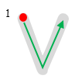
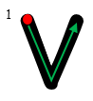
v

v
v
v
v
v
v

v
v
v
v
v
v
v
v

v
v
v
v
v
v
v
v

v
v
v
v
v
v
v

v

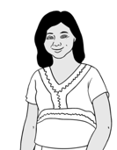
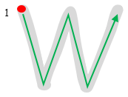
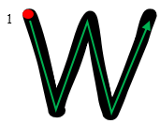

W
W
W
W
W
W
W
W
W
W
W
W
W
W
W

W
W
W
W
W
W
W
W

W
W
W
W
W
W
W

W

woman




w
w
w
w
w
w
w
w
w
w
w
w
w
w
w

w
w
w
w
w
w
w
w

w
w
w
w
w
w
w

w

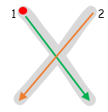
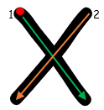
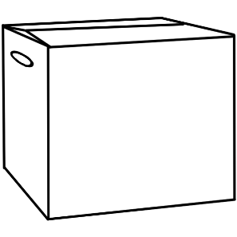

X
X
X
X
X
X

X
X
X
X
X
X
X
X
X
X
X
X
X
X

X

X

X

X
X
X
X
X
X
X

X

box

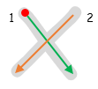
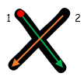

x
x
x
x
x
x
x
x
x
x
x
x
x
x
x
x
x
x
x
x
x
x

x

x
x
x
x
x
x
x

x

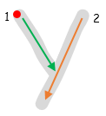
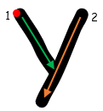
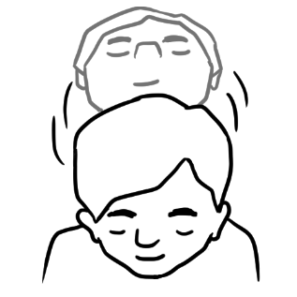

Y
Y
Y
Y
Y
Y
Y
Y
Y
Y
Y
Y
Y
Y
Y

Y
Y
Y
Y
Y
Y
Y

Y

Y
Y
Y
Y
Y
Y
Y
Y

yes

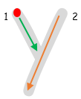
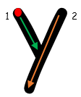

y
y
y
y
y
y
y

y
y
y
y
y
y
y
y

y
y
y
y
y
y
y

y

y
y
y
y
y
y
y

y

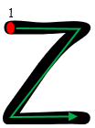
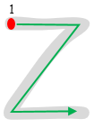
0

Z
Z
Z
Z
Z
Z
Z
Z

Z
Z
Z
Z
Z
Z
Z

Z
Z
Z
Z
Z
Z
Z

Z

Z
Z
Z
Z
Z
Z
Z

Z

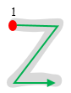
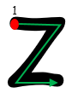
0
zero

z
z
z
z
z
z
z
z
z
z
z
z
z
z
z

z
z
z
z
z
z
z

z

z
z
z
z
z
z
z

z

Copy numbers.
0
1

0
1

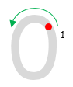

0
0
0
0
0
0
0

0

l
1
l
1



l
l
l
l
l
l
l
l

2
1

2
1

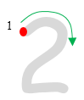

2
2
2
2
2
2
2
2

3
1
3
1

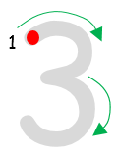

3
3
3
3
3
3
3
3

4
1
2
4
1
2

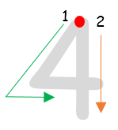

4
4
4
4
4
4
4
4

5
1
2

5
1
2
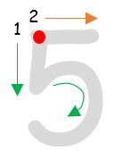

5
5
5
5
5
5
5
5

6
1
6
1
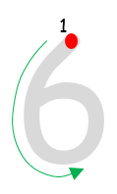

6
6
6
6
6
6
6
6

7
1

7
1
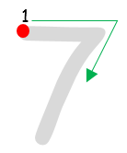

7
7
7
7
7
7
7
7

8
1

8
1
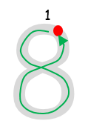

8
8
8
8
8
8
8
8



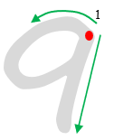

9
9
9
9
9
9
9

9

0
1
l
1

l
l
l
l
l
l
l
0
0
0
0
0
0
0

l
0

