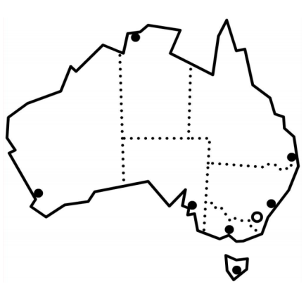

Section 1
Australia

Table of contents
Text for the section 1 – Australia 4
Build vocabulary for Australia 5
Weather vocabulary - AMEP Resources 8
AMEP Volunteer Tutor Resources 8
Create the text for Australia 9
Ordering the text - class work 11
Order the Text 12
Listen and order sentences - 3 levels 15
Level A - Order Sentences 16
Level B - Order Sentences 17
Level C - Order Sentences 18
Spelling – 3 levels 19
Level A - Spelling 20
Level B - Spelling 21
Level C - Spelling 22
Speed Copying – 3 levels 23
Level A - Speed copying 24
Level B - Speed Copying 25
Level C - Speed Copying 26
Dictation – 3 levels 27
Level A - Dictation 28
Level B - Dictation 29
Level C - Dictation 30
Homework activity: Read and write - 3 levels 31
Level A - Read and write 32
Level B - Read and write 33
Level C - Read and write 34
Pronunciation: Linking words ending in s – Class work 35
Appendix – Vocabulary list for Section 1 36
Appendix – an activity with and 37
Acknowledgements 38

Text for the section 1 – Australia

Australia is a big country.
It is very, very, very hot and dry.
But sometimes it rains and rains and rains.

Build vocabulary for Australia
The following is a suggested method to teach vocabulary. It involves drawing simple pictures on the board and miming. The aim is to get the students to suggest the words and then write them on the board. It helps to put the words down one side of the board and leave them there for reference. Use the dashes as a line and show how to write on the line, how to form the letters, model the letter formation and verbalise the word if necessary for ESL literacy students.

VOCABULARY | Board Work
Australia  Draw a map of Australia or project a simple blank map onto the board. Ask, What is it? Students say Australia. | On the right-hand side of the board write  Au _ _ _ _ _ ia  Say Australia. Ask the students what other letters they can hear. Say the word slowly out loud. Do this several times and write in the letters the students identify correctly. Add in the other letters.  Point to the word. Ask students to repeat Australia after you. Spell the word together, pointing to each letter as you spell. Ask how many letters are in the word and count the letters together. Explain why a capital A is used.
big  Using body language mime big and little.  Draw objects on the board to consolidate the words.  Mime big again and ask students for the word. | Write on the board:  _ i _  Repeat the process used to teach the word Australia. Also get students to mime the word as they say it. Explain that the tail of the ‘g’ goes under the line.
hot  Using body language, mime the words hot and cold. You could draw a picture of the sun on the board to help. Get students to mime the word as they say it. | Repeat the process used to teach the word Australia.
dry  Take in a small glass or bottle of water, and wet an area of the desk. Give students the word wet if they can’t get it and point to a dry area. Now, dry the area, and repeat the word dry.  [See photos on the next page.] | Guess the letters _ _ y  Repeat the process used to teach the word Australia. Also show that the tail of the ‘y’ goes under the line.
rains  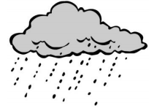  Draw a cloud and rain similar to the one above. Teacher mimes the word - this may include an umbrella. Get students to mime rain coming down. | Write _ _ i _ _ on the board.  Repeat the process used to teach the word Australia.

Images to help teach ‘dry’.
These could be projected or laminated and passed around the class.
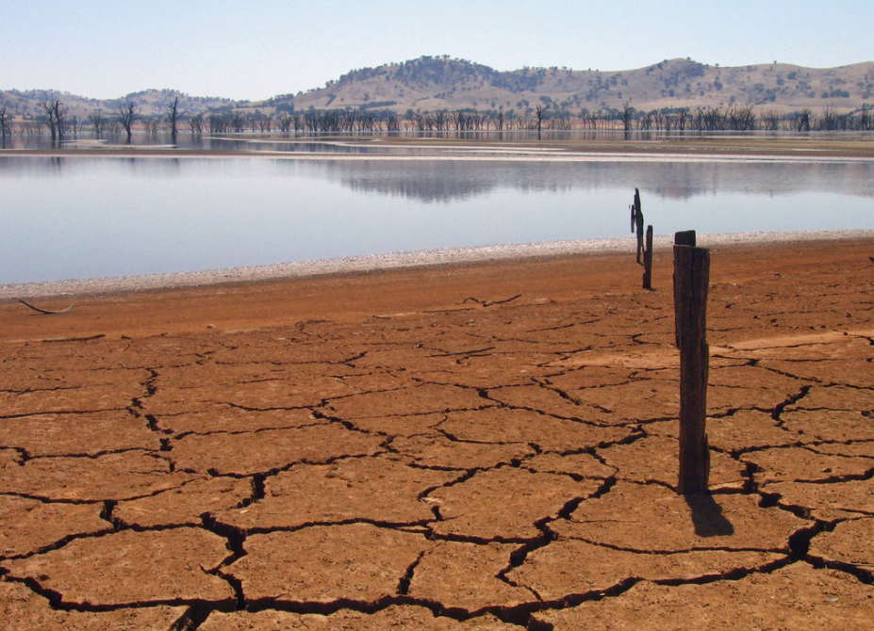

wet

dry

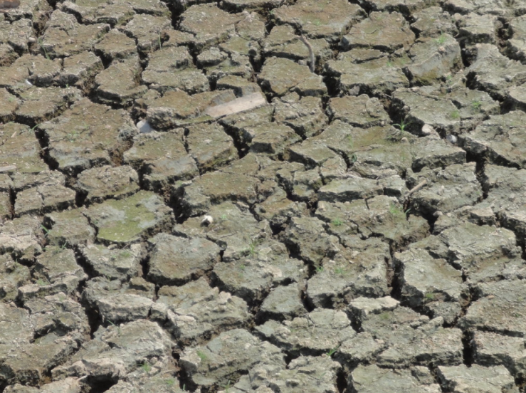

dry

Weather vocabulary - AMEP Resources
The following resources are freely available and useful to pre teach vocabulary relating to weather:

AMEP Volunteer Tutor Resources
Go to:
https://immi.homeaffairs.gov.au/settling-in-australia/amep/volunteer-tutor-resources
Print out the weather flashcards to teach vocabulary
- Click on: Pre-Beginner, Environment.
- Download worksheet 1: Weather Chart
- Do the activity in class each day prior to beginning this unit.

Create the text for Australia
This is the text to be created:
Australia is a big country.
It is very, very, very hot and dry.
But sometimes it rains and rains and rains.

Preparation:
- Have the alphabet in capital and small letters at the top of the board and the vocabulary list down the side of the board.

Aa Bb Cc Dd Ee Ff Gg Hh Ii Jj Kk Ll Mm
Nn Oo Pp Qq Rr Ss Tt Uu Vv Ww Xx Yy Zz

- On the board write:
_ _ _ _ _ _ _ _ _ _ _ _ _ _ _ country.

_ _ _ _ very _ _ _ _ _ _ _ _ _ _ _ _ _ _.

But sometimes _ _ _ _ _ _ _ _ _ _ _ _ _ _ _ _ _ _ _.

Activity

- Ask the students to guess the text. Encourage them to use the vocabulary list.
- Begin by asking them to suggest a letter, any letter. If they guess a letter, or even the whole word from the vocabulary list, write it on the dashes.
- If students can’t get the words, just write them in.
- Mime the words that can be mimed such as big, hot, rains.
- To demonstrate very, very, very hot, draw a sun on the board with longer and redder rays as you mime.
- Get the students to read through the text out aloud with you several times.
- Point to each word as you read together.
- Ask the students to say and then spell each word.
- Draw attention to capital letters, full stops, words, word spaces, initial letter sounds, letter names and sentences.
- Talk about letter formation as you write on the board. e.g. capital A, the tail of the g and y go under the line etc.
- On the board, you will have written the complete text.
- Now rub out three words, but put in the dashes for the letters. e.g.
_ _ _ _ _ _ _ _ _ is a big country.
It is very, very, _ _ _ _ hot and dry.
But sometimes it rains and rains and _ _ _ _ _.

- Point to and say the missing and existing words and read several times together.
- Rub out more words e.g.
_ _ _ _ _ _ _ _ _ is a big country.
It is very, _ _ _ _, _ _ _ _ hot and dry.
But sometimes it rains and _ _ _ _ _ and _ _ _ _ _.

- Read again with the class, pointing to and saying the missing and existing words.
- Continue to rub out words and read again. With some classes it is possible to rub out all the words in this way. You could also leave the first letter of a missing word to give a clue.
- When you have rubbed out as much as you can, ask the students to help you rewrite the text. If you start with Australia, ask if it starts with a capital.
They can use the vocabulary list to help them.

Ordering the text - class work

Preparation
Enlarge and cut out the words on the following page.
Activity
- Give one word to each student.
- Students stand with their words in front of them.
- The teacher reads the sentence.
- Students move to the front of the class, putting themselves in order to make the sentence.
- The class reads the sentence.
- Encourage students to mime the words like big, very hot and rains.
- Ask students to hold their words face down in front of them. Call out words at random, and the students hold up their word when it’s called.
- Once again with their words face down, read the sentences slowly and the students hold up their words in the correct order.

Order the Text
Australia
is |  | a | big
country
 | .

It | is |  | very
very |  |  | very
hot |  |  | and
dry |  | , |  | , | .

sometimes
But |  | it |  | rains
and |  |  | rains
and |  |  | rains
 | .

Listen and order sentences - 3 levels
Preparation
- Copy the sentences on the following pages, enough so that students can work in pairs and at their ability level.
- Provide scissors and glue, and a page of light card for each pair, and an envelope for later storage of the cut-up sentences.
Activity
- Hand out copies of the sentences with the card, glue, scissors and envelopes.
- Demonstrate the process of pasting the page of words onto card, then cutting along the dotted lines to make word cards.
- Students work together to paste the paper onto the card and then cut out the strips.
- As they work, encourage students to say what they are doing like a chant.
We are gluing paper onto the card, onto the card, onto the card.
We are gluing paper onto the card, onto the card, onto the card.
We are cutting with the scissors, with the scissors, with the scissors.
We are cutting with the scissors, cut, cut, cut. etc

This makes for a noisy class, but gives students time to practice speaking. It doesn’t matter that a new tense is being introduced here. It’s a way of practising the form of a new tense so that it is familiar before its use is explained at a later time.
- When the cutting and pasting has been completed, slowly read the Section 1 text to the class and ask students to put the sentences in order as they listen.
Australia is a big country.
It is very, very, very hot and dry.
But sometimes it rains and rains and rains.
- To make it more difficult cut the sentences in half and mix them up. Encourage students to use clues such as the full stops and capital letters. This activity can be repeated over several days. Each time the students find the activity easy, they can cut up the strips into smaller pieces.

Level A - Order Sentences
Australia is |  | a big country.
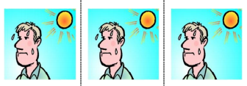  It is very, very, very hot |  |  |   and dry.
But sometimes
But sometimes | 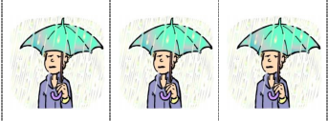  it rains and rains and rains.

Level B - Order Sentences
Australia is | a big country.
It is very, very, very hot

and dry. | But sometimes
it rains and rains and rains.

Level C - Order Sentences

Australia is | a big |  |  | country.
It is |  | very, very,
very hot |  | and dry.
But sometimes |  |  | it rains
and rains |  |  | and rains.

Spelling – 3 levels

- For lower levels use a modified version of ‘Look, say, cover, write, check’.
Teach: Look, say the word out loud, spell the word out loud as you copy.
For higher levels teach ‘Look, say, cover, write, check’.

- It is important that the students:
- Finish one word before writing the next word
- Work down the page rather than across
- Check their spelling with the typed word
- Try to chunk the letters rather than copy letter by letter
- The words are printed twice at each level so that students practise once in class and then again at home or in a following class. In this way, students are shown a way to improve their writing through brief and regular practice.

Level A - Spelling

dry | big
dry | big

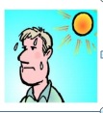 | 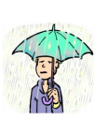
hot | rains
hot | rains

Level B - Spelling
is | big | very | hot
is | big | very | hot

dry | but | and | rain
dry | but | and | rain

Level C - Spelling

sometimes | big | very | hot
sometimes | big | very | hot

dry | but | and | rain
dry | but | and | rain

Speed Copying – 3 levels
One of the simplest ways to improve spelling and writing is to practise speed copying. The goal of such copying is to build speed and proficiency. With regular practice, speed copying can improve spelling, handwriting and memory. Students’ written expression also improves as they memorise common groupings of words and collocations.
Low level students will initially copy letter by letter, but as they become more proficient over time, they will learn to chunk letters, then write whole words, then a few words and finally complete sentences, depending on their level and educational background.
Activity
- Set the timer for 2, 4 or 5 minutes
- Ask the students to copy the same text over and over in that time.
- If they finish copying their text before the time is up, they need to copy it again, and maybe even again.
- Students copy the same text every day for a week, trying to increase the number of words they write each time.
- The text copied can be used for a dictation the following week.
- Choose a new text to copy each week.

Level A - Speed copying

Australia is big.
_______________________________________________
It is hot.
_________________________________________________
It rains.
________________________________________________

Australia is big.
_______________________________________________
It is hot.
_________________________________________________
It rains.
________________________________________________

Level B - Speed Copying

Australia is a big country.
________________________________________________
It is very hot and dry.
________________________________________________
But sometimes it rains.
____________________________________________

Australia is a big country.
________________________________________________
It is very hot and dry.
_________________________________________________
But sometimes it rains.
_____________________________________________

Level C - Speed Copying

Australia is a big country.
It is very, very, very hot and dry.
But sometimes it rains and rains and rains.
______________________________________________________________________________________________________________________________________________________________________________________________________

Australia is a big country.
It is very, very, very hot and dry.
But sometimes it rains and rains and rains.
______________________________________________________________________________________________________________________________________________________________________________________________________

Australia is a big country.
It is very, very, very hot and dry.
But sometimes it rains and rains and rains.
______________________________________________________________________________________________________________________________________________________________________________________________________

Dictation – 3 levels

Activity
Australia is a big country.
It is very, very, very hot and dry.
But sometimes it rains and rains and rains.
All students hear the same text:

The teacher reads a sentence, and each student writes the sentence at their own level.

Level A
Students listen for the missing words and write them in. This activity teaches students to look for the words and copy them.
Level B
Students find the words and copy them on the lines below. The order has been mixed up.

Level C
Students write the sentence using the words below to help with the spelling. For a greater challenge, the words can be folded under, and students try to write from memory. The words also allow the students to check their spelling at the end of the dictation.

Level A - Dictation
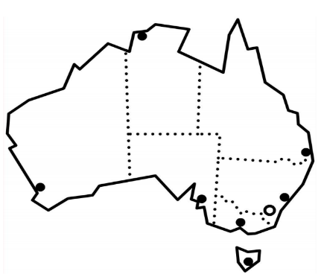
Australia is a big country.
Australia is a _ _ _ country.

+

It is very, very, very hot and dry.
It is very, very very _ _ _ _ _ _ dry.

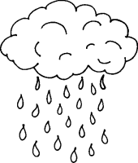
+ +

But sometimes it rains and rains and rains.
But sometimes it rains and _ _ _ _ _ _ _ _ rains

Level B - Dictation

Australia is | it rains and rains and rains.
It is very, very, very hot | a big country.
But sometimes | and dry.

__________________________________________________________________________________________________________________________________________________________________________________________________________________________________________________________________________________________________________________________________

Level C - Dictation

__________________________________________________________________________________________________________________________________________________________________________________________________________________________________________________________________________________________________________________________________

Fold

Australia | big | country
sometimes | hot | rains
and | dry | very
but | a | is
It | it

Homework activity: Read and write - 3 levels
Regular short homework exercises are a good way to develop independent learning skills. Speed copying is an excellent independent exercise as are exercises similar to the one on the following pages. The exercise could be copied twice on one page, back to back to give additional practice. Students will be familiar with the exercise, so may need little guidance when the homework is set.

Level A - Read and write
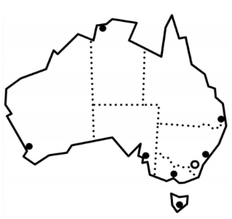
Australia
_______________________________________________

very, very, very hot

__________________________________________________________________

rains and rains and rains

__________________________________________________________________

Level B - Read and write

Australia is a big country.

_________________________________________________________

+
It is very, very, very hot and dry.
__________________________________________________________
But sometimes it rains and rains and rains.

__________________________________________________________

Level C - Read and write
_ _ _ _ _ _ _ _ _ _ _ _ _ _ _ _ _ _ _ _ _ _ .
+
_ _ _ _ _ _ _ _, _ _ _ _, _ _ _ _ _ _ _ _ _ _ _ _ _.
_ _ _ _ _ _ _ _ _ _ _ _ _ _ _ _ _ _ _ _ _ _
_ _ _ _ _ _ _ _ _ _ _ _ _.
Fold

Australia big dry it a
country hot But is
sometimes very and rains

Pronunciation: Linking words ending in s – Class work
The text for Sections 1 – 3 are available on audio.
Activity
- Elicit the text below from the students and write it on the board.
Australia is a big country.
It is very, very, very hot and dry.
But sometimes it rains and rains and rains.

- Select and play the audio while pointing to each word. When the word ends in s,
and the next word begins with a vowel, link the words with a half loop. See below:
Australia is a big country.
It is very, very, very hot and dry.
But sometimes it rains and rains and rains.

- Listen to the audio again.
- Practise saying the linked words. Show how the s sound becomes a z when it joins with the next word. Write the words on the board separately, but run the words together when you say them.
is a = i za
sometimes it = sometime zit
rains and = rain zan [the d is not heard]
- Read the full text with the linking.

Appendix – Vocabulary list for Section 1
Words introduced in this section:

A | Australia, a, and |  | N
B | big, but |  | O
C | country |  | P
D | dry |  | Q
E |  |  | R | rains
F |  |  | S | sometimes
G |  |  | T
H | hot |  | U
I | is, it |  | V | very
J |  |  | W
K |  |  | X
L |  |  | Y
M |  |  | Z

Appendix – an activity with and
A large flashcard with and written on it is useful to practise its use when adding something. Whenever, you’re talking about or listing a number of objects, you can hold up the flashcard before saying the final object. An engaging way to practise this is in the activity below.
The name game
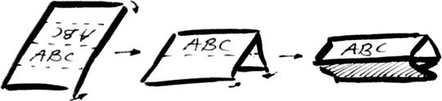
In this game students can learn the names of other students, a polite way of introduction and also the use of and for adding. It’s easier if students have name cards such as these in front of them and harder without the cards. It also works best if the class is arranged in a horseshoe shape, so the students are facing each other.
- Position yourself as student #2 in the horseshoe.
- Write on the board: My name is _________
- Ask student #1 to say: My name is ________ [say their name]
- Now write on the board:
‘My name is ________, and
this is _____________.’

- Introduce yourself and student #1: My name is ________ [say your name],
and this is __________. [say student #1’s name’]
- As you do this, place the flashcard with and on it, between you and student #1.
- Student #3 will introduce themselves, you and student #1.
e.g. My name is _________ (student 3’s name). This is __________(teacher’s name),
and ___________(student 1’s name)
- When and is needed, hold up the flashcard between you and student #1.
- The introductory words this is need only be said before the name of the new person being introduced.
- The game continues round the class adding an extra name with each student. If the class is large, restart the game partway or halfway through, otherwise it can be too difficult for the last few students to remember so many names.

Acknowledgements
Images
Lake Hume | This photo by Tim J Keegan is licensed under CC BY-SA 2.0
Pinang Tunggal Drought | This photo by Marufish is licensed under CC BY-SA 2.0
Name Card | This Photo by Unknown Author is licensed under CC BY-SA-NC
Project team
Vicki Hambling, Lorraine Hatcher-Friel, Sue Paull, Madelena Scott, Mary Wallace, Visual Domain
The Project Team would like to thank the AMEP Service Providers and practitioners who participated in the trial and gave valuable feedback.
This Floods Teaching Material is licensed under a Creative Commons Attribution-NoDerivs 3.0 Australia licence (More information is available here). You are free to use, copy and distribute to anyone in its original form as long as you attribute Department of Home Affairs as the author and you license any derivative work you make available under the same licence.
© Commonwealth of Australia 2021

With the exception of the Commonwealth Coat of Arms, the department’s logo, any material protected by a trade mark and where otherwise noted all material presented in this document is provided under a Creative Commons Attribution 4.0 International (https://creativecommons.org/licenses/by/4.0/) licence.
The details of the relevant licence conditions are available on the Creative Commons website (accessible using the links provided) as is the full legal code for the CC BY 4.0 licence (https://creativecommons.org/licenses/by/4.0/legalcode).
Use of all or part of this document must include the following attribution:-
© Commonwealth of Australia 2021
As far as practicable, material for which the copyright is owned by a third party will be clearly labelled. The department has made all reasonable efforts to ensure that this material has been reproduced in this document with the full consent of the copyright owners.
Copyright requests and enquiries concerning usage not addressed by the CC BY 4.0 licence should be addressed to:
comms@homeaffairs.gov.au at the Department of Home Affairs.
The terms of use for the Commonwealth Coat of Arms are available from the It's an Honour website.
Where a copyright owner, other than the Commonwealth, is identified with respect to this material, please contact that third party copyright owner directly to seek permission.




