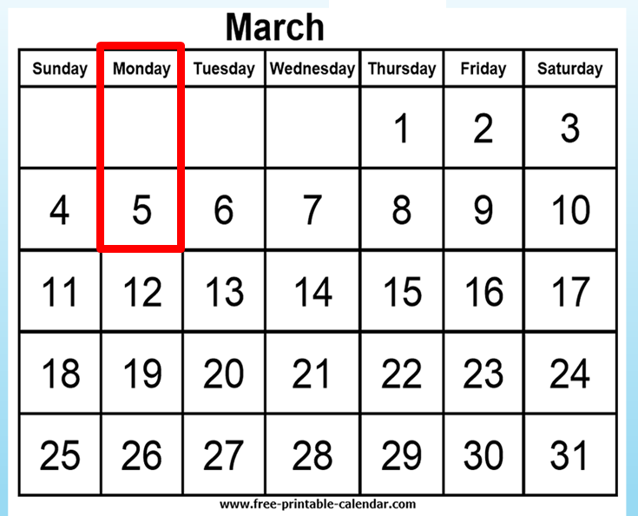

Section 2
Days of the week

Table of contents
PPT - Revise text for the section Australia 3
The text for Days of the week 4
AMEP resources – vocabulary for Days of the week 5
Build vocabulary for Days of the week 7
Create the text for Days of the week 10
Pronunciation – Sentence stress 12
Spelling – 3 levels 14
Level A - Spelling 15
Level B - Spelling 16
Level C - Spelling 17
Spelling Test – 3 levels 18
Level A - Spelling Test 19
Level B - Spelling Test 20
Level C - Spelling Test 21
Speed Copying – 3 levels 22
Level A - Speed Copying 23
Level B - Speed Copying 24
Level C - Speed copying 25
Dictation – 3 levels 26
Level A - Dictation 27
Level B - Dictation 28
Level C - Dictation 29
Appendix - Vocabulary list for Section 1 - 2 31
Appendix - Map of Australia with states and territories 32
Appendix - Prepositions of time 33
Appendix – Capital letters and Punctuation 35
Acknowledgements 36

PPT - Revise text for the section Australia
Before starting work on Section 2, it’s important to revise the text in Section 1. The great advantage of the PPT is that you can show it many times, and at varying speeds.

Download the PPT from the hub.
- Project the PPT in slide show mode. The animation feature will reveal the words slowly to build each sentence.
- The forward arrow on your keyboard will make the pictures and words appear in order. The back arrow will remove the words and pictures.
- Click Escape anytime to close.
- Encourage students to guess the words before they appear.


PPT Revision
Section 1 Australia

The text for Days of the week

In March, in New South Wales, Queensland
and Victoria, it rains and rains and rains.
It rains on Monday.
It rains on Tuesday.
It rains on Wednesday.
It rains on Thursday.
It rains on Friday.
It rains on Saturday.
It rains on Sunday.

AMEP resources – vocabulary for Days of the week
The AMEP provides excellent resources for teaching about the Australian states and territories and also the days of the week. It is a good place to start introducing the vocabulary for this section.

- Australian states and territories
AMEP Volunteer Tutor Resources
For a simple map of Australia go to:
https://immi.homeaffairs.gov.au/settling-in-australia/amep/volunteer-tutor-resources
Click on Pre-Beginner, A New Life
- Worksheet 1 has a map of Australia with the names of the states, territories and the capital cities
- Worksheet 2 has a map of Australia which can be used to make a jigsaw
- Worksheet 3 has a map of Australia with the states marked but no writing

- Days of the week and months of the year
AMEP Volunteer Tutor Resources
There are some simple worksheets to be found here. Follow this link to the pre-beginner page:
https://immi.homeaffairs.gov.au/settling-in-australia/amep/volunteer-tutor-resources/pre-beginner

Click on Education
- Worksheets 1 – 4 cover the days of the week and months of the year
AMEP Online Materials
To practise the pronunciation of the days of the week and the months of the year, go to:
https://ameponline.homeaffairs.gov.au/
- Click on Course Level 1
- Click on A New Life
- Click on Numbers and dates,
- Then Activity 4, Days and months

Build vocabulary for Days of the week
The following is a suggested method to teach vocabulary. It involves drawing simple pictures on the board and miming. The aim is to get the students to suggest the words and then write them on the board. It helps to put the words down one side of the board and leave them there for reference. Use the dashes as a line and show how to write on the line and how to form the letters, model the letter formation and verbalise it if necessary for ESL literacy students.

VOCABULARY | Board Work
Queensland  New South Wales  Victoria  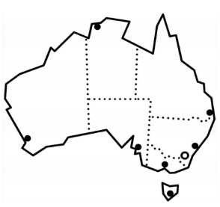  Draw a map of Australia on the board or project a simple blank map onto the board.  Ask, What is it? Roughly draw in the states. Ask the students which state they live in. Mark it on the map. Point to Queensland and ask them if they know the name of that state, point to NSW and point to Victoria. Mark them in. Reading the states can be taught like the face of a clock. | Qu_ _ _ _ land  _ ew _ outh _ ale_  _ ic _ oria  Students guess the missing letters.  Point to the word, say the word together, spell the word together and point to each letter as you spell. Point to the capital letters. Ask how many letters are in the word and count the letters.
  Rain  Revise and mime rain. An umbrella may be useful. | Draw rain clouds and rain on the board.  _ a i _  Repeat the process used to teach the states of Australia.
Monday  Tuesday  Wednesday  Thursday  Friday  Saturday  Sunday  Say the days of the week together. Students could point to the days on their timetable or you could have sets of cards of the days of the week for students to put in order on the desk, hold up, or point to.  Print some large cards, with the days of the week. Seven students hold up a card and arrange themselves in front of the class in the order of a week. You could print the Saturday and Sunday cards on different coloured paper to teach the idea of the weekend. [See the next page] | _ on _ ay  _ _ es _ay  _ednes _ ay  Thur_ _ay  _ _ _ day  _ _ _ urday  _ _ _ day  Repeat the process used to teach the states of Australia.
March  Say the months of the year together. If you have a calendar point to the names on the calendar. Focus on March. | _ ar _ _  Repeat the process used to teach the states of Australia.

Monday
Tuesday
Wednesday
Thursday
Friday
Saturday
Sunday

Create the text for Days of the week

Instructions for the teacher
This is the text to be created:

In March, in New South Wales, Queensland and Victoria, it rains and rains and rains.
It rains on Monday.
It rains on Tuesday.
It rains on Wednesday.
It rains on Thursday.
It rains on Friday.
It rains on Saturday.
It rains on Sunday.

Preparation:
- Have the alphabet in capital and small letters at the top of the board and the vocabulary list down the side of the board.

- On the board write:
In M _ _ _ _ _ _ N _ _ S _ _ _ _ W_ _ _ _,
Q _ _ _ _ _ _ _ _ _ and V _ _ _ _ _ _ _, _ _ _ _ _ _ _
and _ _ _ _ _ _ _ _ _ _ _ _ _ .

Activity
- Ask the students to guess the text. Encourage them to use the vocabulary list.
- Begin by asking them to suggest a letter, any letter. If they guess a letter, or even the whole word from the vocabulary list, write it on the dashes.
- To help predict March use a calendar, or project one. Use the map of Australia to help students identify and spell the states and mime or draw rain on the board.
- If students can’t guess the words, just write them in.
Discuss capital letters, full stops, and sentences as you proceed.
Read the sentence leaving out the filler words, ask students to guess what the words are.
Extend the cloze in this way:
It r_ _ _ _ on M_ _ _ _ _
_ _ r_ _ _ _ _ _ T_ _ _ _ _ _
It _ains _n W_ _ _ _ _day.
_ _ rain_ o_ Th_ _ _ _ _ _.
It _ _ _ _ _ _ _ F_ _ _ _ _.
_ _ _ _ _ _ _ on S _ _ _ _ _ _ _.
_ _ _ _ _ _ _ _ _ S _ _ _ _ _.
You could use flashcards of the days of the week to assist.
Get students to put them in order.
- At the beginning of each sentence and before each day, ask the students if the first letter is a capital or a small letter.
- As you write, demonstrate how the tail of the y in day goes under the line. After writing each day, spell it together, pointing to each letter.
- Spell and clap the letters with a rhythm. e.g. M o n - d a y

- As you write each day, add more rain drops to the rain drawing.
- Once the text is completed on the board, read it together several times, pointing to each word as you read. Ask, How many sentences? Count them together. Ask, How many words? Count the words together pointing to each word.
- Then reverse the whole process by rubbing out, reading, rubbing out, reading and recreating a cloze again. In this exercise, it is easier to rub out whole words rather than single letters. You can leave the first letter of the word to help students recall if you think it is needed.
- Read again with the class, pointing to both the missing words and the existing words. With some classes it is possible to rub out all the words in this way.

Pronunciation – Sentence stress

Preparation
Sentence stress is considered to be the most important element of English pronunciation.
In English, words which carry key information such as nouns, verbs and adjectives are usually stressed and other words unstressed. This creates the distinctive music of the language.

Preparation: Review the days of the week

- Distribute the days of the week cards. [enough for the whole class]
- Students listen and when they hear a day, they hold up that card, then put it down, with the cards one under the other in week order.

It rains on Monday.
It rains on Tuesday.
It rains on Wednesday.
It rains on Thursday.
It rains on Friday.
It rains on Saturday.
It rains on Sunday.
Activity 1: Sentence stress

- Say the first sentence, and ask students which words are longer and louder?
- Put a large dot above the stressed word – in every sentence this is the verb and the noun.
- Get students to clap the sentence as they repeat it. Alternatively they could tap a finger on the desk or punch the air, whatever is easiest.
- Continue to mark the stress in each sentence.
Activity 2: Jazz chant
Jazz chants are an excellent way to teach sentence stress and also grammar. With this chant, students learn the use of on a preposition of time, with days of the week. This jazz chant forms the basis for further work on prepositions of time. [See Appendix]
- Divide the class in half - half the class read A, the other half read B.
- Encourage the students to read with expression and to stress the information words.

Jazz Chant

A | B
It rains | on Monday.
It rains | on Tuesday.
It rains | on Wednesday.
It rains | on Thursday.
It rains | on Friday.
It rains | on Saturday.
It rains | on Sunday.

Spelling – 3 levels

- For lower levels use a modified version of ‘Look, say, cover, write, check’.
Teach: Look, say the word, spell the word out loud as you copy.
For higher levels teach ‘Look, say, cover, write, check’

- It is important that the students:
- Finish one word before writing the next word
- Work down the page rather than across
- Check their spelling with the typed word
- Try to chunk the letters rather than copy letter by letter
- The words are printed twice at each level so that students practise once in class and then again at home or in a following class. In this way, students are shown a way to improve their writing through brief and regular practice.

Level A - Spelling

Monday

Tuesday

Wednesday

Thursday

Friday

Saturday

Sunday

Level B - Spelling
Monday | Tuesday | Wednesday
Monday | Tuesday | Wednesday

Thursday | Friday | Saturday | Sunday
Thursday | Friday | Saturday | Sunday

Level C - Spelling

March | Monday | Tuesday | Wednesday
March | Monday | Tuesday | Wednesday

Thursday | Friday | Saturday | Sunday
Thursday | Friday | Saturday | Sunday

Spelling Test – 3 levels

Activity
In this test, the same words are read to the whole class, but each level has appropriate support.

Level A
This activity teaches students to look for clues. The words are on the page and can be copied, but the students have to locate the letters to copy. Initially, some students may need help with this, and the teacher could underline the bits to copy in red.

Level B
At this level, the difficult sounds have been provided. If the teacher pronounces the word slowly, the students should be able to hear the missing sounds. The answers are below so students can also copy.

Level C
At this level, a student can try to either write the word or they can copy. Allowing students this option and to later check their work removes any fear associated with having a go.

Level A - Spelling Test
Days of the week
Monday  __ o n d a y | Tuesday  __ u e s __ __ __
Wednesday  __ednes__ __ __ | Thursday  Thurs __ __ __
Friday  __ ri __ __ __ | Saturday  __atur__ __ __
Sunday
__un__ __ __

Level B - Spelling Test

Aa Bb Cc Dd Ee Ff Gg Hh Ii Jj Kk Ll Mm Nn Oo Pp Qq Rr Ss Tt Uu Vv Ww Xx Yy Zz

Days of the week
- _ o _ _ _ _
- _ u e _ _ _ _
- _ e d _ e _ _ _ _
- _ _ u r _ _ _ _
- _ r _ _ _ _
- _ _ _ u r _ _ _
- _ _ _ _ _ _

Fold
Check your spelling
Monday | Tuesday | Wednesday | Thursday
Friday | Saturday | Sunday

Level C - Spelling Test

Aa Bb Cc Dd Ee Ff Gg Hh Ii Jj Kk Ll Mm Nn Oo Pp Qq Rr Ss Tt Uu Vv Ww Xx Yy Zz

Days of the week

- ___________________________________________
- ___________________________________________
- ___________________________________________
- ___________________________________________
- ___________________________________________
- ___________________________________________
- ___________________________________________
Fold
Check your spelling
Monday | Tuesday | Wednesday | Thursday
Friday | Saturday | Sunday

Speed Copying – 3 levels

One of the simplest ways to improve spelling and writing is to practise speed copying. The goal of such copying is to build speed and proficiency. With regular practice, speed copying can improve spelling, handwriting and memory. Students’ written expression also improves as they memorise common groupings of words and collocations.
Low level students will initially copy letter by letter, but as they become more proficient over time, they will learn to chunk, then write whole words, then write a few words and then complete sentences, depending on their level and educational background.

Activity
- Set the timer for 2, or 4 or 5 minutes
- Ask the students to copy the same text over and over in that time.
- If they finish copying their text before the time is up, they need to copy it again,
and maybe even again.
- Students copy the same text every day for a week, trying to increase the number of words they write each time.
- The text copied can be used for a dictation the following week.

Level A - Speed Copying

It rains on Monday.
It rains on

It rains on Tuesday.
It rains on

It rains on Wednesday.
It rains on

It rains on Thursday.
It rains on

It rains on Friday.
It rains on

It rains on Saturday.
It rains on

It rains on Sunday.
It rains on

Level B - Speed Copying

It rains on Monday.
______________________________________________

It rains on Tuesday.
______________________________________________

It rains on Wednesday.
______________________________________________

It rains on Thursday.
______________________________________________

It rains on Friday.
______________________________________________

It rains on Saturday.
______________________________________________

It rains on Sunday.
______________________________________________

Level C - Speed copying

In March, in New South Wales, Queensland
______________________________________________________________________________
and Victoria, it rains and rains and rains.
______________________________________________________________________________
It rains on Monday.
______________________________________________________________________________
It rains on Tuesday.
______________________________________________________________________________
It rains on Wednesday.
_____________________________________________________________________________
It rains on Thursday.
______________________________________________________________________________
It rains on Friday.
______________________________________________________________________________
It rains on Saturday.
______________________________________________________________________________
It rains on Sunday.
__________________________________________________________________

Dictation – 3 levels
It rains on Monday.
It rains on Tuesday.
It rains on Wednesday.
It rains on Thursday.
It rains on Friday.
It rains on Saturday.
It rains on Sunday.

Activity
All students hear the same text:

The teacher reads a sentence, and each student writes the sentence at their own level.

Level A
Students listen for the missing letters and write them in. This activity teaches students to look for the letter to copy.
Level B
Students find the words and copy them. For a greater challenge, the words can be folded under, and students try to write from memory. The words allow the student to check their spelling at the end of the dictation.

Level C
Students write the sentence using the words below to help with the spelling. For a greater challenge, the words can be folded under, and students try to write from memory. The words allow the student to check their spelling at the end of the dictation.

Level A - Dictation

It rains on Monday.
M _ _ _ _ _
It rains on Tuesday.
T _ _ _ _ _ _
It rains on Wednesday.
W _ _ _ _ _ _ _ _
It rains on Thursday.
T _ _ _ _ _ _ _
It rains on Friday.
F _ _ _ _ _ .
It rains on Saturday.
S _ _ _ _ _ _ _
It rains on Sunday.
S _ _ _ _ _

Level B - Dictation

Aa Bb Cc Dd Ee Ff Gg Hh Ii Jj Kk Ll Mm Nn Oo Pp Qq Rr Ss Tt Uu Vv Ww Xx Yy Zz

It rains on _ o _ _ _ _ | Monday
It _ _ _ _ _ on _ u e _ _ _ _ | Tuesday
_ _ rains _ _ _ _ d _ e _ _ _ _. | Wednesday
It rains _ _ _ _ u r _ _ _ _ | Thursday
_ _ _ _ _ _ _ on _ r _ _ _ _ | Friday
_ _ _ _ _ _ _ _ _  _ _ _ u r _ _ _ | Saturday
_ _ _ _ _ _ _ _ _ _ _ _ _ _ _ | Sunday

Level C - Dictation

Aa Bb Cc Dd Ee Ff Gg Hh Ii Jj Kk Ll Mm Nn Oo Pp Qq Rr Ss Tt Uu Vv Ww Xx Yy Zz

________________________________________________________________________________________________________________________________________________________________________________________________________________________________________________________________________________________________________________________________________________
Fold
Check your Spelling
Monday | Tuesday | Wednesday | Thursday
Friday | Saturday | Sunday | rains

Appendix - Vocabulary list for Section 1 - 2

Words introduced in this section are in bold.

A | and |  | N | New South Wales
B |  |  | O
C |  |  | P
D |  |  | Q | Queensland
E |  |  | R | rains
F | Friday |  | S | Saturday, Sunday
G |  |  | T | Tuesday, Thursday
H |  |  | U
I | in, it, on |  | V | Victoria
J |  |  | W | Wednesday
K |  |  | X
L |  |  | Y
M | March, Monday |  | Z

Appendix - Map of Australia with states and territories
Project the map of Australia on the board. Draw arrows and write the names of the states and territories in the boxes. Make copies for students to do the same.
Australia
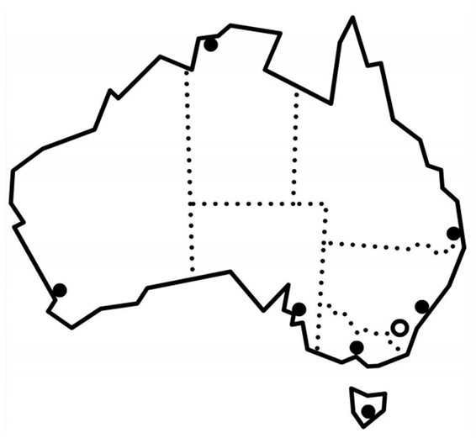

Queensland

Qld Queensland | Tas Tasmania
NSW New South Wales | SA South Australia
ACT Australian Capital Territory | WA Western Australia
Vic Victoria | NT Northern Territory

Appendix - Prepositions of time

Background information
The prepositions of time can be shown on three concentric circles this can work as a visual memory prompt.
- The larger outside circle represents in, for lengths of time, [usually longer]
- months, years, seasons, decades, morning, afternoon and evening.
- The smaller middle circle represents on, for shorter periods of time
- days of the week, the weekend and dates
- The smallest circle represents at precise times
- 9 o’clock, festivals, night

The final diagram
in

on

at

Activity

Draw the circles on a large piece of cardboard to be hung on the wall and added to as the prepositions are introduced. In Section 2, students have learnt on for the days of the week and in for months of the year [March].
- Add on to the middle circle, and in to the outer circle.
- Write the days of the week and March onto small cards
[plus all the months familiar to the students]
- Ask students to blu-tack them to the correct circle on the chart.
Rules:
- Use on before days.
- Use in before months.

- Practise - on Monday in March, on Tuesday in March etc.
- Recap the rules learnt so far.

The chart is then ready so that at can be added when it’s introduced.

March
Friday
Monday
Saturday
Sunday
Thursday
Tuesday
Wednesday
on
in

Appendix – Capital letters and Punctuation

- Capital letters
RULES:
You need a capital letter for:

- The first letter in a sentence.
- The first letter of a day.
- The first letter of a month.
A basic understanding of the rules for capital letters needs to be demonstrated and developed. Students’ attention needs to be regularly drawn to their use.

e.g. It rains on Monday in March.

Activity

Write sentences similar to the ones below on the board and ask students to come out and add the capital letters.

- it rains on monday in march.
- it rains on tuesday in march.
- it rains on wednesday in march.

- Punctuation
Students also need to understand basic punctuation.
Point out the full stop at the end of the sentence.
RULE:
A sentence ends with a full stop.
e.g. It rains on Wednesday in March.
Activity
Write sentences similar to the ones below on the board. Ask students to come out to the board and correct the mistakes.

- it rains on thursday in march
- it rains on friday in march
- it rains on saturday in march
- it rains on sunday in march

Acknowledgements

Images
Globe showing Australia | This Photo by Unknown Author is licensed under CC BY-SA

Project team
Vicki Hambling, Lorraine Hatcher-Friel, Sue Paull, Madelena Scott, Mary Wallace, Visual Domain
The Project Team would like to thank the AMEP Service Providers and practitioners who participated in the trial and gave valuable feedback.
This Floods Teaching Material is licensed under a Creative Commons Attribution-NoDerivs 3.0 Australia licence (More information is available here). You are free to use, copy and distribute to anyone in its original form as long as you attribute Department of Home Affairs as the author and you license any derivative work you make available under the same licence.
© Commonwealth of Australia 2021

With the exception of the Commonwealth Coat of Arms, the department’s logo, any material protected by a trade mark and where otherwise noted all material presented in this document is provided under a Creative Commons Attribution 4.0 International (https://creativecommons.org/licenses/by/4.0/) licence.
The details of the relevant licence conditions are available on the Creative Commons website (accessible using the links provided) as is the full legal code for the CC BY 4.0 licence (https://creativecommons.org/licenses/by/4.0/legalcode).
Use of all or part of this document must include the following attribution:-
© Commonwealth of Australia 2021
As far as practicable, material for which the copyright is owned by a third party will be clearly labelled. The department has made all reasonable efforts to ensure that this material has been reproduced in this document with the full consent of the copyright owners.
Copyright requests and enquiries concerning usage not addressed by the CC BY 4.0 licence should be addressed to:
comms@homeaffairs.gov.au at the Department of Home Affairs.
The terms of use for the Commonwealth Coat of Arms are available from the It's an Honour website.
Where a copyright owner, other than the Commonwealth, is identified with respect to this material, please contact that third party copyright owner directly to seek permission.



