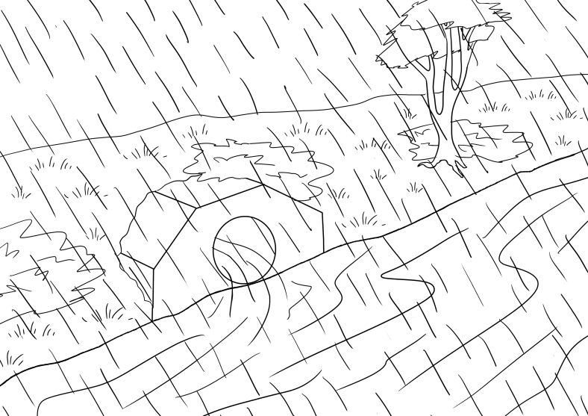

FLOODS
Section 3
Wet Weather

Table of contents
PPT - Revise sections 1 and 2 4
The text for Wet Weather 5
Build vocabulary for Wet Weather 6
Create the text for Wet Weather 9
Pronunciation – Word Stress 11
Listen and order the sentences – 3 levels 12
Level A - Order the sentences 13
Level B - Order the sentences 14
Level C - Order the sentences 15
Spelling – 3 levels 16
Level A - Spelling 17
Level B - Spelling 18
Level C - Spelling 19
Spelling Test – 3 levels 20
Level A - Spelling Test 21
Level B - Spelling Test 22
Level C – Spelling test 23
Speed Copying – 3 levels 24
Level A - Speed Copying 25
Level B - Speed Copying 26
Level C - Speed copying 27
Dictation – 3 levels 28
Level A - Dictation 29
Level B - Dictation 30
Level C - Dictation 31
Read and write homework activity – 3 levels 32
Level A - Read and write 32
Level B - Read and write 33
Level C - Write 34
Appendix - Vocabulary list for Section 3 35
Appendix Audio file – the text for Sections 1 – 3 36
Appendix Singular and plural - Classwork 37
Appendix Present Simple – Class work 39
Appendix Sentence Order – Class work 41
Appendix Sentence Order – 3 levels 42
Level A - Sentence Order 42
Level B - Sentence Order 43
Level C - Sentence Order 44
Acknowledgements 45

PPT - Revise sections 1 and 2

Before starting work on Section 3, it’s important to revise the text in Sections 1 and 2.
The great advantage of the PPT is that you can show it many times, and at varying speeds.

Download the PPT from the hub.
- Project the PPT in slide show mode. The animation feature will reveal the words slowly to build each sentence.
- The forward arrow on your keyboard will make the pictures and words appear in order. The back arrow will remove the words and pictures.
- Click Escape anytime to close.

- Encourage students to guess the words before they appear.
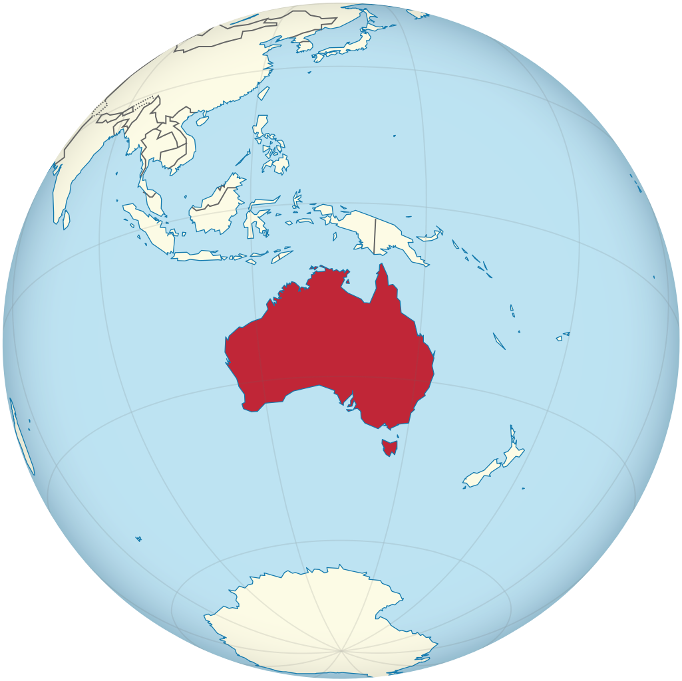

PPT Revision
Section 1 Australia &
Section 2 Days of the week

The text for Wet Weather

The water covers the road.
The water covers the footpath.
The water covers the garden.
The water fills the river.
The water floods the town.

Build vocabulary for Wet Weather
Instructions for the teacher
The following is a suggested method to teach vocabulary. It involves miming, drawing some simple pictures on the board or using picture prompts. The aim is to get the students to suggest the words so then they can be written on the board. It helps to put the words down one side of the board and leave them there for reference.
VOCABULARY | Board Work
water  Take in a glass of water and point to the water. Elicit the word by asking, ‘What is it?’ | Write _ a _ er  Students guess the missing letters.  Point to the word, say the word together, spell the word together, point to each letter as you spell. Ask how many letters in the word, count the letters.
road  Project or hand out pictures of a road. | You could also draw a road on the board with a car on it and ask what it is.  Write _ _ a_.  Students guess the missing letters.  Repeat the process used to teach the word water.
footpath  If you projected a picture of a road, point to the footpath. | If you have drawn the road, put a footpath alongside it and draw a stick figure walking. Ask students, What is it? If they don’t know the word tell them.  _ o o _ _ a _ _  Students guess the missing letters.  Repeat the process used to teach the word water.
garden  Project or hand out pictures of a garden. | You could also draw a garden next to the footpath using coloured board markers.  _ a r _ e _  Repeat the process used to teach the word water.
river  Project or hand out pictures of a river. | _ i _ e r  Repeat the process used to teach the word water.
town  Project a picture of a town or hand out pictures for the students to look at. | _ o w _  Repeat the process used to teach the word water.
rain  Revise and mime rain. An umbrella is useful. | Revise rain. Draw rain and mime rain.  _ a i _  Repeat the process used to teach the word water.
fill  Demonstrate fill by filling a glass or cup with water. | _ i _ _  Repeat the process used to teach the word water.
cover  Use a scarf, a coat, a mask or some paper to cover something.  Ask students to cover their eyes, mouth, nose, ears etc.  Sit the glass of water on a tray or dish and let it overflow so that the bottom of the dish is covered with water. | _ o _ e r  Repeat the process used to teach the word water.
flood  Project a picture to show a flood. You could also select sections of this 7News item to show floodwaters.  https://www.youtube.com/watch?v=iSsq3Es37Kg | _ _ oo _  Repeat the process used to teach the word water.

A flooded town.
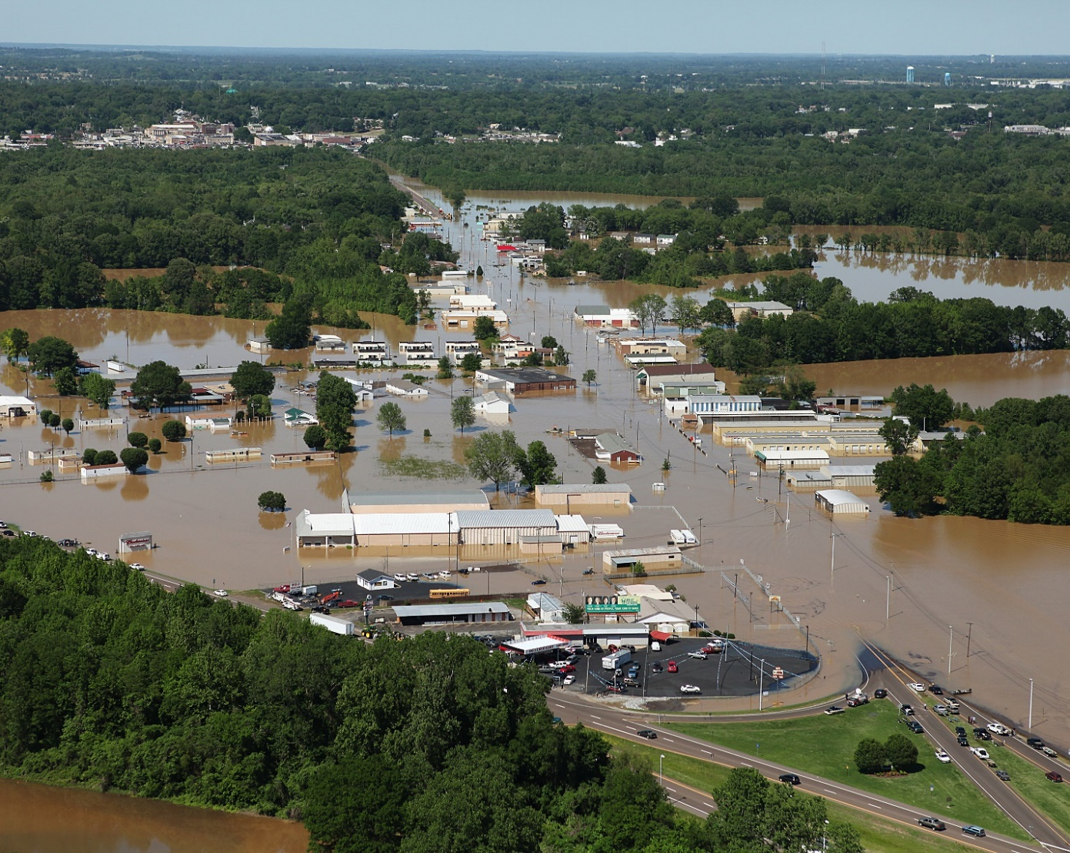
Point to different parts of the photo and elicit some of the words introduced:
water, roads, footpaths, gardens, rivers, town, rain, fills, covers, floods

Create the text for Wet Weather
The water covers the road.
The water covers the footpath.
The water covers the garden.
The water fills the river.
The water floods the town.
This is the text to be created:

Preparation:
- Have the alphabet in capital and small letters at the top of the board and the vocabulary list down the side of the board.

Aa Bb Cc Dd Ee Ff Gg Hh Ii Jj Kk Ll Mm Nn Oo Pp Qq Rr Ss Tt Uu Vv Ww Xx Yy Zz

- On the board write:
The water covers _ _ _ _ _ _ _
_ _ _ w _ _ _ _ c _ _ _ _ _ _ _ _ f _ _ _ _ _ _ _ .

Activity

- Ask the students to guess the text. Encourage them to use the vocabulary list.
- Begin by asking them to suggest a letter, any letter. If they guess a letter, or even the whole word from the vocabulary list, write it on the dashes.
- Mime the words that can be mimed such as covers using a scarf or a mask or use photos or drawings from the earlier vocab work.
- If students can’t guess the words, just write them in.
- Read the text aloud with the students several times. Point to each word as you read together.
- Ask the students to say and then spell each word.
- Draw attention to capital letters, full stops, words, word spaces, initial letter sounds, letter names and sentences.
- Talk about letter formation as you write on the board. e.g. capital T, and where you start and end each letter etc.
- Gradually build the full text using this cloze method.
The water covers the road.
The water covers the footpath.
The w_ _ _ _ c _ _ _ _ _ the g _ _ _ _ _.
_ he _ _ ter f _ _ _ s the r _ _ _ _.
_ he w _ t _ _ f l _ _ _ s the t _ _ _.

- Once the text is completed on the board, read it together several times, pointing to each word as you read. Ask, How many sentences? Count them together. Discuss capital letters and full stops. Ask, How many words? Count the words together pointing to each word.
- Then reverse the whole process by rubbing out, reading, rubbing out, reading and recreating a cloze again. In this exercise, it is easier to rub out whole words rather than single letters. You can leave the first letter of the word to help students recall if you think it is needed.
- Read again with the class, pointing to both the missing words and the existing words. With some classes it is possible to rub out all the words in this way.

Pronunciation – Word Stress
Preparation
When introducing syllables, some people find it easier to call them beats, as in music rather than syllables. Draw the table below on the board omitting the words.

Activity:
- Introduce each word and ask, How many beats? Repeat the word and clap the beats. [syllables]
- As you say the words, write them in the table in the correct column.
- Once all the words are on the board, identify the word stress.
Ask, Which beat is longer and stronger [stressed]?
- Say the words together and clap the beats/syllables. Clap harder on the stressed syllable.
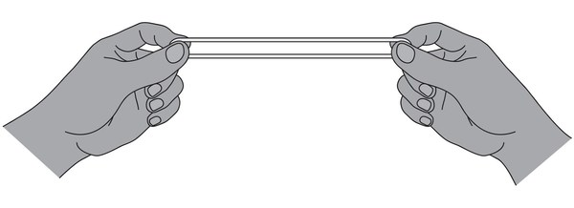
- Mark the stressed syllable with a large dot over the vowel and the unstressed syllables
with a smaller dot.

Large rubber bands are also useful to use when showing word stress. Give each student a band, hold with the fingers and stretch the band out on the stressed syllable.

road rains covers footpath Monday floods
garden fills river town Saturday

One syllable | Two syllables | Three syllables
road | Monday | Saturday
rains | covers
fills | footpath
town | garden
floods | river

Listen and order the sentences – 3 levels

Preparation
- Copy the sentences on the following pages, enough so that students can work in pairs
and at their ability level.
- Provide scissors and glue, and a page of light card for each pair, and an envelope for
later storage of the cut-up sentences.
Activity
- Hand out copies of the sentences with the card, glue, scissors and envelopes.
- Demonstrate the process of pasting the page of words onto the card and then cutting along the dotted lines to make word cards.
- Students work together to paste the paper onto the card and then cut out the strips.
As they work, encourage students to say what they are doing like a chant.
We are gluing paper onto the card, onto the card, onto the card.
We are gluing paper onto the card, onto the card, onto the card.
We are cutting with the scissors, with the scissors, with the scissors.
We are cutting with the scissors, cut, cut, cut. etc.

- This makes for a noisy class but gives students time to practise speaking. It doesn’t matter that a new tense is being introduced here. It’s a way of practising the form of a new tense so that it is familiar before its use is explained at a later time.
- When the cutting and pasting has been completed, read the text to the class and ask students to put the sentences in order.
- To make it more difficult cut the sentences in half and mix them up. Encourage students to use clues such as the full stops and capital letters. This activity can be repeated over several days. Each time the students find the activity easy, they can cut up the strips into smaller pieces.

Level A - Order the sentences
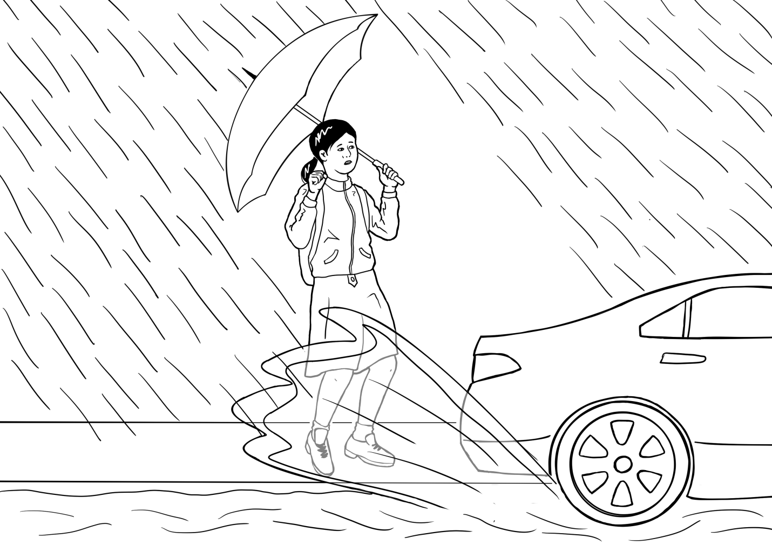 | The water covers the road.
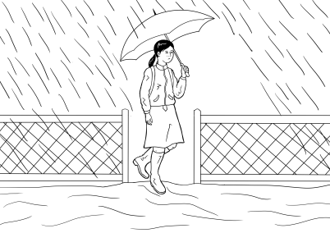 | The water covers the footpath.
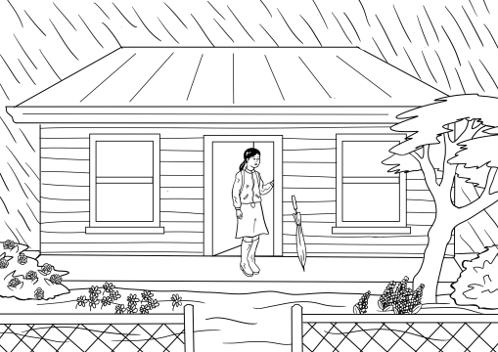 | The water covers the garden.
 | The water fills the river.
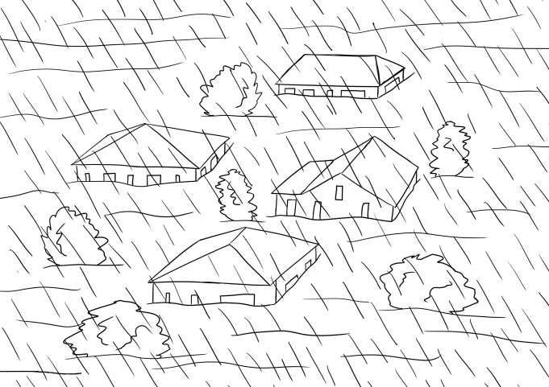 | The water floods the town.

Level B - Order the sentences

The water covers | the road.
The water covers | the footpath.
The water covers | the garden.
The water fills | the river.
The water floods | the town.

Level C - Order the sentences

The water | covers | the road.
The | water covers | the footpath.
The water | covers the | garden.
The | water fills | the river.
The water | floods the | town.

Spelling – 3 levels

- For lower levels use a modified version of ‘Look, say, cover, write, check’.
Teach: Look, say the word out loud, spell the word out loud as you copy.
For higher levels teach ‘Look, say, cover, write, check’.

- It is important that the students:
- Finish one word before writing the next word
- Work down the page rather than across
- Check their spelling with the typed word
- Try to chunk the letters rather than copy letter by letter
- The words are printed twice at each level so that students practise once in class and then again at home or in a following class. In this way, students are shown a way to improve their writing through brief and regular practice.

Level A - Spelling

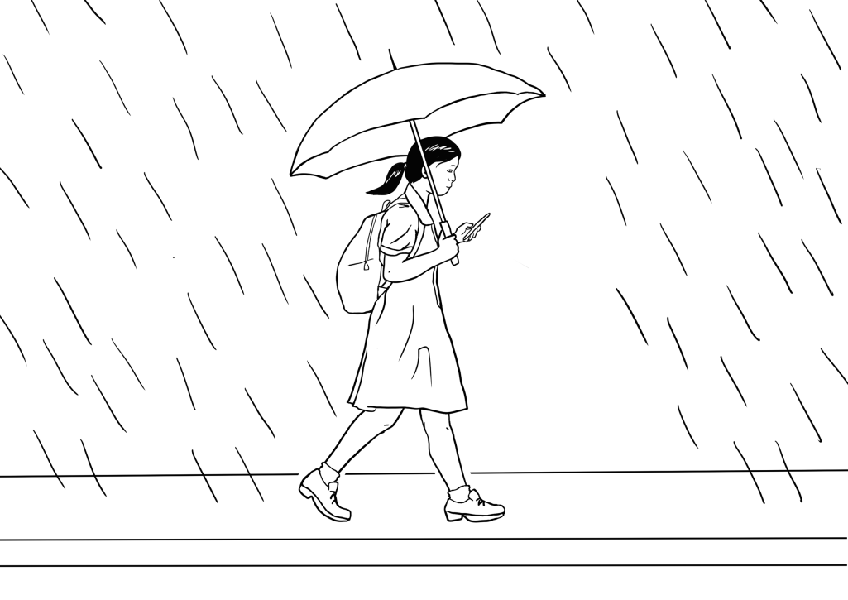
path | water
path | water

fills | river
fills | river

Level B - Spelling

water | river | covers
water | river | covers

path | the | fills
path | the | fills

Level C - Spelling

water | river | covers | fills
water | river | covers | fills

floods | road | footpath | garden
floods | road | footpath | garden

Spelling Test – 3 levels

Activity
In this test, the same words are read to the whole class, but each level has appropriate support.

Level A
This activity teaches students to look for clues. The answers are on the page and can
be copied, but the students need to locate the letters to copy. Initially, some students will need help with this, and the teacher may have to underline in red the letters to copy.

Level B
At this level the difficult sounds have been provided. If the teacher pronounces the word slowly the students should be able to hear the missing sounds. The answers are below so students can also copy.

Level C
At this level a student can try to write the word or they can copy. Allowing students to copy,
or try and check their work takes away any fear associated with having a go.

Level A - Spelling Test

Aa Bb Cc Dd Ee Ff Gg Hh Ii Jj Kk Ll Mm Nn Oo Pp Qq Rr Ss Tt Uu Vv Ww Xx Yy Zz
1 | c o v e r s  _ o v e r s | 2 | f i ll s  _ i ll s
3 | f l o o d s  _ l o o d s | 4 | g a r d e n  _ a r d e n
5 | f o o t p a t h  _ o o t p a t h | 6 | r o a d  _ o a d
7 | r i v e r  _ i v e r | 8 | w a t e r  _ a t e r
9 | t h e  _ _ e | 10 | t o w n  _ o w n

Level B - Spelling Test

Aa Bb Cc Dd Ee Ff Gg Hh Ii Jj Kk Ll Mm Nn Oo Pp Qq Rr Ss Tt Uu Vv Ww Xx Yy Zz

1. _ o _ e r s | 2. ._ i _ _ s
3. _ _ o o _ s | 4. _ a r _ e n
5. _ o o _ _ a t h | 6. _ o a d
7. _ i _ e r | 8. _ a t _ _
9. _ _ e | 10. _ o w _

Fold
Check your spelling
1. covers 2. fills
3. floods 4. garden
5. footpath 6. road
7. river 8. water
9. the 10. town

Level C – Spelling test

Aa Bb Cc Dd Ee Ff Gg Hh Ii Jj Kk Ll Mm Nn Oo Pp Qq Rr Ss Tt Uu Vv Ww Xx Yy Zz

1. _ o _ e r _ |  | 2. _ _ _ l _
3. _ _ o o _ _ |  | 4. _ a _ _ e _
5. _ o o _ _ a t h |  | 6. _ o a _
7. _ _ _ e r |  | 8. _ a _ e _
9. _ _ e |  | 10. _ o w _

Fold
Check your spelling
1. covers 2. fills
3. floods 4. garden
5. footpath 6. road
7. river 8. water
9. the 10. town

Speed Copying – 3 levels

One of the simplest ways to improve spelling and writing is to practise speed copying. The goal of such copying is to build speed and proficiency. With regular practice, speed copying can improve spelling, handwriting and memory. Students’ written expression also improves as they memorise common groupings of words and collocations.
Low level students will initially copy letter by letter, but as they become more proficient over time, they will learn to chunk, then write whole words, then write a few words and finally complete sentences, depending on their level and educational background.
Activity
- Set the timer for 2, or 4 or 5 minutes
- Ask the students to copy the same text over and over in that time.
- If they finish copying their text before the time is up, they need to copy it again, and maybe even again.
- Students copy the same text every day for a week, trying to increase the number of words they write each time.
- The text copied can be used for a dictation the following week.

Level A - Speed Copying

The water fills
______________________________________________
The water fills
______________________________________________
The water fills
______________________________________________

The water covers
______________________________________________
The water covers
______________________________________________
The water covers
______________________________________________

Level B - Speed Copying

The water covers the road.
______________________________________________
The water covers the road.
______________________________________________
The water covers the road.
______________________________________________
The water covers the road.
______________________________________________
The water fills the river.
______________________________________________
The water fills the river.
______________________________________________
The water fills the river.
______________________________________________
The water fills the river.
______________________________________________

Level C - Speed copying

The water covers the road.
______________________________________________
The water covers the footpath.
______________________________________________
The water covers the garden.
______________________________________________
The water fills the river.
______________________________________________
The water floods the town.
______________________________________________
The water covers the road.
______________________________________________
The water covers the footpath.
______________________________________________
The water covers the garden.
______________________________________________
The water fills the river.
______________________________________________
The water floods the town.
______________________________________________

Dictation – 3 levels

Instructions for the teacher

The water covers the road.
The water covers the footpath.
The water covers the garden.
The water fills the river.
The water floods the town.

Activity
All students hear the same text:

The teacher reads a sentence, and each student writes the sentence at their own level.

Level A
Students listen for the missing letters and write them in. To assist, the words water and covers are given in the first sentence. This activity teaches students to look for the words so they can copy. It also encourages students to listen for the letters. The students may need help initially.
Level B
Students find the words and copy them on the lines below. The order has been mixed up.

Level C
Students write the sentence using the words below to help with the spelling. For a greater challenge, the words can be folded under, and students try to write from memory. The words also allow the student to check their spelling at the end of the dictation.

Level A - Dictation
- The water covers the _oad.
- The __ ater __overs the _ootpath.
- The __ ater __overs the _ arden.
The __ ater fills the
_ iver.
The __ ater floods the
_ own.

Level B - Dictation

The water | covers the garden.
 | floods the town.
 | covers the road.
 | covers the footpath.
 | fills the river.

____________________________________________________________________________________________________________________________________________________________________________________________________________________________________________________________________________________________________________________________________________________________________________________________________________________________________

Level C - Dictation

________________________________________________________________________________________________________________________________________________________________________________________________________________________________________________________________________________________________________________________________________________
Fold

the water | fills | the road
covers | the river | the footpath
floods | the town | the garden

Read and write homework activity – 3 levels

Level A - Read and write

- road
________________
- footpath
________________
- garden
________________
- river
________________
- town
________________

Level B - Read and write

The water covers the road.
________________________________
The water covers the footpath.
________________________________
The water covers the garden.
________________________________
The water fills the river.
________________________________
The water floods the town.
________________________________

Level C - Write

Fold
the water | fills | the road
covers | the river | the footpath
floods | the town | the garden

Appendix - Vocabulary list for Section 3

New words introduced in this section.

A |  |  | N
B |  |  | O
C | covers |  | P
D |  |  | Q
E |  |  | R | road, river
F | footpath, fills, floods |  | S
G | garden |  | T | the, town
H |  |  | U
I |  |  | V
J |  |  | W | water
K |  |  | X
L |  |  | Y
M |  |  | Z

Appendix Audio file – the text for Sections 1 – 3
Click on this icon on the hub to hear the audio recording of the text below from Sections 1 – 3.
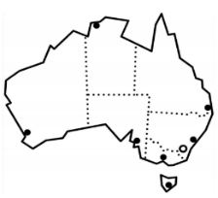

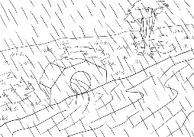
Australia is a big country.

Audio recording for sections
1,2 & 3
It is very, very, very hot and dry.
But sometimes it rains and rains
and rains.

It rains on Monday.
It rains on Tuesday.
It rains on Wednesday.
It rains on Thursday.
It rains on Friday.
It rains on Saturday.
It rains on Sunday.

The water covers the road.
The water covers the footpath.
The water covers the garden.
The water fills the river.
The water floods the town.

Appendix Singular and plural - Classwork

- Countable nouns revision
Draw the chart below on the board. Revise any countable nouns already introduced during class work. Draw or use realia or photos of countable objects and add to the table. Explain that most nouns add an s to make them plural. At this stage avoid nouns ending in y, o, ch, sh etc with less common plural forms.

Singular | Plural
 |  |      | 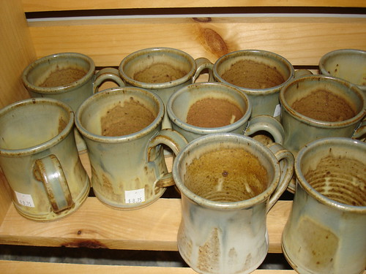
one mug | two mugs | four mugs | many mugs
one _____ | two ________ | four _______ | many ________

- Introduce [or revise] the question ‘How many apples?’ and point to the apple/s. Continue to ask the question with other objects drawn on the table.

- Relate to the work in this section with a jazz chant. Project the chant on the next page onto the board. Divide the class into two and repeat the chant.

Jazz chant

Student A | Student B
There are many, many footpaths, | footpaths, footpaths.
There are many, many footpaths | in the town.
There are many, many gardens, | gardens, gardens.
There are many, many gardens | in the town.
How many rivers, | rivers, rivers,
How many rivers | are in the town?
There’s just one river | river, river.
There’s just one river | in the town.

Appendix Present Simple – Class work
- Revision
Before focusing on the present simple used in this section and section 4, it’s important to have done some introductory work in class on its form, use, time markers and frequency adverbs.

I |  |  | live | in | Queensland.
You |  |  | live | in | Queensland.
He | She | It | lives | in | Queensland.
We |  |  | live | in | Queensland.
They |  |  | live | in | Queensland.
Use:
* Regular habits, activities & events
* Facts
Time markers
every day/morning/week/year etc
Frequency adverbs:
sometimes, always, etc
- Learning grammar through song
The retention of new grammar and vocabulary can be greatly enhanced through song. Two very relevant songs for learning the present simple are ‘What do you do?’ and ‘Where do you live?’ and can be found in: Sing with me! English grammar, conversation and song, Book 1 by Carmel Davies and Sharon Duff

- An activity to focus on the present simple in Section 3
I |  |  | fill | the |   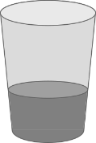        .
You |  |  | fill | the
He | She | It | fills | the
We |  |  | fill | the
They |  |  | fill | the
Preparation: Project or draw the following chart onto the board. You will need two of each of objects on the table below [or different objects] and two large bottles of water. Arrange the two groups of objects on two tables. Stand with two students behind one table, and ask two students to stand behind the other table.

Activity:
- On your table, demonstrate the process. Fill an object with water and say what you are doing - ‘I fill the bowl.’ etc. Then write the sentence on the board.
- Ask students on the other table to fill the same object with water and repeat the action.
- Work through the pronouns in a similar way – with either you or a student demonstrating and the students on the other table copying.
- Initially use the students’ names. e.g. Maria fills the bowl, Abdul fills the bottle, and then substitute with she and he.
- With we and they, the teacher’s group is we and the other group is they.
- Create simple sentences on the board under the table, with a capital letter and a full stop.

Appendix Sentence Order – Class work

- Follow up work on present simple with a focus on sentence word order. Stress that every sentence must have a verb. Many students don’t hear the verb in a sentence, so omit it when writing. This is especially so with the verb to be. Add subject, verb and object to the present simple chart.
- Read the sentences and ask the students to tap the table when they say the verb.
.
Subject |  |  | Verb | Object
I |  |  | fill | the | 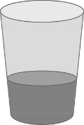    
You |  |  | fill | the
He | She | It | fills | the
We |  |  | fill | the
They |  |  | fill | the

- Add more words from this section and create sentences. Once again, ask the students
to tap the table when they say or hear the verb.
Subject | Verb |  |  | Object
.
the town
the river
the garden
the road
the footpath
The water | covers | fills | floods | .  the town  the river  the garden  the road  the footpath

- Copy the charts on the following pages. Students cut up the sentences along the dotted lines only, to reassemble under the correct heading of subject, verb, object.

Appendix Sentence Order – 3 levels

Level A - Sentence Order
Subject | Verb | Object
Australia | is | a big country.
The water | covers | the road.
The water | covers | the footpath.
The water | covers | the garden.
The water | fills | the river.
The water | floods | the town.

Level B - Sentence Order
Subject | Verb | Object
Australia | is | a big country.
The water | covers | the road.
The water | covers | the footpath.
The water | covers | the garden.
The water | fills | the river.
The water | floods | the town.

Level C - Sentence Order
Subject | Verb | Object
Australia | is | a big country.
The water | covers | the road.
The water | covers | the footpath.
The water | covers | the garden.
The water | fills | the river.
The water | floods | the town.

Acknowledgements
Images
Flooded Town | This Photo by Unknown Author is licensed under CC BY-SA
Rubber bands | This Photo by Unknown Author is licensed under CC BY-ND
Drawing of an apple | This Photo by Unknown Author is licensed under CC BY
Photo of many apples | This Photo by Unknown Author is licensed under CC BY-ND
bottle | This Photo by Unknown Author is licensed under CC BY-NC
mug | This Photo by Unknown Author is licensed under CC BY-NC
Photo of many mugs | This Photo by Unknown Author is licensed under CC BY-NC-ND
glass | This Photo by Unknown Author is licensed under CC BY-NC
bowl | This Photo by Unknown Author is licensed under CC BY
cup | This Photo by Unknown Author is licensed under CC BY-SA-NC
Calendar - March | This Photo by Unknown Author is licensed under CC BY-SA
Project team
Vicki Hambling, Lorraine Hatcher-Friel, Sue Paull, Madelena Scott, Mary Wallace, Visual Domain
Acknowledgements
The Project Team would like to thank the AMEP Service Providers and practitioners who participated in the trial and gave valuable feedback.

This Floods Teaching Material is licensed under a Creative Commons Attribution-NoDerivs 3.0 Australia licence (More information is available here). You are free to use, copy and distribute to anyone in its original form as long as you attribute Department of Home Affairs as the author and you license any derivative work you make available under the same licence.
© Commonwealth of Australia 2021

With the exception of the Commonwealth Coat of Arms, the department’s logo, any material protected by a trade mark and where otherwise noted all material presented in this document is provided under a Creative Commons Attribution 4.0 International (https://creativecommons.org/licenses/by/4.0/) licence.
The details of the relevant licence conditions are available on the Creative Commons website (accessible using the links provided) as is the full legal code for the CC BY 4.0 licence (https://creativecommons.org/licenses/by/4.0/legalcode).
Use of all or part of this document must include the following attribution:-
© Commonwealth of Australia 2021
As far as practicable, material for which the copyright is owned by a third party will be clearly labelled. The department has made all reasonable efforts to ensure that this material has been reproduced in this document with the full consent of the copyright owners.
Copyright requests and enquiries concerning usage not addressed by the CC BY 4.0 licence should be addressed to:
comms@homeaffairs.gov.au at the Department of Home Affairs.
The terms of use for the Commonwealth Coat of Arms are available from the It's an Honour website.
Where a copyright owner, other than the Commonwealth, is identified with respect to this material, please contact that third party copyright owner directly to seek permission.




