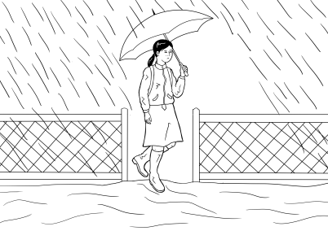

Section 4
Rain, rain, rain

Table of contents
The text for this section 4
Build vocabulary for the story 5
A short version of the story - a class cloze 12
Listen and order the sentences - 3 levels 16
Level A - Order the Sentences 18
Level B - Order the Sentences 21
Level C - Order the Sentences 22
Spell the words – 3 levels 23
Level A - Spelling 24
Level B - Spelling 25
Level C - Spelling 26
A Word Find - 3 levels 27
Level A - Word Find 28
Level B - Word Find 29
Level C - Word Find 30
An individual cloze – 3 levels 31
Level A - Write 32
Level B - Write the words 34
Level C - Write the words 35
PPT - Revise the short version of the story 36
Build the complete story 37
Listen and order the pictures and the text 47
The animated story – Rain, rain, rain 52
Label a picture of Mai 53
Question inflection - What do we need to pack? activity 55
Sentence stress – A jazz chant 57
Using the past simple - regular verbs 58
Change the story into the past – 3 levels 60
Level A - Past Tense 61
Level B – Past Tense 62
Level C - Past Tense 63
A phone conversation using the past simple 64
Appendix - Vocabulary list for Section 4 65
Appendix – Large size story pictures and text 66
Appendix - Photos for ‘What do we pack?’ activity 76
Appendix – The story at Level A 89
Level A - Rain, rain, rain 90
Acknowledgements 93

The text for this section

Rain, rain, rain
It rains on Monday. Mai walks to school in the rain.
It rains on Tuesday. Mai walks to school in the rain again.
It rains on Wednesday. Water covers the road. Mai walks to school in the rain. A car splashes water on her clothes.
It rains on Thursday. Water covers the footpath. Mai walks to school in the rain. She wears her boots.
It rains on Friday. Water covers the garden. Mai stays at home.
It rains on Saturday. Water fills the river.
It rains on Sunday. Water floods the town.
Mai and her family watch the news on Sunday morning.
The SES man knocks on the door on Sunday afternoon.
The man says, “Pack a small bag. Leave now.”

Build vocabulary for the story
In preparation for the story, project the pictures from the story and build the vocabulary
as suggested. The words need to be introduced over a number of days and revised. Revision activities could include the students recording the vocabulary in their books, highlighting the new words and translating into their own language, word lists on the wall, vocab flashcards and a variety of games.

Some words in the story have been introduced already in Section 3, but may need to be revised: fills, floods, covers, footpath, road, garden, river, town

VOCABULARY | Board Work
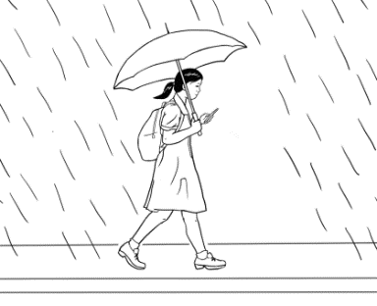  Mai  Revise the names of students in the class, noting the stress and the number of ‘beats’ in each name. Write Mai on the board and under this, write the names of students with the same single syllable stress pattern. | Mai
walk  Mime the word walk and ask some students or the whole class to demonstrate the word walk. After learning the spelling, students could walk and spell the letters of the word walk, out loud on each step. Use 2 fingers on the desk to imitate walking. Point to Mai’s legs and move your 2 fingers. | _ a l _  Say walk. Ask the students what letters they can hear. Say the word slowly out loud. Do this several times and write in the letters the students get right. Add any missing letters and explain the way each letter is formed.  Point to the word. Ask students to repeat the word walk after you. Spell the word together, pointing to each letter as you spell. Ask how many letters in the word, count the letters together.
school  Take a picture of your school or the local school and project it on the board. | _ c h o o _  Repeat the process used to teach the word walk.
again  Get the students to do an action again and again and again. e.g. stand up, sit down, hands up, hands down, look left, look right, clap, stamp feet etc | _ _ _ i _  Repeat the process used to teach the word walk.
splash  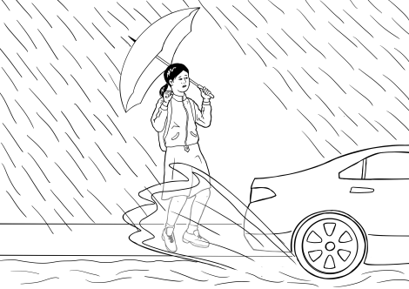  Put some water in a bowl or a mug and splash some on the table. | _ _ _ ash  Repeat the process used to teach the word walk.
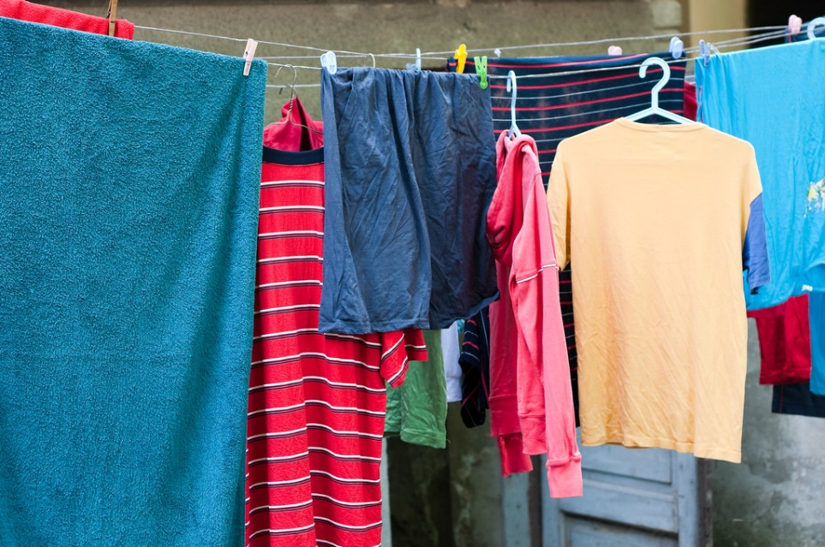  clothes  Show a photo of some clothes, point to your own clothes and the students’ clothes. To explain that this general word includes different pieces of clothing, make a small pile of clothes on the table. | _ _ _ thes  Repeat the process used to teach the word walk.
boots  Draw a picture of boots and point to the boots in the picture of Mai. Check if anyone is wearing boots. | _ o o _ _  Repeat the process used to teach the word walk.
family  Draw a picture of a family or put a large photo of a family on the board. If appropriate, get the students to show a photo of their family to their partner on their phone. | _ _ _ i _ y  Repeat the process used to teach the word walk.
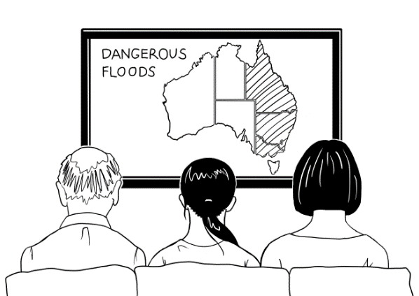  watch  Mime the word watch. Point to the picture of Mai and her family in front of the TV. The time factor is important to distinguish watch from look. | _ a t _ _  Repeat the process used to teach the word walk.
news  Hold up a newspaper or click on a TV news service. | _ew_  Repeat the process used to teach the word walk.
  SES  Project SES logo onto the board or draw it.  Show photos of people being assisted by the SES. Write State Emergency Service on the board and bold the first letters.  Perhaps show part of 7 News video to show SES workers during the NSW floods. | State Emergency Service
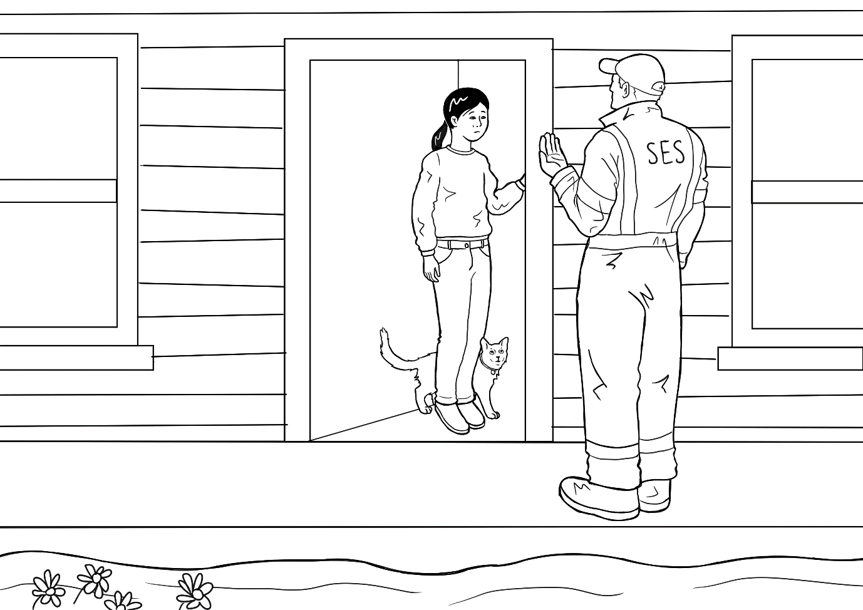  door  Point to the door in the picture. Say ‘Door?’ to the class, look around and encourage them to point to the classroom door. Walk to the door and open and close it. | _ oo _  Repeat the process used to teach the word walk.
knock  Mime the word knock using a closed fist. Go out and knock on the door. Knock on the table - knock once, twice, three times and get students to copy the number of knocks each time. Also revise again here. | k _ _ c _  Repeat the process used to teach the word walk.
a small bag  Point to several different bags belonging to students.  Compare a large and a small bag. Draw a large and a small cup, tree, ball, box etc. Point to the small object and say small. | _ _ all _ _ _  Repeat the process used to teach the word walk.
Pack  Mime the word pack using a bag similar to the one used by Mai and her family. Point to the picture. | _ _ c _  Repeat the process used to teach the word walk.
leave  Demonstrate the word leave by taking the packed bag, waving goodbye and walking out of the classroom - remain outside the room for a minute to give the sense of having left. Revise the last three words – bag, pack and leave at the end of the class by telling students, ‘Pack your bags and leave.’ | _ _ a _ e  Repeat the process used to teach the word walk.
stay  Teach this as an opposite of leave. | _ _ ay _  Repeat the process used to teach the word walk.
home  Draw a picture of a house with no one in it. Write house under it. Draw another picture of a house and this time draw some people inside. Write home under it. | _ _ _ e  Repeat the process used to teach the word walk.
now  Use a clock to show the current time and say now. Wait a minute and point to the time and say now and so on. | _ ow  Repeat the process used to teach the word walk.
morning  Use a clock face to demonstrate the word morning – midnight to midday. When the clock hand gets to around 7am, mime sleeping, waking up, getting up etc. If possible, elicit the times in the morning that students get up. The morning could be drawn on the board as a linear timeline with students’ names written under the time they usually get-up. | _ o r _ i n g  Repeat the process used to teach the word walk.
afternoon  Use a clock face to demonstrate afternoon – midday to 6pm. Continue the timeline from above and note times when class ends, lunch, children’s school ends etc. | _ _ _ er _ oo _  Repeat the process used to teach the word walk.
says  Draw a face on the board with a speech bubble and insert previous spoken words or ones that follow.  Hurry up.  up.  e.g. | _ a y s  Repeat the process used to teach the word walk.

A short version of the story - a class cloze

This shorter version of the story focuses on Mai and uses the vocabulary just learned. Project the cloze below and elicit the missing letters and words to fill in the blank spaces.

1.  Mai w_ _ _ _ to sch _ _ _  in the _ _ _ _ . | 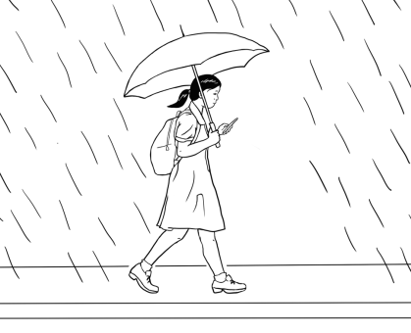
2.  Mai walks t_ s _ _ _ _ _  in the rain a_ _ _ _. | 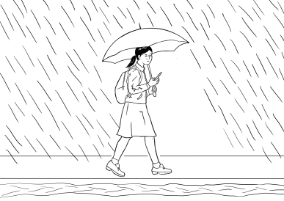
3.
Mai walks to school

in the rain. A c_ _
splashes w _ _ _ _

on her clothes.
4.

Mai walks to school
in the r _ _ _. She

wears her b _ _ _ _.

5.  Mai stays at h _ _ _. | 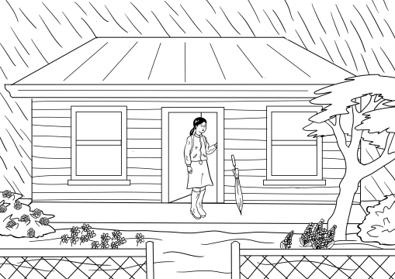
6.  W_ _ _ _ fills the river. | 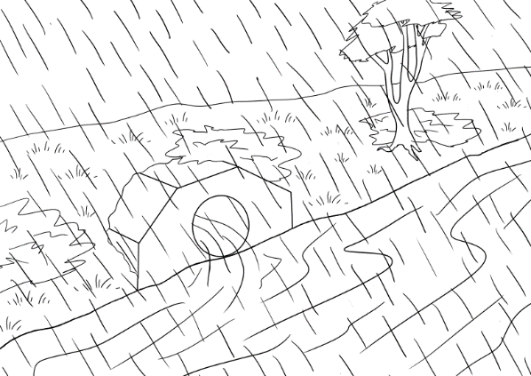
7.  Water floods the t_ _ _. | 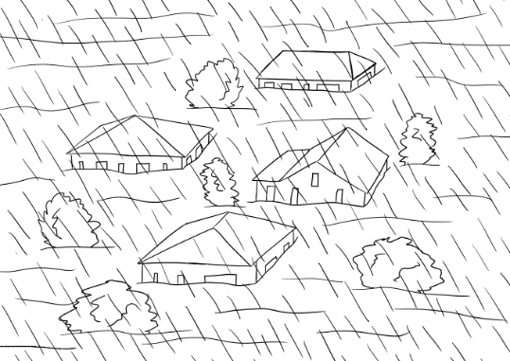
8.  Mai and her f_ _ _ _ _ watch the n_ _ _ . | 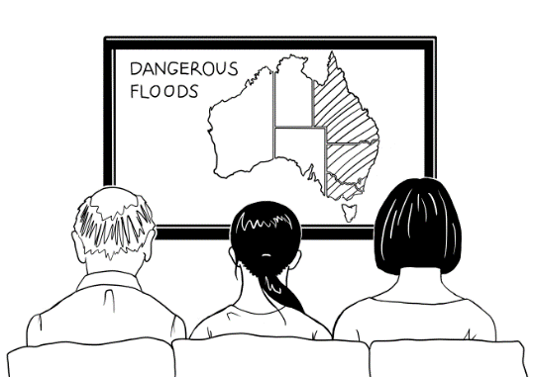
9.
The SES man knocks on
the door . The man
says, “P_ _ _ a small
b_ _. Leave now.”

Listen and order the sentences - 3 levels

Preparation
- Copy the sentences and pictures on the following pages, enough so that students can work in pairs and at their ability level.
- Provide scissors and glue, a page of light card for each pair, and an envelope for later storage of the cut-up sentences.

Activity
- Hand out copies of the sentences with the card, glue, scissors and envelopes.
- Demonstrate the process of pasting the page of words onto the card, then cutting along
the dotted lines to make word cards.
- Students work together to paste the paper onto the card and then cut out the strips.
As they work, encourage students to say what they are doing like a chant.

We are gluing paper onto the card, onto the card, onto the card.
We are gluing paper onto the card, onto the card, onto the card.
We are cutting sentence strips, sentence strips, sentence strips,
We are cutting sentence strips, cut, cut, cut.

This makes for a noisy class, but gives students time to practice speaking. It doesn’t matter that a new tense is being introduced here. It’s a way of practising the form of a new tense so that it is familiar before its use is explained at a later time.

- When the cutting and pasting has been completed, slowly read the text of the shortened story to the class and ask students to put the sentences in order as they listen.
Mai walks to school in the rain.
Mai walks to school in the rain again.
Mai walks to school in the rain. A car splashes water on her clothes.
Mai walks to school in the rain. She wears her boots.
Mai stays at home.
Water fills the river.
Water floods the town.
Mai and her family watch the news.
The SES man knocks on the door. The man says, “Pack a small bag. Leave now.”

- To make it more difficult cut the sentences in half and mix them up. However, with Level A, keep sentences and pictures together until the students are more confident.

- Encourage students to use clues such as the full stops and capital letters. This activity can be repeated over several days. Each time the students find the activity easy, they can cut up the strips into smaller pieces.

After these ordering activities, ask each pair to insert their pictures and text in an envelope. Collect the envelopes for later classes.

Level A - Order the Sentences

Mai walks to school in the rain.

Mai walks to school in the rain again.

Mai walks to school in the rain. A car splashes water on her clothes.
Mai walks to school in the rain. She wears her boots.

Mai stays at home.
Water fills the river.
Water floods the town.
Mai and her family watch the news.
The SES man knocks on the door. The man says,
“Pack a small bag.
Leave now.”

Level B - Order the Sentences

Mai walks to school in the rain.
Mai walks to school in the rain again.
Mai walks to school in the rain. A car splashes water on her clothes.
Mai walks to school in the rain. She wears her boots.
Mai stays at home.
Water fills the river.
Water floods the town.
Mai and her family watch the news.
The SES man knocks on the door. The man says, “Pack a small bag. Leave now.”

Level C - Order the Sentences

Mai walks to school | in the rain.
Mai walks | to school in the rain again.
Mai walks to school in the rain. | A car splashes water on her clothes.
Mai walks to school in the rain. | She wears her boots.
Mai stays | at home.
Water fills | the river.
Water floods | The town.
Mai and her family | watch the news.
The SES man knocks on the door. | The man says, “Pack a small bag. Leave now.”

Spell the words – 3 levels

- For lower levels use a modified version of ‘Look, say, cover, write, check’.
Teach: Look, say the word out loud, spell the word out loud as you copy.
For higher levels teach ‘Look, say, cover, write, check’.
- It is important that the students:
- Finish one word before writing the next word
- Work down the page rather than across.
- Check their spelling with the typed word.
- Try to chunk the letters rather than copy letter by letter
- The words are printed twice at each level so that students practise once in class,
and then again at home or in a following class. In this way, students are shown
a way to improve their writing through brief and regular practice.

Level A - Spelling
walk | car
walk | car

boots | rain
boots | rain

Level B - Spelling

walk | car | rain | boots
walk | car | rain | boots

pack | bag | now | family
pack | bag | now | family

Level C - Spelling

walk | splash | water | boots
walk | splash | water | boots

family | watch | news | now
family | watch | news | now

rain | school | knocks | small
rain | school | knocks | small

A Word Find - 3 levels

Word finds are a helpful way to develop students’ visual word recognition and spelling.
It is also a good time to introduce highlighters. Yellow highlighters are best as they allow the word to be seen clearly and don’t bleed through the page. Yellow is also a stimulating colour and is believed to enhance memory retention.
Project each Word Find and demonstrate the technique for each.

Level A - Word Find


Highlight the words
Mai |  | w | a | l | k
boots |  |  |  |  |  | c | a | r
school |  | M | a | i
walk |  |  | w | a | t | e | r
 |  |  |  | b | o | o | t | s
in
car |  | r | a | i | n
water |  |  |  |  |  |  | i | n
rain |  |  |  | h | o | m | e
home |  |  | s | c | h | o | o | l

Level B - Word Find


Highlight the words
Mai |  | a | s | p | l | a | s | h
pack |  | b | c | d | e | c | a | r
boots |  | p | a | c | k | f | g | h
school |  | i | j | k | h | o | m | e
walk |  | r | a | i | n | l | m | n
splash |  | o | s | c | h | o | o | l
car |  | b | o | o | t | s | p | q
family |  | r | w | a | t | e | r | s
water |  | w | a | l | k | t | u | v
rain |  | w | x | y | z | M | a | i
home |  | n | o | w | a | b | c | d
now |  | e | f | a | m | i | l | y

Level C - Word Find


Highlight the words

walk |  | p | a | c | k | r | a | b | c | d
road |  | e | s | p | l | a | s | h | f | g
boots |  | h | c | i | j | i | k | l | m | n
school |  | o | h | p | q | n | g | r | s | t
pack |  | u | o | v | w | x | a | y | z | a
splash |  | n | o | w | b | c | r | o | a | d
garden |  | d | l | a | e | f | d | g | h | i
family |  | j | k | l | l | n | e | w | s | m
water |  | n | o | k | p | q | n | r | s | t
rain |  | u | w | a | t | c | h | v | w | x
home |  | y | a | z | a | b | h | c | d | e
now |  | f | t | g | h | b | o | o | t | s
watch |  | i | e | j | f | a | m | i | l | y
news |  | k | r | l | m | n | e | o | p | q

An individual cloze – 3 levels

- At level A, students are provided with the pictures, the word and the first letter.
- At Level B, there are no pictures, but some difficult sounds are given and the words are provided at the bottom of the page. This bottom section can be folded over and used to copy or check spelling.
- At Level C, there are no pictures or letters, but the words are provided at the bottom of
the page. This bottom section can be folded over and used to copy or check spelling.

Level A - Write

1.  Mai w_ _ _ _ to school in the rain. | 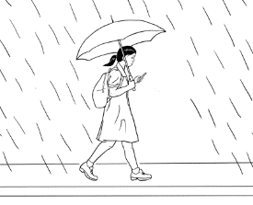  walks
2.  Mai walks to school in the r _ _ _ again. | 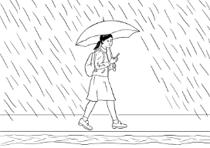  rain
3.  Mai walks to school in the rain.  A c _ _ splashes water on her clothes. | 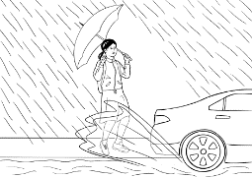  car
4.  Mai walks to school in the rain.  She wears her b _ _ _ _. | 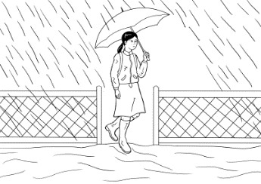  boots

5.  Mai stays at h _ _ _. | 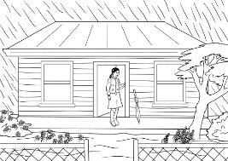  home
6.  W_ _ _ _ fills the river. | water
7.  Water floods the t_ _ _. | 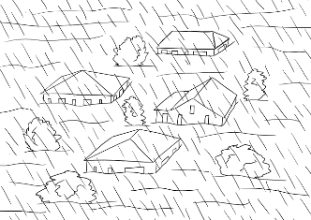  town
8.  Mai and her family watch the n_ _ _ . | 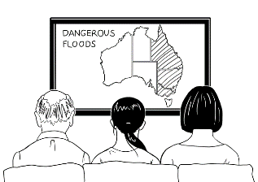  news
9.  The SES man knocks on the  door. The man says, “Pack a  small b _ _. Leave now.” | bag

Level B - Write the words

- Mai _ a l _ _ to school in the _ ai _ .
- Mai walks to _ ch_ _ _ in the rain a _ _ i_.
- Mai walks to school in the rain. A _ ar splashes water on her _ _ _the_.
- Mai walks to school in the rain. She _ears
her _ oo_ _.
- Mai _ _ays at _ _ _ e.
- _ a _ er fills the _ i _er.
- Water _ _ood_ the _ ow _.
- Mai and her _a_ily watch the _ ew _ .
- The SES man knocks on the door. The man says,
“_ac _ a small bag. Leave _ow.”
walks rain school again car clothes
wears boots stays home water river
floods town family news pack now

Level C - Write the words

- Mai _ _ _ _ _ to school in the _ _ _ _ .
- Mai walks to _ _ _ _ _ _ in the rain _ _ _ _ _.
- Mai walks to school in the rain. A _ _ _ splashes water
on her _ _ _ _ _ _ _.
- Mai walks to school in the rain. She _ _ _ _ _ her
_ _ _ _ _.
- Mai _ _ _ _ _ at _ _ _ _.
- _ _ _ _ _ fills the _ _ _ _ _.
- Water _ _ _ _ _ _ the _ _ _ _.
- Mai and her _ _ _ _ _ _ watch the _ _ _ _ .
- The SES man knocks on the door. The man says,
“_ _ _ _ a small bag. Leave _ _ _.”
walks rain school again car clothes
wears boots stays home water river
floods town family news pack now

PPT - Revise the short version of the story

Before introducing the complete story, revise the short version with a PPT. The great advantage of the PPT is that you can show it many times, and at varying speeds.

Download the PPT from the hub.
- Project the PPT in slide show mode. The animation feature will reveal the words slowly
to build each sentence.
- The forward arrow on your keyboard will make the pictures and words appear in order. The back arrow will remove the words and pictures.
- Click Escape anytime to close.
- Encourage students to guess the words before they appear.

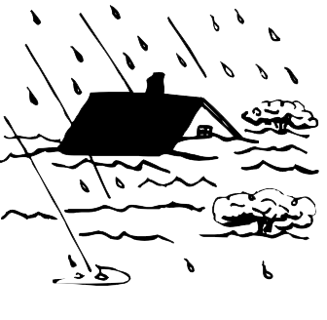

PPT
Rain, rain, rain
short version

Build the complete story

The story can be built in a number of ways. You could use just one method or different ones over several days
- Project the pictures and the sentences with missing words.
Project the following pages on the board and build the whole story together as a class. The words will need to be rubbed off after each slide.

- Project the pictures and build the story on the board
Project only the pictures, and draw lines on the board for each word, working on one sentence at a time. You can give some letters if you like or leave them all blank. Elicit the words and write them on the board and/or ask students to spell each word. If you’re lucky, the board may be large enough to contain the whole story. This would allow you to reverse the process, by rubbing out some of the words and students reading the story recalling the rubbed-out words.

1.

It r _ _ _ _ _ _ M_ _ _ _ _. Mai w_ _ _ _ _ to school in _ _ _ _ _ _ _.

2.
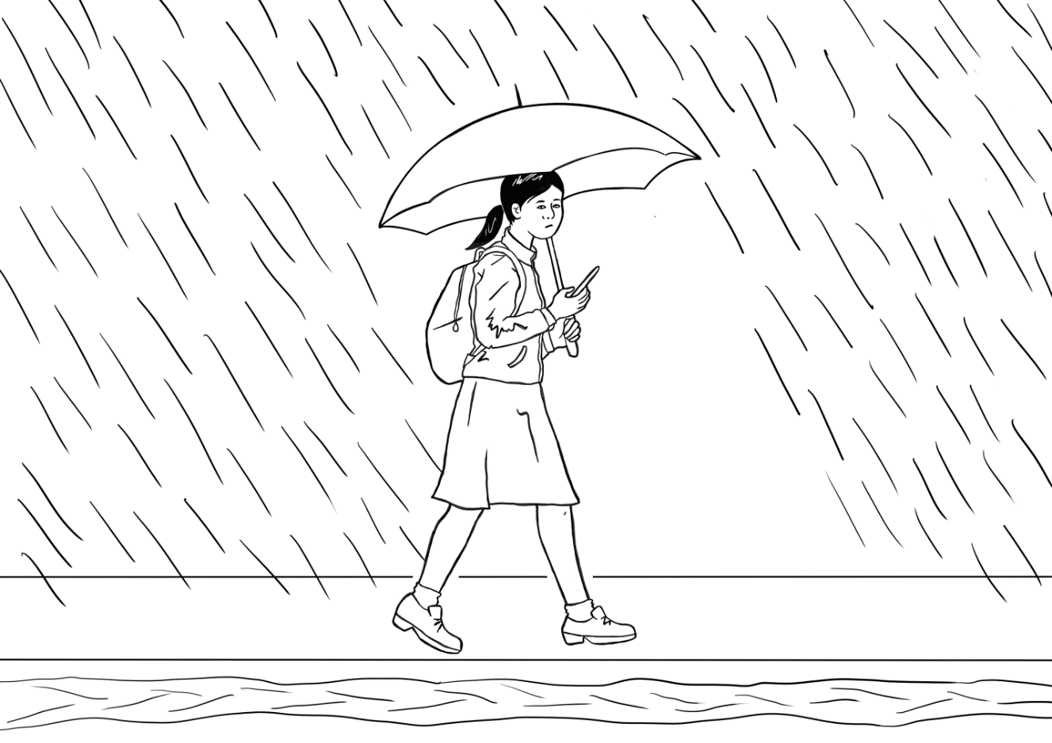

It rains on T_ _ _ _ _ _. M_ _ walks to s_ _ _ _ _ in the r_ _ _ ag_ _ _.

3.

It rains on W_ _ _ _ _day. W_ _ _ _ covers the r_ _ _. Mai w_ _ _ _ to school _ _ the rain. A c_ _ _ _ _ashes water on h_ _ cl_ _ _ _ _.

4.

It r_ _ _ _ on Th_ _ _ _ _ _. Water c_ _ _ _ _
the f _ _ _ path. Mai walks to s_ _ _ _ _
in the rain. She w_ _ _ _ her b_ _ _ _.

5.

It rains _ _ Friday. W_ _ _ _ covers the g_ _ _ _ _. Mai st_ _ _ at h_ _ _.

6.

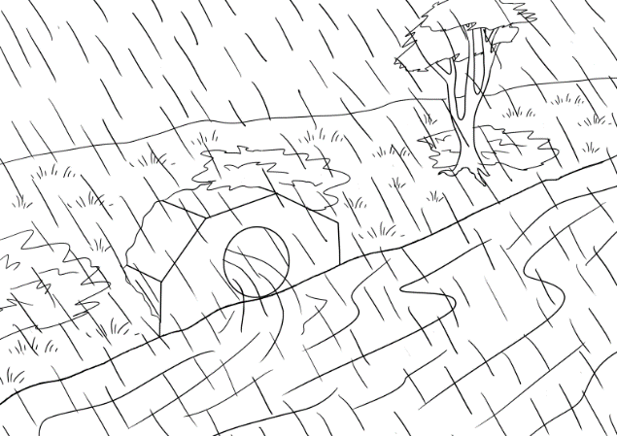

_ _ rains on S _ _ _ _ _ _ _. Water fills
the r _ _ _ _.

7.
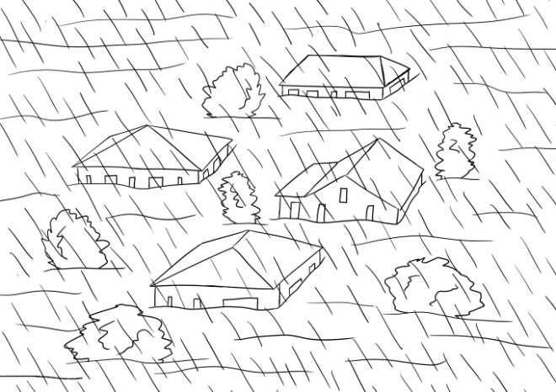

It rains on S_ _ _ _ _. Water fl_ _ _ _
the t_ _ _.

8.
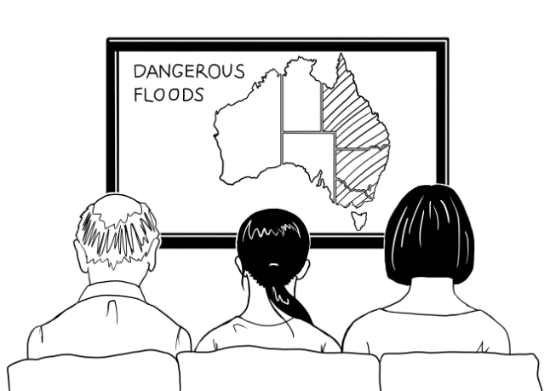

Mai and her f_ _ _ _ _ w_ _ _ _ the n_ _ _ on Sunday morning.

9.

The SES man kn_ _ _ _ on the d_ _ _ on Sunday afternoon. The m_ _ says,
“P_ _ _ a small b_ _. Leave n_ _.”

Listen and order the pictures and the text

Step 1: Order the pictures
Copy the following pages, enough for students to work in pairs. Students cut up the pictures.
As the teacher reads the story, students order the pictures.
It is important to pair higher-level students with lower-level students to provide support when needed.

A class set of scissors is essential. Cutting up is a good preparation for writing as the open and close motion of cutting strengthens the same muscles in the hand that are used in holding a pen or pencil.

Step 2: Order the text next to the pictures
Copy the pages of text enough for students to work in pairs. Students cut up each box of text. As the teacher reads the story, students match the text with the ordered pictures.

It is important to pair higher-level students with lower-level students to provide support when needed.

Step 3: Read the story as a class

- The teacher reads the story, and the students repeat and point to the words as they read.
- Once the students have practised in pairs, ask some higher-level students to read a page aloud to the class. This gives the teacher the opportunity to do some individual correction of pronunciation and stress and also note common issues to address either at the time or in a later class.

After these ordering activities, ask each pair to insert their pictures and text in an envelope. Collect the envelopes for later classes.

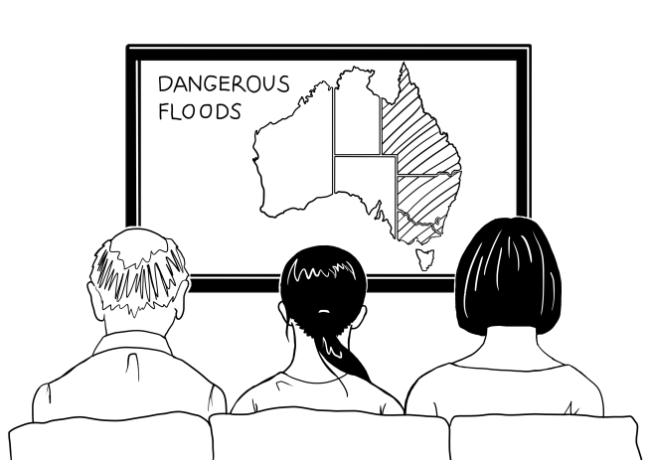

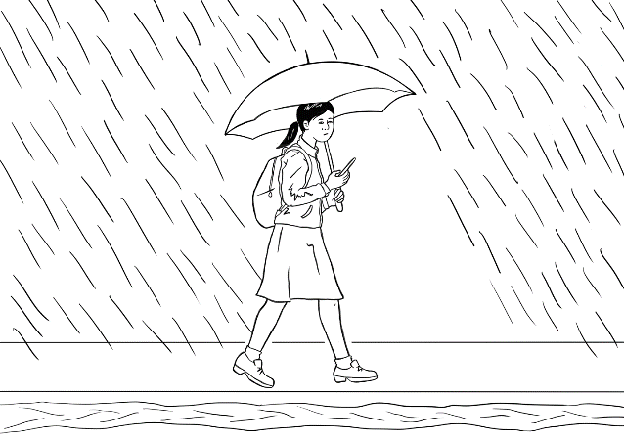

It rains on Wednesday. Water covers the road. Mai walks to school in the rain. A car splashes water on her clothes. | It rains on Thursday. Water covers the footpath. Mai walks to school in the rain. She wears her boots.
It rains on Friday. Water covers the garden. Mai stays at home. | It rains on Tuesday. Mai walks to school in the rain again.
It rains on Monday. Mai walks to school in the rain. | It rains on Saturday. Water fills the river.
The SES man knocks on the door on Sunday afternoon. The man says, “Pack a small bag. Leave now.” | It rains on Sunday. Water floods the town.
Mai and her family watch the news on Sunday morning.

The animated story – Rain, rain, rain

Open the animated version of the story on the hub and listen to the story together.

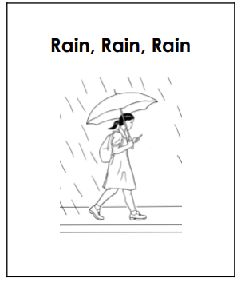

Label a picture of Mai

Labelling is a useful way to revise vocabulary and add some new ones within a familiar context. Copy the drawing on the next page for each student.

- Project the image of Mai on the board and ask some simple questions:
- Who is this?
- What is this? [Point to different things]
- Label each part of the drawing on the board. Add more words in the grey boxes if students are familiar with other vocabulary in the drawing. e.g. dress, uniform, shoes, socks, hair etc
- Colour different parts of the drawing.
- At level A direct the colouring
- At level B students select their colours and later describe their colouring to a partner. e.g a red umbrella
- At level C students select their colours and describe their picture to another student using simple sentences. E.g. Mai has a red umbrella.

Colouring-in is an excellent pre-writing exercise – it provides an opportunity to learn correct pencil grip and strengthen muscles for writing. It is also a calming non-threatening activity and a good way to learn colours.

This is Mai.

rain

Question inflection - What do we need to pack? activity

This activity aims to make students aware of what is important to take in the event of a flood evacuation. It also paves the way for Story 2 ‘Leave now’, in which Mai and her family must pack a bag and find a safe place.
Preparation
- Teach the vocab of possible things to put in the bag. Don’t be limited by the pictures of objects in the appendix. It’s possible to increase the fun by suggesting ridiculous things. Where possible, use realia.
- Print enough pictures for the group activity with the words attached, so each group has a set. Enlarge one set of pictures to use on the board later.

Activity 1: Question Inflection - wh and simple yes/no questions
This is best done over a couple of days.

- Write the question, ‘What do we need to pack?” on the board.
Demonstrate the downward inflection on the word pack with a downward arrow.
- The students practise asking the question using the downward inflection.
- The teacher holds up an object and responds by asking a simple yes/no question.
e.g. A torch? The TV? with an upward inflection.
- Write the simple yes/no questions on the board showing the
upward inflection with an arrow.
Teach body language:
Yes. - nod your head
No. - shake your head
I don’t know. - Lift your hands with palms up, raise your shoulders and show uncertainty on your face.

- Give each student a large picture. Students will respond to the ‘What do we need to pack?” question, with a yes/no question. Students take turns to hold up their picture, and ask a simple question using the upward inflection. The class responds using body language or with a yes or no answer.

Activity 2: ‘What do we need to pack? ‘ - Group activity
- Organise students into groups of three with a set of pictures.
Each student will be a character: Grandfather, mother or Mai.
- Each ‘family’ group then sort the objects into two columns: things to pack and not to pack. Make it very simple, a Yes and a No column.

- Use the enlarged pictures to arrange a final list of the groups’ choices on the board.
Question Inflection - wh and simple yes/no questions
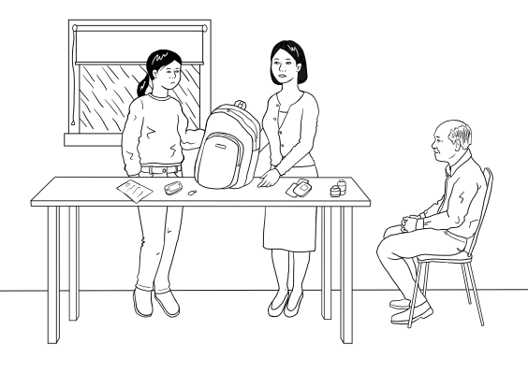
Scenario
The family need to pack a small bag and leave the house. They must decide what to pack in the bag.

wh questions [Open questions]
Inflection falls with wh questions.
 | Say slowly.  This is what we read. | Say quickly.  This is what we hear.
Grandfather | What do we need to pack? | Whadda we need tapack?
Simple yes/no questions [Closed questions]
Inflection goes up at the end of a question requiring a yes or no answer.
Mother | 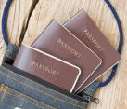  The passports?
Grandfather |   A torch?
Mai |   The TV?  No.
Short Answers
Yes.

Sentence stress – A jazz chant
Jazz Chant – Project the chant. Chant and clap, stressing information words marked with a large dot over the vowel. If a word has more than one syllable,
the correct word stress must be followed: passports, certificates

Come on!
Pack the passports.
Pack the phone.
Pack the pills.
Pack the torch.
Pack the charger.
Pack the water.
Pack the certificates.
Leave now! Hurry, hurry, hurry!

Using the past simple - regular verbs
The story offers an opportunity to introduce past simple regular verbs. Begin by comparing the verbs in a simple table on the board. Some common time markers could also be introduced and sentences created. e.g. It rains every day. It rained last night.

Activity 1 – Verbs, use and common time markers

The verb [infinitive] | The present [simple] tense  Use:  * Regular habits, activities & events  * Facts  Time markers:  every day/morning/week/year etc | The past [simple] tense  Use:  Completed activities and events  Time markers:  yesterday, last night/week/Sunday etc
 |  | add ed
to rain | it rains | it rained
to cover | it covers | it covered
to fill | it fills | it filled
to flood | it floods | it flooded

Activity 2: Change the present to the past
- Project or write the following table on the board.
- The teacher calls out a sentence in the present and the students reply using the past.
- Divide the class in half, half read the present the other half read the past.

Present Tense | Past Tense
It rains on Monday. | It rained on Monday.
It rains on Tuesday. | It rained on Tuesday.
It rains on Wednesday. | It rained on Wednesday.
It rains on Thursday. | It rained on Thursday.
It rains on Friday. | It rained on Friday.
It rains on Saturday. | It rained on Saturday.
It rains on Sunday. | It rained on Sunday.
The water covers the roads. | The water covered the road.
The water covers the footpath. | The water covered the footpath.
The water covers the garden. | The water covered the garden.
The water fills the river. | The water filled the river.
The water floods the town. | The water flooded the town.

Change the story into the past – 3 levels

The following activity provides additional work on regular verbs. The irregular verbs have been provided for the students and written in bold.
Activity

- Project the following pages on the board and demonstrate what needs to be done
at each level.
- Give students a copy of the activity at their level.
- Check and correct it together on the board.

Level A - Past Tense

Past Tense
It rained on Monday.
It _ ain _ d on Monday.
It rained on Tuesday.
It rain _ _ on Tuesday.
It rained on Wednesday.
It ra_n_d on Wednesday.
It rained on Thursday.
It _ai_ed on Thursday.
It rained on Friday.
It r_in_d on Friday.
It rained on Saturday.
It r_ _ned on Saturday.
It rained on Sunday.
It rain_ _ on Sunday.

Verbs | Story
to rain  to walk | It _________ on Monday. Mai ________ to school in the rain.
to rain  to walk | It _________on Tuesday. Mai _____________to school in the rain again.
to rain  to cover  to walk  to splash | It___________ on Wednesday. Water __________ the road. Mai _________ to school in the rain. A car _____________ water on her clothes.
to rain  to cover  to walk  to wear | It__________ on Thursday. Water__________ the footpath. Mai __________ to school in the rain. She wore her boots.
to rain  to cover  to stay | It __________on Friday. Water ___________ the garden.  Mai __________at home.
to rain  to fill | It __________ on Saturday. Water ____________ the river.
to rain  to flood | It __________ on Sunday. Water ___________ the town.
to watch | Mai and her family ________ the news on Sunday morning.
to knock  to say | The SES man __________ on the door on Sunday afternoon. The man said, “Pack a small bag. Leave now.”

Level B – Past Tense

Level C - Past Tense

Verbs | Story
to rain  to walk  to cover  to splash  to wear  to stay  to fill  to flood  to watch  to knock  to say | It _________ on Monday. Mai ________ to school in the rain.
 | It _________on Tuesday. Mai ___________to school in the rain again.
 | It___________ on Wednesday. Water ________ the road. Mai _________ to school in the rain. A car ___________ water on her clothes.
 | It________ on Thursday. Water___________ the footpath. Mai __________ to school in the rain. She wore her boots.
It __________on Friday. Water __________ the garden.
Mai _________at home.
 | It ___________ on Saturday. Water ____________ the river.
 | It ___________ on Sunday. Water ____________ the town.
 | Mai and her family ________ the news on Sunday morning.
 | The SES man __________ on the door on Sunday afternoon. The man said, “Pack a small bag. Leave now.”

A phone conversation using the past simple
This exercise includes a variety of interjections and expressions of surprise that can be used to show attention during a conversation. It is important that students understand that these are not ‘real’ words, but simply show that the listener is listening. Project or write the table on the board. You could also give each student a copy.

Student A | Student B
Hi, how was your week? | Ohhh
Ohhh? | It rained and rained
Oh no! | and rained and rained.
Ohhh? | The water covered the roads.
Ahhh | The water covered the footpaths.
Ohhh! | The water covered the gardens.
Oh no! | The water filled the rivers.
Really? | The water flooded the town.
Oh dear! That’s bad! | Yes. Very, very, very bad.

Appendix - Vocabulary list for Section 4
Words introduced in this section are in bold.

A | a, afternoon, again, at |  | N | news, now
B | bag, boots |  | O | on
C | car, clothes, covers |  | P | pack
D | door |  | Q
E |  |  | R | rain, rains, river, road
F | family, fills, floods, footpath, Friday |  | S | Saturday, says, school, SES, small, splashes, stays, Sunday
G | garden |  | T | the, Thursday, to, town, Tuesday
H | her, home |  | U
I | it, in |  | V
J |  |  | W | walks, watch, water, wears, Wednesday
K | knock |  | X
L | leave |  | Y
M | Mai, man, Monday, morning |  | Z

Appendix – Large size story pictures and text

The following activities recycle the language and should be completed over several days.
Activity 1 : Matching exercise as a class #1
- Enlarge the large size pictures and text to A3 size. [Appendix 6b]
- Print, cut up and laminate the pictures if possible.
- Distribute the 9 pictures and ask students to arrange themselves in the story order in front of the class.
- Distribute the text to 9 students and ask them to match with the corresponding picture.

Activity 2 : Matching exercise as a class #2
- Distribute all the pictures and text. The students then move round the class looking for a match.
If there are more than 18 students, make duplicate copies so everyone has something
to match.
- Pictures can be arranged on the wall later.

It rains on Monday. Mai walks
to school in the rain.

It rains on Tuesday. Mai walks
to school in the rain again.

It rains on Wednesday. Water covers the road. Mai walks to school in the rain. A car splashes water on her clothes.

It rains on Thursday. Water covers the footpath. Mai walks to school
in the rain. She wears her boots.

It rains on Friday. Water covers
the garden. Mai stays at home.

It rains on Saturday. Water fills
the river.

Mai and her family watch the news on Saturday morning.

It rains on Sunday. Water floods
the town.

The SES man knocks on the door on Sunday afternoon. The man says, “Pack a small bag. Leave now.”

Appendix - Photos for ‘What do we pack?’ activity

Cut-up the objects, and leave the words attached.
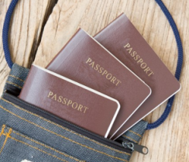 | the passports
 | a USB with photos
 | a phone
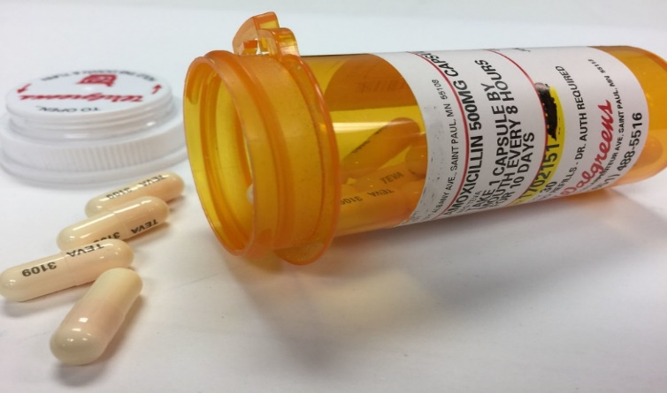 | grandfather’s pills
 | a torch
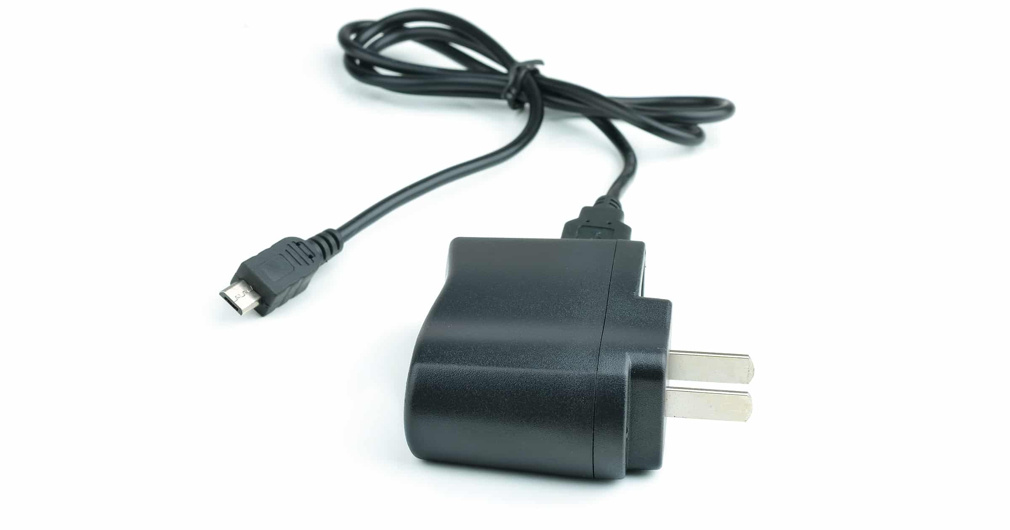 | a phone charger
 | water
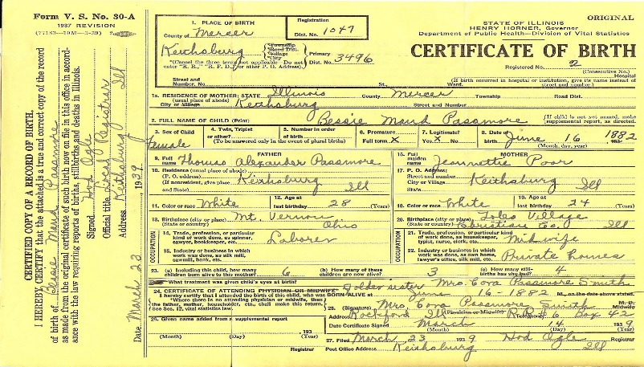   | certificates
 | jewellery
 | money
 | the TV
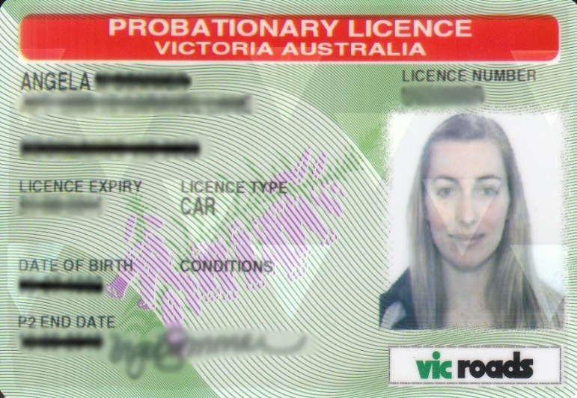 | driving licence
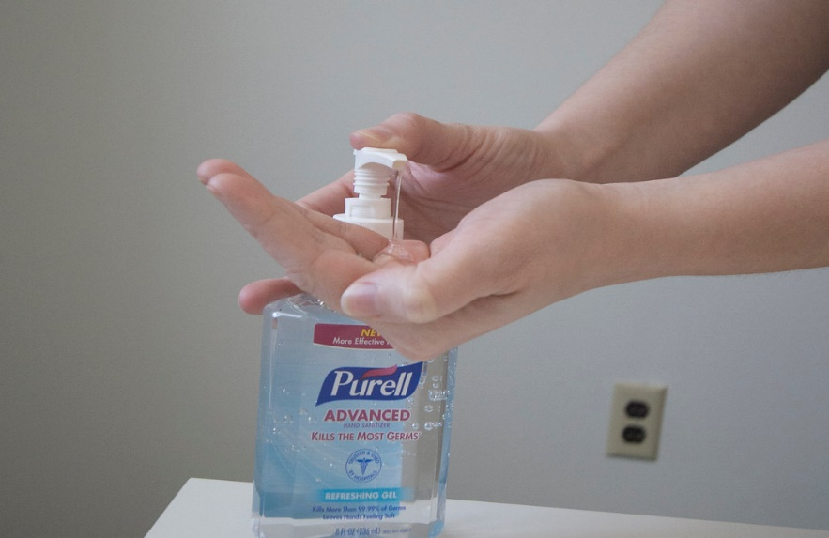 | hand sanitiser
 | books
 | the laptop
 | clothes
 | an umbrella
 | bananas
 | chocolate
 | towels
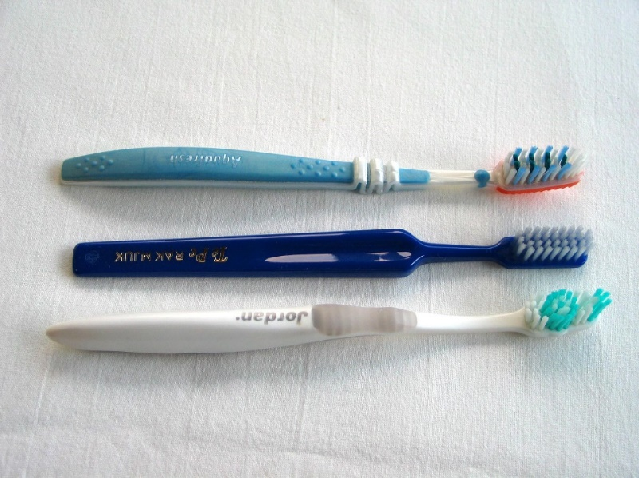 | toothbrushes
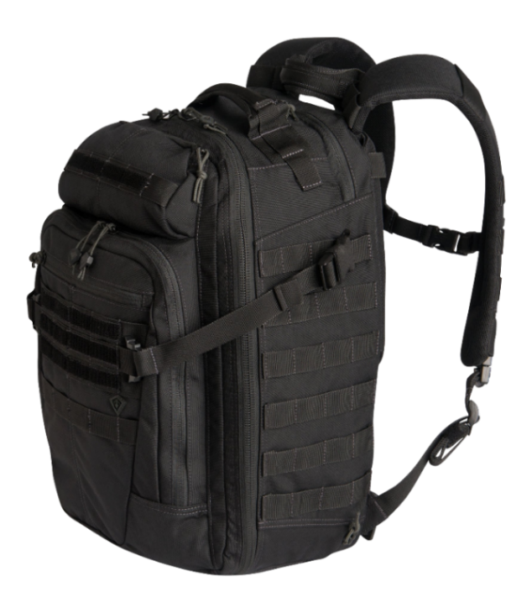 | a backpack
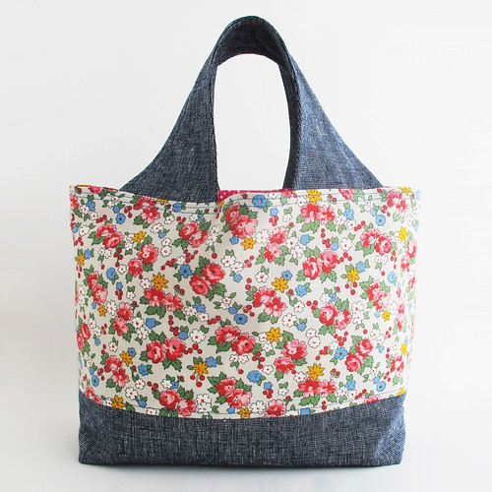 | a shopping bag
 | the cat
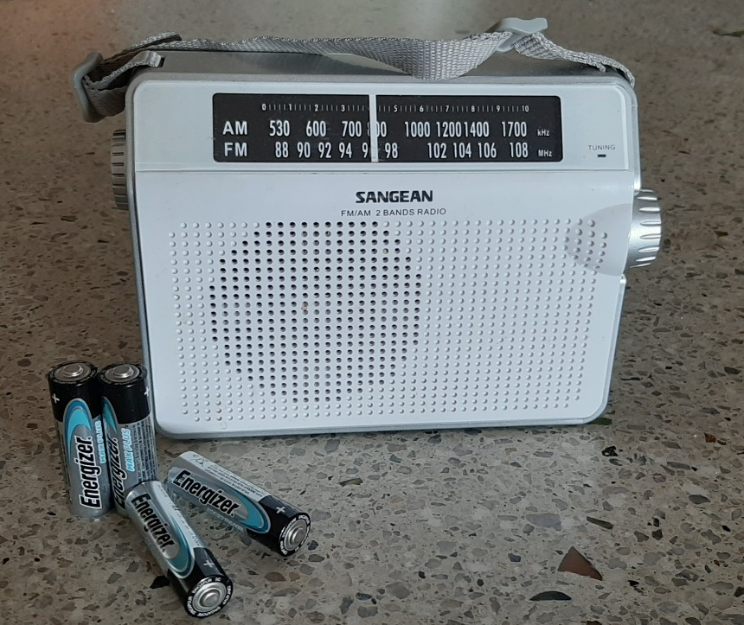 | the radio and batteries
 | the First Aid kit

Appendix – The story at Level A

Some teachers with mixed classes like to make small books for the students at different levels. The following pages have been included to support this activity. To make the word meanings clearer the students could colour the part of the picture the word applies to.
e.g. for the word rain, colour the rain.
Levels B and C can be copied from pictures and text earlier in the section.

Level A - Rain, rain, rain

rains | 1
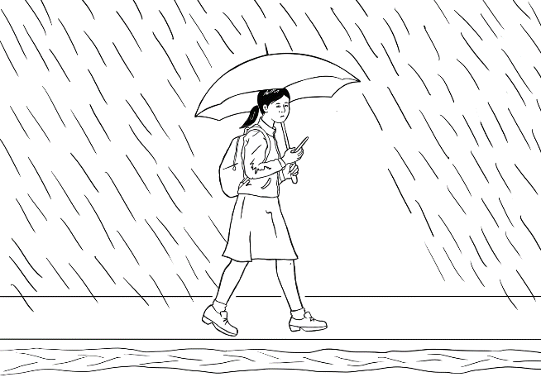  2 | walks
water | 3

4 | footpath
garden | 5
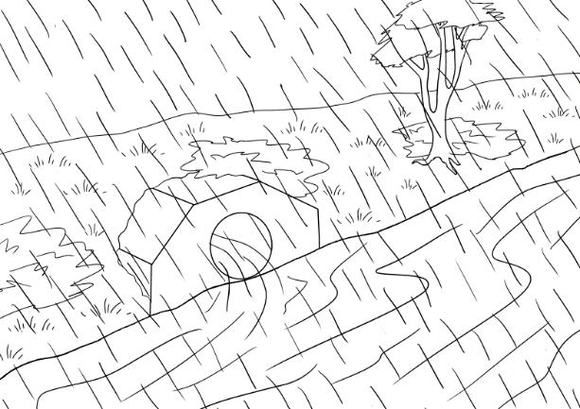  6 | river

town | 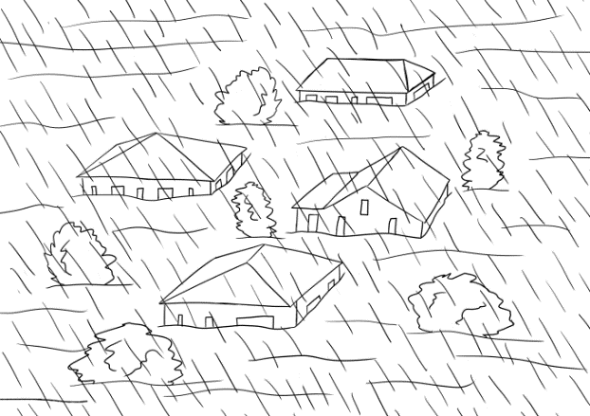  7
8 | news
SES | 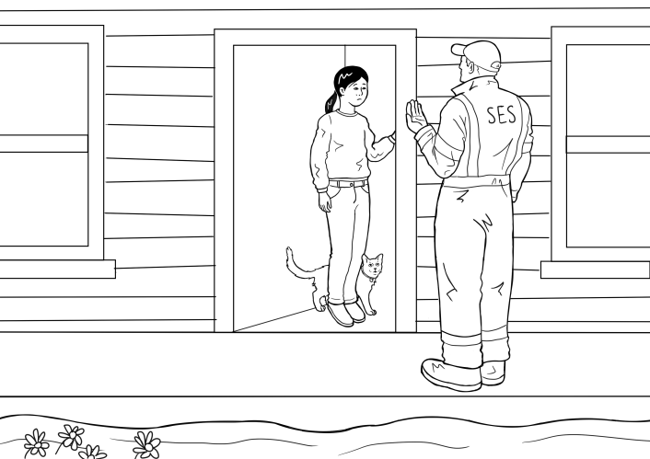  9

Acknowledgements
Images
Passports | https://www.freepik.com/free-photo/passport-fabric-bag_1155960.htm#page=1&query=passport&position=40 by Suksao
Water | This Photo by Unknown Author is licensed under CC BY-SA
USB | This Photo by Unknown Author is licensed under CC BY-NC
Phone | This Photo by Unknown Author is licensed under CC BY-SA
Phone Charger | This Photo by Unknown Author is licensed under CC BY-NC-ND
Torch | This Photo by Unknown Author is licensed under CC BY-NC
Pills | This Photo by Unknown Author is licensed under CC BY-NC
Toothbrushes | This Photo by Unknown Author is licensed under CC BY-SA
Chocolate | This Photo by Unknown Author is licensed under CC BY-NC
Towels | This Photo by Unknown Author is licensed under CC BY-NC
Bananas | This Photo by Unknown Author is licensed under CC BY-NC-ND
Clothes | This Photo by Unknown Author is licensed under CC BY
SES logo | This Photo by Unknown Author is licensed under CC BY-SA
Umbrella | This Photo by Unknown Author is licensed under CC BY-NC
Backpack | This Photo by Unknown Author is licensed under CC BY-NC
Laptop | This Photo by Unknown Author is licensed under CC BY-NC
Books | This Photo by Unknown Author is licensed under CC BY
Hand sanitiser | This Photo by Unknown Author is licensed under CC BY-NC-ND
Driving licence | This Photo by Unknown Author is licensed under CC BY-SA
TV | This Photo by Unknown Author is licensed under CC BY-NC
Money | This Photo by Unknown Author is licensed under CC BY-NC-ND
Jewellery | This Photo by Unknown Author is licensed under CC BY-NC
Certificate of birth | This Photo by Unknown Author is licensed under CC BY-NC-ND
On-line certificate | This Photo by Unknown Author is licensed under CC BY-SA-NC
Shopping bag | This Photo by Unknown Author is licensed under CC BY-SA
A cat | This Photo by Unknown Author is licensed under CC BY-NC
Radio and batteries | This Photo was taken by Sue Paull and is copyright free
First Aid kit | This Photo by Unknown Author is licensed under CC BY-NC
Flooded town | This Photo by Unknown Author is licensed under CC BY-NC
Project team
Vicki Hambling, Lorraine Hatcher-Friel, Sue Paull, Madelena Scott, Mary Wallace, Visual Domain

Acknowledgements
The Project Team would like to thank the AMEP Service Providers and practitioners who participated in the trial and gave valuable feedback.
This Floods Teaching Material is licensed under a Creative Commons Attribution-NoDerivs 3.0 Australia licence (More information is available here). You are free to use, copy and distribute to anyone in its original form as long as you attribute Department of Home Affairs as the author and you license any derivative work you make available under the same licence.
© Commonwealth of Australia 2021

With the exception of the Commonwealth Coat of Arms, the department’s logo, any material protected by a trade mark and where otherwise noted all material presented in this document is provided under a Creative Commons Attribution 4.0 International (https://creativecommons.org/licenses/by/4.0/) licence.
The details of the relevant licence conditions are available on the Creative Commons website (accessible using the links provided) as is the full legal code for the CC BY 4.0 licence (https://creativecommons.org/licenses/by/4.0/legalcode).
Use of all or part of this document must include the following attribution:-
© Commonwealth of Australia 2021
As far as practicable, material for which the copyright is owned by a third party will be clearly labelled. The department has made all reasonable efforts to ensure that this material has been reproduced in this document with the full consent of the copyright owners.
Copyright requests and enquiries concerning usage not addressed by the CC BY 4.0 licence should be addressed to:
comms@homeaffairs.gov.au at the Department of Home Affairs.
The terms of use for the Commonwealth Coat of Arms are available from the It's an Honour website.
Where a copyright owner, other than the Commonwealth, is identified with respect to this material, please contact that third party copyright owner directly to seek permission.




