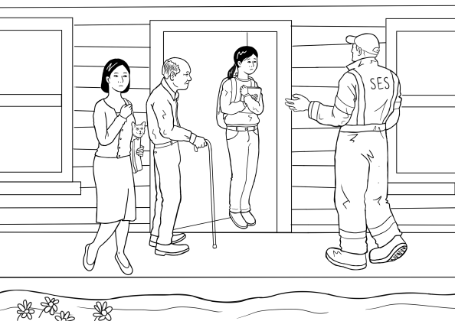

Section 5
Leave Now
Table of contents
Revise animated Story 1 ‘Rain, rain, rain’ 4
The text for Story 2 ‘Leave now’ 5
Build vocabulary for the story 6
A short version of the story - a class cloze 11
Listen and order the sentences - 3 levels 14
Level A - Order the sentences 16
Level B - Order the sentences 19
Level C - Order the sentences 20
Spell the words - 3 levels 21
Level A - Spelling 22
Level B - Spelling 23
Level C - Spelling 24
Speed Copying - 3 levels 25
Level A - Speed Copying 26
Level B - Speed Copying 27
Level C - Speed copying 28
An Individual Cloze - 3 levels 29
Level A - Write the words 30
Level B - Write the words 32
Level C - Write the words 33
PPT - Revise the short version of the story 34
Build the complete story 35
Listen and order the pictures and the text 46
The animated story – Leave now 51
Spell the words - 3 levels 52
Level A - Spelling 53
Level B - Spelling 54
Level C - Spelling 55
Word Find - 3 levels 56
Level A - Word Find 57
Level B - Word Find 58
Level C - Word Find 58
Dictation - 3 levels 60
Level A -Dictation 61
Level B - Dictation 63
Level C - Dictation 65
Labelling and colouring 66
Appendix - Vocabulary list for Section 5 68
Appendix Pronunciation – voiced and unvoiced sounds 69
The imperative form and a short play 70
Appendix – Large size story pictures and text 72
Appendix – The story at Level A 83
Level A - Leave Now 84
Acknowledgements 87

Revise animated Story 1 ‘Rain, rain, rain’

It’s important to reread Story 1 before beginning this section as the stories are sequential.
Open Story 1 ‘Rain, rain, rain’ on the hub and listen to the story together.

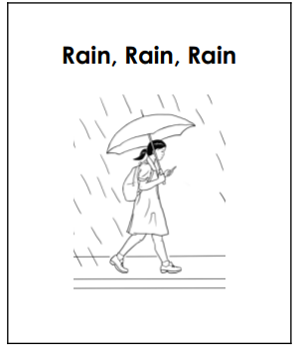

The text for Story 2 ‘Leave now’

Leave Now
The SES man knocks on the door on Sunday afternoon.
The man says, “Pack a small bag. Leave now.”
Mother says, “Hurry up. Pack the bag.
Turn off the TV. Now unplug the TV and the heater.
Go and get the laptop.”
The SES man says, “Come quickly. It’s dangerous.
Leave now. Hurry.”
Mother says, “Is it OK to drive through the water?
Is it safe?”
Mai says, “Oh no, look at that car!”
Grandfather says, “Oh no, look at the tree!”
“Oh no. Stop mum!”
The SES man says, “Stop. The flood water is dangerous.
Drive to the sports centre.”
Mai and her family are safe at the sports centre.

Build vocabulary for the story

Story 2# continues the narrative from Story #1, ‘Rain, Rain, Rain’. Before beginning any work on this story, it’s wise to review Story #1 as much of the vocabulary is recycled in this one. It will also contextualise this story.

Building vocabulary for Story #2
Project the pictures from the story and build the vocabulary as suggested. This can be done over a number of lessons.

VOCABULARY | Board Work
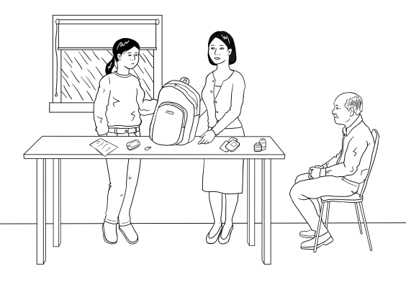  Draw a family of three on the board or project this picture. Revise family and point to Mai. Ask, who is she? Draw a family tree. Point to the mother and ask, who is she and then the grandfather and ask who is he?  Also teach the words man and woman | _ o _ _ e r  Say mother. Ask the students what letters they can hear. Say the word slowly out loud. Do this several times and write in the letters the students get right. Add any missing letters. Be clear about the way each letter is formed.  Point to the word. Ask students to repeat the word mother after you. Spell the word together, pointing to each letter as you spell. Ask how many letters are in the word and count the letters together.  _ _ _ _ _ _ a _ _ _ _  Say grandfather and repeat the process above. Encourage students to guess the ..ther at the end of the word by using the word mother as a model.
hurry up  Students may not be familiar with this expression. Ask the students to stand and walk around the room and then tell them to hurry up. Discuss synonyms like quick and fast and opposites like fast/slow. Use the expression during the class when appropriate. | _ _ _ r y _ _  Repeat the process used to teach the word mother.
turn off, unplug  Teach these words by demonstration. When you have shown the students and they understand, ask them to mime the actions and to say the words as they mime. | _ u r _ _ _ _  _ _ _ _ _ _  Repeat the process used to teach the word mother.
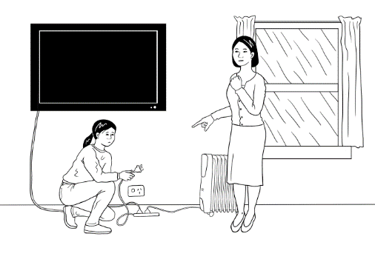  TV  heater  Project the picture above or point to the TV and the heater in the room. Mime warming your hands near a heater and watching TV. | _ _  _ _ a t _ _  Repeat the process used to teach the word mother.  Encourage students to use clues from previous words to guess the spelling of heater. Point to the mother and the grandfather and then to heater. Ask them what the last 2 letters would be.
go and get  Put some familiar articles on a table away from the teacher. Ask a student to go and get something from the table. Ask another student to go and get something else. Turn this into a game. | _ _ _ _ _ _ _ _  Repeat the process used to teach the word mother.
  laptop  Project this picture of a laptop, or point to one. | _ ap _ o _  Repeat the process used to teach the word mother.
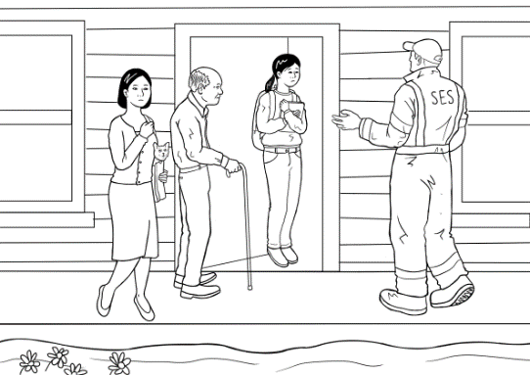  SES  If you have access to the internet, it’s good to project some pictures of SES workers. | _ _ _
Come quickly  Try and use this expression in the normal course of your teaching. | _ o _ e quickly  Repeat the process used to teach the word mother.
dangerous/ safe  These are hard words to explain, ask students to use a bilingual dictionary. You could ask them to write the meanings on the board in their own language. | _ a n _ e _ ou _  _ _ _ e  Repeat the process used to teach the word mother.
leave  this word has been previously taught but it’s good to revise. | _ _ a _ e  Repeat the process used to teach the word mother.
drive and car  Mime driving a car. Ask the students to also mime as they say the words, drive the car, out loud. | _ _ _ _ e  _ a r  Repeat the process used to teach the word mother.
through  A carboard cylinder is a useful aid to teach through. You can roll a marble, push a ruler etc through it. Emphasize the idea of going in and then out the other side. | _ _ _ ough  Repeat the process used to teach the word mother.
look at  Play a game of ‘Look at _____’. Point to different objects and students, in many different directions and encourage students to look. Demonstrate the difference between ‘look at’ and ‘watch’ which the students have already learnt in Story 1. | _ ook _ _  Repeat the process used to teach the word mother.
that  Teach that with this. Repeat the game ‘Look at _______’ but this time substitute that and this. | _ _ _ _  Repeat the process used to teach the word mother.
tree  Draw a simple picture of a tree on the board. | _ _ _ _  Repeat the process used to teach the word mother.
  stop  Put your hand up to indicate stop. Cut out a stop sign and put it on a stick. Ask students to clap, wave, walk, jump etc and hold up the sign to make them stop. Repeat several times. | _ _ _ _  Repeat the process used to teach the word mother.
  sports centre  It’s best to show photos of local sports centres. Mime different sports that might be played there. | _ _ or _ s ce_ _ re  Repeat the process used to teach the word mother.

A short version of the story - a class cloze
This shorter version of the story uses some of the vocabulary just learned. Project the cloze below and elicit the missing words and the spelling of each to fill in the blank spaces.

The SES _ _ _ says, “L _ _ _ _ now.” | 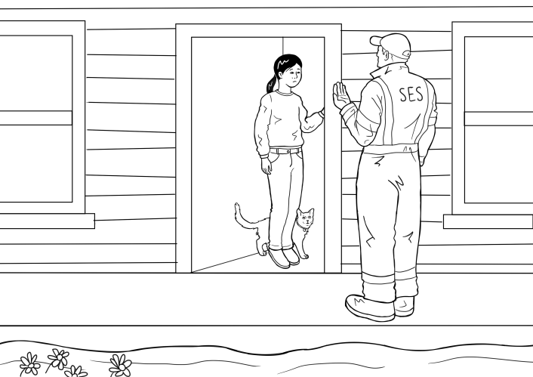
“Pack the _ _ _.”

“Unplug the _ _.“ | 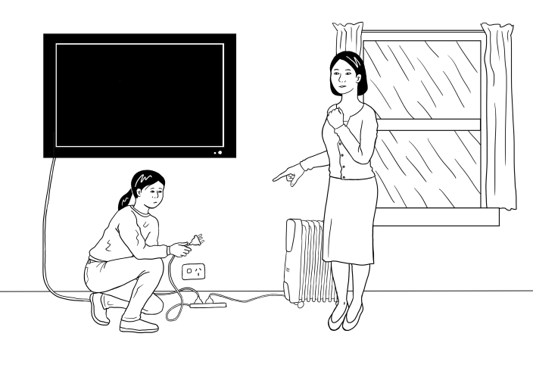
“G _ and g _ _  the laptop.” | 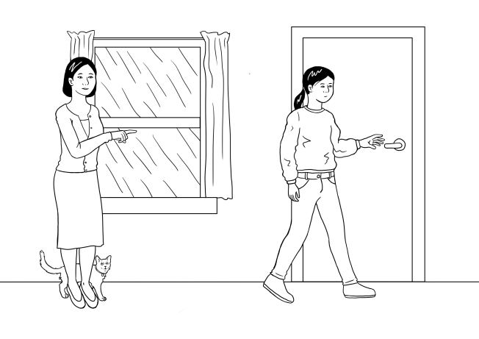
“Come q _ _ _ _ _ _. H_ _ _ _.”
“Is it s_ _ _ to  d _ _ _ _?” | 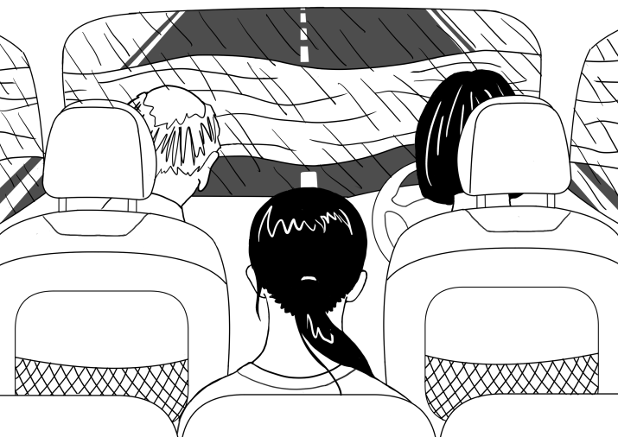
“Oh no. L _ _ _ at the c _ _ and  the t _ _ _ .” | 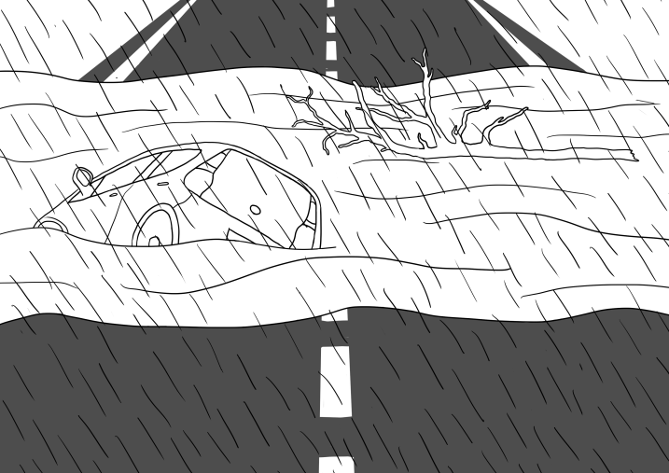
“S _ _ _ , mum!” | 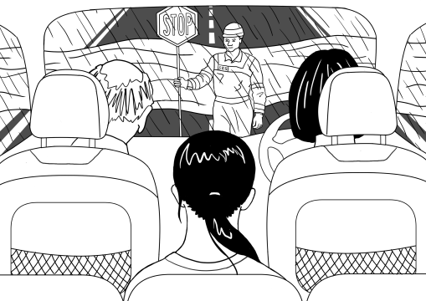
“S_ _ _. D _ _ _ _  to the sp _ _ _ _ centre.” | 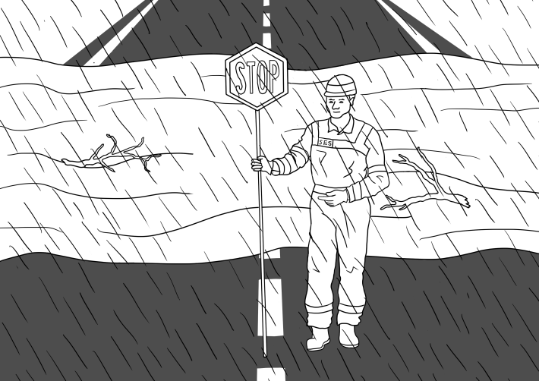
Mai and her  f_ _ _ _ _ are _ _ _ _. | 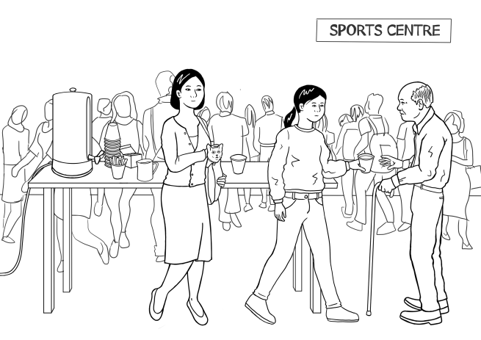

Listen and order the sentences - 3 levels
Preparation
- Copy the sentences on the following pages, enough so that students can work in pairs and at their ability level.
- Provide scissors and glue, and a page of light card for each pair, and an envelope for later storage of the cut-up sentences.
Activity
- Hand out copies of the sentences with the card, glue, scissors and envelopes.
- Demonstrate the process of pasting the page of words onto card, then cutting along the dotted lines to make word cards.
- Students work together to paste the paper onto the card and then cut out the strips.
As they work, encourage students to say what they are doing like a chant.

We are gluing paper onto the card, onto the card, onto the card.
We are gluing paper onto the card, onto the card, onto the card.
We are cutting with the scissors, with the scissors, with the scissors.
We are cutting with the scissors, cut, cut, cut. etc

This makes for a noisy class but gives students time to practice speaking. It doesn’t matter that a new tense is being introduced here. It’s a way of practising the form of a new tense so that it is familiar before its use is explained at a later time.

The SES man says, “Leave now.”
“Pack the bag.”
“Unplug the TV.“
“Go and get the laptop.”
“Come quickly. Hurry.”
“Is it safe to drive?’
“Oh no. Look at the car and the tree.”
“Stop Mum.”
“Stop. Drive to the sports centre.”
Mai and her family are safe.
- When the cutting and pasting has been completed, slowly read the text of the shortened story to the class and ask students to put the sentences in order as they listen.

- To make it more difficult cut the sentences in half and mix them up. However, with Level A, keep sentences and pictures together until the students are more confident.

- Encourage students to use clues such as the full stops and capital letters. This activity can be repeated over several days. Each time the students find the activity easy they can cut up the strips into smaller pieces.
After these ordering activities, ask each pair to insert their pictures and text in an envelope. Collect the envelopes for later classes.

Level A - Order the sentences

The SES man says,  “Leave now.” | 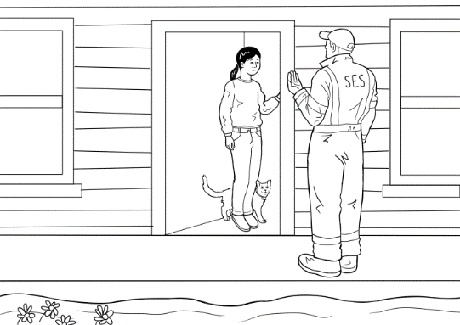
“Pack the bag.”

“Unplug the TV.“
“Go and get the laptop.” | 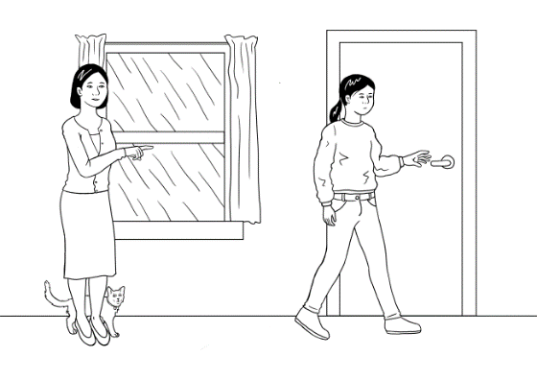
“Come quickly. Hurry.”
“Is it safe to drive?’ | 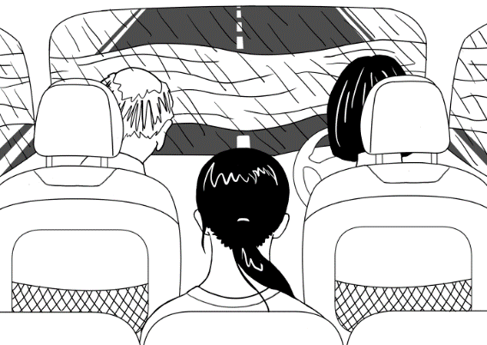
“Oh no. Look at the car and the tree.” | 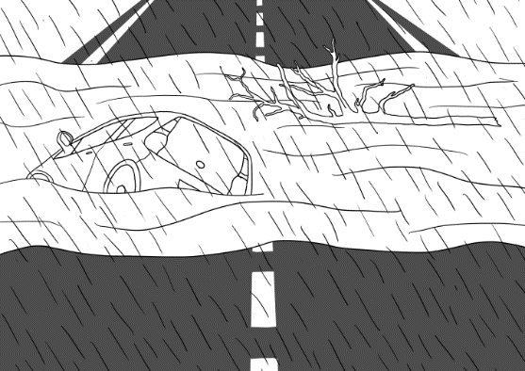
“Stop, mum!” | 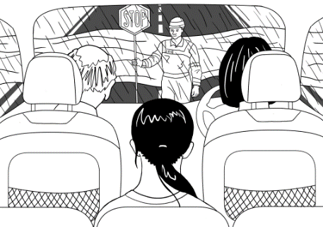
“Stop. Drive to the sports
centre.”
Mai and her family are safe. | 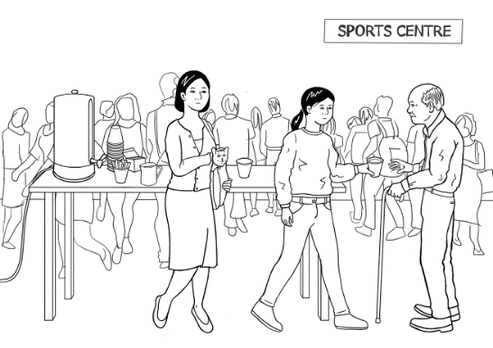

Level B - Order the sentences

“Oh no. Look at the car and the tree.”
The SES man says, “Leave now.”
“Is it safe to drive?’
“Stop. Drive to the sports centre.”
“Come quickly. Hurry.”
“Pack the bag.”
Mai and her family are safe.
“Stop, mum!”
“Go and get the laptop.”
“Unplug the TV.”

Level C - Order the sentences

The SES man says, | “Leave now.”
“Pack | the bag.”
“Unplug | the TV.”
“Go and get | the laptop.”
“Come quickly. | Hurry.”
“Is it safe | to drive?”
“Oh no. Look at | the car and the tree.”
“Stop, | mum!”
“Stop. Drive to | the sports centre.”
Mai and her family | are safe.

Spell the words - 3 levels

- For lower levels use a modified version of ‘Look, say, cover, write, check’.
Teach: Look, say the word out loud, spell the word out loud as you copy.
For higher levels teach ‘Look, say, cover, write, check’.
- It is important that the students:
- Finish one word before writing the next word
- Work down the page rather than across.
- Check their spelling with the typed word.
- Try to chunk the letters rather than copy letter by letter.
- The words are printed twice at each level so that students practise once in class, and then again at home or in a following class. In this way, students are shown a way to improve their writing through brief and regular practice.

Level A - Spelling
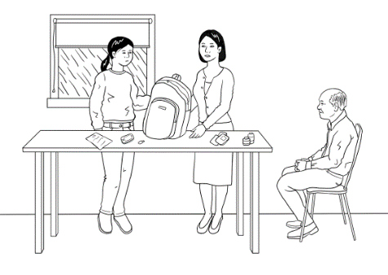

pack | bag
pack | bag

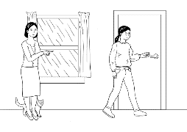
go | get
go | get

Level B - Spelling

mother | tree | go | get
mother | tree | go | get

laptop | unplug | man | stop
laptop | unplug | man | stop

Level C - Spelling

now | says | unplug | laptop
now | says | unplug | laptop

hurry | pack | come | stop
hurry | pack | come | stop

drive | tree | safe | look
drive | tree | safe | look

Speed Copying - 3 levels

One of the simplest ways to improve spelling and writing is to practise speed copying.
The goal of such copying is to build speed and proficiency. With regular practice, speed copying can improve spelling, handwriting and memory. Students’ written expression also improves as they memorise common groupings of words and collocations.
Low level students will initially copy letter by letter, but as they become more proficient over time, they will learn to chunk, then write whole words, then write a few words and then complete sentences, depending on their level and educational background.
Activity
- Set the timer for 2, or 4 or 5 minutes
- Ask the students to copy the same text over and over in that time.
- If they finish copying their text before the time is up, they need to copy it again, and maybe even again.
- Students copy the same text every day for a week, trying to increase the number of words they write each time.
- The text copied can be used for a dictation the following week.

Level A - Speed Copying

Pack the bag.
_________________________________________________________________
Pack the bag.
_________________________________________________________________
Pack the bag.
________________________________________________________________

Stop mum.
__________________________________________________________________

Stop mum.
__________________________________________________________________

Stop mum.
__________________________________________________________________

Level B - Speed Copying

Leave now.
_________________________________________________________
Pack the bag.
_________________________________________________________
Unplug the TV.
_________________________________________________________
Leave now.
_________________________________________________________
Pack the bag.
_________________________________________________________
Unplug the TV.
_________________________________________________________
Leave now.
_________________________________________________________
Pack the bag.
_________________________________________________________
Unplug the TV.
_________________________________________________________

Level C - Speed copying

The SES man says, “Leave now.”
Pack the bag.
Unplug the TV and the heater.
Go and get the laptop.
Come quickly. Hurry.
Is it safe to drive?

An Individual Cloze - 3 levels

At level A, students are provided with the pictures, the word and the first letter.

At Level B, there are no pictures, but some difficult sounds are given and the words are provided at the bottom of the page. This bottom section can be folded over and used to check spelling or for a final check.

At Level C, there are no pictures or letters, but the words are provided at the bottom of the page. This bottom section can be folded over and used to check spelling or for a final check.

Level A - Write the words
The SES man says,  “Pack a small b _ _. Leave now.” | 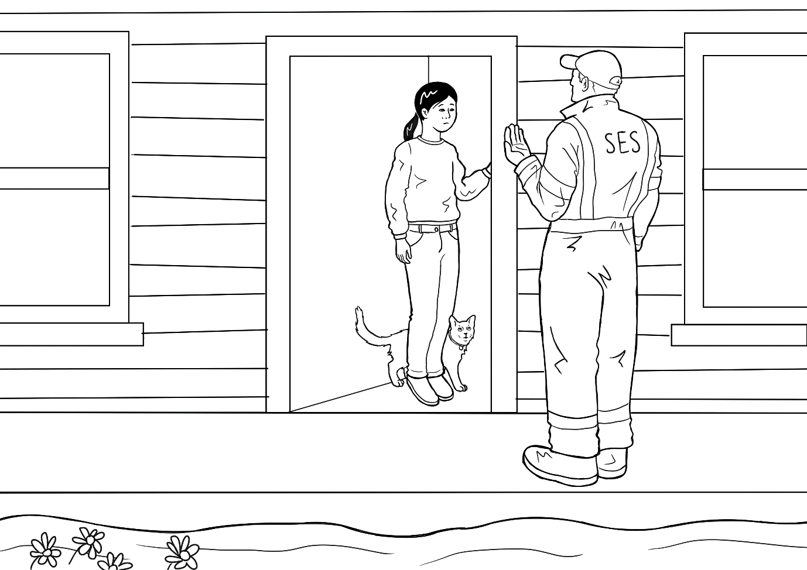  bag
P_ _ _ the bag.” | 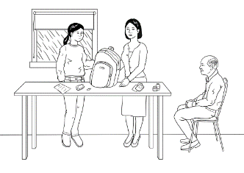Pack
Unplug the _ _ | TV
Go and g _ _ the laptop. | get
C _ _ _ quickly. Hurry. | Come
Is it safe to d _ _ _ _ ? | 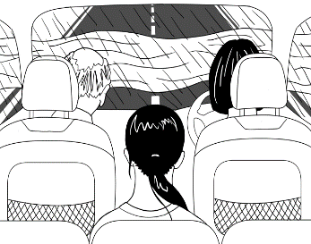  drive
“Oh no. Look at the c _ _  and the tree.” | car
“Stop, m _ _ !” | mum
“S _ _ _. Drive to the sports centre.” | 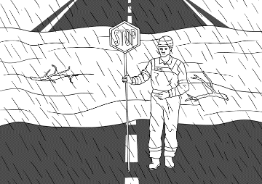  Stop
Mai and her f _ _ _ _ _ are safe. | 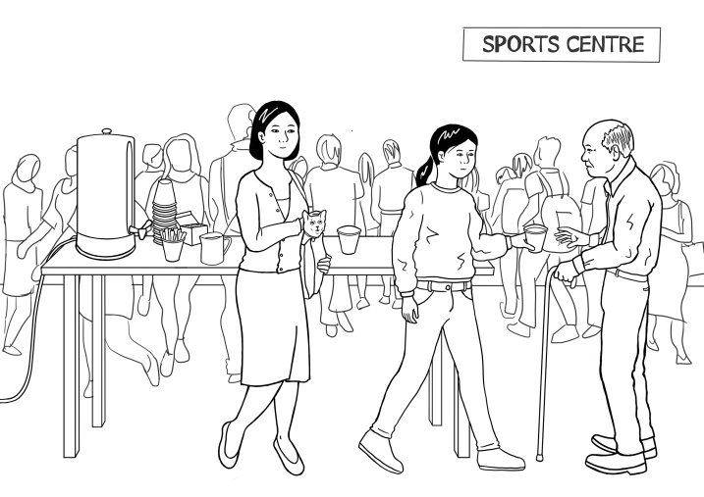  family

Level B - Write the words
- The SES _ _ _ says, “L _ a _ e now.”
- “P _ _ k the _ _ _ .”
- “Unplug the _ _ .“
- “_ _ and _ _ _ the lap _ _ _.”
- “Co_ e quickly. _ urry.”
- “Is it _ _ _ e to _ _ _ _ e ?’
- “Oh no. Look _ _ the car and the _ _ _ _ .”
- “S_ _ _ , m_ _ !”
- “Stop. D _ _ _ e to the _ _ orts centre.”
- Mai _ _ _ her family are _ _ _ e.
Man leave pack bag go get laptop
come Hurry safe drive at tree stop
Mum Drive Sports and safe

Level C - Write the words
- The SES man _ _ _ _, “Leave _ _ _ .”
- “_ _ _ _ the _ _ _ .”
- “_ _ _ _ _ _ the _ _ .“
- “_ _ and _ _ _ the _ _ _ _ _ _ .”
- “_ _ _ _ quickly. _ _ _ _ _ .”
- “Is it _ _ _ _ to _ _ _ _ _ ?’
- “Oh no. _ _ _ _ at the car and the _ _ _ _.”
- “_ _ _ _ , _ _ _!”
- “ _ _ _ _ . _ _ _ _ _ to the sports centre.”
- Mai _ _ _ her family are _ _ _ _ .

says now pack bag unplug TV Go
get laptop Come Hurry safe drive look
tree stop mum Stop Drive and safe

PPT - Revise the short version of the story

Before introducing the complete story, revise the short version with the PPT. The great advantage of the PPT is that you can show it many times, and at varying speeds.

Download the PPT from the hub.

- Project the PPT in slide show mode. The animation feature will reveal the words slowly to build each sentence.
- The forward arrow on your keyboard will make the pictures and words appear in order. The back arrow will remove the words and pictures.
- Click Escape anytime to close.
- Encourage students to guess the words before they appear.

PPT
Leave Now- short version

Build the complete story

The story can be built in a number of ways. You could use just one method or different ones over several days.
- Project the pictures and the sentences with missing words.
Project the following pages on the board and build the whole story together as a class. The words will need to be rubbed off after each slide.

- Project the pictures and build the story on the board
Project only the pictures, and draw lines on the board for each word, working on one sentence at a time. You can give some letters if you like or leave them all blank. Elicit the words and write them on the board and/or ask students to spell each word. If you’re lucky, the board may be large enough to contain the whole story. This would allow you to reverse the process, by rubbing out some of the words and students reading the story recalling the rubbed-out words.

1.

The SES _ _ _ _ _ _ _ _ _ on the _ _ _ _ on Sunday afternoon. The _ _ _ says, “_ _ _ _ a s_ _ _ _ bag. L_ _ _ _ _ _ _ .”

2.

Mother _ _ _ _ , “Hurry up. _ _ _ _ the _ _ _ .”

3.

“Turn _ _ _ the _ _ . Now _ _ _ _ _ _ the TV
and the h_ _ _ _ _ .”

4.

“_ _ and _ _ _ the _ _ _ _ _ _.”

5.

The _ _ _ man _ _ _ _ , “Come q _ _ _ _ _ _ .
It’s dangerous. L_ _ _ _ n _ _ . H _ _ _ _ .”

6.

Mother _ _ _ _ , “Is it OK to d _ _ _ _ through the w _ _ _ _ ? Is it _ _ _ _ ?”

7.

Mai says, “Oh no, l _ _ _ at that _ _ _ !”
Grandfather _ _ _ _ , “Oh no, _ _ _ _
at the _ _ _ _ !”

8.

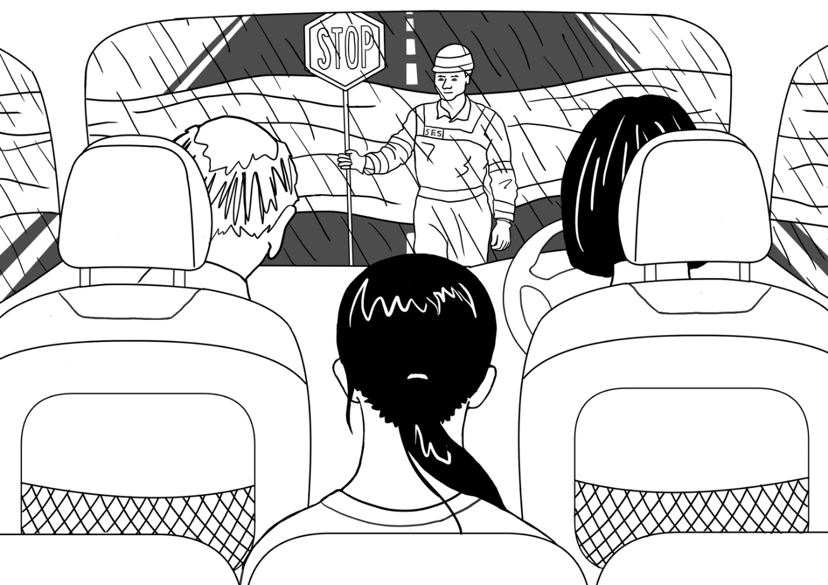

“Oh _ _ , _ _ _ _ mum!”

9.

The _ _ _ _ _ _ _ _ _ _ , “_ _ _ _ .
The flood _ _ _ _ _ is dangerous. _ _ _ _ _
to the _ _ _ _ _ _ centre.”

10.
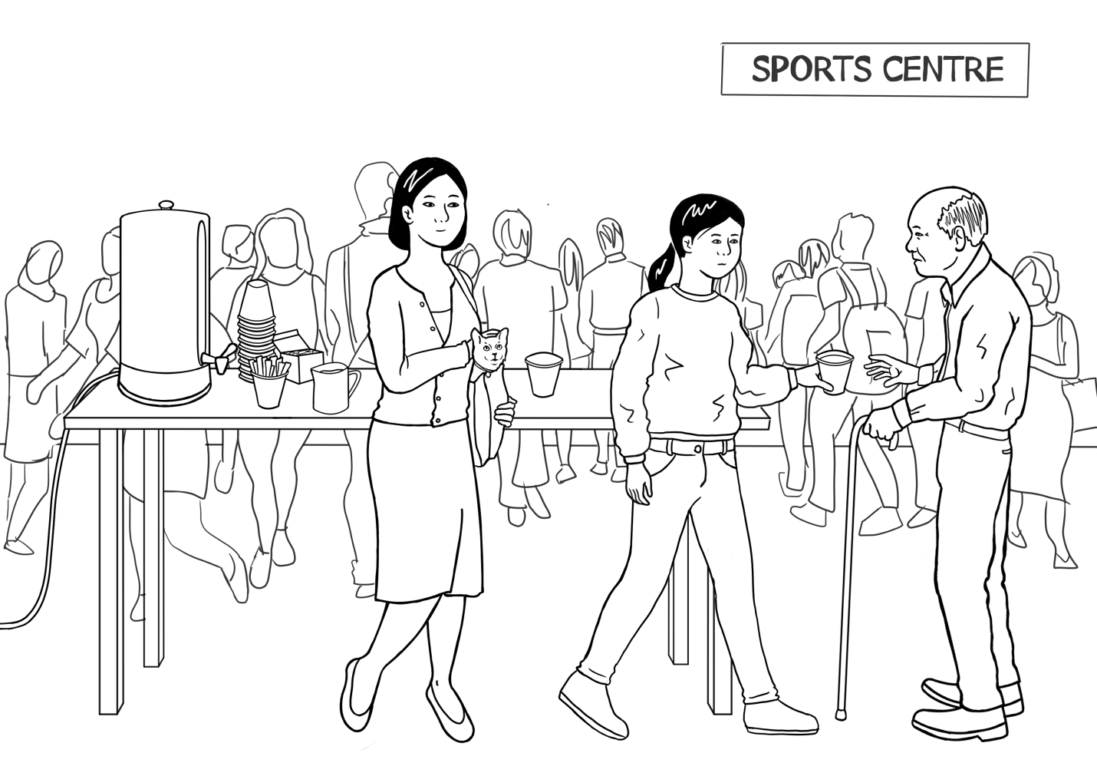

Mai and her _ _ _ _ _ _ are _ _ _ _
at the _ _ _ _ _ _ centre.

Listen and order the pictures and the text

Step 1: Order the pictures
Copy the following pages, enough for students to work in pairs. Students cut up the pictures. As the teacher reads the story, students order the pictures.
It is important to pair higher-level students with lower-level students to provide support when needed.

A class set of scissors is essential. Cutting up is a good preparation for writing as the open and close motion of cutting strengthens the same muscles in the hand that are used in holding a pen or pencil.

Step 2: Order the text next to the pictures
Copy the pages of text enough for students to work in pairs. Students cut up each box of text. As the teacher reads the story, students match the text with the ordered pictures.

It is important to pair higher-level students with lower-level students to provide support when needed.

Step 3: Read the story as a class
- The teacher reads the story, and the students repeat and point to the words as they read.
- Once the students have practised in pairs, ask some higher-level students to read a page aloud to the class. This gives the teacher the opportunity to do some individual correction of pronunciation and stress and also note common issues to address either at the time or in a later class.

After these ordering activities, ask each pair to insert their pictures and text in an envelope.
Collect the envelopes for later classes.

 | 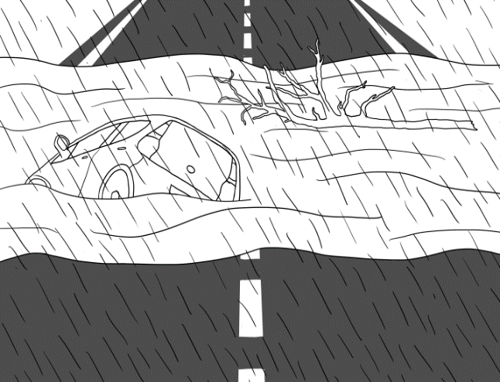
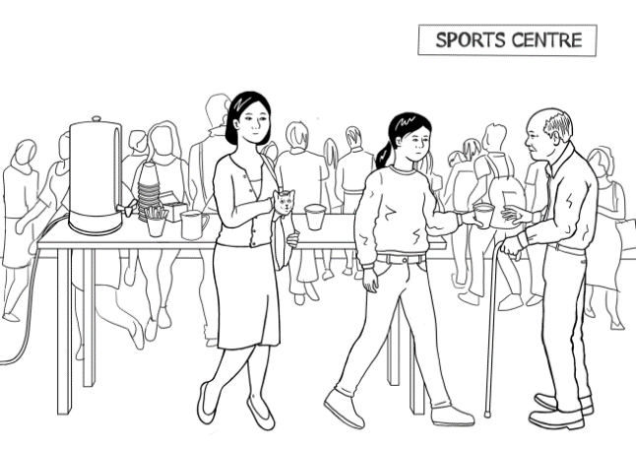

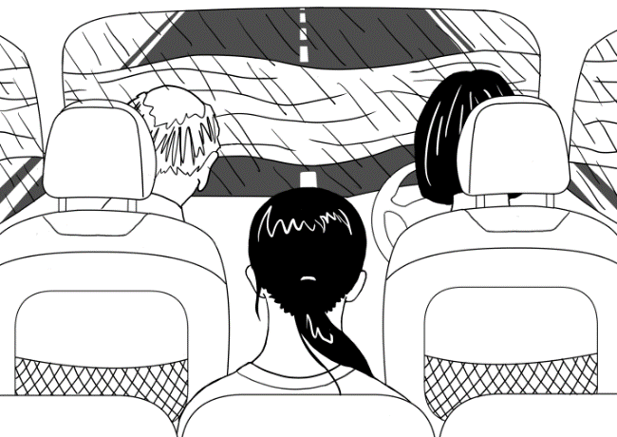

 | 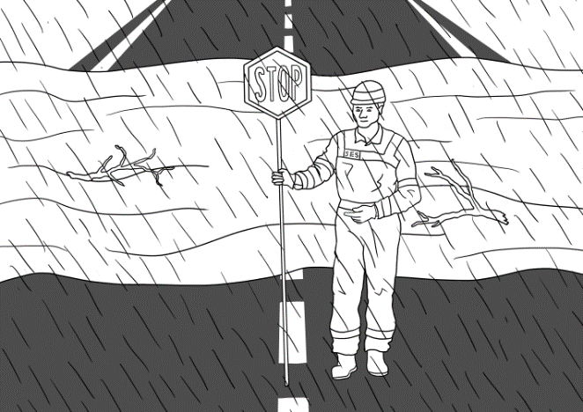
“Go and get the laptop.” |  | The SES man says, “Stop.  The flood water is  dangerous. Drive to the  sports centre.”
Mai says, “Oh no, look at  that car!”  Grandfather says, “Oh no,  look at the tree!” |  | The SES man knocks on the  door on Sunday afternoon.  The man says, “Pack a  small bag. Leave now.”
Mother says, “Hurry up.  Pack the bag.” |  | Mother says, “Is it OK  to drive through the water?  Is it safe?”
The SES man says, “Come  quickly. It’s dangerous.  Leave now. Hurry.” |  | “Oh no, stop mum!”
Mai and her family are safe  at the sports centre. |  | “Turn off the TV. Now unplug  the TV and the heater.”

The animated story – Leave now

Open the animated version of the story on the hub and listen to the story together.

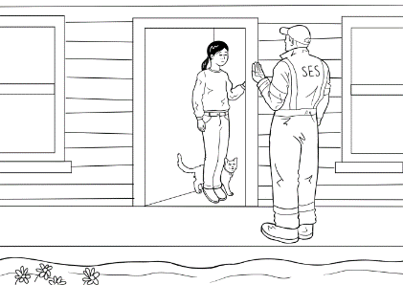

Leave Now

Spell the words - 3 levels

- For lower levels use a modified version of ‘Look, say, cover, write, check’.
Teach: Look, say the word out loud, spell the word out loud as you copy.
For higher levels teach ‘Look, say, cover, write, check’.

- It is important that the students:
- Finish one word before writing the next word
- Work down the page rather than across
- Check their spelling with the typed word
- Try to chunk the letters rather than copy letter by letter
- The words are printed twice at each level so that students practise once in class and then again at home or in a following class. In this way, students are shown a way to improve their writing through brief and regular practice.

Level A - Spelling

man | bag
man | bag

look | safe
look | safe

Level B - Spelling

man |  | pack | bag
man |  | pack | bag

look | stop | safe
look | stop | safe

Level C - Spelling

man | Sunday | bag | says
man | Sunday | bag | says

heater | come | leave | water
heater | come | leave | water

car | flood | sports | family
car | flood | sports | family

Word Find - 3 levels

Word finds are a helpful way to develop students’ visual word recognition and spelling.
It is also a good time to introduce highlighters. Yellow highlighters are best as they allow the word to be seen clearly and don’t bleed through the page. Yellow is also a stimulating colour and is believed to enhance memory retention.
Project each Word Find and demonstrate the technique for each.

Highlight the words
et |  | s | t | o | p
go |  |  |  |  |  | b | a | g
bag |  | g | e | t
stop |  |  |  |  |  | i | s
 |  |  | a | t
mother
is |  |  | c | a | r
it |  |  |  |  |  |  | g | o
at |  |  |  |  | i | t
car |  |  | m | o | t | h | e | r


Level A - Word Find

Level B - Word Find
Highlight the words
now |  | t | h | a | t | a | a | a
pack |  | a | m | o | t | h | e | r
small |  | a | a | a | a | a | a | a
mother |  | h | e | a | t | e | r | a
look |  | a | a | d | r | i | v | e
hurry |  | a | u | n | p | l | u | g
that |  | c | a | r | a | a | a | a
heater |  | a | a | h | u | r | r | y
unplug |  | a | s | m | a | l | l | a
look |  | a | a | a | a | n | o | w
drive |  | s | t | o | p | a | a | a
car |  | a | a | a | s | a | f | e
safe |  | p | a | c | k | a | a | a
stop |  | a | a | a | l | o | o | k


Level C - Word Find

Highlight the words

pack |  | a | b | h | e | a | t | e | r | c
family |  | q | d | u | n | p | l | u | g | e
small |  | u | f | r | g | h | i | j | k | l
knocks |  | i | m | r | n | s | m | a | l | l
come |  | c | o | y | p | q | r | s | o | t
centre |  | k | u | p | v | w | x | y | o | z
stop |  | l | f | a | m | i | l | y | k | a
look |  | y | b | c | c | c | d | e | f | d
mother |  | g | f | k | n | o | c | k | s | r
heater |  | h | l | i | j | m | e | k | t | i
quickly |  | l | o | m | n | e | n | o | o | v
leave |  | p | o | q | r | s | t | u | p | e
drive |  | v | d | w | x | y | r | w | z | a
unplug |  | b | l | e | a | v | e | a | c | d
hurry |  | e | f | g | h | i | j | t | k | l
flood |  | m | n | o | p | q | r | e | s | t
water |  | u | m | o | t | h | e | r | v | w

Dictation - 3 levels

Activity
All students hear the same text:
The SES man knocks on the door on Sunday afternoon. The man says, “Pack a small bag. Leave now.”
Mother says, “Hurry up. Pack the bag. Turn off the TV. Now unplug the TV and the heater. Go and get the laptop.”
The SES man says, “Come quickly. It’s dangerous. Leave now. Hurry.”
Mother says, “Is it OK to drive through the water? Is it safe?”
Mai says, “Oh no, look at that car!”
Grandfather says, “Oh no, look at the tree!”
“Oh no, stop mum!”
The SES man says, “Stop. The flood water is dangerous. Drive to the sports centre.”
Mai and her family are safe at the sports centre.

The teacher reads a sentence, and each student writes the sentence at their own level.

Level A
Students listen for the missing letters and write them in. To assist, SES man is written under the first picture. Students are encouraged to look for words to copy from the text. All the words needed are in bold. The students may need help initially.

Level B
Students listen and can either find the words in bold in the text or write the words from memory.

Level C
Students write the sentences using the words below to help with the spelling. For a greater challenge, the words can be folded under, and students try to write from memory. The words also allow the student to check their spelling at the end of the dictation.

Level A -Dictation

The _ _ _ man knocks on the door on Sunday afternoon. The _ an says, “Pack a small bag. Leave now.” | SES man
Mother says, “Hurry up. Pack
the _ ag.”
“Turn off the TV. Now unplug the
_ _ and the heater.”
“Go _ nd get the laptop.”
The SES man says, “Come quickly.
It’s dangerous. Leave _ ow. Hurry.”
Mother says, “Is it _ _ to drive through the water? Is it safe?”
Mai _ ays, “Oh no, look at that car!”
Grandfather says, “Oh no, _ ook at the tree!”
“Oh _ o, stop mum!”
The SES _ an says, “Stop. The flood _ ater is dangerous. Drive to the sports centre.”
Mai and her family are _afe at the sports centre.

Level B - Dictation

The _ _ _ man knocks on the door on Sunday afternoon. The _ _ _ says, “Pack a small bag. Leave now.”
Mother _ _ _ _ , “Hurry up.
_ _ _ _ the _ _ _.”
“Turn off the TV. Now unplug the _ _ and _ _ _ heater.” | 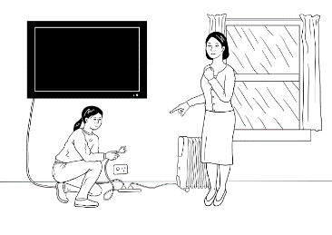
“Go _ _ _ get the laptop.”
The _ _ _ _ _ _ _ _ _ _ , “Come quickly. It’s dangerous. L _ _ _ _ n_ _. Hurry.”
Mother says, “Is it OK to drive through the water? _ _ _ _ safe?”
Mai _ _ _ _ , “Oh no, look at that car!”
Grandfather says, “Oh _ _ , _ _ _ _ _ _ the tree!”
“_ _ _ _ , stop mum!”
The SES man says, “_ _ _ _ . The flood water _ _ dangerous. _ _ _ _ _ to the sports centre.”
Mai and her family are _ _ _ _ at the
_ _ _ _ _ _ centre.

Level C - Dictation
The _ _ _ _ _ _ knocks on the door on _ _ _ _ _ _ afternoon.
The man says, “_ _ _ _ a small _ _ _ . Leave now.”
Mother _ _ _ _ , “Hurry up. _ _ _ _ the _ _ _ . Turn off the TV.
Now _ _ _ _ _ _ the _ _ and the heater. Go and get the _ _ _ _ _ _.”
The SES man says, “_ _ _ _ quickly. It’s dangerous. _ _ _ _ _ now. Hurry.”
Mother says, “Is it OK to _ _ _ _ _ through the _ _ _ _ _ ? Is it _ _ _ _ ?”
Mai says, “Oh no, _ _ _ _ at that _ _ _ !”
Grandfather says, “Oh no, look at the _ _ _ _ !”
“Oh no, _ _ _ _ mum!”
The SES man says, “Stop. The _ _ _ _ _ water is dangerous. Drive to the _ _ _ _ _ _ centre.”
Mai and her _ _ _ _ _ _ are safe at the sports centre.

Fold
SES man | Sunday | pack | bag | says
unplug | TV | laptop | come | leave
drive | water | safe | look | car
tress | stop | flood | sports | family

Labelling and colouring

Labelling is a useful way to revise vocabulary and add some new ones within a familiar context. Colouring is an excellent pre-writing exercise – it provides an opportunity to learn correct pencil grip and strengthen muscles for writing. It is also a calming non-threatening activity and a good way to learn colours.
Preparation:
- Copy the drawing on the next page for each student.
- Provide colouring pencils for groups of students

Activity 1: Labelling and colouring the sports centre picture
- Project the image of the sports centre on the board and ask some simple questions:
Who is this?
What is this? [Point to different things]
- Label each part of the drawing on the board. Add more words if students are familiar with other vocabulary in the drawing. e.g. people, table, cups, coffee etc
- Colour different parts of the drawing.
- At level A direct the colouring
- At level B students select their colours and later describe their colouring to a partner. e.g. a red jumper
- At level C students select their colours and describe their picture to another student using simple sentences. e.g. Mai has a red jumper.
Activity 2: Colour the pictures in the story for a PPT of student work
- Copy all the pictures from the story. You may need duplicate copies [half A4 size] of the same picture so each student has one to colour
- Students select a picture – make sure at least one of each story picture is selected.
- When the pictures are coloured, select one of each in the story and ask students to put them in order. Take a photo of each coloured drawing.
- With the photos, create a colour PPT of the story.
- Use the PPT to admire the students’ work and elicit the story as you click through.

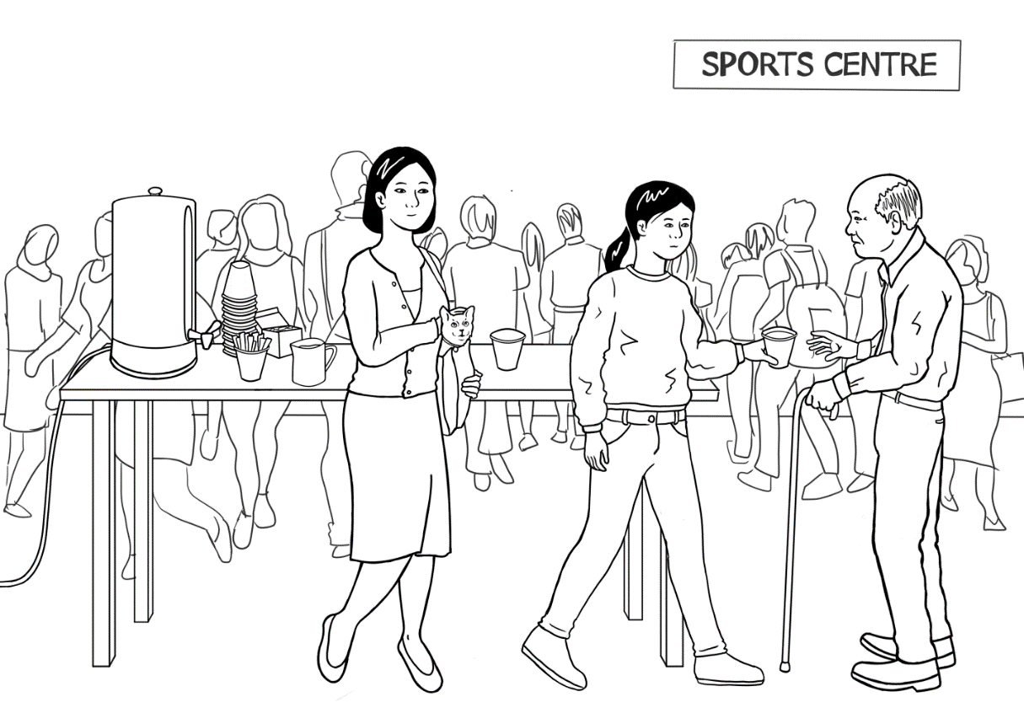

Appendix - Vocabulary list for Section 5
The new words introduced in this section are in bold.
A | a, afternoon, are |  | N | now
B | bag, big |  | O | OK**, Oh no**, on
C | car, centre, come, covers |  | P | pack
D | dangerous, door, drive, dry |  | Q | quickly
E |  |  | R | rains
F | family, fill, floods |  | S | safe, says, SES, small, sports, stop, Sunday
G | get, go, grandfather |  | T | that, the, through, to, tree, turn off*, TV
H | heater, her, home, hot,  hurry up* |  | U | unplug
I | it, in, is |  | V
J |  |  | W | water
K | knock |  | X
L | laptop, leave, look at* |  | Y
M | Mai, man, mother, mum, |  | Z
* hurry up, look at and turn off are phrasal verbs.
**Oh no - is an expression of alarm.
OK - is an expression of agreement

Appendix Pronunciation – voiced and unvoiced sounds

Preparation:
- You will need a box of tissues.
- Give each student a tissue.
Activity:
Demonstrate the sounds using the tissue and ask the students to imitate.
Voiceless sounds - p, k, t, f, s, th | Voiced sounds - b, g, d, v, z, th
Each sound is made with a puff of air.  Hold a tissue near your mouth as you say the letters. The tissue will move. | These sounds are made in your voice box.  Hold a tissue near your mouth as you say the letters. The tissue will not move.  Now, put 2 or 3 fingers on your throat, you can feel your voice box vibrating when you say the letters correctly,
Compare the voiceless and voiced sounds
Can you feel your throat vibrate when you say v and b?
- Put 2 or 3 fingers on your throat.
- Say fffffffff Say v
- Say p Say b

Practise saying the sounds and the words. Insert words in the spaces for k, v and z.
The sounds |  | The sounds
p | pack | b | bag
k |  | g | go, get
t | turn, to, tree, | d | door, drive
f | flood, family | v
s | says, small, Sunday, safe, stop, sports | z
th | through | th | that

The imperative form and a short play

The imperative form is used frequently during the story to give instructions. Many of the verbs are transitive and have an object similar to the ones below.
Activity 1: Warm up with a game of Simon Says to practice the imperative form.
Activity 2: Create the table below on the board and add to this list by using the pictures from the activity ‘What do we pack?’ in section 4. e.g. Get the torch.
Get the first aid kit. etc and using words from earlier sections such as river.

Verb | Object
Pack | a small bag.
Turn off | the TV.
Unplug | the TV.
Unplug | the heater.
Get | the laptop.
Get |   the torch.
Get |   the First Aid kit
Look at | that car.
Look at | the tree.
Look at | the river.
Stop | the car.
Activity 3: Read the list like a jazz chant.

Activity 4: The short play on the following page brings the story to life, recycles the language and gives students a chance to use and play with the language.
Adding movement aids memory and is especially important for some students. Before you begin, demonstrate what the word action means in the play.

Leave Now
Characters: The narrator, the SES man, mother, Mai, grandfather
The narrator | It rains on Monday, Tuesday, Wednesday, Thursday, Friday, Saturday and Sunday. The water covers the road, the footpath and the garden. It fills the river and floods the town. An SES man knocks (action) on the door on Sunday afternoon.
The SES man | “Pack a small bag. Leave now.” (action)
Mai | “Oh no! Mum!” (action)
Mother | “Hurry up. Pack the bag. (action) Turn off the TV. (action)  Now unplug the TV (action) and the heater. (action)  Go and get the laptop.” (action)
The SES man | “Come quickly. It’s dangerous. Leave now. Hurry.” (action)
The narrator | The family get into the car. (action)
Mother | “Is it OK to drive through the water? (action) Is it safe?”
Mai | “Oh no, look at that car!” (action)
Grandfather | “Oh no, look at the tree!” (action)
Mai | “Oh no, stop mum!” (action)
The SES man | “Stop. (action) The flood water is dangerous.  Drive to the sports centre.” (action)
The narrator | Mai and her family are safe at the sports centre. (action)

Appendix – Large size story pictures and text

The following activities recycle the language and should be done over several days.
Activity 1 - Matching exercise as a class #1
- Enlarge the following pages, both pictures and text, print, cut up and laminate if possible.
- Distribute the 10 pictures and ask students to arrange themselves in the story order in front of the class.
- Distribute the text to 10 students and ask them to match with the corresponding picture.

Activity 2 - Matching exercise as a class #2
- Distribute all pictures and text and students move round the class looking for a match. If there are more than 20 students, make duplicate copies so everyone has something to match.
- Pictures can be stuck on the wall later.

Activity 3 - Matching exercise in pairs
- Distribute an envelope with the smaller cut-up pictures and the text to each pair of students. (Envelope from previous activity - Listen and order the sentences, page 14)
- The students match and order the pictures and the text and then read the story. (Make sure you have enough materials so the students can work in pairs).

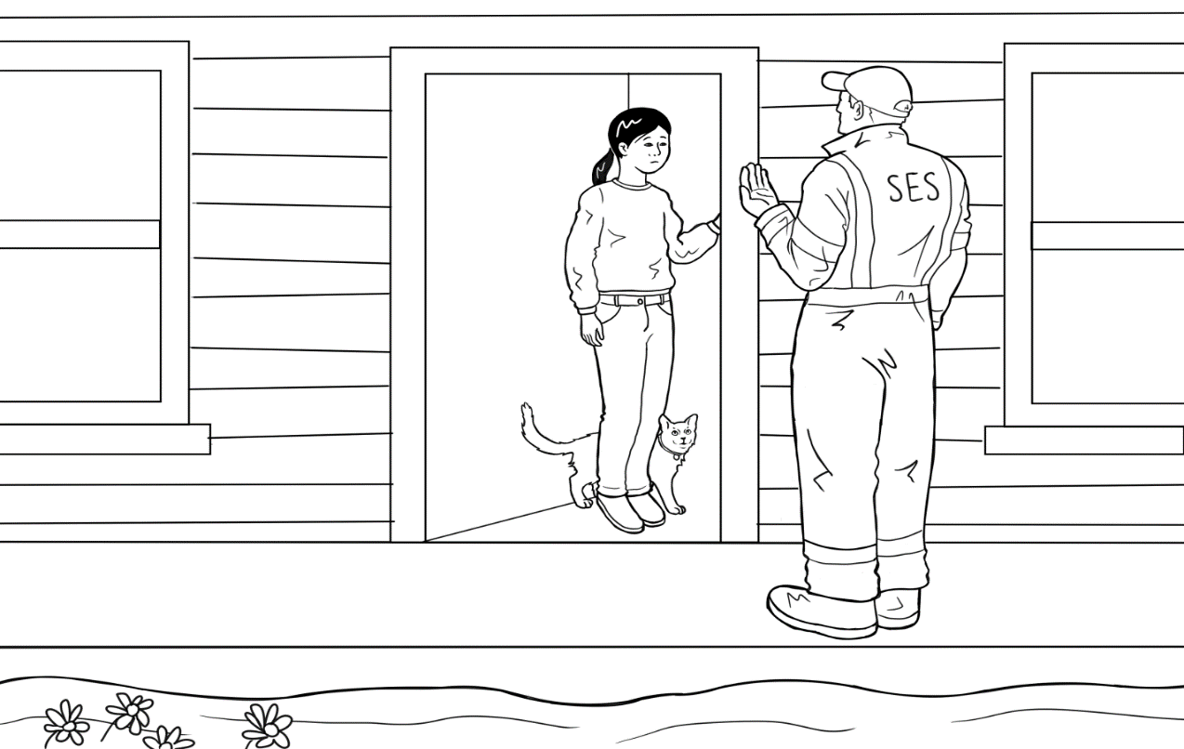

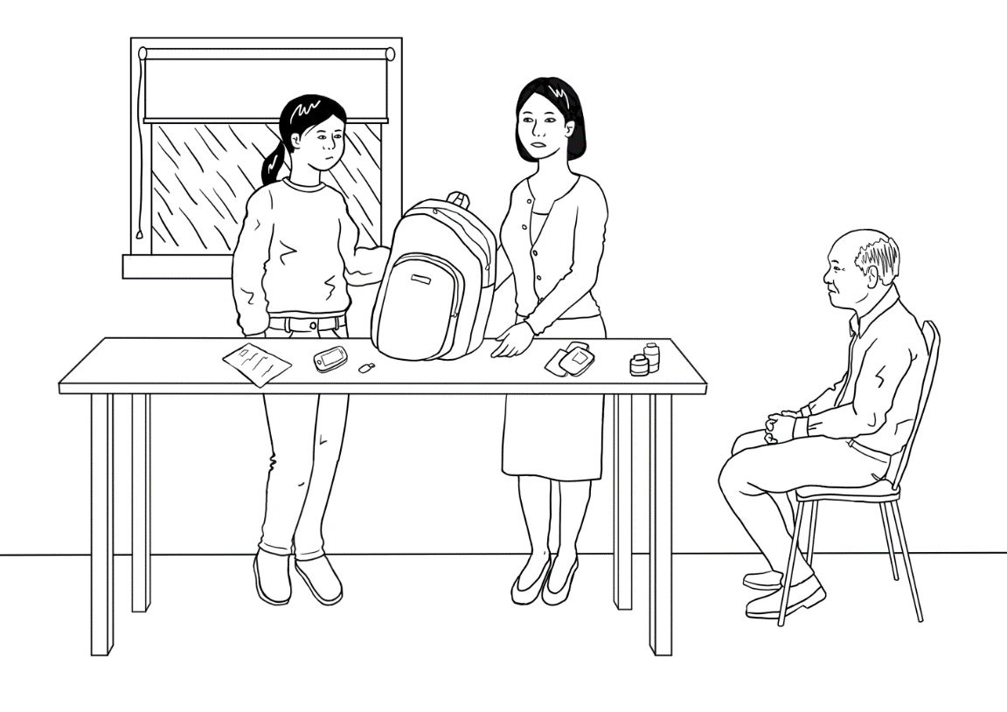

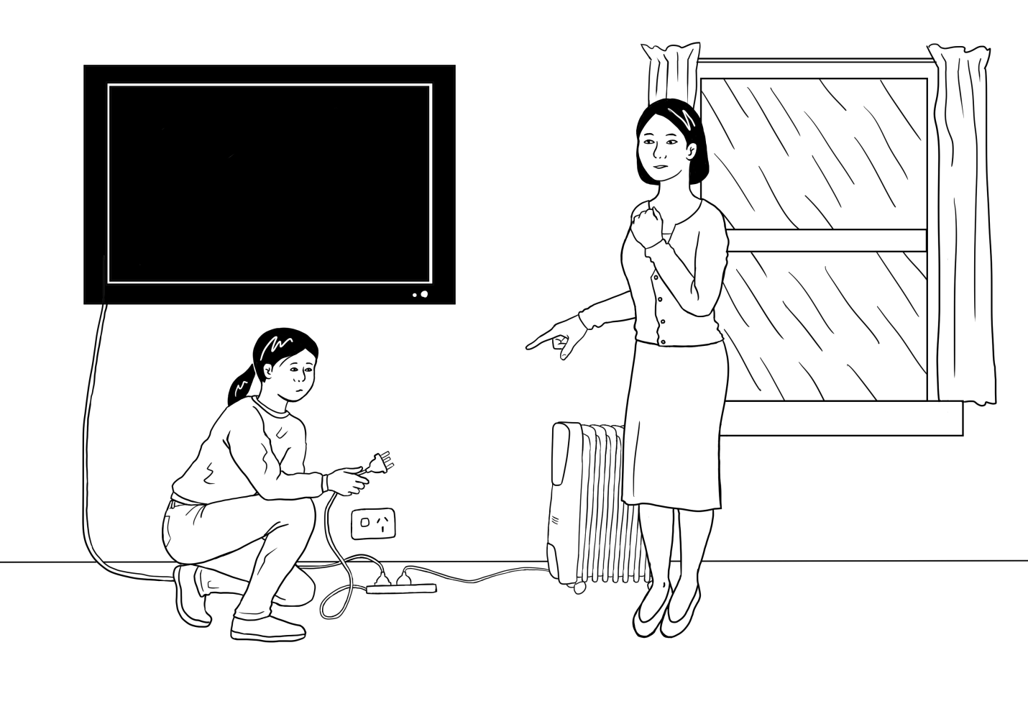
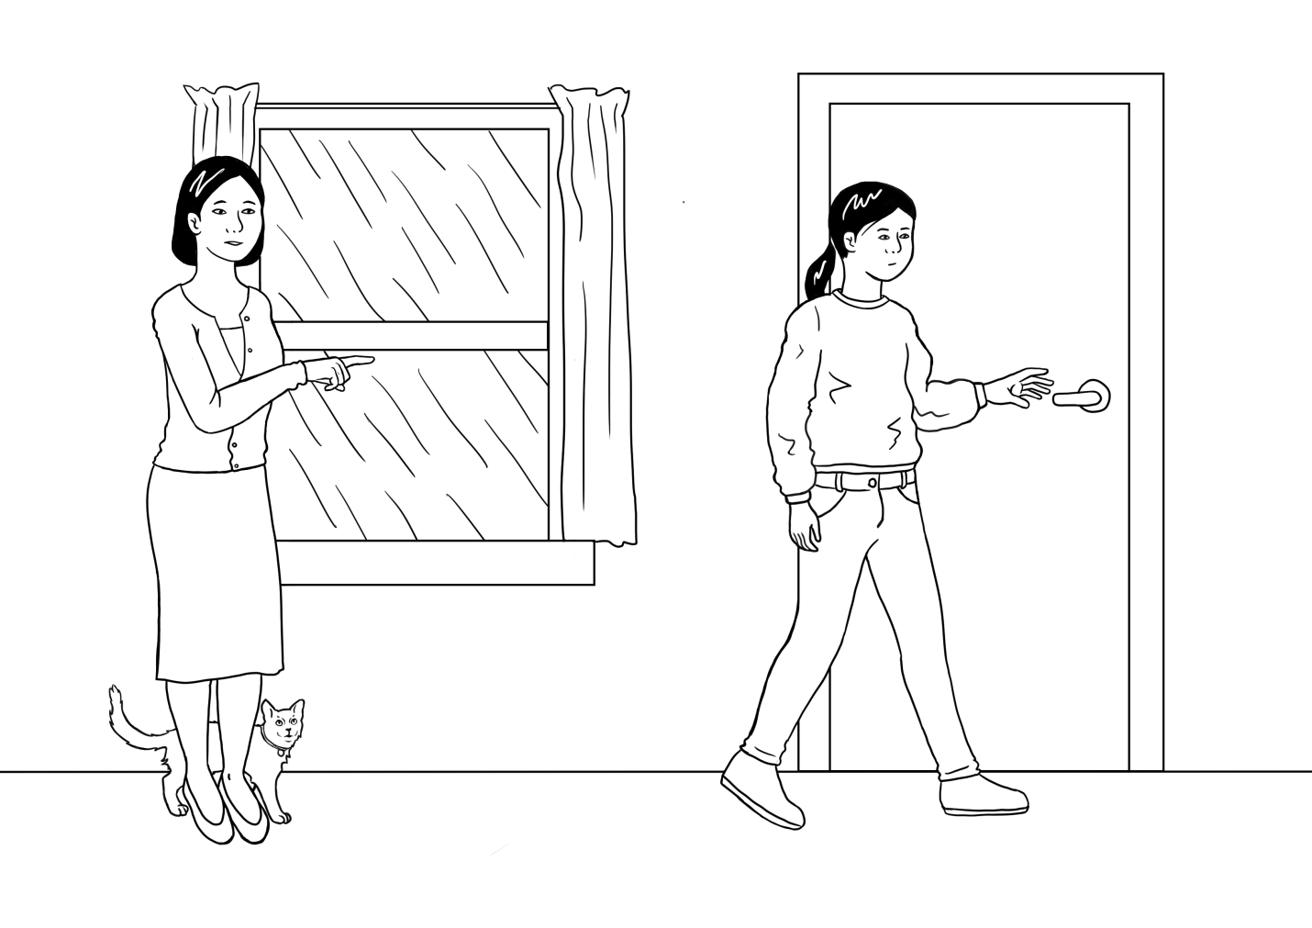
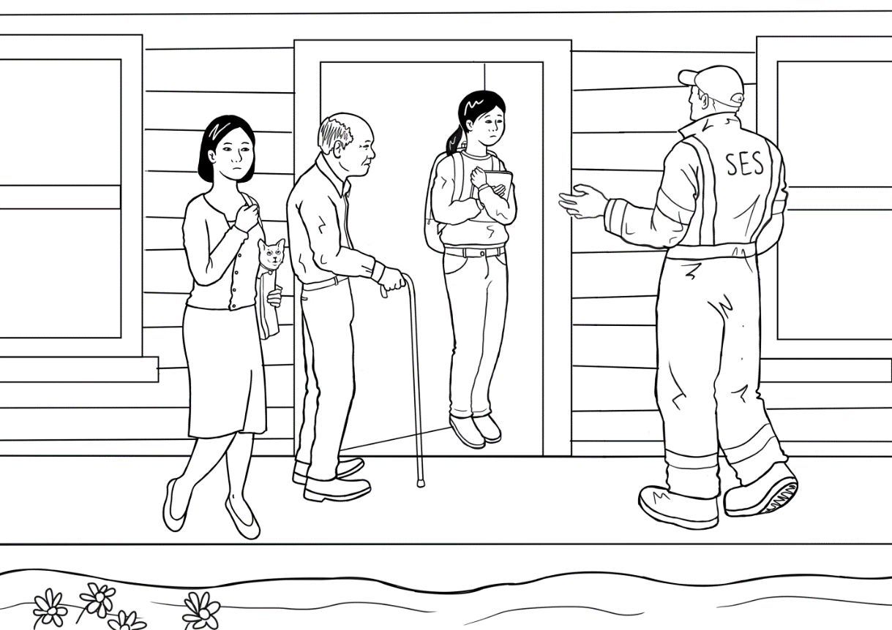

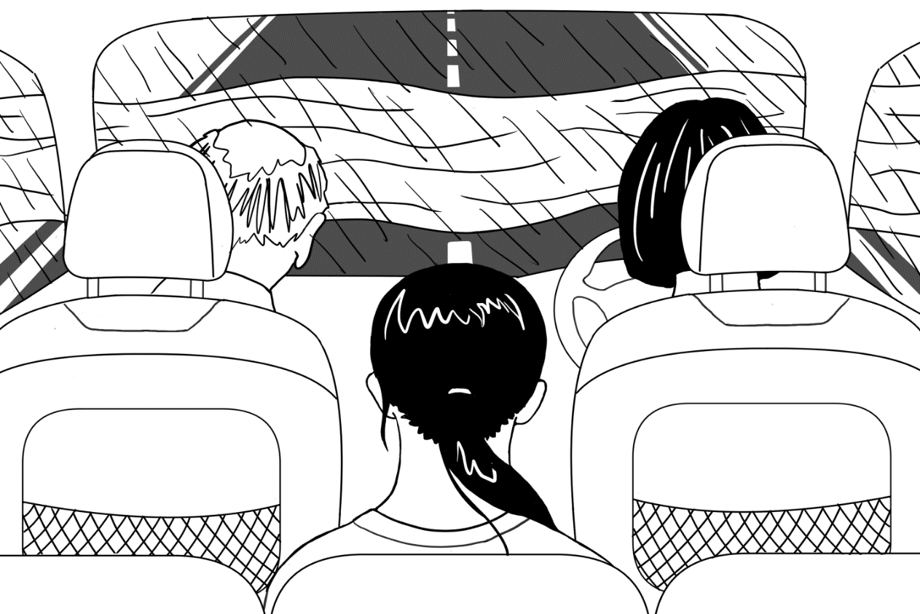

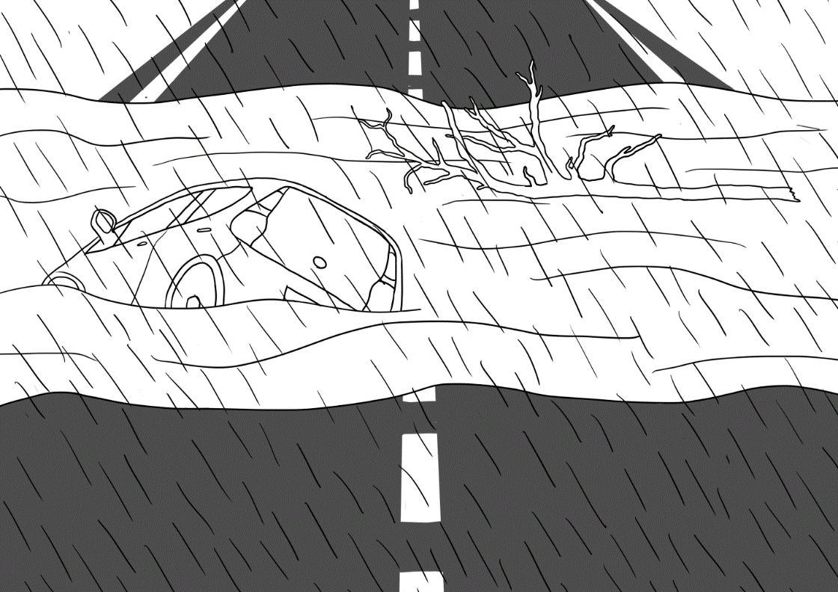

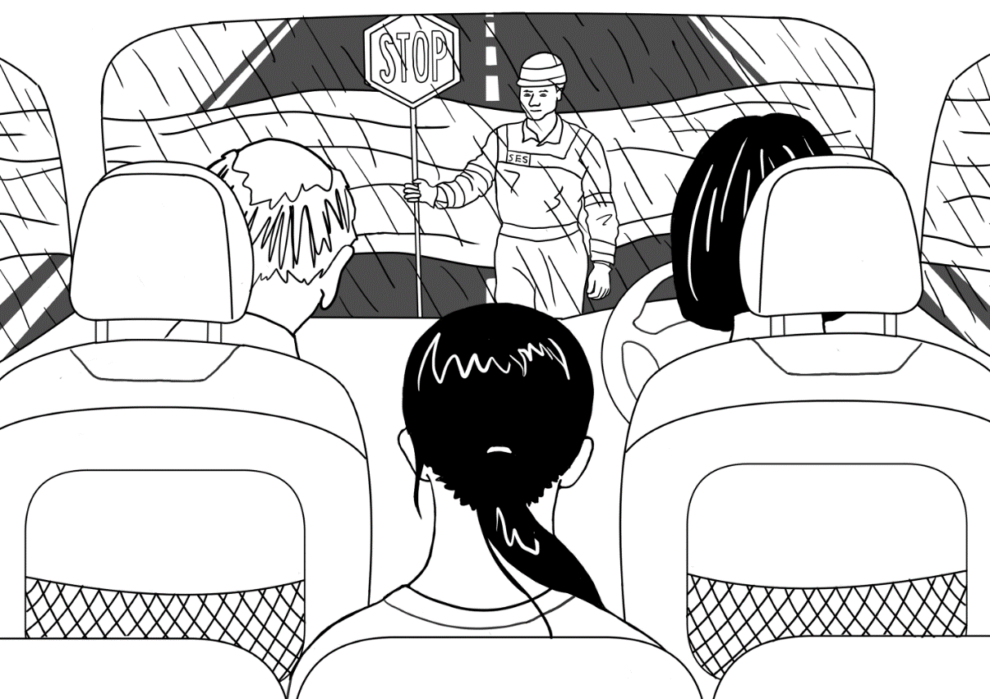

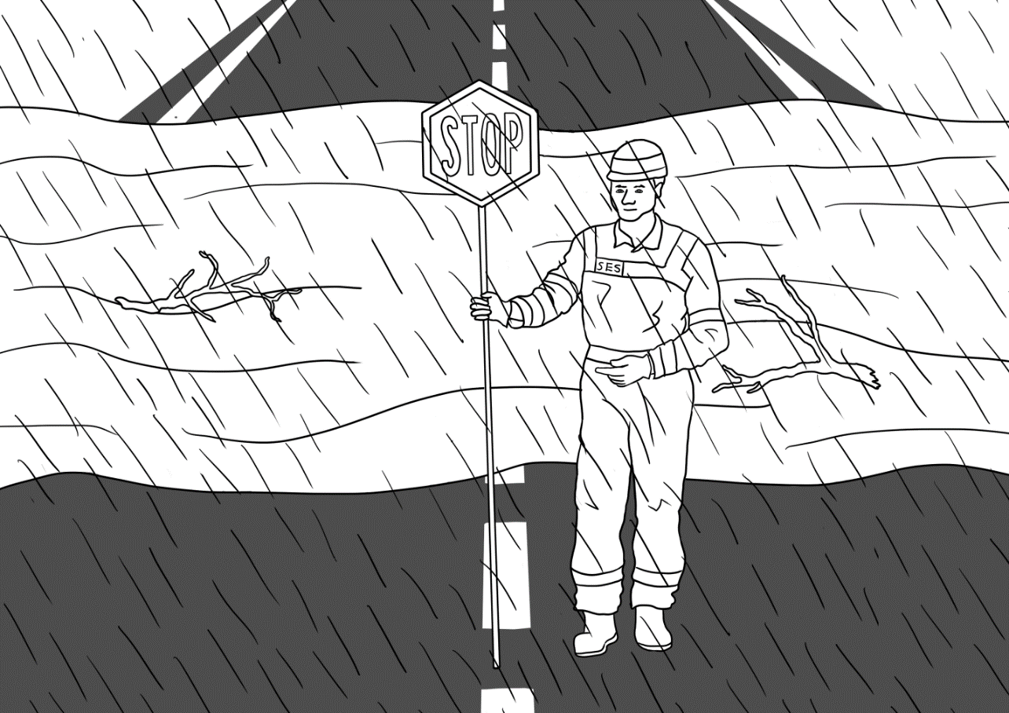

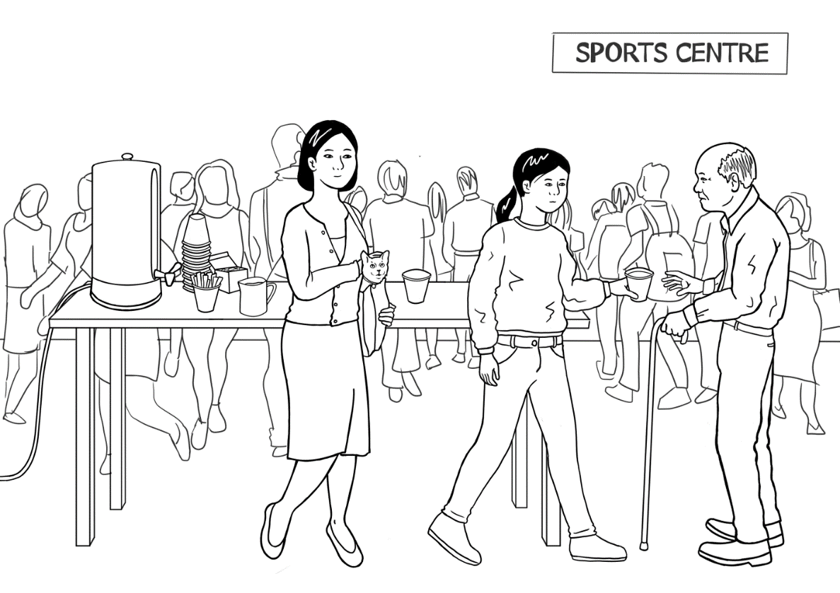

The SES man knocks on the door on Sunday afternoon.
The man says, “Pack a small bag. Leave now.”

Mother says, “Hurry up.
Pack the bag.”

“Turn off the TV. Now unplug the TV and the heater.”

“Go and get the laptop.”

The SES man says, “Come quickly.
It’s dangerous. Leave now.
Hurry.”

Mother says, “Is it OK to drive
through the water? Is it safe?”

Mai says, “Oh no, look at
that car!”
Grandfather says, “Oh no,
look at the tree!”

“Oh no, stop mum!”

The SES man says, “Stop.
The flood water is dangerous.
Drive to the sports centre.”

Mai and her family are safe
at the sports centre.

Appendix – The story at Level A

Some teachers with mixed classes like to make small books for the students at different levels. The following pages have been included to support this activity.

Levels B and C can be copied from pictures and text earlier in the section.

Level A - Leave Now
leave
 | pack
unplug
 | go and get
come | 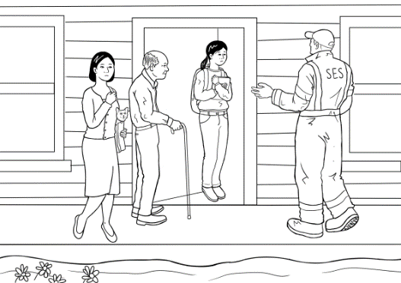
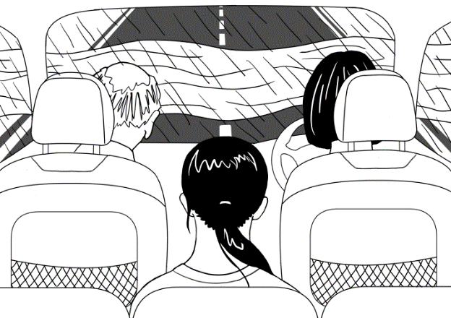 | drive
 | look
stop
 | stop
safe

Acknowledgements
Images
Person with Stop sign | This Photo by Unknown Author is licensed under CC BY-NC
Laptop | This Photo by Unknown Author is licensed under CC BY-NC
Sports Centre | This Photo by Unknown Author is licensed under CC BY-SA
Torch | This Photo by Unknown Author is licensed under CC BY-NC
First Aid kit | This Photo by Unknown Author is licensed under CC BY-NC

Project team
Vicki Hambling, Lorraine Hatcher-Friel, Sue Paull, Madelena Scott, Mary Wallace, Visual Domain
The Project Team would like to thank the AMEP Service Providers and practitioners who participated in the trial and gave valuable feedback.
This Floods Teaching Material is licensed under a Creative Commons Attribution-NoDerivs 3.0 Australia licence (More information is available here). You are free to use, copy and distribute to anyone in its original form as long as you attribute Department of Home Affairs as the author and you license any derivative work you make available under the same licence.
© Commonwealth of Australia 2021

With the exception of the Commonwealth Coat of Arms, the department’s logo, any material protected by a trade mark and where otherwise noted all material presented in this document is provided under a Creative Commons Attribution 4.0 International (https://creativecommons.org/licenses/by/4.0/) licence.
The details of the relevant licence conditions are available on the Creative Commons website (accessible using the links provided) as is the full legal code for the CC BY 4.0 licence (https://creativecommons.org/licenses/by/4.0/legalcode).
Use of all or part of this document must include the following attribution:-
© Commonwealth of Australia 2021
As far as practicable, material for which the copyright is owned by a third party will be clearly labelled. The department has made all reasonable efforts to ensure that this material has been reproduced in this document with the full consent of the copyright owners.
Copyright requests and enquiries concerning usage not addressed by the CC BY 4.0 licence should be addressed to:
comms@homeaffairs.gov.au at the Department of Home Affairs.
The terms of use for the Commonwealth Coat of Arms are available from the It's an Honour website.

Where a copyright owner, other than the Commonwealth, is identified with respect to this material, please contact that third party copyright owner directly to seek permission.



