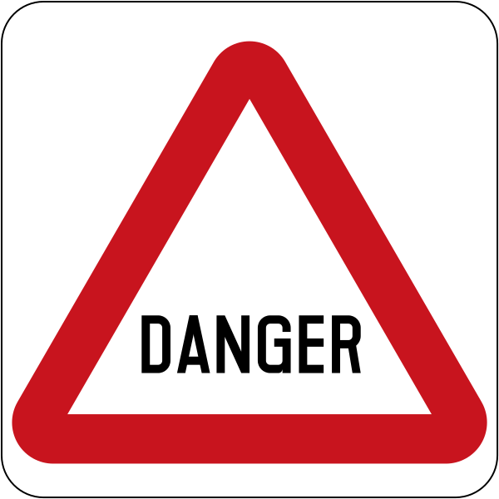

Section 6
Warning Signs and the Danger of Floods

Table of contents
The text for this section 3
Build vocabulary 4
Signs and photos to project when building vocabulary 9
Reading Signs - matching activity 15
Choose the correct sign – class activity 18
Spelling - 3 levels 19
Level A - Spelling 20
Level B – Spelling 21
Level C – Spelling 22
Dictation - 3 levels 23
Level A - Dictation 24
Level B - Dictation 25
Level C - Dictation 26
Pronunciation – Syllable stress in warnings 27
Speaking and listening – using the new vocabulary 28
Short Conversations 32
Warn another class about the danger of floodwater 33
Appendix - Vocabulary list for Section 6 37
Appendix – Additional information about floods 38
Acknowledgements 39

The text for this section

Stop!
Danger
Watch out.
Why?
Floodwater is dangerous.
No playing in floodwater.
No driving in floodwater.
No walking in floodwater.
No swimming in floodwater.

Floodwater is dirty.
Sometimes dead animals are in floodwater.
Sometimes spiders are in floodwater.
Sometimes snakes are in floodwater.
Sometimes electric wires are in floodwater.
Sometimes trees are in floodwater.

Build vocabulary

Project the signs and photos on pages 9 - 14 on the board. Explain their meanings with actions and images and build the vocabulary together. The words need to be introduced over a number of days and revised. Some words have been introduced in previous sections.

VOCABULARY | Board Work
Driving  Project the sign of the car driving on the board, and mime driving. Students will have learnt the word drive in Section 5. Elicit the word. | On the board, write  _ _ _ _ ing  Say the word slowly and ask students what letters they can hear. Write the letters as they call them out. Add any missing letters. Say the word together and spell it with the students. Point to each letter as you spell. Note the formation of g with the tail under the line and also the use of capital letters in signs.
No driving  Project the next picture on the board. Explain what the line across the car means if students are not familiar with it. | _ _ _ _ _ _ _ _ _  Repeat the process used to teach the word driving.
Walking  Project the image and mime walking. | _ _ _ _ _ _ _  Repeat the process used to teach the word driving.
No walking  Project the image and mime walking, but shake your head to indicate no. | _ _ _ _ _ _ _ _ _  Repeat the process used to teach the word driving.
Swimming  Project the image of swimming. Mime swimming. | _ _ i _ _ _ _ _  Repeat the process used to teach the word driving.
No swimming  Project the image. Mime swimming, but then shake your head to indicate no. | _ _ _ _ _ _ _ _ _ _  Repeat the process used to teach the word driving.
Playing  Show the sign with someone playing in water and see if students can guess - playing. | _ _ ay _ _ _  Repeat the process used to teach the word driving.
No playing  Ask students how to make the playing sign say ‘No playing”. Draw a line across the playing sign and indicate No playing. | _ _ _ _ _ _ _ _ _  Repeat the process used to teach the word driving.
Stop  Revise stop. Put your hand up to indicate stop. Ask students to clap, wave, walk, jump etc. then point to the sign for them to stop. Repeat several times. | _ _ _ _  Repeat the process used to teach the word driving.
Danger  Project the danger sign, and show some dangerous situations caused by floods in the photos that follow. Point to each photo and say danger. Mime the car driving towards the collapsed road, stop, look horrified and reverse backwards. Play parts of the 7News report and ask students to call out, ‘Danger!” at dangerous situations in the video.  https://www.youtube.com/watch?v=iSsq3Es37Kg | _ _ n _ er  Repeat the process used to teach the word driving.
watch out  Students will know the word watch from Section 4, but need to be shown that this phrasal verb is a warning, similar to danger and be careful. Use the word with students when there is a sudden dangerous situation. | _ at _ _ ou _  Repeat the process used to teach the word driving.
  why  Draw a stick figure with a question mark speech bubble, palms up and arms outstretched to explain the meaning. | _ h y  Repeat the process used to teach the word driving.
dirty  Teach this word with its opposite – clean. Make a lot of scribbles on the board and say dirty. Then clean them off and say clean. | _ ir _ y  Repeat the process used to teach the word driving.
animals  Show pictures of different animals, group them together and write the heading animals above the group. | _ _ i _ a _ _  Repeat the process used to teach the word driving.
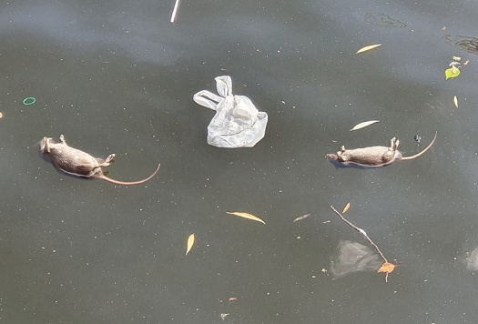  dead  Project the picture of dead animals. | _ e a _  Repeat the process used to teach the word driving.
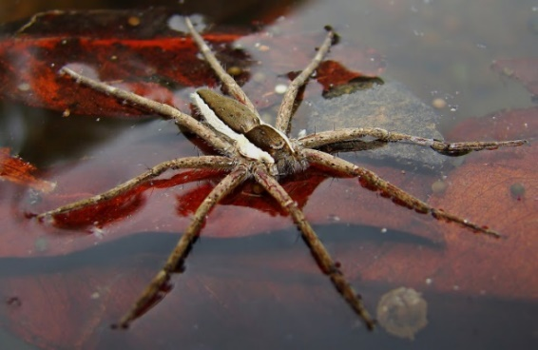  spider  Project or draw a picture of a spider. | _ _ _ _ e r  Repeat the process used to teach the word driving.
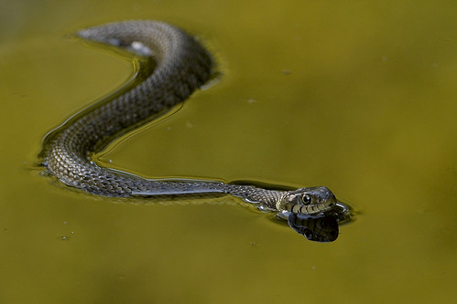  snake  Project or draw a picture of a snake. | _ _ _ _ e  Repeat the process used to teach the word driving.
electric wires  Project or draw some electric wires. Point to wires in the room.  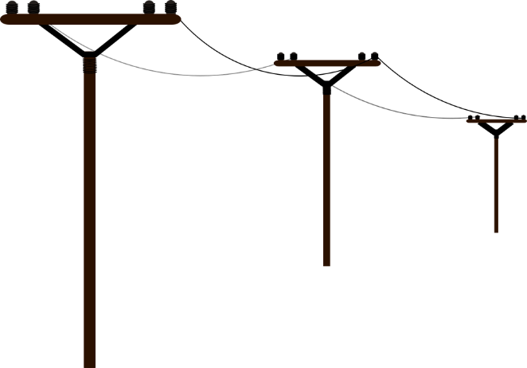 | e l e c _ _ i c _ _ r e s  Repeat the process used to teach the word driving.
this  Teach this word in comparison with that, which was introduced in Section 5. Point to a chair close to you and say ‘This chair’, and point then to a chair further away from you and say ‘That chair’. Point and refer to other objects in a similar way. | t h _ _  Repeat the process used to teach the word driving.

Signs and photos to project when building vocabulary
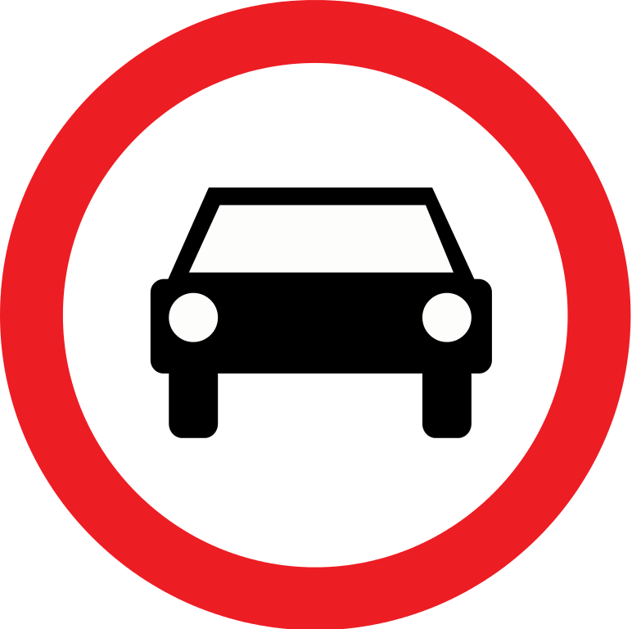
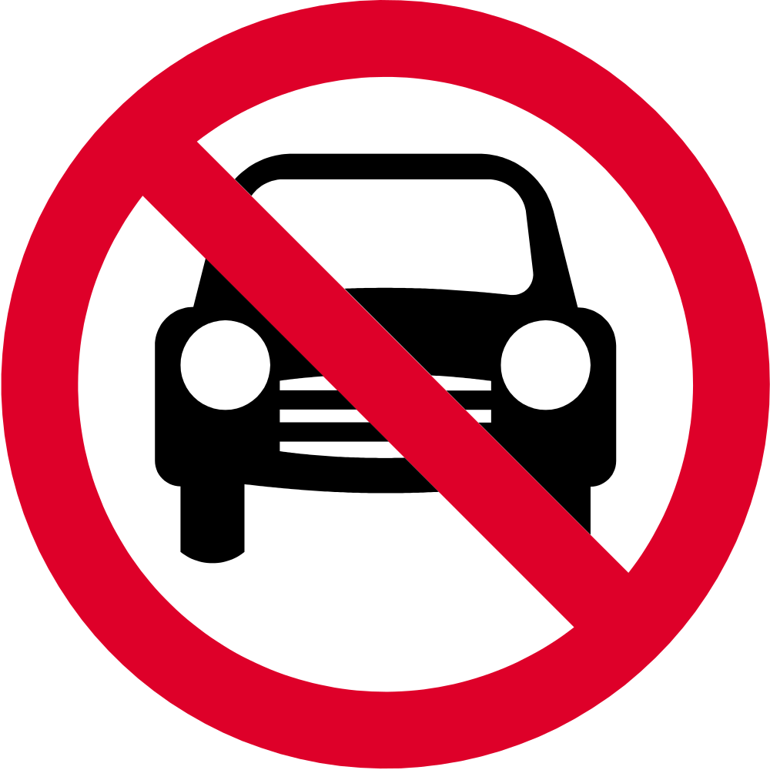
1.
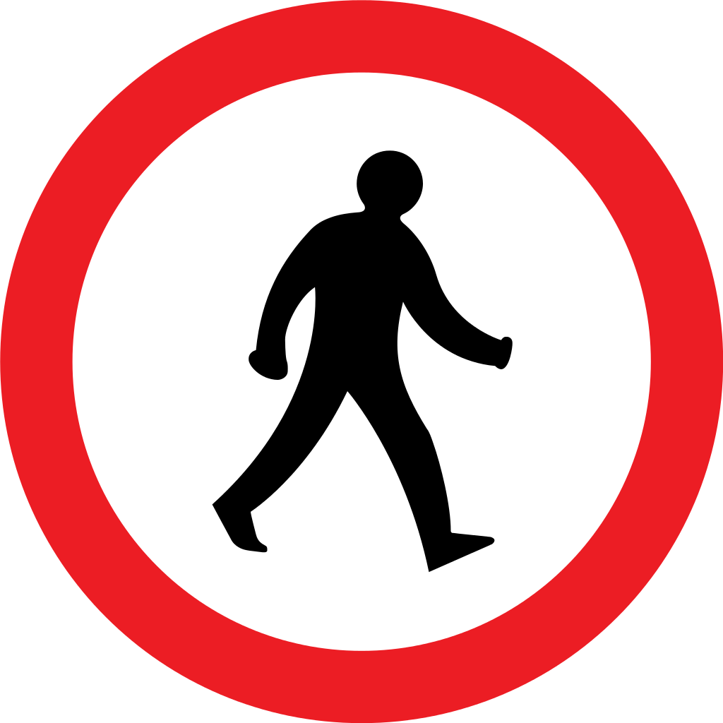
2.


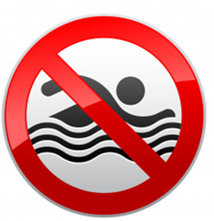
3.




4.


5.

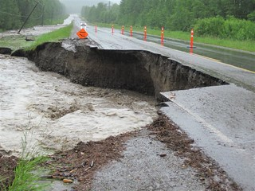
6.
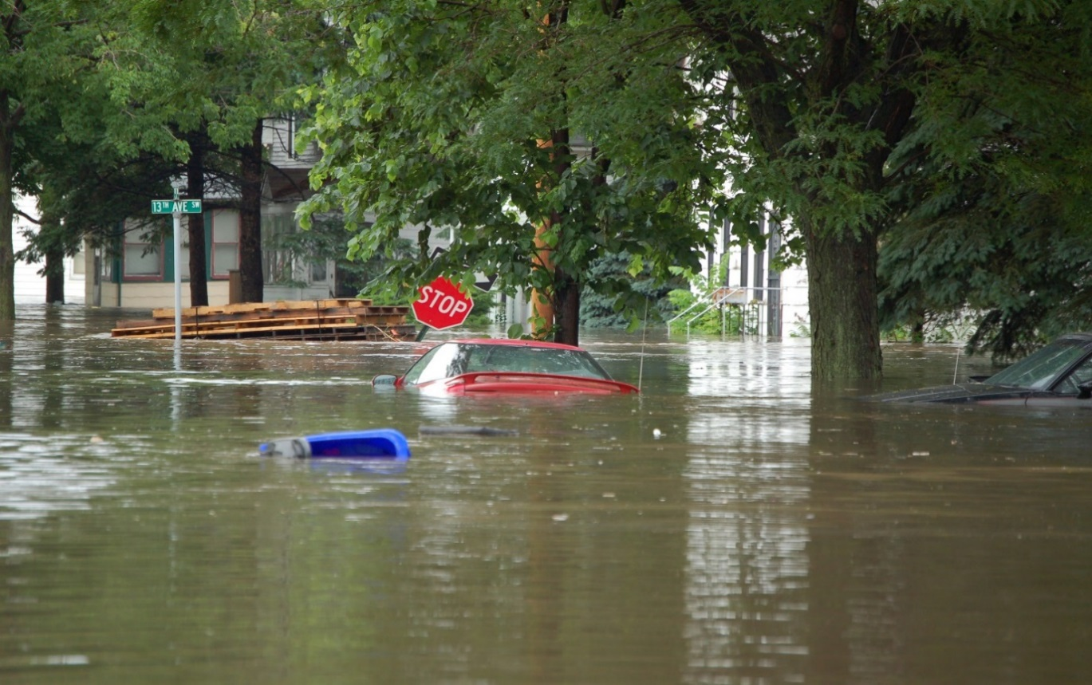

Reading Signs - matching activity

Preparation
- Copy pages with the signs and their meanings for cutting up.
Copy enough so that students can work in pairs.
- You will need a class set of scissors.

Activity
- The students cut up the signs with their meanings.
- The teacher randomly calls out the signs and the students put them
in the order they are mentioned.
- The teacher reads the signs one by one, and the students repeat.
- Once students are confident with the signs, they can cut the signs from
their meanings.
- In pairs, students help each other to match each sign with its meaning.
- Students point to each sign and say the word.
- Students mix up the signs and only one student in the pair does the matching.
- Repeat this with the second student doing the matching.

When completed, put the cut up signs and words into envelopes for later use.

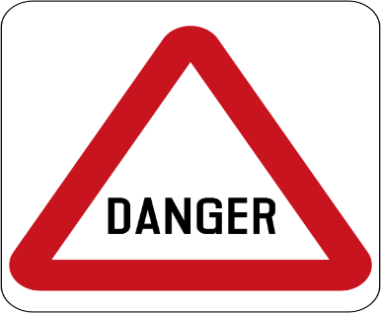 | Danger
 | Playing
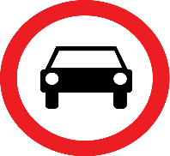 | Driving
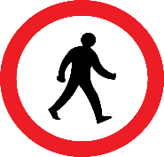 | Walking
 | Stop

 | Swimming
 | No playing
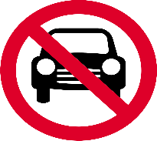 | No driving
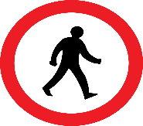 | No walking
 | No swimming

Choose the correct sign – class activity

Project the photo and the signs and invite students to come out to the board tick the signs
they might find near floodwater.

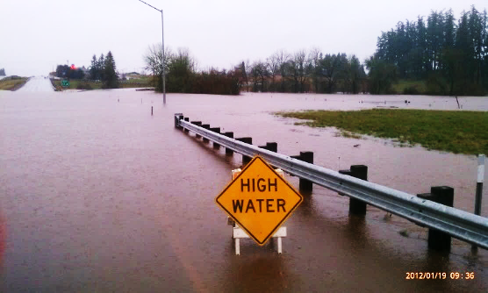
Floodwater
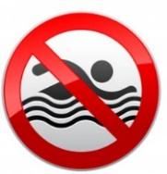 |  | 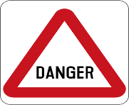 | 
 |  |  | 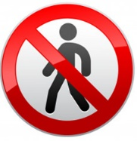

Spelling - 3 levels

Instructions for the teacher

- For lower levels use a modified version of ‘Look, say, cover, write, check’.
Teach: Look, say the word out loud, spell the word out loud as you copy.
Higher level students can ‘Look, say, cover, write, check’.

- It is important that the students:
- Finish one word before writing the next word
- Work down the page rather than across.
- Check their spelling with the typed word.
- Try to chunk the letters rather than copy letter by letter.
- The words are printed twice at each level so that students practise once in class and then again at home or in a following class. In this way, students are shown one way
to improve their writing through brief and regular practice.

Level A - Spelling

playing | driving
playing | driving

walking | swimming
walking | swimming

Level B – Spelling

playing | driving

walking | swimming

Level C – Spelling

playing | driving | walking
 | 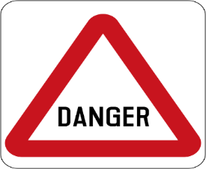
swimming | danger | stop

Dictation - 3 levels

Danger
No playing in flood water
No walking in flood water
No swimming in flood water
No driving in flood water

Activity
All students hear the same text:
The teacher reads a warning, and each student writes the warning at their own level.

Level A
Students listen to the teacher and point to each word as the teacher reads.
They copy the missing letters under the original word.

Level B
Students listen to the teacher, find the phrase and copy it on the lines below. The warnings are not in order.

Level C
Students listen to the teacher and write, but can check their spelling as they go. Higher level students can fold the words under and test themselves only looking at the words when necessary.

Level A - Dictation

Danger
Dang _ _
No playing in floodwater
No play_ _ _ in floodwater
No driving in floodwater
No driv_ _ _ in floodwat_ _

No swimming in floodwater
No swim_ _ _ in floodwat_ _
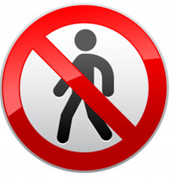 | No walking in floodwater  No walk_ _ _ in floodwat_ _

Level B - Dictation

Danger | in floodwater
No driving | No playing
No swimming | No walking

____________________________________________________________________________________________________________________________________________________________________________________________________________________________________________________________________________________

Level C - Dictation

___________________________________________________________________________________________________________________________________________________________________________________________________________________________________________________________________________________
Fold

danger | in | driving
floodwater | walking | swimming
playing | no

Pronunciation – Syllable stress in warnings

Because of their urgency, more syllables are stressed in warnings than in normal speech.
Activity:
Project the jazz chant onto the board. Chant and clap the stronger stress.
Warning | Stress pattern
Danger!

Watch out!

Floodwater!

No driving!
No swimming!

No walking!
Danger! Watch out!

Speaking and listening – using the new vocabulary

Activity 1 – Additional dangers of floodwater.
- Show some news stories to the students to help explain this message. If the links don’t work, copy them into your browser.
- As you watch, stop the videos at different times to point out different dangers and encourage students to use the language they have learnt to express what they see.
https://www.youtube.com/watch?v=pMMrDRZX_Ss&t=1s | Floodwaters can have snakes, spiders and wildlife.
https://www.huffpost.com/entry/australia-spiders-snakes-flooding_n_60594b63c5b6d6c2a2a97957 | There are a number of videos on this site which help explain the dangers of flood water. The last video shows how fast the water is and how a car can be swept away.

Activity 2 – Vocabulary matching
- Project the pictures on the following pages and elicit the vocabulary for each picture.
- These pictures and words could also be enlarged, cut out and used for a class matching exercise on the board.

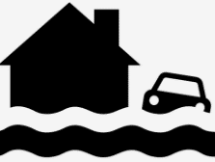 | Floodwater is dangerous.
 | dead animals
 | a spider
 | a snake
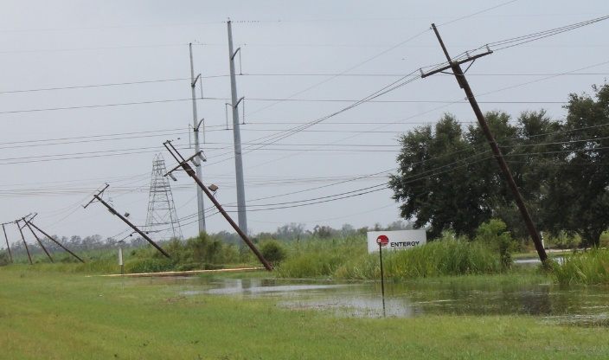 | electric wires
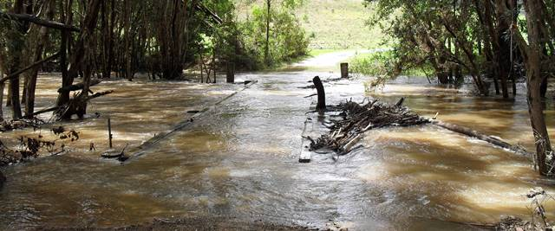 | trees
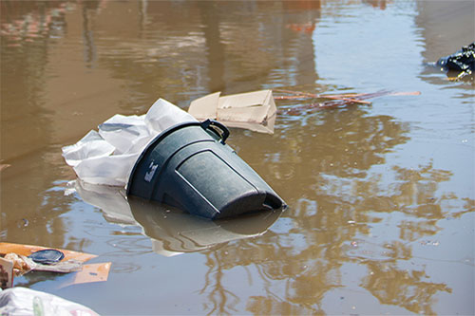 | dirty water

Short Conversations
Activity
- Divide the class into two groups - A [White] & B [Blue]
- Read the conversations together as a class and later in pairs. Make it a little dramatic
and emphasise the key words in bold.
Conversations
1 | A | Floodwater is dangerous.
1 | B | Why?
1 | A | Sometimes trees are in floodwater.
2 | A | Floodwater is dangerous.
2 | B | Why?
2 | A | Sometimes electric wires are in floodwater.
3 | A | Floodwater is dangerous.
3 | B | Why?
3 | A | Sometimes snakes and spiders are in floodwater.
4 | A | Floodwater is dirty and dangerous.
4 | B | Why?
4 | A | Sometimes dead animals are in floodwater.

Warn another class about the danger of floodwater
These oral activities help build student confidence to use the language in different contexts
and outside the classroom.
Activity 1: PPT - Recycle the vocabulary
Download the PPT from the hub.
- Project the PPT in slide show mode. The animation feature will reveal the words slowly to build each sentence.
- The forward arrow on your keyboard will make the pictures and words appear in order. The back arrow will remove the words and pictures.
- Click Escape anytime to close.
- Encourage students to guess the words before they appear.

PPT
Revision
Warning Signs


Activity 2: Prepare to share information with another class
- Distribute the envelopes with the cut-ups from 3 - Reading the signs matching activity
- The students match the signs and their meanings.
- Project the master sheet on the next page to check the matching.
- Students return the cut-ups to the envelopes.
- Project the prompt sheet Floodwater is dangerous. Why? [Page 36]
- Practise the warnings as a class together. Choose confident students to read different warnings.
- Give students a copy of the prompt sheet
- Practise in pairs.

Activity 3: Share information about the dangers of floodwaters with another class
Students need to take the prompt sheet and the envelope with cut-ups to the other class. The master sheet on the next page could be projected if necessary.
- Organise the students into groups of four – two from each class, with weaker students matched with stronger students.
- Students match the signs and their meanings again and explain their meanings to the students in the other class.
- The students use the prompt page to explain the dangers of floodwater to the other students.

Encourage students in both classes to tell friends and neighbours about the dangers of floodwater.

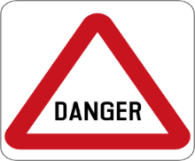 | Danger
 | Playing
 | Driving
 | Walking
 | Swimming
 | No playing
 | No driving
 | No walking
 | No swimming
 |  | Floodwater is dangerous.

Why?
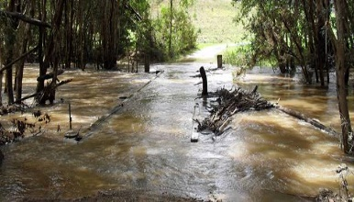

Sometimes trees are in floodwater.

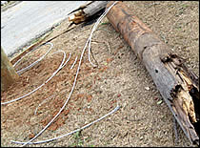

Sometimes electric wires are in floodwater.

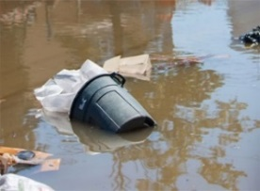
Floodwater is dirty.
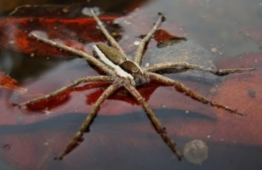

Sometimes spiders are in floodwater.

Sometimes snakes are in floodwater.
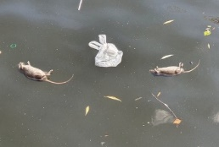
Sometimes dead animals are in floodwater.

Appendix - Vocabulary list for Section 6
Words introduced in this section are in bold.

A | animals, are |  | N | no
B |  |  | O
C | can |  | P | playing
D | driving, danger, dangerous, dead, dirty |  | Q
E | electric |  | R
F | flood, floodwater |  | S | swimming, stop, spiders, snakes, sometimes
G |  |  | T | this, trees
H |  |  | U
I | In, is |  | V
J |  |  | W | walking, water, wires,  *watch out
K |  |  | X
L |  |  | Y
M |  |  | Z
*watch out is a phrasal verb

Appendix – Additional information about floods

The Health Translation website is an online library which enables those working with culturally and linguistically diverse communities to easily find free translated information on health and other general topics.
- Flood information in many languages
Copy this link into your web browser: https://www.healthtranslations.vic.gov.au/bhcv2/bhcht.nsf/PresentDetail?Open&s=FloodSafe_(audio_file)_
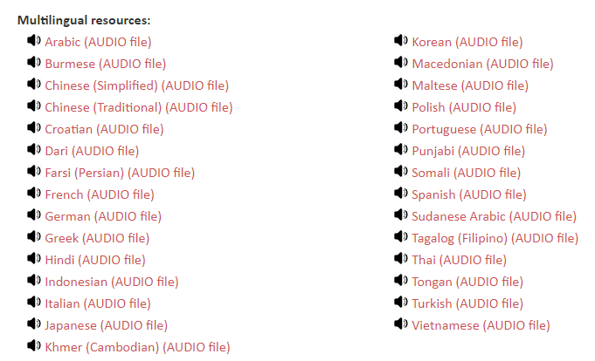
If the link is broken, try going to:
- Health Translations
- Topics
- Emergency
- Click on: view the whole list of resources on the topic of Emergency.
- Click on Floodsafe Fact Sheet to download information written in other languages
- Click on Floodsafe Audio File to listen to the fact sheet read in other languages.

Acknowledgements
Images
Collapsed road | This Photo by Unknown Author is licensed under CC BY-NC-ND
Car submerged in water | This Photo by Unknown Author is licensed under CC BY-SA
Driving sign | This Photo by Unknown Author is licensed under CC BY-SA
No driving sign | This Photo by Unknown Author is licensed under CC BY-SA
Walking sign | This Photo by Unknown Author is licensed under CC BY-SA
No walking sign | This Photo by Unknown Author is licensed under CC BY-SA
Swimming sign | This Photo by Unknown Author is licensed under CC BY-SA
No swimming sign | This Photo by Unknown Author is licensed under CC BY-SA
Playing sign | This Photo by Unknown Author is licensed under CC BY-SA
No playing sign | This Photo by Unknown Author is licensed under CC BY-SA
Figure with a question mark | This Photo by Unknown Author is licensed under CC BY-NC
Stop sign | This Photo by Unknown Author is licensed under CC BY-SA
Danger sign | This Photo by Unknown Author is licensed under CC BY-SA
High water | "High water on road" by OregonDOT is licensed under CC BY 2.0
Dead mice | This image was originally posted to Flickr by Rolf Dietrich Brecher at https://flickr.com/photos/104249543@N07/48460862406 (archive).  It was reviewed on 30 August 2019 by FlickreviewR 2 and was confirmed to be licensed under the terms of the cc-by-2.0.
rubbish | https://www.cdc.gov/nceh/toolkits/floods/default.html
Drawing of telegraph poles | This Photo by Unknown Author is licensed under CC BY-SA
electrical wires | This Photo by Unknown Author is licensed under CC BY-NC-ND
spider | This Photo by Unknown Author is licensed under CC BY-NC-ND
snake | This Photo by Unknown Author is licensed under CC BY-NC-ND

Project team
Vicki Hambling, Lorraine Hatcher-Friel, Sue Paull, Madelena Scott, Mary Wallace, Visual Domain

Acknowledgements
The Project Team would like to thank the AMEP Service Providers and practitioners who participated in the trial and gave valuable feedback.
This Floods Teaching Material is licensed under a Creative Commons Attribution-NoDerivs 3.0 Australia licence (More information is available here). You are free to use, copy and distribute to anyone in its original form as long as you attribute Department of Home Affairs as the author and you license any derivative work you make available under the same licence.
© Commonwealth of Australia 2021

With the exception of the Commonwealth Coat of Arms, the department’s logo, any material protected by a trade mark and where otherwise noted all material presented in this document is provided under a Creative Commons Attribution 4.0 International (https://creativecommons.org/licenses/by/4.0/) licence.
The details of the relevant licence conditions are available on the Creative Commons website (accessible using the links provided) as is the full legal code for the CC BY 4.0 licence (https://creativecommons.org/licenses/by/4.0/legalcode).
Use of all or part of this document must include the following attribution:-
© Commonwealth of Australia 2021
As far as practicable, material for which the copyright is owned by a third party will be clearly labelled. The department has made all reasonable efforts to ensure that this material has been reproduced in this document with the full consent of the copyright owners.
Copyright requests and enquiries concerning usage not addressed by the CC BY 4.0 licence should be addressed to:
comms@homeaffairs.gov.au at the Department of Home Affairs.
The terms of use for the Commonwealth Coat of Arms are available from the It's an Honour website.
Where a copyright owner, other than the Commonwealth, is identified with respect to this material, please contact that third party copyright owner directly to seek permission.




