
Student book with teacher notes

English Ready
22638VIC Certificate 1 in EAL
VU23500 Plan language learning with support

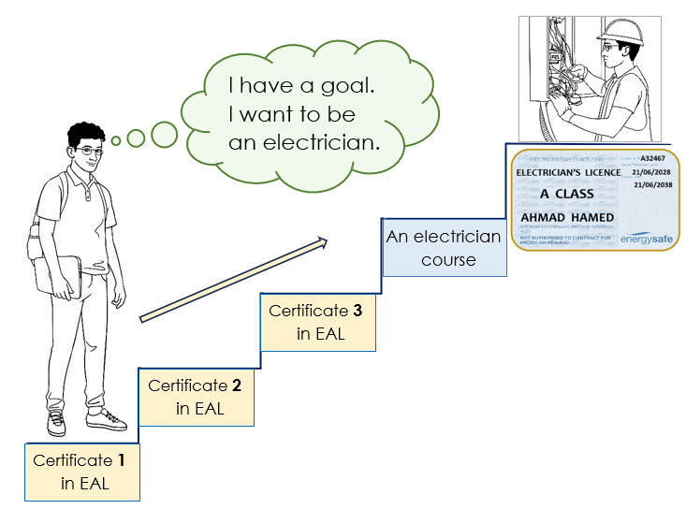
Student Workbook

Student _______________________________________________________
Teacher _______________________________________________________
Class ________________________________________________________
Date ________________________________________________________

Design team: Vicki Hambling, Sue Paull, Frida Dean and Mary Wallace
Illustrations: Madelena Scott

Illustrations acknowledgements:
CFA logo: This Photo by Unknown Author is licensed under CC BY-SA

Acknowledgements: The design team would like to thank the AMEP service providers and practitioners who participated in the trial and gave valuable feedback. The team would also like to acknowledge the use of the EAL Framework which underpins the design of this book.

___________________________________________________________________________
Copyright of the EAL Framework is reserved to the Crown in the right of the State of Victoria. © State of Victoria (Department of Education and Training) 2023.
Use of all or part of this document must include the following attribution:
© Commonwealth of Australia 2024

With the exception of the Commonwealth Coat of Arms, the department’s logo, any material protected by a trade mark and where otherwise noted all material presented in this document is provided under a Creative Commons Attribution 4.0 International (https://creativecommons.org/licenses/by/4.0/) licence.
The details of the relevant licence conditions are available on the Creative Commons website (accessible using the links provided) as is the full legal code for the CC BY 4.0 licence (https://creativecommons.org/licenses/by/4.0/legalcode).
As far as practicable, material for which the copyright is owned by a third party will be clearly labelled. The department has made all reasonable efforts to ensure that this material has been reproduced in this document with the full consent of the copyright owners.
Copyright requests and enquiries concerning usage not addressed by the CC BY 4.0 licence should be addressed to: comms@homeaffairs.gov.au at the Department of Home Affairs.
The terms of use for the Commonwealth Coat of Arms are available from the It's an Honour website.
Where a copyright owner, other than the Commonwealth, is identified with respect to this material, please contact that third party copyright owner directly to seek permission.



This workbook is designed to be used with the support of a teacher.

Table of Contents
1. Introduction 2
2. Meet the students and teachers. 3
3. What helps you learn English? 4
4. Sometimes there’s a problem. 6
5. Ahmad’s plan 8
6. Parwana’s plan 10
7. Ko’s plan and your plan 12
8. At the end – What helped you learn? 16
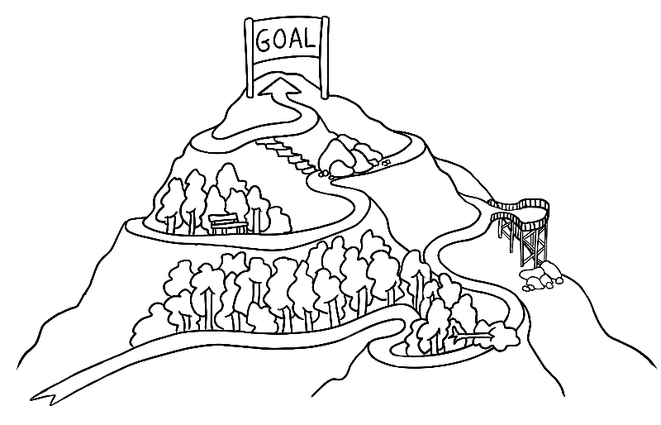

Introduction
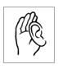
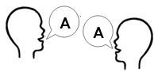
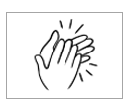
Listen, repeat, clap, mime each instruction for students to imitate.
PPT
Workbook instructions
       | - listen |  | - say
 | - repeat |  | - clap
 | - ask questions | 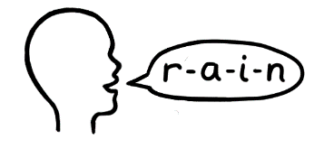 | - spell
 | - match | 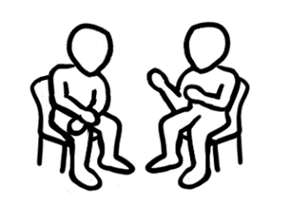 | - *work with a partner
 | - read | 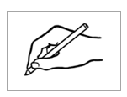 | - write  * Work with a partner  = speak or read  aloud in pairs
 | - copy |    | - circle
 | - tick |  | - highlight
See Teacher resources for ways to practise these expressions.
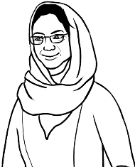

Yes, I understand.
Do you understand?
Are you OK?


No, I don’t understand.

Can you say it again please?


don’t = do not
No. Can you help me please?

Could you speak slowly please?
* Work with a partner
= speak or read aloud
with a partner

Meet the students and teachers.
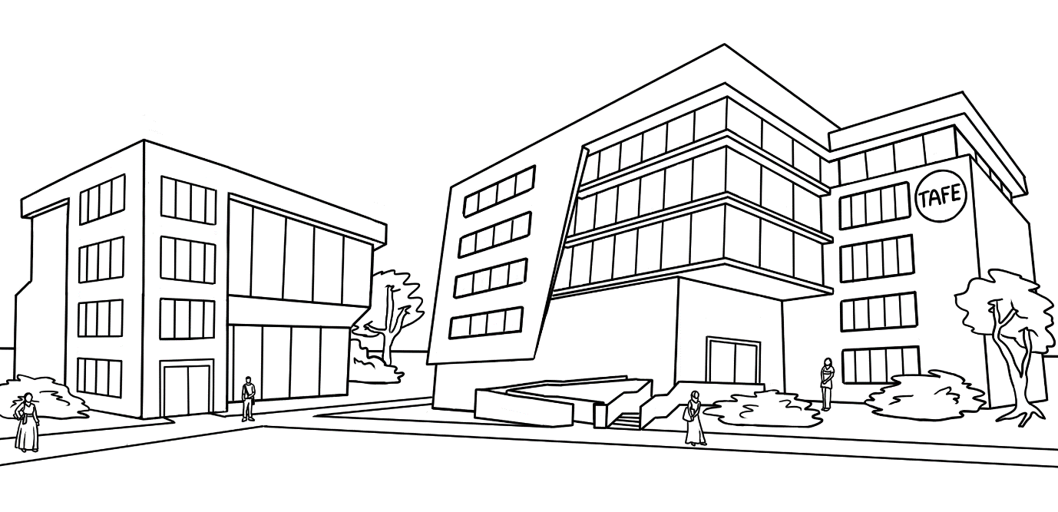
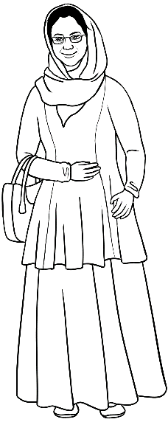




Peter
Amina
Basam
Ahmad
At the
AMEP
Centre

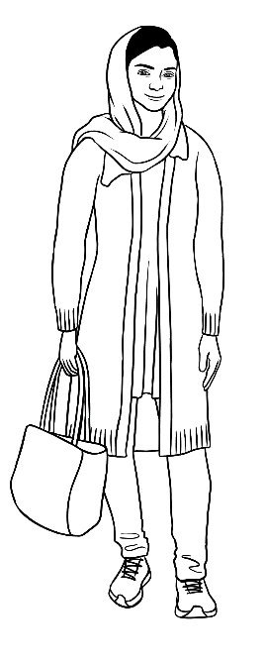
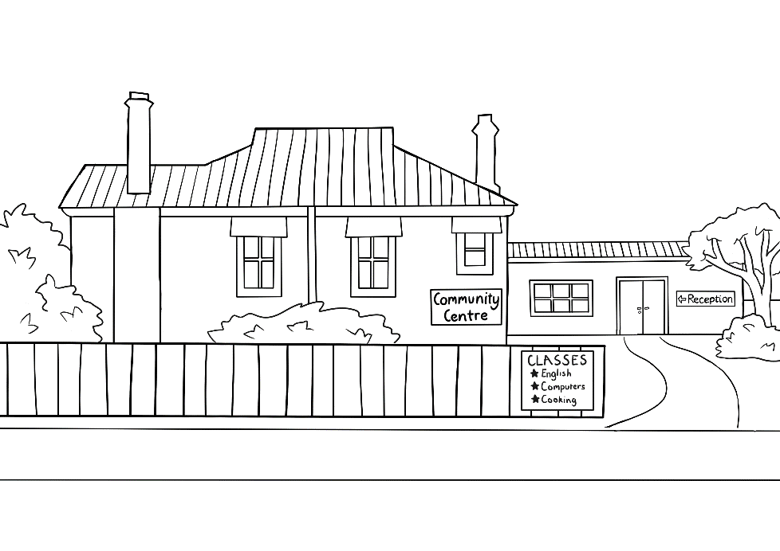
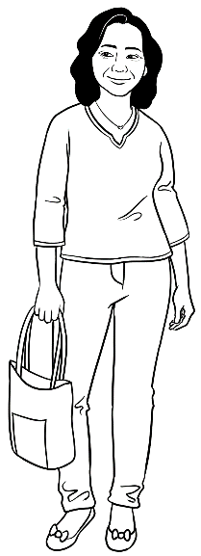
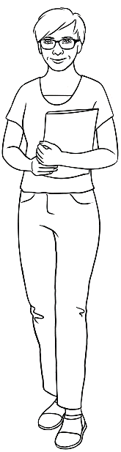
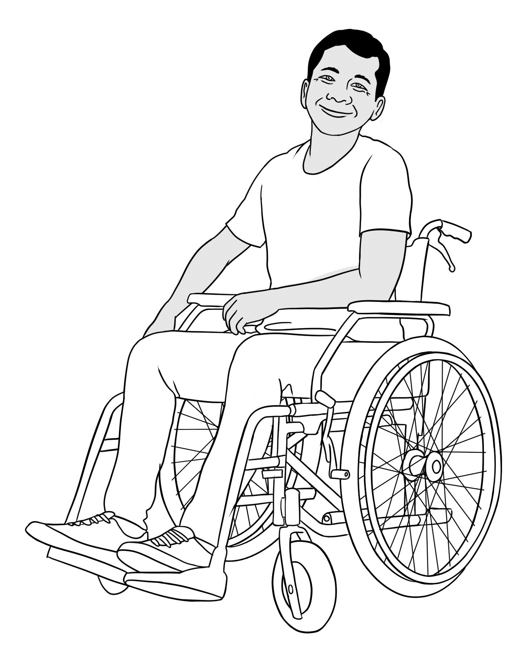

Parwana
Wendy
Linh
Ko
At the Learning Centre

What helps you learn English?
Ask students, What helps you learn English in class? Brainstorm and write ideas about effective ways to learn English in class on the board.

Cut up the cards in the Teacher Resources and distribute a set of 9 in-class cards to each pair of students. Students read the cards aloud and suggest new ideas from the cards to add to the brainstorm on the board.

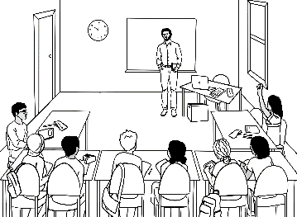
On the mind map, students write ways to learn English
in class, selecting ideas from the board and the cards.

Learn in class
___________________________________________________________________________
2
___________________________________________________________________________
3
___________________________________________________________________________
4
___________________________________________________________________________
5
___________________________________________________________________________
6
___________________________________________________________________________
7
___________________________________________________________________________
8
___________________________________________________________________________
9
Get to class early.
1

Ask students, What helps you learn English outside class? Brainstorm and write ideas about effective ways to learn English outside the class on the board.

Cut up the cards in the Teacher Resources and distribute a set of 9 outside-class cards to each pair of students. Students read the cards aloud and suggest new ideas from the cards to add to the brainstorm on the board.

On the mind map, students write ways to learn English
outside class, selecting ideas from the board and the cards.


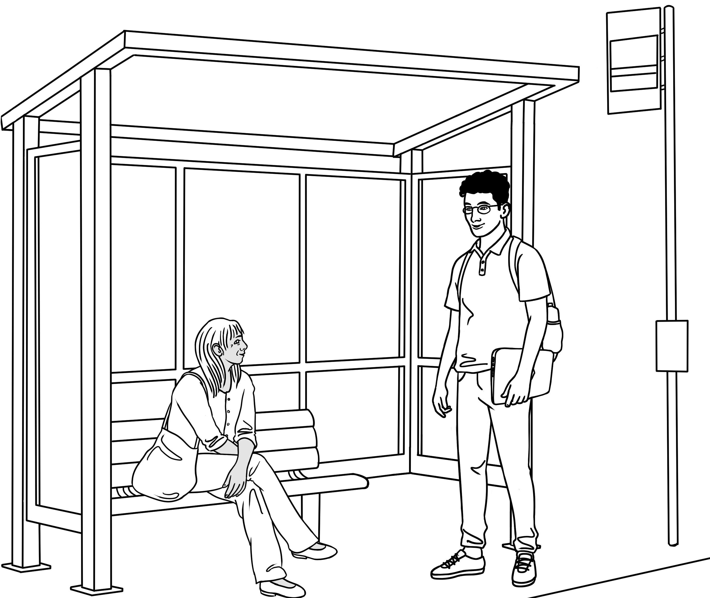
___________________________________________________________________________
2
___________________________________________________________________________
3
___________________________________________________________________________
4
___________________________________________________________________________
5
___________________________________________________________________________
6
___________________________________________________________________________
7
___________________________________________________________________________
8
___________________________________________________________________________
9
Study at home.
1
Learn
outside class

Sometimes there’s a problem.
Students often find it difficult to identify barriers to learning and possible solutions. Tahiil’s story can open a discussion about this. The story can be projected and read together as a class, then later read in pairs.
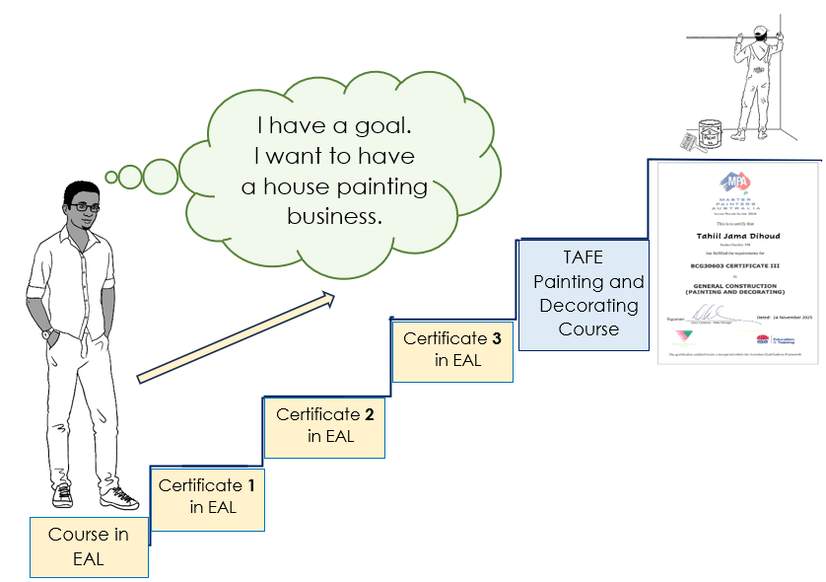
Tahiil had a plan.

1 | Tahiil studied English two nights a week. | 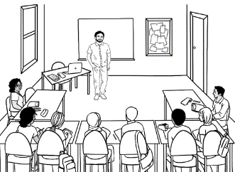
2 | 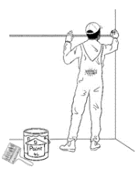  He worked with a house painter  five days a week.
3 |   He took care of his family.
4 | 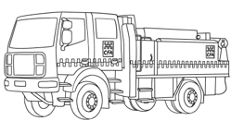    He was a volunteer fireman.

Three months later, Tahiil had a problem.
1 | 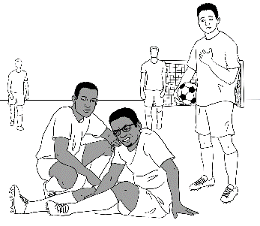  Tahiil had an accident at soccer  and broke his foot.
2 | 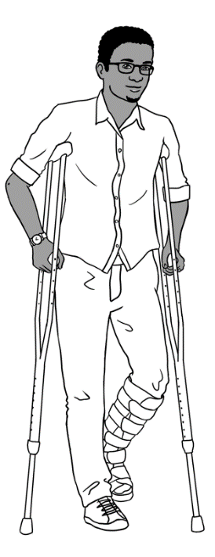  He couldn’t work or go to English class  for eight weeks.

Tahiil had a solution.
1 | 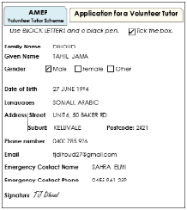  He filled out a form for a volunteer tutor.
2 | 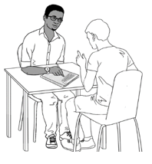  A tutor came to his house every week.
3 |     His brother-in-law helped him  use AMEPOnline.
4 |   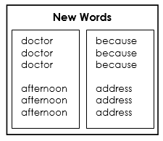  He read and wrote new words  in his notebook.
5 | 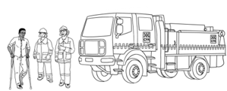  He talked to the volunteer firemen.

Tahiil had a goal and a plan, so his English improved.
TR *Current barriers may include: Childcare, class times, transport problems, lack of sleep, own or family illness, work, lack of confidence, disparate learners in same class, lack of bilingual support, casual learning style in Aust, lack of sleep, class too hard/ too fast, past trauma, sadness, relationship/money issues

Ahmad’s plan
AMEP students are entitled to have a number of documents such as qualifications translated free within the first two years after visa approval. It is important students are made aware of this and also that not all qualifications will be recognised.


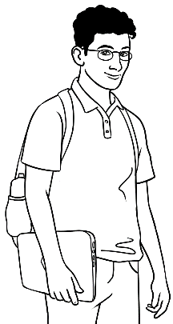
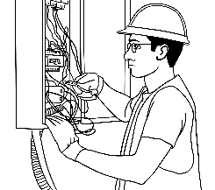
What’s your future
goal Ahmad?
A learning plan will help you get to your goal. I can help you too.
Thanks Peter.
I want to be
an electrician.

1. | Where do you come from Ahmad? |   I come from Syria.
2. | Did you work in your country?  Do you have a qualification?  Is it translated into English? |   Yes. I was an electrician.  Yes I do.  Yes it is.
3. | Did you go to school  in your country? | Yes. I went to school for 10 years.
4. | You’re learning English now. Did you learn English in your country? | Yes. I learnt some English in school.
4. | Did you learn English  in Australia? | No. This is my first class in Australia.
5. | What skills do you have? |   I can use a computer.  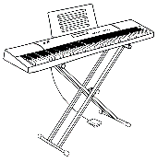  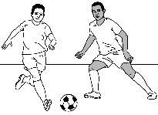  I can play the piano.  I can play soccer.

6. | What is your future goal? | 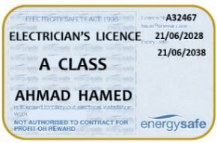  I want to finish Certificate 3 in EAL.  Then I’ll do an electrical course  so I can work as an electrician.
7. | What do you want to improve in this class? |   Speaking, reading and writing.  
8. | What helps you improve in class? | 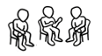    I speak with my classmates.  I ask questions.      I copy new words  into my notebook.
9. | What helps you improve outside class? | 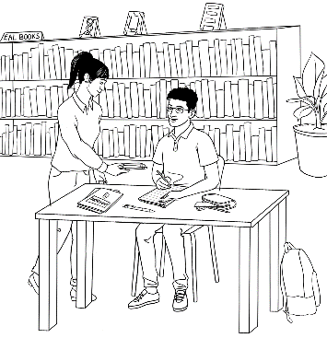  I borrow books and  study in the library.  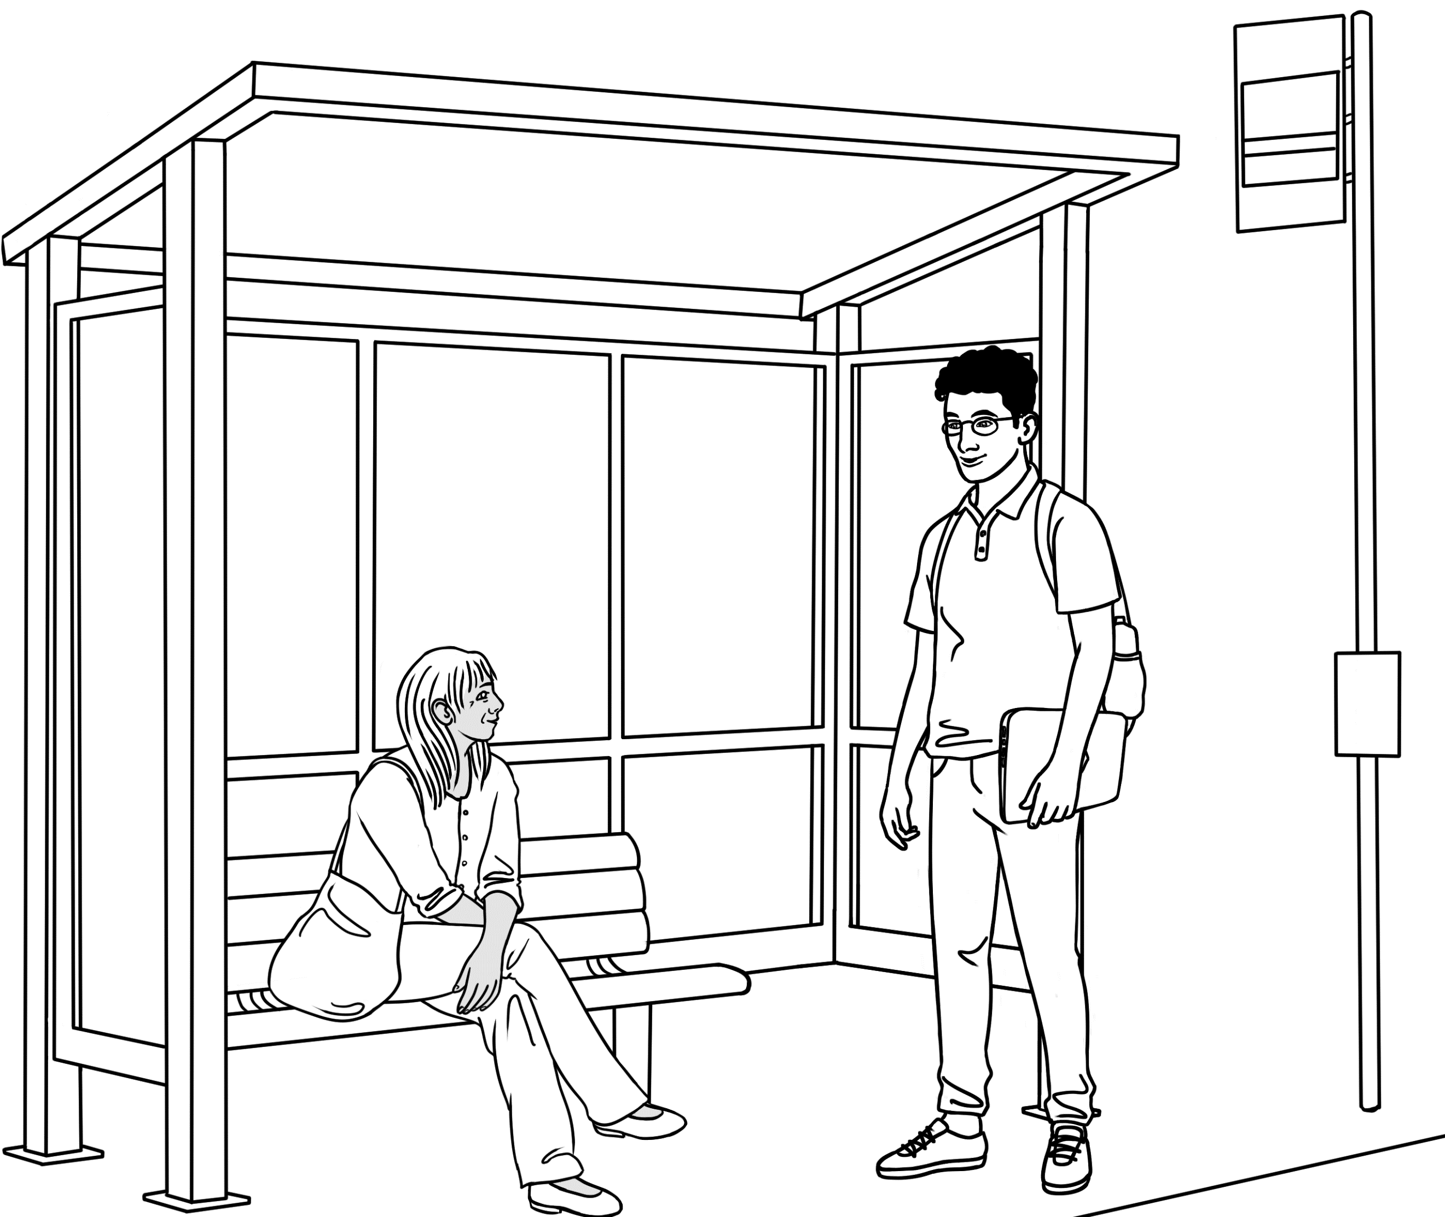  I try to talk to new people.    I use AMEPOnline.  I write new words many  times in my notebook.
10. | What could make your learning difficult?  What is the solution? | 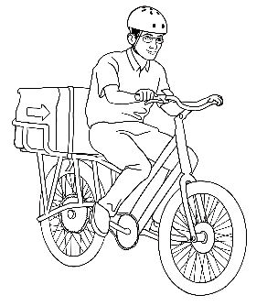  I work on the weekend  delivering pizza.  I study English after class  everyday.

Parwana’s plan

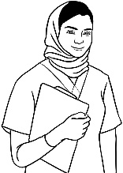
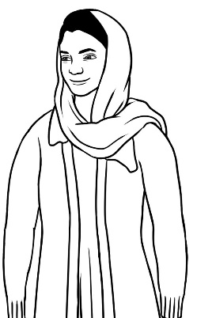

I want
to be
a nurse.
What’s your future
goal Parwana?

A learning plan will help you get to your goal. I can help you too.
Thank you
Wendy.

1. | Where do you come from Parwana? |   I come from Afghanistan.
2. | Did you work in your country? |   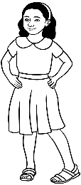  No. I was at home  with my children.
3. | Did you go to school  in your country?  Do you have a certificate?  Is it translated? | Yes. I went to school for 12 years.  Yes I have a certificate.  No. It isn’t.
4. | You’re learning English now.  Did you learn English  in your country? | No, I didn’t.
4. | Did you learn English  in Australia? | 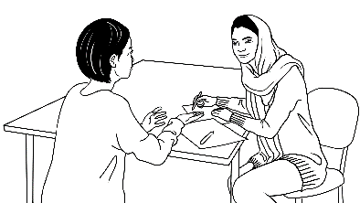  Yes. I learnt English  with a volunteer tutor.
5. | What skills do you have? | I can speak two languages.    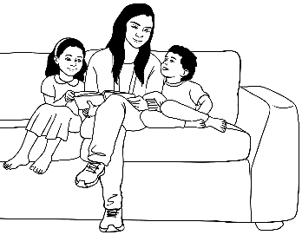  I can sew.  I can read easy English  books to my children.

6. | What is your future goal? | 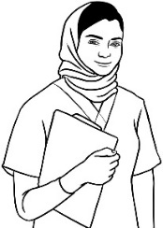  I want to finish Certificate 3 in EAL.  Then I want to study nursing.    Speaking and listening.
7. | What do you want to improve in this class?
8. | What helps you improve in class? | 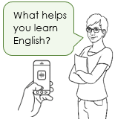  I talk with my friends.  I record the teacher.  I ask questions.
9. | What helps you improve outside class? | 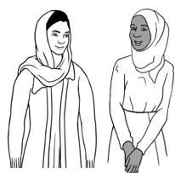  I talk with my tutor  and my neighbours.  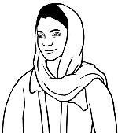  I practise saying new words.  difficult, difficult, difficult    I listen to my teacher and repeat.  What helps you learn English?  What helps you learn English?
10. | What could make your learning difficult?  What is the solution? | 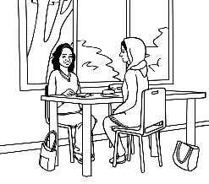  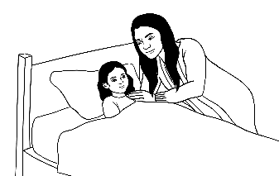  Sometimes my children are sick  so I can’t go to class.  Linh helps me catch up  on class work.

Ko’s plan and your plan
The information students add to the table below could be a useful guide for the completion of their learning plan.
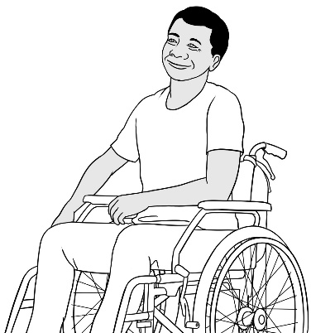

What’s your
future goal Ko?
A learning plan
will help you get
to your goal.
I can help you too.
I want to repair computers.
Thank you Wendy.
What about you?
What’s your future goal?

I want to _________________
______________________________

Teacher |  | Ko | You
1. | Where do you come from? |   I come from Myanmar. | I come from ____________________________.

2. | Did you work  in your country?  Do you have a qualification? | 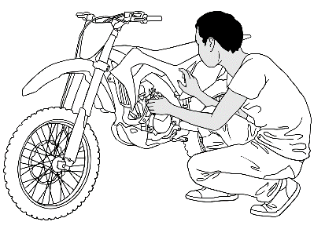  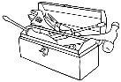  Yes. I was a motorbike mechanic.  No, I don’t. | Yes. I was a ______________________________.  No, I didn’t work.  Yes, I have a qualification.  No, I don’t have a qualification.
3. | Did you go to school in your country? | Yes. I went to school for 8 years. | Yes. I went to school for ______ years.  No, I didn’t go to school.
4. | You’re learning English now.  Did you learn English in your country? | No, I didn’t. | Yes. I learnt for ______ months/years.  No, I didn’t learn English.
4. | Did you learn English in Australia? | Yes. I learnt English for six months  last year. | Yes. I learnt for ______ months/years.  No, I didn’t learn English in Australia.

5. | What skills do you have? | 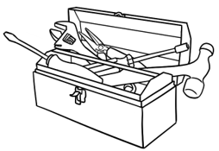  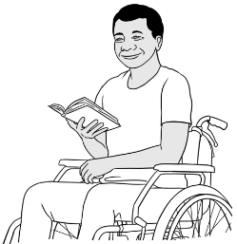  I can fix motor bikes.  I can use a computer.  I can read  in my language. | I can _________________________________________  I can _________________________________________  I can _________________________________________
6. | What is your future goal? |   I want to finish Certificate 3 in EAL.  Then I need to work.  I want to repair  computers. | I want to ___________________________________  _________________________________________________  _________________________________________________
7. | What do you want to improve in this class? | Computer skills, reading  and speaking.   |   

8. | What helps you improve  in class? | 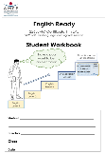  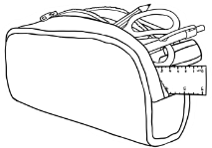  I come prepared  for class.  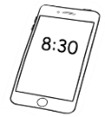  I come to class early  and talk to my friends.  I copy new words  into my notebook. | _________________________________________________  _________________________________________________  _________________________________________________  _________________________________________________  _________________________________________________
9. | What helps you improve outside class? |   I borrow books and use  the computers at the library.  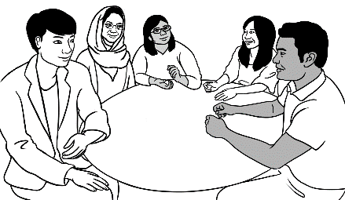  I go to a conversation  group.  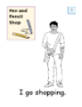  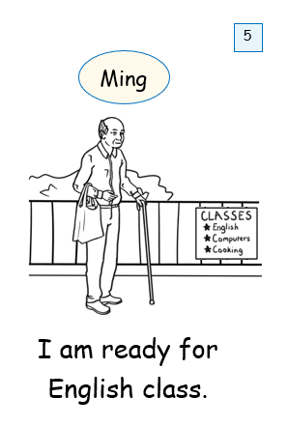  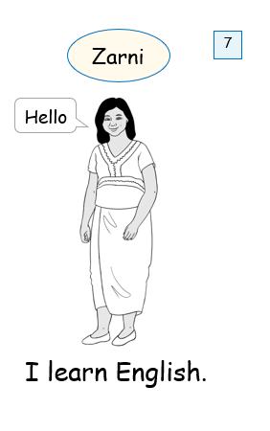  I read English books. | _________________________________________________  _________________________________________________  _________________________________________________  _________________________________________________  _________________________________________________
10. | What could make your learning difficult?  What is the solution? | I need to go to the doctor  once a month.  I make my appointment  outside class time. | ________________________________________________  _________________________________________________  _________________________________________________  ________________________________________________

At the end – What helped you learn?
In pairs, students read and tick what they did in class to help their learning and achieve their goal – in and outside the class.

What helped you learn in class?
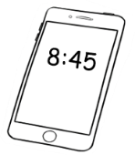
- I came to class early.
- I came prepared for class.
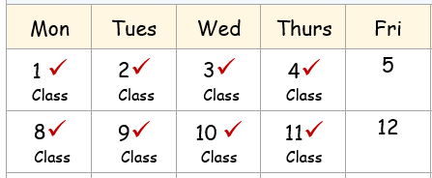
- I came to every class.

- I asked for help.
- I talked to classmates in English.
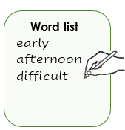
- I wrote new words on a word list.
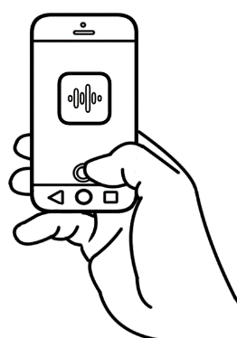
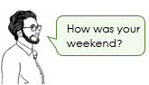
- I recorded the teacher.

- I learnt some computer skills.

- I put my phone on silent.

What helped you learn outside class?
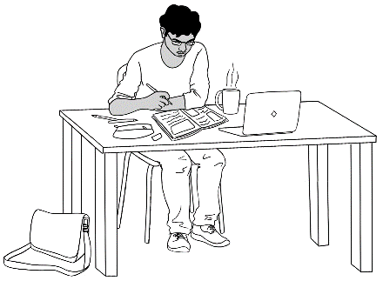
- I reviewed and previewed classwork.
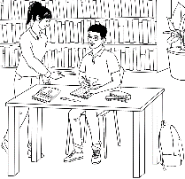
- I borrowed books and
studied in the library.

- I learnt English online.

- I listened to the teacher
How was your weekend?
How was your weekend?
and repeated.
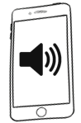
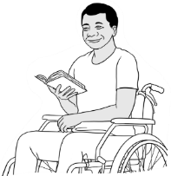
- I read and listened to audio books.

- I said and wrote new words
again and again.
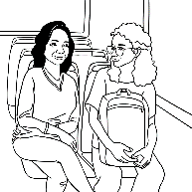
- I talked to new people.
- I went to a conversation class.
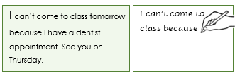

- I speed copied for six minutes
four times a week.

