

English Ready
22638VIC Certificate 1 in EAL
VU23501 Participate in short simple exchanges

Student Workbook
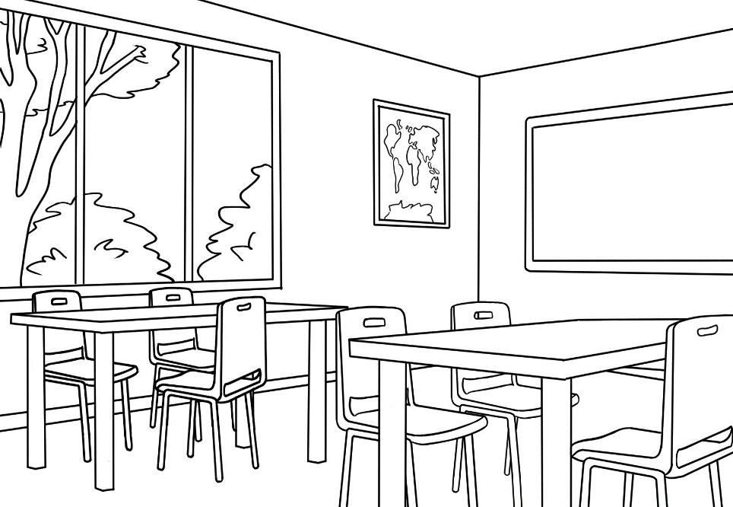
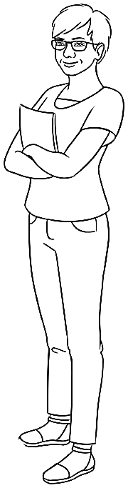
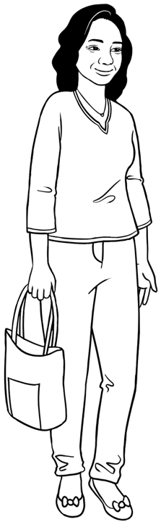

Student _______________________________________________________
Teacher _______________________________________________________
Class ________________________________________________________
Date ________________________________________________________

Design team: Vicki Hambling, Sue Paull, Frida Dean, Glenise Kleehammer and Mary Wallace
Illustrations: Madelena Scott

Illustrations acknowledgements:
Crack in glass, coffee pot & frypan These Photos by Unknown Author is licensed under CC BY-NC
Acknowledgements: The design team would like to thank the AMEP service providers and practitioners who participated in the trial and gave valuable feedback. The team would also like to acknowledge the use of the EAL Framework which underpins the design of this book.

___________________________________________________________________________
Copyright of the EAL Framework is reserved to the Crown in the right of the State of Victoria. © State of Victoria (Department of Education and Training) 2023.
Use of all or part of this document must include the following attribution:
© Commonwealth of Australia 2024

With the exception of the Commonwealth Coat of Arms, the department’s logo, any material protected by a trade mark and where otherwise noted all material presented in this document is provided under a Creative Commons Attribution 4.0 International (https://creativecommons.org/licenses/by/4.0/) licence.
The details of the relevant licence conditions are available on the Creative Commons website (accessible using the links provided) as is the full legal code for the CC BY 4.0 licence (https://creativecommons.org/licenses/by/4.0/legalcode).
As far as practicable, material for which the copyright is owned by a third party will be clearly labelled. The department has made all reasonable efforts to ensure that this material has been reproduced in this document with the full consent of the copyright owners.
Copyright requests and enquiries concerning usage not addressed by the CC BY 4.0 licence should be addressed to: comms@homeaffairs.gov.au at the Department of Home Affairs.
The terms of use for the Commonwealth Coat of Arms are available from the It's an Honour website.
Where a copyright owner, other than the Commonwealth, is identified with respect to this material, please contact that third party copyright owner directly to seek permission.



This workbook is designed to be used with the support of a teacher.

Table of Contents
1. Introduction 2
2. Meet the students and teachers. 3
3. Getting to know you 4
4. Basam starts class. 8
5. Linh starts class. 14
6. Parwana enrols in a class. 18
7. Talk about jobs at home. 24
8. Talk about free time. 30
9. Talk about the weather. 34
10. Talk about family. 36
11. Talk about an excursion. 40
12. Talk about sport. 44
13. Talk about the weekend. 47
14. What will you buy? 50
15. What’s the problem? 52
16. At the medical centre 58
17. At the chemist 60

Introduction
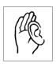
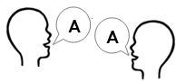
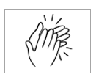
Workbook instructions
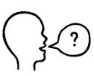       | - listen |  | - say
 | - repeat |  | - clap
 | - ask questions | 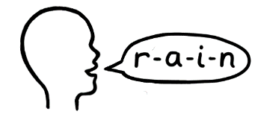 | - spell
 | - match | 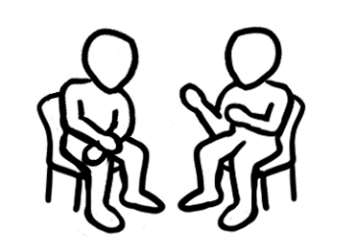 | - work with a partner
 | - read | 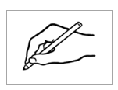 | - write
 | - copy |    | - circle
 | - tick |  | - highlight

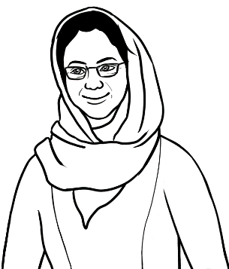
Do you understand?
Yes, I understand.
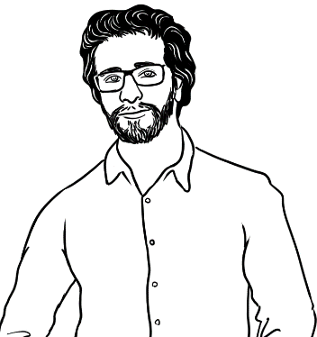

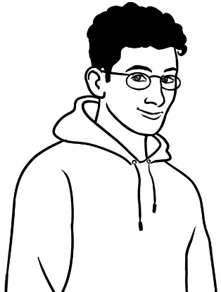
No, I don’t understand.

Can you say it again please?
Are you OK?
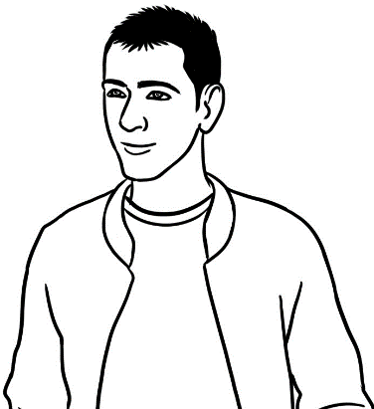
don’t = do not
No. Can you help me please?

Could you speak slowly please?
* Work with a partner
= speak or read aloud
with a partner

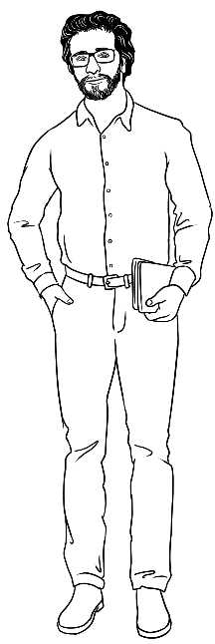
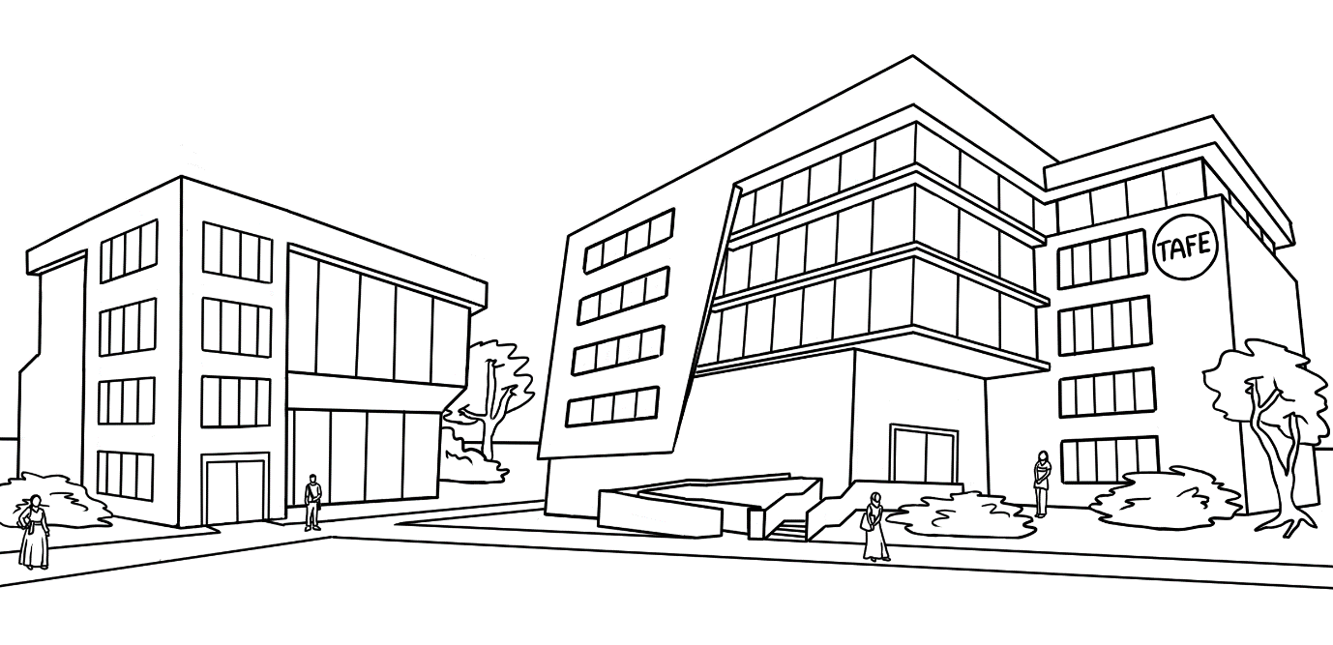
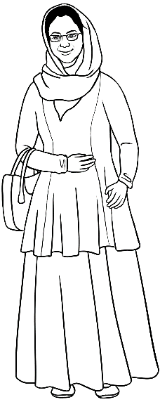
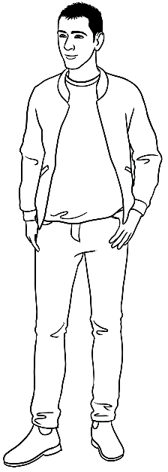
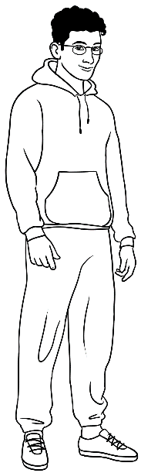
Meet the students and teachers.

Peter
Amina
Basam
Ahmad

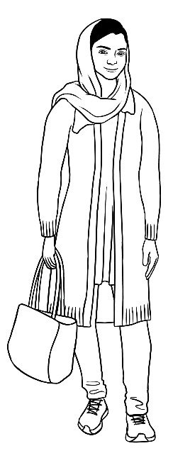
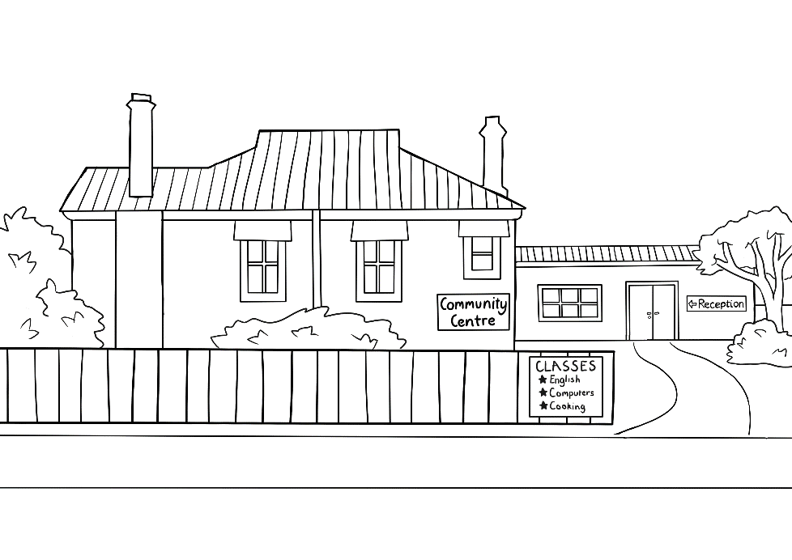
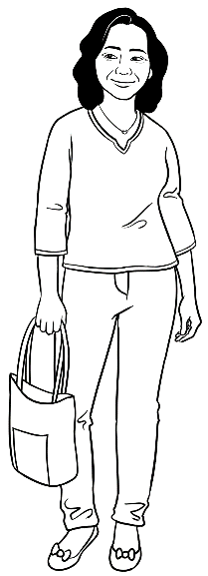
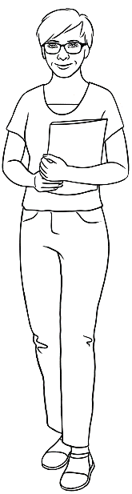
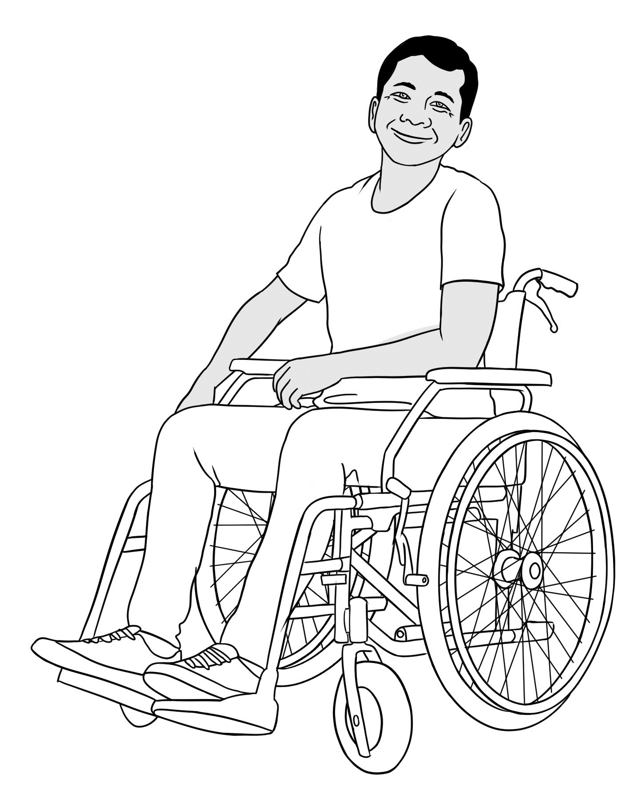

Parwana
Wendy
Linh
Ko

Getting to know you

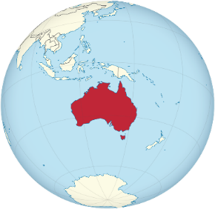

Iraq
Syria
?
Somalia
India

Ethiopia
Vietnam
Afghanistan

China
Myanmar

Amina | Hello. My name’s ______________.
Ahmad | Hi. My name’s _______________.
Amina | Nice to meet you.  Where do you come from _______________?  ^{name}
Ahmad | I come from ___________________.  ^{country}  What about you?  Where do you come from ________________?  ^{name}
Amina | I come from ______________________________.  ^{country}
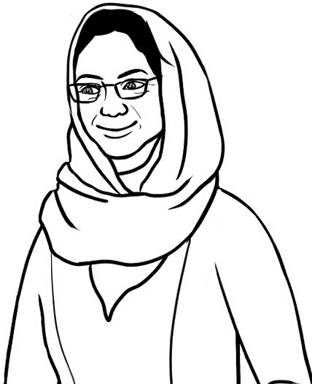
Syria
Ahmad
Afghanistan
Amina

in 1995
in 2003
in 2006
in 2021
in 2023
in 2022
in 2020
in 2019
in 2018
in 2015
in 2010
?

Amina | When did you come to Australia Ahmad?
Ahmad | I came in _____________. What about you?  When did you come here Amina?
Amina | I came in _____________.
2023
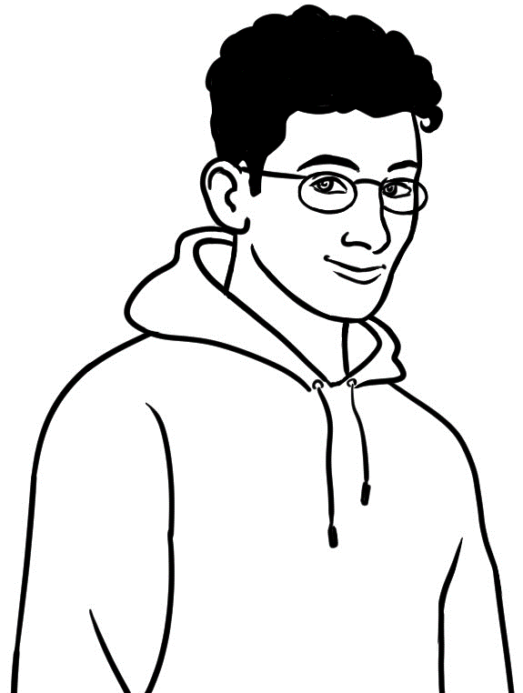
2022

I came to Australia in ______________.

Conversation 1 – Break time

Student A | Hi. My name’s _____________________________.  ^{name}  What’s your name? | - Greeting  Start  with an introduction.
Student B | Hello. I’m ___________________________.  ^{name}  Nice to meet you. | - Greeting  Start  with an introduction.
Student A | Nice to meet you too. | - Greeting  Start  with an introduction.
Student B | Where are you from ___________________________.  ^{name} | - Topic  Coming to Australia
Student A | I come from ___________________________.  ^{country}  What about you? Where are you from? | - Topic  Coming to Australia
Student B | I come from ___________________________.  ^{country}  I came to Australia in ________________.  ^{year}  What about you? When did you come here? | - Topic  Coming to Australia
Student A | I came here in _________________.  ^{year}  Oh. Look at the time. I must get back to class . | - End  Close the conversation.
Student B | Me too. Talk later. | - End  Close the conversation.
Student A | Bye. | - End  Close the conversation.

Conversation 2 - Before class

Student A | Hi _______________________________.  ^{name}  How are you? | - Greeting  Start the conversation  with a greeting.
Student B | Hi _______________________________.  ^{name}  I’m fine thanks. And you? | - Greeting  Start the conversation  with a greeting.
Student A | Yes. I’m OK. | - Greeting  Start the conversation  with a greeting.
Student B | You’re early today. | - Topic  Speaking English
Student A | Yes. I like to be early so I can practise  speaking English. | - Topic  Speaking English
Student B | Me too. We can practise together. | - Topic  Speaking English
Student A | Yes, we can. | - Topic  Speaking English
Student B | Oh. The teacher’s here. Let’s talk later. | - End  Close the conversation.
Student A | Yes. After class? | - End  Close the conversation.
Student B | Yes. Nice to talk to you. | - End  Close the conversation.

Basam starts class.
Basam | Hello. I’m a new student. My name’s Basam.
Peter | Welcome Basam. I’m your teacher.  My name’s Peter.
Basam | Hello Peter. What do I need for class?  I have a pen and a notebook.
Peter | That’s good, but you need a few more things.
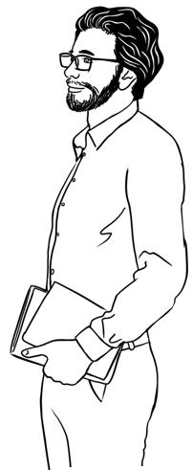
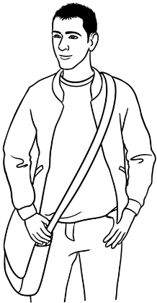

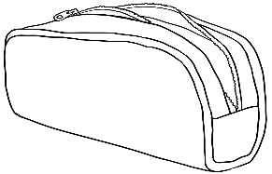  a pencil case  1 | 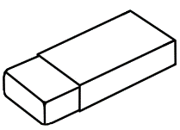  _________________  2 |  | 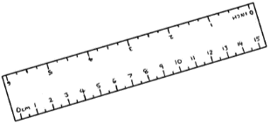  _________________  3
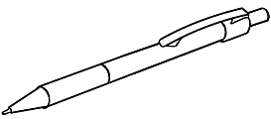  ________________  4 |   __________________  5 |  | 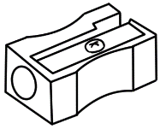  __________________  6
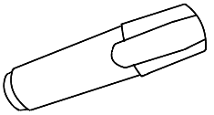  _________________  7 | 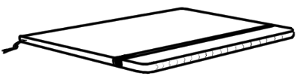  __________________  8 |  | 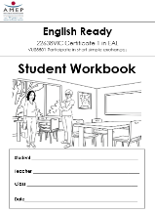  ________________  9
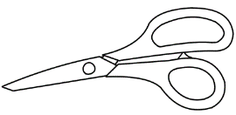  __________________  10 |  | 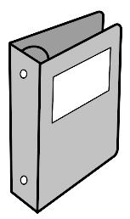  __________________  11 |  | 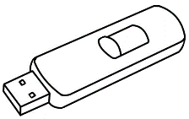  ________________  12

a rubber
a pen
a pencil
a ruler
a notebook
a workbook
a folder
a pencil case
a USB
a sharpener
a highlighter
scissors

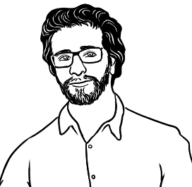
What do you have for class?
What do you need to buy?

I have ____________________________________________________________
____________________________________ and_______________________________.
I need to buy ____________________________________________________________
____________________________________and _____________________________.

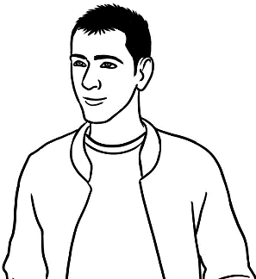
1.
Could I borrow a pencil?

Sure. Here’s one.

Thanks.

____________________________________________________________________________
2.
Could I borrow a highlighter?

Sorry. I don’t have one.

_____________________________________________________________________________
3.
Could I borrow your workbook for a minute?

OK. Here it is.

Thanks Ahmad.

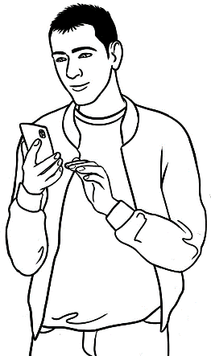
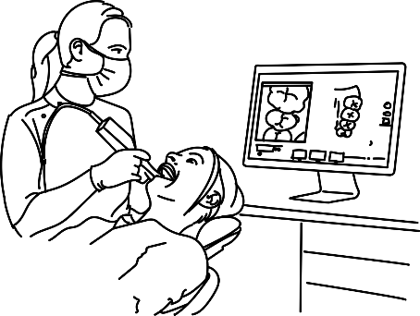

Your next appointment
is on Tuesday 16.05.24
at 11am. Send YES to confirm or call 94673731
Dental Clinic
Yes
Basam has an appointment.
I have a dentist appointment tomorrow.

confirm = agree
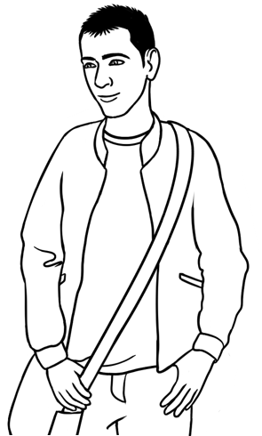
Basam | Excuse me, Peter.
Peter | Yes Basam?
Basam | I can’t come to school tomorrow because I have an appointment.  I’m sorry to miss class.
Peter | That’s OK. I understand.  Next time, could you try to make  your appointment outside class time?
Basam | It’s difficult to make an appointment.
Peter | Ok. Let’s practise together.
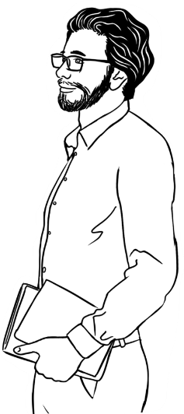

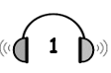

Next week
later | name | fine | What | about
Bye | 2:30 | like | next | no

Basam | Good morning. I’d like to make  an appointment please.
Receptionist | No problem. What’s your ______________?
Basam | Basam Radi.
Receptionist | Basam, what ______________ Wednesday at 10:00?
Basam | Oh sorry, that’s ______________ good.
Receptionist | OK. ______________ about Thursday at 12:00?
Basam | Oh no, that’s no good. Have you got  a ______________ time?
Receptionist | What about ______________?
Basam | Yes that’s ______________.
Receptionist | Good. We’ll see you __________ Thursday at 2:30.
Basam | Thank you. Bye.
Receptionist | ____________.

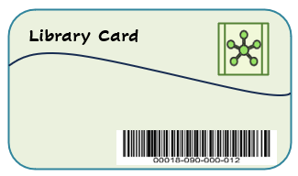
a library card
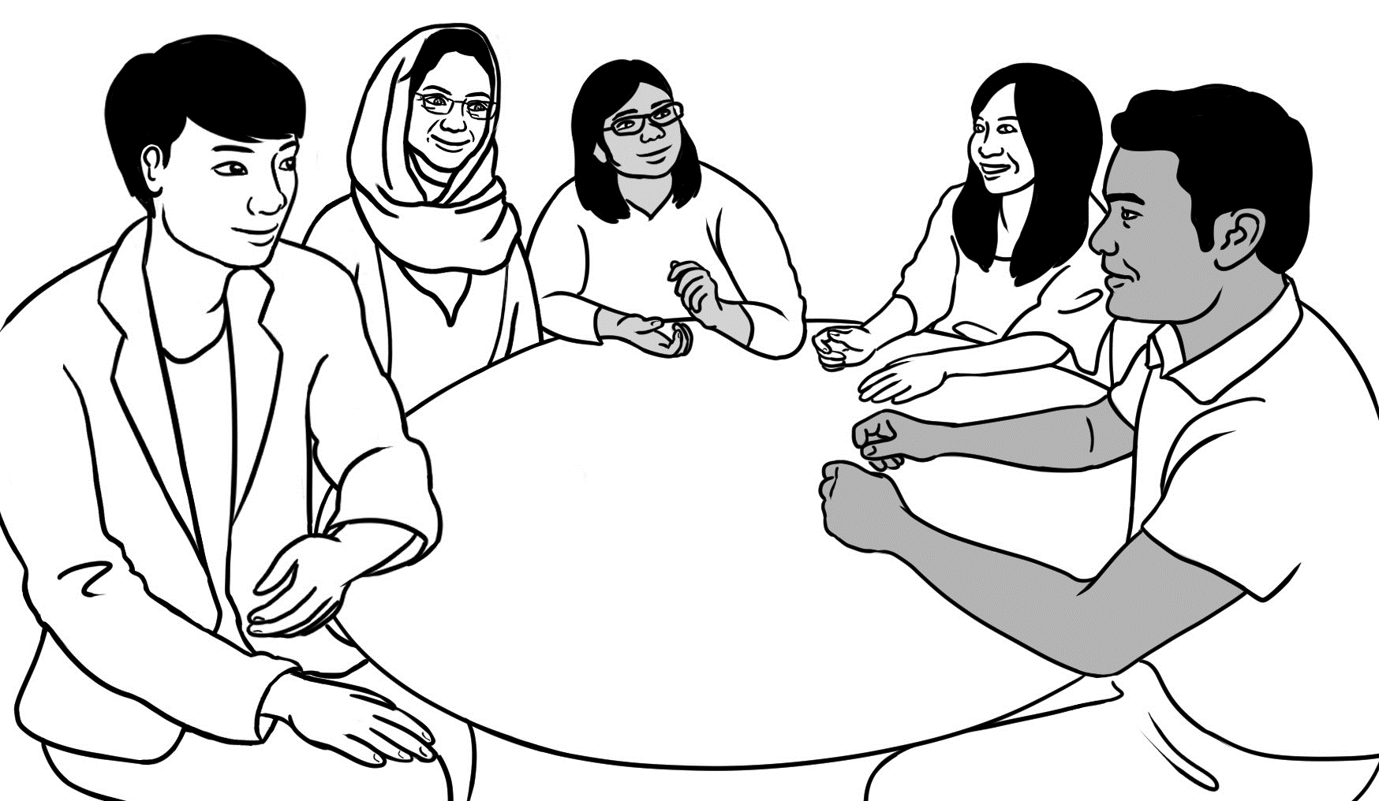
a conversation group
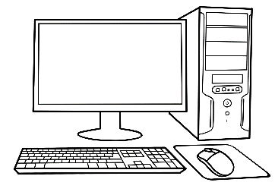
a computer
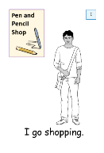
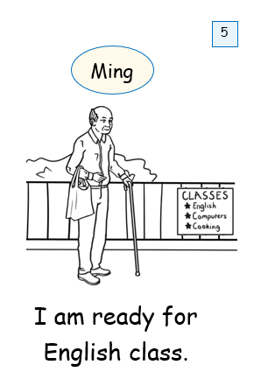
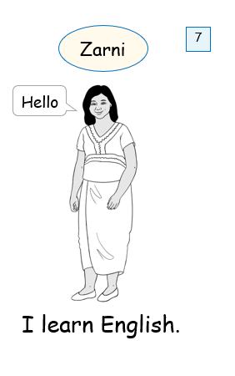
easy English books
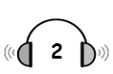

Basam goes to the library.

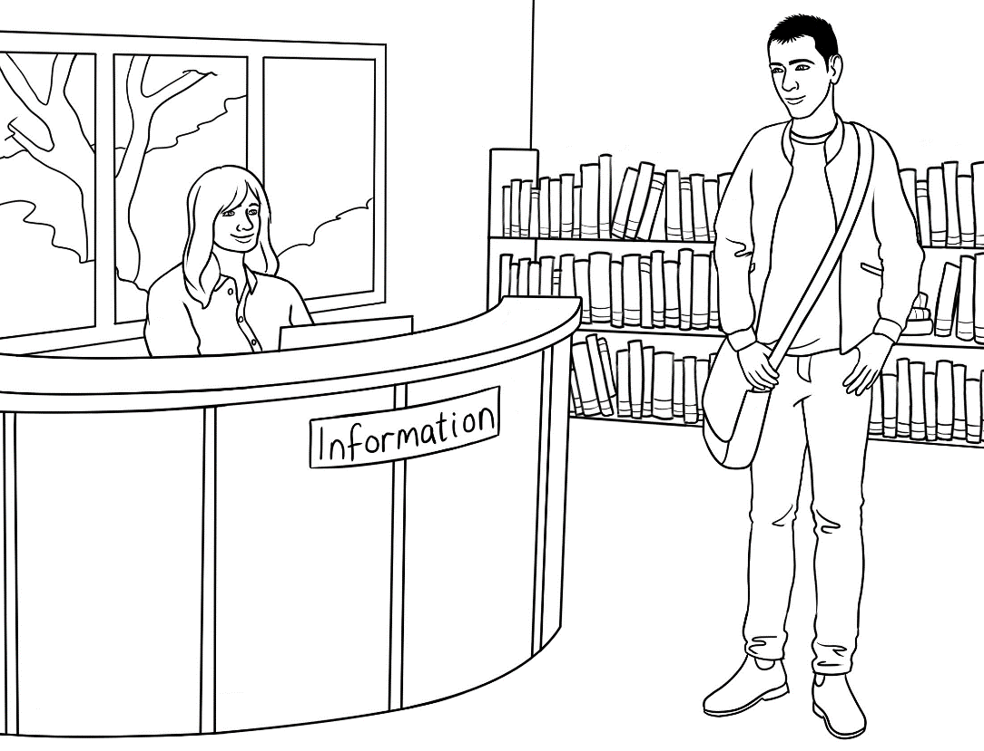

to join the library.
to join a conversation group.
to use a computer.
to borrow some easy English books.

Basam wants
1
Basam’s full name.
his address.
his birthdate.
his phone number.

The librarian wants
2

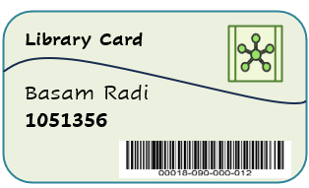
Basam | Excuse me. I’d like to join the library.  Can you help me please?
Librarian | Yes, I can. Can you tell me your full name?
Basam | My name’s Basam Radi.
Librarian | How do you spell your family name?
Basam | Radi R A D I
Librarian | What’s your address?
Basam | It’s Unit 3 / 140 Kemp Street, Kellivale.
Librarian | What’s your phone number?
Basam | 0463 346 291
Librarian | Just a minute. OK, here’s your library card.  You can use the library now.
Basam | Thank you. Can I borrow some easy  English books?
Librarian | Yes. I’ll show you where they are.
Basam | Thank you.

Linh starts class.

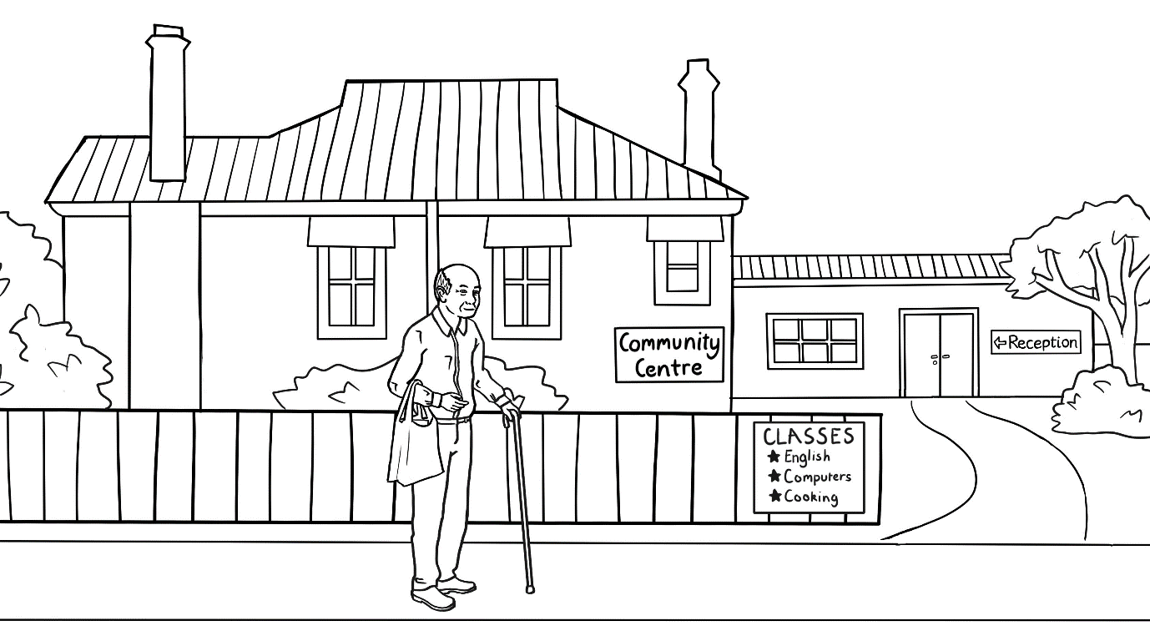
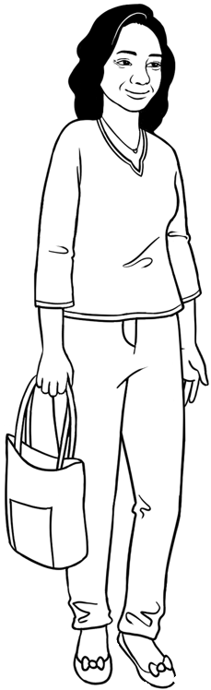

Ming | Hello. My name’s Ming.  Are you a new student?
Linh | Yes. I’m a new student.  My name’s Linh.
Ming | Nice to meet you Linh.
Linh | Can you help me Ming?  Where’s the Level 1 classroom?
Ming | I can show you. Come with me.
Linh | Thank you.

Wendy | Good morning. I’m your teacher.  My name’s Wendy.
Linh | Hello Wendy. My name’s Linh.
Wendy | How do you spell your name?
Linh | Linh. L I N H
Wendy | Did you say L I N A?
Linh | No. L I N H
Wendy | Where do you come from Linh?
Linh | I come from Vietnam.
Wendy | It’s nice to meet you.
Linh | It’s nice to meet you too.

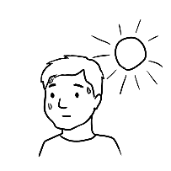 | 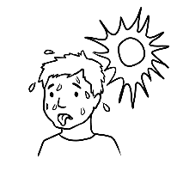 |  | 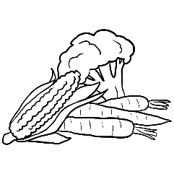
hot | very hot | flowers | vegetables
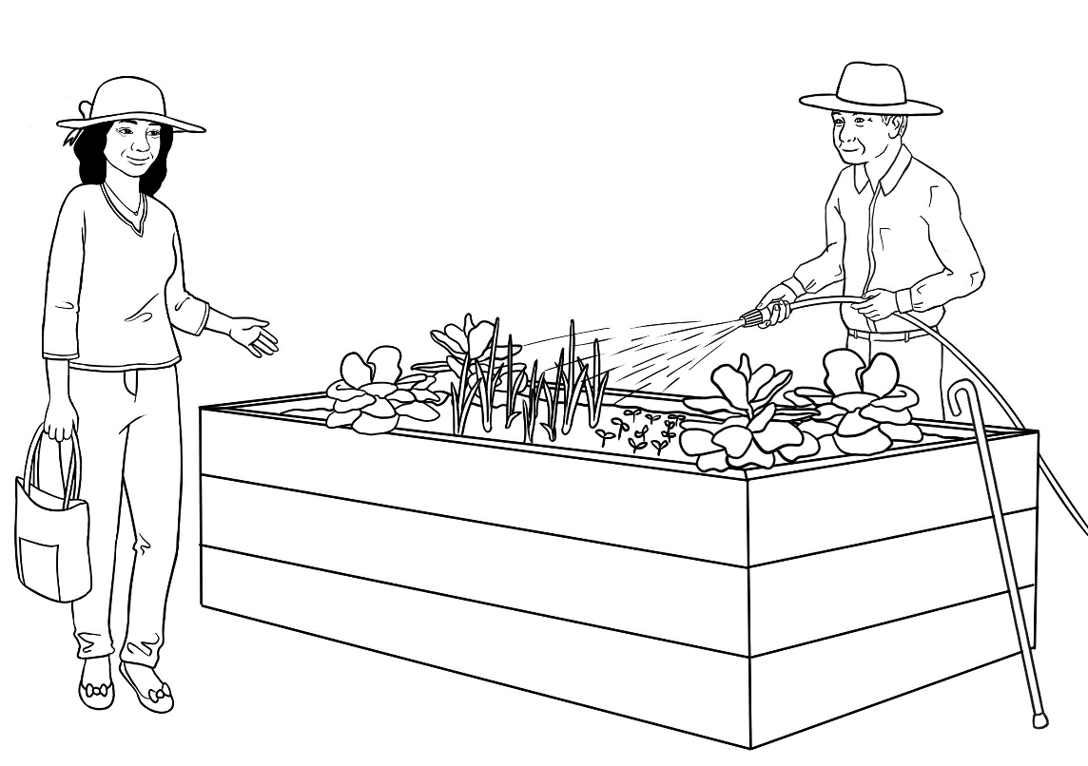  __________ | _______ _______ | ________________ | ________________

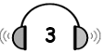

 | Ming works in the garden |  | on Tuesday |  | on Wednesday.
 | He works |  | before class |  | after class.
 | He’s watering |  | the flowers |  | the vegetables.
 | Tomorrow will be |  | hot |  | very hot.
 | Linh will help |  | today |  | next week.

help | vegetables | hot | week | Bye
thanks | Hello | today | Wednesday | very
Linh | Hi Ming.
Ming | Hello Linh. How are you?
Linh | Fine _________________. What are you doing?
Ming | I’m watering the _____________________.  This is our community garden.  I work here on __________________________ before class.
Linh | Oh.
Ming | I need to water _____________________ because tomorrow  will be _______________ ________________.
Linh | Mm. Can I ________________ in the garden?
Ming | Yes. Everyone’s welcome.
Linh | Thanks Ming. I’d better go.  See you here next _______________.
Ming | Bye Linh.
Linh | ______________.

Parwana enrols in a class.
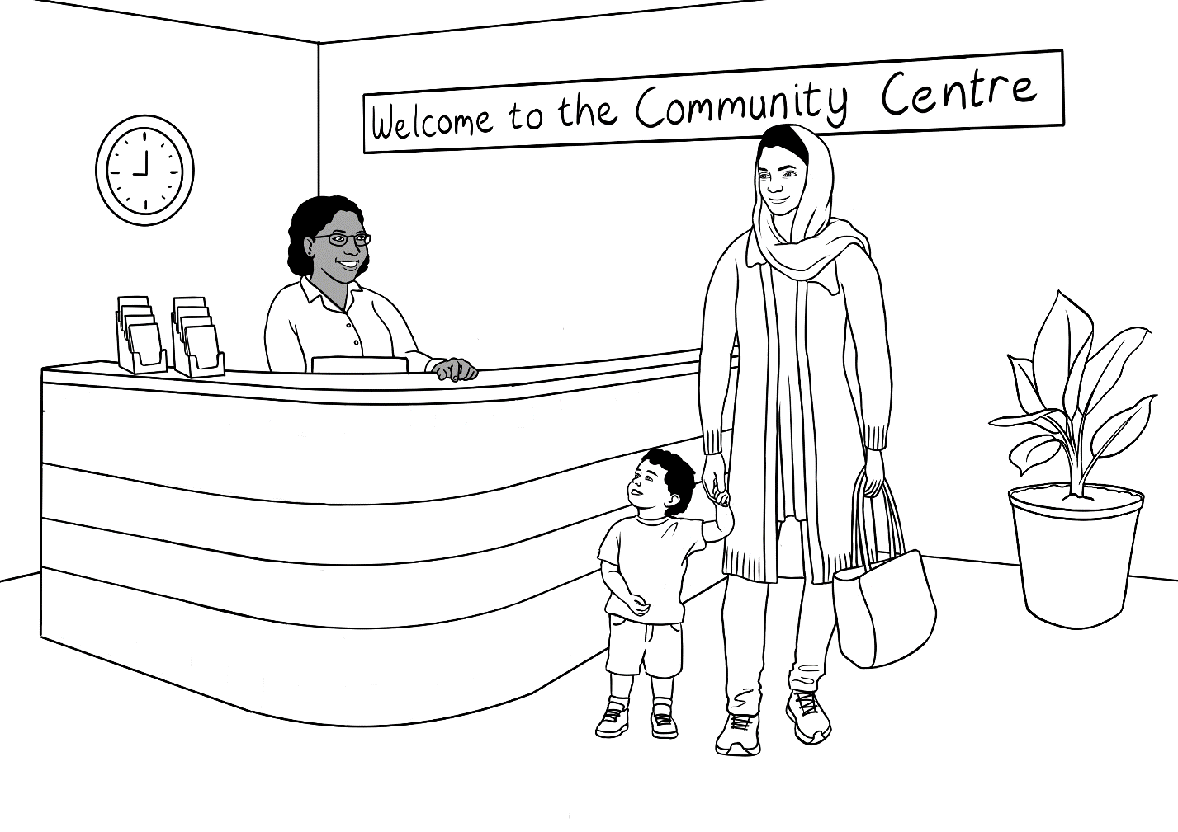

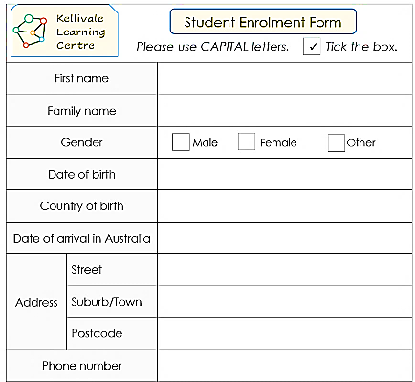
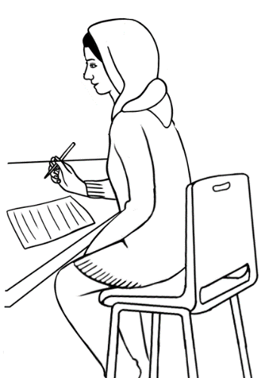
a form
Fill in a form.

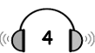

 | Parwana needs to fill in a form. | Yes | No
 | She can come for an interview tomorrow. | Yes | No
 | The interview on Friday is at 10:00. | Yes | No
 | Parwana needs childcare for her son. | Yes | No
 | Forms are difficult for Parwana. | Yes | No

tomorrow | Thanks | 10:30 | a form | No
son | here | fill in | Friday | help
Parwana | Excuse me. Can I enrol in an English class here ?
Receptionist | Yes, you can enrol here. But first you need to fill in  __________________ and have an interview.
Parwana | An interview?
Receptionist | Yes. Can you come for an interview _____________________?
Parwana | ________, I’m sorry. I’m busy tomorrow.
Receptionist | Can you come on ____________________ at ___________?
Parwana | Yes, that’s OK. I need childcare for my ____________.  Do you have childcare here?
Receptionist | Yes, we do. I can give you some information about childcare, but let’s __________ _______ this form first.
Parwana | Oh. Forms are difficult. Can you _____________ me please?
Receptionist | Yes, I can help you.
Parwana | ________________ for your help.

At the childcare centre

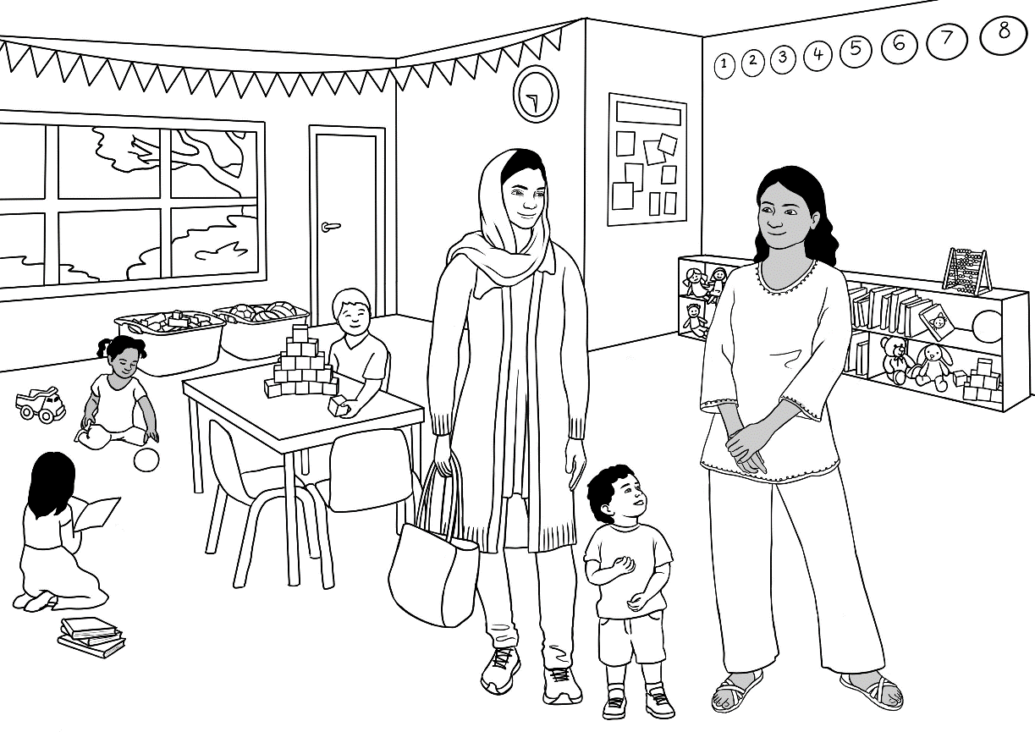

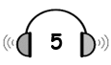  - Parwana’s son is three. | Yes | No
- His birthday is on 13 September. | Yes | No
- He was born in 2021. | Yes | No
- Parwana needs childcare on Monday and Thursday. | Yes | No
- Parwana needs to fill in a form. | Yes | No

Nisha | Hello. Can I help you?
Parwana | Yes. Can I enrol my son for childcare here?
Nisha | Yes, you can. How old is your son?
Parwana | He’s two.
Nisha | What’s his name?
Parwana | Mustafa Tajik.
Nisha | Uh huh. What’s his date of birth?  Uh huh = yes
Parwana | 30 September 2021.
Nisha | 13 September?
Parwana | No. 30 September.
Nisha |   Oh, 30 September. What days do you need childcare?  Oh =
Parwana | Monday and Tuesday.
Nisha | Mm. That’s fine. Can you fill in this form?
Parwana | 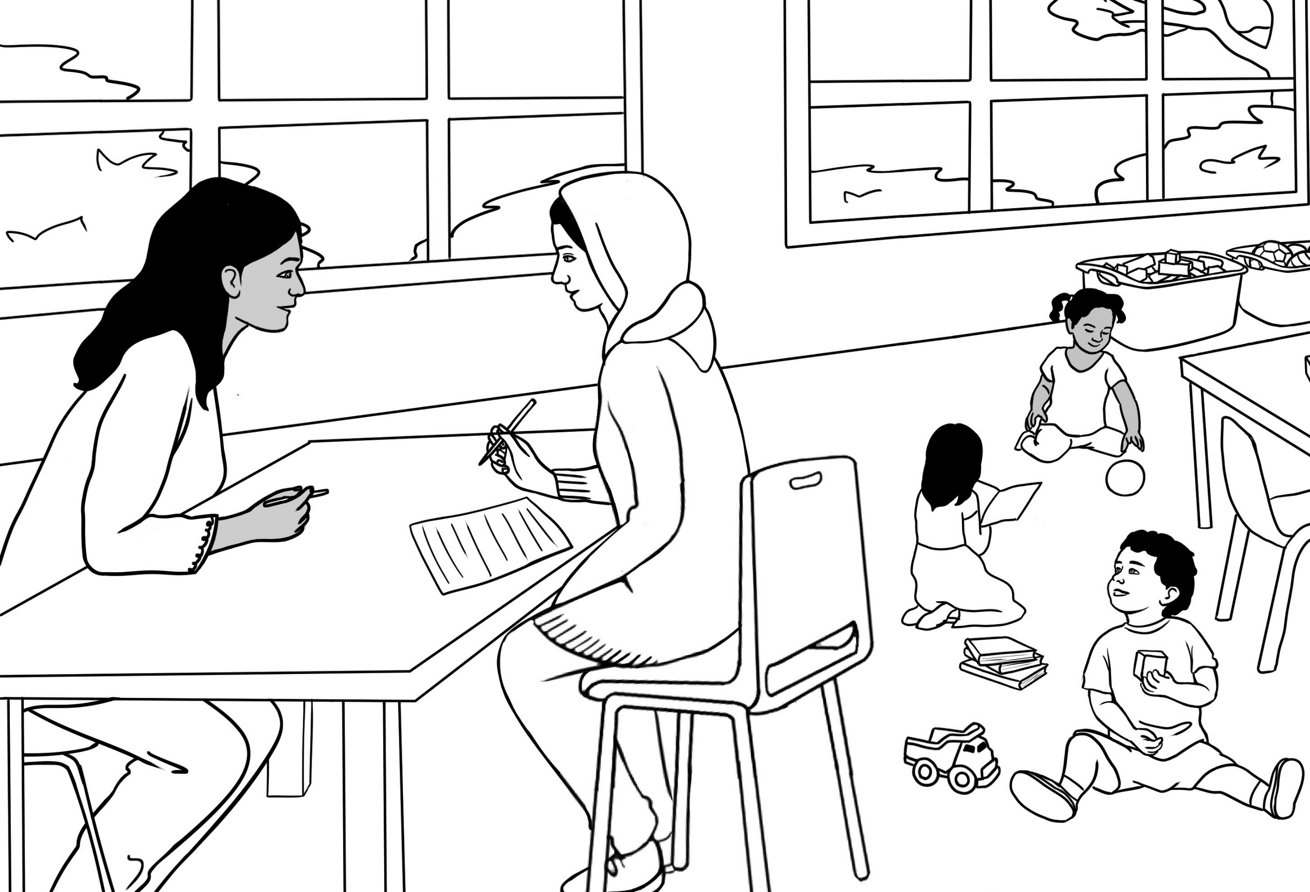  Oh. Can you help me please?
Nisha | Yes, I can help.  Let’s sit down here.

Parwana starts class.

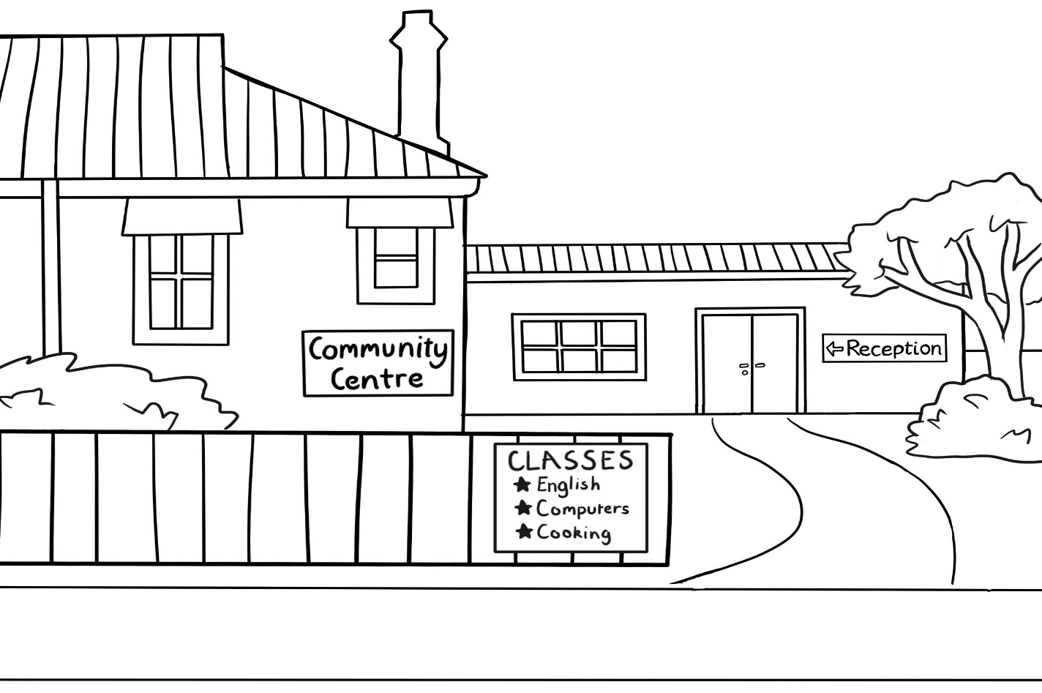
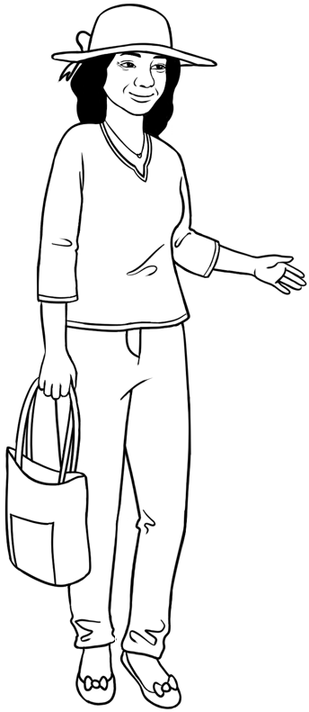
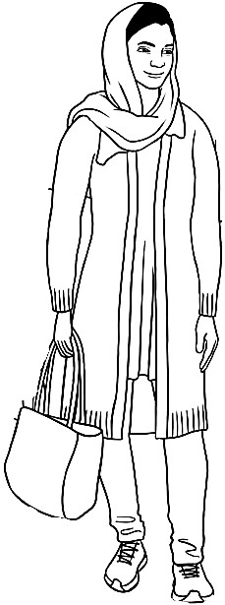

Linh | Hello. My name’s Linh.
Parwana | Hello. My name’s Parwana. I’m a new student.
Linh | Oh. What class are you in?
Parwana | I’m in Level 1.
Linh | Me too. Come and meet our teacher and the students.  We’re in room 2 today, but tomorrow we’re in room 3.
Parwana | Thanks for your help Linh.
Linh | No problem.

- glass class |  | 7. son run
- pill fill |  | 8. name game
- ten pen |  | 9. feeds needs
- fun one |  | 10. two who
- his is |  | 11. thirteen thirty
- meets greets |  | 12. Sunday Monday

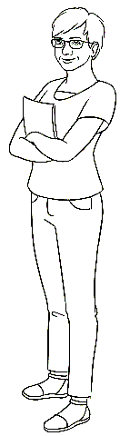
- Parwana wants to go to English class.
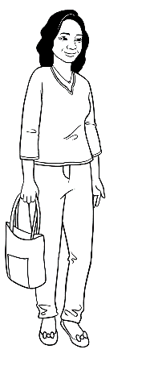
- She needs to fill in a form.
- Parwana has an interview is at 10.
- She goes into English Level one.
- Wendy is Parwana’s teacher.
- Parwana meets Linh.
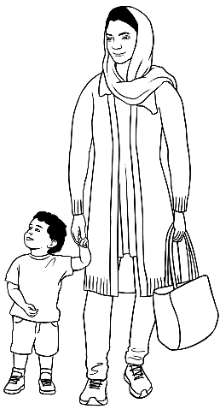
- Parwana has a son.
- His name is Mustafa.
- Mustafa needs to go to childcare.
- He’s two.
- His birthday is on 30 September.
- Childcare is on Monday and Tuesday.

Talk about jobs at home.
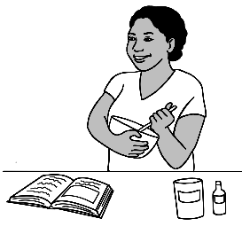

Linh | Do you cook dinner every day Parwana?
Parwana | Yes I do. What about you Linh?  Do you cook dinner every day?
Linh | No, I don’t cook every day, because  my husband cooks sometimes.
Parwana | Oh. You’re lucky.
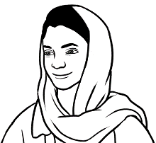
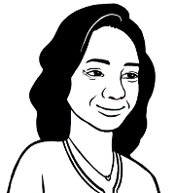

Subject | verb | object | when
I | cook | dinner | every day.
You | cook | dinner | every day.
They | cook | dinner | every day.
We | cook | dinner | every day.
He, She, It | cooks | dinner | every day.

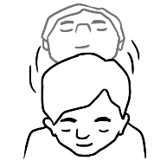

Subject | verb | object | when
I | don’t cook | dinner | every day.
You | don’t cook | dinner | every day.
They | don’t cook | dinner | every day.
We | don’t cook | dinner | every day.
He, She, It | doesn’t cook | dinner | every day.
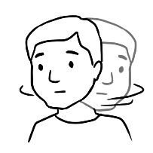
.

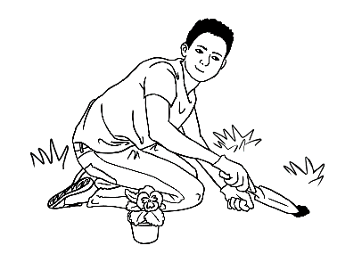
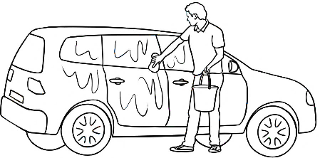

cook dinner
clean the house
work in the garden
wash the car
do the shopping
do some homework
do the washing
do the dishes
cut the grass

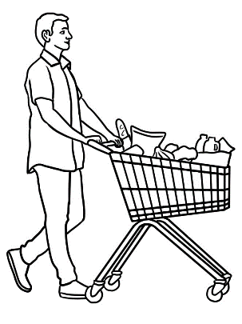

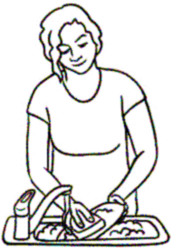
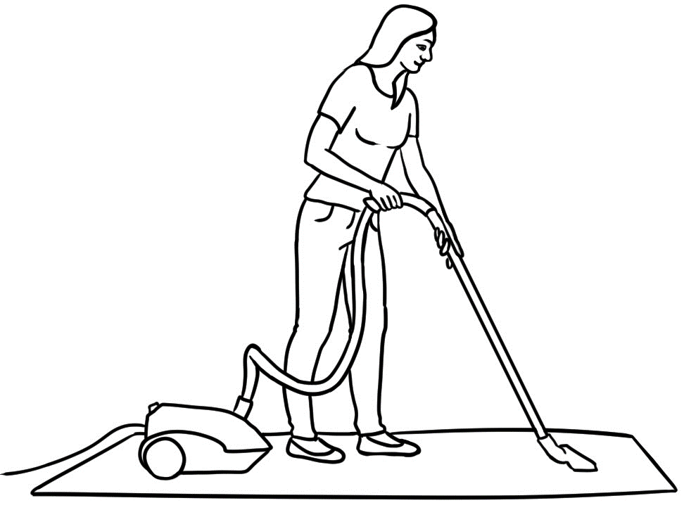

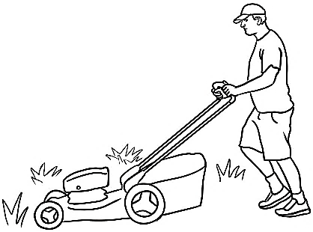

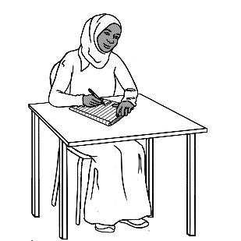

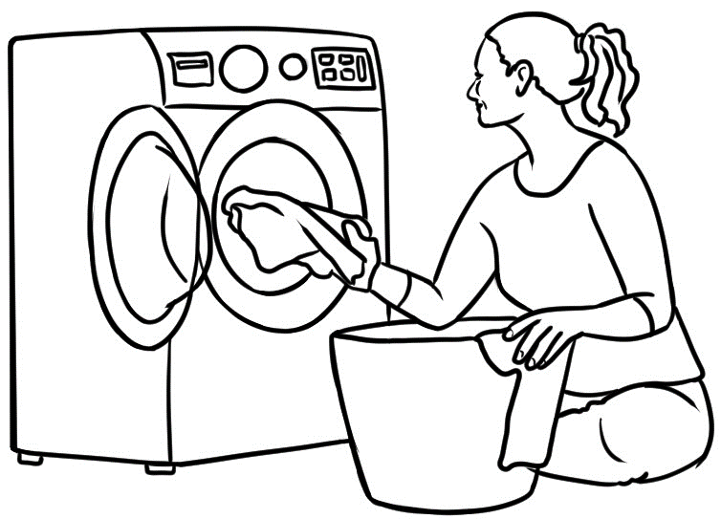

What do you do every day?

I __________________________________________ every day, but
don’t __________________________________________ every day.

My partner __________________________________________ every day,
but doesn’t __________________________________________ every day.

Parwana | Did you clean the house yesterday Linh?
Linh | Yes I did. I cleaned in the morning.  What about you Parwana? Did you clean yesterday?
Parwana | No, I didn’t. I cooked all day because  it was my husband’s birthday.
Linh | Oh. Happy birthday to your husband.

Regular verb - to clean
Subject | verb |  | object | when
I | cleaned | didn’t clean | the house | yesterday.
You
They
We
He, She, It

What did you do yesterday?

I __________________________________________ yesterday.
What didn’t you do yesterday?

I didn’t __________________________________________ yesterday.

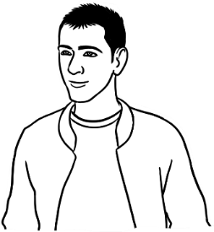

Basam | Did you do the shopping yesterday Ahmad?
Ahmad | No I didn’t, because I worked yesterday. What about you? Did you do the shopping?
Basam | Yes I did. I went to the new supermarket  on North Street.
Ahmad | Oh. What’s it like?
Basam | Very cheap.
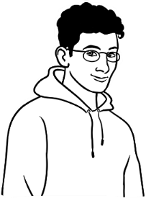

Irregular verb - to do
Subject | verb |  | object | when
I | did | didn’t do | the shopping | yesterday.
You
They
We
He, She, It

Did Ahmad do the shopping yesterday?

No, he ______________ ______ _______ ___________________ yesterday.
Did you do the shopping yesterday?

______________________________________________________________________.

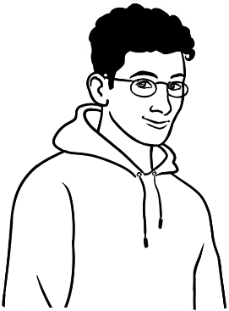
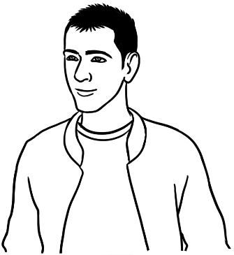
What did you do yesterday? | Yesterday?
Yes, yesterday. | Not much.
Did you clean the house? | No, I didn’t.
Did you wash the car? | No, I didn’t.
Did you cut the grass? | No, I didn’t.
Did you work in the garden? | No, I didn’t.
Did you do the shopping? | No, I didn’t.
Did you do the washing? | No, I didn’t.
Did you do some homework? | Yes, I did.
Did you cook dinner? | Yes, I did.
You cooked dinner? | Uh huh.
Really? | Uh huh.
You can cook? | Uh huh.
Really? | Yeah, really.

Really. = That’s true.
Really? = Is that true?

- way day |  | 6. car jar
- looks cooks |  | 7. wishes dishes
- shopping chopping |  | 8. washing squashing
- work shirt |  | 9. grass class
- mouse house |  | 10. come some
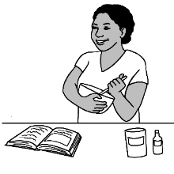

- What do you do every day?
- Parwana cooks dinner every day.
- Basam does the shopping.
- Ahmad doesn’t work in the garden.
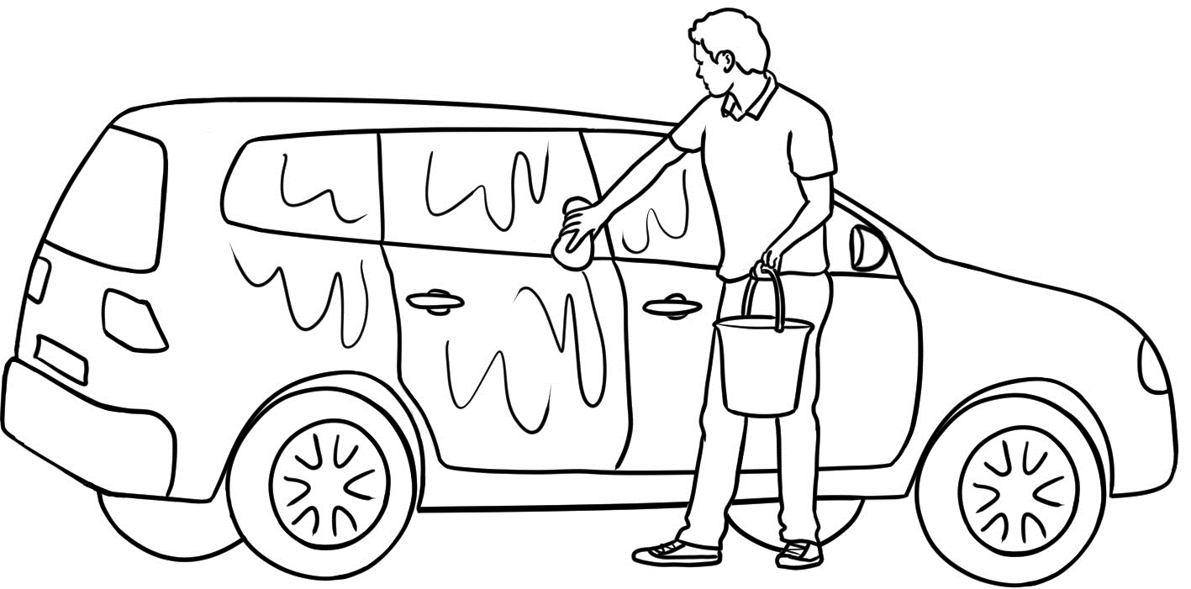
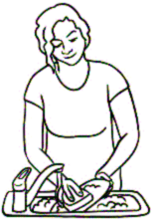
- Linh cleans the house.
- A man washes the car.
- A woman does the dishes.
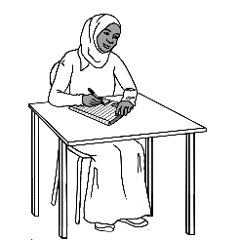
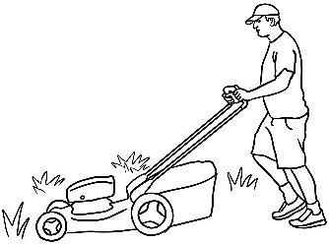
- She also does the washing.
- A man cuts the grass.
- The student does some homework.

Talk about free time.

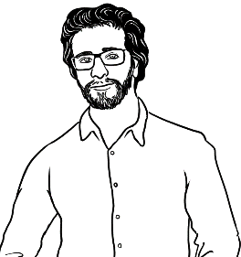
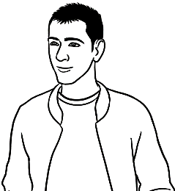
What do you like doing
in your free time?

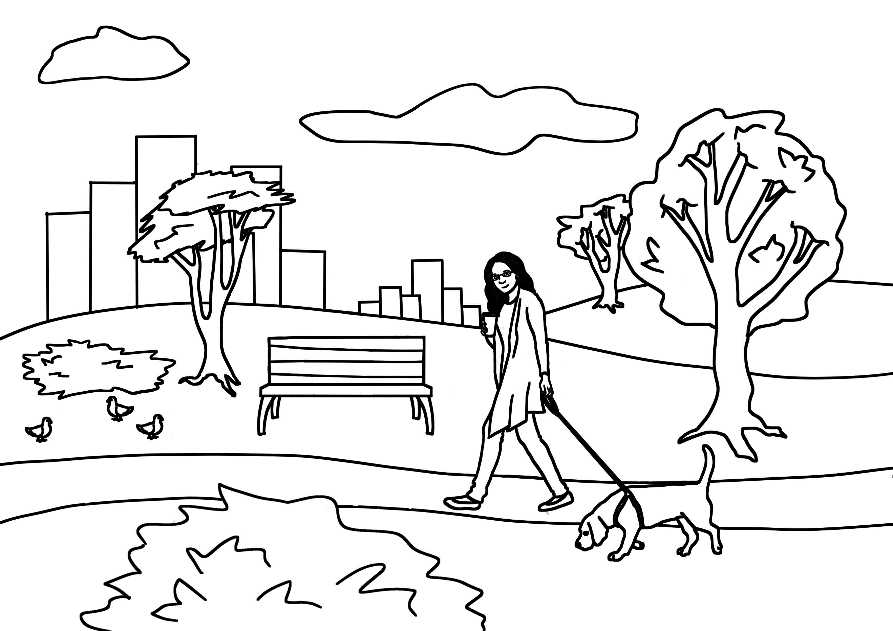 | 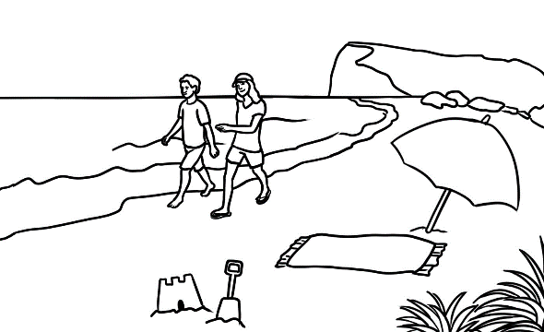 | 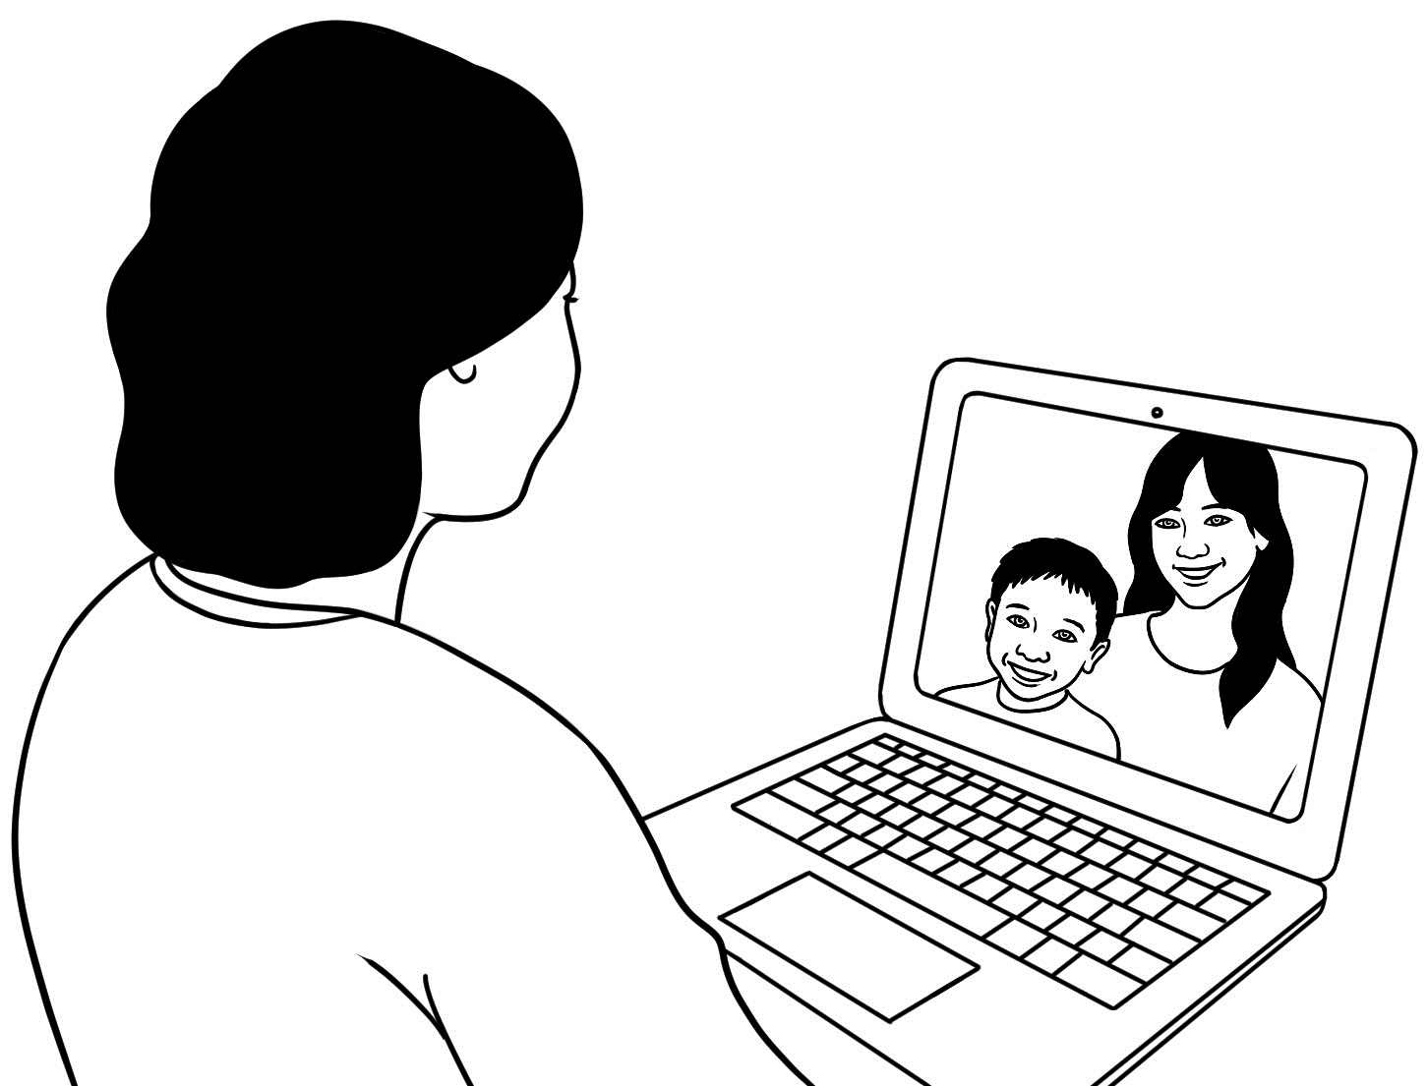
going to the park | going to the beach | talking to family online
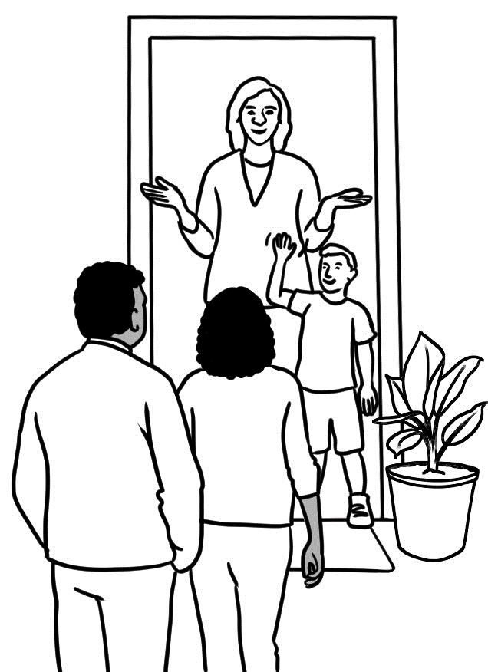 | 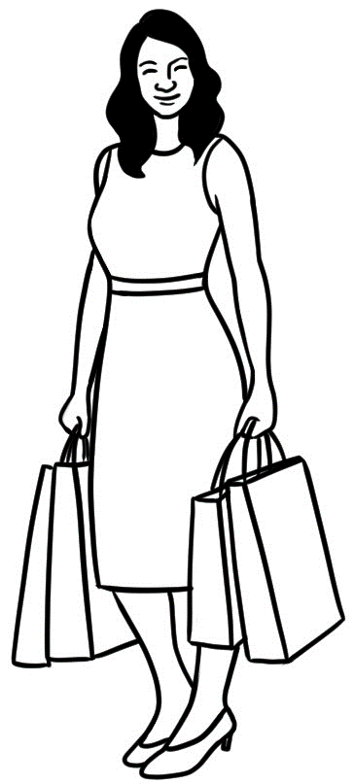 | 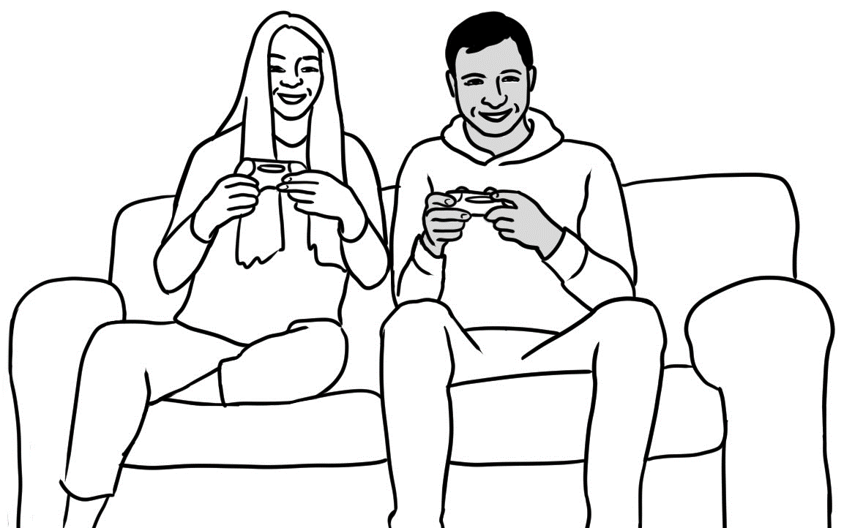
visiting friends | shopping | playing video games
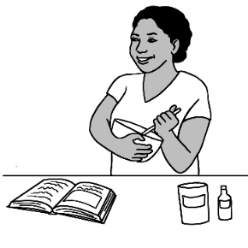 | 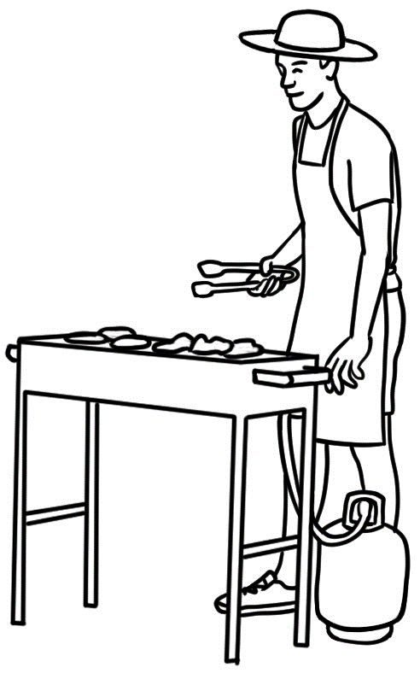 | 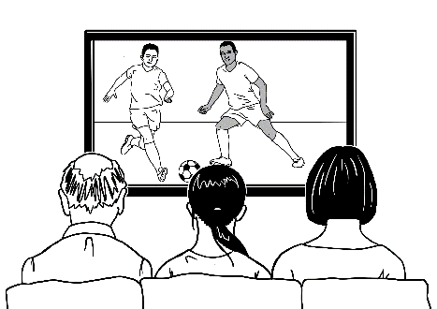
cooking | having a barbeque | watching TV
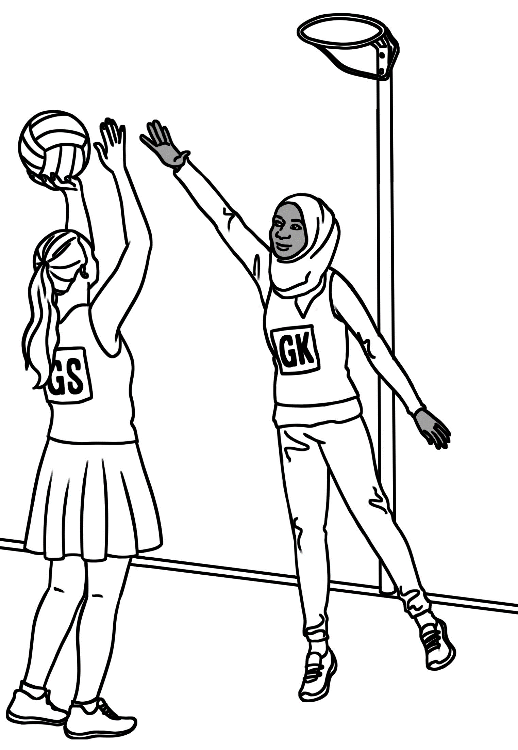 | 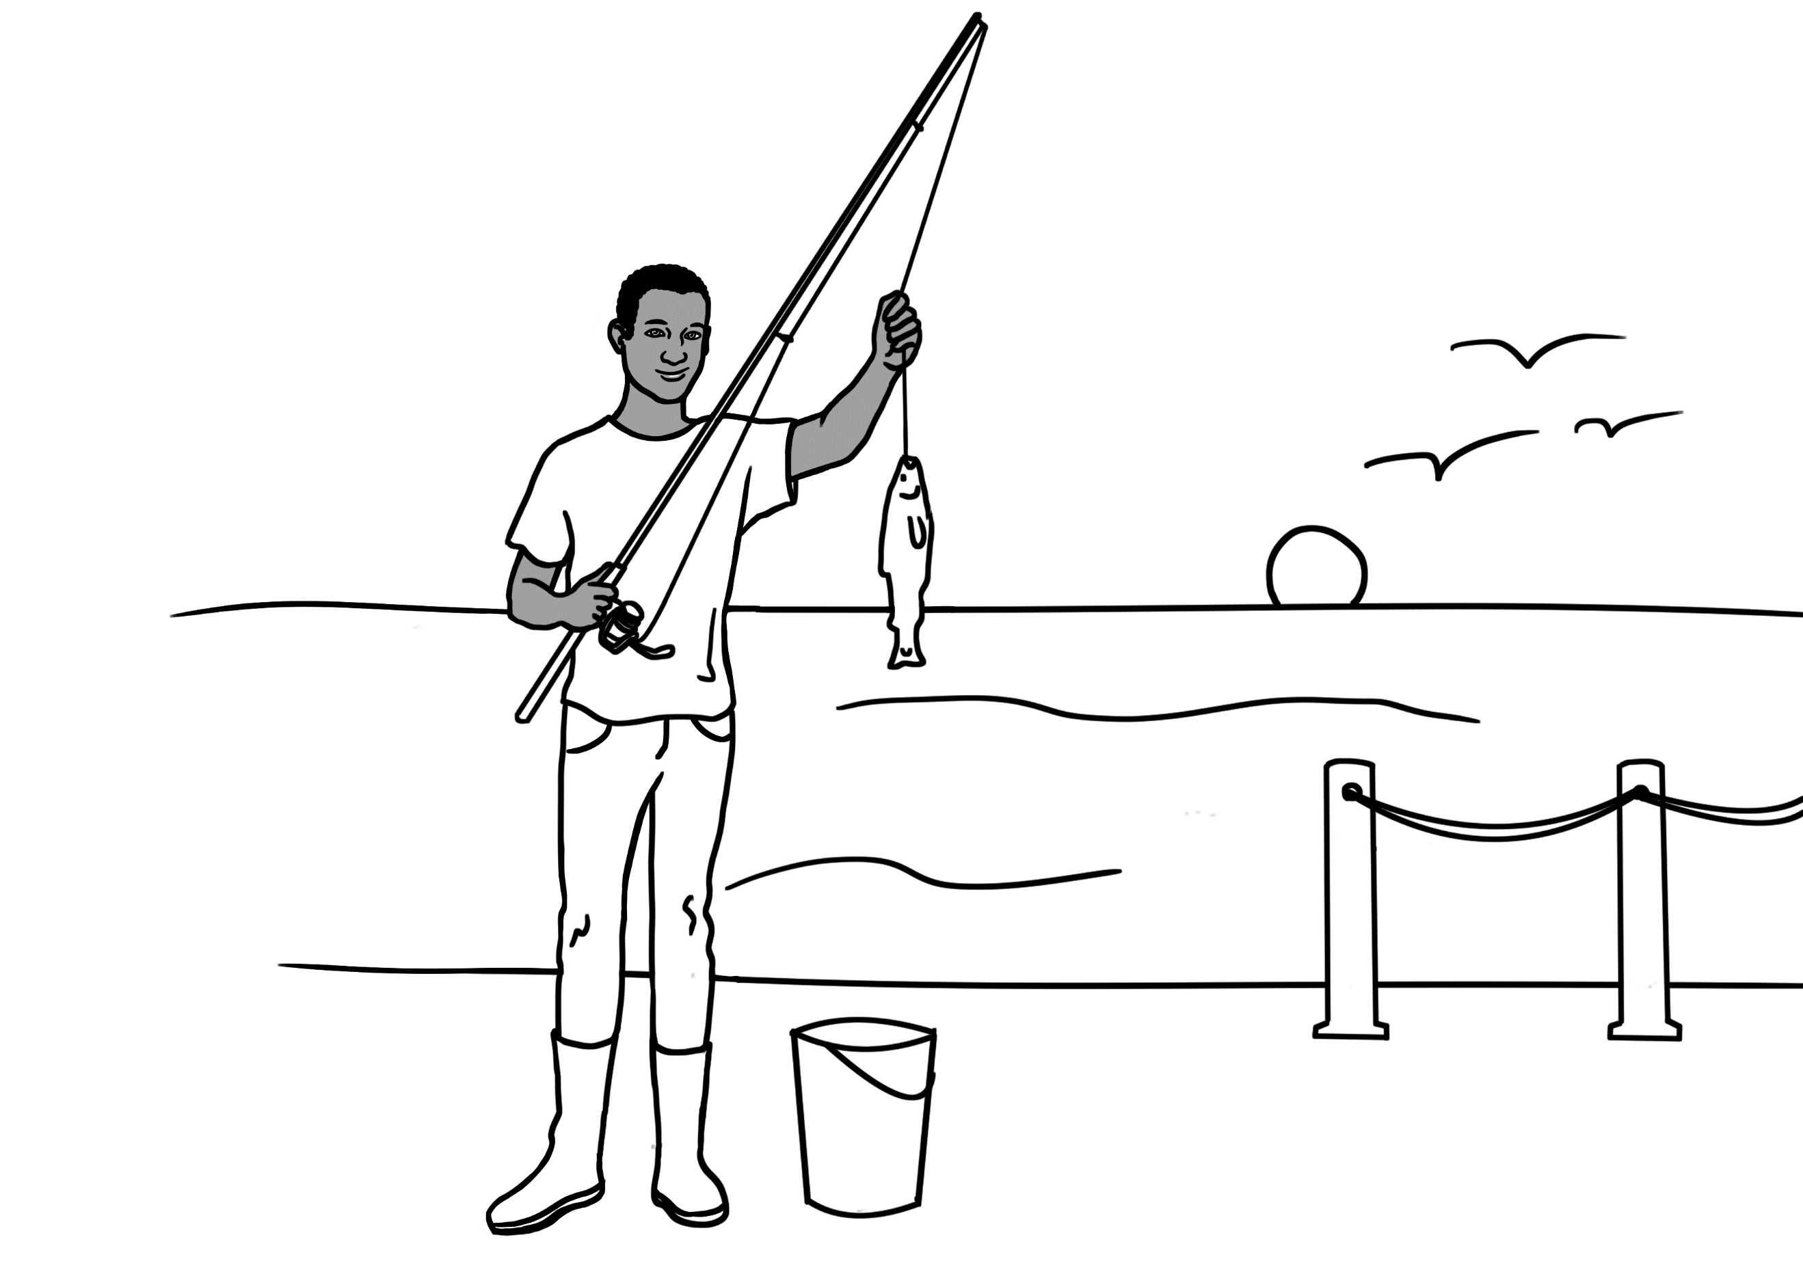 | 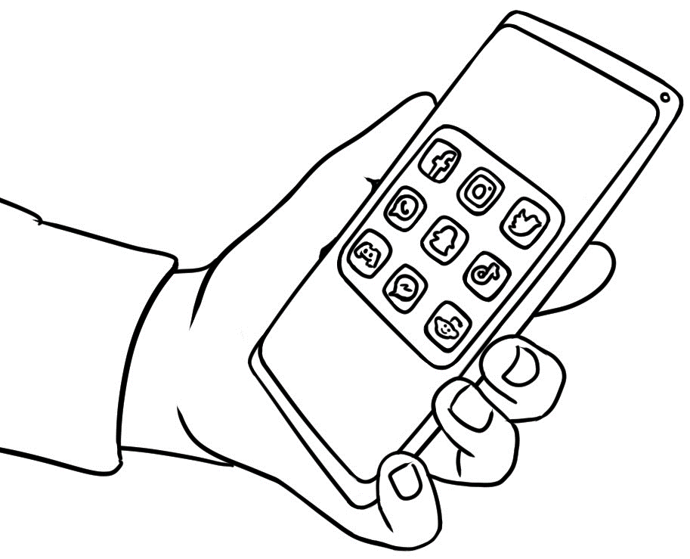
playing sport | fishing | using social media

Yes I do.
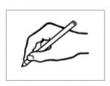
No I don’t.
Do you like cooking?

Do you like __________________ |  | Yes | No | Name
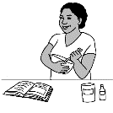
cooking?
 | fishing?
 | shopping?
 | going to the park?
 | going to the beach?
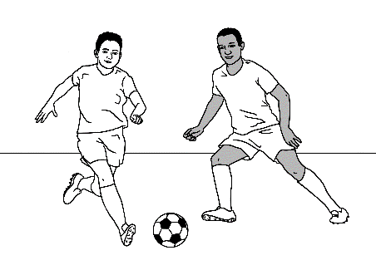
playing sport?
 | having a barbecue?
 | watching TV?
 | visiting friends?
 | using social media?

___________________________ likes _________________________________, but
^{name}
doesn’t like __________________________________________.
going to the park
going to the beach
going to the city
going to a cafe
talking to family online
watching TV
shopping
fishing
visiting friends
cooking
having a barbecue
playing sport
playing video games
using social media
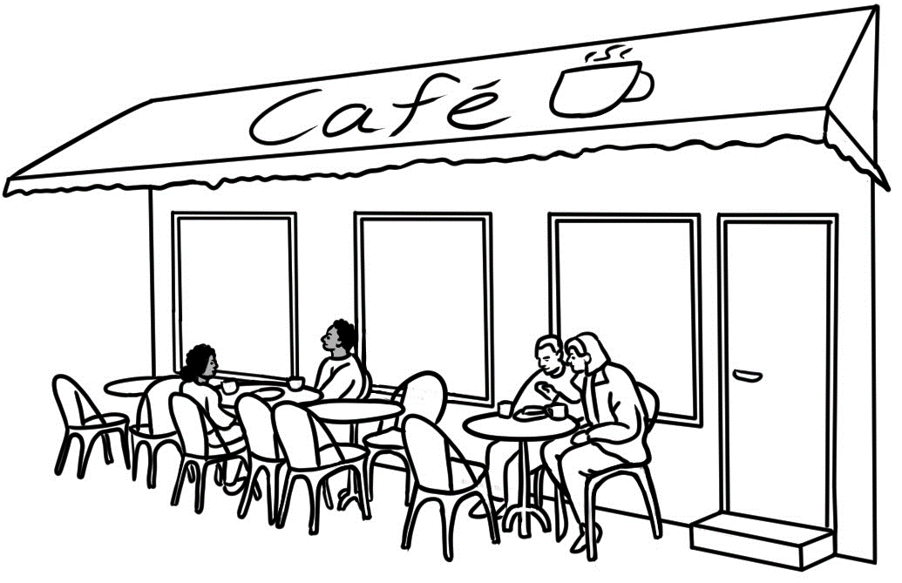

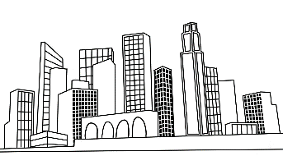

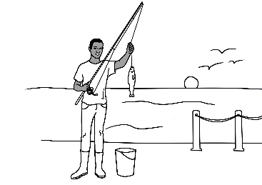

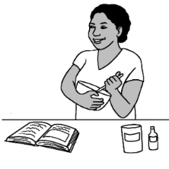
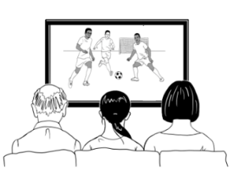

I like _____________________________________________ , but
I don’t like _________________________________________________.

Ahmad | What do you like doing in your free time Basam?
Basam | I like fishing. Do you like fishing Ahmad?
Ahmad | No, I don’t, but I really like playing video games. What about you? Do you like video games?
Basam | Yes, sometimes.  really = very much
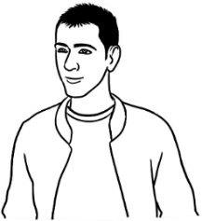
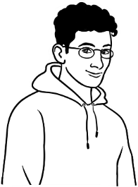

Ahmad | What do you like doing in your free time Amina?
Amina | I like cooking. Do you like cooking Ahmad?
Ahmad | Yes, I do, but I really like using social media.

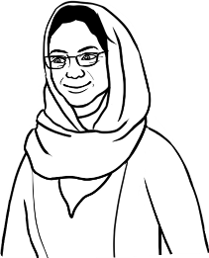

Ahmad | I don’t like working in the garden.  What about you Peter?
Peter | I like working in the garden, but I really like soccer.  What about you? Do you like playing soccer?
Ahmad | Yes, I like playing soccer on the weekend sometimes.

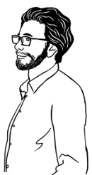

Talk about the weather.

What’s the weather like today?

1 | 2 | 3 | 4 | 5
 |  | 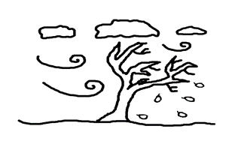 |  | 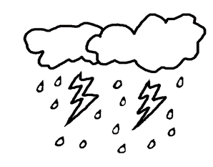
sunny | cloudy | windy | rainy | stormy

6 | 7 | 8 | 9 | 10
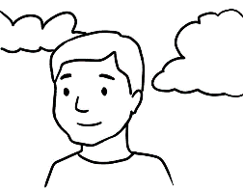 | 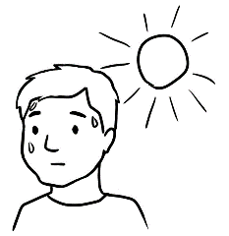 | 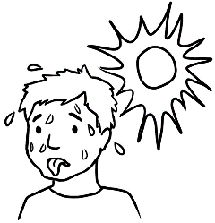 | 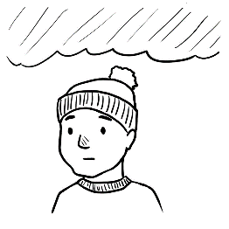 | 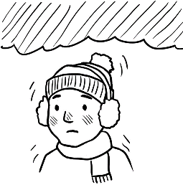
warm | hot | very hot | cold | very cold
20° | 30° | 39° | 12° | 1°

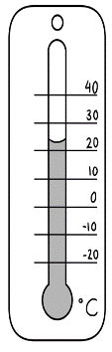

° = degrees
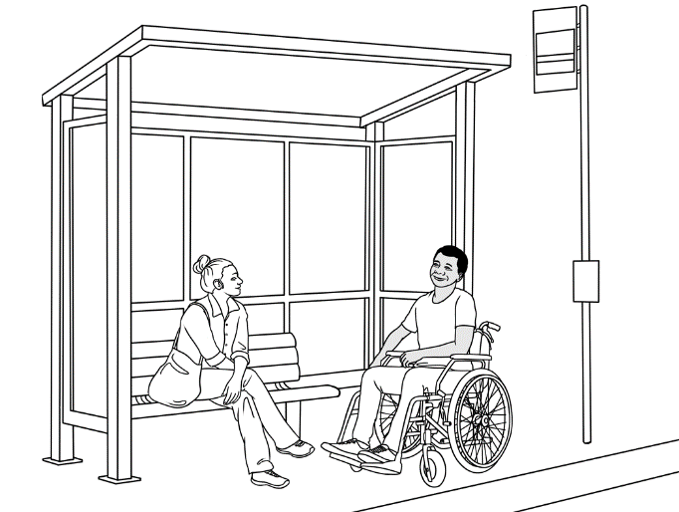
It’s a nice day, isn’t it?

Yes, it’s a lovely day. is.

Start a conversation.

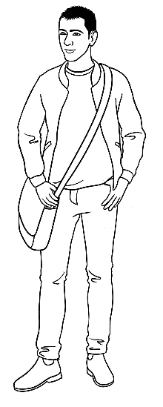
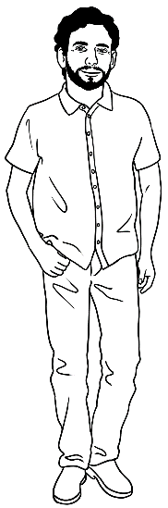
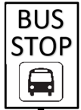
It’s a nice day, isn’t it?

Yes, it is.

1.

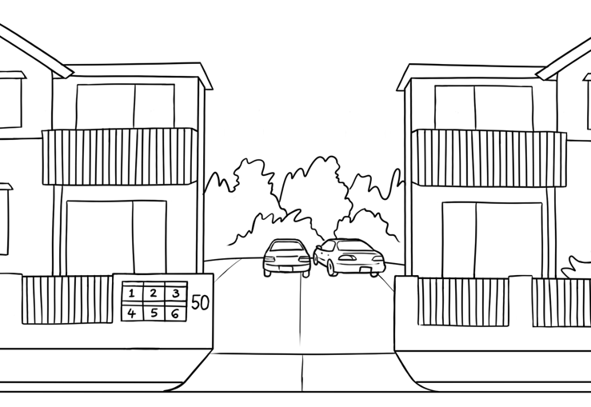
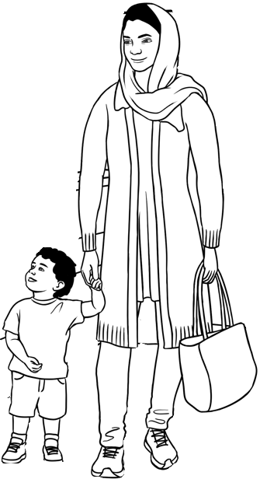
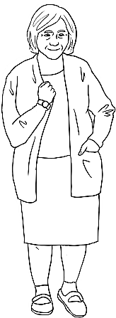
It’s cold today, isn’t it?

Yes.

2.

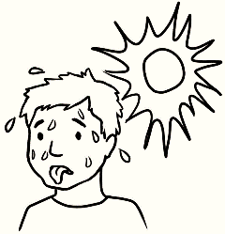
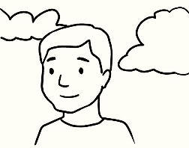


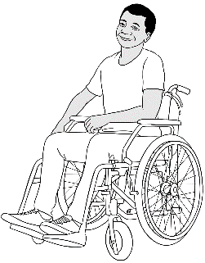
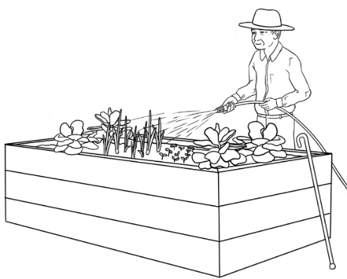
It’s really hot today, isn’t it?

Yes, very hot.

3.

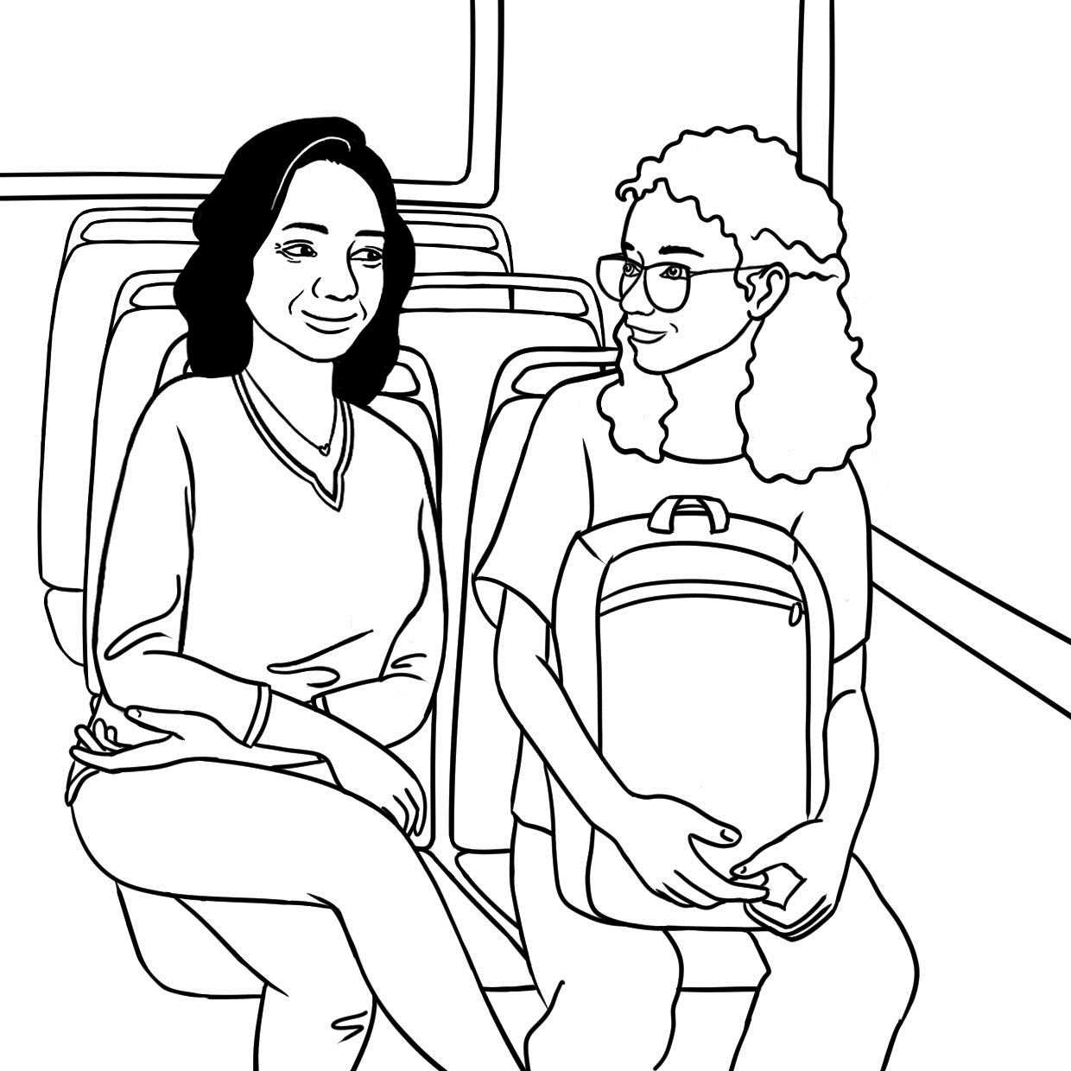
Do you think
it’ll rain today?

Maybe.
It’s very cloudy.

4.

Talk about family.
Focus – correctional stress and vocab related to family
Students need to cover the conversation on the opposite page, discuss the picture, read the statements below and listen to the conversation.

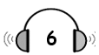
PPT

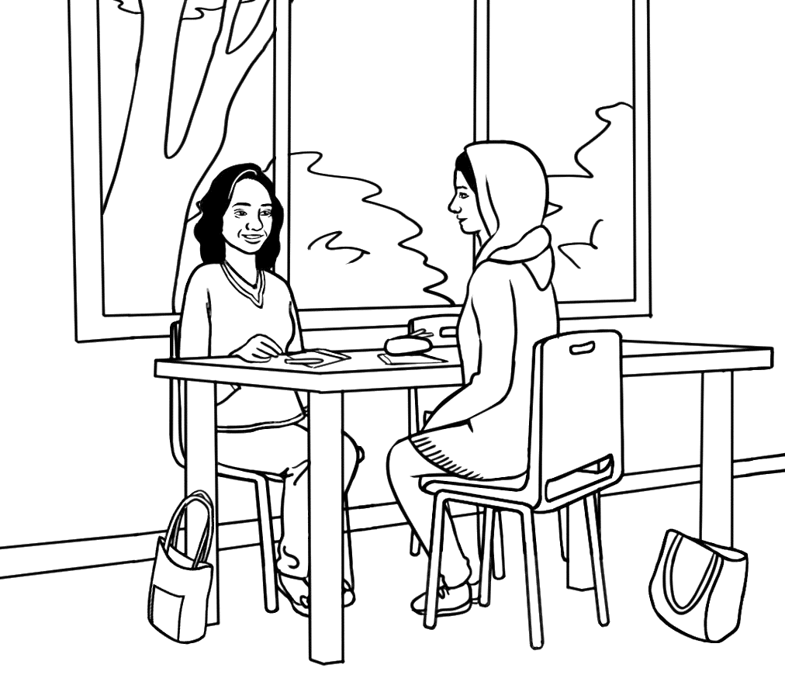

Students may have difficulty talking about family due to past trauma in their country of birth or in Australia. It is important to give students the language to politely avoid talking about the topic. See page 39

1. | Parwana has many of her family in Australia. | Yes | No
2. | She has three children. | Yes | No
3. | She has two sons and a daughter. | Yes | No
4. | Her daughter is 5 years old. | Yes | No
5. | Linh says, ‘What a big family.’ | Yes | No

many | Australia | lucky | brother | Yes
photo | five | children | lovely | two

Linh | Do you have family in Australia Parwana?
Parwana | Yes I do. I have ______________ of my family here.  I have my husband and children, and my parents  and my _____________________.
Linh | Oh. You have ___________________? How many?
Parwana | I have __________.
Linh | A girl and a boy?
Parwana | _____________, a girl and a boy.
Linh | How old are they?
Parwana | My daughter Bibi is _________ and my son Mustafa is two.  Look. I have a ________________ of my family.
Linh | What a _____________family. You’re very lucky Parwana.
Parwana | Yes, I’m very _________________.

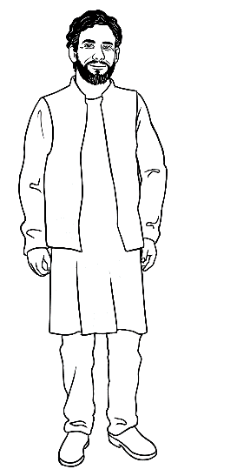
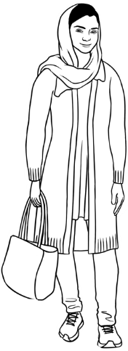
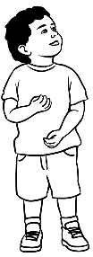
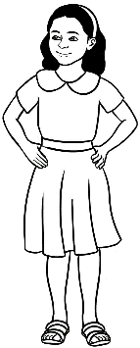
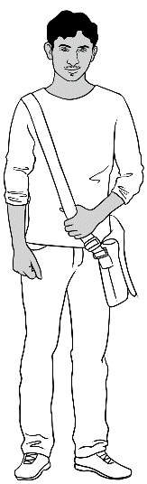
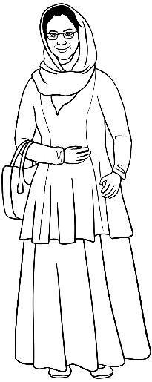
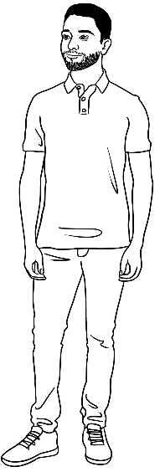
This is my family.

mother | father | brother | husband | son | daughter | me
Amina | Nabi | Rahim | Jomeh | Mustafa | Bibi | Parwana

father  . | father . | mother | mother .
son | ____________ | daughter | ____________
grandfather | _______________ | grandmother | ________________
grandson | _____________ | granddaughter | ________________
husband | ____________ | wife | ____________
brother | ____________ | sister | ____________
uncle | ____________ | aunt | ____________
nephew | ____________ | niece | ____________

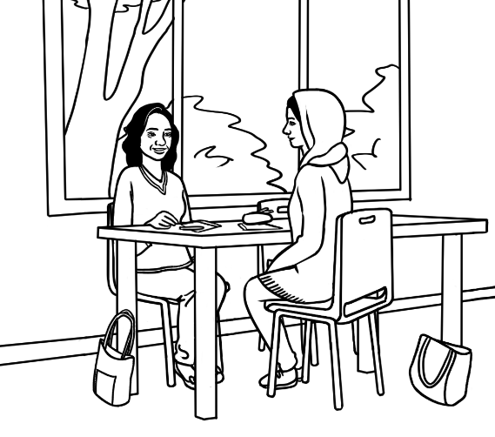

Parwana | Do you have family in Australia Linh?
Linh | Just my husband.
Parwana | Oh that’s hard for you.
Linh | Yes.
Parwana | When did you come to Australia?
Linh | A long time ago.
Parwana | Do you have family in Vietnam?
Linh | I don’t like to talk about my family  Parwana, because it makes me very sad.
Parwana | Oh, I’m sorry Linh.
Linh | That’s OK.
Parwana | Let’s talk about something else.

Talk about an excursion.

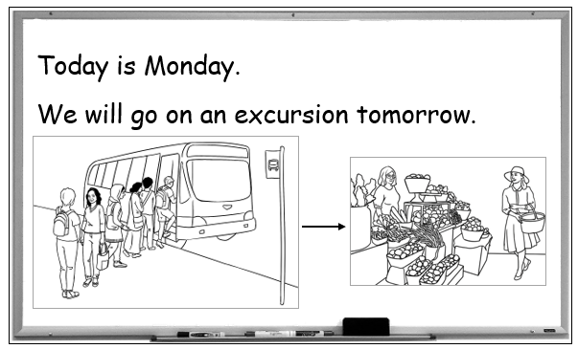

Monday

Wendy | We’ll go on an excursion tomorrow.
Linh | Where will we go?
Wendy | We’ll go to the market.
Linh | How will we get there?
Wendy | We’ll go by bus.
Linh | What time will we leave?
Wendy | We’ll leave at 9:30.
Linh | What time will we get back?
Wendy | We’ll get back at 1 o’clock.

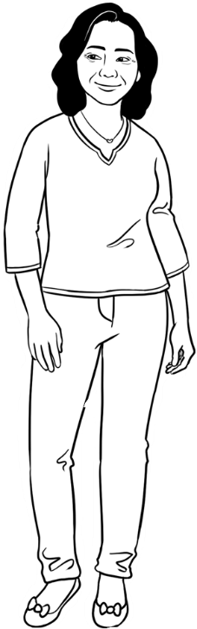
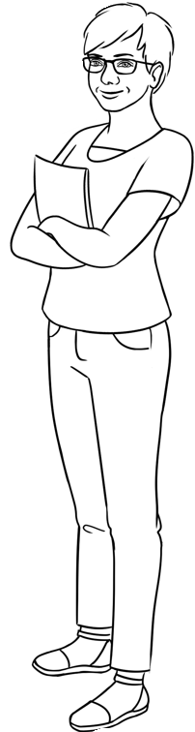

Tuesday
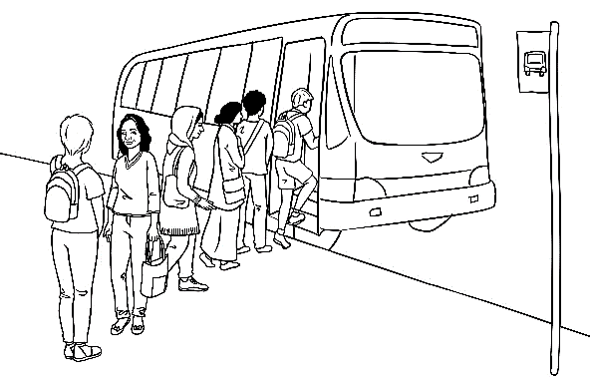 | 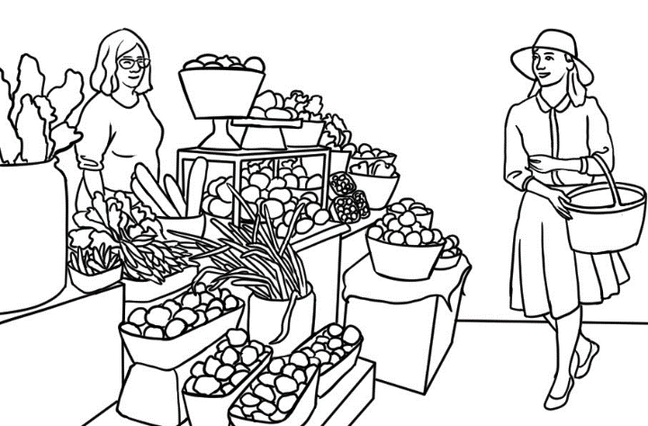
The students get on the bus. | They look around the market.
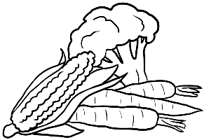  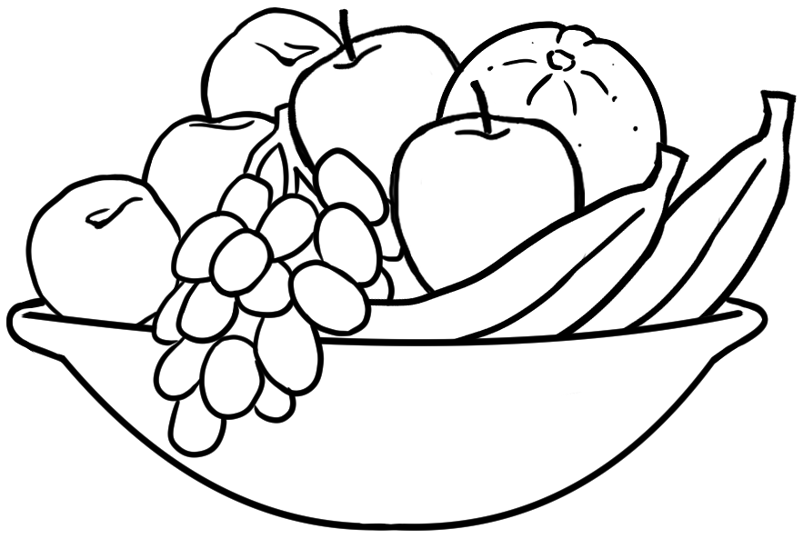 | 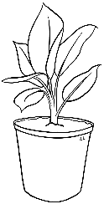  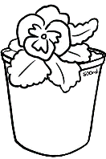  
They buy fruit and vegetables. |   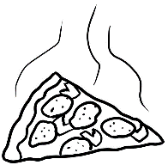    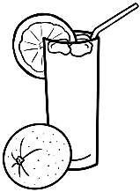  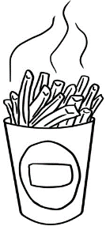    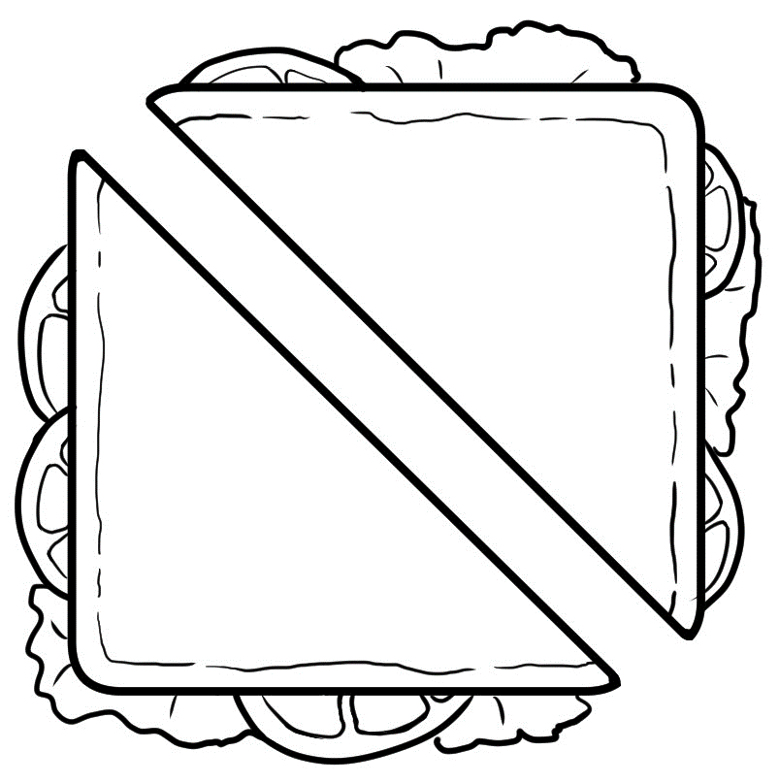  They buy plants and flowers.
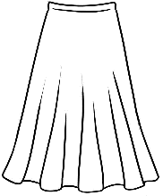
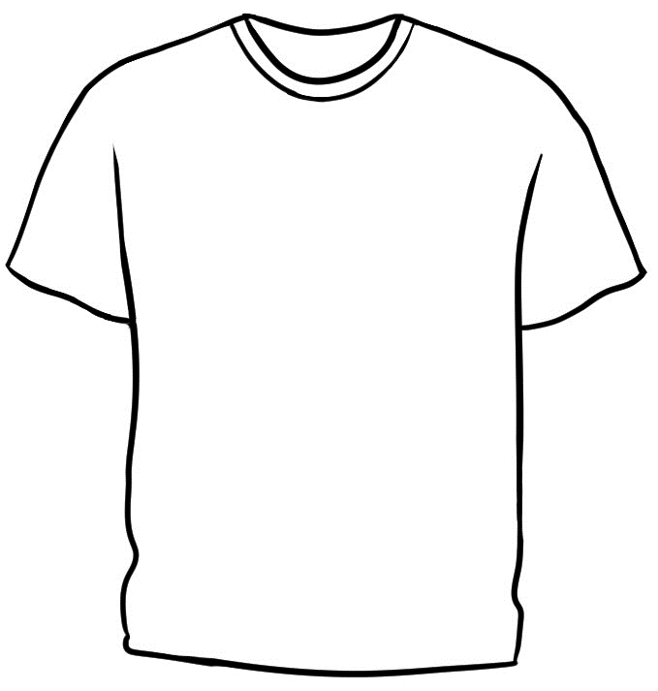
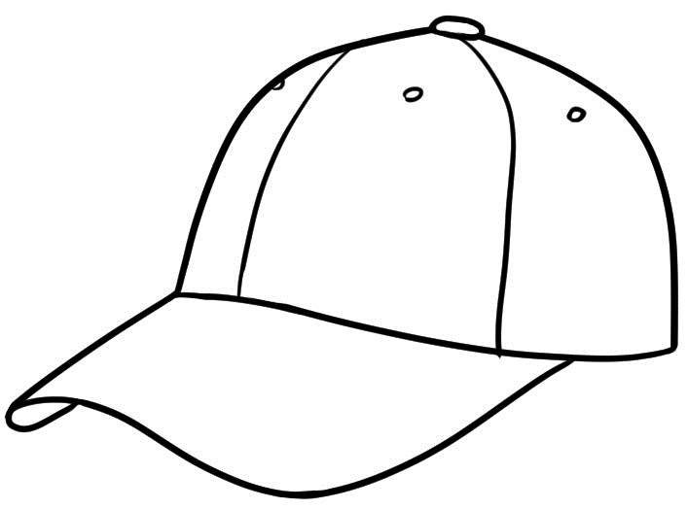
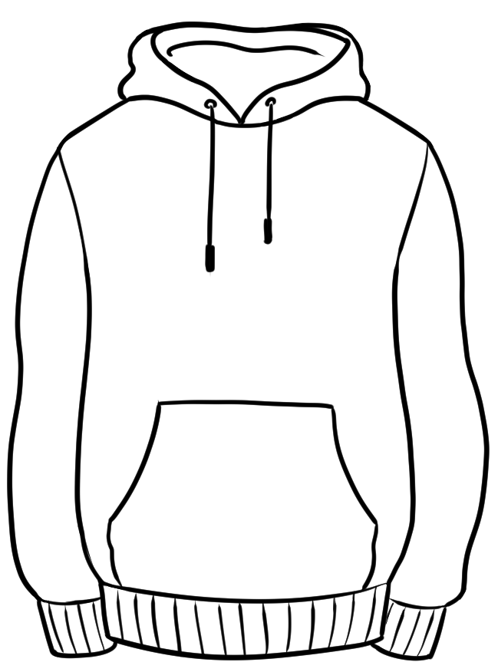
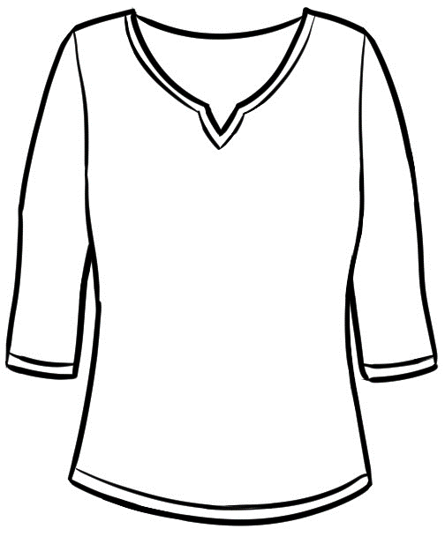

They buy clothes. | They have lunch.
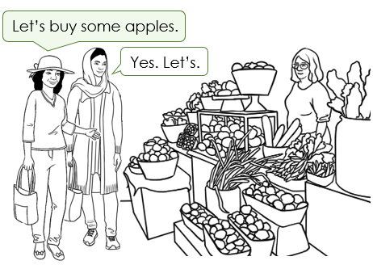 | 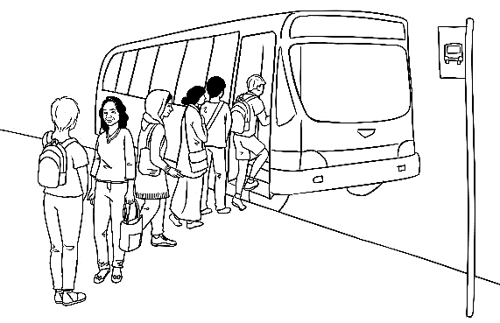
The students speak English. | They catch the bus back  to the centre.

Wednesday
Sarah | Hi Parwana. How are you?
Parwana | Good thanks Sahra.
Sarah | Are you enjoying your English class?
Parwana | Yes I am. Yesterday we _____________  on an excursion to the market.
Sarah | Oh. _________ you have lunch there? | 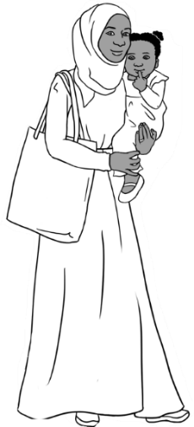 | 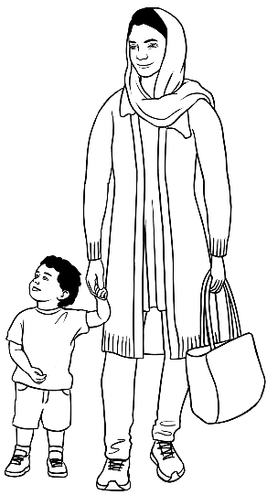
Parwana | Yes, we _________ lunch, but before lunch  we _____________ _____________ the market.
Parwana |  |  | Past
Sarah | _________ you buy anything? |  | went
Parwana | Yes, we ___________ lots of things. Some students ___________ clothes and flowers,  but Linh and I __________ fruit and vegetables.  Then after lunch, we ____________the bus  back to the centre. |  | had
Parwana |  |  | did ⁴
Parwana |  |  | bought ³
Parwana |  |  | caught
Sarah | _________ you enjoy the excursion? |  | spoke
Parwana | Yes I _____ and we __________English all day. |  | looked around
Sarah | Let’s go to the market together sometime.
Parwana | Good idea. See you later Sarah.
Sarah | Yes. See you soon.

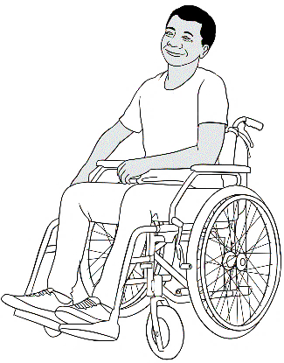
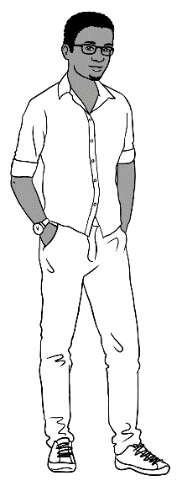

Tahiil | Hi Ko. How’s things?
Ko | Good thanks Tahiil.
Tahiil | How’s your English class?
Ko | Great. We _______ to the market yesterday.
Tahiil | Oh. How _______ you get there?
Ko | We ____________ the bus. |  | Past
Tahiil | How ______ you get your wheel chair  on the bus? |  | went
Tahiil | How ______ you get your wheel chair  on the bus? |  | did ²
Ko | The driver ____ ______ down a ramp for me. |  | caught
Tahiil | Oh, that’s good. How _______ the market? |  | put down
Ko | Good. I __________ a t-shirt and a big bag  of lemons. Would you like some lemons? |  | was
Ko |  |  | bought
Tahiil | Yes please.
Ko | I’ll give them to you later.
Tahiil | OK. I’ll see you then.

Talk about sport.
What sports do you enjoy watching or playing?

soccer
footy
tennis
netball
cricket
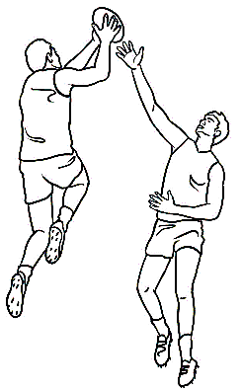

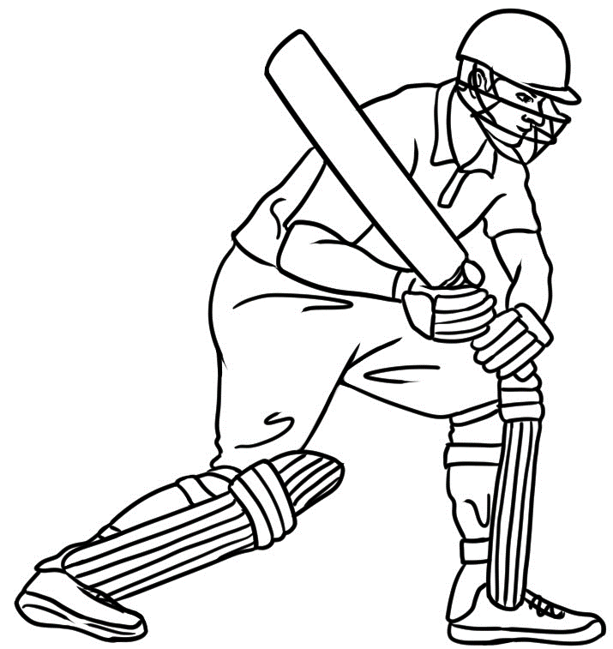

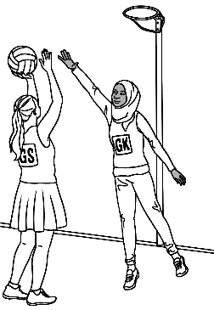
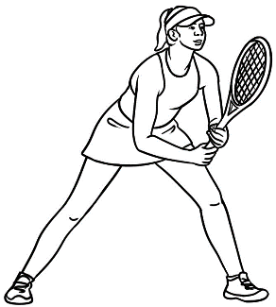

Peter | Have you been to a footy game Basam?
Basam | Footy?
Peter | Yes footy. Aussie Rules. AFL.
Basam | No, not yet. I don’t understand it.  I like soccer.
Peter | Yes, I like soccer, but I like footy too.  It’s a popular sport in Australia.  A popular sport is a sport  many people like.

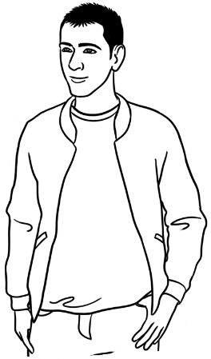
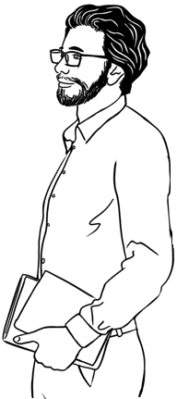

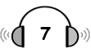

- What sport are Nisha and Parwana talking about?

tennis cricket soccer

- Is Parwana interested in this sport? Yes No

- Where does Nisha come from?

Afghanistan China India

fine | yesterday | where | tired
here | How | interested in | very

Nisha | Hello Parwana. _________ are you?
Parwana | I’m ________ thanks. And you?
Nisha | I’m a little ________. I went to the cricket  _______________ . Are you ______________ ___  cricket?
Parwana | No, I’m not, but it’s a popular ________ isn’t it?
Nisha | Yes, and it’s ________ popular in my country.
Parwana | Oh, ____________ do you come from Nisha?
Nisha | I’m from India.
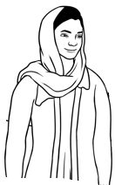
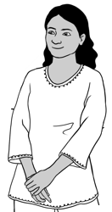

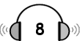

- What sport are Peter and Amina talking about?

footy netball tennis

- Can Amina play this sport? Yes No

- Where is the Australian Open played?

Sydney Melbourne Brisbane

Peter | ______ ______ like tennis Amina?
Amina | Yes, ______ ______ . I really like watching  tennis, ______ I can’t play.
Peter | ______ ______ watch the Australian Open  ______ TV last night?
Amina | The Australian Open? What’s that ?
Peter | It’s _____ tennis competition. ______ ______  in Melbourne in January every year.  ______ the best players come ______ play.  It’s on TV tonight.
Amina | Oh. Then I’ll watch ______ tonight.
it | but | and | Did you | Do you
All | It’s on | I do | on | a

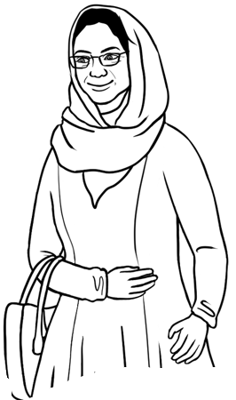

Talk about the weekend.
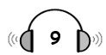
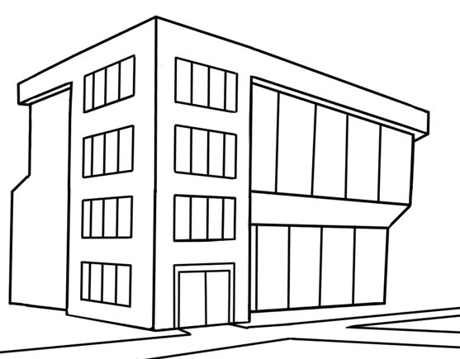
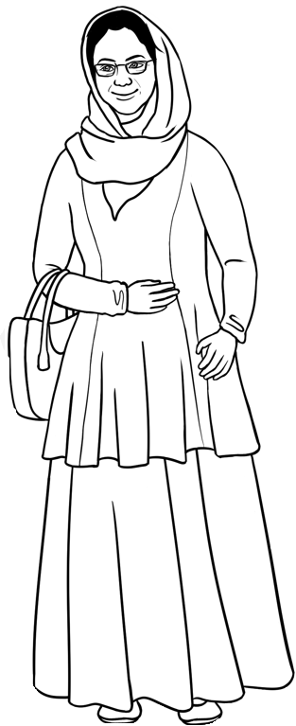
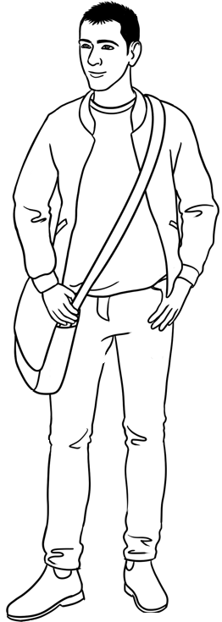
On Monday before class

Basam | Hi Amina. How are you?
Amina | Good thanks Basam. And you?
Basam | I’m fine thanks. How was your weekend?
Amina | It was busy. We went to the beach  on Sunday because it was so hot.
Basam | Yes. It was really hot.  Did you take the grandchildren?
Amina | 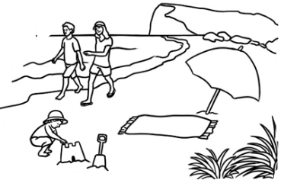  Yes we did. The children loved playing  in the water and on the beach.  Did you have a busy weekend?
Basam | No, it was very quiet. Oh, look at the time.
Amina | Oh yes. It’s time for class. Let’s hurry.

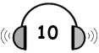
On Monday before class

Wendy | Hi Linh. How are you going?
Linh | Good thanks. How are you Wendy?
Wendy | I’m fine thanks. What did you get up to  on the weekend?
Linh | I went shopping and talked to my friends  in Vietnam. What did you do Wendy?
Wendy | I played netball and went out for dinner  on Saturday.
Linh | That sounds nice.
Wendy | Yes, it was. Excuse me Linh. I need to get  ready for class. Could you help me?
Linh | Yes, I’d love to.
Wendy | Thank you. We need to move this table.
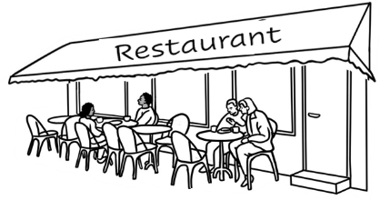
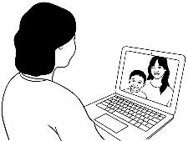
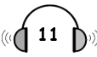
On Monday at break time
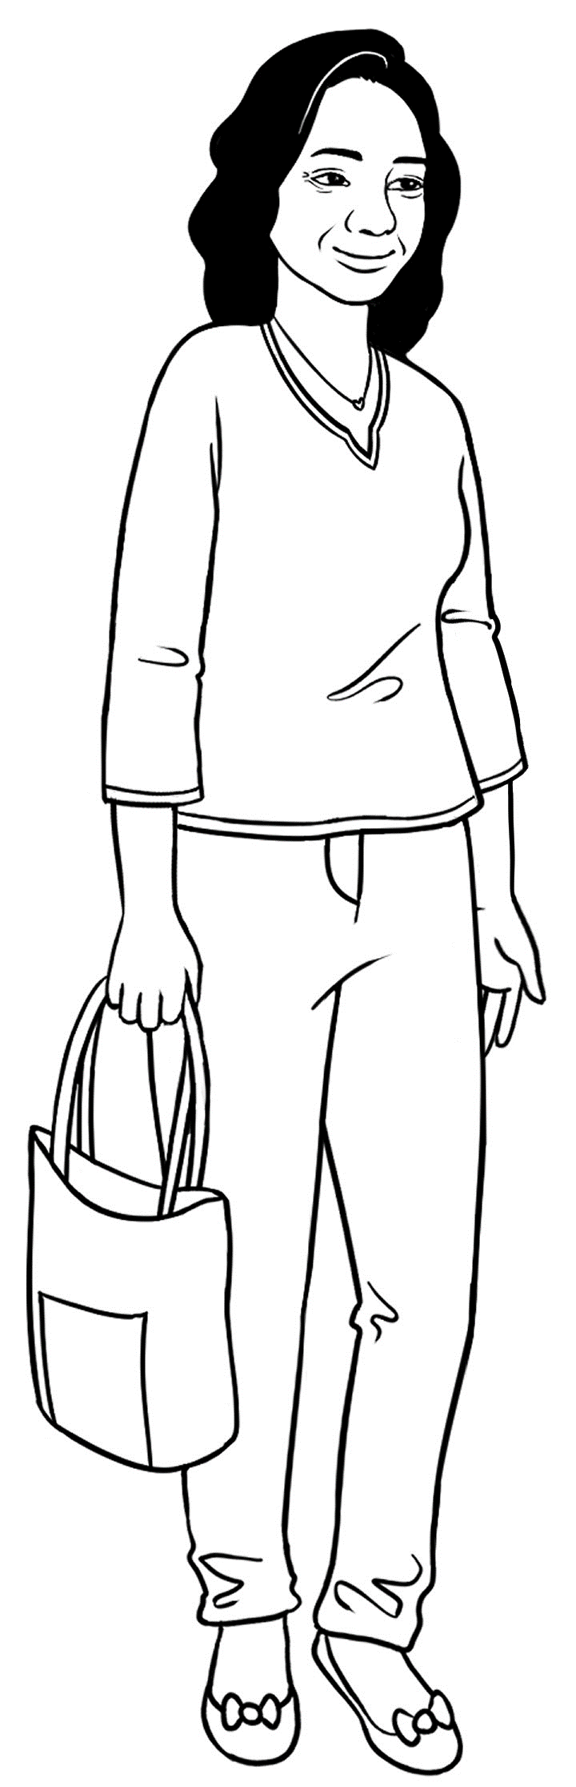
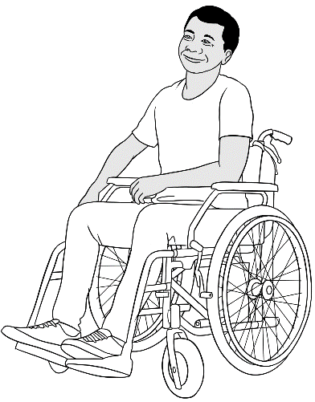

Linh | Hello Ko.
Ko | Hi Linh.
Linh | Did you have a good weekend?
Ko | Yes. I went to the park  with my family.
Linh | It was a beautiful day.
Ko | Yes, we sat on the grass  near the lake.
Linh | Oh nice.
Ko | We had lunch, watched the ducks and  relaxed. What about you?
Linh | We had a very quiet weekend at home.
Ko | Oh, here’s Wendy. Let’s go back to class.
Linh | Yes.

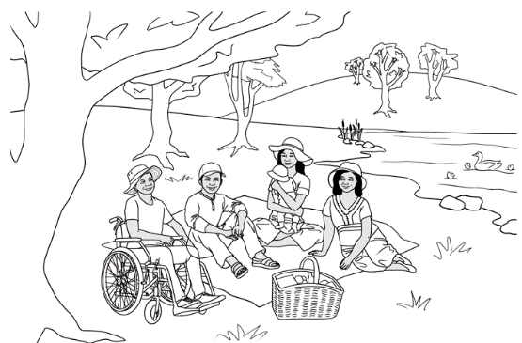

What will you buy?
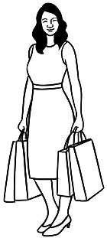
What will you buy?

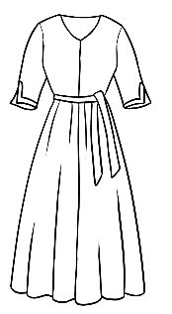  - dress | 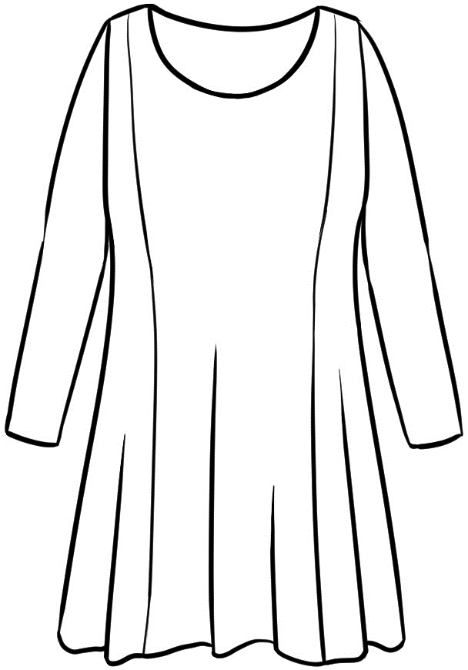  - top | 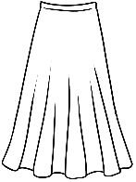  - skirt
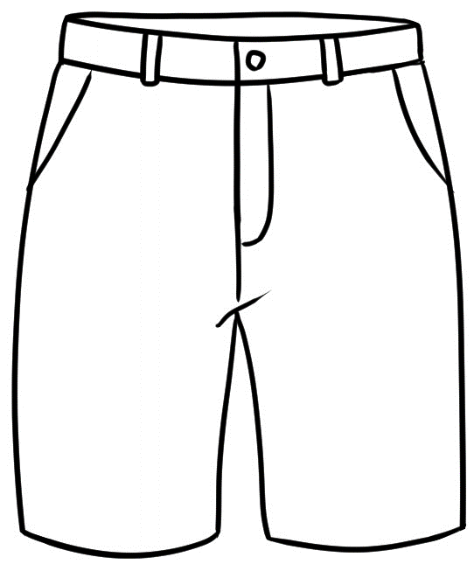  - shorts | 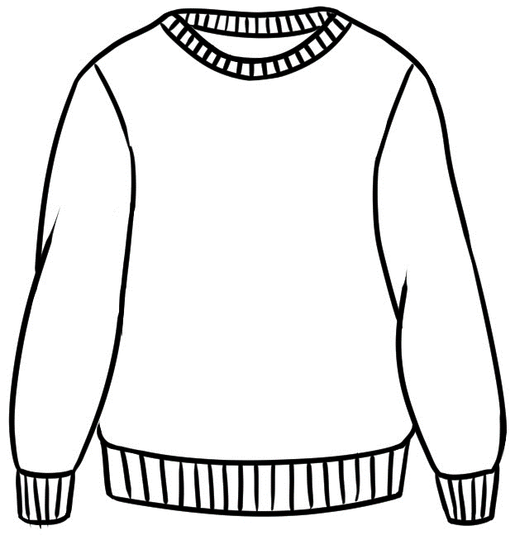  - jumper | 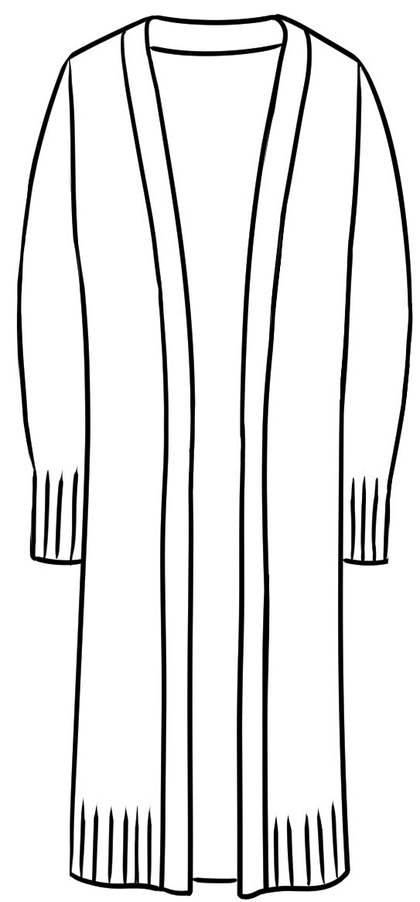  - cardigan
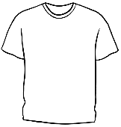  - t-shirt | 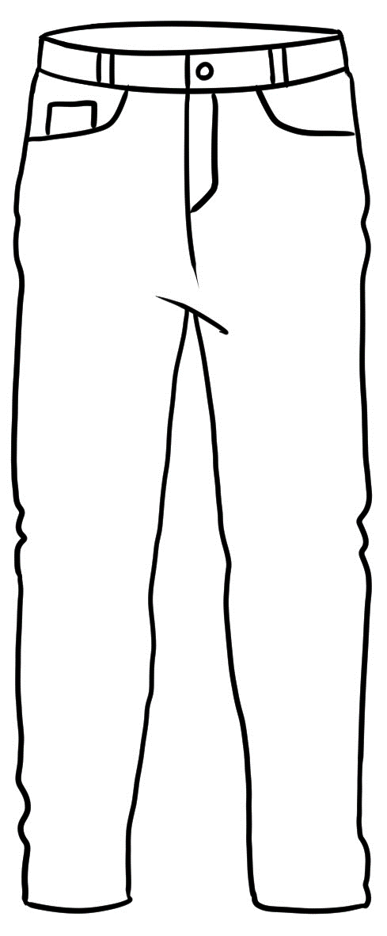  - jeans | 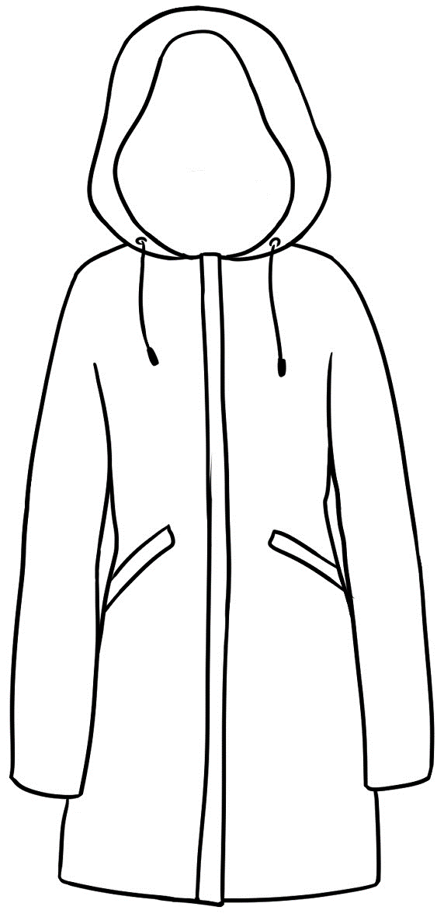  - raincoat
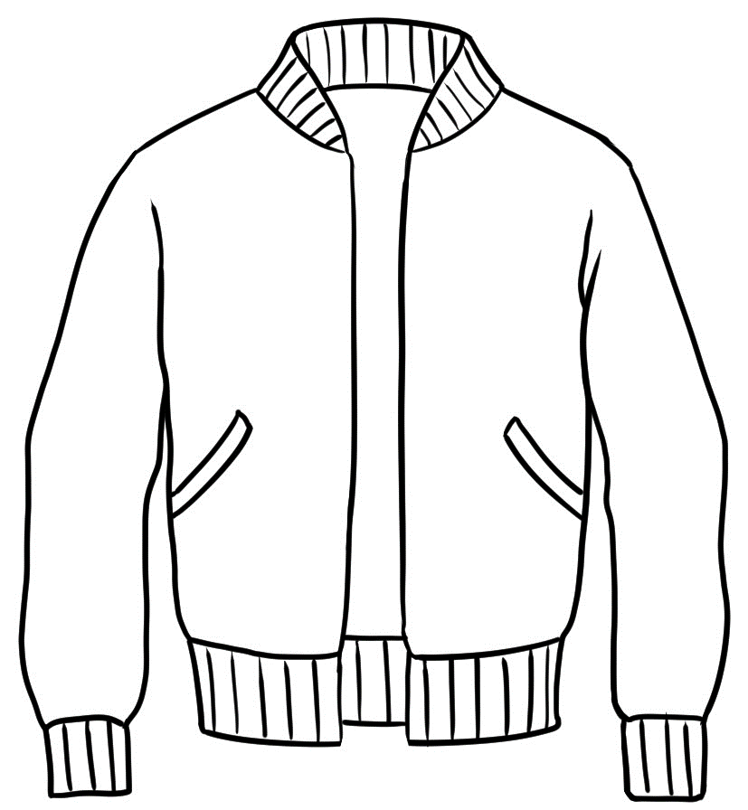  - jacket | 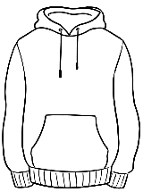  - hoodie | 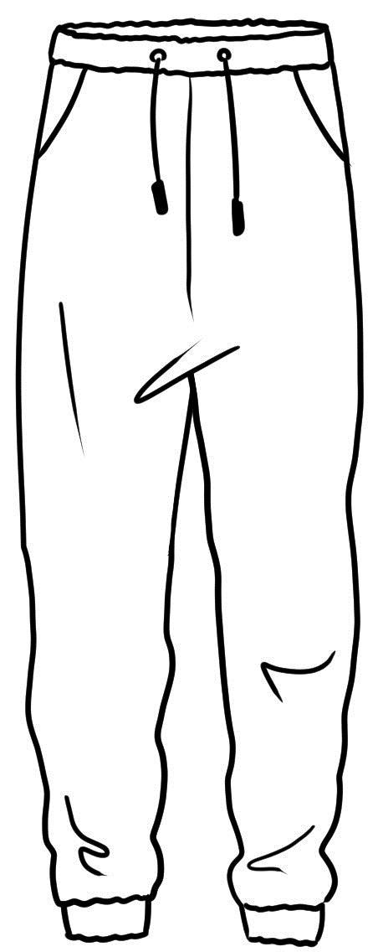  - trackpants
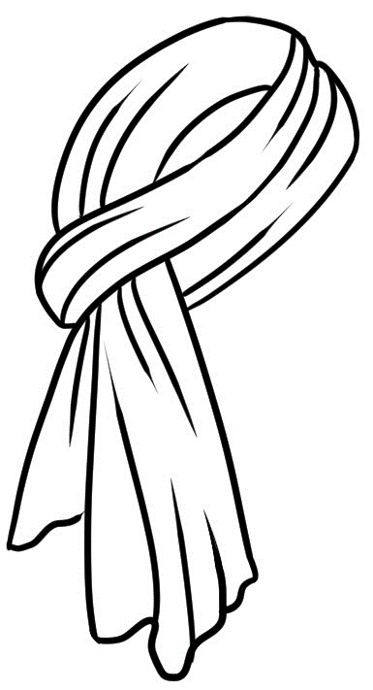  - scarf | 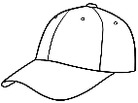  - cap | 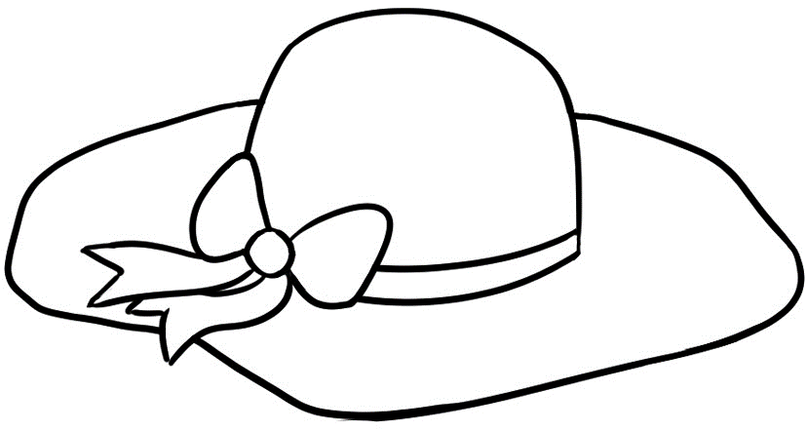  - sunhat
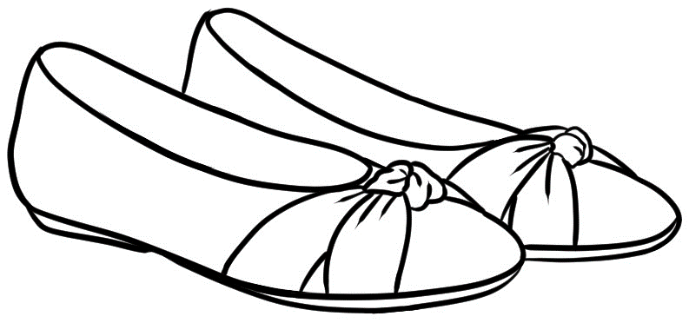  - shoes | 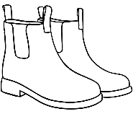  - boots  What will you buy? | 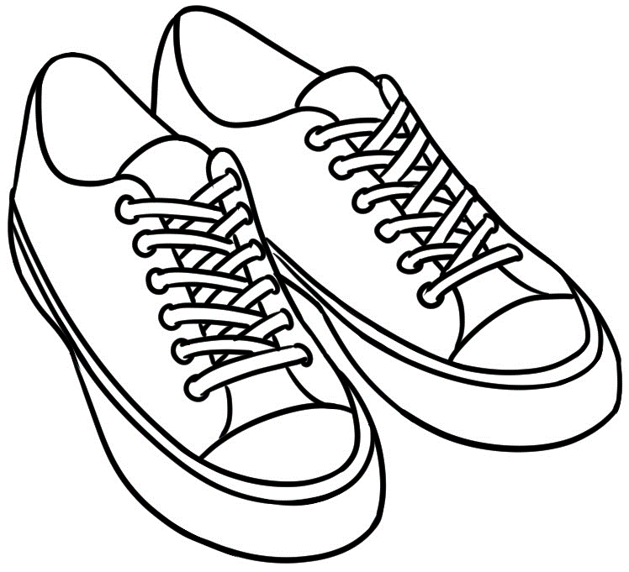  - runners

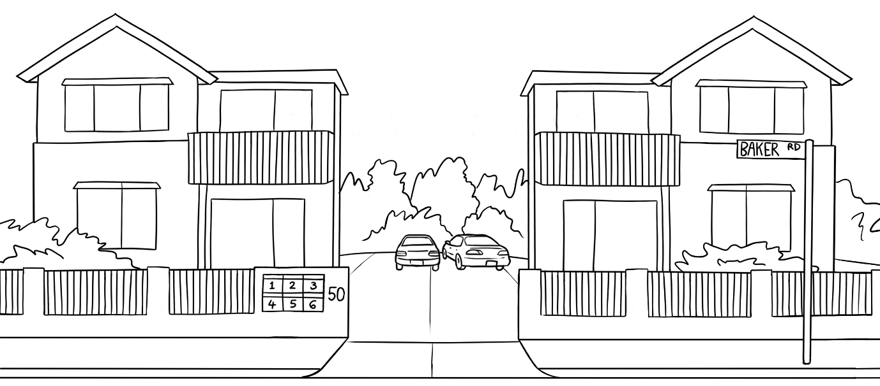
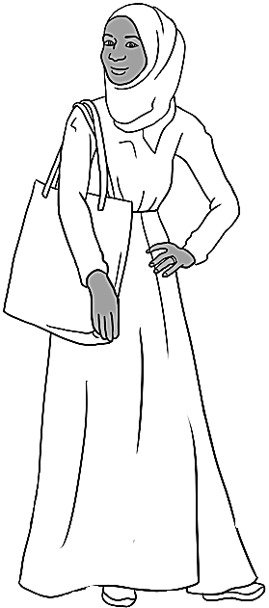
Hi Sahra.
Hi Parwana.

Parwana | Hi Sahra.
Sarah | Hi Parwana. Are you going shopping today?
Parwana | Yes, I am. I need a new skirt and top.
Sarah | I’m going shopping too. I need a new pair of shoes.
Parwana | Let’s go together.
Sarah | OK.
Parwana | Let’s walk to the bus stop.
Sarah | The bus will be here soon.
Parwana | Yes. Let’s walk quickly.  quickly = fast

What’s the problem?
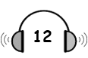

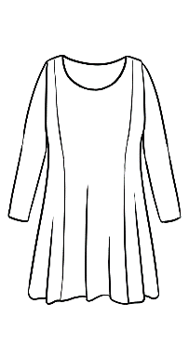

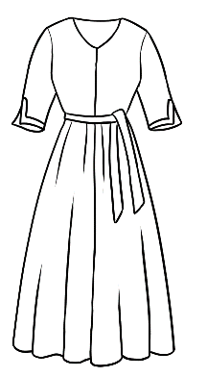
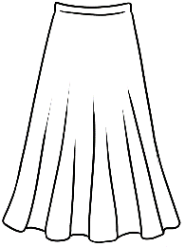
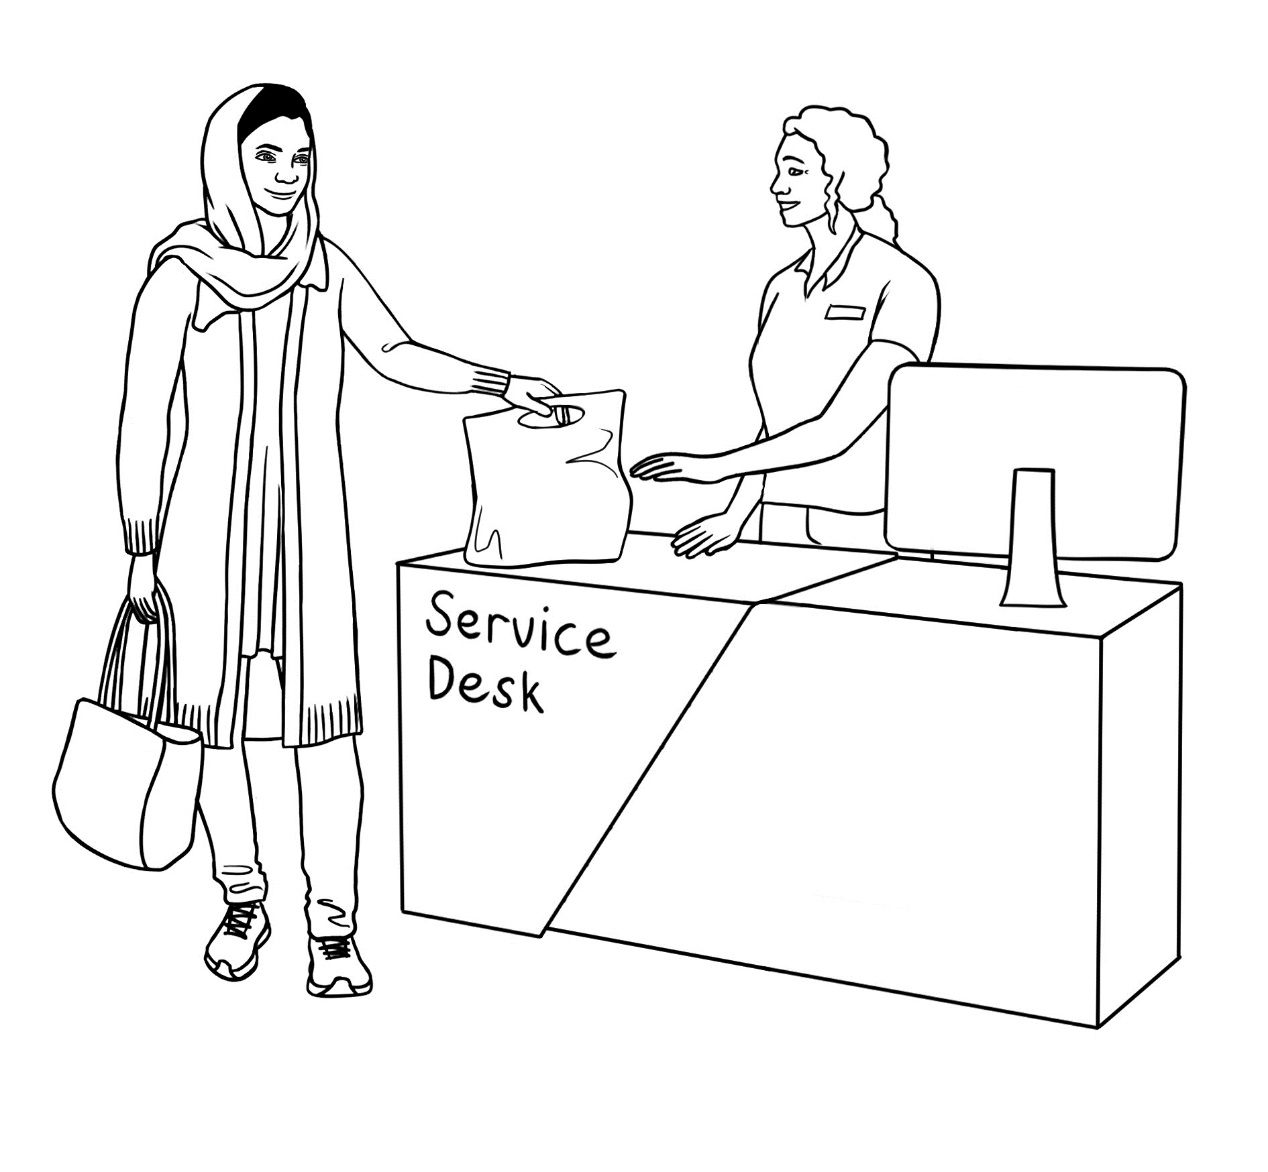

a missing button
a stain
a hole

Parwana
a dress
a top
a skirt

yesterday.
last week.
two days ago.

bought
1
1

There
2
a missing button.
a small hole.
a stain.

is

Parwana’s phone number.
her debit card.
the receipt.

The shop assistant
3
needs

Parwana | Hello. I bought this skirt yesterday, but there’s  a small hole in it.
Shop assistant | Oh. Where’s the hole?
Parwana | Just here.
Shop assistant | Oh yes. Do you have the receipt?
Parwana | Yes. Here it is.
Shop assistant | That’s fine. Would you like an exchange  or a refund?
Parwana | Oh. What does that mean?
Shop assistant | An exchange means you can change  the skirt for a new one. A refund means  you can get your money back.
Parwana | I’d like an exchange please.
Shop assistant | Okay. Can you get another skirt and bring it back here?
Parwana | Here’s a new skirt.
Shop assistant | Do you need a bag?
Parwana | No thanks, I have a bag. Thanks for your help.
Shop assistant | You’re very welcome.
5 minutes later

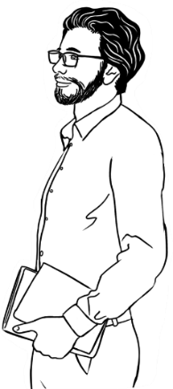
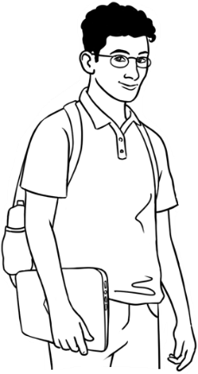
Peter | Hi Ahmad. How’s your new laptop?
Ahmad | Hello Peter. The laptop’s no good.
Peter | Oh. What’s the problem?
Ahmad | I bought it last week, but it’s faulty.
Peter | Will you take it back?  faulty = not working well
Ahmad | Yes. I’m going to the computer store after class.
Peter | Do you have the receipt?
Ahmad | Yes, I do.

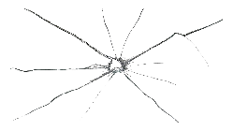
There’s a scratch on the screen.
The buttons
don’t work.
The screen
is cracked.
The battery doesn’t recharge.
The mouse pad doesn’t work.
The camera doesn’t work.
What’s the problem
with Ahmad’s laptop?

Ahmad | Hello. I bought this laptop last week,  but it’s faulty.
Shop assistant | What’s the __________________?
Ahmad | The battery doesn’t ______________________.
Shop assistant | That’s _____ good. Do you have your receipt?
Ahmad | Yes. It’s on my _________________ here.
Shop assistant | That’s _________. Would you like an exchange  or a refund.
Ahmad | I’d like a _______________ please.
Shop assistant | Certainly. Do you have ____________ card?
Ahmad | Yes. Here it is.
Shop assistant | I’ll put the money onto your ____________.
Ahmad | Thank you.
Shop assistant | I’m _____________ about the problem.
Ahmad | That’s okay. Bye
Shop assistant | Bye.
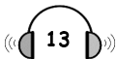
problem | phone | card | your | recharge
refund | not | fine | last week | sorry

Student A | I bought this _______________  yesterday, but there’s a problem. | 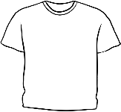
Student B | Oh. What’s the problem?
Student A | It’s ___________________________ | 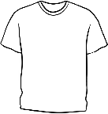  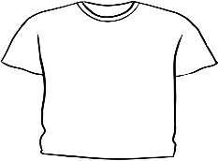  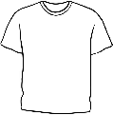  too big  too small  the wrong colour
Student B | Would you like an exchange  or a refund?
Student A | I’d like _______________ please. | 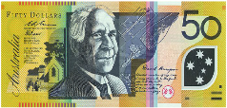  an exchange  a refund
Student B | Certainly. That’s no problem.  I can help you with that.
Student A | Thank you very much.
Student B | You’re welcome.  See you again.
Student A | Bye.

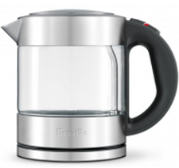
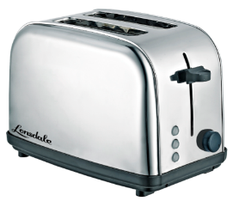
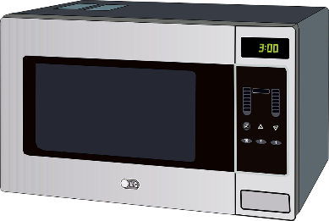
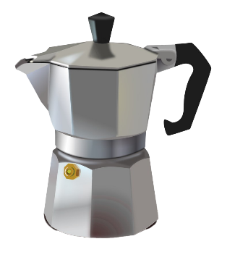
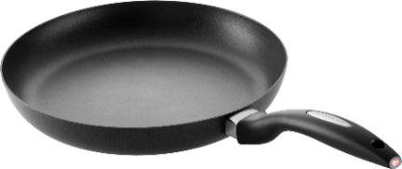
coffee pot
fry pan
electric jug
toaster
microwave
- What did you buy?

2. When did you buy it?

today | two days ago | three days ago | last weekend
yesterday | last week | two weeks ago | last Monday

3. What’s the problem?

There’s a crack. | 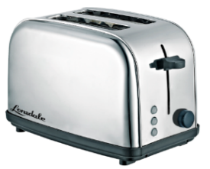    There’s a scratch. | 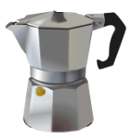  The top’s missing.
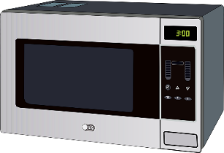  It doesn’t work. | 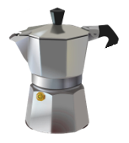    It’s broken. | 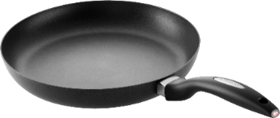  The handle’s loose.

At the medical centre
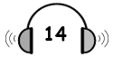

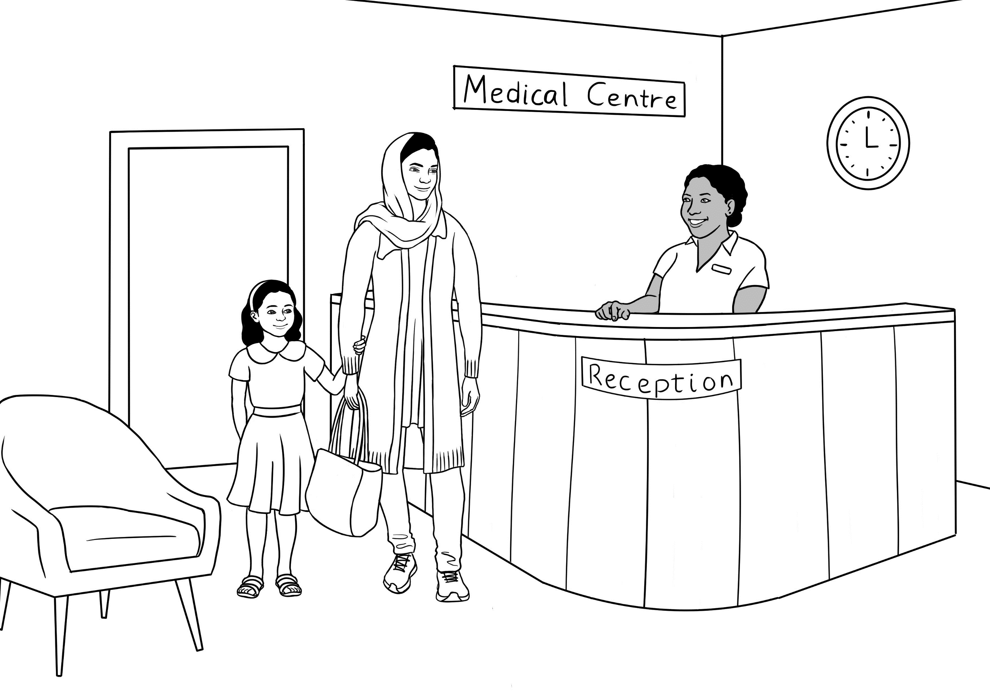

Parwana
an appointment
with the dentist.
with the doctor.
with the nurse.

needs
1

Parwana
an interpreter.

needs
doesn’t need

2

The receptionist
Parwana’s full name.
her address.
her Medicare card.

needs
3

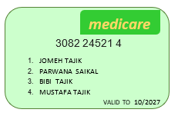
Receptionist | Good morning. Can I help you?
Parwana | Yes. I need an appointment with the doctor.
Receptionist | Have you been here before?
Parwana | No I haven’t.
Receptionist | OK. What’s your full name please?
Parwana | Parwana Saikal. S A I K A L.
Receptionist | Do you have a Medicare card Parwana?
Parwana | Yes. Here it is.
Receptionist | Can you come tomorrow at 11?
Parwana | Yes. I can, but I need an interpreter.
Receptionist | I’ll arrange an interpreter. What language  do you speak?
Parwana | Pashto.
Receptionist | Could you fill in this form too please?
Parwana | Yes, thank you. See you tomorrow.
Receptionist | Yes. Bye.

At the chemist
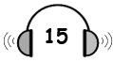

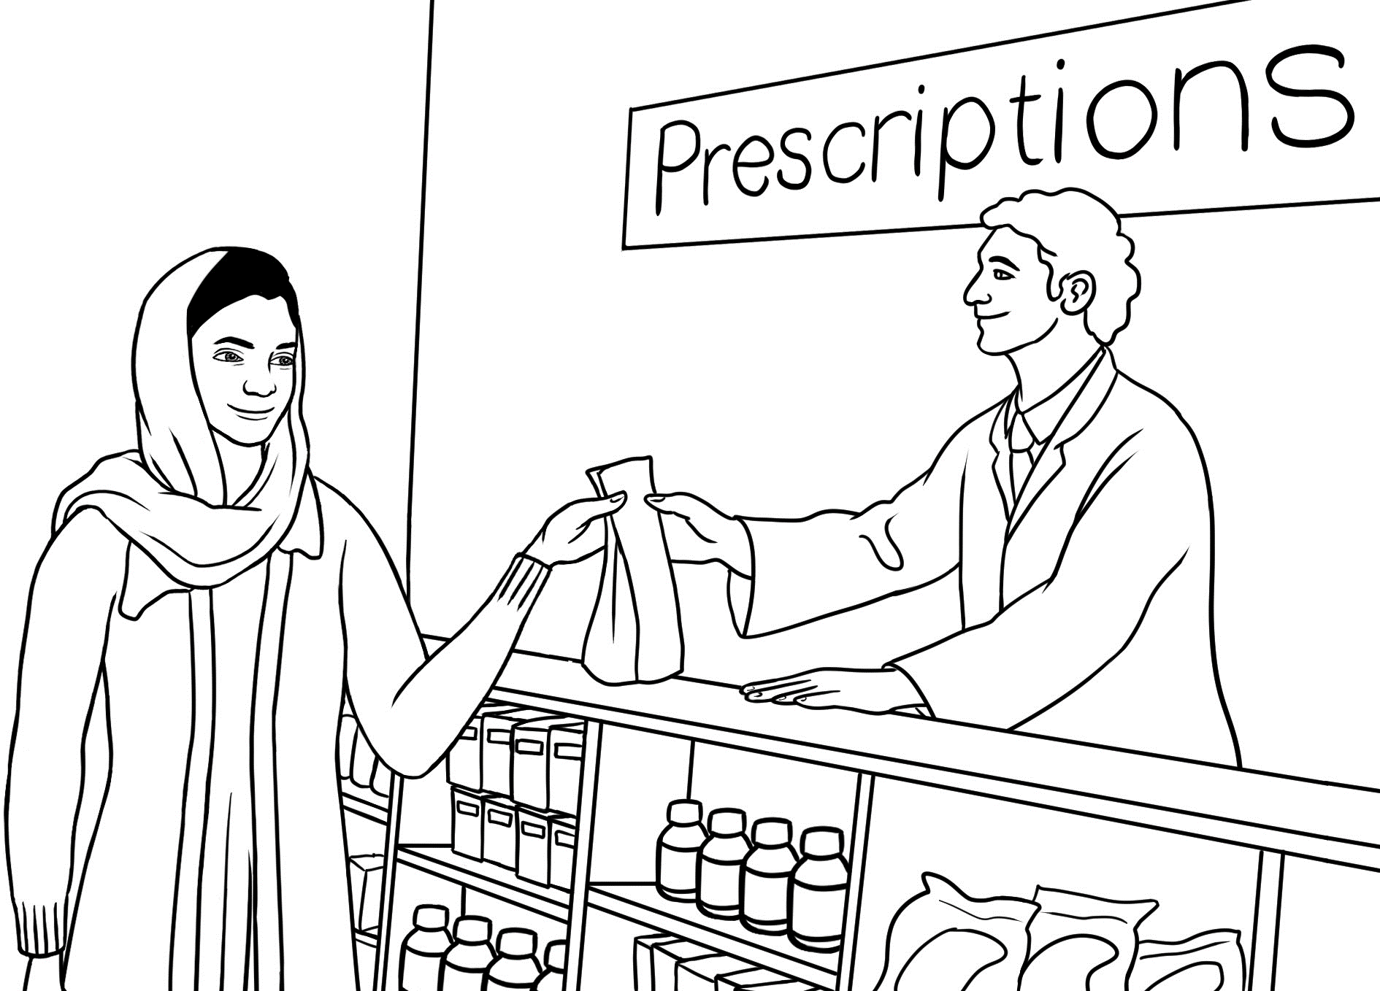

1. | Parwana goes to the chemist with a script. | Yes | No
2. | She needs some medicine. | Yes | No
3. | Her script is ready in about five minutes. | Yes | No
4. | Parwana says, ‘I want to pay for this.’ | Yes | No
5. | Parwana pays in cash. | Yes | No

Parwana | Hi. I’d like to leave this script please.
Chemist | Have you had this medicine before?
Parwana | Yes, I have.
Chemist | That’s fine. It will take about 15 minutes.
Parwana | OK. I’ll wait here.  15 minutes later
Chemist | Your script is ready now. Please pay at the register.
Parwana | OK. Thanks.  At the register
Cashier | Next please.
Parwana | I’d like to pay for this.
Cashier | Sure. Is that card or cash?
Parwana | Card, please.
Cashier | Just tap here when you’re ready.
Parwana | OK?  She taps the card.
Cashier | Yes, that’s fine. Thanks very much.
Parwana | Thanks. Bye.

