

English Ready
22638VIC Certificate I in EAL
VU23502 Give and respond to short simple spoken information

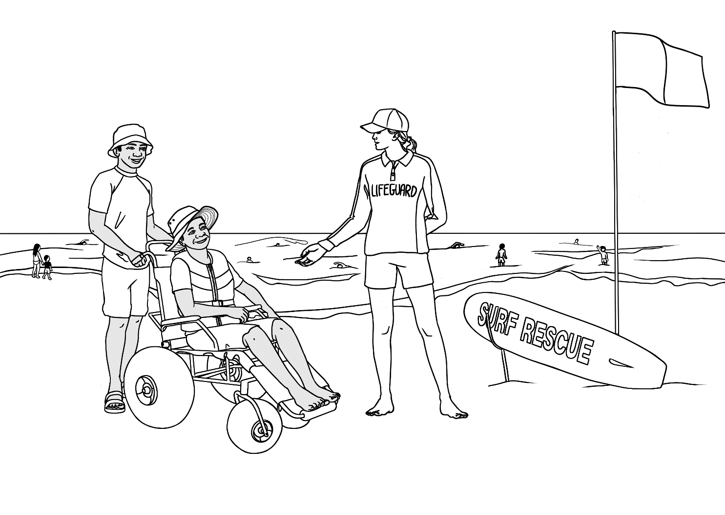
Student Workbook

Student _______________________________________________________
Teacher _______________________________________________________
Class ________________________________________________________
Date ________________________________________________________

Design team: Vicki Hambling, Sue Paull, Frida Dean, Glenise Kleehammer and Mary Wallace
Illustrations: Madelena Scott

Illustrations acknowledgements:
Fork lift This Photo by Unknown Author is licensed under CC BY-SA-NC
Parking sign-Image by <a href="https://pixabay.com/users/wikimediaimages-185597/?utm_source=link-
River symbol, worried & sick emojis, coffee pot, First Aid kit, modern car These Photos by Unknown Author is licensed under CC BY-NC
Sound and fishing icons, This Photo by Unknown Author is licensed under CC BY-SA
Lithium batteries - by Clip Art
Lace doily This Photo by Unknown Author is licensed under CC BY-NC-ND
A gift - <a href="https://www.freepik.com/free-vector/gift-box-white-background_47754818.htm#query=gift%20box%20clipart&position=1&from_view=keyword&track=ais_user&uuid=b49eac75-2bbb-4c01-93e2-04f26db477c2">Image by brgfx</a> on Freepik
Icon for solar power <a href="https://www.flaticon.com/free-icons/solar-panel" title="solar panel icons">Solar panel icons created by Freepik - Flaticon</a>
Icon for wind power <a href="https://www.flaticon.com/free-icons/wind-turbine" title="wind turbine icons">Wind turbine icons created by Smashicons - Flaticon</a>
Glass decanter <a href="https://www.freepik.com/free-vector/vintage-decanter-illustration-vector-remixed-from-artwork-by-john-dana_19085355.htm#fromView=search&page=1&position=26&uuid=d8178df8-2480-4f7f-b0ad-62ad4d3ce7b1">Image by rawpixel.com on Freepik</a>
Acknowledgements: The design team would like to thank the AMEP service providers and practitioners who participated in the trial and gave valuable feedback. The team would also like to acknowledge the use of the EAL Framework which underpins the design of this book.
___________________________________________________________________________
Copyright of the EAL Framework is reserved to the Crown in the right of the State of Victoria. © State of Victoria (Department of Education and Training) 2023.
Use of all or part of this document must include the following attribution:
© Commonwealth of Australia 2024

With the exception of the Commonwealth Coat of Arms, the department’s logo, any material protected by a trade mark and where otherwise noted all material presented in this document is provided under a Creative Commons Attribution 4.0 International (https://creativecommons.org/licenses/by/4.0/) licence.
The details of the relevant licence conditions are available on the Creative Commons website (accessible using the links provided) as is the full legal code for the CC BY 4.0 licence (https://creativecommons.org/licenses/by/4.0/legalcode).
As far as practicable, material for which the copyright is owned by a third party will be clearly labelled. The department has made all reasonable efforts to ensure that this material has been reproduced in this document with the full consent of the copyright owners.
Copyright requests and enquiries concerning usage not addressed by the CC BY 4.0 licence should be addressed to: comms@homeaffairs.gov.au at the Department of Home Affairs.
The terms of use for the Commonwealth Coat of Arms are available from the It's an Honour website.
Where a copyright owner, other than the Commonwealth, is identified with respect to this material, please contact that third party copyright owner directly to seek permission.



This workbook is designed to be used with the support of a teacher.

Table of Contents
1. Meet the students and teachers 2
2. Meet two families. 3
3. Workbook instructions 4
4. Information about someone 5
5. The park 14
6. An excursion to the park 25
7. A place to rent 31
8. Sale at the Op Shop 36
9. An invitation 40
10. The beach and the pool 42
11. A quick and easy meal 48
12. Information transcripts 54

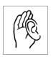
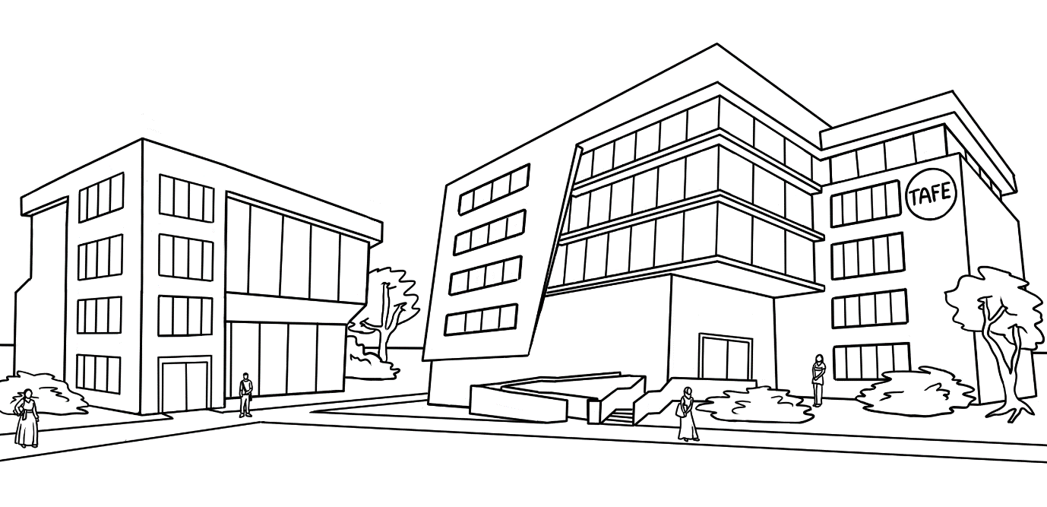
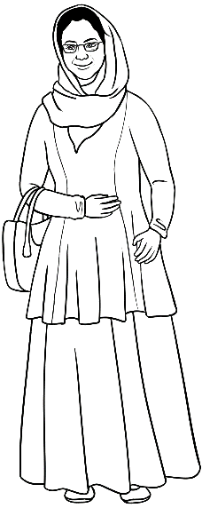
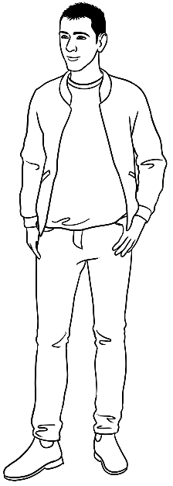
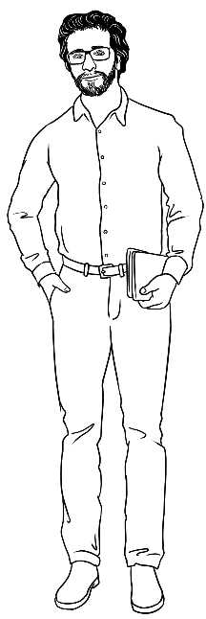
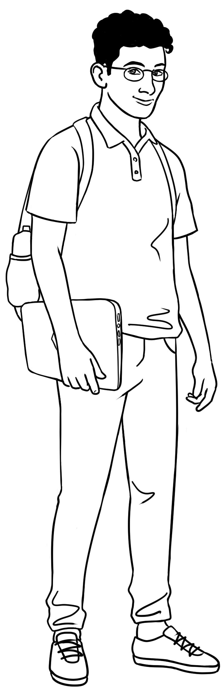
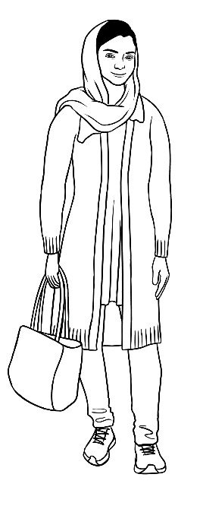
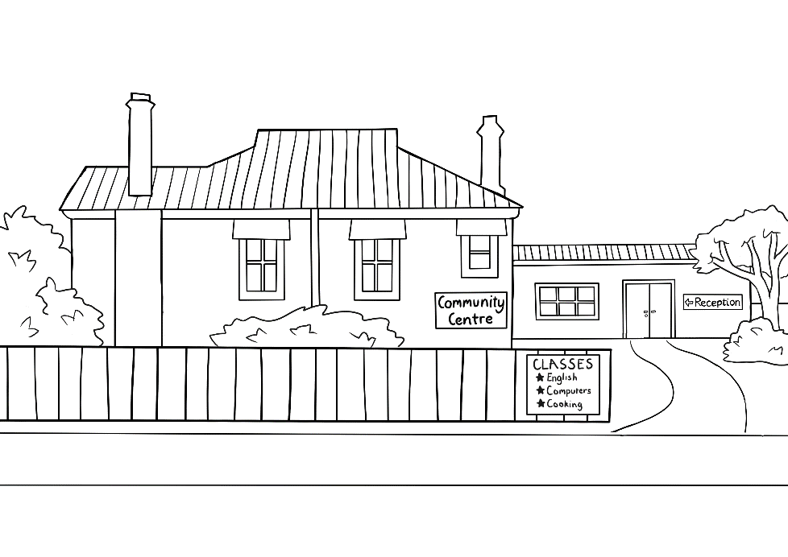
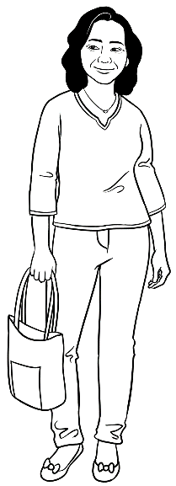
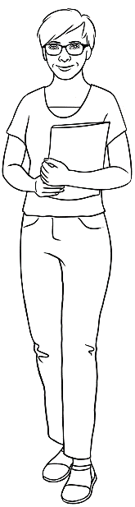
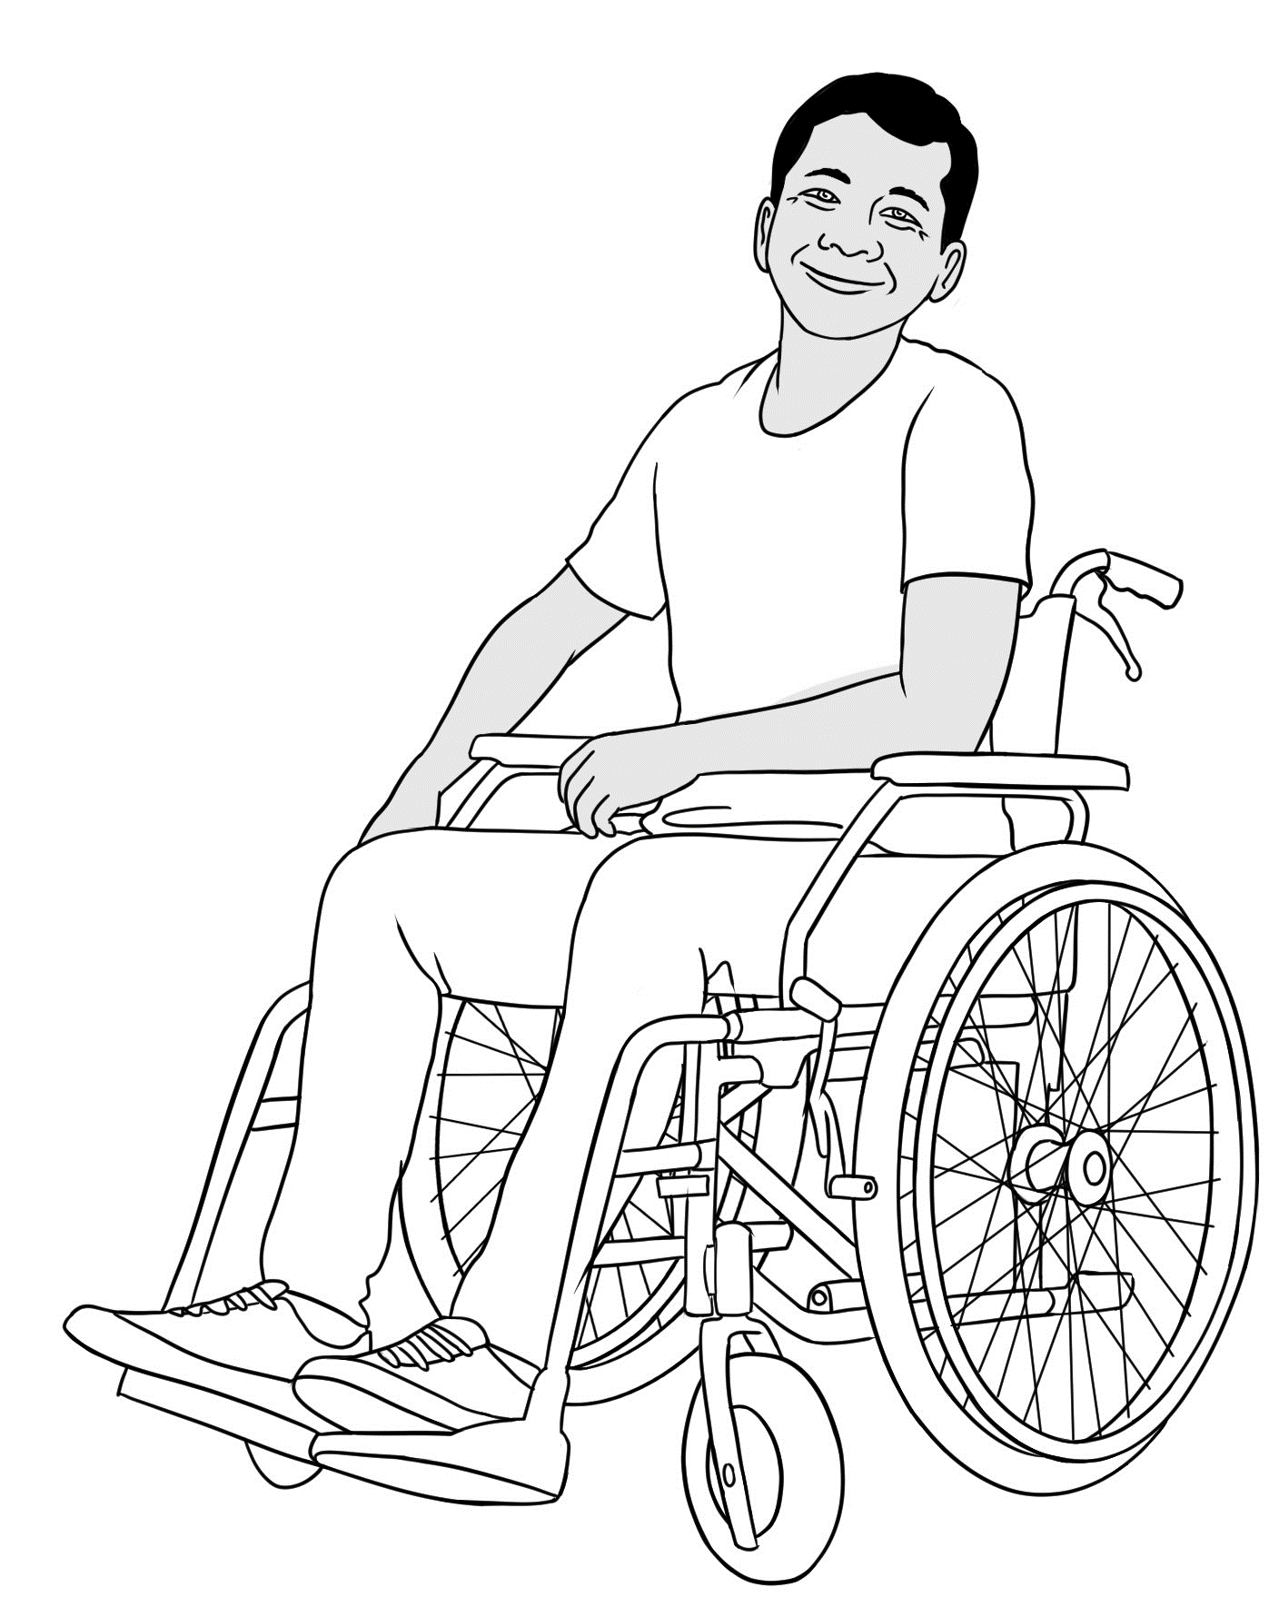
Meet the students and teachers

Peter
Amina
Basam
Ahmad
At the
AMEP
Centre

Parwana
Wendy
Linh
Ko
At the Learning Centre

Meet two families.

me |  | daughter |  | son |  | husband |  | mother | father |  | brother
Parwana |  | Bibi |  | Mustafa |  | Jomeh |  | Amina | Nabi |  | Rahim
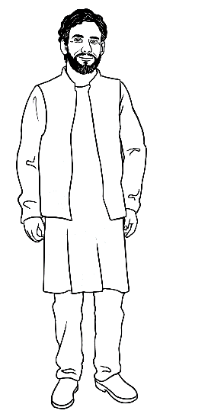
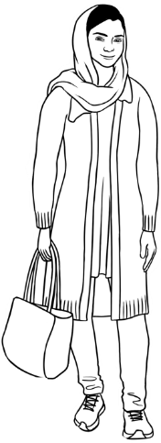
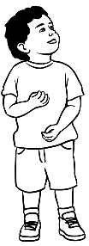
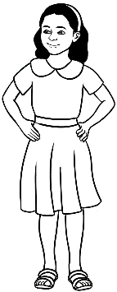
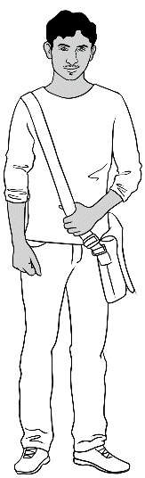
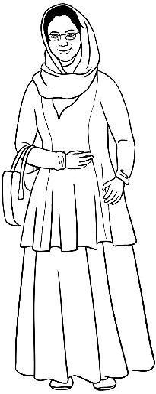
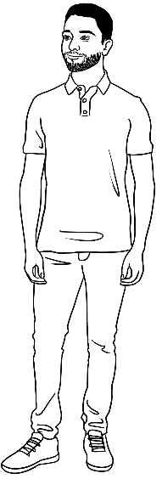
Parwana’s family

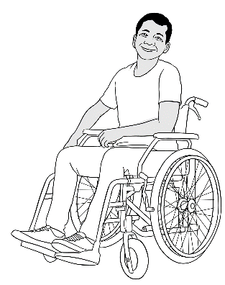
Ko’s family
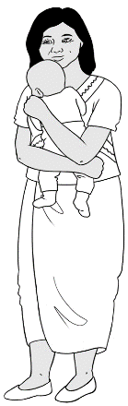
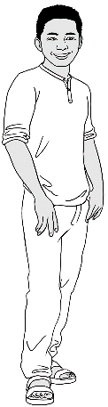
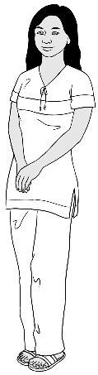
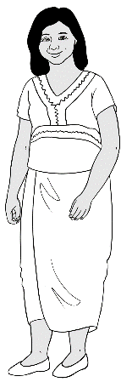
me | wife | daughter | son-in-law | grandson
Ko | Zani | San | Thein | Yaza
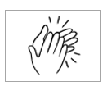
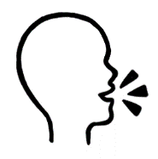

son  wife | mother father  sister brother  daughter grandson  husband | son-in-law

Workbook instructions

- listen |  | - say
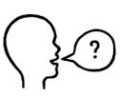  - ask questions |  | 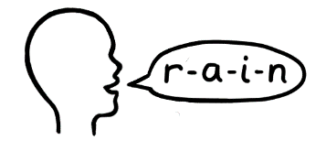  - spell
  - read |  | 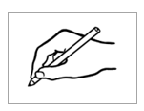  - write
- tick |  |   - circle
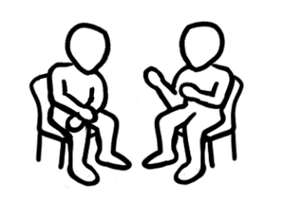  - work with a partner |  | - clap
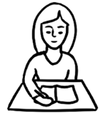  - Check your work. |  |   - Ask for help.

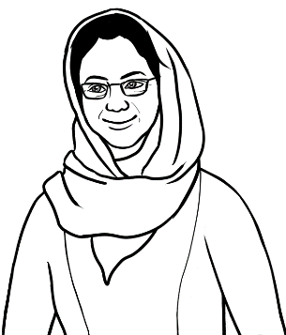
Do you understand?
Yes, I understand.

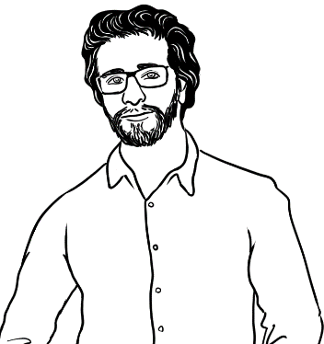
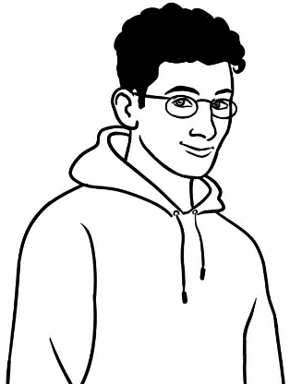
No, I don’t understand.

Can you say it again please?
Are you OK?
Could you speak slowly please?
don’t = do not

No. Can you help me please?
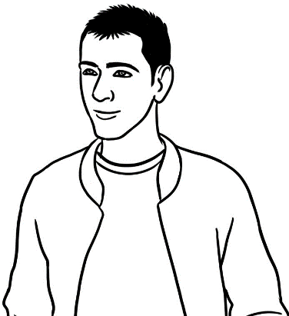
Could you check my work?

Information about someone
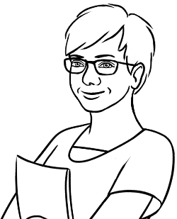
Ask your teacher
some questions.

My teacher
- What’s your name?
__________________________
2. Where do you come from?
__________________________

3. Are you married or single?
__________________________

5. What are your future plans?
__________________________________
__________________________________
__________________________________
6. What do you do
in your free time?
___________________________________________________
7. What are you good at?
____________________________________________________
4. Do you have any children?
__________________________________

Future plans
Learn | 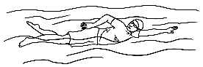  to swim. |  | 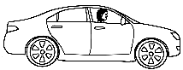  to drive. |  | 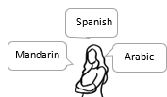  to speak a new language.
  First Aid. |  |   to dance. |  | 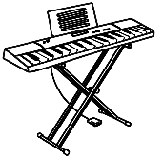  to play the piano. |  | 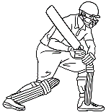  to play cricket.

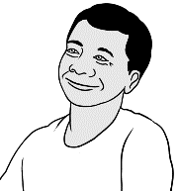
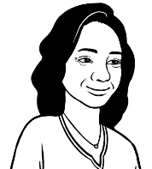
Linh asks Ko some questions.

- What’s your name? | My name is Ko.
- Where do you come from? | I come from Myanmar.
- Are you married or single? | I’m married.
- Do you have children? | I have a daughter and a grandson.
- What are your  future plans? | I want to finish my English study.  Then I want to learn how to repair computers.
- What do you do  in your free time? | I like reading and using computers.
- What are you good at? | 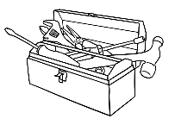  I’m good at fixing things.

Future plans
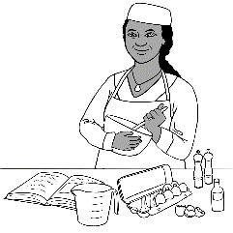
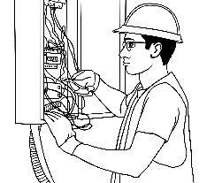
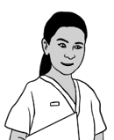
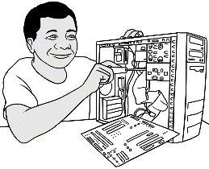
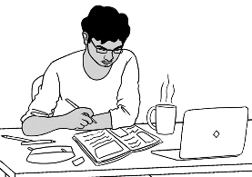

study | nursing | electrician | repair computers | cook
fork lift driver | child care | gardener | receptionist | house painter
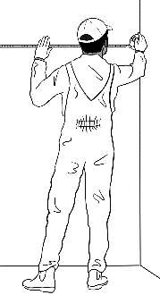
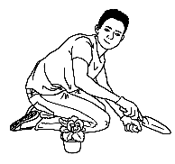
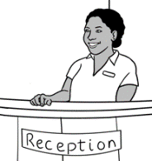
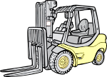
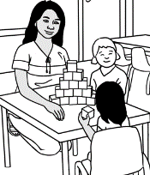

Free time

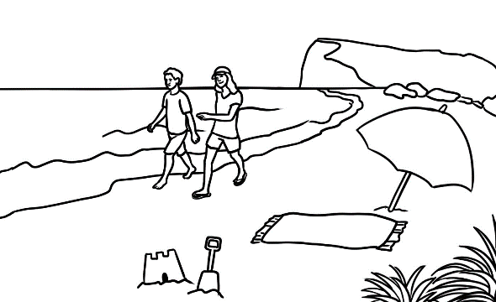
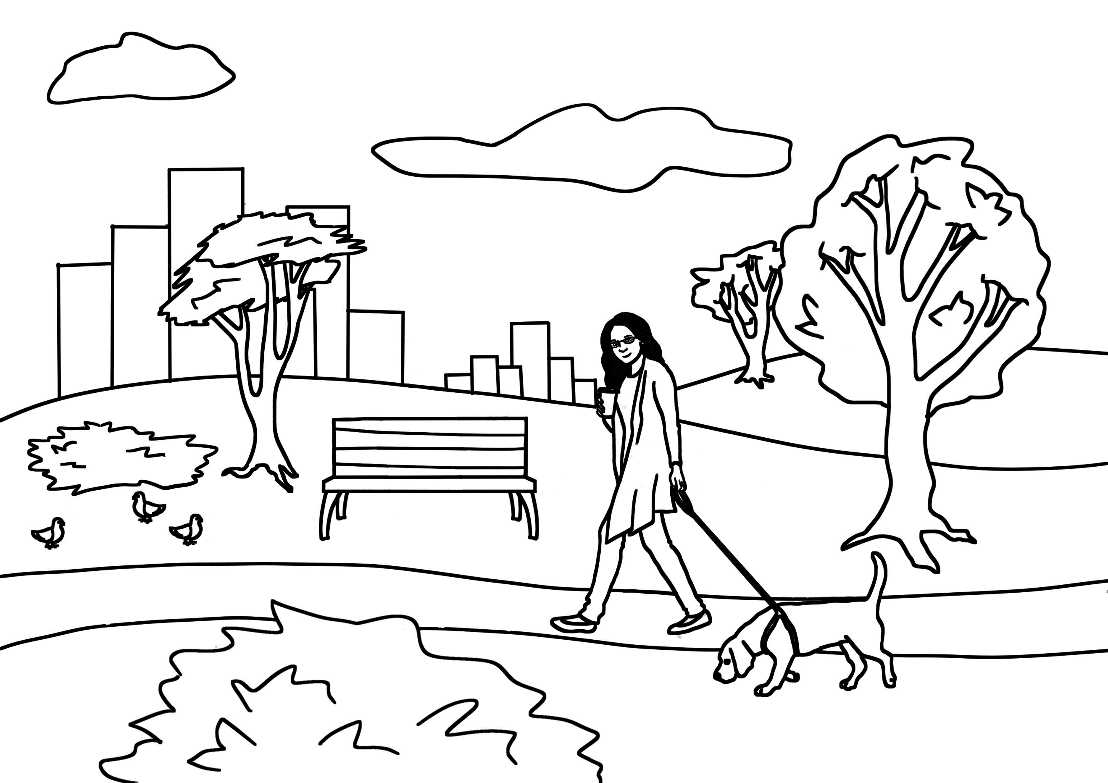
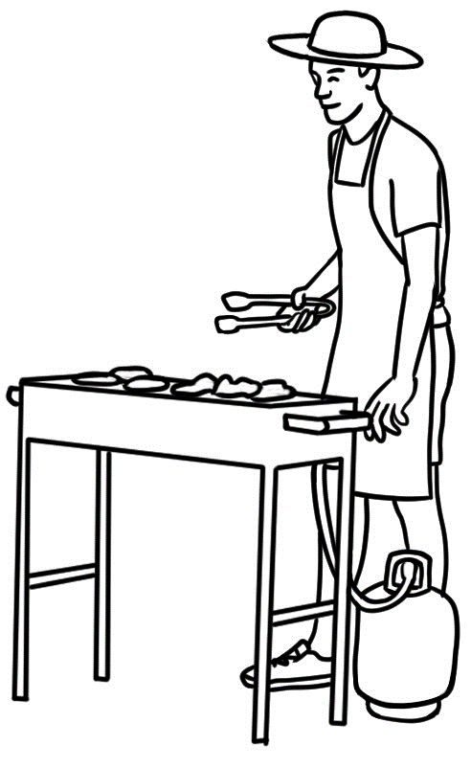
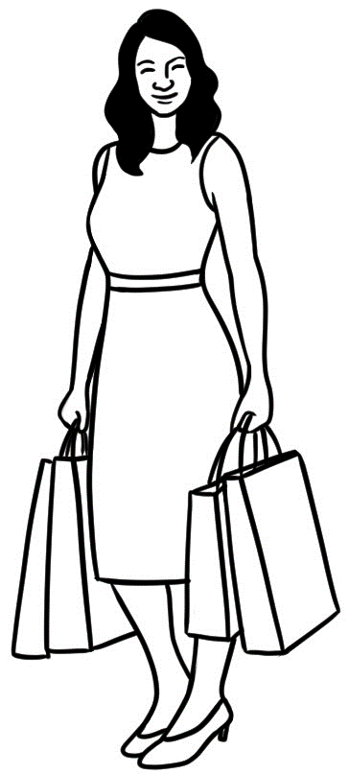
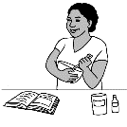
cooking | going to the park | going to the beach | shopping | gardening | having a barbecue
playing sport | playing video games | watching TV | visiting friends | using social media | using computers

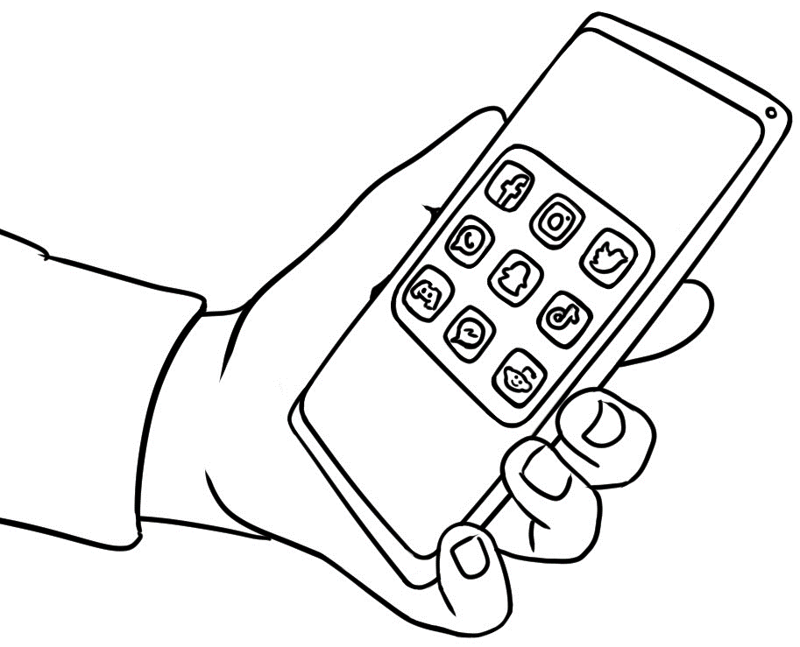
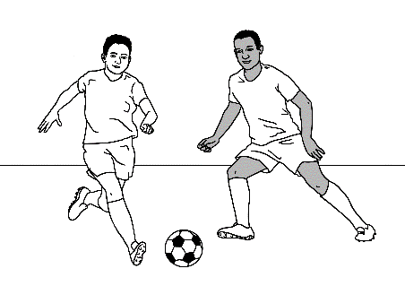
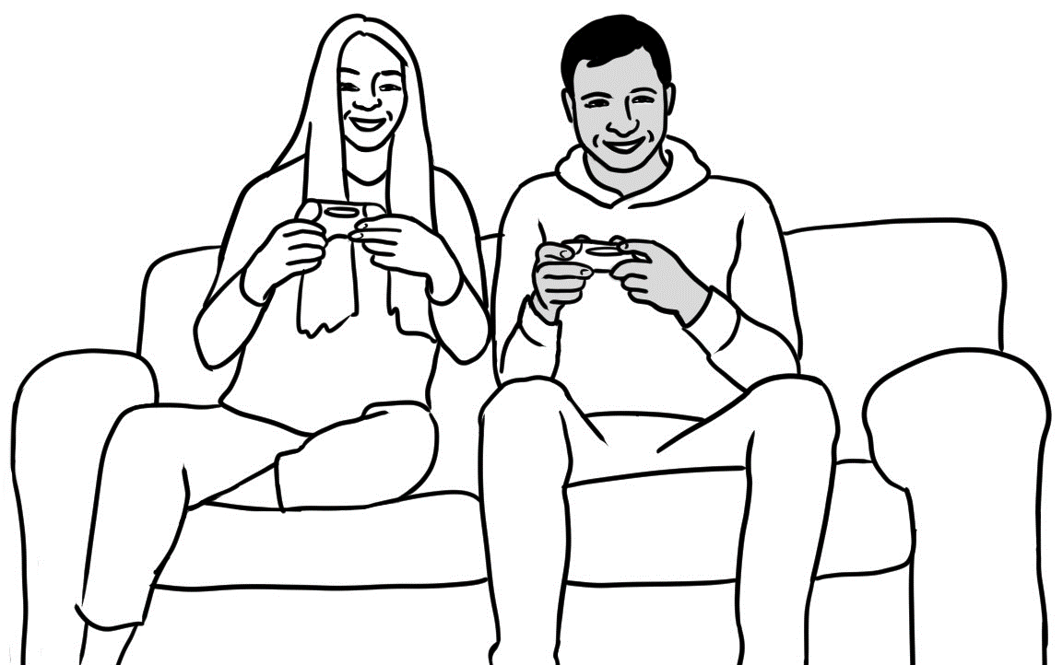
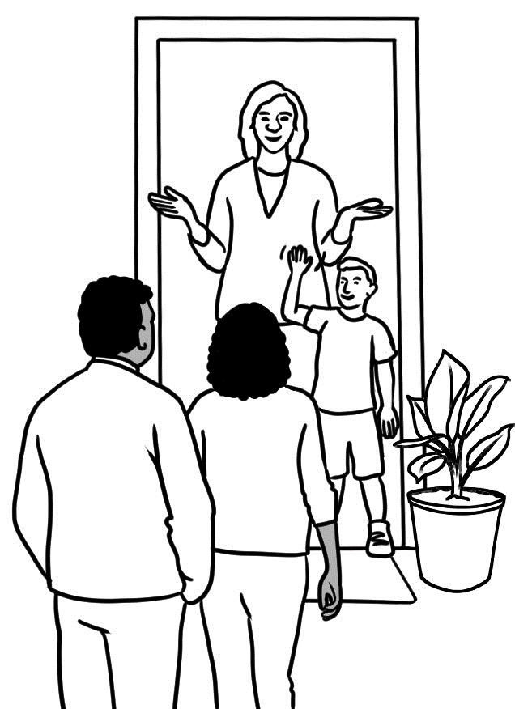
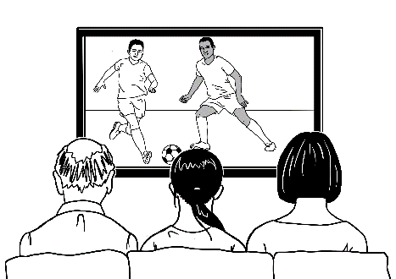
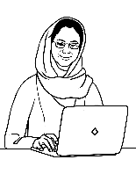

What are you good at?

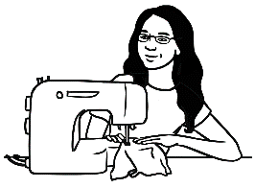
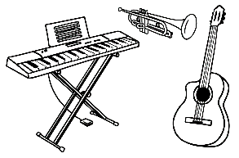
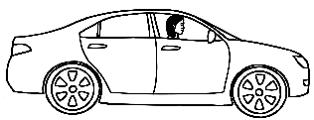
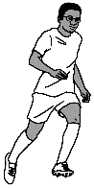

driving | cooking | running | music | sewing
playing sport | fishing | fixing things | swimming | using computers

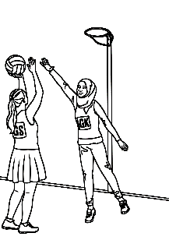
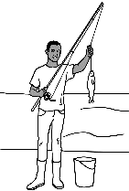
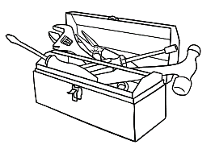
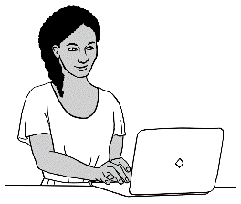
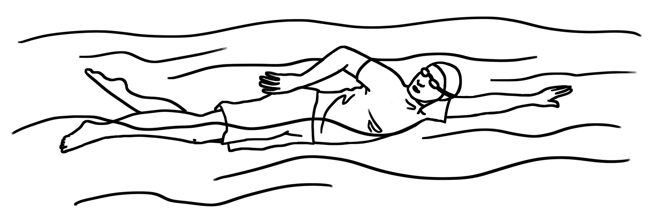

Write your information.
- What’s your name? | My name is ____________________________.
- Where do you come from? | I come from___________________________.
- Are you married or single? | I’m _________________________.
- Do you have children? | I ___________________ __________________.  ^{have / don’t have} ^{a child /children}
- What are your  future plans? | I want to _______________________________  Then I want to ____________________________  __________________________________________
- What do you do  in your free time? | I like ___________________________  and ____________________________.
- What are you good at? | I’m good at ____________________________.

Verb to be
Long | Short
I am | I’m
He is  She is  It is | He’s  She’s  It’s
You are  We are  They are | You’re  We’re  They’re

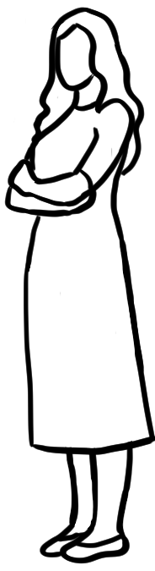
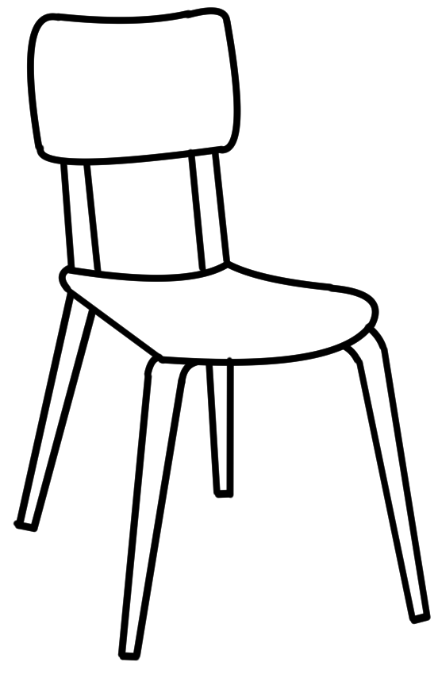

He She It

Subject | Verbs
Subject | be | have | like | come | want
I | am | have | like | come | want
He, She, It | is | has | likes | comes | wants
You, We, They | are | have | like | come | want

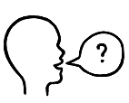
Can you spell
that please?
Interview your partner.

- What’s your name? | My partner’s name is ________________________.
- Where do you come from? | He / She comes from ________________________.
- Are you married or single? | He / She’s ___________________________.
- Do you have children? | He / She ___________________ __________________.  ^{has / doesn’t have} ^{a child /children}
- What are your  future plans? | He / She wants to __________________________.  Then he/she wants to ______________________  ___________________________________________.
- What do you do in your  free time? | ____________________ likes ____________________  ^{Partner’s name}  and ____________________________.
- What are you good at? | He / She’s good at _________________________.

I want to tell you
about Mike.
Wendy gives a talk about someone.

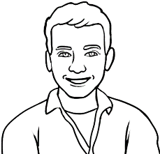
- Who’s Mike?
Wendy’s older brother

Mike
Wendy’s younger brother
Wendy’s younger sister

Information | True | False
- Mike comes from Poland.
- He came to Australia six years ago.
- He lives in Brisbane now.
- He’s married.
- He has two children.
- What information is true about Mike?


- What company does Mike work for?


a gas power company

a wind power company
a solar power company



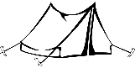
- What does he love doing with his family in the holidays?

camping. fishing swimming




- Wendy says that Mike is a great
dancer. cook. soccer player.

Ko gives a talk about someone.
I want to tell you
about Thein.
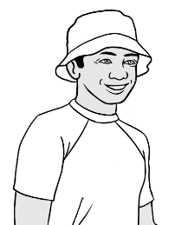
Thein
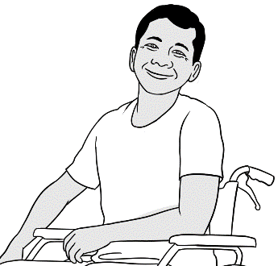
- Who’s Thein?

Ko’s friend
Ko’s son
Ko’s son-in-law

- Where does he come from?

America Myanmar Mexico

- Does he have children?

Yes, three. Yes, two. Yes, one.

Information | True | False
- Thein wants to finish his English study.
- He wants to learn about gardening.
- He works for a house painter.
- He works two days a week.
- Thein likes fishing.
- He’s a very good swimmer.
- What information is true about Thein?

- Thein is

kind. hard-working. friendly. healthy.

A talk about someone
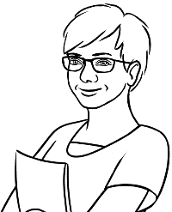
Ko wrote a plan
for his talk.
I practised with my family before my talk.

Plan | A talk about Thein
- Greeting  Say and write the person’s name. | Good morning/afternoon everyone.  My name is Ko.  Today I want to tell you about Thein.
- A photo | Here’s a photo of Thein.
- Information  Family/ friend  Birth country  Married / single  Children  Future plans  Free time  Skills | Thein is my son-in-law.  He comes from Myanmar.  He’s married to my daughter and they have a beautiful baby son.  Thein wants to finish his English study. Then he wants to go to TAFE and learn about gardening. He works for a gardener two days a week. He loves gardening.  Thein also likes playing soccer and going to the beach. He’s a very good swimmer.
- Your opinion | Thein is kind and friendly.
- Thank you and questions | Thank you for listening.  Do you have any questions?

A talk about someone


Plan | A talk about ____________________________
- Greeting  Say and write  the person’s name. | Good morning/afternoon everyone.  My name is ________________________________.  Today I want to tell you about ______________.
- A photo | Here’s a photo of __________________________.
- Information  Family/ friend  Birth country  Married / single  Children  Future plans  Free time  Skills | _____________________________________________________________  _____________________________________________________________  _____________________________________________________________  _____________________________________________________________  _____________________________________________________________  _____________________________________________________________  _____________________________________________________________  _____________________________________________________________  _____________________________________________________________  _____________________________________________________________  _____________________________________________________________  _____________________________________________________________
- Your opinion | ____________________________________________________________.
- Thank you and questions | Thank you for listening.  Do you have any questions?

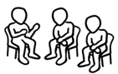

The park

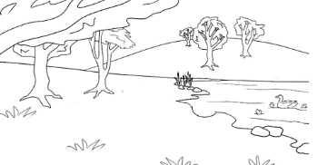  a park | 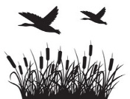  wetlands
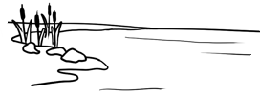  a lake |   toilets
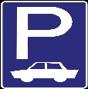  a car park |   a picnic spot
  a playground | 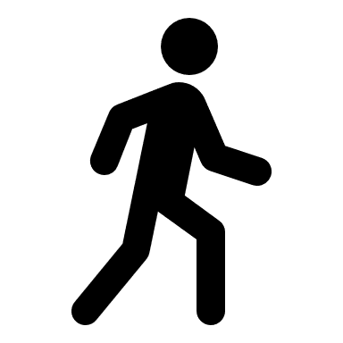  a walking track
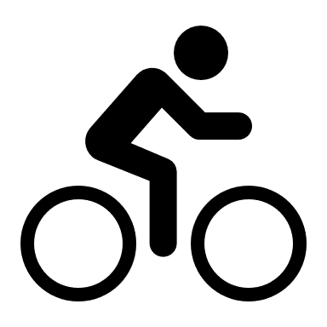  a bike track |   a drinking tap
  a dog park |   a barbecue

a river
  a picnic shelter |     an exercise station

a shelter = a place with a roof
a track = a path
wetlands = a swamp

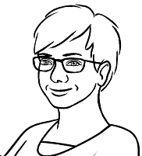
Find and say the names of places on the map with a partner.

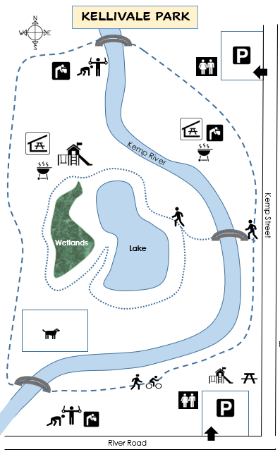
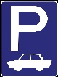

Toilets
Playground
Exercise station
Walking track
Walking and bike track
Picnic spot
Picnic shelter
Barbecue
Dog park
Drinking tap



Short answers
Yes, it does.
No, it doesn’t.
Ask your partner about their local park.

Does it have
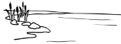  - a lake ? |   - toilets ? |  |   - wetlands ?
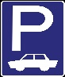  - a car park ? | - a playground ? |  | - a dog park ?
- a bike track? |   - a river? |  | - a picnic spot?
- a walking track? | - a drinking tap? |  | - a barbecue?
- a picnic shelter? |  | - an exercise station?

Write about your partner’s park.

My partner’s park has _____________________________________________
____________________________________________________________________________________________________________________________________
__________________________________and ___________________________.

A children’s playground
 | a bench |  | a tree |  | a bush
 | a swing |  | a slide |  | a spade
 | a fence |  | a gate
1 | a tree-house |  | a ladder |  | a sandpit
 | a sunshade |  | a bucket |  | a see-saw

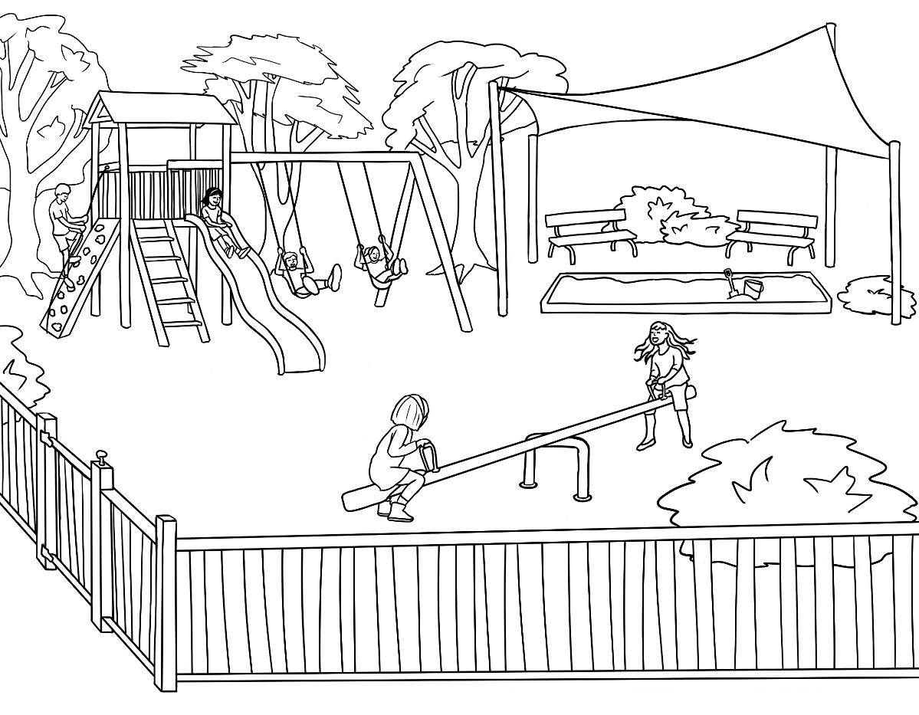
2
4
1

3

5
13
6
14
12
11

8
7

9
10

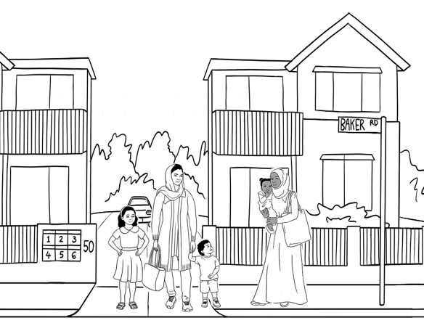
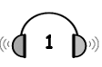

Parwana talks to Sahra.

- What does Parwana
talk about?
an old playground

a new playground

- Parwana talks about the playground, because

her children like the playground.
Sahra’s daughter will like the playground.

she’s going to the playground tomorrow.

- Where is the playground?

near the lake near the toilets near the car park

- When did Parwana go there?

on Friday on Saturday on Sunday

- Parwana gives some information about the playground.

Information | True | False
- The playground has a long slide.
- It has three swings.
- It has a sandpit.
- It has a see-saw.
- It has shady trees and a safety fence.
- It has a sunshade over the swings.
- Parwana’s children really like the playground.

Parwana | Hi Sahra. | really  Saturday  nice  will like  new  long  love  fence  lake  sandpit  shady  next  two  trees  see-saw
Sahra | Hi Parwana. Did you have a nice weekend?
Parwana | Yes. We went to the _______ playground  in the park.
Sahra | Oh. When did you go there?
Parwana | On ______________.
Sahra | Did the children like it?
Parwana | They _________ liked it. Your daughter Hani  _______ _______it too. It has a _______ slide  and _______ swings. There’s a sandpit and  a ______________.
Sahra | Oh yes. Hani will ______ it. Where’s the playground?
Parwana | It’s near the _______.
Sahra | Is the playground ________?
Parwana | Yes. There are many ______ and there’s a sunshade over the __________. The children are safe because the playground has a _________.
Sahra | Let’s go together _______ weekend.
Parwana | Okay. Good idea.
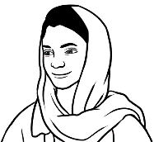
Sahra asked Parwana some questions.
ask questios.
- Did you have a nice weekend? | Yes  I did. | No,  I didn’t.
- Did the children like it? | Yes  they did | No,  they didn’t.
- Is the playground shady? | Yes,  it is | No,  it isn’t.
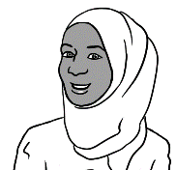

Did you have a nice weekend?

__________________________________________________________________

She went
on Saturday.
She went
to the playground.
They’ll go to the playground together.
It’s near the lake.

- What did Parwana do on the weekend?
- When did she go there?
- Where is the playground?
- What will Parwana and Sahra do next weekend?

- What did you do on the weekend?
- Where did you go?
- What will you do next weekend?

Information about a favourite place
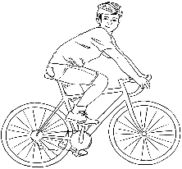
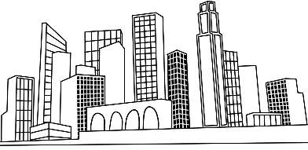
Where is it?
near = close to
in the city |  | 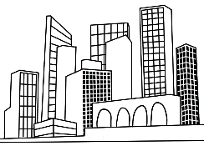  near the city
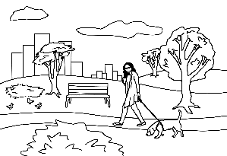  in the park |  | near the lake
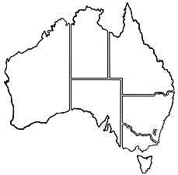  in Queensland |  | 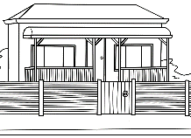  near my place
Tell me about it.
There is a sandpit.  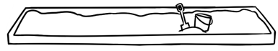  There’s a sandpit. |  | 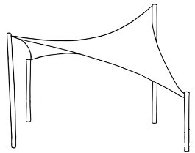  There is a sunshade.  There’s a sun shade.
There are two benches.  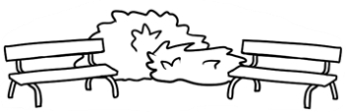 |  | 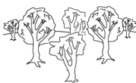  There are many trees.
What can you do there?
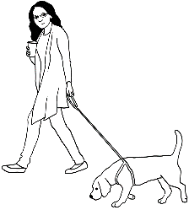  You can walk. | 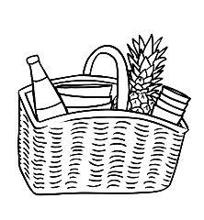  You can have a picnic. |  | 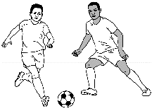  You can play soccer.
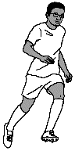  You can run. | You can ride a bike. |  | 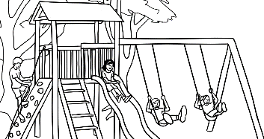  The children can play.

A talk about a favourite place
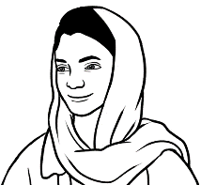
Parwana wrote
a plan for her talk.
I practised many times in class
and with my family before my talk.

Plan | My favourite place – The new playground
- Greeting  Say and write  the place name. | Good morning/afternoon everyone.  My name is Parwana.  Today I want to tell you about the new playground.
- A photo | Here’s a photo of the playground.
- Information  Where is it?  Tell me about it.  What can you do there? | The new playground is in the Kellivale Park near the lake.  There’s a long slide and a see-saw. There’s a sandpit with a big sunshade over it. There are two swings and many trees.  The playground has a safety fence.  My children can play on the slide and  in the sandpit. I can sit in the shade  and watch them.
- Your opinion | The playground is a fun safe place for my children.
- Thank you and questions | Thank you for listening.  Do you have any questions?

A talk about my favourite place

Plan | My favourite place ________________________
- Greeting  Say and write  the place name. | Good morning/afternoon everyone.  My name is _______________________________.  Today I want to tell you about  _______________________________________________.
- A photo | Here’s a photo of ________________________________.
- Information  Where is it?  Tell me about it.  What can you  do there? | __________________________________________________________________  _________________________________________________________________  _________________________________________________________________  _________________________________________________________________  _________________________________________________________________  _________________________________________________________________  _________________________________________________________________  _________________________________________________________________  _________________________________________________________________  _________________________________________________________________  _________________________________________________________________
- Your opinion | ____________________________________________________  ______________________________________________________.
- Thank you and questions | Thank you for listening.  Do you have any questions?
After practise in class and at home, students give their short talk [without reading] to a small group or the class.
Make sentences and ask questions
in the Present Tense.

Sentences | Subject | Verb | Where | When
Sentences | I, You, We, They | go  walk | to the park  to the shop  to class  to work | every day.  every week.  on Monday.  on the weekend.
Sentences | He, She, It | goes  walks | to the park  to the shop  to class  to work | every day.  every week.  on Monday.  on the weekend.
Questions

Do | I, you, we, they | go  walk | to the park  to the shop  to class  to work | every day?  every week?  on Monday?  on the weekend?
Does | he, she, it | go  walk | to the park  to the shop  to class  to work | every day?  every week?  on Monday?  on the weekend?

Do
every week?
to class
go
you

Do you go to class every week?

to the shop
Do
walk
on the weekend?
they

___________________________________________________________________________________________________________

to work
Does
go
she
on Monday?

___________________________________________________________________________________________________________
Does
to class
walk
he
every day?

________________________________________________________________________________________________________

An excursion to the park
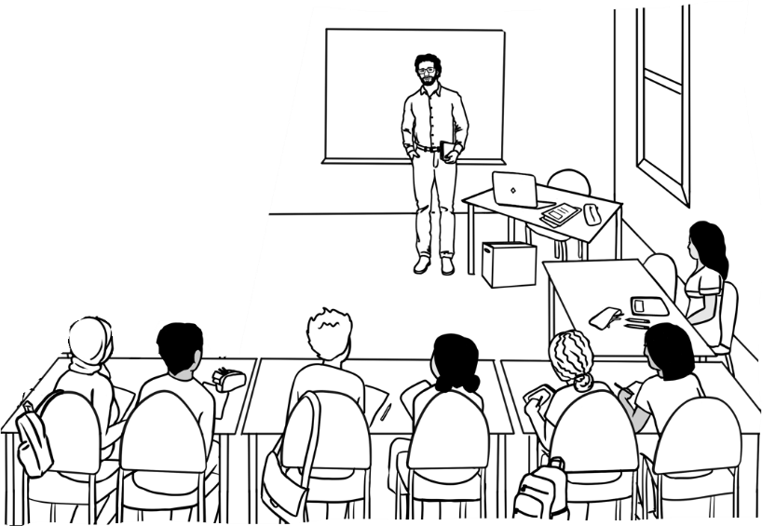
A weather check

I hope the weather is fine for our excursion. Let’s listen to the weather report.

- The report is about the weather

today. tomorrow. next week.

- What day is the report for?

Tuesday Wednesday Thursday

- What is the date?

21 September 21 November 21 December

- The weather in the morning will be

 |  | 
Sunny and hot 30° | Sunny and warm 25° | Cloudy and warm 20°

- The weather in the afternoon will be
 | 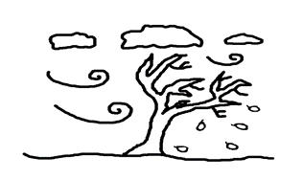
Wet and cold 14° |  | Windy and very cold 8° |  | Windy and cold 14°

A voice message on WhatsApp
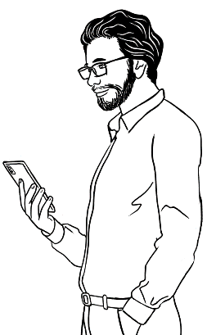
I’ll remind the students about the excursion tomorrow.
- Where is Peter’s class going?
to the library

to the park.
to the beach

- Where will they meet?
at in the park at the library in the classroom

- What time do they meet?

9:15 9:30 9:45

- How long does it take to walk there?

25 minutes 20 minutes 15 minutes

- They will have their morning tea at the picnic shelter near
the lake the river the playground

- What should they bring?
a notebook morning tea a drink

- What should they wear?
a hat a raincoat comfortable shoes
comfortable shoes = easy for walking

- How will they get there?
by bus by walking by car

- Peter says, ‘Don’t be _____________________________.
^{early / late / sick}

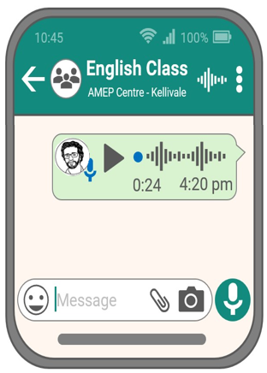

playground | late | shoes
morning | park | 25
classroom | picnic | 9:30
a hat | 12:30 | a drink

Don’t forget our excursion to the park tomorrow. We’ll meet
in the _______________________ at _________ and be back by __________.
It takes about _________ minutes to walk to the park. Then we’ll walk to the __________shelter near the ____________________. We’ll have our morning tea there. Please bring ___ __________ and some _______________ tea to share. Wear comfortable ____________ and ___ ________.
See you tomorrow and don’t be ___________.

- park dark |  | 7. ear near
- borrow tomorrow |  | 8. tea see
- street meet |  | 9. wink drink
- back pack |  | - too shoe
- bake take |  | - share square
- when then |  | - late mate

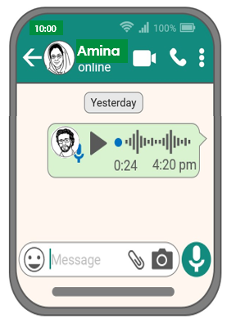
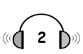
Amina’s late.

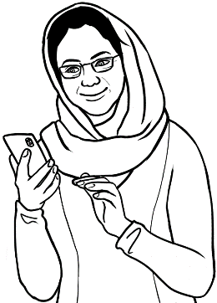
I’m late. Where’s my class?
I’ll call my teacher.

- Amina calls her teacher because she can’t find
a. her handbag. b. her class. c. her notebook.
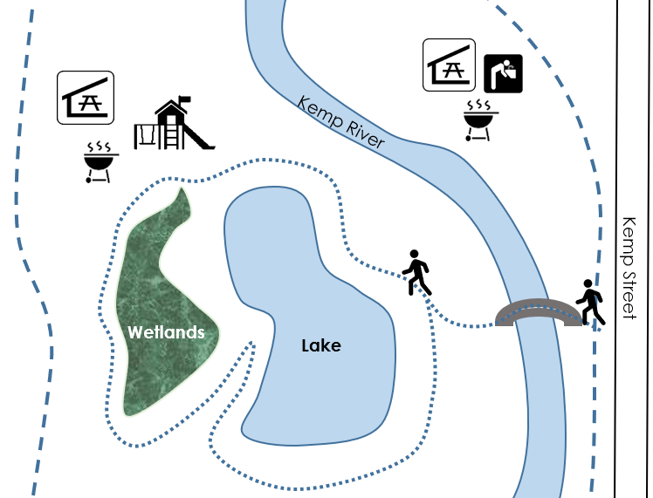

- Where is Amina?
- Where is her class?

- Peter’s directions
- Walk over the bridge to the lake. | True | False
- Turn left at the lake. | True | False
- Walk round the lake to the wetlands. | True | False
- We’re at the picnic shelter. | True | False
- We’re next to the river. | True | False





- How does Amina feel?
- happy b. sad b. worried c. tired

Amina | Hello Peter. | bridge  Where  over  on  round  behind worried  picnic  right  left  late  soon  shelter
Peter | Hi Amina.
Amina | I’m worried. I can’t find you.
Peter | ___________ are you?
Amina | I’m on the little ___________ near Kemp Street.
Peter | Walk ________ the bridge to the lake.  Then turn _____________.
Amina | Did you say turn ___________?
Peter | No, turn right. Walk ___________ the lake to the playground. We’re at the ___________ shelter  ___________ the playground.
Amina | You’re at the picnic ______________?
Peter | That’s right.
Amina | Thanks Peter. I’m sorry I’m ___________.
Peter | Don’t worry. See you ___________.

Walk over the bridge. |   Walk  round  the lake.
  Turn left. | Turn right.

Lake
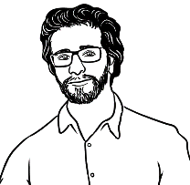
How do you feel?
Long | Short |         happy.  sad.  worried.  tired.  interested.  sick.
I am | I’m
He is  She is  It is | He’s  She’s  It’s
You are  We are  They are | You’re  We’re  They’re

Long | Short | on an excursion.  in the park.  on the bridge.  at the picnic shelter.  in class.  at home.
I am | I’m
He is  She is  It is | He’s  She’s  It’s
You are  We are  They are | You’re  We’re  They’re
Where’s everyone?

Where’s = Where is

 | I’m | She’s | He’s
 | You’re | We’re | They’re
 | It’s | She’s | You’re
 | We’re | They’re | She’s
 | You’re | He’s | It’s
 | He’s | It’s | I’m

A place to rent
  a house |   a bedroom
  a unit |   a bathroom
  a bath |   a laundry
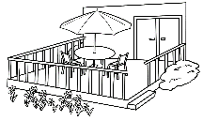  a deck |   a garage

a garden






a workshop
  a separate toilet |   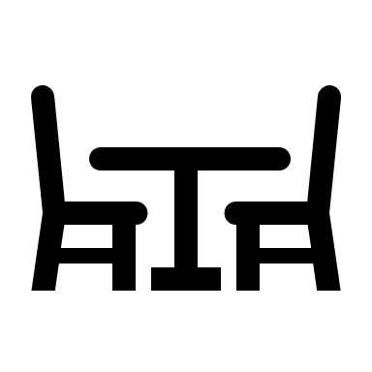  a living room
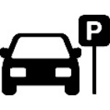
a parking space
lithium batteries | 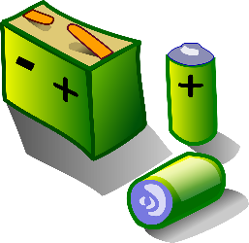

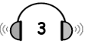
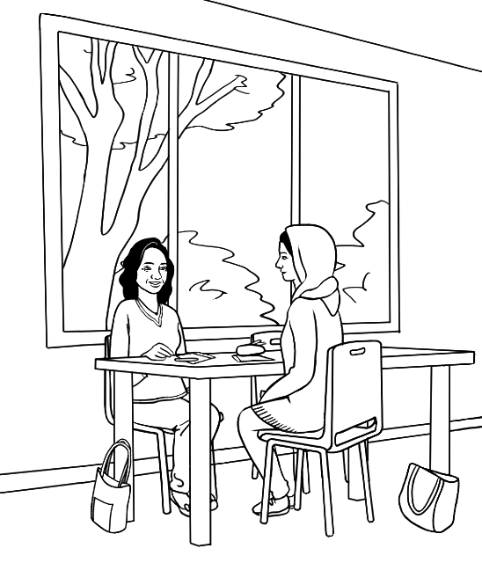
A new home

- What are Linh and Parwana
talking about?

Parwana’s new home
Linh’s new home
the teacher’s new home

- What street is the new home in?
Blue Street Dew Street View Street

- How long does it take to walk to the shops?

5 minutes 10 minutes 15 minutes

- The new home is
a new house. an old house. an old unit.

- The new home has

a small garden. a big garden. two bedrooms.
a front deck. a back deck. a garage.

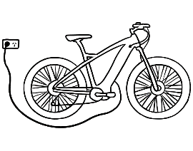
- The garage will be used for
a car. a workshop an e-bike.

- You can’t keep e-bikes inside a house because

they are oily and dirty.
the batteries can catch fire.
they are noisy.


- Parwana didn’t know about lithium batteries. She says,
I’m glad. That’s interesting. That’s worrying.

charge a bike = fill with electricity
glad = happy
Linh | I moved into my new home yesterday Parwana. | in  Street  home  shops  Where  old  two  five  e-bike  fire  back  interesting  inside  garage away
Parwana | That’s great Linh. _______________ is it?
Linh | It’s _______ View Street.
Parwana | New Street?
Linh | No. View ___________, V – I – E – W.
Parwana | Is it near the ___________?
Linh | Yes. It’s only a ___________-minute walk.
Parwana | So, tell me about your new home.
Linh | Well, it’s an ________ house with ______ bedrooms.  It has a small garden, a sunny __________ deck  and a garage.
Parwana | Do you need a garage?
Linh | Yes. I need a place for my ______________.
Parwana | Why can’t you keep the bike _____________?
Linh | I need to charge my bike _________ from the house because lithium batteries can catch _________.
Parwana | That’s ______________________. I didn’t know that.
Linh | Yes. The batteries can be dangerous,  so I’m glad we have a ________________.

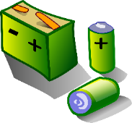
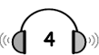
lithium batteries
What do you know about lithium batteries?

- Llithium batteries are in
  - mobile phones. |  |   - laptops. |   - tablets.
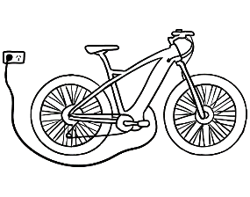  - e-bikes. | 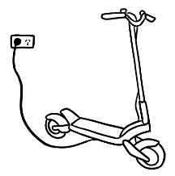  - e-scooters. |  | 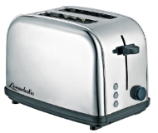  - toasters.
  - toys. | 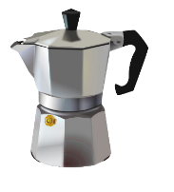  - coffee pots. |  | 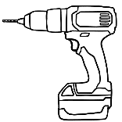  - power tools.

- Is this true or false?
Information about lithium batteries | True | False
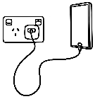
- You can recharge the batteries.
- You can charge them anywhere.

- They can be dangerous.
- They can get very hot.
- The batteries can catch fire.

- It’s easy to put out a battery fire.


- What is safe?
- \ | 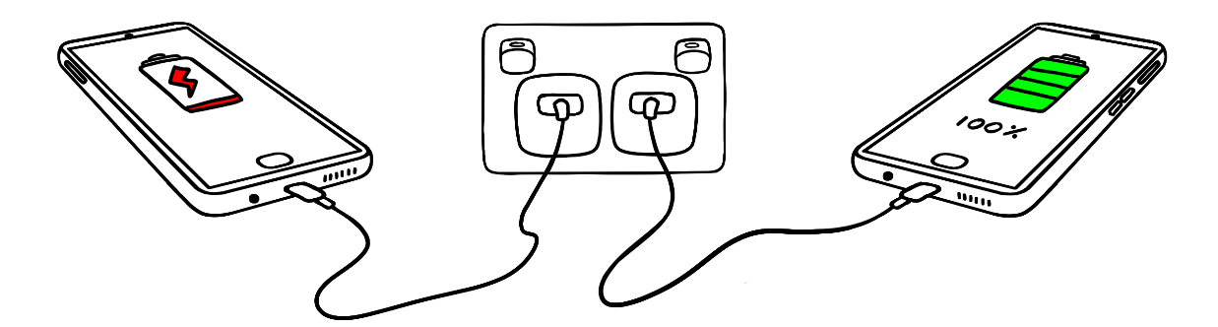
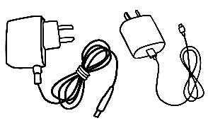 | 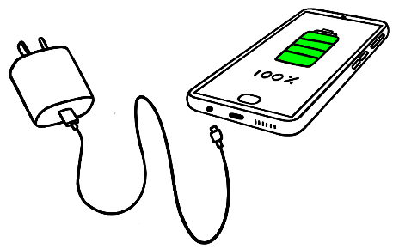
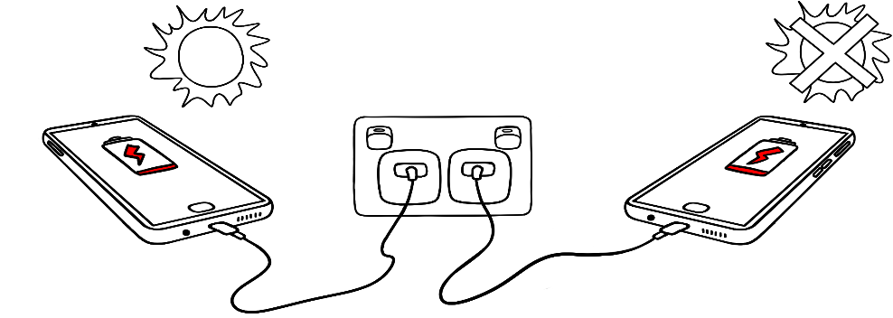

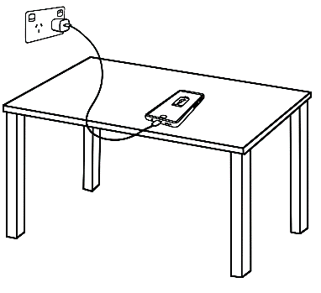 | 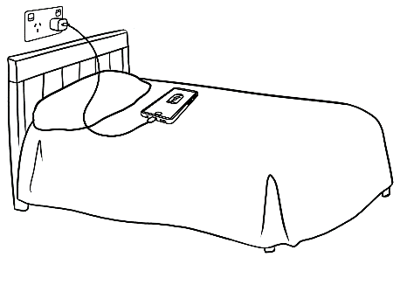
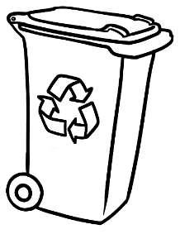
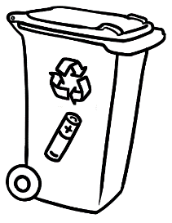
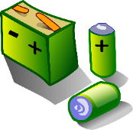

Sale at the Op Shop
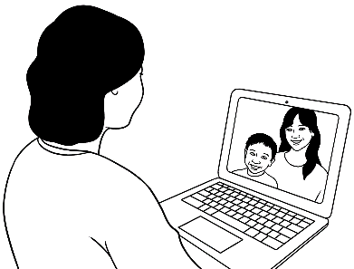
I bought some things
at the OP Shop sale.
Linh talks to her friend.

- When did Linh go to the sale?

on the weekend yesterday today

- She went to the sale because she wanted to buy things for
Chinese new Year. her new home. her brother.

- What did she buy?

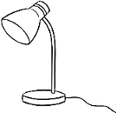  a lamp | 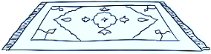  a rug | 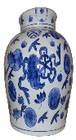  a vase | 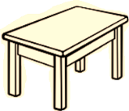  a table

- Information about the vase | True | False
- It’s a glass vase.
- It’s blue and white.
- It was made in Vietnam.
- It’s 13 centimetres tall.
- It’s very old.

- Why is the vase special to Linh?

It’s very old.
It’s very beautiful.
It was very cheap.

Information about a special object
Where did you get it?
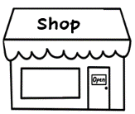
I bought it at a shop in the city.
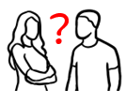

It was a gift from ___________________.
Where was it made?

It was made in ________________.
What does it look like?
It’s blue and white. |   It’s big.    It’s small. |  | 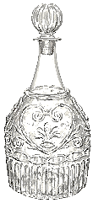  It’s glass.
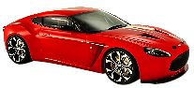  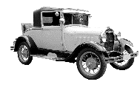  It’s old. It’s new. | It’s 30 centimetres long. |  | It’s wooden.
What do you do with it?
I put flowers in it.   | I put books in it.  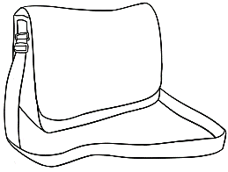 |  | 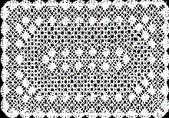  I put it on the table.

Linh gives a talk about a special object.
an object = a thing
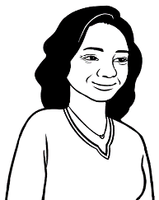
I practised many times in class
and at home before my talk.
Linh wrote a plan
for her talk.

Plan |  | My talk – A special vase
- Greeting  Say and write the name of the object. | Good morning/afternoon everyone.  My name is Linh.  Today I want to tell you about  a special vase.
- The special object | 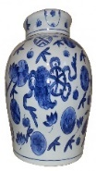  This is the vase.
- Information  Where did you get  the object?  Where was it made?  What does it look like?  What do you do  with it? | I bought this pottery vase last week at the Op Shop. It was very cheap, but it’s very beautiful.  It was made in China and is very old.  It’s blue and white and about 30 centimetres tall.  I put flowers in it. I put it on my new table, in my new home.
- Why is it special? | It’s special because it’s very old.
- Thank you and questions | Thank you for listening.  Do you have any questions?

A talk about a special object

Plan | My talk _____________________________
- Greeting  Say and write  the name of  the object. | Good morning/afternoon everyone.  Today I want to tell you about  a special __________________________________.
- The special object | This is ________________________________________.
- Information  Where and when did you get the object?  Where was it made?  What does it look like?  What do you do  with it? | ______________________________________________________  ______________________________________________________  ______________________________________________________  ______________________________________________________  ______________________________________________________  ______________________________________________________  ______________________________________________________  ______________________________________________________  ______________________________________________________  ______________________________________________________  ______________________________________________________  ______________________________________________________
- Why is it special? | It’s special because____________________________  _____________________________________________________.
- Thank you and questions | Thank you for listening.  Do you have any questions?

An invitation
Basam gets a voice message.

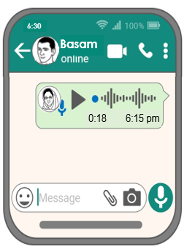
- Who is the voice message from?

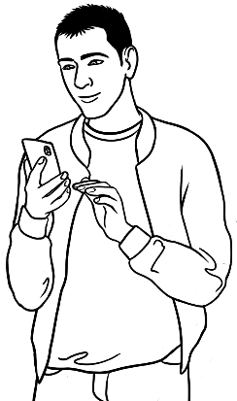
Ahmad
Peter
Amina

- What is the message about?

homework
an invitation
an excursion

- What day is the barbecue?
Sunday

Saturday
Friday

- What time is the barbecue?

12:00 12:30 1:00

- Where is the barbecue?

46 Baker Rd 36 Baker Rd 46 Laker Rd

- Who will be there?

Linh Amina’s family Peter
- What can Basam bring?

fruit drinks nothing

- Why is Amina having a barbecue?

for fun for her birthday for Ahmad’s birthday

- When does Basam need to reply to Amina’s invitation?
tomorrow today tonight

I’m having a barbecue.  Would you like to come? |  | I’d love to come.  When is it?
On the weekend. |  | On Saturday?
On Sunday. |  | What time?
At 12:30. |  | At 2:30?
At 12:30. |  | Where is it?
At our place. |  | At your place?
At our place. |  | What can I bring?
Nothing.  There’ll be lots of food. |  | I’ll bring a cake.
No, no. Thank you. |  | I’ll bring a salad.
No, no. Thank you. |  | I’ll bring a pizza.
No, no.  Just bring yourself. |  | Okay.  Thanks Amina.
Basam’s coming too. |  | Great.
You can meet my family. |  | Great.
See you Sunday. |  | Great. See ya.
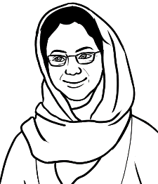
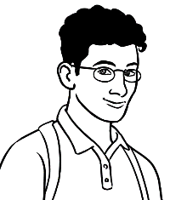

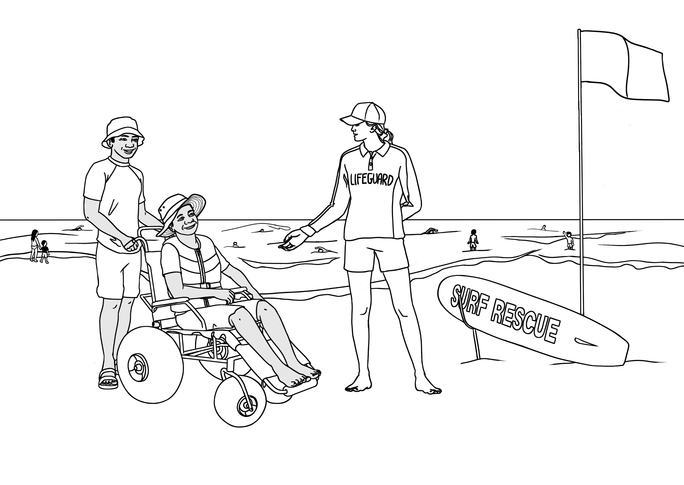
The beach and the pool
tyre
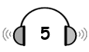
Ko goes to the beach.

- What are they
talking about?

the weather
the beach
the wheelchair

2. Information | True | False

- The wheelchair is comfortable.
push
- It’s not easy to push.
- The tyres are very thin.
- The chair can go in the water.
- Ko should return the chair after 5.
- Ko can book the chair any day.

3. The lifeguard said, Stay between the
rocks. flags. people.

- The lifeguard also said to stay
in the shallow water. in the deep water.

Book the chair.

shallow
return
free
What does it mean?
Put your name down for the chair.
not deep
take back
costs nothing

Lifeguard | Hello. Is the beach wheelchair comfortable? | very  wheelchair  in  flags  fat  chair  first  water  push  day  return  free  shallow  problem  help  beach  Yes  Before
Ko | Yes, ________ comfortable.
Lifeguard | Have you used the ________ before?
Ko | No. This is the ________ time.
Lifeguard | The _____ tyres make the chair easy to ______ over  the sand. You can take it in the ________too.
Ko | Yes. I want to go _____ the water.
Lifeguard | Stay between the _________ and in the _____________ water.
Ko | When should I ___________ the chair?
Lifeguard | __________ 5.
Ko | Can I book the chair any ________?
Lifeguard | ______. The beach wheelchair is _______ because we want everyone to enjoy our beautiful ________.
Ko | Thanks for your ________.
Lifeguard | No _____________. Have fun.

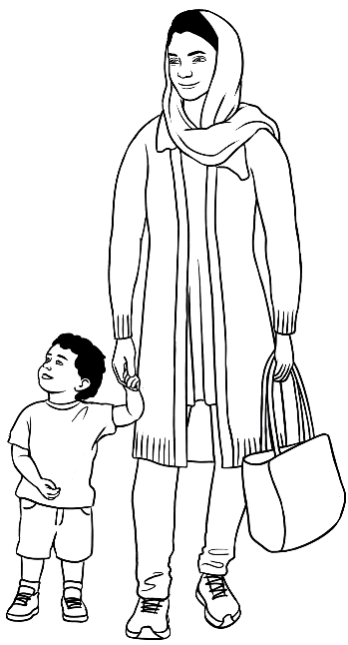
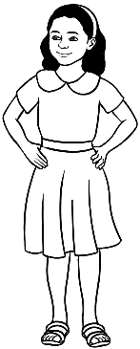
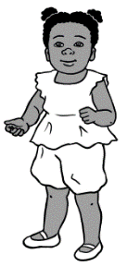
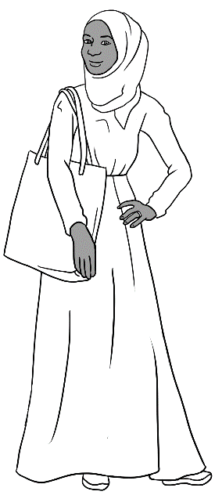
Hani loves her swimming lessons.
I want my children
to have swimming
lessons too.
Swimming lessons

What questions will Parwana ask Sahra?

do |  | want |  | does |  | go |  | can learn
do |  | cost |  | does |  | go |  | lessons
 | Who can learn to swim?
 | Where ________ Hani _______ for swimming _____________?
 | When ________ Hani ________ to the pool?
 | What ________ the lessons _________?
 | Why ________ you __________Hani to learn to swim?

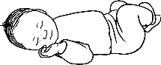
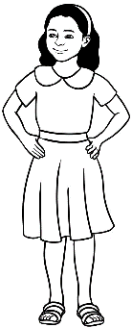
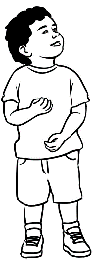
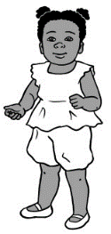
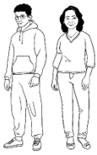
What does Sahra say?

Who can learn to swim? | babies | children | adults
Where does Hani go for  swimming lessons? | 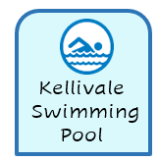    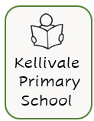
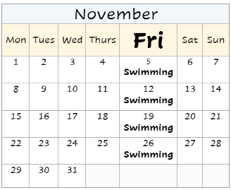
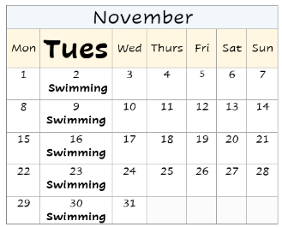
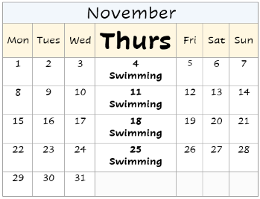

When does Hani go to the pool?
What do the lessons cost? |     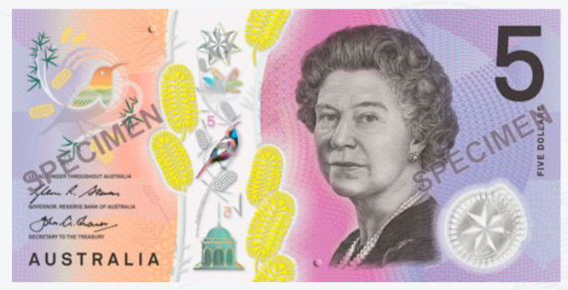  
Why do you want Hani to learn to swim? | to make her strong   |     to make her safe in the water | It’s important learn to swim  in Australia.

Parwana | Who can learn to swim Sahra? Anyone? | does  lessons  goes  babies  Pool  adults  Anyone  Tuesday  hospital  cost  safe  water  Health  enrol  strong  $15  too Australia want
Sahra | Yes. Anyone can learn, ____________, children  and ___________.
Parwana | Where does Hani go for swimming ___________?
Sahra | We go to the Kellivale Swimming __________.  It’s in North Street, opposite the ______________.
Parwana | When ________ Hani go to the pool?
Sahra | Hani ______ to the pool on ____________ morning, but there are different lesson times.
Parwana | What do the lessons __________?
Sahra | I have a ____________ Care Card, so I pay _______  a lesson.
Parwana | Why do you __________ Hani to learn to swim?
Sahra | Swimming will make her __________. I want Hani  to be _________ in the water. It’s important  to learn to swim in _________________.
Parwana | I want my children to be safe in the ___________.  I’ll __________ them in classes ________. Thanks for  the information Sahra.

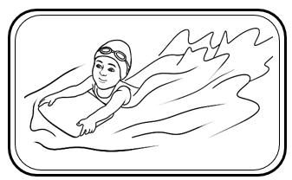
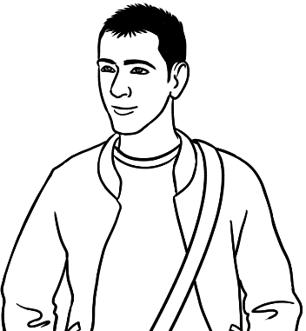
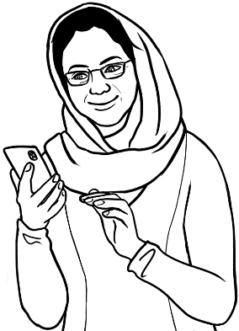
It’s my granddaughter Bibi.
She’s learning to swim.
Who’s that
in the photo Amina?

Basam | Amina
Who can learn to swim? | Anyone.
Where can you learn? | At the pool.
When can you learn? | Anytime.
What does it cost? | I’m not sure.

Questions | Me | Partner 1 | Partner 2 | Partner 3
- Can you swim?
- Can you cook?
- Can you ride a bike?
- Can you sew?
- Can you fix things?
- Can you drive?
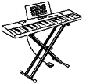
- Can you play the piano?
- Can you play soccer?
- Can you dance?

A quick and easy meal
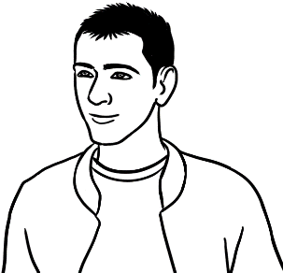
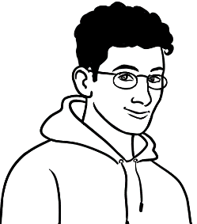
Can you cook Basam?
No, but I want to learn.
I can teach you. Here’s a pizza recipe with only six ingredients.

ingredients = _________________
  a tomato |   a potato | 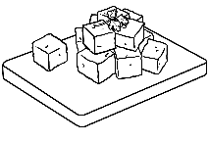  feta cheese
a tomato
  an onion |   a pizza base | 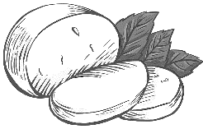  mozarella cheese
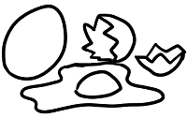  an egg |   garlic | 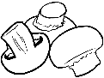  mushrooms
  an eggplant | 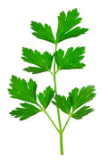  parsley | 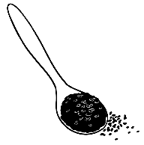  black sesame seeds

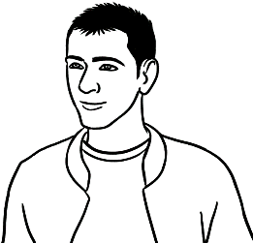

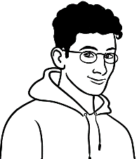
Is the pizza easy to make Ahmad?
Yes, easy and quick.
I’ll tell you how to make it.

- Why is Ahmad talking about pizza?

He eats pizza every day.

Basam wants to learn to cook.

Ahmad has an easy recipe.

- Instructions | True | False
- Heat the oven to 100°C.
- Grate a cup of mozzarella cheese.
- Grate a cup of feta cheese.
- Chop ½ cup of parsley.
- Break an egg into a bowl.
- Add the cheese and parsley.
- Add 2 teaspoons of black sesame seeds.
- Mix together and spread on the pizza base.
- Cook for 10 minutes.

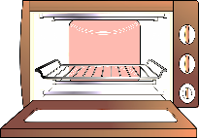

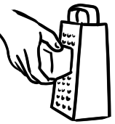

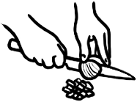

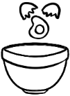





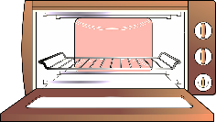

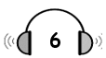
What happened?

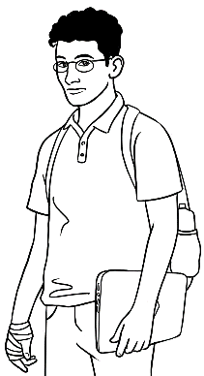
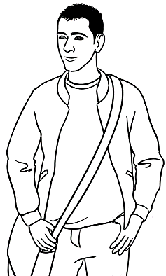
- What are Basam and Ahmad talking about?

Basam’s cooking
Ahmad’s hand

Ahmad’s pizza


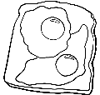
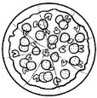
- What did Ahmad cook yesterday?

noodles fried eggs a pizza

- What happened to his hand?

He burnt his hand.
He cut his hand.
He broke his hand.

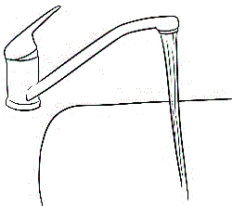
- What did Ahmad do quickly?

He put his hand in salty water.
He put his hand in cold running water.
He put his hand in warm water.

- How long did he keep his hand in water?

3 minutes 6 minutes 10 minutes

- Why did he put his hand in water? He wanted to

warm his hand.
cool his hand.
wash his hand.

Basam | What did you do to your hand Ahmad? | hurt  kept  did  do  better  made  burnt  burnt  cooled  put  Did  help
Ahmad | I _________ it. I _________ a pizza yesterday  and _________ my hand on the pan.
Basam | Oh no.
Ahmad | Yes it really _______, but I quickly _________ my hand in cold running water. I _________ it there for 10 minutes.
Basam | _________ that _________?
Ahmad | Yes. The water _________the burn.  It’s much _________ today.

Present |  | Past |  | Present Past
do |  | burnt |  | do _________
burn |  | put |  | burn _________
make |  | kept |  | make _________
hurt |  | did |  | hurt _________
put |  | made |  | put _________
keep |  | hurt |  | keep _________
help |  | cooled |  | help __________
cool |  | helped |  | cool __________

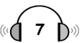
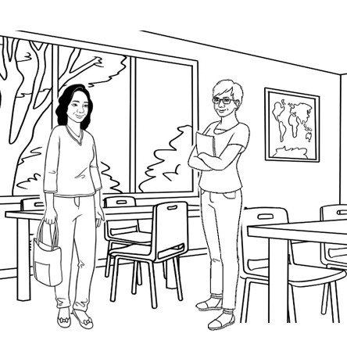

Linh talks to Wendy.
- What are Linh and Wendy
talking about?

Linh’s recipe
Linh’s accident
Linh’s homework

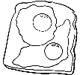
- What did Linh cook yesterday?

noodles fried eggs a pizza

- On the weekend, Linh hurt

her hand. her head. her leg.

- What did she do after her accident? She put

an ice pack on her head.
an ice pack on her leg.
her hand in warm water.

- What did she do next? She sat down

with her head up. with her leg up.

- How long did she sit?

15 minutes 20 minutes 25 minutes

- How does Linh feel today?
not well better much better

limping =
slipped =
fell =
dropped =

ice pack =

Wendy | You’re limping Linh. | dropped  cooked  limping  didn’t hit  didn’t see  hurt  happened  slipped  slipped  fell  fell  feel  sat  20  put  was
Linh | Yes. I __________ and _____ on the weekend.
Wendy | What ________________?
Linh | I ___________ some noodles for lunch and  ____________some on the floor.
Wendy | Oh?
Linh | I ________ ______the noodles and ___________  on them. I _________ on my leg.
Wendy | Oh dear.
Linh | It really ________ so I _________ an ice pack  on my leg. Then I ______with my leg up  for ____ minutes. I ______ lucky I _______ _____ my head.
Wendy | How do you _________ today?
Linh | Much better.

Write the past tense of the verbs.
am | was |  | slip
fall |  |  | happen
hurt |  |  | drop
put |  |  | cook
sit

Information transcripts

Wendy’s Talk Page 10
Mike is my younger brother. He came to Australia from England
six years ago. He lives in Sydney now with his wife and two children.
He works for a solar power company. He loves camping with his family in the holidays. My brother is hard-working and kind. He’s also
a great cook.

Ko’s Talk Page 11
Thein is my son-in-law. He comes from Myanmar. He’s married to
my daughter and they have a beautiful baby son. Thein wants to finish his English study. Then he wants to go to TAFE and learn about gardening.
He works for a gardener two days a week. He loves gardening. Thein also likes playing soccer and going to the beach. He’s a very good swimmer. He’s kind and friendly.

The weather report Page 25
Here’s the Kellivale weather report for tomorrow, Tuesday 21 November. It’ll be warm and sunny in the morning with a temperature of 25 degrees. The weather will change in the late afternoon. It will be windy and cold. The temperature will drop
to 14 degrees.

A talk about lithium batteries Page 35
Litihum batteries are everywhere. The batteries are in mobile phones, toys, laptops, tablets, e-scooters, e-bikes and power tools. You can recharge them, but they can be dangerous. Be careful where you charge them. The batteries can get very hot and catch fire. Battery fires are very hard to put out. Here are some safety tips:
- Unplug the battery when it is fully charged.
- Use the correct charger.
- Charge batteries out of sunlight.
- Charge batteries on a table or desk.
- Put old batteries in a battery recycling bin.

Linh’s talks to her friend Page 36
I wanted some things for my new home, so I went to
the sale at the OP Shop today. Everything was half price and I bought a lamp, a table and a beautiful pottery vase. The vase is very old and was made in China. It’s blue and white and about 30 centimetres tall. It’s special because it’s very old.

Amina’s voice message to Basam Page 40
Hi Basam. This is Amina. Can you come to a BBQ at my place on Sunday. It’s at 12:30? My address is 48 Baker Rd. It’s my birthday and you can meet my family. I want to invite Ahmad too. Don’t bring any food. We’ll have lots of food. Can you let me know tomorrow? Bye.

Cooking instructions Page 49
- Heat the oven to 180°C.
- Grate a cup of mozarella cheese.
- Grate ½ cup of feta cheese.
- Chop ½ cup of parsley.
- Break an egg into a bowl.
- Add the cheese, parsley and a teaspoon
of black sesame seeds to the bowl.
- Mix together and spread on the pizza base.
- Bake in the hot oven for 15 minutes.

