
Student book with teacher notes

English Ready
22638VIC Certificate I in EAL
VU23502 Give and respond to short simple spoken information

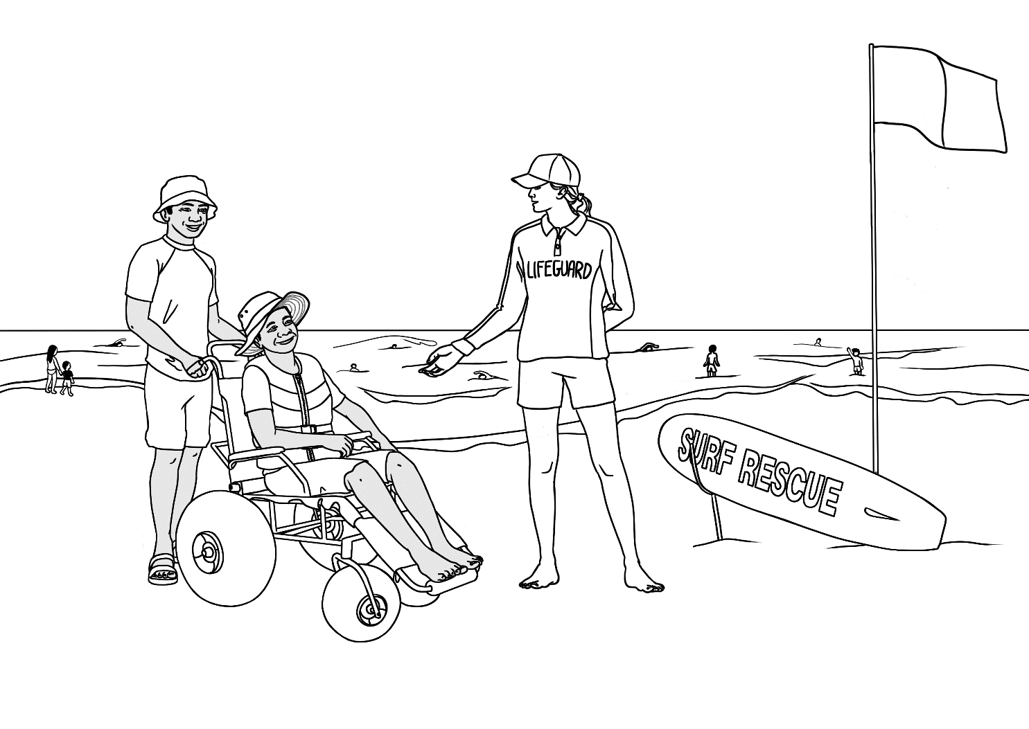
Student Workbook

Student _______________________________________________________
Teacher _______________________________________________________
Class ________________________________________________________
Date ________________________________________________________

Design team: Vicki Hambling, Sue Paull, Frida Dean, Glenise Kleehammer and Mary Wallace
Illustrations: Madelena Scott

Illustrations acknowledgements:
Fork lift This Photo by Unknown Author is licensed under CC BY-SA-NC
Parking sign-Image by <a href="https://pixabay.com/users/wikimediaimages-185597/?utm_source=link-
River symbol, worried & sick emojis, coffee pot, First Aid kit, modern car These Photos by Unknown Author is licensed under CC BY-NC
Sound and fishing icons, This Photo by Unknown Author is licensed under CC BY-SA
Lithium batteries - by Clip art
Lace doily This Photo by Unknown Author is licensed under CC BY-NC-ND
A gift - <a href="https://www.freepik.com/free-vector/gift-box-white-background_47754818.htm#query=gift%20box%20clipart&position=1&from_view=keyword&track=ais_user&uuid=b49eac75-2bbb-4c01-93e2-04f26db477c2">Image by brgfx</a> on Freepik
Icon for solar power <a href="https://www.flaticon.com/free-icons/solar-panel" title="solar panel icons">Solar panel icons created by Freepik - Flaticon</a>
Icon for wind power <a href="https://www.flaticon.com/free-icons/wind-turbine" title="wind turbine icons">Wind turbine icons created by Smashicons - Flaticon</a>
Glass decanter <a href="https://www.freepik.com/free-vector/vintage-decanter-illustration-vector-remixed-from-artwork-by-john-dana_19085355.htm#fromView=search&page=1&position=26&uuid=d8178df8-2480-4f7f-b0ad-62ad4d3ce7b1">Image by rawpixel.com on Freepik</a>
Acknowledgements: The design team would like to thank the AMEP service providers and practitioners who participated in the trial and gave valuable feedback. The team would also like to acknowledge the use of the EAL Framework which underpins the design of this book.
___________________________________________________________________________
Copyright of the EAL Framework is reserved to the Crown in the right of the State of Victoria. © State of Victoria (Department of Education and Training) 2023.
Use of all or part of this document must include the following attribution:
© Commonwealth of Australia 2024

With the exception of the Commonwealth Coat of Arms, the department’s logo, any material protected by a trade mark and where otherwise noted all material presented in this document is provided under a Creative Commons Attribution 4.0 International (https://creativecommons.org/licenses/by/4.0/) licence.
The details of the relevant licence conditions are available on the Creative Commons website (accessible using the links provided) as is the full legal code for the CC BY 4.0 licence (https://creativecommons.org/licenses/by/4.0/legalcode).
As far as practicable, material for which the copyright is owned by a third party will be clearly labelled. The department has made all reasonable efforts to ensure that this material has been reproduced in this document with the full consent of the copyright owners.
Copyright requests and enquiries concerning usage not addressed by the CC BY 4.0 licence should be addressed to: comms@homeaffairs.gov.au at the Department of Home Affairs.
The terms of use for the Commonwealth Coat of Arms are available from the It's an Honour website.
Where a copyright owner, other than the Commonwealth, is identified with respect to this material, please contact that third party copyright owner directly to seek permission.



This workbook is designed to be used with the support of a teacher.
It complements VU23504 Read and Write short simple informational texts and is best used concurrently so language elements are recycled.
See the Teacher Resources for activities to support the work in this book.
To pre-teach vocabulary in each section, see the Word Lists at the back of the Teacher Resources.

Table of Contents
1. Meet the students and teachers 2
2. Meet two families. 3
3. Workbook instructions 4
4. Information about someone 5
5. The park 14
6. An excursion to the park 25
7. A place to rent 31
8. Sale at the Op Shop 36
9. An invitation 40
10. The beach and the pool 42
11. A quick and easy meal 48
12. Information transcripts 54

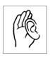
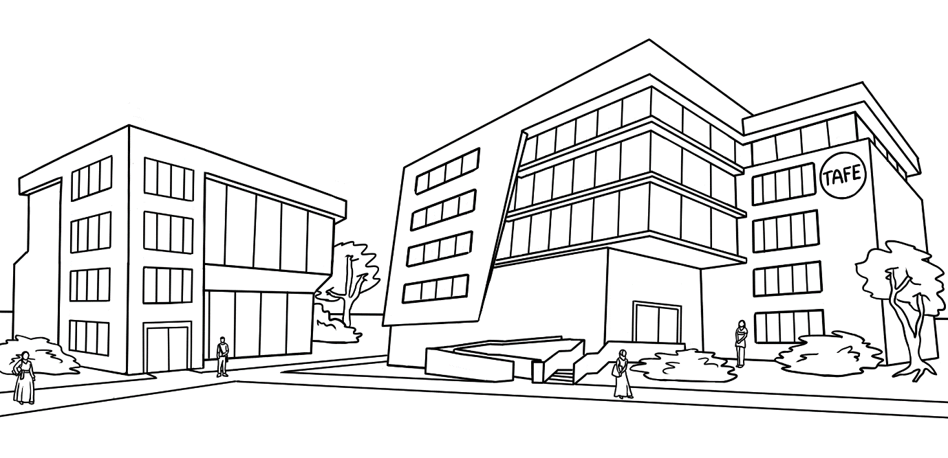
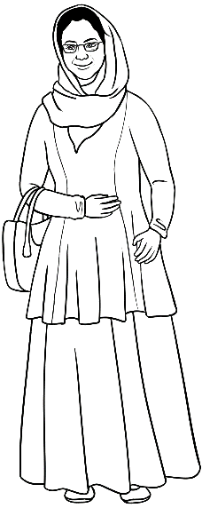
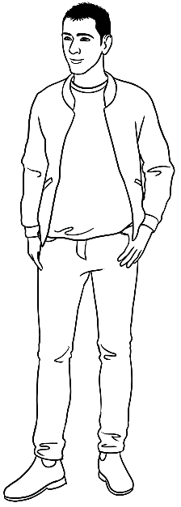
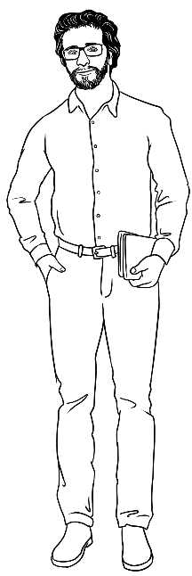
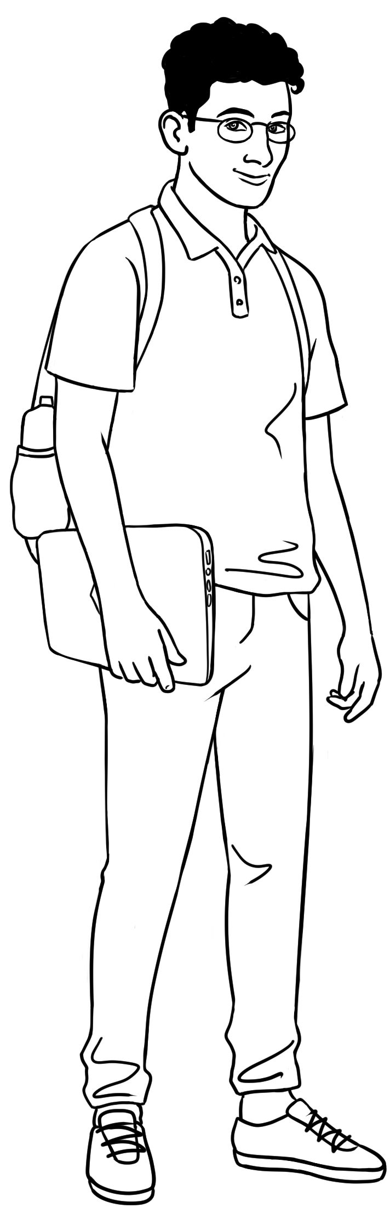
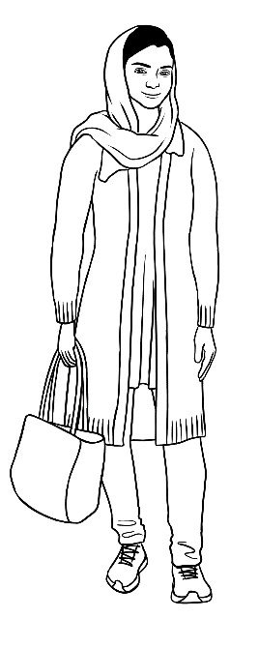
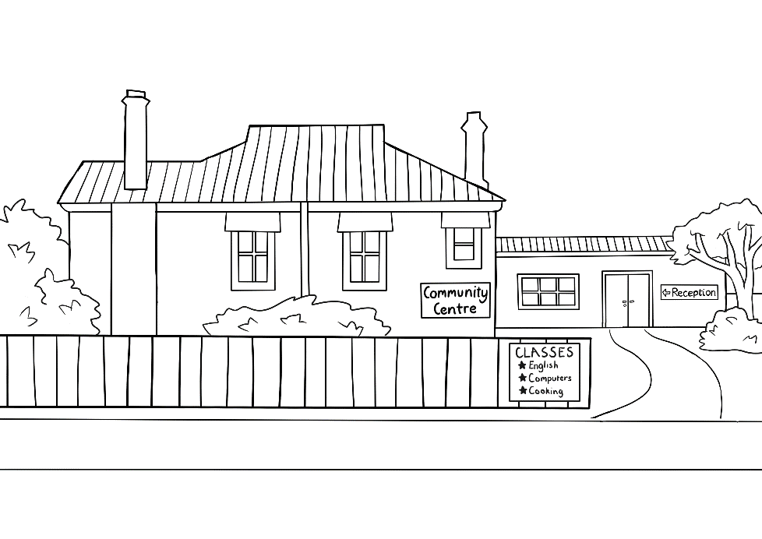
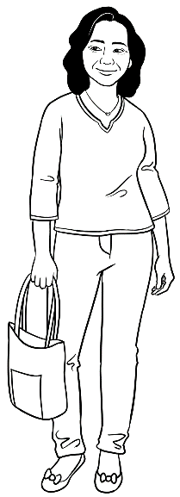
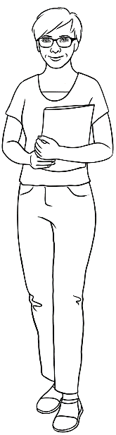
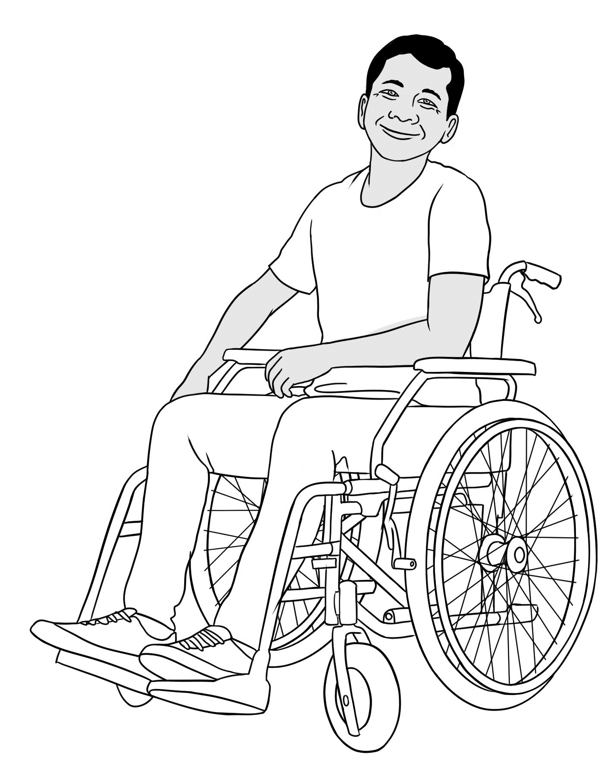
Meet the students and teachers

Peter
Amina
Basam
Ahmad
At the
AMEP
Centre

Parwana
Wendy
Linh
Ko
At the Learning Centre

Meet two families.
Listen, repeat, clap family members – daughter, son, husband etc. NB – Amina is Parwana’s mother.

me |  | daughter |  | son |  | husband |  | mother | father |  | brother
Parwana |  | Bibi |  | Mustafa |  | Jomeh |  | Amina | Nabi |  | Rahim
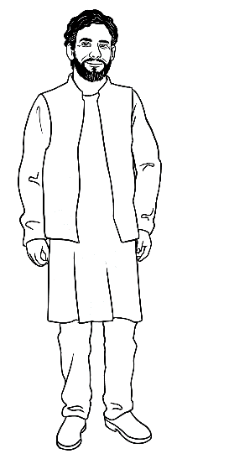
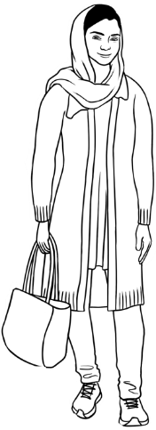
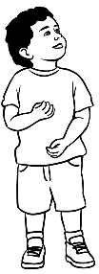
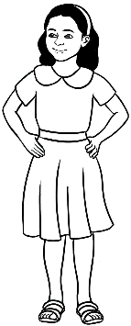
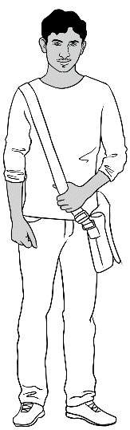
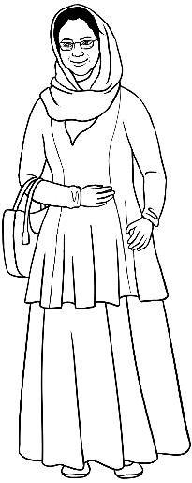
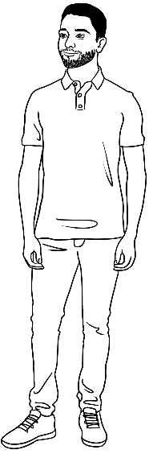
Parwana’s family

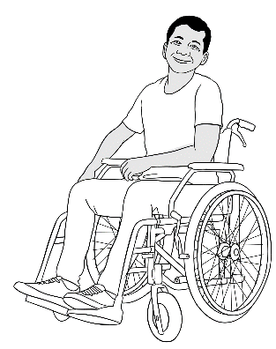
Ko’s family
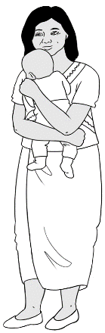
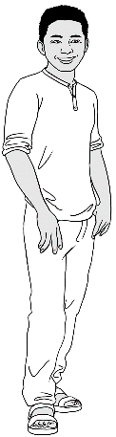
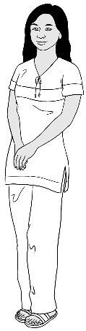
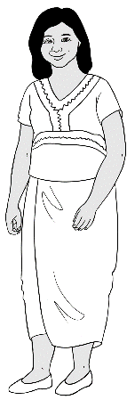
me | wife | daughter | son-in-law | grandson
Ko | Zani | San | Thein | Yaza
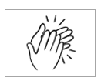
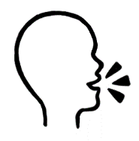

son  wife | mother father  sister brother  daughter grandson  husband | son-in-law

Workbook instructions
PPT – Workbook instructions
Listen, repeat, clap, mime each instruction for students to imitate.
- listen |  | - say
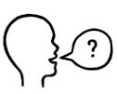  - ask questions |  | 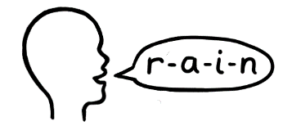  - spell
  - read |  | 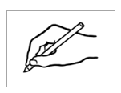  - write
- tick |  |   - circle  * Work with a partner  = speak or read  aloud in pairs
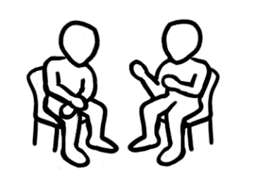  - *work with a partner |  | - clap
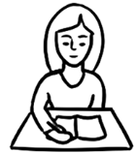  - Check your work. |  |   - Ask for help.

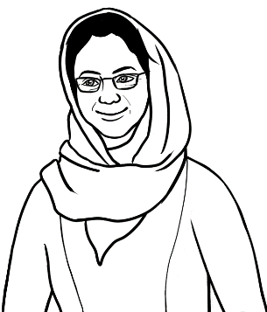
Do you understand?
Yes, I understand.

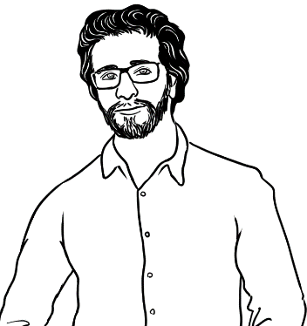
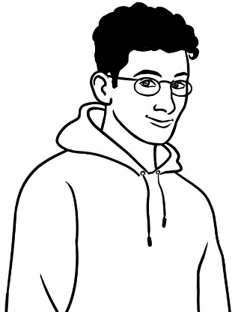
No, I don’t understand.

Can you say it again please?
Are you OK?
Could you speak slowly please?
don’t = do not

See Teacher resources
for ways to practise
these expressions.
No. Can you help me please?
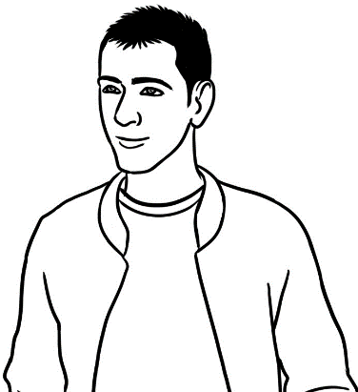
Could you check my work?

Information about someone
Questions 3 and 4 may be questions both teachers
and students are reluctant to answer. Explain that
it is okay to make up answers. The truth is not essential
in this situation. Write your answers to the students’ questions on the board for the students to copy.
Future plans - In their learning plan, students need to consider English/vocational study and work plans. Here you can expand future goals to include broader study options and leisure activities. See below.

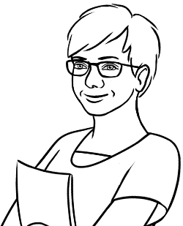
Ask your teacher
some questions.

- What’s your name?
__________________________
2. Where do you come from?
__________________________

My teacher
3. Are you married or single?
__________________________

7. What are you good at?
____________________________________________________
4. Do you have any children?
__________________________________

5. What are your future plans?
__________________________________
__________________________________
__________________________________
6. What do you do
in your free time?
___________________________________________________

Future plans
Learn | 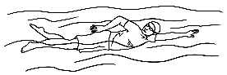  to swim. |  | 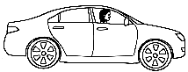  to drive. |  | 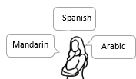  to speak a new language.
  First Aid. |  |   to dance. |  | 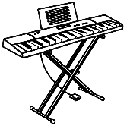  to play the piano. |  | 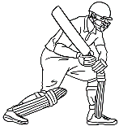  to play cricket.

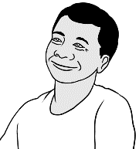
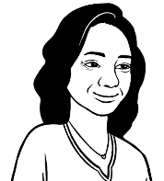
Linh asks Ko some questions.

- What’s your name? | My name is Ko.  Vocabulary for this exercise:  - For question 4, turn back to page 3.  - For question 6 & 7, show the PPT Free Time and complete the exercises on the following page.
- Where do you come from? | I come from Myanmar.
- Are you married or single? | I’m married.
- Do you have children? | I have a daughter and a grandson.
- What are your  future plans? | I want to finish my English study.  Then I want to learn how to repair computers.
- What do you do  in your free time? | I like reading and using computers.
- What are you good at? | 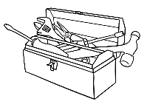  I’m good at fixing things.
Match the future plans. Elicit
additional study and work plans
and write on the board.
Future plans
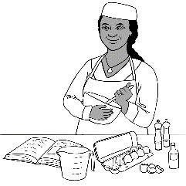
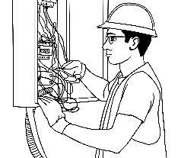
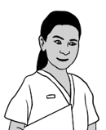
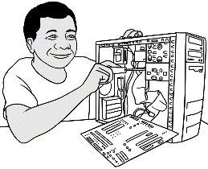
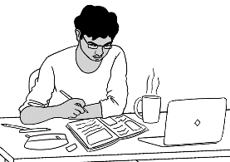

study | nursing | electrician | repair computers | cook
fork lift driver | child care | gardener | receptionist | house painter
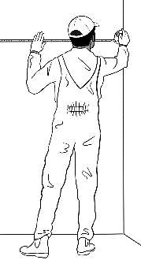
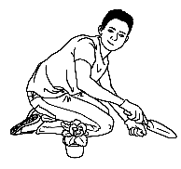
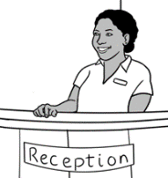
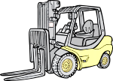
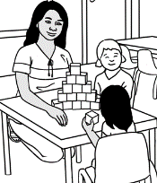

Free time
Match the free time activities. Elicit additional activities and write on the board.

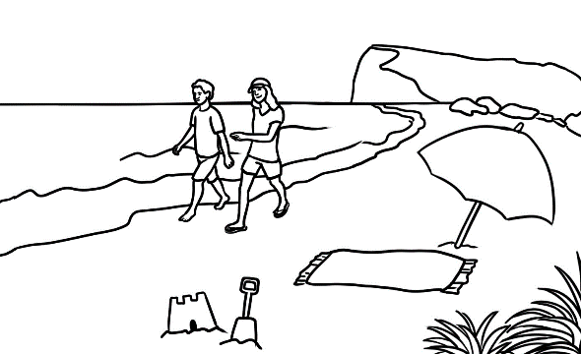
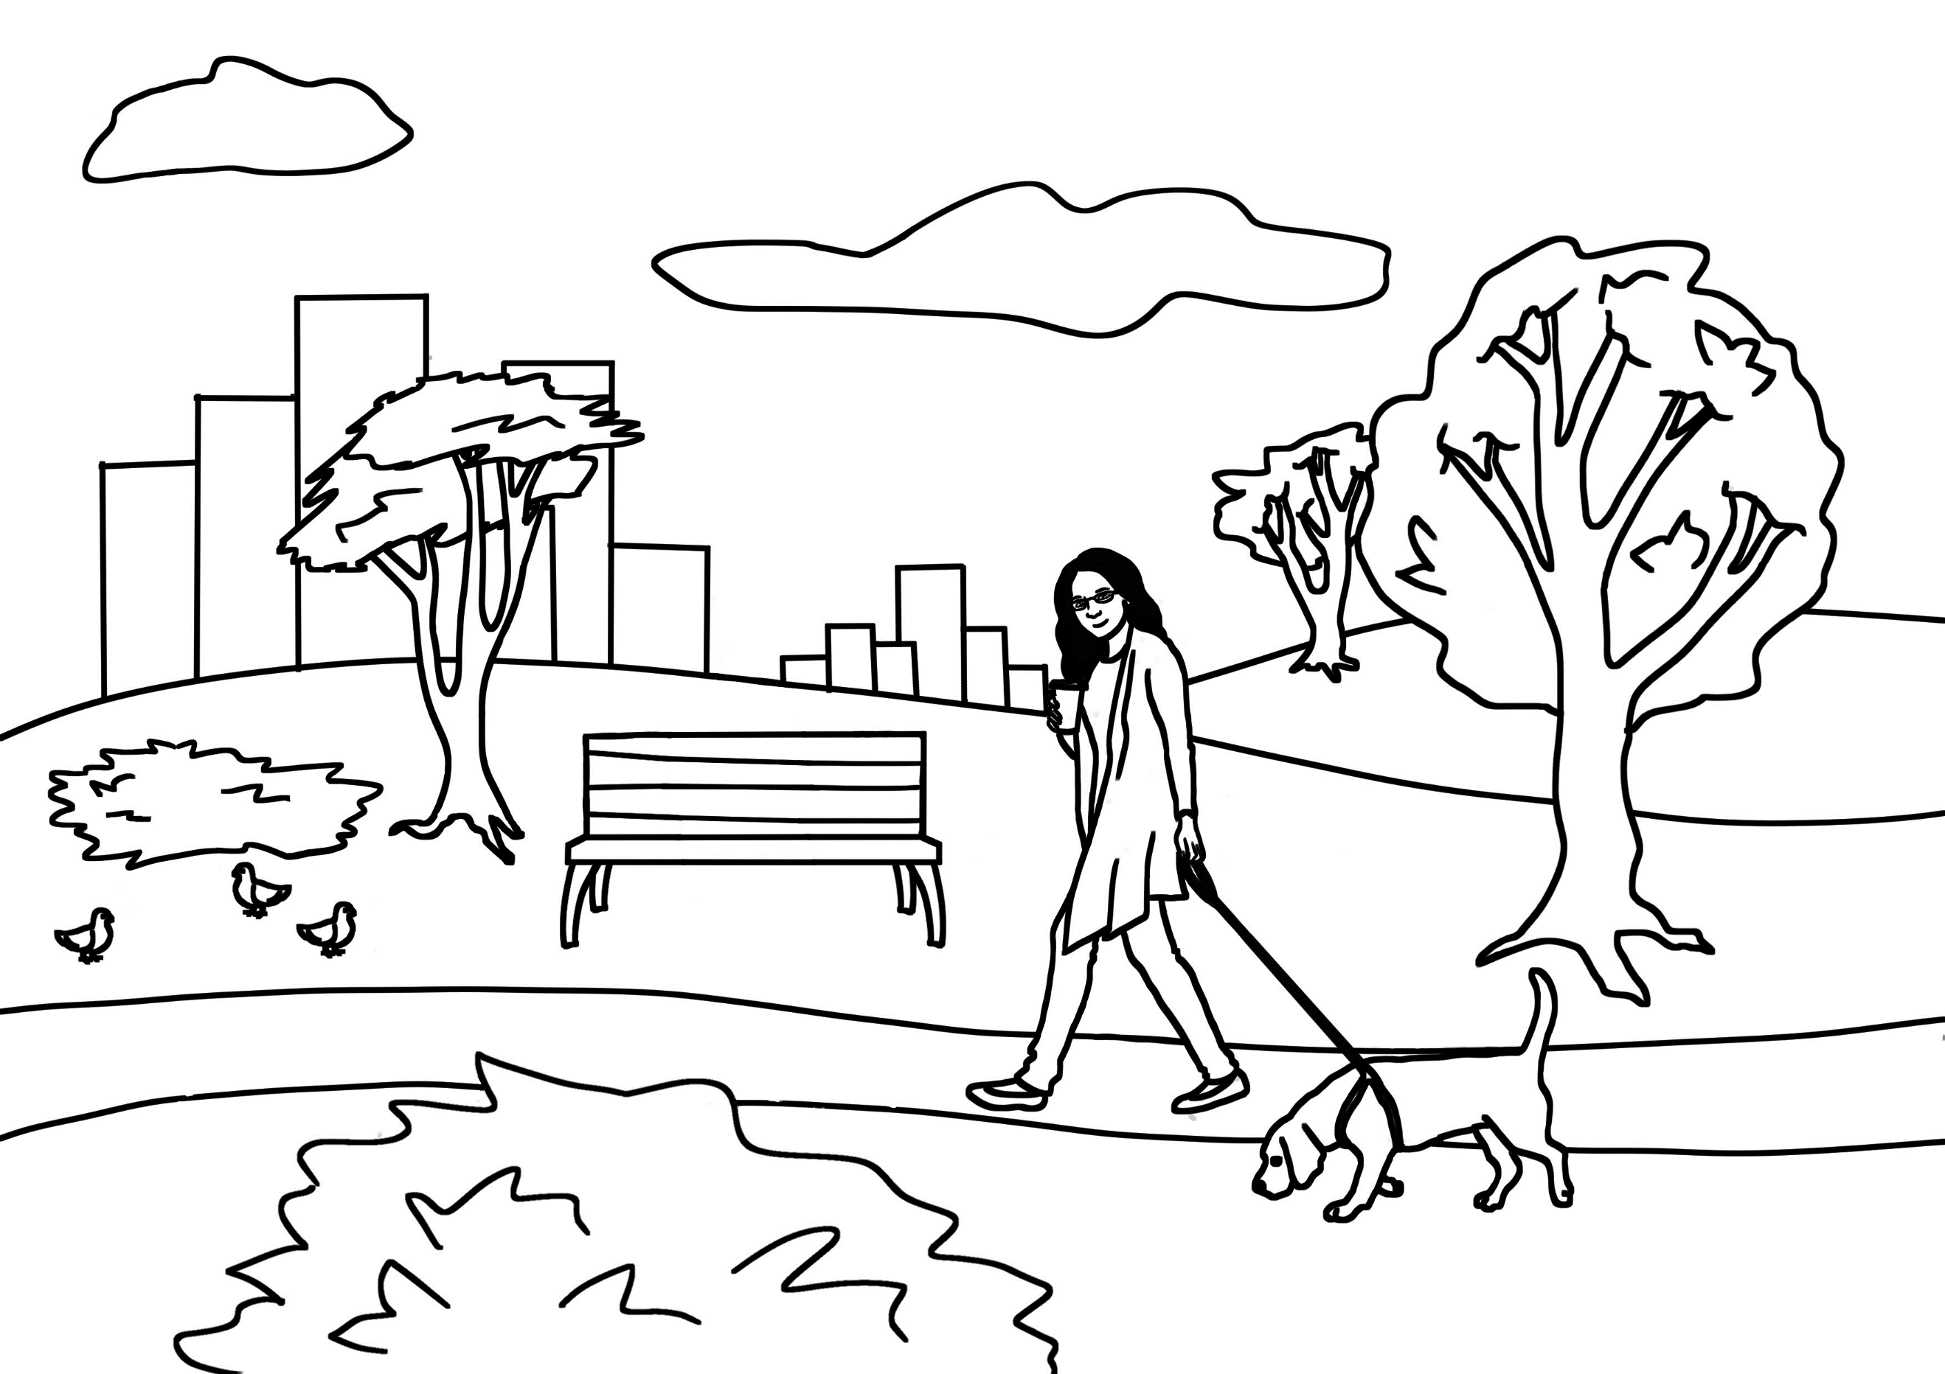
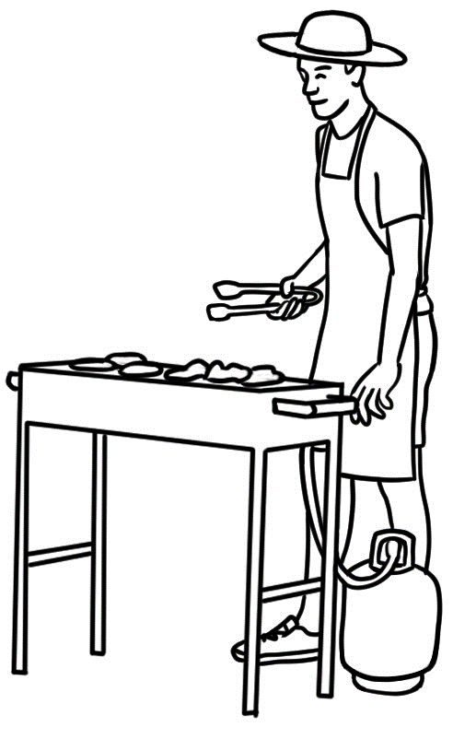
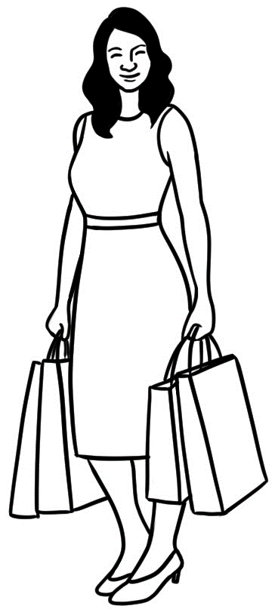
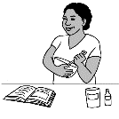
cooking | going to the park | going to the beach | shopping | gardening | having a barbecue
playing sport | playing video games | watching TV | visiting friends | using social media | using computers

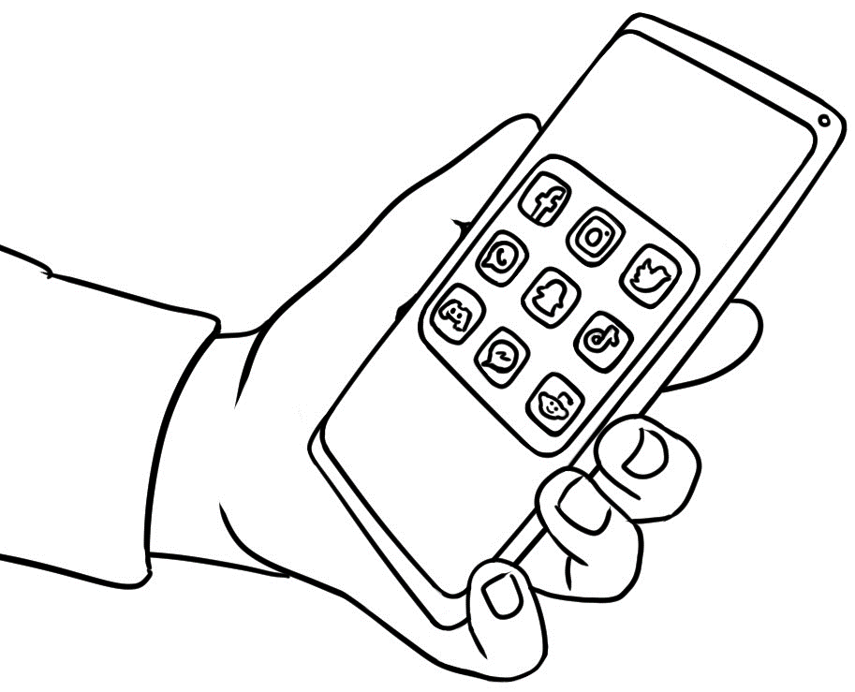
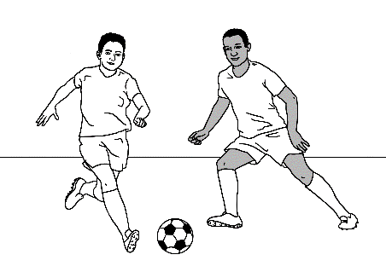
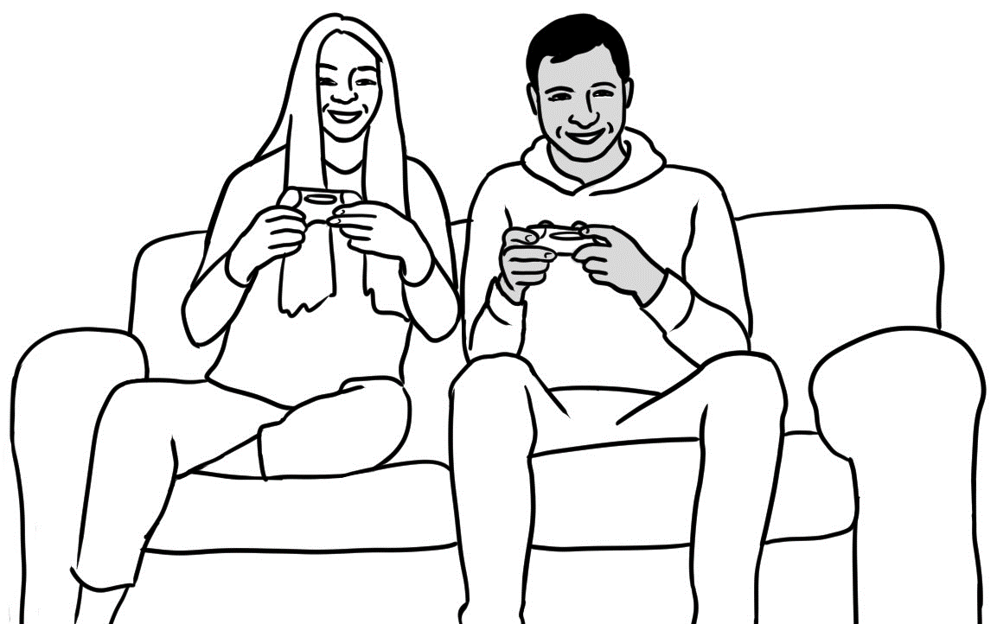
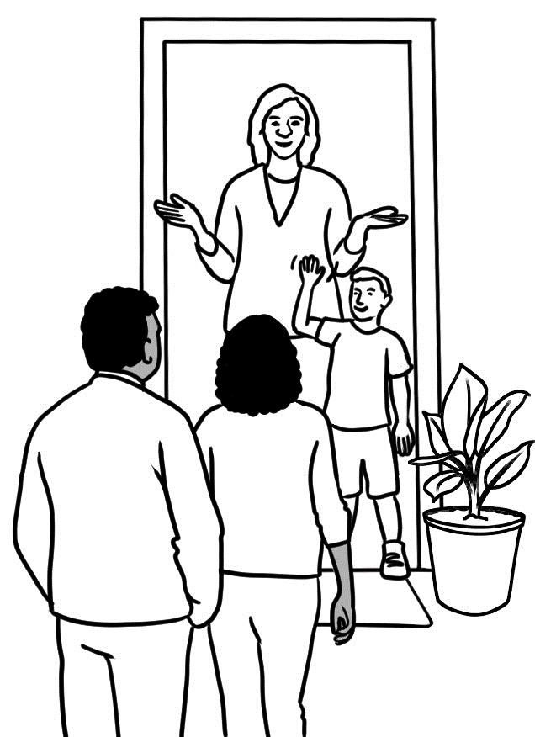
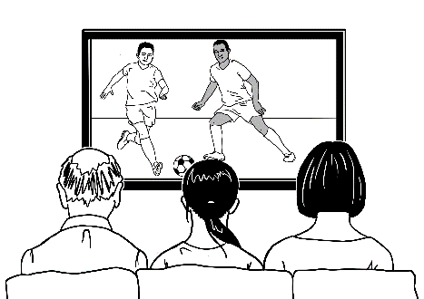
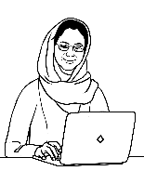

What are you good at?
Match the skills. Elicit additional skills and write on the board.

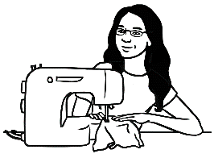
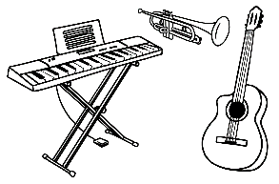
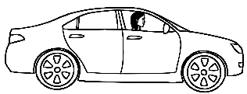
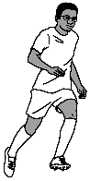

driving | cooking | running | music | sewing
playing sport | fishing | fixing things | swimming | using computers

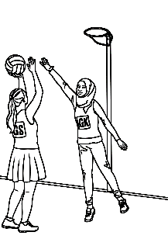
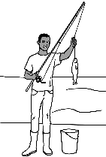
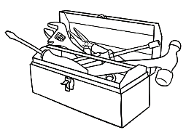

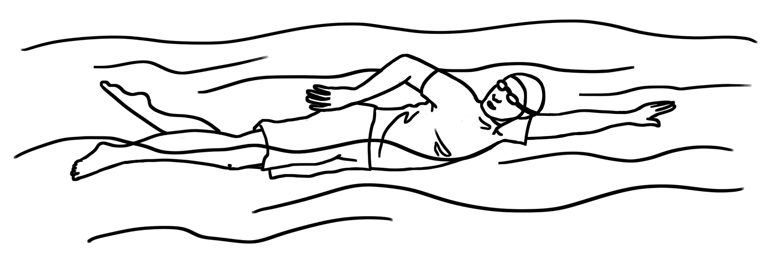

See the Teacher Resources pages 16 – 30 for two transactions which include the need to give personal information in the library and the police station. The transactions have audio, listening questions, a cloze and sequencing strips at two levels.
Write your information.
- What’s your name? | My name is ____________________________.
- Where do you come from? | I come from___________________________.
- Are you married or single? | I’m _________________________.
- Do you have children? | I ___________________ __________________.  ^{have / don’t have} ^{a child /children}
- What are your  future plans? | I want to _______________________________  Then I want to ____________________________  __________________________________________
- What do you do  in your free time? | I like ___________________________  and ____________________________.
- What are you good at? | I’m good at ____________________________.

Verb to be
Long | Short
I am | I’m
He is  She is  It is | He’s  She’s  It’s
You are  We are  They are | You’re  We’re  They’re

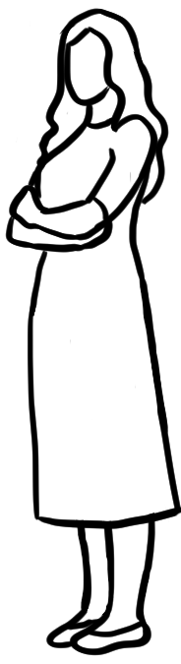
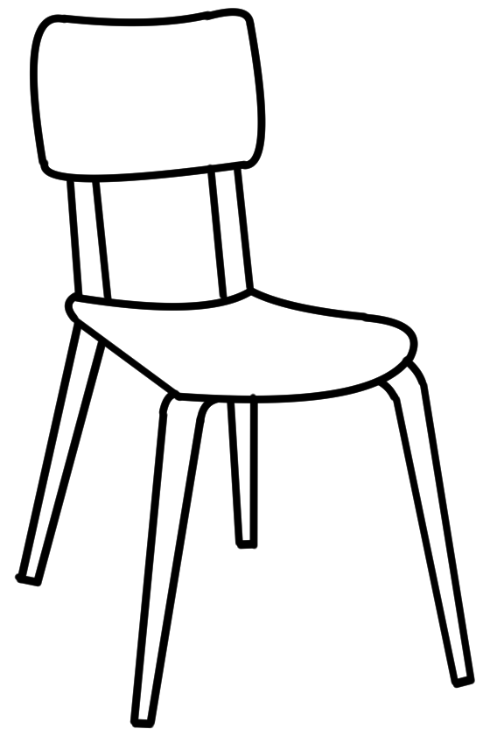

He She It
Grammar focus
- Long and short forms
of the verb to be and
the use of the short form
in speaking.
- The s ending for 3rd person
singular forms in the
Present Simple.

Subject | Verbs
Subject | be | have | like | come | want
I | am | have | like | come | want
He, She, It | is | has | likes | comes | wants
You, We, They | are | have | like | come | want
Students need to ask the questions and also ask their partner to spell any words they can’t spell. Discourage copying.

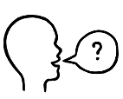
Can you spell
that please?
Interview your partner.

- What’s your name? | My partner’s name is ________________________.
- Where do you come from? | He / She comes from ________________________.
- Are you married or single? | He / She’s ___________________________.
- Do you have children? | He / She ___________________ __________________.  ^{has / doesn’t have} ^{a child /children}
- What are your  future plans? | He / She wants to __________________________.  Then he/she wants to ______________________  ___________________________________________.
- What do you do in your  free time? | ____________________ likes ____________________  ^{Partner’s name}  and ____________________________.
- What are you good at? | He / She’s good at _________________________.

In a group of three or four, students give some information about their partner. Encourage students to speak rather than read.

I want to tell you
about Mike.
Wendy gives a talk about someone.

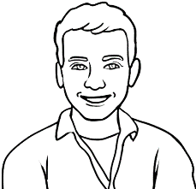
- Who’s Mike?
Wendy’s older brother

Mike
Wendy’s younger brother
Wendy’s younger sister

Read the questions together before reading Wendy’s talk to the class.
Information | True | False
- Mike comes from Poland.
- He came to Australia six years ago.
- He lives in Brisbane now.
Ticked answers are only shown in this teacher version of the workbook.
- He’s married.
- He has two children.
- What information is true about Mike?


- What company does Mike work for?
Wendy’s Talk
Mike is my younger brother. He came to Australia from England six years ago. He lives in Sydney now with his wife and two children. He works for a solar power company. He loves camping with his family in the holidays. My brother is hard-working and kind.
He’s also a great cook.


a gas power company

a wind power company
a solar power company



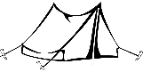
- What does he love doing with his family in the holidays?
camping. fishing swimming




- Wendy says that Mike is a great
dancer. cook. soccer player.

See the Teacher Resources page 31-34 for a talk by Wendy about herself. The activity includes listening questions and a plan for her talk.
Ko gives a talk about someone.
Read the questions together before reading Ko’s talk to the class.
I want to tell you
about Thein.
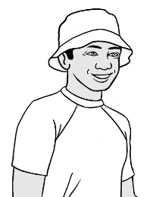
Thein
- Who’s Thein?

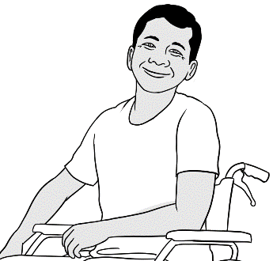
Ko’s friend
Ko’s son
Ko’s son-in-law
Thein Say th as in the and the long i = thine

- Where does he come from?

America Myanmar Mexico

- Does he have children?

Yes, three. Yes, two. Yes, one.

Information | True | False
- Thein wants to finish his English study.
- He wants to learn about gardening.
- He works for a house painter.
- He works two days a week.
- Thein likes fishing.
- He’s a very good swimmer.
- What information is true about Thein?
Students may need to tick more than one answer.
- Thein is

kind. hard-working. friendly. healthy.
Ko’s Talk
Thein is my son-in-law. He comes from Myanmar. He’s married to my daughter and they have a beautiful baby son. Thein wants to finish
his English study. Then he wants to go to TAFE and learn about gardening. He works for a gardener two days a week. He loves gardening. Thein also likes playing soccer and going to the beach. He’s a very good swimmer.
He’s kind and friendly.

Plan | A talk about Thein
- Greeting  Say and write the person’s name. | Good morning/afternoon everyone.  My name is Ko.  Today I want to tell you about Thein.
- A photo | Here’s a photo of Thein.
- Information  Family/ friend  Birth country  Married / single  Children  Future plans  Free time  Skills | Thein is my son-in-law.  He comes from Myanmar.  He’s married to my daughter and they have a beautiful baby son.  Thein wants to finish his English study. Then he wants to go to TAFE and learn about gardening. He works for a gardener two days a week. He loves gardening.  Thein also likes playing soccer and going to the beach. He’s a very good swimmer.
- Your opinion | Thein is kind and friendly.
- Thank you and questions | Thank you for listening.  Do you have any questions?
A talk about someone
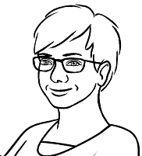
Ko wrote a plan
for his talk.
I practised with my family before my talk.

Ko’s talk and his plan provide a model for students to give a talk about someone.
- After reading Thien’s talk, brainstorm people students could talk about - family or friends.
- Project page 13 and model a talk about someone you know. As you give your talk, point to relevant parts of the plan and show a photo of the person.
- Practise standard phrases & sentences such as those in blue many times.
- The name of the person must be written on the board or on paper in Step 1.

Paw

A talk about someone

Students write a draft of their talk in their notebook. They check their work and ask the teacher to check
it as well.

Students write their final edited copy here.
Plan | A talk about ____________________________
- Greeting  Say and write  the person’s name. | Good morning/afternoon everyone.  My name is ________________________________.  Today I want to tell you about ______________.
- A photo | Here’s a photo of __________________________.
- Information  Family/ friend  Birth country  Married / single  Children  Future plans  Free time  Skills | _____________________________________________________________  _____________________________________________________________  _____________________________________________________________  _____________________________________________________________  _____________________________________________________________  _____________________________________________________________  _____________________________________________________________  _____________________________________________________________  _____________________________________________________________  _____________________________________________________________  _____________________________________________________________  _____________________________________________________________
- Your opinion | ____________________________________________________________.
- Thank you and questions | Thank you for listening.  Do you have any questions?

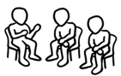
After practice in class and at home, students give their short talk [without reading] to a small group.

The park
Say and clap the stress patterns. The unstressed syllable is soft and the stressed syllable is longer and stronger.
Grammar - The indefinite article identifies the words as countable nouns.
Extension - Write two of the stress patterns on the board and
list familiar words with similar patterns.

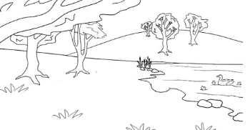  a park | 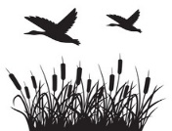  wetlands
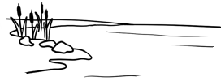  a lake |   toilets
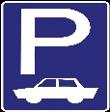  a car park |   a picnic spot
  a playground | 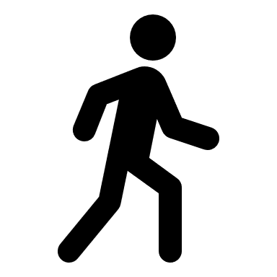  a walking track
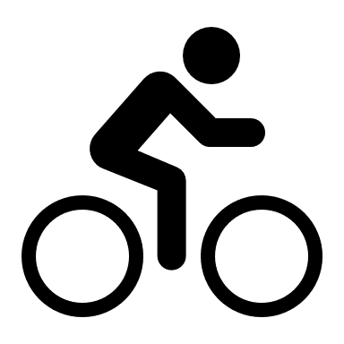  a bike track |   a drinking tap
  a dog park |   a barbecue

a river
  a picnic shelter |     an exercise station

a shelter = a place with a roof
a track = a path
wetlands = a swamp

Find and say the names of places on the map with a partner.
Students practise
saying names of places on the map using the correct stress pattern.

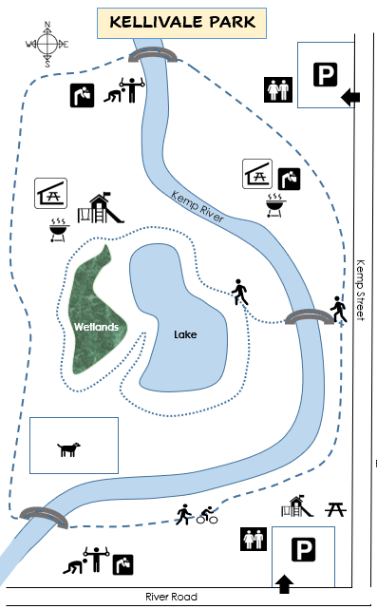
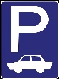

Toilets
Playground
Exercise station
Walking track
Walking and bike track
Picnic spot
Picnic shelter
Barbecue
Dog park
Drinking tap



Ask your partner about their local park.

Ask closed questions focusing on the upward inflection. Give short answers.

Short answers
Yes, it does.
No, it doesn’t.

Does it have
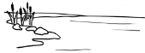  - a lake ? |   - toilets ? |  |   - wetlands ?
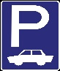  - a car park ? | - a playground ? |  | - a dog park ?
- a bike track? |   - a river? |  | - a picnic spot?
- a walking track? | - a drinking tap? |  | - a barbecue?
- a picnic shelter? |  | - an exercise station?

Write about your partner’s park.

My partner’s park has _____________________________________________
____________________________________________________________________________________________________________________________________
__________________________________and ___________________________.
Students read what they have written aloud to their partner and/or the class.

1. Say and clap the stress patterns.
Grammar - The indefinite article identifies the words as countable nouns. Note that ‘a’ is pronounced with the unstressed Schwa .
Extension - Write the stress patterns on the board and list familiar words with similar patterns.
2. Write the numbers from the boxes in the picture to match the words below.

A children’s playground
3 | a bench | 2 | a tree | 7 | a bush
13 | a swing | 12 | a slide | 6 | a spade
9 | a fence | 10 | a gate
1 | a tree-house | 11 | a ladder | 14 | a sandpit
4 | a sunshade | 5 | a bucket | 8 | a see-saw

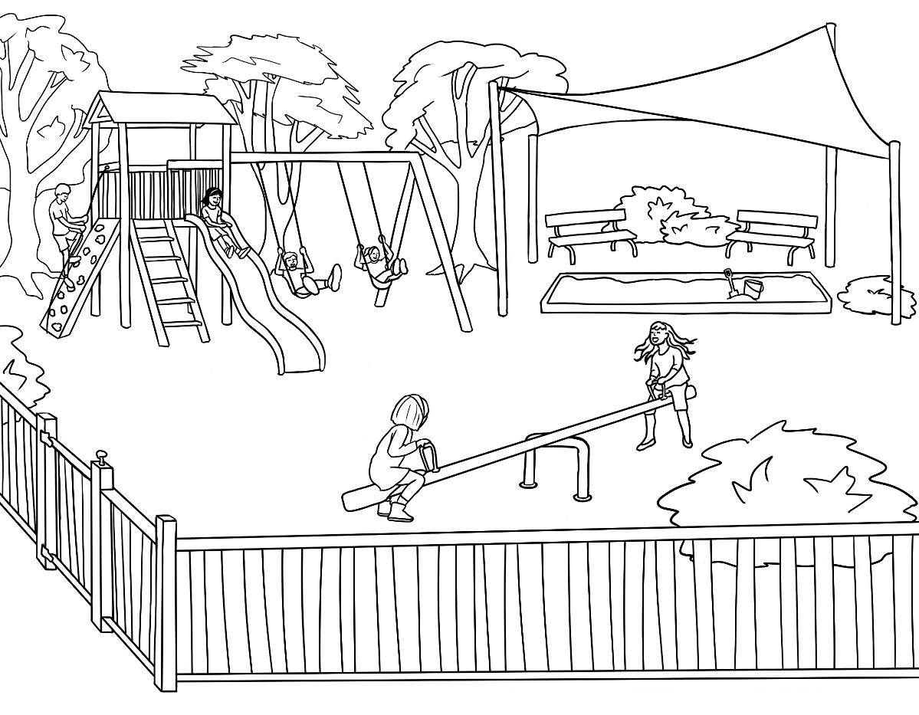
2
4
1

3

5
13
6
14
12
11

8
7

9
10

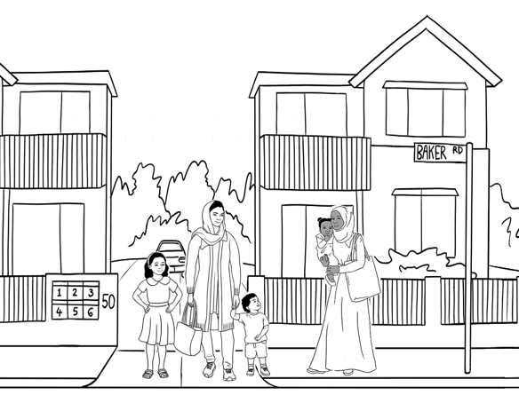
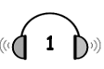
Read the questions together before listening to the recording of the conversation. Ask students to cover the opposite page. There may be more than one answer for some questions.

Parwana talks to Sahra.

- What does Parwana
talk about?
an old playground

a new playground

- Parwana talks about the playground, because

her children like the playground.
Sahra’s daughter will like the playground.

she’s going to the playground tomorrow.

- Where is the playground?

near the lake near the toilets near the car park

- When did Parwana go there?

on Friday on Saturday on Sunday

- Parwana gives some information about the playground.

Information | True | False
- The playground has a long slide.
- It has three swings.
- It has a sandpit.
- It has a see-saw.
- It has shady trees and a safety fence.
- It has a sunshade over the swings.
- Parwana’s children really like the playground.

Parwana | Hi Sahra. | really  Saturday  nice  will like  new  long  love  fence  lake  sandpit  shady  next  two  trees  see-saw
Sahra | Hi Parwana. Did you have a nice weekend?
Parwana | Yes. We went to the new playground  in the park.
Sahra | Oh. When did you go there?
Parwana | On Saturday.
Sahra | Did the children like it?
Parwana | They really liked it. Your daughter Hani  will like it too. It has a long slide  and two swings. There’s a sandpit and  a see-saw.
Sahra | Oh yes. Hani will love it. Where’s the playground?
Parwana | It’s near the lake.
Sahra | Is the playground shady?
Parwana | Yes. There are many trees and there’s a sunshade over the sandpit. The children are safe because the playground has a fence.
Sahra | Let’s go together next weekend.
Parwana | Okay. Good idea.
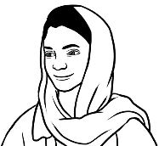
Sahra asked Parwana some questions.
ask questios.
Read the closed questions with an upward inflection.
Circle the answers Parwana gave.
- Did you have a nice weekend? | Yes  I did. | No,  I didn’t.
- Did the children like it? | Yes  they did | No,  they didn’t.
- Is the playground shady? | Yes,  it is | No,  it isn’t.
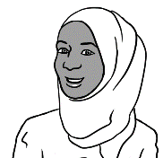

Did you have a nice weekend?

__________________________________________________________________
Explain that questions beginning with wh words are open. The rule is
that open questions should be said with a downward inflection.
Match the questions and answers.

She went
on Saturday.
She went
to the playground.
They’ll go to the playground together.
It’s near the lake.

- What did Parwana do on the weekend?
- When did she go there?
- Where is the playground?
- What will Parwana and Sahra do next weekend?

- What did you do on the weekend?
- Where did you go?
- What will you do next weekend?
Ask students to tell the class something their partner did on the weekend or something he/she will do next weekend.

Information about a favourite place
Brainstorm favourite places either
locally or anywhere in Australia
and write them on the board.
Project photos of some places.
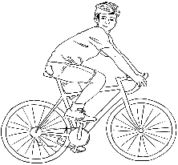

Where is it?
near = close to
in the city |  |   near the city
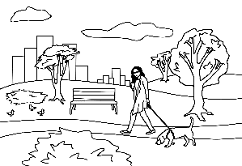  in the park |  | near the lake
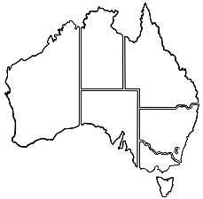  in Queensland |  | 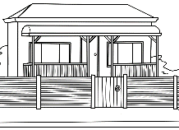  near my place
Grammar There is & there are used to introduce people or things. The short form there’s is used in spoken English.
See the Teacher Resources for activities to practise this grammar.
Tell me about it.
There is a sandpit.  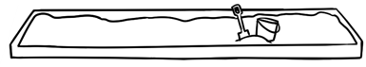  There’s a sandpit. |  | 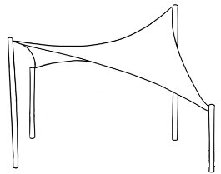  There is a sunshade.  There’s a sun shade.
There are two benches.  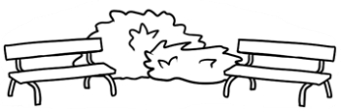 |  | 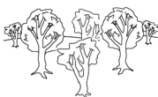  There are many trees.
What can you do there?
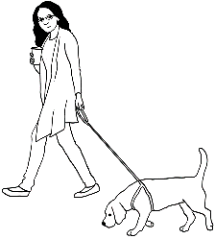  You can walk. | 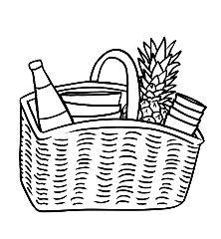  You can have a picnic. |  | 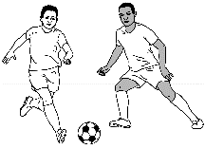  You can play soccer.
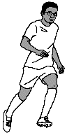  You can run. | You can ride a bike. |  | 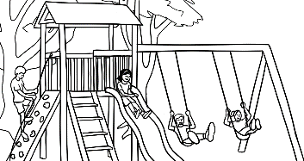  The children can play.

A talk about a favourite place
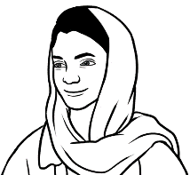
Parwana wrote
a plan for her talk.
I practised many times in class
and with my family before my talk.
Parwana’s talk and plan provide a model for students to give a talk.
- After reading Parwana’s talk, brainstorm places students could talk about.
- Project page 23 and model a talk about one of your favourite places. As you give your talk, point to relevant parts of the plan and show a photo of the place.
- Practise standard phrases & sentences such as those in blue many times.
- The name of the place must be written on the board or paper in Step 1.

Paw

Plan | My favourite place – The new playground
- Greeting  Say and write  the place name. | Good morning/afternoon everyone.  My name is Parwana.  Today I want to tell you about the new playground.
- A photo | Here’s a photo of the playground.
- Information  Where is it?  Tell me about it.  What can you do there? | The new playground is in the Kellivale Park near the lake.  There’s a long slide and a see-saw. There’s a sandpit with a big sunshade over it. There are two swings and many trees.  The playground has a safety fence.  My children can play on the slide and  in the sandpit. I can sit in the shade  and watch them.
- Your opinion | The playground is a fun safe place for my children.
- Thank you and questions | Thank you for listening.  Do you have any questions?

A talk about my favourite place

Students write a draft of their talk in their notebook. They check their work and then ask the teacher to check it as well.

Plan | My favourite place ________________________
- Greeting  Say and write  the place name. | Good morning/afternoon everyone.  My name is _______________________________.  Today I want to tell you about  _______________________________________________.
- A photo | Here’s a photo of ________________________________.
- Information  Where is it?  Tell me about it.  What can you  do there? | __________________________________________________________________  _________________________________________________________________  _________________________________________________________________  _________________________________________________________________  _________________________________________________________________  _________________________________________________________________  _________________________________________________________________  _________________________________________________________________  _________________________________________________________________  _________________________________________________________________  _________________________________________________________________
- Your opinion | ____________________________________________________  ______________________________________________________.
- Thank you and questions | Thank you for listening.  Do you have any questions?
Students write their final edited copy below.
Students give their talk to a small group or the class.
After practise in class and at home, students give their short talk [without reading] to a small group or the class.
Make sentences and ask questions
in the Present Tense.

Sentences | Subject | Verb | Where | When
Sentences | I, You, We, They | go  walk | to the park  to the shop  to class  to work | every day.  every week.  on Monday.  on the weekend.
Sentences | He, She, It | goes  walks | to the park  to the shop  to class  to work | every day.  every week.  on Monday.  on the weekend.
Questions

Do | I, you, we, they | go  walk | to the park  to the shop  to class  to work | every day?  every week?  on Monday?  on the weekend?
Does | he, she, it | go  walk | to the park  to the shop  to class  to work | every day?  every week?  on Monday?  on the weekend?

Grammar focus – Present Simple,
word order, common time markers and use of the verb to do to make questions. This tense features most commonly in information texts.
Demonstrate how to make sentences and questions using the table. Students can create sentences and
ask questions in pairs.

Do
every week?
to class
go
you

Do you go to class every week?

to the shop
Do
walk
on the weekend?
they

___________________________________________________________________________________________________________

to work
Does
go
she
on Monday?

___________________________________________________________________________________________________________
Does
to class
walk
he
every day?

________________________________________________________________________________________________________

An excursion to the park
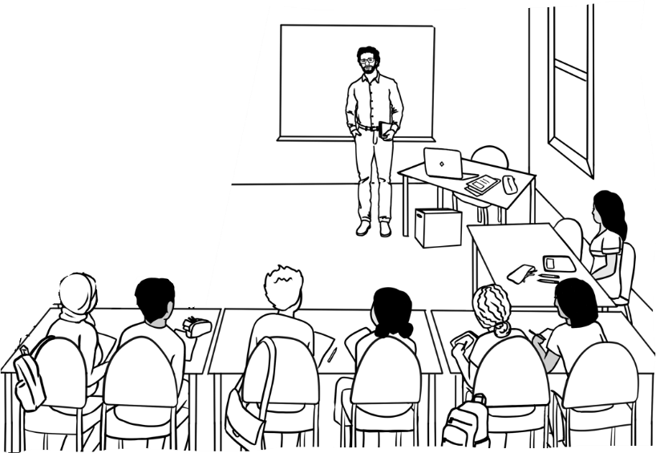
A weather check
I hope the weather is fine
for our excursion. Let’s listen to the weather report.

Read the questions together before you read the weather report. Students can later read the transcript of the report at the back of their book.

- The report is about the weather

today. tomorrow. next week.

- What day is the report for?

Tuesday Wednesday Thursday

- What is the date?

21 September 21 November 21 December

- The weather in the morning will be

 |  | 
Sunny and hot 30° | Sunny and warm 25° | Cloudy and warm 20°

- The weather in the afternoon will be
 | 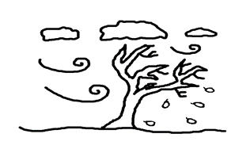
Wet and cold 14° |  | Windy and very cold 8° |  | Windy and cold 14°

The weather report
Here’s the Kellivale weather report for tomorrow, Tuesday 21 November.
It’ll be warm and sunny in the morning with a temperature of 25 degrees. The weather will change in the late afternoon. It will be windy and cold.
The temperature will drop to 14 degrees.

Ask students to cover the voice message on opposite page and read the listening questions together. You read the voice message to the class and students tick the answers.
A voice message on WhatsApp
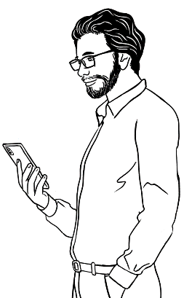
I’ll remind the students
about the excursion tomorrow.
- Where is Peter’s class going?
to the library

to the park.
Students may need to tick more than one answer for some questions.
to the beach

- Where will they meet?
at in the park at the library in the classroom

- What time do they meet?

9:15 9:30 9:45

- How long does it take to walk there?

25 minutes 20 minutes 15 minutes

- They will have their morning tea at the picnic shelter near
the lake the river the playground

- What should they bring?
a notebook morning tea a drink

- What should they wear?
a hat a raincoat comfortable shoes
comfortable shoes = easy for walking

- How will they get there?
by bus by walking by car

- Peter says, ‘Don’t be _____________________________.
^{early / late / sick}

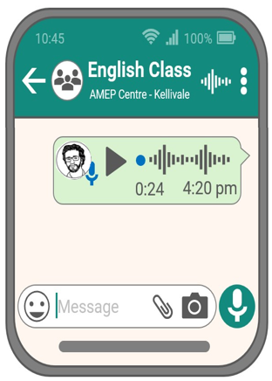

playground | late | shoes
morning | park | 25
classroom | picnic | 9:30
a hat | 12:30 | a drink

Don’t forget our excursion to the park tomorrow. We’ll meet
in the classroom at 9:30 and be back by 12:30.
It takes about 25 minutes to walk to the park. Then we’ll walk
to the picnic shelter near the playground. We’ll have our morning tea there. Please bring a drink and some morning
tea to share. Wear comfortable shoes and a hat.
See you tomorrow and don’t be late.

Minimal pairs – In each row, read the word pairs. Then select and say one word in each pair and students circle the word.

- park dark |  | 7. ear near
- borrow tomorrow |  | 8. tea see
- street meet |  | 9. wink drink
- back pack |  | - too shoe
- bake take |  | - share square
- when then |  | - late mate

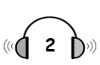
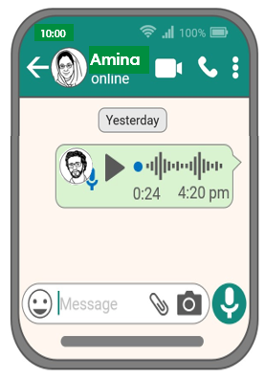
Amina’s late.
Ask students to cover the opposite page.
Read the questions together, then listen to the audio. Students then tick their answers.
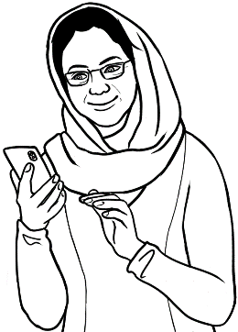

I’m late. Where’s my class?
I’ll call my teacher.

- Amina calls her teacher because she can’t find
a. her handbag. b. her class. c. her notebook.
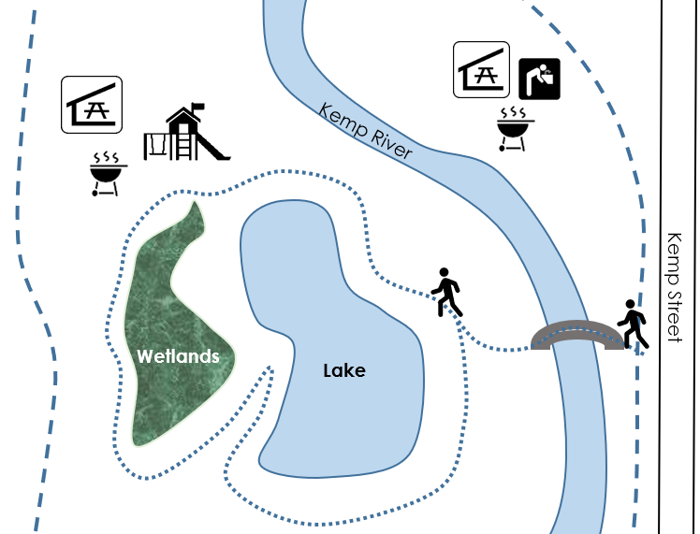

- Where is Amina?
- Where is her class?
Students circle where Amina and her class are.

- Peter’s directions
- Walk over the bridge to the lake. | True | False
- Turn left at the lake. | True | False
- Walk round the lake to the wetlands. | True | False
- We’re at the picnic shelter. | True | False
- We’re next to the river. | True | False





- How does Amina feel?
- happy b. sad b. worried c. tired

Amina | Hello Peter. | bridge  Where  over  on  round  behind worried  picnic  right  left  late  soon  shelter
Peter | Hi Amina.
Amina | I’m worried. I can’t find you.
Peter | Where are you?
Amina | I’m on the little bridge near Kemp Street.
Peter | Walk over the bridge to the lake.  Then turn right.
Amina | Did you say turn left?
Peter | No, turn right. Walk round the lake to the playground. We’re at the picnic shelter  behind the playground.
Amina | You’re at the picnic shelter?
Peter | That’s right.
Amina | Thanks Peter. I’m sorry I’m late.
Peter | Don’t worry. See you soon.

Walk over the bridge. |   Walk  round  the lake.
  Turn left. | Turn right.

Students read the conversation above and the directions opposite aloud in pairs.

Lake
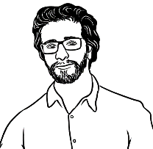
How do you feel?
Long | Short |         happy.  sad.  worried.  tired.  interested.  sick.
I am | I’m
He is  She is  It is | He’s  She’s  It’s
You are  We are  They are | You’re  We’re  They’re

Common contractions of the verb to be.
Mime the emotions in exercise 1 and read the contracted forms in exercise 1 and 2 together.

Long | Short | on an excursion.  in the park.  on the bridge.  at the picnic shelter.  in class.  at home.
I am | I’m
He is  She is  It is | He’s  She’s  It’s
You are  We are  They are | You’re  We’re  They’re
Where’s everyone?

Where’s = Where is

Read aloud and students repeat the three contractions in each row, Select and say one of the three for students to circle.
 | I’m | She’s | He’s
 | You’re | We’re | They’re
 | It’s | She’s | You’re
 | We’re | They’re | She’s
 | You’re | He’s | It’s
 | He’s | It’s | I’m

A place to rent
The indefinite articles have been included to:
- show the article is always pronounced with the unstressed schwa
- identify the words as uncountable nouns.
  a house | 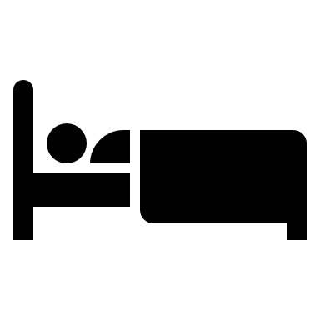  a bedroom
  a unit |   a bathroom
  a bath | 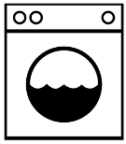  a laundry
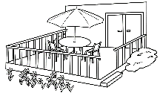  a deck |   a garage

a garden






a workshop
  a separate toilet |   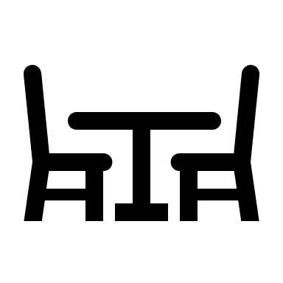  a living room
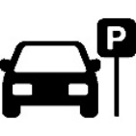
a parking space
lithium batteries | 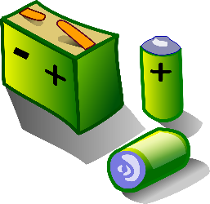

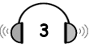
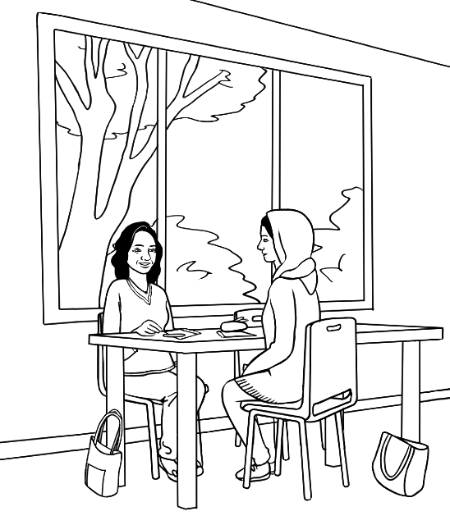
Ask students to cover the opposite page. Read the questions below together before listening to the recording of the conversation.
There can be more than one answer for some questions.

A new home

- What are Linh and Parwana
talking about?

Parwana’s new home
Linh’s new home
the teacher’s new home

- What street is the new home in?
Blue Street Dew Street View Street

- How long does it take to walk to the shops?

5 minutes 10 minutes 15 minutes

- The new home is
a new house. an old house. an old unit.

- The new home has

a small garden. a big garden. two bedrooms.
a front deck. a back deck. a garage.

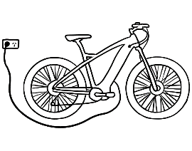
- The garage will be used for
a car. a workshop an e-bike.

- You can’t keep e-bikes inside a house because

they are oily and dirty.
the batteries can catch fire.
they are noisy.


- Parwana didn’t know about lithium batteries. She says,
I’m glad. That’s interesting. That’s worrying.

charge a bike = fill with electricity
glad = happy
Linh | I moved into my new home yesterday Parwana. | in  Street  home  shops  Where  old  two  five  e-bike  fire  back  interesting  inside  garage away
Parwana | That’s great Linh. Where is it?
Linh | It’s in View Street.
Parwana | New Street?
Linh | No. View Street, V – I – E – W.
Parwana | Is it near the shops?
Linh | Yes. It’s only a five-minute walk.
Parwana | So, tell me about your new home.
Linh | Well, it’s an old house with two bedrooms.  It has a small garden, a sunny back deck  and a garage.
Parwana | Do you need a garage?
Linh | Yes. I need a place for my e-bike.
Parwana | Why can’t you keep the bike inside?
Linh | I need to charge my bike away from the house because lithium batteries can catch fire.
Parwana | That’s interesting. I didn’t know that.
Linh | Yes. The batteries can be dangerous,  so I’m glad we have a garage.
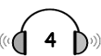
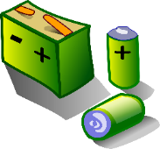
What do you know about lithium batteries?
lithium batteries
Grammar – Use the plural form when talking about things in general.

Read the questions together before listening to the recording of the information about lithium batteries. The transcript is at the back of this book.
- Llithium batteries are in
  - mobile phones. |  |   - laptops. |   - tablets.
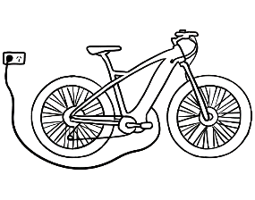  - e-bikes. | 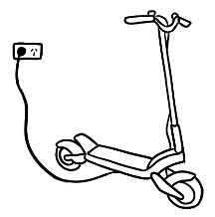  - e-scooters. |  | 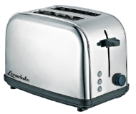  - toasters.
  - toys. | 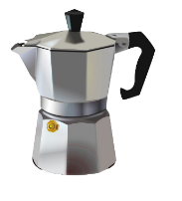  - coffee pots. |  | 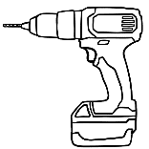  - power tools.

- Is this true or false?
Information about lithium batteries | True | False
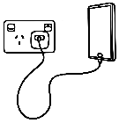
- You can recharge the batteries.
- You can charge them anywhere.

- They can be dangerous.
- They can get very hot.
- The batteries can catch fire.

- It’s easy to put out a battery fire.


- What is safe?
- \ | 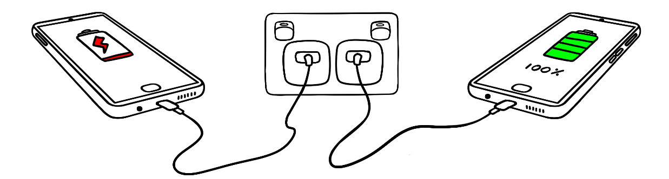
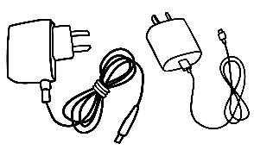 | 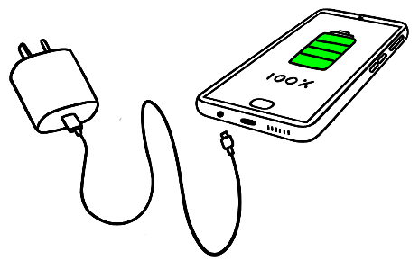
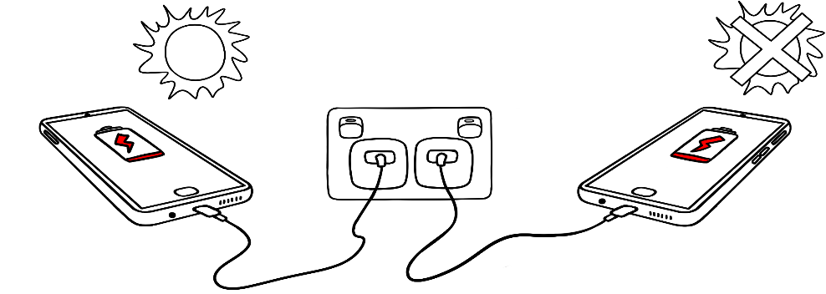

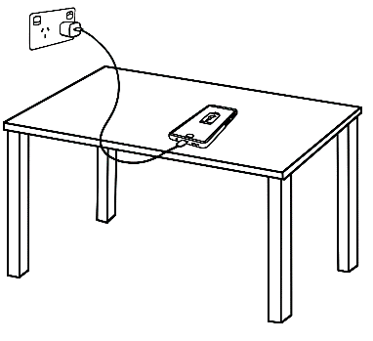 | 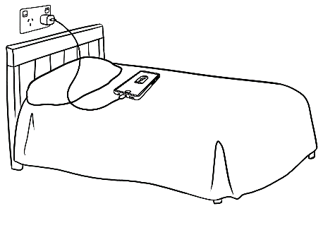
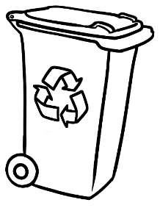
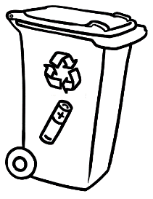


Sale at the Op Shop
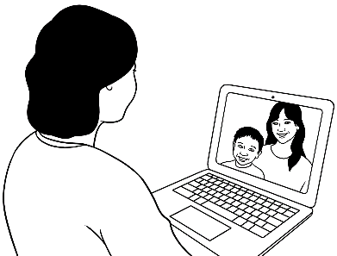
I bought some things
at the OP Shop sale.
Read the questions together before you read Linh’s description of her purchase to her friend.
The transcript can also be found at the back of this book.
Linh talks to her friend.
Students may need to tick more than one answer for some questions.

- When did Linh go to the sale?

on the weekend yesterday today

- She went to the sale because she wanted to buy things for
Chinese new Year. her new home. her brother.

- What did she buy?

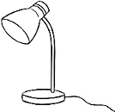  a lamp | 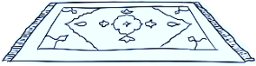  a rug | 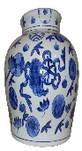  a vase | 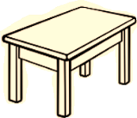  a table

- Information about the vase | True | False
- It’s a glass vase.
- It’s blue and white.
- It was made in Vietnam.
- It’s 13 centimetres tall.
- It’s very old.

- Why is the vase special to Linh?

It’s very old.
Linh’s talks to her friend
I wanted some things for my new home, so I went to
the sale at the OP Shop today. Everything was half price and I bought a lamp, a table and a beautiful pottery vase. The vase is very old and was made in China. It’s blue and white and about 30 centimetres tall. It’s special because it’s very old.
It’s very beautiful.
It was very cheap.

Information about a special object
Where did you get it?
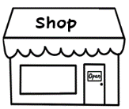
I bought it at a shop in the city.
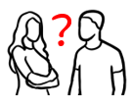

It was a gift from ___________________.
Where was it made?
Grammar The passive form here can be taught as
a collocation rather than as a grammar point.

Ask students to check where other things they own were made. e.g. phone, stationery, watch, shoes, clothes, bags, car, white goods etc

It was made in ________________.
What does it look like?
It’s blue and white. |   It’s big.    It’s small. |  | 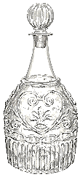  It’s glass.
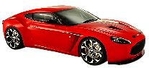  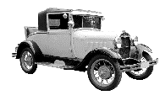  It’s old. It’s new. | It’s 30 centimetres long. |  | It’s wooden.
What do you do with it?
I put flowers in it.   | I put books in it.  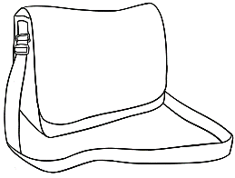 |  | 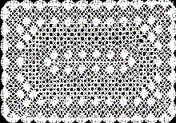  I put it on the table.

Linh gives a talk about a special object.
an object = a thing
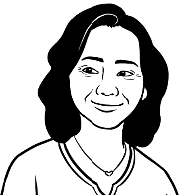
Linh wrote a plan
for her talk.
I practised many times in class
and at home before my talk.

Students use the plan and Linh’s talk as a model for a talk.
- Brainstorm ideas of different objects.
- Project page 39 & model a talk about an object that is special for you. Show the object to the class and as you give your talk, point to relevant parts of the plan.
- Practise standard phrases and sentences such as those in blue many times.
- The name of the object must be written on the board or on paper in Step 1.

Plan |  | My talk – A special vase
- Greeting  Say and write the name of the object. | Good morning/afternoon everyone.  My name is Linh.  Today I want to tell you about  a special vase.  Grammar Note the use of the indefinite article, a special vase, for the first mention. Then the definite article, This is the vase,  for the second mention.
- The special object | 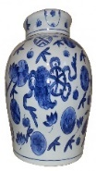  This is the vase.
- Information  Where did you get  the object?  Where was it made?  What does it look like?  What do you do  with it? | I bought this pottery vase last week at the Op Shop. It was very cheap, but it’s very beautiful.  It was made in China and is very old.  It’s blue and white and about 30 centimetres tall.  I put flowers in it. I put it on my new table, in my new home.
- Why is it special? | It’s special because it’s very old.
- Thank you and questions | Thank you for listening.  Do you have any questions?

Students write a draft of their talk
in their notebook. They check their work and then ask the teacher to check it as well. Their final edited copy can be written here.
A talk about a special object

Plan | My talk _____________________________
- Greeting  Say and write  the name of  the object. | Good morning/afternoon everyone.  Today I want to tell you about  a special __________________________________.
- The special object | This is ________________________________________.
- Information  Where and when did you get the object?  Where was it made?  What does it look like?  What do you do  with it? | ______________________________________________________  ______________________________________________________  ______________________________________________________  ______________________________________________________  ______________________________________________________  ______________________________________________________  ______________________________________________________  ______________________________________________________  ______________________________________________________  ______________________________________________________  ______________________________________________________  ______________________________________________________
- Why is it special? | It’s special because____________________________  _____________________________________________________.
- Thank you and questions | Thank you for listening.  Do you have any questions?

After practice in class and at home, students give their short talk [without reading] to the class or a small group.

An invitation
Read the questions together before you read the voice message. The transcript of the message is also at the back of this book.
Basam gets a voice message.

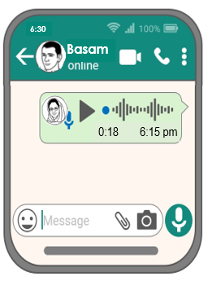
- Who is the voice message from?
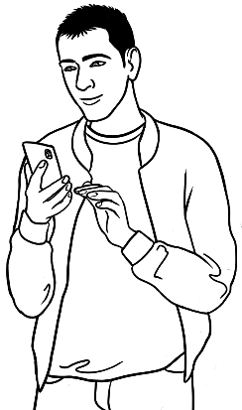
Ahmad

Peter
Amina

- What is the message about?
homework

an invitation
an excursion
Amina’s voice message to Basam
Hi Basam. This is Amina. Can you come to a BBQ at my place on Sunday.
It’s at 12:30? My address is 46 Baker Rd. It’s my birthday and you can meet my family. I want to invite Ahmad too. Don’t bring any food. We’ll have lots of food. Can you let me know tomorrow? Bye.

- What day is the barbecue?
Sunday

Saturday
Friday

- What time is the barbecue?

12:00 12:30 1:00

- Where is the barbecue?

46 Baker Rd 36 Baker Rd 46 Laker Rd

- Who will be there?

Linh Amina’s family Peter
- What can Basam bring?

fruit drinks nothing

- Why is Amina having a barbecue?

for fun for her birthday for Ahmad’s birthday

- When does Basam need to reply to Amina’s invitation?
tomorrow today tonight

Jazz chant
The chant revises common expressions, question inflection and correctional stress.
Read together as a class, then in pairs, then together as a class again.

I’m having a barbecue.  Would you like to come? |  | I’d love to come.  When is it?
On the weekend. |  | On Saturday?
On Sunday. |  | What time?
At 12:30. |  | At 2:30?
At 12:30. |  | Where is it?
At our place. |  | At your place?
At our place. |  | What can I bring?
Nothing.  There’ll be lots of food. |  | I’ll bring a cake.
No, no. Thank you. |  | I’ll bring a salad.
No, no. Thank you. |  | I’ll bring a pizza.
No, no.  Just bring yourself. |  | Okay.  Thanks Amina.
Basam’s coming too. |  | Great.
You can meet my family. |  | Great.
See you Sunday. |  | Great. See ya.
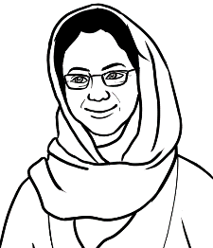
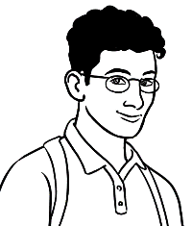

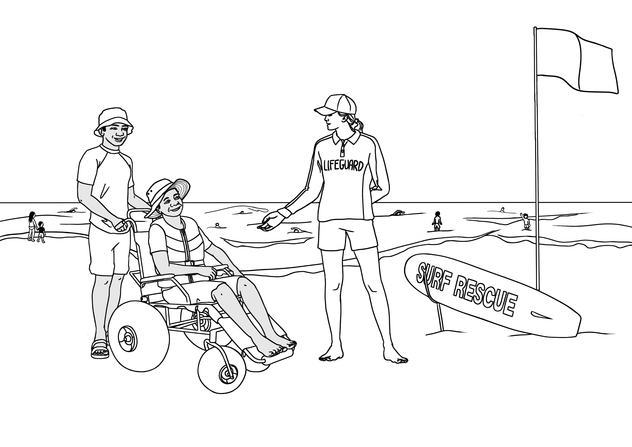
The beach and the pool
tyre
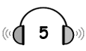
Ko goes to the beach.

Read the questions together before listening to the recording of the conversation. Ask students to cover the opposite page.
- What are they
talking about?

the weather
the beach
the wheelchair

2. Information | True | False

- The wheelchair is comfortable.
push
- It’s not easy to push.
- The tyres are very thin.
- The chair can go in the water.
- Ko should return the chair after 5.
- Ko can book the chair any day.

3. The lifeguard said, Stay between the
rocks. flags. people.

- The lifeguard also said to stay
in the shallow water. in the deep water.

Book the chair.

shallow
return
free
What does it mean?
Put your name down for the chair.
not deep
take back
costs nothing

Lifeguard | Hello. Is the beach wheelchair comfortable? | very  wheelchair  in  flags  fat  chair  first  water  push  day  return  free  shallow  problem  help  beach  Yes  Before
Ko | Yes, very comfortable.
Lifeguard | Have you used the chair before?
Ko | No. This is the first time.
Lifeguard | The fat tyres make the chair easy to push over  the sand. You can take it in the water too.
Ko | Yes. I want to go in the water.
Lifeguard | Stay between the flags and in the  shallow water.
Ko | When should I return the chair?
Lifeguard | Before 5.
Ko | Can I book the chair any day?
Lifeguard | Yes. The beach wheelchair is free because  we want everyone to enjoy our beautiful beach.
Ko | Thanks for your help.
Lifeguard | No problem. Have fun.

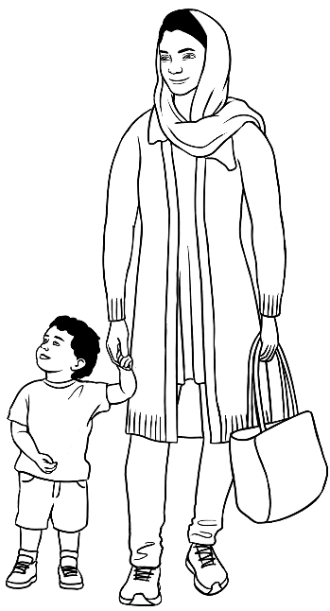
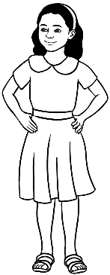
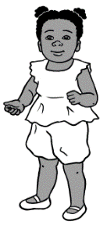
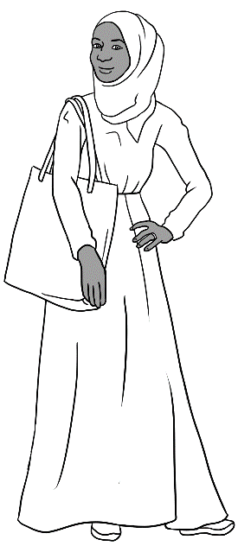
Hani loves her swimming lessons.
I want my children
to have swimming
lessons too.
Swimming lessons

What questions will Parwana ask Sahra?

do |  | want |  | does |  | go |  | can learn
do |  | cost |  | does |  | go |  | lessons
 | Who can learn to swim?
 | Where does Hani go for swimming lessons?
 | When does Hani go to the pool?
 | What do the lessons cost?
 | Why do you want Hani to learn to swim?
Read the conversation on page 46. Students tick the answers on the following page.
Support the reading of the conversation by writing Sahra and Parwana’s names on the board and pointing to each character as you read their part of the dialogue.

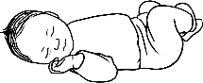
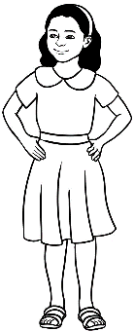
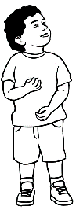
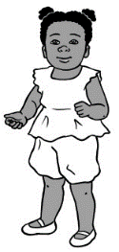
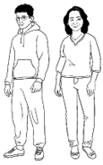
What does Sahra say?

Students may need to tick more than one answer for some questions.

Who can learn to swim? | babies | children | adults
Where does Hani go for  swimming lessons? | 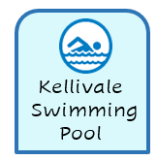    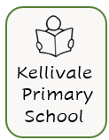
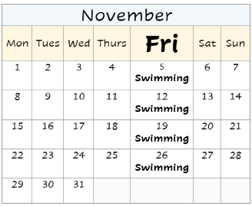
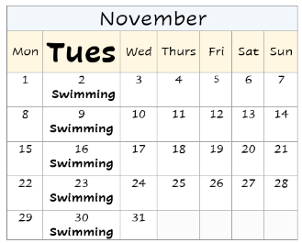
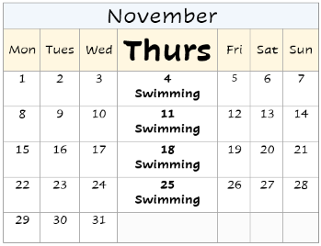

When does Hani go to the pool?
What do the lessons cost? |       
Why do you want Hani to learn to swim? | to make her strong   |     to make her safe in the water | It’s important learn to swim  in Australia.

Parwana | Who can learn to swim Sahra? Anyone? | does  lessons  goes  babies  Pool  adults  Anyone  Tuesday  hospital  cost  safe  water  Health  enrol  strong  $15  too Australia want
Sahra | Yes. Anyone can learn, babies, children  and adults.
Parwana | Where does Hani go for swimming lessons?
Sahra | We go to the Kellivale Swimming Pool.  It’s in North Street, opposite the hospital.
Parwana | When does Hani go to the pool?
Sahra | Hani goes to the pool on Tuesday morning, but there are different lesson times.
Parwana | What do the lessons cost?
Sahra | I have a Health Care Card, so I pay $15  a lesson.
Parwana | Why do you want Hani to learn to swim?
Sahra | Swimming will make her strong. I want Hani  to be safe in the water. It’s important  to learn to swim in Australia.
Parwana | I want my children to be safe in the water.  I’ll enrol them in classes too. Thanks for  the information Sahra.

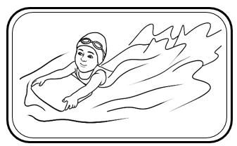
Read the conversation in the table as a jazz chant to help students memorise these common questions.

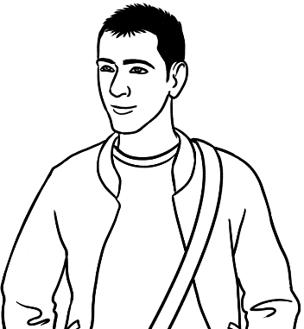
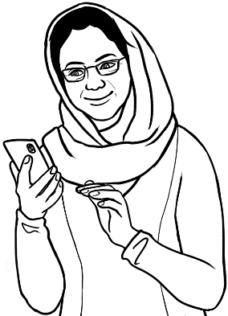
It’s my granddaughter Bibi.
She’s learning to swim.
Who’s that
in the photo Amina?

Basam | Amina
Who can learn to swim? | Anyone.
Where can you learn? | At the pool.
When can you learn? | Anytime.
What does it cost? | I’m not sure.

Questions | Me | Partner 1 | Partner 2 | Partner 3
- Can you swim?
- Can you cook? |  | Students work in groups of 4. After completing the survey for themselves, the group works as two pairs. Students ask their partner the questions on the survey and record their answers. Once completed, they swap partners and repeat the process. When everyone has finished, tally and record the skills on the board by asking, Who can swim? etc
- Can you ride a bike?
- Can you sew?
- Can you fix things?
- Can you drive?
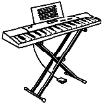
- Can you play the piano?
- Can you play soccer?
- Can you dance?

A quick and easy meal
Ask students to cover the opposite page.
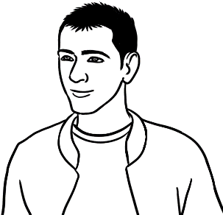
Can you cook Basam?
No, but I want to learn.
I can teach you. Here’s a pizza recipe with only six ingredients.
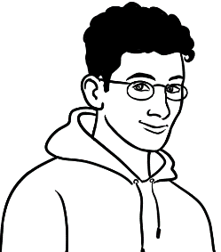

ingredients = _________________
Students write the meaning
of ingredients in their language.
- Ask students to guess the six ingredients in Ahmad’s pizza.
- Read the ingredients – a pizza base, an egg, mozzarella cheese, feta cheese, parsley and black sesame seeds. Students tick the ingredients and write the words.

  a tomato | 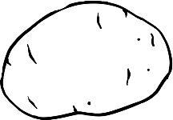  a potato | 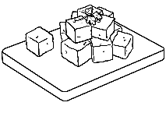  feta cheese
a tomato
  an onion |   a pizza base | 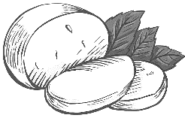  mozarella cheese
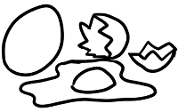  an egg |   garlic | 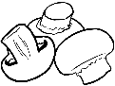  mushrooms
  an eggplant | 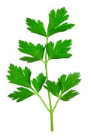  parsley | 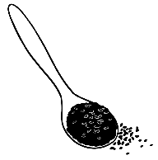  black sesame seeds
The base of this traditional Syrian pizza is normally home-made, not shop-bought. We tested the recipe before including it here, but it proved to be a little dry, perhaps due to the inferior base. Ask students how the recipe might be improved and the ingredients they use for their pizza.

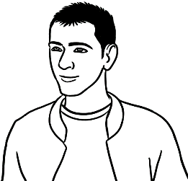

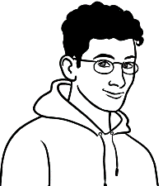
Yes, easy and quick.
I’ll tell you how to make it.
Is the pizza easy to make Ahmad?
Read the questions together before you read the cooking instructions. The instructions are also at the back of this book.

Cooking instructions
- Heat the oven to 180°C
- Grate a cup of mozarella the cheese.
- Grate ½ cup of feta cheese
- Chop ½ cup of parsley
- Break an egg into a bowl.
- Add the cheese, parsley and a teaspoon
of black sesame seeds to the bowl.
- Mix together and spread on the pizza base.
- Bake in the hot oven for 15 minutes.

- Why is Ahmad talking about pizza?

He eats pizza every day.

Basam wants to learn to cook.

Ahmad has an easy recipe.

- Instructions | True | False
- Heat the oven to 100°C.
- Grate a cup of mozzarella cheese.
- Grate a cup of feta cheese.
- Chop ½ cup of parsley.
- Break an egg into a bowl.
- Add the cheese and parsley.
- Add 2 teaspoons of black sesame seeds.
- Mix together and spread on the pizza base.
- Cook for 10 minutes.

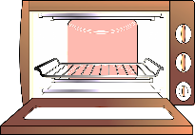



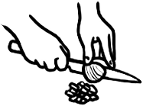

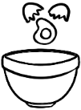

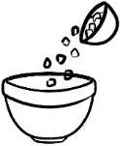

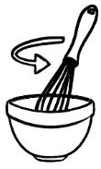

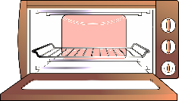

Student correct the above instructions and read the corrected instructions in pairs.

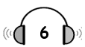
Read the questions together before listening to the recording of the conversation. Ask students to cover the opposite page.
What happened?

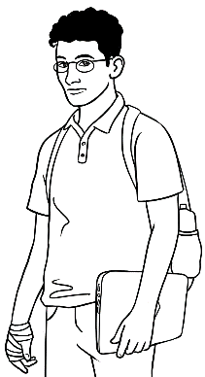
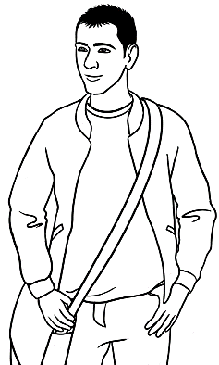
- What are Basam and Ahmad talking about?

Basam’s cooking
Ahmad’s hand

Ahmad’s pizza


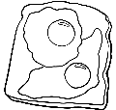
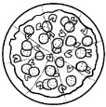
- What did Ahmad cook yesterday?

noodles fried eggs a pizza

- What happened to his hand?

He burnt his hand.
He cut his hand.
He broke his hand.

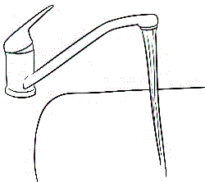
- What did Ahmad do quickly?

He put his hand in salty water.
He put his hand in cold running water.
He put his hand in warm water.

- How long did he keep his hand in water?

3 minutes 6 minutes 10 minutes

- Why did he put his hand in water? He wanted to

warm his hand.
cool his hand.
wash his hand.

Verbs are in irregular and regular groups.
Basam | What did you do to your hand Ahmad? | hurt  kept  did  do  better  made  burnt  burnt  cooled  put  Did  help
Ahmad | I burnt it. I made a pizza yesterday  and burnt my hand on the pan.
Basam | Oh no.
Ahmad | Yes it really hurt, but I quickly put  my hand in cold running water. I kept  it there for 10 minutes.
Basam | Did that help?
Ahmad | Yes. The water cooled the burn.  It’s much better today.

Present |  | Past |  | Present Past
do |  | burnt |  | do _________
burn |  | put |  | burn _________
make |  | kept |  | make _________
hurt |  | did |  | hurt _________
put |  | made |  | put _________
keep |  | hurt |  | keep _________
help |  | cooled |  | help __________
cool |  | helped |  | cool __________

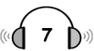
Read the questions together before listening to the recording of the conversation. Ask students to cover the opposite page.
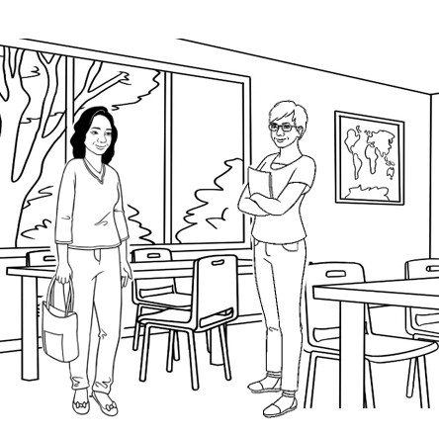
Linh talks to Wendy.

- What are Linh and Wendy
talking about?

Linh’s recipe
Linh’s accident
Linh’s homework

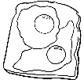
- What did Linh cook yesterday?

noodles fried eggs a pizza

- On the weekend, Linh hurt

her hand. her head. her leg.

- What did she do after her accident? She put

an ice pack on her head.
an ice pack on her leg.
her hand in warm water.

- What did she do next? She sat down

with her head up. with her leg up.

- How long did she sit?

15 minutes 20 minutes 25 minutes

- How does Linh feel today?
not well better much better

Mime new vocabulary before listening. Students write the meanings in their own language.
dropped =

slipped =
fell =
limping =

ice pack =

Wendy | You’re limping Linh. | dropped  cooked  limping  didn’t hit  didn’t see  hurt  happened  slipped  slipped  fell  fell  feel  sat  20  put  was
Linh | Yes. I slipped and fell on the weekend.
Wendy | What happened?
Linh | I cooked some noodles for lunch and  dropped some on the floor.
Wendy | Oh?
Linh | I didn’t see the noodles and slipped  on them. I fell on my leg.
Wendy | Oh dear.
Linh | It really hurt so I put an ice pack  on my leg. Then I sat with my leg up  for 20 minutes. I was lucky I didn’t hit  my head.
Wendy | How do you feel today?
Linh | Much better.

Write the past tense of the verbs.
Write the past tense of the verbs.
am | was |  | slip
fall |  |  | happen
hurt |  |  | drop
put |  |  | cook
sit

Information transcripts
This section contains transcripts of information texts which are not included in the student version of the workbook. The transcripts are useful in many ways. e.g.
- After the initial exercise in the book, students can read while listening to the teacher.
- Students can record the teacher reading the text; then listen and read at home.
- To create additional cloze exercises .

Wendy’s Talk Page 10
Mike is my younger brother. He came to Australia from England
six years ago. He lives in Sydney now with his wife and two children.
He works for a solar power company. He loves camping with his family in the holidays. My brother is hard-working and kind. He’s also
a great cook.

Ko’s Talk Page 11
Thein is my son-in-law. He comes from Myanmar. He’s married to
my daughter and they have a beautiful baby son. Thein wants to finish his English study. Then he wants to go to TAFE and learn about gardening.
He works for a gardener two days a week. He loves gardening. Thein also likes playing soccer and going to the beach. He’s a very good swimmer. He’s kind and friendly.

The weather report Page 25
Here’s the Kellivale weather report for tomorrow, Tuesday 21 November. It’ll be warm and sunny in the morning with a temperature of 25 degrees. The weather will change in the late afternoon. It will be windy and cold. The temperature will drop
to 14 degrees.

A talk about lithium batteries Page 35
This talk has an audio recording.
Litihum batteries are everywhere. The batteries are in mobile phones, toys, laptops, tablets, e-scooters, e-bikes and power tools. You can recharge them, but they can be dangerous. Be careful where you charge them. The batteries can get very hot and catch fire. Battery fires are very hard to put out. Here are some safety tips:
- Unplug the battery when it is fully charged.
- Use the correct charger.
- Charge batteries out of sunlight.
- Charge batteries on a table or desk.
- Put old batteries in a battery recycling bin.

Linh’s talks to her friend Page 36
I wanted some things for my new home, so I went to
the sale at the OP Shop today. Everything was half price and I bought a lamp, a table and a beautiful pottery vase. The vase is very old and was made in China. It’s blue and white and about 30 centimetres tall. It’s special because it’s very old.

Amina’s voice message to Basam Page 40
Hi Basam. This is Amina. Can you come to a BBQ at my place on Sunday. It’s at 12:30? My address is 48 Baker Rd. It’s my birthday and you can meet my family. I want to invite Ahmad too. Don’t bring any food. We’ll have lots of food. Can you let me know tomorrow? Bye.

Cooking instructions Page 49
- Heat the oven to 180°C.
- Grate a cup of mozarella cheese.
- Grate ½ cup of feta cheese.
- Chop ½ cup of parsley.
- Break an egg into a bowl.
- Add the cheese, parsley and a teaspoon
of black sesame seeds to the bowl.
- Mix together and spread on the pizza base.
- Bake in the hot oven for 15 minutes.

