

English Ready
22638VIC Certificate I in EAL
VU23504 Read and write short simple informational texts

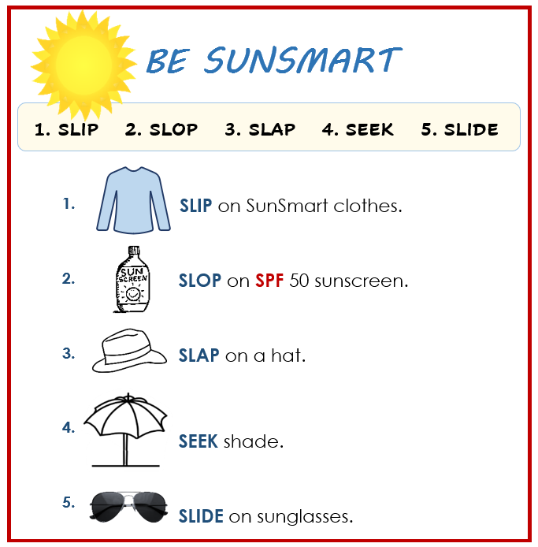
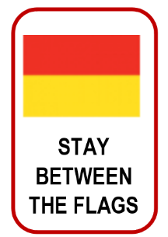
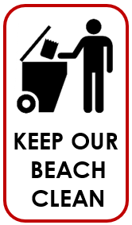
Student Workbook

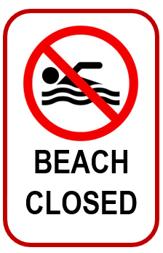

Student _______________________________________________________
Teacher _______________________________________________________
Class ________________________________________________________
Date ________________________________________________________

Design team: Vicki Hambling, Sue Paull, Frida Dean, Glenise Kleehammer and Mary Wallace
Illustrations: Madelena Scott

Illustrations acknowledgements:
Dog on a lead, vase This Photo by Unknown Author is licensed under CC BY-SA-NC
Sunscreen bottle, garden and map icons, recycle logo, toy box These Photos by Unknown Author is licensed under CC BY-NC
Pull drawing, parsley These Photos by Unknown Author is licensed under CC BY-SA
Tap and water, house inspection, BBQ icon These Photos by Unknown Author is licensed under CC BY
Onion This Photo by Unknown Author is licensed under CC BY-NC-ND
Parked car icon by<a href="https://www.freepik.com/icon/parked-car_75905">Icon by Freepik</a>

Acknowledgements: The design team would like to thank the AMEP service providers and practitioners who participated in the trial and gave valuable feedback. The team would also like to acknowledge the use of the EAL Framework which underpins the design of this book.
___________________________________________________________________________
Copyright of the EAL Framework is reserved to the Crown in the right of the State of Victoria. © State of Victoria (Department of Education and Training) 2023.
Use of all or part of this document must include the following attribution:
© Commonwealth of Australia 2024
+
With the exception of the Commonwealth Coat of Arms, the department’s logo, any material protected by a trade mark and where otherwise noted all material presented in this document is provided under a Creative Commons Attribution 4.0 International (https://creativecommons.org/licenses/by/4.0/) licence.
The details of the relevant licence conditions are available on the Creative Commons website (accessible using the links provided) as is the full legal code for the CC BY 4.0 licence (https://creativecommons.org/licenses/by/4.0/legalcode).
As far as practicable, material for which the copyright is owned by a third party will be clearly labelled. The department has made all reasonable efforts to ensure that this material has been reproduced in this document with the full consent of the copyright owners.
Copyright requests and enquiries concerning usage not addressed by the CC BY 4.0 licence should be addressed to: comms@homeaffairs.gov.au at the Department of Home Affairs.
The terms of use for the Commonwealth Coat of Arms are available from the It's an Honour website.
Where a copyright owner, other than the Commonwealth, is identified with respect to this material, please contact that third party copyright owner directly to seek permission.



This workbook is designed to be used with the support of a teacher.

Table of Contents
1. Meet the students and teachers 3
2. Meet two families. 4
3. Workbook instructions 5
4. Some information about me 7
5. The park 12
6. A picnic in the park 18
7. A place to rent 22
8. Sale at the Op Shop 30
9. An invitation 32
10. The beach 34
11. A quick and easy meal 42

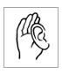
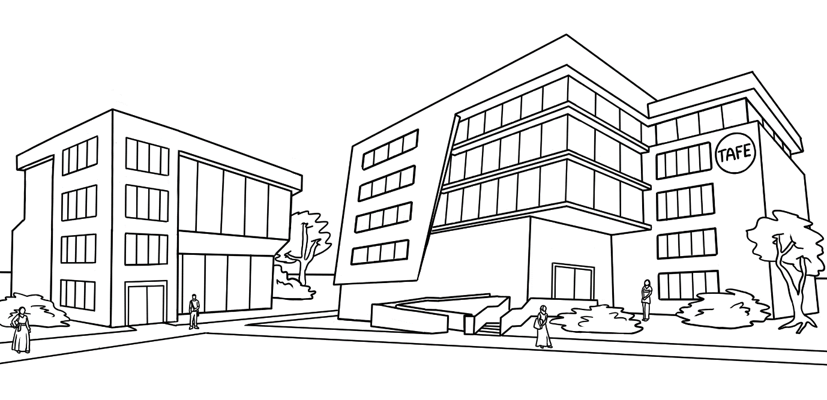
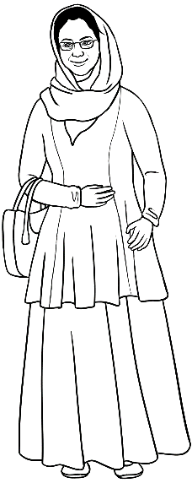
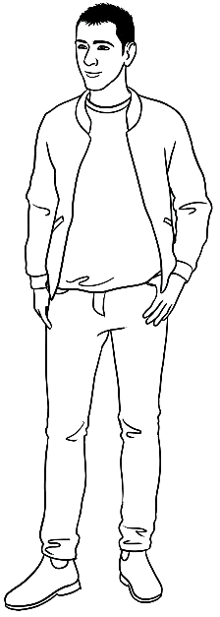
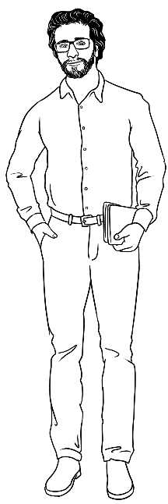
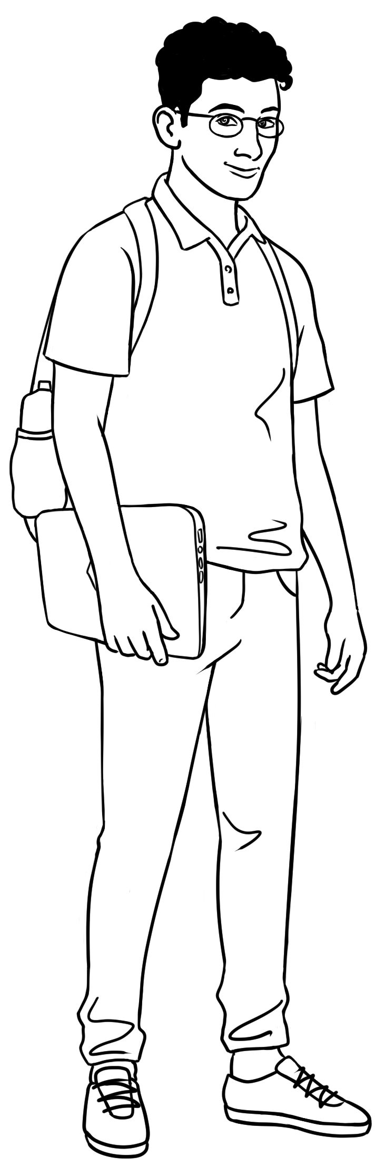
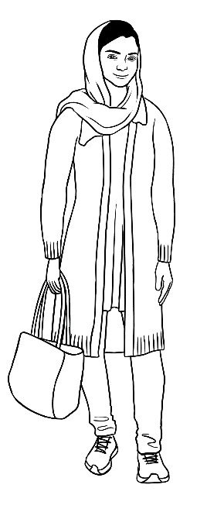
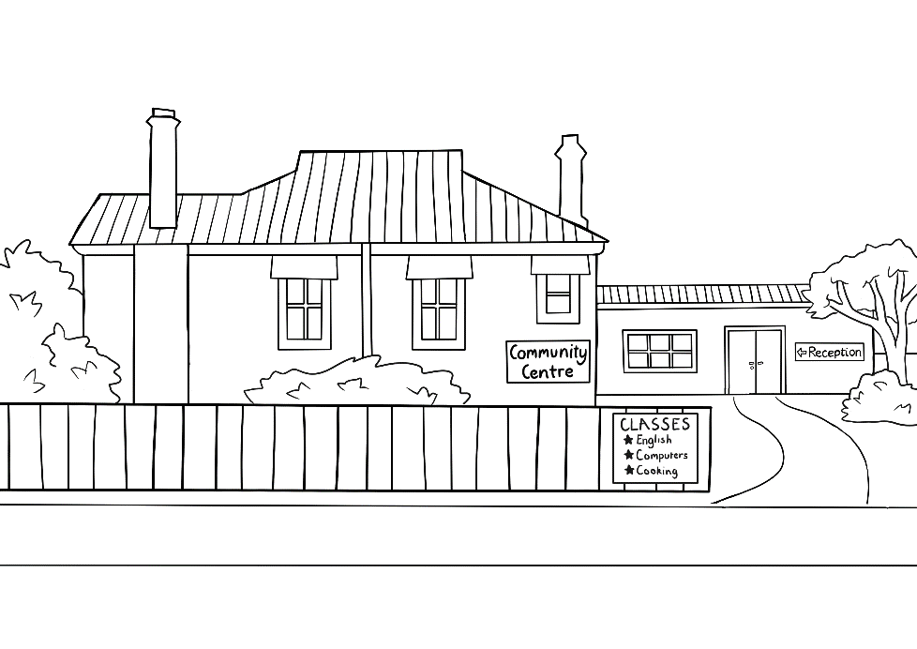
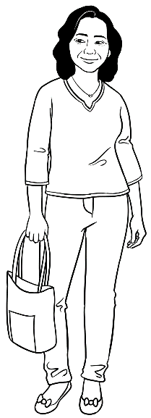
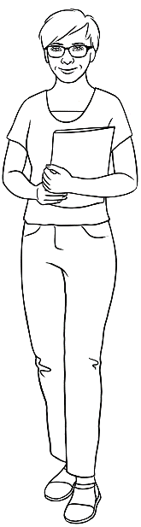
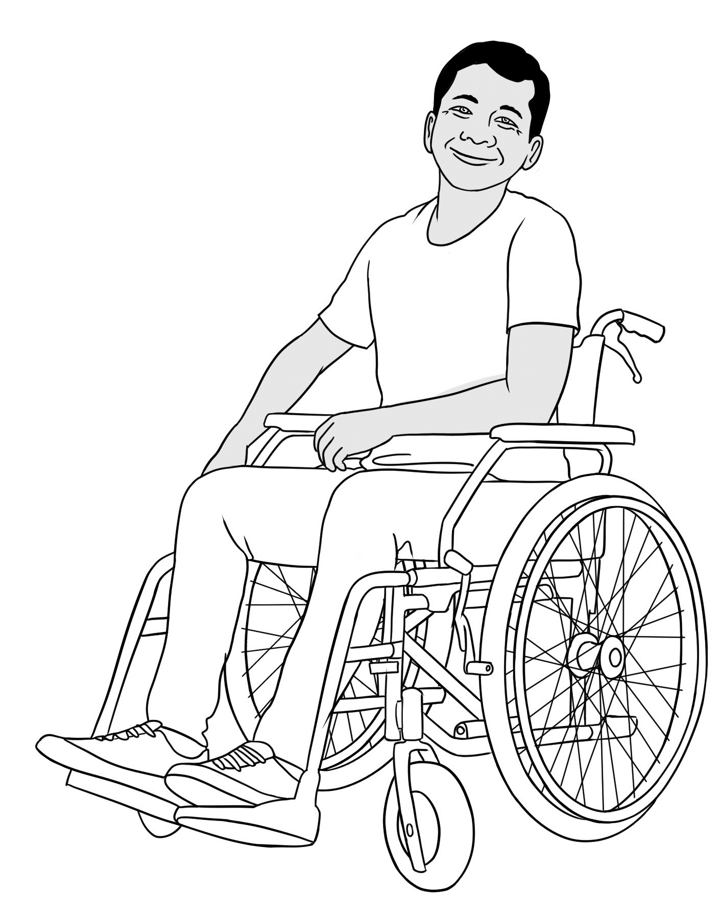
Meet the students and teachers

Peter
Amina
Basam
Ahmad
At the
AMEP
Centre

Parwana
Wendy
Linh
Ko
At the Learning Centre

Meet two families.

me |  | daughter |  | son |  | husband |  | mother | father |  | brother
Parwana |  | Bibi |  | Mustafa |  | Jomeh |  | Amina | Nabi |  | Rahim
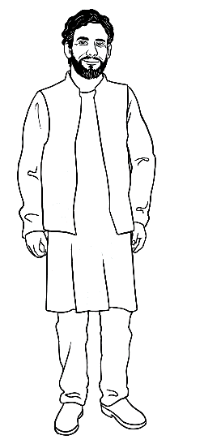
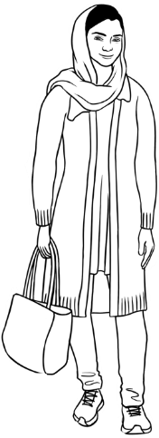
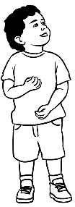
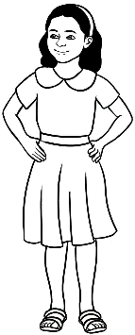
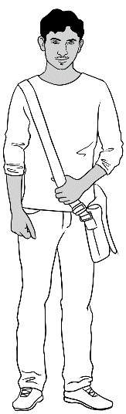
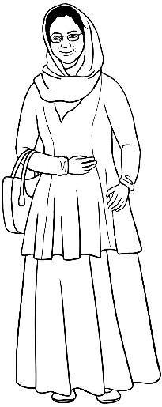
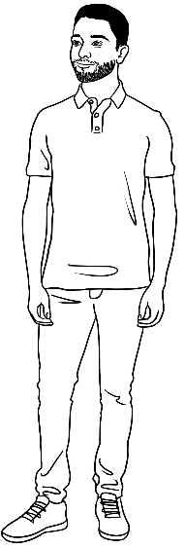
Parwana’s family

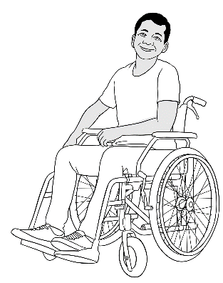
Ko’s family
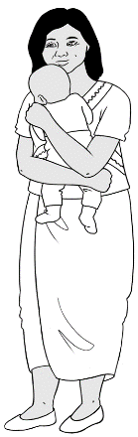
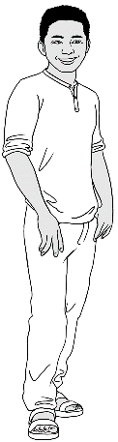
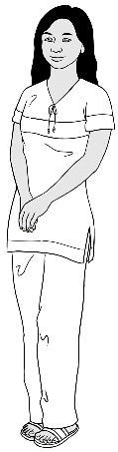
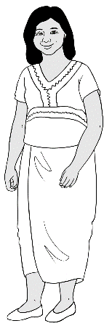
me | wife | daughter | son-in-law | grandson
Ko | Zani | San | Thein | Yaza

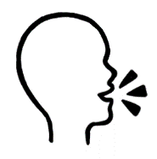

mother | father | daughter | son
mother | _____________ | _____________ | _____________
wife | husband | sister | brother
_____________ | _____________ | _____________ | _____________

Workbook instructions
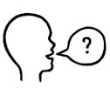
- listen |  | - say
  - read |  | 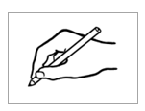  - write
- ask questions | 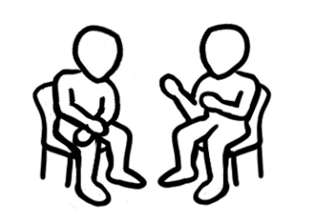 | - work with a partner
- copy |  |   - circle
- tick |  |   - highlight
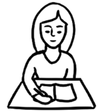  - check your work |  |   - ask for help

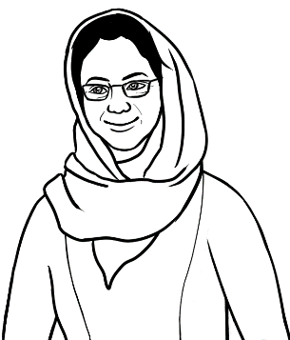
Do you understand?
Yes, I understand.

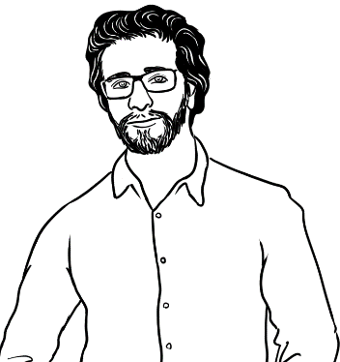
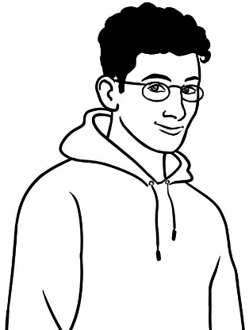
No, I don’t understand.

Can you say it again please?
Are you OK?
Could you speak slowly please?
don’t = do not

No. Can you help me please?
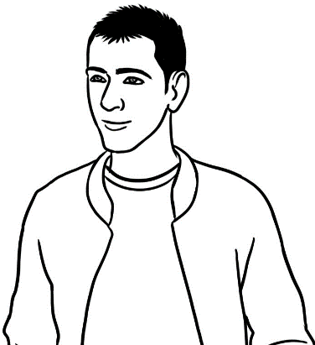
Could you check my work?
* Work with a partner
= speak or read aloud
with a partner
Capital letters

A | B | C | D | E | F | G | H | I | J | K | L | M
N | O | P | Q | R | S | T | U | V | W | X | Y | Z
a | b | c | d | e | f | g | h | i | j | k | l | m
n | o | p | q | r | s | t | u | v | w | x | y | z

Proper nouns are specific names
and start with a CAPITAL letter.
Common nouns
are general names.

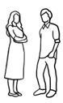
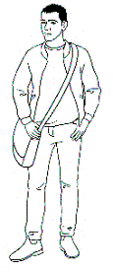
a man
a woman
Basam
Linh

Common nouns |  |  | Proper nouns | 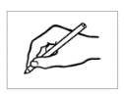
 | a man |  | - Australia
 | a woman |  | - Sunday
 | a street |  | - Basam | 1
 | a suburb |  | - Kellivale
 | a country |  | - Linh
 | a park |  | - Kellivale Park
 | a day |  | - Kemp Street
 | a month |  | - November

Some information about me
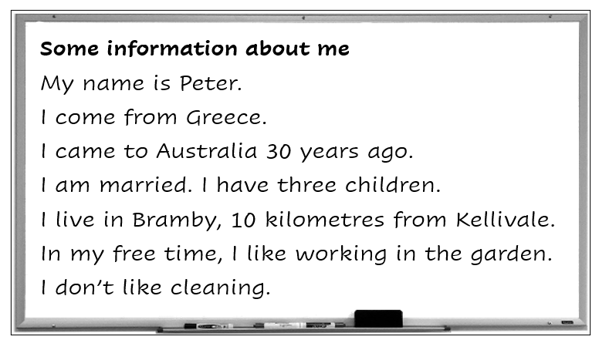
Here’s some information
about me.

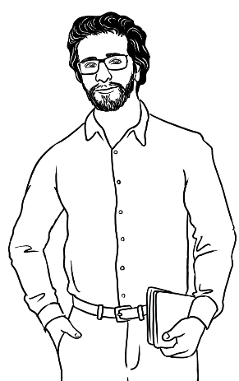

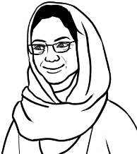  Amina | My name is Amina.  I come from Afghanistan.  I came to Australia in 2023.  I am married. I have two grandchildren.  I live in Kellivale with my family.  In my free time, I like cooking.  I don’t like shopping.
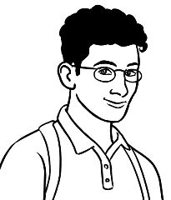  Ahmad | My name is Ahmad.  I come from Syria.  I came to Australia two years ago.  I am not married.  look after = take care of  I look after my brother and sister.  In my free time, I like playing video games.  I don’t like gardening.
Information |  | True | False
- I come from Syria.
- I live with my family.
- I came to Australia three years ago.
- I am not married.

Join two sentences with and.
Sentence 1 | My name is Peter.
Sentence 2 |   I come from Greece.
Join the sentences. | My name is Peter and I come from Greece. .
Sentence 1 | My name is Basam.
Sentence 2 | 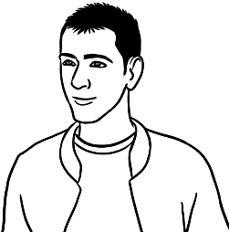  I come from Iraq.
Join the sentences. | ___________________________________________________________

Join two sentences with and.

- My name is Ahmad _________ I come from Syria.

- My name is Amina __________ I come from Afghanistan.
Join two sentences about you.

Sentence 1 | My name is _____________________________.
Sentence 2 | I come from ____________________________.
Join the sentences. | ___________________________________________________________
- I am married and I have three children.
I am married and have three children .
- I am married and I have two grandchildren.
I am married and have two grandchildren.

Join two sentences with but.
Sentence 1 | I am not married.
Sentence 2 | I have a girlfriend.
Join the sentences. | I am not married, but I have a girlfriend. .
Sentence 1 | I am not married.
Sentence 2 | I look after my brother and sister.
Join the sentences. | _______________________________________________________  _______________________________________________________
Sentence 1 | In my free time I like fishing.
Sentence 2 | I don’t like cooking.
Join the sentences. | _______________________________________________________  _______________________________________________________
Sentence 1 | In my free time I like cooking.
Sentence 2 | I don’t like shopping.
Join the sentences. | _______________________________________________________  _______________________________________________________
 | Join two sentences about you.
Sentence 1 | In my free time I like ______________________________ .
Sentence 2 | I don’t like ___________________________________________ .
Join the sentences. | _______________________________________________________  _______________________________________________________

Basam wants to write some information about himself for his classmates.
This is my writing plan.

First / given name |  | My name is Basam.
Country of origin |  | I come from Iraq.
Date of arrival |  | I came to Australia last year.
Marital status |  | I am not married. I have a girlfriend.
Children |  | 0
Where do you live? |  | I live in Kellivale with my sister.
Likes |  | In my free time I like fishing.
Dislikes |  | I don’t like cooking.
Here’s my information in a paragraph.
a paragraph = two or more
sentences about one topic.

My name is Basam and I come from Iraq. I came
to Australia last year. I am not married, but I have a girlfriend. I live in Kellivale with my sister. In my free time I like fishing, but I don’t like cooking.

My name _____ Basam and I _________ from Iraq. I _______
to Australia last year. I ______ not married, but I ________ a girlfriend. I ________ in Kellivale with my sister. In my free time I _______ fishing, but I _______ ______ cooking.

Write some information about yourself for your classmates. First, write a plan.

First / given name |  | My name is __________________________.
Country of origin |  | I come from _________________________.
Date of arrival |  | I came to Australia __________________.
Marital status |  | I am ________________________________.
Children |  | I have _________________ children.
Where do you live? |  | I live in ______________________________.
Likes |  | In my free time I like _________________.
Dislikes |  | I don’t like ___________________________.

Write your information in a paragraph
and join some sentences.

________________________________________________________________________________________________________________________________________________________________________________________________________________________________________________________________________________________________________________________________________________________________________________________________________________________________________________________________________________________________________________________________________________________________________________________________________________________________________
Can you check
my work please?

The park




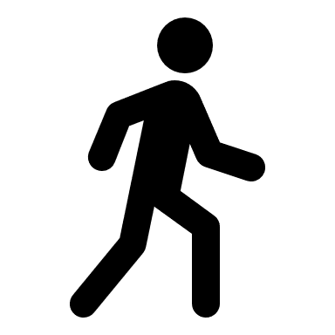
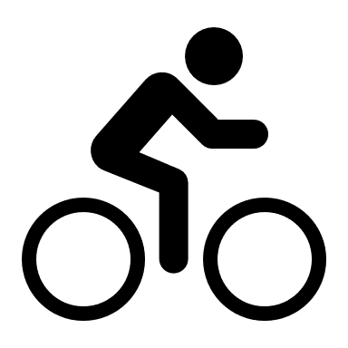


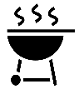


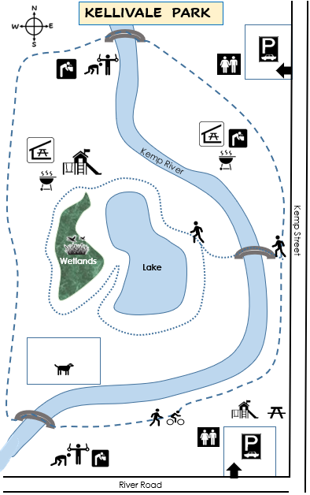

Toilets
Playground
Exercise station
Walking track
Walking & bike track
Picnic spot
Picnic shelter
BBQ
Dog park
Drinking tap

Icons |  |  |  | Meanings
 |  |  |  | - Exercise station
 | 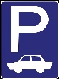 |  |  | - Picnic spot
 |  |  |  | - Walking track
 |  |  |  | - Dog park
 |  |  |  | - Toilets
 |  |  |  | - Picnic shelter
 |  |  |  | - Drinking tap
 |  |  |  | - Entry | 1
- Walking and
bike track
 |  |  |  | - Car park
 |  |  |  | - Playground
 |  |  |  | - BBQ

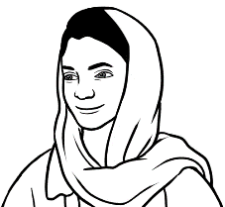
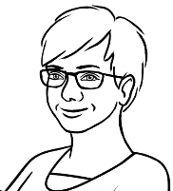
I like the walking track and the playground.

What do you like
in the park Parwana?
shelter = place with a roof
track = path

What do you like in your local park?

I want to take my family
for a picnic in the park.
I’ll find some information
on the council website.

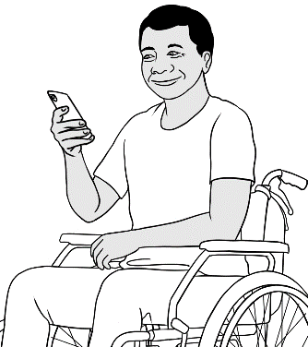

Ko types ____________ in the box.
Search
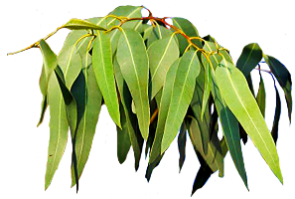

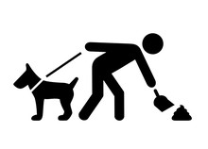

park
Search
Kellivale Shire Council

Kellivale Park
A snapshot of the park
- Shady trees
- Drinking taps
- BBQs
- Picnic tables
- Lake and wetlands
- Playgrounds
- Exercise stations
- Dog park
- Toilets
The Kellivale Park is next to Kemp Street and
close to the centre of town. This large park
has four kilometres of tracks for bikes and
walkers. There are many beautiful old trees,
two large picnic shelters and many picnic spots.

Walk, run or ride your bike beside the river
and under the shady trees. Have a picnic
or a BBQ near the lake. Children will enjoy
the two new playgrounds.

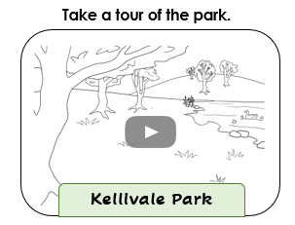
Remember:
- Please do not feed the ducks.
- No BBQs on Fire Ban days*.
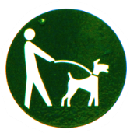
- Keep our park clean.

- Keep dogs on a lead.

- Clean up after your dog.

* Fire Ban days - Very hot and windy days.
There can be no fires outdoors on these days.

- This website page gives some information about:

Kellivale shops Kellivale Park Park opening hours.

- What can you find in the park?

a lake a pool toilets picnic tables

a café BBQs ducks drinking water taps

What’s important to remember?

- Do not feed ___________________.
BBQs
dogs
the ducks
Clean up
clean

- Keep our park _______________.

- No ______________ on Fire Ban days.

- Keep __________ on a lead.

- ______________ after your dog.

How many?

- There are _________ kilometres of tracks for bikes and walkers.
- There are _________ large picnic shelters.
- There are _________ new playgrounds.

old
quiet
shady
beautiful
large

not noisy
not young
not small
not sunny
lovely

Highlight the adjectives in the text.

Nouns
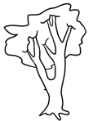  There is one tree.  Singular  one | There are two trees.

Plural
more than one

How many?

- one  1 one | - two | - three | - four | - five
- six | - seven | - eight | - nine

Kellivale Park | True | False
- There is one dog park.
- There are three BBQs.
- There are two playgrounds.
- There are five parking places.
- There are four picnic shelters.

Different plurals

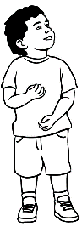 | 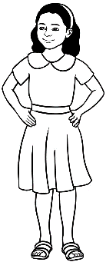 |  |  |  | 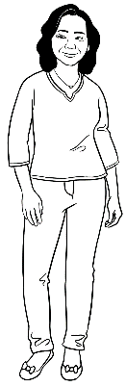
a child | children | a man | men | a woman | women
a child

Adjectives
  a small tree. | 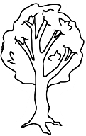  a large tree.

large = big

large | big | small | tiny | old | new | beautiful
quiet | noisy | clean | dirty | muddy | shady | friendly
an old tree | a __________________ lake
a __________________ park | a __________________ playground
a __________________ BBQ | a __________________ dog
a __________________ bike | a __________________ duck
a __________________ river | a __________________ track
a __________________ child | a __________________ picnic shelter

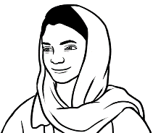
Parwana uses some adjectives.

- There is a large park close to my house.
too = also
- There is a new playground too.

- There is a shady walking track in the park.

- There are many old trees too.

- There are some friendly dogs on leads in the park.

A picnic in the park
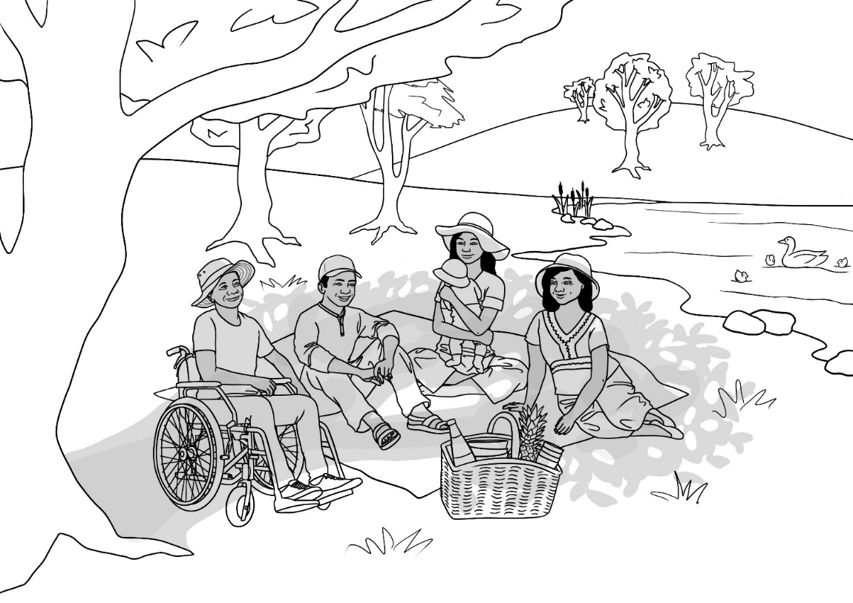

6
3
7
9
8
12
2
1
5
4
10
11

4 | hill |  | basket |  | duck |  | water bottle
hill
 | rug |  | hat |  | tree |  | sunscreen
 | grass |  | shade |  | lake |  | wheelchair

How many?
one person / two people
___________basket | __________ rug | ___________ducks
____________hats | ___________trees | ___________ baby
___________ people | ___________ men | ___________women

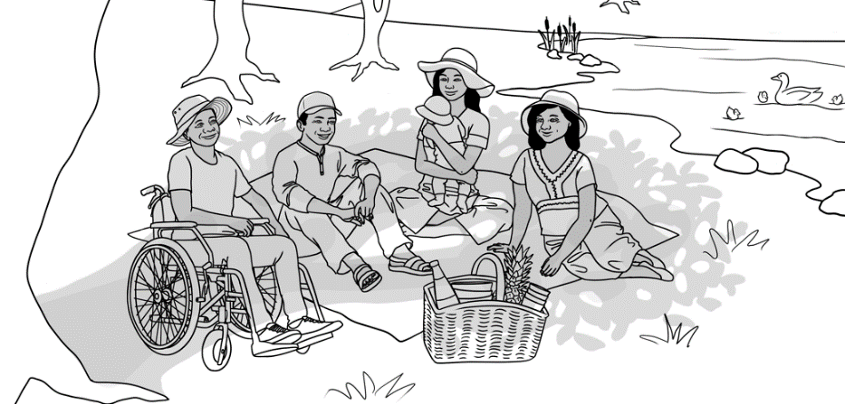

Ko’s family have a picnic.

- Where?
in
in
in
under
on
on
next to
next to
next to
- Ko’s family are in the park.
- They are _____ a rug __________a tree.
- They are ______ the shade _________ ____ the lake.
- The ducks are _____ the lake.
- The water bottle is ______ the basket.
- The picnic basket is _________ _____ the rug.
- The sunscreen is _________ _____ the basket.

- Where are Ko’s family? in the park
next to the rug
next to the basket
on the lake
in the park
in the basket

- Where are the ducks? ________________________
- Where is the water bottle? ________________________
- Where is the basket? ________________________
- Where is the sunscreen? ________________________

in class
in the library
in the car
in bed
on the bus
on the train
at home

Where are you now?

I am ___________________________.
In three hours, I am usually _______________________.
In ten hours, I am usually _________________________.

Subject | Verb | Where
I | am | in class.  in the library.  in the park.  in the car.  on the bus.  on the train.  at home.
He, She, It | is
You, We, They | are
Present Simple
Verb to be

are
in the park.
Ko’s family

Ko’s family are in the park.

on a rug
under a tree.
are
They

___________________________________________________________________________________________________________

next to the lake.
are
They
in the shade

___________________________________________________________________________________________________________
The ducks
are
on the lake.

___________________________________________________________________________________________________________
is
in the basket.
The water bottle

___________________________________________________________________________________________________________
f.
next to the rug.
The picnic basket
is
___________________________________________________________________________________________________________

Signs in the park

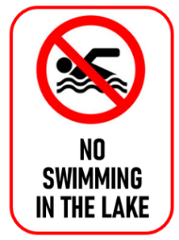
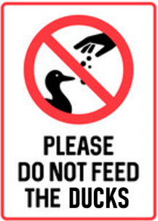
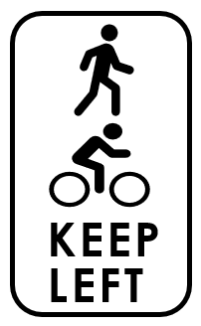

- You should do this.

- You must do this or you will pay fine.
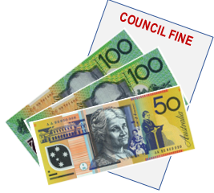
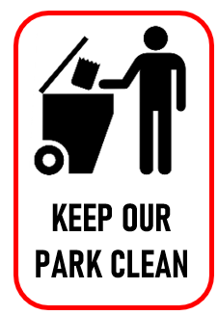
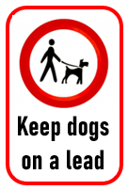
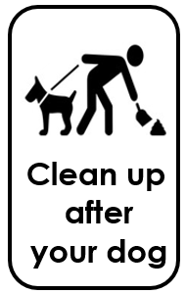
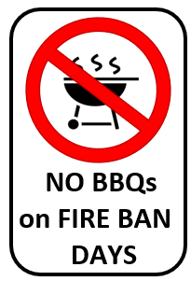

BBQs = barbecues
should
must

- You should not ___________ in the lake.
keep
keep
keep
swim
clean up light
feed
- You __________________________________ ______________________________ your dog on a lead.
- You ___________________________________ not _________ a BBQ on a fire ban day.
- You ___________________________________ _____________________________ left on the tracks.
- You ___________________________________ not _____________________________ the ducks.
- You ___________________________________ _____________________________ the park clean.
- You ___________________________________ _____________________________________ after your dog.

A place to rent
landlord = the owner
place = home
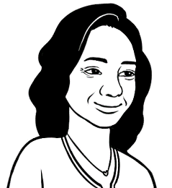
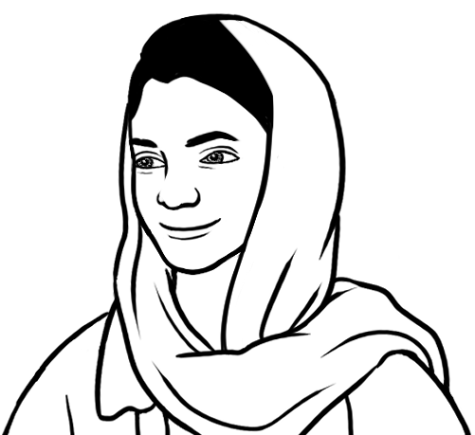
My landlord is selling my house.
I have to find a place to rent.
There are many things to do.
Oh no. What will you do?

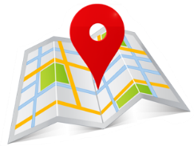  First, where do I want to live? | 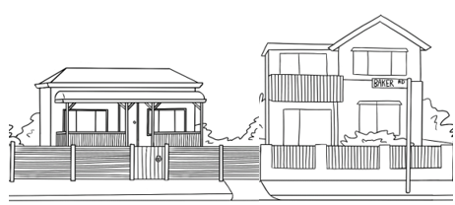  Second, what do I want?
Third, I read some ads  and go to some inspections.   | Then, I apply for a place.  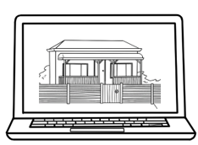
Next, I read and sign      the contract. | Finally, I pay the bond    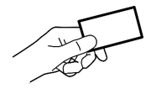  and two weeks rent.

- First, where do I want to live?
______________________________________________

- Second, what do I want?

______________________________________________
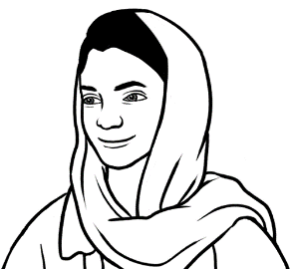
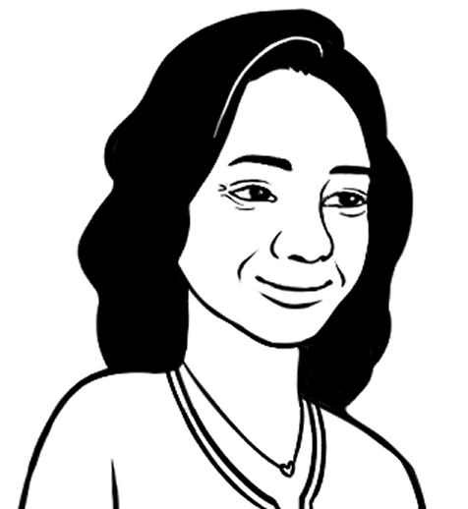
I want to live in Kellivale.

Do you want
a house or a unit?
I’m not sure.

 |  | Linh wants | Parwana has | You have
 |     a house or  a unit | not sure | a house
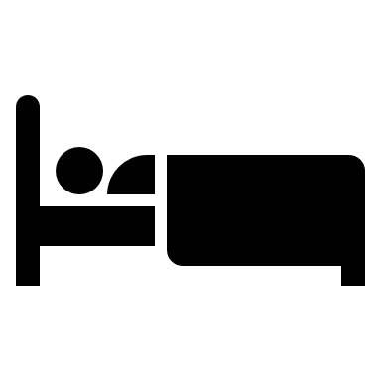
bedrooms

bathroom

bath

separate toilet
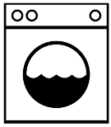
separate laundry


living room

garage
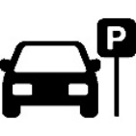
parking space
10. |   garden

Present Simple Verbs

Subject | verb | object
I, You, We, They | want  have | a house.  a unit.  three bedrooms.  two bathrooms.  a garden.  a garage.  a deck.
He, She, It | wants  has



- Linh wants to live in Kellivale. True False
- She wants three bedrooms. True False
- Parwana has two bathrooms. True False
- I have a garden. True False
Subject | verb | object
I, You, We, They | do not want don’t want  do not have  don’t have | a house.  a unit.  three bedrooms.  two bathrooms.  a garden.  a garage.  a deck.
He, She, It | does not want  doesn’t want  does not have  doesn’t have



- Linh _______________________ two bathrooms.
^{wants / doesn’t want}
- She ________________________ two living rooms.
^{wants / doesn’t want}
- Parwana _____________________ two garages.
^{has / doesn’t have}
- I ____________________ a separate toilet.
^{have / don’t have}
I read some ads and looked at two places yesterday.
That’s good.
Can you show me the ads?
ads = advertisements

House to rent | Unit to rent
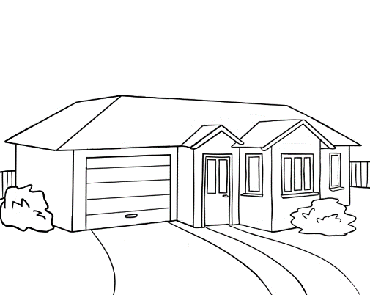 | 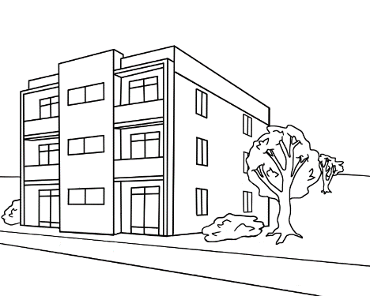
56 View St, Kellivale NSW | 1/62 Laura St, Kellivale NSW
2 1 1 1 | 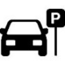  1 1 1
$480 per week | $420 per week
Bond $1,920 | Bond $1,680
Small garden and deck  Close to the shops. | Small balcony  Close to the park
Inspection 16 March, 4pm | Inspection 9 March, 11:30am
Available now | Available on 31 March
available = ready to move in
bond = usually 4 weeks rent
The real estate agent keeps
the bond money until you move out.
inspection = check
bedroom  __________________ | bathroom  __________________ | separate toilet  ________________________
bath  __________________ | garage  __________________ | 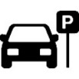  parking space  ____________________

 | The ads are for | a _____________to rent. | a _____________ to rent.
 | The street is | ________________ Street. | ________________ Street.
 | The rent per week is | $_____________ . | $_____________ .
 | The bond is | $_____________ . | $_____________ .
 | It is close to | the _____________ . | the _____________ .
 | The inspection is | on ________________ . | on ________________ .

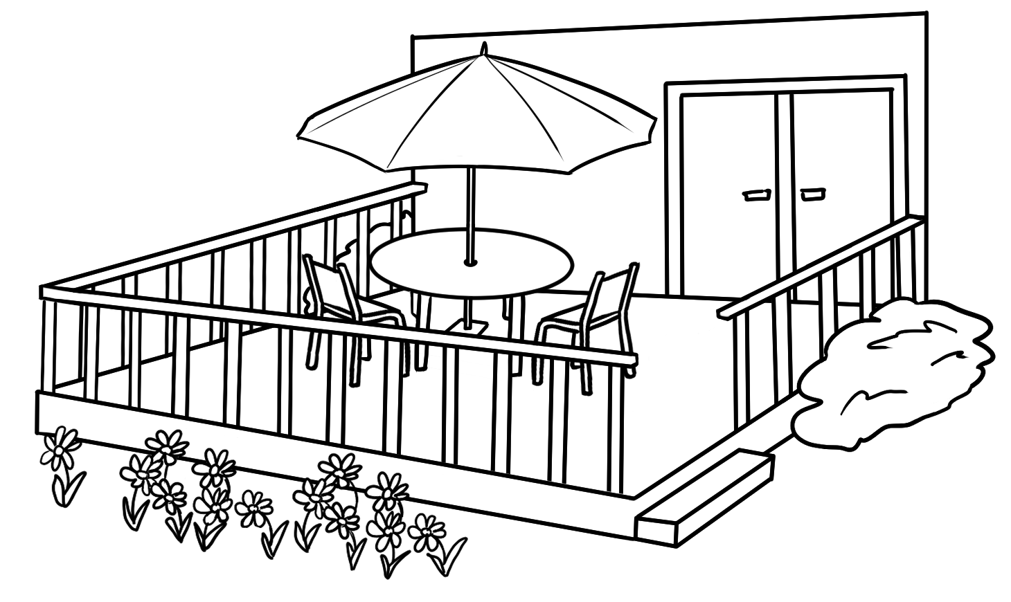
I like the house best. I really like
the back deck and garden.
a deck

- Does the house have two bedrooms? Yes No

- Does it have a separate toilet? Yes No

- Does it have a garage? Yes No

- Does it have a garden? Yes No
What about you?

 | How many bedrooms do you have?
 | How many bathrooms do you have?
 | Do you have a separate toilet? | Yes | No
 | Do you have a garage? | Yes | No
 | Do you have a garden? | Yes | No
 | Do you have a deck? | Yes | No


Here’s some information about my new home.
a house a home

Add some adjectives.
old
new
large
big
small
tiny
beautiful
great
sunny
separate

- I now live in an old house close to the shops.
- It has two _________________ bedrooms.
- It has one ________________ bathroom.
- It has a _________________ living room.
- It has a ______________ kitchen. It has a ______________ laundry.
- It has a _______________ garage.
- It has a _______________ garden.
- It has a _______________ back deck. It doesn’t have a front deck.

Join some sentences.

Sentence 1 | It has two small bedrooms.
Sentence 2 | It has a new bathroom.
Join the sentences. | It has two small bedrooms and  it has a new bathroom.
Sentence 1 | It has a sunny back deck.
Sentence 2 | It doesn’t have a front deck.
Join the sentences. | It has a sunny back deck, but  it doesn’t have a front deck.

Add the adjectives in the paragraph.
I now live in an ________________house close to the shops.
It has two ____________ bedrooms and a ___________bathroom. It has a _____________living room. It has a __________ kitchen and a _______________ laundry. It has a ______________ garage and a __________ garden. It has a ________________back deck, but doesn’t have a front deck.

Write some sentences about your home. Add adjectives.

 |  | Adjective | Noun
 | I live in a |  | house / unit
 | It has |  | bedrooms.
 | It has |  | bathrooms.
 | It has a |  | living room.
 | It has a |  | kitchen.
 | It has a |  | laundry.
 | It has a  It doesn’t have a |  | garage.
 | It has a  It doesn’t have a |  | garden.
 | It has a  It doesn’t have a |  | back deck.

Write about your home for your teacher.
Join some sentences in a paragraph.

________________________________________________________________________________________________________________________________________________________________________________________________________________________________________________________________________________________________________________________________________________________________________________________________________________________________________________________________________________________________________________________________________________________________________________________________________________________________________
Can you check
my work please?

We need a bigger place because my family is getting bigger. I want to look at this house.

House to rent

69 Laura Street, Kellivale NSW

3 1 1 1
$420 per week
Bond $1,680
Large garden, solar power
Close to the primary school
Inspection 31 March, 1:00pm
Available 30 April.
Call: Megan 0466 325 692
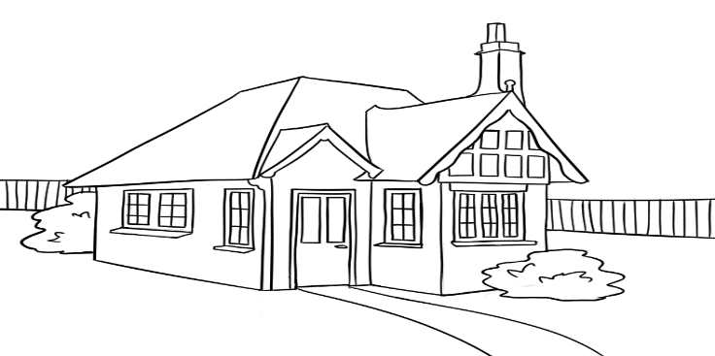


solar = sun

primary = first

- Ko needs a bigger place because his family is getting_________________.

- How much is the rent per week? ________________

- How much is the bond? ________________

- When can Ko look at the house? _____________________________

- When is the house available? _____________________

- Who can he call about the house? _____________________

What do these words mean?

primary | available | inspection | solar | large
ready | first | big | check | sun

Sale at the Op Shop
Recycle = use again
I can buy some things
for my new home
at the sale.
op shop = sells used things

50% off everything!
Sale

RECYCLE OP SHOP

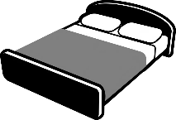

Towels and Bedding

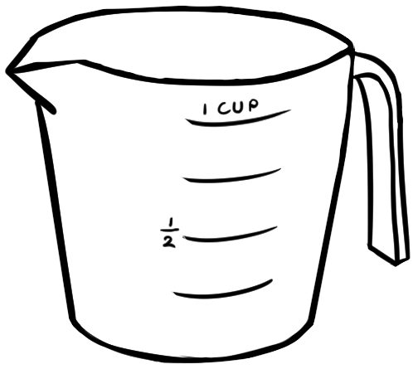
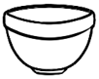
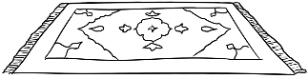

Kitchenware
Homewares

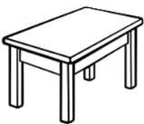
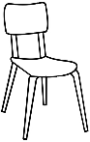
Furniture
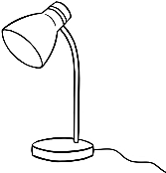
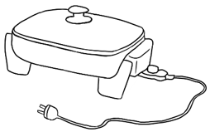
Electrical
Books

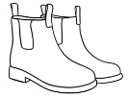
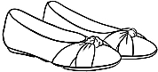
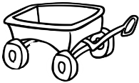
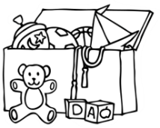
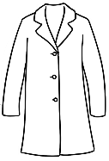
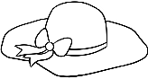
Footwear
Toys
Clothing

Come and find a bargain!

Opening hours: 9am – 5pm, Tuesday - Sunday
Volunteers needed: Speak to our manager
Address: 75 River Road, Kellivale Phone: [02] 6467 3232

volunteers = work for free
bargain = something cheap

- This is an advertisement for

a shoe shop sale. an OP Shop sale. a toy shop sale.

- What can you buy?
books chairs vegetables toys

rugs bread shoes towels

- Everything is

20% off. 40% off. 50% off.

- The opening hours are _____ am - _____pm, Tuesday - _________________ .
- The address is 75 ____________ _______________ Kellivale.
- The phone number is [02] ___________________.


recycle |  | something cheap
op shop |  | work for free
50% |  | use again
bargain |  | sells used things
volunteers |  | half  Highlight the words in the advertisement.

An invitation
I want to invite my teacher
and classmates to my new home
for a house-warming party.


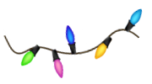
House-warming Party!
Dear teacher and classmates,
Come to a housewarming party at my new house!
When Sunday 4 June
Time 2 - 5 pm
Where 56 View Street, Kellivale
Bring Please bring a small plate of food to share.
RSVP Call Linh on 0567 322 184 before Wednesday
See you there!

house-warming = celebrate a new home

RSVP = answer an invitation

- Why did Linh write an invitation?
She is having a _______________________________ _______________ .

- Who did she invite? her ________________ and __________________________

- When is the party? on ____________________________

- What time does the party start? at ________________

- What does everyone need to bring? _________________________________________

- What does everyone need to do before Wednesday? ______________________

Match the meanings.

RSVP |  | 56 View Street, Kellivale
house-warming |  | for everyone
date |  | answer an invitation
address |  | Sunday 4 June
to share |  | celebrate a new home


Write an invitation
for a morning tea.

- Why will we write an invitation?
We are having a _________________________________________________

- Who will we invite? ______________________________________________________________
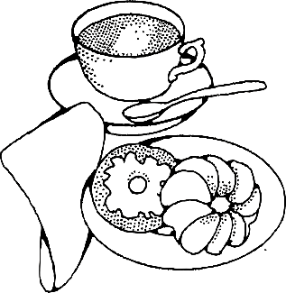
An invitation
Dear ________________________________________________ ,
Come to _____________________________________________________
When _____________________________________
Time ________________________
Where ____________________________________________
Bring ___________________________________________
RSVP _________________________________before ______________________
^{name} ^{date}

The beach
On Friday afternoon
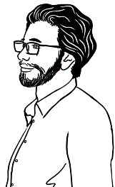
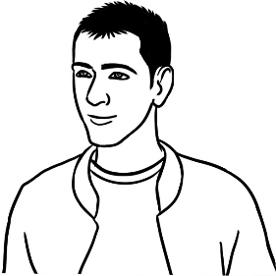
Where are you going this weekend Basam?
I’m going fishing
at Rocky Beach.
Good luck fishing.
Remember to be SunSmart.
Yes. It’s easy to get burnt at the beach.


BE SUNSMART
1. SLIP 2. SLOP 3. SLAP 4. SEEK 5. SLIDE

Be SunSmart in Australia.
Check the UV index every day.
Your skin can burn when
the UV index is 3 and over.

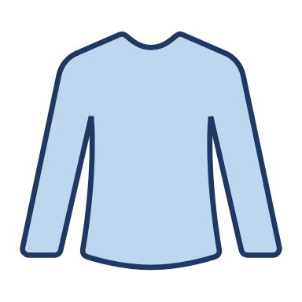 | SLIP on SunSmart clothes.
 | SLOP on SPF 50 sunscreen every 2 to 4 hours.
 | SLAP on a hat and cover your face, neck and ears.
 | SEEK shade.
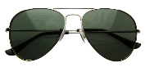 | SLIDE on sunglasses.

SPF = Sun Protection Factor
- SPF 15 is low protection
- SPF 50 is high protection
UV = Ultraviolet rays from the sun
index = level

This information is about safety:

in the rain. in the sun. in the wind.

- UV rays |  | put on
- index |  | put on
- slop on |  | put on
- slap on |  | Sun Protection Factor
- SPF |  | ultraviolet rays
- seek |  | level
- slide on |  | look for

Match the meanings.

Slap on
Seek
Slip on
Slide on
Slop on

- Slip on SunSmart clothes.
- ________________________________________ SPF 50 sunscreen.
- ________________________________________ a hat.
- ________________________________________ shade.
- ________________________________________ sunglasses.
Remember
Be
SunSmart
in Australia.

__________________________________________________________________

the UV Index
every
Check
day.

__________________________________________________________________

What’s the UV level now?
- The UV level now is __________.
^{number}
low moderate high very high extreme.
It is

On Monday morning
Peter | Did you catch any fish  on the weekend Basam?
Basam | No, but I saw a man knocked over  by a wave and pulled out to sea.
Peter | Was he OK?
Basam | Yes. Two lifesavers rescued him.
Peter | Was he pulled out by a rip current?
Basam | What’s a rip?

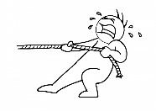
pull =


current =
quick moving water

    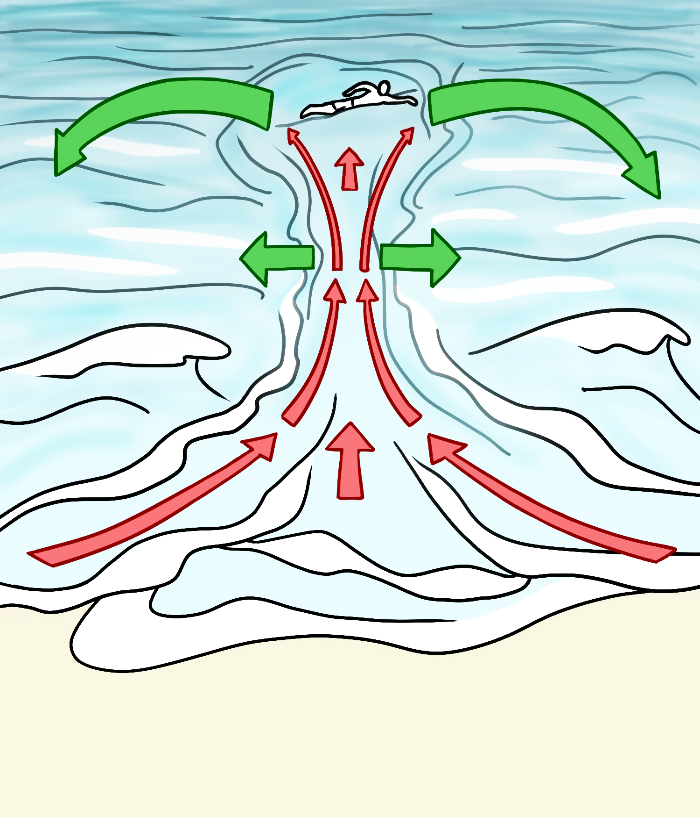  Rips are dangerous. | What is a rip?  - A rip is a strong narrow current that pulls out  to sea.  - It can pull a person away from the beach very quickly.  - Rips can be difficult  to see.  - Rips are the greatest danger on Australian beaches.  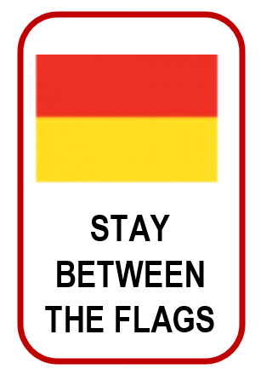  Remember always
Rip current
Way out of the rip

quickly | danger | are | Rips | difficult
the beach | current | sea | can pull | Australian
The information is about ____________________.

- A rip is a strong current that pulls out to _______________ .
- A rip ________ ________ a person away from ______ ______________.
- It can pull a person very__________________.
- __________ can be _______________to see.
- They ______ the greatest _____________on ________________beaches.
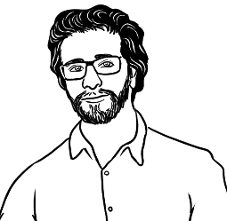
Find words with
an opposite meaning.


safe | dangerous
weak
wide
push
slowly
easy

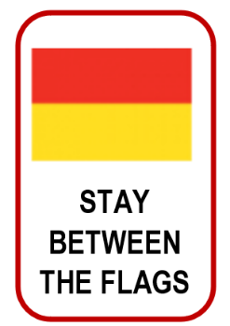

Copy in CAPITAL letters.

Remember always _______________________________________________________ .

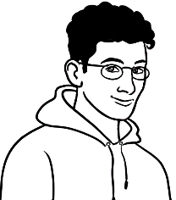
Look at this newspaper story Ahmad. There was a rescue at Rocky Beach on Sunday. I was there!
Really? What happened?
Read the story.

The Kellivale Weekly
26 November
Beach rescue  Last Sunday, lifesavers rescued a young man at Rocky Beach in NSW. The man was in ankle-deep water and suddenly a wave knocked him over. A strong rip current then pulled him out to sea.  The man didn’t panic. He stayed calm and waved his arm. Two surf lifesavers saw him and quickly rescued him on a surfboard. He was safe, but he was very cold and exhausted. | BEACH WARNINGS  Always read the signs.  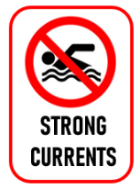  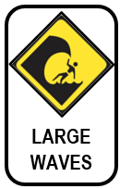  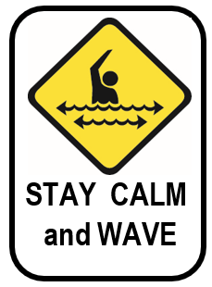
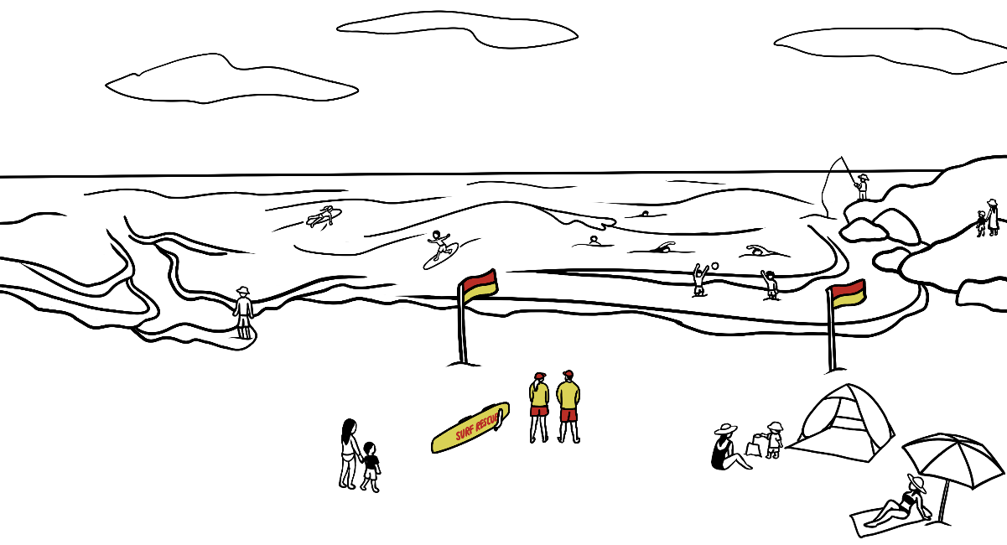
Dangerous rip
at Rocky Beach

The newspaper story gives information about

a beach swim. a beach rescue. Rocky Beach.

- Who did the lifesavers rescue? __________________________________

- Where did it happen? at ______________________________________

- When did it happen? last ____________________________________

- What knocked the man over? ___________________________________

- What pulled him out to sea? ______________________________________

surfboard | calm | saw | cold | arm

- The man stayed calm and waved his _______________ .

- Two lifesavers _______________ him.

- They rescued him on a _____________________________ .

- The man was very __________________ and exhausted.

- rescued saved
shallow
pushed
very tired
saved
quiet

- ankle-deep ________________________

- knocked ___________________________

- calm _______________________________

- exhausted _________________________

Past Simple Verbs

Regular verbs |  |  | Irregular verbs
Present | Past |  | Present | Past
rescue  knock  pull  stay  wave  happen | rescued  knocked  pulled  stayed  waved  happened |  | see  have /has  go  catch | saw  had  went  caught

Present
Past
Every week, life savers rescue people at the beach.
Last Sunday, life savers rescued a young man at the beach.
knock | wave | pull | see | rescue | stay
knocked

Suddenly
him
knocked
over.
a large wave

Suddenly a large wave knocked him over.
A strong rip
him

to sea.
out

________________________________________________________________________________
his arm.

calm
He

and

________________________________________________________________________________
Two
him

and
life savers

him.

Verb to be
Subject | Present | Past
I | am | was
He, She, It | is | was
You, We, They | are | were

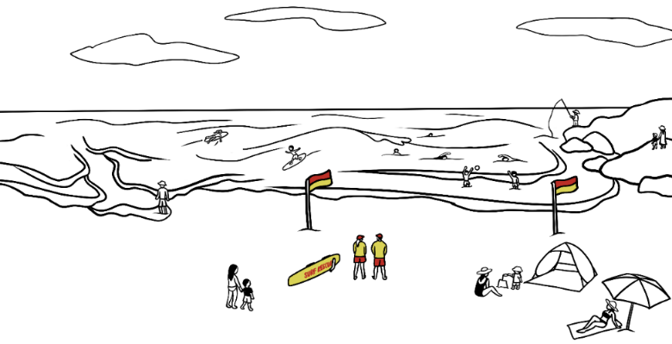
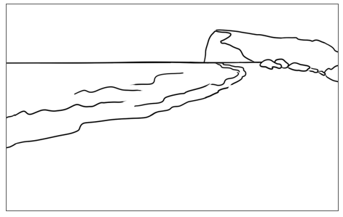
Today
Yesterday

Present
Past
- There were some people at the beach yesterday.
- There are no people at the beach today.

- Basam was at the beach yesterday.
He _______ in the library today.

- Amina ______ in the library yesterday.
She _______ in class today.

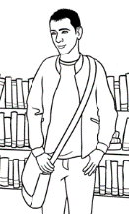
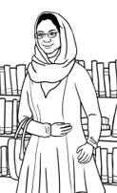
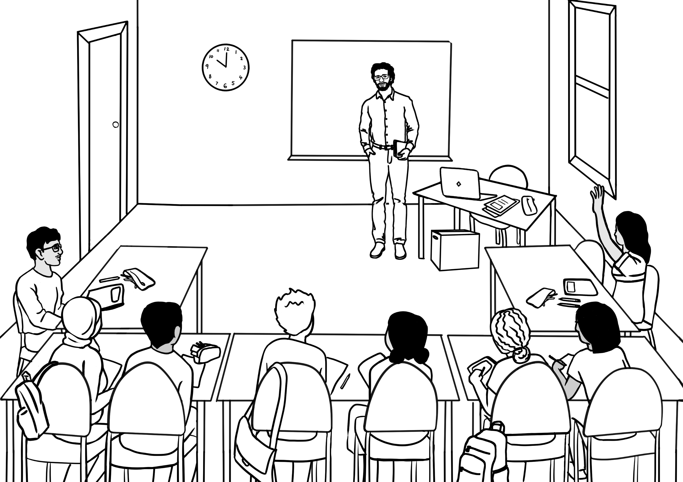
- We ________ at home yesterday.
We ________ in class today.

- I _______ _______________________________________ yesterday.
I _______ in class today.

A quick and easy meal
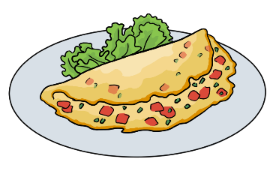
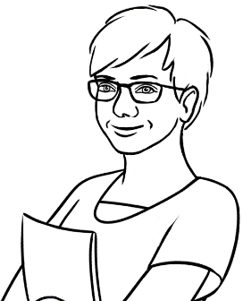
A few eggs make a quick and easy meal. I sometimes make an omelette and use these ingredients.

a few = about 3 or 4
ingredients = _________________
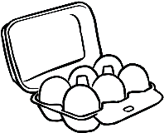 |  | cheese |  | 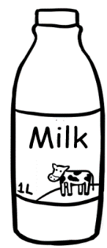 |  | salt
 |  | eggs |  | 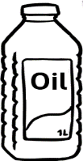 |  | pepper
 |  | parsley |  | 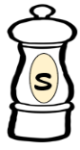 |  | milk
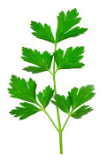 |  | tomatoes |  | 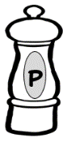 |  | oil

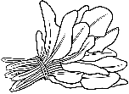
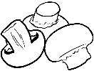
I sometimes add mushrooms or spinach.

sometimes
I
add
mushrooms
spinach.
or

_____________________________________________________________________
The ingredients
eggs, _______________________________________________________
____________________________________________________________________________________________________________________________________

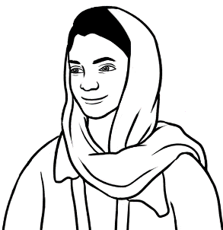
Does your family
like eggs Parwana?
Yes. They love eggs.
What ingredients do you use
in your favourite egg recipe?

Ingredients |  | Parwana | Wendy | Your  teacher | Me
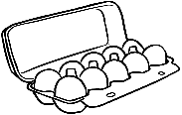
eggs
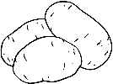
potatoes

tomatoes


onions
 | cheese
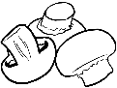
mushrooms
 | spinach
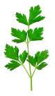
parsley
 | milk
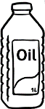
oil

salt

pepper

water

You can count these things – 1, 2, 3…
Countable nouns

  an egg | 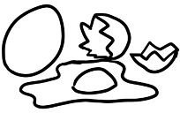  two eggs | an onion |  | two onions
an egg
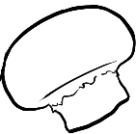  a mushroom | 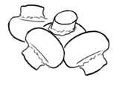  four mushrooms | 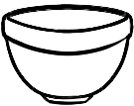  a bowl |  | two bowls
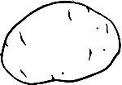  a potato | three potatoes | a tomato |  | four tomatoes

You can’t count these things.
Uncountable nouns

spinach | cheese | parsley | milk
spinach
oil |   water | salt | pepper

Cooking verbs

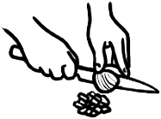  chop | 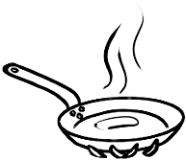  heat | 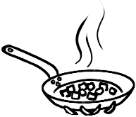  fry | 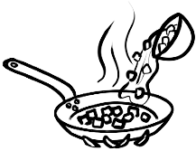  add
chop
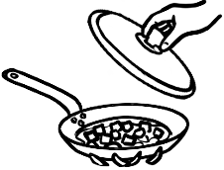  cover and cook | 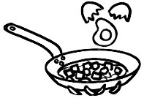  break eggs | 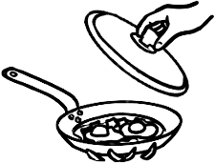  cover and cook | 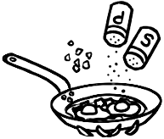  add
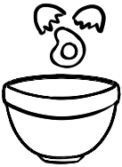  break eggs | 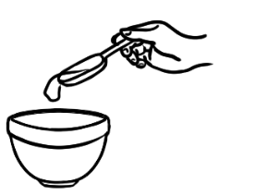  add | 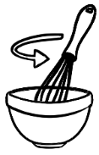  beat | 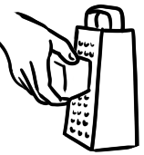  grate
break eggs
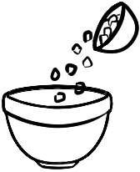  add | 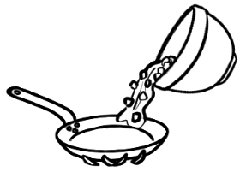  pour | 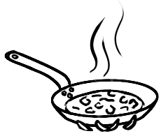  cook gently | 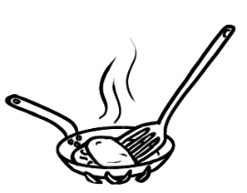  fold
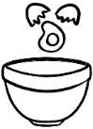
3 eggs
milk
- Break the eggs into a bowl.
__________________________________________________

- Add the milk to the bowl.

__________________________________________________

This is my favourite egg recipe.
a teaspoon = tsp
a small spoon
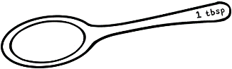
a tablespoon = tbsp
a large spoon

Parwana’s recipe
- 4 eggs  - 2 potatoes  - 2 tomatoes  - 1 onion |  |  | 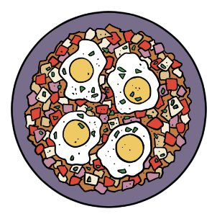  - 3 tbsp oil  - 1 tbsp parsley  - ½ tsp pepper  - ½ tsp salt
 |  | Chop the potatoes, ___________, tomatoes and parsley.

Heat the __________.
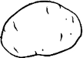
Fry the onion and _____________ gently until soft.
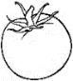
Add the _________________.
 |  | Cover and cook gently for 7 minutes.
 |  | Break the ___________ on top of the vegetables.
 |  | Cover and cook gently for 5 minutes.
 |  | Add the salt, ____________ and ______________.

The instructions

- Chop the potatoes, onion, tomatoes and parsley.
Add
Add
Break
Chop
cook
cook
Cover
Cover
Fry
Heat

- ______________ the oil.

- ______________ the onion and potato gently until soft.

- ______________ the tomatoes.

- ______________ and ____________ gently for 7 minutes.

- ______________ the eggs on top of the vegetables.

- ______________ and ____________gently for 5 minutes.

- ______________ the salt, pepper and parsley.

Chop
and parsley.
the potato, onion,
tomato
______________________________________________________________ .
the oil.
Heat
______________________________________ .
and
the onion
potato
Fry
until soft.

_________________________________________________________________________________ .

Add
the tomatoes.

_________________________________________________________________________________ .
Cover
and
cook
for 7 minutes.

_____________________________________________________________ .
This is my favourite egg recipe.
Wendy’s Omelette
- 3 eggs  - 1 tomato  - 1 tablespoon parsley  - 2 tablespoons cheese |  |  | - 2 tablespoons milk  - 1 tablespoon oil  - salt and pepper
 | 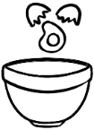 | Break the eggs into a bowl.
 |  | ____________the milk to the bowl.
 | 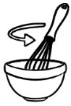 | ____________ the eggs and milk.
 | 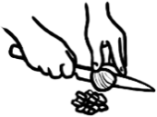 | ____________ the tomato and parsley.
 |  | ____________ the cheese.
 | 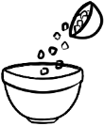 | ___________ the tomato, parsley, cheese,  salt and pepper.
 |  | ___________ the oil.
 |  | ___________ the egg mixture into the pan.
 |  | ____________ gently.
 |  | ____________ the omelette,

Ingredients

Instructions
Add
Chop
Break
Grate
Beat

Add
Pour
Heat
Fold
Cook

I sometimes add mushrooms or spinach.

always 100%
usually 90%
sometimes 50%
never 0%

Wendy | My egg dish is different to yours.  I always add cheese and parsley.
Parwana | I never add cheese.
Wendy | I sometimes add mushrooms or spinach.
Parwana | I never add mushrooms or spinach.
Wendy | I never add potatoes or onions.
Parwana | I always add potatoes and onions.
Wendy | Do you always add parsley?
Parwana | Oh. Usually.
always | usually | sometimes | never

- Wendy ________________ adds cheese and ___________________.

- Parwana _______________ adds _______________ and onions.

- Wendy ___________________ adds mushrooms or ________________.

- Parwana _________________ adds parsley.

- Parwana _________________ adds cheese.

- Wendy ___________________adds potatoes or _________________.

Favourite quick and easy meals
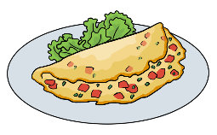
I sometimes cook an omelette
for dinner.
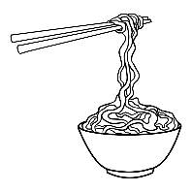
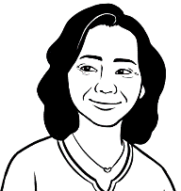
I love noodles for lunch.
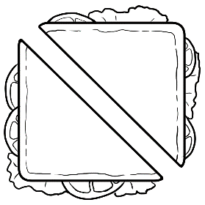
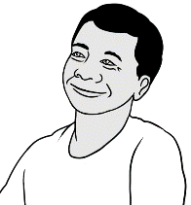
I usually make a sandwich
for lunch.
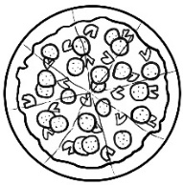
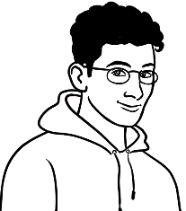
I sometimes make
a cheese pizza.
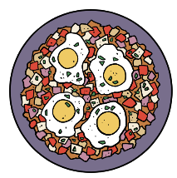
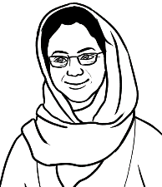
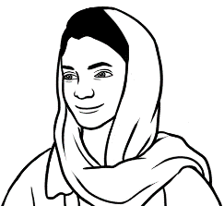
We love this Afghani egg dish.
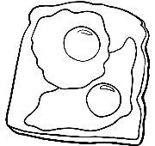
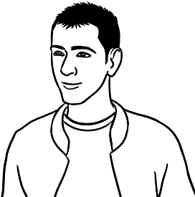
I sometimes have
two fried eggs
on toast for breakfast.
- My favourite quick and easy meal is _________________________________________________________________________
What’s your favourite quick and easy meal?

