

English Ready
22638VIC Certificate 1 in EAL
VU23500 Plan language learning with support

Teacher Resources
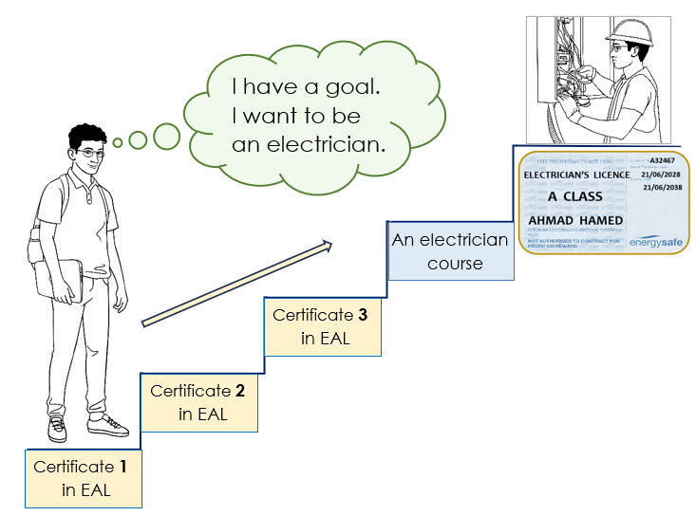

Design team: Vicki Hambling, Sue Paull, Frida Dean and Mary Wallace
Illustrations: Madelena Scott

Illustrations acknowledgements:
CFA logo: This Photo by Unknown Author is licensed under CC BY-SA
Sound & Settings icons, Chemist sign- These photos by Unknown Author is licensed under CC BY-NC

Acknowledgements: The design team would like to thank the AMEP service providers and practitioners who participated in the trial and gave valuable feedback. The team would also like to acknowledge the use of the EAL Framework which underpins the design of this book.

___________________________________________________________________________
Copyright of the EAL Framework is reserved to the Crown in the right of the State of Victoria. © State of Victoria (Department of Education and Training) 2023.
Use of all or part of this document must include the following attribution:
© Commonwealth of Australia 2024

With the exception of the Commonwealth Coat of Arms, the department’s logo, any material protected by a trade mark and where otherwise noted all material presented in this document is provided under a Creative Commons Attribution 4.0 International (https://creativecommons.org/licenses/by/4.0/) licence.
The details of the relevant licence conditions are available on the Creative Commons website (accessible using the links provided) as is the full legal code for the CC BY 4.0 licence (https://creativecommons.org/licenses/by/4.0/legalcode).
As far as practicable, material for which the copyright is owned by a third party will be clearly labelled. The department has made all reasonable efforts to ensure that this material has been reproduced in this document with the full consent of the copyright owners.
Copyright requests and enquiries concerning usage not addressed by the CC BY 4.0 licence should be addressed to: comms@homeaffairs.gov.au at the Department of Home Affairs.
The terms of use for the Commonwealth Coat of Arms are available from the It's an Honour website.
Where a copyright owner, other than the Commonwealth, is identified with respect to this material, please contact that third party copyright owner directly to seek permission.



Introduction to the books
The Teacher Resources
The resources book is an electronic reference and all materials can be adapted and printed as needed. PowerPoint slides have been created to introduce, consolidate and revise some vocabulary. This icon indicates a PowerPoint Presentation:
PPT

The Student Workbook
The student book requires teacher direction and is not intended for independent learning. It is also not intended to be the only material used to teach the unit or to be used as an assessment task. It is highly recommended that students buy and use a notebook for general class work and practice. The book is available as a Word document so that teachers can:
- localise and update the content
- adjust the material to suit the requirements of particular classes
- delete or add materials as required. If you add or deduct pages, be mindful of the layout as the document has been designed so that particular pages are opposite one another.

NB. Teacher versions of the student workbooks and also the worksheets in this book contain notes to indicate the language focus and/or guidance for the exercise. Teacher notes such as this one need to be removed before printing for students.
Listen, repeat, clap and mime each instruction for students to imitate.

Section 1 – 4: These sections include activities to support the first four sections
in the Student Workbook.
Section 5: This section offers ways to expand and assist students’ goal setting.
Section 6 – 7: These sections focus on developing a wide range of learning skills
to help students achieve their short-term and long-term goals.

Table of Contents
1. Introduction 2
2. Meet the students and teachers. 4
3. What helps you learn English? 7
4. Sometimes there’s a problem. 17
5. Help students set goals. 21
6. Cultural differences 22
7. Summary of learning strategies 24

Introduction

- Learning to learn is an on-going process

Learning to learn is incremental and activities to develop learning skills
are best integrated throughout the course.

The language features in the Knowledge Evidence for this learning unit
are embedded in the teacher and student books. The grammar and vocabulary requirements listed are taught more explicitly in the oral
and written units.

- Workbook instructions
The workbook is not designed for independent learning and students will require guidance for activities by the teacher. To minimise distractions from the page content, icons replace written instructions in the workbooks. Some additional teacher notes have been included in text boxes in the teacher version of the student book.

The PowerPoint gives a simple introduction to the icons. Show the PPT on slide show. Show the PPT again, and delay the appearance of the instruction word. Encourage students to guess and mime the instruction.

- Do you understand?
Use the expressions - Print the expressions and encourage their use through regular practice:
- Give the five expressions to five students. Select the most confident students at first.
- Ask these students to use their expression at least once during the class – initially with the teacher and later with each other.
Note
Additional activities to familiarise students with the workbook instructions and ‘Do you understand?’ type expressions can be found in the Teacher Resources for Unit VU23501 – Participate in short simple exchanges.

PPT – Workbook instructions

3. Do you understand?

I don’t understand.
Can you say it again please?
Can you help me please?
Could you speak slowly please?
Can you spell that please?

Meet the students and teachers.
The characters
All the drawings in the student workbook are available to be used in the design of additional materials. The bio data chart below was created to maintain consistency of information throughout the English Ready books at the three levels - Course in Initial EAL, Course in EAL and Certificate 1 in EAL.
It may be useful to update character information. Characters unshaded appear in Certificate 1 in EAL books and those in grey feature in the Course in EAL books as well.

Name | Family  members | Country of origin | Age / Date of birth | Date of arrival | Address  Kellivale  2421 | Phone
Ming Wu | Lan, Bao, Mai | China | 27.03.1959 | 07.05.19 | 70 Wattle St | 0418 335 748
Sahra Omar Elmi | Tahiil, Hani  Abdi | Somalia | 07.07.96 | 09.06.22 | Unit 6, 50 Baker Rd | 0455 961 259
Linh Nguyen |  | Vietnam | 60 |  | Unit 1, 140 Kemp St
Nisha Kumar | Pari (f)  Dev (m) | India |  |  | 18 Sea St  Near Taree NSW | 0411 825 999
Basam Radi |  | Iraq | 30  05.08.1993 |  | Unit 3, 140 Kemp St | 0455 328 691
Nabi Saikal | Husband and wife  Parents of Parwana | Afghanistan | 48 | 2023 | 48 Baker Road | 0462 595 751  NabSaikal @gmail.com
Amina Tarukh | Husband and wife  Parents of Parwana | Afghanistan | 46 | 2023 | 48 Baker Road | 0466 379 142  ATarukh13@gmail.com
Parwana Saikal | Rahim’s sister | Afghanistan | 25  09.05.1998 | 12.01.23 | 48 Baker Road | 0476 756 932 Parwana27@gmail.com
Jomeh Tajik | Parwana’s husband | Afghanistan | 27 |  | 48 Baker Road
Bibi Tajik | Girl 5 | Afghanistan |  |  | 48 Baker Road
Mustafa Tajik | Boy 2 | Afghanistan |  |  | 48 Baker Road
Rahim Saikal | Parwana’s brother | Afghanistan | 19  07.05.03 |  | 48 Baker Road | 0469 883 412  rahims003@gmail.com

Bio data continued

Name | Family  members | Country of origin | Age / Date of birth | Date of arrival | Address in Kellivale  2421 | Phone
Ahmad Hamed | Carim (m 19)  Fatima (f 15) | Syria | 21  25.08.2001 | 2022 | 260 North St | 0492 665 732
Ko Tun | Zarni Tun – wife San Tun – daughter  Thein Myint –  son-in-law [24]  Yaza - grandson | Myanmar |  |  | 4/ 50 Baker St
Pam |  | Australia | 70 |  | 5/50 Baker Rd
Teacher - Peter |  | Greece | 38 |  |  | 0436 924 651
Teacher - Wendy |  | England | 45







Peter
Amina
Basam
Ahmad
At the
AMEP
Centre
Certificate 1 in EAL Characters


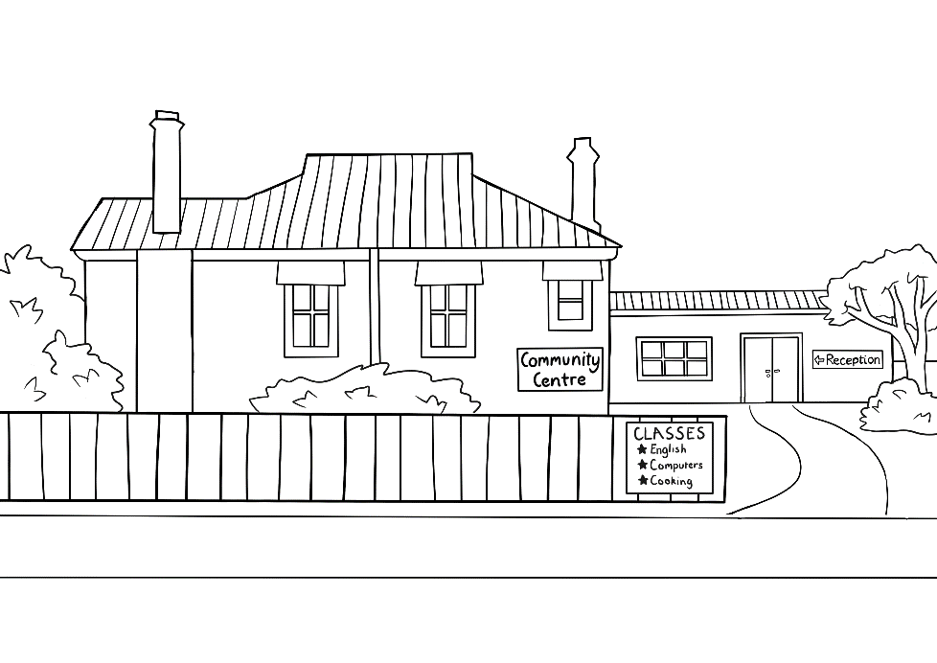


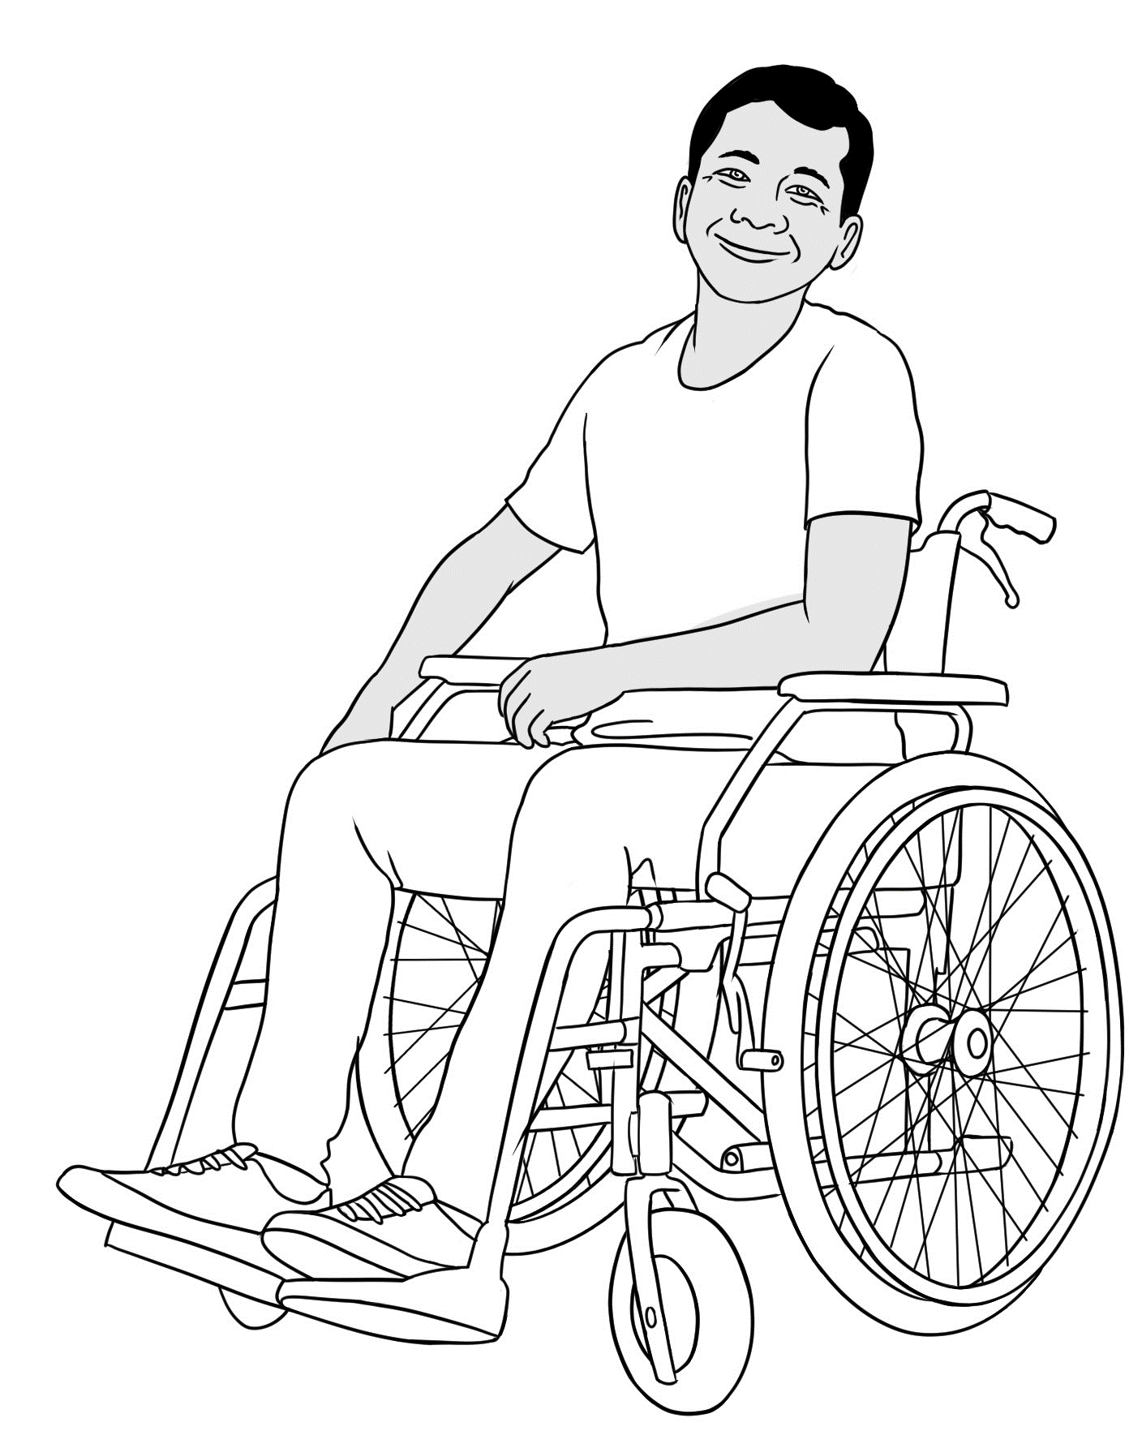

Parwana
Wendy
Linh
Ko
At the Learning Centre

What helps you learn English?
Introduction
Given that many AMEP students may have had limited schooling, it is important to broaden their concept of ways to learn. Attending an English class provides momentum and guidance in learning, but students need to learn to be active and independent learners, inside and outside the classroom. They also need to understand the importance of learning in different places and situations.
- Learn in and outside the class - Brainstorm
The cards on the following two pages support the brainstorm about learning in the Student Workbook [Pages 4 & 5]. Focus on learning in the class first.
- Brainstorm ideas about how to learn best in class and write these ideas
on the board.
- Print and cut up the nine cards and give each pair of students a set.
- Students call out new ideas from the cards to add to the brainstorm.
- Students record nine ideas on the mind map in their workbook.
Repeat the procedure for learning outside the classroom.
In preparation for classes, teachers can alert students to the vocabulary lists at the end of the Student Workbooks for units VU23501 Participate in short simple exchanges and VU23503 Read and write short simple messages and forms. Students can use the lists to familiarise themselves with the language to be covered in the following class. Encourage students to review after class and preview before class; teach the meaning of these words.
A learning review can be found at the end of the Student Workbook on pages 16 – 17. The review is written in Past Simple so students can reflect on the steps they have taken in their learning.

- Learn in class - Cards
  Come to class early. | Come prepared  for class.     | Come to every class.  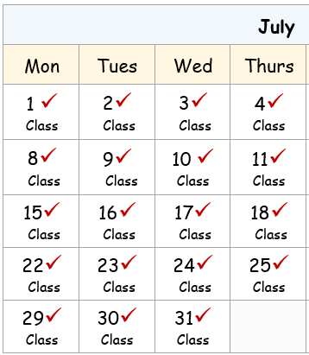
Ask for help.      Can you help me please Peter? |     Talk to classmates  In English.  Did you have  a busy weekend Parwana?  Very busy. |   Write new words  on a word list.  Word list  early  afternoon  difficult
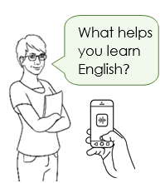  Record the teacher. | Learn some computer skills.   | Put your phone  on silent.  

- Learn outside class - Cards
Review and preview classwork.   | Borrow books and study in the library.  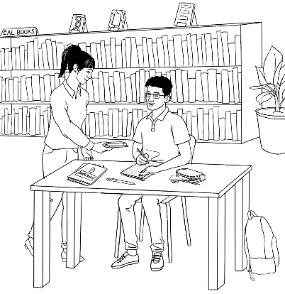 | Learn English online.  
Listen to the recording of the teacher and repeat.    What helps you learn English?  What helps you learn English? | Read and listen to audio books.     |   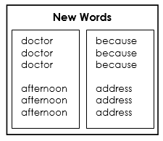      Say and write new words again and again.
Talk to new people.  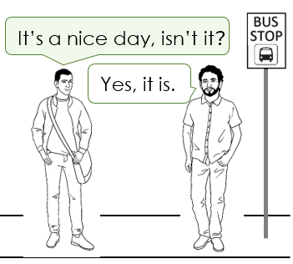 | Go to a conversation class.   | 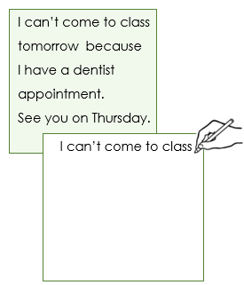    Speed copy for six minutes four times  a week.

- Focus on skills
The brainstorming of learning strategies inside and outside the classroom addresses both the oral and written skills in English. However, within a learning plan, students are asked to focus on specific skill areas.
- Usually speaking is the most common area of need, and activities to strengthen both speaking and listening skills need to be included in every lesson. A noisy classroom is a good sign.
- The next area of need is usually one or more of the written skills of reading, writing and spelling.
- Skills in grammar and vocabulary acquisition are embedded in
all skill areas.
It’s important to explain to the students about the goal and skills focus of classroom activities, to show what skills are being taught.

- Skills focus cards
- Speaking and listening skills
- Reading, writing and spelling skills [Grey cards]

Activity 1 – Skills cards to support the writing of a learning plan
- Print and cut up all the cards, enough to have a complete set for each group of 3 or 4 students. Divide each set into two groups –
1. Speaking and Listening cards 2. Reading and Writing cards.
- When students are writing their learning plans, give out a set of the Speaking and Listening cards to each student group so they can select the skills they want to develop and record in their plans.
- Collect those cards, and repeat the activity with a set of the Reading and Writing cards.

Activity 2 – The practice of learning skills
The recording of skills in a learning plan is meaningless if the skills are not encouraged and put into practice. This can be done in a number of ways:

- Learning skills posters
- Enlarge one page of the cards and print large enough for a wall poster. Select one skill a day to focus on. This may be in response to a class or particular student’s needs. Individual students could also select a skill to focus on.
- Enlarge and print the rest of the pages of the cards one by one, and repeat the selection of a skill to practise each day.
- The posters can be used to indicate the skills being developed in the class at any time.

Activity 3 – Individual checklists of skills
A small number of skills could be selected to create a checklist of each student’s specific learning needs and used as a tailored study skill prompt. Each student is likely to have a different set of skills.

Activity 4 – Survey of students
Print a page of the skills cards, enough for each student to have a page. Students work in small groups and ask questions e.g. Do you listen to the teacher? Do you talk to other students? Students record the positive or negative answers. Tally the responses on the board and follow up any learning gaps in following classes.
Activity 5 - Teacher interview
A personal interview can be helpful for students who may not be progressing. The cards can be used as a prompt to help students choose better strategies to assist their learning.
Activity 6 – Grammar practice
Grammar can be woven into the previous activities. Grammar such as:
  - Modals - will, need to, have to
e.g. I will ask for help. I need to talk to new people.

  - Adverbs of frequency - always, often, sometimes, never
e.g. I always ask for help. I sometimes talk to new people.

  - Simple connectives - and, because
e.g. I’ll borrow books from the library and read every day.
I need to listen and repeat because it will help my speaking.

  - Verb tenses and time markers - Present and Past Simple
e.g. I use new words every day. [Present Simple]
I go to a conversation class once a week. [Present Simple]
I talked to friends in English on Saturday. [Past Simple]

3a. Speaking and listening skills
      Listen to  the teacher.  Open your  workbook. |   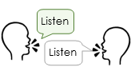  Listen and repeat. | 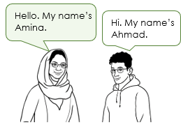  Talk to other students.
Talk to friends  In English.  Did you have  a busy weekend Parwana?  Really busy. | 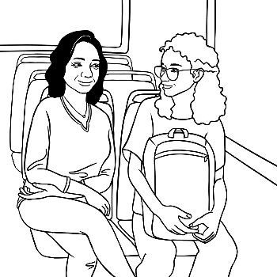  Use new words.  It’s really hot today. | Talk to new people.
Record the teacher. | Listen to the teacher and repeat.  What helps you learn English?  What helps you learn English? |   Repeat sentences and phrases again and again.  It’s time for class.  It’s time for class.  It’s time for class.

3a. Speaking and listening skills
  Say, ‘I don’t understand.’  I don’t understand. | Ask for help.  Can you help me please Peter? | Ask questions.  
Say and clap  the stress.       | Listen to and read audio books. | Go to a conversation class.
Listen to and  sing songs.     |   Sing along to songs on YouTube videos. | Use AMEPOnline.

3a. Speaking and listening skills
Watch English movies with subtitles.   | 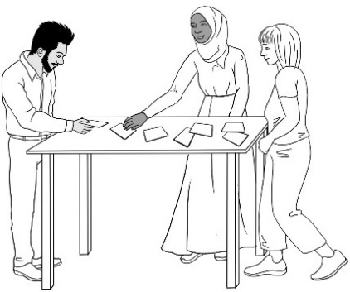  Play games. | Go shopping  with friends.  
Go on excursions.  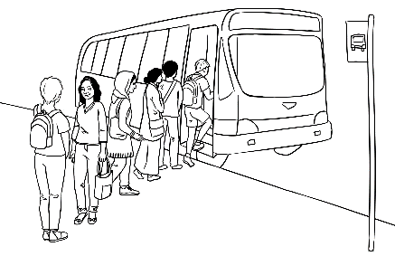 | Speak English with team mates.    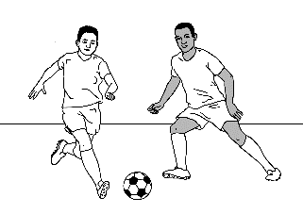 | Speak English  with other volunteers.  
Join a sports club.    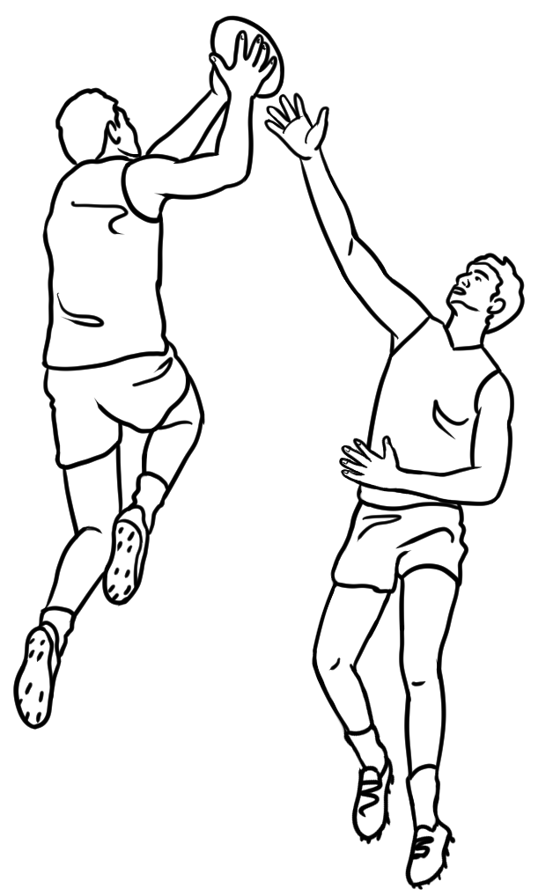 |   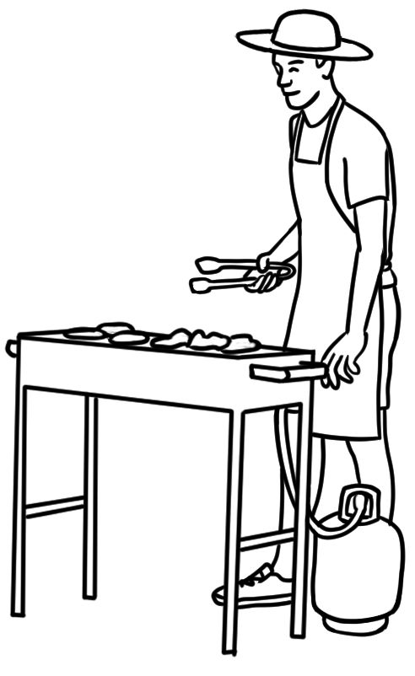  Have a BBQ  with classmates. |   Talk to people  at the child care centre.

3b. Reading, writing and spelling skills
    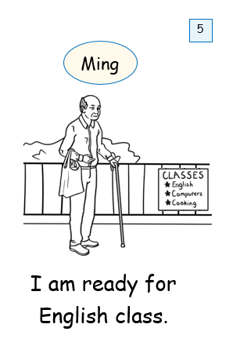  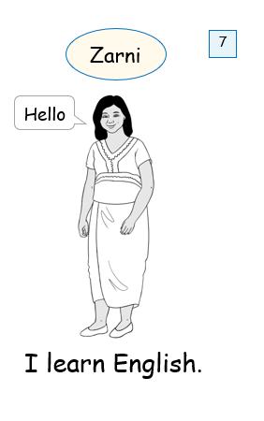  Borrow books from the library and read  every day. | Learn words about  a topic.    Park  tree bench  bird path  bush clouds |   Change the settings on your phone to English.
Write new words  on a word list.  Word list  early  afternoon  difficult | Copy words again and again. | Copy sentences from the board  into a notebook.    
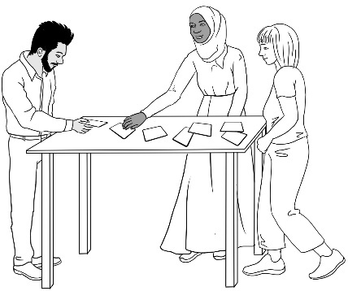  Play games. |   Write words  in colour. |   Speed copy for six minutes every day.

3b. Reading, writing and spelling skills
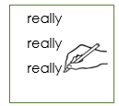    Write and say new words again and again.  really, really, really |   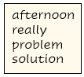  Put the words on your fridge and  read them  every day. | 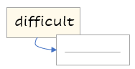  Write a new word on one side of a card and write the word in your language on the back.
Take a photo of new words on your phone.  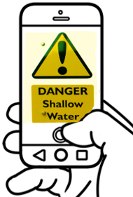 | Use AMEPOnline. | Type sentences on the computer.  
  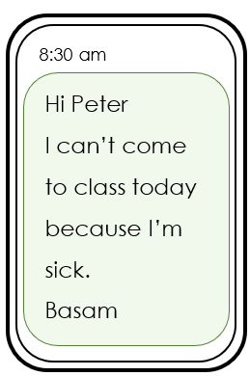  Write text messages. | Practise sentences for dictation in class.    We went on an excursion to the market.  We went on an excursion to the market. | 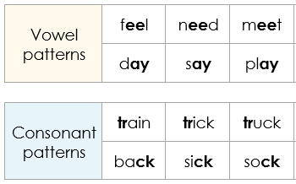  Practise spelling patterns.

Sometimes there’s a problem.
Introduction
Newly arrived migrants and refugees are likely to have a number of barriers to their learning. It’s important that students are aware that there are resources available to help. Although more complex financial, housing and relationship issues need to be referred to the coordinator or other qualified professionals, more common problems and possible solutions can be discussed in class. Such discussion can help students realise that they are not alone in experiencing barriers to learning and that they can learn new ways to solve these problems with the help of their teacher and classmates.
Activity 1 – Sometimes there’s a problem
Project the drawing below depicting how barriers, distractions and delays may slow the journey to a goal. Ask students to point out the barriers on the path [the tree and rockfall], the distractions and delays [the lookout and bench] and the need to sometimes take a slightly different path to the one originally planned [the steps]. The drawing can be used to explain the meaning of the words problem, difficulty, and solution.

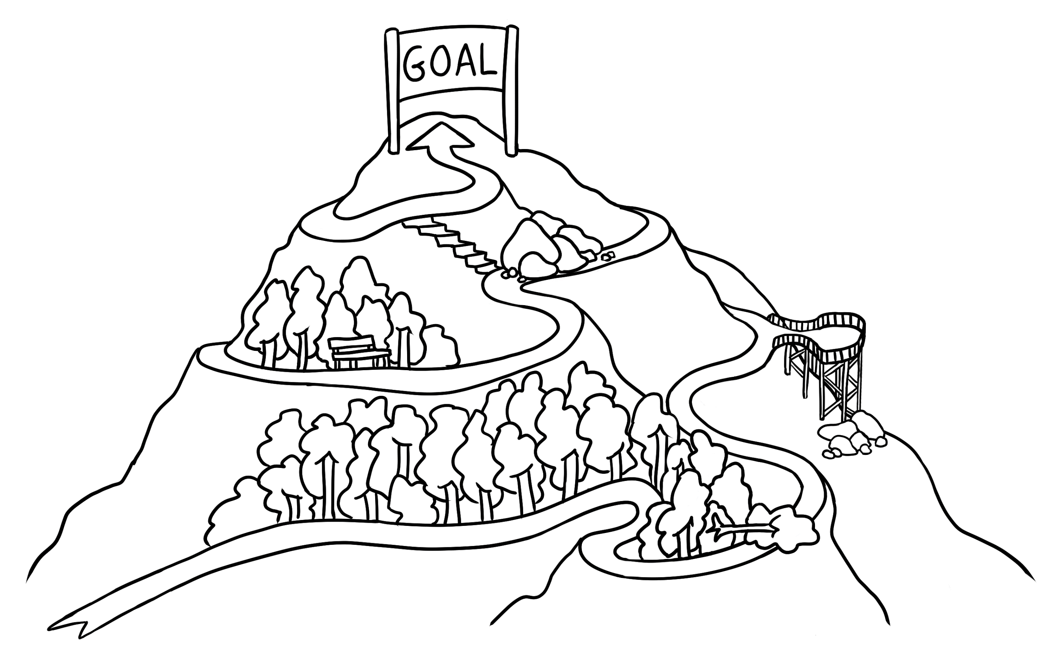

The most common problem and one solution
The most common problem for students is absence from class for a range
of reasons such as sickness, caring responsibilities, specialist medical appointments, housing, settlement issues etc. It is important that early in the course, students are encouraged to pair up with a classmate to help catch up on classwork if and when they are unable to attend class.
Activity 2
Brainstorm some possible problems and solutions on the board.
Problems may be:
- Educational
- Cultural
- Settlement related
- Due to past experiences e.g. trauma
- Health – medical, dental
- Work related
- Personal e.g. busy home life, carer demands
Solutions/help sources may include:
- the current learning institution
- settlement organisations
- charitable organisations/churches
- the community e.g. sporting clubs, the local council
- personal management
Activity 3
Print the following pages. [Remove the pink teacher box.]
Students tick the solution they would try for each problem.



Instruct students to tick the solutions
that they might try.

Problems | Some solutions
1. I have a busy life.      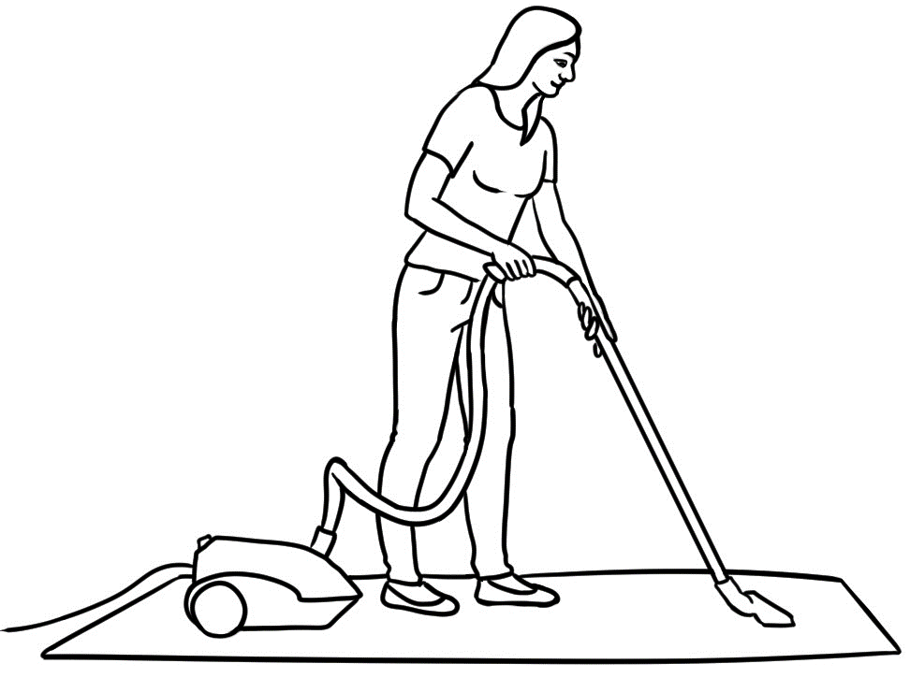  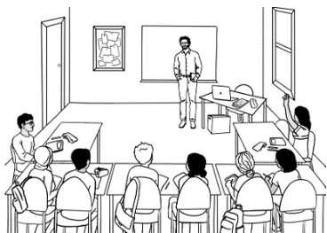  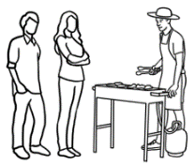    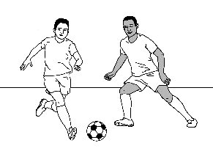  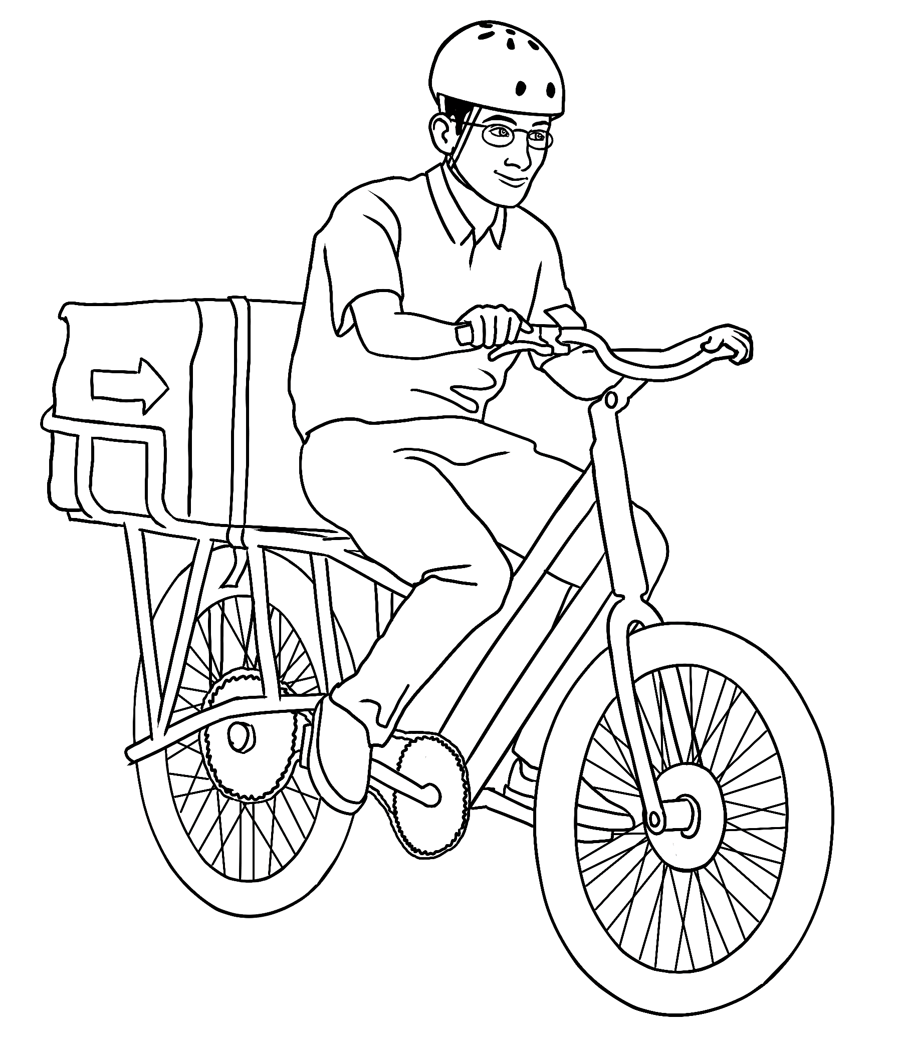     | 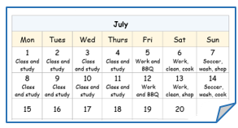  - Make a timetable.  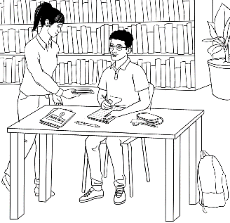  - Study in the library  after class every day.  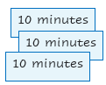  - Study three times a day,  for 10 minutes each time.
2. I miss class because  I am sick.  I miss class because  my child is sick.   |   - Catch up  on classwork  with a classmate.  - Look after your sick child  and try to study at home.    - Ask someone in your family  to look after your sick child.

Problems | Some solutions
  - I have an appointment. | 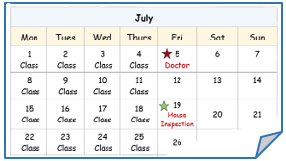  - Make an appointment  outside class time.    - Change the appointment time so it is outside class time.  
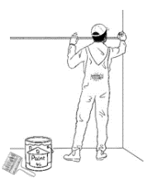  - I work.  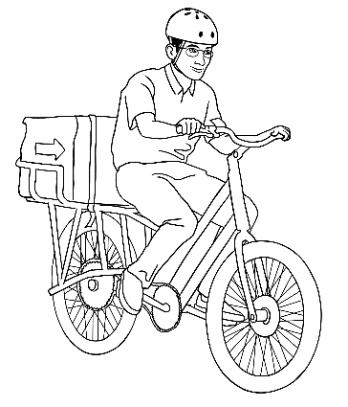 | - Work outside class time.  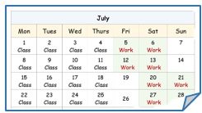    - Learn with  AMEPOnline.    - Ask for a volunteer  tutor.  - Enrol in a part-time class.

Help students set goals.
Help students set their goals
Throughout the term organise activities to support students when planning their future. Where possible, provide information in a student’s first language. Some ideas for future planning:
- Excursions
Excursions not only allow students time to talk to one another in English, but also give them an opportunity to see a range of study and work options.
Visit local:
- TAFE or Registered Training Organisations [RTO]
Sometimes these organisations will offer short taster courses.
- Large employers e.g. Bunnings, MacDonalds
- Volunteering centres e.g. Op Shop, CFA

- Speakers
Speakers can inspire students and open up new avenues for study and work. However, it is critical that all speakers are aware of the English level of the class and adapt the speed and complexity of their language accordingly. Recommend the use of visual aids or a data show. Possible speakers could be:
- A career advisor from the TAFE or RTO to talk about available courses
- A student study counsellor to talk to small groups of students
- A volunteer from the SES or CFA to speak about their work
- Ex-students to talk about their learning journey
- An employer to talk to students about their expectations of an employee, especially their English level and general employability skills.
- Someone from a recruitment agency to talk about job opportunities.
- Pair-up with students from a higher-level class to interview each other and talk about future plans.

Cultural differences
Students are encouraged to communicate in English outside the classroom with classmates, neighbours and strangers. However for some students, there may be reasons preventing them doing this. A discussion of cultural differences can help explain and potentially break down some of the barriers to engagement and communication.

- Cultural differences in the classroom

A good place to start discussion is about cultural differences in the classroom. Learning in Australia is compared to learning in students’ countries of birth on pages 25 – 27 in the Course in EAL Student Workbook for the unit VU23494 Use strategies to develop language learning with support.

- Cultural differences more generally

The table on the following page is a teacher reference. Discuss relevant questions when appropriate and role play to demonstrate with more confident students.

Cultural differences
- Is it okay to interrupt the teacher?
- Is it okay to ask the teacher to repeat something?
- Is it okay to tell the teacher you don’t understand?
- Is it okay to tell the teacher the lesson is too hard or too fast?
- Is it okay for a woman to ask a man a question?
- Is it okay for a man to ask a woman a question?
- Is it okay to keep eye contact when talking to someone?
- Is it okay to smile at a stranger? Is it okay to say hello?
- Can a woman introduce herself to a man?
- Can a man introduce himself to a woman?
- Is it okay to sit next to someone of the opposite sex?
- Is it okay to stand very close to a person when you talk to them?

Summary of learning strategies
Introduction
To learn effectively students need to use a variety of strategies. There is no right or wrong way; it is a personal choice and strategies vary according to the task. However, students with little or disrupted education may have
few skills in learning.
For students to become familiar with new learning strategies, it may be necessary to practise in class first and many strategies can be adapted to meet differing levels of learning ability. For example to practise Useful expressions to show understanding, the activity could be adapted for three levels:
- High level students: Memorise three sentences.
I don’t understand.
Can you say it again please?
Could you speak slowly please?

- Mid-level students: Memorise 2 sentences
I don’t understand.
Can you say it again please?

- Beginner students:
I don’t understand.
In the student book, the students could highlight the expressions they have to learn. On their phones, they could record the teacher reading the three expressions, and then listen and repeat at home.
It is useful to keep a record of the learning strategies introduced throughout the course. This can ensure that a wide range of strategies are introduced and practised both inside and outside the class. e.g.
Week and Strategy | Activity
Week 1  Expressions of understanding | Highlight the expression to learn.  Record the teacher.  Listen and repeat at home again and again.  Use the expressions in class.
Week 2

- Summary lists of learning strategies can be found on the following pages. These are for teacher reference and include ways to improve skills in:
- Study
- Vocabulary acquisition
- Listening
- Speaking
- Reading
- Writing

Select a strategy a day or each week to discuss and practise. Students may suggest alternative strategies which can also be trialed by the class.
An example of a strategy to develop more active learners
Encourage students to take a photo of texts in their day-to-day lives such as at the supermarket, on a bus, on the street, at the health centre. They read the text and consider the following questions about it:
- Where did you see it?
- What does it mean?
- Why was it there?
- Would you see this in your country of birth?
Students could share their photos with other students, or could forward
them to the teacher for projection and discussion in class.
[Idea presented at a LWA workshop Linguistic Mindfulness in 2022 by Karen Barber at North Metro TAFE , WA.]
As students try new ways to learn and see positive results, their confidence will improve and learning will become faster and easier.

- Conversation models from unit VU23501 Participate in short simple exchanges. [See page 34]
- Simple phrases and expressions from conversations could be practised and memorised.
- Students could rehearse in pairs and perform these dialogues for the class.

1a. Strategies to improve study skills
- Have a goal. Goals are important and motivating.
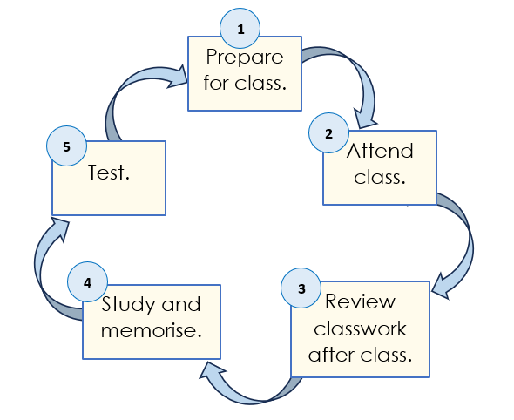
- Practise a five-step study cycle:
- Prepare for class
- Attend class
- Review the class work
as soon as possible after class
- Study and memorise new words,
phrases and sentences
- Test.
The study cycle could be printed in A3 to create a class poster as above.
- Repeat and review are key elements for successful learning. Brief regular practise and repetition fixes words, phrases or sentences into the long-term memory. It is important to review regularly to retain information. Reading and saying words aloud assists retention.
- Use a memory aid - Visualise the meaning of a word, say the word aloud and mime it, clap the syllables, say the word in a specific location e.g. to remember the rooms of a house, say the names of each room while standing in it. [Rooms can also be labelled.]
- Daily study is motivating and effective; it maintains momentum. The commitment of studying with a friend can make this easier.
- Create a quiet place to study - without distractions is the ideal. If home is busy, the library after class offers an excellent space.
- Divide study time into short chunks and stagger the sessions.
e.g. a list of words or sentences to learn for a dictation on a Friday -
Study for 10 minutes at a time on Sunday, Tuesday, and Thursday.
This is more effective than studying for 10 minutes on three consecutive days and more effective than studying for 30 minutes on one day.
- Regular attendance is critical. Come on time, participate and remain until the end of the class. When classes are missed, students need to ask a friend to catch up on work and collect handouts.
- Use AMEPOnline. This site has a wealth of materials to support learning.
- An AMEP volunteer tutor can offer additional support.
- A learning diary can make students more aware of their learning.
e.g.: Today I spoke English to _______ . I borrowed a book from the library.

1b. Strategies to improve skills in vocabulary retention
- Make flashcards:
- with a word and a picture.
- with a word in English on one side and the translation
on the reverse side
- Use new words three times the first day then at least once a day
over the following week.
- Use the senses to experience words as broadly as possible.
e.g. kiwi fruit - feel, smell and taste one. Words are more easily remembered when several senses are used.
- Copy the same word over and over, reading it aloud and visualising it.
- Group words:
- in topics e.g. time - days of week, months, seasons
- with similar meanings e.g. sick, ill, unwell
- Review new words before going to sleep.
- Use visual and location skills to boost memory e.g. Label things in
a picture, in the class, around the home and garden.
Put several objects on a tray, cover with a cloth and ask students to recall. This can also be done with familiar words written at random on the board, covered and then written from memory.
- Set a goal to learn 4 new words every day. Write the 4 words on:
- the palm of the hand
- a piece of card to put it in a pocket, and take out throughout
the day to memorise.
- a sticky note and attach it to the fridge. Look at and say
the words when opening the fridge door.
When the words are memorised, write them from memory.
- Learn shortened and colloquial words and when to use them appropriately. e.g. arvo (afternoon); barbie (BBQ); bickie (biscuit); chockie (chocolate) mozzie (mosquito)
- Chunk words into syllables, noting the stress.
e.g. enrolment - en rol ment
- The Word List on pages 37 - 38 contains the words used in the student workbook and can be printed for revision and homework activities.

1c. Strategies to improve listening
- Watch English movies with English subtitles.
- Movies on YouTube can be watched with the speed slowed down to hear more words and phrases.
- Replay sections of movies many times to be clear about the dialogue.
- Listen to music in English, the same song over and over. Access YouTube clips with the lyrics.
- Borrow simple books with audio from the library. Listen to the audio, read the book and read aloud over and over. Close the book and just listen to the audio over and over.
- Record the audio for some English Ready units on a phone and listen at home.
- Access the audio from AMEPOnline.
- Listen to native-speakers when out shopping or on public transport.
- Some TV programs designed for children offer slow, clear listening opportunities.

1d. Strategies to improve speaking
- It’s important to express understanding and need:
- Ask questions
- Ask for help
- Say when you don’t understand
- Ask the teacher to speak more slowly.
- Memorise a phrase or sentence from the workbooks by repeating it over and over every day.
- Model and practise making introductions in class. Encourage students to introduce themselves to others, smile and look at the person.
- Talk to a wide range of people - classmates, neighbours and native speakers. Talk as much as possible and don’t worry about the mistakes; making mistakes is how learning happens.
- Borrow simple books with audio from the library. Listen to the audio, read the book and read aloud over and over.
- Sing in English. Watch YouTube videos of songs with the lyrics. Download songs and memorise the words and melody.
- Read conversations from the unit VU23501 Participate in short simple exchanges and practice them over and over with a friend. Use the conversation as a model to write a new conversation. Once the teacher has corrected it, rewrite and read with a classmate. See Page 26 for a guide to conversations in the unit VU23501.
- Speak in front of the mirror. Speak loudly. Record your voice.
- Mark the stress on words to help with pronunciation
- Record classroom conversations on a phone and listen to them at home. Repeat them aloud.
- Join a sports club, a volunteer organisation or help out at the child care centre or school. This can help integrate families into the community.
- Organise social activities with classmates from different language backgrounds. Have a picnic, a game of soccer, a BBQ etc

1e. Strategies to improve reading
- Revise class texts as soon as possible after class. Look up any words not understood, write them down and learn them.
- Read in English every day. Select a news article in your first language to become familiar with the content and then find an article in English on the same topic.
- Introduce common sound patterns. Although words from other languages have made English more challenging to read and spell, approximately 80% of English words have regular patterns and rules.
To develop independent reading skills, work on the sounds needs to be done systematically and revised regularly.
A summary of the long and short vowel sounds used in the student workbook can be found on pages 34 - 36. Additional resources to support the teaching of sounds can be found in the following English Ready books:
- Letter Sounds developed for Course in Initial EAL, Unit VU22578 Recognise letters of the alphabet and their sounds – A very basic introduction to sounds.
- Teacher Resources for Certificate 1 in EAL [Access], Unit VU23503 Read and write short simple messages and forms – Initial sounds, consonant blends and two consonants make one sound,
pages 10 – 13; letter clusters used in the unit pages 70 – 72.
- Teacher Resources for Certificate 1 in EAL [Access], Unit VU23501 Participate in short simple exchanges – Consonant clusters used in the unit pages 96 – 97.
- Select a book at the right level. Don’t get a book that’s too hard .Read the title. Scan the book looking at any pictures or diagrams to get an idea of what the book is about.
- Listen to an audio recording while reading. Look up new words and write down them down with their meaning.
- Read the book aloud pausing at punctuation. Reading every day will build up vocabulary and help with writing.
- Change the language setting to English on devices. This will build vocabulary with the repetition of notifications and language.
- Ask your children to read to you.

1f. Strategies to improve writing
- Write a sentence every day. Ask your teacher to correct it. Write it again with no mistakes.
- Next step: Write two or three sentences every day. Leave a blank line between the writing for the teacher to correct. Copy the corrected sentences with no mistakes.
- Memorise the spelling of words. Use the Look, say, cover, write, check technique or other techniques noted in the Teacher Resources for Unit VU23503 Read and write short simple messages and forms on pages 39 - 42.
- Introduce common sound patterns. Knowing the common sound patterns expands a student’s word bank, makes the memorization of words easier and so allows students to write with more speed and confidence. See the information about the importance of teaching sounds on the previous page. A summary of the long and short vowel sounds used in the student workbook can be found on in this book on pages 32 - 34. The spelling of the sounds is ordered with the most common pattern in the first column.
- Word list – A summary of words used in the student workbook can be found in this book on page 35. This can be printed and used for spelling practice and dictation, and for pronunciation. A blank template is also included on page 36 for students to create their own word list.
- Practise speed copying. Set a timer for six minutes. Take one paragraph in your student book. Copy the paragraph over and over for six minutes every day for a week. You will get faster and more accurate each day. The next week select a different paragraph.
- Send text messages or emails to friends. If possible, the teacher could organise email pen-pals from other classes in the learning centre or even in centres across the world.
- Use models to guide writing.

Long vowel patterns – Words in the student workbook
Long a
a_e | ai | ay | a
classmates | painter | days | timetable
make | again | play | change
games |  | okay
translated |  | say
Long e
ee | ea | y | e
week | speak | study | he
volunteer | read | family | be
need | easy | country
speed | teach | copy
three | repeat | library
 | each | every
 | team

Long i
i_e | y | igh | i
outside | my | nights | silent
five | try |  | child
fireman | type
write
time
online
life
Long o
o_e | oa | o | ew
home |  | go | sew
broke |  | piano
note |  | so
wrote
phone

The Long u sound is uncommon in English and no examples are used in the student workbook.

Short vowel patterns
Short a |  |  | Short e |  |  |  | Short i
a |  |  | e |  |  |  | i
plan |  |  | help |  |  |  | did |  | finish
can |  |  | get |  |  |  | is |  | list
have |  |  | yes |  |  |  | in |  | miss
catch |  |  | went |  |  |  | skill |  | listen
man |  |  | then |  |  |  | with
stand |  |  | text |  |  |  | sick
back |  |  |  |  |  |  | fix
Short o |  |  |  |  |  | Short u
o |  | a |  |  |  | u |  | o
from |  | want |  |  |  | study |  | come
borrow |  | what |  |  |  | club |  | some
 |  | was
 |  | watch

Word List from the student workbook
A | again, accident, after, ask, appointment, audio |  | N | nights, notebook, nurse, neighbours, need
B | business, broke, borrow, |  | O | outside, once, online
C | country, certificate, course, catch up, conversation, copied |  | P | please, plan, painter, play, piano, practice, prepared, previewed
D | delivering, difficult |  | Q | qualification, questions
E | early, eight, every, electrician, easy |  | R | record, repeat, repair, reviewed
F | fireman, foot, filled, form, future, first, finish, fix, four |  | S | slowly, study, soccer, skills, solution, sew, sick, speed, six, silent
G | goal, group |  | T | tutor, talk, translated
H | help, home, house |  | U | understand
I | improve |  | V | volunteer
J |  |  | W | week, work
K |  |  | X
L | list |  | Y
M | motorbike, mechanic,  months, minutes |  | Z

Word List - Blank
A |  |  | N
B |  |  | O
C |  |  | P
D |  |  | Q
E |  |  | R
F |  |  | S
G |  |  | T
H |  |  | U
I |  |  | V
J |  |  | W
K |  |  | X
L |  |  | Y
M |  |  | Z

2. Conversation models
VU23501 Participate in short simple exchanges
Situations | Pages | Topics
Students introduce themselves and talk  to other students. | 4 – 7, 14, 22  17  24 – 27  33  37, 39  47, 49 | Introductions  The garden  Jobs at home  Free time  Family  The weekend
Students talk to teachers. | 8, 15  10  40  44, 46  48  54 | Meet the teacher  Can’t come to class  Plan an excursion  Sport - footy and tennis  The weekend  Ahmad’s laptop
Enrolment | 19  21 | An English class  Child care
At the library | 13 | Joining the library
Shopping | 51  53  55  56  61 | Arrange to go shopping  Return clothing  Return a laptop  Return some clothing  Buy medicine at the chemist
Speak to a stranger. | 34 - 35 | Talk about the weather
Talk to a neighbour. | 42 - 43 | Talk about an excursion
Talk to a childcare worker. | 45 | Sport - cricket
Talk at work with workmates & customers. | AMEPOnline | Participate in short simple exchanges  - Assad and Noora working in  a supermarket
Make appointments. | 11, 19, 59 | Medical appointments

