

English Ready
22638VIC Certificate 1 in EAL
VU23501 Participate in short simple exchanges

Teacher Resources
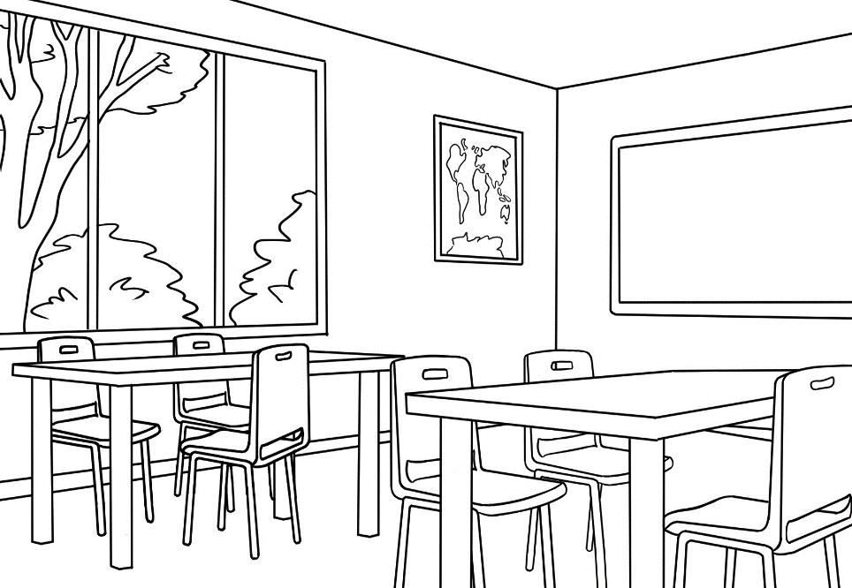
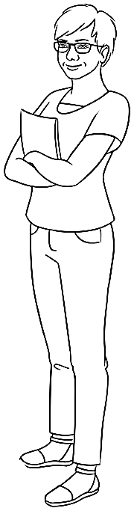
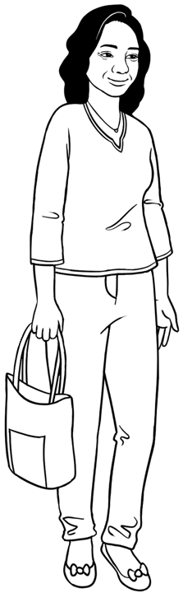

Design team: Vicki Hambling, Sue Paull, Frida Dean, Glenise Kleehammer and Mary Wallace
Illustrations: Madelena Scott

Illustrations acknowledgements:
Crack in glass, coffee pot & frypan, sunglasses These Photos by Unknown Author is licensed under CC BY-NC
Australian coat of arms on the health care card This Photo by Unknown Author is licensed under CC BY-SA
Acknowledgements: The design team would like to thank the AMEP service providers and practitioners who participated in the trial and gave valuable feedback. The team would also like to acknowledge the use of the EAL Framework which underpins the design of this book.
___________________________________________________________________________
Copyright of the EAL Framework is reserved to the Crown in the right of the State of Victoria. © State of Victoria (Department of Education and Training) 2023.
Use of all or part of this document must include the following attribution:
© Commonwealth of Australia 2024

With the exception of the Commonwealth Coat of Arms, the department’s logo, any material protected by a trade mark and where otherwise noted all material presented in this document is provided under a Creative Commons Attribution 4.0 International (https://creativecommons.org/licenses/by/4.0/) licence.
The details of the relevant licence conditions are available on the Creative Commons website (accessible using the links provided) as is the full legal code for the CC BY 4.0 licence (https://creativecommons.org/licenses/by/4.0/legalcode).
As far as practicable, material for which the copyright is owned by a third party will be clearly labelled. The department has made all reasonable efforts to ensure that this material has been reproduced in this document with the full consent of the copyright owners.
Copyright requests and enquiries concerning usage not addressed by the CC BY 4.0 licence should be addressed to: comms@homeaffairs.gov.au at the Department of Home Affairs.
The terms of use for the Commonwealth Coat of Arms are available from the It's an Honour website.
Where a copyright owner, other than the Commonwealth, is identified with respect to this material, please contact that third party copyright owner directly to seek permission.



Introduction
The Teacher Book
The book is an electronic reference and all materials can be adapted and printed as needed. Worksheets have teacher notes that can be removed prior to printing. Resources here include:
- pair work and class work
- revision and homework
- pronunciation
- extension
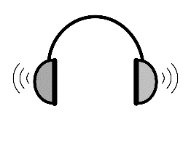
The book contains audio transcripts and links to the audio MP3 files can be found on the English Ready webpage. PowerPoint slides have been created to introduce, consolidate and revise vocabulary. The following icons indicate:
Mp3 audio files
PowerPoint.
PPT

The Student Workbook
The student book requires teacher direction and is not intended for independent learning. Although the workbook addresses all the unit requirements, it is not intended to be the only material used to teach these units or to be used as an assessment task. It is highly recommended that students buy and use a notebook for general class work and practice. The book is available as a Word document so that teachers can:
- localise and update the content
- adjust the material to suit the requirements of particular classes
- delete or add materials as required. If you add or deduct pages, be mindful of the layout as the document has been designed so that particular pages are opposite one another. Also removing pages may mean that the book no longer covers all the requirements of the unit.

NB. Teacher versions of the student workbooks and also the worksheets in this book contain notes to indicate the language focus and/or guide for the exercise.
Teacher notes such as this one on worksheets in the Teacher Resources need to be removed before printing.
Listen, repeat, clap and mime each instruction for students to imitate.

Table of Contents
1. Introduction 4
2. Meet the students and teachers. 12
3. Getting to know you 15
4. Basam starts class. 23
5. Linh starts class. 31
6. Parwana enrols in a class. 36
7. Talk about jobs at home. 40
8. Talk about free time. 47
9. Talk about the weather. 58
10. Talk about family. 63
11. Talk about an excursion. 65
12. Talk about sport. 69
13. Talk about the weekend. 71
14. What will you buy? 80
15. What’s the problem? 85
16. At the medical centre 92
17. At the chemist 94
18. Word lists 96

Introduction

- Pronunciation
Pronunciation needs to be done in the context of everyday teaching and the following two resources are highly recommended and give practical ideas and guidance on ways to do this:
- Lynda Yates and Beth Zielinski Give it a Go: Teaching Pronunciation to Adults can be downloaded free from the following site:
https://www.academia.edu/87980183/Give_it_a_go_teaching_pronunciation_to_adults
- Carringbush has developed a series of free teacher training videos for teachers of adult EAL learners at foundation level. The videos feature approaches of teaching pronunciation, vocabulary, text and other tips.
https://carringbush.org.au/teacher-training-videos/

2. Teaching word stress
Below are some of the techniques suggested in the book by Lynda Yates and Beth Zielinski Give it a Go: Teaching Pronunciation to Adults. [See page 78]

Technique | Examples
- Physically demonstrate the strong stress with movement. | Explore a variety of methods:  Tap the table, punch the air, clap, tap your foot, click your fingers, stretch a rubber band, raise and lower your hand.    e.g. Amina  na  A  mi
- Hum the word. | understand mm - mm - MMM
- Vocalise the pattern | understand di di da
- Sound and kinesthetic together | Hum the word and use the hand movements at the same time.

- Visual and auditory | Close your fist next to your face and open it when you say the stressed syllable.
- Draw the word stress | understand
- Use Cuisenaire rods  or cards |     Use rods or card to show the stress.  later today
- Make lists of words with their stress patterns for students to practice.  This could be a wall chart or a temporary list on the board of new words of the day.  Note: In words that end in tion or sion, such as instruction, station, admission, the stress always falls before the final syllable.
  again | listen
  repeat | partner
  today
  later
  instruction

- Workbook instructions
The workbook is not designed for independent learning and students will require guidance for activities by the teacher. To minimise distractions from the page content, icons replace written instructions in the workbooks. Some additional teacher notes have been included in text boxes in the teacher version of the student book.

The following activities can help students recognise and remember the meaning of the icons. Remove the teacher instruction text boxes before printing for students.
Activities
- Show on slide show. Once students have been introduced to the icons, delay the appearance of the instruction word and encourage students to guess and mime the instruction.
- Syllables and word stress - Project the table on the next page. Clap the syllables, clapping louder on the stressed syllable.
- Instructions - Listening worksheet.

- Do you understand?
Activities
- Sentence stress - Project the sentences and clap more loudly on the stressed syllables.
- Use the expressions - Print the expressions and encourage their use through regular practice:
- Give the four expressions to four students. Select the most confident students at first.
- Ask these students to use their expression at least once during the class – initially with the teacher and later with each other.
- Give the expressions to different students in following classes.

- Syllables and word stress – Worksheet
This worksheet revises the worksheet instructions and clarification requests. Emphasise that stressed syllables sound louder and longer, (See page 26
Give it a Go) and that it can be difficult to understand what is being said if the stress is incorrect.

PPT – Workbook instructions

Activity 3b Instructions– Syllables and word stress

 | 
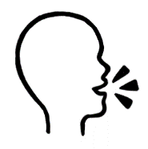  say | 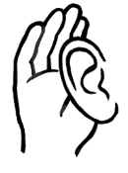  listen | 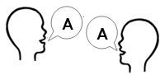  repeat
  clap | highlight
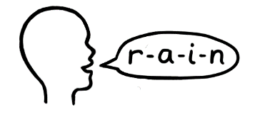  spell |     copy
  read |   circle
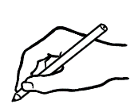  write | 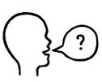  question
tick | 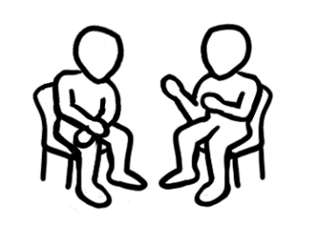  partner

match

Activity 3c Instructions - Listening
Print and cut into three. Say each instruction word at random in the blue row; students number the icons. Emphasise the word stress. Repeat for the grey row.
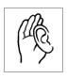
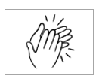

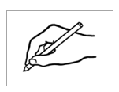


Activity 4a Do you understand? – Sentence stress
- I understand.
- I don’t understand.
- Can you say it again please?
- Can you spell that please?
- Can you help me please?
- Could you speak slowly please?

Activity 4b Do you understand – Use the expressions

I don’t understand.
Can you say it again please?
Can you help me please?
Could you speak slowly please?
Can you spell that please?

5. Syllables and word stress – Worksheet
Say the words aloud, clap and count the syllables and write the number of syllables in the box.

again | 2 |  | partner |  |  | speak
circle |  |  | question |  |  | spell
clap |  |  | read |  |  | start
copy |  |  | record |  |  | teacher
could |  |  | repeat |  |  | tick
highlight |  |  | say |  |  | understand
listen |  |  | slowly |  |  | write

Say the words aloud, and clap the strong stress loudly.
Add the stress pattern dots next to each word.

again |  |  | partner |  |  | speak
circle |  |  | question |  |  | spell
clap |  |  | read |  |  | start
copy |  |  | record |  |  | teacher
could |  |  | repeat |  |  | tick
highlight |  |  | say |  |  | understand
listen |  |  | slowly |  |  | write

Meet the students and teachers.
The characters
All the drawings in the student workbook are available to be used in the design of additional materials. The bio data chart below was created to maintain consistency of information throughout the English Ready books at the three levels - Course in Initial EAL, Course in EAL and Certificate 1 in EAL. It may be useful to update character information. Characters unshaded appear in Certificate 1 in EAL books and those in grey feature in the Course in EAL books as well.

Name | Family  members | Country of origin | Age / Date of birth | Date of arrival | Address in Kellivale  2421 | Phone
Ming Wu | Lan, Bao, Mai | China | 27.3.1959 | 07.05.19 | 70 Wattle St | 0418 335 748
Sahra Omar Elmi | Tahiil, Hani  Abdi | Somalia | 7.7.96 | 9.6.22 | Unit 6, 50 Baker Rd | 0455 961 259
Linh Nguyen |  | Vietnam | 60 |  | Unit 1, 140 Kemp St
Nisha Kumar | Pari (f)  Dev (m) | India |  |  | 18 Sea St  Lives near Taree NSW | 0411 825 999
Basam Radi |  | Iraq | 30  5/08/1993 |  | Unit 3, 140 Kemp St | 0455 328 691
Nabi Saikal | Husband and wife  Parents of Parwana | Afghanistan  Pashto | 48 | 2023 | 48 Baker Road | 0462 595 751
Amina Tarukh | Husband and wife  Parents of Parwana | Afghanistan  Pashto | 46 | 2023 | 48 Baker Road | 0466 379 142  ATarukh13@gmail.com
Parwana Saikal | Rahim’s sister | Afghanistan  Pashto | 25  09/05/1998 | 12/01/2023 | 48 Baker Road | 0476 756 932 Parwana27@gmail.com
Jomeh Tajik | Parwana’s husband | Afghanistan  Pashto | 27  25/08/1996 |  | 48 Baker Road
Bibi Tajik | Girl 5 | Afghanistan  Pashto |  |  | 48 Baker Road
Mustafa Tajik | Boy 2 | Afghanistan  Pashto |  |  | 48 Baker Road
Rahim Saikal | Parwana’s brother | Afghanistan  Pashto | 19  07/05/03 |  | 48 Baker Road | 0469 883 412

Name | Family  members | Country of origin | Age / Date of birth | Date of arrival | Address in Kellivale  2421 | Phone
Ahmad Hamed | Carim (m 19)  Fatima (f 15) | Syria | 21  25/08/2001 | 2022 | 260 North St | 0492 665 732
Ko Tun | Zarni Tun – wife San Tun – daughter  Yaza - grandson | Myanmar | 47  4/1/1977 |  | 4/ 50 Baker St | 0564 891 410
Pam |  | Australia | 70 |  | 5/50 Baker Rd
Teacher - Peter |  | Greece | 38 |  |  | 0436 924 651
Teacher - Wendy |  | England | 45
Bio data continued

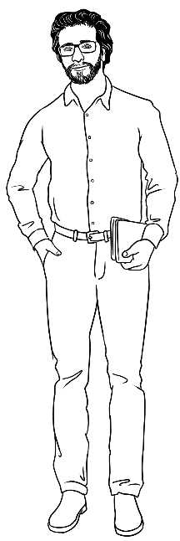
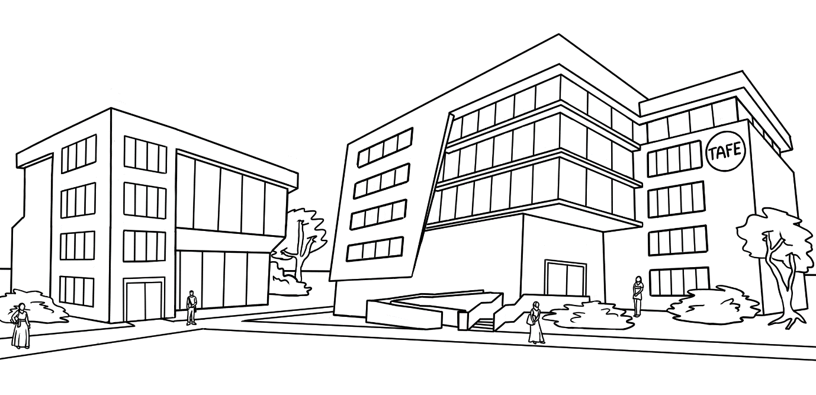
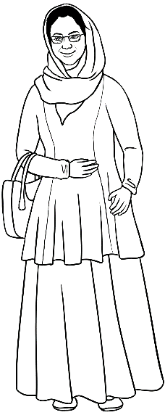
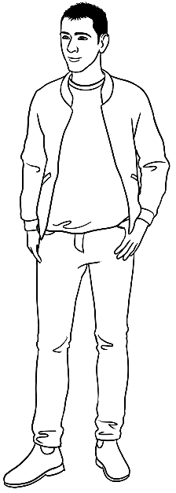
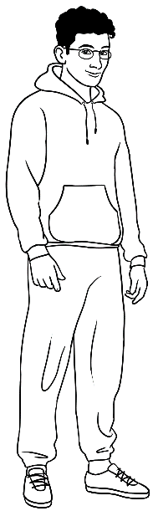
Level 1 Characters

Peter
Amina
Basam
Ahmad

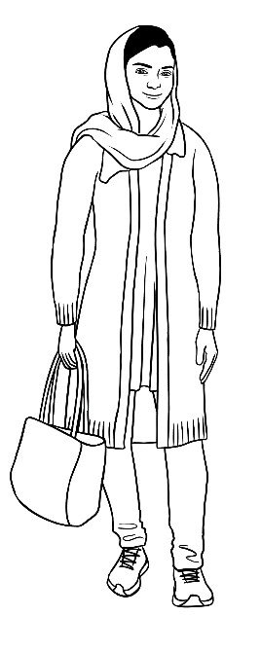
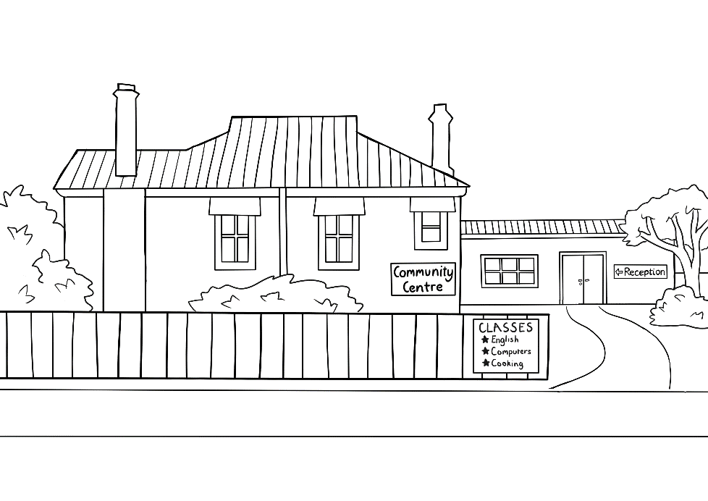
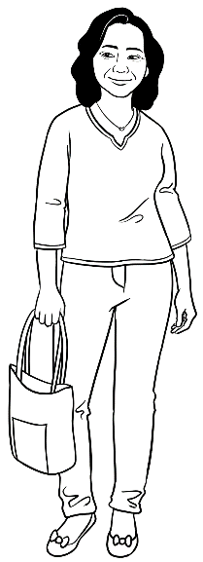
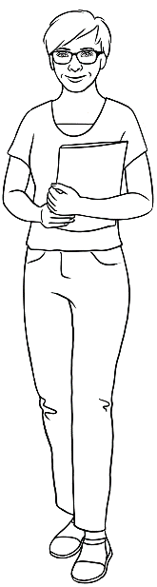
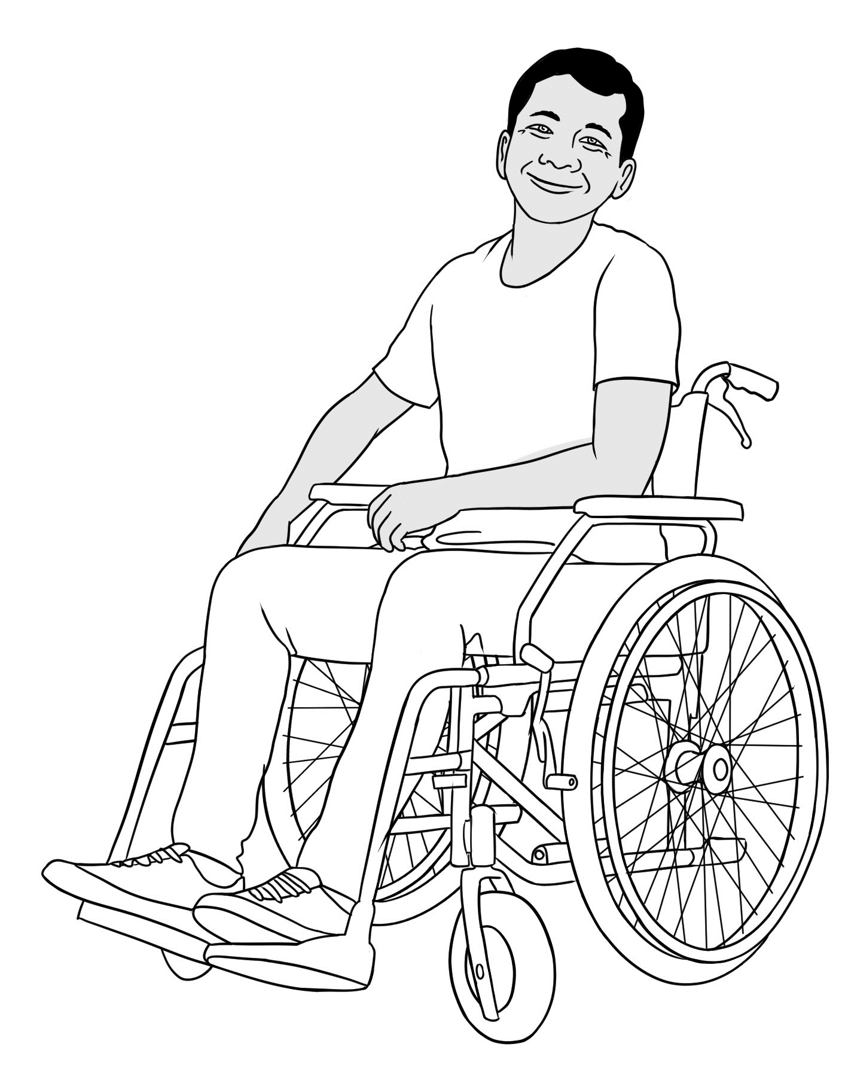

Parwana
Wendy
Linh
Ko

Getting to know you
- Introducing people
Use the names of characters in the book to teach syllables and stress.
- Create a grid on the board [as below] and add the names of the characters. Listen to each name, say it and while saying it, clap, tap the desk or punch the air to count the syllables. Write the number of syllables on the grid.
- Say the word again, exaggerating the stressed syllable, clapping, tapping and punching more strongly on the stressed syllable. Also show the word with your hand, lifting it on the stressed syllable.
e.g. Amina

- Add the stress pattern on the grid and continue with each character.

Repeat this activity with the names of students in the class.
Note: Some learners find syllables and word stress difficult. For example, English speakers hear one syllable in the word crisp, but Japanese speakers can hear four syllables ku / ri / su / pu.
(Lynda Yates and Beth Zielinski Give it a Go: Teaching Pronunciation to Adults, p 25)

na
A
mi

Names | How many syllables? | Stress pattern
Wendy | 2 | O o
Peter | 2 | O o
Amina | 3 | o O o
Basam | 2 | O o
Ahmad | 2 | O o
Parwana | 3 | o O o
Linh | 1 | O
Ko | 1 | O

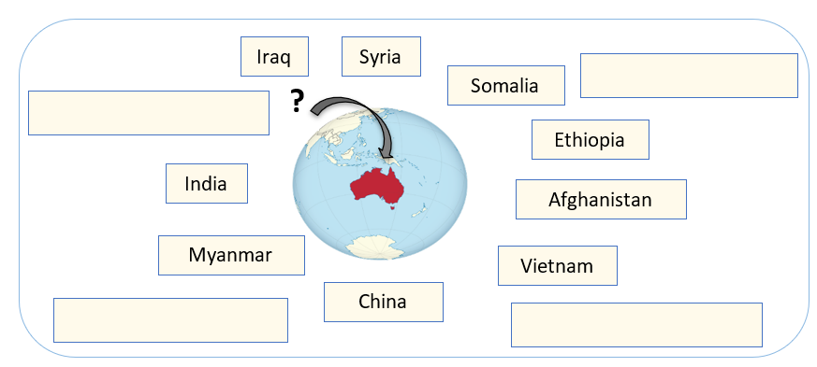
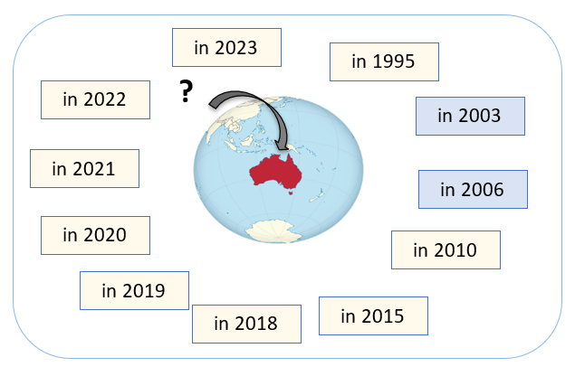
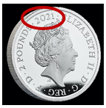
- Where do you come from?

- Put some stress pattern dots on the board.
e.g.
Read out the name of a country, clap the stress pattern and ask students to match the country to the stress pattern. Students need time to repeat the name and clap the pattern before identifying the country.

- The class sits in a circle. They take turns to throw a soft ball to each other. The person who receives the ball says their name and where
they come from.
e.g. I’m _______________ and I come from ______________.
^{name} ^{country}
- Repeat the above activities with the names of students in the class, relevant suburbs, towns and street names.

- When did you come to Australia?

- Practise saying the years – Class activity
- The years after 1909 and 2009 are read by coupling the numbers.
e.g. 1945 = nineteen – forty-five, 2012 = twenty - twelve etc.
- The years 1900 – 1909, 2000 – 2009 are read differently.
e.g. 1900 is nineteen hundred, 2000 is two thousand
then 2001 is two thousand and one and two etc.

- Read the years on coins.
Students to empty their pockets/purses and read the dates
on their coins.

- Saying the years - Information gap activity
If students are unfamiliar with reading a grid, demonstrate the activity below on the board.
4. Asking questions about someone - Pair work
Print and cut up the worksheet on the following page. Students work in pairs. It’s important that students only look at their own half. Demonstrate the activity with a confident student, especially the question - Can you spell that please?

5. Giving correct personal details
It’s important for students to practise giving their personal details one-to-one with a teacher or volunteer tutor. Do this early in the course at convenient times during classes. Teachers can record student details on the template page 20 and check for accuracy on a health card or other documentation.

3c. Saying the years - Information gap activity
Student A
 | A | B | C | D | E
1 |  | 2006 |  | 2022
2 | 2010 |  | 2021 |  | 2018
3 |  | 1994 |  | 1989
4 | 1983 |  | 1971 |  | 2000
Student B
 | A | B | C | D | E
1 | 2023 |  | 2003 |  | 2015
2 |  | 2019 |  | 1995
3 | 2001 |  | 2013 |  | 1998
4 |  | 1986 |  | 1978

4. Asking questions about someone - Pair work
Can you spell that please?

Student A
A a | B b | C c | D d | E e | F f | G g | H h | I i | J j | K k | L l | M m
N n | O o | P p | Q q | R r | S s | T t | U u | V v | W w | X x | Y y | Z z
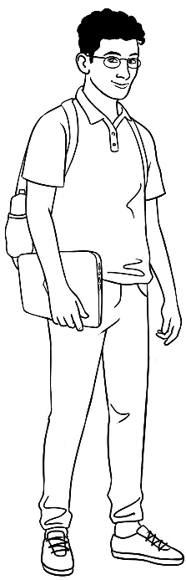
- What’s his first name? Ahmad
- What’s his family name? __________________________
- Where does he come from? Syria
- When did he come to Australia? __________________
- What street does he live in? North Street
- What’s the number of his house? __________________
- What’s his brother’s name? Carim
- What’s his sister’s name? ____________________

Student B
Can you spell that please?

A a | B b | C c | D d | E e | F f | G g | H h | I i | J j | K k | L l | M m
N n | O o | P p | Q q | R r | S s | T t | U u | V v | W w | X x | Y y | Z z
- What’s his first name? _________________________
- What’s his family name? Hamed
- Where does he come from? ___________________
- When did he come to Australia? 2022
- What street does he live in? ____________________
- What’s the number of his house? 260
- What’s his brother’s name? __________________
- What’s his sister’s name? Fatima

5. Giving correct personal details
Teacher/tutor writes student answers and compares accuracy with documentation.
Date_________________________
What’s your first name? Can you spell it please?
What’s your family name? Can you spell it please?
What country do you come from?
What language do you speak?
Can you tell me your address?
What’s the name of your street? Can you spell it please?
What’s the name of your suburb? Can you spell it please?
What’s your postcode?
What’s your telephone number?

5. Sentence stress - Common phrases in introductions

- Once a class is familiar with a phrase or a sentence, write it on the board and mark the sentence stress. Say the phrase or sentence many times clapping, tapping, stamping etc the stressed parts.
e.g.
Good morning. o O o
What’s your name? o o O
It’s nice to meet you. o O o o o
Nice to meet you too. O o o o o
What about you? o o O

- Demonstrate how putting stress on different words in a sentence changes the meaning.
e.g.
I came to Australia in 2023. [I came then, not anyone else]
I came to Australia in 2023. [Not at another time – e.g. 2022]

- Kinaesthetic movement can highlight and help students remember common stress patterns.
e.g.

Good mor ning.
- Hum the phrase.
e.g. mm MM mm
Good mor ning

- Combine kinaesthetic and humming together.
e.g.

mm MM mm
Good mor ning.
- Clap the words that are stressed in the sentence, then the whole sentence with the unstressed words fitting into the beat.
e.g. must back class I must get back to class.

6. Linking

Although it can make distinguishing each word difficult, linking creates smoother speech and is an important feature of spoken English.
A common linking is between final consonant sounds and the initial vowels in a following word.

e.g. My name’s Amina. = My name’sAmina.

My name’s Ahmad. = My name’sAhmad.

Thanks Ahmad. = ThanksAhmad.

What about you? = Whatabout you?

I have an appointment. = I haveanappointment.

7. Unsounded letters
In Australian English, the letter r is often unsounded:
- Within words when followed by another consonant
e.g. Saturday, morning
- In words that end in er, or, ar such as mother, doctor, grammar, the er, or, ar are pronounced as the unstressed schwa sound - uh.

8. Common expressions in introductions – Chant [Below]

A | B
Good morning | Good morning
Nice to see you. | Nice to see you too.
How are you? | How are you?
I’m good thanks. | I’m good thanks too.
When did you get here? | When did you get here?
I came here in 2022. | I came here in 2022, too.
Really? | Yes really!

Basam starts class.


- In the classroom - Stationery
Activities

- Show on slide show. Once students have been introduced to the stationery objects, delay the appearance of the word and encourage students to guess the word.

- Inflection – Questions and statements

- Demonstrate inflection by using your finger to show the up and down inflection:
- downward for wh questions and for statements and answers
e.g. What do you have/need for class?
When did you come to Australia?
I came here in 2022. etc

- upward for simple yes/no questions.
e.g. Do you have a pencil?
Could I borrow a pencil?
Does he/she need to buy a pencil? etc

- Classroom stationery - Pair work information gap
Print and cut up the worksheet on the following page. Students work in pairs, with one half of the worksheet - Student A or Student B. It’s important that students only look at their own half. Demonstrate the activity with a confident student, especially the question and answers and the use of the indefinite article and the upward yes/no question inflection:
Does he/she need to buy ___________________?
^{name of object}
Yes she/he does. No she/he doesn’t.

PPT - Stationery

- Conversation chants Can I borrow____________?
Practise the short conversations as a chant. Project page 27, divide the class in half and chant the requests and responses, placing stress on key words and using an upward inflection for the yes/no questions.
- Conversations Can I borrow____________? Class activity
  - Positive responses
Print in colour and cut up enough copies of the short positive conversations, so that each student has either an A or B slip of paper. Students walk around the room and ask questions or give responses depending whether they are A or B. [The use of colour makes it easier for students to distinguish between A and B.]
  - Negative responses
Repeat the exercise for negative responses.
Note – This will only work if positive and negative conversations are practised separately.

- Joining the library - Stress patterns in key words
Print the worksheet on page 30. On the worksheet, the main stress is marked on key content words. Students work in pairs, take turns to substitute their own details in the conversation while stressing the key words and using a downward inflection for wh questions.

1c. Classroom stationery - Pair work information gap
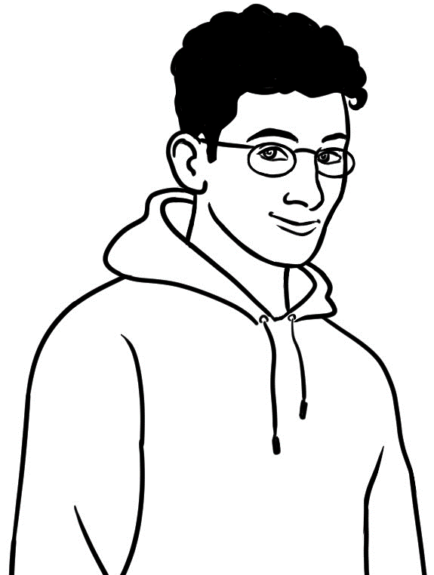
Student A
What does Ahmad need to buy for class?

Does he need to buy ________________?

a rubber | a pen | a pencil | a ruler
a notebook | a folder | a pencil case | a USB
a sharpener | a highlighter | a workbook | scissors
Ahmad needs to buy

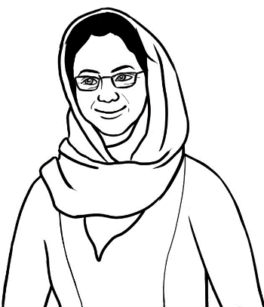
Yes, she does.

No, she doesn’t.

a rubber | a pen | a pencil | a ruler
a notebook | a folder | a pencil case | a USB
a sharpener | a highlighter | a workbook | scissors
Amina needs to buy

Ahmad needs to buy _________________________, ___________________,
______________________, _________________________, ____________________,
______________________, and _______________________________.

Check your work.

Student B
Yes, he does.

No, he doesn’t.

Ahmad needs to buy
a rubber | a pen | a pencil | a ruler
a notebook | a folder | a pencil case | a USB
a sharpener | a highlighter | a workbook | scissors

What does Amina need to buy for class?
Does she need to buy ________________?

a rubber | a pen | a pencil | a ruler
a notebook | a folder | a pencil case | a USB
a sharpener | a highlighter | a workbook | scissors

Amina needs to buy

Amina needs to buy ________________________, ________________________,
______________________, _________________________, ______________________,
______________________, and _________________________,
Check your work.
1d. Conversation chants – Can I borrow _____________?
A | B
Do you have a rubber? | Yes, I do.
Can I borrow it please? | Sure.
Thanks. | No worries.

A | B
Do you have a ruler? | Yes I do.
Can I borrow it for a minute? | OK.
Thanks a lot. | No problem.

A | B
Do you have a spare pencil? | No I don’t have one.
That’s OK. | Sorry.

A | B
Do you have a highlighter? | Yes I do.
Can I borrow it for class today? | Sorry. I’m using it.

1e. Conversations Can I borrow___________? Class activity - Positive responses
A | B
Do you have a rubber? | Yes I do.
Can I borrow it please? | Sure.
Thanks. | No worries.
A | B
Do you have a ruler? | Yes I do.
Can I borrow it for a minute? | OK.
Thank you. | Not a problem.
A | B
Do you have a spare highlighter? | Yes.
Can I borrow it please? | Sure
Thanks. I’ll give it back in a minute. | That’s fine.
A | B
Do you have a pencil? | Yes, I have two.
Can I borrow one for class today? | Yes, sure.
Thanks a lot. | OK.

1e. Conversations Can I borrow___________? Class activity –Negative responses

A | B
Do you have a sharpener? | No. I don’t have one.
No worries.
A | B
Do you have a pencil? | No I don’t.
That’s OK. | No worries.
A | B
Do you have a rubber? | Sorry. I don’t have one
No problem. I’ll ask someone else. | OK.
A | B
Do you have a highlighter? | Yes, I do.
Can I borrow it for a minute? | Sorry, I’m using it.

2. Joining the library -Stress patterns in key words
Student | Excuse me. I’d like to join the library.  Can you help me?
Librarian | Yes, I can. Can you tell me your full name?
Student | My name’s _______________________________.
Librarian | How do you spell your family name?
Student | ________________________ _________________________
Librarian | What’s your address?
Student | It’s _____________________________________________.
Librarian | What’s your phone number?
Student | _______________________________.
Librarian | Just a minute. OK, here’s your library card.  You can use the library now.
Student | Thank you. Can I borrow some easy  English books?
Librarian | Yes. I’ll show you where they are.
Student | Thank you.

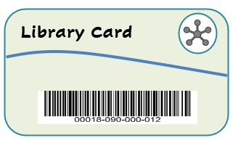

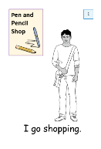
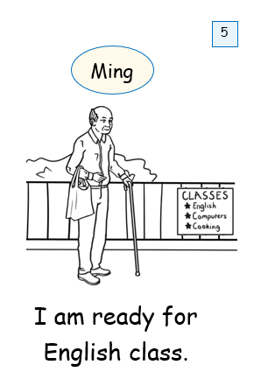
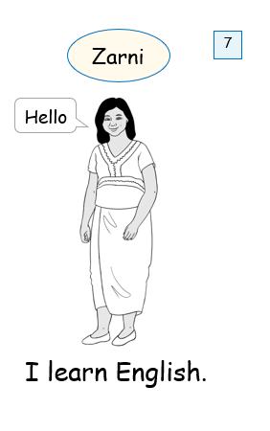

Linh starts class.

1. Correctional stress – class activity
Write about 8 – 10 familiar words or numbers on the whiteboard.

The words and numbers above provide the correct answers to the questions
the teacher will ask. When introducing the activity, point to the answer after asking the question. Later, students can locate the correct answer. When students answer, they need to place stress on the corrected word.
 | Teacher | Student
1 | Today is Tuesday. | No, it’s Wednesday.
2 | It’s 10 o’clock. | No, it’s 12 o’clock.
3 | It’s good to be late for class. | No, it’s good to be early.
4 | This is a notebook. [Hold up a workbook.] | No, it’s a workbook.
5 | This is blue. [Hold up something black.] | No, it’s black.
6 | I have a tooth ache. I’ll go to the doctor. | No, go to the dentist.
7 | Ahmad comes from China. | No, he comes from Syria.
8 | This year is 2022. | No, it’s __________.  ^{current year}

Note: This activity could be adapted for a variety of purposes.
e.g. a comprehension activity with two teams.
- Write some correct and some incorrect answers to questions on the board.
- A student from each team stands in front of the board and tries to be first to circle the answer after the teacher asks a question.

12
Wednesday
Syria
early
2024
dentist
black
workbook

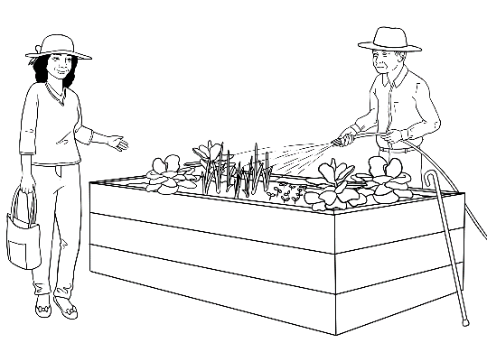
2. Listening and sequencing - An exercise for mixed level classes
The conversation between Linh and Ming has been
organised at three levels of difficulty which allows
all students to do the same exercise, but at their
current level of skill. The same technique could
be used with other conversations in the student
workbook to create listening exercises.
This is a listening activity. The teacher needs to walk around to help and check students’ work as they listen and sequence the text.
- Print each of the levels on the following pages.
- Students select their level and cut up the strips.
- With their workbooks closed, students sequence the strips of text.
- Read the text for students to check their work.
- Give students a paper clip to hold the strips and collect these for later revision and/or for students to try a higher level the following day.

Level A
Oh.
Today I need to water the vegetables because
tomorrow will be very hot.
Bye.
Bye Linh.
Thanks Ming. I’ll see you here next week.
Hello Linh. How are you?
Mmm. I’d like to help. Can I help in the garden?
I’m watering the vegetables.
This is our community garden.
I work here on Wednesday before class.
Hi Ming.
Yes. Everyone’s welcome.
Fine thanks. What are you doing?

Level B
Oh.
Today I need to water the vegetables because tomorrow will be very hot.
Bye.
Bye Linh.
Thanks Ming.
I’ll see you here next week.
Hello Linh. How are you?
Mmm. I’d like to help.
Can I help in the garden?
I’m watering the vegetables.
This is our community garden.
I work here on Wednesday before class.
Hi Ming.
Yes. Everyone’s welcome.
Fine thanks. What are you doing?

Level C
Mmm. I’d like to help.
Hi Ming.
Bye.
Bye Linh.
Yes. Everyone’s welcome.
Oh.
Thanks Ming.
I’ll see you here | next week.
Hello Linh. | How are you?
Today I need to water the vegetables | because tomorrow  will be very hot.
Can I help | in the garden?
I’m watering | the vegetables.
This is | our community garden.
I work here on Wednesday | before class.
Fine thanks. | What are you doing?

Parwana enrols in a class.
- Correctional stress – pair work
Revise correctional stress on the board using an example on the following worksheet. Students work in pairs and swap roles once they have completed the six short exchanges.

 | Student A | Student B
1 | The interview is at 10:30. | Did you say 9:30?
1 | No, 10:30. | Ah. 10:30.
2 | How old is your son? | He’s two.
2 | Did you say two? | Yes, two.
3 | What’s his date of birth? | 30 September 2021
3 | 13 September? | No, 30 September.
4 | What days do you need childcare? | Monday and Tuesday.
4 | Monday and Thursday? | No, Monday and Tuesday.
5 | What’s your address? | 48 Baker Road, Kellivale
5 | Did you say Laker Road? | No, Baker Road.
6 | When did you come to Australia? | I came here in 2023.
6 | In 2020? | No, in 2023.

- Listening and sequencing in two levels
The simpler level A retains the green background colour of the first speaker, while the more difficult level B has no colour to define the speakers.
- Copy and cut up the strips.
- Read each line of the transaction slowly.
- Students listen and order the strips.
- Students read the transaction in pairs.

Level A
Uh huh. What’s his date of birth?
Yes, you can. How old is your son?
What’s his name?
Hello. Can I help you?
Oh, 30 September. What days do you need childcare?
13 September?
Yes, I can help. Let’s sit down here.
Mm. That’s fine. Can you fill in this form?
Oh. Can you help me please?
Monday and Tuesday.
He’s two.
Yes. Can I enrol my son for childcare here?
30 September 2021.
No. 30 September.
Mustafa Tajik.

Level B
Uh huh. What’s his date of birth?
Yes, you can. How old is your son?
What’s his name?
Hello. Can I help you?
Oh, 30 September. What days do you need childcare?
13 September?
Yes, I can help. Let’s sit down here.
Mm. That’s fine. Can you fill in this form?
Oh. Can you help me please?
Monday and Tuesday.
He’s two.
Yes. Can I enrol my son for childcare here?
30 September 2021.
No. 30 September.
Mustafa Tajik.

Talk about jobs at home.
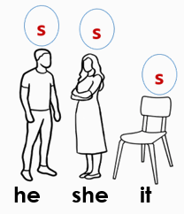
- Vocabulary

Show on slide show. Once students are familiar with the jobs at home, delay the appearance of the word and encourage students to guess it.

- Present Simple
Regular activities such as jobs around the home are a useful topic to teach the present simple tense. Other common topics are regular habits and routines especially around time e.g. I get up at 7. I have breakfast at 7:30.
I go to class/work at 8:30. etc

A challenge in the Present Simple tense is the addition
of s for the 3rd person singular with both positive and
negative forms. Draw a simple visual memory prompt
and encourage students to do the same. e.g.
Activities

- Jazz chants
Chants are quick and useful ways to practise and memorise grammar and collocations. The chants on the next page focus on the present simple tense [first person and third person singular, positive and negative], and also the upward inflection in yes/no questions.
- Begin with chant #1 and once familiar, move onto chant #2.
- Divide the class into two – one half reads the black text and the other reads the red.
- Encourage students to be animated and exaggerate words in bold and questions.

- Present Simple survey [3rd person singular] – Regular habits on Monday.
The survey includes content covered in the Course in EAL student workbooks, and consolidates the use of Present Simple for regular habits.
- Project the survey on page 38 and practise the three questions students need to ask.
- Set a time limit and students walk around the room, interviewing five other students and recording names and times on the grid.
- When the time limit is up or when students have completed the survey, record Baos’ times in exercise 2.
- Record the names and times of two students interviewed.
- Students can read these sentences aloud in pairs or to the class.
- Repeat the survey with different days and activities.

PPT – At home

2a
Jazz Chants

Here’s my Saturday.
This is what I do.

I do some homework.
Do some homework?
Yes I do.

I do the washing.
Do the washing?
Yes I do.

I clean the house.
Clean the house?
Yes I do.

I cook lunch.
Cook lunch?
Yes I do.

I do the dishes.
Do the dishes?
Yes I do.

I work in the garden.
Work in the garden?
Yes I do.

Wow! You’re amazing!

But, I don’t do the shopping.
Don’t do the shopping?
No I don’t.

And, I don’t wash the car.
Don’t wash the car?
No. I don’t have a car!
You don’t have a car?
No, not yet.

2
1
Here’s Linh’s Saturday.
This is what she does.

She does some homework.
Does some homework?
Yes she does.

She does the washing.
Does the washing?
Yes she does.

She cleans the house.
Cleans the house?
Yes she does.

She cuts the grass.
Cuts the grass?
Yes she does.

She works in the garden.
Works in the garden?
Yes she does.

She washes the car.
Washes the car?
Yes she does.

Wow! She’s amazing!

But, she doesn’t cook lunch.
Doesn’t cook lunch?
No she doesn’t.

She doesn’t do the dishes.
Doesn’t do the dishes?
No she doesn’t.

She goes out for lunch
every Saturday.
Lucky Linh!
Lucky Linh!

b. Present Simple survey – regular habits

 | On Monday
 | 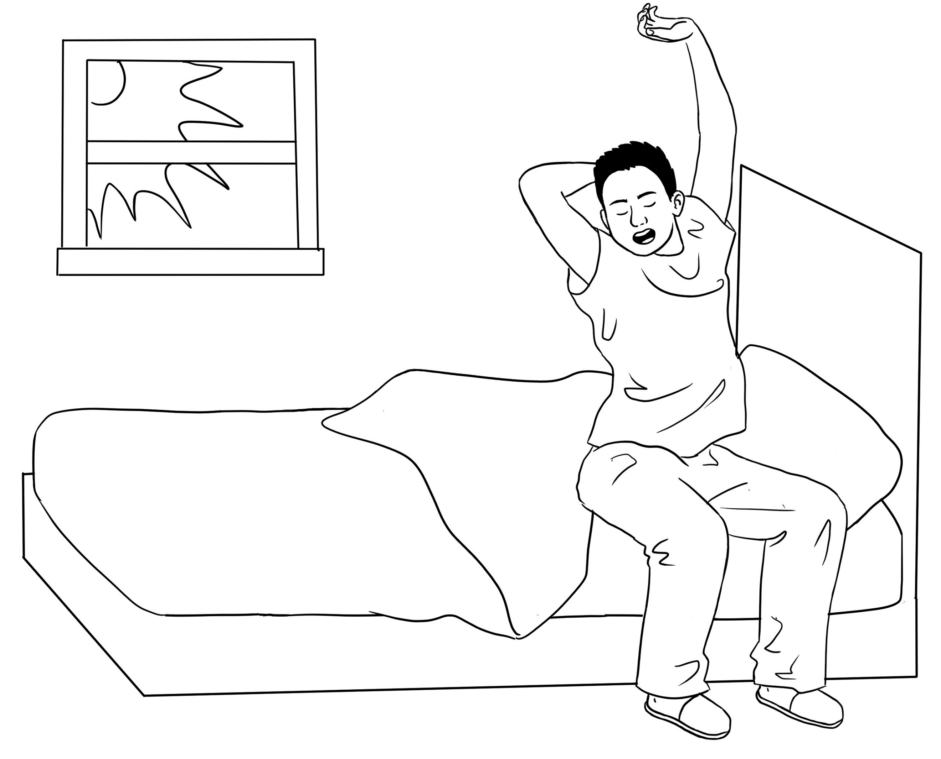 | 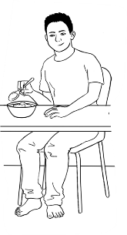 | 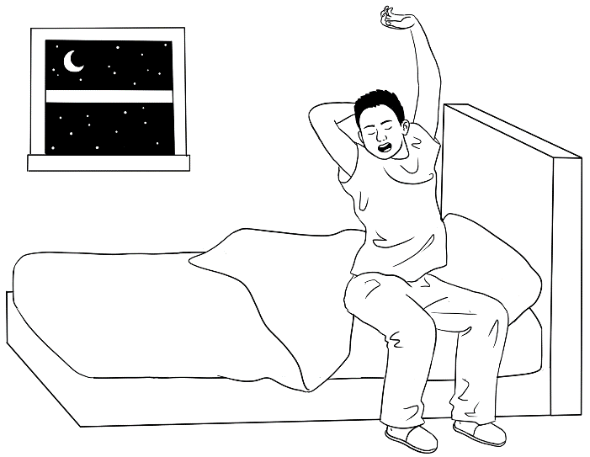
Names | What time do you get up? | What time do you have breakfast? | What time do you go to bed?
Bao | at 7:30 | at 8:00 | at 11:00
- Bao gets up at __________ and has breakfast at _________.
He goes to bed at __________.

- ____________________ gets up at __________and has breakfast at _______.
^{name}
He / She goes to bed at __________.

- ______________________________________________________________________________________________________________________________

- Past Simple - Irregular verbs
Irregular verbs need to be memorised. Regular practise with short activities to break up a class can be helpful.

- Irregular verbs race
- Write a list of familiar irregular verbs on the board in present simple. Write a second list with same verbs, but in a different order at the other end of the board.
- Students form two teams in front of the lists; each team with a whiteboard marker.
- On the signal, the first student in each team writes the past simple form next to the first verb, hands the marker to the next student and goes to the back of the line.
- The team that finishes first with no errors is the winner.

Team 1
come came
cut
do
give
go
have
make
meet
read
say
see

Team 2
do did
come
read
go
have
cut
meet
say
give
make
see

b. The Fly Slap Game
You will need two new different coloured fly swats and a whiteboard.
- Divide the class into two teams, named after the colours of the swats.
- Write the base form of irregular verbs randomly over the board.
Say the verbs as you write and ask students to repeat. Elicit sentences with each verb in the Present Simple.
- A student from each team stands at the board holding their team’s swat.
- Students in the class take turns to call out a verb. The first student at the board to slap the verb and give the past tense form, wins a point for their team, and wins an extra point if they can put the past tense verb in a sentence.
- Rotate students after about four words and keep score on the board.
Note: This game can be used to revise any vocabulary.

4. Past Simple - Regular verbs

- Introduction The pronunciation of ed at the end of all regular verbs depends on whether the final sound in the verb is voiced or unvoiced.
On the table below are pairs of sounds where the only difference in their pronunciation is whether they are voiced or unvoiced.

Voiced sounds | Unvoiced sounds
b ball | p pencil
d dog | t tea
g go | k kick
v very | f five
z zero | s six
th this | th three
j jug | ch chair

- Students can feel the difference in the paired sounds when they put their hand on their throat. Say for example, the sound b and they will feel their vocal chords vibrate. Now ask them to say the sound p, and the chords won’t vibrate.
- Hold a tissue in front of the mouth and say both sounds. With b, the tissue barely moves, but with p, the puff of air will move the tissue.
- Continue with all the paired sounds on the table.

b. The pronunciation of ed in Past Simple regular verbs
- When ed is added to verbs ending in an unvoiced consonant, it is pronounced t.
- When ed is added to a voiced sound, vowel or consonant, it is pronounced d.
- When ed is added to a word ending in the letter t or d, it is pronounced ed [e is the schwa sound.]
Draw a table on the board similar to the one below and read aloud familiar Past Simple regular verbs emphasising the pronunciation of ed. When students say the sound of ed write the verb in the correct column. [Verbs in blue are the workbook instructions.]
t  after unvoiced sounds | d  after voiced sounds | ed  after t and d
cooked | cleaned | repeated
worked | washed | highlighted
walked | listened
fixed | copied
asked | circled
matched
clapped

5. Regular and irregular verbs - Additional Practice
- The teacher calls out the verb in its base form and students call out the past tense together. This could also be done in teams. Each team uses a list of familiar verbs and takes turns to call out a verb with the other team answering either together or individually.

- Students sit in a circle, each with a verb picture card. [See following pages]
Write a list of time markers on the board and students take turns to create a sentence using a time marker.
e.g. Yesterday I ___________ , On Saturday my husband______________,
On the weekend we___________
Note: Pictures in grey are new scenarios not introduced in the student workbook.

[Idea from Lynda Yates and Beth Zielinski Give it a Go: Teaching Pronunciation to Adults]

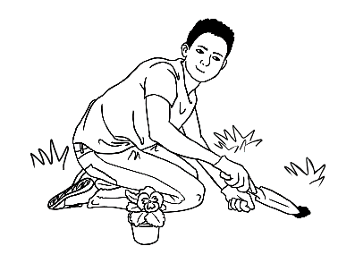 | 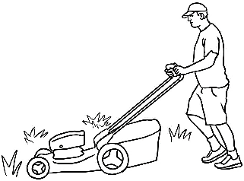 | 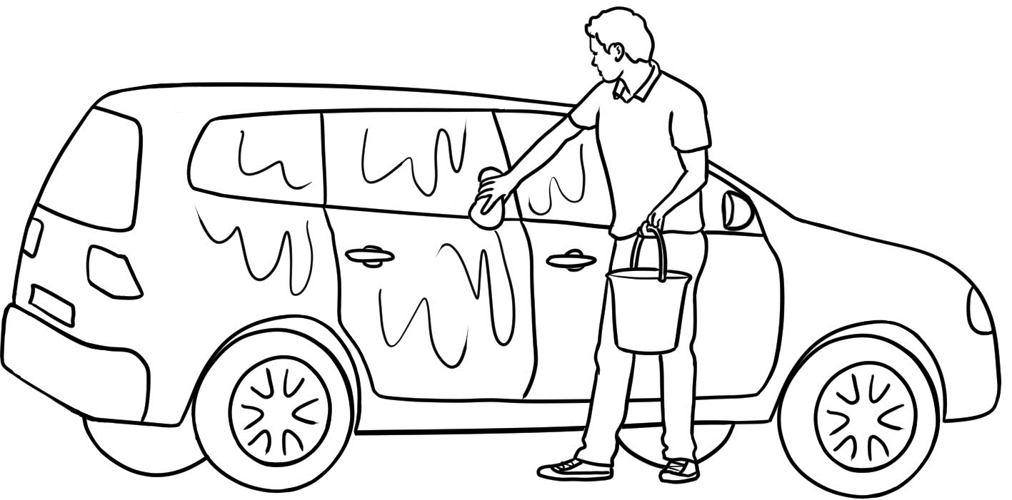
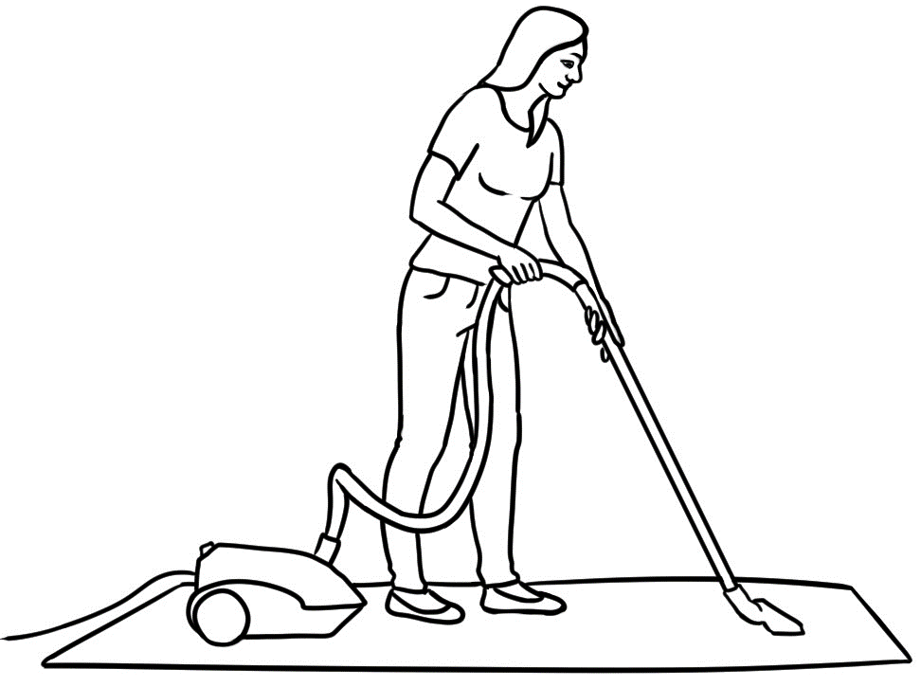 | 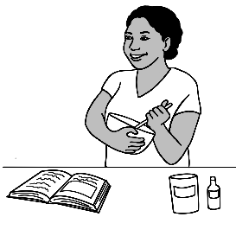 | 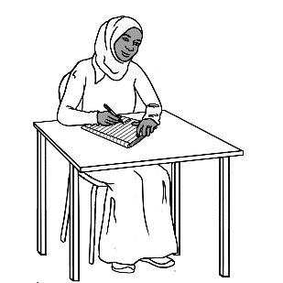
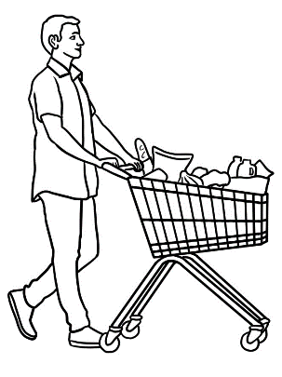 | 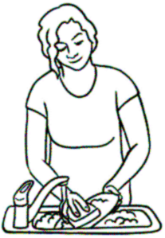 | 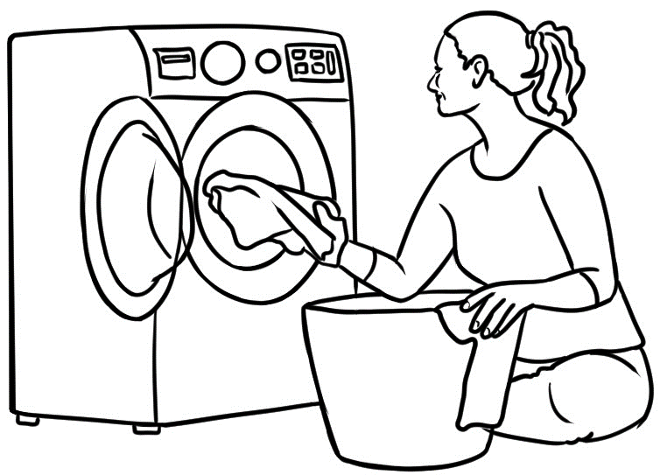
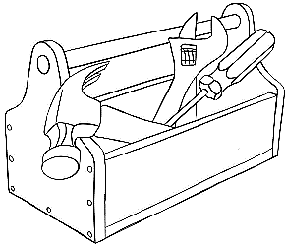 | 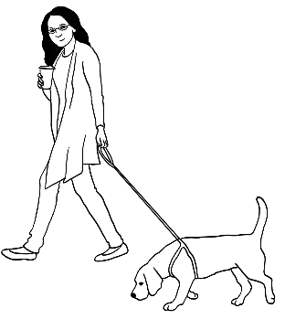 | 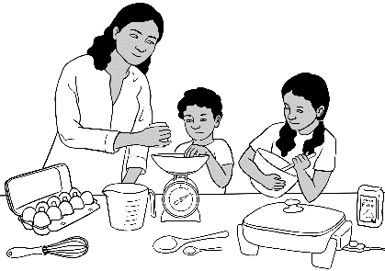

Talk about free time.
- Vocabulary

Show the free time activities on slide show. Once students are familiar with the activities, delay the appearance of the words and encourage students to guess.

- Grammar – Gerunds [A verb form which functions as a noun by adding ing.]
Although gerunds are not taught explicitly at Level 1 in EAL, they are introduced as they are the most natural form to use when talking about free time preferences. The infinitive rather than the gerund can also be used.
e.g. I like to cook.
Note: I enjoy can be substituted for I like, but used only with the gerund.
e.g. I enjoy cooking. NOT I enjoy to cook.

Activity - gerunds and conjunctions and & but
- Cut up the free-time cards on the following pages.
- Students work in pairs with two picture cards.
- Write I like on the board and students create compound sentences about their preferences.
e.g. I like fishing and I like cooking. I like cooking, but I don’t like fishing.
- Students take turns to tell the class about their preferences.
- Swap cards with other students, repeat the exercise and this time students tell the class about their partner’s preferences.
e.g. ______________ likes cooking and she/he likes fishing.
______________ likes cooking, but she/he doesn’t like fishing.
Note: Picture cards in grey are scenarios not introduced in this section of
the student workbook.
- Grammar - Present continuous [for current actions]
Introduce the tense by asking students, ‘What am I doing?’ Do a variety of actions such as sitting, walking, writing etc, and write these actions on the board e.g. I am sitting down. I’m walking. I’m writing. Emphasise that this tense form is used for actions that are happening right now. Write the verb forms on the board including the contraction of the verb to be.
 | I | am | reading. |  | I | ‘m | reading.
 | He | is | reading. |  | He  She  It | ‘s | reading.
 | She
 | It
 | You | are | reading. |  | You  We  They | ‘re | reading.
 | We
 | They

PPT – Free time

Present Continuous [continued]
Activity 1. – What are you doing now?
- Cut up the cards on the following pages.
- Students work in pairs, each with a picture card. They ask each other – What are you doing now?
- Students create sentences using present continuous.
e.g. I’m fishing. I’m going to the park.
- Students take turns to tell the class what they’re doing.
- Swap cards with other students, repeat the exercise and this time students tell the class what their partner’s doing.
e.g. My partner’s swimming.
Activity 2 – Worksheet Where are you going now?
Remove pink teacher direction boxes before printing.

Activity 3 – Chant - Going to the park/beach on a hot day
Use mime to teach parts of the body and the importance of using sunscreen, wearing a hat and being hydrated while outside in the Australian sun. Extend the chant with sunscreen to include other exposed body parts, arms, hands, feet etc.
Activity 4. Present Simple with time markers – Pair work
- Read the model conversation as a class, stressing the words in bold.
- Students work in pairs and
- substitute the words in blue in the model conversation, with activities from the larger table
- select a time marker. Additional time markers could be selected from a list on the board.
When students are familiar with the activity, adverbs of frequency such as always, usually, often, sometimes could also be substituted.

Activity 5. Past Simple with time markers
This activity is a mirror image of Activity 4, but with Past Simple verbs and time markers.

Activity 6 – Lists of verbs covered in the workbook
Use the lists in a variety of ways:
- Call out each verb and students give the past simple form.
- Write the verbs on the board and students call out the Past Simple.
- Use for homework or in class - students write the verbs in Past Simple.

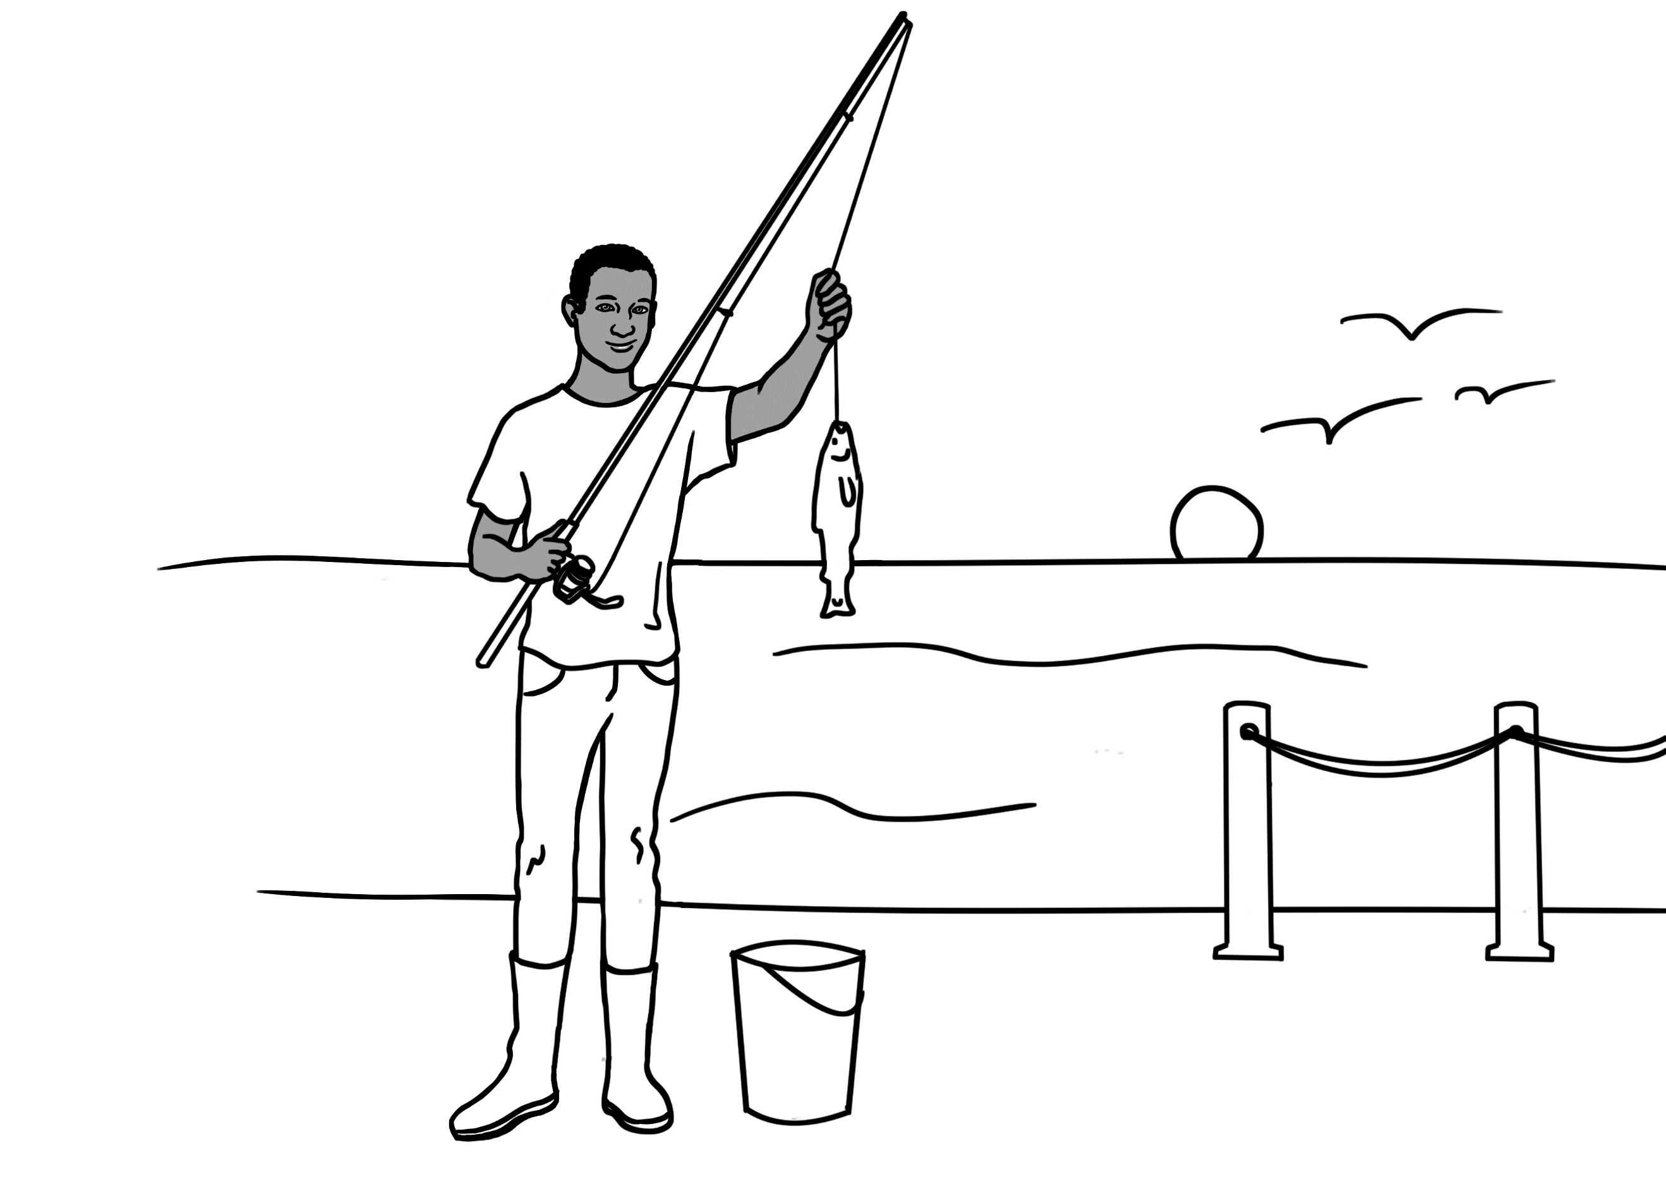 | 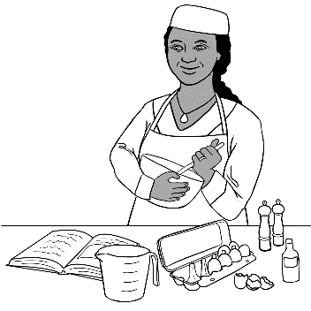 | 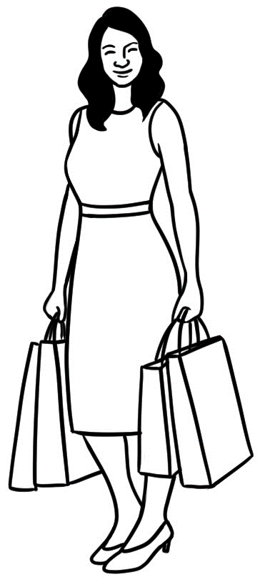
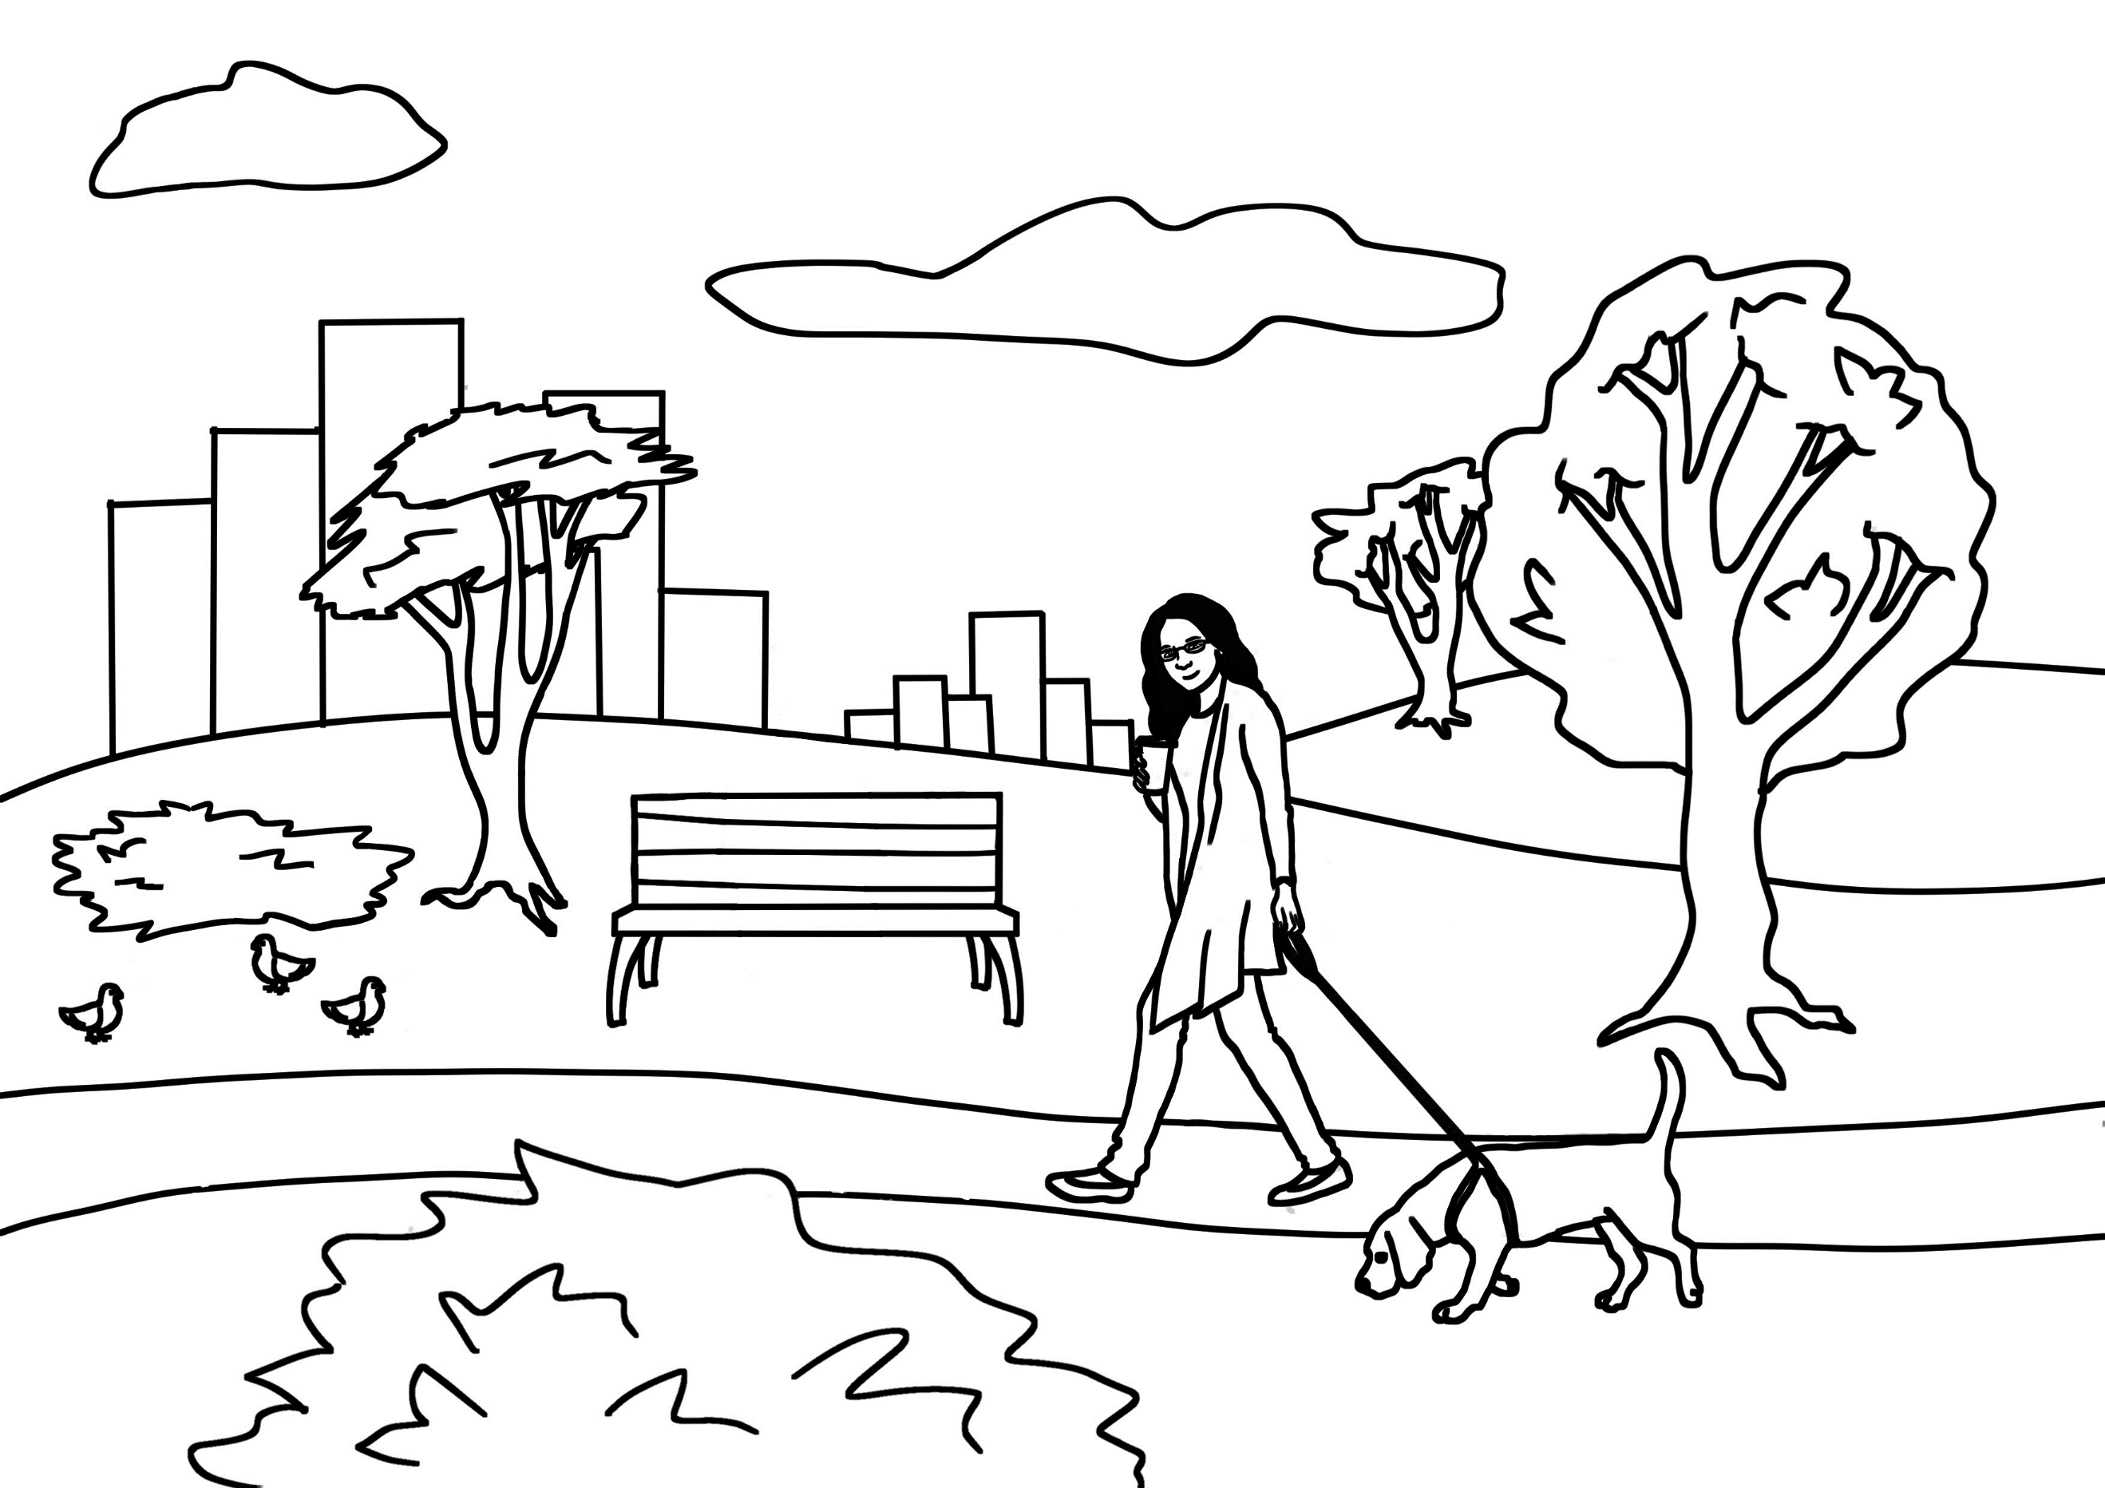 | 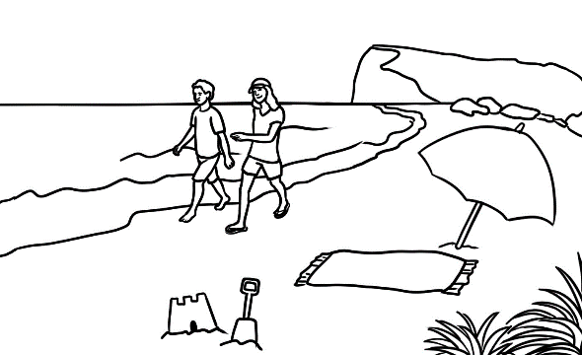 | 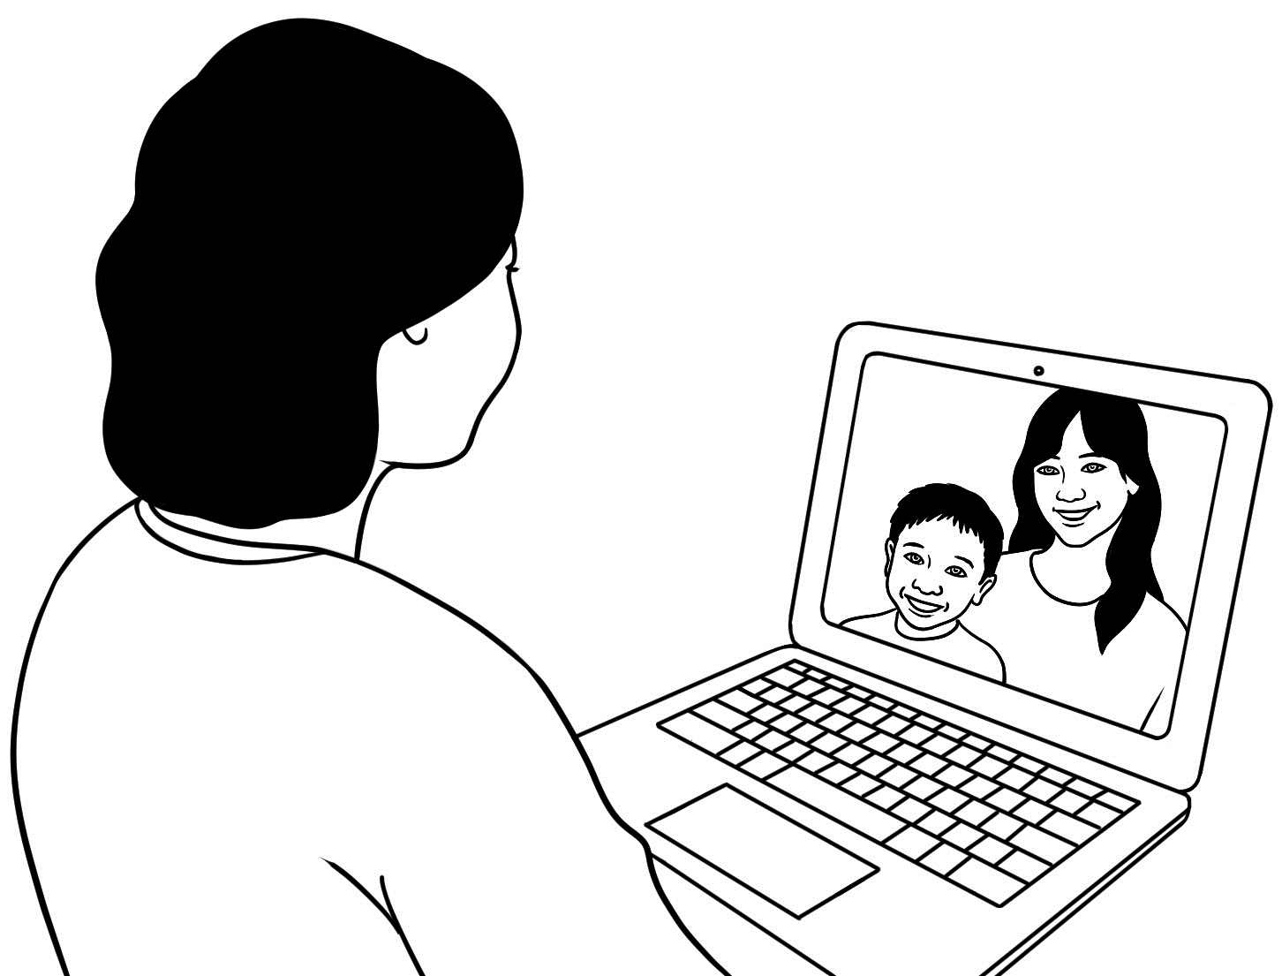
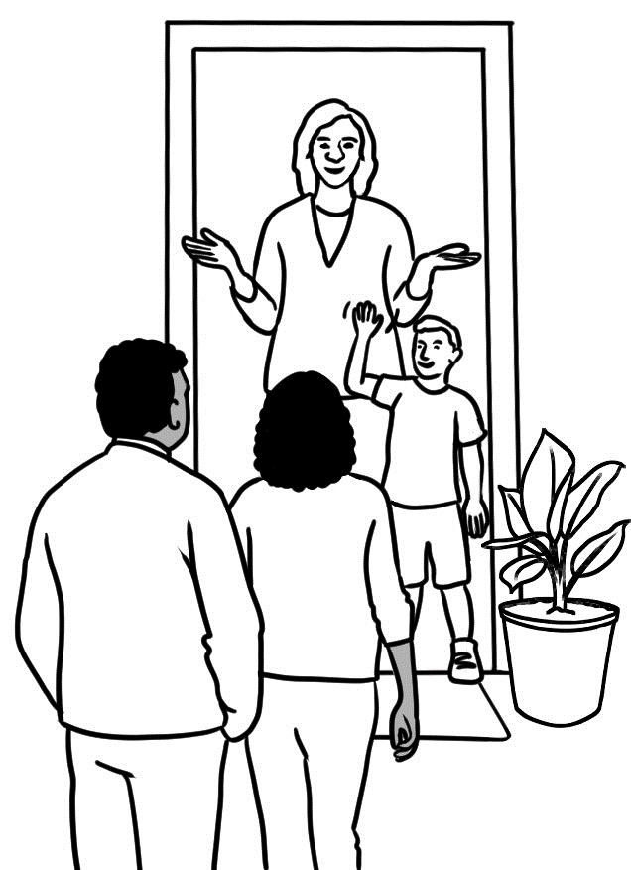 | 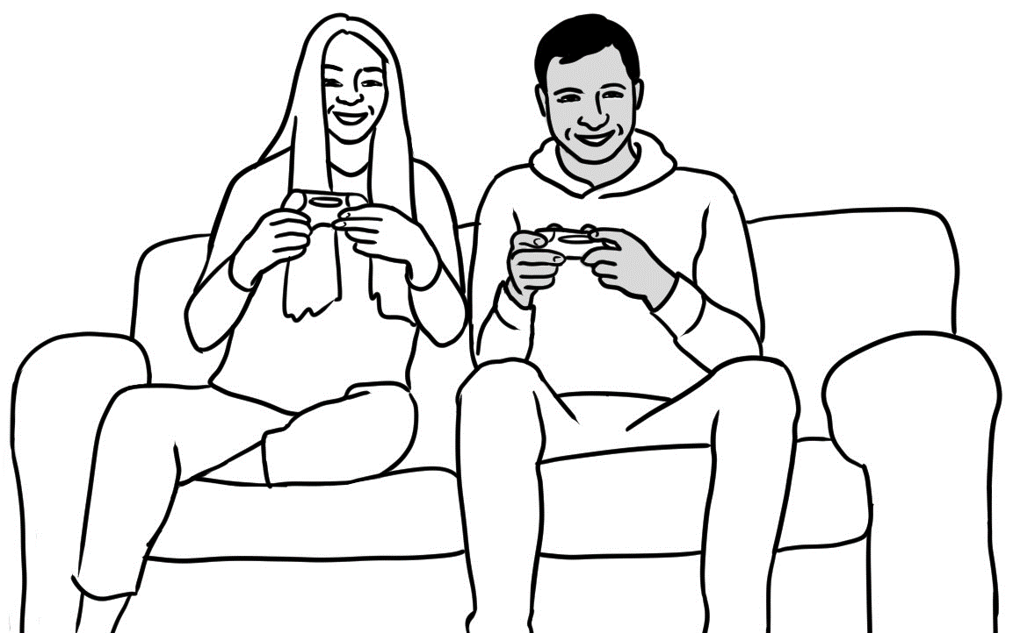 | 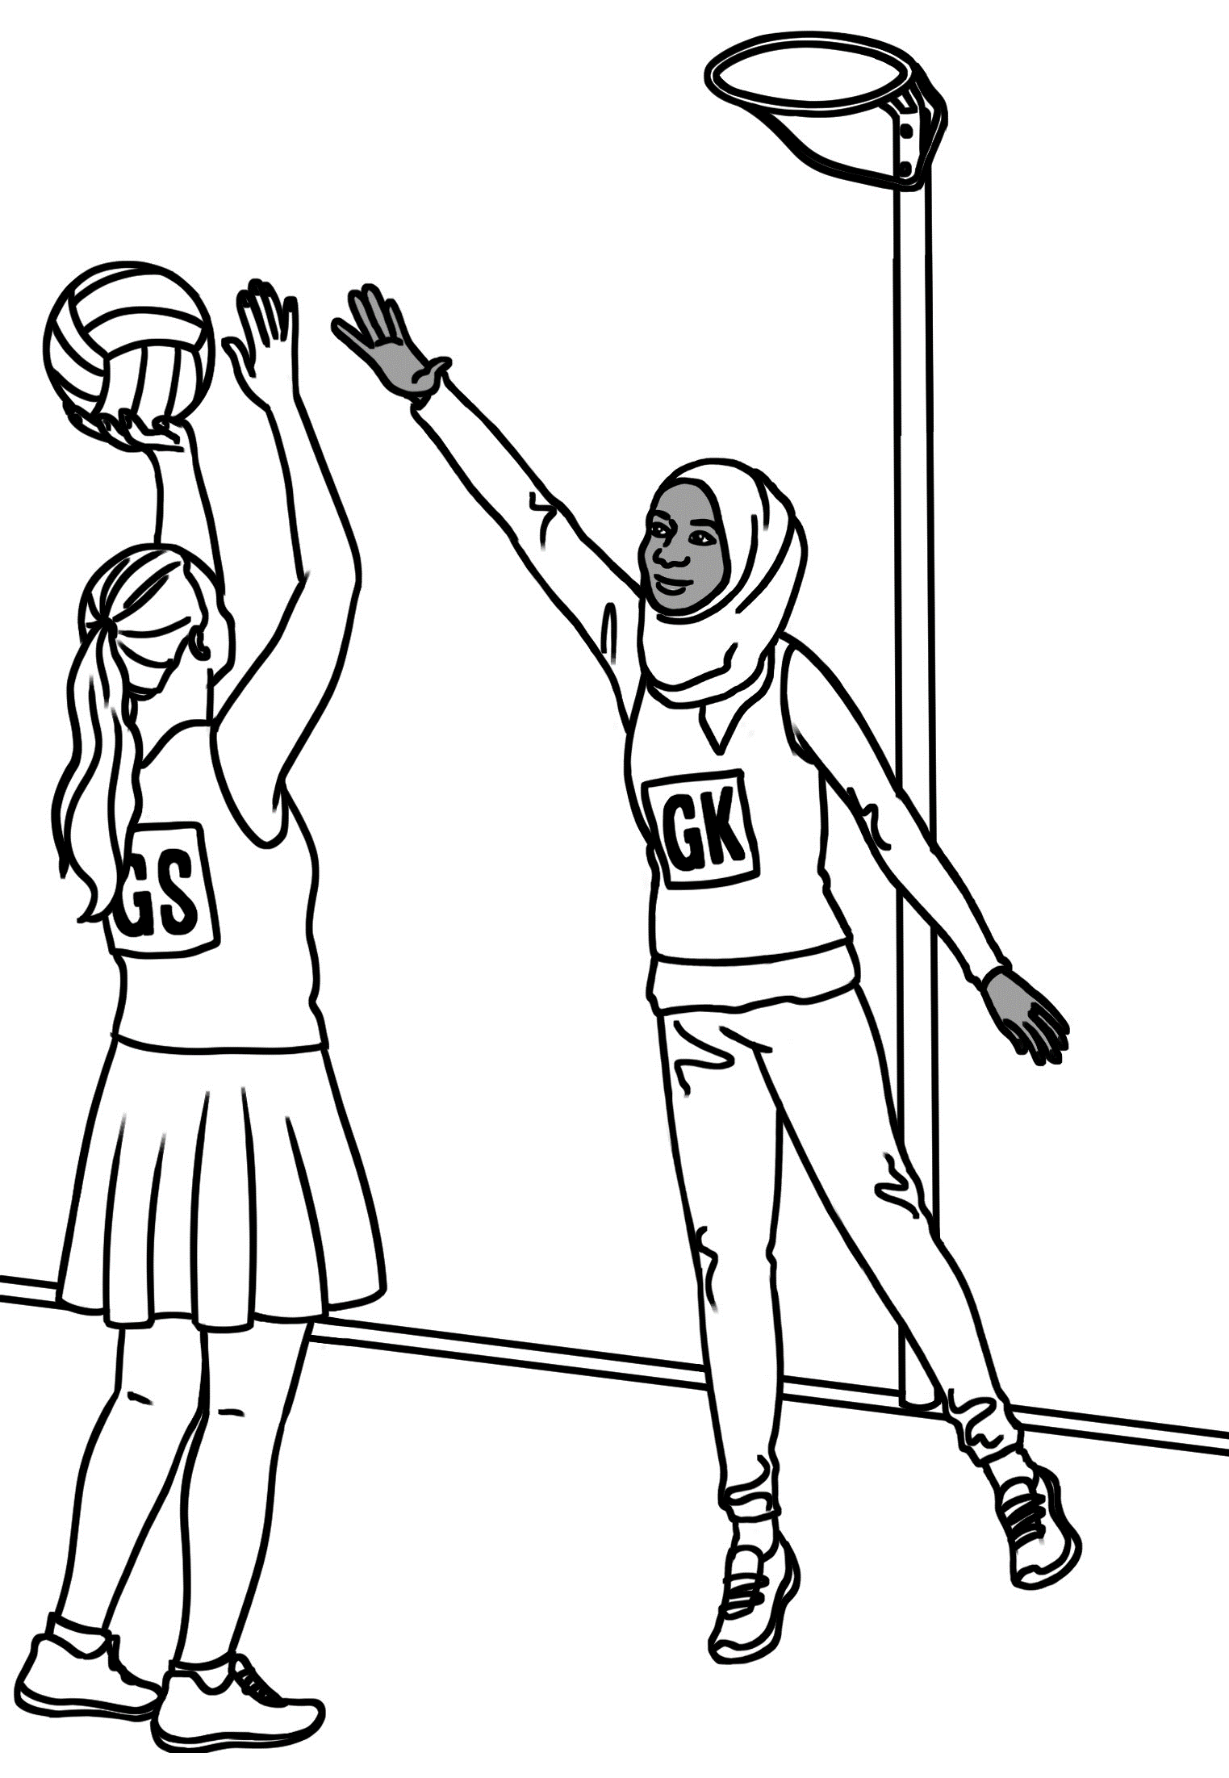
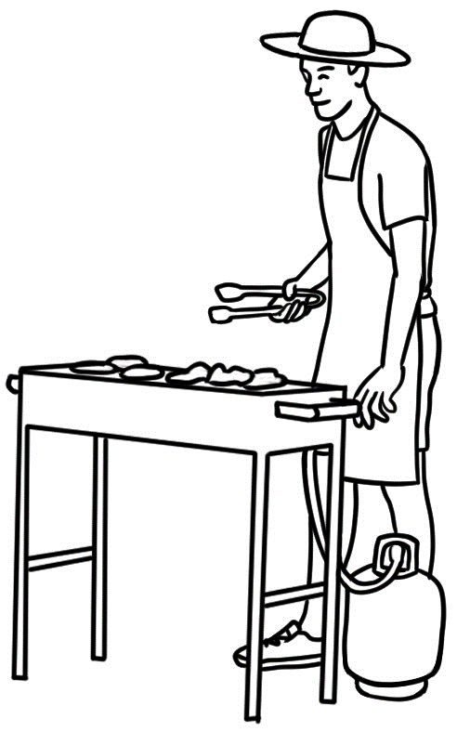 | 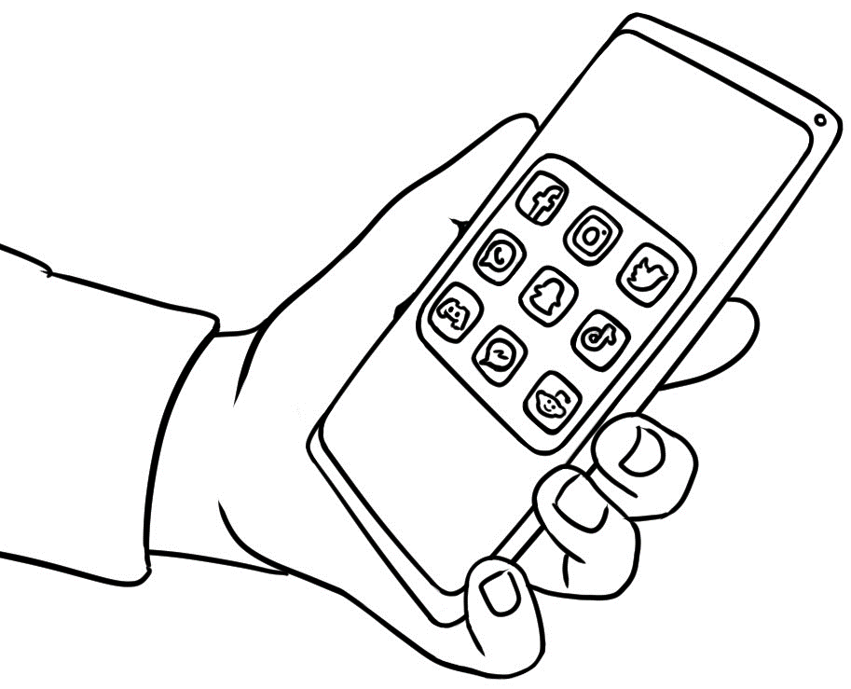 | 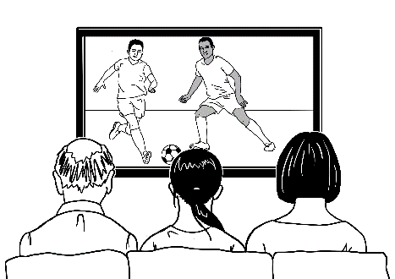

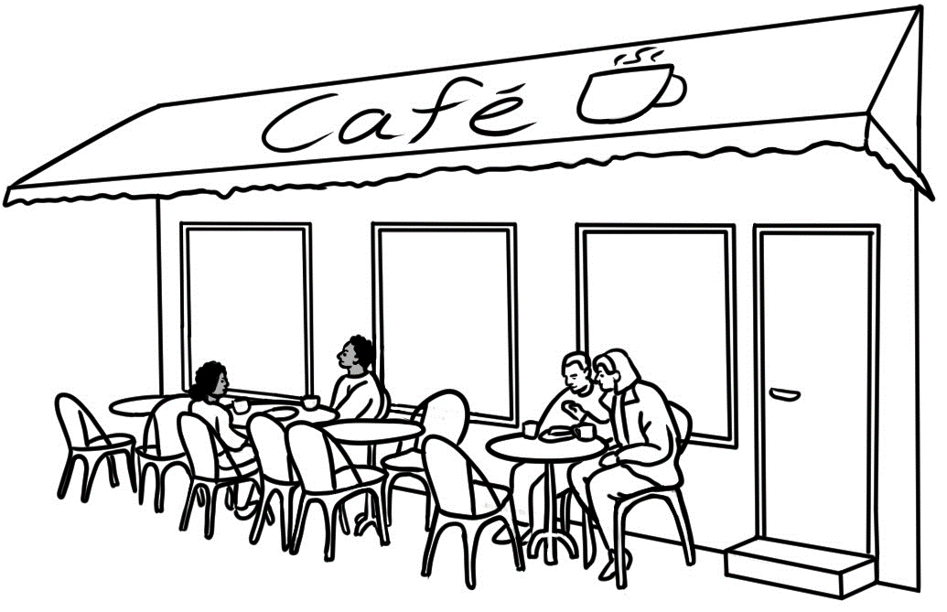 |  | 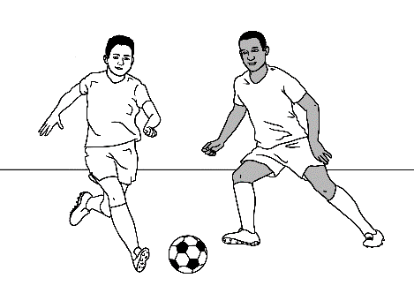
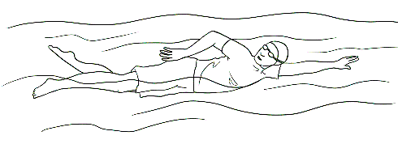 | 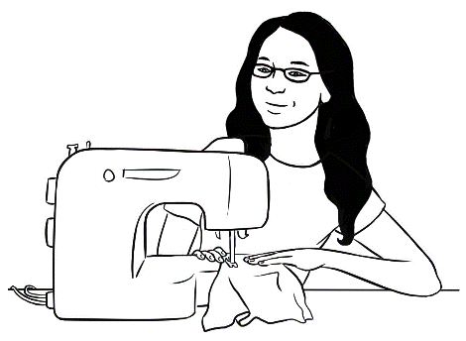 | 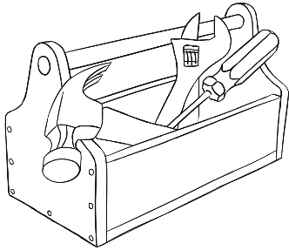
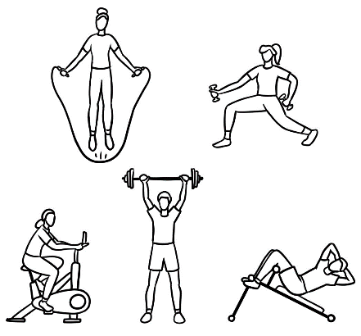 | 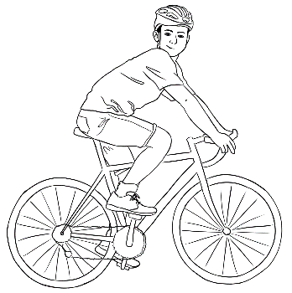 | 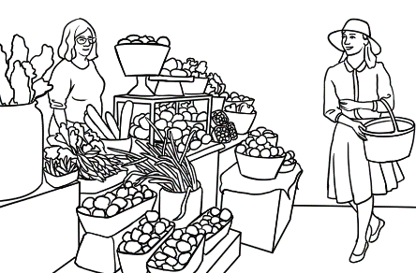
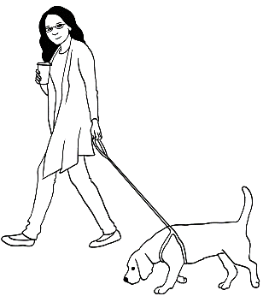 | 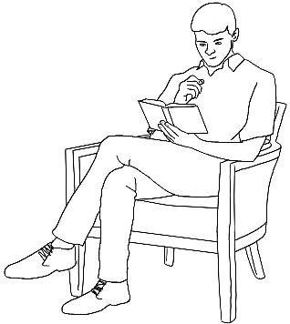 | 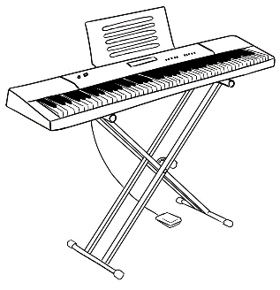

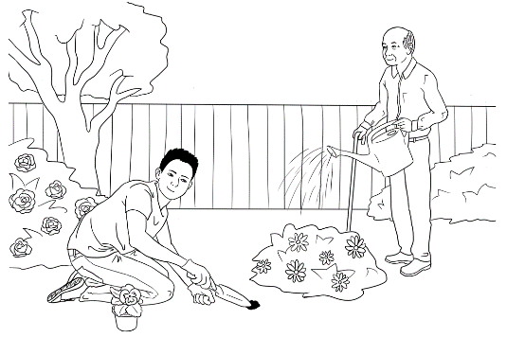 | 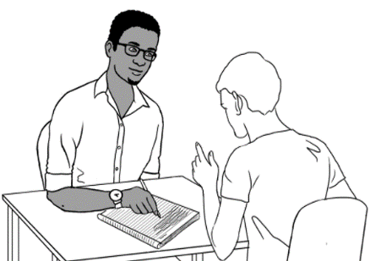 | 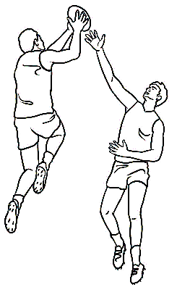
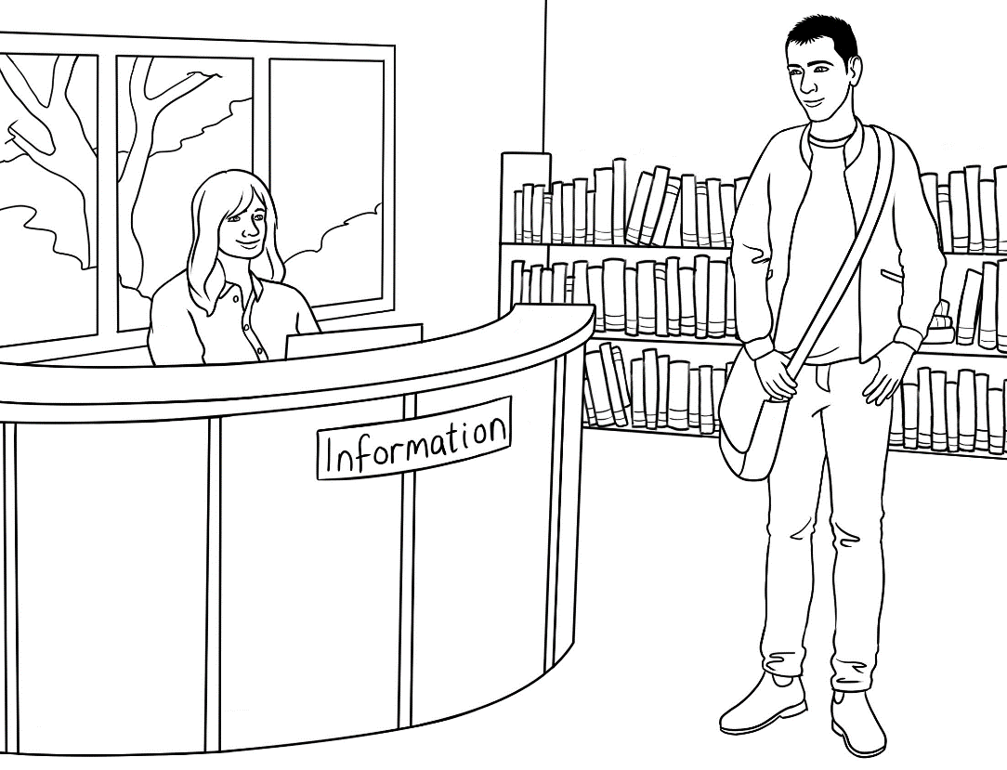 | 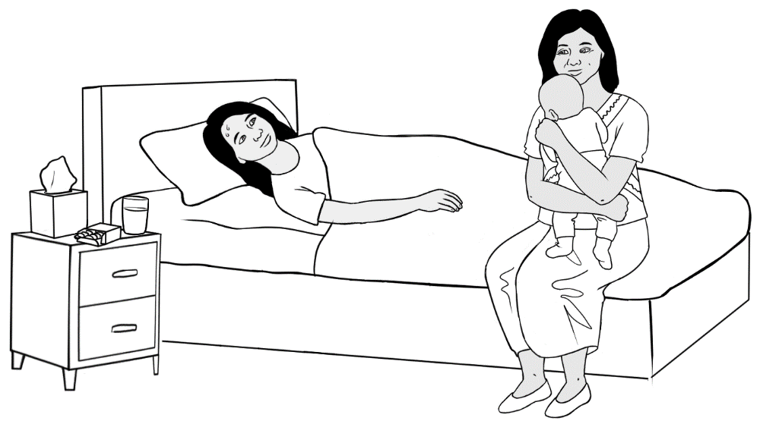 | 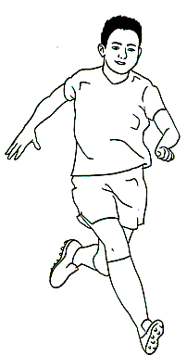
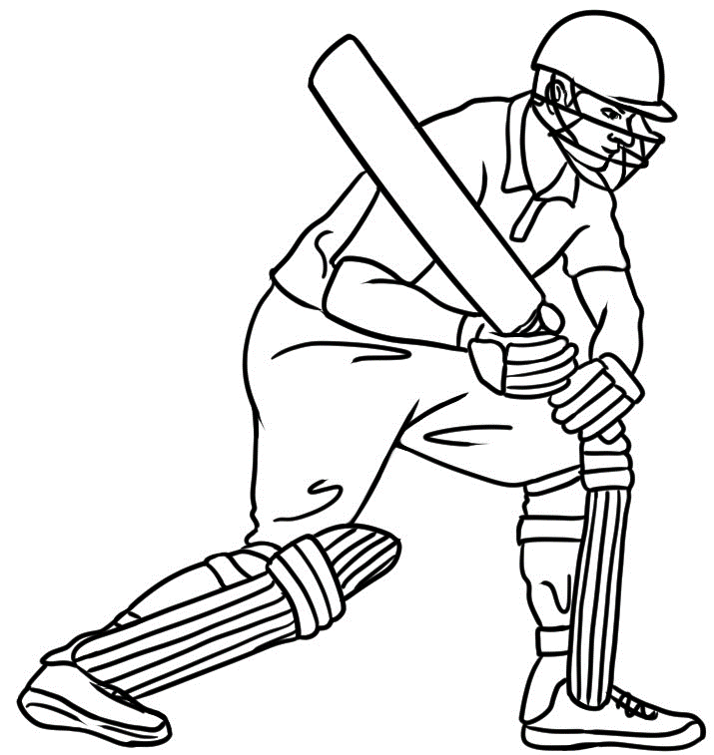 | 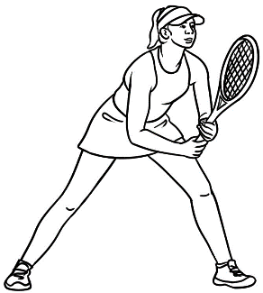 | 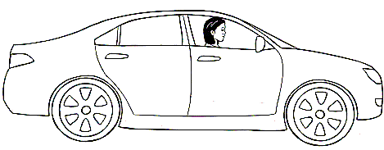
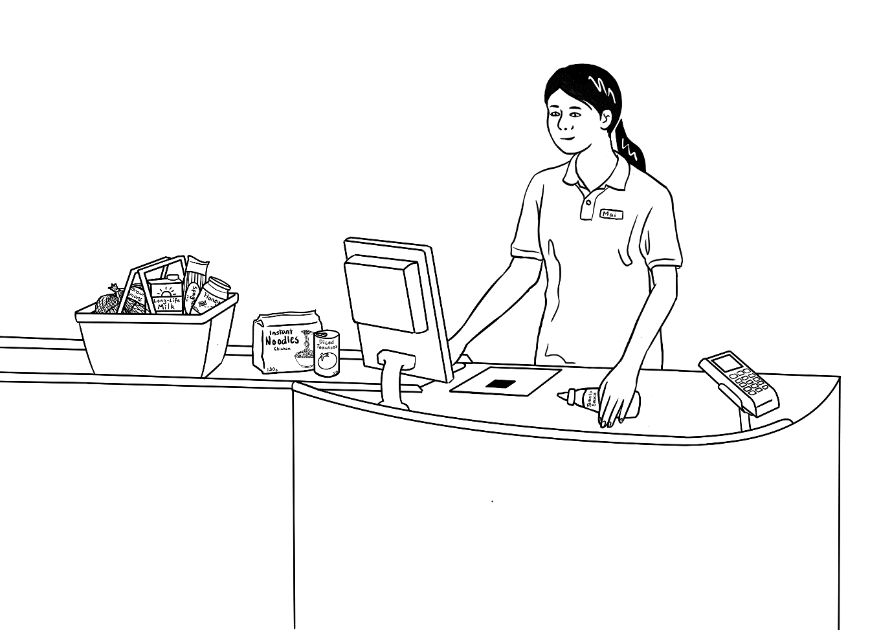 | 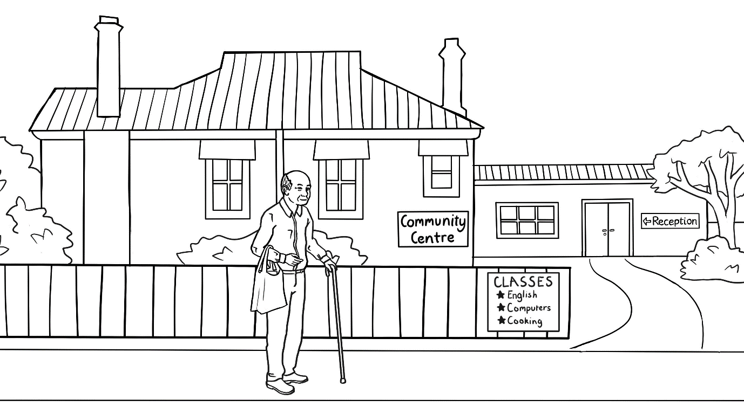 | 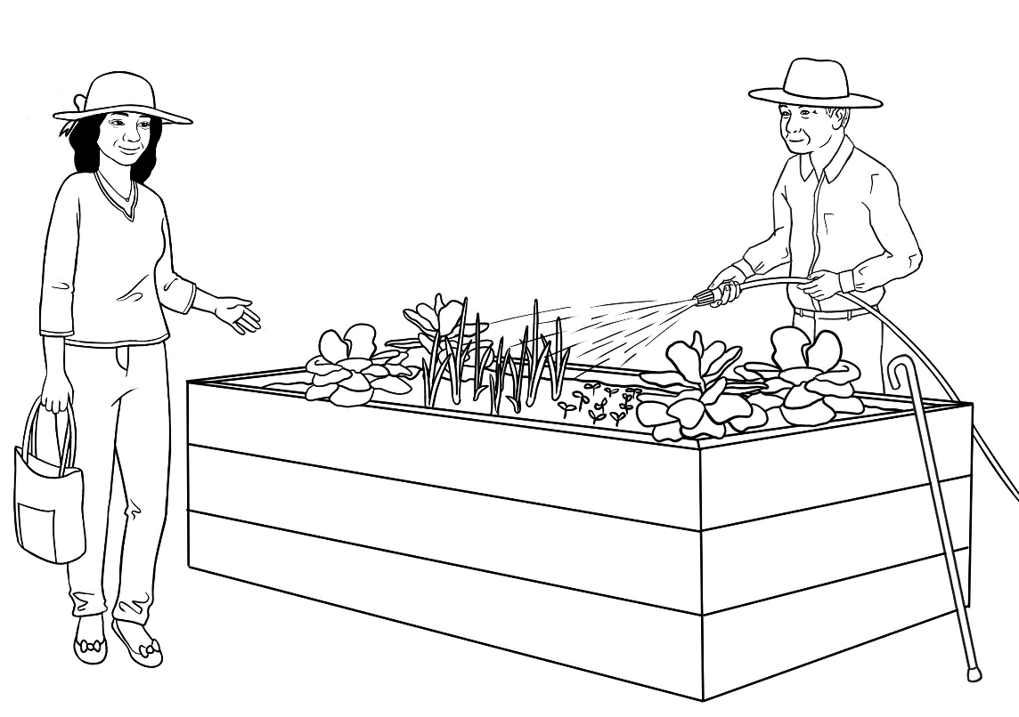

Activity 2 : Present Continuous Worksheet – Where are you going now?

Where are you going now?

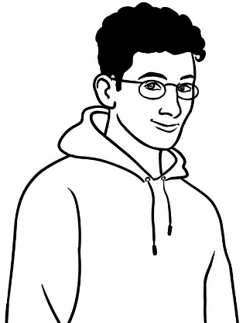
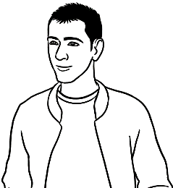
Ahmad | Hi Basam, where are you going?
Basam | I’m going to the park. Wanna come?
Ahmad | Sorry, I can’t. We’re going to  the beach. Come with us.
Basam | Sounds great. OK, thanks, I will.

Long | Short |  | Where?
I am | I’m | going | to the park.  to the beach.  to the city.  to a café.
He is  She is  It is | He’s  She’s  It’s | going | to the park.  to the beach.  to the city.  to a café.
You are  We are  They are | You’re  We’re  They’re | going | to the park.  to the beach.  to the city.  to a café.

Write and say in the short form.
He is
- going to the park.___________________________________________________
She is
- going to the beach. ________________________________________________
We are
- going to the city. _________________________________________________
They are
- going to a café. _________________________________________________

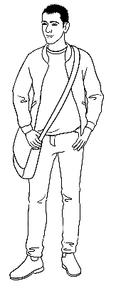

- I’m going home.
- I’m going to the beach.
- I’m going to the gym.
- We’re going to the city.
- We’re going to the market.

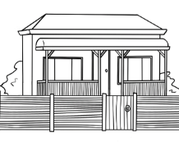

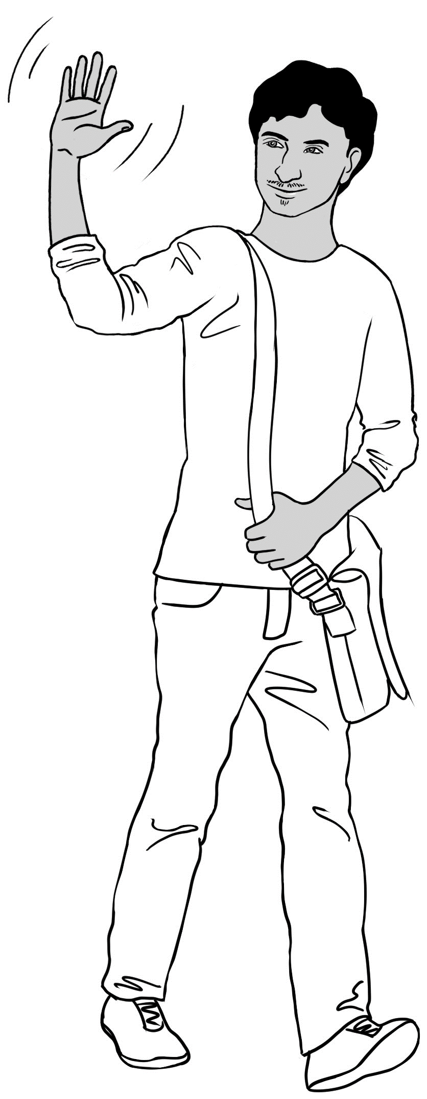
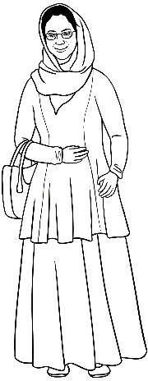
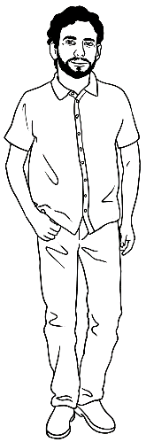
.

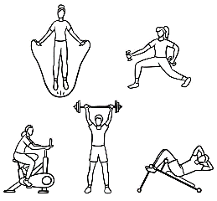

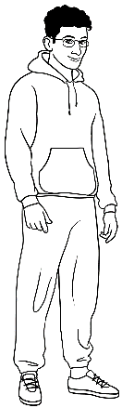
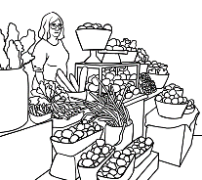

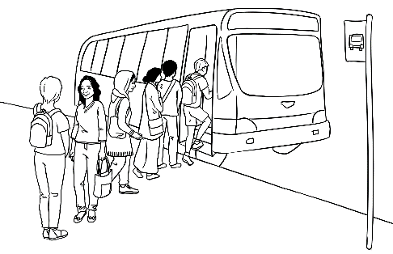

Students orally insert names and places in the gaps.
Student A | Hi _________________, where are you going?  ^{Name}
Student B | I’m going to _____________________. Wanna come?  ^{Where to?}
Student A | Sorry, I can’t. We’re going to _____________________.  ^{Where to?}  Come with us.
Student B | Sounds great. OK, thanks, I will.

Activity 3 – Chant Going to the park/beach on a hot day.
Teacher | Students
We’re going to the park. | We’re going to the park.
Where are we going? | We’re going to the park.
We’re putting on sunscreen. | We’re putting on sunscreen.
What are we doing? | We’re putting on sunscreen.
We’re putting it on our nose. | We’re putting it on our nose.
Where are we putting it? | We’re putting it on our nose.
We’re putting it on our cheeks. | We’re putting it on our cheeks.
Where are we putting it? | We’re putting it on our cheeks.
We’re putting it on our necks. | We’re putting it on our necks.
Where are we putting it? | We’re putting it on our necks.
We’re putting on our hats. | We’re putting on our hats.
What are we doing? | We’re putting on our hats.
Now we’re ready. | Yes, we’re ready.
We’re going, we’re going, we’re going to the park.

Activity 4. Present Simple with time markers
Student A | Student B
What do you do every Saturday? | Every Saturday? I do some shopping.
Every Saturday? | Yes, every Saturday. What do you do?
I go to the library and do some homework. | Mm. Every Saturday?
Yes, every Saturday.

Present Simple

go to the  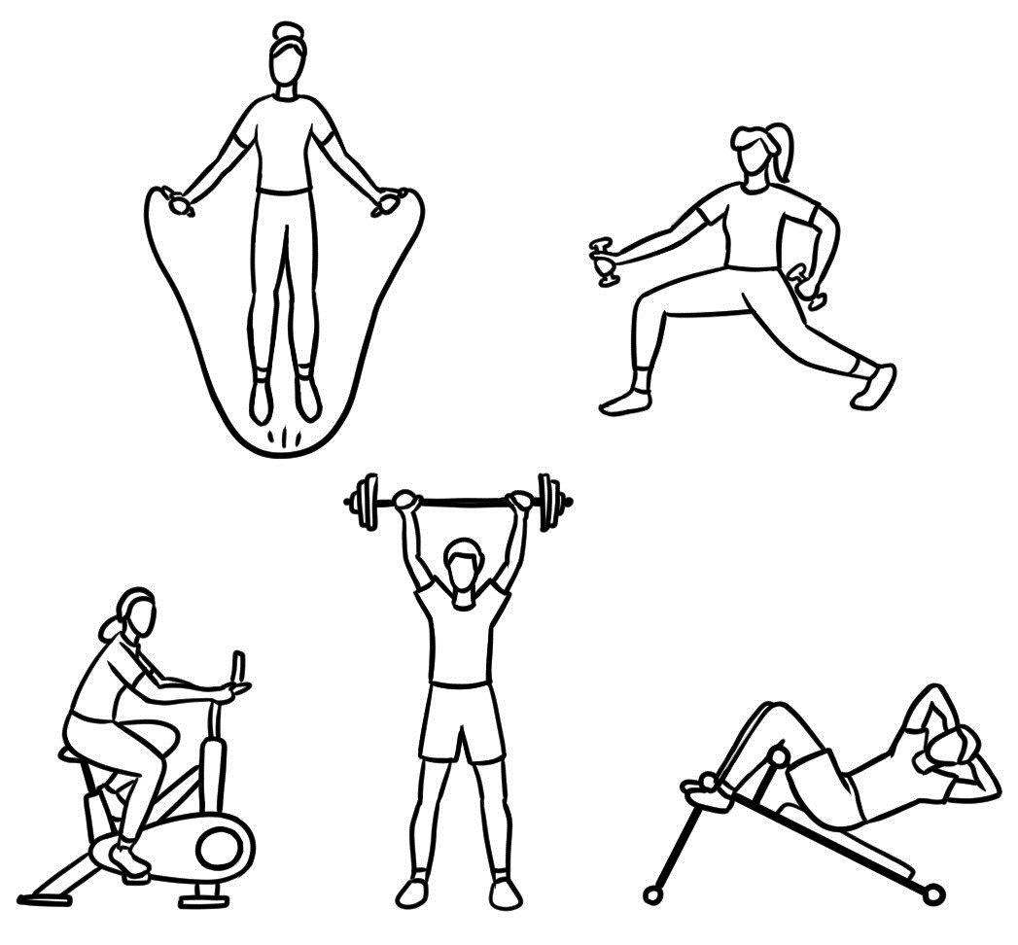 | 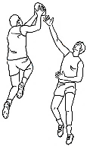  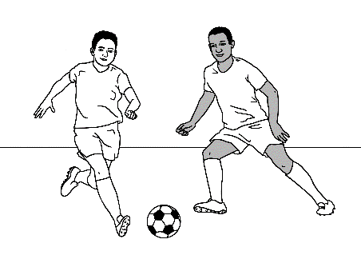  play | 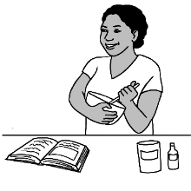  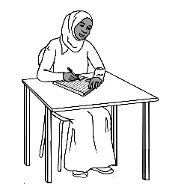  do some | Present Simple  time markers
 |  |  | everyday
 |  |  | every morning
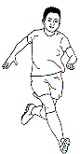  go for a  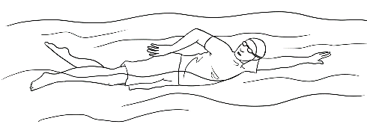  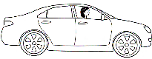 |  |  | every afternoon
 |  |  | every Sunday
 |  |  | every Friday
go to work | play the piano |  | every weekend

Student A | Student B
What did you do last Sunday? | Last Sunday? I went to the gym. What did you do last Sunday?
I went for a bike ride. | That sounds good.
Activity 5. Past Simple with time markers
Past Simple

went to the | played | did some | Past Simple  time markers
 |  |  | last year
 |  |  | this morning
went for a |  |  | yesterday
 |  |  | last week
 |  |  | last friday
went to work | played the piano |  | last weekend

Activity 6 – Verb lists
Irregular Verbs

be | am / is  are | was were | have |  | send
come |  |  | make |  | speak
cut |  |  | meet |  | spell
do |  |  | read |  | tell
drive |  |  | run |  | understand
give |  |  | say |  | write
go |  |  | see

ask |  | help |  | sit
borrow |  | highlight |  | start
chat |  | join |  | talk
circle |  | like |  | tick
clap |  | listen |  | use
clean |  | miss |  | visit
close |  | need |  | walk
cook |  | play |  | want
copy |  | practise |  | wash
enrol |  | record |  | watch
fill |  | repeat |  | water
fix |  | show |  | work
Regular Verbs

Talk about the weather.

- Vocabulary

- Show on slide show. Once students are familiar with the weather icons, delay the appearance of the words and encourage students to guess.
- Extend vocabulary related to weather by gradually introducing some of the words and expressions on the grids below which could be turned into wall charts.
- Pair work worksheet

- Complex sentences with because and so [Past Simple]

Working with a partner, students create complex sentences orally using because [a reason] and so[a result] using positive and negative forms.

PPT – The weather

1b. Vocabulary extension
  sunny | 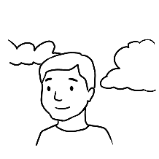  warm | It’s a beautiful day.  It’s fantastic weather.
 | 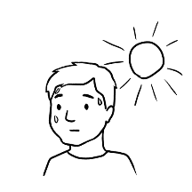  hot | It’s a good day  for the beach.
 | 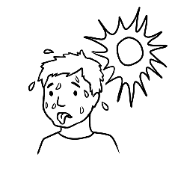  very hot | It’s too hot.  It’s scorching.  It’s boiling.
 |   hot and dry | It’s very dry.

Vocabulary extension - continued
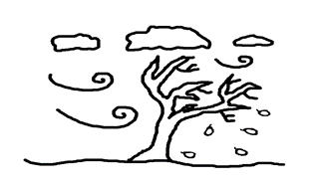  windy | 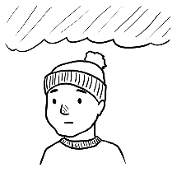  cold | It’s chilly weather.  It’s freezing.  It’s so windy.
 | 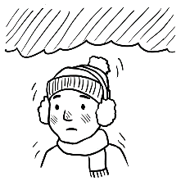  very cold | It’s chilly weather.  It’s freezing.  It’s so windy.
 | hot | It’s too hot and windy.

  cloudy | hot | It looks like rain.  It might rain.
 | cold | It looks like rain.  It might rain.
  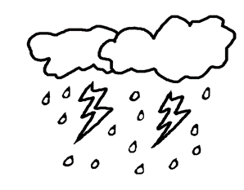  rainy  stormy | cold | It’s wet and cold.  It’s miserable weather.
 | hot | It’s pouring.  It’s very humid.  It’s a wild storm.

1c The weather – Pair work Worksheet
What’s the weather like today?

- What’s the weather like today? | cloudy | warm
It’s cloudy and warm today.
- What’s the weather like today? |   sunny | hot
- What’s the weather like today? |   sunny | very hot
- What’s the weather like today? | rainy windy | cold
- What’s the weather like today? | stormy | very cold
- What’s the weather like today? | rainy | warm

2. Complex sentences with because and so – positive forms
Positive

I went to the park
because it was sunny.
It was sunny
so I went to the park.
.

because |  |  | so
 | 
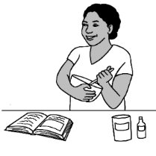

Negative
because |  |  | so
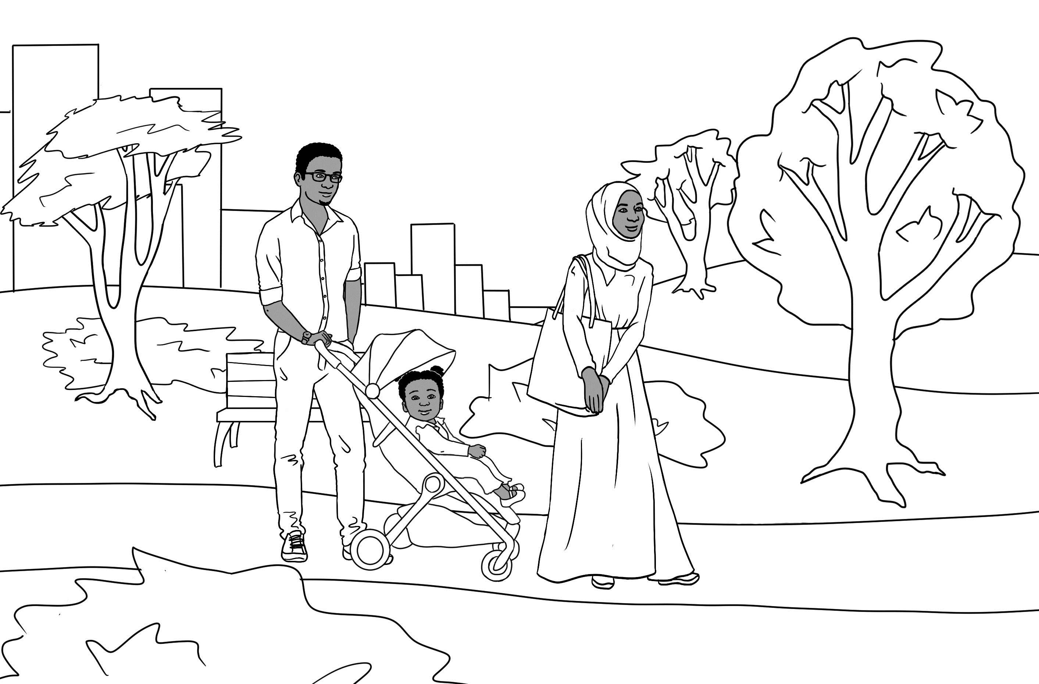
 |  |  |  | 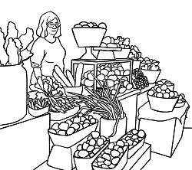

It was rainy so we didn’t go
to the park.
.
We didn’t go to the park
because it was rainy.

Talk about family.

- Vocabulary

Show on slide show about Parwana’s family. Once students are familiar with the family relationships, delay the appearance of the words and encourage students to guess.
- Introduce your family
As some students in the class may have suffered trauma, family loss and separation in their previous homeland or in Australia, there are two options for introducing a family. Students may choose to introduce:
- Sahra’s family
- Their own family
Students can choose the option with which they feel most comfortable. Students who have a photo/s can show a partner and introduce their family members by name and relationship. Students can refer to page 38 in the student workbook to guide them.

PPT - Family

Sahra’s family

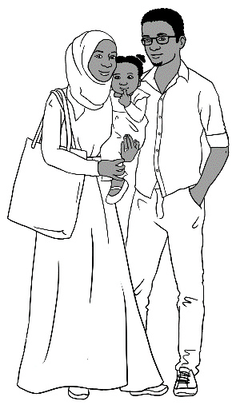
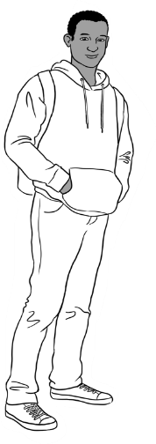
This is my family.

Tahiil
Abdi
Hani
Sarah
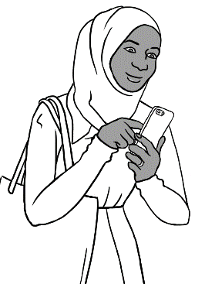

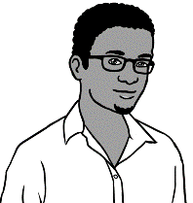
- This is Sahra’s family.
mother
father
husband
wife
daughter
daughter
brother
sister
uncle
- This is her________________________ Tahiil.
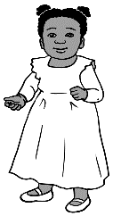
- Sahra is Tahiil’s _____________________.
- This is her__________________________ Hani.
- Sahra is Hani’s _____________________.
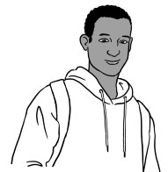
- Tahiil is Hani’s ______________________.
- This is her__________________________ Abdi.
- Sahra is Abdi’s _____________________.
- Abdi is Hani’s ______________________.
- They come from Somalia.

Talk about an excursion.

- Listening to excursion arrangements.

- An excursion to the market - Excursion #1 Listening
This exercise needs to be completed before reading about the excursion in Section 11 in the Student Workbook.
- Students need to read the listening questions together.
- The teacher reads each sentence slowly allowing time for students to circle the correct answer.

- An excursion to the beach - Excursion #2 Listening
This is a similar exercise to the one above with, but with different details and students need to write their answers in the spaces. Dictate each sentence slowly and allow time for students to circle the correct answer on the answer sheet.
- An excursion to the gardens - Excursion #3 – Information gap pair-work
- Practise the questions students will need to ask to find the missing information on their table.
- Student A needs to write four answers in the yellow boxes and Student B needs to write their answers in the blue boxes.

- Vocabulary
Show on slide show. Once students are familiar with the details about the excursion, delay the appearance of the sentences and encourage students to guess.

1a An excursion to the market - Excursion #1 - Listening
Teacher Sheet - Read the sentences.
- Next week, we’re going on an excursion to the market.
- We’re going on Tuesday 5 September.
- We’ll meet at the bus stop.
- We’ll meet there at 9:30am.
- The bus ticket will cost $5.50.
- We’ll come back at 1:00pm.
- Bring a drink bottle and a hat.
- If you can’t come on the day, please phone me on 0400 789 651.

Excursion #1
1 | Where are you going? | to the museum | to the market | to the city
2 | When are you going? | on Thursday  5 September | on Tuesday  15 September | on Tuesday  5 September
3 | Where do you meet? | at the bus stop | at the train station | at TAFE
4 | What time do you meet? | at 8:00 | at 8:30 | at 9:30
5 | What will it cost? | $5.15 | $5.50 | $5.55
6 | What time do you  come back? | at 11:00 | at 12:00 | at 1:00
7 | What do you bring? | a drink bottle and lunch | a drink bottle and hat | a drink bottle and coat
8 | What number do you call if you can’t come? | 0400 789 652 | 0400 786 951 | - 651

1b An excursion to the beach - Excursion #2 Listening
Teacher Sheet - Read the sentences.
- Next month we’re going on an excursion to the beach.
- We’re going on Monday, 25 November.
- We’re going by train.
- We’ll meet at the station.
- We’ll meet there at 8:45am.
- It’ll cost $7.00.
- We will be back at 2pm.
- Bring a drink bottle, lunch, sunscreen and a hat.
- If you want to swim, bring bathers and a towel.
- If you swim, swim between the flags.

Excursion #2
train | $7.00 | the beach | a hat
2pm | bathers | sunscreen | the flags
8:45am | 25 November | a towel | the station

- Where are we going for our excursion? to ________________________
- When are we going? on Monday________________________
- How are we going? by ________________________
- Where will we meet? at ________________________
- What time will we meet? at __________________
- How much will it cost? ______________________
- What time will we be back? at _______________________
- What do I need to bring? a drink bottle, ________________________,
lunch and ___________________
- If I want to swim, what do I bring? ______________ and _________________
- Where must I swim? between ________________________

1c. An excursion to the gardens - Excursion #3 – Information gap pair-work
A
Where are we going?
Can you spell it please?
1 | Where are we going?
2 | When are we going? | 30 September
3 | How will we get there?
4 | Where do we meet? | classroom
5 | What time do we meet?
6 | How much will it cost? | nothing
7 | When do we come back?
8 | What do we bring? | Food to share

B
To the gardens.
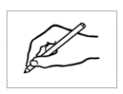
1 | Where are we going? | to the gardens
2 | When are we going?
3 | How will we get there? | walk
4 | Where do we meet?
5 | What time do we meet? | 12:00
6 | How much will it cost?
7 | When do we come back? | 3:00
8 | What do we bring?
G – A – R – D – E – N - S

Talk about sport.
- Vocabulary

Talking about sport is an easy way into a conversation in Australia.
This section focuses on five of the most popular sports. Show the PPT
about the five most popular sports on slide show and encourage students
to guess each sport before the word appears.

- Survey – What’s the most popular sport? –group work
This survey introduces alternative answers to yes/no - adverbs of frequency sometimes and never. It also includes every week, a common time marker for Present Simple.
- Print a survey for each student and practise the questions and answers.
- Groups of 4 work best as students can work in pairs then swap partners.
- Each student answers the questions about themselves, putting a tick for a positive answer or a cross for a negative one.
- They then interview each student in the group.
- Once the survey is completed, the results could be recorded on the board to identify the most popular sport.

PPT – Sport

2. Survey
What’s the most popular sport?
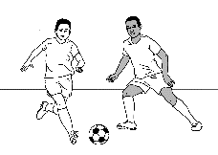
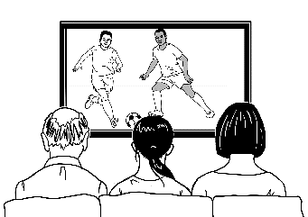
Question Answer
Do you play soccer?
Do you watch soccer?
Yes, sometimes.
No, I don’t.
Yes, every week.
No, never.

X

Do you | play |  | watch | play | watch | play | watch | play | watch | play | watch
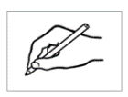  Student name | 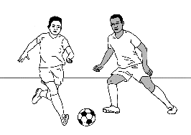  soccer? |  |  | 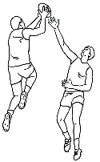  footy? |  | 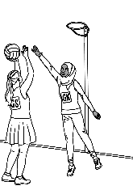  netball? |  | 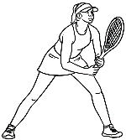  tennis? |  | 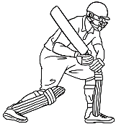  tennis?
You

Talk about the weekend.
- Conversation structure – Wall chart
Create a wall chart with greetings, topics and closing. Add to it as new vocabulary and topics are introduced.

- A listening cloze exercise in graded levels
The cloze exercises on pages 73 - 76 extend the first conversation in Section 13 in the student workbook. Most classes have a range of levels, but it is possible to do the same activity with all students by using graded worksheets. The answers can be folded under or be referred to.
Once the activity is complete, higher-level students correct their own work.
Allowing students to determine their own level builds both skills and confidence. The difference in the levels:

- Level A: Font size 16. First sounds only missing.
- Level B: The letters missing are easy to hear.
- Level C: The dashes for each letter in the word support the learner.
- Level D: There are no supports for this level.

- Listening to a conversation
- Cloze
- Students fold the words for the cloze and listen.
- The teacher reads the full conversation on page 78.
- Read it again and pause before the missing words and elicit these.
- Students unfold the missing word list and complete the cloze.
- Read in pairs and role play similar conversations.
- Sequence a conversation
- Cut up the strips.
- Sequence as the conversation is read slowly.

- Chant about the weekend – Fishing
Chants are a helpful way to remember collocations, grammar forms, pronunciation and word stress. Chants can be spoken in a number of ways:
- Teacher / student
- Two teams of students – Team A is Ahmad; Team B is Basam
- Students in pairs.

- Conversation – Wall Chart
- Greetings | Good morning  Good afternoon  Hello  Hi  Hi. How are you?  Fine thanks. And you?
- Topics | Free time  The weather  Family  Weekend activities  Sport
- End  the conversation | Nice to see you.  I’ve got to go. [Gotta go]  See you later. [See ya]  Bye for now.  Bye

- A listening cloze exercise in graded levels – Level A
Basam | Hi Amina. How are __ou?
Amina | Good __ __ anks Basam. And you?
Basam | I’m __ ine thanks. How was your weekend?
Amina | It was busy. We __ ent to the beach  on Sunday because it was so __ ot.
Basam | Yes. It was really hot. Did you __ ake  the grandchildren?
Amina | Yes we did. The children __ oved playing  in the water and on the __ and.  Did you __ ave a busy weekend?
Basam | No. it was __ ery quiet.  Oh, look at the __ ime.
Amina | Oh yes. It’s time for __ __ ass. Let’s hurry.

Fold
Check your answers.
you | thanks | fine | went
hot | take | loved | sand
have | very | time | class

2. A listening cloze exercise in graded levels – Level B
Basam | Hi Amina. How a _ e you?
Amina | Good _ _ ank _ Basam. And you?
Basam | I’m _ _ _ e thanks. How was your weekend?
Amina | It was busy. We _ _ _ _ to the beach  on Sunday because it was so _ _ _.
Basam | Yes. It was really hot. Did you _ _ _ e  the grandchildren?
Amina | Yes we did. The children _ o _ e _ playing  in the water and on the _ _ _ _  Did you _ a _ e a busy weekend?
Basam | No. it was _ e _ y quiet. Oh, look at the _ _ _ e.
Amina | Oh yes. It’s time for _ _ ass . Let’s hurry.

Fold

are | thanks | fine | went
hot | take | loved | sand
have | very | time | class
Check your answers.

2. A listening cloze exercise in graded levels – Level C
Basam | Hi Amina. How _ _ _ you?
Amina | Good _ _ _ _ _ _ Basam. And you?
Basam | I’m _ _ _ _ thanks. How was your weekend?
Amina | It was busy. We _ _ _ _ to the beach  on Sunday because it was so _ _ _.
Basam | Yes. It was really hot. Did you _ _ _ _  the grandchildren?
Amina | Yes we did. The children _ _ _ _ _ playing  in the water and on the _ _ _ _  Did you _ _ _ _ a busy weekend?
Basam | No. it was _ _ _ _ quiet. Oh, look at the _ _ _ _.
Amina | Oh yes. It’s time for _ _ _ _ _ . Let’s hurry.

Fold

Check your answers
are | thanks | fine | went
hot | take | loved | sand
have | very | time | class

2. A listening cloze exercise in graded levels – Level D
Basam | Hi Amina. How ______ you?
Amina | Good ________ Basam. And you?
Basam | I’m ________thanks. How was your weekend?
Amina | It was busy. We _________ to the beach  on Sunday because it was so _________
Basam | Yes. It was really hot. Did you _______  the grandchildren?
Amina | Yes we did. The children _________ playing  in the water and on the __________  Did you _________ a busy weekend?
Basam | No. it was ______ quiet. Oh, look at the _______
Amina | Oh yes. It’s time for ____________ Let’s hurry.

Fold

are | thanks | fine | went
hot | take | loved | sand
have | very | time | class
Check your answers

3. Listening to a conversation
On Monday before class

Wendy | Hi Linh. _________ are you going? |  | fine  weekend  How  Good  ready  shopping  lunch  table  netball  help dinner  love
Linh | _________ thanks. How are you Wendy?
Wendy | I’m ________ thanks. What did you get up to  on the ______________ ?
Linh | I went ____________ and met some friends  for ________. What did you do Wendy?
Wendy | I played _________ and went out for ________  on Saturday.
Linh | That sounds nice.
Wendy | Yes, it was. Excuse me Linh. I need to  get _________ for class. Could you _____ me?
Linh | Yes, I’d _________ to.
Wendy | Thank you. We need to move this ________ .

3. Sequence a conversation
Linh | Oh nice.
Ko | Hi Linh.
Linh | Did you have a good weekend?
Ko | Yes, we sat on the grass near the lake.
Linh | We had a very quiet weekend at home.
Ko | Oh, here’s Wendy. Let’s go back to class.
Linh | Yes.
Ko | We had lunch, watched the ducks and  relaxed. What about you?
Linh | Hello Ko.
Ko | Yes. I went to the park with my family.
Linh | It was a beautiful day.

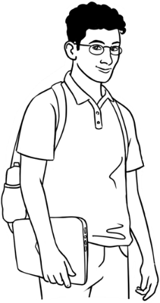
4. Chant about the weekend - Fishing
Hi Basam. | Hi Ahmad.
What did you do on Sunday? | I went fishing.
Where did you go? | I went to the beach.
What did you take? | I took my bag.
Uh huh. | I took my fishing rod.
Uh huh. | I took some food.
Good idea. | I took my water bottle.
Uh huh. | I put on my runners.
Uh huh. | I put on some sunscreen.
Uh huh. | I put on my sunglasses.
Uh huh. | I put on my hat.
Uh huh. | I put on my safety vest.
Great. | Then I went fishing.
Did you catch a fish? | Nothing.
Nothing? | Not one fish.
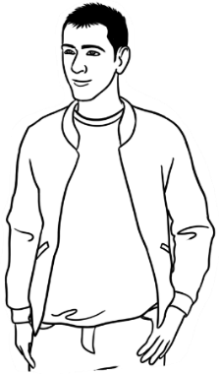

What will you buy?

- Vocabulary

Show all the clothing on slide show. Once students are familiar with the clothes, delay the appearance of the sentences and encourage students to guess.
Focus on the use of the indefinite article and introduce a pair of for the jeans, shoes etc

- Items that come in pairs
- Hold up a pair of scissors and say I have a pair of scissors.
Explain that much of our clothing comes in pairs, as many parts of our bodies are duplicated. e.g. arms, legs
- The worksheet on page 82 could be projected before students match
the items of clothing.
- Working in pairs, students take turns to ask their partner questions about what they are wearing. e.g. Are you wearing a pair of socks? Their partner points to the corresponding drawing on their worksheet and answers.

- Clothing Games for fun and light relief
For these games, you need a wide range of:
- clothing pictures out of catalogues or magazines
- cardboard cut-out doll clothes
- second-hand clothes. *
Game 1 – Dress an imaginary person
- Before starting the game, ask a number of students to stand and identify a piece of clothing they are wearing.
- Pick up pictures/items of clothing for students to name.
- Students form two teams. [Limit the numbers in each team to make the game manageable] Each team will dress an imaginary person.
- Call out an item of clothing e.g. a long-sleeved shirt. All the students then chant a long-sleeved shirt, a long-sleeved shirt etc.
[It’s important to include the indefinite article before each noun.]
- A student from each team runs to grab the picture/item and lay it on the ‘person’. Continue in this way until the ‘person’ is fully dressed.
- When students are more familiar with the game, call out a list of items e.g. a cap, a t-shirt, a pair of shoes and the students chant a cap, a t-shirt, a pair of shoes, a cap, a t-shirt, a pair of shoes etc

PPT - Clothing

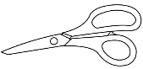

*Note: Some students may not be comfortable handling second-hand clothes.

Game 2 - Clothing and weather
Make sure you have pictures/items of clothing for all weathers including warm hats, summer hats, scarves, raincoats, umbrellas, sandals, boots, long-sleeved and short-sleeved shirts etc. Describe the weather and the teams must select what their character will wear.
Note: The topic of clothing lends itself to the Present Continuous tense.
e.g. I’m/He’s wearing a pair of jeans and a t-shirt.

4. Pair work - Information gap
This activity practises singular and plural nouns and pairs of items. Students should use the indefinite article before singular nouns.
- Students work in pairs and it’s important they don’t show their worksheet to their partner.
Student A asks questions in the rows with stars - 1, 3, 5
Student B asks questions in the rows with dots – 2, 4, 6

- Demonstrate the activity, by doing A1 and A2 together. Students answer the question, e.g. in A1, both students have two t-shirts, so they tick the A1 box. In A2, the students have different items of clothing, so cross the A2 box.
- Students ask questions of the whole row and then swap roles.
- The final tally should be 9 the same and 9 different.

2. Items that come in pairs
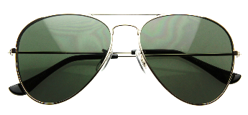
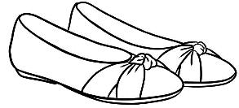
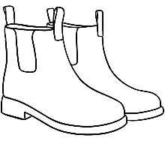
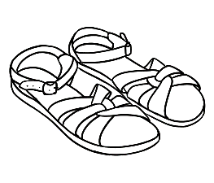
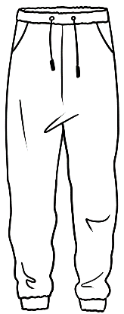
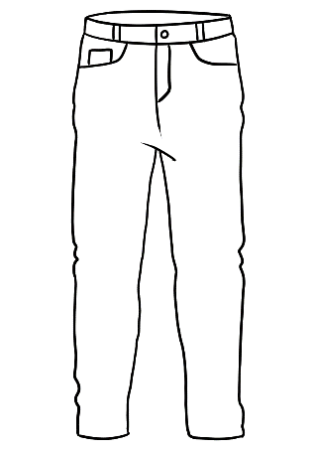
- a pair of shoes
- a pair of runners
- a pair of sandals
- a pair of boots
- a pair of socks
- a pair of gloves
- a pair of jeans
- a pair of shorts
- a pair of trackpants
- a pair of glasses
- a pair of sunglasses
- a pair of earrings
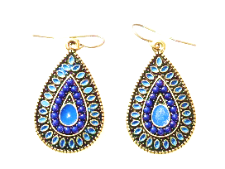
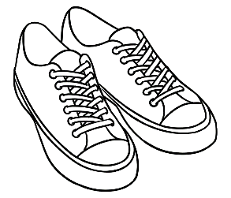
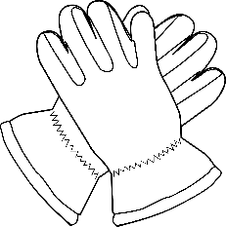

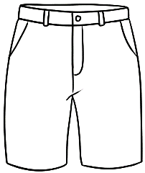



Are you wearing a pair of socks?
Yes I am.
No I’m not.

- Pair work information gap
 | A | B | C
1 | 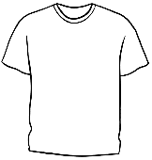 | 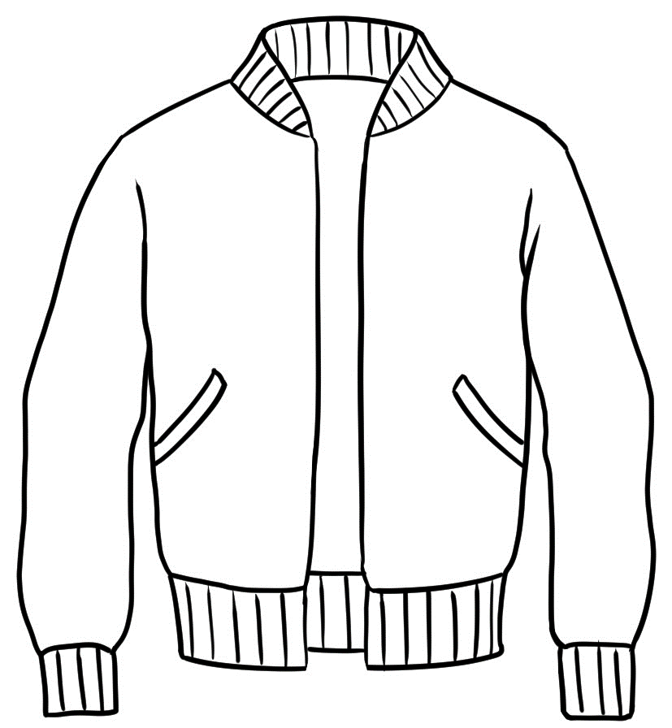 | 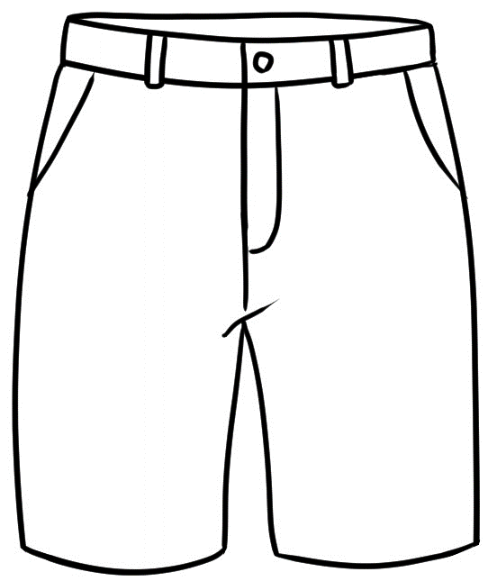  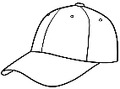
2 | 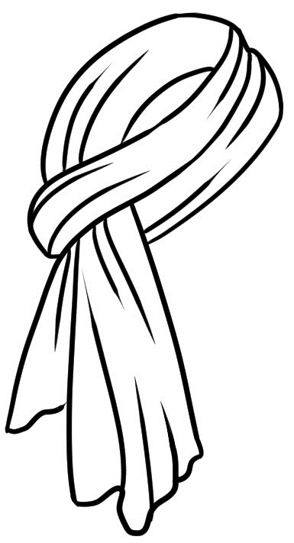  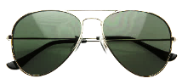 | 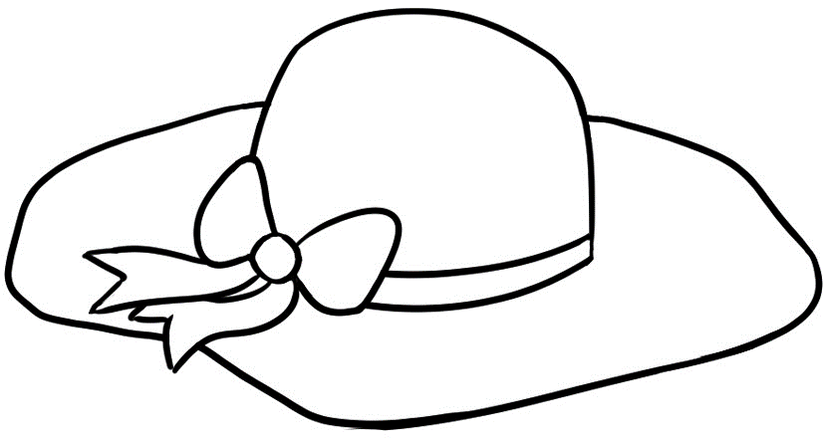  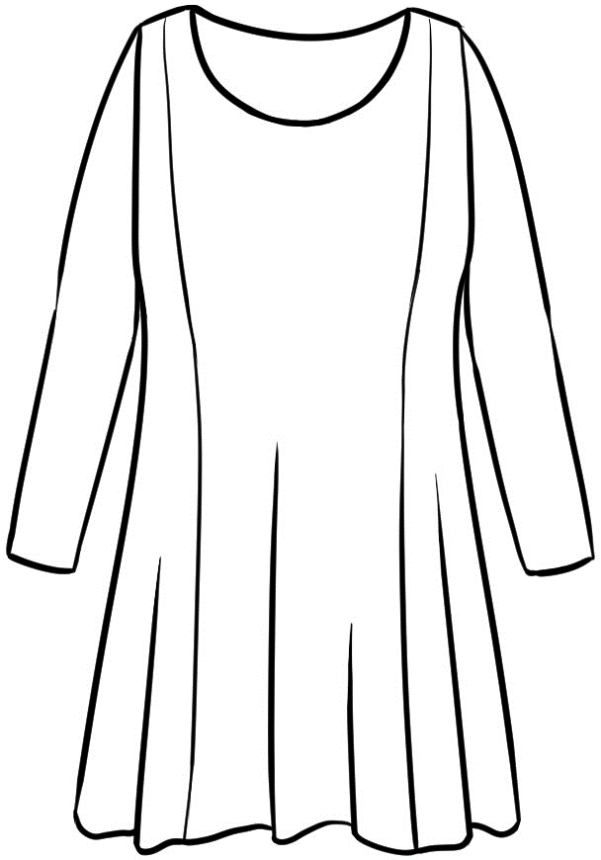 | 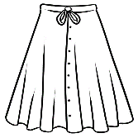
3 |  | 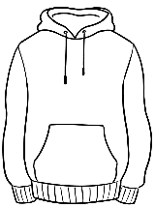 | 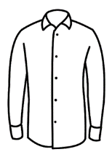
4 | 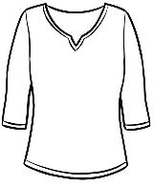 |  | 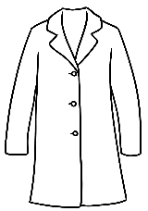  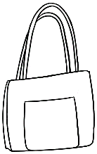
5 |  | 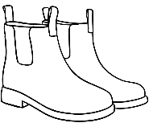 | 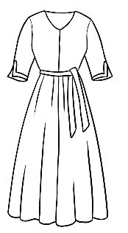  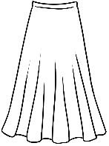
6 |  | 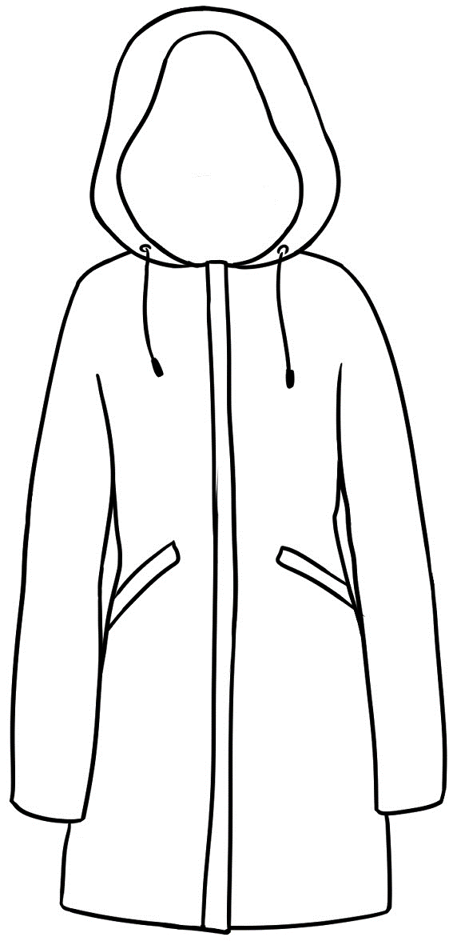  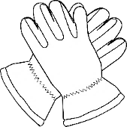 | 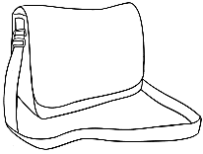
Student A
What’s in A1?
What’s in B1?
Is it the same or different?

X

Student B
What’s in A2?
What’s in B2?
Is it the same or different?

X
 | A | B | C
1
2
3 |  | 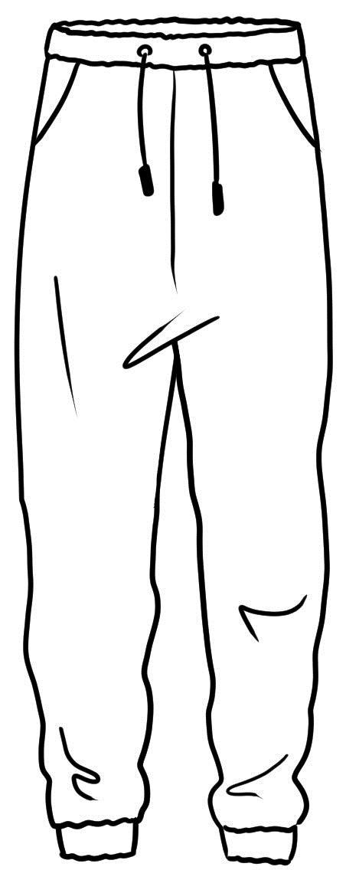
4
5
6

What’s the problem?
- Listen to a transaction and sequence
There are two transactions to order. Students need to cut up the strips.
Read each transaction for students to:
- Listen and sequence
- Highlight the greetings
- Underline the closings
- Read in pairs.

- What’s the problem – Transactional language
Worksheet #1
This worksheet follows up on the exercise in the student workbook and can be used for homework. Students could write and read their sentences to the class the following day. Each scenario could be the basis of a role play.
Worksheet #2
This worksheet is an extension of Worksheet #1 and can also be used for homework. It adds the element of time. Students could write and read their sentences to the class the following day.

- A transaction – Returning a hoodie
The purpose behind this transaction is to explain to students that although all goods can be returned and exchanged, not all stores will offer a refund.
- Read the transaction and students complete the cloze.
- Role play the transaction.
- Alter the role play by changing the item being returned.

- A useful resource - Chen and Lin Buy a Microwave
In the reader Chen and Lin Buy a Microwave, the couple return their faulty microwave and ask for help about the purchase of an expensive product.
This Australian reader is available at five levels from the ESL Reads website: https://eslreads.com/ [There is a charge for this resource.]
Check out Clare Harris’s blog for other resources: https://clareharris.com/australian-eal-resources-whats-free-an-update/

Parwana | No thanks, I have a bag. Thanks for your help.
Shop assistant | An exchange means you can change  the skirt for a new one. A refund means  you can get your money back.
Parwana | Oh. What does that mean?
Shop assistant | Oh yes. Do you have the receipt?
Parwana | Yes. Here it is.
Shop assistant | You’re very welcome.
Parwana | Here’s a new skirt.
Shop assistant | Do you need a bag?
Parwana | Just here.
Shop assistant | That’s fine. Would you like an exchange  or a refund?
Parwana | Hello. I bought this skirt yesterday, but there’s  a small hole in it.
Shop assistant | Oh. Where’s the hole?
Parwana | I’d like an exchange please.
Shop assistant | Okay. Can you get another skirt and bring it back here?
- Listening to a transaction and sequence #1

- Listening to a transaction and sequence #2
Ahmad | I’d like a refund please.
Shop assistant | That’s fine. Would you like an exchange  or a refund.
Ahmad | Hello. I bought this laptop last week,  but it’s faulty.
Shop assistant | I’ll put the money onto your card.
Ahmad | Thank you.
Shop assistant | What’s the problem?
Ahmad | The battery doesn’t recharge.
Shop assistant | Bye.
Ahmad | That’s okay. Bye
Shop assistant | I’m sorry about the problem.
Ahmad | Yes. It’s on my phone here.
Shop assistant | Certainly. Do you have your card?
Ahmad | Yes. Here it is.
Shop assistant | That’s not good. Do you have your receipt?

- What’s the problem – Transactional language - Worksheet #1
What’s the problem? roblemrppproblemblem?

an electric jug | a toaster | a fry pan | a coffee pot | a microwave

What did you buy? |  | What’s the problem?
a coffee pot | 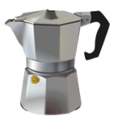 | There’s a crack.
 | 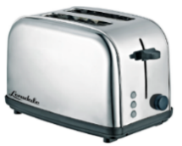   | The top’s missing.
 | 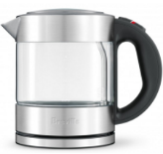   | There’s a scratch.
 | 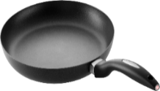 | It’s broken.
 | 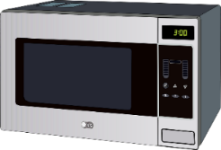 | The handle’s loose.
 | 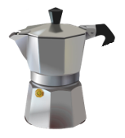   | It doesn’t work.

- I bought a coffee pot, but the top’s missing.
- I bought a ___________________, but __________________________.
- I bought a ___________________________________________________.
- _______________________________________________________________.
- _______________________________________________________________.
.

- What’s the problem – Transactional language – Worksheet #2
- What did you buy?

- When did you buy it?

- What’s the problem?

today | two days ago | three days ago | last weekend
yesterday | last week | two weeks ago | last Monday

I bought | What? | When? | Problem?
I bought | a coffee pot | three days ago | but the top’s missing.
I bought | a
I bought | a
I bought | a
Role play the transactions.
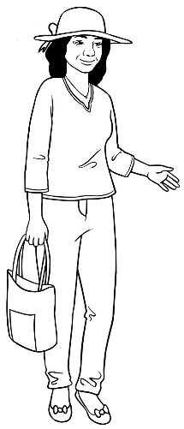
What’s the problem?
I bought a coffee pot
three days ago, but
the top’s missing.

faulty
exchange
swap
big
receipt
hoodie
help
refund
welcome
3. A transaction – Returning a hoodie [Answer sheet on the following page]
Hi. I have a problem with this ____________________.
What’s the problem?
I bought it last week, but it’s too ________________.
Do you have the ____________________?
Yes. Here it is.
No problem. I can ______________________ it for you.
Could I get a _____________________?
No, the hoodie is not ___________________.
You can get another one in your size.
Ok.
Please get a new hoodie and bring it back here.
Here it is.
I’ll _________________ it over for you.
Thanks for your ________________.
You’re ____________________. See you again.
Bye.

3. A transaction – Returning a hoodie [Answer sheet]
Hi. I have a problem with this hoodie.
What’s the problem?
I bought it last week, but it’s too big.
Do you have the receipt?
Yes. Here it is.
No problem. I can exchange it for you.
Could I get a refund?
No, the hoodie is not faulty.
You can get another one in your size.
Ok.
Please get a smaller size and bring it back here.
Here it is.
I’ll swap it over for you.
Thanks for your help.
You’re welcome. See you again.
Bye.

At the medical centre
Make an appointment at the medical centre
The transaction on the following page is from the student workbook. Students can work in pairs to:
- Read the transaction and substitute their own details in the gaps. Then swap roles.
- Role play the transaction in front of the class when they are more familiar with the language.

Receptionist | Good morning. Can I help you?
You | Yes. I need an appointment with the doctor.
Receptionist | Have you been here before?
You | No I haven’t.
Receptionist | OK. What’s your full name?
You | _____________________ ______________________
Receptionist | Can you spell your family name please?
You | ______________________ ___ ___ ___ ___ ___ ___ ___ ___  ^{say name} ^{spell name}
Receptionist | Do you have a Medicare card?
Parwana | Yes. Here it is.
Receptionist | Can you come on _________________ at ___________?
You | Yes. I can, but I need an interpreter.
Receptionist | I’ll arrange an interpreter. What language  do you speak?
You | ______________________.  ^{language}
Receptionist | Could you fill in this form too please?
You | Yes, thank you. See you on _____________________.  ^{day}
Receptionist | Yes. Bye.

At the chemist
At the chemist – Short conversations in pairs
- Role play the chemist scene in the student workbook with the class.
- Cut up the short exchanges below and on the following page.
- Students read the short exchanges in pairs.
- Pairs then swap their conversation with another pair, and read the new exchange.
- After some practice, encourage students to role play an exchange in the chemist in front of the class.

Chemist | Hello, how can I help you?
Customer | I’m looking for a bigger packet of this please.
Chemist | It’s over here.
Customer | Thanks very much.
Chemist | Hi. Can I help you?
Customer | Where can I find one of these please?
Chemist | I can show you. Here it is.
Customer | Thanks. That’s very helpful.

Chemist | Hi. Can I help you?
Customer | Where can I find this medicine?
Chemist | I’ll check out the back. Here it is.
Customer | Thanks for your help.
Chemist | Do you need any help?
Customer | I can’t find the sunscreen.
Chemist | It’s down here.
Customer | Thanks a lot.
Chemist | Can I help you?
Customer | No. I’m just looking.
Chemist | That’s fine. Let me know if you need any help.
Customer | Thank you.

1
Hi, can I help you?

4
Thanks, that’s very helpful.

2
Where can I find one of these please?

Customer
3
I can show you.

Customer
Chemist
Chemist

Word lists
Word lists
- Consonant clusters
Consonant clusters can be at the beginning, in the middle or at the end of a word. Clusters used in the student book are listed in the tables on pages 96 - 97. Exercises c, d, and e below suggest ways to use these lists.

- Complete list of words from the student workbook
There is a one-page word list for most sections. The word lists can be used in a variety of ways:
- Printed and used as a homework booklet so students can familiarise themselves with the vocabulary before beginning a new section in the workbook.
- As worksheets to complete in class before beginning each section.
- Students could record the teacher reading the words on their phones. It’s important for the teacher to pause after each word to allow time for the students to repeat the word as they listen back at home.
- Used to create word-finds and crosswords and for dictation.
- Students could also be shown how to create their own word-finds on puzzlemaker.com in their computer class.
There are some examples of sentences or phrases from the workbook in the Use column. Students could also:
- Add a synonym
- Write their own sentences. These would need to be checked if not copied from the workbook.

- Consonant clusters
sh | th (voiceless) | th (voiced) | ch
English | three | that | teacher
sharpener | thanks | they | chat
show | with | brother | childcare
she | thing | mother | cheap
dishes | Thursday | father | beach
washing | birthdate | then | watching
shopping | North | together | children
fishing |  |  | catch
shorts |  |  | lunch
shirt |  |  | exchange
shoes |  |  | recharge
cash |  |  | much

sp | fr | cl | str
spell | from | class | Australia
speaking | free | clinic | street
sport | friends | clean
 | fruit | cloudy
 | frypan | clothes

pr | st | pl | gr
practise | students | please | group
problem | starts | playing | grass
pretty | stormy | plants | great
 | stain |  | grandchildren
 | store
 | toaster
 | yesterday

ph | ck | fl | cr
photo | back | flowers | cricket
phone | clock |  | credit
 | jacket |  | crack
 | trackpants

dr | sk | sc | sm
dress | skirt | scarf | small
 |  | scratch
 |  | screen
 |  | script

br | wh
bring | what
broken | where
 | when

- Word lists
Word | Stress pattern | Translate | Use
again | o O
circle | O o
clap | O
copy | O o
could | O
highlight | O o
listen | O o
match | O
partner | O o
question | O o
read | O
repeat | o O
say | O
slowly | O o
spell | O
tick | O
write | O
Section 1 – Introduction

Word | Stress Pattern |  | Translate | Use
about | o O |  |  | What about you?
before | o O
break | O |  |  | It’s break time.
centre | O o |  |  | Learning Centre
class | O
come | O |  |  | I come from Vietnam.
early | O o |  |  | I like to be early.
get back | o | O |  | I must get back to class.
later | O o |  |  | Talk later.
look | O
meet | O |  |  | Nice to meet you.
nice | O |  |  | Nice to meet you too.
practise | O o |  |  | We can practise speaking.
chat | O |  |  | Let’s chat later.
time | O
together | o O o |  |  | We can practice together.
what | O |  |  | What is your name?
when | O |  |  | When did you come?
where | O |  |  | Where are you from?
Sections 2/ 3 – Meet the students/Getting to know you

Section 4 - Basam starts class at TAFE
Word | Stress Pattern | Translate | Use
appointment | o O o |  | I have an appointment.
because | o O
borrow | O o |  | Could I borrow a pen?
card | O |  | Here’s your library card.
easy | O o
few | O |  | You need a few more.
library | O o
minute | O o |  | Just a minute.
miss | O |  | It’s not good to miss class.
more | O
need | O |  | What do you need?
outside | o O |  | Make appointments outside class time.
show | O
sure | O
things | O |  | You need a few more things.
tomorrow | o O o
try | O
welcome | O o

Section 5 - Linh starts class at the community centre
Word | Stress Pattern | Translate | Use
after | O o
because | o O
better | O o |  | I’d better go.
classroom | O o
everyone | O o o |  | Everyone is welcome.
flowers | O o
garden | O o
help | O |  | Can you help me?
new | O |  | I’m a new student.
show | O |  | I can show you.
tomorrow | o O o |  | Tomorrow will be hot.
Tuesday | O o
vegetables | O o o
watering | O o o |  | I’m watering the garden.
Wednesday | O o
with | O |  | Come with me.
work | O

Word | Stress Pattern |  |  | Translate | Use
birth | O |  |  |  | What’s your date of birth?
birthday | O o |  |  |  | When’s your birthday?
born | O |  |  |  | Where were you born?
busy | O o |  |  |  | I’m busy tomorrow.
childcare | O o
difficult | O o o |  |  |  | Forms are difficult.
enrol | o O |  |  |  | Can I enrol here?
Excuse me | o O |  | o
fill in | O | o |  |  | Fill in this form.
first | O |  |  |  | First, fill in the form.
form | O
Friday | O o
information | o o O o
interview | O o o
Monday | O o
September | o O o
sorry | O o |  |  |  | I’m sorry.

Section 6 - Parwana enrols in a class

Section 7 - Talk about jobs at home
Word | Stress Pattern | Translate | Use
also | O o
cheap | O |  | It’s very cheap.
clean | O
cook | O |  | Cook the dinner.
cut | O |  | Cut the grass.
dinner | O o
dishes | O o |  | Wash the dishes.
grass | O
homework | O o |  | Do some homework.
house | O |  | Clean the house.
husband | O o
like | O |  | What’s it like?
lucky | O o
man | O
morning | O o
really | O o
sometimes | O o
wash | O |  | Wash the car.
woman | O o
yesterday | O o o
Section 8 - Talk about free time
Word | Stress Pattern |  | Translate | Use
beach | O |  |  | going to the beach
city | O o |  |  | going to the city
fish | O |  |  | I like fishing.
free time | O | O |  | What do you do in your free time?
friends | O
go | O
like | O |  |  | I like cooking.
online | o O |  |  | I talk to family online.
park | O |  |  | I go to the park.
play | O
social media | O o
social media | O o o
sport | O |  |  | I play sport.
use | O |  |  | I use social media.
video games | O o |  |  | I play video games.
video games | O |  |  | I play video games.
visit | O o |  |  | I visit friends.
watch | O |  |  | I watch TV.
weekend | O o |  |  | Saturday and Sunday

Word | Stress Pattern |  | Translate |  | Use
aunt | O
brother | O o
children | O o |  |  |  | I have two children.
daughter | O o |  |  |  | I have a daughter.
family | O o |  |  |  | What a big family.
granddaughter | O o o
grandfather | O o o
grandmother | O o o
grandson | O o
hard | O |  |  |  | That’s hard for you.
husband | O o
lovely | O o
many | O o
nephew | O o
niece | O
parents | O o
sister | O o
son | O |  |  |  | I have one son.
uncle | O o
wife |  | O
Section 10 Talk about family

Section 11 - Talk about an excursion
Word | Stress Pattern |  | Translate | Use
back to | O | o |  | They catch the bus back  to the centre.
bus | O
catch | O |  |  | They catch the bus.
clothes | O
enjoy | o O |  |  | Did you enjoy it?
excursion | o O o
fruit | O
get back | o | O |  | What time will we get back?
idea | o O o |  |  | Good idea.
leave | O
look around | O |  |  | We will look around the market.
look around | o O |  |  | We will look around the market.
lunch | O
market | O o
plants | O
ramp | O |  |  | The driver put down a ramp.
together | o O o |  |  | Let’s go together.

Section 12 Talk about sport
Word | Stress Pattern |  | Translate | Use
all | O |  |  | All the best players
Aussie Rules | O | O |  | Australian Rules Football
best | O |  |  | All the best players come and play.
competition | o o O o
cricket | O o
every year | O o | o |  | They play every year.
footy | O o |  |  | football
interested | O o o |  |  | Is she interested?
January | O o o
last night | o | O
netball | O o
popular | O o o |  |  | It’s a popular sport.
talking about | O o |  |  | What are they talking about?
talking about | o O |  |  | What are they talking about?
tennis | O o
tired | O |  |  | I’m a little tired.
tonight | o O

Section 13 - Talk about the weekend
Word | Stress Pattern |  |  |  | Translate | Use
excuse | o O |  |  |  |  | Excuse me.
get ready | O |  | O o |  |  | I need to get ready.
get up to | o | O |  | o |  | What did you get up to?
go back | o |  | O |  |  | Let’s go back to class.
going | O o |  |  |  |  | How are you going?
grass | O
hurry | O o |  |  |  |  | Let’s hurry.
lake | O
loved | O |  |  |  |  | They loved the water.
move | O
quiet | O o |  |  |  |  | We had a quiet weekend.
relaxed | o O
sounds | O |  |  |  |  | That sounds nice.
table | O o
water | O o

Section 14 - What will you buy?
Word | Stress Pattern |  | Translate | Use
boots | O
cap | O
cardigan | O o o
dress | O
hoodie | O o
jacket | O o
jeans | O
jumper | O o
pair of | O | o
raincoat | O o
runners | O o
scarf | O
shorts | O
shoes | O
skirt | O
soon | O |  |  | The bus will be here soon.
sunhat | O o
top | O
trackpants | O o
t-shirt | O o

Word | Stress Pattern |  |  | Translate | Use
battery | O o
button | O o
cracked | O
exchange | o O
faulty | O o
handle | O o |  |  |  | The handle is loose.
hole | O
mean | O |  |  |  | What does that mean?
missing | O o
receipt | o O
recharge | o O
refund | O o
scratch | O
screen | O
stain | O
store | O
take it back | O | o | O |  | Will you take it back?
Section 15 What’s the problem?

Section 16 At the medical centre
Word | Stress Pattern |  | Translate | Use
address | o O
arrange | o O |  |  | I’ll arrange an interpreter.
dentist | O o
doctor | O o
full name | O | O |  | What’s your full name?
have you been | o | o |  | Have you been here before?
have you been | O |  |  | Have you been here before?
interpreter | o O o o
language | O o
medical | O o o |  |  | Medical Centre
Medicare card | O o o
Medicare card | O
need | O
nurse | O
receptionist | o O o o

Word | Stress Pattern | Translate | Use
cash | O |  | Is that card or cash?
chemist | O o
fine | O |  | That’s fine.
just | O |  | Just tap here.
medication | o o O o
next | O
pay | O |  | I’d like to pay.
ready | O o |  | Your script is ready.
register | O o o
script | O
sure | O
tap | O |  | Tap here when you’re ready.
wait | O

Section 17 - At the chemist

