

English Ready
22638VIC Certificate I in EAL
VU23502 Give and respond to short simple spoken information

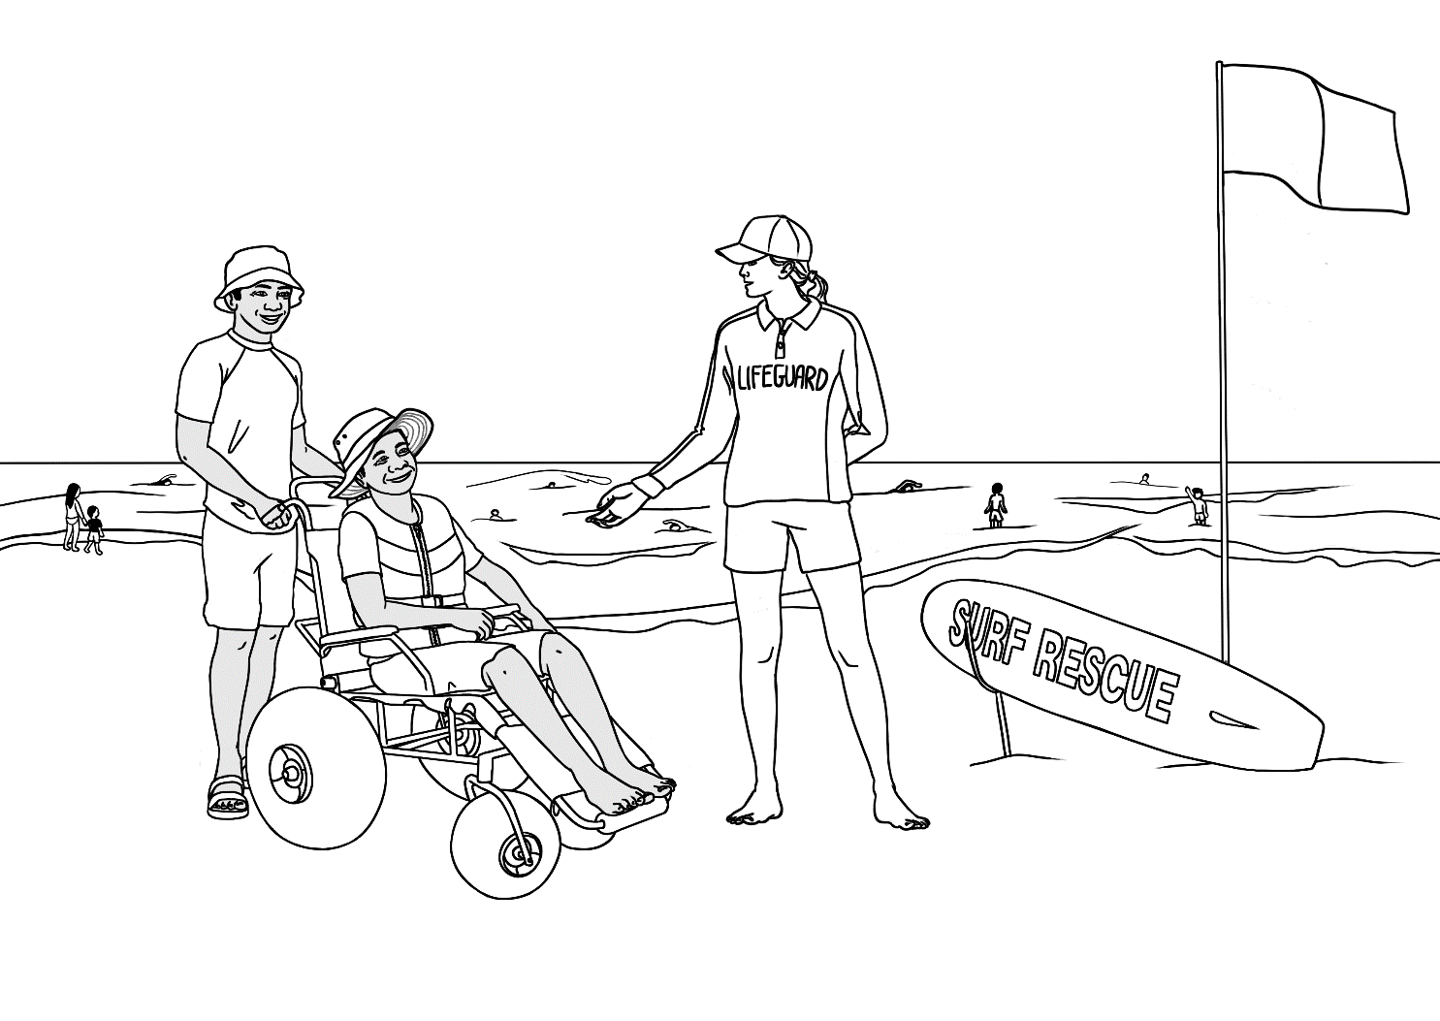
Teacher Resources

Design team: Vicki Hambling, Sue Paull, Frida Dean, Glenise Kleehammer and Mary Wallace
Illustrations: Madelena Scott

Illustrations acknowledgements:
Harmony Day Image by <a href="https://www.freepik.com/free-vector/people-celebrating-holi-festival_6754122.htm#query=diverse%20harmony&position=0&from_view=keyword&track=ais_user&uuid=b88b8aaf-417c-452c-8feb-ec400563f5a6">Freepik</a>
Acknowledgements: The design team would like to thank the AMEP service providers and practitioners who participated in the trial and gave valuable feedback. The team would also like to acknowledge the use of the EAL Framework which underpins the design of this book.
___________________________________________________________________________
Copyright of the EAL Framework is reserved to the Crown in the right of the State of Victoria. © State of Victoria (Department of Education and Training) 2023.
Use of all or part of this document must include the following attribution:
© Commonwealth of Australia 2024

With the exception of the Commonwealth Coat of Arms, the department’s logo, any material protected by a trade mark and where otherwise noted all material presented in this document is provided under a Creative Commons Attribution 4.0 International (https://creativecommons.org/licenses/by/4.0/) licence.
The details of the relevant licence conditions are available on the Creative Commons website (accessible using the links provided) as is the full legal code for the CC BY 4.0 licence (https://creativecommons.org/licenses/by/4.0/legalcode).
As far as practicable, material for which the copyright is owned by a third party will be clearly labelled. The department has made all reasonable efforts to ensure that this material has been reproduced in this document with the full consent of the copyright owners.
Copyright requests and enquiries concerning usage not addressed by the CC BY 4.0 licence should be addressed to: comms@homeaffairs.gov.au at the Department of Home Affairs.
The terms of use for the Commonwealth Coat of Arms are available from the It's an Honour website.
Where a copyright owner, other than the Commonwealth, is identified with respect to this material, please contact that third party copyright owner directly to seek permission.



Introduction
The Teacher Book
The book is an electronic reference and all materials can be adapted and printed as needed. Worksheets have teacher notes that can be removed prior to printing. Resources here include:
- pair work and class work
- revision and homework
- extension
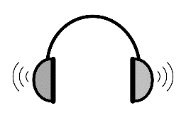
PowerPoint slides have been created to introduce, consolidate and revise vocabulary. This icon indicates a PowerPoint Presentation:
PPT
There are two mp3 listening files indicated by this icon.

The Student Workbook
The student book requires teacher direction and is not intended for independent learning. It is also not intended to be the only material used to teach these units or to be used as an assessment task. It is highly recommended that students buy and use a notebook for general class work and practice. The book is available as a Word document so that teachers can:
- localise and update the content
- adjust the material to suit the requirements of particular classes
- delete or add materials as required. If you add or deduct pages, be mindful of the layout as the document has been designed so that particular pages are opposite one another.

NB. Teacher versions of the student workbooks and also the worksheets
in this book contain notes to indicate the language focus and/or guide for the exercise. Teacher notes such as this one need to be removed before printing for students.
Read the questions below before listening to the conversation. Tell students that In some questions, there may be more than one correct answer.

These resources complement VU23504 Read and Write short simple informational texts.

Table of Contents
1. Meet the students and teachers 2
2. Meet two families. 5
3. Workbook instructions 8
4. Information about someone 11
5. The park 35
6. An excursion to the park 46
7. A place to rent 50
8. Sale at the Op Shop 59
9. An invitation 65
10. The beach and the pool 70
11. A quick and easy meal 80
12. Word Lists 91

Meet the students and teachers
The characters
Illustrations in this book and the student workbook are available for use in the design of additional materials.
The bio data chart below was created to maintain consistency of information throughout the English Ready books at the three levels - Course in Initial EAL, Course in EAL and Certificate 1 in EAL. It may be useful to update character information at times. All the characters feature in the Certificate 1 in EAL books. However, those in grey and blue also feature in the Course in EAL and the Course in Initial EAL books respectively.

Name | Family  members | Country of origin | Age / Date of birth | Date of arrival | Address in Kellivale  2421 | Phone
Linh Nguyen |  | Vietnam | 60 |  | 56 View St  [moved here in this book] | 0567 322 184
Basam Radi |  | Iraq | 30  05.08.1993 | 2023 | Unit 3, 140 Kemp St | 0455 328 691
Nabi Saikal | Husband and wife  Parents of Parwana | Afghanistan  Pashto | 48 | 2023 | 48 Baker Rd | 0462 595 751  NabSaikal @gmail.com
Amina Tarukh | Husband and wife  Parents of Parwana | Afghanistan  Pashto | 46 | 2023 | 48 Baker Rd | 0466 379 142  ATarukh13@gmail.com
Parwana Saikal | Rahim’s sister | Afghanistan  Pashto | 25  09.05.1998 | 12.01.23 | 48 Baker Rd | 0476 756 932 Parwana27@gmail.com
Jomeh Tajik | Parwana’s husband | Afghanistan  Pashto | 27 |  | 48 Baker Rd
Bibi Tajik | Girl 5 | Afghanistan  Pashto |  |  | 48 Baker Rd
Mustafa Tajik | Boy 2 | Afghanistan  Pashto |  |  | 48 Baker Rd
Rahim Saikal | Parwana’s brother | Afghanistan  Pashto | 19  07.05.03 |  | 48 Baker Rd | 0469 883 412  rahims003@  gmail.com

Name | Family  members | Country of origin | Age / Date of birth | Date of arrival | Address in Kellivale  2421 | Phone
Ahmad Hamed | Carim (m 19)  Fatima (f 15) | Syria | 21  25.08.2001 | 2022 | 260 North St | 0492 665 732
Ko Tun | Zarni Tun – wife  San Tun – daughter  Thein Myint –  son-in-law  Yaza - grandson | Myanmar |  |  | Unit 4  50 Baker Rd
Sahra Omar Elmi | Hani – daughter  2 years | Somalia | 7.07.96 | 9.6.22 | Unit 6  50 Baker Rd | 0455 961 259
Teacher - Peter |  | Greece | 38 |  | Bramby NSW | 0436 924 651
Teacher - Wendy |  | England | 45

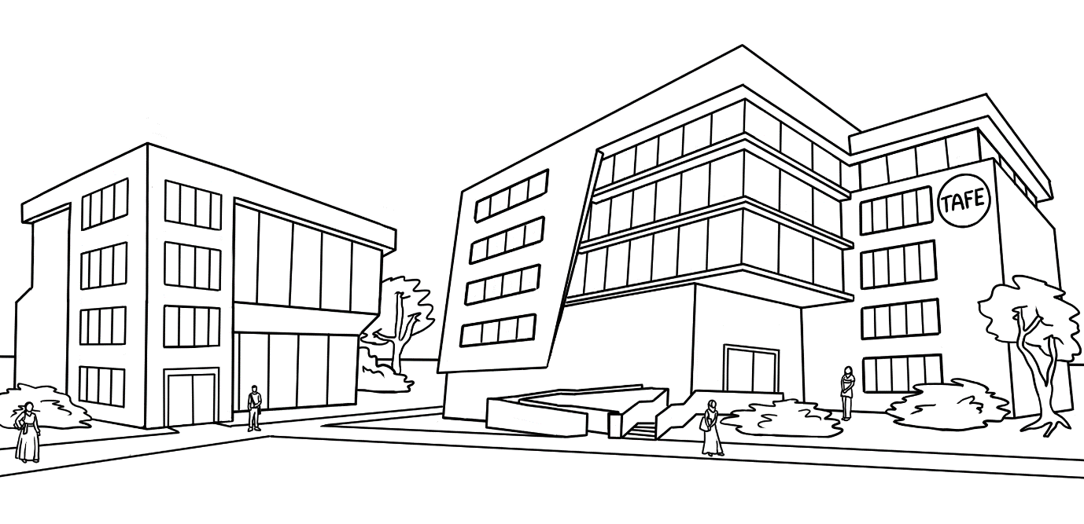
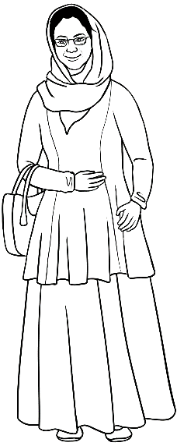
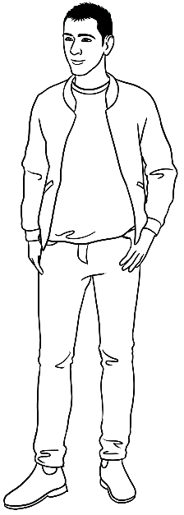
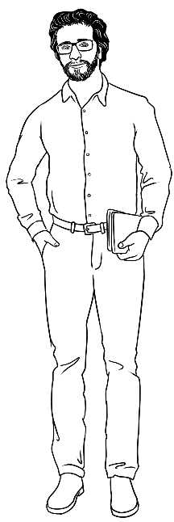
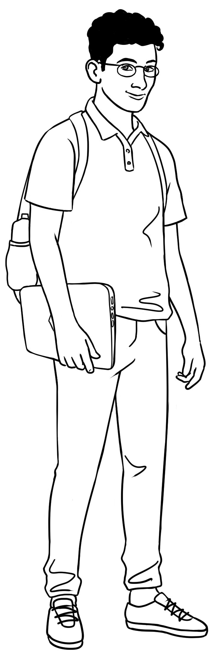
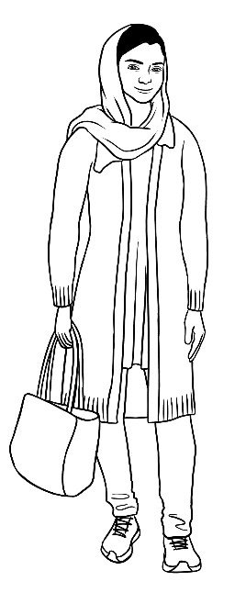
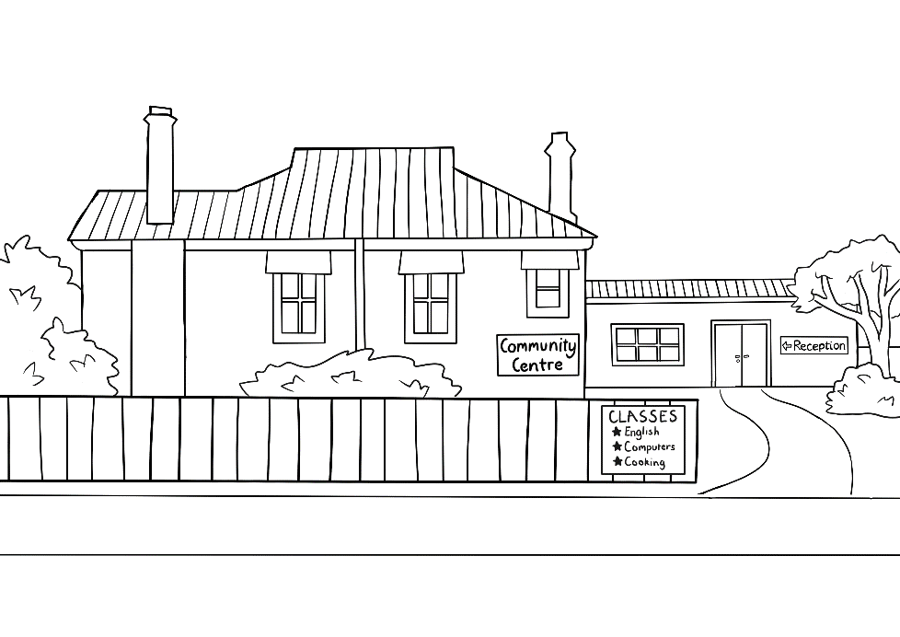
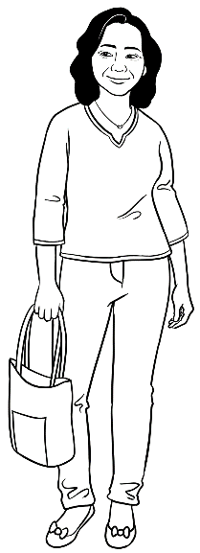
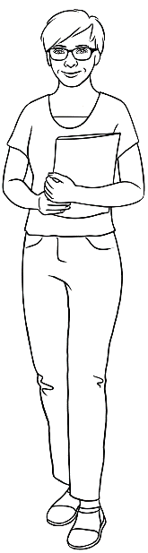
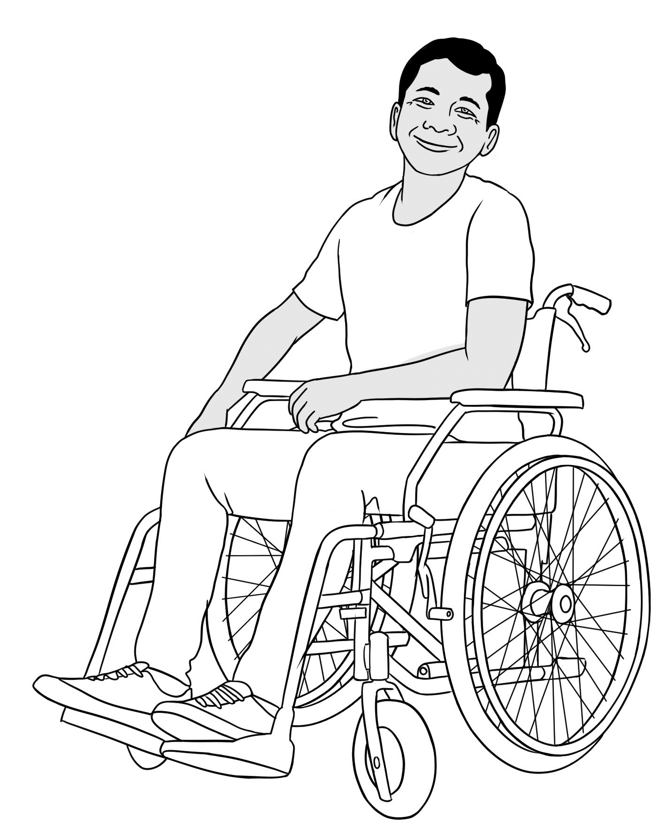

Peter
Amina
Basam
Ahmad
At the
AMEP
Centre

Parwana
Wendy
Linh
Ko
At the Learning Centre

Meet two families.
These two families include Parwana, Amina and Ko, three students in the Certificate 1 in EAL student workbooks. Their family members feature in this unit and units VU23500, VU23501, VU23502 & VU23503. Project:
- #1 and point to any member of Parwana’s family and elicit her relationship.
- #2 and point to any member of Rahim’s family and elicit his relationship.
- #3 and point to any member of Ko’s family and elicit his relationship.
- #4 and point to any member of Zani’s family and elicit her relationship.
- #5 and point to any member of Thein’s family and elicit his relationship.
Introduce the family members using the polite expression This is and the correct 3rd person pronouns. e.g.
Parwana’s family – This is her daughter Bibi. This is her son Mustafa.
Rahim’s family – This is his niece Bibi. This is his brother-in-law Jomeh.
Ko’s family – This is his wife Zarni. This is his son-in-law Thein.
Thein’s family – This is his wife San. This is his father-in-law Ko.
Zani’s family – This is her husband Ko. This is her grandson Yaza.

Parwana’s family

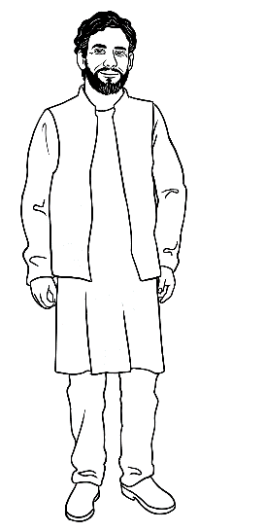
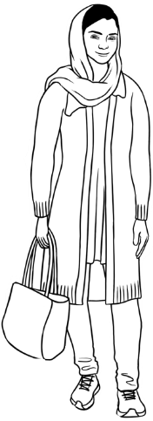
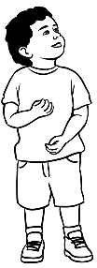
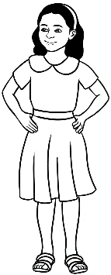
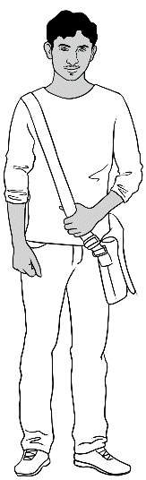
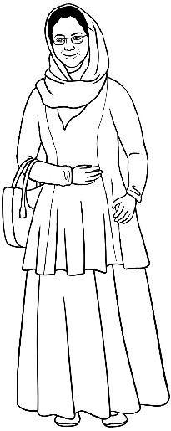
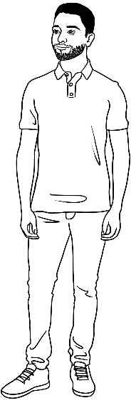
me |  | daughter |  | son |  | husband |  | mother | father |  | brother
Parwana |  | Bibi |  | Mustafa |  | Jomeh |  | Amina | Nabi |  | Rahim

Rahim’s family

me |  | sister |  | niece | nephew |  | brother-in-law |  | mother | father
Rahim |  | Parwana |  | Bibi | Mustafa |  | Jomeh |  | Amina | Nabi

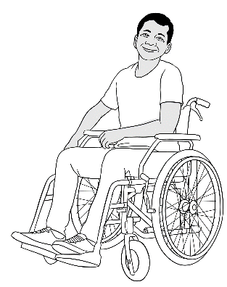
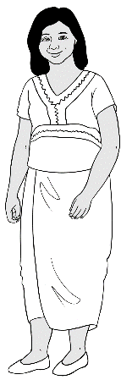
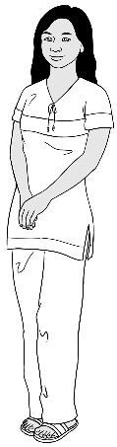
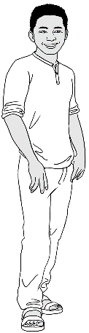
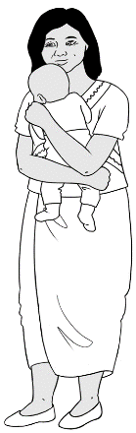

me | wife | daughter |  |  | son-in-law |  | grandson
Ko | Zani | San |  |  | Thein |  | Yaza
 | Zani’s family
me | husband |  | daughter | son-in-law |  | grandson
Zani | Ko |  | San | Thein |  | Yaza
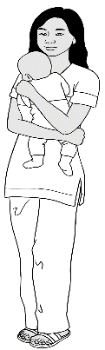 | Thein’s family
me | wife |  | son | mother-in-law |  | father-in-law
Thein | San |  | Yaza | Zani |  | Ko
Ko’s family

Workbook instructions
Workbook instructions
To minimise distractions from the page content, icons replace written instructions in the workbooks. However, students will still require guidance for activities by the teacher. Some additional teacher instructions have been given in text boxes in the teacher version of the student book. The following activities can help students recognise and remember the meaning of the icons.
Activity 1 - Vocabulary
The PPT includes all the icons used in the Certificate 1 in EAL units. You may wish to delete the icons that are not relevant to the student workbook for this unit.
Show on slide show. Once students have been introduced to the icons, delay the appearance of the instruction word and encourage students to guess and mime the instruction.
Activity 2 - Teaching syllables and word stress
- Say a word from the list below, repeat it, breaking it into syllables and
stressing the strong syllable.

- Demonstrate physically by:

  - clapping
  - tapping your hand, a pen or a ruler on the table
  - punching the air
  - stamping your feet
  - taking a step for each syllable
  - using a rubber band to stretch out on the stressed syllable.

- Ask students to repeat the word with the action several times.
- Create a table on the board similar to the one on the following page,
writing the word in the correct column.
- Repeat the process with the remaining words.

In a later class, the words could be enlarged and written on paper. Students could then attach the words to the board in the correct column using magnets or copy the words in the column.

Syllables
1 | 2
read | listen  questions  copy  partner  circle  highlight
say | listen  questions  copy  partner  circle  highlight
write | listen  questions  copy  partner  circle  highlight
tick | listen  questions  copy  partner  circle  highlight
check | listen  questions  copy  partner  circle  highlight
work | listen  questions  copy  partner  circle  highlight
ask | listen  questions  copy  partner  circle  highlight
help | listen  questions  copy  partner  circle  highlight

Activity 3 - Make requests for repetition or clarification
- Teach students the requests for clarification and repetition introduced
in the student workbook
- Print the requests on the following page, laminate and cut up.
- Build confidence in using the expressions through regular class practice:
- Give the five expressions to five students. Select the most confident students at first.
- Ask these students to use their expression at least once during the class – initially with the teacher and later with each other.
- Give the expressions to different students in following classes.

Sorry. I don’t understand.
Can you help me please?
Can you say that again please?
Can you speak slowly please?
Can you spell that please?

Information about someone
The key goals of this unit are for students to understand and give spoken information, and activities need to be provided for students to build their confidence in achieving this. Speaking to more than one person in a group or to the whole class can be challenging for many, so it’s important to build confidence through regular non-threatening practice.
This section begins the process of building that confidence. Students can listen to and to give information using the vocabulary and grammar they are most familiar with, to talk about the people they know best – themselves, family and friends.
Activity 1 – Round the class activities
Organise the class to stand in a circle or arrange the class tables in a U-shape. It is important that:
- students have eye-contact with each other
- the grammar and vocabulary used are controlled and familiar so students feel relaxed about participating.
Examples of activities:
- Introduce yourself [Use a large ball or a bean bag]
Say your name and where you come from and throw the ball to someone. They say their name and where they come from and throw the ball to someone else. The game continues until everyone has had a turn.
The information given can be varied in each game. e.g. free time activities, favourite food, favourite colour, lucky number, the time you get up/go to bed
- Introduce yourself and the person next to you.
My name is ________ and this is _____________. Demonstrate how to introduce someone with an outstretched hand towards the person, palm up. This introduction can be revised when a new student joins the class.
Activity 2 – A daily weather check
Select a student from the roll to check the day’s weather report and the UV rating on-line. The check can be done before class or during the break and the student then tells the class. Chose a different student each day.

Activity 3 – Pay for the chance to ask questions and give answers.
Many students who are confident speaking in class frequently monopolise this space and reduce opportunities for less confident students to speak. The following activity can be used occasionally to bring more balance to the speaking space in a class. The activity encourages reluctant speakers, and makes more confident speakers aware of how often they speak and how this can limit the learning of others.

- Give each student three or four small items of currency
e.g. fake money, buttons, matches, small slips of card
- Whenever a student asks or answers a question, they need
to pay, and move one of their items of currency into the middle of the table.
- Once a student has used all their currency, they cannot speak until most of the class has used their currency by asking questions or giving answers. This usually leads to the whole class encouraging the more reluctant students to speak and builds a more cooperative approach
to learning.
Note: This activity creates an artificial situation in a class and should only be used occasionally. However, using it just once can develop an awareness of the need for all students to speak and develop their oral skills in class.
Activity 4 – Personal information [Pair work]
This pair-work information gap activity allows student to practise listening to and answering questions about personal details. The grammar focus is on:
- wh questions
- personal pronouns, third person singular – he/his, she/her.
- Contractions – What’s, it’s

- Print enough copies of the alphabet strips and the worksheets for Students A and B. The alphabet strips are an aid to spelling, but may not be needed by all students.
- Demonstrate the activity with a confident student. Student A asks questions first and writes the answers given by Student B.
- Emphasise that students must not show their worksheet to their partner; all questions and answers must be given orally.


Activity 4 – Personal information – Pair work
Your person is a woman. Use she and her.
Student A

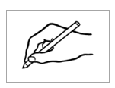
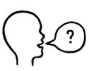
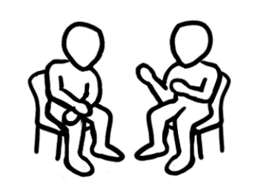
Can you spell that please?
What’s her first name?

- What’s her first name? ________________________________
- What’s her family name? ________________________________
- Where does she come from?________________________________
- Is she married or single?________________________________
- Does she have children?________________________________
- What are her future plans?________________________________
- What does she do in her free time?______________________________
- What’s she good at?________________________________


 | First Name | Ko
 | Family Name | Tun
 | Country of Origin | Myanmar
 | Marital status | married
 | Children | one daughter
 | Future plans | to repair computers
 | Free Time | reading
 | Good at | fixing things

Student B
 | First Name | Parwana
 | Family Name | Saikal
 | Country of Origin | Afghanistan
 | Marital status | married
 | Children | 2
 | Future plans | to be a nurse
 | Free Time | cooking
 | Good at | learning English


Your person is a man. Use he and his.
Can you spell that please?
What’s his first name?

- What’s his first name? ________________________________
- What’s his family name? ________________________________
- Where does he come from?________________________________
- Is he married or single?________________________________
- Does he have children?________________________________
- What are his future plans?________________________________
- What does he do in his free time?______________________________
- What’s he good at?________________________________

Activity 4 – Personal information – Pair work – Alphabet strips

A a | B b | C c | D d | E e | F f | G g | H h | I i | J j | K k | L l | M m
N n | O o | P p | Q q | R r | S s | T t | U u | V v | W w | X x | Y y | Z z
A a | B b | C c | D d | E e | F f | G g | H h | I i | J j | K k | L l | M m
N n | O o | P p | Q q | R r | S s | T t | U u | V v | W w | X x | Y y | Z z
A a | B b | C c | D d | E e | F f | G g | H h | I i | J j | K k | L l | M m
N n | O o | P p | Q q | R r | S s | T t | U u | V v | W w | X x | Y y | Z z
A a | B b | C c | D d | E e | F f | G g | H h | I i | J j | K k | L l | M m
N n | O o | P p | Q q | R r | S s | T t | U u | V v | W w | X x | Y y | Z z
A a | B b | C c | D d | E e | F f | G g | H h | I i | J j | K k | L l | M m
N n | O o | P p | Q q | R r | S s | T t | U u | V v | W w | X x | Y y | Z z
A a | B b | C c | D d | E e | F f | G g | H h | I i | J j | K k | L l | M m
N n | O o | P p | Q q | R r | S s | T t | U u | V v | W w | X x | Y y | Z z

Activity 5 – Personal information embedded in transactions
- Basam at the library
- Ahmad at the police station
With both transactions it is useful to discuss different forms of ID. Repeat the conversations, substituting different forms of ID.
The transactions include an audio mp3 recording, questions, a cloze activity [for At the library] and sequencing strips.

Sequencing strips
The sequencing slips are at two levels, with level A indicating the first speaker in green, while Level B has no colour. The two levels of difficulty allow students to do the same exercise, but at their current level of skill. All the conversations in the student workbook have been organised at two levels in this resource book.

The sequencing is a listening activity. The teacher needs to walk around to help and check students’ work as they listen and sequence the text.
- Print each of the levels on the following pages.
- Students are given the level that is suitable for their skill level. When students become more familiar with the activity, they may feel confident about selecting or requesting a different level.
- Students cut up the strips.
- With their workbooks closed, read the text slowly for the students to sequence the strips of text.
- Once sequenced, reread the text for students to check their work.
- Give students a paper clip to hold the strips and collect these for later revision and/or for students to try a higher level the following day.
Note: Remove the pink teacher boxes before printing the worksheets.

Activity 5a – Basam at the library

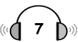
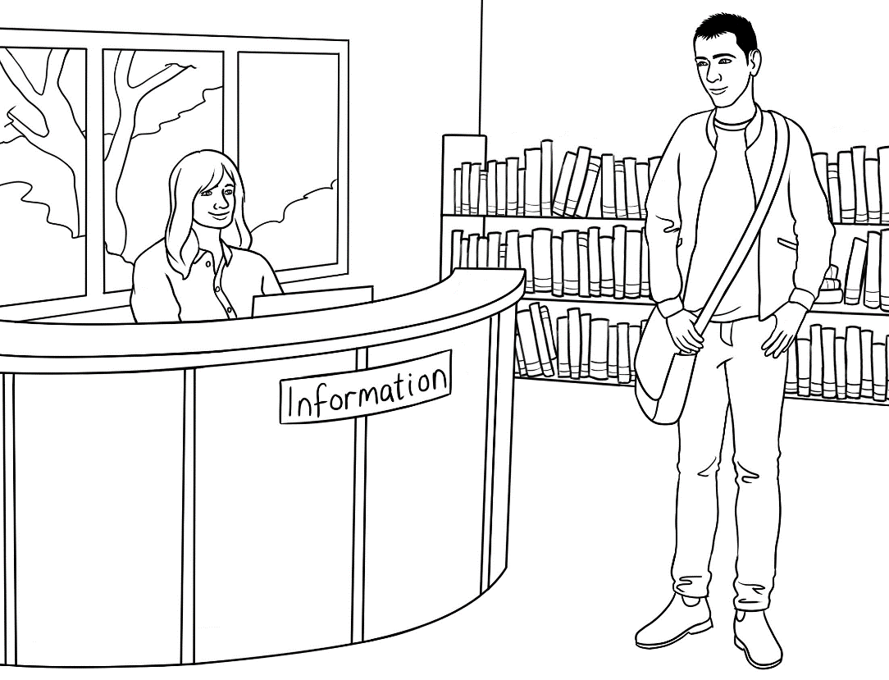

At the library
Read the questions below before listening to the conversation. Tell students that In some questions, there may be more than one correct answer.

- Why is Basam speaking to the librarian?
He wants to use a computer today.

He lost his card yesterday.
He needs an English grammar book.

- When did Basam join the library?
last week last month yesterday

- The librarian asks Basam for some information.

his name his date of birth his address

- What ID does Basam show the librarian?
his licence his passport his Medicare card

- The librarian says, ‘I can cancel that card.’
Cancel means
stop. find. look for.

- A few minutes is about

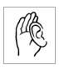
a minute. three minutes. ten minutes.

Basam | Excuse me. Can you help me please? | Street  give  please  joined  help  lost  minutes  cancel  date  have  new  Thank  card  August  address
Librarian | Yes. How can I _________ you?
Basam | My name is Basam Radi. I ____________ the library last week, but I ___________  my library card yesterday.
Librarian | That’s not a problem. I can __________that card and ________you a new one.
Basam | Thank you.
Librarian | What’s your _________ of birth Basam?
Basam | 5 _____________ 1993.
Librarian | And your ________________?
Basam | Unit 3, 140 Kemp _______________.
Librarian | 114 Kemp Street?
Basam | No. 140.
Librarian | Do you __________ any ID Basam?
Basam | Yes. Here’s my Medicare ___________.
Librarian | That’s fine. I’ll get you a _________card.  Can you wait a few _____________?
Basam | Yes I can. ___________ you very much.
Activity 5a – Basam at the library - Answers
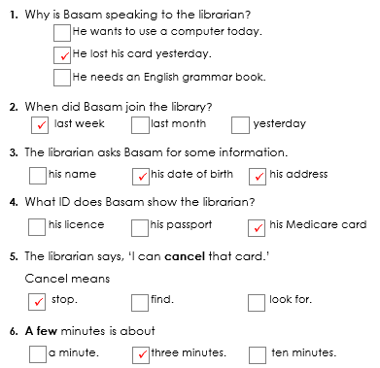
Questions

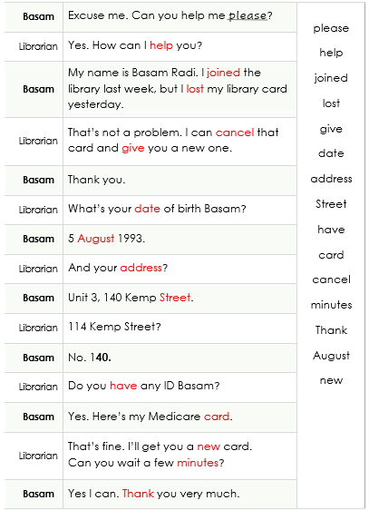
Cloze

Activity 5a – Basam at the library - Sequencing

Level A
Yes I can. Thank you very much.
Do you have any ID?
No. 140.
That’s fine. I’ll get you a new card.
Can you wait a few minutes?
5 August 1993
114 Kemp Street?
Yes. Here’s my Medicare card.
That’s not a problem. I can cancel that card
and give you a new one.
Unit 3, 140 Kemp Street.
What’s your date of birth Basam?

Thank you.
And your address?
My name is Basam Radi. I joined the library last week, but I lost my library card yesterday
Yes. How can I help you?
Excuse me. Can you help me please?

Activity 5a – Basam at the library - Sequencing
Level B
Yes I can. Thank you very much.
Do you have any ID?
No. 140.
That’s fine. I’ll get you a new card.
Can you wait a few minutes?
5 August 1993
114 Kemp Street?
Yes. Here’s my Medicare card.
That’s not a problem. I can cancel that card
and give you a new one.
Unit 3, 140 Kemp Street.
What’s your date of birth Basam?

Thank you.
And your address?
My name is Basam Radi. I joined the library last week, but I lost my library card yesterday
Yes. How can I help you?
Excuse me. Can you help me please?

Activity 5b – Ahmad at the police station


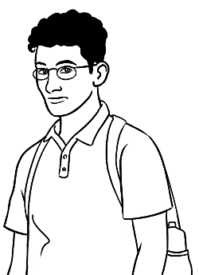
At the police station

- Why is Ahmad at the police station?
Someone stole his wallet.

Someone stole his motor bike.
Read the questions below before listening to the conversation.
Tell students that In some questions, there may be more than one correct answer.
Someone stole his driver’s licence.

- When did Ahmad go to the party?

14 June 24 June 25 August

- The police officer asks Ahmad for some information.

his name his date of birth his address

- Ahmad lives in North Street. His street number is

215 250 260
- What ID does Ahmad show the police officer?

his student card his passport his Medicare card

- Where can Ahmad order a new licence?

at train station at the police station on-line

- What does the police officer give Ahmad?

a licence a report some money

Other lost objects can be substituted in this transaction - house keys, car keys, work keys, mobile phone, wallet, handbag

Ahmad | Good morning.
Police officer | Morning. How can I help you?
Ahmad | Someone stole my driver’s licence.
Police officer | Okay. I need some details.  Can you give me your full name?
Ahmad | Ahmad Hamed.
Police officer | Can you spell your family name Ahmad?
Ahmad | Hamed H – A – M – E – D.
Police officer | Okay Ahmad. Can you tell me what happened?
Ahmad | I went to a party. There were a lot of people. Then  I got home and my licence wasn’t in my wallet.
Police officer | When was the party?
Ahmad | Last Saturday, 14 June.
Police officer | I need some more details - your date of birth and address?
Ahmad | My date of birth is 25 August, 2001.  My address is 260 North Street Kellivale.
Police officer | Do you have some ID?
Ahmad | Yes. My student card and Medicare card.
Police officer | Thanks. I’ll cancel your license, but you can order  a new one online. Here’s a copy of my report.
Ahmad | Thanks for your help.

Activity 5b – Ahmad at the police station - Answers

Listening questions
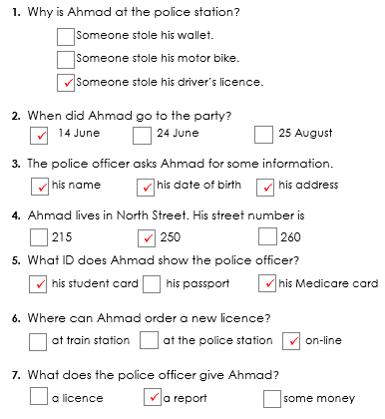

Activity 5b – Ahmad at the police station – Sequencing
Ahmad Hamed.
Morning. How can I help you?
Hamed H – A – M – E – D.
Okay. I need some details.
Can you give me your full name?
I went to a party. There were a lot of people. Then
I got home and my licence wasn’t in my wallet.
Can you spell your family name Ahmad?
Someone stole my driver’s licence.
Okay Ahmad. Can you tell me what happened?
Good morning.
When was the party?
Level A

Yes. My student card and Medicare card.
I need some more details - your date of birth
and address?
Thanks for your help.
Do you have some ID?
Last Saturday, 14 June.
Thanks. I’ll cancel your license, but you can order
a new one online. Here’s a copy of my report.
My date of birth is 25 August, 2001.
My address is 260 North Street Kellivale.

Activity 5b – Ahmad at the police station – Sequencing
Level B
Ahmad Hamed.
Morning. How can I help you?
Hamed H – A – M – E – D.
Okay. I need some details.
Can you give me your full name?
I went to a party. There were a lot of people. Then
I got home and my licence wasn’t in my wallet.
Can you spell your family name Ahmad?
Someone stole my driver’s licence.
Okay Ahmad. Can you tell me what happened?
Good morning.
When was the party?

Yes. My student card and Medicare card.
I need some more details - your date of birth
and address?
Thanks for your help.
Do you have some ID?
Last Saturday, 14 June.
Thanks. I’ll cancel your license, but you can order
a new one online. Here’s a copy of my report.
My date of birth is 25 August, 2001.
My address is 260 North Street Kellivale.

Activity 6 – Wendy gives a talk

This activity provides an additional talk to support those in the student workbook. It’s important to show that not all the points in Step 3 of the plan need to be covered in the talk. e.g Wendy doesn’t mention her marital state/children, nor does she say what she is good at. She mentions her work, and adds a new point to her plan - Work. Details also don’t need to follow the order suggested on the plan. Wendy’s talk includes:
- Listening questions
- Transcript of the talk
- Plan for the talk

Activity 6 – Wendy give a talk about someone – Listening questions

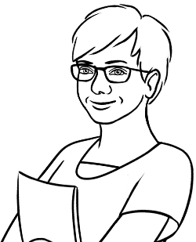

- Who is Wendy talking about?

her friend
her sister
herself

- Where does she come from?

New Zealand the USA England

- When did she come to Australia?

1 year ago. 5 years ago. 10 years ago.

- Why did Wendy come to Australia?

She wanted a new job.
She wanted to have fun.
She wanted to travel.
- Information | True | False
- She was a nurse In England.
- She misses her family.
- Wendy has a new friend in Australia.
- On the weekend, she likes cooking.


- She also likes bushwalking.
- Wendy would like to travel to South Australia.
- She would like to go there next year.

Activity 6 – Wendy give a talk – Transcript and answers
Wendy’s talk
Good morning/afternoon everyone. My name is Wendy. Today I want to tell you some information about me. Here’s a photo of me at school in England.

I came to Australia from England five years ago because I wanted to travel. I was a teacher in England and I’m a teacher
in Australia too. I miss my family, but I have many new friends now. On the weekends, I like reading and bushwalking. Next year I’d like to travel by train to Western Australia. I really love the big blue skies here.

Thank you for listening. Do you have any questions?

Paw

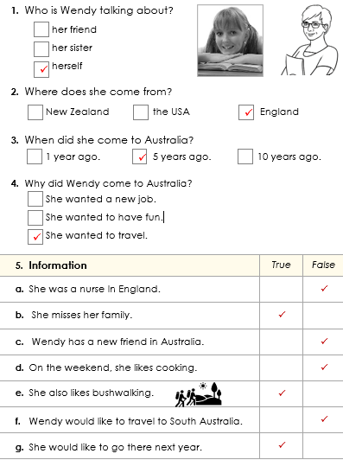

Activity 6 – Wendy gives a talk about someone – Plan
Some information about me
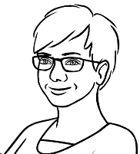
I wrote a plan for my talk.

Plan | A talk about me
- Greeting  Say and write the person’s name. | Good morning/afternoon everyone.  My name is Wendy.  Today I want to tell you some information about me.
- A photo | Here’s a photo of me at school in England.
- Information  Family/ friend  Birth country  Married / single  Children  Work  Free time  Future plans  Skills | I came to Australia from England five years ago because I wanted to travel.  I was a teacher in England and I’m a teacher in Australia too. I miss my family, but I have many new friends now.  On the weekends, I like reading and bushwalking. Next year I’d like to travel by train to Western Australia.
- Your opinion | I really love the big blue skies here.
- Thank you and questions | Thank you for listening.  Do you have any questions?

The park

Activity 1 – There is and there are [Class work]
In this section, students need to prepare to talk about a place they are familiar with. In preparation for describing a place, the expressions there is and there are need to be practised. These expression introduce people and things.
- Project a photo such as the photo below from Creative Commons,
or use your own photos of places, local and nationally.

- Ask questions:
- What do you see?
Students respond using the introductory phrases. There’s … There are …
e.g. tall buildings, skyscrapers, the city, a large white building, a river, a sports ground, a bridge
- What can you do there?
e.g. You can walk in the park. You can ride a bike beside the river.
You can play sport on the sports ground.
c. Can you…?
Can you cross the river? Can you swim in the river? Can you ride a bike
to the city? Can you walk to the city?

Activity 2 – Identifying places on a map [Pair work]
The following two maps of Kellivale Park are essentially the same as the map in the student workbook, except the icons in each map here have been positioned differently.
- Students work in pairs.
- Give each student either map A or B and instruct students to keep their maps ‘secret’. Students could sit back-to-back to make this easier.
- Students open the student workbook to page 15 and use the key to help with the vocabulary.
- They then take turns to ask questions:
- Student A asks – What’s in A1?
Student B answers – a compass. In this square, both maps
have the same image, so both students tick the square.
- Student B then asks – What’s in A2? If the icon is the same, students tick the square; if it is different they put a cross in the square.
Demonstrate this with a confident student.
- Encourage students to use clarifying questions such as Can you say it again please?
- Set a time limit for the activity. Students don’t need to ask about every square.
This activity recycles vocabulary, and gives practice in asking questions and using contractions.

Activity 2 – Identifying places on a map – Student A
Map A Student A
Is it the same or different?

X
What’s in A1?
Can you say it again please?

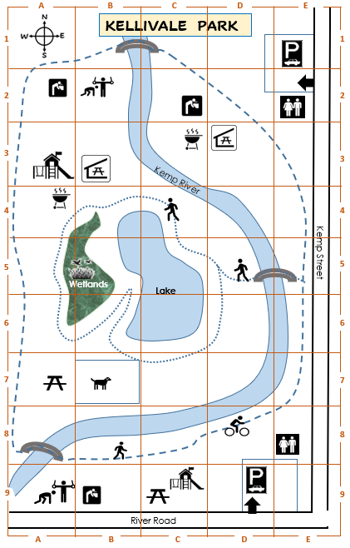

Activity 2 – Identifying places on a map – Student B
Map B Student B
Can you say it again please?
What’s in A2?
Is it the same or different?

X

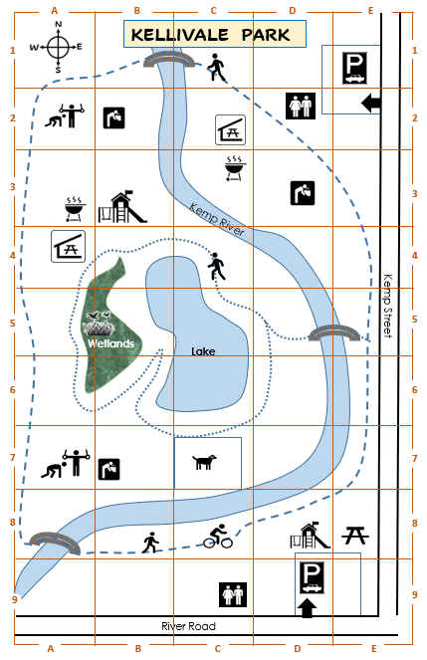

Activity 3 – Parwana talks to Sahra - Sequencing
The following conversation between Parwana and Sahra is included in the student workbook. The sequencing slips are at two levels, with level A indicating the first speaker in green, while Level B has no colour. The two levels of difficulty allow students to do the same exercise, but at their current level of skill.

Level A
Okay. Good idea.
Is the playground shady?
Yes. There are many trees and there’s a sunshade over the sandpit. The children are safe because
the playground has a fence.

Leval A [Continued]
On Saturday.
Hi Parwana. Did you have a nice weekend?
It’s near the lake.
Oh. When did you go there?
They really liked it. Your daughter Hani will like it too. It has a long slide and two swings. There’s a sandpit and a see-saw.
Let’s go together next weekend.
Yes. We went to the new playground in the park.
Oh yes. Hani will love it. Where’s the playground?
Hi Sahra.
Did the children like it?

Activity 3 -The new playground - Sequencing
Level B
Did the children like it?
Hi Sahra.
Yes. We went to the new playground in the park.
It’s near the lake.
On Saturday.
Hi Parwana. Did you have a nice weekend?
Yes. There are many trees and there’s a sunshade over the sandpit. The children are safe because
the playground has a fence.
Let’s go together next weekend.
Oh. When did you go there?
Oh yes. Hani will love it. Where’s the playground?

They really liked it. Your daughter Hani will like it too. It has a long slide and two swings. There’s a sandpit and a see-saw.
Is the playground shady?
Okay. Good idea.

Activity 4- Correctional stress – class activity
A class activity based on Parwana and Sahra’s talk about the new playground. Complete this exercise after Parwana and Sahra’s conversation on
pages 18 – 19 in the student workbook. Write the following words
on the board.

These words provide the correct answers to the questions the teacher will ask about the conversation. When introducing the activity, point to the answer after asking the question. Later, students can locate the correct answer. When students answer, they need to place stress on the corrected word.
 | Teacher | Student
1 | Sahra went to the park on Sunday. | No, on Saturday.
2 | The playground is old. | No, it’s new.
3 | The slide is short. | No, it’s long.
4 | The playground is near the road. | No, it’s near the lake.
5 | The sunshade is over the see-saw. | No, it’s over the sandpit..
6 | Parwana has three children. | No, she has two children.
7 | Sahra has a son. | No, she has a daughter.
8 | They want to go to the park next Friday. | No, next weekend.

This activity can be adapted for any section in the student workbook.

long
Saturday
new
sandpit
two
weekend
lake
daughter

Activity 5 – A council advertisement – Listening [Class activity]
This is an announcement that would accompany some visuals on a council website. It needs to be read by the teacher. The listening exercise follows the pattern of other listening exercises in the student workbook and includes listening questions.
- Read the questions together as a class.
- Read the council advertisement to the students slowly a couple of times, giving students time to tick the answers.
- The transcript can be printed later for students to listen to and read.
Note: There is more than one answer for the final question.

Transcript
The fun run advertisement

Come to Kellivale Park next Sunday 5 June, for our annual 12 kilometre fun run. Everyone is welcome, but children under 12 must run with an adult. It costs $20 and $10 for students. All the money will go to the Cancer Council.
Meet at 10 am near the Kemp Street car park. You can run or walk and stop at any time. After the run, there’ll be a free barbecue near the river. Bring your family and friends.

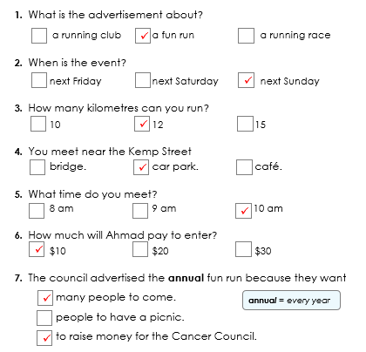
Answers

Activity 5 – A council advertisement – Listening questions

A council advertisement



Do you like running Ahmad?
Yes I do.
Listen to this advertisement
on the council website.
You can listen to the ad.

- What is the advertisement about?

a running club a fun run a running race

- When is the event?

next Friday next Saturday next Sunday

- How many kilometres can you run?

10 12 15

- You meet near the Kemp Street
bridge. car park. café.

- What time do you meet?
8 am 9 am 10 am

- How much will Ahmad pay to enter?

$10 $20 $30

- The council advertised the annual fun run because they want

many people to come.
annual = every year
people to have a picnic.

to raise money for the Cancer Council.

An excursion to the park
Activity 1 - Syllables and word stress
- Say a word from the list below or any words introduced in class.
Repeat it, breaking it into syllables.
- Demonstrate the syllables physically by:

  - tapping your hand, a pen or a ruler on the table
  - clapping
  - punching the air
  - stamping your feet
  - taking a step for each syllable
  - stretching a rubber band on the strong syllable.
- Ask students to repeat the word with the action several times.
- Count the syllables as you clap or tap etc
- Create a table on the board similar to the one below. Write the word in the correct column.
- Repeat the process with the remaining words.

weather | report | excursion | comfortable
Tuesday | today | September | understand
morning | remind | tomorrow | afternoon
library | forget
classroom | behind
minutes | again
teacher | repeat

Activity 1 - Syllables and word stress - Worksheet
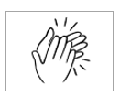

weather | excursion | again
Tuesday | today | library
September | remind | tomorrow
forget | comfortable | report
classroom | behind | minutes
repeat | afternoon | understand
teacher | morning

Activity 2 – Amina’s late - sequencing
This is a listening activity. The teacher needs to walk around to help and check students’ work as they listen and sequence the text. See notes in this book on page 16 about sequencing activities.

Level A
Thanks Peter. I’m sorry I’m late.
Hi Amina.
You’re at the picnic shelter?
Where are you?
Did you say turn left?
Don’t worry. See you soon.
Hello Peter.
No, turn right. Walk round the lake to the playground. We’re at the picnic shelter behind the playground.
I’m worried. I can’t find you.
That’s right.
I’m on the little bridge near Kemp Street.
Walk over the bridge to the lake. Then turn right.

Activity 2 – Amina’s late - sequencing
Level B
Thanks Peter. I’m sorry I’m late.
Where are you?
I’m worried. I can’t find you.
Hi Amina.
I’m on the little bridge near Kemp Street.
Don’t worry. See you soon.
Did you say turn left?
No, turn right. Walk round the lake to the playground. We’re at the picnic shelter behind the playground.
Walk over the bridge to the lake. Then turn right.
That’s right.
Hello Peter.
You’re at the picnic shelter?

A place to rent
Activity 1 – Vocabulary– parts of a house [Pair work]
The vocabulary squares can be used for a variety of activities:
- Matching in pairs – Print enough copies of page 51 so each pair of students has a page. Students cut up the squares and match. The words can then be copied into notebooks. [Store cut-up squares in envelopes for later use.]

- Concentration – Mix the squares face down on the table and students take turns to turn over two squares. If the picture and word match, students keep them and have another turn. If the squares don’t match, students turn them face down again. The winner is the student who ends up with the most pairs when all squares have been matched.

- Creating new partners for class pair work - Give pictures to one half the class and the matching words to the other half. Students need to find their match and then sit and work together.

Activity 2 – My dream house [Group work]
- Model describing your dream house:

Students work in small groups. Give both sets of pictures on pages 51 and 52 to each student. Each person lays out a selection of cards to create their own house design. They then describe it to the group.
e.g. My house has 4 bedrooms. It has ….
My unit has 2 bedrooms. It has …

- The best house I lived in – repeat the previous activity but each person lays out a selection of cards to create the best house they’ve lived in. They then describe it to the group. [Pre-teach past simple: It had…]

Activity 1 & 2 – Vocabulary – parts of a house
 | house |  | unit
 | bedroom |  | bathroom
 | bath |  | separate toilet
 | laundry |    | living room
 | garage |  | parking space
 | garden | 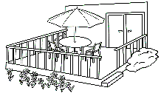 | deck

Activity 2 - Additional set of cards for the design of dream homes
 | bedroom |  | bedroom
 | bedroom |  | bedroom
 | bathroom |  | bathroom
 | bath |  | separate toilet
 | laundry |  | living room
 | garage |  | parking space
 | garden |  | deck

Activity 3 – House survey [Small group]
- Print a survey sheet for each student.
- Project the questions below or write them on the board.
- Students work in groups of four and ask the questions below of the members of their group.
- Students interview one partner, and then change partners until they have interviewed the three other students in the group.

Questions
- Do you live in a house?
- Do you live in a flat?
- How many bedrooms do you have?
- How many bathrooms do you have?
- Do you have a bath?
- Do you have a separate toilet?
- How many living rooms do you have?
- Do you have a separate laundry?
- Do you have a parking place?
- Do you have a garage?
- Do you have a garden?
- Do you have a deck?

Activity 3 – House survey - Worksheet
Student 1
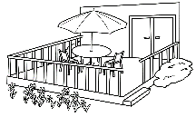
Student 2
Student 3

Activity 4 – A new home
The following conversation between Parwana and Linh is included in the student workbook. The sequencing slips are at two levels, with level A indicating the first speaker in green, while Level B has no colour. The two levels of difficulty allow students to do the same exercise, but at their skill level.

Level A
Yes. The batteries can be dangerous, so I’m glad we have a garage.
Why can’t you keep the bike inside?
Well, it’s an old house with two bedrooms. It has a small garden, a sunny back deck and a garage.
That’s interesting. I didn’t know that.
It’s in View Street.

No. View Street, V – I – E – W.
That’s great Linh. Where is it?
Yes. I need a place for my e-bike.
So, tell me about your new home.
Yes. It’s only a five-minute walk.
Do you need a garage?
I moved into my new home yesterday Parwana.
New Street?
I need to charge my bike away from the house because lithium batteries can catch fire.
Is it near the shops?

Level B
New Street?
Is it near the shops?
It’s in View Street.
Yes. It’s only a five-minute walk.
Why can’t you keep the bike inside?
That’s great Linh. Where is it?
Do you need a garage?
That’s interesting. I didn’t know that.
Well, it’s an old house with two bedrooms. It has a small garden, a sunny back deck and a garage.
I moved into my new home yesterday Parwana.

Yes. I need a place for my e-bike.
No. View Street, V – I – E – W.
I need to charge my bike away from the house because lithium batteries can catch fire.
So, tell me about your new home.
Yes. The batteries can be dangerous, so I’m glad we have a garage.

Sale at the Op Shop
Objects in the Op Shop

Activity 1 – Naming items [Pair work]
In this information gap activity, students name items on their worksheet and identify if they are the same or different to those on their partner’s worksheet.
There are two levels:
Level A – includes only one item in a square and the vocabulary includes vocabulary in the student workbook for this unit and unit VU23504 Read and write informational texts.
Level B - features more items in a square and vocabulary from other Certificate 1 in EAL units.

- Students work in pairs. It’s important they don’t show their worksheet to their partner.

Student A asks questions in rows 1 and 3 with stars.
Student B asks questions in rows 2 and 4 with dots.
- Demonstrate the Level A activity, by doing A1 and A2 together.
Students answer the question, e.g. in A1, both students have jeans,
so they tick the A1 box. In A2, the students have different items,
so cross the A2 box.
- Students ask questions about the whole row and then swap roles.
Activity 2 – Where was it made? Where were they made?
As part of the description of an object, it is common to mention where it was made. Although the passive is not taught at Certificate 1 in EAL, it can be taught as a collocation.
- Project page ___ and note:
- the use of was made for singular objects and were made for plural objects.
- the use of the definite article the, as the questions are about specific objects.
- Ask questions Where was the t-shirt made? Where were the jeans made? and students nominate a country.
- Ask student to check where things they own were made. e.g. their phone, pen, watch, shoes, clothes, car.

Garden

Activity 1 – Naming items Level A
Student A
What’s in A1?
Is it the same or different?

X
 | A | B | C
1 | 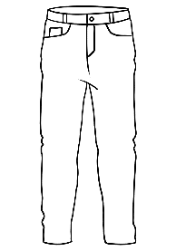  jeans | 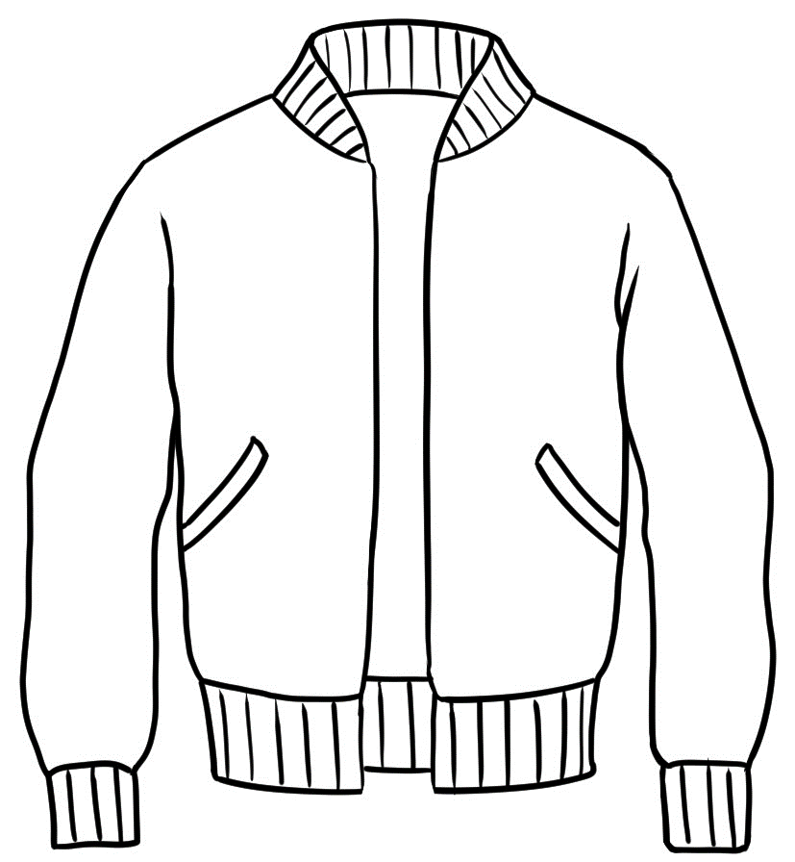  a jacket | 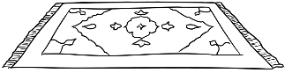  a rug
2 | 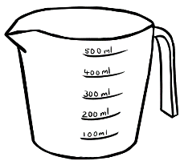  a jug |   a vase | 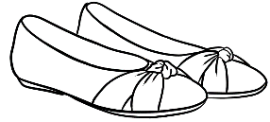  shoes
3 | 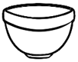  a bowl |   a hat | 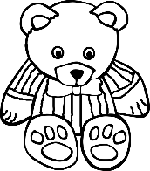  a toy
4 | 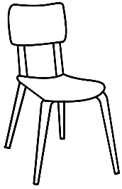  a chair |   a lamp | 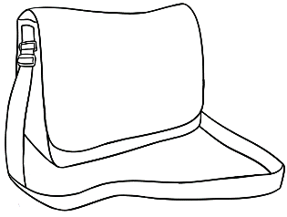  a bag
What’s in B1?

Activity 1 – Naming items Level A

Student B
Is it the same or different?

X
What’s in A2?
What’s in B2?
 | A | B | C
1 | jeans |   a toy | a rug
2 | 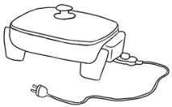  a frypan | a vase | 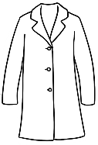  a coat
3 | 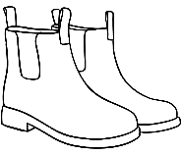  boots | a hat |   a table
4 | a chair | 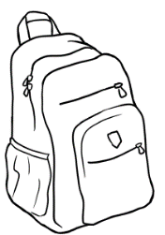  a backpack |   a cap

Activity 1 – Naming items Level B
Student A
Is it the same or different?

X
What’s in A1?
 | A | B | C
1 | a pair of jeans |   a bowl and a spoon | two chairs
2 | 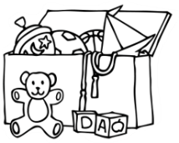  a box of toys |   a pair of runners | 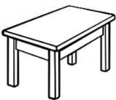  a table
3 | a backpack | 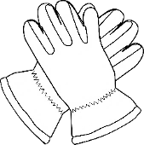  a pair of gloves |   a coat and a scarf
4 |   a pair of earrings | 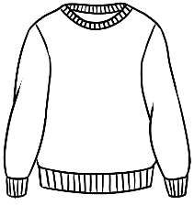  a jumper |   a cap and a t-shirt
What’s in B1?

Activity 1 – Naming items Level B

Student B
Is it the same or different?

X
What’s in A2?
What’s in B2?
 | A | B | C
1 | 2 pairs of jeans | a bowl and a spoon | three chairs
2 | a box of toys |   a pair of runners and a pair of socks |   a table and a vase
3 | two backpacks | a pair of gloves | a coat and a scarf
4 | a pair of earrings | 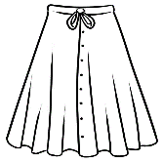  a jumper and a skirt | a t-shirt

Activity 2 – Where was it made? Where were they made?
Where was it made? | Where were they made?
  the t-shirt | 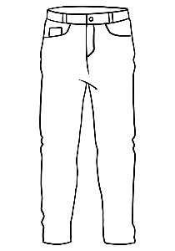  the jeans
the scarf | the earrings
  the coat |   the runners
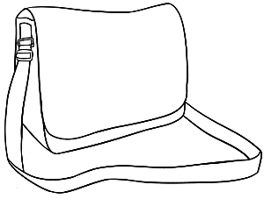  the bag | 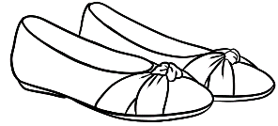  the shoes
  the hat | the gloves

in China

in India
in Italy
in England
in Myanmar
in the USA
in Vietnam
in Iraq
in Syria
in Afghanistan
in Greece
in Australia

An invitation
Activity 1 – Amina invites Ahmad to a barbecue.
This is a conversation that needs to be read by the teacher. It recycles the WhatsApp invitation from Amina to Basam in the student workbook on page 40. The listening exercise follows the pattern of other listening exercises in the student workbook and includes listening questions and a cloze exercise.
- Read the questions on the next page together as a class.
- Read the conversation below to the students slowly a couple of times, giving students time to tick the answers. If possible, record the conversation with another teacher prior to the class. You can improvise playing two roles in the conversation by projecting pictures of Amina and Ahmad and pointing to each speaker as you read their part.
Note: There is more than one answer for question 5.

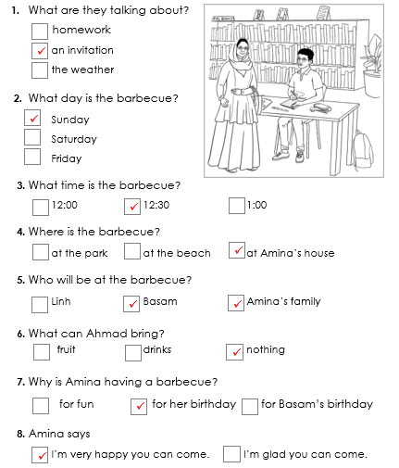
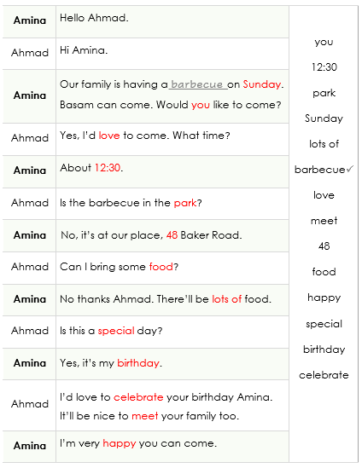
Transcript Answers

Activity 1 – Amina invites Ahmad to a barbecue. Listening questions

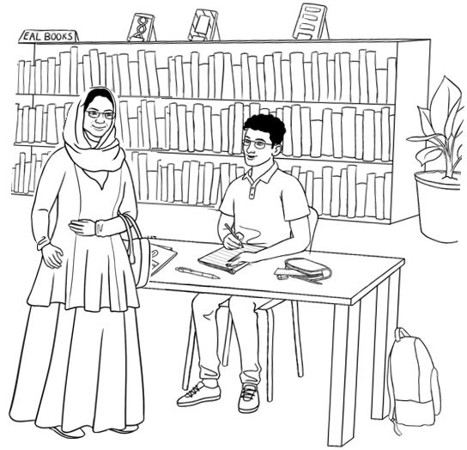
- What are they talking about?
homework

an invitation
the weather

- What day is the barbecue?
Sunday

Saturday
Friday

- What time is the barbecue?

12:00 12:30 1:00

- Where is the barbecue?

at the park at the beach at Amina’s house

- Who will be at the barbecue?
Linh Basam Amina’s family

- What can Ahmad bring?
fruit drinks nothing

- Why is Amina having a barbecue?
for fun for her birthday for Basam’s birthday

- Amina says

I’m very happy you can come. I’m glad you can come.

Activity 1 – Amina invites Ahmad to a barbecue. Cloze
Amina | Hello Ahmad. | you  12:30  park  Sunday  lots of  barbecue  love  meet  48  food  happy special  birthday  celebrate
Ahmad | Hi Amina.
Amina | Our family is having a barbecue on _________.  Basam can come. Would ______ like to come?
Ahmad | Yes, I’d ________ to come. What time?
Amina | About ________.
Ahmad | Is the barbecue in the _________?
Amina | No, it’s at our place, _____ Baker Road.
Ahmad | Can I bring some __________?
Amina | No thanks Ahmad. There’ll be ______ ___ food.
Ahmad | Is this a ______________day?
Amina | Yes, it’s my _______________.
Ahmad | I’d love to _____________ your birthday Amina.  It’ll be nice to __________ your family too.
Amina | I’m very ___________ you can come.

Activity 2 – An invitation to Harmony Day
The following invitation is an example of one that could be used to invite other student groups to an event. Ideally students would memorise sections of the invitation and go as a small group to other classes to invite them to the event.
- Vocabulary – write the words in the text box below on the board and explain each. Leave the words on the board, so students can copy any words they may need in the listening exercise.
- Give each student a copy of the listening cloze. Read the invitation slowly while students write the missing words.


Harmony Day
harmony celebrate
cultures food
orange shoes

Transcript
Good morning everyone.
Next Monday is Harmony Day.
Harmony Day is on 21 March every year.
It’s a day to celebrate our different cultures.
We celebrate with food, music and dancing.
Come and join us next Monday at 11:30.
Lunch is at 12:30 in the garden.
Singing and dancing starts at 1:30.
Bring a plate of food to share.
Wear special clothes from your country or something orange.
Wear your dancing shoes.
Don’t forget Monday 21 March is Harmony Day.

Activity 2 – An invitation to Harmony Day

Event Name ___________________ ________
Date ______ ______________
Time _____ : _____am
Lunch _____ : _____ pm
Music _____ : _____ pm
Bring a plate of _______________
Wear special clothes or something ___________ .
Wear your dancing ____________ .

Harmony Day


Harmony Day
Event Name ___________________ ________
Date ______ ______________
Time _____ : _____am
Lunch _____ : _____ pm
Music _____ : _____ pm
Bring a plate of _______________
Wear special clothes or something ___________ .
Wear your dancing ____________ .

The beach and the pool

Activity 1 – Ko goes to the beach Sequencing
As in other sequencing activities in this book, the sequencing is at two levels and designed to be used as a listening activity.

Stay between the flags and in the shallow water.
Yes, very comfortable.
The fat tyres make the chair easy to push
over the sand. You can take it in the water too.
No. This is the first time.
Have you used the chair before?
Yes. I want to go in the water.
Hello. Is the beach wheelchair comfortable?
When should I return the chair?
No problem. Have fun.
Level A

Thanks for your help.
Yes. The beach wheelchair is free because we want everyone to enjoy our beautiful beach.
Can I book the chair any day?
Before 5.

Activity 1 – Ko goes to the beach – sequencing

Level B
Hello. Is the beach wheelchair comfortable?
Yes, very comfortable.
Have you used the chair before?
No. This is the first time.
The fat tyres make the chair easy to push over
the sand. You can take it in the water too.
Yes. I want to go in the water.
Stay between the flags and in the shallow water.
When should I return the chair?
Before 5.
Can I book the chair any day?

Yes. The beach wheelchair is free because we want everyone to enjoy our beautiful beach.
Thanks for your help.
No problem. Have fun.

Activity 2 - The UV-Index Listening
Read the information about the UV Index to students. Students fill in missing information.
The UV Protection poster could be enlarged for a wall chart and adapted for other activities.

Transcript
The UV index helps us be SunSmart. The index has five levels, low, moderate, high, very high and extreme. Remember the numbers for each level:
- Low is 1 and 2.
- Moderate is 3, 4 and 5.
- High is 6 and 7.
- Very high is 8, 9 and 10.
- Extreme is 11+
UV rays are from the sun. You cannot see or feel them, but your skin can burn when the UV index is 3 and over.
Keep safe. Download the free SunSmart app today.

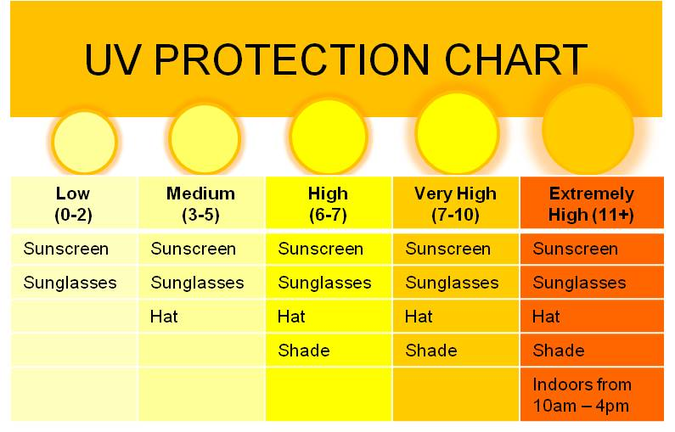
This Photo by Unknown Author is licensed under CC BY-SA

Activity 2 - The UV-Index Listening


feel | five | safe | free
3 | sun | helps | high

The UV index ______________ us be SunSmart. The index has
________ levels, low, moderate, ____________, very high and extreme. Remember the numbers for each level:
the UV Index
Low |  |  | Moderate |  |  |  | High |  |  | Very high |  |  |  | Extreme

UV rays are from the ________. You cannot see or _________ them, but your skin can burn when the UV index is _____ and over.
Keep _________. Download the __________ SunSmart app today.

Activity 3 - Swimming lessons – Matching questions and answers
The questions in green and the answers in white can be cut up and matched. Students can take turns to ask and answer the questions.

Who can learn to swim Sahra? Anyone?
Where does Hani go for swimming lessons?
When does Hani go to the pool?
What do the lessons cost?
Why do you want Hani to learn to swim?

Yes. Anyone can learn, babies, children and adults.
We go to the Kellivale Swimming Pool. It’s in North Street, opposite the hospital.
Hani goes to the pool on Tuesday morning, but
there are different lesson times.
I have a Health Care Card, so I pay $15 a lesson.
Swimming will make her strong. I want Hani to be safe in the water. It’s important to learn to swim
in Australia.

Activity 4 - At the pool – Listening [Class activity]
Before the listening exercise, project the pictures below and teach this vocabulary: a nappy, open, close, a café, diving
- Give each student a listening sheet.
- Slowly read each announcement while students complete the missing words.


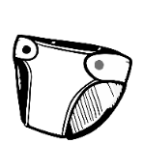
a nappy diving

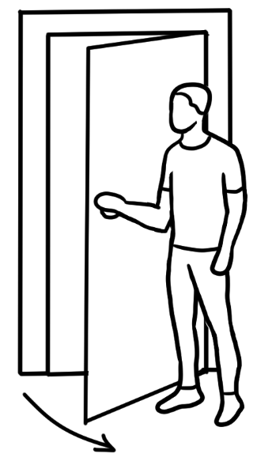
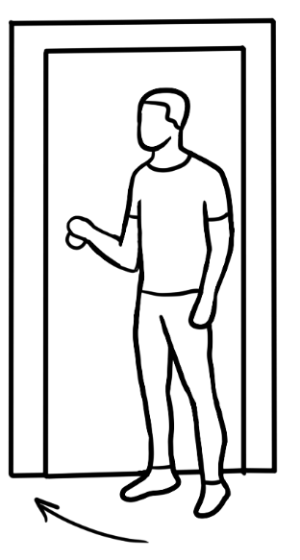

open close

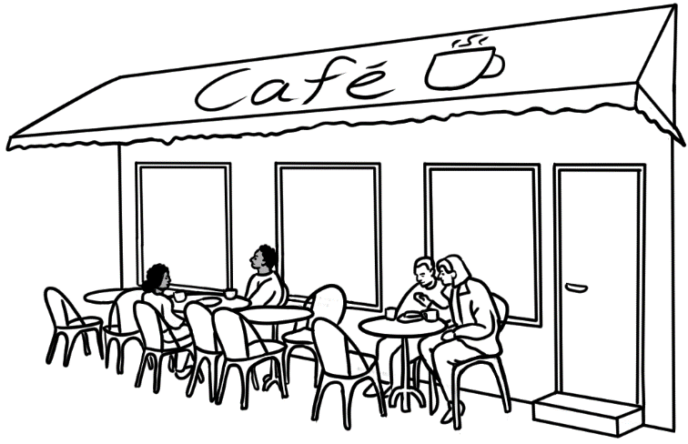

a café

At the pool - Transcript
- Good morning swimmers.
Swimming lessons for babies will begin at 10:30.
Babies must wear swimming nappies.
- All swimmers
Please shower before you swim.
- All swimmers, please follow the rules.
- No running.
- No diving in the small pools.
- The café will open at 11.
Please do not eat food in the pool.
- The café close in 15 minutes.
The pool closes in 30 minutes.

Activity 4 - At the pool – Listening worksheet

At the pool

- Good morning swimmers.  Swimming lessons for __________will begin at ______.  Babies must wear ______________nappies. | swimming  babies  running  diving  eat  before  small  10:30  30  11  15
- All swimmers
Please shower ___________ you swim.

- All swimmers, please follow the rules.
- No ______________.
- No ______________in the _________ pools.

- The café will open at _________.
Please do not ___________ food in the pool.

- The café closes in ________ minutes.
The pool closes in ________ minutes.

A quick and easy meal
Vocabulary and grammar revision
The following activities revise vocabulary and grammar included in this section in the student workbook.
Activity 1 – What did they buy?
- Print the student worksheet on the following page.
- Slowly read what each character bought from the shopping chart below and students tick their answers.
Extension – Play the round the class accumulative activity where each student says I bought some… and adds the previous student’s purchase to theirs.
Student 1 I bought some cheese.
Student 2 I bought some cheese and some eggs.
Student 3 I bought some cheese, eggs and spinach. etc
This game can be varied:
- I went to the shop and bought some ….
- I went to the shop and bought some …[choices follow in alphabetical order.]

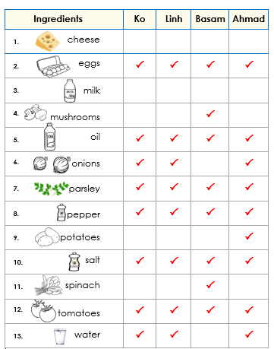
Activity 1 – What did they buy?
Shopping chart

Ingredients |  | Ko | Linh | Basam | Ahmad

cheese
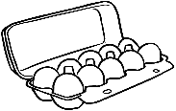
eggs

milk
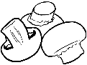
mushrooms

oil


onions


parsley

pepper

potatoes

salt

spinach

tomatoes

water
Activity 1 – What did they buy? Student worksheet

Activity 2 – Food [Pair work]
- Print the student worksheets on the following page.
- Students take turns to ask questions about what food is in the empty grey boxes on their grid.
- It is important that students don’t copy, but ask each other to spell any words they can’t spell.
Activity 3 – Bingo [Class work]
A vocabulary revision exercise.

Activity 4 – Chant [Class work]
This chant helps students remember common questions and collocations, and introduces the word oodles. Divide the class into A and B and once students are familiar with the chant, one or more students can take the teacher’s role.

Activity 5 – Sequencing of two conversations about kitchen accidents
As with other sequencing activities in this book, the sequencing for these two conversations is at two levels and are designed to be used as listening activities.
- What happened? This is based on the conversation on pages 50 -51 in the student workbook.
- Linh talks to Wendy. This is based on the conversation on pages 52 -53 in the student workbook.

Activity 2 – Food

Can you spell that please?
What’s in A1?
Write in the white boxes.
Student A
 | A | B | C | D
1 | cheese | eggs | potatoes
2 | tomatoes | salt
3 | water |  | onions

Can you spell that please?
What’s in B1?
Write in the white boxes.
Student B
 | A | B | C | D
1 | cheese | eggs |  | mushrooms
2 |  |  | spinach | oil
3 |  |   parsley |  | milk

Activity 3 – Bingo Master Sheet
  garlic |   sesame seeds |   potatoes
  salt | mushrooms
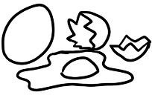  eggs |   eggplant |   tomato
  pepper |  | 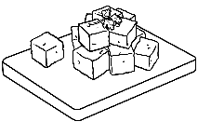  feta

Activity 3 – Bingo Student cards

garlic | sesame seeds | potatoes |  | tomato | mushrooms | feta
salt | mushrooms | feta |  | pepper | eggplant | eggs
eggs | eggplant | tomato |  | garlic | potatoes | sesame seeds
Card 3
 |  |  |  | Card 4
feta |   potatoes | sesame seeds |  | eggplant
garlic | eggplant | eggs |  | sesame seeds | potatoes | garlic
tomato | mushrooms |  |  | feta | mushrooms | tomato

Card 1 Card 2

Activity 4 – Chant

Teacher | A | B
Linh goes shopping. | Who goes shopping? | Linh goes shopping.
She goes on Friday. | When does she go? | She goes on Friday.
Linh goes to the market. | Where does she go? | She goes to the market.
She buys eggs and milk. | What does she buy? | She buys eggs and milk.
She buys lots of noodles. | What does she buy? | She buys lots of noodles.
Linh cooks some noodles. | What does she cook? | She cooks some noodles.
Oodles of noodles. | What did you say? | Oodles of noodles.

Activity 5 – What happened? Sequencing

Level A
Oh no.
Yes. The water cooled the burn. It’s much better today.
What did you do to your hand Ahmad?
Yes it really hurt, but I quickly put my hand in cold running water. I kept it there for 10 minutes.
Did that help?
I burnt it. I made a pizza yesterday and burnt my hand on the pan.

Level B
Did that help?
I burnt it. I made a pizza yesterday and burnt my hand on the pan.
Yes. The water cooled the burn. It’s much better today.
Yes it really hurt, but I quickly put my hand in cold running water. I kept it there for 10 minutes.
What did you do to your hand Ahmad?
Oh no.

Activity 5 – Linh talks to Wendy. Sequencing

Oh?
Much better.
What happened?
It really hurt so I put an ice pack on my leg. Then I sat with my leg up for 20 minutes. I was lucky I didn’t hit my head.
How do you feel today?
I cooked some noodles for lunch and dropped some on the floor.
Oh dear.
I didn’t see the noodles and slipped on them.
I fell on my leg.
You’re limping Linh.
Yes. I slipped and fell on the weekend.
Level A

Level B
I didn’t see the noodles and slipped on them.
I fell on my leg.
Oh?
What happened?
Much better.
Yes. I slipped and fell on the weekend.
You’re limping Linh.
How do you feel today?
It really hurt so I put an ice pack on my leg. Then I sat with my leg up for 20 minutes. I was lucky I didn’t hit my head.
I cooked some noodles for lunch and
dropped some on the floor.
Oh dear.

Word Lists
Additional materials in the English Ready resource books
Teachers with a mixed ability class might find the Course in EAL and the Course in Initial EAL materials useful. Feel free to adapt the materials where necessary using the characters from Certificate 1 in EAL. The Teacher Resources will give you many ideas.
- Letter clusters
The words in the lists of letter clusters appear throughout the student book and can be used to practise pronunciation, draw attention to spelling patterns and create games.

- Word lists
Lists of most words used in each section are on the following pages. Some students like to see the words used in a section before they begin the section. The lists can be used in a variety of ways:
- Make a word list book for students to take home so they can prepare the vocabulary before each class.
- Hand out a list in class and prepare together as a class activity.
- Use the lists to look for and draw attention to common sounds, stress and spelling patterns. It’s important to stagger the focus on word patterns, as introducing too many at once can be overwhelming.
e.g. the most common ways to write the long e sound:
- ee as in see, tree, free, week, meet, street, green, feel
- ea as in clean, bean, eat, meal, east
- y as in happy, sunny, rainy, windy, copy, lucky, twenty, thirty
However, the long e sound can also be written as:
e as in he, ei as in receive, ie as in brief and i as in police.

- Letter clusters
st | ck | ch | ing
station  stay  street  strong  student  study  cost  first  just  last  list  must  past | back  black  check  deck  pack  quick  rock  tick  lucky | chair  chant  charge  cheap  check  cheese  children  China  Chinese  chop  beach  catch  each  lunch  much  such  watch  which  teacher | coming  going  having  learning  talking  asking  listening  reading  working  camping  cooking  gardening  playing  running  swimming  limping  living  parking  everything  meaning  morning  nothing  interesting

br | cl | fr | gr
break  bring  broke  brother | clap  class  cloudy | free  Friday  fried  friends  from  fruit | grandson  grate  great  greeting  ground  ingredients
pl | sh | sp | tion
place  plans  play  playing  player  playground  please  eggplant  reply | shade  shallow  share  she  shelter  shoes  shop  short  should  show  bush  English  finish  fish  push  wash | space  spade  speak  special  spell  sport  spot  spread  hospital  teaspoon | question  direction  information  instruction  invitation  station  reception

Word List Sections 1 - 3
A | ask, again |  | N
B | brother |  | O
C | centre, check, clap, circle, could, can |  | P | partner, please
D | daughter |  | Q | question
E |  |  | R | read
F | father |  | S | son, spell, say, speak, slowly
G | grandson |  | T | tick
H | husband, help |  | U | understand
I |  |  | V
J |  |  | W | wife, write, work
K |  |  | X
L | learning, listen |  | Y
M | mother |  | Z

Word List Section 4
A | any, about, ago, afternoon |  | N | name, now
B | before, birth, beautiful, baby, beach |  | O | older, one, opinion
C | children, computers, come, company, country, camping |  | P | plans, power, painter, plan, practiced, person, photo, playing
D | days |  | Q
E |  |  | R | repair
F | future, free, finish, fixing, friend, finish |  | S | single, study, someone, six, solar, son, soccer, swimmer
G | good, gas, gardening, greeting, going, great |  | T | time, things, talk, tell, true, two, three, today, thank
H | have, holidays, house, healthy, hard-working |  | U | using
I | interview, information |  | V
J |  |  | W | want, where, what, wind, week, wrote
K | kind |  | X
L | learn, like, lives, loves |  | Y | your, younger, years
M | married, morning |  | Z

Word List Section 5
A | asked |  | N | new, near, nice, next
B | bench, bush, bike, bucket, because, barbecue |  | O | old
C | car, city |  | P | playground, park, place, picnic
D | drinking, dog |  | Q
E | exercise |  | R | really, run, ride
F | fence, fun, false |  | S | swing, slide, spade, sunshade, sandpit, some  see-saw, shady, safety, safe, spot, shelter, station
G | gate |  | T | tree, tomorrow, toilets, tap, true, three, together, track
H | house |  | U
I | idea |  | V
J |  |  | W | will, weekend, what, when, where, walk, wetlands
K |  |  | X
L | ladder, lake, long |  | Y
M | many |  | Z

Word List Section 6
A |  |  | N | near, notebook
B | bring, bus, bridge |  | O | our
C | cloudy, classroom, call, comfortable, cold, change, call |  | P | picnic
D | drink, directions, degrees, drop |  | Q
E | excursion, easy, early, everyone |  | R | report, remind, river, raincoat, round, right
F | fine, feel, false, find |  | S | sunny, students, should, shoes, sick, sad, soon, short, see
G | get |  | T | today, tomorrow, there, turn, tired, true, temperature
H | hope, hot, hat, home handbag, happy |  | U
I | interested |  | V | voice
J |  |  | W | weather, warm, wet, windy, worried, wear
K |  |  | X
L | library, late, left |  | Y
M | message, meet, minutes, morning tea |  | Z

Word List Section 7
A | advertisement,  away from, anywhere |  | N | noisy, need
B | bath, bedroom, big, back, batteries, bin |  | O | oily
C | catch, charge, coffee, careful, correct |  | P | place, pot, power-tools
D | deck, dirty, dangerous, desk |  | Q
E | electricity, easy, everywhere |  | R | room, recharge, recycling
F | front, fire, fully |  | S | separate, space, shops, small, safe, scooter, safety-tips, sunlight
G | garage, garden, glad |  | T | toilet, toaster, toy, table tablets, tell
H | hot |  | U | unit, unplug
I | inspection, inside, interesting |  | V
J |  |  | W | workshop
K | keep, know |  | X
L | laundry, living, lithium, laptops |  | Y
M | Mobile-phones, move |  | Z

Word List Section 8
A |  |  | N | new
B | bought, buy, blue, beautiful |  | O | object, old
C | centimetres, cheap, city |  | P | plan, practice, price, put
D |  |  | Q
E | everything |  | R | rug
F | friend, false, flowers |  | S | sale, special, show, shop
G | glass, gift |  | T | things, table, tall, true, today
H | home, half |  | U
I | information |  | V | vase
J |  |  | W | white, wanted, wooden, went
K |  |  | X
L | lamp, long |  | Y | yesterday
M |  |  | Z

Word List Section 9
A | about, address |  | N | nothing
B | bring, birthday |  | O | our
C | cake |  | P | place, pizza
D | drinks |  | Q
E |  |  | R | reply
F | Friday, food, fruit, family |  | S | Saturday, Sunday, salad
G | great |  | T | Thursday, Tuesday, time, tonight, today, tomorrow
H | homework |  | U
I | invitation |  | V | voice
J |  |  | W | Wednesday, would
K | know |  | X
L | lots |  | Y | your, yourself
M | message, meet, Monday |  | Z

A | after, any, adults, anyone, anytime |  | N | nothing
B | beach, between, before, babies, book |  | O
C | comfortable, cost |  | P | push, people, problem, pool, photo, piano, put, pay
D | deep, different, dance |  | Q
E | easy, everyone, enjoy, enrol |  | R | rocks, return
F | flags, first, fat, fun, fix |  | S | shallow, strong, safe, sew, stay, said
G |  |  | T | tyres, thin, too, things,  take back
H | help, hospital |  | U
I | important, information |  | V
J |  |  | W | weather, wheelchair, water
K |  |  | X
L | lessons, learn |  | Y
M |  |  | Z
Word List Section 10

A | add, accident |  | N | noodles, next
B | break, bowl, black, broke, burn, better |  | O | oven, onion
C | cheese, chop, cook, cut, cold, cool |  | P | parsley, put, potato, pizza base
D | drop |  | Q | quick
E | egg, eggplant |  | R | recipe, running, really
F | fried, fall, feta cheese |  | S | seven, sesame, seeds, spread, salty, slip, sit
G | grate, garlic |  | T | together, tomato
H | heat, hand, hurt, help, homework, head, happen, hit |  | U
I | ingredients, ice-pack |  | V
J |  |  | W | warm, wash
K | keep |  | X
L | leg, limp |  | Y
M | meal, mix, mushrooms |  | Z
Word List Section 11

Word List Verbs
A | am, are, ask, add |  | N | need
B | bring, buy, book, break, burn |  | O
C | circle, clap, check, come, cook, camp, call, catch, charge, cost, chop, cut, cool |  | P | play, practise, put, push, pay
D | do, drive, dance, drink, drop |  | Q
E | enrol |  | R | read, repair, run, ride, recharge, reply, return
F | fix, finish, fish, find, feel, fall |  | S | say, spell, speak, swim, study, shop, sew, see, stay, spread, sit, slip
G | go, garden, get, give, grate |  | T | tick, turn, tell, talk, take
H | help, have, heat, hurt |  | U | understand, use
I | is |  | V | visit
J |  |  | W | was, were, write, work, watch, want, walk, wear, warm, worry, wash
K | keep, know |  | X
L | listen, learn, like, love, limp |  | Y
M | meet, move, make, mix |  | Z

