

English Ready
22638VIC Certificate I in EAL
VU23504 Read and write short simple informational texts

Teacher Resources
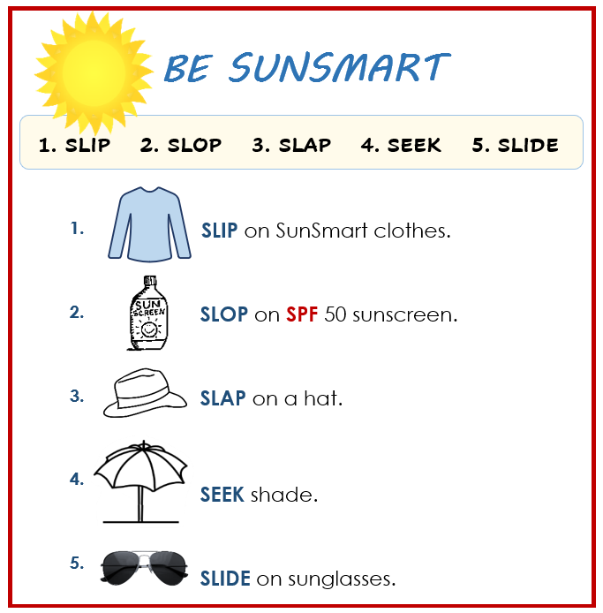



Design team: Vicki Hambling, Sue Paull, Frida Dean, Glenise Kleehammer and Mary Wallace
Illustrations: Madelena Scott

Illustrations acknowledgements:
Vase This Photo by Unknown Author is licensed under CC BY-SA-NC
Sunscreen bottle, recycle logo, toy bear, car tyres These Photos by Unknown Author is licensed under CC BY-NC
Car parking sign, parsley, Surf Lifesaving logo, schwa symbol These Photos by Unknown Author is licensed under CC BY-SA
House inspection, BBQ icon, Surf lifesavers These Photos by Unknown Author is licensed under CC BY
Onion, This Photo by Unknown Author is licensed under CC BY-NC-ND
Acknowledgements: The design team would like to thank the AMEP service providers and practitioners who participated in the trial and gave valuable feedback. The team would also like to acknowledge the use of the EAL Framework which underpins the design of this book. ___________________________________________________________________________
Copyright of the EAL Framework is reserved to the Crown in the right of the State of Victoria. © State of Victoria (Department of Education and Training) 2023.
Use of all or part of this document must include the following attribution:
© Commonwealth of Australia 2024
+
With the exception of the Commonwealth Coat of Arms, the department’s logo, any material protected by a trade mark and where otherwise noted all material presented in this document is provided under a Creative Commons Attribution 4.0 International (https://creativecommons.org/licenses/by/4.0/) licence.
The details of the relevant licence conditions are available on the Creative Commons website (accessible using the links provided) as is the full legal code for the CC BY 4.0 licence (https://creativecommons.org/licenses/by/4.0/legalcode).
As far as practicable, material for which the copyright is owned by a third party will be clearly labelled. The department has made all reasonable efforts to ensure that this material has been reproduced in this document with the full consent of the copyright owners.
Copyright requests and enquiries concerning usage not addressed by the CC BY 4.0 licence should be addressed to: comms@homeaffairs.gov.au at the Department of Home Affairs.
The terms of use for the Commonwealth Coat of Arms are available from the It's an Honour website.
Where a copyright owner, other than the Commonwealth, is identified with respect to this material, please contact that third party copyright owner directly to seek permission.



Introduction
The Teacher Book
The book is an electronic reference and all materials can be adapted and printed as needed. Worksheets have teacher notes that can be removed prior to printing. Resources here include:
- pair work and class work
- revision and homework
- extension
PowerPoint slides have been created to introduce, consolidate and revise vocabulary. This icon indicates a PowerPoint Presentation:
PPT

The Student Workbook
The student book requires teacher direction and is not intended for independent learning. It is also not intended to be the only material used to teach these units or to be used as an assessment task. It is highly recommended that students buy and use a notebook for general class work and practice. The book is available as a Word document so that teachers can:
- localise and update the content
- adjust the material to suit the requirements of particular classes
- delete or add materials as required. If you add or deduct pages, be mindful of the layout as the document has been designed so that particular pages are opposite one another.

NB. Teacher versions of the student workbooks and also the worksheets in this book contain notes to indicate the language focus and/or guide for the exercise. Teacher notes such as this one need to be removed before printing for students.
Rewrite the sentences adding
the capital letters and full stops.
and full stops.

Table of Contents
1. Meet the students and teachers 3
2. Meet two families. 6
3. Workbook instructions 9
4. Some information about me 11
5. The park 20
6. A picnic in the park 26
7. A place to rent 37
8. Sale at the Op Shop 46
9. An invitation 49
10. The beach 51
11. A quick and easy meal 77
12. Additional materials, websites and word lists 83

Meet the students and teachers
The characters
Illustrations in this book and the student workbook are available for use in the design of additional materials.
The bio data chart below was created to maintain consistency of information throughout the English Ready books at the three levels - Course in Initial EAL, Course in EAL and Certificate 1 in EAL. It may be useful to update character information at times. All the characters feature in the Certificate 1 in EAL books. However, those in grey and blue also feature in the Course in EAL and the Course in Initial EAL books respectively.

Name | Family  members | Country of origin | Age / Date of birth |  | Date of arrival | Address in Kellivale  2421 | Phone
Linh Nguyen |  | Vietnam |  | 60 |  | 56 View St  [new home] | 0567 322 184
Basam Radi |  | Iraq |  | 30  05.08.1993 | 2023 | Unit 3, 140 Kemp St | 0455 328 691
Nabi Saikal | Husband and wife  Parents of Parwana | Afghanistan  Pashto |  | 48 | 2023 | 48 Baker Road | 0462 595 751  NabSaikal @gmail.com
Amina Tarukh | Husband and wife  Parents of Parwana |  |  | 46 | 2023 | 48 Baker Road | 0466 379 142  ATarukh13@gmail.com
Parwana Saikal | Rahim’s sister |  |  | 25  09.05.1998 | 12.01.23 | 48 Baker Road | 0476 756 932 Parwana27@gmail.com
Jomeh Tajik | Parwana’s husband |  |  | 27 |  | 48 Baker Road
Bibi Tajik | Girl 5 |  |  |  |  | 48 Baker Road
Mustafa Tajik | Boy 2 |  |  |  |  | 48 Baker Road
Rahim Saikal | Parwana’s brother |  |  | 19  07.05.03 |  | 48 Baker Road | 0469 883 412  rahims003@gmail.com

Name | Family  members | Country of origin | Age / Date of birth | Date of arrival | Address in Kellivale  2421 | Phone
Ahmad Hamed | Carim (m 19)  Fatima (f 15) | Syria | 21  25.08.2001 | 2022 | 260 North St | 0492 665 732
Ko Tun | Zarni Tun – wife  San Tun – daughter  Thein Myint –  son-in-law  Yaza - grandson | Myanmar |  |  | 4/ 50 Baker St
Sahra Omar Elmi | Hani – daughter  2 years | Somalia | 7.07.96 | 9.6.22 | Unit 6  50 Baker Rd | 0455 961 259
Teacher - Peter |  | Greece | 38 |  | Bramby NSW | 0436 924 651
Teacher - Wendy |  | England | 45

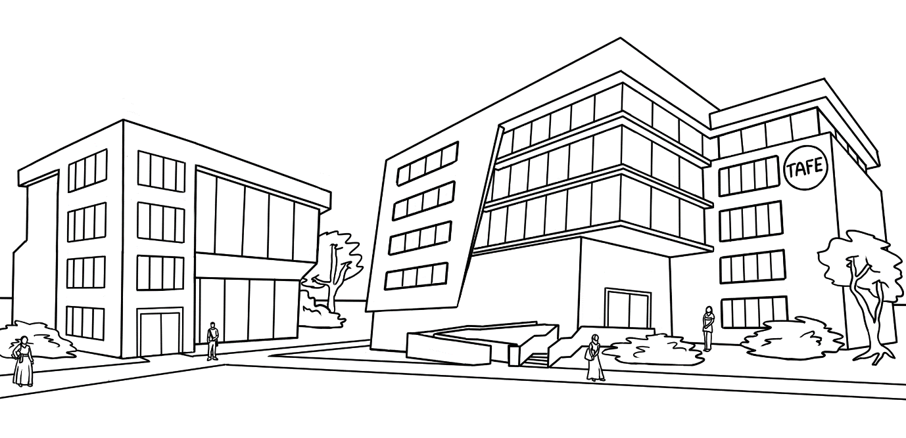
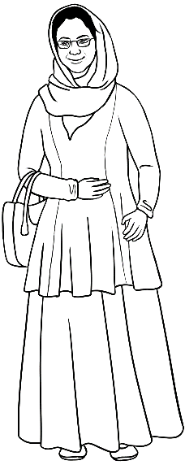
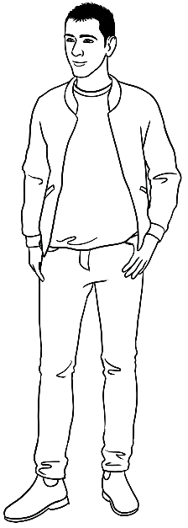

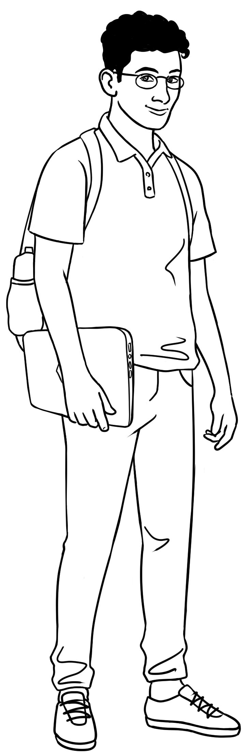
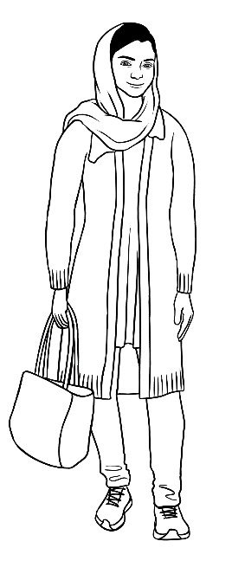
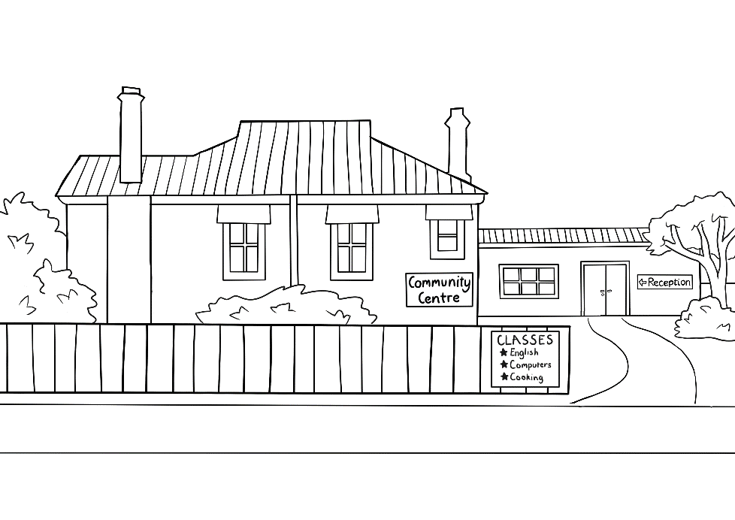
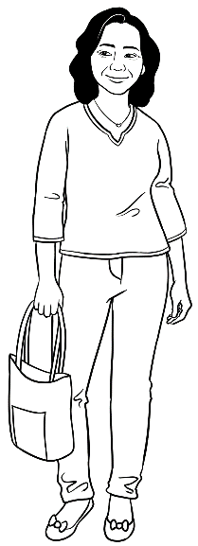
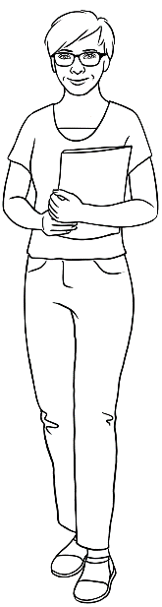
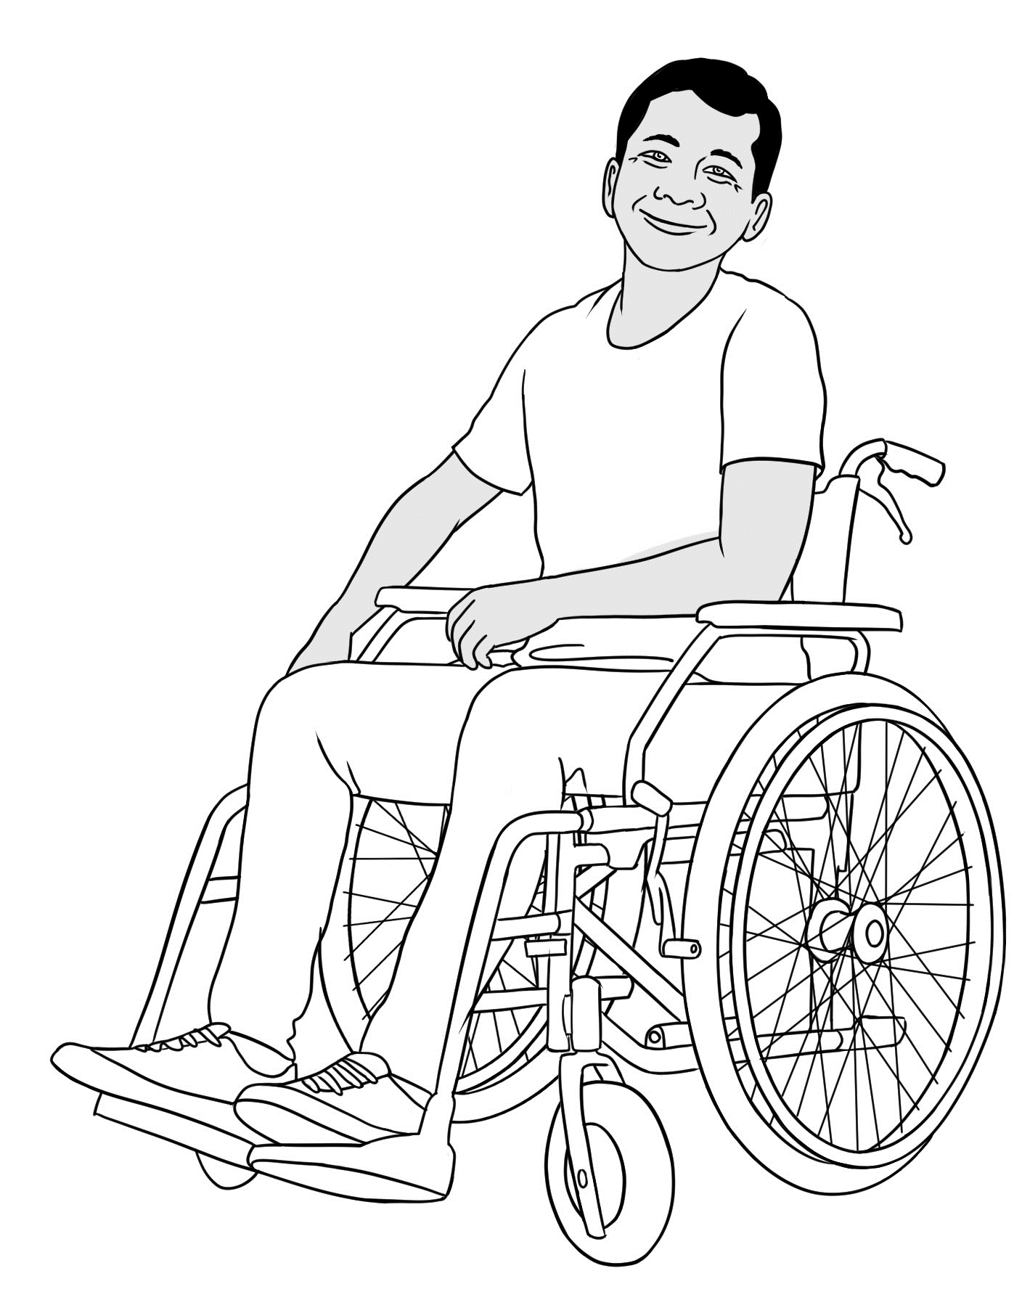
Certificate 1 in EAL characters

Peter
Amina
Basam
Ahmad
At the
AMEP
Centre

Parwana
Wendy
Linh
Ko
At the Learning Centre

Meet two families.
These two families include three student characters in Certificate 1 in EAL student workbooks - Parwana, Amina and Ko. Their family members feature in this unit and units VU23500, VU23501, VU23502 & VU23503 . Project:
- #1 and point to any member of Parwana’s family and elicit their relationship.
- #2 and point to any member of Bibi’s family and elicit their relationship.
- #3 and point to any member of Ko’s family and elicit their relationship.
- #4 and point to any member of San’s family and elicit their relationship.
Introduce the family members using the polite expression This is and the correct 3rd person pronouns. e.g.
Parwana’s family – This is her daughter Bibi. This is her son Mustafa.
Ko’s family – This is his wife Zarni. This is his son-in-law Thein.

Parwana’s family

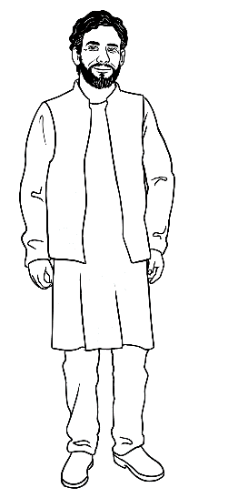
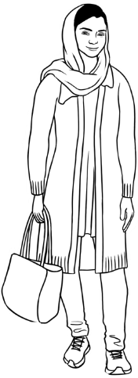
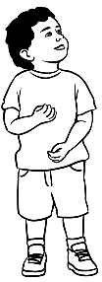
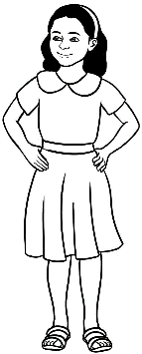
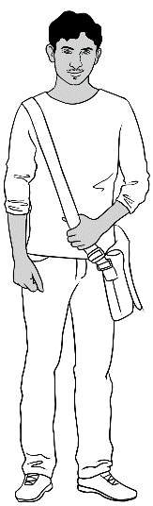
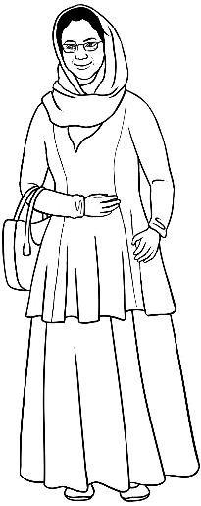
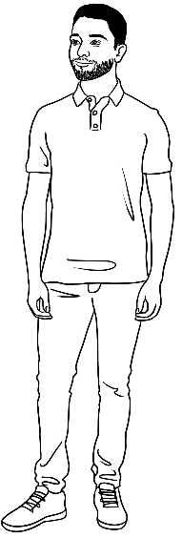
me |  | daughter |  | son |  | husband |  | mother | father |  | brother
Parwana |  | Bibi |  | Mustafa |  | Jomeh |  | Amina | Nabi |  | Rahim

Bibi’s family
me |  | brother |  | mother |  | father |  | grand mother | grand father |  | uncle
Bibi |  | Mustafa |  | Parwana |  | Jomeh |  | Amina | Nabi |  | Rahim

Ko’s family

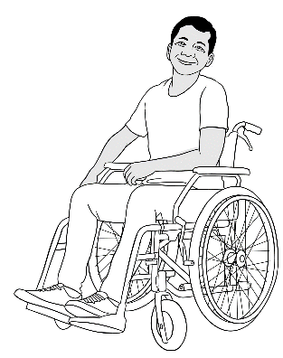
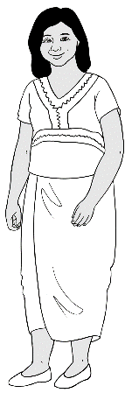
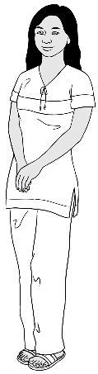
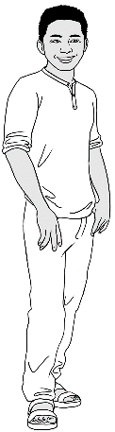
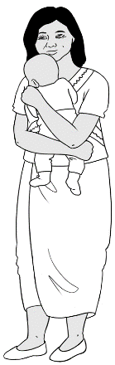

me | wife | daughter | son-in-law | grandson
Ko | Zani | San | Thein | Yaza

San’s family

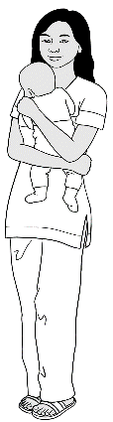
me | mother | father | husband | son
San | Zani | San | Thein | Yaza

Workbook instructions
Workbook instructions
To minimise distractions from the page content, icons replace written instructions in the workbooks. However, students will still require guidance for activities by the teacher. Some additional teacher instructions have been given in text boxes in the teacher version of the student book. The following activities can help students recognise and remember the meaning of the icons.
Activity 1 – Vocabulary
Show on slide show. Once students have been introduced to the icons, delay the appearance of the instruction word and encourage students
to guess and mime the instruction.

Activity 2 – Workbook instructions
Remove the pink teacher instruction boxes and print a worksheet
for each student.
- Students match the instructions to the icons in exercise 1.
- They read the instructions aloud to their partner.
- In exercise 2, the teacher reads the workbook instructions below starting with read and finishing with circle. Students write the number
of the instruction in the boxes.

Do you understand? expressions.
For ways to practise these expressions see the Teacher Resources for unit VU23502 Give and respond to short, simple spoken information.

PPT – Workbook instructions

read | say | listen | ask questions | write | work with a partner
tick | Check your work | highlight | copy | Ask for help | circle

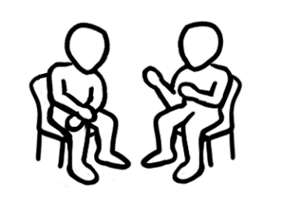

Match the words to the icons and read in pairs.

- listen
- say
- read
- write
- ask questions
- work with a partner
- copy
- circle
- tick
- highlight
- check your work
- ask for help

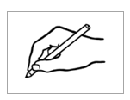
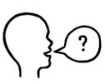




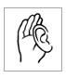



Students write the number of each instruction as they are read out. Start with read.

3

Some information about me

The focus of this section is on writing personal information, joining sentences and introducing paragraphs. The worksheets on the following pages provide practise in these writing skills and can be used for class revision or homework.

Activity 1 – A world map
A large world map on the wall is an invaluable aid for any classroom. Students could locate and stick a pin into Greece [Teacher Peter’s birth country] and other countries that the characters in the books and students and teachers in the class come from.

Activity 2 – Revision of capitals and full stops
Worksheets 1 & 2. – These two worksheets recycle the information on page 7-10 in the Student Workbook.

Activity 3 – Planning writing
Worksheets 1 & 2 – These worksheets scaffold writing - from a plan to sentences and then a paragraph. They recycle the information on pages 7 – 10 in the Student Workbook.

Activity 2 - Worksheet 1
CAPITAL LETTERS

Use a capital letter for the first letter of:

- sentences
- the names of people, places,
days and months
- the word I.
Full stops

Use a full stop at the end
of a sentence.

Rewrite the sentences
adding the capital letters
and full stops.

my name is peter
My name is Peter.
i come from greece
i came to australia 30 years ago
i am married
i live in bramby, 10 kilometres from kellivale



my name is basam and i come from iraq. i came to australia
last year. i am not married, but i have a girlfriend.
Rewrite the paragraph adding the capital letters.

Activity 2 - Worksheet 2
Full stops

Use a full stop at the end
of a sentence.
CAPITAL LETTERS

Use a capital letter for the first letter of:

- sentences
- the names of people, places,
days and months
- the word I.

Rewrite the sentences
adding the capital letters
and full stops.
my name is amina
My name is Amina.
i come from afghanistan
i came to australia in 2023
i am married
i live in kellivale with my family

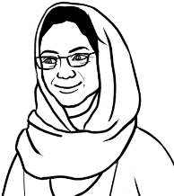



Rewrite the paragraph adding the capital letters.
my name is ahmad and i come from syria. i came to australia
two years ago. i am not married, but i look after my brother and sister.

Activity 3 -Worksheet 1
Peter’s information
Read page 7 in the Student Workbook.

Step 1: Plan |  | Step 2: Write sentences
First name/ given name |  | My name is Peter.
Country of origin
Date of arrival
Marital status
Family
Where do you live?
Likes
Dislikes
Highlight the capital letters.

Step 3: Write the sentences in a paragraph.
My name is Peter and I come from Greece. I came to Australia 30 years ago. I am married and have three children. I live in Bramby. In my free time I like working in the garden, but I don’t like cleaning.

Activity 3 - Worksheet 2
Amina’s information
Read page 7 in the Student Workbook.
Step 1: Plan |  | Step 2: Write sentences
First name/ given name
Country of origin
Date of arrival
Marital status
Family
Where do you live?
Likes
Dislikes

Step 3: Write the sentences in a paragraph.
______________________________________________________________________________
______________________________________________________________________________
______________________________________________________________________________
______________________________________________________________________________
______________________________________________________________________________
______________________________________________________________________________
______________________________________________________________________________

Activity 3 – A whole class writing activity
The revision of vocabulary and writing structures is very helpful, in particular for students who are struggling. This activity includes the planning and writing of sentences and a paragraph on the board. Follow these steps:
- Project the plan on page 17 on the board.
- Prepare the text you want the students to create before the activity.
e.g.

- Build a story about a character or a student on the board with the students, sentence by sentence. Scaffold this by writing some words
and leaving some gaps.
e.g. My _______ _____ Ko. I ________ _______ Myanmar.
- As each sentence is completed, read the information with the class pointing to each word as it is read.

- Once the story is completed, rub out two words and read again. Rub out two more words and read again, pointing to each word and to each missing word. The number of words removed in this way will depend on the class.
- Once as many words as possible have been removed, elicit the missing words by reading the text again together. Repeat the words, and ask students what *sounds they can hear. Write the letters and add any difficult sounds.
- Distribute the worksheets on pages 18 – 19, giving each student the appropriate level. The lowest level students may need assistance in reading the text. The teacher can read the text or students can complete from memory.
* For practice on sounds see the Teacher resources for unit VU23503
Read and write short simple messages and forms, pages 10 – 13.

My name is Ko.
I come from Myanmar.
I came to Australia one year ago.
I am married.
I live with my wife, daughter, son in law and grandson.
We live in Baker Street.
I like computers.
I don’t like fishing.

Activity 3 - Plan
Ko’s information
First name/ given name | 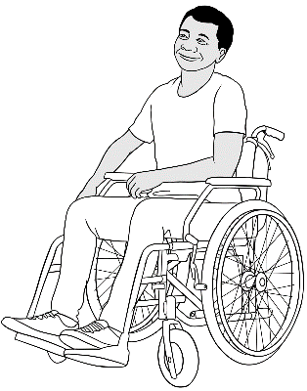  Ko
Country of origin | Myanmar
Arrival in Australia | one year ago
Marital status | married
Family | wife, daughter, son-in-law, grandson
Where do you live? | Baker Street
Likes | computers
Dislikes | fishing

Activity 3 – Dictation Level A

Level A Student Name ________________________________________

My _ a _ e is Ko.
I _ o _ _ from Myanmar.
_ came to Australia one year _ go.
_ _ _ married.
_ live with _ y wife, daughter, son-in-law and grandson.
We live _ _ Baker Street.
_ like computers.
_ don’t like _ ishing.

Activity 3 – Dictation Level B & C

Level B Student Name _________________________________________

_ y _ _ _ e _ _ Ko.
_ _ o _ _ _ _ _ _ Myanmar.
_ _ _ _ _ _ _ Australia one year _ _ _ .
_ _ _ _ arried.
_ live _ _ _ _ _ _ _ ife, _aughter, son- _ _ -law
and grandson.
_ _ _ _ _ _ _ _ Baker Street.
_ like computers.
I don’t _ _ _ _ fishing.

Level C Student Name: ________________________________________

_ _ _ _ _ _ _ _ Ko.
_ _ _ _ _ _ _ _ _ Myanmar.
_ _ _ _ _ _ _ Australia _ _ _ year _ _ _ .
_ _ _ _ _ _ _ _ _ _ .
_ _ _ _ _ _ _ _ _ _ _ _ _ _ _ , daughter,

son-in-law _ _ _ grandson.
_ _ _ _ _ _ _ _ Baker Street.
_ _ _ _ _ computers.
_ don’t _ _ _ _ _ _ _ _ _ _ _.

The park

Activity 1 - The meaning of the icons on the Kellivale Park map
The reading of maps may be a completely new experience for some students,
so before looking at the map of Kellivale Park in the student workbook, it is important to scaffold the map reading by introducing the icons on the map. Project the icons on the following page. Explain their meanings with actions and images and build the vocabulary together. One way to do this could be:
VOCABULARY | Board Work
walking  Project the icon for walking. Mime the action and elicit the word. | On the board, write :  _ _ _ _ ing  Say the word slowly and ask students what letters they can hear. Write the letters as they call them out. [The al is pronounced or, so will be difficult to identify. Link it to the word talk. ]  Say the word and spell it together. Point to each letter as you spell. Note the formation of g with the tail under the line.
Repeat the process with all the icons.

Activity 1 - Icons on the Kellivale Park map
 | 


 | 
 | 
 |   
 | 

Activity 2 - Write about a local park [for more advanced groups]
Two ways to stimulate and guide writing:
- An excursion
After reading about Kellivale Park, organise an excursion to a local park. Another class could be invited to join the excursion. [See section 9 for guidance on writing an invitation.] Make the following vocabulary list and writing model relevant to the park visited. Encourage students to use their workbooks for vocabulary and spelling support. A template for planning and writing can be found on page 24. Students may need support in the use of
a model.

- A drawing or photo of a park
Project a photo of a park or the drawing on page 25. Develop a vocabulary list, and then write sentences and a short paragraph about the park using the template on page24. This could be done as a class or individually.

Vocabulary list
nouns | adjectives | verbs | adverbs
children, kids | old | walk | sometimes
dog | young | play | never
family | local | sit | usually
swing | small | use
slide | large | kick
fence | wooden | like
bench | every | talk
football | safety | relax
people | shady
day | dirty
evening

Model
Plan | Sentences
Where is  the park? | My local park is in Albert Street.
Describe  the park. | It is a small park.  It is beautiful.
What is  in the park? | It has a playground with a safety fence.  It has a swing and a slide.  The park has many wooden benches.  It has many large shady trees.
What do people do there? | Small children use the playground every day.  People have barbecues and picnics on the weekend.  Old people walk in the park in the evening.  They relax and talk.
What do you do there sometimes? | I like walking in the park sometimes.

A paragraph

My local park is in Albert Street. It is a small park, but it is beautiful. It has a playground with a safety fence, a swing and a slide. The park has many wooden benches and large shady trees. Small children use the playground every day. People have barbecues and picnics on the weekend. Old people walk in the park in the evening. They relax and talk. I like walking in the park sometimes.

My local park
Plan | Sentences
Where is
the park?
Describe
the park.
What is
in the park?
What can people do there?
What do you do there sometimes?

Write a paragraph.
________________________________________________________________________________________________________________________________________________________________________________________________________________________________________________________________________________________________________________________________________________________________________________________________________________________________________________________________________________________________________________________________________________________________________________________________________________________________________________
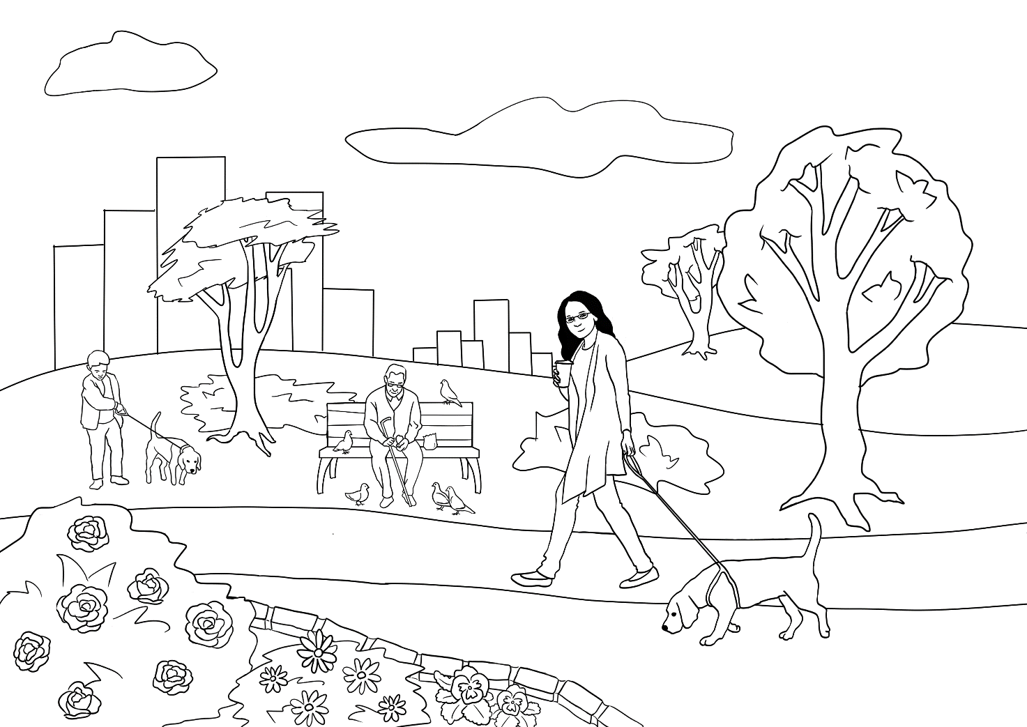

A picnic in the park
The key focus in this section is on sentence structure, prepositions of place and Present Simple forms of the verb to be. In Activity 2 below, students can also practise Present Simple forms of the verb to have.
Activity 1 – Vocabulary and spelling
Project Drawing #1 on the following page. Elicit the names of the items. Write the words on the board for the students to copy using the following technique:
- After the correct word is given, say the word for students to repeat.
- On the board put a dash for each letter in the word.
- Say the word again and ask students what sounds they can hear.
As they call out a sound, write it in the corect place.
- Draw attention to spelling patterns and write in the letters too difficult to guess.
This activity encourages students to have a go and builds their confidence.
Activity 2 – Practising the verb to have
Students will need coloured pencils and to turn to page 18 in the student workbook.
- Project Drawing #2 on the following page.
- Write the verb forms of the verb to have on the board.
Subject | verb
I, You, We, They | have
He, She, It | has
- Read the following sentences and the students colour the drawing.

- Ko has a dark blue hat.
- Thien has a black cap.
- San has an orange hat.
- Yaza has a light blue hat.
- Zani has a green hat.
- They have a brown basket.
- They have a yellow pineapple.

- Write each sentence on the board after it is read.
- Students copy the sentences into their notebooks.

Other adjectives such as small, tiny, large, big, beautiful, delicious etc could be added to the descriptions.

Drawing #1
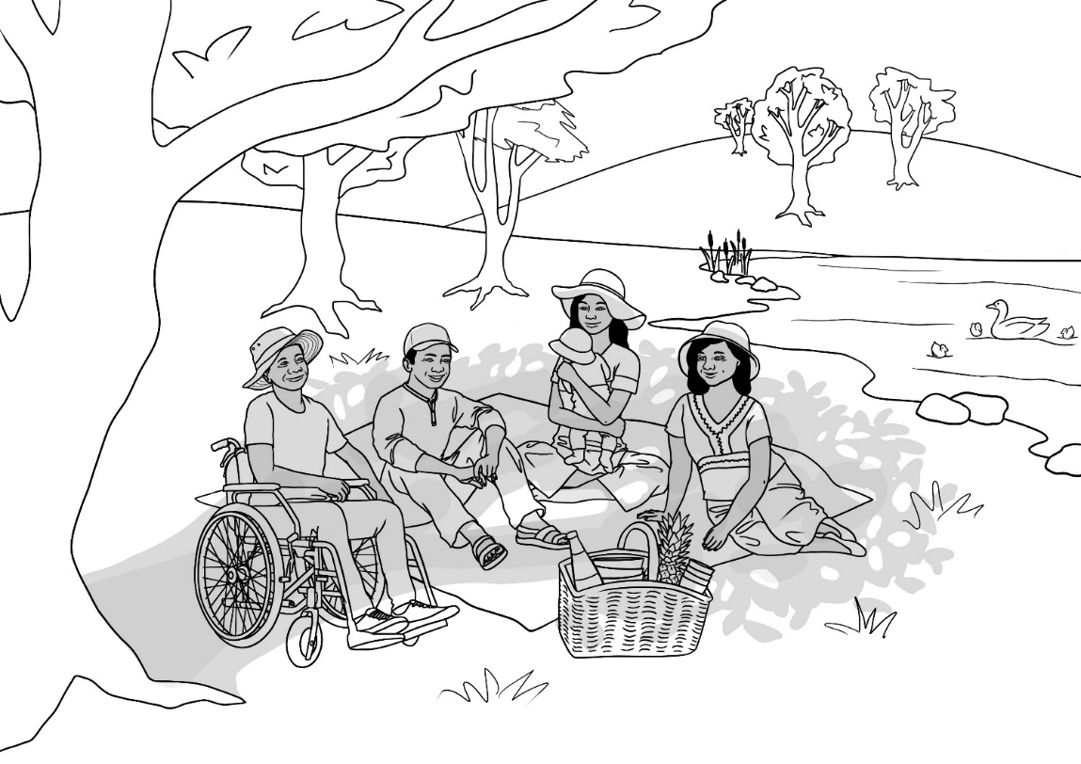

6
3
7
9
8
12
2
1
5
4
10
11

Drawing #2
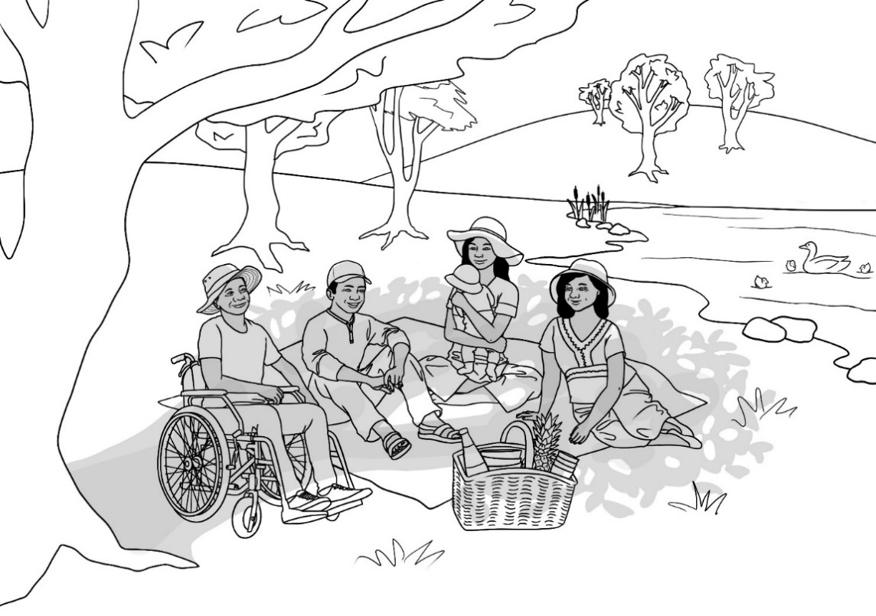

San
Thein
Yaza

Zarni
Ko

Activity 3 – Signs at the park - Dictation
The dictation is available at three levels for mixed level classes. Use the activity as a model to design other materials to support low level students.
- Revise the signs in the Student Workbook on page 21.
- Print the three levels of dictation and give each student the dictation most suited to their current level. Later, when students become more familiar with the exercise, they can ask for a higher or lower-level dictation according to their skills.
- Students hear the same text. The teacher reads the message on the signs and each student writes at their level. All students listen to the teacher and then:
- Level A
Point to each word as the teacher reads.
They then fill in the missing letters.
- Level B
Students can copy if needed.
The answers are not in order.
- Level C
Can check their spelling as they go.
Higher level students can fold the words under and test themselves only looking at the words when necessary.

Note: Explain that signs have no full stops and are generally written in capital letters to make them more urgent. However, in the dictation, normal sentence structure is followed.

- Keep left.
- Please do not feed the ducks.
- Keep our park clean.
- No swimming in the lake.
- Keep dogs on a lead.
- No BBQs on Fire Ban days.

Level A - Dictation
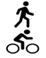 | _ ee _ _ ef _ .
 | _ _ ea _ e _ o _ o _  _ ee _ the _uck_.
 | _ee_ our _ar_ _lea_.
 | _o swimm_ _ _ in the _ake.
 | _ee_ _og_ on a _ea_.
 | _o BBQs o_ _ire Ba_ _ays.

Level B - Dictation
No BBQs on Fire Ban days. | Keep our park clean.
Please do not feed the ducks. | Keep dogs on a lead.
No swimming in the lake. | Keep Left

Fold
 | _ _ _ _ _ _ _ _
 | Please _ _ _ _ _ _ _ _ _ _ _ _ ducks.
 | Keep _ _ _ _ _ _ _ _ _ _ _ _.
 | _ _ swimm _ _ _ _ _ _ _ _ lake.
 | _ _ _ _ _ _ _ _ _ _ a lead.
 | _ _ BBQS _ _ Fire _ _ _ _ _ _ _ .

Level C - Dictation
____________________________________ .
___________________________________________
___________________________________________ .
_____________________________________________ .
___________________________________________
___________________________________________ .
___________________________________________
___________________________________________ .
___________________________________________
___________________________________________ .

Fold
No BBQs on Fire Ban days | Keep our park clean.
Please do not feed the ducks. | Keep dogs on a lead.
No swimming in the lake. | Keep Left

Activity 4 – Vocabulary revision
The vocabulary lists can be found at the back of this book and include the words introduced in each section. One kinaesthetic revision game is:
The Fly Slap Game
* You will need two new different coloured fly swats and a whiteboard.
- Divide the class into two teams, named after the colours of the swats.
- Write the revision words randomly over the board. Say the words as you write and ask students to repeat. Elicit sentences with each word.
- A student from each team stands at the board holding their team’s swat.
- Students in the class take turns to call out a word. The first student at the board to slap the word wins a point for their team.
- Rotate students after about four words until everyone [if possible] has had a turn with the swats.
- Keep score on the board.
Extension: An extra point can be won if a team creates a sentence containing
the word.

Activity 5 – A game of Scattergories
Scattergories is a simple and enjoyable way to recycle vocabulary. Introduce the game after students have completed the exercise on adjectives on page 17 of the Student Workbook. The game can be also used to practise nouns.
Games 1 and 2 - Adjectives
The goal of the games on the following page is to write appropriate adjectives in the space before each noun. The adjectives must be different to the ones chosen by the other groups. Points are only awarded to groups who have a unique adjective; no points are scored when the same adjective is chosen. Secrecy is important!
- Organise the class into groups of three or four.
- Elicit adjectives from page 17 in the student workbook and list them on the board. Add additional familiar adjectives to the list.
- Print the Games 1 & 2 on the following page, one for each group.
- Cut the page in half and give each group a copy of Game 1.
- Set a time limit.
- Groups then chose and write adjectives before the five nouns.
- When the time is up, each group reads their first adjective/noun phrase; points are recorded on the board for groups with unique adjectives.
- Continue this process for the five phrases.
- Then play Game 2, adding points to the scores for Game 1.
Games 3 & 4 - Nouns
Repeat the process above, but this time elicit and write nouns in a list on the board. Groups need to select a noun to go with each adjective.
There is a template for additional games with different adjectives and nouns.

Game 1 – Add an adjective
- a ________________________ town
- a ________________________ city
- a ________________________ river
- a ________________________ bike
- a ________________________ tree
Game 2 – Add an adjective
- a ________________________classroom
- a ________________________road
- a ________________________ flower
- a ________________________ day
- a ________________________ woman

Game 3 – Add a noun
- a small ________________________
- a large ________________________
- a beautiful ________________________
- a quiet ________________________
- an old ________________________
Game 4 – Add a noun
- a shady ________________________
- a clean ________________________
- a dirty ________________________
- a friendly ________________________
- a young ________________________

Game 1
- a ________________________
- a ________________________
- a ________________________
- a ________________________
- a ________________________
- a ________________________
Game 2
- a ________________________
- a ________________________
- a ________________________
- a ________________________
- a ________________________
- a ________________________

A place to rent
Activity 1 – The home rental process - Cloze for a disparate class
There are three levels for this activity to cater for a disparate class.
- Print the three levels of the cloze and lay them out on a table for students to select the level that suits their current skills.
- Read the text on page 22 of the student workbook while the class listen.
- Students fill in the missing letters or words, remembering to tick each word in the grey box on the right once it has been used.
Activity 2 – Word finds at three levels.
Print the three levels of the word finds and lay them out on a table for students to select the level that suits their current skills. Students need to tick the words on the list at the top of the page as they find them in the puzzle.
- Level A – Words are horizontal only
- Level B – Words are horizontal and vertical
- Level C - Words are horizontal, vertical and diagonal
Answers to each word find are on page 44.
Activity 3 – Sentence variation
This exercise for more confident students, compares the placement of adjectives before the noun and after the verb to be. Project the table on page 45.
- Read together with the class, adding the adjectives and nouns in the spaces.
- Print the page for students to complete for revision and/or homework.

Activity 1 - Cloze - Level A
First
want
live
Second
want
read
go
some
place
Next
read
sign
Finally
pay
bond
  1. | _ irst, where do I _ ant to _ ive?
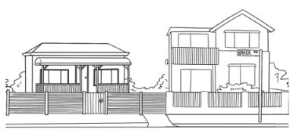  2. | _ econd, what do I _ ant?
  3. | Third, I _ ead some ads and  _ o to _ ome inspections.
  4. | Then, I apply for a _ lace.
    5. | _ ext , I _ ead and _ ign the contract.
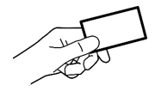  6. | _ inally, I _ ay the _ ond and two weeks rent.

Activity 1 - Cloze - Level B
1. | F _ _ _ _ , where do I w _ _ _ to live?
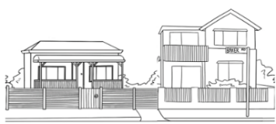  2. | S _ _ _ _ _, what do I _ _ _ _?
3. | T _ _ _ _ , I r _ _ _ some ads and  go to some _ _ spections.
4. | Th _ _, I a _ _ _ _ for a place.
  5. | N _ _ _ , I r _ _ _ and sign the _ _ _tract.
6. | F _ _ _ _ _ _, I p _ _ the bond and  two weeks _ _ _t.

first second third
then
next finally
want
want
read
read
apply
pay
inspections
rent
contract

Activity 1 - Cloze - Level C
1. | _________, ___________do I _________ to_________?
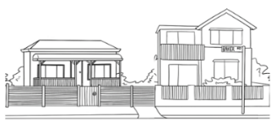  2. | _________, what do I _ _ _ _ ?
3. | __________, I _________ some ads and _____ to some inspections.
4. | __________, I _________ for a place.
5. | __________, I ________ and ________  the contract.
6. | ___________, I ______ the bond and  two weeks rent.

first
second third
then
next
finally where
live
want
read
go
apply
sign
pay

Activity 2 - Word Find Level A
  house |   unit |   bedroom |   bathroom |   bath
  toilet |   separate laundry |  |     living room
  garage |   parking space |  |   garden | 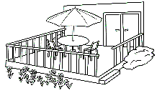  deck

h | o | u | s | e | t | b | a | t | h | r | o | o | m
b | g | l | i | v | i | n | g | r | o | o | m | s | p
c | b | e | d | r | o | o | m | o | d | e | c | k | t
l | a | u | n | d | r | y | l | u | h | o | r | e | e
j | k | g | a | r | a | g | e | l | s | p | a | c | e
t | p | a | r | k | i | n | g | z | s | q | a | g | e
s | p | m | u | v | o | b | y | g | a | r | d | e | n
b | a | t | h | r | l | t | o | i | l | e | t | n | d
s | e | p | a | r | a | t | e | l | o | o | s | e | d

Activity 2 - Word Find Level B
house | unit | bedroom | bathroom | bath
toilet | separate laundry |  | living room
garage | parking space |  | garden | deck

h | o | u | s | e | b | b | a | t | h | r | o | o | m
s | p | n | y | s | v | e | c | j | d | l | k | n | l
e | k | i | t | p | c | d | b | a | t | h | d | k | i
p | o | t | p | a | h | r | t | o | i | l | e | t | v
a | c | o | n | c | p | o | f | s | c | m | c | t | i
r | p | i | w | e | h | o | g | b | d | u | k | o | n
a | z | r | r | o | o | m | p | a | r | k | i | n | g
t | g | a | r | d | e | n | p | g | a | r | a | g | e
e | m | o | u | d | l | a | u | n | d | r | y | d | s

Activity 2 - Word Find Level C
house | unit | bedroom | bathroom | bath
toilet | separate laundry |  | living room
garage | parking space |  | garden | deck

h | o | s | e | t | s | s | v | u | e | b | m | n | p
b | o | l | t | z | l | d | e | c | k | a | d | e | a
a | e | u | n | i | t | n | s | p | a | c | e | t | r
t | g | d | s | l | n | o | l | k | a | p | r | t | k
h | a | w | r | e | v | r | i | o | b | r | d | h | i
r | r | y | q | o | n | o | v | l | j | l | a | i | n
o | d | a | s | d | o | o | i | f | e | g | h | t | g
o | e | b | a | t | h | m | n | x | b | t | n | m | e
m | n | y | r | d | h | g | g | a | r | a | g | e | o

Activity 2 - Word Find Answers
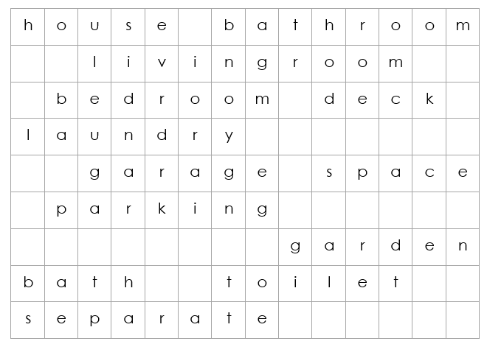

Level A

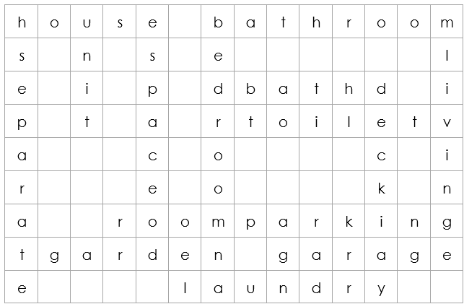

Level B

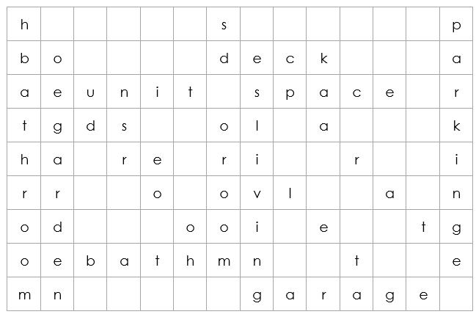

Level C

Activity 3 - Sentence variation

Adjective before the noun | Adjective after the verb to be
- It is an old house. | The house is old.
- It has large bedrooms. | The bedrooms are large.
- It has a small bathroom. | The bathroom is ________________.
- It has a sunny living room. | The ___________ _______ is _____________.
- It has wooden floors. | The ___________ are ______________.
- It has a new kitchen. | The _____________ is ______________.
- It has a tiny laundry. | The ______________ is _____________ .
- It has a big garage. | The ______________ is _____________.
- It has a beautiful garden. | The ______________ is _____________.
- It has a great back deck. | The _________ ________ is __________ .

Sale at the Op Shop
Activity 1 - Cloze
Students can refer to their workbook for support in doing this activity.
Activity 2 – True or false information
The focus of this activity is to:
- identify true and false information
- practise the positive and negative forms of the modal can.
In practising this modal, emphasise that modals must be followed by the infinitive form of the verb.
Once the worksheet is completed, ask students where they can buy the objects that can’t be bought at the Op Shop.

Activity 1 - Cloze
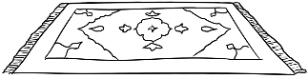


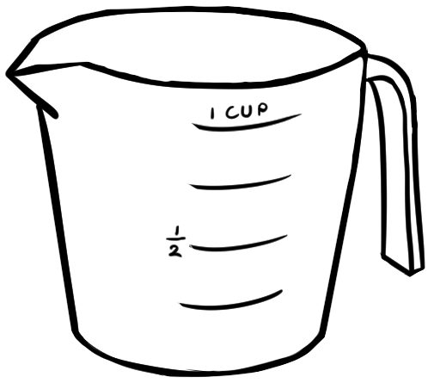
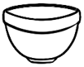

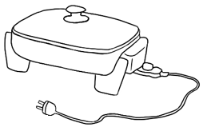
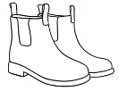
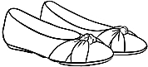
Homewares
__________ware
______________
__________
______________

Electrical
Towels
Toys
Home
Furniture
Footwear
Kitchen
Clothing
Books


_________ and Bedding

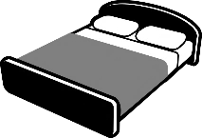

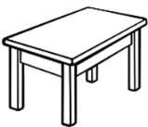
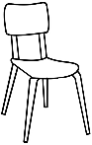
_______________

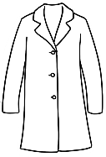
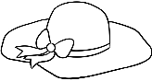
___________

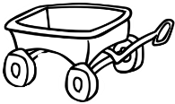
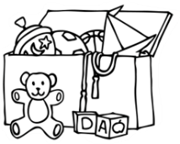
__________

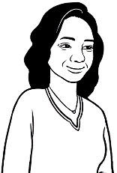
Activity 2 – True or false information
Once completed, ask students where each of the goods could be found in the shop.
What can I buy at the Op Shop?

Information | True | False
- You can buy shoes.

- You can buy books.
- You can buy hats.

- You can buy phones.

- You can buy plants.
- You can buy chairs.

- You can buy car tyres.
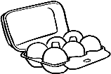
- You can buy eggs.
- You can buy rugs.
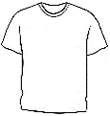
- You can buy t-shirts.


- You can buy spoons.
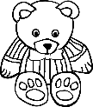
- You can buy toys.

An invitation
Social events
Social activities can improve morale and help a class to connect and thrive.
An easy to organise social event could be a morning or afternoon tea with another class and/or staff at the learning centre. This would involve:
- Writing an invitation to the class/staff
- Reading a recipe and preparing food for the event.
Activity 1 – Write an invitation
The invitation below is identical to the one on page 33 of the workbook. Once students complete the invitation in their books, ask one student to copy the details onto the template below, cut it out and deliver it to the invited class.

An invitation

Dear ________________________________________________ ,
Come to ____________________________________________
When _____________________________________
Time ________________________
Where ____________________________________________
RSVP _________________________________before ______________________
^{name} ^{date}

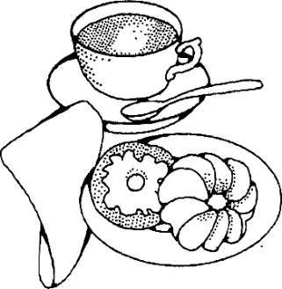

Activity 2 – Reading a recipe and preparing food for the event.
The following recipe does not require cooking and makes enough for about 50 small serves. The recipe has been tested and is very sweet, but also delicious. Equipment needed:
- a microwave and a fridge.
- a large mixing bowl, a tablespoon, a sharp knife, a chopping board,
a lamington tin.
Project the recipe and make together in class the day before the morning tea.

Chocolate and date slice
Ingredients
160 gms butter

120 gms dates
120 gms dark chocolate bits
60 gms preserved ginger
90 gms rice bubbles
Instructions

- Chop the dates and ginger finely.
- Melt the butter and the chocolate in a microwave for 20 seconds.
- Stir and melt again for 20 seconds.
- Melt and stir until the butter and chocolate is melted.
- Add the dates and ginger and stir.
- Add the rice bubbles and stir.
- Press into a tin, cover and refridgerate until firm.
- Cut into small slices.

The beach
Understanding the free SunSmart app
Access the app from the webpage: https://www.sunsmart.com.au/resources/sunsmart-app
The app can be downloaded onto phones and gives UV and sun protection alerts daily and seven-day forecasts in Australia and across the world. It is available in eight languages.
Project the diagram below from the app and ask the questions below.

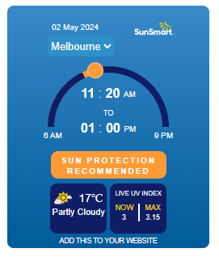

- Who is this message from?
- What city or town in Australia is this for?
- What is the date of the message?
- What is the temperature?
- Is it sunny?
- What is the current UV index rating?
- Do you need sun protection?

Developing Spelling Skills
Due to the irregularities in English spelling, it is important to practise a wide range of strategies to strengthen spelling skills. The following approaches can help improve skills. For further ideas, check the Teacher Resources for unit VU23503 Read and write short simple messages and forms, Section 7,
pages 39 – 47.
Activity 1 – Speed-copying at three levels
One of the simplest and most effective ways to improve spelling and writing is speed-copying. With regular practice, speed-copying can improve spelling, handwriting and memory. Students’ written expression also improves as they memorise common groupings of words and collocations.
Low level students will initially copy letter by letter, but as they become more proficient, they learn to chunk letters, write whole words, then a few words and finally complete sentences.
The method is:
- Set the timer for 2, 4 or 5 minutes.
- Ask the students to copy the same text over and over in that time.
- If they finish copying their text before the time is up, they need to copy it again, and maybe even again.
- Students copy the same text every day for a week, trying to increase the number of words they write each time.
- The text copied can be used for a dictation the following week.
- Choose a new text to copy each week.
On the following pages are examples of speed-copying texts available at three levels for disparate classes. Copy each page twice, back-to-back, so the activity can be completed on separate days. Allow students to select the level that is most suitable for them.
Activity 2 – Dictation of speed-copying texts at three levels
Follow up speed-copying exercises by dictating the practised texts. The same text is dictated to all levels. If students have practised speed-copying regularly, the dictation allows them to measure their progress.

Activity 1 – Spelling Speed-Copying Level A
 |  |  |  | 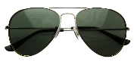
slip | slop | slap | seek | slide
slip | slop | slap | seek | slide
slip | slop | slap | seek | slide
slip | slop | slap | seek | slide
slip | slop | slap | seek | slide
slip | slop | slap | seek | slide
slip | slop | slap | seek | slide
slip | slop | slap | seek | slide

Activity 1 -Spelling Speed-Copying Level B
Slip on SunSmart clothes.
________________________________________________________
Slop on SPF 50 sunscreen.
________________________________________________________
Slap on a hat.
________________________________________________________
Seek shade.
________________________________________________________
Slide on sunglasses.
________________________________________________________

Slip on SunSmart clothes.
________________________________________________________
Slop on SPF 50 sunscreen.
________________________________________________________
Slap on a hat.
________________________________________________________
Seek shade.
________________________________________________________
Slide on sunglasses.
________________________________________________________

Activity 1 - Spelling Speed-Copying Level C

Slip on SunSmart clothes.
______________________________________________________________
Slop on SPF 50 sunscreen every 2 to 4 hours.
______________________________________________________________
Slap on a hat to cover your face, neck and ears.
______________________________________________________________
Seek shade.
______________________________________________________________
Slide on sunglasses.
______________________________________________________________

Slip on SunSmart clothes.
______________________________________________________________
Slop on SPF 50 sunscreen every 2 to 4 hours.
______________________________________________________________
Slap on a hat to cover your face, neck and ears.
______________________________________________________________
Seek shade.
__________________________________________________________________
Slide on sunglasses.
______________________________________________________________

Activity 2 - Spelling -Dictation Level A

_ _ _ _ on SunSmart clothes.
_ _ _ _ on SPF 50 sunscreen every 2 to 4 hours.
_ _ _ _ on a hat to cover your face, neck and ears.
_ _ _ _ shade.
_ _ _ _ _ on sunglasses.

Fold


Slip | Slop | Slap
Seek | Slide

Activity 2 - Spelling -Dictation Level B

_ _ _ _ _ _ _ _ _ _ _ _ _ _ _ _ _ _ _ _ _.

_ _ _ _ _ _ _ _ _ _ _ _ _ _ _ _ _ _ _ _ every 2 to 4 hours.

_ _ _ _ _ _ _ _ _ _ to cover your face, neck and ears.

_ _ _ _ _ _ _ _ _.

_ _ _ _ _ _ _ _ _ _ _ _ _ _ _ _ _.

Fold

Slip on SunSmart clothes.
Slop on SPF 50 sunscreen every 2 to 4 hours.
Slap on a hat to cover your face, neck and ears.
Seek shade.
Slide on sunglasses.

Activity 2 - Spelling -Dictation Level C

_ _ _ _ _ _ _ _ _ _ _ _ _ _ _ _ _ _ _ _ _.

_ _ _ _ _ _ _ _ _ _ _ _ _ _ _ _ _ _ _ _ _ _ _ _ _
_ _ _ _ _ _ _ _ _.

_ _ _ _ _ _ _ _ _ _ _ _ _ _ _ _ _ _ _ _ _ _ _ _ _,
_ _ _ _ _ _ _ _ _ _ _.

_ _ _ _ _ _ _ _ _.

_ _ _ _ _ _ _ _ _ _ _ _ _ _ _ _ _.

Fold

Slip on SunSmart clothes.
Slop on SPF 50 sunscreen every 2 to 4 hours.
Slap on a hat to cover your face, neck and ears.
Seek shade.
Slide on sunglasses.
Activity 3– Spelling and remembering common words – Days of the week
To develop speed and proficiency in writing, it is important to expand the number of common words that can be memorised and written easily and correctly. Students will have differing needs in spelling, both in the words they need to remember and their speed in learning.

On the following pages, practice in spelling the days of the week is modelled to support three levels of learning. However, any words may be substituted to replace the days of the week.

For lower levels:
- Use a modified version of Look, Say, Cover, Write, Check
Look, Say the word, Spell the word out loud as you copy.
The words need to be retyped regularly to avoid students copying incorrectly.
For higher levels:
- Teach Look, Say, Cover, Write, Check

It is important at all levels that students:
- Copy under a word rather than next to a word.
- Finish copying one word before writing the next word.
- Work down repeating each word rather than across.
- Check their spelling with the typed word.
- Try to chunk the letters rather than copy letter by letter.
The words are printed twice at each level, so that students practise once in class and then again at home or in a following class. In this way, students are shown a way to improve their writing through brief and regular practice.

Activity 3 – Spelling Common words Level A

Monday | Tuesday | Wednesday
Monday | Tuesday | Wednesday

Thursday | Friday | Saturday | Sunday
Thursday | Friday | Saturday | Sunday

Monday | Tuesday | Wednesday
Monday | Tuesday | Wednesday
Thursday | Friday | Saturday | Sunday
Thursday | Friday | Saturday | Sunday

Activity 3 – Spelling Common words Level B
Monday | Tuesday | Wednesday
Monday | Tuesday | Wednesday

Thursday | Friday | Saturday | Sunday
Thursday | Friday | Saturday | Sunday

Activity 3 – Spelling Common words Level C
Monday | Tuesday | Wednesday | Thursday
Monday | Tuesday | Wednesday | Thursday

Friday | Saturday | Sunday | The week
Friday | Saturday | Sunday | The week

Activity 4– Testing spelling
Different levels for mixed level classes
Spelling Test
In this test, the same words are read to the whole class, but each level has support appropriate to their skill level.
Level A
Students to look for clues. The words are on the page and can be copied, but the students need to locate the letters to copy. Initially, some students may need help with this, and the teacher could underline in red the letters to copy.
Level B
The difficult sounds have been provided. If the words are pronounced slowly, the students should be able to hear the missing sounds. The answers are below so students can also copy.
Level C
Students can write or copy the word. Providing this option and later allowing time to check work removes any fear associated with having a go.

Activity 4– Testing spelling Level A

Student Name:___________________________________________

Aa Bb Cc Dd Ee Ff Gg Hh Ii Jj Kk Ll Mm Nn Oo Pp Qq Rr Ss Tt Uu Vv Ww Xx Yy Zz

Days of the week
Monday  __ o n d a y | Tuesday  __ u e s __ __ __
Wednesday  __ ednes__ __ __ | Thursday  Thurs __ __ __
Friday  __ ri __ __ __ | Saturday  __ atur__ __ __
Sunday
__ un__ __ __

Activity 4– Testing spelling Level B

Student Name:___________________________________________

Aa Bb Cc Dd Ee Ff Gg Hh Ii Jj Kk Ll Mm Nn Oo Pp Qq Rr Ss Tt Uu Vv Ww Xx Yy Zz

Days of the week
- _ o _ _ _ _
- _ u e _ _ _ _
- _ e d n e _ _ _ _
- _ _ u r _ _ _ _
- _ r _ _ _ _
- _ _ _ u r _ _ _
- _ _ _ _ _ _
Fold

Monday | Tuesday | Wednesday | Thursday
Friday | Saturday | Sunday

Activity 4– Testing spelling Level C

Student Name:___________________________________________

Aa Bb Cc Dd Ee Ff Gg Hh Ii Jj Kk Ll Mm Nn Oo Pp Qq Rr Ss Tt Uu Vv Ww Xx Yy Zz

Days of the week
- ___________________________________________
- ___________________________________________
- ___________________________________________
- ___________________________________________
- ___________________________________________
- ___________________________________________
- ___________________________________________
- ___________________________________________
Fold

Monday | Tuesday | Wednesday | Thursday
Friday | Saturday | Sunday | The week

A useful resource – a set of small whiteboards
A set of small whiteboards, coloured markers and erasers is an invaluable resource for any classroom. The boards need to be roughly 500 x 600cm, with one board for each group of three to four students. Small whiteboards are infinitely useful as they:
- are erasable, portable and suitable for any certificate level
- save paper and are not as intimidating as paper
- encourage greater class participation and enhance group work
- encourage students to learn from each other
- provide a different stimulus in the class
- allow the teacher to see mistakes easily.

A set of whiteboards is a great investment, and relatively inexpensive at approximately $15 a board.
Activity – Writing follow-up with whiteboards
Once students are writing sentences independently, it is practical to address common mistakes as a class, with more capable students contributing to the teaching.
- Organise students into groups of three or four at tables.
- Give each group a whiteboard, a few markers and an eraser.*
- Select about 4 to 5 sentences from student writing, with mistakes you want to focus on such as in grammar, spelling or punctuation.
- Write one sentence at a time on the main whiteboard.
- Each group copies the sentence on their board and corrects it together.
- Set a time limit.
- Correct the sentence together on the main whiteboard and students make any corrections needed on their board.
* To add an edge of tension and competition give each group a kitty of fake money [about $300 broken into $5, $10, $20, etc notes] Before correcting
the sentences together [Step 7 above], students use their fake money to bet on their accuracy. The teacher goes round to check each group’s corrections, matching the bet if the group is correct, or taking the money if they are incorrect. The winner is the group at the end with the most money.

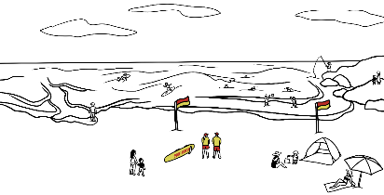
Pre - teaching for the newspaper article – Beach Rescue
Activity 1 – The states of Australia
Project the map of Australia on the board. Draw arrows and write the names of the states and territories in the boxes. Make copies for students to do the same.

Activity 2 – Label the picture of Rocky Beach NSW
Before reading the newspaper article, pre-teach the vocabulary.
Project the picture of the beach on page 70 and give students a copy to label.
On the table below are the words from the article that need to be taught,
but there is more in the picture that can be labelled.
Label the nouns | Mime the Verbs | Mime the adjectives  and adverbs
young man  lifesaver  wave  sea  rip current  ankle deep water  surfboard | rescue  knock over  pull  panic  stay  wave  see | strong  calm  safe  cold  exhausted  large  suddenly  quickly

Activity 3 – Sequencing the story [To follow pages 38 – 41 in the student workbook]
Students:
- Select the level that suits their skill
- Cut up the sentences on pages 71-72 and sequence in pairs.
- Write the story as a paragraph in their notebooks.
Activity 4 _ AMEPOnline Unit Stay Safe [Cert 1 VU22099]
In Topic 2, starting at slide 17, there are two animated videos with activities dealing with beach and swimming pool safety.

Activity 1 – The states of Australia

Australia
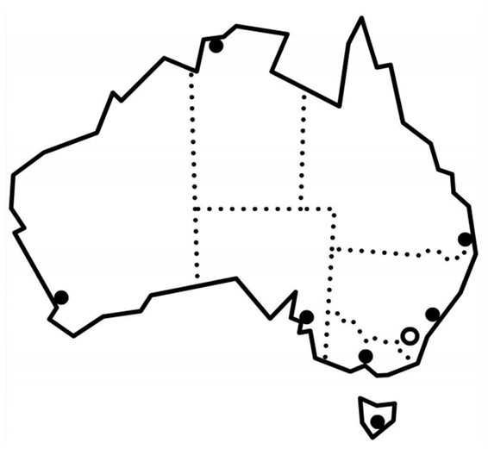
Queensland

Qld Queensland | Tas Tasmania
NSW New South Wales | SA South Australia
Vic Victoria | WA Western Australia
ACT Australian Capital Territory | NT Northern Territory

Activity 2 – Label the picture of Rocky Beach
Rocky Beach in New South Wales

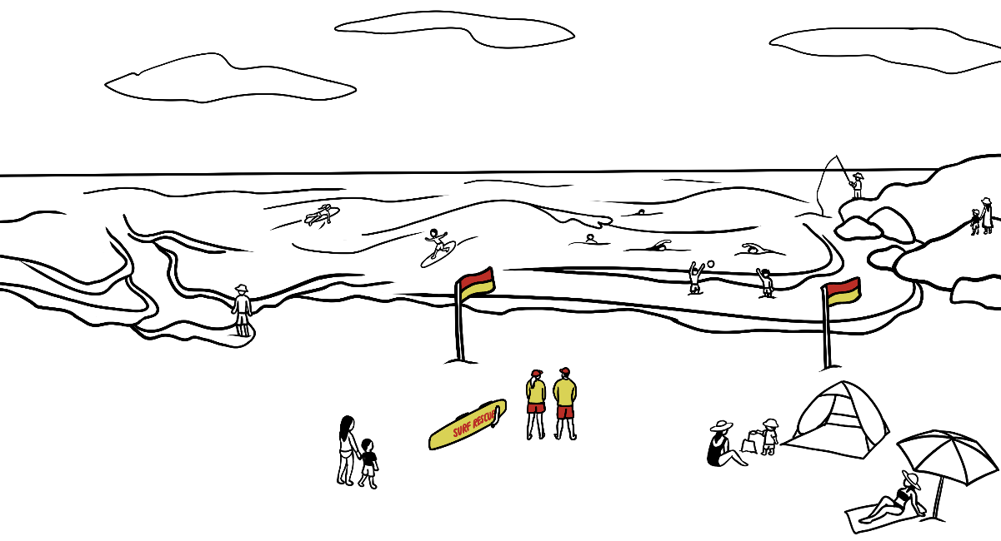

Label the Nouns. | Mime
Label the Nouns. | Verbs Adjectives Adverbs
young man  lifesaver  wave  sea  rip current  ankle deep water  surfboard | rescue  knock over  pull  panic  stay  wave  see | strong  calm  safe  cold  exhausted  large | suddenly  quickly

Activity 3 – Sequencing the story – Level A
The man didn’t panic.
He was safe, but he was very cold and exhausted.
The man was in ankle-deep water and suddenly a wave knocked him over.
He stayed calm and waved his arm.
A strong rip current then pulled him out to sea.
Last Sunday, life savers rescued a young man at Rocky Beach in NSW.
Two surf lifesavers saw him and quickly rescued him on a surfboard.

Activity 3 – Sequencing the story – Level B & C
The man didn’t panic. | and suddenly a wave knocked him over.
He was safe, | and quickly rescued him on a surfboard.
The man was in ankle-deep water |  | but he was very cold and exhausted.
He stayed calm and waved his arm. |  |  | at Rocky Beach in NSW.
A strong rip current then pulled him out to sea.
Last Sunday, life savers rescued a young man
Two surf lifesavers saw him

Activity 4 – Information about a volunteer organisation – Surf Life Saving Club
In Australia volunteer work is common and seen as beneficial in so many ways.
It is important to discuss this with students from countries where this is not common and point out the many benefits:
- Free training and the gaining of new skills
- Work experience that can lead to paid work
- The opportunity to meet different people
- Connects people to their local community and develops a sense of belonging
- Offers a chance to develop English skills.

This activity addresses all the performance criteria in Element 1.

Activity 5 – Revision worksheet for this section
The worksheet can be done together in class or given to students for homework. Remember to remove the pink teacher instruction boxes before printing.

Activity 4 – Information about a volunteer organisation - Surf Life Saving Club



A lifesaver gave this to me at Rocky Beach.
What’s it about?

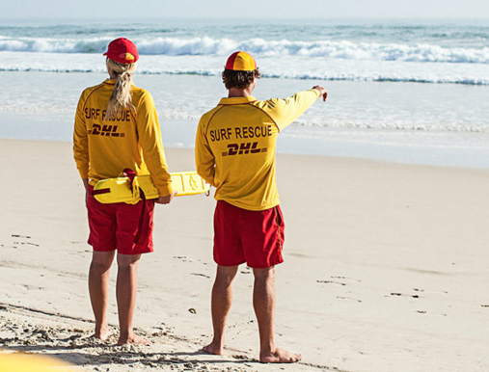

Rocky Beach Surf Life Saving Club
We need more volunteer lifesavers.

We love Rocky Beach and volunteer lifesavers keep
our beach safe. Our lifesavers are highly trained,
but we need more. Anyone over the age of 13 can start training to be a lifesaver. You learn about first aid,
surf rescue and water safety. Volunteers are not paid,
but the training is free.
Rocky Beach Surf Lifesaving Club is one of hundreds
of surf lifesaving clubs in Australia. Children, teenagers, young adults and older adults can join our club.
It is a big friendly family.
We need more surf lifesavers
at Rocky Beach. Lifesavers
save lives and keep our beach
safe for everyone.

Find more information on our website sls.com.au.
Volunteer at Rocky Beach.

A lifesaver gave this information to Basam because the club needs more

money. volunteer lifesavers. swimmers.

- What Surf Lifesaving Club wrote this information? ___________ ____________

- When can you start training? at the age of ___________

- What can you learn? ________________________________________________

________________________________________________________________________

- Who can join the club? ________________________________________________

________________________________________________________________________

- Volunteers are not paid. True False

- Anyone over 13 can learn to be a lifesaver. True False

- Training to be a lifesaver is expensive. True False

- You can find information on sls.com.au. True False

very well
100s
not dangerous
emergency medical help
someone who works for no pay.

first aid
volunteer
highly
hundreds
safe

Activity 5 – Revision worksheet for this section
Read out capital letters at random for students to circle.

A a B b C c D d E e F f G g H h I i J j K k L l M m N n O o P p Q q R r S s T t U u V v W w X x Y y Z z
CAPITAL LETTERS:

Use a capital letter for the first letter of:

- sentences
- the names of people, places
days and months
- the word I.

Rewrite the sentences with capital letters.

on sunday 16 november a young man was walking
_____________________________________________________________________
in ankle deep water at rocky beach in nsw.
_____________________________________________________________________
suddenly a wave knocked him over.
_____________________________________________________________________
Is it true or false?

- A rip is always safe. true false
- You can see a rip easily. true false
- A rip can pull you out to sea quickly. true false
Complete the sentences.
Two life savers saw him because he_____________________________
He was safe, but he________________________________________________

A quick and easy meal
Activity 1 – Vocabulary matching – Ingredients and cooking verbs.
The vocabulary squares can be used for a variety of activities:
- Matching in pairs - Copy enough pages so each pair of students has a page. Cut up the squares and match. The words can then be copied into notebooks. [Store cut-up squares in envelopes for later use.]

- Concentration – Mix the squares face down on the table and students take turns to turn over two squares. If the picture and word match, students keep them and have another turn. If the squares don’t match, students turn them face down again. The winner is the student who ends up with the most pairs when all squares have been matched.
- Making new partners for class pair work - Cut up one set of either the ingredients or verbs. Give pictures to one half the class and the matching words to the other half. Students need to find their match and then sit and work together.
Activity 2 – Sequencing the instructions of a recipe
There are three levels for this activity:
Level A - The strips are in order.
Level B -The strips are not in order.
Level C - The strips are not in order and the images do not match the strips.

- Students select the level best suited to their skills.
- They cut the instructions into strips.
- Listen to the teacher and put them in order
Activity 3 – AMEPOnline Unit Christine makes Anzac biscuits [Cert VU22106]
This unit covers some of the language in this unit and is a useful additional resource.

Activity 1 – Vocabulary matching – Ingredients
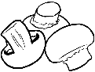 | mushrooms |  | spinach
 | oil |  | milk
 | pepper |  | salt
  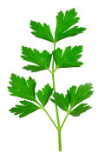 | parsley |  | tomatoes
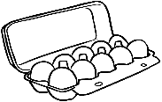 | eggs |  | cheese
 | onions |  | water

Activity 1 – Vocabulary matching – Cooking verbs
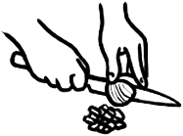 | chop | 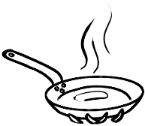 | heat
 | fry |  | add
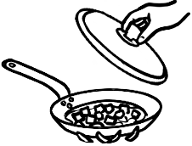 | cover | 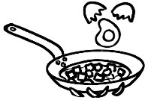 | break
 | grate |  | beat
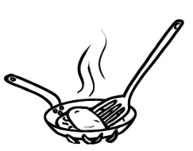 | fold | 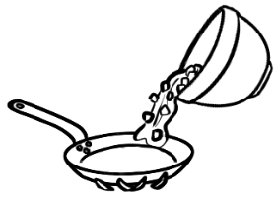 | pour

 | Break the eggs into a bowl.
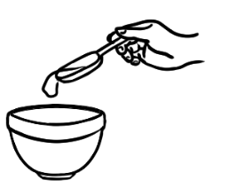 | Add the milk to the bowl.
 | Beat the eggs and milk.
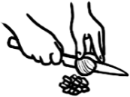 | Chop the tomato and parsley.
 | Grate the cheese.
 | Add the tomato, parsley, cheese,  salt and pepper.
 | Heat the oil.
 | Pour the egg mixture into the pan.
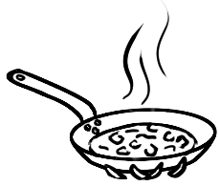 | Cook gently.
 | Fold the omelette,
Activity 2 – Sequencing the instructions of a recipe - Level A

Activity 2 – Sequencing the instructions of a recipe - Level B
Pour the egg mixture into the pan.
Chop the tomato and parsley.
Fold the omelette,
Add the tomato, parsley, cheese,
salt and pepper.
Grate the cheese.
Cook gently.

Heat the oil.
Break the eggs into a bowl.
Beat the eggs and milk.
Add the milk to the bowl.

Activity 2 – Sequencing the instructions of a recipe - Level C
Pour the egg mixture into the pan.
Chop the tomato and parsley.
Fold the omelette,
Add the tomato, parsley, cheese,
salt and pepper.
Grate the cheese.
Cook gently.

Heat the oil.
Break the eggs into a bowl.
Beat the eggs and milk.
Add the milk to the bowl.

Additional materials, websites and word lists
- Additional materials in the English Ready resource books
Teachers with a mixed ability class might find the Course in EAL and the Course in Initial EAL materials useful. Feel free to adapt the materials where necessary using the characters from Certificate 1 in EAL. The Teacher Resources for the following units will give you many ideas.

 | Course in EAL  Teachers Resources for units:  VU23497 & VU23499 | Course In EAL  Teachers Resources for units:  VU23496 & VU23498
months | _____ | Pages g 19, 30, 34, 35, 36
days | _____ | Pages 44, 45, 46
Personal information | _____ | Pages 21 & 22, 42, 43
family | Pages 23, 24 | Pages 37, 38
numbers | Pages 27, 30 | Pages 39,40
Dates and times | Page 71 | _____

2. Useful websites
Beach Safety multilingual
http://www.waverley.nsw.gov.au/recreation/beaches_and_coast/beach_safety/beach_safety_in_15_languages

Surf Safety multilingual
Multilingual | SLSA Beachsafe
3. Readers for Purchase - Check on the internet.:
- The May Street Stories by Carmel Davies - At the Park
- Sing with me stories by Carmel Davies & Sharon Duff -
The sun is out today
- PRACE Page Turners (4 levels available)
- ESLREADS.com books by Lauren Piovesan
- Claire Harris ESL books Aus
4. Letter clusters
The words in the lists of letter clusters appear throughout the student book and can be used to practise pronunciation, draw attention to spelling patterns and create games.
5. Word lists
A list of most words used in a section are on the following pages. Some students like to see the words used in a section before they begin the section. The lists can be used in a variety of ways:
- Make a word-list book for students to take home so they can prepare the vocabulary before each class.
- Hand out a list in class and prepare together as a class activity.
- Use the lists to look for and draw attention to common spelling patterns. It’s important to stagger the focus on spelling patterns, as introducing too many at once can be overwhelming. e.g. the most common ways to write the long a sound:
- a_e as in name, game, late, gate, gave, wave, save, lake, cake, make
- ai as in rain, main, pain, train, mail, rail
- ay as in day, say, way, stay, play, away

3. Letter clusters
  er schwa | ck | ch | ing
danger | back | cheese | opening
cover | track | children | fishing
answer |  | cheap | swimming
bigger | check | chop | morning
father | neck | check | evening
November | deck | chair | parking
mother |  |  | drinking
daughter | tick | beach | walking
lifesaver | quick | match
brother |  | search | shopping
owner | knock | spinach | bedding
never |  | catch | getting
partner | duck |  | living
pepper | luck | wheelchair | using
remember |  | kitchen
river |  |  | everything
shelter
under
water

br | cl | fr | gr
bread | class | free | grass
break | clap | Friday | grate
bring | clean | friendly | grandson
brother | close | front | great
 |  | fry | ingredients
 |  |  | playground
pl | sh | sp | tion
place | shade | speak | section
plate | shallow | spell | question
play | share | spinach | station
please | shelter | spoon | instruction
plural | shoe |  | information
 | shop |  | protection
 | should
 | fish
 | push
 | mushroom

Words in Sections 1 - 3
A | again, Australia |  | N | November, nine
B | brother |  | O | one
C | clap, copy, circle, could, country |  | P | partner, please, park
D | daughter, day |  | Q | question
E | eight |  | R | repeat, read
F | family, father, four, five |  | S | son, say, spell, speak, slowly, street, suburb, Sunday, six, seven
G | grandson |  | T | tick, two, three, ten
H | husband, highlight, help |  | U | understand
I |  |  | V
J |  |  | W | wife, write, work woman
K |  |  | X
L | listen |  | Y
M | mother, me, match, man, month |  | Z

Words in Section 4 - Some information about me
A | Australia, ago, arrival |  | N | name
B |  |  | O | origin
C | come, came, children, clean, cooking, check |  | P | play, paragraph
D | date, dislikes |  | Q
E |  |  | R
F | free, fishing |  | S | shopping, sister, sentences, swimming
G | garden, games grandchildren, girlfriend |  | T | time
H |  |  | U
I |  |  | V | video
J | join |  | W | who
K | kilometres |  | X
L | live, like |  | Y | years
M | married, marital status |  | Z

Words in Section 5 – The Park
A | area, adjectives |  | N | next to, near, new, noisy, nouns
B | bike, beautiful, beside, barbecue, |  | O | old, opening
C | close to, centre, clean up, cafe |  | P | picnic, park, public, parking, playground, please, pool, plural
D | dog, drinking, ducks, dirty |  | Q | quiet
E | exercise, entry, enjoy |  | R | ride, run, river, remember
F | feed, fire ban, friendly |  | S | station, shelter shady search box, singular
G |  |  | T | track, toilets, take, tiny, types, taps, town, trees
H | half, hours |  | U | using, under
I | information, important |  | V
J |  |  | W | walking, water, want website, wetland
K | keep |  | X
L | lake, large, lead |  | Y
M | many, muddy |  | Z

Words in Section 6 – A picnic in the park
A |  |  | N
B | basket, bed, bus |  | O
C | class, car |  | P | people, pay
D | duck |  | Q
E |  |  | R | rug
F | fine |  | S | sunscreen, shade, signs, should
G | grass |  | T | train
H | hill, hat, home |  | U | usually
I |  |  | V
J |  |  | W | water bottle, women wheelchair
K |  |  | X
L | library |  | Y
M | men, must |  | Z

Words in Section 7 – A place to rent
A | ads, apply, available |  | N | next
B | bond, bedroom, bathroom, bath, balcony, back, bigger |  | O | owner
C | contract, check |  | P | place, partner, power  primary
D | deck |  | Q
E |  |  | R | rent, ready
F | first, finally, front |  | S | selling, second, sunny separate, small, shops, solar, school, sun
G | go, garage, garden, great, getting |  | T | things, third, then
H | home |  | U | unit
I | inspections |  | V
J |  |  | W | where, what
K | kitchen |  | X
L | landlord, laundry, living room, look |  | Y
M | many |  | Z

Words in Section 8 – Sale st the Op Shop
A | advertisement, again |  | N
B | bedding, books, bargain, bread |  | O
C | clothing, chairs, cheap |  | P
D |  |  | Q
E | everything, electrical |  | R | recycle
F | furniture, footwear |  | S | sale, shoe, shop
G |  |  | T | towels, toys
H | homewares, highlight |  | U | used
I |  |  | V | volunteer, vegetables
J |  |  | W
K | kitchenware |  | X
L |  |  | Y
M | manager |  | Z

Words in Section 9 – An invitation
A | answer |  | N | need
B | before, bring |  | O
C | call, celebrate |  | P | party, plate
D | date |  | Q
E | everyone |  | R
F | food |  | S | share, Sunday, small, start
G |  |  | T | tea
H | house-warming, having |  | U
I | invite |  | V
J | June |  | W | why, what, when, write  Wednesday
K |  |  | X
L |  |  | Y
M |  |  | Z

Words in Section 10 – The beach
A | afternoon, ankle, arm |  | N | neck, narrow
B | burn, between, beach |  | O | over
C | check, clothes, catch, current, calm, cold |  | P | protection, person, pull, push, panic
D | difficult, danger, deep |  | Q | quick, quiet
E | easy, every, ears, exhausted |  | R | rays, rain, remember, rescue, rip
F | Friday, fish, face, flags |  | S | slip, slop, slap, seek slide, skin, sunscreen, shade, sunglasses, safety, sun, sea, strong, safe, slowly, suddenly, surf, surfboard, shallow
G | good luck, greatest |  | T | tired, today
H | hat, high, home |  | U | ultraviolet
I | index, information |  | V
J |  |  | W | weekend, wind, wave, week, wide
K | knock over |  | X
L | level, low, lifesavers, library |  | Y | yesterday
M | morning, match, meanings |  | Z

Words in Section 11 – A quick and easy meal
A | add, always |  | N | never
B | bowl, break, beat |  | O | omelette, oil, onions
C | cheese, chop, cover, cook |  | P | parsley, pepper, potatoes, pour
D |  |  | Q
E | eggs |  | R | recipe
F | few, fry, fold, favourite |  | S | sometimes, salt, spinach, spoon
G | grate, gently |  | T | tomatoes, teaspoon, tablespoon
H | heat |  | U | usually
I | ingredients, instructions |  | V | vegetables
J |  |  | W | water
K |  |  | X
L |  |  | Y
M | meal, milk, mushrooms  minutes |  | Z

