

English Ready
22638VIC Certificate 1 in EAL
VU23556 Use limited digital technology and skills

Teacher Resources
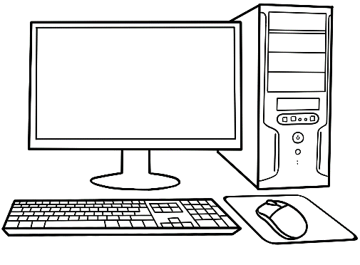



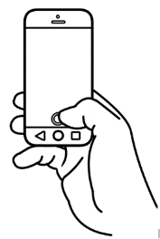

Design team: Bernard Miles, Vicki Hambling, Sue Paull, Frida Dean, Glenise Kleehammer and Mary Wallace
Illustrations: Madelena Scott

Illustrations acknowledgements:
Computer stretches Poster https://chiropracticlife.com.au/best-desk-stretches/
Parts of a computer for matching This Photo by Unknown Author is licensed under CC BY-NC
Google Translate icon This Photo by Unknown Author is licensed under CC BY

Acknowledgements: The design team would like to thank the AMEP service providers and practitioners who participated in the trial and gave valuable feedback. The team would also like to acknowledge the use of the EAL Framework which underpins the design of this book.
___________________________________________________________________________
Copyright of the EAL Framework is reserved to the Crown in the right of the State of Victoria. © State of Victoria (Department of Education and Training) 2023.
Use of all or part of this document must include the following attribution:
© Commonwealth of Australia 2024

With the exception of the Commonwealth Coat of Arms, the department’s logo, any material protected by a trade mark and where otherwise noted all material presented in this document is provided under a Creative Commons Attribution 4.0 International (https://creativecommons.org/licenses/by/4.0/) licence.
The details of the relevant licence conditions are available on the Creative Commons website (accessible using the links provided) as is the full legal code for the CC BY 4.0 licence (https://creativecommons.org/licenses/by/4.0/legalcode).
As far as practicable, material for which the copyright is owned by a third party will be clearly labelled. The department has made all reasonable efforts to ensure that this material has been reproduced in this document with the full consent of the copyright owners.
Copyright requests and enquiries concerning usage not addressed by the CC BY 4.0 licence should be addressed to: comms@homeaffairs.gov.au at the Department of Home Affairs.
The terms of use for the Commonwealth Coat of Arms are available from the It's an Honour website.
Where a copyright owner, other than the Commonwealth, is identified with respect to this material, please contact that third party copyright owner directly to seek permission.



Introduction to the books
The Teacher Resources
The resources book is an electronic reference and all materials can be adapted and printed as needed.
PowerPoint slides have been created to introduce, consolidate and revise
some vocabulary. This icon indicates a PowerPoint Presentation:
PPTs are best played in Slide Show from the beginning. Transitions allow time
for students to name parts of computers, phones and programs before the words appear.
PPT

The Student Workbook
The student book requires teacher direction and is not intended for independent learning. It is also not intended to be the only material used to teach the unit or to be used as an assessment task. It is highly recommended that students buy and use a notebook for general class work and practice. The book is available as a Word document so that teachers can:
- localise and update the content
- adjust the material to suit the requirements of particular classes
- delete or add materials as required. If you add or deduct pages, be mindful of the layout as the document has been designed so that particular pages are opposite one another.

NB. Teacher versions of the student workbooks contain notes to indicate the language focus and/or guidance for the exercise.

Table of Contents
1. Introduction 3
Meet the students and the teachers. 3
2. Computer devices 6
Scams 6
3. Computers 9
a. Computer safety 10
b. Parts of a computer 14
c. The keyboard 17
d. Typing practice 21
e. Strong passwords 23
4. Mobile phones 26
a. Phone icons 26
b. Phone safety and etiquette 29
c. Mobile phone information search 30
d. WhatsApp 31
5. Learn English on computers and phones. 40
Google Translate 40
6. Digital skills checklist 44
7. Additional resources 46

Introduction

Meet the students and the teachers.
The characters
All the drawings in the student workbook are available to be used in the design of additional materials. The bio data chart below was created to maintain consistency of information throughout the English Ready books at the three levels - Course in Initial EAL, Course in EAL and Certificate 1 in EAL.
It may be useful to update character information. Unshaded characters also appear in Certificate 1 in EAL books and those in grey feature in the Course in EAL books.

Name | Family  members | Country of origin | Age / Date of birth | Date of arrival | Address  Kellivale  2421 | Phone
Ming Wu | Lan, Bao, Mai | China | 27.03.1959 | 07.05.19 | 70 Wattle St | 0418 335 748
Sahra Omar Elmi | Tahiil, Hani  Abdi | Somalia | 07.07.96 | 09.06.22 | Unit 6, 50 Baker Rd | 0455 961 259
Linh Nguyen |  | Vietnam | 60 |  | Unit 1, 140 Kemp St
Nisha Kumar | Pari (f)  Dev (m) | India |  |  | 18 Sea St  Near Taree NSW | 0411 825 999
Basam Radi |  | Iraq | 30  05.08.1993 |  | Unit 3, 140 Kemp St | 0455 328 691
Nabi Saikal | Husband and wife  Parents of Parwana | Afghanistan | 48 | 2023 | 48 Baker Road | 0462 595 751  NabSaikal @gmail.com
Amina Tarukh | Husband and wife  Parents of Parwana | Afghanistan | 46 | 2023 | 48 Baker Road | 0466 379 142  ATarukh13@gmail.com
Parwana Saikal | Rahim’s sister | Afghanistan | 25  09.05.1998 | 12.01.23 | 48 Baker Road | 0476 756 932 Parwana27@gmail.com
Jomeh Tajik | Parwana’s husband | Afghanistan | 27 |  | 48 Baker Road
Bibi Tajik | Girl 5 | Afghanistan |  |  | 48 Baker Road
Mustafa Tajik | Boy 2 | Afghanistan |  |  | 48 Baker Road
Rahim Saikal | Parwana’s brother | Afghanistan | 19  07.05.03 |  | 48 Baker Road | 0469 883 412  rahims003@gmail.com

Bio data continued

Name | Family  members | Country of origin | Age / Date of birth | Date of arrival | Address in Kellivale  2421 | Phone
Ahmad Hamed | Carim (m 19)  Fatima (f 15) | Syria | 21  25.08.2001 | 2022 | 260 North St | 0492 665 732
Ko Tun | Zarni Tun – wife San Tun – daughter  Thein Myint –  son-in-law [24]  Yaza - grandson | Myanmar |  |  | 4/ 50 Baker St
Pam |  | Australia | 70 |  | 5/50 Baker Rd
Teacher - Peter |  | Greece | 38 |  |  | 0436 924 651
Teacher - Wendy |  | England | 45

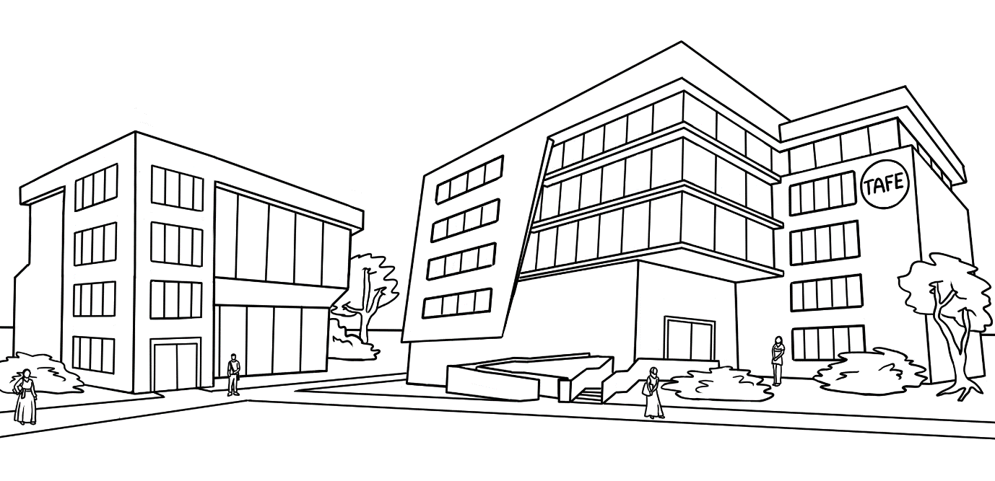
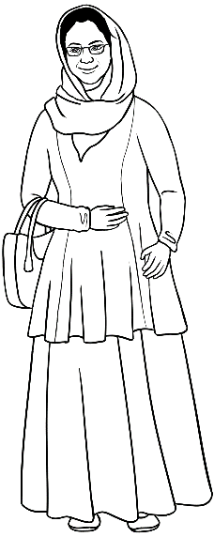
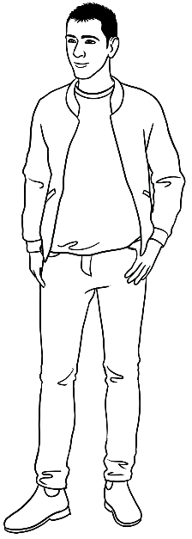
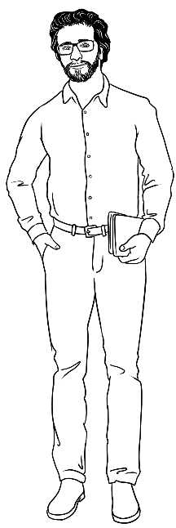
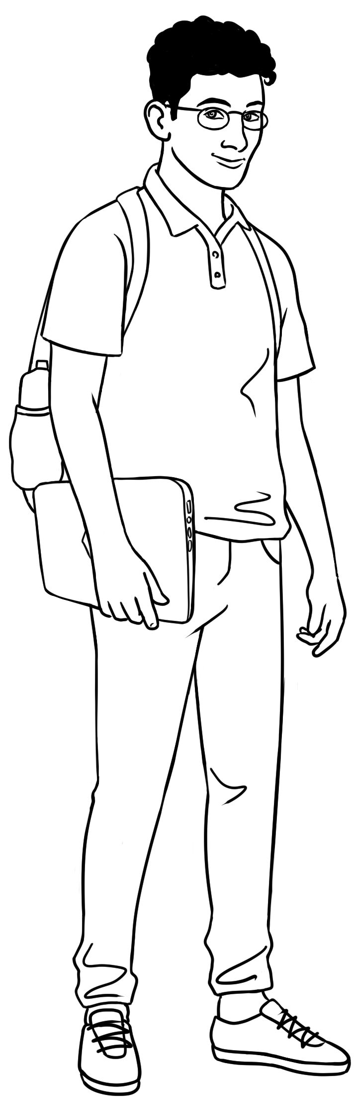
Certificate 1 in EAL Characters

Peter
Amina
Basam
Ahmad
At the
AMEP
Centre

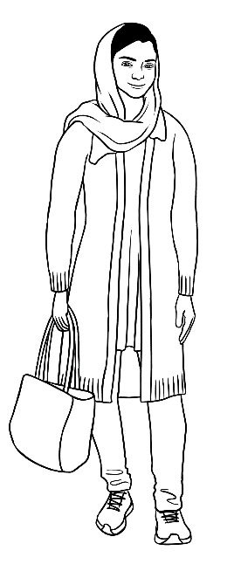
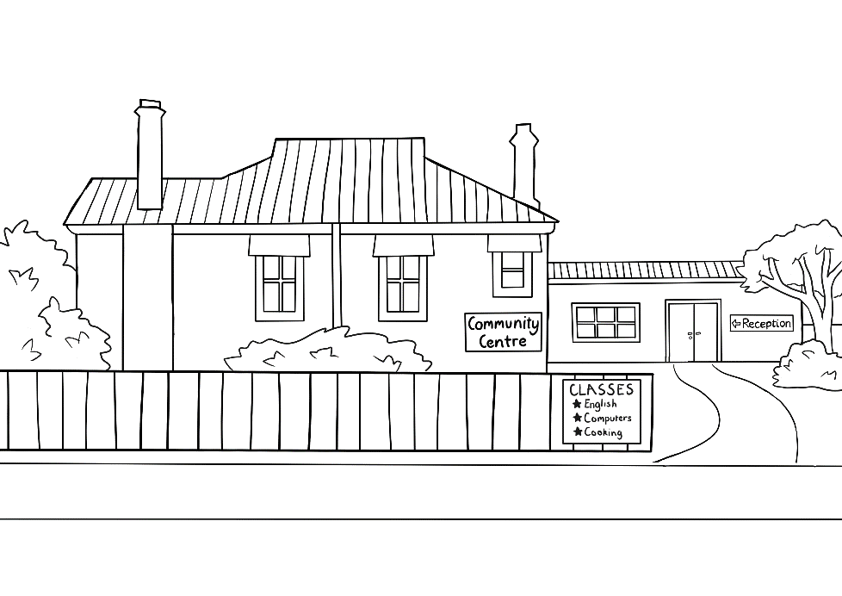
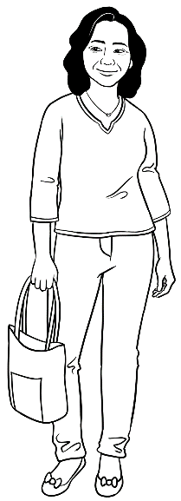
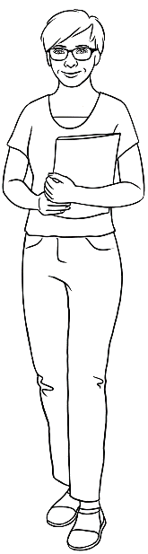
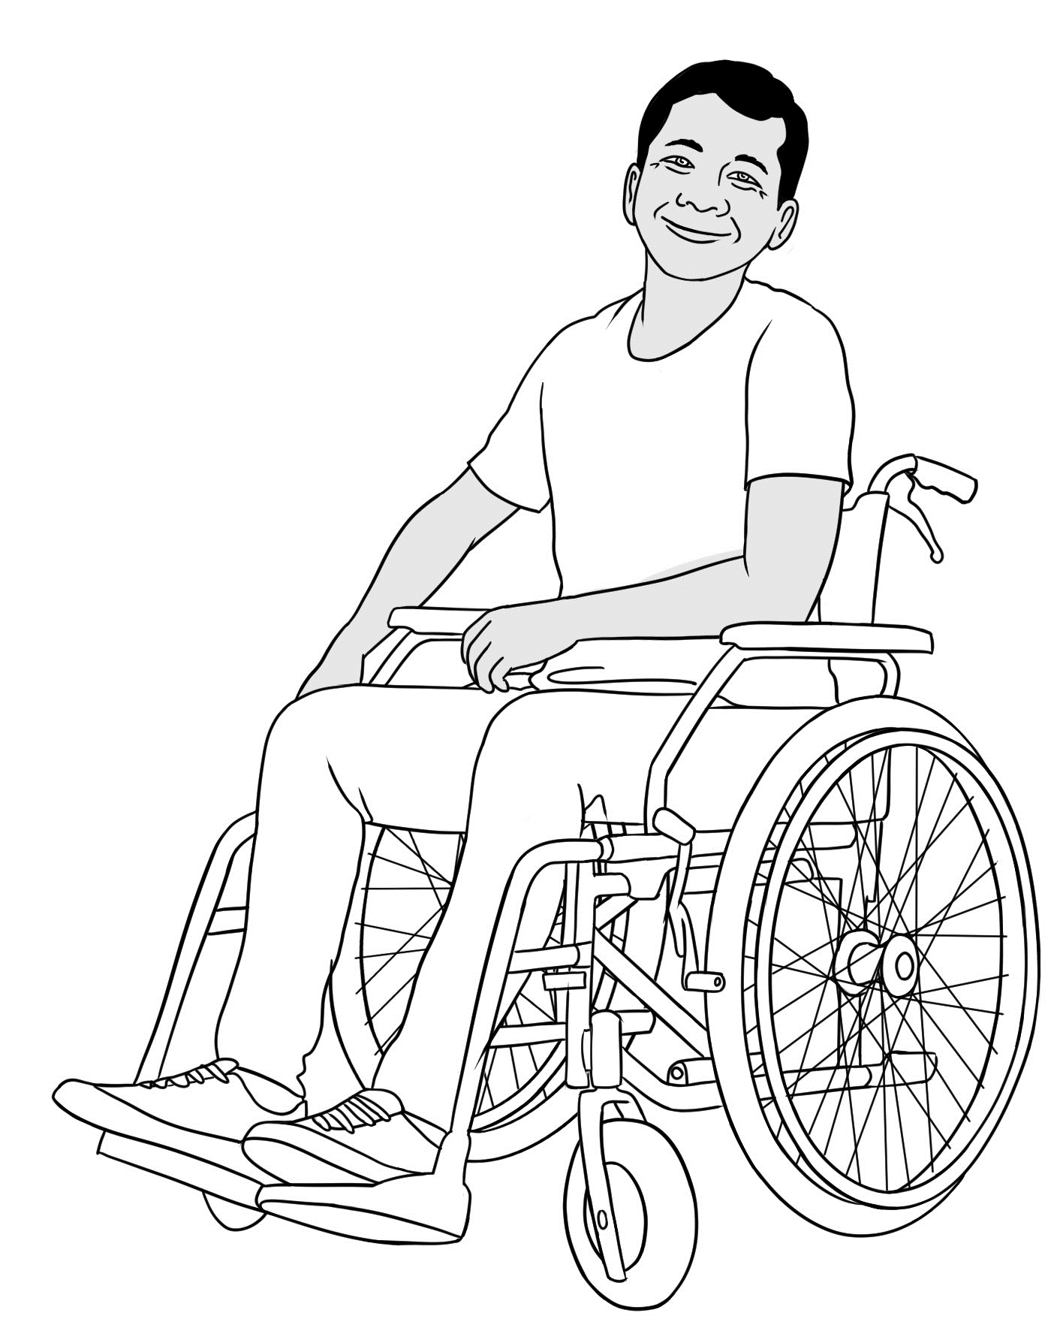

Parwana
Wendy
Linh
Ko
At the Learning Centre

Computer devices

Scams
This activity is based on the AMEP Online unit VU22099 Recognise and interpret safety signs and symbols [Stay safe], Topic 4: Safety Online. Topic 4 has an animated video which starts at slide 11, about a mobile phone scam. The video presents a problem and a solution to the scam..
https://ameponline.homeaffairs.gov.au/course/view.php?id=90
You could project relevant images from the online materials to support an introduction to scams.
Activity 1 – Talk about scams
Write each question about scams on the board, elicit responses and write simple answers to each question. Possible answers are included below:
- What is a scam?
It’s a trick to get money or personal information.
- What do we call a person who scams?
A scammer
- How do scammers contact you?
phone calls, messages, emails, websites, online ads, social media, dating sites
- Have you ever seen a scam message?
- How do you know if it’s a scam?
You don’t know the person; you don’t know the phone number; they try to scare you; they want money; they want your personal information; they want your password; they don’t use your name; the web address doesn’t look OK.
- What if you are not sure?
You receive a message from a bank. You’re not sure if it’s a scam or not.
Don’t click on any links in the message. Go on the internet and log in to your bank account. If there’s an important message, it will be in your online bank account. You can also go to the bank and check.
- Should you reply to scammers?
No.

Activity 2 – Worksheet - Be careful of scams
This worksheet focuses on scam messages. Read the information in the box together. Students match the type of scam to the scam message. These are five of the most common types of scam messages.

More resources and information
- Scam Watch
https://www.scamwatch.gov.au/types-of-scams/text-or-sms-scams
- Be Connected – Avoiding common scams
https://beconnected.esafety.gov.au/topic-library/identifying-and-avoiding-scams/avoiding-common-scams
- West Justice – How to be safe from scams (Easy English Guide)
https://www.westjustice.org.au/cms_uploads/docs/west-justice_scams_easy-english_final_print_web-accessible.pdf


Activity 2 - Worksheet
pretend =
Scams

Some people try to get your money or personal information.
These people are scammers. They send a message to you and the information is not true. What do you do?

- Do not reply.
- Do not click on any link.


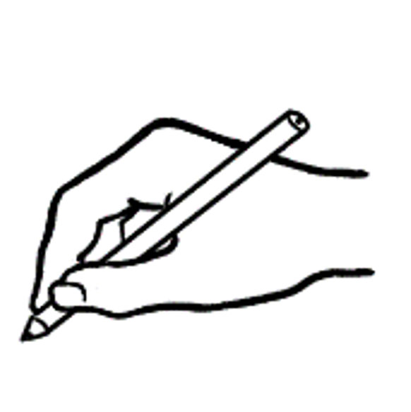
Match the scams to the messages.


Congratulations! You won a $200 gift card. You only have 24 hours to claim!
Click here: http://pr.ize/87475
AusPost: We couldn’t deliver your parcel today. Click here to choose a delivery option: https://delivery.site/93750
YourBank: Your details are not up to date. Please enter your bank details here: https://your.bank/69274

Your phone bill is OVERDUE. Pay now:
https://my.net/32864

Hi Mum. I lost my phone and wallet.
I need money for petrol.
Please call me on this number 0432 53167.

The scammer says
you won a prize.
The scammer says
you have a delivery.
The scammer pretends to be a bank or a business.
The scammer says you must pay money.
The scammer pretends to be a friend or family member.

Computers
Computer safety – Refer to page 8 in the student workbook.
Activity 1 – Sit correctly.
Start this activity with a revision of parts of the body. Name a body part and ask students to point to it on their own body.
Look at the drawing on page 8 in the student workbook and ask students to sit in the same way at their desk. Project page 11 in this book and compare the correct and incorrect ways of sitting. Explain simply and by demonstrating, the importance of sitting correctly:
- It’s more comfortable.
- Sitting the wrong way for a long time can hurt your back, neck, shoulders, wrists and eyes etc.
Page 11 in this book could be enlarged and used as a poster in the computer room.
- See also Video: Correct sitting position [The language is difficult, so could be muted.]
https://www.youtube.com/watch?v=l78saXwHoIk

Activity 2 – Don’t have a bright light on the screen
Explain that screen glare can cause eye strain, headaches and migraines.
Activity 3 – Be careful of electric cords.
Check the floor for any cords lying around. Could people trip over them?
Cords should be under the desk or along the wall.
Activity 4 – Take a break, move and stretch [Class activity]
Rest your eyes:
- Rest your eyes every 20 minutes.
- Look far away for 20 seconds.
Move your body:
- Move your body every 30 – 40 minutes [Set a timer to remind you]
- Do some exercises in your chair - stretch your arms and legs.
- Walk around for a few minutes.
Activity 5 – Stretch poster
Enlarge and put up the poster on page 12 in this book in the computer room.
Cut out the stretches on the poster, give one stretch exercise to a student before the class. The student can demonstrate the stretch for the class to imitate.
The poster website: https://chiropracticlife.com.au/best-desk-stretches/

See also this short video - Video: How to stretch at work
https://www.youtube.com/watch?v=NRPXGBuJm9U

a. Computer safety
Activity 6 - Computer safety checklist
To complete the checklist, students can work in pairs and ask their partner to observe and check if their posture is correct.
It doesn’t matter if all the items on the checklist cannot be ticked (for example, the computer room may not have adjustable chairs). Even if the sitting posture is not perfect, having regular breaks and stretches can help.
More resources
There are more aspects to computer safety not covered in these texts, for example, the positioning of the keyboard. Students can explore more resources online:
- AMEP Online: Stay well (using a standing desk) Topic 3, Slide 11 This is an animated video about a man at his work desk.
https://ameponline.homeaffairs.gov.au/course/view.php?id=89

Computer safety

Sit correctly
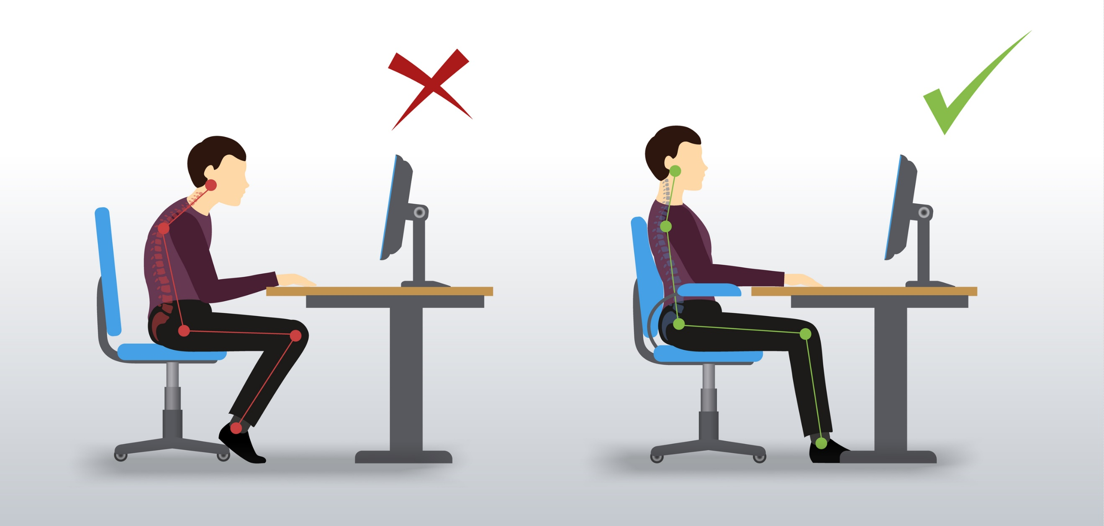
elbows a little higher than the table
lean on the backrest
feet flat on the ground
Correct way to sit:
straight back

feet not flat
elbows lower than the table
Incorrect way to sit:
not leaning on the backrest
back is not straight
Activity 1 – Sit correctly

Activity 5 – Stretch poster
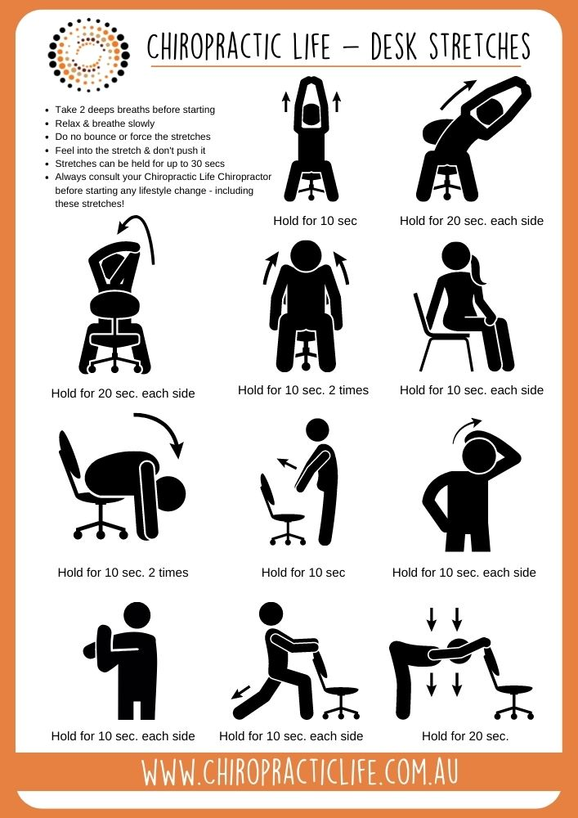

Activity 6 - Computer safety checklist

Computer safety checklist

 | 1. Your back is straight.
 | 2. You are leaning on the backrest.
 | 3. Your elbows are a little higher than the table.
 | 4. Your feet are flat.
 | 5. You take a break and move every 30 minutes.
 | 6. You do some stretches during your break.
 | 5. The screen has no glare.
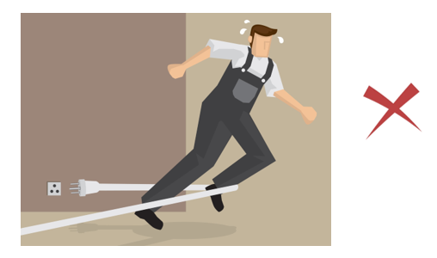 | 6. There are no cords to trip over.

b. Parts of a computer
Parts of a computer – Pictures and words
The drawings of the computer parts on the following page are different to those in the student workbook. This
- demonstrates that different brands and models will look a little different.
- introduces three new parts - a monitor, scanner and mouse mat.
The picture cards can be:
- projected for revision
- cut up for matching with the words.

Parts of a computer – Pictures

 |  | 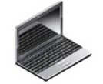 | 
   |  | 
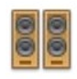 | 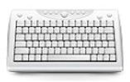 |  | 
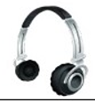 | 

Parts of a computer – Words

a desktop computer | a computer tower | a laptop | a monitor
a mouse  mat | a tablet | a mouse | a screen
a keyboard | speakers | a scanner | a printer
headphones | ear buds

c. The keyboard

The following activities can be done on a real keyboard or on a printed one. It would be useful to laminate a set of printed keyboards for the class. Students could use whiteboard markers to draw on them, and then wipe them off afterwards. Both large and small keyboards are on the following pages. Begin by showing the PPT. Activities on the keyboards:
PPT 2. The keyboard
Activity 1 – Follow instructions on a keyboard
- Press a letter key to type a small letter.
- Hold Shift and press a letter key to type a capital letter.
- Press Caps lock to keep typing in capital letters.
- Press a number key to type a number.
- Hold Shift and press a number key to type a symbol.
- Press Spacebar to type a space.
- Press Enter to move to the next line. (On some keyboards, it’s called Return.)
- Press Delete to remove text to the right.
- Press Backspace to remove text to the left.
Activity 2. - Hand position
Students can practice resting their index fingers on the F and J keys. This is the ideal position to rest hands while pausing in typing. Most keyboards have small bumps on these two keys so they are easy to locate without looking.
Activity 3 - Listen and press the keys
Say a letter or number, and students press (or circle) the key. e.g. F, L, 8, R, 9, E.
You can increase the complexity by saying letter combinations, whole words or longer numbers. e.g. bus, 12, window, 82.
Activity 4 - Listen and press the keys using the Shift key
Say a letter, number or symbol that may require the use of the Shift key.
e.g. capital L, dollar sign $, capital W, question mark?, full stop. Remind students
to keep holding the Shift key when they press the second key. Do some more practice, alternating between keys that require and don’t require the Shift key.
Activity 5 - Students work in pairs
Students work in pairs to do Activities 3 and 4.
Extension - Symbols chart
Some students may ask about the names of all the symbols. It is not necessary to know them all, but a reference chart has been provided for curious students. It has been grouped according to usage, with the top group most used.

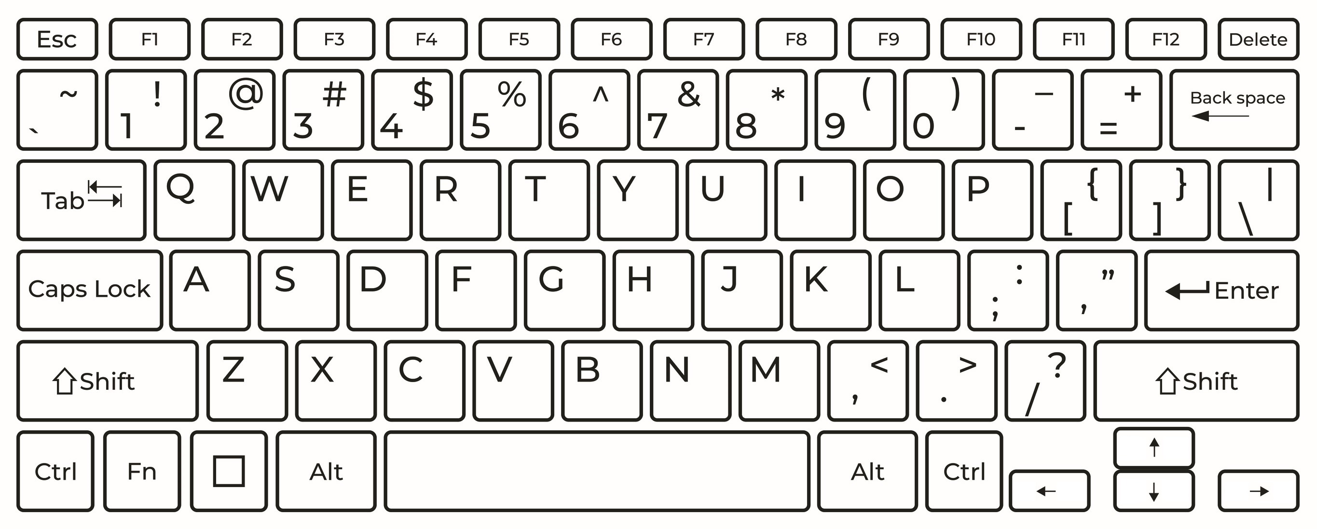

Extension
Keyboard Symbols

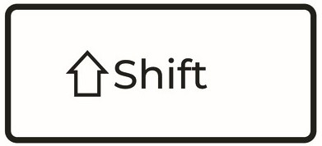
Hold to type the top symbol.

. | 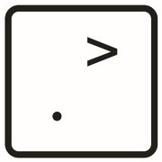 | full stop / dot | @ |  | at
, | 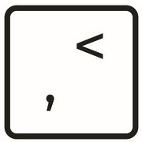 | comma | # |  | hash
? |  | question mark | $ |  | dollar
! |  | exclamation mark | % | 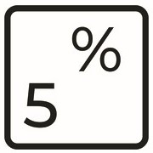 | percent
’ | 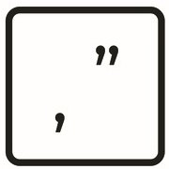 | apostrophe
: | 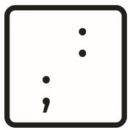 | colon | & | 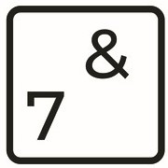 | and
; |  | semicolon | * | 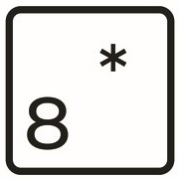 | asterisk
“ |  | double quotation mark | ( | 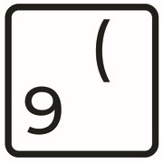 | open bracket
/ |  | slash | ) |  | close bracket
 |  |  | _ | 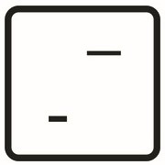 | underscore
+ | 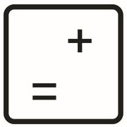 | plus | - |  | dash / minus
= |  | equals

Typing practice

The following activities need:
- a computer and keyboard
- a word processing program e.g. Word or Google Docs
Activity 1 - Typing practice
Four texts have been provided for students to type. To type the texts, students need to apply their knowledge of keyboard functions, such as how to:
- type words, and insert spaces between words
- type numbers
- type capital letters by holding Shift or pressing Caps Lock
- type symbols and punctuation marks by holding Shift
- go to a new line by pressing Enter
- correct mistakes using Backspace or Delete.
Encourage students to ask each other for help. They can practise giving instructions and asking for repetition and clarification. e.g. How do I make a capital letter?
Can you show me again please?
Instructions for opening a new Word document are provided in the student workbook on page 19.
Activity 2 - Extension activities
Using these texts as models, students can type their own texts. They can also find other texts in their books or online.
For an extra challenge, students can work in pairs. One person dictates and the other person types.
Activity 3 - Saving the document
Students may want to know how to save the document. The process varies depending on whether they are using MS Word or Google Docs. It also varies depending on whether they are saving to the computer’s hard drive, or to an external USB. Remind students that if they save it to the hard drive, they will need to use the same computer again to access the document.
Activity 4 - Online typing lessons
Here are some free websites with interactive typing lessons and games:
- Typing.com https://www.typing.com/
- Typing Club https://www.typingclub.com/

Activity 1 - Typing practice

Typing practice

Text 1

Hi. My name is Parwana. I come from Afghanistan. I am 25 years old. I live in Kellivale. I have two children.
My daughter is 5 and my son is 2. My husband’s name is Jomeh. We arrived in Australia in 2023. I study English now.

Text 2

Hi Linh. How are you? We’re having a picnic on Sunday. Do you want to come? You can bring your family. It’s at 1pm at Kellivale Park.

Text 3 Students write the words on the form and their details.

First name ____________________________________
Surname ________________________________
Date of birth ____________________________
Country of origin ________________________
Address _______________________________________
Phone number __________________________
Email _____________________________________

Strong passwords

Accessing accounts online require a password and it is important to discuss the importance of strong passwords especially for internet banking.
Activity 1 - Password tips - Worksheet
Revise the symbols needed for this activity - $ @ * ? # etc.
Project the worksheet or print for each student, and read the worksheet together.
Some additional discussion points:
- Personal information, such as your own birthday, is not safe. Consider a date that is not on any of your own personal documents
e.g. the date of a friend’s wedding
- Avoid patterns, such as letters or numbers in sequence - abc123, repeated characters -3333ffff - or rows of letters from the computer keyboard -Qwerty.
- Most websites have password requirements. e.g. Google requires:
  - 8 characters or more.
  - a mix of letters, numbers and symbols.
- A mix of letters, numbers and symbols makes your password stronger, but it also makes it more difficult to remember. If you can’t remember your password, you could write it on a piece of paper and keep it in a safe place.
- Don’t put the paper near your computer.
- Don’t write your name, username or email address on the paper.
- Don’t write your passwords in emails or computer files.
- Words, phrases or sentences can make a password easier to remember. Replace some letters with numbers or symbols.
e.g. a could become @, i could become!, l could become 1, s could become $, and g could become 8. Also, use a mix of small and capital letters.
- Make sure no one is looking at you while you enter your password.
- Always log out of your account, especially if you are on a public computer.
Activity 2 – Are the passwords strong or weak? – matching exercise in pairs
Students cut up the cards and organise them in two columns under the correct heading – Strong or Weak.
Some answers are obvious: password is a very weak password.
Some are more ambiguous: @17Feb22 meets the criteria for a strong password (small letters, capital letters, numbers and symbols), but it’s a date. This would not be safe if it’s their birthday, or a family member’s birthday.
Additional resource:
- GCF Global: Creating strong passwords
[Use without the sound and encourage students to suggest what might be said.]
https://edu.gcfglobal.org/en/internetsafety/creating-strong-passwords/1/

Activity 1 - Password tips – Worksheet

You need a password for your online bank and email accounts. A password keeps your account safe.

You need a strong password. A strong password is difficult for people to guess.
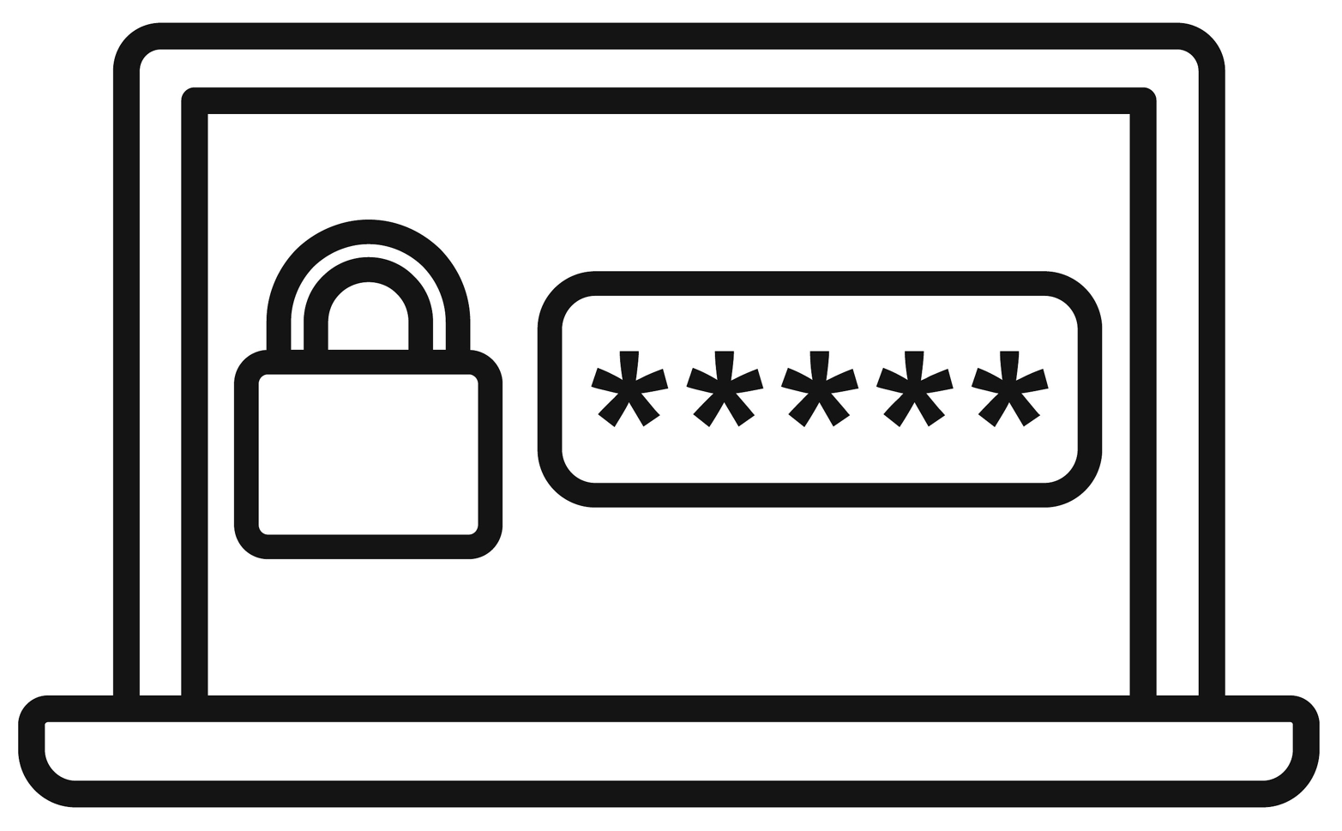

1. Don’t use personal information: names, birthdays, addresses.

Parwana1998 16Oct92
2. Don’t use common words or names.

Banana SydneyNSW
3. Don’t use patterns. They are too easy to guess.

abc123 3333ffff Qwerty
4. A strong password has different letters, numbers and symbols:

  - small letters: a b c
Zgs@45?

  - capital letters: A B C
  - numbers 1 2 3
  - symbols: ? $ @ * #
5. You can use words. Change some letters to numbers or symbols.
6@pp1e*PIEs

6 apple pies =
6. You can use a sentence or words from a song.
Idc@7itM#

I drink coffee at 7 in the morning! =

Activity 1 - Password tips – Strong or weak passwords?

Strong passwords | 456xyz
Weak passwords | 3@mJx8$
W*tCoo@? | asdfgh456
@17Feb22 | Noodles1
password | F1$#S0up!
9876543? | A1B2C3D4
$unL18ht* | Password@321

Mobile phones

a. Phone icons

Phone icon cards
The cards on the following pages contain 12 common phone icons found in many apps, including WhatsApp. They are helpful to learn, as they are usually not labelled in the phone apps. There are a variety of ways to use the cards and in each of the activities below, students can discuss the meaning of each icon.
Activity 1 - Match images to words
Print and cut the image and word cards separately (single-sided). Students say the name of each icon and then match it to the word.
Activity 2 - Flash cards
Print the image and word cards back-to-back. Students say what each icon means, then turn the card over to check.
The word cards are in reverse order compared to the image cards so they will match up when printed back-to-back.
Activity 3 - Listen and point
Cutting is not required. Say the name of the icon, and students point to it.
Activity 4 - Memory game
Print two sets of the image cards, single-sided. Students place the 24 cards face down in a random order. They flip two cards each time. If the cards match, they identify their meaning and put them to the side. If they don’t match, they flip them face down again. Continue until all pairs have been matched.
Activity 5 - Find the icons on your phone
Project the images on the following page. Students see how many of the icons are on their phone. The icons can be found on apps such as WhatsApp, text messaging, YouTube, internet browsers etc.
Activity 6 – Extension - Additional icons
Students can find icons not included in the 12 cards. These could include:
 | audio |  | locked
 | phone connection |  | attach a file
 | delete |  | go back
Encourage students to draw the icons on the board and identify their meaning.

Phone icon cards - Images

 |  | 
 |  | 
 |  | 
 |  | 

Phone icon cards - Words

internet | battery | power
camera | video  call | phone  call
search | play | voice recorder
home | close | send

Phone safety and etiquette

Activity - Is it safe? Is it polite?
Depending on the level of the class, discuss the issues on the table below in pairs small groups or as a class. Some situations do not have a definite answer. If a mobile phone should not be used in a certain situation, ask Why:
- Is it illegal?
- Is it dangerous?
- Is it rude?
- Will it disturb other people?
In some situations, such as in class, church or the cinema, it is polite turn the volume to silent [See student workbook page 26] or put the phone on silent mode.
Check if students know how to do this.
NB. The process for putting the phone in silent mode varies for each phone model.


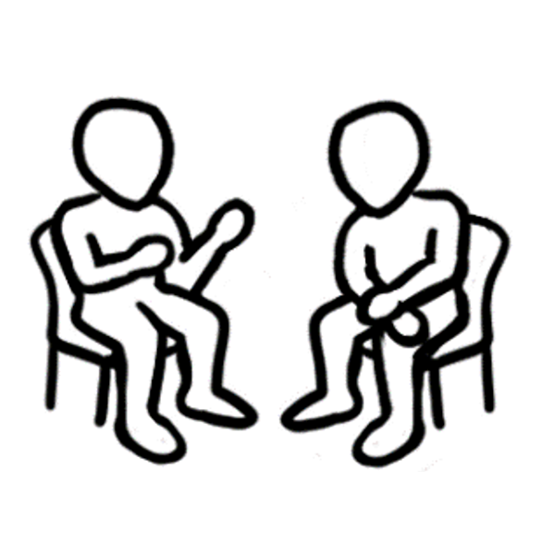

Mobile phones

You can use a mobile phone . . . | True | False
1. in class.
2. while you’re driving.
3. on the bus.
4. while you’re riding a bike.
5. while you’re walking along the street.
6. while you’re having dinner with people.
7. while you’re cooking.
8. in the park.
9.

Mobile phone information search

Activity – Find information on your phone
Students use their mobile phone to find various types of information and use a variety of common apps. The activity could also be done on a tablet or computer.
If appropriate, you could also add some additional tasks: take a photo, check the photo, send a message.

Mobile phone information search

Use your mobile phone to do this work.

1. What’s the time?
2. What’s the date?
3. What’s your battery level?
4. What’s the weather today?
5. What’s 23 x 16?
6. What day of the week is 25 December?
7. What’s the address of the library?
8. What time does the library close?

WhatsApp
Many learning centres use WhatsApp to communicate easily with students. Setting up a class group enables a teacher to send group or individual spoken or written messages, and for students to do the same. The following pages demonstrate many functions on the app and can be used as worksheets or projected and explained in class.
Activity 1 – Sending a text message
A PPT is available to support this introduction.
Activity 2 – The top, middle and bottom of the screen - Worksheet
Print pages 33 - 34 back-to-back for labelling.
Activity 3 – Basam receives a message
Print and distribute the worksheet for students to complete.
Activity 4 – Reply to a message.
This worksheet shows how to send a text message reply for students who have access to WhatsApp.
Activity 5 – The digital keyboard
The keyboard on phones differs from a computer keyboard. It is helpful first to project page ___ and explain these differences and then give each student a worksheet to complete exercise 2.
Activity 6 – Send a voice message.
Teaching students how to send a voice message is very empowering for students who are more confident in speaking than writing.
Activity 6 – Read and send messages in a WhatsApp group.
This page is an introduction to a WhatsApp group.

appa to a text message
PPT 5. WhatsApp

Activity 1 – Sending a text message


The WhatsApp screen

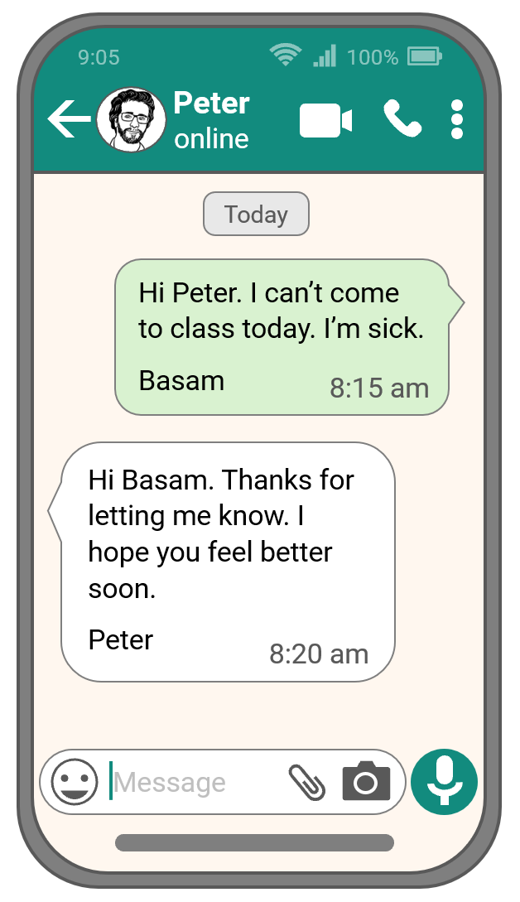
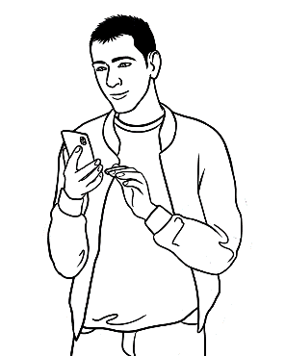
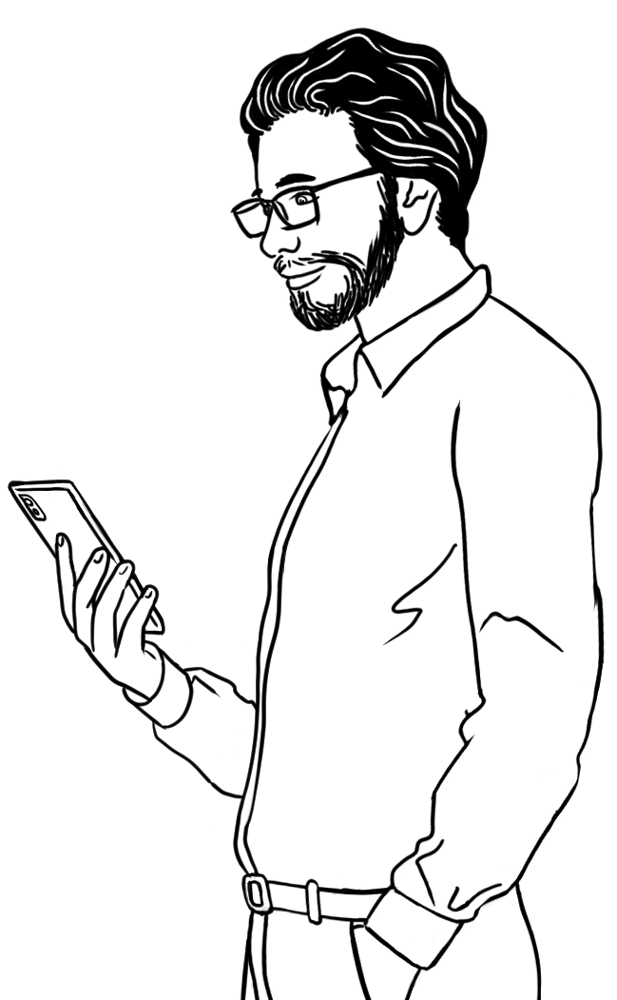
- Basam sends
a message
to Peter.
2. Peter sends
a reply to Basam.

Activity 2 – The top, middle and bottom of the screen - Worksheet

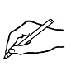
WhatsApp – top

You are messaging Peter | Video call Peter
Go back  2 | More actions
Call Peter – a voice call, not video

2
3
4
1
5

WhatsApp – middle
The time of the messages | Peter’s message
Basam’s message | They sent the messages today.
1
2
3
4

Activity 2 – The bottom of the screen – Worksheet [continued]
WhatsApp – bottom

Send a photo | Send a voice message
Type a new message | Send a document
Send an emoji (a small picture)

1
2
3
4
5

Activity 3 – Basam receives a message
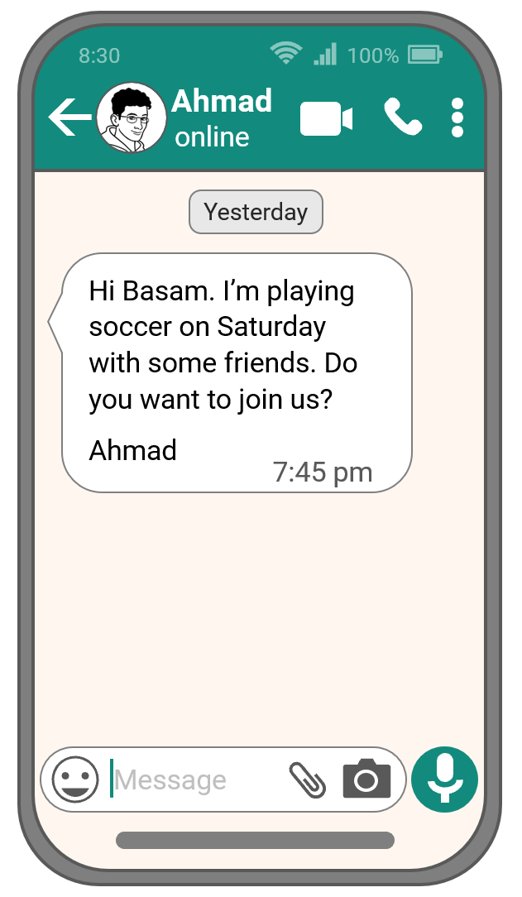


Basam gets a message.

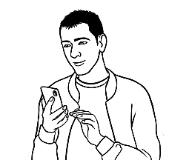

a. Who sent a message to Basam? _________________________
b. When did he send the message? _________________________
c. What time did he send the message? _________________________
Which icon should Basam tap? |  |  |  |  | 
- He wants to send a photo.
- He wants to send a voice message.
- He wants to have a video call.
- He wants to have a voice call.
- He wants to send an emoji.

Activity 4 – Reply to a message.

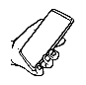
Reply to a message.

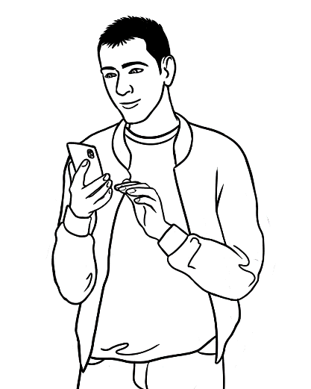

1. First, tap the message box.

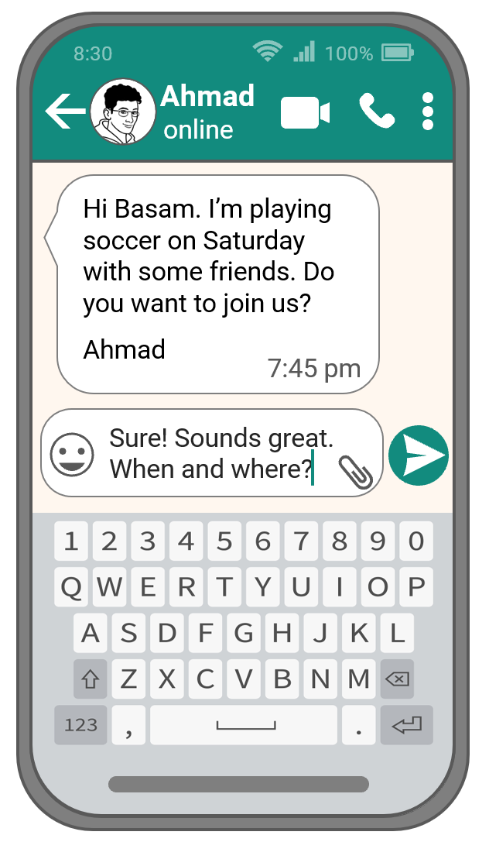

2. Next, type your message.
Use the digital keyboard to type.
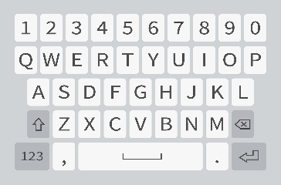

3. Check your message.

4. Then, tap the Send icon.

Activity 5 – The digital keyboard - Worksheet
Digital keyboard



Useful keys

 | Shift: Type a capital letter. A B C
 | Backspace: Remove text on the left. X
 | Switch keyboard: Change to another keyboard  with numbers and symbols. 1 2 3 ? $ @
 | Spacebar: Type a space.
 | Enter: Go to the next line.
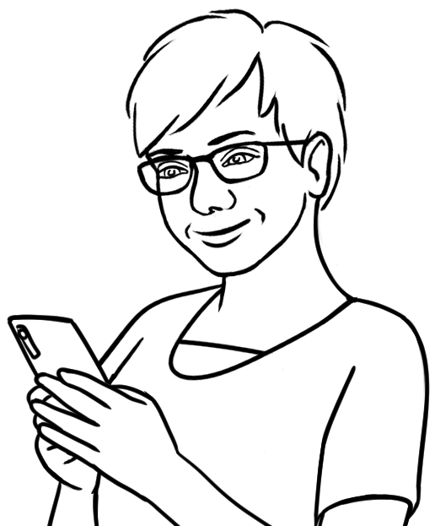

Highlight the keys I say.

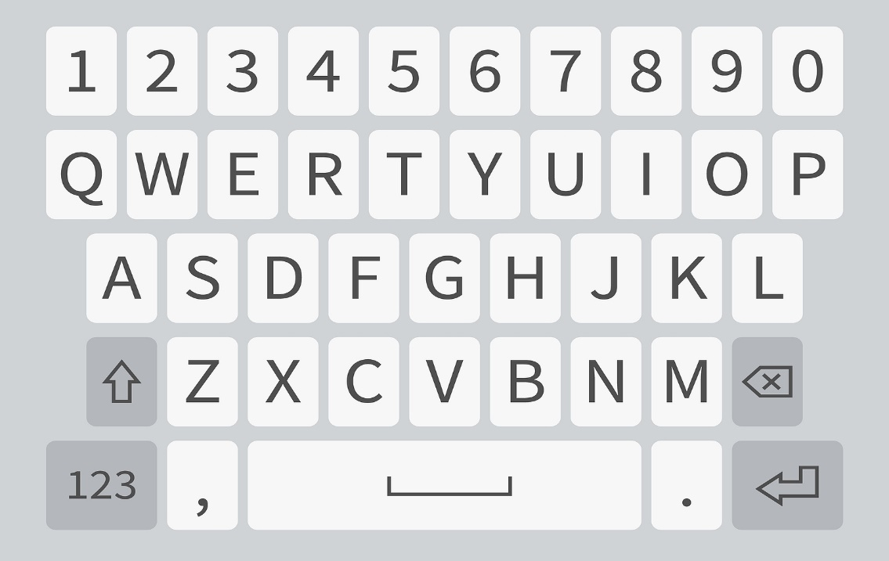

Activity 6 – Send a voice message.

Send a voice message

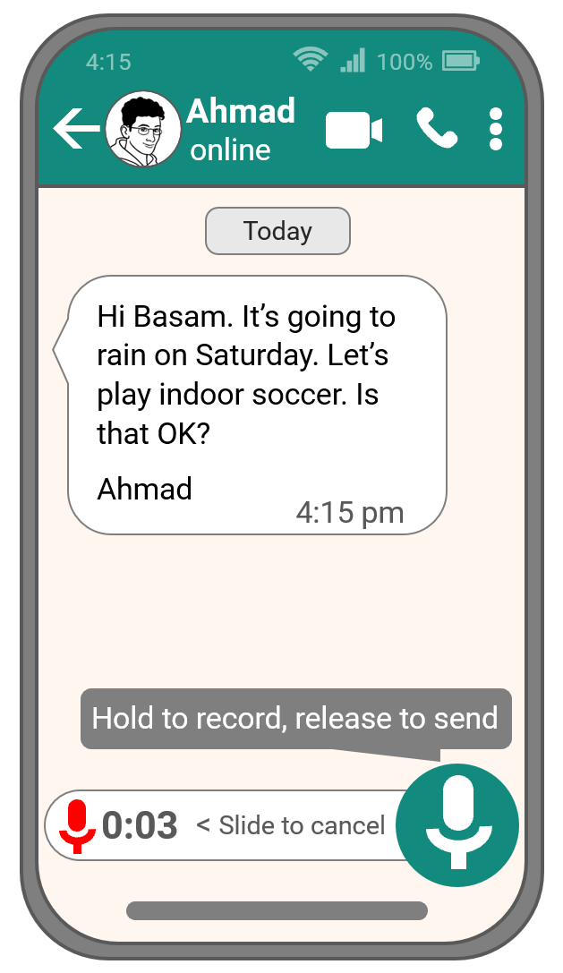

1. First, press and hold the
Voice message icon.


2. Then, talk.
Hi Ahmad. That’s a good idea. Where will I meet you?
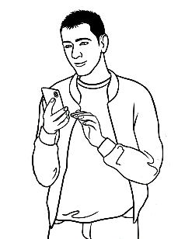


3. Take your finger off the button
to send your message.

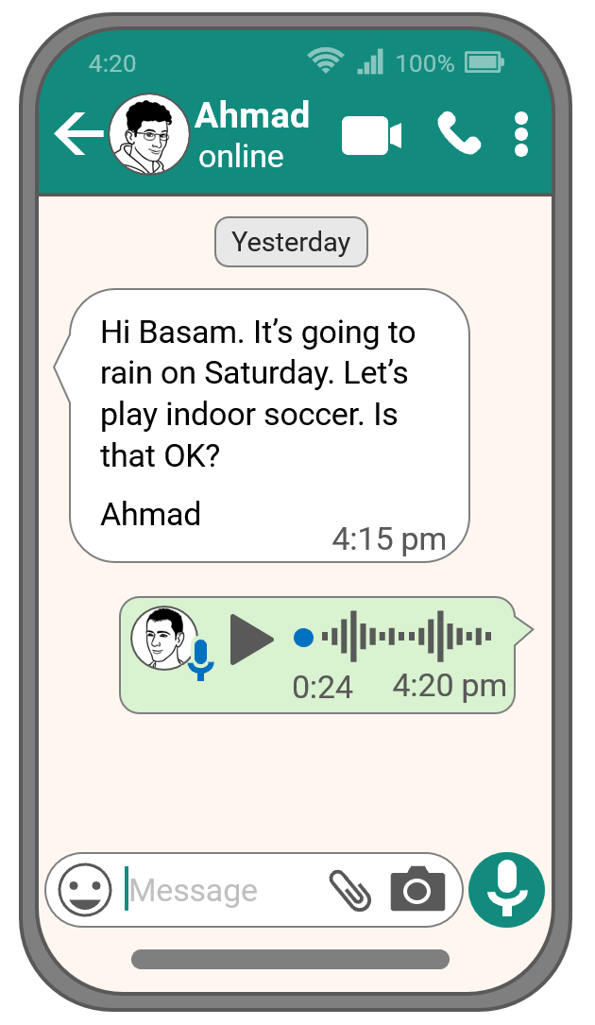

4. Tap Play to hear your message.
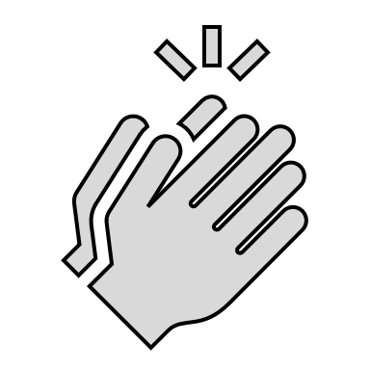

5. Swipe left on your message
to cancel it.


Activity 6 – Receive and send messages on a WhatsApp group.

Receive and send messages in a WhatsApp group.
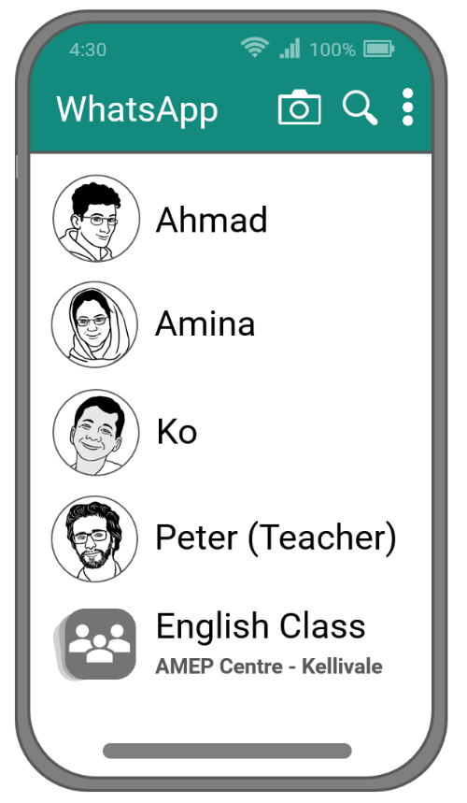
Our class has a WhatsApp group.

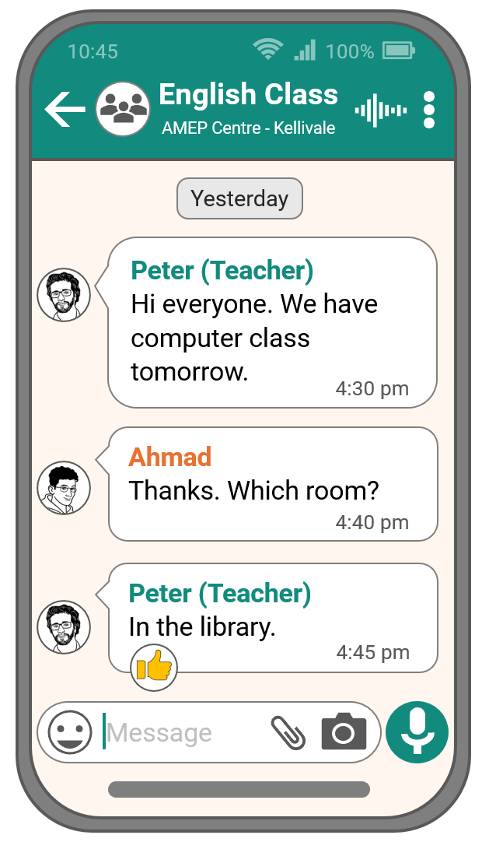

I can receive and send messages
to my teacher and classmates.

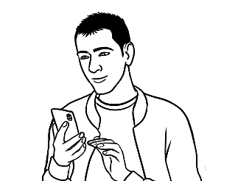
receive = get

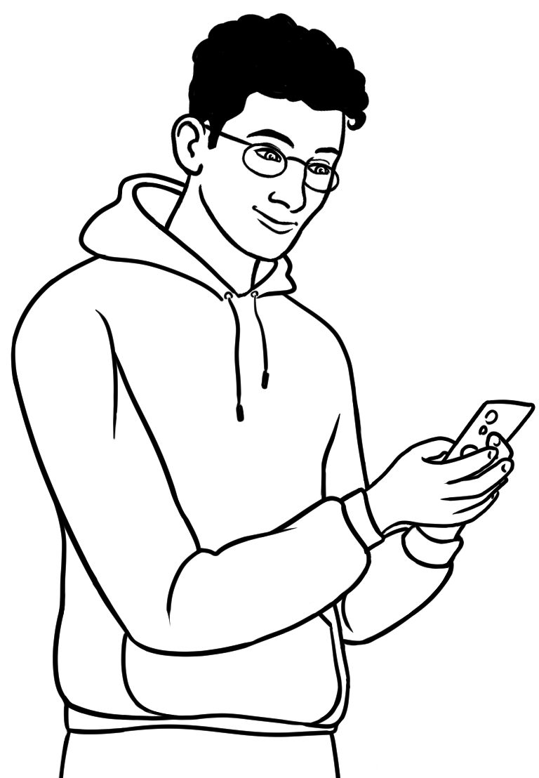
We can all read or listen to
the messages.

Learn English on computers and phones.

Google Translate

Activity 1 - Use Google Translate
The two pages in this activity show the steps in using Google Translate. The pages can be projected for students to follow as a class and later printed for each student. Students will need access to a mobile phone and an internet connection. The activity can also be done on a tablet or computer, but the interface will vary slightly from the instructions.
Note: In instruction 3, the digital keyboard may automatically change the Enter key to a Go key.

Activity 2 – Translate the words - Worksheet
The words on the worksheet appear in the student workbook, but can be edited
to add a more relevant selection of words.

Activity 3 - Extension activities
Students can do a variety of other activities with Google Translate:
- Translate and write down any unknown words in a reading text.
- Use the microphone to input the word (instead of typing).
- Translate from a student’s own language to English. This could be difficult if the language does not use the Latin alphabet (such as Arabic or Chinese).
In this case, the options could be:
    - set-up the phone to type in the student’s language
    - use voice input
    - use the camera to detect the word written on paper.
- Use to check the pronunciation of a word. e.g. Wednesday
- Go to Google Translate and type in Wednesday
- Tap the speaker icon and students can hear the word and use as a model.
Students can also input whole sentences. Although the computer-generated voice may not be perfect in terms of intonation, it can be a good option when there is no-one around to help.

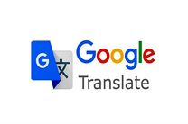
Activity 1 - Use Google Translate

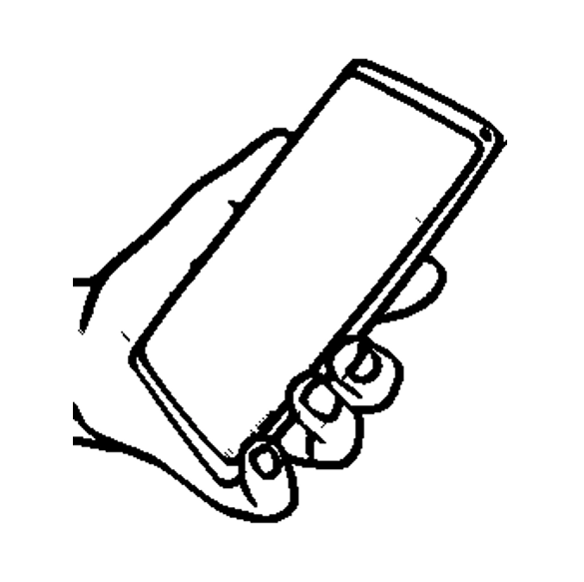
translate = change

I can translate words into Arabic.

I can translate English words into Greek
on Google Translate.

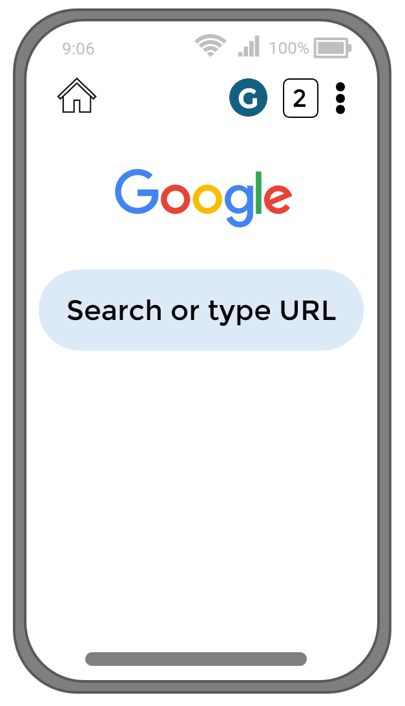
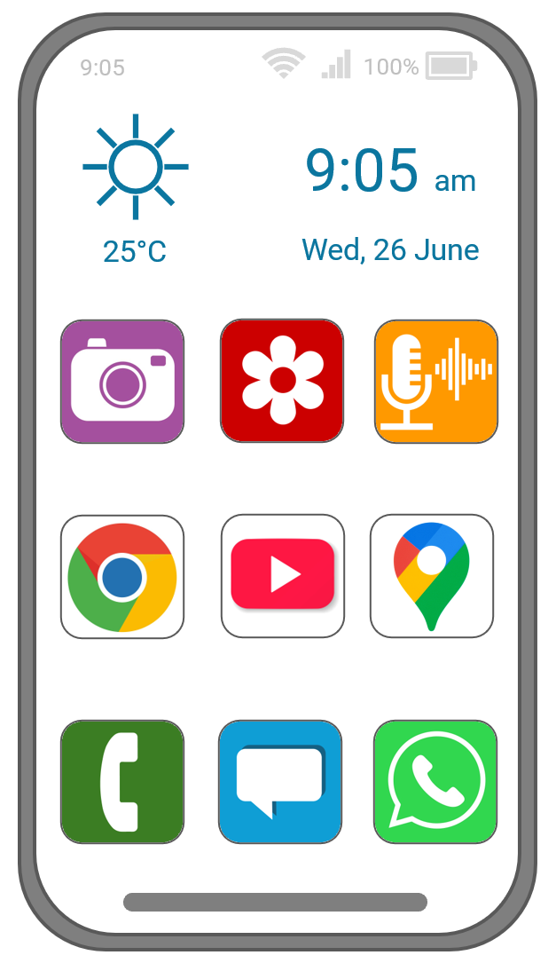
2. Next, tap the search bar.
1. First tap the internet browser icon.

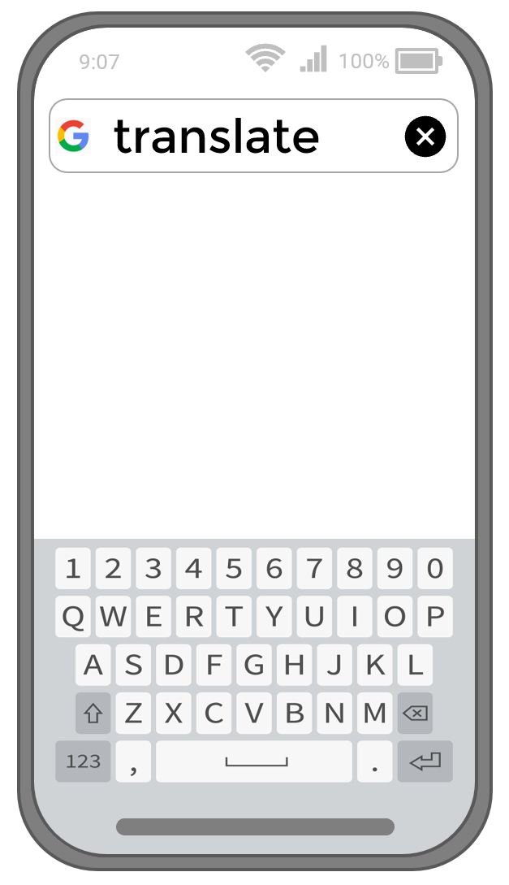

4. Tap Enter / Go.
3. Then type translate.

Activity 1 - Use Google Translate [continued]
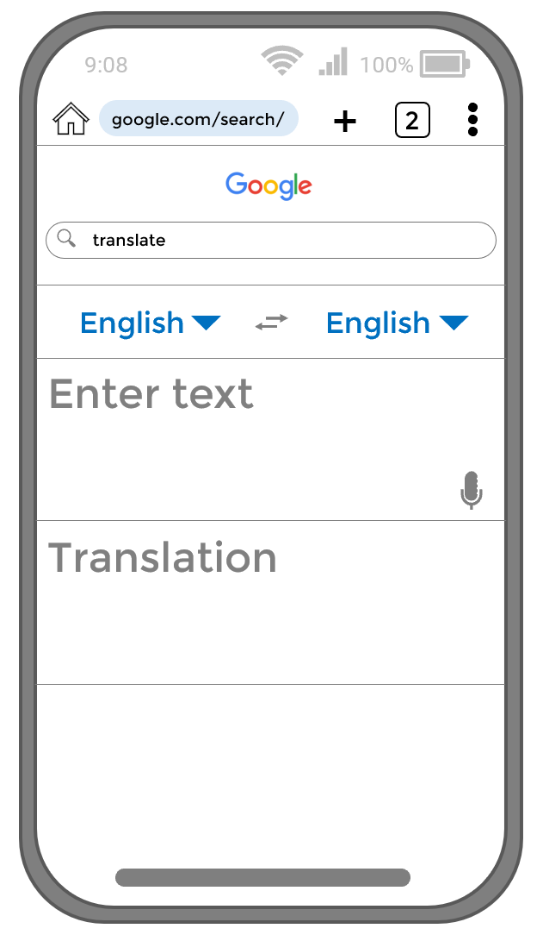
5. Tap to change the language.

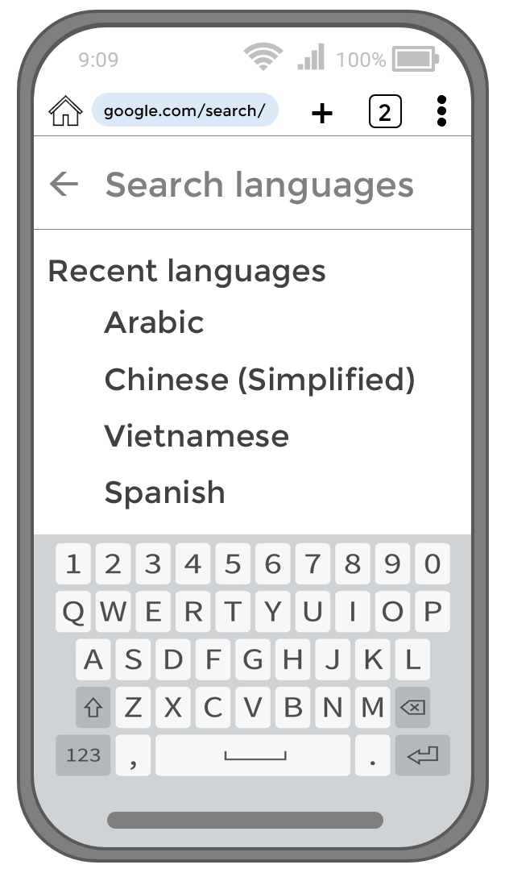
7. Then tap Enter.
6. Type your language
or find it on the list.

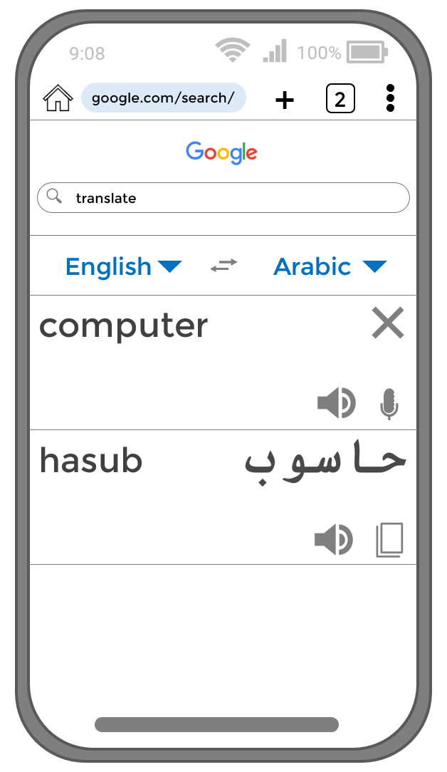

8. Type the
English word.
Read the word
in your language.
10. Tap X to translate
another word.
9. Tap the speaker icon to listen.

Activity 2 - Translate the words
Translate the words

English |  | Your language
1 | volume
2 | symbol
3 | useful
4 | arrows
5 | delete
6 | cursor
7 | actions
8 | password
9 | icon
10 | program

Digital skills checklist

The digital skills checklist separates computer and mobile phone skills. Using AMEP Online has been included on both lists to encourage students to access it both on a computer and mobile phone.
Students can do the checklist at any time, before, during or towards the end of the unit. They could even complete the checklist at different times throughout the unit, to see how much progress they have made.
Edit the checklist to add any other relevant skills students have been learning.

Digital skills checklists

Computer skills |  | Yes | Not sure | No
1 | I know the parts of a desktop computer.
2 | I know the parts of a laptop computer.
3 | I can type capital letters.
4 | I can type symbols.
5 | I can use a mouse.
6 | I can start up a computer.
7 | I can open Word and type.
8 | I can shut down a computer.
9 | I can use AMEP Online.

Mobile phone skills |  | Yes | Not sure | No
1 | I know the parts of a mobile phone.
2 | I understand mobile phone symbols.
3 | I can unlock my phone.
4 | I can turn off my phone.
5 | I can take a photo.
6 | I can record a video.
7 | I can use WhatsApp.
8 | I can use Google Translate.
9 | I can use AMEP Online.

Additional resources

1. PowerPoint presentations
PPT
These PowerPoint presentations can be found on the English Ready site:
1. Parts of a computer
2. The keyboard
3. Parts of a mobile phone
4. Mobile phone home screen
5. WhatsApp screen
3. Online tools
These free online tools can be used for very flexible communication between the teacher and students, and between students. They can encourage collaboration and creativity. Although the tools are free, some have premium upgrade options.
- WhatsApp (mobile app): If the class is interested in setting up a class group, the students can choose a group name, and set up some rules for the group. Such a group has many benefits and creates a platform for:
- easy communication outside class.
- sharing announcements and learning resources such as YouTube videos.
- developing a cooperative class dynamic

- Padlet is an interactive bulletin board. Set up a board (you get up to three free boards), and provide the link to students. On the board, students can post text, images, links, videos and voice. Everyone can see each other’s posts. It’s useful for activities such as self-introductions, sharing writing and brainstorming.

- Kahoot is a platform on which you can create quizzes and learning games. Set up a quiz, provide a link to students, and everyone can play against each other in real-time.

- Google Forms is typically used to collect information, but it can also be used to create quizzes. For example, you could embed a YouTube video into a form, and then create a set of comprehension questions underneath it. It cannot give instant feedback after each question, but it can provide feedback at the end of the quiz. Google Forms is very simple and easy to use. For more complex quizzes, you could try other platforms such as Jotform or Typeform.

3. Online resources
Here are some websites with ready-to-use resources for students.
- AMEP Online has interactive online lessons for English, numeracy, digital skills, safety and citizenship.
https://ameponline.homeaffairs.gov.au/
- Be Connected has lessons and videos on using digital technology. There is a strong focus on e-safety.
https://beconnected.esafety.gov.au/
- GCF Global has a large range of lessons on digital skills, as well as job-seeking skills, numeracy and English.
https://edu.gcfglobal.org/en/
- SBS Learn English has videos audio podcasts and articles for English learners.
https://www.sbs.com.au/language/english/en/learn-english

